MONITORING FOREST COVER CHANGE IN PROTECTED AREAS OF PANDAM NATIONAL PARK, NIGERIA USING SENTINEL-2 IMAGERY AND GOOGLE EARTH ENGINE

John B. Dakagan ^{a*}, Samuel A. Wash ª, Leah Y. Magu ª, Shiphrah A. Retu ª, Rabecca Agwu ª, Vivian A. Zamani ª, Okolo. S. Abimajeª, Tanko D.^{b}

ª National Centre for Remote Sensing (NCRS), Jos, Plateau State, Nigeria
^{b}Federal University Lokoja, Kogi State, Nigeria

ABSTRACT

The high demand for certain species of wood in China and other parts of the world, including Nigeria, has exerted pressure on protected areas worldwide. Pandam National Park is one of the forests affected by this demand through the activities of illegal loggers locally in connivance with foreign wood merchants. This study was conducted to assess the status of vegetation cover of the protected area before the peak of devastation, at the peak of the devastation, and after the peak of the devastation. The objective is to quantify the spatial and temporal changes in forest cover using remote sensing and GIS techniques. The Google Earth Engine (GEE) cloud-based platform was used to analyze Sentinel-2 images of 2019, 2021, and 2023, targeting landcover changes that took place during those periods. The results indicated the sensitivity of the Normalized Difference Vegetation Index (NDVI) as a healthier forest in 2019 (0.7436), which deteriorated in 2021 (0.73), but with improvement in 2023 (0.80), based on the maximum and minimum values of NDVIs. The forest area at 85.82% in 2019 reduced to 75.91% in 2021, but improved to 81.92% in 2023. The cumulative forest cover change to the 2019-2021 period indicated that 208.55 sq km of forest was changed to bare surface, more than the same change in 2021-2023, which had 195.62 sq km, a reduction in forest cover destruction of 12.93 sq km. In the same vein, in 2019-2021, the bare surface change to forest was -208.95, negatively showing losses of forested area. Similarly, the change of bare surface to forest in 2021-2023 of -195.48 showed lesser losses compared to 2019-2021. The Federal Government of Nigeria (FGN) needs to strengthen the enforcement of forest protection laws and invest in regular monitoring using advanced geospatial technologies. Integrating communities in forest surveillance alongside forest guards and adopting sustainable resource-use practices can help prevent further forest degradation. The government should reafforest the park and make it a hub for tourism, rather than just upgrading it to a National Park.

Keywords: Illegal logging, Forest cover change, Protected areas, Sentinel-2, Google Earth Engine (GEE)

INTRODUCTION

Global forest cover has declined by 31% (4.06 billion ha) and continues to shrink(Ref.). Since 1990, 420 million ha of forest, larger than India, have been lost, including 10 million ha between 2015 and 2020, roughly the size of Iceland (FAO, 2020). Selective logging has affected about 400 million ha in the tropics and 1 billion ha worldwide (Putz et al., 2022).
Africa’s tropical forests have become major hotspots for illegal logging due to their dense vegetation and high international demand for timber. This exploitation is largely driven by the Chinese market, which relies on small-scale loggers to supply high-value rosewood. China’s extensive rosewood industry, supported by state-backed financing estimated to have 3,000 rosewood factories across 25 areas in the country, is worth $75 million and has intensified illegal extraction, making rosewood the most heavily smuggled wildlife product globally (Environmental Investigation Agency, 2019; Africa Centre for Strategic Studies, 2022).
Logging is degrading tropical forests at rates higher than deforestation, driving extensive rosewood exploitation in Nigeria’s Sudan and Guinea Savannah regions. Unsustainable legal and illegal logging, alongside unregulated resource extraction, have depleted protected forests, while market-driven selective logging often leads to broader forest clearing and damage to younger trees (ICIR, 2016; Pearson et al., 2017; da Silva & Rodgers, 2018; Okechalu et al., 2021).
Protected Areas (PAs) have expanded since the 1990s, with global commitments to protect 17% of land by 2020 under the Convention on Biological Diversity. However, despite this growth, PAs remain increasingly threatened by human activities such as settlement encroachment, agriculture, mining, logging, and wildlife exploitation. By 2018, over 230,000 terrestrial PAs covered 14.9% of the Earth’s land surface and inland waters and protected only a small proportion of global tree cover (Lindsey et al., 2014; UNEP-WCMC, 2018).
International frameworks emphasize the establishment and management of protected areas as essential for biodiversity conservation and sustainable development. The Convention on Biological Diversity and the 2030 Sustainable Development Agenda, particularly SDGs 14 and 15, recognize protected areas as a central conservation strategy. However, despite these commitments, the condition of protected areas continues to deteriorate as global biodiversity loss intensifies toward 2030 (UN, 1992; UNEP, 2016).
Empirical Studies
Nguyen et al., (2025) monitored forest cover changes in Vietnam using remote sensing (RS) and geographic information systems (GIS) using GEE via a random forest algorithm. The CA-Markov model and the MOLUSCE module were also used. Projections for 2030, using MOLUSCE, suggested impacts from agricultural expansion, deforestation, and restoration efforts on forest area.
Tariq et al., (2023) used Geographic Information System (GIS) and Remote Sensing (RS) approaches with integrated machine learning tools, such as Support Vector Machine (SVM), Naive Bayes Tree (NBT), and Kernel Logistic Regression (KLR), to track spatiotemporal changes in forest cover in Khyber Pakhtun Khwa (KPK), Pakistan. Their results demonstrated that simultaneous reforestation in arid land locations enhanced forest maintenance techniques and the use of RS and GIS in routine forestry organization operations.
Studies in West African forest reserves showed vegetation loss due to human activities. In Onigambari Reserve, dense forest, plantations, and sparse vegetation could decline by 20.9%, 16.1%, and 20%, respectively (Tobore et al., 2021). In Ghana, logging caused major forest losses, with Gbelle Game Reserve losing ~56,050 ha and Ankasa National Park ~1,793 ha between 1990 and 2020 (Afele et al., 2022). Illegal timber logging often targets specific high-value tree species. In Ghana, Triplochiton scleroxylon accounted for 23% of trees exploited by illegal loggers (Abugre & Kazaare, 2010).
Some studies showed that illegal logging affects not only the trees harvested but also the surrounding unlogged trees. Forest change detection in the Metchie-Ngoum Protection Forest Reserve in Cameroon revealed that logging was a major driver of forest loss. The study also showed that a guided conservation approach, emphasizing community participation, regular eco-guard monitoring, sensitization, and participatory forest mapping, can support more sustainable forest reserve management (Fokeng et al., 2020).
In Cameroon’s Melap Forest Reserve, forest cover declined from 1,345 ha in 1988 to 664 ha in 2018, representing a loss of 680.9 ha (about 49%) over 30 years. This decline corresponded with increases in savannah (+315 ha), cropland (+351 ha), built-up areas (+9 ha), and bare soil (+6 ha) (Temgoua et al., 2022).

Studies in Nigeria
Studies in tropical Nigeria highlight threats to forest regions from illegal timber exploitation. Ahmed and Olaitan (2024) noted that the unlawful export of timber, often aided by tax and royalty relief, increases personal income for syndicates at the expense of national development, emphasizing the need for stricter laws and regulations.
Southern Nigeria’s dense forests have fuelled widespread illegal timber extraction. Studies showed that strong networks of local and foreign syndicates, often involving young, unemployed, and able-bodied men and women, exploit precious woods as a means of survival (Ikuomola, Okunola, & Akindutire, 2016).
Namuene and Egbe (2022) found that logging reduces the productivity of future trees, emphasizing the need for sustainable timber extraction to protect remaining stands. Similarly, Bisong and Mfon (2022) reported in Southeast Nigeria that higher logging intensities correlate with greater damage to unlogged trees, reducing their population and increasing stand destruction, demonstrating that logging intensity is a key factor in collateral forest damage.
In southwestern Nigeria, timber exploitation studies recorded the harvesting of 60 tree species in free areas and 57 species in reserves, with a total of 111,377 stems exploited, amounting to an estimated timber volume of 295,089.67 m³. Logging activities increased steadily between 2003 and 2004, followed by a reduction in 2005 (Adekunle, Olagoke, & Ogundare, 2013). In Osun State, Olugbadieye et al., (2021) reported extensive timber harvesting in Shasha, Ago-Owu, and Ikeji-Ipetu Forest Reserves, where illegal logging and timber processing are highly prevalent, posing challenges to forest conservation.
Forest monitoring studies showed that Normalized Difference Vegetation Index (NDVI) and Green Normalized Difference Vegetation Index (GNDVI) are highly reliable spectral indices for mapping and tracking forest cover change, offering strong correlation and high validation accuracy (Warner et al., 2016). Similarly, at Pandam National Park in Nigeria, African Rosewood (Pterocarpus erinaceus) and other valuable tree species were heavily logged, highlighting the selective pressure on economically important trees (Mwansat & Da’an, 2017).
Socio-economic assessments around Pandam National Park further revealed that wood businessmen account for 73% of tree cutting, while 93% of respondents attributed timber extraction to perceived government approval, highlighting the strong human and policy drivers of forest degradation (Habila et al., 2022).
Forestry Regulation Reforms
Forest Trends (2005) identified three main types of illegal logging: high-level commercial logging often involving state or military actors; small-scale community logging that violates traditional and local livelihood rights; and illegal logging in conflict zones, where timber is exploited to fund armed or terrorist activities. Borner, Marinho, and Wunder (2015) showed that strong law enforcement and governance in Brazil reduced forest loss in the Amazon, with annual deforestation declining from over 27,000 sq km in 2004 to less than 5,000 sq km in 2012. Their study highlights the effectiveness of well-implemented regulations in curbing deforestation, despite weak forest regulation in many other regions.
Trifkovic et al., (2023) found that forest policy reforms in Myanmar, intended to curb illegal logging through compliance with international timber legality standards, largely failed. The study revealed that deforestation increased alongside the global tropical timber trade, and policy reforms did not achieve sustainability goals, instead creating opportunities for continued illegal logging.
Chigonu et al., (2023) examined legal strategies against illegal logging in the US and Australia to inform policy in Nigeria. They found that Nigeria lacks legislation prohibiting illegal logging and recommended the enactment of national laws to preserve forests and regulate timber trade as essential measures to combat illegal logging.
Ufomba and Eze (2024) identified key constraints to enforcing illegal logging regulations in Nigeria, including corruption, weak legal frameworks, poor coordination, inadequate staffing, and state monopoly over forest ownership. Similarly, Dakagan (2023) highlighted the role of forests, such as Pandam National Park, as havens for criminal activities like kidnapping and armed robbery, affecting local communities and travellers. Both studies emphasize the need for stronger legal, administrative, and security measures to protect forests and surrounding populations.
Monitoring forest change using widely available remote sensing data has become essential for understanding forest degradation and associated environmental risks. Accurate and reliable information is critical for this process, and geospatial technologies provide effective tools for forest assessment. In this regard, Google Earth Engine offers a robust platform for efficient monitoring of forests and protected areas (Hu et al., 2021; Sharifi et al., 2022).
By giving the scientific community vital information about the temporal and spatial trends of forest loss, the paper facilitates the development of evidence-based conservation plans. By demonstrating how geospatial technologies, such as remote sensing and GIS, can effectively identify and measure illicit activity in protected areas, this advances methodological techniques. This study aims to assess the extent of illegal forest cover change in protected areas and provide information for improved policy enforcement and resource management.
Problem Statement
- Logging activities in the Pandam National Park have led to forest cover loss and degradation, unauthorized deforestation, and illegal logging. As a result, truly undisturbed forest ecosystems are gradually disappearing, and young plants have been destroyed through indiscriminate felling of trees, thereby exposing a large expanse of bare surface in the study area (Mohammad & Adam, 2010; Gibson et al., 2011; Karamage et al., 2016; Mwansat et al., 2016; Nimmak et al., 2020; Da’an et al., 2020; Moisa et al., 2022).
MATERIALS AND METHODS

The Study Area
Pandam National Park, located in Qua’anpan Local Government Area, Plateau State, Nigeria, lies between latitude 8°35′ N and 8°55′ N and longitude 8°00′ E and 10°00′ E, covering 224 sq km. It is bounded on the East by Namu and Kayarda towns, to the West and North by the Dop River, and on the South by Aningo and Pandam towns (Figure 1). Originally owned and managed by the Plateau State Government through the Plateau State Tourism Corporation, it was formally converted to a National Park when Governor Caleb Mutfwang handed it over to the Federal Government, placing it under the Nigeria National Park Service. (Ezealor, 2002; Akosim et al., 2007; Da’an, 2020). The upgrade to a National Park was initiated by former Governor Simon Bako Lalong in 2021, but the park’s formal handover was officially completed by his successor, Governor Caleb Mutfwang, on September 16, 2025.
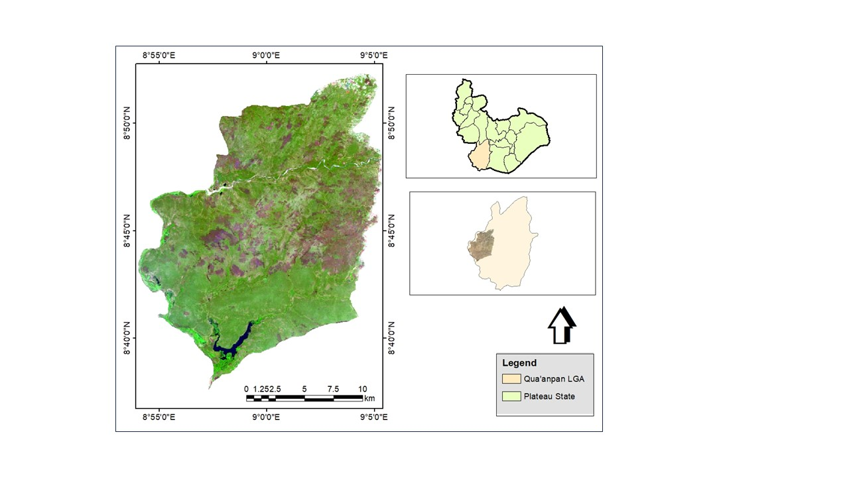
Figure 1: Plateau State showing the Study Area
Source: Author, 2024
Pandam National Park was gazettedin 1972 and officially began operations on October 25, 1975, under Joseph Gomwalk, the then Military Governor of Benue–Plateau State. Parts of the game reserve were later converted into a Park to protect its savanna wetlands and forests. Due to persistent conservation and security challenges, the Federal Government of Nigeria designated it as one of 10 new National Parks in 2020 to conserve biodiversity and reduce criminality in protected areas.
During the transition between the handover of the reserve and its full takeover by the Nigerian National Park Service, the area experienced widespread illegal logging and effectively became a no-man’s forest. Local resistance to the destruction was deflected to the Federal Government, while the reserve turned into a hotspot for illegal fishing, grazing, hunting, armed robbery, and kidnapping, resulting in damages to biodiversity and serious environmental consequences (Choji, 2023; Dakagan, 2023).
Climate
The Pandam area experiences a wet season from April to November and a dry season from December to March. Monthly mean rainfall ranges from 0.0 to 243.5 mm, with an annual total of about 1,000–1,500 mm. The area has an annual mean temperature of approximately 32 °C, while monthly mean temperatures vary from 25.8 °C in August to 35.7 °C in March (Ezealor, 2002; Akosim et al., 2007; Dami & Manu, 2008; Hudu & Ibrahim, 2021).
Relief and Drainage
Pandam National Park ranges in altitude from 175 to 315 m above sea level, sloping gradually southwards to form a basin that includes Pandam Lake, a 2 km² wetland complex. The Park is well drained, with the southern part fed by the Kurmi, Zurzurfa, and Dogon Ruwa streams flowing into Pandam Lake, while the northern and western areas are drained by the Dop and Li rivers and their tributaries (Ezealor, 2002; Akosim et al., 2007; Akosim et al., 2008).
Vegetation
Pandam National Park covers approximately 224 sq km of pristine savanna, wetlands, and forest, though it has been affected by various anthropogenic activities (Ezealor, 2002; Dami & Manu, 2008; Popoola et al., 2020).
Datasets
Remote sensing data
Sentinel-2 images from 2019, 2021, and 2023 were used for supervised classification at biennial intervals to assess land-cover changes in Pandam National Park. The years were selected to represent pre-peak timber exploitation (2019), peak timber exploitation (2021), and post-peak timber exploitation (2023). The targeted year 2019 marks when logging was progressively mild, but 2021 represents the most disastrous year within the window period of handover of the Park to the FGN, while 2023 marked when the Park was abandoned because the targeted trees were exhausted. Images were obtained via Google Earth Engine (GEE), which facilitated cloud-based processing and avoided challenges with data storage, network issues, and satellite downloads.
Secondary data
Administrative spatial data for Nigeria and Plateau State were obtained from GRID.3 to delineate the study area, with boundaries clearly defined using Google Satellite Hybrid imagery. The dataset, projected to WGS 1984, Zone 32N, was essential for accurate statistics following land-cover classification in the research area.
Image Processing
Image preprocessing
Satellite images for 2019, 2021, and 2023 were selected with less than 10% cloud cover, mostly during the dry season, to ensure clear visibility of forest features and relevant variables for analysis before preprocessing. Google Earth Engine (GEE) was used to query and filter the Landsat images for the research region using ee.ImageCollection(), with a 10% cloud cover threshold and a date range specified. The NDVI derivation method was used to determine the NDVI. NDVI = (NIR - Red) / (NIR + Red) is the result of applying the normalizedDifference() function to the NIR and Red bands of the images.
Ground truthing was undertaken through field surveys and high-resolution imagery to verify landcover classes in Pandam National Park, to ensure spatial and temporal consistency with the Sentinel-2 acquisition dates. The validated reference data were divided into training and validation sets to train the Random Forest classifier in Google Earth Engine, thereby improving and strengthening the credibility of the forest cover change findings.
Land cover classification in Google Earth Engine (GEE)
Google Earth Engine (GEE) was used to perform land cover classification of vegetation, water bodies, and bare land, calculating the annual mean of pixels to create single images for each period. The web-based GEE platform enabled remote sensing analysis without downloading images, and classification of Sentinel-2 images for 2019, 2021, and 2023 revealed the spatial extent of environmental damage through statistical analysis (Ezealor, 2002; Akosim et al., 2007).
Random forest classification algorithm
Random Forest classification was used due to its high performance across diverse datasets, robustness to noise, and superior classification accuracy compared to other algorithms. Classification was done using training data and spectral indices (including NDVI) as input features. The Random Forest algorithm (ee.Classifier.randomForest()) was used to classify the land cover in the image collection.
Change detection
The study conducted change detection analysis on Pandam National Park by classifying Sentinel images from 2019, 2021, and 2023 and converting the resulting thematic maps into vector format. The vectors were intersected to identify transitions between feature classes over time, and the changes were visualized using bar graphs in MS Excel. The analysis revealed sizable illegal timber extraction and highlighted the environmental impacts associated with land-use changes.

RESULTS
Forest Cover Sensitivity Using Spectral Index
The Normalized Difference Vegetation Index (NDVI) analysis for 2019, 2021, and 2023 shows variations in vegetation health and density over time, which were used to assess forest cover change and infer the rate of forest loss. NDVI values range from +1 to −1, where values closer to +1 indicate dense, healthy vegetation, and values closer to −1 represent areas with little or no vegetation (such as bare land, degraded forest, or built-up surfaces). By comparing the NDVI maps across the three years, areas showing a consistent reduction in NDVI values can be interpreted as zones experiencing progressive deforestation or forest disturbance, whereas stable or increasing NDVI values suggest vegetation recovery or regeneration.
The NDVI results show notable temporal changes in forest condition between 2019 and 2023. In 2019 (Fig. 2), the dominant high NDVI value (0.7436) indicates extensive healthy vegetation before major disturbance, while the lowest value (−0.1935) suggests limited areas of low vegetation. By 2021 (Fig. 3), generally lower NDVI values across the forest reflect widespread vegetation loss and forest devastation, marking the peak period of degradation. In 2023 (Fig. 4), the increase in the highest NDVI value to 0.80 indicates partial vegetation recovery, particularly at lower levels. Overall, the results suggest a transition from healthy forest cover to degradation, largely due to illegal logging activities, with 2021 representing the height of forest loss, followed by signs of gradual recovery after the takeover by the National Park Service.
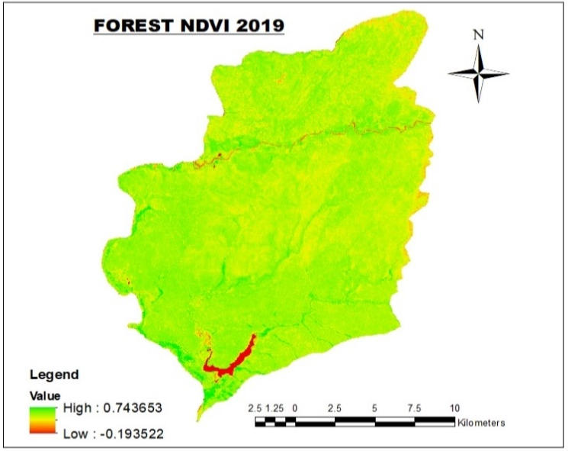
Figure 2: Forest Cover NDVI 2019

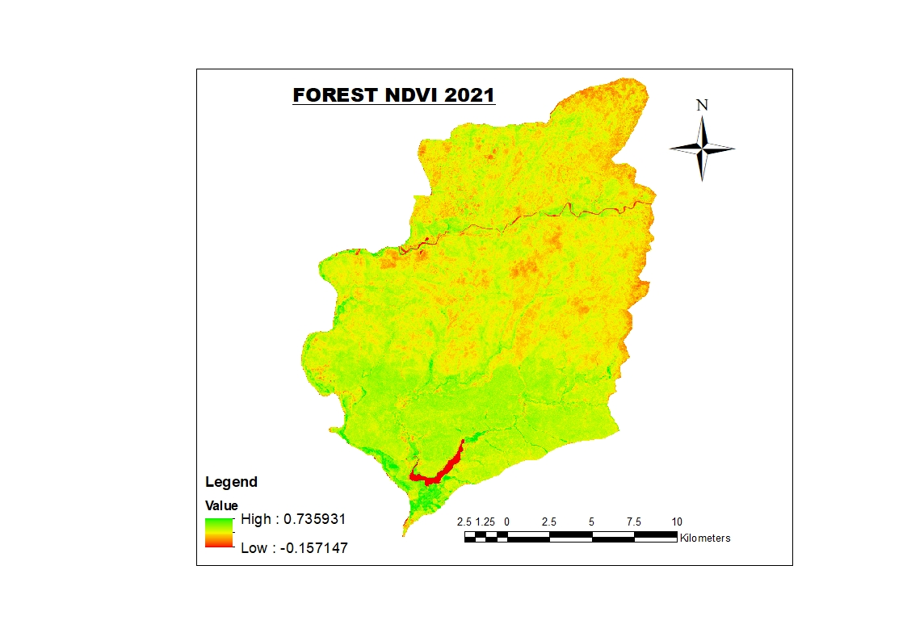
Figure 3: Forest Cover NDVI 2021
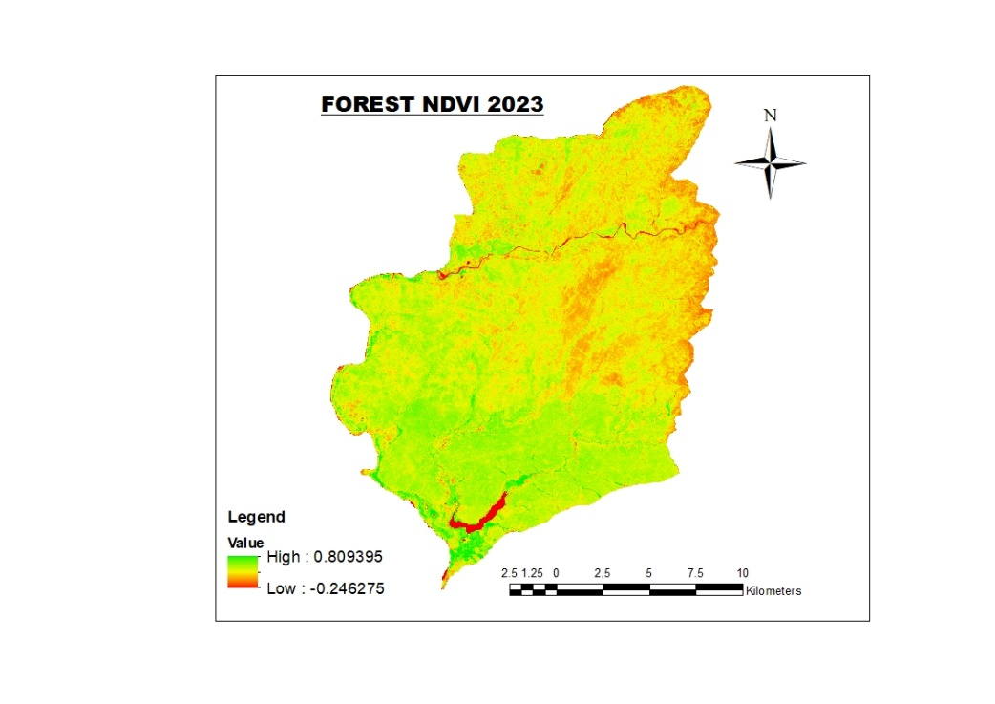
Figure 4: Forest Cover NDVI 2023

Forest Cover Changes from 2019-2023
The classified forest cover results reveal sizable land-cover changes between 2019 and 2023. Water bodies remained relatively stable throughout the period, indicating minimal hydrological change. In contrast, bare ground increased markedly from 13.49% in 2019 to 23.52% in 2021, reflecting extensive forest clearing driven by illegal timber extraction. By 2023, the reduction in bare surfaces to 17.47% suggests a decline in logging activities and the onset of vegetation regeneration. Similarly, vegetation cover decreased substantially from 85.82% in 2019 to 75.91% in 2021, confirming intense forest degradation during this period. The subsequent increase to 81.92% in 2023 indicates partial forest recovery, likely due to natural regrowth following the cessation of intensive logging (Fig 5). Overall, the results demonstrate a clear pattern of forest exploitation peaking in 2021, followed by signs of gradual ecological recovery (Fig. 6-8)

Figure 5: Forest Cover 2019-2023
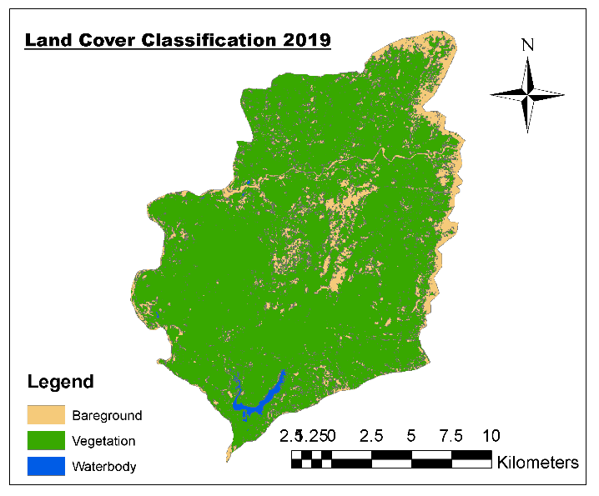
Figure 6: Forest Cover of 2019
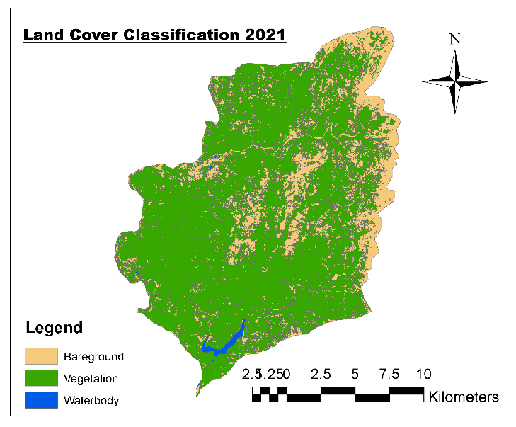
Figure 7: Forest Cover of 2021
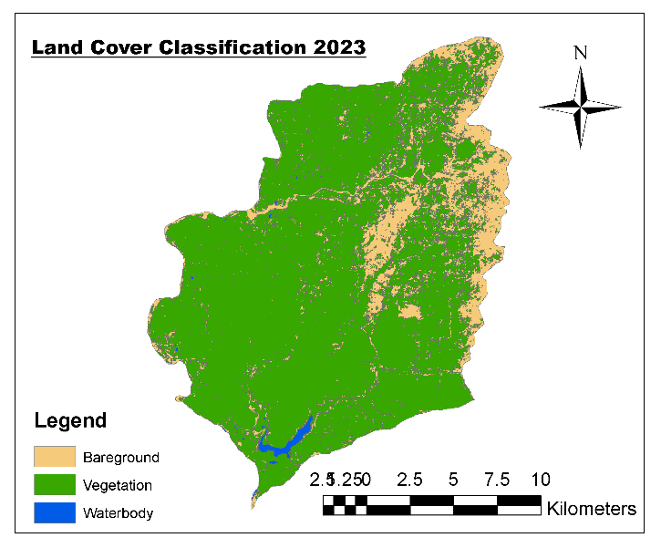
Figure 8: Forest Cover of 2023

Forest Transformation from 2019-2021 and 2021-2023
The biennial analysis highlights a pronounced transformation in forest condition across the study period. Between 2019 (pre-peak devastation) and 2021 (peak devastation), the forest experienced ruthless degradation, with large areas converted from vegetated cover to bare ground, marking the period of maximum forest loss. This extensive transformation reflects uncontrolled exploitation driven by intensive logging activities involving both local actors and foreign rosewood merchants, occurring in the absence of effective regulatory or community control. By 2023 (post-peak), the forest condition reflects the lasting impact of this peak-period destruction, underscoring the scale and intensity of the degradation experienced during the 2019–2021 interval (Fig. 9).
The results indicate that weak enforcement of conservation laws and unclear governance over natural resources facilitated the involvement of external actors, which in turn encouraged local participation in illegal logging activities. The 2021–2023 (Fig. 10) period shows a clear departure from the earlier phase of degradation, as satellite imagery reveals a notable conversion of bare surfaces back to vegetated areas. This change suggests natural regeneration, with tree stumps and secondary vegetation re-sprouting and gradually covering previously degraded land. However, despite this visible recovery, the regenerated secondary vegetation lacks the structural complexity and ecological functions of the original primary forest, indicating that full ecological restoration has not yet been achieved.

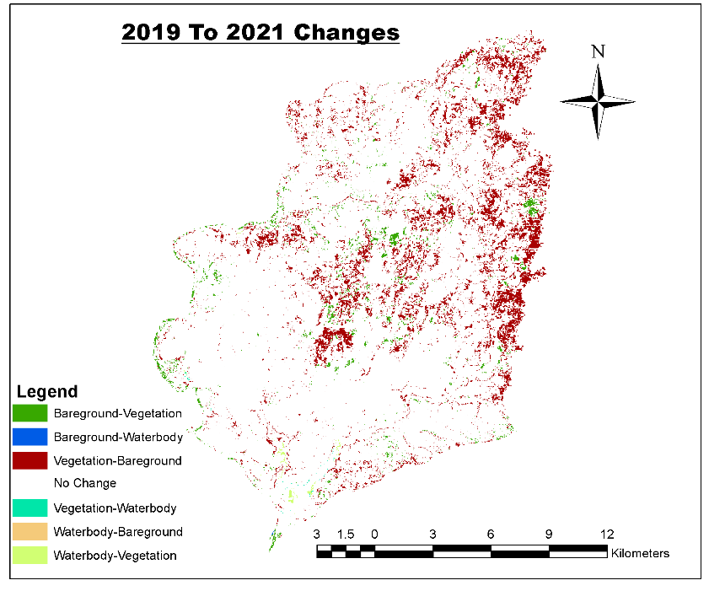
Figure 9: Forest transformation from 2019 – 2021 (Change Detection)
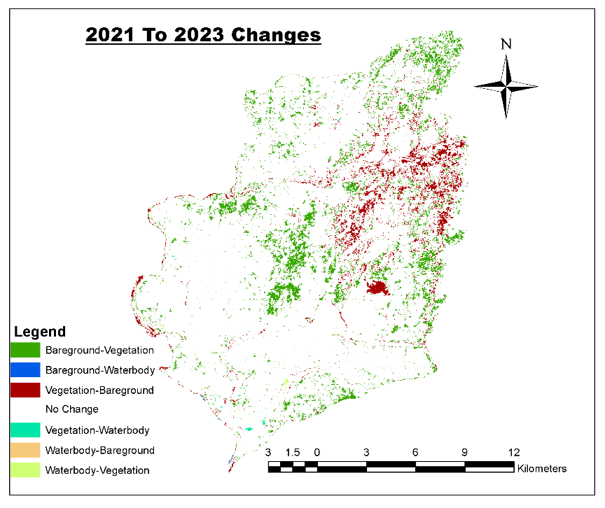
Figure 10: Forest transformation from 2021 - 2023 (Change Detection)

The forest–bare surface dynamics reveal critical insights for conservation planning and decision-making. The cumulative forest cover change to the 2019-2021 period of peak destruction indicated that a larger area of forest (208.55 sq km) was converted to bare surface compared to the 2021–2023 period (195.62 sq km), which had a reduction in forest cover destruction of 12.93 sq km (Figs. 11 and 12), indicating that forest destruction was more intense during the earlier period. Likewise, the negative conversion values from bare surface to forest in 2019–2021 (−208.95 sq km) reflect greater forest loss than in 2021–2023 (−195.48 sq km). The comparatively lower magnitude of these conversions in the latter period suggests a decline in the rate and intensity of forest devastation after 2021, pointing to a gradual easing of destructive activities, though forest loss persisted.

Figure 11: Changed Area from 2019-2021

Figure 12: Changed Area from 2021-2023

DISCUSSION
The study used Sentinel-2 NDVI data from 2019, 2021, and 2023 to assess forest condition. The resulting spectral index trends clearly captured forest degradation over time, consistent with Warner et al. (2016), who found that NDVI is a robust vegetation index for mapping and monitoring forest cover with high validation accuracy. In this case, timber extraction was so massive that even raw Sentinel-2 images displayed extensive brown (non-vegetated) surfaces, indicating extremely high disturbance intensity. The research highlights that even officially conserved areas are heavily encroached, suggesting that degradation in unrestricted areas may even be more, with negative environmental consequences.
Illegal logging in the study area reflects high-scale commercial timber crime, as described by Forest Trends (2005), and has destroyed forest cover. The study found a shift from densely vegetated forests to sparsely forested areas primarily due to illegal timber extraction, consistent with previous studies (Adekunle, Olagoke, & Ogundare, 2013; Abugre & Kazaare, 2010; Mwansat & Da’an, 2017; Olugbadieye et al., 2021). This degradation is selective, targeting valuable species like African rosewood, which leads to stunted growth, mortality of surrounding trees, and expansion of bare surfaces (Mwansat & Da’an, 2017; Abugre & Kazaare, 2010; Bisong & Mfon, 2022; Namuene & Egbe, 2022). The findings highlight that species-focused illegal logging accelerates forest sparsity and threatens future forest regeneration.
The study observed a transformation of forested areas into bare surfaces, consistent with prior findings (Tobore et al., 2021; Afele et al., 2022; Temgoua et al., 2022), showing forest loss replaced by other land uses. Unlike ordinary vegetation, primary forests with tall, long-grown trees provide critical ecological services that cannot be fully restored by secondary regrowth. Change detection between 2021–2023 indicated some lower-level vegetation recovery, but secondary forests cannot replicate the ecological functions of primary forests (Potapov et al., 2008; Fisher, Turner & Morling, 2009; Vries et al., 2012; Palmer et al., 2004).
Afele et al., (2022) found that logging was the second major driver of vegetation loss in forest reserves, after agricultural encroachment. Initially small-scale and illegal, logging escalated with the involvement of foreign timber merchants, causing widespread forest destruction. This prompted an investigation into the pre-devastation, peak devastation, and post-devastation periods. The illegal logging during the invasion window, which targeted the forest's transition to a park, was the study's main focus.
CONCLUSION
The devastation of Pandam National Park during its transition to a National Park raises concerns and highlights the issues of federal ownership of natural resources, where illegal activities occur unchecked. The study highlights the dynamic nature of forests and the increasing pressure from anthropogenic factors. Findings demonstrate the effectiveness of remote sensing and GIS techniques in detecting spatial and temporal changes in forest cover, providing reliable data for conservation planning. The results underscore the need for strengthened enforcement, continuous monitoring, and community participation to reduce forest degradation within the park. Sustainable management strategies must integrate scientific evidence with local knowledge to ensure long-term protection. Overall, consistent monitoring and collaborative governance remain essential for preserving the integrity of Pandam National Park. This article can be of importance to natural resources managers, policy makers, and implementers, especially those managing large-scale plantation forests, mineral water, and general vegetation cover. Proper attention to Pandam National Park in Qua’anpan LGA, Plateau State, is essential to ensure the transition enhances protection rather than enabling destruction.

Competing interests
Authors have declared that no competing interests exist.

DISCLAIMER (ARTIFICIAL INTELLIGENCE)
Authors hereby declare that NO generative AI technologies such as Large Language Models (ChatGPT, COPILOT, etc.) and text-to-image generators have been used during the writing or editing of this manuscript.

References

Abugre, S., & Kazaare, F. P. (2010). Trends and Status of Illegal Timber Logging in Three Forest Districts of The Brong-Ahafo Region of Ghana. Ghana J. Forestry, 26, 89-100.
Adekunle, V. A. J., Olagoke, A. O., & Ogundare, L. F. (2013). Timber Exploitation Rate in Tropical Rainforest Ecosystem of Southwest Nigeria and Its Implications on Sustainable Forest Management. Applied Ecology and Environmental Research 11(1): 123-136.
Afele, J. T., Nimo, E., Lawal, B., & Afele, I. K. (2022). Deforestation in Ghana: Evidence from selected Forest Reserves across six ecological zones. International Journal of Forest, Animal and Fisheries Research (IJFAF) 6(1), 7-17.
Ahmed, Y. A., & Olaitan, R. A. (2024). The Challenges of Deforestation and Management in Nigeria: Suggestions for Improvement. Ghana Journal of Geography 16 (1), 193-220.
Akosim, C., Kwaga, B. T. & Mamman, G. S. (2007). Flora Resources and Structure in Pandam Wildlife Park, Pandam, Plateau State, Nigeria. Agricultural Journal. 2(6): 740- 747.
Bisong, F. E., & Mfon, P. (2022). Effects of Logging on Stand Damage in the Rainforest of South-eastern Nigeria. West African Journal of Applied Ecology · September 2009.
Borner, J., Marinho, E., & Wunder, S. (2015). Mixing Carrots and Sticks to Conserve Forests in the Brazilian Amazon: A Spatial Probabilistic Modeling Approach. PLoS ONE 10(2):
Chigonu, E., Oby, C. M., Otonye, K. V., & Ehio, D. K. (2023). Illegal Logging and Environmental Impacts: The Case of Nigeria and Lessons from the USA and Australia. The Journal of Environmental and Human Right Law 2 (6), 140-161.
Choji, I. D. (2023). Concern over unhindered exploitation of fauna and flora in Pandam National Park. https://www.environew.snigeria.com/concern-over-unhindered-exploitation-of-fauna-and-flora-in-pandam-national-park/ Accessed 26/06/2024.
Da’an, S. A., Jidangkat, M., Chaskda, A. A., & Mwansat, G. S. (2020). Livelihoods and biodiversity conservation: A survey of socioeconomic activities around Pandam Game Reserve, Plateau State, Nigeria. Journal of Applied Science and Environmental Management, 24(6), 979-983.
Dakagan, J, B. (2023). Kidnapping in Communities Adjoining Conserved Areas: The Case of Pandam Wildlife Park and Namu (Jepjan). The International Journal of Humanities & Social Studies, 11(5), 18-201.
Dakagan, J. B. (2025). The Complexity of Land Grabbing. Published by Insights Bathrobas, Jos, Plateau State, Nigeria.
Dami, F. D., & Manu, S. A. (2008). The Bird Species of Pandam Wildlife Park and the Surrounding Farmlands. Science World Journal Vol 3 (2007). www.scienceworld journal.com.
da Silva, A. M., & Rodgers, J. (2018). Deforestation across the World: Causes and Alternatives for Mitigating. International Journal of Environmental Science and Development 9(3), 67-73.
Forest Trends (2005). Strategies to combat illegal logging and Forest Crime. Forest Trends. Washington DC. 4pp.
Ezealor, A. U ed. (2002). Critical Site for Biodiversity Conservation in Nigeria NCF, Lagos, Nigeria.
Fisher, R., Turner, K., & Morling, P. (2009). Defining and classifying ecosystem services for decision making, Ecol. Econ., 68, 643–653.
Fokeng, R. M., Forje, W. G., Meli, V. M., & Bodzemo, B. N. (2020). Multi-temporal forest cover change detection in the Metchie-Ngoum Protection Forest Reserve, West Region of Cameroon. The Egyptian Journal of Remote Sensing and Space Sciences 23, 113–124.
Gibson, L et al., (2011). “Primary forests are irreplaceable for sustaining tropical biodiversity,” Nature, 478, 378–383.
Nguyen, A., Kovyazin, V., & Pham, C. (2025). Application of Remote Sensing and GIS in Monitoring Forest Cover Changes in Vietnam Based on Natural Zoning. Land, 14(5), 1037.
Habila, M. T., Uzoma, A. C., Charles, I. C., & Olalekan, O. J. (2022). Socio-Economic Status and Activities of Neighboring Communities in Pandam Wildlife Park, Plateau State, Nigeria. IMCC Journal of Science, 2, 29-41.
Hudu A. B., & Ibrahim I. O. (2021). Socio-Economic Impact of Wildlife Management of Pandam Wildlife Park in Qua'anpan Local Government Area of Plateau State, Nigeria. Journal of Research in Forestry, Wildlife & Environment 13(4): 93 – 100.
ICIR (2016). How China Fuels Deforestation in Nigeria, West Africa. Retrieved on the 14th February 2017 from: http://www.icirnigeria.org/how-china-fuelsdeforestation-in-nigeria-west-africa/
Ikuomola, A. D., Okunola, R. A., & Akindutire, F. A. (2016). Criminality: Illegal Logging of Woods in Nigeria’s South-West Forest Belt. African Journal of Criminology and Justice Studies: AJCJS, 9(1), 141-153.
Karamage, F., Shao, H., Chen, X., Ndayisaba, F., Nahayo, L., Kayiranga, A., & Zhang, C. (2016). Deforestation effects on soil erosion in the Lake Kivu Basin, DR Congo-Rwanda. Forests 7(11):281.
Lindsey, P. A., Nyirenda, V. R., Barnes, J. I., Becker, M. S., McRobb, R., Tambling, C. J., Taylor, W. A., Watson, F. G., & Sas-Rolfes, M. (2014). Underperformance of African protected area networks and the case for new conservation models: insights from Zambia. PLoS ONE 9, e94109.
Mohammad, A. G., & Adam, M. A. (2010). The impact of vegetative cover type on runoff and soil erosion under different land uses. CATENA 81(2):97–103. https://doi.org/10.1016/j.catena.2010.01.008.
Moisa, M. B., Dejene, I. N., Hirko, O., & Gemeda, D. O. (2022). Impact of deforestation on soil erosion in the highland areas of western Ethiopia using geospatial techniques: a case study of the upper anger watershed. Asia Pac J Reg Sci. https://doi.org/10.1007/s41685-022-00238-7.
Mwansat, G. S., Da'an, S. A., & Nwabueze, E. (2016). Seasonal responses of two faunal taxa to fire treatments in Yankari Game Reserve. FULafia Journal of Science & Technology 2 (2): 80- 85.
Mwansat, G. S., & Da’an, S. A. (2017). Halt The Deforestation in Pandam Wildlife Park. African Journal of Natural Sciences 20, 53-56.
Namuene, K. S., & Egbe, A. E. (2022). Impact of Timber Logging on Neighbouring Stands in a Forest of the South Western Cameroon. Open Journal of Forestry, 12, 248-262.
Nimmak, S. P., & Onwuadiochi, I. C. (2020). Assessment of the socio-cultural and economic challenges of ecotourism industry in Pandam Game Reserve, Plateau State, Nigeria. IOSR Journal of Environmental Science, Toxicology and Food Technology. (IOSR-JESTFT), 14(6), 22 – 32.
Okechalu, A. A., Amonum, J. I., & Agbidye, F. S. (2021). Plant Diversity and Composition in Pandam Wildlife Park, Plateau State, Nigeria. Journal of Research in Forestry, Wildlife & Environment 13(2).
Olugbadieye, O. G., Daramola, J. O., Adesuyi, F. E., Akinbowale, A. S., & Adekunle, V. A. J. (2021). Rate of timber harvest and the effects of illegal activities on forest conservation in Southwestern Nigeria. Asian Journal of Forestry 5(1) 8-16.
Palmer, M. A. et al., (2004). Ecology for a crowded planet, Science, 304, 1252–1253.
Pearson, T. R. H., Brown, S., Murray, L., & Sidman, G. (2017). Greenhouse gas emissions from tropical forest degradation: An underestimated source. Carbon Balance and Management, 12. doi:10.1186/s13021-017-0072-2.
Popoola, A. S., Okechalu, S. O., Likita, M. S., Lapkat, L. G., Bako, A., Maikano, S., Ademola, T. O., & U. F. Yahaya (2020). Detection and Evaluation of Deforestation Trend in Pandam Game Reserve, Plateau State, Nigeria. African Scholar Journal of Agriculture and Agricultural Tech. (JAAT-1). 18(1).
Potapov, P. et al., (2008). Mapping the world's intact forest landscapes by remote sensing, Ecol. Soc., 13,51–66.
Putz, F. E., Romero, C., Sist, P., Schwartz, G., Thompson, I., Roopsind, R., Ruslandi, Medjibe, V. & Ellis, P. (2022). Sustained timber yield claims, considerations, and tradeoffs for selectively logged forests. PNAS Nexus 1: 1-7.
Sharifi, A., Mahdipour H., Moradi, E., & Tariq, A. (2022). Agricultural field extraction with deep learning algorithm and satellite imagery. J Indian Soc Remote Sens. 50(2):417–423.
Tariq, A., Jiago, Y., Li, Q., Gao, J., LU, L., Soujan, W., Almutairi, K. F., & Habib-ur-Rahman. M. (2023). Modelling, mapping and monitoring of forest cover changes, using support vector machine, kernel logistic regression and naive bayes tree models with optical remote sensing data. Heliyon 9 (2023) e13212.
Temgoua, L. F., Elono, l. M., Njiaghait, Y. M., Ngouh, A., & Kengne, C. N. (2022). Land use and land cover dynamics in the Melap Forest Reserve, West Cameroon: implications for sustainable management, Geology, Ecology, and Landscapes, 6:4, 305-315.
Tobore, A., Alabi, K., Oyerinde, G., & Senjobi, B. (2021). Forest cover change in Onigambari reserve, Ibadan, Nigeria: Application of vegetation index and Markov chain techniques. The Egyptian Journal of Remote Sensing and Space Sciences 24 (2021) 983–990.
Trifkovic, N., Rand, J., Rodriguez, P C., & Tarp, F. (2023). Economic and environmental upgrading after a policy reform: The case of timber value chain in Myanmar. Journal of Rural Studies 99, 20–34.
Ufomba, H., & Eze, E. (2024). The Constraints to Effective Implementing of Illegal Logging Prohibition Regulation in Nigeria. International Journal of Social Science and Human Research. 7(3) 1921-1928.
UNEP. Protected Planet Report 2016: Data, Maps & Figures (April 2016). Available online: https://www.protectedplanet.net/c/protected-planet-report-2016/protected-planet-report-2016--data- -maps-figures (accessed on 8 March 2019).
UNEP-WCMC. User Manual for the World Database on Protected Areas and World Database on Other Effective Area-Based Conservation Measures: 1.5; UNEP-WCMC: Cambridge, UK, 2018. Available online: http: //wcmc.io/WDPA_Manual (accessed on 31 December 2019).
Vries, F. T. et al., (20212). Land use alters the resistance and resilience of soil food webs to drought, Nature Climate Change, 2, 276–280.
Warner, T. A., Skowronski, N. S., & Gallagher, M. R. (2016). High spatial resolution burn severity mapping of the New Jersey Pine Barrens with WorldView-3near-infrared and shortwave infrared imagery. Int. J. Remote Sens. 38 (2), 598–616.

