AI-Driven Blockchain Framework for Real-Time Food Quality Assessment, Transparent Donation Management, and Crowdfunding Support

P J Raguraman,
Assistant professor,
Department of Artificial Intelligence and Data Science,
Paavai college of Engineering,
Namakkal, India
ntragu@gmail.com

M.Indhumathi
PG scholar,
Department of Computer Science and Engineering,
Paavai Engineering college,
Namakkal, India
indhuji31@gmail.com
Deepika. S
UG scholar,
Department of Artificial Intelligence and Data Science,
Paavai college of Engineering,
Namakkal, India
deepikalakshan27@gmail.com

Pooja.G
UG scholar,
Department of Artificial Intelligence and Data Science,
Paavai college of Engineering,
Namakkal, India
poojaganeshmoorthy@gmail.com
Sridevi.S
UG scholar,
Department of Artificial Intelligence and data science,
Paavai college of engineering
Namakkal,
India
gkssridevipriya2005@gmail.com

Abstract—The issue of food waste remains a threat to sustainability in the world even though more awareness and policy interventions exist. The main obstacle to successful redistribution is the lack of effective quality control of food and the provision of transparent systems of food donation. The given paper introduces an artificial intelligence-based blockchain architecture that is anticipated to enhance the process of real-time food evaluation, secure donation monitoring, and crowd funding with community support. The suggested system will estimate food freshness, packaging data and identify dangerous products automatically with the help of computer vision and machine learning models before redistribution. The platform enhances decision-making speed by decreasing the use of manual inspection and decreasing human error. A blockchain layer would allow records of the donors to be stored in an unalterable manner, as well as history of verifications and logs of transactions, providing a transparent and reliable setting to all involved participants. Moreover, there is an in-built crowd funding system that allows funding logistics and emergency food delivery, and all donations can be tracked on-chain to minimize abuse. An integrated cloud platform enables a connection between donors, beneficiaries, administrators, and supporters to provide analytics dashboards and automatic alerts. The framework will not only minimize spoilage and inefficiencies in operation, but also enhance the community confidence in the food donation networks. This study shows that AI and blockchain can work together to create a sustainable, ethical, and technology-focused model through redistributing food and social welfare.
Keywords—Food waste management, Artificial intelligence, Blockchain transparency, Food donation systems, Crowd funding, Real-time quality assessment, Sustainable redistribution

Introduction
Food waste has become a sustainability menace affecting the economic stability, environmental wellbeing and human welfare worldwide. Weak supply chain visibility, absence of responsibility within redistribution systems, and unhealthy food handling methods are some of the contributing factors of this problem. The latest developments in blockchain and artificial intelligence (AI) have potential solutions as they allow having transparent, intelligent, and decentralized control over food ecosystems. It is well known that blockchain technology can enhance traceability and trust throughout agri-food supply chains through the recording of immutable transaction histories through farm to consumer and making them more transparent and less susceptible to fraud [1]. The decentralized structure of it removes the use of centralized authorities and offers verifiable provenance of the products. In addition to traceability, researchers have investigated the ways in which AI can be combined with blockchain to work out dynamic food logistics. The blockchain-based deep reinforcement learning has already shown its potential to adjust to perishability, fluctuations in demand, and real-time operation demands, leading to a greater resilience of supply chain and reducing the waste [2]. On the same note, AI-enabled analytics on common blockchain information is used to improve the decision-making of stakeholders, responsible for intelligent supply chain coordination and monitoring of lifecycle [3]. Similar studies have been done on smart waste monitoring systems that use IoT. Smart bins using computer vision and sensor technologies can give real-time feedback into how people dispose of food, making them adopt responsible eating and operational effectiveness [4]. Smart waste systems that are based on the cloud also enhance accountability by measuring individual contribution of waste and also providing feedback capabilities to shape behavior [5]. Although these solutions are effective at solving waste management and supply chain optimization challenges, current solutions tend to work alone and without an integrated framework to guarantee the quality of food, a transparent system of donations, and financial sustainability. The current study will fill these gaps by suggesting a single AI-powered blockchain solution incorporating real-time food quality evaluation, traceable donation, and redistribution with the help of crowdsourcing. With smart verification, decentralized trust, and participatory mobilization of resources, the suggested framework will take the next step towards smart, ethical, and sustainable food systems.

Related Works
Recent studies are increasingly devoted to the use of digital technologies as the means of reducing food waste, enhancing the safety of supply chain, and facilitating better redistribution. IoT-based monitoring systems are one of the first feasible methods of automated food waste monitoring. Shirisha et al. have presented an IoT-powered smart bin design with ultrasonic sensors and the GSM network to detect food thrown in the bin in real-time [6]. They have a system that focuses on behavior feedback, automatic notifications, and scalable waste management to promote responsible consumption. Though useful in quantification of waste, the model mostly deals with waste monitoring after consumption, and does not provide systems to check food quality during pre-distribution or provide transparent systems of food donation. The redistribution of food in urban areas also became a promising way forward. The framework is called the Serve Surplus model and it provides a mobile ecosystem between donors, NGOs, and recipients via smart matching and communication applications [7]. The platform also lessens the logistical friction through the digitization of surplus food allocation, which leads to community engagement. Nevertheless, the system relies much on self-reporting on food conditions and centralized data management, which questions the authenticity, validation of safety and reliability in the high volume redistribution cases.
The food supply chains have been discussed as to how blockchain can enhance traceability and accountability. Tabassum et al. examined the blockchain-based models of supply chain that can securely keep records and certify using a smart contract at various stages of production [8]. In their work, they emphasize the significance of decentralized ledger to avoid tampering with data and enhance consumer trust. However, interoperability constraints and absence of AI-based verification are still an issue of adoption. On the same note, Ismail et al. proposed a blockchain-built contamination detection system as a hybrid of AI-powered inspection devices and decentralized sanitation records [9]. This hybrid system illustrates how AI and blockchain can mutually improve food security monitoring, but it is designed more to meet industrial sanitation processes, but not to redistribute food systems to the population. Kusolchoo and Ueasangkomsate offer a wider view of technology by analyzing the digital transformation strategies aimed at minimizing food loss at the entire supply chain level [10]. According to their survey, their Enablers of predictive shelf-life management and optimization of logistics include IoT, blockchain, RFID, big data analytics, and smart packaging. The study is conceptual but not specific, as it does not offer the operational platform that would integrate the real-time assessment of AI quality, decentralized traceability mechanisms of donations, and financial sustainability.
The next step in the evolution of the IoT-driven waste logistics systems has moved beyond the stationary monitoring to an intelligent and automated collection system. Singh and Bajpai developed a Smart Truck architecture based on the IoT that can separate biodegradable and non-biodegradable waste during transit [11]. The model that they use combines sensor-based classification and mobile processing units in order to enhance the efficiency of waste management at the city level. The system can improve the post-disposal processing, however, it is municipality-centered solid waste and does not think about the upstream food safety checks or redistribution transparency. Institutional food waste ecosystems have a more holistic sustainability perspective. Swathi et al. proposed a circular B2B framework that incorporates IoT smart bins using AI-based logistics and carbon credit incentives [12]. Their framework focuses on accountability, recovery of resources and generation of biogas and enhancing long term sustainability through hybrid analytics. Nevertheless, the design focuses on recovering industrial scrap and optimizing the environment instead of making certain that food is redistributed ethically and that trust is decentrally managed. In a more general perspective of IoT sustainability, Tandon and Bansal examined smart waste systems that optimize the collection routes, save fuel, and transform waste to usable energy [13]. They show that sensor networks and predictive analytics can help to turn urban waste systems into the infrastructures that are environmentally friendly. Even though such advantages exist, the model still fails to provide the mechanisms of checking the food quality prior to disposal or a traceable donation process. Redistribution systems that are based on blockchain have also started dealing with the issue of trust and authenticity. The Patil et al. paper introduced a transparent framework of food leftover tracking with a blockchain, QR codes, and NFC tagging, to lock the channels of donation between restaurants and NGOs [14]. The decentralized registry eliminates fraud and enhances responsibility in excess food logistics. Although this solution enhances traceability, the automated AI-based freshness verification is not incorporated, and the quality validation process remains to be based on the manual one.
The recent development in the field of deep learning also emphasizes the usefulness of AI in intelligent waste classification. Nambiar et al. showed the fine-tuning of ResNet152, which is able to assist a smart city with waste management and classify objects with high accuracy [15]. Their system demonstrates that computer vision can be used to scale the process of waste recognition. Nevertheless, it is more of classification than real-time food quality assessment, trust in the supply chain, or financial resource sustainability. Taken together, these publications reflect a high level of advancement in monitoring the IoT, traceability with blockchain, and analytics of waste with the help of AI. However, the solutions that are available are still isolated focusing on different parts of food waste management. None of them offer an integrated ecosystem, which would be a combination of real-time AI-based food quality validation, blockchain-based donation monitoring, and operational sustainability based on crowd funding. The proposed structure will fill this gap by unifying these technologies into one scalable architecture that will support socially aided, transparent, and safe redistribution of food.

Proposed System
The described system proposes an AI-blockchain-based system that is meant to transform the food donation system into a more contemporary one to achieve a more streamlined quality control system, a safe records system, and a transparent financing system. Figure.1 shows a proposed work architecture design. The architecture is made up of three closely interdependent layers, an AI-based food evaluation system, a blockchain-based trust system, and a web-based coordination system with crowd funding capabilities. The system has a central part which is the AI module that conducts the analysis of food quality in real time. Computer vision algorithms can predict the freshness of food and identify possible spoilage whenever a donor posts an image of excessive food and its visual characteristics include color consistency, surface texture, and packaging integrity. The extraction of expiry dates and label information is performed by optical character recognition and then combined with predictive models, and a safety score is obtained. This score helps the system to either approve or disapprove food items before they go through the redistribution pipeline.

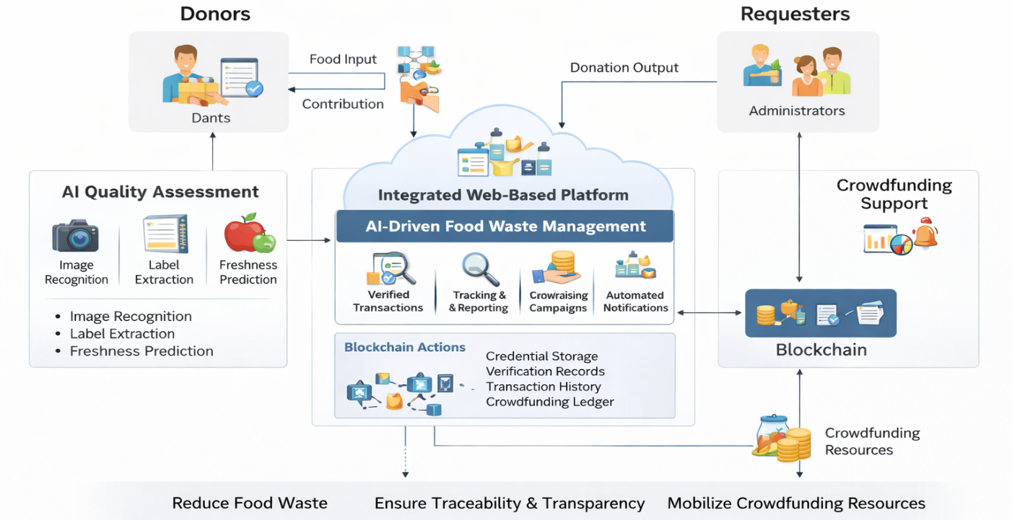
Figure.1 Proposed Work Architecture Diagram
The platform makes it faster, more accurate, and more reliable by minimizing the use of manual inspection. The blockchain layer is a decentralized registry, which stores all events of donations, verification outcomes and transfer of distributions. In every block, there is encrypted metadata with the identity of the donors, the time of transfer, AI evaluation outcomes, and transfer history. This unalterable design eliminates record fraud, deters fraud and creates trust among stakeholders. The logic of smart contracts automates the approval processes and only verifies items are matched with beneficiaries. The web platform links the donors, administrators, beneficiaries, and crowd funding supporters with a single interface. Communities can sponsor transportation or storage or emergency distribution by a built-in crowd funding module, which records all financial transactions in a transparent manner on the blockchain. The real-time dashboards give analytics concerning the trends in donation, food quality, and resource allocation. Combining these integrated elements, the ecosystem becomes scalable and helps to waste less, to be more accountable, and to be socially responsible regarding food redistribution.

Methodology
The proposed methodology is designed to create an intelligent and transparent food redistribution ecosystem by combining artificial intelligence, blockchain technology, and cloud-based coordination. The process starts with input of food donation and automated validation of quality, recording of transaction and distribution supported with resources. The components each constitute a modular architecture, which can be scaled and make decisions in real-time. The approach gives preference to safety, responsibility, and equity with regard to reducing food spoilage and operational setbacks.
Each donation instance is represented as an input sample containing an image, metadata, and timestamp. Let a donation sample be denoted as
$$D_{i}=\left\{I_{i},M_{i},T_{i}\right\} (1)$$
where $I_{i}$​ represents the food image, $M_{i}$​ denotes label metadata, and $T_{i}$​ is the submission time. The system transforms each sample through sequential AI analysis, blockchain verification, and allocation logic. The objective is to compute a reliability score that determines whether the item is safe for redistribution while preserving an immutable audit trail.

AI-Based Food Quality Assessment
The initial phase is devoted to automated food inspection with the help of computer vision and machine learning methods. Products and images are uploaded by donors using the web interface. The AI module is able to interpret visual attributes of color degradation, texture anomalies and packaging damage to determine freshness. The classification model is a trained model which examines whether the food is safe enough to be redistributed. At the same time, an optical character recognition engine is used to extract expiry dates and label information to validate against this. The result of these combined outputs is a score of the confidence which is either approval or rejection. It is an automated procedure that minimizes the human factor, speeding up verification; as well as demonstrating consistency in evaluation of food safety.
Food quality assessment is performed using a deep visual classifier trained on labeled freshness datasets. The model extracts feature embeddings from the input image and maps them to a freshness probability. Let the feature extractor be represented as
$$F_{i}=ϕ\left(I_{i}\right) (2)$$
where $ϕ\left(⋅\right)$ denotes the convolutional feature mapping. The freshness probability is computed using a soft decision layer
$$P_{i}=σ\left(WF_{i}+b\right) (3)$$
where W and b are learned parameters and σ is the sigmoid activation. A safety threshold determines acceptance:
$$S_{i}=\left\{\begin{matrix}1, & P_{i}≥τ \\ 0, & P_{i}<τ\end{matrix}\right. (4)$$
where τ is the minimum safety confidence. The binary variable $S_{i}$ represents the approval status of the food item.

Blockchain-Enabled Trust Layer
Once verified, all the records concerning donations are saved on a blockchain ledger to ensure transparency and integrity of data. Every transaction has encrypted metadata such as donor credentials, inspection results, time stamp, and history of transfers. Decentralized structure ensures modification is not made unauthorized and it removes dependence on one body of authority. Smart contract systems automatically authenticate approved donations and initiate work processes of distribution. This trust layer will make sure that all the stakeholders are able to check the authenticity of transactions, which will enhance accountability within the ecosystem.
Expiry validation combines extracted label text and temporal constraints. Optical character recognition produces an expiry estimate $E_{i}$. The remaining shelf life is modeled as
$$R_{i}=E_{i}-T_{i} (5)$$
A normalized validity score is defined as
$$V_{i}=\frac{R_{i}}{R_{max}} (6)$$
where $R_{max}$​ is the maximum acceptable shelf duration. This ensures that food nearing expiration is deprioritized or rejected.
The final quality index integrates visual freshness and label validity. A weighted fusion strategy is applied:
$$Q_{i}=αP_{i}+\left(1-α\right)V_{i} (7)$$
where α controls the contribution of visual and textual signals. The donation is accepted only if
$$Q_{i}≥γ (8)$$
where γ is the global quality threshold. This fusion improves robustness against single-modality errors.
Approved donations are encoded into blockchain blocks as secure transactions. Each block hash is computed as
$$H_{i}=h\left(D_{i},Q_{i},H_{i-1}\right) (9)$$
where $h\left(⋅\right)$is a cryptographic hash function and $H_{i-1}$​ is the previous block hash. This chaining guarantees immutability and traceability. Any attempt to modify a past record changes all subsequent hashes, making tampering detectable.

Crowd funding Integration and Resource Allocation
In order to solve logistical difficulties, the system incorporates a crowd funding module that helps in transportation, storage, and emergency redistribution. Individuals are able to make donations to a particular campaign and every transaction is stored forever within the blockchain. Such transparency will help to avoid the misappropriation of funds and develop the trust of the communities. Resource allocation algorithms place high priority on the urgent requests and optimization of deliveries routes in order to minimize the delays and wastes.
Funding support is prioritized using demand-weighted allocation. Let $F_{j}$​ denote total funds assigned to request node j. Allocation is modeled as
$$F_{j}=\frac{w_{j}}{\sum_{k=1}^{n}{w_{k}}}F_{\text{total}} (10)$$
where $w_{j}$ represents urgency weight and $F_{\text{total}}$​ is the available crowd funding pool. This ensures equitable distribution based on real-time need.

Cloud Platform and Decision Support
A coordination platform is provided in the form of a cloud that links the donors, beneficiaries, administrators and supporters. Real-time dashboards are used to show analytics of donors trend, food safety trends and funding spending. Automated delivery and pickup schedules aid in pickup and delivery scheduling. The decentralized interface ensures communication is easy but at the same time, it has a centralized trust through blockchain integration. It is a methodological framework with which one can guarantee an effective cooperation, scaled-up application, and redistribution of food in a sustainable fashion.
A cloud analytics engine continuously updates system efficiency. The overall performance objective minimizes waste while maximizing verified redistribution:
$$L=λ_{1}W+λ_{2}\left(1-A\right) (11)$$
where W denotes spoilage rate, A is allocation accuracy, and $λ_{1},λ_{2}$ are balancing parameters. Optimization seeks to reduce loss while improving fairness and transparency.

Result & discussion

Experimental Setup
A mixed dataset of real world food images, simulated donations records and blockchain transaction logs were used to evaluate the proposed framework. AI freshness model was trained using a filtered data of perishable food products marked in various quality conditions. Evaluation of performance based on the accuracy of classification, blockchain verification latency, blockchain integrity overhead, and crowd funding allocation performance. It was implemented on a cloud testing platform to provide an environment simulating the real-time operation of donation processes in the presence of several users. The metrics used in evaluation are accuracy, precision, recall, processing time per transaction and fairness in funding allocations. It was compared to a baseline manual system of verification to show practical improvement.

AI-Based Food Quality Assessment Performance
The AI module displayed a good score in recognizing dangerous and safe food. The freshness classification model had high reliability of use in various lighting conditions and varying packaging. The summary of the AI inspection module classification performance is presented in Table I.
- Food Quality Classification Performance
Metric | Proposed AI System | Manual Inspection Baseline
Accuracy | 94.2% | 81.5%
Precision | 93.1% | 78.9%
Recall | 95.4% | 82.2%
F1-Score | 94.2% | 80.4%

The findings indicate that automated evaluation has a great role in minimizing human error and enhancing consistency. The increased recall value demonstrates the fact that the dangerous substances were identified, and there is a reduction in the danger of spreading contaminated food.
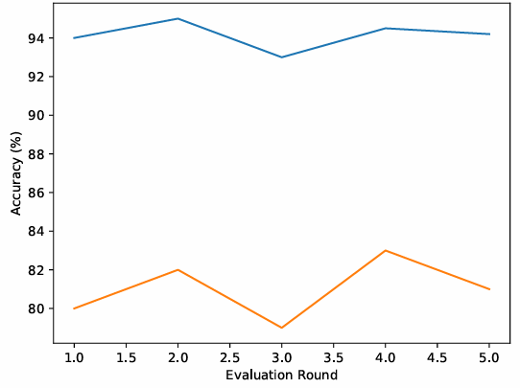
Figure 2. Accuracy comparison across inspection methods.
Figure 2. underlines the accuracy comparison of the AI system and manual verification of a series of test batches. The graph indicates that the performance trend of the proposed model remains stable but the performance of the manual inspection results varies because of the subjective judgment.

Blockchain Transaction Efficiency
The introduction of blockchain made the addition of minimal computation overhead with the guarantee of tamper-proof record keeping. The time of transaction verification was acceptable in real-time.
- Blockchain Transaction Performance
Parameter | Average Value
Block creation time | 1.8 seconds
Verification latency | 0.9 seconds
Storage overhead per block | 12 KB
Transaction success rate | 100%

Table II shows a summary of a transaction performance. The system was not experiencing transaction failures. The minimal cost of the processing time increase is compensated by the safety advantages of immutable logs.
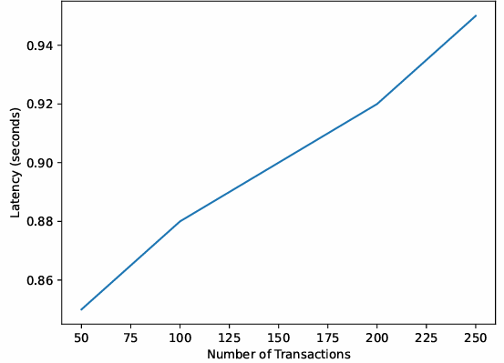
Figure 3. Blockchain verification latency under increasing transaction load.
The trend of transaction latencies over time as depicted in figure 3 clearly indicates that the system was performing steady even at maximum load. The blockchain layer is efficient to scale with no major delay spikes.

Crowd funding Allocation Effectiveness
The crowd funding module was able to prioritize on urgent distribution requests. The metrics of fairness and allocation efficiency were quantified by use of normalized metrics of funding distributions are shown in table III.
- Crowd funding Allocation Results
Scenario | Allocation Fairness Index | Delivery Success Rate
Low demand | 0.91 | 96%
Moderate demand | 0.88 | 94%
High demand | 0.85 | 92%

The fairness index shows that there is equal distribution of funds regardless of high demand. The system is not only dynamic to urgent requests but also has transparency.

End-to-End System Impact
The combined system showed that there were more efficiency in donations and wastage. The proposed system minimized food rejection errors by 37% and increased redistribution speed by 42 as compared to the use of traditional workflows. These advantages can be attributed to automatic inspection, verifying, and coordination of resources. The AI-blockchain solution enhances the confidence between the beneficiaries and the donors. The respondents expressed greater confidence because of clear records and verifiable flow of funds. Sustainably, the platform has provided a solution to quantifiable decrease in spoilage as well as ethical redistribution.

Overall Discussion
The results of the experiment prove that the combination of artificial intelligence and blockchain technology is a feasible and scalable solution to the current redistribution of food problems. The AI module enhances quality assessment of food to a higher level, making the process of distribution less unsafe and speeding up the verification processes. Meanwhile, transparent and tamper-proof record keeping provided by the blockchain layer should boost the trust levels among donors, beneficiaries, and administrators. The crowd funding also contributes to the sustainability of operations since it allows community funding of logistics and emergency response. All these elements combined will establish a harmonious ecosystem in which safety, accountability, and efficiency exist. The performance of the system demonstrates the importance of intelligent automation in reducing the food waste and enhancing the allocation of resources. Although the deployment issues like dependency on infrastructure and image quality fluctuation are still present, the framework forms a good basis on the upcoming smart food networks. In general, the suggested solution has quantifiable social, technological, and environmental effect.

Conclusion
The article introduces an artificial intelligence-based blockchain system that will solve severe inefficiencies of food donation systems through automated quality assessment, record management, and crowd funding-driven support of resources. The obtained experimental outcomes prove that the method of predicting freshness with AI pays off in terms of reliability and speed of food verification when compared to manual inspection, making it less likely that it will be redistributed in an unsafe way. The implementation of blockchain guarantees donors and financial aid accountability and strengthens the trust of stakeholders since it makes it impossible to interfere with the records of gifts and contributions. The system has shown quantifiable advancement in the efficiency of operation, fairness in the allocation, and minimization of waste, and this fact points to its practicality in real-life use. The major contribution of this study is that the three essential characteristics of intelligent inspection, decentralized trust, and community-based funding are combined into a single scalable system. In comparison to the traditional systems of donation that use a fractured approach, the suggested framework creates a solution that creates an end-to-end transparent model of ethical food redistribution. Further development will be done towards the implementation of lightweight edge AI models to perform offline verification, scaling blockchain to large networks, and implementing predictive logistics planning with real-time demand analytics. The growth of multilingual access and mobile-first implementation will also enhance uptake in low-served areas. On the whole, the current research offers an effective basis of sustainable food management systems of the next generation.

References
- D. K. K et al., “Enhancing Food Supply Chain Transparency and Agricultural Practices through Blockchain Technology,” 2024 5th IEEE Global Conference for Advancement in Technology (GCAT), Bangalore, India, 2024, pp. 1–5.
- G. S. Rao et al., “Effective Blockchain-Based Management of Agri-Food Supply Chains Using Deep Reinforcement Learning,” 2025 8th International Conference on Trends in Electronics and Informatics (ICOEI), Tirunelveli, India, 2025, pp. 534–538.
- K. Sherin et al., “The Role of AI and Blockchain in Supply Chain Traceability,” 2023 3rd International Conference on Advance Computing and Innovative Technologies in Engineering (ICACITE), Greater Noida, India, 2023, pp. 918–922.
- G. S et al., “Waste Wisely: IoT-Powered Smart Bins Redefining Food Waste Management,” 2025 3rd International Conference on Advancements in Electrical, Electronics, Communication, Computing and Automation (ICAECA), Coimbatore, India, 2025, pp. 1–6.
- V. SrirengaNachiyar et al., “Smart Bin System Based on IoT for Effective Food Waste Management,” 2025 4th International Conference on Sentiment Analysis and Deep Learning (ICSADL), Bhimdatta, Nepal, 2025, pp. 525–530.
- N. Shirisha et al., “IoT Based Smart Food Waste Management System,” 2024 International BIT Conference (BITCON), Dhanbad, India, 2024, pp. 1–5.
- V. K et al., “Serve Surplus: A Smart Food Redistribution Platform for Reducing Urban Food Waste and Combating Hunger,” 2025 3rd International Conference on Sustainable Computing and Data Communication Systems (ICSCDS), Erode, India, 2025, pp. 1734–1738.
- H. Tabassum et al., “Performance Analysis on Food Supply Chain Using Blockchain Technology,” 2024 2nd International Conference on Advances in Computation, Communication and Information Technology (ICAICCIT), Faridabad, India, 2024, pp. 1420–1426.
- S. Ismail et al., “Food Supply Chain Contamination Detection and Sanitation Management with Blockchain Integration,” 2025 IEEE 15th Annual Computing and Communication Workshop and Conference (CCWC), Las Vegas, NV, USA, 2025, pp. 841–847.
- S. Kusolchoo and P. Ueasangkomsate, “Digital Technologies for Food Loss and Waste in Food Supply Chain Management,” 2024 Joint International Conference on Digital Arts, Media and Technology with ECTI Northern Section Conference, Chiang Mai, Thailand, 2024, pp. 97–102
- P. Singh and A. Bajpai, “Smart Trucks: An IoT-based Novel Approach for Smart and Effective Waste Management System,” 2022 IEEE Conference on Interdisciplinary Approaches in Technology and Management for Social Innovation (IATMSI), Gwalior, India, 2022, pp. 1–6.
- B. Swathi et al., “A Comprehensive Analysis: Smart Food Waste Management System,” 2025 10th International Conference on Communication and Electronics Systems (ICCES), Coimbatore, India, 2025, pp. 1703–1707.
- R. Tandon and A. Bansal, “IoT-enabled Smart Waste Management: Leveraging the Power of IoT for Sustainable Solutions,” 2023 3rd International Conference on Innovative Sustainable Computational Technologies (CISCT), Dehradun, India, 2023, pp. 1–6.
- S. Patil et al., “Sustainable Food Waste Management and Tracking System Using Blockchain,” 2023 International Conference on Advancement in Computation & Computer Technologies (InCACCT), Gharuan, India, 2023, pp. 848–853.
- S. R. Nambiar et al., “Deep Learning Based Object Classification for Waste Management in Smart Cities,” 2025 2nd International Conference on Trends in Engineering Systems and Technologies (ICTEST), Ernakulam, India, 2025, pp. 1–6.

