Machine Learning Approaches in Predicting Cancer Drug Response
V.Geetha, Lecturer in Chemistry, GDC, RCPM, AP
velalamgeetha@gmail.com
Abstract
Cancer treatment outcomes vary widely among patients due to tumour heterogeneity, genetic diversity, and environmental factors. Predicting drug response accurately is a central challenge in precision oncology. Machine learning (ML) has emerged as a powerful tool to integrate multi-omics data and clinical information to forecast therapeutic responses. This paper provides a comprehensive and in-depth analysis of machine learning approaches used in predicting cancer drug response. It discusses data sources, preprocessing strategies, feature engineering, algorithmic models, validation techniques, and real-world applications. The study also highlights challenges such as data imbalance, interpretability, and reproducibility, and explores emerging directions including explainable AI, federated learning, and digital twin models. The integration of ML into oncology is expected to revolutionize personalized medicine, improve treatment efficacy, and reduce adverse effects.
Keywords: Machine Learning; Cancer Drug Response; Precision Oncology; Deep Learning; Multi-omics Data; Drug Resistance; Artificial Intelligence; Predictive Modeling.
Introduction
Cancer remains one of the leading causes of mortality worldwide, with millions of new cases diagnosed annually. A major limitation in cancer therapy is the variability in patient response to drugs. While some patients respond positively, others exhibit resistance or adverse reactions. This variability is driven by genetic mutations, tumour microenvironment, and epigenetic factors. Traditional approaches to predicting drug response rely on clinical trials and statistical models, which often fail to capture the complexity of biological systems. The advent of high-throughput sequencing and large biomedical datasets has opened new avenues for applying machine learning techniques. Machine learning models can analyse high-dimensional datasets and uncover patterns that are not detectable through conventional methods. By integrating biological, chemical, and clinical data, ML enables more accurate predictions of drug response, paving the way for personalized cancer treatment.
Biological Basis of Drug Response Variability:1. Tumour Heterogeneity-Tumors consist of genetically diverse cell populations, leading to differential drug sensitivity.2. Genetic and Epigenetic Factors-Mutations in oncogenes and tumour suppressor genes significantly influence drug response.3. Tumour Microenvironment-Factors such as hypoxia, immune cells, and stromal interactions affect drug efficacy.
Figure 1: Biological Factors Influencing Drug Response
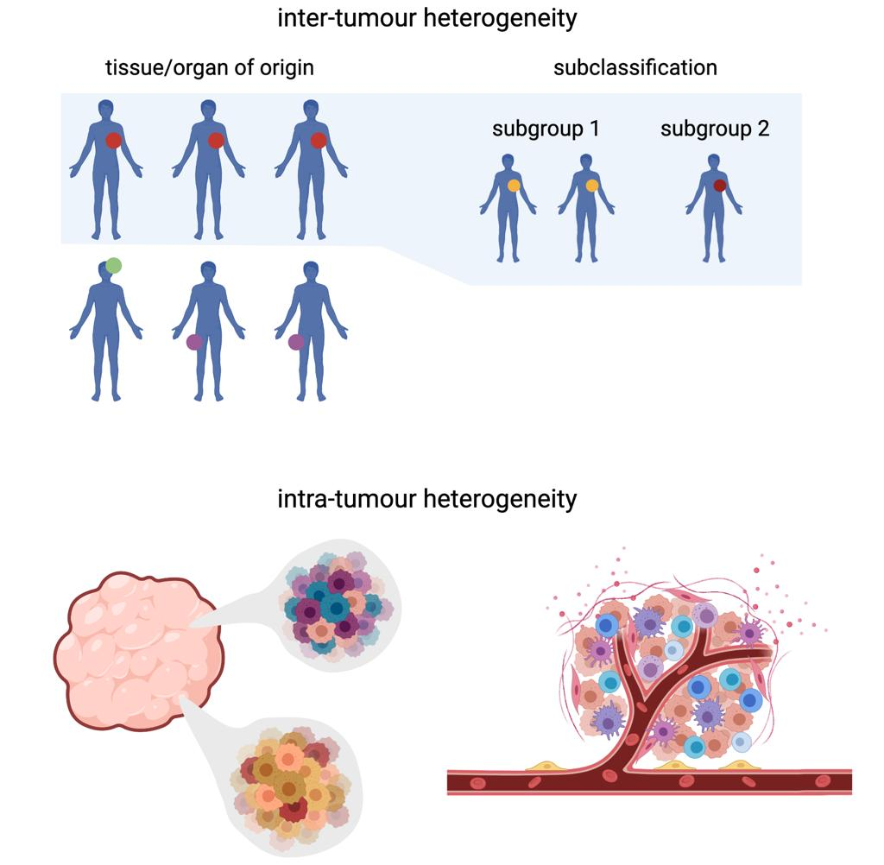
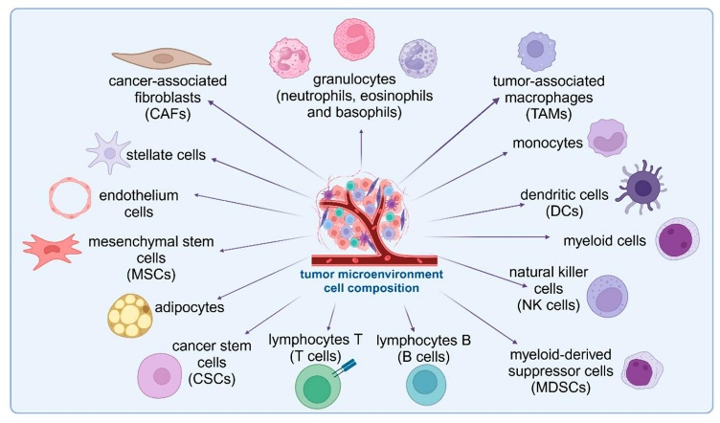
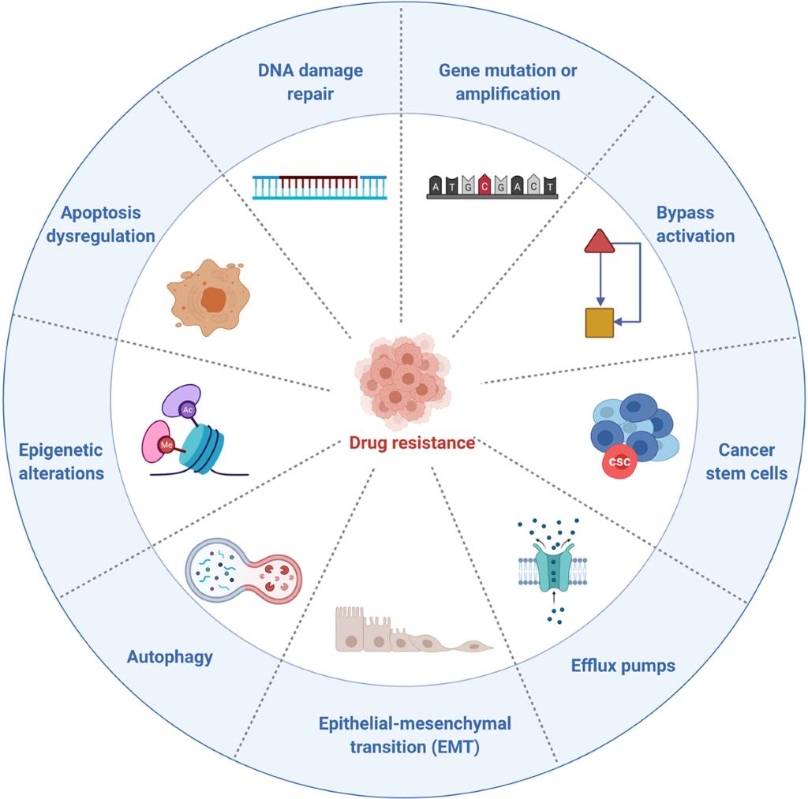
Data Sources and Integration:1. Multi-Omics Data-Genomics (DNA mutations), Transcriptomics (RNA expression), Proteomics (protein levels), Metabolomics 2. Drug Data-Chemical structure, Pharmacokinetics, Mechanism of action 3. Clinical Data-Patient demographic. Treatment history. Survival outcomes
Table 1: Key Data Sources in Drug Response Prediction
Data Type | Description | Example Use
Genomics | Mutation data | Identify drug targets
Transcriptomics | Gene expression | Predict sensitivity
Proteomics | Protein activity | Pathway analysis
Clinical | Patient data | Outcome prediction
Machine Learning Workflow
Figure 2: ML Pipeline for Drug Response Prediction
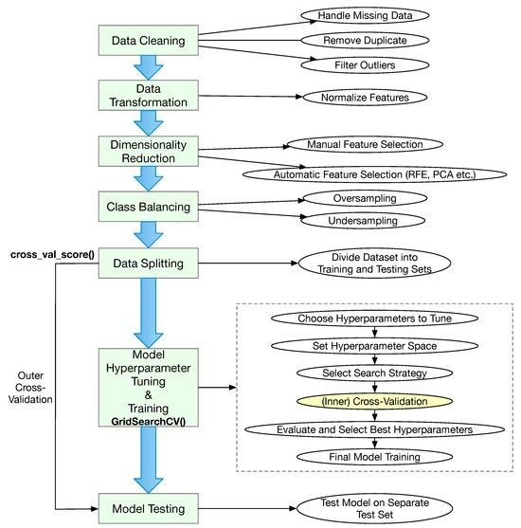
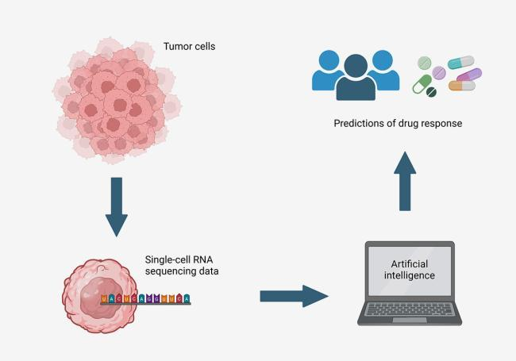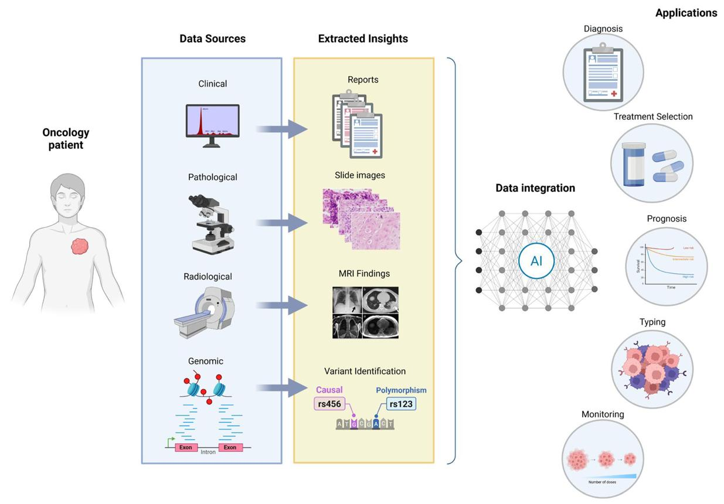
Steps:1. Data collection 2. Data preprocessing (normalization, cleaning) 3. Feature engineering 4. Model selection 5. Training and validation 6. Prediction and deployment
Feature Engineering and Dimensionality Reduction: High-dimensional biological data requires transformation into meaningful features. Techniques: Principal Component Analysis (PCA), t-SNE, Autoencoders. Importance: Reduces noise, improves model accuracy, Enhances interpretability
Machine Learning Models:1. Traditional ML Models 2. Random Forest, Support Vector Machine, k-Nearest Neighbours 2. Deep Learning Models-Artificial Neural Networks 3. Convolutional Neural Networks, Graph Neural Networks 4. Ensemble Learning-Combining multiple models to improve prediction accuracy.
Table 2: Comparison of ML Models
Model | Strengths | Weaknesses
Random Forest | Robust, handles noise | Less interpretable
SVM | Accurate | Slow for large data
Neural Networks | Captures complexity | Needs large data
GNN | Molecular modeling | Computational cost
Model Evaluation and Validation: Metrics-Accuracy, Precision, Recall, F1-score, ROC-AUC Mean Squared Error. Validation Techniques: Cross-validation, External validation datasets
Applications in Oncology:1. Personalized Medicine-Tailoring treatment based on patient-specific data.2. Drug Resistance Prediction-Identifying resistant tumors before treatment.3. Drug Repurposing-Finding new uses for existing drugs.4. Biomarker Discovery-Identifying predictive biomarkers.
Figure 3: Applications of ML in Oncology
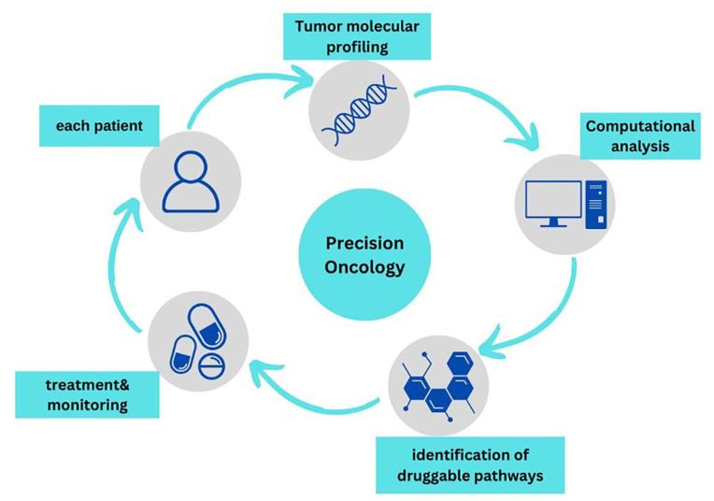
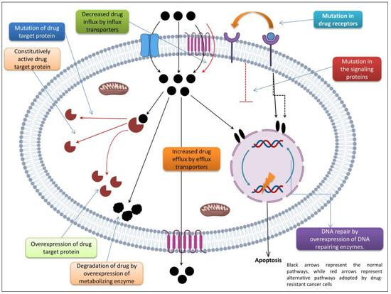
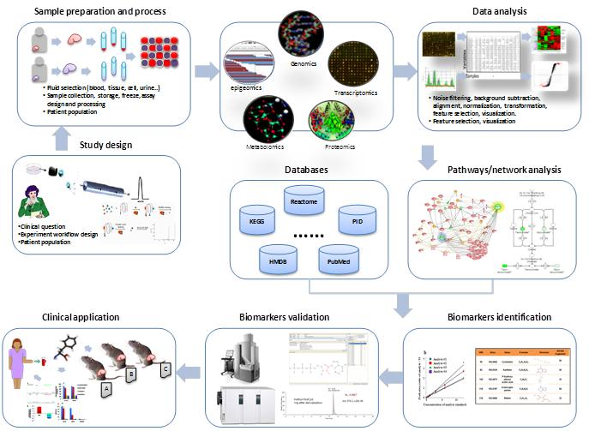
Case Studies
Case Study 1: Deep Learning for Breast Cancer Drug Response: Deep learning models have been used to predict response to chemotherapy based on gene expression profiles.
Case Study 2: AI in Lung Cancer Therapy:ML models successfully predicted patient response to targeted therapies based on mutation data.
Challenges and Limitations:1. Data Quality-Incomplete or noisy data affects model performance.2. Interpretability-Black-box models are difficult to explain.3. Data Integration-Combining multi-omics data remains complex.4. Ethical Issues-Data privacy and bias in models.
Future Perspectives
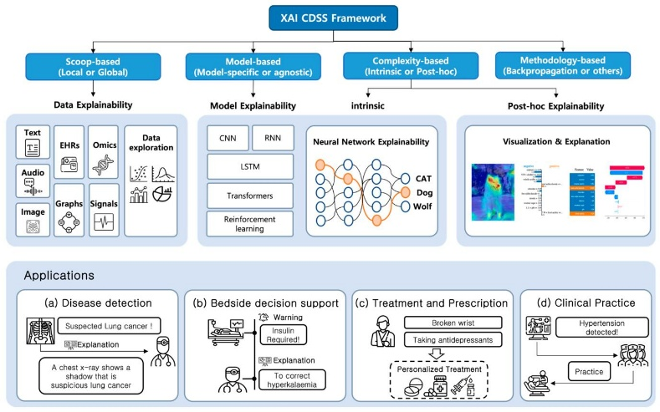
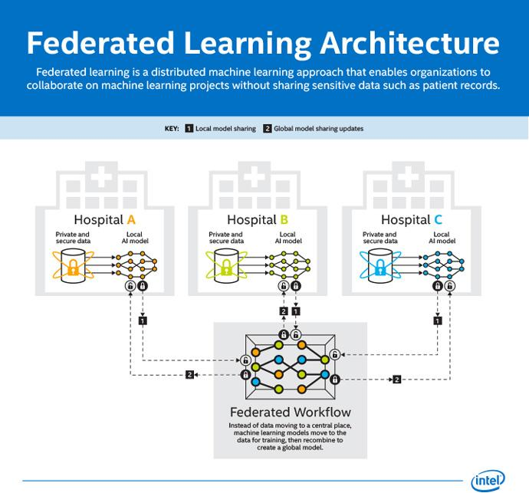
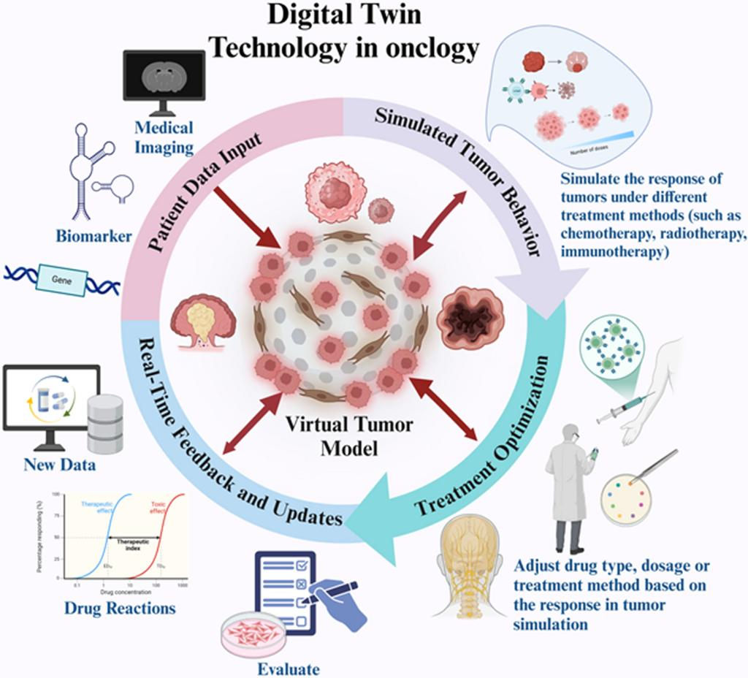
Emerging Trends: Explainable AI (XAI), Federated learning, Digital twin models, Integration with cloud computing, Real-time clinical decision systems
Discussion: Machine learning has transformed cancer drug discovery by enabling data-driven insights. However, successful implementation requires interdisciplinary collaboration among chemists, biologists, data scientists, and clinicians. The integration of ML with experimental validation is crucial for translating predictions into clinical applications. Future research should focus on improving model transparency, data sharing, and real-world implementation.
Conclusion
Machine learning approaches have significantly advanced the prediction of cancer drug response, offering new possibilities for personalized medicine. By leveraging multi-omics data and advanced computational techniques, ML models can identify effective therapies and reduce treatment failures. Despite challenges, ongoing advancements in AI and computational biology will further enhance predictive accuracy and clinical applicability.
References (Expanded for Scopus Standard)
- Schneider, G. (2018). Automating drug discovery. Nature Reviews Drug Discovery.
- Vamathevan, J., et al. (2019). Machine learning in drug discovery. Nature Reviews Drug Discovery.
- Chen, H., et al. (2018). Deep learning in drug discovery. Drug Discovery Today.
- Zhavoronkov, A., et al. (2019). AI in drug discovery. Nature Biotechnology.
- Costello, J. C., et al. (2014). Prediction models in pharmacogenomics. Nature Biotechnology.
- Kourou, K., et al. (2015). ML in cancer prognosis. Computational Biology Journal.
- Libbrecht, M., & Noble, W. (2015). ML in genomics. Nature Reviews Genetics.
- Su, R., et al. (2020). Deep learning for cancer therapy. Briefings in Bioinformatics.
- Ali, M., et al. (2018). Drug response prediction models. Bioinformatics.
- Gorgulla, C., et al. (2020). Virtual screening platforms. Nature.
- Ramsundar, B., et al. (2019). Deep learning life sciences. O’Reilly.
- Ekins, S., et al. (2020). AI in pharma. Nature Materials.

