Flood Alert Mapper: A Community-Powered Real-Time Flood Reporting and Rescue Location System

ABSTRACT

Flooding remains one of the most destructive natural disasters affecting communities, particularly in urban and low-lying areas where delayed reporting and inaccurate information hinder effective emergency response operations. Traditional flood monitoring systems often rely on centralized reporting mechanisms that may not provide real-time situational awareness and community-based verification. This study aimed to develop a Flood Alert Mapper: A Community-Powered Real-Time Flood Reporting and Rescue Location System capable of supporting real-time flood monitoring, AI-assisted validation, community participation, and emergency notification dissemination. The study utilized a developmental-descriptive research design and adopted the Rapid Application Development (RAD) model in designing and implementing the proposed system. The developed web-based platform integrated real-time flood mapping, crowdsourced flood reporting, AI-assisted confidence scoring using MobileNetV2, community validation mechanisms, and automated notification features. The system computed report reliability using a weighted confidence formula combining AI-generated analysis and community validation results.

Keywords: AI-assisted Validation, Community Reporting, Disaster Management, Emergency Notification System, Flood Monitoring, Real-time Mapping

INTRODUCTION

Flooding is one of the most frequent and destructive natural hazards in the world causing significant loss of life, damage to infrastructure, and disruption of the economy. Floods account for nearly 35 to 40% of all weather-related disasters globally and affect more people annually than any other type of natural disaster (UNDRR, 2020). In the Philippines, flooding is a recurring crisis due to its geographical location, heavy rainfall patterns, and exposure to typhoons. It was reported that from 2010 to 2019, floods and typhoons were among the leading natural disasters responsible for billions of pesos in damages and thousands of casualties (PSA, 2020). This recurring threat emphasizes the urgent need for more effective, localized, and community-driven systems to improve disaster preparedness and response.
Traditional flood monitoring relies on centralized meteorological forecasts, hydrological models, and sensor networks. These systems are important; however, they often face limitations such as insufficient coverage in remote areas, delayed information dissemination, and lack of ground-level data. In many instances, flood victims are the first to experience the disaster, yet their observations are not integrated into formal response mechanisms (Rautela, 2020). This gap has given rise to the development of Community-Based Flood Early Warning Systems (CBFEWS), which emphasize active citizen participation in reporting and monitoring local flood conditions. Studies in Ethiopia and Niger have shown that engaging local communities in flood monitoring improves inclusivity, ownership, and timeliness of disaster responses (Nigussie et al., 2025).
In urban context, localized real-time monitoring has already been piloted through sensor networks. For instance, New York City’s FloodNet project deployed low-cost ultrasonic sensors in flood-prone neighborhoods, providing hyper-local flood data to residents and authorities (NYU Tandon School of Engineering, 2025). Sensor-based systems are promising but it requires significant funding and infrastructure which are often unavailable in developing countries like the Philippines. A more feasible alternative for resource-constrained communities is a map-based, citizen-powered reporting system that leverages smartphone technology and internet connectivity, tools already accessible to a large portion of the population.
This study proposes the Flood Alert Mapper, a community-powered, real-time flood reporting and rescue locator system. This system enables users to pin their current location on a shared digital map and indicate the severity of flooding using a simple colored system. These inputs will be instantly visualized on a live map accessible to both community members and officials. Such an approach mirrors findings from EWS studies that emphasize the value of impact-based forecasting, where severity classifications help responders quickly prioritize high-risk areas (Tarchiani et al., 2020).
Moreover, the Flood Alert Mapper incorporates features specifically designed to support disaster management authorities. Through an admin dashboard, barangay officials, and rescue coordinators can monitor real-time reports, prioritize severe cases, and deploy response teams accordingly. Reports are also logged into a database, allowing officials to generate exportable documents for post-disaster analysis, resource planning, and future disaster preparedness. This aligns with research highlighting the importance of systematically archiving disaster data for long term risk reduction strategies (Jayawardene et al., 2021).
The integration of community-driven reporting, live mapping, and administrative monitoring directly addresses the existing gaps in current flood early warning systems in the Philippines. By empowering residents to serve as both observers and contributors of flood data, this system strengthens the link between local communities and authorities encouraging quicker response times and more coordinated rescue efforts. Ultimately, this study seeks to not only mitigate the immediate impacts of flooding but also to build a sustainable database that enhances preparedness, resilience, and adaptive capacity against future disasters.

RELATED LITERATURE AND STUDIES

Flood Risks and Needs for Early Warning
Floods are one of the most severe disasters experienced worldwide, causing widespread social damage and significant economic losses every year. According to Mostafiz et al. (2022), floods cause significant damage to infrastructure and human settlements, especially in urban areas where the risk is increased due to the lack of proper drainage systems and rapid urbanization. In this regard, Pandey and Basnet (2023) found that effective early warning systems (EWS) are still crucial to reduce the impact of disasters. However, their effectiveness depends on various social and technological factors such as speed, accuracy, and easy access to information. According to Shah et al. (2023), barriers at the community level—such as lack of integration of all sectors, lack of trust, and lack of awareness—often hinder the successful implementation of early warning systems against floods, especially in developing countries.
Extreme rainfall events are becoming more frequent and intense due to climate change, necessitating better community-based adaptation strategies and forecasting. According to Islam et al. (2025), early warning systems are becoming more and more important in managing climate risk in order to lessen human vulnerability and increase catastrophe resilience. Generally, these studies highlight the critical need for a reliable, real-time system, and inclusiveness that can successfully control the risks of flood by combining scientific data with local observations.

Forecasting Innovations and Flood Early Warning Systems (FEWS)
Traditional hydrological forecasting methods gave way to integrated, multi-source platforms that include real time data collection, visualization, and modeling in contemporary flood early warning systems. In Bangkok Thailand, Chitwatkulsiri et al. (2022), created the Real-Time Flood Forecasting System (RTFlood System), which showed that digital mapping and real time data assimilation greatly increase the accuracy and timeliness of flood warnings. Correspondingly, Lagmay et al. (2024), introduced an impact-based flood forecasting model in Asia with the goal of empowering locals with easily accessible flood data, enabling localized response and early preventive steps.
Derouin (2024), highlighted that by offering street-level information instead of broad regional signals, hyper-localized alert systems are revolutionizing flood management in urban settings. Turner and Sun (2024) created an open source online architecture that provides near real time flood event representation and encourages quick information dissemination and transparency. Collectively, these shows the trend toward interactive, data-driven early warning systems that improve situational awareness and enable end users to take immediate action.

Data-Driven Monitoring and Technological Innovations: IoT & AI
Flood detection and monitoring capacities have been greatly enhanced by the incorporation of emerging technologies such as internet of things (IoT), artificial intelligence (AI), and big data analytics. Ridwan (2022), highlighted the systems’ capacity to transmit data in real-time and continuously monitor hydrological conditions in his thorough analysis of IoT-based flood early warning systems. Mitkari et al. (2023), demonstrated how technology can close communication gaps between the public and authorities by implementing a smart flood alarm system employing internet of things (IoT) sensors that gather water-level data and initiate automatic notifications.
In addition, Rizal et al. (2024) created an IoT-based flood detection model that is coupled with a decision support system (DSS), enabling effective resource deployment and well-informed decision making. Moreover, Gersaniva and Damasco (2025), presented a novel flood monitoring system that uses clever data visualization to improve community safety and catastrophe response. Yuan et al. (2021), also covered the idea of “smart flood resilience”, which uses community-scale big data for real time situational awareness and predictive flood risk monitoring. Overall, these studies demonstrate how IoT, AI, and data-driven methodologies can offer the technology basis for flood monitoring systems that are adaptable, responsive, and community-integrated.

Data Validation, Crowdsourcing, and Real-Time Mapping
The importance of crowdsourcing data in improving flood monitoring accuracy and timeliness has been highlighted by recent studies. According to Esparza et al. (2024), including crowdsourced flood reports greatly enhanced road network inundation mapping, transportation management, and providing vital information for emergency response. Sunkara et al. (2020) also showed that by combining community input with satellite imagery, semantic segmentation, and crowdsourcing improve flood map accuracy.
Vongkusolkit et al. (2023) demonstrated that AI-assisted classification may produce trustworthy flood maps with less labeled data by using poorly supervised machine learning for near real-time flood mapping. According to Derouin (2024) and Turner & Sun (2024), transparency and participation in disaster management are strengthened when public input is combined with web-based visualization. The idea of a community-powered flood alert mapping system, in which user-generated data contributes to a dynamic, live flood map confirmed by public engagement and system intelligence, is supported by these findings.

Local Engagement and Community-Based Flood Monitoring
The significance of community involvement in flood alert systems has been well recognized in both international and local context. Salgado et al. (2025) put forward a framework that combines institutional and community-based flood early warning systems, concluding that local engagement improves trust and information exchange between citizens and authorities. Kamau (2024) illustrated a similar method in Kenya, where a real time flood monitoring and alert system strengthened local resilience by incorporating community technology.
In the Philippines, Abella & Enriquez (2024) created a community-based flood alert system utilizing long range (LoRa) technology in Occidental Mindoro, demonstrating that local participation and affordable communication networks can efficiently provide timely alerts in rural settings. Additionally, Evangelio (2024) explored the implementation of EWS in Batangas, highlighting that participatory strategies enhance preparedness and lead to better responses among residents. Previously, Abon et al. (2012) showed that community-based flood monitoring in the Bicol River Basin facilitated quicker and more contextually precise alerts, serving as an early model for participatory disaster management systems.

Real Time Alerts and IoT Enabled Flood Detection
Recent studies examined how the internet of things (IoT) can improve real time flood detection, data transmission, and emergency response efforts. Halim et al. (2024) implemented a LoRa-based sensor network for flood warnings in recreational areas, demonstrating that long range wireless technologies can effectively address geographic and connectivity challenges. Similarly, Te at al. (2024) created an IoT-based urban flood monitoring system utilizing high performance pressure sensors with LoRaWAN connectivity, which is capable of providing real time, high precision readings.
Tolentino (2022) introduced a real-time flood detection and alert system that automatically dispatches warnings through sensor-activated communication, emphasizing the effectiveness of integrating sensor-based automation into early warning systems (EWS). Muhd Zain et al. (2020) also developed a GSM-based flood warning and monitoring system that effectively communicated flood alerts to local residents, emphasizing the role of mobile communication in implementing early warning systems.
In a more recent investigation, Neypes et al. (2024) proposed a smart framework that fuses IoT and artificial intelligence (AI) for flood prediction, showcasing how machine learning improves accuracy in monitoring water levels and predicting floods. Likewise, Aguirre (2025) created an IoT-based flood monitoring and early warning system featuring a web dashboard and SMS notifications, successfully merging digital accessibility with emergency communication. Collectively, these studies highlight that IoT-enabled monitoring, when integrated with AI and data analytics, provides a dependable and scalable approach for real time disaster management.

Modeling, Data Analytics, and Forecasting Systems
Advanced modeling and simulation methods are also essential for enhancing flood prediction and decision making processes. Daang et al. (2023) performed a hydrologic and hydraulic analysis of flood in Pasig City, offering valuable insights for managing urban flood challenges and shaping policy. Ruaro & So (2022) employed regression-based weather models to explore flood prediction trends, demonstrating that computational models can effectively complement sensor-derived data in forecasting.
Tao et al. (2024) examined cutting-edge sensor technologies for flood monitoring, underscoring how the integration of multiple sensors – including satellite imagery, radar, and AI-driven tools improve both real time detection and assessments following disasters. These analytical frameworks highlight the significance of combining data from diverse sources and utilizing predictive analytics, both of which play a critical role in the design of the Flood Alert Mapper for providing up-to-date and precise situational awareness.

Governance in EWS Implementation and Institutional Collaboration
The effectiveness of flood early warning systems hinges on institutional capacity and policy backing. Khan & Ilyas (2021) highlighted key factors contributing to the failure of FEWRS, including insufficient stakeholder cooperation, limited funding, and inadequate community involvement all of which undermine the sustainability of these systems. The ASEAN Committee on Disaster Management (2024) reiterated these issues, stressing the importance of regional collaboration and shared data systems to enhance comprehensive warning procedures. Salgado et al. (2025) suggested that combining institutional frameworks with community-driven initiative could strengthen coordination and trust, connecting formal disaster management agencies with local responders.

Local Studies on Disaster Preparedness and Awareness
Local studies in the Philippines underscores the significance of community awareness and information accessibility in preparation for floods. Paguia et al. (2023) investigated how residents in the coastal areas of San Jose, Occidental Mindoro, obtain disaster-related information, revealing that the majority depend on informal sources and social networks rather than official alerts. This highlights the need to enhance digital communication platforms and establish more user-friendly web-based alert systems.
Abella & Enriquez (2024) as well as Evangelio (2024) both pointed out that localized flood alert systems strengthen the connection between technology and social behavior by fostering community ownership and encouraging collective action. Furthermore, Daang et al. (2023) and Tolentino (2022) demonstrated how sensor-based systems and predictive modeling can augment community reports, thereby improving the accuracy of local flood mapping.

RESEARCH DESIGN AND METHODOLOGY

Research Design

This study utilized a developmental-descriptive research design in developing the Flood Alert Mapper: A Community-Powered Real-Time Flood Reporting and Rescue Location System. The study focused on the design, development, and implementation of a web-based platform capable of supporting real-time flood reporting, flood severity visualization, community-based validation, and emergency notification dissemination.
The developmental aspect of the study involved the creation of a functional system prototype integrating mapping technologies, AI-assisted confidence scoring, and crowdsourced flood validation mechanisms. Meanwhile, the descriptive aspect focused on presenting and describing the operational processes, functionalities, and system components of the developed platform.
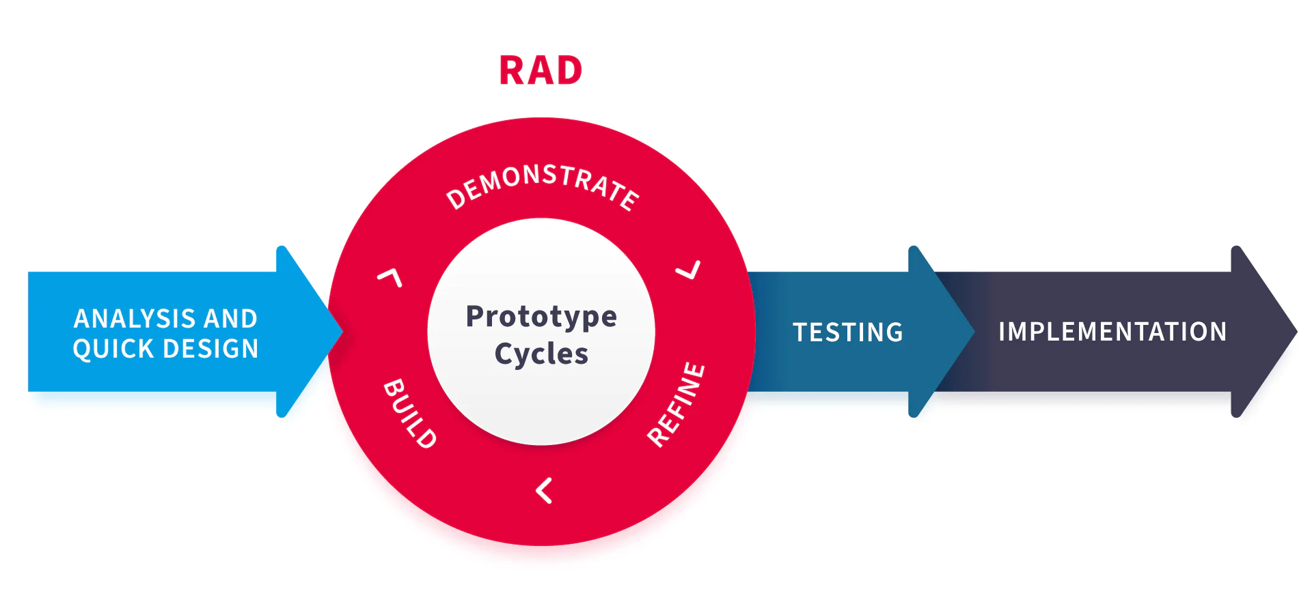
Figure 1. Rapid Application Development (RAD) Model

The study adopted the Rapid Application Development (RAD) model in developing the Flood Alert Mapper System as the system development methodology due to its suitability for iterative prototyping, rapid interface development, continuous testing, and user-centered system enhancement. The RAD model allowed the researchers to continuously refine the system through iterative design and testing procedures.

Requirement Planning
During this phase, the researchers identified the major problems associated with flood monitoring and emergency communication in flood-prone communities. Existing issues such as delayed flood reporting, lack of real-time situational awareness, unreliable information dissemination, and limited community participation were analyzed to determine the system requirements. The researchers also reviewed existing flood monitoring systems and related literature to identify technological approaches suitable for localized disaster response management.

The researchers identified the following essential system features:
- real-time flood reporting,
- live flood map visualization,
- AI-assisted flood confidence analysis,
- community-based report validation,
- automated notification dissemination,
- and administrative monitoring functionalities.

User Design
During the user design phase, the graphical user interface (GUI), navigation structure, and system workflow were designed to ensure accessibility and usability.

The researchers developed several major interfaces including:
- Live Flood Map Interface
- Flood Report Detail Interface
- Community Validation Interface
- Flood Report Submission Form
- Notification Monitoring Interface
- Administrative Dashboard

The system was designed to allow users to easily submit flood reports, validate ongoing incidents, and access real-time flood updates using a web browser environment. This visual representation enabled users and emergency responders to quickly identify high-risk areas.

The flood mapping interface utilized color-coded markers to represent flood severity levels:
- Yellow → Light Flooding
Orange → Moderate Flooding
- Red → Severe Flooding

Construction
The construction phase involved the actual development and implementation of the system using web technologies such as HTML, CSS, and JavaScript. The researchers implemented an interactive flood mapping interface using scalable vector graphics (SVG)-based visualization techniques to dynamically display flood incidents on the digital map.

The developed system allowed users to submit flood reports containing:
- flood severity classification,
- textual descriptions,
- GPS-based location information,
- and multimedia evidence such as photos or videos.

The system also integrated an AI-assisted confidence scoring mechanism to evaluate the reliability of submitted reports. The confidence score combined AI-generated flood analysis and community validation results.

The confidence score was computed using the formula:
Confidence Score = (AI Score*0.4) + (Community Vote Ratio*0.6)
Where:
- AI Score represents the confidence value generated by the AI classifier;
- Community Vote Ratio represents the percentage of community confirmation votes.

The system classified reports according to the following confidence score thresholds:
- 75% and above = Verified
- 40% to 74% = Pending
- Below 40% = Unverified

Additionally, the system implemented a notification mechanism that automatically triggers SMS alerts when flood severity reaches moderate or severe levels and receives sufficient community confirmations. The AI-assisted image analysis component utilized the MobileNetV2 model for flood-related media classification and validation support.

Cutover
The cutover phase involved system testing, debugging, and refinement procedures to ensure proper functionality and interface stability.

The researchers conducted functionality testing on the following system features:
- flood report submission,
- live flood map visualization,
- confidence score computation,
- community validation functions,
- notification triggering,
- and administrative monitoring capabilities.

Necessary revisions and interface improvements were applied after identifying operational inconsistencies during testing procedures. The researchers ensured that the system interfaces remained responsive, accessible, and functional within browser-based environments.

Technologies Used
HTML 5 | System structure and content organization
CSS3 | User interface styling and responsiveness
JavaScript | System functionality and interactivity
SVG-Based Mapping | Interactive flood map visualization
MobileNetV2 | AI-assisted image analysis and classification
Web Browser Environment | System accessibility and deployment

System Architecture
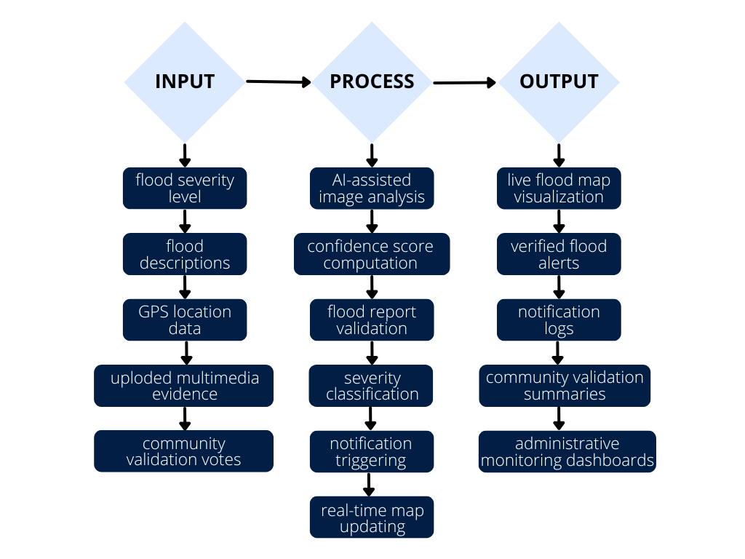
Figure 2. Flood Alert Mapper System Architecture

Testing Procedure
The researchers conducted functionality testing to determine whether the developed system performed according to its intended design and operational objectives.

The testing procedures focused on the following areas:
- flood report generation,
- real-time map visualization,
- confidence score calculation,
- community confirmation and denial voting,
- notification dissemination,
- and administrative monitoring functions.

The researchers verified whether the generated confidence scores correctly changed according to AI analysis and community voting results. Notification triggering rules were also evaluated to determine whether SMS alerts were activated only for verified moderate and severe flood incidents.System responsiveness and interface consistency were also observed during testing procedures.

RESULTS AND DISCUSSION

Results

The developed Flood Alert Mapper System successfully displayed flood reports through an interactive digital map interface. The map interface enabled users and emergency responders to identify affected areas in real time and monitor ongoing flood situations efficiently. Flood incidents were represented using color-coded markers based on severity levels:
- Yellow for light flooding,
- Orange for moderate flooding,
- and Red for severe flooding.
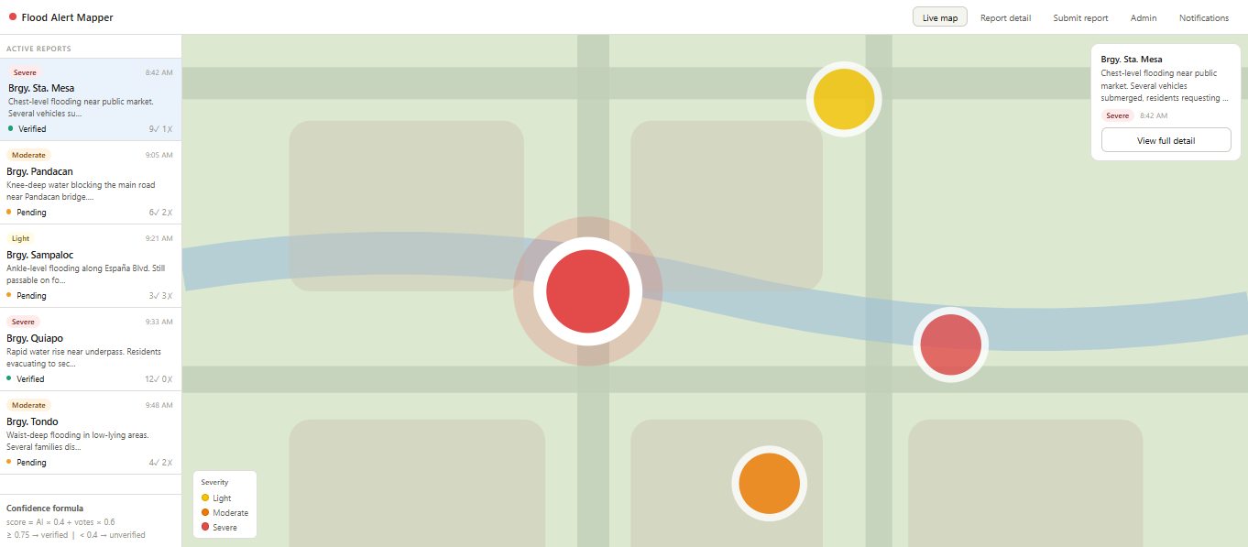
Figure 3. Real-Time Flood Mapping Interface

The system successfully allowed users to submit flood reports containing descriptions, flood severity classifications, GPS-based location data, and multimedia evidence. Submitted reports were automatically processed and displayed on the live flood map after validation procedures.The report submission interface also allowed users to classify incidents according to flood severity levels, improving report organization and prioritization.
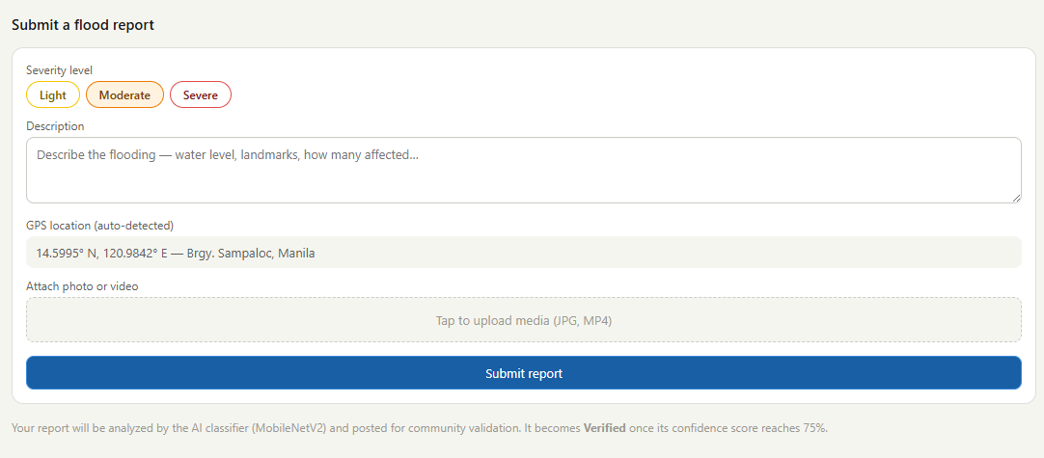
Figure 4. Flood Report Submission
The implemented AI-assisted confidence scoring mechanism successfully evaluated the reliability of submitted flood reports. The confidence score dynamically changed according to the combination of AI-generated analysis and community validation votes. Reports receiving higher community confirmation votes achieved higher confidence scores and were automatically classified as “Verified.” The implemented confidence classification thresholds enabled the system to distinguish between verified, pending, and unverified flood reports.
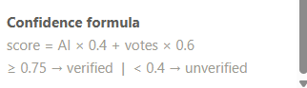
Figure 5. AI-assisted Confidence Scoring Formula

The community validation feature successfully enabled users to confirm or deny submitted flood reports. The voting mechanism dynamically updated the confidence score of each report, allowing crowdsourced validation to contribute to the reliability of flood information presented by the system. This feature minimized the likelihood of misinformation by incorporating community participation into the flood verification process.
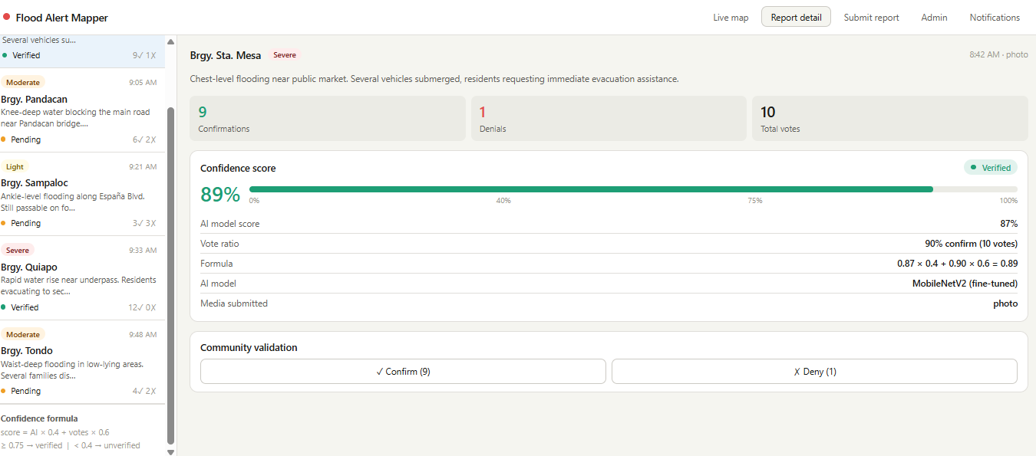
Figure 6. Community Validation Mechanism

The notification mechanism successfully generated automated alerts based on predefined severity and validation conditions. Moderate and severe flood incidents with sufficient confirmation votes triggered SMS notifications, while light flood incidents generated in-app notifications only. This notification filtering mechanism reduced unnecessary alerts and improved the relevance of emergency notifications.
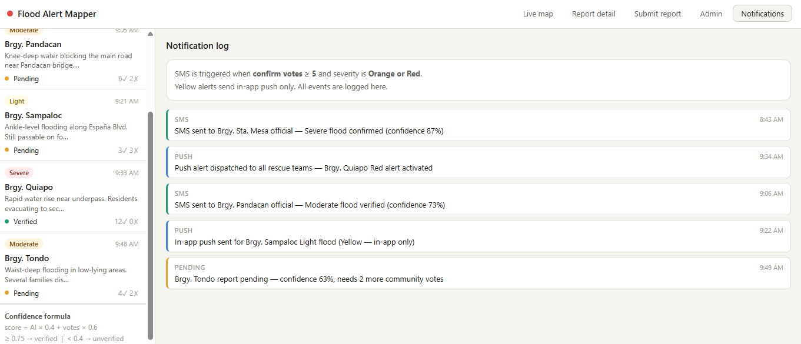
Figure 7. Notification System

The dashboard enabled administrators and emergency personnel to monitor flood conditions efficiently and identify priority areas requiring immediate response.

The administrative dashboard successfully displayed:
- total flood reports,
- verified incidents,
- severe flood alerts,
- and confidence score summaries.
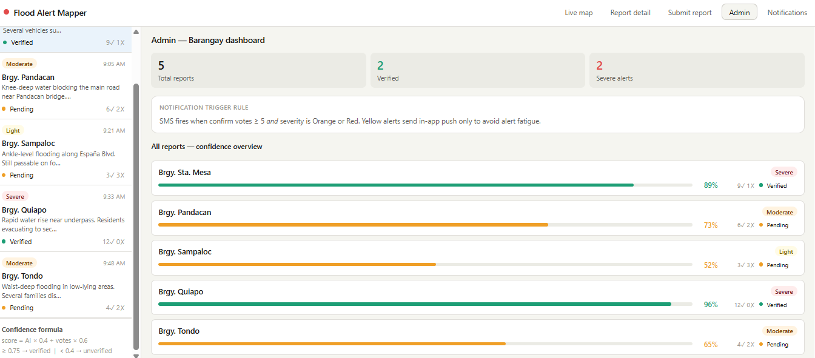
Figure 8. Administrative Dashboard

Discussion

The results of the study demonstrate that the Flood Alert Mapper System effectively integrates real-time flood monitoring, community participation, and AI-assisted validation mechanisms to improve flood reporting and emergency response coordination.
The live flood mapping interface enhanced situational awareness by allowing users and emergency responders to visualize flood incidents immediately after report submission. The use of color-coded severity indicators further improved the readability and prioritization of flood information within the system.
The integration of community-based validation strengthened the reliability of submitted reports by allowing users to confirm or deny ongoing flood incidents. This crowdsourced validation approach minimized misinformation and increased the credibility of flood-related data. Furthermore, the AI-assisted confidence scoring mechanism improved report prioritization by combining automated flood analysis with community validation feedback. The implemented scoring mechanism enabled the system to distinguish verified flood incidents from unreliable or insufficiently validated reports. The notification dissemination mechanism also contributed to efficient emergency communication by reducing alert fatigue. By restricting SMS notifications to moderate and severe flood incidents with sufficient validation, the system ensured that emergency alerts remained relevant and actionable.
The administrative dashboard further enhanced monitoring efficiency by consolidating flood reports, confidence levels, and notification summaries into a centralized monitoring interface. Overall, the developed Flood Alert Mapper System demonstrates the potential of integrating AI-assisted analysis, crowdsourced validation, and real-time mapping technologies in improving localized flood disaster monitoring and emergency response management

CONCLUSION

The study successfully developed the Flood Alert Mapper: A Community-Powered Real-Time Flood Reporting and Rescue Location System designed to support real-time flood monitoring, community participation, and emergency response coordination. The developed system successfully integrated real-time flood mapping, AI-assisted confidence scoring, community-based validation, and automated notification dissemination within a web-based platform. The implementation of the confidence scoring mechanism improved the reliability of flood reports by combining AI-generated analysis and crowdsourced validation results.
The findings indicate that the system can improve situational awareness, minimize misinformation, and enhance disaster response coordination during flood-related emergencies. The integration of community participation and intelligent validation mechanisms demonstrates the potential of technology-driven disaster management systems in supporting localized emergency operations.
Overall, the study highlights the effectiveness of combining real-time mapping technologies, artificial intelligence, and community-powered validation in improving flood disaster monitoring and emergency communication systems.

REFERENCES

Abella, A. P., & Enriquez, M. (2024). Community-based flood alert system using long-range technology for Brgy. San Agustin, San Jose, Occidental Mindoro. Mindoro Journal of Social Sciences and Development Studies, 1(2), 27–34. https://journal.omsc.edu.ph/index.php/mjssds/article/view/10
Abon, C. C., David, C. P. C., & Tabios, G. Q., III. (2012). Community-based monitoring for flood early warning system: An example in central Bicol River Basin, Philippines. Disaster Prevention and Management: An International Journal, 21(1), 85–96. https://doi.org/10.1108/09653561211202728
Aguirre, A. (2025). Development of an IoT-based flood monitoring and early warning system with real-time web dashboard and SMS notification. Scribd. https://www.scribd.com/document/884201022/Development-of-an-IoT-Based-Flood-Monitoring-and-Early-Warning-System-With-Real-Time-Web-Dashboard-and-SMS-Notification
Association of Southeast Asian Nations Committee on Disaster Management. (2024). Strengthening ASEAN multi-hazard end-to-end early-warning system for natural disasters: An assessment of current capacity. Pacific Disaster Center. https://doi.org/10.13140/RG.2.2.18422.61769
Chitwatkulsiri, D., Miyamoto, H., Irvine, K. N., Pilailar, S., & Loc, H. H. (2022). Development and application of a real-time flood forecasting system (RTFlood System) in a tropical urban area: A case study of Ramkhamhaeng Polder, Bangkok, Thailand. Water, 14(10), 1641. https://doi.org/10.3390/w14101641
Daang, C. S., Go, D. M. L., Pagaduan, J. M. A., Santos, T. A. S., Vinluan, C. D. P., & De Leon, M. P. (2023). Hydrologic and hydraulic simulation of flooding in areas along Ilugin River and Buli Creek in Pasig, Philippines. In Research Congress Proceedings 2023 – SEE-11. De La Salle University. https://www.dlsu.edu.ph/wp-content/uploads/pdf/conferences/research-congress-proceedings/2023/SEE-11.pdf
Derouin, S. (2024). Alerting communities to hyper-localized urban flooding. Eos. https://doi.org/10.1029/2024EO240172
Esparza, M., Farahmand, H., Liu, X., et al. (2024). Enhancing inundation monitoring of road networks using crowdsourced flood reports. Urban Informatics, 3, 25. https://doi.org/10.1007/s44212-024-00055-7
Evangelio, C. T. (2024). Early warning system implementation in Banjo West, Tanauan, Batangas, Philippines. IDRIM Journal. https://www.idrimjournal.com/api/v1/articles/124778-early-warning-system-implementation-in-banjo-west-tanauan-batangas-philippines.pdf
Gersaniva, J. A., & Damasco, L. B., Jr. (2025). Innovative flood monitoring system: Enhancing disaster response and community safety. International Journal of Innovative Science and Research Technology, 10(6), 2901–2910. https://doi.org/10.38124/ijisrt/25jun1859
Halim, I., Hamid, R., & Jamaluddin, M. (2024). Rapid flood warning system in recreational areas using LoRa-based sensor networks. Journal of Computing Research and Innovation. https://ir.uitm.edu.my/id/eprint/104107/1/104107.pdf
Hammood, W. A., Abdullah Arshah, R., Mohamad Asmara, S., Al Halbusi, H., Hammood, O. A., & Al Abri, S. (2021). A systematic review on flood early warning and response systems (FEWRS): A deep review and analysis. Sustainability, 13(1), 440. https://www.mdpi.com/2071-1050/13/1/440
Islam, M. M., et al. (2025). Early warning systems in climate risk management: Roles and implementations in eradicating barriers and overcoming challenges. https://www.sciencedirect.com/science/article/pii/S2666592125000071
Kamau, G. (2024). A real-time flood monitoring and alert system: Enhancing community resilience through technology integration – A case study of River Tana in Kenya. International Journal of Engineering and Science, 13(12), 73–80. https://theijes.com/papers/vol13-issue12/13127280.pdf
Khan, A., & Ilyas, M. (2021). Critical failure factors of flood early warning and response systems: A structured review and interpretive structural modelling analysis. Geosciences, 13(5), 137. https://www.mdpi.com/2076-3263/13/5/137
Lagmay, A. M. F., Bagtasa, G., Andal, D. F., et al. (2024). An impact-based flood forecasting system for citizen empowerment. Asian Journal of Agriculture and Development, 21, 129–148. https://doi.org/10.22004/ag.econ.348355
Mitkari, M. S., Suryakar, H., Mali, Y., Shaikh, Y., & Mullani, Z. (2023, May). Smart flood alert system using IoT. International Research Journal of Modernization in Engineering Technology and Science, 5(5). https://www.irjmets.com/uploadedfiles/paper/issue_5_may_2023/39881/final/fin_irjmets1684917924.pdf
Mostafiz, R. B., Rahim, M. A., Friedland, C. J., Rohli, R. V., Bushra, N., & Orooji, F. (2022). A data-driven spatial approach to characterize the flood hazard. Frontiers in Big Data, 5, 1022900. https://doi.org/10.3389/fdata.2022.1022900
Muhd Zain, N., Elias, L. S., Paidi, Z., & Othman, M. (2020). Flood warning and monitoring system (FWMS) using GSM technology. Journal of Computing Research and Innovation, 5(1), 8–19. https://doi.org/10.24191/jcrinn.v5i1.158
Najafi, H., Shrestha, P. K., Rakovec, O., Apel, H., Vorogushyn, S., Kumar, R., Thober, S., Merz, B., & Samaniego, L. (2024). High-resolution impact-based early warning system for riverine flooding. Nature Communications, 15, Article 3726. https://doi.org/10.1038/s41467-024-48065-y
Nigussie, L., Bekele, T. W., Haile, A. T., Mdee, A., Nicol, A., Cohen, J., Osei-Amponsah, C., Zeray Tedla, H., & Demissie, K. (2025). Does a citizen science approach enhance the effectiveness of flood early warning systems? Evidence from the Akaki catchment, Ethiopia. Citizen Science: Theory and Practice, 10(1). https://doi.org/10.5334/cstp.763
Pandey, C. L., & Basnet, A. (2023). Challenges and prospects of flood early warning systems: A study of Narayani Basin. Asian Journal of Water, Environment and Pollution, 20(1), 17–24. https://doi.org/10.3233/AJW230004
Pelone, B. C., & Arellano, A. J. P. (2024). Flood preparedness and utilization of early warning systems among households in selected flood-prone areas in Tagum City, Davao del
Norte. Davao Research Journal, 15(1), 35–49. https://doi.org/10.59120/drj.v15i1.149
Ridwan, I. F. (2022). Internet of Things development for flood early warning monitoring system: A review. Journal of Computation Physics and Earth Science. https://journal.physan.org/index.php/jocpes/article/view/27
Rizal, M., Warni, E., Angriawan, R., Hariadi, M., Arif, ., & Maulina, D. (2024). Design of flood early detection based on the Internet of Things and decision support system. Ingénierie des Systèmes d’Information. https://doi.org/10.18280/isi.290335
Ruaro, E., & So, N. (2022). Analyzing weather patterns for predicting floods with regression models. Research Congress. De La Salle University Integrated School. https://animorepository.dlsu.edu.ph/cgi/viewcontent.cgi?article=1160&context=conf_shsrescon
Shah, A. A., Ullah, A., Khan, N. A., Khan, A., Tariq, M. A. U. R., & Xu, C. (2023). Community social barriers to non-technical aspects of flood early warning systems and NGO-led interventions: The case of Pakistan. Frontiers in Earth Science, 11. https://doi.org/10.3389/feart.2023.1068721
Salgado, M. J., Alfonso, L., & Vélez Upegui, J. J. (2025). Towards integrating community and institutional flood early warning systems: A framework applied to an Andean tropical case. International Journal of Disaster Risk Reduction, 116(2), Article 105126. https://doi.org/10.1016/j.ijdrr.2024.105126
Sunkara, V., Purri, M., Le Saux, B., & Adams, J. (2020). Street to cloud: Improving flood maps with crowdsourcing and semantic segmentation. arXiv. https://arxiv.org/abs/2111.06461
Tao, Y., Tian, B., Adhikari, B. R., Zuo, Q., Luo, X., & Di, B. (2024). A review of cutting-edge sensor technologies for improved flood monitoring and damage assessment. Sensors, 24(21), 7090. https://www.mdpi.com/1424-8220/24/21/7090
Tolentino, L. K. S. (2022). Real-time flood detection, alarm and monitoring system. Journal of Computing in Engineering and Applied Arts, 7(1). https://www.dlsu.edu.ph/wp-content/uploads/pdf/research/journals/jciea/vol-7-1/2tolentino.pdf
Turner, R., & Sun, C. (2024). Near real-time responsive flood event representation: An open-source interactive web application architecture. ISPRS Annals, X-4, 365–2024. https://isprs-annals.copernicus.org/articles/X-4-2024/365/2024/
Vongkusolkit, J., Peng, B., Wu, M., Huang, Q., & Andresen, C. G. (2023). Near real-time flood mapping with weakly supervised machine learning. Remote Sensing, 15(13), 3263. https://doi.org/10.3390/rs15133263
Yasmin, T., Khamis, K., Ross, A., Sen, S., Sharma, A., Sen, D., Sen, S., Buytaert, W., & Hannah, D. M. (2023). Brief communication: Inclusiveness in designing an early warning system for flood resilience. Natural Hazards and Earth System Sciences, 23(2), 667. https://doi.org/10.5194/nhess-23-667-2023
Yuan, F., Fan, C., Farahmand, H., Coleman, N., Esmalian, A., et al. (2021). Smart flood resilience: Harnessing community-scale big data for predictive flood risk monitoring, rapid impact assessment, and situational awareness. arXiv. https://arxiv.org/abs/2111.06461
Zahri, R., Md Ali, A. H., Rambat, S., Ghazali, N. H., Ahmad, Y., & Hamzah, M. H. (2025). Flood early warning systems (FEWS) in enhancing disaster risk reduction and community resilience: A systematic review. International Journal of Law, Government and Communication. https://gaexcellence.com/ijlgc/article/view/5352

