FROM EXTERNAL PRESSURE TO INTERNAL RESPONSIBILITY: MOTIVATIONAL CHANGE AMONG MEN PARTICIPATING IN DOMESTIC VIOLENCE COUNSELLING PROGRAMMES IN ALBANIA

Abstract
Motivation is a central mechanism in behavioural change processes within domestic violence perpetrator interventions. Many men initially enter counselling programmes because of external pressures, including court mandates, probation requirements, police referral, family pressure, or child protection involvement. However, sustainable change requires a gradual movement from compliance with external demands toward personal responsibility, autonomous motivation, and commitment to non-violent behaviour. Despite the expansion of perpetrator programmes across Europe, limited empirical research has examined motivational change among participants in the Western Balkan context. This study examines motivational pathways among men participating in structured domestic violence counselling programmes implemented by the Office for Men and Boys (ZDB) in Northern Albania during 2025. Drawing on Self-Determination Theory, the Transtheoretical Model of Change, and motivational interviewing principles, the study explores how participant motivation evolves during counselling. A descriptive longitudinal design was applied using monitoring data from 78 men enrolled in ZDB programmes. Data were collected through the Work With Perpetrators European Network (WWP EN) Impact Monitoring Toolkit across programme phases, with particular attention to referral pathways, reasons for participation, and reasons for remaining engaged. Findings show that mandatory institutional referrals represented 79.59% of recorded referral pathways, while voluntary referrals represented 20.41%. At programme entry, external motivations predominated, accounting for 56.00% of reported reasons for participation, compared with 30.00% internal motivation and 14.00% combined motivation. By the middle phase of the programme, internal motivation increased to 47.06%, while external motivation decreased to 35.29%. Participants increasingly reported personal goals such as stopping abusive behaviour, improving family relationships, becoming better fathers, taking responsibility for harm, and developing healthier communication skills. The study suggests that perpetrator counselling can support a progressive transition from externally regulated attendance to internal responsibility for change. This motivational transition may represent an important process mechanism linking programme participation with engagement, retention, and behavioural transformation. The findings highlight the need to integrate motivational approaches into perpetrator programmes while maintaining strong referral and monitoring systems.
Keywords: motivation, behaviour change, domestic violence, perpetrators, counselling programmes, Self-Determination Theory

1. Introduction
Domestic violence remains a persistent social, public health, and human rights challenge with consequences for victim-survivors, children, families, communities, and institutions. International standards increasingly emphasise that effective responses to domestic violence should combine protection and support for women and children with structured interventions for men who use violence (Ajdukovic & Pauncz, 2015; World Health Organization [WHO], 2021). Within this coordinated response, perpetrator programmes are expected to promote accountability, reduce violent behaviour, and contribute to increased safety for partners, ex-partners, and children (Work With Perpetrators European Network [WWP EN], 2017).
Research on perpetrator interventions has often focused on behavioural outcomes, including reduced violence, recidivism, partner-reported safety, and programme completion (Akoensi et al., 2013; Kelly & Westmarland, 2015). These outcomes remain essential, but they do not fully explain how change occurs. A participant may attend sessions, complete a programme, and still fail to develop genuine accountability. Conversely, meaningful change may begin before programme completion when a participant starts to recognise harm, reflect on the consequences of his actions, and develop personal reasons for behaving differently. For this reason, motivational processes deserve focused empirical attention.
Motivation is especially important in perpetrator programmes because many participants do not enter intervention voluntarily. Men may be referred through civil or criminal courts, probation services, police structures, child protection units, municipal social services, or pressure from family members. Such pathways can create an initial form of participation based on compliance rather than readiness to change. This does not mean that mandatory participation is ineffective. Rather, it suggests that the starting point of intervention is often external pressure, and the clinical challenge is to transform this pressure into reflection, responsibility, and internal commitment (Murphy & Eckhardt, 2005).
Self-Determination Theory provides a useful framework for understanding this process. Deci and Ryan (2000) distinguish between controlled forms of motivation, driven by external demands or fear of consequences, and autonomous forms of motivation, guided by personal values, identification with goals, and internal commitment. Later developments of the theory emphasise that motivation exists along a continuum rather than as a simple division between motivated and unmotivated behaviour (Ryan & Deci, 2020). In the context of perpetrator counselling, this means that a participant may begin attendance because of a court requirement but gradually develop more personally meaningful reasons for change.
The Transtheoretical Model of Change offers a complementary perspective. Prochaska and DiClemente (1983) conceptualise behaviour change as a staged process that includes precontemplation, contemplation, preparation, action, and maintenance. Men entering perpetrator programmes through mandatory referral may initially show denial, minimisation, or externalisation of responsibility. These patterns resemble precontemplation or early contemplation. Through structured counselling, participants may move toward greater awareness, preparation for change, and action. This staged perspective is particularly useful because it avoids treating motivation as a fixed trait and instead views it as a process that can develop through intervention.
Motivational Interviewing further contributes to this perspective by treating ambivalence as a normal part of change. Miller and Rollnick (2013) argue that practitioners can support change by helping clients explore discrepancies between their current behaviour and their own goals or values. In perpetrator work, motivational approaches must be used carefully, because accountability and victim safety remain central. Nevertheless, motivational methods can help practitioners work with resistance, denial, and ambivalence without abandoning the principle that responsibility for violence belongs to the perpetrator.
The European literature on perpetrator interventions has increasingly recognised that attendance alone is insufficient as an indicator of effectiveness. Programme monitoring should examine not only what participants report, but also whether intervention processes support responsibility, non-violent alternatives, emotional regulation, and partner safety (Jones, 2015; WWP EN, 2017). In this sense, motivation can be understood as a process variable that helps explain why some participants engage more deeply in intervention while others remain compliant but resistant.
In Albania and the wider Western Balkan region, empirical research on perpetrator programmes remains limited. Existing work has mainly addressed legal frameworks, service implementation, referral systems, and behavioural outcomes. Less attention has been paid to the motivational pathways through which men enter and remain engaged in counselling. This gap is important because local services often operate within complex institutional conditions, where court referrals, probation supervision, municipal services, and civil society organisations interact in shaping participant engagement.
The Office for Men and Boys (ZDB) in Northern Albania provides structured counselling for men referred through mandatory and voluntary pathways. The programme is aligned with European principles for perpetrator work and uses monitoring tools that capture referral routes, motivation, behavioural indicators, and partner or ex-partner safety information. The present study uses these monitoring data to examine how motivation changes during programme participation. The central research question is: How does participant motivation evolve during engagement in domestic violence counselling programmes, and to what extent do participants move from external compliance toward internal responsibility for change?

2. Methodology

2.1 Research Design
This study employed a descriptive longitudinal design to examine motivational change among men participating in domestic violence counselling programmes in Northern Albania. The design was practice-based and non-experimental. It did not include a control group and does not claim causal inference. Instead, it examined patterns of motivation across programme phases and interpreted these patterns through established theories of motivation and behaviour change.
A longitudinal approach was appropriate because motivation is dynamic. Participants may enter a programme because of external pressure, but their reasons for continued participation may shift as counselling progresses. The study therefore examined referral pathways and motivational categories at programme entry and during the middle phase of intervention.

2.2 Participants and Programme Context
The study was based on monitoring data from 78 men enrolled in ZDB counselling programmes during 2025 across several municipalities in Northern Albania. Participants were adults referred through a combination of mandatory and voluntary pathways. Mandatory mechanisms included courts, probation services, police structures, child protection units, and municipal social services. Voluntary pathways included self-referral, family encouragement, partner recommendation, and referral from health, counselling, or community-based services.
Available participant profile data indicate that many participants were between 31 and 50 years old, that many were employed full time, and that most had children. These characteristics are relevant because perpetrator programmes frequently work with men whose violent behaviour is embedded in family, parenting, economic, and institutional contexts.
Table 1. Participant profile and selected baseline characteristics
Indicator | Value
Total programme participants | 78
Age 31-40 | 20 (40.82%)
Age 41-50 | 14 (28.57%)
Full-time employed | 28 (58.33%)
Unemployed | 12 (25.00%)
Low or mid-low income | 31 (63.27%)
Participants with children | 37 (75.50%)
Note. Percentages are based on available responses for the relevant item and may vary due to missing data.

2.3 Instruments and Measures
Data were collected using the Work With Perpetrators European Network Impact Monitoring Toolkit. The Toolkit was developed to support harmonised monitoring of perpetrator programmes across Europe and includes questionnaires administered at several assessment points (Jones, 2015; WWP EN, 2017). For this study, the analysis focused on sections related to referral pathways, reasons for participation, reasons for remaining in the programme, participant reflections, and indicators of engagement.
Participant motivations were classified into three categories: internal motivation, external motivation, and combined motivation. Internal motivation referred to reasons linked to personal responsibility, desire to stop abusive behaviour, improved parenting, emotional self-regulation, healthier relationships, and concern for family wellbeing. External motivation referred to court orders, probation requirements, police involvement, child protection pressure, family pressure, fear of sanctions, or other externally imposed reasons. Combined motivation referred to responses that included both personal and externally regulated reasons.

2.4 Data Analysis
The analysis used descriptive statistics, including frequencies and percentages. Referral pathways were examined to identify the relative proportion of mandatory and voluntary entry into the programme. Motivational categories were compared between programme entry (T0/T1) and the middle phase of intervention (T2).
The interpretation of results was guided by Self-Determination Theory (Deci & Ryan, 2000; Ryan & Deci, 2020), the Transtheoretical Model of Change (Prochaska & DiClemente, 1983), and motivational interviewing principles (Miller & Rollnick, 2013). This theoretical triangulation allowed the study to interpret changes in motivation not only as descriptive shifts in percentages, but as possible movement from controlled regulation and early readiness stages toward greater autonomy, accountability, and commitment.

2.5 Ethical Considerations
The study used anonymised monitoring data collected during programme implementation. Findings are presented in aggregated form, and no identifying information about participants, partners, ex-partners, or children is included. The analysis was conducted with sensitivity to the ethical demands of domestic violence work, especially the importance of victim safety, confidentiality, and non-blaming language.
The use of a motivational framework does not excuse or minimise violent behaviour. Rather, it aims to identify psychological mechanisms that may support accountability and sustainable change. Participant responsibility remains central throughout the interpretation of the findings.

3. Findings and Discussion

3.1 Referral Pathways and the Starting Point of Motivation
The first finding concerns how participants entered the programme. Recorded referral data show that the majority of participants were referred through mandatory institutional pathways. Mandatory referrals accounted for 79.59% of recorded referral routes, while voluntary referrals accounted for 20.41%. This indicates that courts, probation services, police structures, child protection mechanisms, and municipal services remain crucial entry points for perpetrator intervention in Northern Albania.
From a motivational perspective, the dominance of mandatory referrals is significant. It suggests that programme entry often begins with external pressure rather than self-initiated readiness. This pattern is consistent with European perpetrator programme literature, which shows that many men do not voluntarily seek support until institutional consequences or relationship crises occur (Ajdukovic & Pauncz, 2015; Gondolf, 2012).
Table 2. Referral pathways to the counselling programme
Referral pathway | Frequency | Percentage
Mandatory institutional referral | 39 | 79.59%
Voluntary referral | 10 | 20.41%
Total | 49 | 100.00%
Note. Mandatory pathways include courts, probation, police, child protection, and other institutional referral mechanisms.

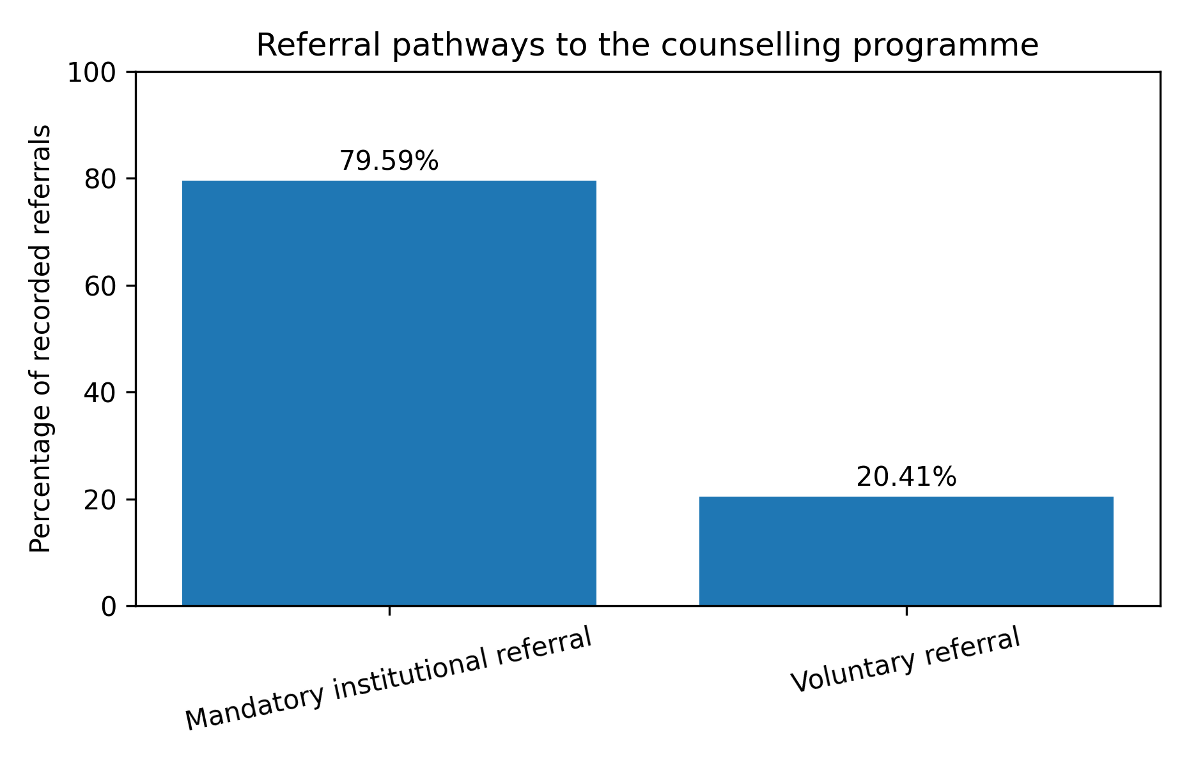
Figure 1. Referral pathways to the counselling programme.

3.2 Initial Motivation for Programme Entry
At programme entry, external motivations were the most frequent category. External reasons accounted for 56.00% of reported motivations, while internal motivations accounted for 30.00%. A smaller group, 14.00%, reported combined internal and external reasons. External motivations included court requirements, probation obligations, child protection involvement, family pressure, and the wish to avoid legal consequences.
Internal motivations included the desire to stop violent behaviour, improve the relationship with a partner or family members, become a better father, regulate emotions, and communicate without violence. Although internal motivation was less frequent at entry, its presence in nearly one third of responses indicates that some participants were already beginning to identify personal reasons for change before or at the start of the programme.
These findings can be interpreted through Self-Determination Theory. At entry, many participants appear to be located closer to controlled regulation, where behaviour is guided by external demands or sanctions (Deci & Ryan, 2000). However, the presence of internal motivation suggests that programme entry is not uniform. Some participants begin intervention with ambivalence, combining legal pressure with personal concern about the consequences of their behaviour.
Table 3. Motivation at programme entry
Motivation type | Frequency | Percentage
Internal motivation | 15 | 30.00%
External motivation | 28 | 56.00%
Combined motivation | 7 | 14.00%
Total | 50 | 100.00%
Note. Programme entry combines T0/T1 data from available responses.

3.3 Motivational Change During Programme Participation
The central finding of this study concerns the shift in motivation between programme entry and the middle phase of intervention. By T2, internal motivation increased to 47.06%, while external motivation decreased to 35.29%. Combined motivation also increased slightly to 17.65%. This pattern suggests a movement from externally regulated attendance toward more personally meaningful reasons for continued participation.
Participants increasingly reported motivations connected to responsibility and self-change. These included stopping abusive behaviour, improving family relationships, being more present and responsible as fathers, recognising the emotional impact of violence, and learning healthier communication skills. These changes are consistent with the idea that counselling can create opportunities for reflection, accountability, and movement along the continuum from controlled to autonomous motivation (Ryan & Deci, 2020).
From the perspective of the Transtheoretical Model, the shift may also indicate movement from precontemplation or early contemplation toward preparation and action. Participants who initially attended because they were required to do so may gradually become more capable of recognising the problem and identifying personal goals for change (Prochaska & DiClemente, 1983).
Table 4. Participant motivation across programme phases
Motivation type | Programme entry (T0/T1) | Middle phase (T2) | Direction of change
Internal motivation | 30.00% | 47.06% | Increase
External motivation | 56.00% | 35.29% | Decrease
Combined motivation | 14.00% | 17.65% | Slight increase
Note. Percentages are based on available responses at the relevant phase.

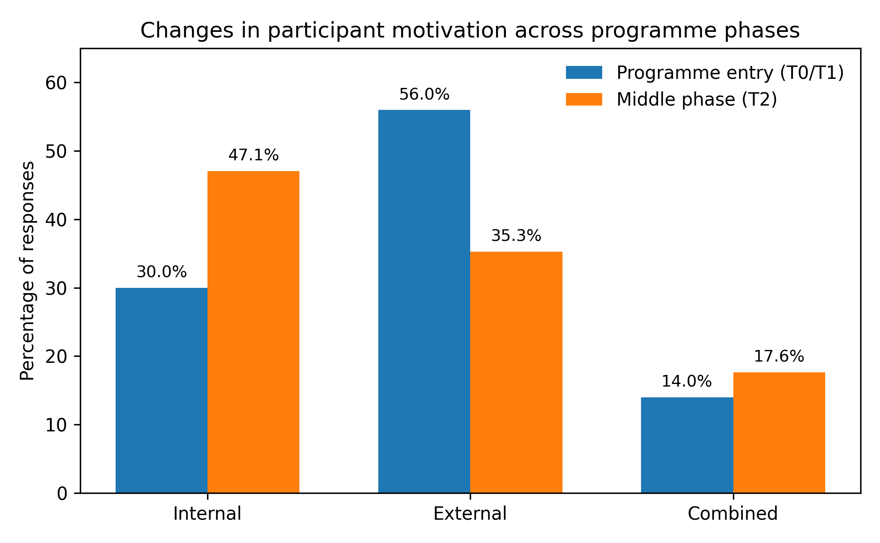
Figure 2. Changes in participant motivation across programme phases.

3.4 Motivation, Engagement, and Retention
The findings also point to the importance of motivation for engagement and retention. Participants who expressed internal reasons at T2 were more likely to describe self-reflective goals and future-oriented intentions. They referred to becoming more responsible, improving relationships, and learning to behave differently. By contrast, participants whose motivation remained primarily external tended to emphasise legal obligations, court expectations, or the need to complete requirements.
Although the available data do not allow causal testing between motivation and programme completion, the results are consistent with research suggesting that internally motivated participants are more likely to engage meaningfully in intervention (Murphy & Eckhardt, 2005). This does not imply that external pressure is unnecessary. In many cases, external pressure creates the initial condition that brings participants into contact with the programme. However, external pressure alone may not be sufficient for sustained change. The counselling process must support the internalisation of responsibility.
Retention remains a challenge in perpetrator programmes, and the available monitoring data show a decline in completed questionnaires across later assessment points. This pattern reflects a broader difficulty in the field. Participants may drop out because of employment demands, migration, reduced legal pressure, relationship separation, shame, resistance, or practical barriers. These factors show that engagement is shaped by both motivational and structural conditions.

3.5 Conceptual Interpretation of Motivational Progression
The motivational shift observed in the data can be represented as a gradual progression. Many participants appear to begin with external pressure and compliance. Through counselling, reflection, and confrontation with the consequences of their behaviour, some move toward accountability and internal responsibility. This does not occur automatically, and not all participants make the same transition. Nevertheless, the observed increase in internal motivation suggests that intervention can support this process.
Figure 3 presents a conceptual model of motivational progression derived from the study findings and informed by Self-Determination Theory, the Transtheoretical Model, and motivational interviewing. The model is not intended as a linear path followed by all participants, but as an interpretive framework for understanding how external pressure may become a starting point for more autonomous commitment to change.
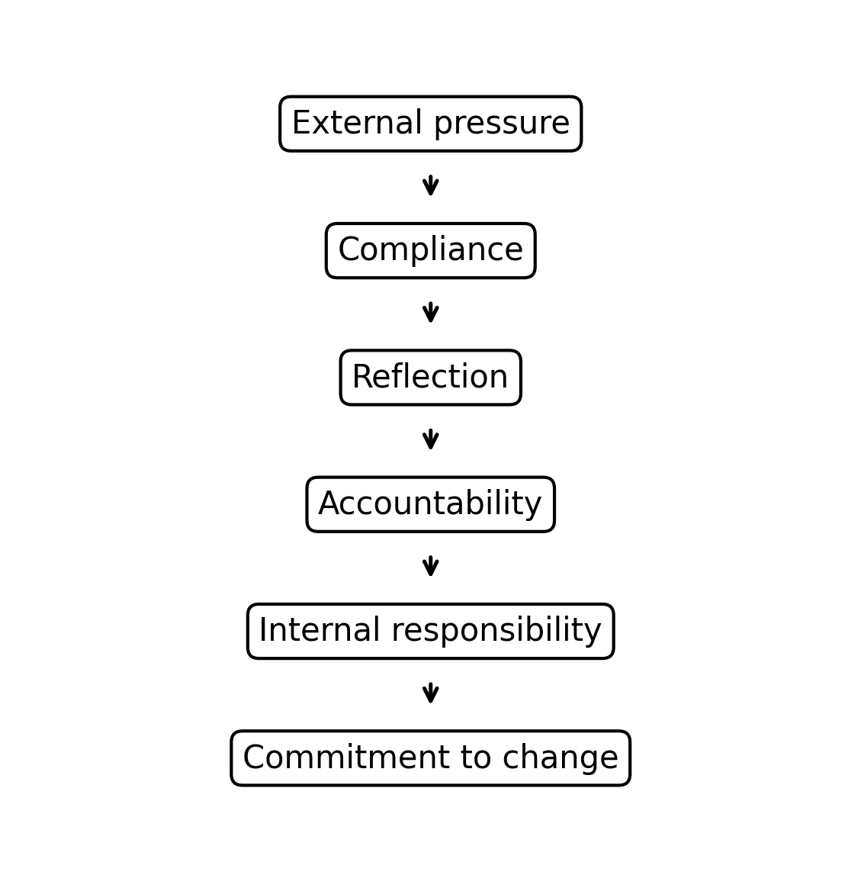
Figure 3. Conceptual model of motivational progression during counselling.

Table 5. Theoretical interpretation of motivational categories
Empirical category | Self-Determination Theory interpretation | Stages of Change interpretation
External motivation | Controlled regulation based on external pressure, sanctions, or obligations | Precontemplation or early contemplation
Combined motivation | Partial internalisation, where external demands coexist with personal concern | Contemplation or preparation
Internal motivation | More autonomous motivation linked to responsibility, values, and personal goals | Preparation or action
Note. The table provides an interpretive framework and does not imply that each participant follows the same pathway.

3.6 Implications for Counselling Practice
The findings have several implications for practice. First, practitioners should not assume that low internal motivation at intake means that intervention is impossible. Many participants may begin in a compliant or resistant position, but motivation can develop during counselling. This supports the use of structured motivational approaches that combine accountability with reflection and goal development.
Second, programme facilitators should assess motivation repeatedly, not only at intake. A participant's reasons for attending may change as he becomes more aware of the impact of violence and the expectations of non-violent relationships. Repeated assessment can help practitioners identify whether participants are moving toward responsibility or remaining in external compliance.
Third, mandatory referrals remain important. The findings do not support replacing legal pressure with purely voluntary participation. Rather, they suggest that institutional pressure can serve as an entry point, but counselling must transform compliance into commitment. This requires coordination between courts, probation services, police, municipalities, child protection structures, and specialised counselling providers.
Finally, motivational work must remain connected to victim safety. Encouraging internal motivation does not mean prioritising the participant's personal growth over the safety of partners, ex-partners, and children. Motivation should be developed within a framework of accountability, risk awareness, and coordinated monitoring (WWP EN, 2017).

4. Limitations
Several limitations should be considered. First, the study used a descriptive longitudinal design without a control group. Therefore, it cannot establish causal relationships between counselling participation and motivational change. The results should be interpreted as practice-based evidence rather than definitive proof of intervention effectiveness.
Second, the analysis relied on monitoring data collected during routine programme implementation. This increases ecological validity because the data reflect real-world practice, but it also limits the precision of measurement. Motivational categories were derived from participant responses and classified into internal, external, or combined categories. Although theoretically informed, this classification involves interpretive judgement.
Third, response numbers declined across later programme phases. The T2 motivational data are based on fewer responses than entry data, which limits the strength of comparison. Attrition is common in perpetrator programmes, but it remains an important methodological challenge.
Fourth, the study was conducted in Northern Albania within a specific organisational and institutional context. Findings may not be directly generalisable to other regions or countries. Cultural norms, legal practices, referral systems, and service availability may influence participant motivation and programme engagement.

5. Conclusion
This study examined motivational change among men participating in domestic violence counselling programmes implemented by ZDB in Northern Albania. The findings indicate that most participants initially entered the programme through mandatory institutional referrals and that external motivation dominated at programme entry. However, by the middle phase of intervention, internal motivation had increased and external motivation had decreased.
This pattern suggests that perpetrator counselling can support a transition from compliance with external requirements toward greater personal responsibility and commitment to change. The shift from external pressure to internal responsibility appears to be a meaningful process mechanism in domestic violence intervention. It may help explain why some participants engage more deeply with counselling and begin to develop non-violent alternatives.
The study contributes to the limited empirical literature on perpetrator programmes in Albania and the Western Balkans by focusing on motivation rather than only behavioural outcomes. It shows that the psychological processes underlying engagement deserve systematic attention. Future research should examine the relationship between motivation, programme completion, behavioural outcomes, and partner-reported safety using larger samples, mixed-methods designs, and follow-up data.
For practice and policy, the findings highlight the need to combine strong referral systems with counselling approaches that develop accountability, emotional awareness, and autonomous commitment to change. Mandatory referrals can bring men into the programme, but sustainable change requires more than attendance. It requires a movement from external pressure toward internal responsibility.

References
Ajdukovic, D., & Pauncz, A. (2015). How to start a perpetrator programme? Issues and dilemmas of the start-up process. Work With Perpetrators European Network.
Akoensi, T. D., Koehler, J. A., Loesel, F., & Humphreys, D. K. (2013). Domestic violence perpetrator programs in Europe, Part II: A systematic review of the state of evidence. International Journal of Offender Therapy and Comparative Criminology, 57(10), 1206-1225. https://doi.org/10.1177/0306624X12468110
Deci, E. L., & Ryan, R. M. (2000). The what and why of goal pursuits: Human needs and the self-determination of behavior. Psychological Inquiry, 11(4), 227-268. https://doi.org/10.1207/S15327965PLI1104_01
Gondolf, E. W. (2012). The future of batterer programs: Reassessing evidence-based practice. Northeastern University Press.
Heise, L. L. (1998). Violence against women: An integrated, ecological framework. Violence Against Women, 4(3), 262-290. https://doi.org/10.1177/1077801298004003002
Hester, M., Lilley, S.-J., O'Prey, L., & Budde, J. (2014). Overview and analysis of research studies evaluating European perpetrator programmes. IMPACT Project.
Jones, C. (2015). Implementing the IMPACT Toolkit (Part II). Work With Perpetrators European Network.
Kelly, L., & Westmarland, N. (2015). Domestic violence perpetrator programmes: Steps towards change. Project Mirabal final report. London Metropolitan University.
Miller, W. R., & Rollnick, S. (2013). Motivational interviewing: Helping people change (3rd ed.). Guilford Press.
Murphy, C. M., & Eckhardt, C. I. (2005). Treating the abusive partner: An individualized cognitive-behavioral approach. Guilford Press.
Prochaska, J. O., & DiClemente, C. C. (1983). Stages and processes of self-change in smoking: Toward an integrative model of change. Journal of Consulting and Clinical Psychology, 51(3), 390-395. https://doi.org/10.1037/0022-006X.51.3.390
Respect. (2017). The Respect standard for work with perpetrators of domestic abuse. Respect.
Ryan, R. M., & Deci, E. L. (2020). Intrinsic and extrinsic motivation from a self-determination theory perspective: Definitions, theory, practices, and future directions. Contemporary Educational Psychology, 61, Article 101860. https://doi.org/10.1016/j.cedpsych.2020.101860
Work With Perpetrators European Network. (2017). An update on implementing the Impact Toolkit: Working Paper 3. WWP EN.
World Health Organization. (2021). Violence against women prevalence estimates, 2018: Global, regional and national prevalence estimates for intimate partner violence against women and global and regional prevalence estimates for non-partner sexual violence against women. World Health Organization.

