“Evaluation of the Construction Delays of the 12-Storey Commercial Building of RFM Corporation in Panay Avenue, Diliman, Quezon City”

ABSTRACT
This research evaluates the primary causes and operational impacts of construction delays during the development of the 12-Storey Commercial Building of RFM Corporation in Diliman, Quezon City. Utilizing a quantitative, descriptive-evaluative design, the study gathered primary data from forty key project personnel, predominantly comprising laborers and skilled workers. The investigation systematically assessed four project variables—client administration, contractor execution, resource allocation, and external environmental conditions—to determine their specific influence on project timelines and overall financial performance.
​The findings establish that project disruptions are primarily driven by internal variables rather than external environmental factors. The most significant causes of schedule and cost overruns are frequent client-mandated design changes, severe shortages of skilled and unskilled labor, and contractor errors requiring rework. To optimize future high-density vertical construction timelines, the study recommends establishing stricter pre-qualification criteria for subcontractors and suppliers, alongside utilizing lean construction methodologies to minimize waste and optimize operational flow.
KEYWORDS

- construction delays, cost overruns, schedule extensions, delay mitigation, lean construction, high-density urban developments.

INTRODUCTION
The global construction industry frequently struggles with schedule overruns that disrupt project life cycles, inflate costs, and lead to complex contractual disputes. In the Philippines, this challenge is intensified by distinct systemic variables, such as urban traffic congestion, and complex technical processes. High-density urban zones like Diliman, Quezon City present further site-specific constraints, including limited staging areas for heavy equipment and strict zoning regulations. Despite advancements in modern scheduling software and lean construction methodologies, there remains a gap in evaluations of operational delays in congested mid-rise commercial developments.
This study addresses this gap by evaluating the primary causes and operational impacts of construction delays during the construction of the 12-Storey Commercial Building of RFM Corporation in Panay Avenue. The primary objective is to identify and categorize these delay factors—spanning client administration, contractor execution, resource allocation, and environmental constraints—to propose targeted mitigation frameworks that optimize timelines for future high-density vertical projects

METHODOLOGY
The researchers employed a quantitative approach utilizing a descriptive-evaluative design to measure and assess the impact of project delays on the RFM Project. The target population comprised key operational personnel directly involved in the RFM Corporation project site. Given the controlled environment of the project, complete enumeration was applied to select a sample of forty (40) respondents, which included project managers, site engineers, construction managers, supervisors, and skilled laborers.
​The primary instrument for data collection was a structured, expert-validated survey questionnaire. This tool utilized a five-point scale to precisely quantify the significance of various delay factors. The data gathering procedure was executed in three phases: securing formal endorsement from the RFM Corporation Project Manager, distributing the instrument directly to the workforce on-site, and retrieving the completed forms for auditing. For data processing and statistical treatment, the responses were organized and analyzed using Microsoft Excel, applying standard statistical tools including frequency distribution, percentage calculations, and weighted means to conclusively rank the most disruptive factors.

CONCLUSIONS/RECOMMENDATIONS

Demographic Profile of Respondents
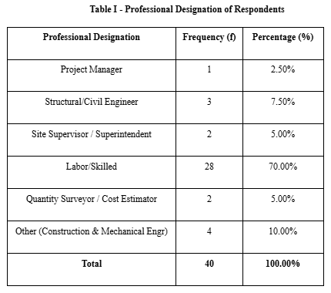
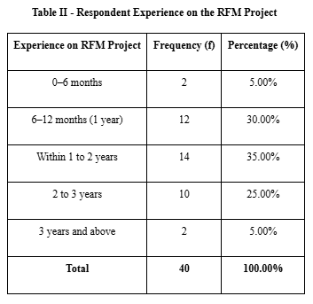
​The evaluation utilized a sample size of forty respondents directly involved in the RFM Project. The data indicates that laborers and skilled workers constituted the majority of the workforce at 70.00%, which aligns with standard personnel distribution in localized civil engineering and vertical construction. Furthermore, the largest segment of respondents (35.00%) has a tenure of one to two years at the construction of the RFM Project, ensuring the data reflects a grounded, operational understanding of the project's timeline and constraints. This can be seen in Tables I and II
​Primary Factors Contributing to Construction D\
Table IV - Frequency of Delay Factors
The interpretation of survey results categorized delay factors into client administration, contractor execution, resource allocation, and external conditions. The results reveal that "Frequent design changes as requested/instructed by the client" serves as the primary bottleneck, ranking first overall with a weighted mean of 4.25 ("All the Time"). Within resource allocation, the "Shortages of skilled or unskilled labor" ranked second globally with a 4.20 weighted mean.
Notably, contractor execution errors requiring structural rework ranked third, recording a 3.90 weighted mean. These findings establish that internal operational inefficiencies and client-mandated alterations disrupt project momentum far more significantly than external factors, such as changes in government regulations, which ranked lowest overall.

Impact on Schedule Extensions and Cost Overruns
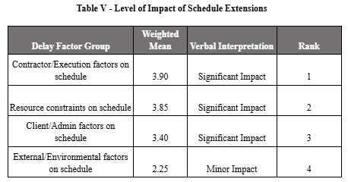
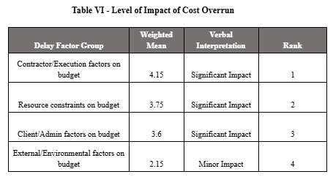
​When assessing the level of impact on project performance, internal operations represent the most critical risk. Contractor and execution factors ranked first in driving both schedule extensions (weighted mean of 3.90) and cost overruns (weighted mean of 4.15), both classified as having a "Significant Impact". Resource constraints and client administrative factors closely followed in severity.
Conversely, external and environmental variables—including the severe meteorological conditions frequently encountered in Philippine construction—were perceived as having only a "Minor Impact" on both time and budget. This reinforces that the observed delays are predominantly rooted in process and stakeholder management rather than environmental unpredictability. This is stated in Tables V and VI.

Proposed Mitigation Strategies
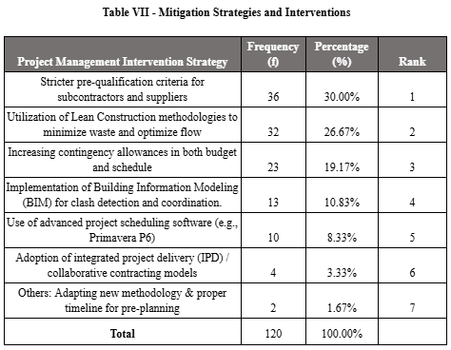
​Addressing operational vulnerabilities requires a transition from reactive fixes to proactive action. The favored mitigation strategy among the surveyed workforce is the implementation of "Stricter pre-qualification criteria for subcontractors and suppliers," capturing 30.00% of the total responses.
The "Utilization of Lean Construction methodologies to minimize waste and optimize flow" ranked second at 26.67%. This distribution demonstrates a strong preference for securing upfront stakeholder capability and streamlining physical workflow, rather than relying heavily on technological interventions like Building Information Modeling (BIM) or advanced scheduling software, which ranked significantly lower in practical preference.

REFERENCES

- Ashish, C. (2018). Non-Destructive Techniques for Evaluation and Health Monitoring of Concrete Structures- A Review. https://www(.)semanticscholar.org/paper/Non-Destructive-Techniques-for-Evaluation-and-of-A-Ashish/92ef514f7a6d44ec27287d77ce2989832fe18b20
- ​Ballard et al. (2007). Application of Lean principles in complex construction projects. https://iglc.net/Papers/Details/460
- ​Chua et al. (2003). Adoption of the Theory of Constraints within the construction context. https://ascelibrary.org/doi/10.1061/%28ASCE%290733-9364%282003%29129%3A3%28293%29
- ​Cruz, & Intal. (2022). Process Performance Improvement for an Elevator Construction Company. https://ieomsociety.org/proceedings/2022orlando/553.pdf
- ​Deng, & Smyth. (2013). Application of Contingency Theory to project management and construction firm performance. https://ascelibrary.org/doi/10.1061/%28ASCE%29CO.1943-7862.0000738
- ​Forcael et al. (2020). Workflow efficiency and mitigation of time overruns using Lean principles. https://www.mdpi.com/2079-8954/13/9/782
- ​Goldratt, E. M. (1984). The Goal. https://en.wikipedia.org/wiki/The_Goal_(novel
- ​Hanisch, & Wald. (2012). Context factors and Contingency Theory in mitigating project delays. https://www.researchgate.net/publication/257961127_A_Bibliometric_View_on_the_Use_of_Contingency_Theory_in_Project_Management_Research
- ​Jensen, M. C., & Meckling, W. H. (1976). Theory of the firm: Managerial behavior, agency costs and ownership structure. https://www.sciencedirect.com/science/article/pii/0304405X7690026X
- Koskela, L. (1992). Application of the new production philosophy to construction. https://iglc.net/Papers/Details/1
- ​Lau, & Kong. (2006). Project development as a production process under the Theory of Constraints. https://scholar.google.com/scholar?q=Lau+Kong+2006+Theory+of+Constraints
- ​Lawrence, P., & Lorsch, J. (1967). Organizational management and Contingency Theory. https://scholar.google.com/scholar?q=Lawrence+Lorsch+1967+Contingency+Theory
- ​Woodward, J. (1958). Contingency Theory in organizational frameworks. https://scholar.google.com/scholar?q=Woodward+1958+Contingency+Theory\
- ​Causes and Impacts of Delays in Ethiopian Public Construction Projects (Case on Debre Markos University Construction Projects). https://www.semanticscholar.org/paper/Causes-and-Impacts-of-Delays-in-Ethiopian-Public-on-Demissew-Abiy/5f60c181ae4be1f1eb78b9a5a5e9ee65a8918a1a
- ​Construction Worker Headcount System for Cost-efficient Planning to Residential Buildings in Pampanga, Philippines. https://www.researchgate.net/publication/357629490_Construction_Worker_Headcount_System_for_Cost-efficient_Planning_to_Residential_Buildings_in_Pampanga_Philippines
- Proposing solutions to reduce factors affecting the delay of construction phase in high-rise building projects. https://www.researchgate.net/publication/367058239_PROPOSING_SOLUTIONS_TO_REDUCE_FACTORS_AFFECTING_THE_DELAY_OF_CONSTRUCTION_PHASE_IN_HIGH-RISE_BUILDING_PROJECTS

ABOUT THE AUTHORS

Gillian Keith V. Espiritu is currently a student of Masters of Civil Engineering Major in Construction Technology and Management at Bulacan State University.

Kenny Dy M. Gallegos is currently a student of Masters of Civil Engineering Major in Construction Technology and Management at Bulacan State University.

John Daren M. Galvez is currently a student of Masters of Civil Engineering Major in Construction Technology and Management at Bulacan State University.

