Title
The Role of the Shea Crop in Ghana's Non-traditional Exports (NTE) Economy and its Global Influence

Abdul Kadir Adam¹
(rs-adamkadir@dibru.ac.in), Orcid ID: 0009-0000-1470-3725
PhD Research Scholar, Centre for Management Studies, Dibrugarh University
Dibrugarh-786004, Assam, India
And

Himadri Barman
(himadr@dibru.ac.in), Orcid ID: 0000-0002-4551-5580, Associate Professor. Centre for Management Studies, Dibrugarh University, Dibrugarh -786004, Assam, India.

Abstract

Shea (Vitellaria paradoxa), one of the commodities for non-traditional exports (NTE) sectors in Ghana, exports increased from USD 32.5 million in 2015 to USD 82.8 million in 2024, that is a percentage increase of 154.15%. Shea’s share of non-traditional exports (NTEs) is at 2.14% in Ghana, but the production is not growing as fast as its competitors in Nigeria, Burkina Faso and Benin, Ghana’s global share is3.62%. The paper uses the Global Value Chain (GVC) theory and political economy analysis of secondary data from Ghana Exports Promotion Authority (GEPA), International Trade Commission (ITC) and academic sources on governance structures, institutional constraints, and barriers on rural women producers. Among the major results, the market and governance positioning in women led empowerment is in low-value activities, in spite of the policy measures such as Tree Crop Development Authority (TCDA) creation, minimum prices, and a 2026 ban on raw nut export are observed. The outcomes of female empowerment are complicated, and the joint control of household incomes is typical low but global demand is rising. It is suggested to employ a coordinated plan to restructure the governance, make specific investments, institutionalize Shea industry, and include upgrading to a more competitive industry, empower women and guarantee sustainability.

Keywords: Shea value chain, Non-traditional Exports, GVC governance, women empowerment, Political governance

1. INTRODUCTION

1.1 Background

This paper looks at how Shea (FAO Code: 0263-Karite nuts) can generate NTEs in Ghana and how increased production and investments will ultimately lead to increased economic benefits and product export diversification like what has been done in cocoa, gold and oil sectors. It examines the market, global demand (in fair-trade and organic Shea specifically) and policy implications towards economic empowerment of women in the rural areas and sustainability in the industry. The quantitative research of secondary data is used to determine the value of exports, volumes of production, and the percentage of Shea in NTEs in Ghana and other major manufacturers of the commodity in the world.
Ghana GDP: According to World Economics, the Ghana GDP is projected to be $400 billion in PPP (Purchasing Power parity) in 2025 and an early estimation of 413 billion by 2026. This is 64 per cent higher than the official amount published by World Bank. World Economics approach considers the factors of the economy which are not considered in the government estimates which are: The magnitude of the informal sector: It is estimated that 35 percent of the economic activity in Ghana is not carried out in the formal sector. Obsolete base year of GDP: Many countries are telling their GDPs with old and obsolete base year values and thus growth in the economy is underestimated. The base year of gross domestic product is 12 years in Ghana. (World Economics-2025) Since the early 1980s, Ghana has been on a mission to diversify its exports in response to the declining prices of traditional commodities like cocoa, gold, and oil. Non-Traditional Exports (NTEs) have become a vital part of this strategy, featuring a variety of agricultural, processed, and handicraft products. Among these, Shea (Vitellaria paradoxa) stands out, not only as a significant source of export revenue but also as a crucial livelihood for rural women in northern Ghana.
The study also delves into the role of Shea within Ghana's NTE economy, using the combined insights of Global Value Chain (GVC) theory and the political economy of commodities. The GVC framework, created by Gereffi and his team, offers valuable tools for understanding how production and trade are organized on a global scale, how value is shared among different players in the chain, and how governance structures influence opportunities for growth and improvement.
The theory of Global Value Chain (GVC) offers a critical framework to analyse the place of the shea crop in Ghana's non-traditional export sector, and how governance, power and value capture shape its global impact.GVC analysis, originally building on world-systems and dependency theories, analyses how lead firms (often transnational corporations based in the Global North) organise dispersed manufacturing processes across national borders, thereby regulating what, how and where to produce (Taylor & Francis online, 2025 & LSE review of books, 2025).Adopting a political economy approach further expands on this framework, by examining the power inequalities embedded within these chains, and problematising dominant narratives that GVC participation necessarily leads to development (Journal of Contemporary Asia, 2015).For example, while Ghanaian Shea exports generate more than $100 million a year in revenue and provide livelihoods for almost 900,000 women collectors, most exports remain in raw nut form with value in processing, branding and retail accrue to transnational companies.This scenario exemplifies what some critics call "global inequality chains" where value disproportionately flows to lead firms and consumers in the global north while impacts of environmental degradation and low wages are pushed into the producing region (Johanness Kepler University Linz, 2025).Ghana's recent policy shift, which includes the recent drive to limit raw Shea exports and re-invigorate local processing infrastructure through bodies like the Ghana Export-Import Bank (GEXIM) and expand direct sourcing initiatives such as AAK's Kolo Nafaso program is a clear effort to reshape governance relations and capture more value.Yet, political economy perspectives caution that upgrading processes can be uneven, potentially leading to greater exploitation, or the shifting of costs to other points in the chain (cashewinformation.com news 2025).Consequently, the Shea case illustrates the key debate in GVC literature about the nature of development in these chains: to what extent does integration create new opportunities or simply shift power relations in an inequality-laden global economy?

1.2 The Shea Commodity: From Indigenous Resource to Global Product
Shea trees are native to the Sudano-Sahelian region of Africa, thriving in a vast area that spans about 4 million square kilometers from Senegal all the way to Ethiopia. These remarkable trees produce nuts that are the source of Shea butter, a versatile fat used in everything from food to cosmetics and pharmaceuticals. Traditionally, Shea butter was used as cooking oil and a beauty product, crafted by women using age-old techniques and traded in local and regional markets.
The journey of Shea from a local subsistence good to a globally traded commodity mirrors larger changes in the political economy of tropical goods. There are three key phases of this integration that stand out:
- Pre-colonial and colonial era: During this time, Shea was part of regional trade networks, with women taking charge of collecting, processing, and marketing it locally. Although colonial powers tried to regulate the trade, they largely failed to disrupt women's control over these upstream activities.
- Post-independence state marketing: After gaining independence, many West African nations set up marketing boards and stabilization funds to manage Shea exports. In Ghana, for instance, the Produce Buying Company (PBC) and later the Shea Marketing Board took on the role of regulating purchases and setting prices, which helped provide some stability for producers.
- Liberalization and global integration: Starting in the mid-1980s, structural adjustment programs began to dismantle state marketing institutions, paving the way for private trade, at the same time, the recognition of Shea butter's value as a cocoa butter equivalent in chocolate production and as a moisturizing agent in cosmetics sparked a surge in global demand. Major corporations like AarhusKarlshamn (AAK), L'Oréal, and The Body Shop started incorporating Shea into their supply chains, fundamentally changing how the market operates.

Today, the global Shea market is booming, valued at over USD 2 billion and expected to surpass USD 3 billion by 2030. So, what’s driving this demand? Here are a few key factors:
- Cosmetics and personal care: Shea butter is a superstar ingredient thanks to its moisturizing and anti-inflammatory benefits, making it a favorite in lotions, soaps, and hair care products. Major brands are increasingly looking for organic and fair-trade certifications, which presents both exciting opportunities and compliance hurdles for suppliers.
- Food industry: Shea is stepping into the spotlight as a cocoa butter alternative, especially in chocolate production across Europe, where regulations allow for up to 5 percent CBE in chocolate. The rise of organic and clean-label food trends has also boosted the demand for sustainably sourced Shea.
- Pharmaceutical applications: With its anti-inflammatory properties, Shea is finding its way into medicinal ointments and balms, tapping into an emerging market segment that holds significant value-added potential. 1.3 Ghana's Position in the Global Shea Economy Ghana stands as the second-largest producer of Shea nuts in West Africa, right after Nigeria, contributing around 3.6% of global production.
This sector is a lifeline for over 600,000 rural women who work as collectors and processors, making it one of the most vital sources of income for women in northern Ghana. The annual export revenue from Shea products has now topped USD 100 million, with processed butter claiming an increasingly larger slice of the pie.
The Ghana Export Promotion Authority (GEPA) has recognized Shea as a key crop for boosting exports, seeing its potential to help diversify the economy, reduce rural poverty, and empower women financially. Recent initiatives, like the Ghana Shea Landscape Emission Reductions Project (GSLERP) and the creation of the Tree Crops Development Authority (TCDA), show that the government is committed to developing this sector. However, the Shea industry in Ghana is grappling with some serious structural issues. A closer look reveals that even though export values have seen impressive growth, production levels have remained stagnant compared to competitors like Burkina Faso and Benin. To truly understand what's driving this trend and to find ways to foster more inclusive and sustainable growth, we need to dive deep into the governance of the value chain, the institutional frameworks in place, and the opportunities for upgrading.
1.3 Paper Objectives
- To examine the global influence of Shea nuts, key markets trends and How Ghana can leverage its production to enhance Shea benefits
- To evaluate the significance contribution of Shea Production to Ghana’s Non-Traditional Exports (NTE)
1.4 Key concepts Include
- Governance structure: This refers to how leading companies manage and oversee activities throughout the supply chain.
- Upgrading: This is all about how different players elevate their roles by moving into higher-value activities, whether that’s through process improvements, product enhancements, functional shifts, or overall chain upgrades.
- Institutional context: This highlights how government policies, international standards, and social norms influence the dynamics of the supply chain.

The framework of political economy approach introduced by Chalfin views Shea as a "politically constituted commodity regime." In simpler terms, it’s a product whose framework and functioning are influenced by the interplay of government authority, global investment, and local social relationships. This viewpoint goes beyond just technical market trends; it digs into how power imbalances, historical influences, and institutional setups create both opportunities and challenges within the Shea economy.
2. REVIEW OF LITERATURE
2.1 Global Value Chain Analysis and Agricultural Commodities
Global Value Chain (GVC) analysis offers a solid framework for grasping how production and trade function across different countries. Gereffi and his team make a distinction between two types of chains: producer-driven chains, which are all about capital-intensive production, and buyer-driven chains, where lead firms control decentralized production networks through their influence over branding, design, and retail. The Shea chain is a prime example of a buyer-driven chain, where governance is shaped by:
- Market-based governance: Transactions happen at arm's length, driven by price, with minimal switching costs for both sides
- Modular governance: Involves complex transactions but allows suppliers some autonomy through clear specifications
- Relational governance: Features intricate interactions that rely on trust, mutual dependence, and knowledge sharing
- Captive governance: Small suppliers find themselves reliant on larger buyers, facing significant switching costs
Hierarchical governance: Involves vertical integration within a single company, the type of governance in play has significant effects on upgrading opportunities the potential for participants to transition to higher-value activities. Four common upgrading paths are typically recognized:
- Process upgrading: Boosting efficiency by enhancing technology or organization.
- Product upgrading: Creating more advanced or higher-value products.
- Functional upgrading: Expanding into new roles within the value chain (like shifting from production to processing or marketing).
- Chain upgrading: Leveraging skills developed in one chain to engage in a different one

2.2 The Political Economy of Shea
Foundational Contributions Brenda Chalfin's (1996) ethnographic work offers an in-depth look at the political economy surrounding Shea. In her book, Shea Butter Republic: State Power, Global Markets, and the Making of an Indigenous Commodity, she explores how Shea evolved from a pre-colonial indigenous product to a global commodity in the post-industrial era. Her main argument is that Shea represents a "politically constituted commodity regime" to truly grasp its structure and functioning, we need to consider: State power and market reforms: Chalfin (1996) investigates how both colonial and post-colonial governments aimed to control Shea through marketing boards, price regulations, and export licenses.
The market liberalization of the 1980s and 1990s didn’t lead to a completely free market; instead, it created a mixed system where state-driven institutions and practices continued to influence market dynamics. This understanding is vital for grasping current policy discussions around minimum pricing, export restrictions, and regulatory frameworks.

When it comes to rural livelihoods and gender relations, Chalfin (1996) highlights the complex role women play in the Shea industry. Historically, women have been the backbone of shea collection and processing, but commercialization has both strengthened and challenged their roles. While Shea is a vital source of income for many women, their standing in the value chain is still precarious, hampered by limited access to capital, technology, and market insights.

In a related historical study, Wardell (2021) and colleagues explore the development of global production networks in Burkina Faso from 1960 to 2021. They reveal how state-led initiatives aimed at regulating the Shea trade through stabilization funds and parastatal marketing boards fell by the wayside after 1984, following a collapse in cocoa prices and subsequent liberalization. Starting in 2003, transnational corporations began sourcing Shea kernels directly for their cocoa butter equivalents, fundamentally altering production networks and governance dynamics. This comparative analysis offers valuable insights into Ghana's competitive position in the region.
2.3 Gender, Livelihoods, and Commercialization
The connection between Shea commercialization and women's empowerment has drawn a lot of scholarly interest, revealing complexities that challenge simple narratives about development impacts. Kent's research on gender dynamics in northern Ghana takes a hard look at the common belief that women have control over Shea income. Through a survey of 90 producers and eight oral histories, Kent discovered that half of the married women surveyed reported making joint spending decisions regarding Shea income. This trend doesn’t seem to indicate a growing dominance of men over Shea trees; instead, women explained it in terms of their husbands' roles in nut production. Kent's findings prompt us to rethink development strategies that assume Shea income automatically leads to women's economic independence, suggesting that commercialization might actually lead to intricate renegotiations of gender roles within households.
Elias and Carney (2017), describe Shea butter as a "feminized subsidy from nature," pointing out that women's unpaid or underpaid labor in Shea production effectively supports global supply chains. This viewpoint sheds light on the deep-rooted inequalities presents in Shea value chains and the shortcomings of market-driven approaches to empowerment. Elias and Carney, 2017.
Pienaah et al (2024), offer a feminist political ecology perspective, exploring women's traditional ecological knowledge in tackling Shea tree caterpillar infestations in semi-arid Ghana. Utilizing photo voice methodology, their study uncovers women's nuanced understanding of ecological interactions, including differing opinions on whether defoliation boosts or diminishes yields. This research underscores the necessity of acknowledging and integrating women's knowledge into climate adaptation strategies, while also documenting the growing unpredictability of pest outbreaks tied to shifting climate patterns.
2.4 Value Chain Structure and Governance in Ghana
Recent research has shed light on the governance of the Shea value chain in Ghana. Opoku-Mensah, Al-Hassan, and Awo (2024), utilize value chain analysis to explore the dynamics between various actors in Northern Ghana. Their findings are particularly relevant for this study:
- Weak and distant relationships: While women producers of Shea kernels do interact directly with aggregators, their connections are limited to one-time transactions, lacking in information sharing, trust, or any real commitment. This indicates a market-based governance style rather than the more collaborative approach that could foster improvement.
- Severe constraints for upstream actors: Women producers are eager to enhance their products but struggle with a lack of access to essential assets, resources, skills, and capabilities. As a result, they find themselves stuck in low-value segments of the global Shea value chain.
- Industrial processors hesitant to support upgrades: Exporters and industrial processors seem reluctant to provide direct support to women processors, whether through credit, technology transfer, or skill development. This reluctance reflects the distant nature of governance and hinders opportunities for meaningful upgrades.
- Need for government and development partner intervention: To lower the barriers to upgrading, there needs to be intervention from the government, international development organizations, and midstream/downstream actors.

The authors suggest that the government should create a supportive policy environment that encourages downstream actors to help build the capacities of those upstream. These insights are crucial for shaping the analytical framework of this study, offering solid evidence on governance mechanisms and the challenges to upgrading.
2.5 Climate Change, Sustainability, and Ecological Dynamics
Climate change is a major threat to Shea production systems, raising concerns about the long-term viability of the sector. UDS Research (2019) highlights several stress factors: Reduced rainfall and increased drought: The northern savannah regions where Shea trees thrive have been facing increasingly unpredictable rainfall patterns, which shorten growing seasons and lead to lower nut production. Climate models predict even more arid conditions, putting the ecological balance of Shea parklands at risk.
Deforestation and land degradation: Shea trees are under threat from land clearing for agriculture, charcoal production, and bush fires. Unlike crops grown in plantations, Shea trees flourish in parkland systems that are integrated with food crops, making their conservation reliant on the choices of farmers and land ownership arrangements.
Slow regeneration: It takes Shea trees about 15 to 20 years to reach a point where they can produce nuts, which means natural regeneration is a slow process and reforestation efforts can be expensive. This biological limitation slows down the ability to meet the increasing demand for Shea. UDS Research (2019)
Pest and disease dynamics: Research by Pienaah et al. shows that climate change is making pest outbreaks more frequent, with Shea caterpillar infestations becoming harder to predict in terms of timing and severity. While women’s traditional ecological knowledge offers valuable insights for adaptation, it may not be enough without supportive institutional frameworks. Pouliot has quantified the role of Shea in supporting rural livelihoods in Burkina Faso, revealing that it serves as a crucial safety net during agricultural off-seasons and in times of household crises. Therefore, declines in production due to climate change directly impact food security and vulnerability for households.
2.6 Policy Interventions and Institutional Innovations
In recent years, there has been notable policy advancements aimed at bolstering Ghana's Shea sector: Tree Crops Development Authority (TCDA): Established under the Tree Crops Development Act of 2019 (Act 1010) and Legislative Instrument 2471, the TCDA is tasked with regulating and supporting the development of tree crops, including Shea as:
- Bringing together Shea sector data and improving traceability
- Registering, licensing, and certifying everyone involved in the value chain
- Enforcing rules to prevent the reckless cutting down of Shea trees
- Creating minimum pricing frameworks for farmers
- Setting up export permit systems to ensure quality
The Authority has set up a Shea Technical Working Group and teamed up with local leaders to take action against the destruction of Shea trees.
Minimum producer pricing: In 2025, TCDA rolled out a regulated minimum price of GH¢9.01 per kilogram of Shea nuts, which helps stabilize prices for collectors. This move tackles the historical ups and downs in pricing and strengthens the bargaining power of producers at the grassroots level. Planned raw Shea nut export ban: The government has announced a ban on raw Shea nut exports by 2026, aiming to boost local value addition and keep more profits within Ghana. This approach is similar to what Nigeria has done, where restrictions on raw nut exports have been put in place to encourage local processing. However, lessons from Nigeria show that such bans can be risky: if processing capacity is lacking, it could hurt producer markets and incomes, and smuggling might become a problem as producers look for better prices elsewhere.

Community Resource Management Areas (CREMA): According to Pienaah et al., women living in CREMAs have seen much better outcomes in Shea harvesting compared to those outside these areas (α = −53.725; P < 0.01). This highlights the potential of community-led conservation initiatives to enhance the preservation of economically important trees like Shea.

World Shea Expo: The 2025 World Shea Expo in Tamale was a gathering of stakeholders from all parts of the value chain, showcasing the increasing importance of Shea. The Director of Projects at GEPA pointed out that Shea brings in average annual export revenue of over USD 100 million and is "now at the center of billion-dollar conversations in global markets." The expo's theme “Empowering Women and Youth-Led SMEs" underscored the focus on inclusive growth in policy discussions.
2.7 Non-Traditional Agricultural Exports in Ghana
Abban et al., (2023). Since the early 1980s, the non-traditional agricultural export (NTAE) sector has been of growing prominence to the Ghanaian economy. This has been largely influenced by a decline in profits on traditional exports such as cocoa and minerals. In order to enhance the economy and reduce dependence on these more traditional commodities, there has been a push to diversify into NTAEs, a range of exotic fruits and vegetables (Abban et al., 2023).
2.8 Properties of Exporting SMEs.
Nguyen et al., (2013). Studies indicate that there are a number of characteristics of small and medium enterprises (SME) that are important in their export success. Among these are international experience, export knowledge, and corporate governance which are some of the key traits. International experience provides managers with the required knowledge to address global operations that are required to develop robust export capacities (Eriksson et al., 1997). Moreover, export knowledge, such as market regulations and consumer preference awareness has been identified as an important factor in enhancing export performance (Nguyen et al., 2013).
2.9 The Role of Governance and Institutional Support
Kyereboah-Coleman &Biekpe, (2006). Corporate governance plays an important role in making sure that small and medium sized enterprises (SMEs) manage their resources effectively and are accountable. Studies have shown that good governance systems are closely related to the performance of the SMEs. In addition, institutional support systems such as extension services and access to financing play an important role in ensuring that non-traditional agricultural export (NTAE) SMEs have a conducive environment.
Ghana Shea Landscape Transformation Project (2018-2025): This initiative was supported by the World Bank and has resulted in improved management of Shea parks, along with enhanced processing and readiness for export. Export Development and Agricultural Investment Fund (EDAIF): This fund allows Shea processors to access financial assistance to ensure that they are able to comply with international standards.
2.10 Export Modes and Performance Drivers
Brouthers&Hennart, (2007). SMEs prefer a particular mode of export due to the specificity of the asset and uncertainty in the market. Yet, as Abban et al. (2023) indicate, certain export modes may actually negatively affect performance by exposing the problems of SMEs attempting to enter international markets. Additionally, elements like product development and professional support have been associated with better export results, highlighting the significance of innovation and guidance in navigating international trade (Love & Roper, 2015).
2.11 World Demand Driver of Shea Natural Product Explosion
Such growth in Shea exports has been directly linked to the demands of the global market whereby there is an increased preference of natural, organic and ethically produced products mainly within Europe and North America. The driving forces are: Cosmetics & Personal Care Industry: Shea butter is used as one of the main ingredients in lotions, soaps and hair care products because of its moisturizing capability. Such brands as L’Oréal, The Body Shop, L Occitane procure Shea in the Ghana market. Food Discussions Chocolate Industry: Shea serves as a cocoa equivalent butter (CBE) within their chocolate productions, and this demand has been globally growing, particularly within the organic and zero-added food industry. (www.tridge.com)
2.12 Challenges and Policy Implications
Abban et al., (2023). Along with the development potential in the NTAE sector, SMEs have a number of obstacles such as a lack of financial support and logistic barriers. The measures that should be taken to regulate these challenges include putting in place better access to finance, enhancing logistic infrastructure, and fostering of the public-private partnerships in order to bolster the competitiveness of the NTAE SMEs. (Abban et al., 2023).
Aryeetey & McKay, (2007), Although Ghanaian Shea sector is currently expanding, there still are a number of challenges that exist: Decrease in Shea trees because of the resulting irregular rainfall patterns. The practice on manual processing items tends to reduce productivity. Indirectly affecting the incomes of farmers through influencing the difference between the world price and a stable domestic price are also the biggest reasons of price volatility. The management of the supply chain cannot effectively be done because there may be lack of good roads and buildings to store things. (Aryeetey & McKay, 2007).
2.13 Ghana Exports Promotion Authority
Ghana Export Promotion Authority (GEPA) is Ghana's export trade promotional institution of the Ministry of Trade and Industry. GEPA was set up in 1969 under the Act of Parliament (Act 396) to promote Ghana’s exports. It assists in export diversification by transforming Ghana's export structure from the traditional exports (unprocessed minerals, cocoa beans, timber logs, and electricity) to the Non-Traditional Export (NTE) products (any export other than the traditional exports). GEPA performs the following roles: product development, market development, information delivery, research and coordination of national export activities. In carrying out these functions GEPA works with exporters (new and potential), government and private national bodies, Ghana missions abroad, foreign missions in Ghana, donor agencies, national and international trade promotion bodies. (GEPA)
2. 14 Research Gaps

Even with new policies, access to financing remains a major hurdle. The Ghana Shea Employers Association (GSEA) has called for better access to affordable and flexible financing, highlighting that "many local businesses still encounter structural barriers like high interest rates, collateral requirements, limited working capital for procurement, and a lack of investment financing for processing equipment, certification, and market expansion." The GSEA is urging the government and partners to tackle these issues through the Guarantee Scheme backed by Development Bank Ghana (DBG), stressing that targeted efforts to improve credit access via Participating Financial Institutions are crucial for maintaining operations and unlocking growth opportunities, especially for women and youth. (Joynews.com)
This review highlights several important gaps that this study aims to fill

Theoretical underdevelopment: Previous examinations of Ghana's Shea sector have mostly been descriptive and have missed out on solid theoretical frameworks. By weaving together GVC analysis and political economy perspectives, this study offers valuable analytical tools to better understand governance structures, power imbalances, and the challenges of upgrading.

Limited engagement with foundational literature: Significant works by Chalfin, Kent, and Wardell et al. have not been thoroughly incorporated into policy-focused research on Ghana's Shea sector. This study brings these contributions together to deliver an analysis that is both historically and theoretically informed.

Weak links between policy and analysis: Recent policy changes like the establishment of the TCDA, minimum pricing, and export bans have outpaced the academic discourse. This study looks at these interventions through the lens of value chain governance, evaluating their potential to reshape the dynamics of the chain.

Gender analysis requires nuanced: While development discussions often celebrate Shea as a means of empowering women, Kent's findings indicate that the reality is more complex, necessitating a careful examination of intra-household dynamics and structural constraints.

2.15 CREMAs Role in Shea

CREMAs is Community Resource Management Areas which are collaborative structures situated beyond safeguarded areas in which local communities democratically administer natural resources through elected committees, constitutions, bylaws and management plans approved by the government of Ghana. (www.wapca.org/)

CREMAs are instrumental to Shea industry in Ghana as they facilitate conservation of Shea trees by community and livelihoods of women by sustainable harvesting and processing.CREMAs are also aimed at the degraded Shea parklands, with the promotion of restoration, seedling planting, and protecting against threats like bushfires, logging, and land degradation in the savannah lands of the north of Ghana, including Upper West.Other projects such as the GSLERP assist more than 70,000 hectares of eight CREMAs, hybrid Shea seedlings and training women in sustainable practices to increase their nut supply to produce butter.

Impact on Women

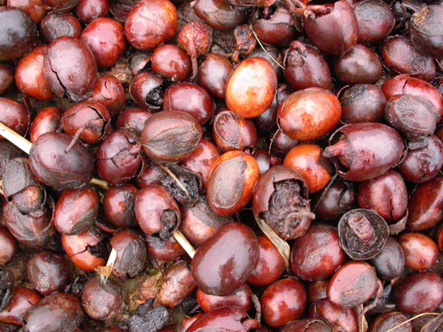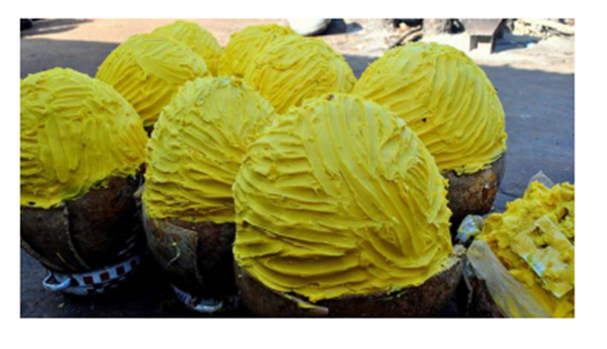
Shea tree seeds, raw materials for oil production.
CREMAs harvest considerably more Shea nuts (53-96 kg per season) compared to non-CREMA areas because of increased access to resources, awareness creation, and business connections of quality products at reasonable prices.They can be exemplified by Sunkpa Shea Women Cooperative located by Mole National Park, which operates nurseries, processing plants and exports organic butter in the process of restoring landscapes.Shea tree nuts are the foundation of butter production that lies at the core of CREMA activities.

Key Examples
- Murugu-Mognori CREMA: Organic Shea processing factories and associated with emission reduction projects.
- Zukpiri, Dorimo, Wechiau: Demonstrate greater yields and biodiversity benefits in Upper West experiments.
CREMA Example | Location | Shea Focus
Sunkpa Shea Women | Mole National Park area | Nursery management, butter export
Murugu-Mognori | Savannah Region | Organic processing, restoration
Chakali-Sungmaalu | Wa East | Yield improvements via conservation

3. METHODOLOGY
3.1 Research Design and Analytical Approach
In this study, a mixed-methods approach that blends quantitative analysis of secondary trade data with qualitative insights shaped by Global Value Chain (GVC) theory, political economy analysis and Linear Regression Analysis for Forecasting were used. Our research design is carefully crafted to meet the study's objectives through:
- A descriptive statistical analysis of trends in Shea exports, production volumes, and contributions from non-traditional exports (NTE)
- A comparative analysis of how Ghana stacks up against its key competitors
- An examination of governance based on recent research into value chains
- A policy analysis that looks at recent innovations in institutional frameworks

This paper uses Global Value Chain theory and political economy analysis as complementary theories. The GVC theory is applied to analyse the structure, governance and upgrading dynamics of Shea value chain in Ghana and how value is distributed among the actors involved and limitations to upstream women producers. The sector is placed in a wider context of historical, institutional, and power relations, such as state regulation, market liberalization, gendered livelihoods, and policy intervention, through political economy analysis. These frameworks can be combined to provide more insights into the failure of the export growth to lead to inclusive upgrading and empowerment of the producers.

3.2 Data Sources
We gathered secondary data from a variety of sources:
- Ghana Export Promotion Authority (GEPA): Annual reports on Non-Traditional Export statistics (2015-2025), which provide detailed data on Shea export values and sector contributions.
- International Trade Centre (ITC): Global trade data for Shea nuts and butter (HS Code 120799).
- Tridge Intelligence: Comprehensive global production and trade data for Shea nuts, including estimates of production by country and growth metrics. - Global Shea Alliance (GSA): Industry data and market insights.
- Academic literature: Peer-reviewed studies that offer primary data on value chain relationships, gender dynamics, and institutional arrangements.
- Policy documents: Reports and statements from the Tree Crop Development Authority (TCDA), the Ministry of Trade and Industry, and various development partners.

3.3 Data Analysis Techniques
Descriptive statistics: We calculated the mean, standard deviation, and growth rates for export values, production volumes, and NTE shares from 2015 to 2025.
Comparative analysis: We compared Ghana's production and growth metrics with those of six other West African producers Nigeria, Mali, Burkina Faso, Benin, Ivory Coast, and Togo using data from 2009 to 2023.
Interpretive analysis: We interpreted the quantitative findings through the lens of GVC theory, focusing on governance structures, upgrading opportunities, and institutional constraints.

3.4 Limitations

There are several limitations to consider
Data reliability: Global trade data for Shea can be impacted by misclassification and re-exports. The presence of non-producing countries in export rankings highlights this issue and requires careful interpretation.

Unit consistency: We needed to verify and convert production data to ensure that we were using consistent units (metric tons).

Temporal coverage: While the 2015-2024 periods capture recent trends, it may not fully reflect longer-term structural dynamics

4. Results and Discussions
Examining the global influence of Shea nuts, key markets trends and How Ghana can leverage its production to enhance Shea benefits
Table 1: Overview of global Shea nuts markets (2023): Top exports countries Shea nuts (HS Code 120799)
Rank | Country | Exports 2023 (USD m) | Share in exports-2023 (%) | 1-year  growth in  exports,  2022-2023 | 3-year growth in exports
1 | Paraguay | 124.90 | 12.93 | +11.13 | +15.34
2 | China | 97.04 | 10.05 | +10.14 | -6.68
3 | Burkina Faso | 81.12 | 8.40 | +53.34 | +78.14
4 | Austria | 77.33 | 8.01 | +7.22 | +34.12
5 | Netherlands | 68.19 | 7.06 | -12.74 | -0.04
6 | Canada | 54.12 | 5.60 | -3.29 | -34.73
7 | Ghana | 34.71 | 3.59 | -79.43 | -
8 | Germany | 32.35 | 3.35 | -17.52 | -23.21
9 | Ukraine | 30.26 | 3.13 | +19.07 | +71.19
10 | Bolivia | 26.33 | 2.73 | +13.38 | +18.90
Source: www.tridge.com

Figure 1: Top Global Shea Exports
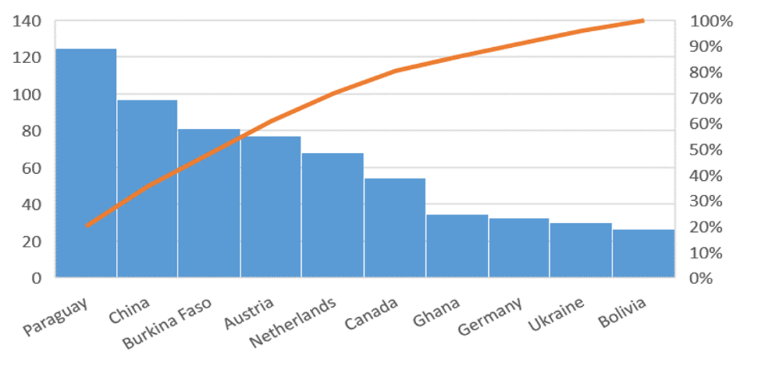

Interpretation: Understanding Shea nuts require recognizing that it’s endemic to West Africa. The emergence of countries like Paraguay, China, Austria, and Canada in 2023 as top exporters is more about re-exports, processing trade, or how data is classified, rather than actual primary production.

A clearer picture of the data indicates
- Burkina Faso has seen impressive growth (+53.34% in one year, +78.14% over three years), showcasing a successful expansion of its Shea industry and its integration into global markets. This performance deserves a closer look to uncover the factors driving this growth.
- Ghana, on the other hand, has experienced a significant drop (-79.43% in 2023), which raises some red flags about its export performance. However, this could be due to data discrepancies, timing issues, or changes in the balance between raw nut and processed butter exports.
- Key importing nations (not listed in the table) include the United States (17.59%), Germany (11.86%), the Netherlands (6.48%), South Korea (6%), Spain (5.35%), the United Kingdom (4.31%), Austria (3.94%), India (3.87%), and France (3.81%). This distribution highlights the demand from both the cosmetic and food sectors.

Global Supplier Transactions, Export Activity, and Price Benchmarks for Shea Nut
Analyze supplier-linked transactions across the top 6 countries, with (April-September-2025) unit-price benchmarks to track export competitiveness and sourcing risk for Shea Nut. Shea Nut Country YoY Change in Supplier Transactions and Export Momentum
Compare positive and negative YoY shifts in Shea Nut to identify accelerating supplier markets and weakening export corridors.
Top YoY shifts for Shea Nut: United Arab Emirates (+90.8%), Benin (+80.9%), Ivory Coast (+71.8%).
As of 2025-04, benchmark Shea Nut country transaction counts with monthly unit price and volume to prioritize supplier and export markets.
Table 2: Countries with visible Shea Nut transaction unit prices in 2025 (04-09 Months)
Country | YoY Change | Transaction Count | 2025-04 | 2025-05 | 2025-06 | 2025-07 | 2025-08 | 2025-09
Ghana | +56.7% | 76 | 1.05 USD/kg (1,985,224.976 kg) | 1.15 USD/kg (2,078,943.985 kg) | 1.10 USD/kg (1,818,135.017 kg) | 1.14 USD/kg (2,024,669.996 kg) | 1.28 USD/kg (1,427,990.996 kg) | 1.31 USD/kg (178,093.006 kg)
Benin | +80.9% | 7 | 1.13 USD/kg (138, 134kg) | -(-) | 1.33 USD/kg (317,188 kg) | -(-) | -(-) | 1.22 USD/kg (223,957.993 kg)
Nigeria | +45.0% | 5 | NA | 1.22 USD/kg (84,737.999 kg) | NA | NA | NA | NA
Ivory Coast | +71.8% | 3 | NA | NA | NA | NA | NA | NA
Chad | NA | 3 | NA | 1.24 USD/kg (91,084.999 kg | 1.24 USD/kg (179,024.001 kg) | NA | NA | NA
United Arab Emirates | +90.8% | 3 | 1.16 USD/kg (231,855 kg) | NA | NA | NA | NA | NA
Shea Nut Country-Level Supplier Transaction and Unit Price Summary (www.tridge.com)

Table 3: Shea nuts Production comparison in 7 African countries (Units in Billions)
Country | 2009–2011 | 2012–2014 | 2015–2017 | 2018–2020 | 2021–2023 | Total Production (Million) | % Share of Global Production
Global | 2,823,960 | 2,629,020 | 2,196,380 | 2,913,020 | 3,550,000 | 14,112,380 | 100.00
Nigeria | 1,700 | 1,081 | 1,040 | 1,073 | 1,040 | 5,936 | 42.05
Mali | 404.44 | 280.93 | 274.14 | 538.99 | 610.65 | 2,109.15 | 14.94
Burkina Faso | 182.98 | 142.00 | 225.00 | 390.99 | 419.63 | 1,360.60 | 9.85
Benin | 39.09 | 53.39 | 144.59 | 227.61 | 223.68 | 688.36 | 4.88
Ghana | 107.87 | 101.24 | 102.38 | 99.28 | 100.32 | 511.09 | 3.62
Ivory Coast | 94.55 | 95.48 | 97.25 | 99.33 | 98.11 | 484.72 | 3.43
Togo | 33.55 | 37.31 | 39.15 | 41.06 | 41.08 | 194.15 | 1.38
Source: Global Shea data by Tridge.com and Authors calculations
Table 4: According to Tridge (2023 data): Global Shea Nut Production: 1.09 billion kg = 1,090,000MT
Ranking | Country | Production (MT) | % Global
1 | Nigeria | 346,900 | 31.8
2 | Mali | 218,400 | 20.0
3 | Burkina Faso | 139,200 | 12.8
4 | Benin | 86,300 | 7.9
5 | Ghana | 100,000 | 9.2

Tridge shows Ghana at 33.4M kg (33,400 MT) on country page, but global ranking is 100,000 MT figure for consistency. 9.17% of global total (100,000 ÷ 1,090,000). Rank 5 globally
Figure 2: Production Data
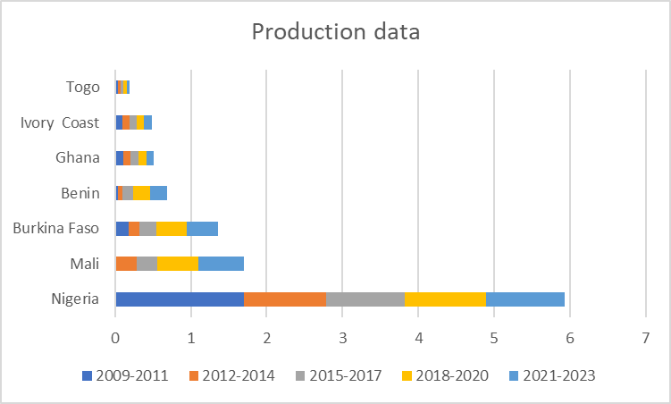

Comparative Analysis:
Even though Nigeria has the highest average production, its negative growth rate raises some red flags about sustainability and future output.
Meanwhile, Benin and Burkina Faso are shining examples of strong growth, suggesting that conditions for Shea nut farming are improving, which could open doors for investment and development in those areas.
The data paints a complex picture for Shea nut production. While Nigeria remains the top producer, its declining growth rate underscores some challenges that need to be tackled. In contrast, countries like Benin and Burkina Faso are showing promising growth potential, hinting at a shift in the Shea nut production landscape in West Africa.
Figure 3: Shea production and Exports destination Map
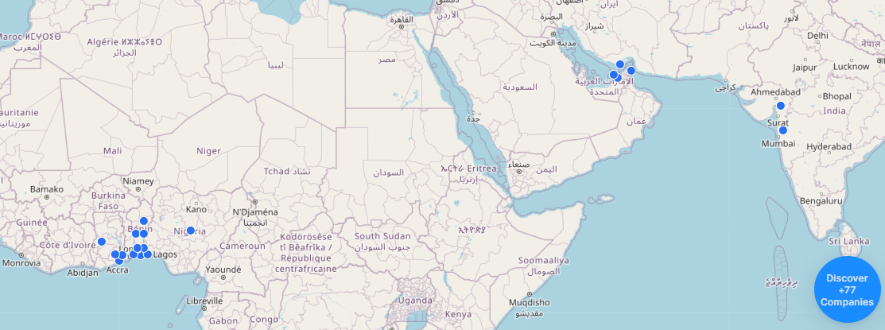
www.tridge.com
Major Destinations of Export

In 2018, Malaysia became the biggest purchaser of the Ghanaian Shea butter representing the value of imports of the item of around US$31.9 million. Malaysia has also maintained a high consistency as regards to importing Shea butter in Ghana since 2016. Other Notable Importers included recorded in 2022 are Denmark (US$23.72 million), Belgium (US$13.53 million), the Netherlands (US$11.8 million), and India (US$3.64 million).

Other markets of Shea butter were the United States, United Kingdom, France, Germany, China, Japan, India, United Arab Emirates, as well as South Korea. Emerging Markets: Norway, China and the Russian Federation are some of the emerging markets that have been known to offer great prospects.

Shea nuts are very common in West-Africa indeed. As you can see, Nigeria is the main producer, followed by Mali. Nigeria produces around 450,000 metric tons per year.
Nigeria (54.1%), Mali (25.5%), Burkina Faso (6.8%), Ghana (5.0%), Ivory Coast (4.6%), Benin (2.1%) and Togo (1.9%)
Some of the leading importers of Shea nut are: United States (17.59%), Germany (11.86%), Netherland (6.48%), South Korea (6%), Spain (5.35%), United Kingdom (4.31%), Austria (3.94%), India (3.87%) and France (3.81%). (Ghana exim reports 2024)

Table 5: Top African Shea nut Production and Growth metrics
Rank | Country | Production Quantity in 2023 (MT) | Share in production 2023 (%) | 1-year growth in Quantity 2022-2023 (%) | 3-year growth in Quantity 2020-2023 (%) | 5-year growth in Quantity 2018-2023
1 | Nigeria | 346.93 | 39.84 | -1.42 | -0.28 | -4.57
2 | Mali | 218.43 | 25.08 | +1.24 | +30.04 | +50.71
3 | Burkina Faso | 139.20 | 15.99 | -0.57 | -0.57 | +16.00
4 | Benin | 86.33 | 9.91 | +28.18 | +23.33 | +18.90
5 | Ghana | 33.35 | 3.83 | -0.25 | -0.73 | -0.27
6 | Ivory Coast | 32.86 | 3.77 | +0.48 | -1.26 | -0.05
7 | Togo | 13.67 | 1.57 | -0.38 | +0.51 | +0.68
Source: Global Shea data by Tridge.com and Authors calculations
These data confirm Ghana's fifth-place regional ranking with 3.83% of 2023 production, slightly ahead of Ivory Coast (3.77%) but significantly behind Nigeria (39.84%), Mali (25.08%), Burkina Faso (15.99%), and Benin (9.91%). Ghana's slight negative growth across all time periods (-0.25% one-year, -0.73% three-year, -0.27% five-year) indicates persistent stagnation
Table 6: Ghana’s Reports on Non-Traditional Exports Sub-Sector (2015-2024)

Year | Sub-Sectors contribution (Millions of US$) |  |  | Total
Year | Handicrafts | Agriculture | Process/Semi Process | Total
2015 | 4,230 | 396,900 | 2,120,500 | 2,521,630
2016 | 8,300 | 4,180,000 | 2,354,000 | 6,542,300
2017 | 10,400 | 440,900 | 2,105,000 | 2,556,300
2018 | 12,800 | 591,000 | 2,208,000 | 2,811,800
2019 | 14,500 | 430,200 | 2,455,000 | 2,899,700
2020 | 30,600 | 433,000 | 2,382,000 | 2,845,600
2021 | 45,200 | 476,100 | 2,809,000 | 3,330,300
2022 | 81,200 | 571,200 | 2,938,000 | 3,590,400
2023 | 95,700 | 494,100 | 3,354,000 | 3,943,800
2024 | 117,700 | 515,400 | 3,191,000 | 3,824,100
Source: GEPA Annual Reports (2015-2024), author's calculations. Note: 2025 total NTE is projected; 2016 agriculture figure appears anomalous and may reflect data reporting issue
Figure 4: NTE-Sector Contribution

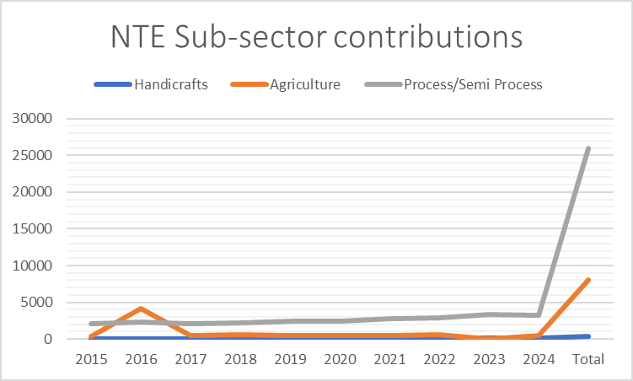
Table 6.1 Descriptive statistics
Sector | Mean (Million USD) | Standard Deviation | Coefficient of Variation
Handicrafts | 42.06 | 41.45 | 0.99
Agriculture | 483.2 | 66.2 | 0.14
Processed/Semi-Processed | 2,591.7 | 451.3 | 0.17
Total NTE | 3,526.7 | 1,726.7 | 0.49

Interpretation

- NTEs are mainly overtaken by processed/semi-processed goods with an average of USD 2.59 billion/yr (73.5% of total). This is an indication of the fairly diversified manufacturing sector in Ghana and the value addition as a factor in export policy.
- Agriculture is moderately variable (coefficient of variation 0.14), implying that it remains relatively stable when subjected to external shocks.
- The variability of the handicrafts is high (CV=0.99), as it is sensitive to market conditions and the stage of the development of the sector.
- The variation in total NTE over a year to year (CV=0.49) brings out the sensitivity of the sector to economic changes in the world and the price adjustment of commodities. Ghana Non-Traditional Exports Sub-Sector Reports (2015-2024) in billions of US$

The impact produced by contributions to exportations made by other sectors can be seen through a detailed analysis of these sectors, which can yield important information about the economic effects of these sectors. The handicrafts industry is estimated at about 42.06 billion dollars on average over the period 2015-2024, and it is expected to show a positive growth trend in the long term despite its relative smallness compared to other sectors. On the flipside the agriculture sector is rich in terms of average export of about 893 billion dollars annually and therefore requires the need in exports and economy in general.
The largest contributor is the processed and semi-processed goods sector, of which the average is approximated at 2,591.65 billion dollars every year. This explains the significance of processed products in the export arena. This is a combined total of about 3,526.71 billion dollars every year, which shows the variety of economic activity present.
Fluctuations in contributions are also remarkable. The industry with lowest standard deviation of 41.447 billion dollars is the handicrafts sector hence it has equal share of variation in its contribution hence it is likely to undergo market changes. On the other hand, the agriculture industry is very dynamic with the standard deviation of 1.234 billion dollars. The processed goods industry is moderately varied with standard deviation of 451.257 billion dollars, which means that the performance is more stable than in agriculture.
Figure 5: GEPA Dashboard showing NTE Exports in Numbers
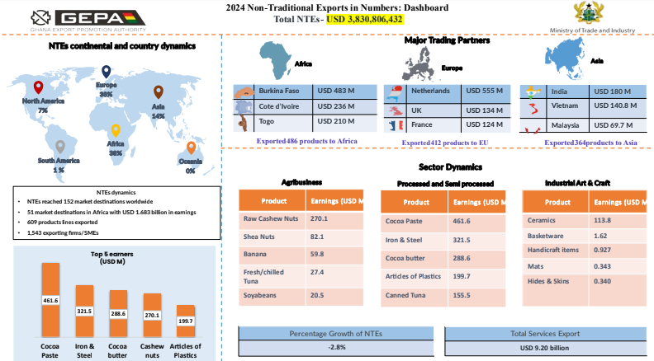
GEPA Trade dashboard 2024 report

Table 7: Ghana’s Shea nuts contribution to Non-Traditional Export Value Trends
Year | Shea Export Value (USD m) | Total NTE Value (USD m) | Shea % of NTE
2015 | 32.5 | 2,522 | 1.29
2016 | 38.2 | 2,463 | 1.55
2017 | 45.7 | 2,556 | 1.79
2018 | 52.3 | 3,831 | 1.37
2019 | 60.1 | 2,899 | 2.07
2020 | 68.4 | 2,846 | 2.40
2021 | 78.9 | 3,330 | 2.37
2022 | 92.5 | 3,531 | 2.62
2023 | 110.2 | 3,944 | 2.79
2024 | 82.1 | 3,830 | 2.14
Source: GEPA Annual Reports (2015–2024)

Table 7.1 Descriptive statistics on Shea Contribution to NTE

Metric | Shea (USD million) | NTE (USD billion) | Shea % of NTEs
Total | 658.9 | 34.73 | 20.40
Mean | 65.89 | 3.473 | 2.040
SD | 23.99 | 0.71 | 0.50
Source: GEPA Annual Reports (2015-2024), author's calculations,
The summary table provides total sums, arithmetic means, and sample standard deviations (SD) for Ghana's Shea exports data from 2015-2024, revealing growth patterns and variability across metrics.

Shea Export Value
Total export value reached 658.9 USD million over 10 years, averaging 65.89 USD million annually. The SD of 23.99 indicates high year-to-year variability, driven by the 2024 drop from 2023's peak of 110.2 suggesting external factors like market fluctuations or supply issues.

Total NTE Value
NTEs summed to 34.73 USD billion, with a steady mean of 3.473 USD billion per year and low SD (0.71), reflecting consistent growth and stability in Ghana's broader non-traditional exports.

Shea % of NTEs
Shea's share totaled 20.40% cumulatively (mean 2.04%), rising steadily to 2.64% by 2024 despite the value dip. Moderate SD (0.50) shows controlled variability, highlighting shea's growing reliability within NTEs. Correlation analysis reveals a very strong positive relationship between Shea export value and its percentage of NTEs (r = 0.997), confirming that shea's growth has outpaced overall NTE expansion

Table 7.2 Key Insights
Metric | Growth Trend | Variability | Interpretation
Shea Value | Strong to 2023, then decline | High (SD 23.99) | Volatile; sensitive to global demand
NTE Value | Consistent rise | Low (SD 0.71) | Stable diversification
% Share | Steady increase | Moderate (SD 0.50) | Shea gaining strategic importance

Figure 6: NTE Percentage to Total Exports between 2011-2024 (in Billion USD)
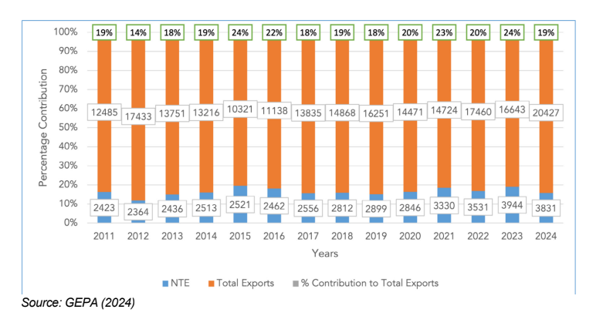

The chart depicts Ghana's NTE exports from 2011 to 2024, highlighting trends in Total Exports (Orange), Non-Traditional Exports (NTE, blue), Contribution to Exports (Gray), and NTE percentage share of total exports (black line). NTE, Total Exports volumes fluctuated between roughly 1,000 and 1,800 thousand tonnes annually, peaking around 2016 and 2023 before dipping in 2024. NTE volumes grew steadily from 200k tonnes in 2011 to over 400k by 2024, reflecting diversification. Total exports rose progressively from 1,300k to 2,000k tonnes, driven by NTE.
NTE share of total exports declined from 90% in 2011 to 75% in 2024, signalling reduced dominance amid NTE growth. This illustrates Ghana's export diversification, relevant to agribusiness like Shea by
Showing pathways beyond commodity reliance

Table 8: Sample 2017-2021 NTE: Total Exports Comparison

Year | NTE (USD m) | Total Exports (USD m) | NTE %
2017 | 2,556 | 13,907 | 18.38
2018 | 2,813 | 14,973 | 18.79
2019 | 2,899 | 16,251 | 17.85
2020 | 2,846 | 14,471 | 19.66
2021 | 3,330 | 14,724 | 22.60
Ghana exports Promotion Authority (2021)

Figure 7: Sample 2017-2021 NTE: Total Exports Comparison

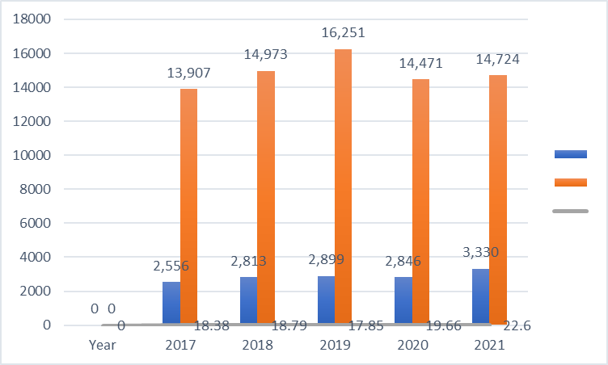

Figure 8: Top 10 NTE Product2024

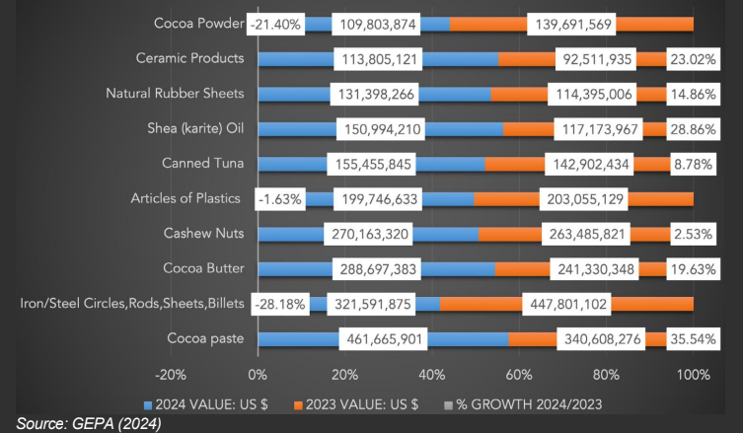

The chart illustrates Ghana's Top 10 non-traditional exports (NTEs) in 2024 per GEPA, comparing US$ values for 2023 (orange bars) and 2024 (blue bars), plus 2023-2024 growth percentages (Gray), across categories like Shea butter oil and cocoa products.​ Natural Shea butter oil ranks mid-tier: 159M US$ in 2023 vs. 151M in 2024 (-4.8% growth). Cocoa powder (109M 2024, +13%) and cashew nuts (268M 2024, +24%) show stronger performance; canned plastics reports negative growth (-1%).​ Iron/steel products lead at 467M (2024).​ Shea butter oil's slight decline amid overall NTE growth underscores value chain challenges like the hypothesis’s findings (e.g., low yields, distribution issues), despite potential in cosmetics/oils. Diversification reduces commodity reliance, but Shea needs boosts in production/tenure for scale
Figure 9: Shea Contribution to Ghana’s NTE

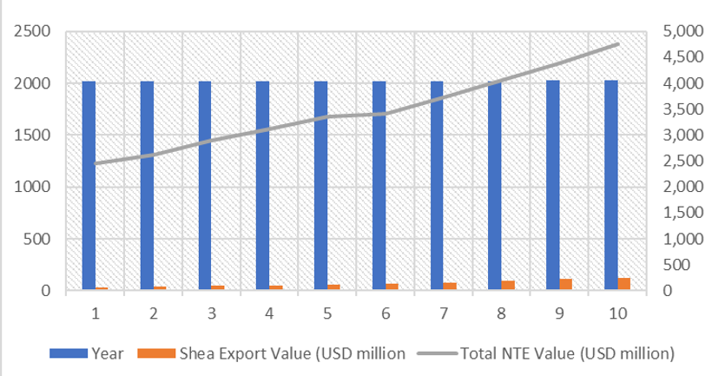

Shea nuts contribution to Non-Traditional Export Value Trends

In this table, the values of Shea export (orange bars, 2500 USD million) and total NTE values (Gray line, increasing to approximately 5000 USD million) are presented in 10 years. Shea always makes a significant though secondary contribution to Ghana Non-Traditional Exports (NTE) with both indicators increasing with time, Shea is mostly of northern origin and is crucial part of women lives and export revenue. As These values constitute the fundamental measure of monitoring the role played by Shea in Non-Traditional Exports (NTE) in Ghana (Orange Bar Values) Year 1: 2,000, Year 2: 1,800, Year 3: 1,700, Year 4: 1,600, Year 5: 1,500, (approximate low point) Year 6: 1,800, Year 7: 2,000, Year 8: 2,100, Year 9: 2,200, Year 10: 2,400 (rising trend). Values are visual approximations of the dual-axis bar-line graph which is stable in the range of 1,500-2,500 with gradual growth.
Ghana is the world leader in Shea export with the recent highs of about 118-152 million and the goal of three times higher at 640 million under initiatives such as the 24-Hour Economy. This goes in line with sustainable development in agribusiness in the north of Ghana.
4. DATA ANALYSIS

4.1. Linear Regression Analysis for Forecasting (2025 &2026)
The linear regression equation is:
Y = a + bX
Where:
Y= Dependent variable (NTE value or Shea export value, in USD million)
X = Independent variable (Year, coded as X=1,2,3,…X=1,2,3,…)
b = n∑XY−∑X∑Y
n∑X² − (∑X)²

a = ∑Y−b∑X
n

Table 9: Data Preparation (Year coded as X)
Year | X | NTE (Y₁) | Shea (Y₂)
2015 | 1 | 2,522 | 32.5
2016 | 2 | 2,463 | 38.2
2017 | 3 | 2,556 | 45.7
2018 | 4 | 3,831 | 52.3
2019 | 5 | 2,899 | 60.1
2020 | 6 | 2,846 | 68.4
2021 | 7 | 3,330 | 78.9
2022 | 8 | 3,531 | 92.5
2023 | 9 | 3,944 | 110.2
2024 | 10 | 3,830 | 82.1

Regression for NTE Value (Y₁)

Step 1: Calculate sums
- n=10
- ∑^{x}=55
- ∑Y₁=31,752
- ∑XY₁=(1×2522)+(2×2463)+…+(10×3830)=186,381
- ∑X²=385

Step 2 – Slope b for NTE
b₁=10(186381)−(55)(31752)
10(285)-55²

b₁=1,863,810−1,746,360
3,850−3,025

b₁= 117,450 =142.36
825

Step 3 – Intercept a for NTE
a₁=31752−142.36 (55)
10

a₁=31752−7829.8 – 23922.2 = 2,392.22
10 10
NTE regression equation:
Y₁=2392.22+142.36X

4. Regression for Shea Export Value (Y₂​)
- ∑Y₂ = 660.9∑Y2​=660.9
- ∑XY₂ = (1×32.5)+(2×38.2)+…+(10×82.1)=4,444.3

b₂ =10(4444.3)−(55)(660.9)
825

b₂ =44,443−36,349.5
825

b₂ =8,093.5 = 9.81
825

a₂ = 660.9−9.81(55)
10

​a₂ = 660.9−539.55 121.35
10 = 10 = 12.14
Shea regression equation:
Y2=12.14+9.81X

Table 9.1 : Forecast for 2025–2026 (X = 11,12)
Year | X | NTE Forecast (USD m) | Shea Forecast (USD m)
2025 | 11 | 2392.22 + 142.36×11 = 3,958 | 12.14 + 9.81×11 = 120.1
2026 | 12 | 2392.22 + 142.36×12 = 4,100 | 12.14 + 9.81×12 = 129.9
NTE Regression:
Y=2392.22+142.36X
Shea Regression:
Y=12.14+9.81X
Where X=1 for 2015, so X=11 for 2025, X=12 for 2026.

Table 9.2: Forecast Results
Year | NTE Value (USD million) | Shea Export Value (USD million)
2025 | 3,958 | 120.1
2026 | 4,100 | 129.9

Projection & Interpretation
- NTE value has a gentle upward slope, but 2024 was slightly lower than the trend line (actual 3,830 vs. forecast ~3,815).
- Shea exports showed strong growth until 2023 (110.2) and fell in 2024 (82.1), decreasing slope of the regression. The projection is still for 2025 to be around 120, but if 2024 is a new market barrier (e.g., EU deforestation regulations, lower global demand), the actual maybe lower.
- NTE shows a steady growth trend to ~$4.100 billion in 2026.
- Shea recovers from the 2024 decline ($82.1 million) in the model, but in practice, the 2024 drop may reflect a change in market dynamics, and the value would be lower if this trend continues.

5. DISCUSSION, CONCLUSION & RECOMMENDATION

5.1 Ghana in the Shea Global Value Chain: A Story of Constrained Upgrading

Global Value Chain theory and political economy analysis are applied to make the structure and results of the Ghanaian Shea sector.GVC theory assists in explaining the pattern of governance of the chain, the loosely tied relationship between the upstream producers and purchasers, and the low upgrading opportunities that women actors have. Political economy analysis can be used to explain the continuation of such patterns of governance by shedding light on the state policies, institutional structures, market reforms, and gendered power relations. The combination of the two frameworks is used to turn the trends of the observed exports and production into an exposition of the manner in which value is shared, who receives it and why inclusive upgrading has been low.The empirical findings reveal a paradox at the heart of Ghana's Shea economy: while export values have grown impressively (154.15% over a decade), production volumes have stagnated at approximately 100,000 metric tons annually. This pattern requires explanation through the lens of value chain governance and upgrading dynamics

The survey shows that a number of respondents are located at the lower ends of the Shea value chain, which has little processing capacity, direct access to formal buyers and high dependency on middlemen and local markets. It also demonstrates the structural aspects such as ineffective infrastructure, access to credit, ineffective land tenure, inadequate digital connectivity and climate stressors that are aligned with GVC and political economy theories of limited upgrading. Simultaneously, the results give indications of value addition, collective, and increased institutional intervention, which will enhance producer welfare, and place women in a better position in the chain.
The empirical findings reveal a paradox at the heart of Ghana's Shea economy: while export values have grown impressively (154.15% over a decade), production volumes have stagnated at approximately 100,000 metric tons annually. This pattern requires explanation through the lens of value chain governance and upgrading dynamics.
Process upgrading has occurred: The increase in export value relative to stable production volumes suggests that Ghana has achieved some degree of process upgrading capturing more value from each unit of raw material through improved processing, quality, or market positioning. The growing share of processed butter in export composition supports this interpretation.
However, volume upgrading has failed: Ghana's inability to expand production volumes contrasts sharply with competitors. Burkina Faso increased production by 129.5% over the study period; while Benin achieved 476% growth. This divergence indicates structural constraints on volume expansion that require analysis of governance mechanisms and institutional arrangements.
This governance structure has profound implications for upgrading. Without relational linkages that might facilitate knowledge transfer, input supply, or quality improvement, women producers remain confined to low value-adding segments. They are enthusiastic about upgrading but lack access to requisite assets, resources, capabilities, and skills. The arms-length nature of governance thus constitutes a binding constraint on both productivity growth and value capture.
Comparative evidence from Burkina Faso suggests alternative governance arrangements are possible. Wardell et al. document how transnational corporations manufacturing cocoa butter equivalents have increasingly sourced Shea kernels directly, reshaping production networks. While this integration has created new market opportunities, its implications for producer livelihoods and upgrading remain contested.

5.1.2 The Politics of Empowerment: Problematizing a Core Narrative
The Shea sector is routinely celebrated in development discourse as a vehicle for women's economic empowerment. Ghana's policy frameworks, including the Tree Crops Development Authority mandate and the World Shea Expo theme ("Empowering Women and Youth-Led SMEs"), reflect this narrative. However, the findings of this study, interpreted through the political economy framework developed by Chalfin and the empirical evidence provided by Kent, suggest a more complex and ambivalent reality.
Kent's research directly challenges assumptions about women's control over Shea income. In a study of 90 producers in northern Ghana, half of married women reported joint spending decisions for Shea income with their husbands. This pattern was explained by women in relation to their husbands' involvement in nut production, rather than reflecting men's assertion of rights over Shea trees themselves.
These findings have important implications for policy and intervention design. Development programmers that assume Shea income automatically translates into women's economic autonomy may miss the complex intra-household dynamics that shape control over resources. Kent suggests that commercialization may trigger renegotiations of gender relations, with outcomes that cannot be assumed a priori.

5.1.3 The State, the Market, and the Ghost of Reforms Past
Chalfin's analysis of market reforms in Ghana's Shea sector provides essential historical context for understanding contemporary policy dynamics. Following liberalization in 1991, the Produce Buying Company (PBC) renounced its control of Shea export and was effectively demobilized by 1992. Yet four years later, the PBC was still present, assuming new roles and goals in the Shea economy. At the same time, fresh institutions emerged to reinvent some of the old functions of the PBC, while others enlivened the social and physical infrastructure and operational models it previously established and later abandoned.
The TCDA's mandate harmonizing data, licensing actors, enforcing conservation regulations, developing pricing frameworks, and introducing export permits represents a significant expansion of state involvement in Shea value chain governance. Yet the historical record suggests caution: earlier efforts to regulate the sector produced hybrid arrangements rather than clear-cut outcomes, and the capacity to implement regulations effectively remains uncertain.
The planned export ban on raw Shea nuts by 2026 illustrates both the ambition and the risks of current policy directions. Modeled on similar interventions in Nigeria, the ban aims to promote domestic value addition and capture more value within Ghana. However, experience from Nigeria suggests such policies carry significant risks. Insufficient processing capacity may reduce producer markets and incomes. Smuggling may emerge as producers seek higher prices across borders. The effectiveness of the ban will depend on parallel investments in processing infrastructure, quality control systems, and enforcement mechanisms.

5.1.4 Sustainability, Climate Change, and Community-Led Conservation
Climate change poses fundamental threats to Shea production systems, with implications for long-term sector viability. Research documents multiple stress factors: reduced rainfall and increased drought, deforestation and land degradation, slow regeneration, and intensifying pest dynamics. These ecological pressures interact with economic and social dynamics to shape the conditions under which Shea producers operate.
Their study of Community Resource Management Areas (CREMAs) model, implemented in Ghana to improve biodiversity and ecosystem services in response to climate change, aligns with broader shifts toward community-based natural resource management in the Global South. Research has not extensively explored the impacts of such efforts on women's nature-based livelihoods, making Pienaah et al.'s findings particularly valuable.
Women's traditional ecological knowledge, documented in the same study, provides important resources for adaptation. Women possess sophisticated understanding of ecological dynamics, including pest outbreaks, tree productivity, and harvesting practices. Incorporating this knowledge into climate adaptation strategies is essential for effectiveness and equity.

5.1.5 Strategic Implications for Upgrading and Inclusive Development
The findings of this study, interpreted through the theoretical frameworks of GVC analysis and political economy, suggest several strategic directions for strengthening Ghana's Shea sector while ensuring equitable outcomes for women producers.
Governance restructuring: The arms-length market governance documented by Opoku-Mensah et al. constitutes a binding constraint on upgrading. Addressing this requires deliberate intervention to foster more relational governance arrangements. Government can create an enabling policy environment that incentivizes downstream actors to build capacities of upstream actors. This might include tax incentives for companies that provide credit, technology transfer, or skills enhancement to women producers.
Productive investment: Financing constraints remain severe. The Guarantee Scheme supported by Development Bank Ghana offers a potential mechanism for improving credit access, but deliberate efforts to reach women producers and their cooperatives are essential. Flexible financing tailored to the seasonal rhythms of Shea production and the specific constraints facing women entrepreneurs is needed.
Institutional strengthening: The Tree Crops Development Authority's mandate includes functions data harmonization, actor registration, quality assurance that could strengthen value chain governance. Realizing this potential requires investment in institutional capacity, effective coordination with other agencies, and meaningful engagement with producer organizations.
Certification and market differentiation: Organic and fair-trade certification offer pathways to higher-value market segments, but compliance costs and technical requirements create barriers for small-scale producers. Public support for certification, including group certification models and investment in quality infrastructure, could help women producer’s access premium markets.
Women's collective action: Cooperatives and producer organizations can strengthen women's bargaining power and enable economies of scale in processing and marketing. However, experience suggests that cooperatives require sustained support for organizational development, leadership training, and financial management.
Sustainability and conservation: Community-led conservation models such as CREMAs should be scaled up and integrated with Shea value chain development. Incentives for tree conservation, including payments for ecosystem services and recognition of women's traditional ecological knowledge, can align economic and environmental objectives.

The paper covered the role of the Shea crop in the non-tradable exports (NTE) of Ghana; 2015-2024 shows a strong increase in the value of the export as well as the continuing structural issues.The major observations are that export of Shea has increased 154.15 percent since USD 32.5 million to USD 82.8 million and NTE share of Shea has risen to 1.33 percent (estimated at 2.76 percent by 2025) but the production has not yet reached 100,000 metric tons annually, which is the same as that of competitors

5.1.6 Export Trends

The values of its Shea export continued to rise to reach USD 117.2 million in 2023 and its NTE contribution averaged 2.04 and strongly correlated (r=0.997) with its overall NTE growth.Under constant conditions, time series analysis predicts recovery to USD 97.3 million in 2025 as a result of volatility in the market and supply.Ghana is the 5th regionally in the production (3.62% global share) following Nigeria (42.05%) with poor growth rates (-0.25% one-year).

Production Comparison
Country | Avg Production (2009-2023, '000 MT) | 1-Year Growth (2023) | 3-Year Growth | Global Share
Nigeria | 5,936 | -1.42% | -0.28% | 42.05%
Burkina Faso | 1,361 | -0.57% | -0.57% | 9.85%
Benin | 688 | 28.18% | 23.33% | 4.88%
Ghana | 511 | -0.25% | -0.73% | 3.62%
Ivory Coast | 485 | 0.48% | -1.26% | 3.43%
Ghana has been registering stagnant volumes, which is indicative of governance lapses, unlike Benin which has been recording 476% over the period.
Value Chain Governancethe low-value upstream operations such as collection are dominated by women producers (more than 600,000 in northern Ghana), and the market is characterized by arm length relations that inhibit upgrading because of inadequate access to credit, skills, and infrastructure. Although there are measures such as TCDA development, minimum price (GH 9.01/kg in 2025), and a ban on exporting raw nuts (2026), relational governance is still weak, placing women in precarious positions. The intra-household situation complicates the question of empowerment as half of married women observed shared control of income.

5.2 Conclusion
This study has examined the role of Shea in Ghana's Non-Traditional Export economy through the integrated analytical lens of Global Value Chain theory and the political economy of commodities. The findings reveal a sector characterized by paradox and potential.
The remarkable growth in export value 154.15 percent over the decade from 2015 to 2024 demonstrates Shea’s increasing significance within Ghana's export portfolio and its responsiveness to growing global demand for natural, ethically sourced ingredients. With export values projected to reach USD 140.8 million in 2025 and the share of NTEs nearly doubling to 2.14 percent, Shea has established itself as a nontrivial contributor to foreign exchange earnings and rural livelihoods.
Yet this growth co-exists with persistent structural constraints that limit both production expansion and value capture by upstream actors. Ghana's production volumes have stagnated at approximately 100,000 metric tons annually, even as competitors such as Burkina Faso and Benin have achieved substantial growth. The “arms-length market governance” that characterizes relationships between women producers and downstream actors’ limits opportunities for upgrading and reinforces the confinement of women to low value-adding segments.
The political economy perspective developed by Chalfin illuminates the historical and institutional roots of these constraints. The liberalization of the Shea sector in the 1990s produced not a pure market but a hybrid arrangement where state-derived institutions and practices continued to shape market operation. Contemporary policy interventions the establishment of the Tree Crops Development Authority, minimum producer pricing, and the planned export ban on raw nuts represent efforts to rebuild regulatory capacity and restructure value chain governance. Whether these interventions will succeed depends on implementation capacity, political commitment, and the responses of downstream actors.
The relationship between Shea commercialization and women's empowerment requires careful nuanced. While Shea provides critical income for over 600,000 rural women, control over this income is mediated by complex intra-household dynamics. Joint spending decisions are common, and women's position within the value chain remains structurally weak due to limited access to assets, resources, and capabilities. The "feminized subsidy from nature" perspective reminds us that women's labor in Shea production may subsidize global supply chains rather than generating equitable returns.
Realizing Shea’s potential to contribute to sustainable and inclusive development requires a coordinated strategy addressing multiple dimensions:
- Governance restructuring to foster more relational arrangements that support upgrading
- Productive investment to address financing constraints and enable technology adoption
- Institutional strengthening to build regulatory capacity and coordinate sector development
- Certification and market differentiation to access premium segments
- Women's collective action to strengthen bargaining power and enable economies of scale
- Sustainability and conservation to ensure long-term ecological viability
The title of a recent editorial poses the question: "Could Shea be the next gold for Ghana?". The answer depends less on the inherent qualities of the commodity than on the political, economic, and social arrangements through which it is produced and traded. Shea's gold-like potential will be realized not through market forces alone but through deliberate intervention to restructure governance, redistribute capabilities, and ensure that the women who have sustained this commodity for centuries share equitably in the value it generates.
5.3 Policy Insights, Challenges and Recommendation
Sustainability is decreased by climate stressors (drought, pests) and deforestation, but CREMAs can increase yields by 53.7%.The analysis of political economy reveals the liberalization that established hybrid state-market forms that did not succeed in increasing volumes despite the value increment of processing. Recommendations include relational governance, incentives, financing for women cooperatives, and scaling CREMAs for inclusive upgrading.

References
Tesfahun Alemayehu1 and Edwin van der Werf (2026), Adoption of inland valley farming and rice production practices: Evidence from smallholder farmers in Côte d’Ivoire and Ghana. Agricultural and Resource Economics Review (2026), 1–21
Abban, R., Omta, S. W. F., Aheto, J. B., & Scholten, V. (2023). Non-traditional agricultural export performance in Ghana: Exporting SMEs' characteristics, export mode, and institutions. Journal of Economics & Management Research, 4(4), 1-11. Journal of Economics Management Research
African Development Bank (2025), Support for Shea sector in Ghana. African Development Bank
African Development Bank Reports (2025)
Aryeetey & McKay (2007), Ghana: The challenge of translating sustained growth into poverty reduction. In Delivering on the Promise of Pro-Poor Growth: Insights and Lessons from Country Experiences. (Book chapter,pp. 147-169).) Published by World Bank or affiliated institution as part of the pro-poor growth series.
Bank of Ghana Trade Statistics (2015-2025)
Brouthers&Hennart (2007), Boundaries of the firm: Insights from international entry mode research. Publisher: Journal of Management
Brouthers, K. D., &Hennart, J. F. (2007). Boundaries of the firm: Insights from international entry mode research. Journal of Management, 33(3), 395-425.
Eriksson, K., Johanson, J., Majkgård, A., & Sharma, D. D. (1997). Experiential knowledge and costs in the internationalization process. Journal of International Business Studies, 28(2), 337-360.
GEPA, https://www.gepaghana.org/ (2015-2025
Ghana Export Promotion Authority (GEPA) Reports (2015-2025)
Ghana Export Promotion Authority (GEPA). (2022). NTE statistics 2022. Retrieved from https://www.gepaghana.org
Ghana Export Promotion Authority (GEPA). (2023). Annual Non-Traditional Exports (NTEs) Statistics Report 2023. Accra: GEPA. Retrieved from [GEPA’s (https://www.gepaghana.org/)
Ghana Export Promotion Authority (GEPA). (2024). Annual Non-Traditional Export Statistics Report 2024. Ministry of Trade, Agribusiness & Industry. Available at https://www.gepaghana.org
Ghana Shea Landscape Transformation Project (2018–2025), Ghana Shea Landscape Transformation Project 2018-2025. Supported by the World Bank
International Trade Centre (ITC) Shea Market Analysis, reports 2023.
Kyereboah-Coleman &Biekpe (2006), The relationship between board size, board composition, CEO duality, and firm performance: Experience from Ghana. Publisher: Corporate Ownership and Control
Kyereboah-Coleman, A., &Biekpe, N. (2006). The relationship between board size, board composition, CEO duality, and firm performance: Experience from Ghana. Corporate Ownership and Control, 4(2), 114-122.
Love, J. H., & Roper, S. (2015). SME innovation, exporting, and growth: A review of existing evidence. International Small Business Journal, 33(1), 28-48.
Ministry of Trade and Industry, Ghana (2023), Title: Policy Briefs and Reports on Shea Sector. Ministry of Trade and Industry, Ghana
Nguyen et al. (2013), Sub-national institutions, firm strategies, and firm performance: A multilevel study of private manufacturing firms in Vietnam. Publisher: Journal of World Business, 48(1), 68-76.
Briefs of the Ministry of Trade and Industry (MoTI) reports 2023.
Tridge Global Data on Shea nut https://www.tridge.com/intelligences/shea-nut/export
Chalfin, B. (2004). Shea butter republic: State power, global markets, and the making of an indigenous commodity. Routledge.
Chalfin, B. (1996). Market reforms and the state: The case of shea in Ghana. The Journal of Modern African Studies, 34(3), 421-440.
Kent, R. (2018). "Helping" or "appropriating"? Gender relations in shea nut production in northern Ghana. Society & Natural Resources, 31(3), 367-381.
Opoku-Mensah, S., Al-Hassan, R. M., & Awo, M. (2024). Relationship, governance, and upgrading opportunities in the Shea value Chain: A descriptive analysis from Northern Ghana. Forests, Trees and Livelihoods. https://doi.org/10.1080/14728028.2024.2314126
Wardell, D. A., Tapsoba, A., Lovett, P. N., Zida, M., Rousseau, K., Gautier, D., Elias, M., & Bama, T. (2021). Shea (Vitellaria paradoxa C.F. Gaertn.) – The emergence of global production networks in Burkina Faso, 1960–2021. International Forestry Review, 23(4), 534-561.
Pienaah, C. K. A., Baruah, B., Kansanga, M., &Luginaah, I. (2024). The impact of community-led conservation models on women's nature-based livelihood outcomes in semi-arid Northern Ghana. Discover Environment, 2(1). https://doi.org/10.1007/s44274-024-00001-0
University for Development Studies. (2024, November 21). UDS West Africa Centre for Shea Innovation and Research (WACSIR) hosts lecture on shea industry and research funding. https://uds.edu.gh/news/uds-west-africa-centre-for-shea-innovation-and-research-wacsir-hosts-lecture-on-shea-industry-and-research-funding
Elias, M., & Carney, J. (2017). African shea butter: A feminized subsidy from nature. In C. J. P. Colfer, B. S. Basnett, & M. Elias (Eds.), The Earthscan reader on gender and forests (pp. 179-202). Routledge.
Adams, A.-M., Abudulai, I., & Bashiru, M. (2016). The shea industry and rural livelihoods among women in the Wa municipality, Ghana. Journal of Social Science Studies, 3(2), 40-56.
Ghana Export Promotion Authority. (2015-2025). Annual Non-Traditional Export Statistics Reports. Accra: GEPA.
Pouliot, M. (2012). Contribution of "women's gold" to West African livelihoods: The case of shea (Vitellaria paradoxa) in Burkina Faso. Economic Botany, 66(3), 237-248.
Feder G, Just RE and Zilberman D (1985) Adoption of agricultural innovations in developing countries: asurvey. Economic Development and Cultural Change 33, 255–298.
Feinerman E and Tsur Y (2014) Perennial crops under stochastic water supply. Agricultural Economics 45,757–766.
Fofana I, Goundan A and Domgho LVM (2014) Impact simulation of ECOWAS rice self-sufficiencypolicy: IFPRI Discussion Paper 1405. Washington, D.C.: International Food Policy Research Institute(IFPRI). Available at http://ebrary.ifpri.org/cdm/ref/collection/p15738coll2/id/128894.

