Mapping Review on AI, Employee Experience, and Work Performance: A Bibliometric Analysis
Abstract
This bibliometric review examines the evolving relationship between artificial intelligence (AI), employee experience (EX), and work performance (WP) in organisational contexts from 2000 to 2025. As AI continues to transform human resource management practices, increasing scholarly attention has been directed toward understanding its impact on employee-centric outcomes and organisational effectiveness. The study analyses 373 peer-reviewed articles indexed in the Web of Science database, selected through the PRISMA screening process. Bibliometric and science mapping techniques were employed using Biblioshiny and VOSviewer to evaluate publication trends, leading authors and institutions, geographic contributions, keyword co-occurrence, and collaboration networks. The findings reveal a significant surge in research output after 2020, indicating heightened academic and practical interest in AI-driven HRM. Key themes identified include AI-enabled decision-making, employee engagement, performance enhancement, and organisational productivity. More recent studies increasingly focus on ethical considerations, transparency, employee well-being, and inclusivity in AI applications. This study offers a novel contribution by integrating AI, employee experience, and work performance into a single analytical framework, an area that has received limited systematic exploration. By mapping thematic evolution over 25 years, it highlights a clear shift toward human-centred and sustainability-oriented perspectives in AI research. Additionally, the study uncovers collaboration patterns and conceptual developments, providing valuable insights for future research directions in the field.
Keywords: Artificial Intelligence (AI), Employee Experience (EX), Work Performance (WP), Human Resource Management (HRM), Bibliometric Review.

1. Introduction
The contemporary workplace is undergoing a profound transformation driven by rapid advances in Artificial Intelligence (AI), which are reshaping how work is designed, performed, and evaluated across organisational contexts (Tambe et al., 2019). Unlike earlier waves of digitalisation that focused primarily on automation and efficiency, AI technologies increasingly interact with human judgment, decision-making, and emotional labour, thereby influencing the very experience of work itself (Budhwar et al., 2023). As organisations adopt machine learning, people analytics, and generative AI tools, employees are no longer passive recipients of technology but active participants in human-machine systems that redefine roles and expectations (Bessen, 2019).
This shift has elevated employee experience from a peripheral concern to a strategic priority, particularly in technology-intensive work environments (Malik et al., 2023). Employee experience reflects how individuals perceive, interpret, and emotionally respond to their interactions with organisational systems, including AI-enabled processes (Braganza et al., 2021). When AI systems are integrated into performance management, recruitment, or workflow coordination, they shape not only outcomes but also employees’ sense of fairness, autonomy, and trust (Hughes et al., 2019). These experiential dimensions are increasingly recognised as critical determinants of sustainable work performance in AI-mediated contexts (Cheng et al., 2022).
At the same time, work performance remains a central organisational concern driving AI adoption, as firms seek to enhance productivity, accuracy, and decision quality (Ramachandran et al., 2022). Empirical studies suggest that AI can support employees by automating routine tasks and providing data-driven insights, thereby enhancing performance at both individual and team levels (Tong et al., 2021). However, performance gains are neither automatic nor uniform; they depend heavily on how employees perceive and adapt to AI systems within their work environment (Man Tang et al., 2022).
1.1 Theoretical Perspectives Informing the Nexus
Several theoretical lenses help explain the complex relationship between AI, employee experience, and performance. Complementarity theory emphasises that AI contributes positively to performance when it aligns with human skills and task requirements, reinforcing employees’ sense of usefulness and competence (Man Tang et al., 2022). Role theory further explains how AI alters role expectations and responsibilities, influencing role clarity and emotional responses at work (Arslan et al., 2022).
Psychological contract theory highlights how AI adoption reshapes perceived obligations between employees and organisations, affecting trust, commitment, and engagement (Braganza et al., 2021). From a socio-technical systems perspective, AI outcomes are understood as products of interaction between technology, organisational structures, and human agency rather than technology alone (Bag et al., 2021).
1.2 Insights from Prior Research
Existing research on artificial intelligence and work performance has largely emphasised efficiency, productivity, and task optimisation, presenting AI as a tool that augments human capability and improves decision quality (Dixon et al., 2021; Tong et al., 2021). While these studies demonstrate measurable performance gains, they also indicate that outcomes depend on how AI systems are introduced and perceived by employees, particularly in contexts where transparency and autonomy are limited (Cheng et al., 2022).
In parallel, research on employee experience highlights the emotional and psychological implications of AI adoption, documenting both positive outcomes, such as enhanced engagement and negative responses, including anxiety, burnout, and perceptions of surveillance (Kong et al., 2021; Giermindl et al., 2022). Comparative evidence increasingly suggests that employee experience mediates the relationship between AI adoption and work performance, yet prior reviews often examine these dynamics in isolation, limiting theoretical integration and cumulative insight (Malik et al., 2023; Panda et al., 2025).
1.3 Why a Review of the Nexus of Employee Experience, Work Performance, and AI Is Necessary
Although research on artificial intelligence in the workplace has expanded rapidly, the literature remains conceptually fragmented across disciplines and research traditions (Vrontis et al., 2023). Studies in human resource management predominantly emphasise AI applications and functional efficiency, often giving limited attention to how these technologies are experienced by employees in their day-to-day work (Arora et al., 2024). In contrast, employee experience research foregrounds engagement, trust, and well-being but frequently treats AI as a contextual backdrop rather than a central explanatory mechanism (Özmen & Gökhan, 2024).
While existing systematic reviews have advanced understanding of AI-related workplace outcomes, their qualitative orientation constrains insight into broader research patterns and intellectual linkages (Pereira et al., 2023). Bibliometric approaches offer a complementary perspective by mapping influential contributions and thematic evolution; however, prior analyses rarely integrate employee experience and work performance within a unified framework, despite evidence that experiential responses critically shape performance in AI-enabled environments (Mathushan et al., 2023; Cheng et al., 2022; Soulami et al., 2024).
1.4 Scope and Focus of the Present Review
This bibliometric review examines research addressing the interconnected relationship between artificial intelligence, employee experience, and work performance across organisational contexts. It includes conceptual and empirical studies that explore AI-enabled HRM systems, human–AI interaction, employee perceptions of intelligent technologies, and performance-related outcomes at individual and collective levels (Arslan et al., 2022; Qamar et al., 2021). Rather than treating technology, experience, and performance as isolated constructs, the review adopts an integrative perspective that reflects the realities of AI-mediated work environments.
By mapping publication trends, citation relationships, and thematic development, the review seeks to identify influential contributions and emerging research trajectories shaping this field (Kaushal et al., 2023). Particular attention is given to how experiential dimensions such as engagement, trust, and fairness are linked to performance outcomes in AI-enabled settings, as well as to variations in how work performance is conceptualised across studies (Braganza et al., 2021; Ramachandran et al., 2022; Arora et al., 2024).
1.5 Research Gap and Contribution
Although the literature on AI in the workplace has grown rapidly, a lack of integrated understanding remains regarding how employee experience and work performance are jointly shaped by AI adoption (Arora et al., 2024). Existing bibliometric reviews focus predominantly on technological applications or HR functions, offering limited insight into experiential and performance-related dynamics (Kaushal et al., 2023). Moreover, theoretical perspectives are often applied selectively, hindering cumulative theory building (Soulami et al., 2024).
This study addresses these gaps by providing a bibliometric synthesis of research at the nexus of employee experience, work performance, and artificial intelligence by exploring the following questions to gain a deeper understanding of the connections between them.
Q1. What are the Keyword Co-occurrence Network, Co-authorship Network, seminal trends, and highly cited works that characterise the scholarly discourse on artificial intelligence, employee experience, and work performance?
Q2. Which prolific authors, institutions, countries, and publication outlets have made the most significant contributions to advancing knowledge in this domain?
2. Research Methodology
This study employs a comprehensive bibliometric review to map and analyse the academic discourse on artificial intelligence, employee experience, and work performance. The Preferred Reporting Items for Systematic Reviews and Meta-Analyses (PRISMA) protocol was employed for the identification, screening, and selection of relevant publications and to ensure transparency and replicability. Bibliometric analysis was subsequently conducted using VOSviewer, which facilitates co-authorship, co-occurrence, citation analysis, clustering, and visualisation, and Biblioshiny (an R package with a Bibliometric interface), which assists researchers in mapping collaborations, themes, and significant works via interactive bibliometric networks to combine descriptive and science mapping techniques.
2.1 Data Sources
A prominent and influential bibliographic database, Web of Science (WoS), was chosen for data extraction (Mathushan et al., 2023). Data extraction was performed on September 29, 2025, on the bases of year (2000-2025) with the assistance of a search string from the database by using these keywords: - (“Artificial Intelligence” OR “AI”) AND (“Human Resource Management” OR “HRM” OR “Human Resource” OR “Talent Management” OR “Employee Management”) AND (“Employee Experience” OR “Employee Engagement” OR “Workplace Experience” OR “Employee satisfaction”) AND (“Work Performance” OR “Job Performance” OR “Employee Performance” OR “Task Performance”). The base of the years of paper selection, 2000-2025, was chosen because papers related to this theme were not available before the year 2000 on the WOS database. For inclusion and exclusion criteria, we utilised the PRISMA model.

2.2 Data Filtering and Screening
The Figure 1 PRISMA approach is a recognised and rigorous methodology designed to systematically identify, select, and evaluate pertinent literature, therefore enhancing the accuracy and reproducibility of the review process (Al Naqbi et al., 2024). The model is usually illustrated using the PRISMA flow diagram, which outlines four primary stages: Identification, Screening, Eligibility, and Inclusion. During phase 1 of identification, 1,417 records were obtained from the Web of Science database. After removing 458 entries that were outside the chosen time period, 959 records remained for screening. 942 reports were considered for further retrieval after removing 17 reports based on document type (only articles and review papers were considered). Book chapters, books, notes, editorials, and book series were excluded. Only English language studies were considered. After removing 569 documents based on subject area, the final review contained 373 studies, which served as the foundational dataset for interpretation and analysis.

Identification of studies via databases and registers

Records Identified from the Web of Science database
(n =1417)
Identification

Records removed based on year (n =458)

Records screened
(n = 959)

Records excluded based on Document type (n = 17)
Screening

Reports sought for retrieval (n = 942)

Records excluded based on subject (n = 569)

Studies included in the review (n = 373)

Included

Source: https://www.prisma-statement.org/prisma-2020-flow-diagram
Figure 1: PRISMA Flow Diagram
3. Analysis and findings
This study employs descriptive analysis to examine publishing and citation trends, as well as the leading authors, journals, institutions, and nations. Scientific mapping is utilised to investigate co-authorship networks, keyword co-occurrence, thematic structures, and patterns of collaboration.
3.1. Descriptive Analysis
Table 1 shows an overview of the bibliometric dataset from 2000 to 2025. A total of 330 records were retrieved from 111 sources, with an annual growth rate of 22.72%. The documents are 1.71 years old on average, and each publication receives around 31.75 citations. In terms of content, the dataset contains 778 Keywords Plus and 1126 author keywords provided by 1,025 authors. 23 authors created single-authored works, and a single author wrote 24 documents. Each document had an average of 3.58 co-authors, with international collaborations for 47.88%. Articles (296) dominated the collection, with reviews (34) following closely behind.
Table 1: Overview of data.
Description | Result
Main Information About Data
Timespan | 2000:2025
Sources (Journals) | 111
Documents | 330
Annual Growth Rate % | 22.72
Document Average Age | 1.71
Average citations per doc | 31.75
References | 21538
Document Contents
Keywords Plus (ID) | 778
Author's Keywords (DE) | 1126
Authors
Authors | 1025
Authors of single-authored docs | 23
Authors Collaboration
Single-authored docs | 24
Co-Authors per Doc | 3.58
International co-authorships % | 47.88
Document Types
Article | 238
article; early access | 58
Review | 30
review; early access | 4
Source: - Biblioshiny
Figure 2 shows the annual scientific production trend from 2000 to 2025. There is no publication between 2000 to 2002. From 2002, Research output remained quite low and constant until roughly 2018. A substantial boom occurred beginning in 2020, with publications peaking dramatically in 2024 and 2025, showing increased scholarly attention to the topic during this time period. Overall, the trend shows an exponential increase in scientific contributions, notably in recent years.
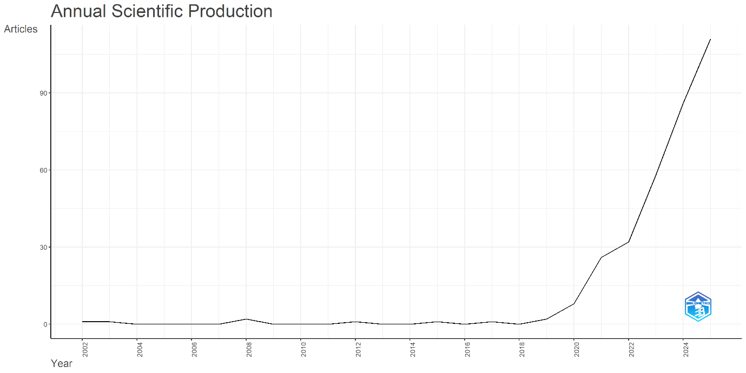
Source: Biblioshiny
Figure 2: Publication Trend Year-wise

Figure 3 presents the use of Bradford's Law to identify the key journals that contribute to the field. The distribution reveals that a small number of journals account for the majority of publications, known as "core sources," while the remaining journals contribute fewer articles in a dispersed way. Journals such as Personnel Review, International Journal of Human Resource Management, Human Resource Management, and Human Resource Management Review stand out as the most productive, publishing a disproportionately large number of publications compared to others. This emphasises the concentration of information transmission in a few significant sources, in line with Bradford's Law, which emphasises the uneven distribution of scientific output across journals.
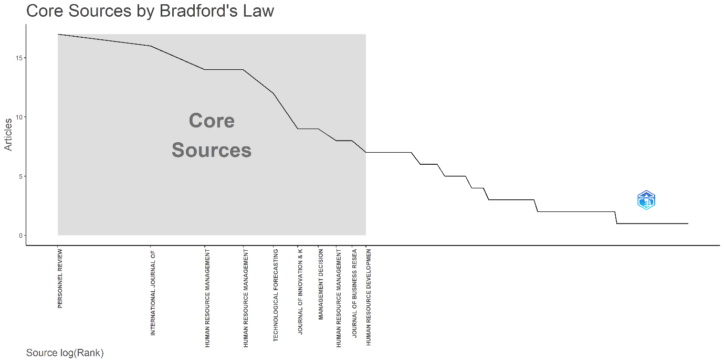
Source: Biblioshiny
Figure 3: Core Sources by Bradford’s Law in the AI in HRM Domain
The top 15 highly cited journals are listed in Table 2, with the Human Resource Management Review (1,436 citations) and the International Journal of Human Resource Management (1,010 citations) standing out as the most influential due to their key roles and ongoing contributions to the field of human resource management research. With 862 citations, Technological Forecasting and Social Change ranks third, emphasising the importance of social and technological perspectives in the field. The Human Resource Management Journal and the International Journal of Manpower, with 542 and 525 citations respectively, are additional notable sources that demonstrate significant scholarly impact. Despite having only one publication each, California Management Review and Strategic Management Journal are among the most cited sources, illustrating the substantial influence of their individual articles. Overall, the data reveal that most human resource management research is published in specialised HR and management journals, with a few multidisciplinary publications receiving significant citations.

Table 2: Top 15 Highly Cited Sources
No. | Sources | Total Citation | Total Publications
1 | Human Resource Management Review | 1436 | 14
2 | International Journal of Human Resource Management | 1010 | 16
3 | Technological Forecasting and Social Change | 862 | 12
4 | Human Resource Management Journal | 542 | 8
5 | International Journal of Manpower | 525 | 7
6 | International Journal of Contemporary Hospitality Management | 471 | 7
7 | California Management Review | 468 | 1
8 | Human Resource Management | 405 | 14
9 | Journal of Business Research | 244 | 8
10 | Journal of Hospitality Marketing & Management | 243 | 3
11 | Journal of Innovation & Knowledge | 241 | 9
12 | Technology In Society | 239 | 7
13 | Management Decision | 238 | 9
14 | Strategic Management Journal | 206 | 1
15 | Management Science | 191 | 2

Source: Author’s Own Work
Table 3 displays the top 10 most prolific authors based on their publications in this field. Malik A is the leading author with 16 publications and 917 citations, making him the most significant in this area. Budhwar P follows with 12 publications and 871 citations, showing ongoing academic effort. Authors such as Prikshat V and Kumar S contribute with 6 articles each. Chowdhury S, Dutta D, and Nguyen M each have 6 publications, while Pereira V, Patel P, and Varma A each have 4. Pereira V has the highest number of citations (995) among them. Overall, the data indicate that, despite differences in publication frequency, productivity, and citation impact are key indicators of research importance in this field.

Table 3: Top 10 Most prolific Authors as per Documents published
NO. | Author | Total Citation | Total Publication
1 | Malik A | 917 | 16
2 | Budhwar P | 871 | 12
3 | Prikshat V | 198 | 6
4 | Kumar S | 92 | 6
5 | Chowdhury S | 691 | 5
6 | Dutta D | 81 | 5
7 | Nguyen M | 28 | 5
8 | Pereira V | 995 | 4
9 | Patel P | 72 | 4
10 | Varma A | 315 | 4

Source: Author’s Own Work
Figure 4 illustrates the publishing trends of the five top universities from 2000 to 2025, showing that research productivity increased significantly after 2020. Aston University and the Indian Institute of Management (IIM) system both exhibit significant research activity in recent years, with the latter showing the fastest increase and becoming the most prolific contributor by 2025. While the University System of Ohio displays a more modest and stable pattern of output, the University of Newcastle and the University System of Georgia show constant rising patterns, showing consistent intellectual effort. Overall, the chart shows a noticeable increase in institutional research output after 2020, indicating growing scholarly interest and cooperation in the area.
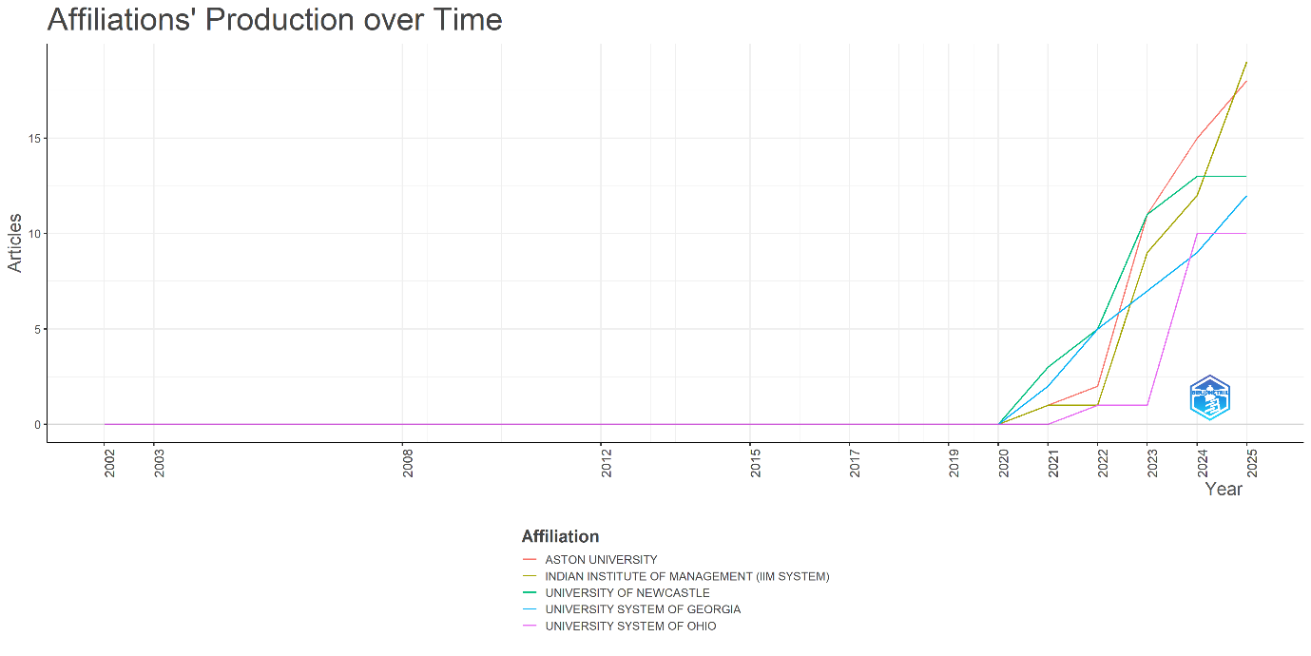
Source: Biblioshiny
Figure 4: Affiliations based on production over time
Table 4 presents the total citations and research productivity of various countries in AI research within HRM. France has the highest total citations (1391) and a strong average citation rate (86.9) across 120 papers, despite its modest output, highlighting its significant influence in the field. The United States and the United Kingdom follow, with 1371 and 1350 citations, respectively. Their consistent contributions are evident in their impressive publication counts (500 and 284). Cyprus, with a small research output, produces high-quality work, as shown by its notable citation impact (average of 252 per article) from only 12 publications. In contrast, China and India, with more publications (325 and 143, respectively), have lower average citations, indicating a broader but less impactful publication trend. Finland, Sweden, and Switzerland demonstrate strong average citation rates (79.6, 76.0, and 70.7), reflecting high-quality academic output despite fewer publications. Overall, the data show that research quantity and citation impact vary significantly between countries, with some exerting greater influence despite fewer publications.

Table 4: Top 15 Most Cited Countries

Country | Total Citation | Average Article Citations | Total Publications
France | 1391 | 86.90 | 120
USA | 1371 | 24.90 | 500
United Kingdom | 1350 | 46.60 | 284
Australia | 944 | 35.00 | 193
China | 940 | 18.80 | 325
Cyprus | 756 | 252.00 | 12
Germany | 571 | 31.70 | 95
Italy | 522 | 30.70 | 114
Finland | 398 | 79.60 | 27
Netherlands | 284 | 35.50 | 71
India | 222 | 11.70 | 143
Switzerland | 212 | 70.70 | 28
Canada | 209 | 52.20 | 41
Sweden | 152 | 76.00 | 29
Malaysia | 124 | 20.70 | 42
Source: Author’s own work
Table 5 highlights the rapid growth and scholarly significance by showcasing the top 15 highly cited works on AI and HRM. Tambe et al. (2019) and Vrontis et al. (2022) list important challenges and frameworks in AI-HRM integration, following Bag et al. (2021), the most referenced article, which focuses on AI adoption and sustainability. Recent research by Budhwar et al. (2023) and Chowdhury et al. (2023) indicates a growing interest in generative AI and how it affects HR procedures. Overall, the table highlights the dominance of top HR publications and the growing scholarly interest in HRM research powered by AI.

Table 5: Top 15 Highly Cited Documents
Rank | Title | Author | Journal | Total Citation
1 | Role of institutional pressures and resources in the adoption of big data analytics-powered artificial intelligence, sustainable manufacturing practices, and circular economy capabilities | Bag et al., (2021) | Technological Forecasting and Social Change | 488
2 | Artificial Intelligence in Human Resources Management: Challenges and a Path Forward | Tambe et al., (2019) | California Management Review | 468
3 | Artificial intelligence, robotics, advanced technologies and human resource management: a systematic review | Vrontis et al., (2022) | The International Journal of Human Resource Management | 450
4 | Unlocking the value of artificial intelligence in human resource management through AI capability framework | Chowdhury et al., (2023) | Human Resource Management Review | 312
5 | Human resource management in the age of generative artificial intelligence: Perspectives and research directions on ChatGPT | Budhwar et al., (2023) | Human Resource Management Journal | 292
6 | A systematic literature review on the impact of artificial intelligence on workplace outcomes: A multi-process perspective | Pereira et al., (2023) | Human Resource Management Review | 208
7 | The Janus face of artificial intelligence feedback: Deployment versus disclosure effects on employee performance | Tong et al., (2021) | Strategic Management Journal | 206
8 | Influences of artificial intelligence (AI) awareness on career competency and job burnout | Kong et al., (2021) | International Journal of Contemporary Hospitality Management | 204
9 | The Robot Revolution: Managerial and Employment Consequences for Firms | Dixon et al., (2021) | Management Science | 189
10 | Productive employment and decent work: The impact of AI adoption on psychological contracts, job engagement and employee trust | Braganza et al., (2021) | Journal of Business Research | 186
11 | The adoption of artificial intelligence in employee recruitment: The influence of contextual factors | Pan et al., (2022) | Artificial intelligence and international HRM | 178
12 | Impact of artificial intelligence on employees working in industry 4.0 led organizations | Malik et al., (2022) | International Journal of Manpower | 161
13 | Emotional intelligence or artificial intelligence–an employee perspective | Prentice et al., (2020) | Journal of Hospitality Marketing & Management | 154
14 | When conscientious employees meet intelligent machines: An integrative approach inspired by complementarity theory and role theory | Tang et al., (2022) | Academy of Management Journal | 150
15 | The dark sides of people analytics: reviewing the perils for organisations and employees | Giermindl et al., (2022) | European Journal of Information Systems | 133
Source: Author's own work
3.2. Scientific Mapping
Figure 5 illustrates a co-occurrence network visualization that presents the conceptual framework and new research topics linking human resource management and artificial intelligence. Human resource management and artificial intelligence are the two largest and most central nodes, indicating their frequent co-occurrence and dominant roles, signifying that AI-driven techniques are increasingly influencing HRM research and practices. Digital transformation, talent management, technology adoption, and machine learning are closely related terms that describe how HR operations incorporate new technology. The human and ethical aspects of AI in the workplace appear to be gaining more attention, as seen by emerging terms like employee experience, AI ethics, and emotional intelligence. The colour gradient (from blue to yellow) shows how research has evolved. The yellow-green nodes represent more recent topics (2024–2025), indicating that scholars are now more interested in employee empowerment, AI literacy, and strategic HR transformation. This map demonstrates that AI–HRM research is constantly evolving and involves many different fields. It also shows how it is shifting from a focus on technology to a focus on people and strategy.
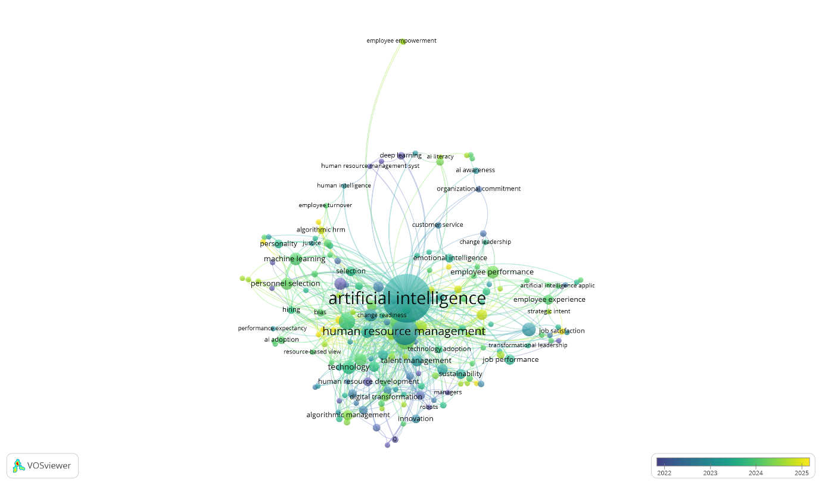
Source: VOSviewer
Figure 5: The co-occurrence network of keywords in the domain of AI in HRM
Figure 6 illustrates the co-citation network of authors within the research area linking artificial intelligence (AI) and human resource management (HRM). The connections indicate the frequency with which two authors are cited together, reflecting their mutual influence and shared topics that connect them. The nodes represent the authors. The network displays three main categories of scholarly concepts. Well-known writers such as Malik A., Tambe P., Chowdhury S., and Pereira V. belong to the green cluster, which focuses on the potential applications of AI in HRM and evolving organisations. The red cluster, including individuals like Brynjolfsson E and Davenport T H, explores the technological and economic impacts of AI and digital innovation on organisations. The blue cluster highlights significant contributions to performance evaluation, management, and innovation that advance AI–HRM research, featuring Podsakoff P M, Fornell C, and Teece D J. The connections among these clusters illustrate the growing integration of technological, strategic, and managerial perspectives, demonstrating how AI-HRM research draws upon a diverse range of important yet interconnected scholarly work.

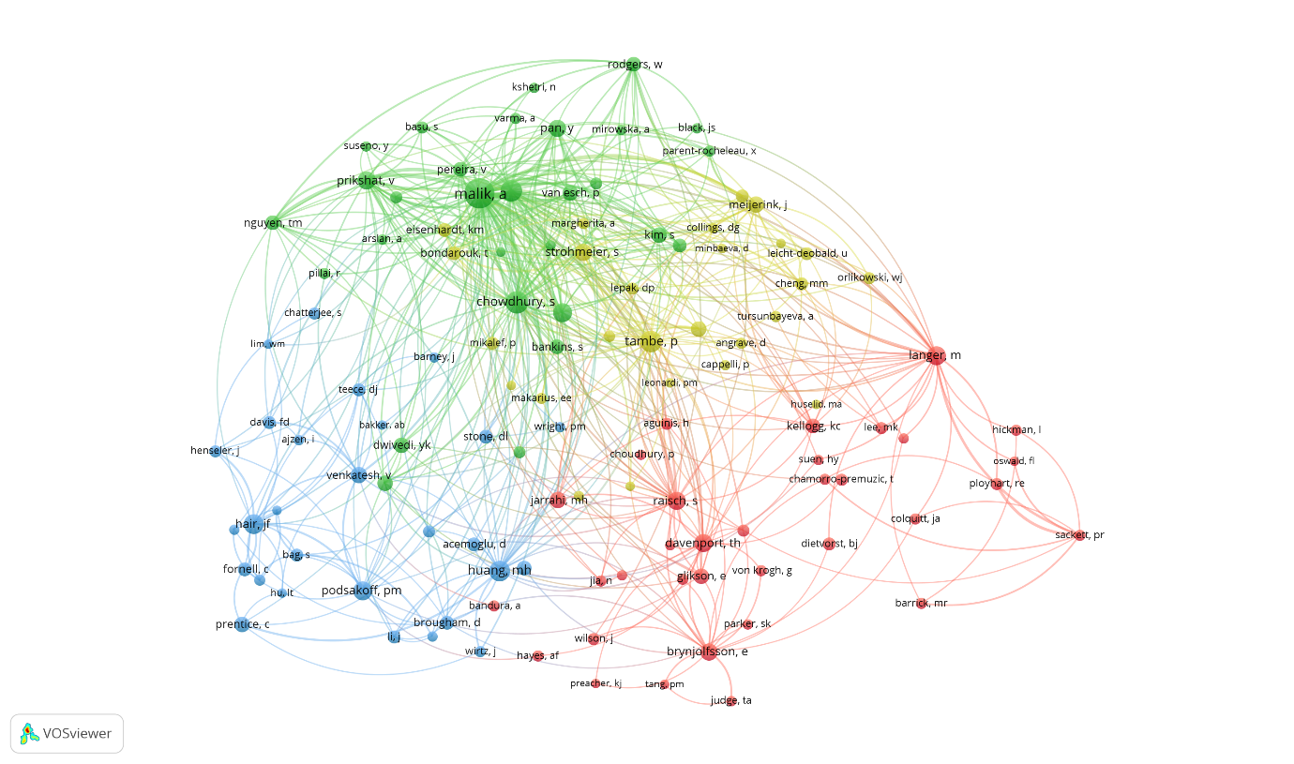
Source: VOSviewer
Figure 6: Co-Citation Network of Authors
Figure 7 shows that, based on topical importance and development, this thematic map illustrates the conceptual framework of research at the intersection of artificial intelligence and human resource management. The upper-right quadrant (Motor Themes) features highly developed and significant themes, such as generative artificial intelligence (GenAI), HR analytics, human resource management, and artificial intelligence. These areas are advancing progress in the field. The lower-right quadrant (Basic Themes), which underpins the AI-HRM study, encompasses core yet less developed themes, including job happiness, emotional intelligence, employee performance, and employee engagement. The upper-left quadrant (Niche Themes) contains specialised but less interconnected fields such as algorithmic HRM, algorithmic bias, discrimination, technology adoption, and digital transformation, indicating focused but limited links with mainstream research. The Niche topics and fading themes are where knowledge is exchanged. Lastly, the lower-left quadrant (Emerging or Declining Themes) features AI identity, resilience, and work performance—either emerging areas or topics receiving less scholarly attention. Overall, the map reveals that AI and HRM are the most prominent and evolving concerns, reflecting growing academic interest in integrating ethical, technological, and human-centred aspects within the HR framework.
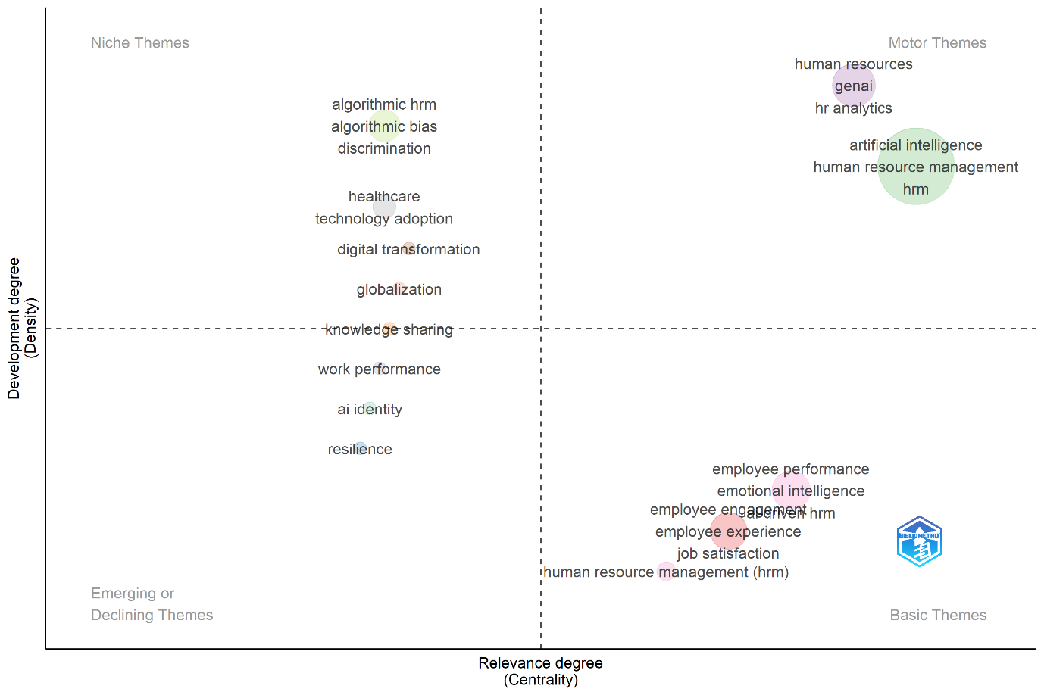
Source: Biblioshiny
Figure 7: The Thematic Map according to development degree and relevance degree
Figure 8 shows a map illustrating how different countries are shaded in various shades of blue, with darker tones indicating higher levels of academic collaboration and research output. The strength and variety of these international connections are reflected by the density and direction of the lines linking countries, which represent co-authorship links or collaborative research efforts. The chart clearly demonstrates that countries with strong international ties and key collaboration hubs include the US, UK, China, and Australia. Because they frequently collaborate with a diverse range of countries across continents, these nations are vital to the development of international research. Other main contributors include Europe (Germany, France, Italy), Japan, Canada, and India, suggesting that high-income countries mainly dominate international research networks. This map highlights the importance of international cooperation in scholarly work. Collaborative research not only enhances the visibility and impact of scientific efforts but also promotes innovation, capacity building, and knowledge sharing. Since areas with lower engagement (shown in grey or light blue) often struggle to connect with international research networks, these patterns may reveal disparities in research funding and infrastructure. Overall, this figure emphasises the interconnectedness of modern scientific research and the growing importance of cross-border academic collaborations.
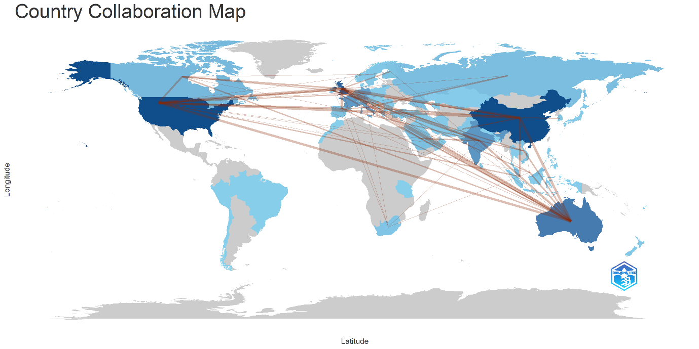
Source: Biblioshiny
Figure 8: The Country Collaboration Map
Figure 9 shows a network visualisation that depicts patterns of institutional collaboration between universities and higher education systems. The links between each node, representing a university or university system, indicate co-authorship or academic collaboration relationships. The colour-coded clusters represent various regional affiliations or cooperative groupings. Strong UK-Australian interactions are shown in the orange cluster, which is centred on Aston University, the University of London, and the University of Reading. Indian management institutions are expanding globally, as evidenced by the red cluster, which is headed by the Indian Institute of Management (IIM system) and displays active connections with Asian and worldwide universities. The University System of Georgia, Texas A&M University System, and University System of Ohio dominate the blue cluster, which reflects significant regional collaboration in the US. This implies that public university systems in the United States have a strong domestic academic network. The University of Illinois System and Pennsylvania State University are among the smaller but clearly identifiable collaborative organisations that make up the purple and pink clusters; these could be specialised research partnerships. Hong Kong Polytechnic University and other isolated nodes point to a lack of collaborative connections within this network.
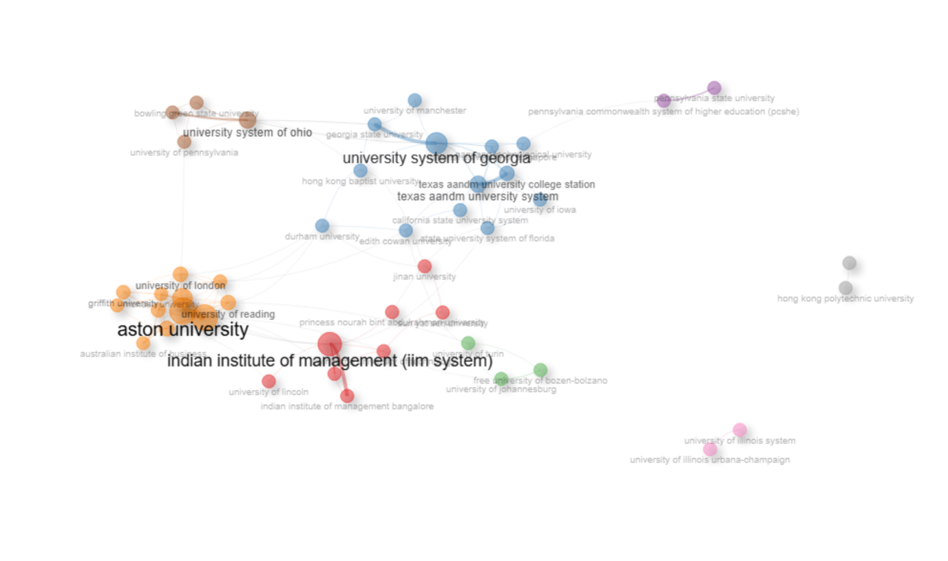
Source: Biblioshiny
Figure 9: Collaboration network of universities
Figure 10: The co-authorship network illustrates the collaborative links between researchers in a specific field. Each node represents an author, while the connecting lines show joint publications. The size of a node indicates how often an author collaborates or publishes. The network reveals several important clusters for collaboration. Among them, Ashish Malik and Pawan Budhwar stand out as key figures, showing strong connections with scholars such as Mai Nguyen, Parth Patel, and Arup Varma. Their links clearly demonstrate efforts to build and maintain international research collaborations. The Vijay Pereira group is a capable team likely interested in organisational or human resource management topics, based on connections to authors such as Bamber, Mustafa Ozbilgin, and Qijie Xiao, which suggests the presence of other active, cross-disciplinary research networks. The colour gradient depicts the publishing timeline, with more recent partnerships (in yellow) involving emerging academics, such as Nguyen Mai and Ebesam Abdullah Alzeby, and older partnerships (in blue and green) with Budhwar and Pereira. Centred on Budhwar and Malik, the network exemplifies a vibrant, cohesive academic community that promotes collaborative research across disciplines.

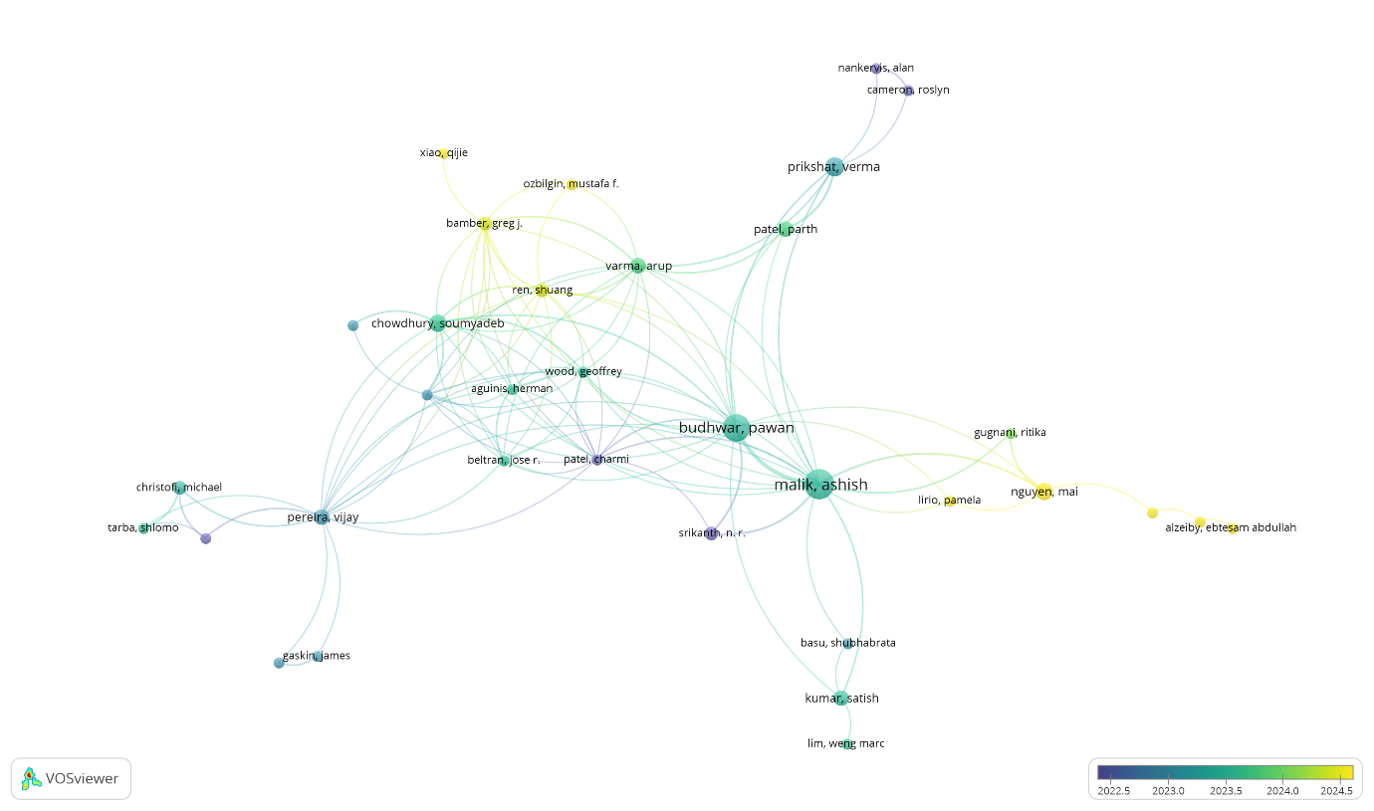
Source: VOSviewer
Figure 10: Co-authorship network analysis
Figure 11 illustrates the intellectual connections between authors through a bibliographic coupling visualisation based on references shared across their works. Each node represents an author, and the lines connecting them indicate the extent of overlap in their cited references, reflecting conceptual or thematic closeness in research. As the most prominent author, Ashish Malik's work is linked to many other scholars throughout clusters and frequently shares references, as shown by the map. A dense network of closely related researchers, including Greg Bamber, Soumyadeb Chowdhury, Arup Varma, Geoffrey Wood, and Mustafa Özbilgin, surrounds Malik, demonstrating a strong intellectual foundation in organisational studies and human resource management. Recent links, highlighted in yellow-green tones, connect emerging contributors such as Nguyen Mai, Ritika Gugnal, and Ebesam Abdullah Alzeby, positioned on the periphery and indicating rising interest in the core ideas of the field. Meanwhile, clusters including David De Cremer, Michael Campion, and Boone Caroline represent different but interconnected research subdomains, possibly focusing on performance, behaviour, and leadership.

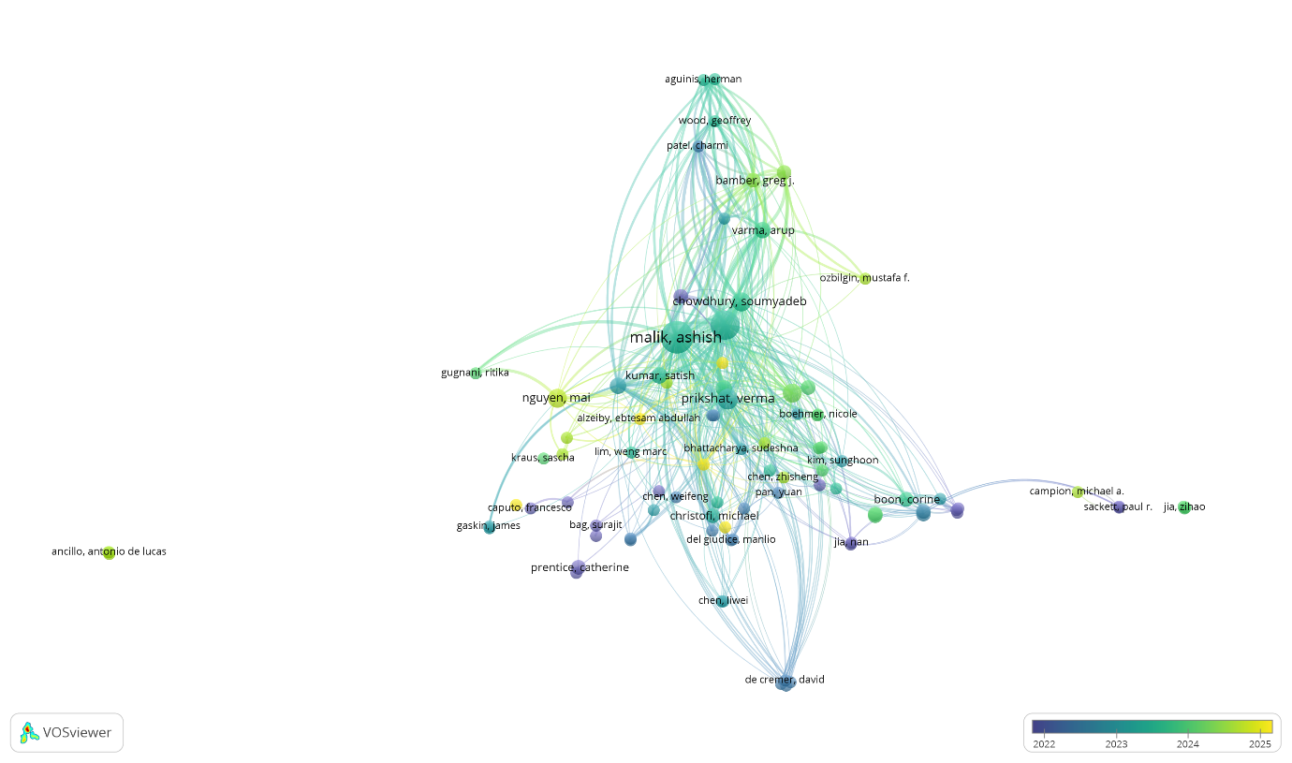
Source: VOSviewer
Figure 11: Bibliographic Coupling Analysis
4. Limitations and Future Research Directions
This bibliometric review provides a structured overview of research at the intersection of artificial intelligence, employee experience, and work performance; however, certain limitations should be acknowledged. The analysis is based exclusively on publications indexed in the Web of Science database and restricted to English-language journal articles and review papers. While this ensures data quality and consistency, it may exclude relevant studies published in other databases, languages, or formats, thereby limiting the comprehensiveness of the review. In addition, bibliometric methods rely on citation patterns and keyword relationships, which capture the intellectual structure of the field but do not account for the contextual depth or methodological rigour of individual studies. Consequently, nuanced organisational and employee-level dynamics associated with AI adoption may not be fully reflected.
These limitations also offer directions for future research. Subsequent studies could extend this work by incorporating multiple databases and complementary review methods, such as systematic reviews or meta-analyses, to deepen analytical insight. Greater emphasis on empirical and longitudinal research is needed to examine how employee experience mediates or shapes work performance in AI-enabled environments over time. Future scholarship would also benefit from stronger theoretical integration, particularly through human-centred, ethical, and socio-technical perspectives, to inform sustainable and inclusive AI adoption in organisational contexts.
5. Conclusion and Findings
This bibliometric review offers a structured synthesis of research examining the relationship between artificial intelligence, employee experience, and work performance. The analysis reveals a pronounced growth in scholarly output after 2020, reflecting increasing academic and managerial interest in AI-driven HRM and workplace transformation. Findings highlight the dominance of HRM and management journals, the influence of a small group of prolific authors and institutions and the emergence of collaborative international research networks. Thematic mapping indicates a gradual shift from technology-focused discussions toward human-centred, ethical, and experiential perspectives, with employee experience increasingly positioned as a key mechanism linking AI adoption to performance outcomes. At the same time, the field remains conceptually fragmented, with limited theoretical integration across studies. By consolidating existing knowledge and identifying emerging themes, this review provides a clear foundation for future research aimed at developing sustainable, inclusive, and performance-oriented AI practices in organisational contexts.
6. Bibliography
Al Naqbi, H., Bahroun, Z., & Ahmed, V. (2024). Enhancing work productivity through generative artificial intelligence: A comprehensive literature review. Sustainability, 16(3), 1166. https://doi.org/10.3390/su16031166
Arora, M., Gupta, J., Mittal, A., & Prakash, A. (2024). A bibliometric review of artificial intelligence technologies in human resource management: An overview of research trends. Global Knowledge, Memory and Communication. https://doi.org/10.1108/GKMC-04-2024-0237
Arslan, A., Cooper, C., Khan, Z., Golgeci, I., & Ali, I. (2022). Artificial intelligence and human workers interaction at team level: A conceptual assessment of the challenges and potential HRM strategies. International Journal of Manpower, 43(1), 75–88. https://doi.org/10.1108/IJM-01-2021-0052
Bag, S., Pretorius, J. H. C., Gupta, S., & Dwivedi, Y. K. (2021). Role of institutional pressures and resources in the adoption of big data analytics powered artificial intelligence, sustainable manufacturing practices and circular economy capabilities. Technological Forecasting and Social Change, 163, 120420.https://doi.org/10.1016/j.techfore.2020.120420
Bessen, J. (2019). AI and jobs: The role of demand (No. w24235). National Bureau of Economic Research. https://doi.org/10.3386/w24235
Bhandari, A. (2024). Demystifying Organization Success: A Bibliometric Analysis and Future Research Agenda. FIIB Business Review, 15(1), 36-58. https://doi.org/10.1177/23197145231216861
Braganza, A., Chen, W., Canhoto, A., & Sap, S. (2021). Productive employment and decent work: The impact of AI adoption on psychological contracts, job engagement and employee trust. Journal of business research, 131, 485-494.https://doi.org/10.1016/j.jbusres.2020.08.018
Budhwar, P., Chowdhury, S., Wood, G., Aguinis, H., Bamber, G. J., Beltran, J. R., ... & Varma, A. (2023). Human resource management in the age of generative artificial intelligence: Perspectives and research directions on ChatGPT. Human Resource Management Journal, 33(3), 606-659.10.1111/1748-8583.12524
Cheng, K. T., Chang, K., & Tai, H. W. (2022). AI boosts performance but affects employee emotions. Information Resources Management Journal, 35(1), 1–18. https://doi.org/10.4018/irmj.314220
Chowdhury, S., Dey, P., Joel-Edgar, S., Bhattacharya, S., Rodriguez-Espindola, O., Abadie, A., & Truong, L. (2023). Unlocking the value of artificial intelligence in human resource management through AI capability framework. Human resource management review, 33(1), 100899.https://doi.org/10.1016/j.hrmr.2022.100899
Dastane, O., & Haba, H. F. (2023). The Landscape of Digital Natives Research: A Bibliometric and Science Mapping Analysis. FIIB Business Review, 0(0). https://doi.org/10.1177/23197145221137960
Dixon, J., Hong, B., & Wu, L. (2021). The robot revolution: Managerial and employment consequences for firms. Management Science, 67(9), 5586–5605. https://doi.org/10.1287/mnsc.2020.3812
Erixon, F. (2018). Recipe: The economic benefits of globalization for business and consumers. https://ecipe.org/publications/the-economic-benefits-of-globalization
Giermindl, L. M., Strich, F., Christ, O., Leicht-Deobald, U., & Redzepi, A. (2022). The dark sides of people analytics: reviewing the perils for organisations and employees. European Journal of Information Systems, 31(3), 410-435.10.1080/0960085X.2021.1927213
Grewal, D., Benoit, S., Noble, S. M., Guha, A., Ahlbom, C. P., & Nordfält, J. (2023). Leveraging in-store technology and AI: Increasing customer and employee efficiency and enhancing their experiences. Journal of Retailing, 99(4), 487–504. https://doi.org/10.1016/j.jretai.2023.10.002
Hughes, C., Robert, L., Frady, K., & Arroyos, A. (2019). Artificial intelligence, employee engagement, fairness, and job outcomes. In Managing Technology and Middle- and Low-skilled Employees (The Changing Context of Managing People) (pp. 61–68). Emerald Publishing. https://doi.org/10.1108/978-1-78973-077-720191005
Jia, Q., Guo, Y., Li, R., Li, Y., & Chen, Y. (2018). A conceptual artificial intelligence application framework in human resource management. ICEB 2018 Proceedings (pp. 91). https://aisel.aisnet.org/iceb2018/9
Kaushal, N., Kaurav, R. P. S., & Sivathanu, B. (2023). Artificial intelligence and HRM: Identifying future research agenda using systematic literature review and bibliometric analysis. Management Review Quarterly, 73, 455–493. https://doi.org/10.1007/s11301-021-00249-2
Kong, H., Yuan, Y., Baruch, Y., Bu, N., Jiang, X., & Wang, K. (2021). Influences of artificial intelligence (AI) awareness on career competency and job burnout. International Journal of Contemporary Hospitality Management, 33(2), 717-734.https://doi.org/10.1108/IJCHM-07-2020-0789
Malik, A., Budhwar, P., Mohan, H., & NR, S. (2023). Employee experience—the missing link for engaging employees: Insights from an MNE's AI-based HR ecosystem. Human Resource Management, 62(1), 97–115. https://doi.org/10.1002/hrm.22133
Malik, N., Tripathi, S. N., Kar, A. K., & Gupta, S. (2022). Impact of artificial intelligence on employees working in industry 4.0 led organizations. International Journal of Manpower, 43(2), 334-354.https://doi.org/10.1108/IJM-03-2021-0173
Man Tang, P., Koopman, J., McClean, S. T., Zhang, J. H., Li, C. H., De Cremer, D., ... & Ng, C. T. S. (2022). When conscientious employees meet intelligent machines: An integrative approach inspired by complementarity theory and role theory. Academy of Management journal, 65(3), 1019-1054.10.5465/amj.2020.1516
Mathushan, P., Gamage, A. S., & Wachissara, V. (2023). Human resource management and artificial intelligence: A bibliometric exploration. Journal of Business Research and Insights (Former Vidyodaya Journal of Management), 9(1). https://doi.org/10.31357/vjm.v9iI.6370
Özmen, Ö. M., & Gökhan, S. (2024). Examining studies on the relationship between employee experience and digital transformation through bibliometric analysis. International Social Sciences Studies Journal, 10(8). https://doi.org/10.5281/zenodo.13383676
Panda, G., Aggarwal, S., Kaswan, M. S., & Dhillon, K. (2025). Artificial intelligence in agile human resource practices: Systematic literature review and bibliometric analysis. International Journal of Lean Six Sigma, 16(4), 918–945. https://doi.org/10.1108/IJLSS-07-2024-0159
Pan, Y., Froese, F., Liu, N., Hu, Y., & Ye, M. (2023). The adoption of artificial intelligence in employee recruitment: The influence of contextual factors. In Artificial intelligence and international HRM (pp. 60-82). Routledge 10.1080/09585192.2021.1879206
Pereira, V., Hadjielias, E., Christofi, M., & Vrontis, D. (2023). A systematic literature review on the impact of artificial intelligence on workplace outcomes: A multi-process perspective. Human Resource Management Review, 33(1), 100857.https://doi.org/10.1016/j.hrmr.2021.100857
Prentice, C., Dominique Lopes, S., & Wang, X. (2020). Emotional intelligence or artificial intelligence–an employee perspective. Journal of Hospitality Marketing & Management, 29(4), 377-403.10.1080/19368623.2019.1647124
Qamar, Y., Agrawal, R. K., Samad, T. A., & Jabbour, C. J. C. (2021). When technology meets people: The interplay of artificial intelligence and human resource management. Journal of Enterprise Information Management, 34(5), 1339–1370. https://doi.org/10.1108/JEIM-11-2020-0436
Ramachandran, K. K., Mary, A. A. S., Hawladar, S., Asokk, D., Bhaskar, B., & Pitroda, J. R. (2022). Machine learning and role of artificial intelligence in optimizing work performance and employee behavior. Materials Today: Proceedings, 51, 2327–2331. https://doi.org/10.1016/j.matpr.2021.11.544
Smith, A., & Anderson, J. (2020). AI, robotics, and the future of jobs. Pew Research Center.
Soulami, M., Benchekroun, S., & Galiulina, A. (2024). Exploring how AI adoption in the workplace affects employees: A bibliometric and systematic review. Frontiers in Artificial Intelligence, 7, 1473872. https://doi.org/10.3389/frai.2024.1473872
Tambe, P., Cappelli, P., & Yakubovich, V. (2019). Artificial intelligence in human resources management: Challenges and a path forward. California management review, 61(4), 15-42.https://doi.org/10.1177/0008125619867910
Tong, S., Jia, N., Luo, X., & Fang, Z. (2021). The Janus face of artificial intelligence feedback: Deployment versus disclosure effects on employee performance. Strategic Management Journal, 42(9), 1600–1631. https://doi.org/10.1002/smj.3322
Vrontis, D., Christofi, M., Pereira, V., Tarba, S., Makrides, A., & Trichina, E. (2023). Artificial intelligence, robotics, advanced technologies and human resource management: a systematic review. Artificial intelligence and international HRM, 172-201.https://doi.org/10.1080/09585192.2020.1871398

