Hall and ion slip effects on MHD free convective flow of chemical reaction - applications

Abstract : Hall and ion-slip impacts on unsteady MHD free convective laminar flow of an incompressible viscous, electrically conducting and heat generation/ absorbing fluid enclosed with a semi-infinite porous plate within a rotating frame has been premeditated. The plate is assumed to be moving with a constant velocity in the direction of fluid movement. A uniform transverse magnetic field is applied at right angles to the porous surface, which is absorbing the fluid with a suction velocity changing with time. The non-dimensional governing equations for present investigation are solved analytically making use of two term harmonic and non-harmonic functions. The graphical results of velocity, temperature and concentration distributions on the analytical solutions are displayed and discussed with reference to pertinent parameters. There is an intense world wide activity in the development of instrumentation for medical diagnosis and bio screening based on biological labeling and detection of nano particles. The skin friction coefficient increases in Hall and ion slip parameters. Out comes disclose that the impact of thermal convection of nano particles has increased the tempertature distribution, which helps in destroying the cancer cells during the drug delivery process.
Key words.Hall effect, ion effect, MHD,Chemical reaction,Nano
1.Introduction.
Flow through porous medium with nano particles has significant applications in biomedical science (such as drug delivery and cancer treatment to treat radiotherapy) and chemical engineering (transport of chemicals).A major interest of convective heat transmission of nano fluids in sciences and engineering is incredibly significant. It is due to various varieties of cool devices like micro- electronics and electronic gear and solar power technology. Water, ethylene glycol, and engine oil are heating or cooling agents and play a decisive job in thermal management of many industries with poor thermal conductivity. Recent investigations have given more attention towards thermal convection flows. The rate of thermal energy transmission from one point to another point enhances in several conductive and convection processes. The thermal energy vigorously depends on the variation of heat at the loco- motion. However, in thermal radiation, energy transmission between two bodies depends upon absolute heat variation. Thermal radiation has so many applications in biomedical.[1-3]
The investigation of heat generation or absorption consequences in moving fluids is significant in sight of quite a few substantial problems, they are, and fluids undergo exothermic or else endothermic chemical reaction. Outstanding to the quick development of electronic technology, effectual freezing of electronic apparatus has became certified and freezing of electronic apparatus ranges from own transistors to foremost structure computers and from energy providers to telephone switch panels and thermal diffusion impacts has been exploited for isotopes separation in the combination among gases with extremely low molecular weight (H2 and He) and average molecular weight. Magnetic field plays an important role in numerous fields such as biological, chemical, mechanical and medical research. In clinical and medical research the magnets are extremely important to create three dimensional images of anatomical and diagnostic importance from nuclear magnetic resonance signals. In view of these applications, the present research is to the effects of radiation on magneto hydrodynamic (MHD) flow and heat transfer problem has become innovative and significant industrially. At high functioning of heat and radiation impact might be moderately momentous. Numerous processes in manufacturing regions occur at huge temperature and consideration of radiation heat transport becomes extremely significant for the construction of the significant apparatus. Nuclear energy plants, some gas turbines and the different propulsion machines for satellites, missiles, aircraft, and space vehicles are illustrations of several engineering regions.
The liquefied flow problems in rotating medium have drawn attention of many researchers who investigated hydrodynamic flow of a viscous, incompressible fluid in rotating medium consid- ering different aspects of the problem. There has been considerable interest in the problems of MHD flow in a rotating medium during past few decades due to their geophysical and astrophysical signif- icance and their application in fluid engineering. Many imperative problems, like, maintenance and secular variations of terrestrial magnetic field due to motion in Earth’s liquid core, internal rota- tion rate of the sun, structure of rotating magnetic stars, planetary and solar dynamo problems, MHD Ekman pumping, turbo machi- nes, rotating MHD generators, rotating drum type separator in closed cycle two phase MHD generator flow etc. are directly gov- erned by the action of Coriolis and magnetic forces. The effects of Coriolis force are more significant than that of inertial and viscous forces. In addition to it, Coriolis and magnetic forces are compara- ble in magnitude. In many realistic applications requiring strong magnetic field there is a need to think both the Hall and ion slip currents because of the significant effect they have on the vector of the current density and transitively on the magnetic force idiom. Ellahi et al.[4] discussed the Hall and ion-slip impacts on the peri- stalsis Jeffreys fluid flow through a rectangular channel every- where it is inhomogeneous. Bhatti et al.[5] carried out research on the effects of Hall and ion-slip on non-Newtonian fluid flow with the Reynolds number as zero. Srinivasacharya and Shafeeur- rahman [6] studied amid two analogous concentric cylinders for the Hall and ion slip effects on MHD mixed convective nanofluid. Jitendra and Srinivasa [7] discussed Hall and ion slip effects on convective flow of rotating fluid past an exponential accelerated vertical plate. Krishna and Chamkha [8] explored the thermal radiation and heat absorption, diffusion-thermo and Hall and ion slip effects on MHD free convection rotating flow by nanofluids past a moving porous plate with constant heat source. Sara and Bhatti [9] investigated the MHD peristaltic induced flow of a nanofluid in a non-uniform channel with chemical reaction, Hall and ion slip effects. Srinivasacharya and Kaladhar [10] investigated the Hall and ion slip effects on fully developed electrically conduct- ing couple stress fluid flow between parallel disks using Homotopy analysis method. Ibrahim and Anbessa [11] discussed the problem of Hall and ion-slip effects on a mixed convection flow of an elec- trically conducting nanofluid over a stretching sheet in a perme- able medium and is solved numerically using a spectral relaxation method. Nawaz and Zubair [12] explored the three dimensional flow of nano-plasma in the presence of uniform applied magnetic field perpendicular to two dimensional nonlinear stretching surfaces with Hall and ion slip currents when Joule heat- ing and viscous dissipation are of considerable order of magnitude. Krishna et al. [13] investigated the Hall and ion slip effects on the unsteady MHD free convective rotating flow through porous med- ium past an exponentially accelerated inclined plate. The com- bined effects of Hall and ion slip on MHD rotating flow of ciliary propulsion of microscopic organism through porous medium have been studied by Krishna et al.[14]. Krishna and Chamkha [15] investigated the Hall and ion slip effects on the MHD convective flow of elastico-viscous fluid through porous medium between two rigidly rotating parallel plates with time fluctuating sinusoidal pressure gradient. Krishna [16] reported that the Hall and ion slip effects on MHD free convective rotating flow bounded by the semi- infinite vertical porous surface. Krishna [17] discussed the MHD laminar flow of an elastico-viscous electrically conducting Walter’s fluid through a circular cylinder or a pipe. Hall and ion slip effects on unsteady MHD Convective Rotating flow of Nanofluids have been discussed by Krishna and Chamkha [18]. Ibrahim and Anbessa [19] explored the mixed convection flow of Eyring-Powell nano-fluid over a linearly stretching sheet through a porous medium with Cattaneo–Christov heat and mass flux model in the presence of Joule heating, Hall and ion slip effects. Ibrahim et al. [20] studied the effects of the chemical reaction and radiation absorption on the unsteady MHD free convection flow past a semi infinite vertical permeable moving plate by the influence of heat source and suc- tion. Ajibade and Umar [21] investigated the effects of chemical reaction and radiation absorption on the unsteady MHD natural convection flow in a vertical channel filled with porous materials, one of the plate moves with a constant velocity in the direction of fluid flow while the other plate is stationary and which absorbs the fluid with a suction velocity varying with time. Krishna [22] investigated the influence of thermal radiation, Hall and ion-slip impacts on the unsteady MHD free convective rotating flow of Jef- freys fluid past an infinite vertical porous plate with the ramped wall temperature.
2.Formulation of the problem.
We have deemed the radiation-absorption, chemical reaction, Hall and ion-slip impacts on the unsteady two-dimensional flow of a laminar, viscous, electrically conducting fluid over a semiinfinite vertical moving porous plate embedded in a uniform porous medium with a uniform transverse magnetic field in the existence of thermal and concentration buoyancy effects. The physical configuration of the problem is as shown in Physical model. It is assumed that there is no applied voltage which implies that, the absence of an electrical field. The fluid properties are assumed to be constant except that the influence of density variation with temperature has been considered only in the body-force term. The concentration of diffusing species is very small in comparison to other chemical species, the concentration of species far from the wall, $C_{∞}$, is infinitesimally small and hence the Soret and Dufour effects are neglected. The chemical reactions are taking place in the flow and all thermophysical properties are assumed to be constant of the linear momentum equation which is approximated according to the Boussinesq approximation. Due to the semi-infinite plane surface assumption, the flow variables are functions of $z$ and the time $t$ only.
Under these assumptions, the governing equations that describe the physical situation in a rotating frame are specified by,
$\frac{∂u}{∂x}+\frac{∂v}{∂y}=0$ (1)
$\frac{∂u}{∂t}+w\frac{∂u}{∂z}-2Ωv=v\frac{∂^{2}u}{∂z^{2}}+\frac{B_{0}J_{y}}{ρ}-\frac{v}{k}u+gβ\left(T-T_{∞}\right)+gβ^{*}\left(C-C_{∞}\right)$ (2)
$\frac{∂v}{∂t}+w\frac{∂v}{∂z}+2Ωu=v\frac{∂^{2}u}{∂z^{2}}-\frac{B_{0}J_{x}}{ρ}-\frac{v}{k}v$ (3)
$\frac{∂T}{∂t}+w\frac{∂T}{∂z}=\frac{k_{1}}{ρC_{p}}\frac{∂^{2}T}{∂z^{2}}-\frac{Q_{0}}{ρC_{p}}\left(T-T_{∞}\right)+Q_{l}^{*}\left(C-C_{∞}\right)$ (4)
$\frac{∂C}{∂t}+w\frac{∂C}{∂z}=D\frac{∂^{2}C}{∂z^{2}}-K_{l}\left(C-C_{∞}\right)$ (5)
The magnetic and viscous dissipations are neglected in this study. The third and fourth terms on the right hand side of the momentum Eq. (2) denote the thermal and concentration buoyancy effects, respectively. Also, the second and third terms on the right hand side of the energy Eq. (4) represents the heat and radiation absorption effects, respectively. It is assumed that the permeable plate moves with a variable velocity in the direction of fluid flow. In addition, it is assumed that the temperature and the concentration at the wall as well as the suction velocity are exponentially varying with time. Under these assumptions, the suitable boundary conditions for the velocity, temperature and concentration fields are
$u=u_{0},v=0,T=T_{w}+ε\left(T_{w}-T_{∞}\right)e^{nt}$,
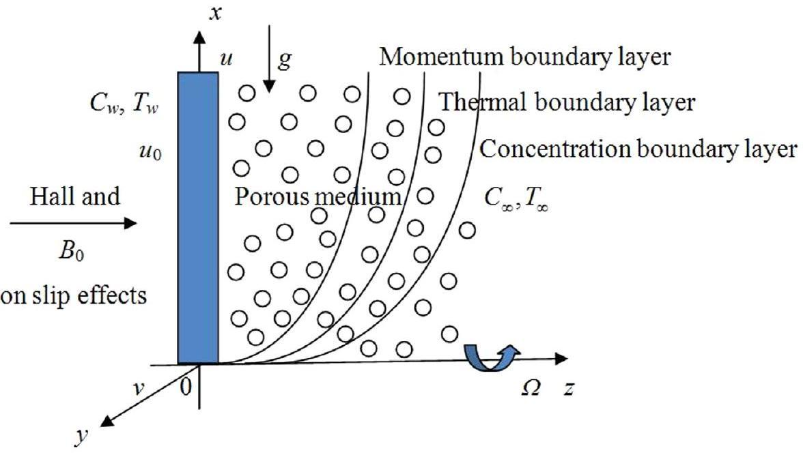
Physical model.
$C=C_{w}+ε\left(C_{w}-C_{∞}\right)e^{nt},$at $z=0$,
$u=0,v=0,T→T_{∞},C→C_{∞},$at$z→∞$
It is clear from Eq. (1) that the suction velocity at the plate surface is not a function of $z$ but a function of time only. Assuming that it takes the following exponential form as,
$w=-w_{0}\left(1+εAe^{nt}\right)$
where$A$ is a real positive constant, $ε$ and $εA$ are small less than unity, and $w_{0}$ is a suction velocity scale, which has non-zero positive constant. The negative sign indicates that suction is towards porous materials.
The electron-atom collision frequency is assumed to be very high, so that Hall and ion slip currents cannot be neglected. Hence, the Hall and ion slip currents give rise to the velocity in $y$-direction. When the strength of the magnetic field is very large, the generalized Ohm's law is modified to include the Hall and ion slip effect
$J=σ(E+V×B)-\frac{ω_{e}τ_{e}}{B_{0}}(J×B)+\frac{ω_{e}τ_{e}β_{i}}{B_{0}^{2}}((J×B)×B))$ (6)
Additionally, it is assumed that the Hall parameter $β_{e}=ω_{e}τ_{e}∼O(1)$ and the ion slip parameter $β_{i}=ω_{i}τ_{i}<<1$,
$\left(1+β_{i}β_{e}\right)J_{x}+β_{e}J_{y}=σB_{0}v$
$\left(1+β_{i}β_{e}\right)J_{y}-β_{e}J_{x}=-σB_{0}u$
$J_{x}=σB_{0}\left(α_{2}u+α_{1}v\right)$
$J_{y}=-σB_{0}\left(α_{2}v-α_{1}u\right)$
where, $α_{1}=\frac{1+β_{e}β_{i}}{{\left(1+β_{e}β_{i}\right)}^{2}+β_{e}^{2}}$ and $α_{2}=\frac{β_{e}}{{\left(1+β_{e}β_{i}\right)}^{2}+β_{e}^{2}}$
$\frac{∂u}{∂t}-w_{0}\left(1+εAe^{nt}\right)\frac{∂u}{∂z}-2Ωv=v\frac{∂^{2}u}{∂z^{2}}+\frac{σB_{0}^{2}\left(α_{2}v-α_{1}u\right)}{ρ}- \frac{v}{k}u+gβ\left(T-T_{∞}\right)+gβ^{*}\left(C-C_{∞}\right)$ (7)
$\frac{∂v}{∂t}-w_{0}\left(1+εAe^{nt}\right)\frac{∂v}{∂z}+2Ωu=v\frac{∂^{2}v}{∂z^{2}}-\frac{σB_{0}^{2}\left(α_{2}u+α_{1}v\right)}{ρ}-\frac{v}{k}v$as,
$\frac{∂q}{∂t}-w_{0}\left(1+εAe^{nt}\right)\frac{∂q}{∂z}+2iΩq=v\frac{∂^{2}q}{∂z^{2}}-\left(\frac{σB_{0}^{2}\left(α_{1}+iα_{2}\right)}{ρ}+\frac{v}{k}\right)q,+ gβ\left(T-T_{∞}\right)+gβ^{*}\left(C-C_{∞}\right)$ (8)
On introducing the non-dimensional quantities,
$z^{*}=\frac{zw_{0}}{v},q=\frac{q}{q_{0}},t^{*}=\frac{tw_{0}^{2}}{v},u_{0}^{*}=\frac{u_{0}}{w_{0}},θ=\frac{T-T_{∞}}{T_{w}-T_{∞}}$,
$ϕ=\frac{C-C_{∞}}{C_{w}-C_{∞}},P_{r}=\frac{μc_{p}}{k_{1}},Sc=\frac{v}{D}$,
$Gr=\frac{gβv\left(T_{w}-T_{∞}\right)}{w_{0}^{3}},Gm=\frac{gβ^{*}v\left(C_{w}-C_{∞}\right)}{w_{0}^{3}},K=\frac{v}{kw_{0}^{2}},R=\frac{Ωv}{w_{0}^{2}},Kc=\frac{K_{l}v}{w_{0}^{2}}$,
$M^{2}=\frac{σB_{0}^{2}v}{ρw_{0}^{2}},H=\frac{Q_{0}v}{ρc_{p}w_{0}^{2}},Q_{l}=\frac{vQ_{l}^{*}\left(C_{w}-C_{∞}\right)}{\left(T_{w}-T_{∞}\right)w_{0}^{2}}$
Making use of the above non-dimensional variables, can be expressed in non dimensional form as,
$\frac{∂q}{∂t}-\left(1+εAe^{nt}\right)\frac{∂q}{∂z}= \frac{∂^{2}q}{∂z^{2}}-\left(M^{2}\left(α_{1}+iα_{2}\right)+2iR+\frac{1}{K}\right)q +Grθ+Gmϕ \frac{∂θ}{∂t}-\left(1+εAe^{nt}\right)\frac{∂θ}{∂z}= \frac{1}{Pr}\frac{∂^{2}θ}{∂z^{2}}-Hθ+Q_{l}ϕ \frac{∂ϕ}{∂t}-\left(1+εAe^{nt}\right)\frac{∂ϕ}{∂z}= \frac{1}{Sc}\frac{∂^{2}ϕ}{∂z^{2}}-Kcϕ$ (9)
The boundary conditions are
$q=u_{0},θ=1+εe^{nt},ϕ=1+εe^{nt}$at $z=0$,
$q→0,θ→0,ϕ→0$at$z→∞$
However, it can be reduced to a set of ordinary differential equations in dimensionless form that can be solved analytically. This can be done by representing the velocity, temperature and the concentration as,
$q(z,t)=q_{0}(z)+εe^{nt}q_{1}(z)+O\left(ε^{2}\right)$
$θ(z,t)=θ_{0}(z)+εe^{nt}θ_{1}(z)+O\left(ε^{2}\right)$
$ϕ(z,t)=ϕ_{0}(z)+εe^{nt}ϕ_{1}(z)+O\left(ε^{2}\right)$
simplifying, it is obtained the following pairs of equations of zeroth and first orders be,
$\frac{d^{2}q_{0}}{dz^{2}}+\frac{dq_{0}}{dz}-\left(M^{2}\left(α_{1}+iα_{2}\right)+2iR+\frac{1}{K}\right)q_{0}=-Grθ_{0}+Gmϕ_{0}$ (10)
$\frac{d^{2}θ_{0}}{dz^{2}}+Pr⁡\frac{dθ_{0}}{dz}-Pr⁡Hq_{0}=-Q_{l}Pr⁡ϕ_{0}$ (11)
$\frac{d^{2}ϕ_{0}}{dz^{2}}+Sc\frac{dϕ_{0}}{dz}-ScKcϕ_{0}=0$
Subjected to the boundary conditions
$q_{0}=u_{0},θ_{0}=1,ϕ_{0}=1$at $z=0$,
$q_{0}→0,θ_{0}→0,ϕ_{0}→0$at$z→∞$
And
$\frac{d^{2}q_{1}}{dz^{2}}+\frac{dq_{1}}{dz}-\left(M^{2}\left(α_{1}+iα_{2}\right)+2iR+\frac{1}{K}+n\right)q_{1}= -A\frac{dq_{0}}{dz}-Grθ_{1}-Gmϕ_{1}$ (12)
$\frac{d^{2}θ_{1}}{dz^{2}}+Pr⁡\frac{dθ_{1}}{dz}-Pr⁡(H+n)q_{1}=-APr⁡\frac{dθ_{0}}{dz}-Q_{l}Pr⁡ϕ_{1}$ (13)
$\frac{d^{2}ϕ_{1}}{dz^{2}}+Sc\frac{dϕ_{0}}{dz}-Sc(Kc+n)ϕ_{1}=-ASc\frac{dϕ_{0}}{dz}$ (14)
Through the boundary conditions
$q_{1}=0,θ_{1}=1,ϕ_{1}=1$at $z=0$,
$q_{1}→0,θ_{1}→0,ϕ_{1}→0$at$z→∞$
$q(z,t)= a_{2}e^{-m_{1}z}+a_{3}e^{-m_{2}z}+a_{4}e^{-m_{3}z}+εe^{nt}(a_{10}e^{-m_{1}z}+a_{11}e^{-m_{2}z}+ a_{12}e^{-m_{3}z}+a_{13}e^{-m_{4}z}+a_{14}e^{-m_{5}z}+a_{15}e^{-m_{6}z})$ (15)
$θ(z,t)=e^{-m_{2}z}+a_{1}\left(e^{-m_{1}z}-e^{-m_{2}z}\right)+$
$εe^{nt}\left(a_{6}e^{-m_{1}z}+a_{7}e^{-m_{2}z}+a_{8}e^{-m_{4}z}+a_{9}e^{-m_{5}z}\right)$ (16)
$ϕ(z,t)=e^{-m_{1}z}+εe^{nt}\left[e^{-m_{4}z}+a_{5}\left(e^{-m_{1}z}-e^{-m_{4}z}\right)\right]$ (17)
The physical quantities of interest are the wall shear stress $τ_{w}$ and the local surface heat transfer rate $q_{w}$. These are defined by
$τ_{w}=μ{\left(\frac{∂q}{∂z}\right)}_{z=0}=ρw_{0}^{2}q^{'}(0)$
Consequently, the local friction factor $C_{f}$ is given by
$C_{f}= \frac{τ_{w}}{ρw_{0}^{2}}=q^{'}(0)=-m_{1}a_{2}-m_{2}a_{3}-m_{3}a_{4}- εe^{nt}\left(m_{1}a_{10}+m_{2}a_{11}+m_{3}a_{12}+m_{4}a_{13}+m_{5}a_{14}+m_{6}a_{15}\right)$ (18)
The local surface heat flux is given by,
$q_{w}=-k_{2}{\left(\frac{∂T}{∂z}\right)}_{z=0}$
where, $k_{2}$ is the effective thermal conductivity, together with the definition of the local Nusselt number, $Nu_{x}=\frac{q_{w}}{T_{w}-T_{∞}}\frac{x}{k_{2}}$
It is written be,
$\frac{Nu}{Re_{x}}=-{\left(\frac{∂θ}{∂z}\right)}_{z=0}=m_{2}+a_{1}\left(m_{1}-m_{2}\right)+ εe^{nt}\left(m_{1}a_{6}+m_{2}a_{7}+m_{4}a_{8}+m_{5}a_{9}\right)$ (19)
where, ${Re}_{x}=w_{0}x/v$ is the local Reynolds number.
The local surface mass flux is given by,$q_{m}=-D_{m}{\left(\frac{∂C}{∂z}\right)}_{z=0}$
where$D_{m}$ is the effective molecular diffusivity, together with the definition of the local Sherwood number, $S_{x}=q_{m}x/\left[D_{m}\left(C_{w}-C_{∞}\right)\right]$
It is written be,$\frac{Sh}{Re_{x}}=-{\left(\frac{∂ϕ}{∂z}\right)}_{z=0}=m_{1}+εe^{nt}\left(m_{4}-a_{5}\left(m_{1}-m_{4}\right)\right)$ (20)

3.Analysis of the numerical results
The impacts of Hall and ion slip for the radiative MHD rotating flow of viscous an incompressible electrically conducting Jeffreys fluid over an infinite vertical flat porous plate with the ramped wall velocity and temperature, and an isothermal plate have been explored in this investigation. The Laplace transformation technique was used to establish the analytical solutions of governing equations with initial and boundary conditions; afterwards it has been taken by the inverse Laplace transformations. The applications of the ramped wall velocity and temperature, and an isothermal plate conditions result in the fact that evaluation of inverse Laplace transform happen to cumbersome as of the existence of both the poles and branch points. velocity will be vanished. There itself no time independent expressions attained in the velocity distributions for the case of ramped wall velocity and temperature. Analogous behaviour of the velocity distribution is also scrutinized if the time is large for the case of isothermal plate during the fluid region. Magnetic field parameter M, the permeability parameter K, rotation parameter R, Radiation parameter Ra, Hall and ion slip parameters me and mi, and the time t. The resultant velocity distribution and temperature profiles are displayed graphically through the Figs.1 to6. Consequently, it is regarded as that the values of Hartmann number M= 2, 5 and 8 for developing of Hall and ion slip impacts, the permeability parameter is 0.5 ≤ K < 2, the rotation parameter 0.5 ≤ R < 3, and radiation parameter 0 < Ra < 8. Porosity fraction is lies in between 0 and 1, characteristically the range from fewer than the value 0.005 for solid granite and to higher than 0.5 for charcoal and soil. Hence, it is considered porosity as φ = 0.5, and the fraction of relaxationto retardation time λ1 = 0.5. For the computational analysis, it considered that, M = 2, K = 1, R = 1, me = 1, mi = 0.2, λ = 1, Gr = 3, Pr =0.71, t = 0.5, Ra = 2,and plotted the profiles speckled over the range. The fluid resultant velocity is growing and then exceedingly petite distances from the surface accomplished to those highest values and subsequently, seeking gradually declined within the fluid velocity to the level of vanishing. Besides, the fluid velocity for the ramped wall velocity and temperatures is always less significant as contrast with the case for the isothermal plate. The influences of the Hartmann number M for resultant velocity are interpreting through the Fig. 1. It is anticipated that, an increasing in the quantities of Hartmann number M lessens the resultant velocity profiles on both cases with ramped wall velocity and temperatures, and the
It is appeared through the Fig. 2 that, the resultant velocity improved with an increasing in the permeability parameter K on both cases of ramped wall velocity and temperature, and the isothermal plate. It is anticipated that, the drag force reduces with an enlargement in the permeability in porous medium and then led to augment the velocity profiles in both cases throughout the fluid flow.
The Fig. 3 revealed the effects of rotation parameter for the resultant velocity with the ramped wall velocity and temperature, and the isothermal plate. It is recognized that, on each kind, the resultantvelocity accelerates on growing in rotation parameter into the fluid constituency closed towards the plate. The rotation has the propensity to augment the resultant velocity during the fluid region. Despite of the details that, the rotation is recognized to influence fluid velocity, those accelerating effect is widespread merely through the fluid medium near the plate where this has reversed accomplishment on remaining area and then finally vanished.
Fig. 4 portrayed that, the resultant velocity distribution with the Hall and ion slip parameter on both kinds of ramped wall velocity and temperature, and the isothermal plate. It is scrutinized that, a strengthening in the Hall and ion slip parameter, these outcomes enhanced the resultant velocities and the momentum boundary layers thicknesses in the complete fluid region. The incorporating of Hall parameter diminishes the regimented conductivity and consequently moves down the magnetic resisting ferocity. Furthermore, as enlarge in ion slip parameter, then proficient conductivity heightens. Due to this reason, the attenuating forces are diminishing and accordingly the resultant velocity reinforces.
Furthermore, the influences in thermal radiation parameter Ra for the resultant velocity are illustrated in the Fig. 5 for both cases of ramped wall velocity and temperature, and the isothermal plate. The profiles are depicted that the velocity enlarges with increasing in the thermal radiation parameter. It is for the reason that the strength in thermal radiation parameter has increased to rotate and enlarged the rate of energy transport to the fluid. These connections are keeping the components of the fluid particles get smoothly destroyed, as well therefore reduces the viscosity in nature. It is constructed for the fluid going faster. It played a foremost responsibility to enhance the velocity profiles.
From Fig. 6 demonstrated the effects of non-dimensional time t on the resultant velocity on various kinds of ramped wall velocity and temperature, and the isothermal plate. It is noted that, the fluid resultant velocity is escalating with an enhancement in time for both cases of ramped temperature and isothermal plate. Therefore, the resultant velocity is a growing function of time variable across the fluid vicinity.

Table 1 exhibited the variations of the shear stress τw through pertinent parameters and it is declined with heighten in the permeability parameter K, thermal Grashof number Gr, radiating parameter Ra, rotating parameter R and the time t, whereas, it is magnifying through an enhancing in the parameters Hartmann number M, Jeffreys fluid parameter λ, Prandtl number Pr, Hall parameter me and ion slip parameter mi in both cases of ramped wall velocity and temperature, and isothermal plate.

Table 2 displayed the rate in heat transport at the plate to fluid by the expression in Nusselt number Nu is influencing through the thermal radiation parameter Ra and Prandtl number Pr. The Nusselt number repudiates through an escalating in the thermal radiation parameter even as it enhanced by rising in the Prandtl number for the both cases throughout the fluid medium. The fascinating observations are constructed for the ramped wall velocity and temperature, the Nusselt number is amplifying nearby quicker rate for superior Prandtl number. It is accentuating in ramped wall velocity and temperature and lessens in the isothermal plate through an escalating in time t.

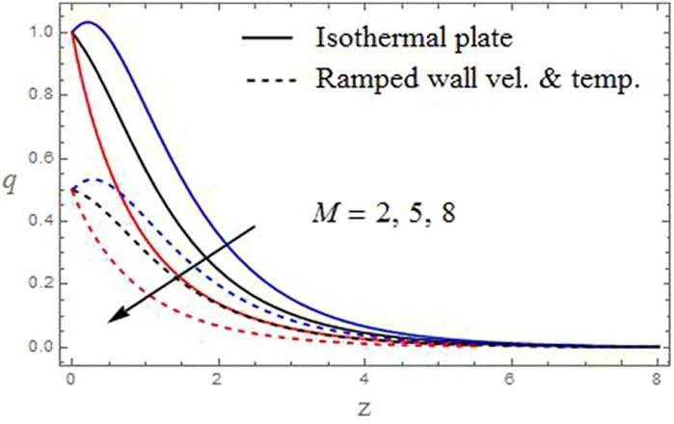
Fig.1. The velocity profiles aginst with M
K=1,R=1,me=1,mi=0.2,λ=1,Pr=0.71,Gr=3,Ra=2,t=0.5

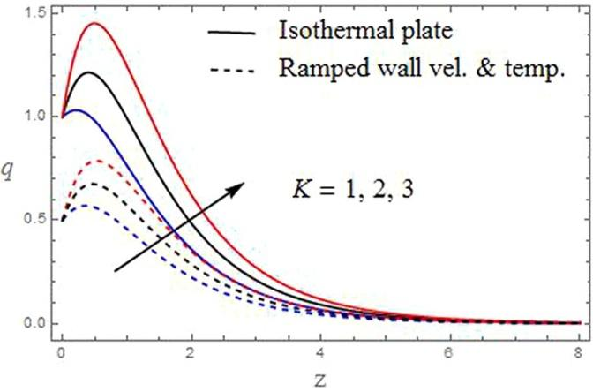
Fig.2. The velocity profiles aginst with K
M=2,R=1,me=1,mi=0.2,λ=1,Pr=0.71,Gr=3,Ra=2,t=0.5

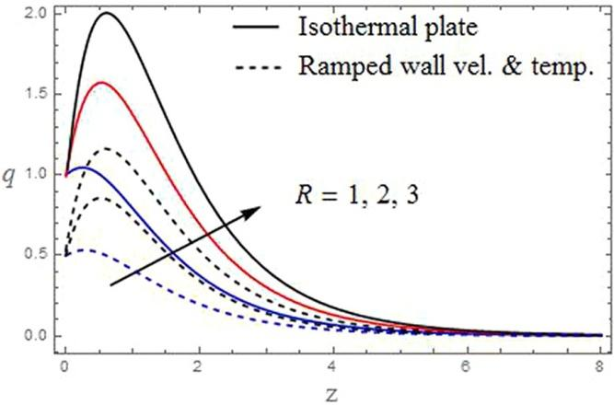

Fig.3. The velocity profiles aginst with R
M=2,K=1,me=1,mi=0.2,λ=1,Pr=0.71,Gr=3,Ra=2,t=0.5

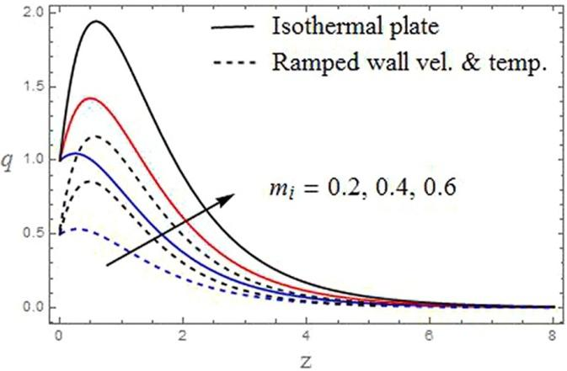
Fig.4. The velocity profiles aginst with mi
K=1,R=1,me=1,M=2 ,λ=1,Pr=0.71,Gr=3,Ra=2,t=0.5
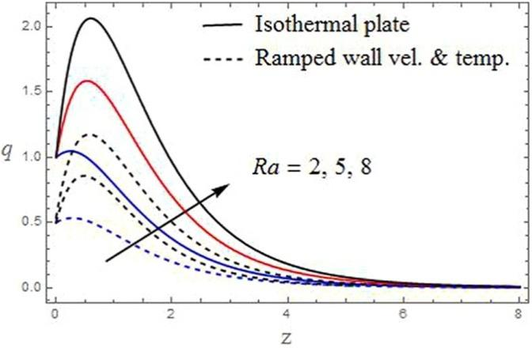
Fig.5. The velocity profiles aginst withRa
K=1,R=1,me=1,mi=0.2,λ=1,Pr=0.71,Gr=3,M=2, t=0.5
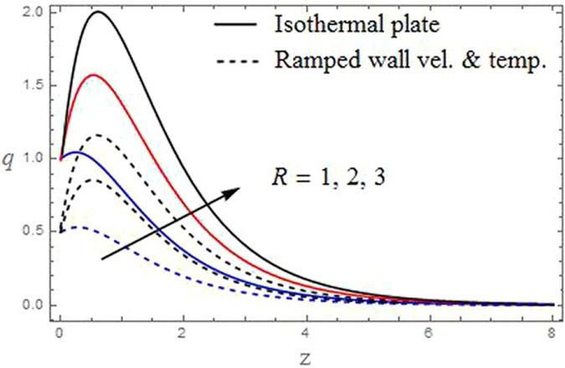
Fig.6. The velocity profiles aginst with t
K=1,R=1,me=1,mi=0.2,λ=1,Pr=0.71,Gr=3,Ra=2,M=2

Table.1.Shear stress
M | K | R | λ | Pr | Gr | R_{a} | m_{e} | m_{i} | t | Ramped wall Velocity and Temperature | Isothermal plate
2 | 0.5 | 1 | 1 | 0.71 | 3 | 2 | 1 | 0.2 | 0.2 | 0.71458 | 0.84567
5 |  |  |  |  |  |  |  |  |  | 0.82536 | 0.98568
8 |  |  |  |  |  |  |  |  |  | 0.94568 | 1.02536
 | 1 |  |  |  |  |  |  |  |  | 0.61547 | 0.84597
 | 1 |  |  |  |  |  |  |  |  | 0.58974 | 0.74897
 |  | 2 |  |  |  |  |  |  |  | 0.59467 | 0.74896
 |  | 3 |  |  |  |  |  |  |  | 0.22365 | 0.68945
 |  |  | 2 |  |  |  |  |  |  | 0.75846 | 0.32548
 |  |  | 3 |  |  |  |  |  |  | 0.80023 | 0.98456
 |  |  |  | 1.38 |  |  |  |  |  | 0.85473 | 0.99874
 |  |  |  | 7.00 |  |  |  |  |  | 1.34456 | 1.35568
 |  |  |  |  | 5 |  |  |  |  | 0.59463 | 2.03569
 |  |  |  |  | 7 |  |  |  |  | 0.58472 | 0.87998
 |  |  |  |  |  | 4 |  |  |  | 0.35489 | 0.84456
 |  |  |  |  |  | 6 |  |  |  | 0.18956 | 0.90567
 |  |  |  |  |  |  | 2 |  |  | 0.78967 | 0.78965
 |  |  |  |  |  |  | 3 |  |  | 1.23568 | 1.22587
 |  |  |  |  |  |  | 0.4 |  |  | 0.98596 | 2.12548
 |  |  |  |  |  |  | 0.6 |  |  | 1.00259 | 1.35489
 |  |  |  |  |  |  |  | 0.4 |  | 0.55268 | 0.78954
 |  |  |  |  |  |  |  | 0.6 |  | 0.59478 | 0.68745

Table.2 Nusselt number
Pr | Ra | t | Ramped wall Velocity and Temperature | Isothermal plate
0.71 | 2 | 0.2 | 0.25689 | 0.789546
1.38 |  |  | 0.29478 | 0.978956
7.00 |  |  | 0.77894 | 1.875967
 | 4 |  | 0.25874 | 0.578946
 | 6 |  | 0.256987 | 0.487967
 |  | 0.4 | 0.448976 | 0.444589
 |  | 0.6 | 0.578965 | 0.378946

4.References.
[1]Veera Krishna, M., Subba Reddy, G., Chamkha, A.J.: Hall effects on unsteady MHD oscillatory free convective flow of second grade fluid through porous medium between two vertical plates. Phy Flu. 30, 023106 (2018). https://doi.org/10.1063/1.5010863
[2] Veera Krishna, M., Chamkha, A.J.: Hall effects on unsteady MHD flow of second grade fluid through porous medium with ramped wall temperature and ramped surface concentration. Phy Flu. 30, 053101 (2018). https://doi.org/10.1063/1.5025542.
[3] Veera Krishna ,M., Chamkha, A.J.: Hall and ion slip effects on Unsteady MHD Convective Rotating flow of Nano fluids—Application in Biomedical Engineering. Journal of the Egyptian Mathematical Society.28,(2020).https://doi.org/10.1186/s42787-019-0065-2
[4] R. Ellahi, M.M. Bhatti, I. Pop, Effects of Hall and ion-slip on MHD peristaltic flow of Jeffrey fluid in a non-uniform rectangular duct, Int. J. Numer. Meth. Heat Fluid Flow 26 (6) (2016) 1802–1820.
[5] M.M. Bhatti, M.A. Abbas, M.M. Rashidi, Effect of Hall and ion-slip on peristaltic blood flow of Eyring Powell fluid in a non-uniform porous channel, World J.
[6] D. Srinivasacharya, Md. Shafeeurrahman, Hall and ion-slip effects on mixed convection flow of nanofluid between two concentric cylinders, J. Assoc. Arab Univ. Basic Appl. Sci. 24 (1) (2017) 223–231
[7] K.S. Jitendra, C.T. Srinivasa, Unsteady natural convection flow of a rotating fluid past an exponential accelerated vertical plate with Hall current, ion-slip and magnetic effect, Multidiscipline Model. Mater. Struct. 14 (2) (2018) 216–235.
[8] M.V. Krishna, A.J. Chamkha, Hall and ion-slip effects on MHD rotating boundary layer flow of nanofluid past an infinite vertical plate embedded in a porous medium, Results Phys. 15 (2019) 102652.
[9] I.A. Sara, M.M. Bhatti, The study of non-Newtonian nanofluid with Hall and ion-slip effects on peristaltically induced motion in a non-uniform channel, RSC Adv. 8 (2018) 7904–7915.
[10] D. Srinivasacharya, K. Kaladhar, Analytical solution for Hall and Ion-slip effects on mixed convection flow of couple stress fluid between parallel disks, Math. Comput. Model. 57 (2013) 2494–2509.
[11] W. Ibrahim, T. Anbessa, Mixed convection flow of nanofluid with Hall and ion- slip effects using spectral relaxation method, J. Egypt. Math. Soc. 27 (2019) 1–22.
[12] M. Nawaz, T. Zubair, Finite element study of three dimensional radiative nano- plasma flow subject to Hall and ion slip currents, Results Phys. 7 (2017) 4111– 4122.
[13] M.V. Krishna, N.A. Ahamad, A.J. Chamkha, Hall and ion slip effects on unsteady MHD free convective rotating flow through a saturated porous medium over an exponential accelerated plate, Alexandria Eng. J. 59 (2020) 565–577.
[14] M.V. Krishna, C.S. Sravanthi, R.S.R. Gorla, Hall and ion slip effects on MHD rotating flow of ciliary propulsion of microscopic organism through porous media, Int. Commun. Heat Mass Transf. 112 (2020) 104500.
[15] M.V. Krishna, A.J. Chamkha, Hall and ion slip effects on MHD rotating flow of elastico-viscous fluid through porous medium, Int. Commun. Heat Mass Transf. 113 (2020) 104494.
[16] M.V. Krishna, Hall and ion slip effects on MHD free convective rotating flow bounded by the semi-infinite vertical porous surface, Heat Transfer 49 (4) (2020) 1920–1938.
[17] M.V. Krishna, Hall and ion slip effects on MHD laminar flow of an elastic- viscous (Walter’s-B) fluid, Heat Transfer 49 (4) (2020) 2311–2329.
[18] M.V. Krishna, A.J. Chamkha, Hall and ion slip effects on Unsteady MHD convective rotating flow of nanofluids - application in biomedical engineering, J. Egypt. Math. Soc. 28 (1) (2020) 1–14.
[19] W. Ibrahim, T. Anbessa, Hall and ion slip effects on mixed convection flow of Eyring-Powell nanofluid over a stretching surface, Adv. Math. Phys. 2020 (2020) 1–16.
[20] F.S. Ibrahim, A.M. Elaiw, A.A. Bakr, Effect of the chemical reaction and radiation absorption on the unsteady MHD free convection flow past a semi infinite vertical permeable moving plate with heat source and suction, Commun. Nonlinear Sci. Numer. Simulat. 13 (2008) 1056–1066.
[21] A.O. Ajibade, A.M. Umar, Effect of chemical reaction and radiation absorption on the unsteady MHD free convection Couette flow in a vertical channel filled with porous materials, Afr. Mat. 27 (2016) 201–213.
[22] M.V. Krishna, Hall and ion slip impacts on unsteady MHD free convective rotating flow of Jeffreys fluid with ramped wall temperature, Int. Commun. Heat Mass Transfer 119 (2020) 104927.

