Hire Ready AI: An AI-Powered Resume Builder and Mock Interview Preparation System

- Introduction
Preparing for job interviews is crucial for securing em-ployment. However, many candidates rely on traditional methods like studying written materials or enrolling in coach-ing programs, which often lack personalized feedback and immediate responses. This can lead to difficulties with com-munication, confidence, and organized preparation. Fortu-nately, advancements in artificial intelligence now enable the creation of simulated interview environments that provide real-time evaluations. Technologies such as natural language processing, machine learning, and speech recognition em-power these systems to analyze responses and offer valuable insights. This document introduces Hire Ready AI, a plat-form that consolidates resume building and interview prac-tice into a unified system. Its objective is to provide users with continuous feedback, helping them to systematically and effectively improve their performance. The platform also features adaptive learning systems that monitor user advancement and adjust question difficulty based on indi-vidual performance. By pinpointing common areas of weakness, such as unclear explanations, a lack of structure, or low confidence, the

system offers tailored advice for enhancement. It fur-ther simulates various interview settings, encompassing technical, behavioral, and HR interviews, to ensure com-prehensive preparation. This ongoing, personalized feed-back mechanism assists users in developing consistency, improving the quality of their responses, and cultivating the self-assurance necessary for effective performance in actual interviews.

- Literature review
In recent years, the adoption of AI-driven interview sys-tems and resume analysis tools has surged. A multitude of platforms now provide mock interview environments, al-lowing individuals to practice and receive automated feed-back. These systems typically leverage existing datasets and standard assessment methodologies.
Resume parsing tools utilize natural language pro-cessing to extract relevant data from resumes. While bene-ficial, many of these tools fall short in comprehensively evaluating communication skills, confidence levels, and be-havioral attributes.
Currently, most available solutions focus on either re-sume creation or interview preparation in isolation. This creates a demand for an integrated system capable of deliv-ering a holistic evaluation and personalized feedback across a spectrum of essential skills.
Many current platforms utilize fixed question banks and rigid evaluation methods, which can hinder their capacity to cater to individual user needs and the ever-changing de-mands of the industry. These systems often lack a deep un-derstanding of context and are unable to replicate the dy-namic nature of actual interviews.

- System architecture
The architecture follows a layered client–server framework consisting of:
- User Interaction Layer

Accepts user inputs consisting of resume add, inter-view responses (textual content/voice), and shows outputs including generated questions, feedback, and performance rankings via an interactive interface.
- Utility Layer
The software layer methods user inputs, validates resume information, and manages interview waft. It ensures comfy conversation between the frontend and backend at the same time as dealing with session control and response formatting.
- Server Layer
The server handles incoming requests and routes them to suitable device components. It coordi-nates among the resume database, LLM module, NLP engine, and evalua-tion gadget to preserve efficient facts drift.
- AI Processing Module
This module makes use of a massive Language version (LLM) to generate interview questions based on resume in-formation. NLP strategies analyze user responses, at the same time as voice inputs are processed to access conversa-tion and self-belief ranges.
- Evaluation and Remarks Module
This element calculates performance ratings and stores consequences in databases. It affords based comments, in-clusive of strengths and weaknesses, and shows them at the dashboard for continuous consumer development.
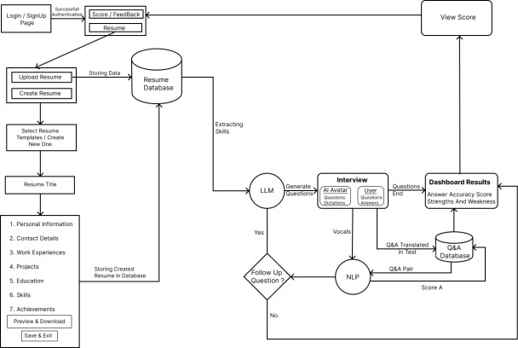
Figure 1: System Architecture

- Methodology
The system follows a sequential multimodal pipe-line:
- User registers/login and submits personal details along with resume data.
- System extracts relevant information and gen-erates context-aware interview questions using LLMs.
- User responds to questions through text or voice in-put.

- Voice responses are converted into text using speech
recognition technology.
- NLP processes analyze responses for accuracy, rel-evance, and fluency.
- Voice analysis evaluates tone, speech patterns, and confidence levels.
- System computes scores and generates struc-tured feedback reports.
- Results are stored in the database and displayed on the dashboard with strengths and weak-nesses.

- Mathematical model
To evaluate multimodal output quality, a composite scoring function is introduced:
Q=wTT+wCC+wFF+wRR
Where:
T = Text accuracy SCORE
C = Communication quality score
F = Confidence score
R = RESUME RELEVANCE SCORE WEIGHTS SATISFY:
𝑤_{T} + 𝑤_{C} + 𝑤_{𝐹} + 𝑤_{R} = 1

This weighted evaluation ensures balanced assess-ment across modalities.
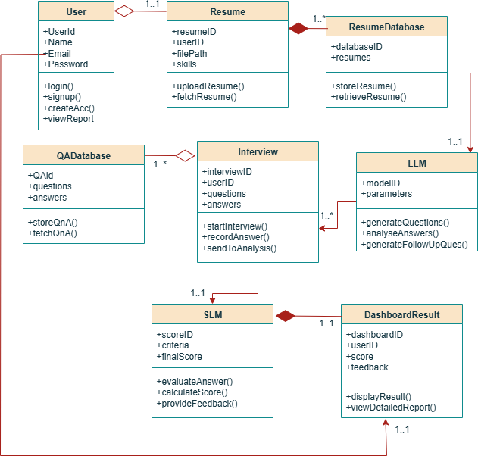

Figure 2: Class Diagram

- Experimental results and discussion

Testing of the prototype revealed that it successfully pro-duced context-sensitive interview questions and effectively assessed user answers. The system was capable of processing both textual and vocal inputs, delivering relevant feedback that corresponded with user performance.

It ensured a reliable connection between its various

components, facilitating smooth transitions among resume evaluation, question formulation, and answer assessment.
The assessment of performance showed that the time taken for question creation and NLP analysis was satisfac-tory, while voice recognition demanded a moderate level of computational power. Stress testing verified that the system operated steadily with multiple user sessions, maintaining consistent response management and feedback provision.

Some challenges faced included enhancing the accuracy of response evaluation and fine-tuning speech analysis to boost confidence detection. Ongoing improvements to the model contributed to better quality of feedback, uniformity in scoring, and greater overall dependability of the system.
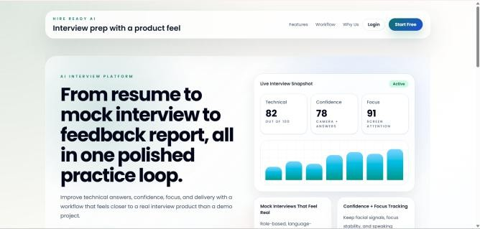

Figure 3: Home Page
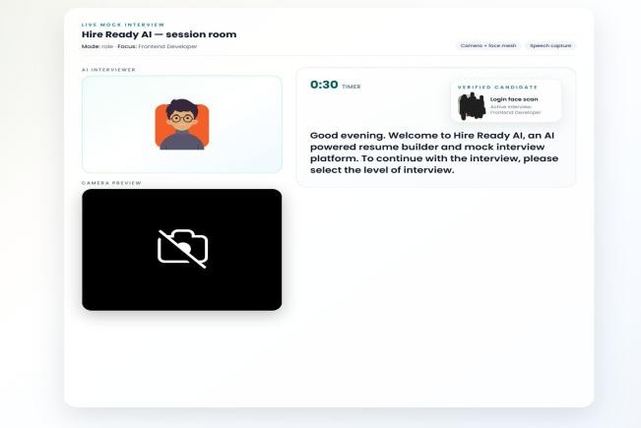
Figure 4: Interview Session
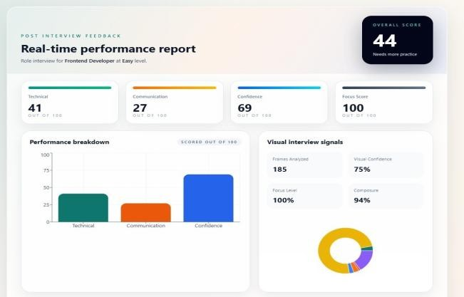
Figure 5: Generated Feedback
Performance Metrics
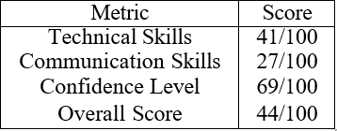

Table 1: Candidate Performance Metrics

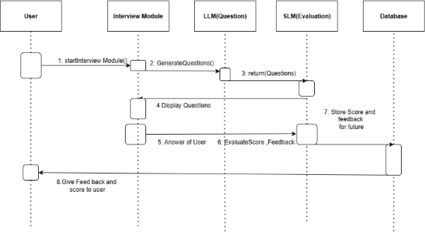

The comparison highlights the integrated nature of HireReady AI.

Figure 6: Sequence Diagram

- Conclusion
HireReady AI – This document introduced Hire Ready AI, an artificial intelligence-driven platform aimed at help-ing individuals create resumes and prepare for interviews. Utilizing advanced techniques such as natural language processing, speech analysis, and machine learning, the plat-form offers instant feedback and assessments. Findings in-dicate that users can enhance their skills through ongoing practice and tailored advice. The system is built to be both scalable and flexible, catering to a diverse audience. In summary, Hire Ready AI proves to be a valuable resource for improving interview readiness.

Acknowledgment
The researchers express their heartfelt gratitude to the pro-ject supervisor and the Computer Engineering Department for their invaluable guidance and assistance throughout this re-search endeavor. The support from the institutional facilities and technical resources was instrumental in executing the proposed system.

References
- J. Manuel et al., “Q&AI: AI-powered mock inter-view bot,” IEEE, 2023.
- R. A. M. Rajeswari et al., “InterviewIQ: AI chat-bot for candidates,” IEEE, 2023.
- R. M. Marvaniya et al., “Smart Prep: AI-based in-terview system,” IJCS, 2023.
- Y. Liang et al., “Resume parsing using multi-task learning,” IEEE, 2023..
- S. V. Golande et al., “AI mock interview evalua-tor,” 2025.
- S. Mohanty et al., “Resumate: NLP-based recruit-ment system,” IEEE, 2023.

