AAZHI ARAN:LORAWAN-ENABLED INTELLIGENT MARITIME BORDER SECURITY AND CREW SAFETY SYSTEM

Mrs. S.S.Karthigaa Devi*, Sandeep K**, Cibi Charles J**, Murali Krishnan S**,Karthikeyan S **
* Assistant Professor, IT, Hindusthan Institute of Technology, Coimbatore
** Student, Fourth year, IT, Hindusthan Institute of Technology, Coimbatore

Abstract- Fishing communities operating in remote maritime environments face significant safety challenges due to unreliable communication systems, unclear international sea borders, harsh weather conditions, and delayed emergency response. These factors often lead to accidental border crossings and hazardous situations, threatening the lives of fishermen. To address these issues, this paper proposes a LoRaWAN-Enabled Intelligent Maritime Border Security and Crew Safety System that provides a reliable and energy- efficient solution for enhancing maritime safety.
The proposed system is built using an ESP32 LoRa module integrated with a GPS module, DHT11 temperature and humidity sensor, air quality sensor, DC motor with motor driver, buzzer, LCD display, and an emergency switch. The GPS module continuously monitors the real-time location of the fishing boat, while predefined maritime boundary coordinates are used to detect proximity to restricted zones. Environmental conditions inside the boat are monitored using the DHT11 and air quality sensors to ensure crew safety.
The system operates on a three-level safety mechanism. Level 1 provides early warnings through visual and audible alerts, Level 2 issues danger alerts with motor speed reduction, and Level 3 initiates critical actions such as automatic motor reversal to prevent border crossing. Environmental threshold violations also trigger alerts to notify the crew.
In emergency situations, fishermen can activate the emergency switch to transmit distress signals along with GPS coordinates via LoRaWAN. The system also supports boat-to-boat communication, enabling nearby vessels to share alerts and assist each other without relying on cellular networks.
The proposed system is cost-effective, reliable, and suitable for small-scale fishing operations. It enhances safety by integrating border monitoring, environmental sensing, and long-range communication in a single platform.

Keywords: LoRaWAN, Maritime Safety, Border Security, GPS Tracking, Air Quality Monitoring, ESP32, Emergency Communication, Smart Fishing System.

I. Introduction

Fishing communities operate in some of the most challenging and unpredictable environments, where safety risks are significantly high due to harsh maritime conditions. The open sea presents numerous dangers such as rough weather, strong currents, equipment failures, and limited access to timely emergency assistance. Many small-scale fishing boats still rely on traditional navigation methods, which often lack accuracy and reliability. This limitation frequently results in accidental crossing of international maritime boundaries, leading to serious legal consequences and safety concerns.

In addition to navigation challenges, onboard environmental conditions play a critical role in ensuring the health and safety of fishermen. Poor ventilation within fishing vessels can lead to the accumulation of harmful gases and oxygen deficiency. Furthermore, high temperature and humidity levels can cause dehydration, heat stress, and discomfort, thereby reducing operational efficiency and increasing health risks.

Communication is another major challenge in maritime environments. Conventional communication systems such as VHF radios have limited range and may not function effectively over long distances. Similarly, cellular networks become unavailable once boats move far from the coastline. Although satellite communication systems provide reliable connectivity, their high cost makes them impractical for small and medium-scale fishermen.

Recent advancements in the Internet of Things (IoT) have enabled the development of smart and cost-effective solutions for remote monitoring and safety applications. Among these technologies, LoRaWAN has emerged as a promising communication protocol due to its long-range capability and low power consumption. By integrating LoRaWAN with GPS tracking, environmental sensors, and automated control mechanisms, it is possible to design a comprehensive maritime safety system.

The proposed LoRaWAN-Enabled Intelligent Maritime Border Security and Crew Safety System aims to address these challenges by providing real-time location monitoring, maritime boundary detection, environmental sensing, and emergency communication. The system ensures improved safety, enhanced situational awareness, and reliable long- range communication for fishermen operating in remote marine environments.

II BLOCK DIAGRAM

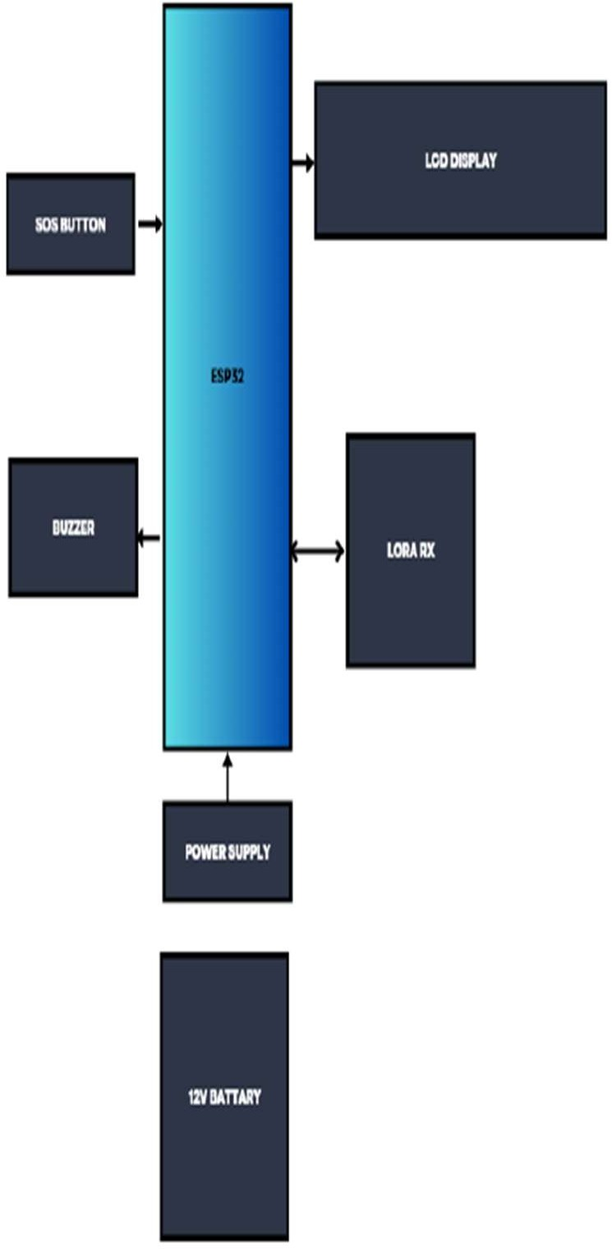

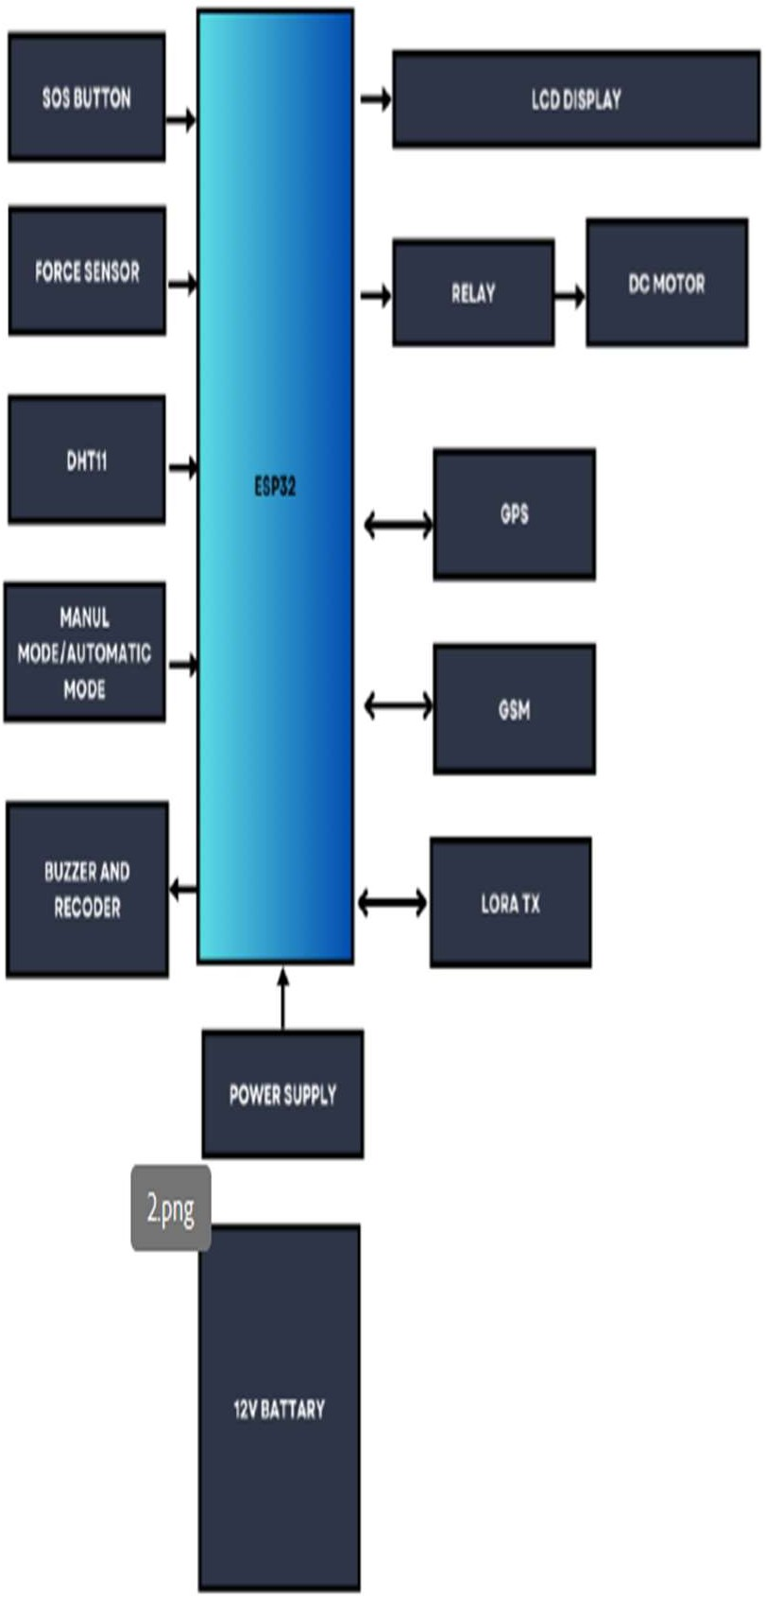
Fig 2.1: Transmitter side
Fig:2.2 Receiver side

FEASIBILITY STUDY

Feasibility Study

Feasibility analysis is an essential phase in system design that determines whether a proposed system is practical, implementable, and sustainable. The proposed Aazhi Aran: LoRaWAN-Enabled Intelligent Maritime Border Security and Crew Safety System is evaluated in terms of technical and economic aspects. The study confirms that the system is achievable using existing technologies and effectively addresses real-world maritime safety challenges.

Technical Feasibility

The proposed system is technically feasible as it utilizes established IoT and communication technologies. LoRaWAN provides long-range, low- power communication suitable for remote maritime environments where conventional networks are unavailable. The system is built using an ESP32 LoRa module integrated with GPS, DHT11, air quality sensors, LCD display, buzzer, motor driver, and emergency switch, all of which are widely available and easy to interface.
Software implementation involves storing predefined maritime boundary coordinates and performing distance calculations using standard algorithms. The three-level safety mechanism and motor control operations are implemented through simple and reliable programmed logic. Additionally, LoRa enables boat-to-boat communication without requiring internet connectivity, ensuring robustness in open sea conditions. Hence, the system is technically viable and reliable.

Economic Feasibility

The system is economically feasible as it is designed using low-cost and readily available components. Unlike expensive satellite communication systems, LoRaWAN eliminates recurring network costs while providing long-range connectivity. The overall system cost, including sensors, communication modules, and control components, remains affordable for small-scale fishermen.
The system is also energy-efficient, reducing long-term operational costs. Its benefits, such as preventing border violations, improving safety, and enabling quick emergency response, outweigh the implementation cost. Therefore, the project is cost- effective and financially practical.

System Design

The system design describes the overall architecture and operation of the proposed maritime safety system. It integrates LoRaWAN communication, GPS-based location tracking, environmental monitoring, and automated control mechanisms.
The GPS module continuously tracks the boat’s location and compares it with predefined maritime boundaries. Based on proximity, a three-level alert mechanism is activated. Environmental sensors monitor onboard conditions, while the controller initiates preventive actions such as motor speed reduction or reversal when necessary. The system also enables long-range communication for distress alerts and boat-to-boat interaction, ensuring reliable operation in remote areas.

Data,Input,Output Design

    - Data Design

The system processes various types of data, including GPS coordinates, environmental parameters, alert levels, and emergency signals. Real-time data is analyzed by the controller, and critical information is transmitted via LoRaWAN. The system ensures efficient and reliable data handling for safety monitoring.

Input Design

Inputs are collected from GPS modules, environmental sensors, and emergency switches. These inputs provide real-time location, environmental conditions, and manual distress signals, enabling accurate monitoring and timely response.

Output Design

Outputs include visual and audible alerts, automated motor control actions, and LoRa-based communication signals. The system generates multi-level warnings, sends emergency alerts with location data, and activates preventive mechanisms to enhance safety.

Problem Definition

Fishing communities face several challenges due to limited communication and lack of safety systems in maritime environments. Accidental border crossing occurs due to the absence of real-time navigation alerts, leading to legal issues. Communication gaps arise as GSM networks fail in deep sea regions, and satellite systems are expensive. Emergency response is often delayed due to the inability to transmit accurate location data. Additionally, onboard environmental conditions such as high temperature, humidity, and harmful gases pose health risks. The absence of automated safety mechanisms further increases vulnerability.
To address these issues, the proposed system integrates GPS tracking, environmental monitoring, long-range communication, and automated control features into a single platform, providing a reliable and cost-effective solution for improving maritime safety.

REQUIREMENT ANALYSIS

Requirement analysis is a crucial phase in system development that identifies user needs, system functionalities, and technical resources required for successful implementation. For the proposed Aazhi Aran: LoRaWAN- Enabled Intelligent Maritime Border Security and Crew Safety System, this phase ensures that the system effectively

addresses real-world maritime safety challenges. The requirements are categorized into user requirements, system requirements, and software requirements.

User Requirements

The primary users of the system are fishermen operating in remote maritime environments. They require real-time GPS-based location monitoring to avoid accidental crossing of international boundaries. The system must provide early warning alerts using visual and audible indicators and implement preventive actions such as motor speed reduction and reversal.

Reliable long-range communication is essential due to the unavailability of GSM networks in deep sea areas. Therefore, the system must support LoRaWAN- based communication for emergency alerts and boat- to-boat interaction. Additionally, fishermen require a simple emergency distress mechanism that transmits GPS coordinates during critical situations.

Environmental monitoring is also necessary to ensure onboard safety by tracking temperature, humidity, and air quality. The system must be cost- effective, easy to use, and require minimal maintenance to ensure accessibility for small-scale fishermen.

System Requirements

The system is designed using hardware components such as the ESP32 LoRa module, GPS module, DHT11 sensor, air quality sensor, LCD display, buzzer, motor driver with DC motor, emergency switch, and power supply unit. These components work together to enable real-time monitoring, communication, and automated safety control.

Functionally, the system continuously tracks the boat’s location and compares it with stored maritime boundaries to detect proximity. A three-level alert mechanism is implemented to provide warnings and initiate preventive actions. The system also monitors environmental conditions and supports emergency communication through LoRa. Additionally, boat-to- boat communication enhances coordination and safety.

Non-functional requirements include high reliability, energy efficiency, durability in harsh marine conditions, scalability for future enhancements, and real-time response to ensure immediate alerts and actions.

Software Requirements

The software implementation is based on embedded programming using C/C++ in development environments such as Arduino IDE or ESP-IDF. The system utilizes LoRaWAN protocol for long-range, low-power communication.

Key software modules include GPS processing, boundary detection, sensor monitoring, alert control,
emergency communication, and boat-to-boat communication. These modules ensure real-time data processing, efficient computation, and fast response. The system is designed to handle continuous data acquisition, provide accurate alerts, and maintain reliable communication in maritime environments.

V METHODOLOGY

Method

The proposed Aazhi Aran: LoRaWAN-Enabled Intelligent Maritime Border Security and Crew Safety System is designed to enhance maritime safety by integrating GPS- based tracking, LoRaWAN communication, environmental monitoring, and automated control mechanisms. Traditional navigation methods lack reliability in deep-sea environments, leading to risks such as accidental border crossing and communication failure.
To overcome these challenges, the system continuously monitors the boat’s location using GPS and compares it with predefined maritime boundary coordinates. A three-level safety mechanism is implemented to provide alerts, reduce motor speed, and initiate automatic motor reversal when necessary. Environmental sensors monitor onboard conditions, while LoRaWAN ensures long-range communication for distress alerts and boat-to-boat interaction. This integrated approach improves safety, communication reliability, and operational efficiency.

Data Acquisition and Monitoring

The system collects real-time data from multiple sources, including GPS, environmental sensors, and LoRa communication modules. The GPS module provides continuous location tracking, which is used for boundary detection. Environmental sensors measure temperature, humidity, and air quality to ensure crew safety. LoRaWAN enables long-range transmission of location data and alerts without relying on cellular networks.

Data Processing and Analysis

The acquired data is processed by the microcontroller using embedded algorithms. GPS coordinates are compared with stored boundary values to determine proximity levels. Based on this analysis, the system generates alerts and activates appropriate safety mechanisms. Sensor data is also analyzed to detect abnormal environmental conditions, ensuring real-time decision-making and improved situational awareness.

Control and Protection Mechanism

The system implements an automated three-level safety mechanism. The first level provides warning alerts, the second level reduces motor speed, and the third level activates motor reversal upon boundary crossing. Additionally, emergency distress signals with GPS coordinates are transmitted via LoRaWAN, enabling quick response from nearby boats or monitoring stations. These automated controls reduce human error and enhance safety.

LoRaWAN-Based Communication

LoRaWAN enables reliable long-range communication for real-time data transmission, boat- to-boat communication, and emergency alerts. It ensures connectivity in remote marine regions where conventional networks are unavailable, thereby improving coordination and response during critical situations.

System Implementation and Testing
The system is tested to ensure reliability and performance. GPS testing verifies accurate location tracking and boundary detection, while sensor testing ensures proper environmental monitoring. LoRa communication is evaluated for long-range data transmission, and the safety mechanism is tested for correct alert generation and motor control. Emergency alert functionality is also validated to ensure timely transmission of distress signals.

IMPLEMENTATION AND MAINTENANCE

Implementation

The implementation phase describes the deployment and operation of the Aazhi Aran: LoRaWAN-Enabled Intelligent Maritime Border Security and Crew Safety System. The system integrates GPS tracking, LoRaWAN communication, environmental sensors, and automated safety mechanisms to enhance maritime safety. It consists of two main modules: the Fishermen Module and the Monitoring Authority Module.

The Fishermen Module operates onboard the boat and provides real-time monitoring of location, environmental conditions, and safety alerts. During system initialization, the microcontroller activates the GPS, LoRa module, and sensors to collect real- time data. The system continuously compares GPS coordinates with predefined maritime boundaries to detect proximity.

A three-level safety mechanism is implemented: initial warning alerts, automatic motor speed reduction, and motor reversal upon boundary crossing. In emergency situations, fishermen can trigger a distress alert, which transmits GPS coordinates via LoRaWAN. The system also supports boat-to-boat communication for improved coordination in remote areas.

The Monitoring Authority Module operates at coastal stations and receives data through a LoRa gateway. Authorities can monitor boat locations, detect boundary violations, and respond to emergency alerts. Real-time GPS data enables quick identification of distressed vessels, improving rescue operations and maritime supervision.

Maintenance

Maintenance ensures long-term reliability and performance of the system in harsh marine environments.

Sensor maintenance includes periodic calibration, cleaning, and replacement to ensure accurate environmental monitoring. Software maintenance involves firmware updates and system optimization to improve performance and reduce errors.

Communication maintenance focuses on checking LoRa modules, antenna alignment, and network performance to ensure reliable long-range communication. Hardware maintenance includes inspection of GPS modules, motor control systems, and power supply units to maintain proper functionality.

Finally, system safety and data management involve regular data logging, backup, and performance evaluation. These practices help in identifying system improvements and ensuring efficient operation, reliability, and enhanced maritime safety over time.

HARDWARE AND SOFTWARE REQUIREMENTS

Hardware Requirements
The hardware components of the proposed system are selected to ensure reliable operation, real-time monitoring, and efficient communication in maritime environments. These components collectively support navigation tracking, environmental sensing, communication, and safety control mechanisms.

ESP32-WROOM-32
The ESP32-WROOM-32 is the core processing unit of the system, featuring a dual-core processor with integrated Wi-Fi and Bluetooth. It provides sufficient memory, multiple I/O interfaces, and supports various communication protocols. The module is suitable for custom PCB design and simplifies development due to its pre-certified design.

GPIO Pins
The ESP32 includes multiple GPIO pins that support digital, analog, and capacitive touch functionalities. These pins can be configured as input or output based on system requirements. Some pins are input-only and lack internal pull-up/down resistors, requiring careful usage during system design.

Power Supply Unit
power supply converts AC input into a stable DC output required for electronic components. It consists of a transformer, rectifier, filter, and voltage regulator. A 7805 regulator is used to provide a constant 5V DC supply for the microcontroller and sensors, ensuring stable and safe operation.

LCD Display
A 16×2 LCD display is used to present real-time information such as GPS coordinates, environmental data, and safety alerts. It is based on the HD44780 controller and supports both 4-bit and 8-bit interfacing modes.

LoRa Technology (SX1278)
LoRa is a low-power, long-range wireless communication technology used for transmitting data over distances up to 15–20 km. The SX1278 module operates at

433 MHz and enables reliable communication without cellular networks, supporting both data transmission and boat-to-boat communication.

GSM SIM800A Module
The GSM SIM800A module provides GSM/GPRS communication for SMS, voice, and data transfer. It operates on dual-band frequencies and supports AT commands for interfacing with microcontrollers, enabling backup communication when required.

GPS Module (NEO-6M)
The GPS module continuously tracks the boat’s location by receiving satellite signals and provides latitude and longitude data. This data is used for maritime boundary detection and emergency location sharing.

ESP32 Microcontroller
The ESP32 microcontroller acts as the central control unit, processing GPS data, sensor inputs, and controlling safety mechanisms. It supports multiple communication protocols such as UART, SPI, I2C, ADC, and DAC, making it suitable for complex IoT applications.

DHT11 Sensor
The DHT11 sensor measures temperature and humidity with reliable accuracy. It operates within a defined range and provides digital output, making it suitable for environmental monitoring inside the boat.

DC Motor
The DC motor is used to control the movement of the boat. Its speed and direction can be adjusted by varying voltage and polarity, enabling automated safety actions such as speed reduction and reversal.

L298N Motor Driver
The L298N motor driver is a dual H-bridge driver that controls motor speed and direction using PWM and logic signals. It enables precise control of DC motors required for safety mechanisms.

FlexiForce A401 Sensor
The FlexiForce A401 is a thin, flexible force sensor used to measure pressure or load. It is suitable for compact embedded applications and can be integrated into safety monitoring systems.

Buzzer
A buzzer is used as an audio signaling device to provide alerts and warnings. It generates sound based on electrical signals and is widely used in safety and notification systems.

Programming Environments
The ESP32 supports multiple programming environments such as Arduino IDE, PlatformIO, MicroPython, and ESP-IDF. In this system, Arduino IDE is primarily used due to its simplicity and ease of development.

OUTPUT AND DICUSSION
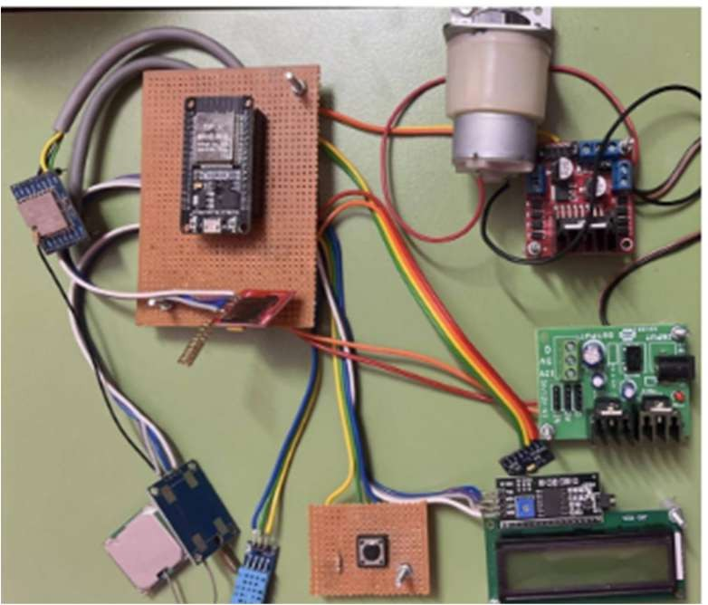
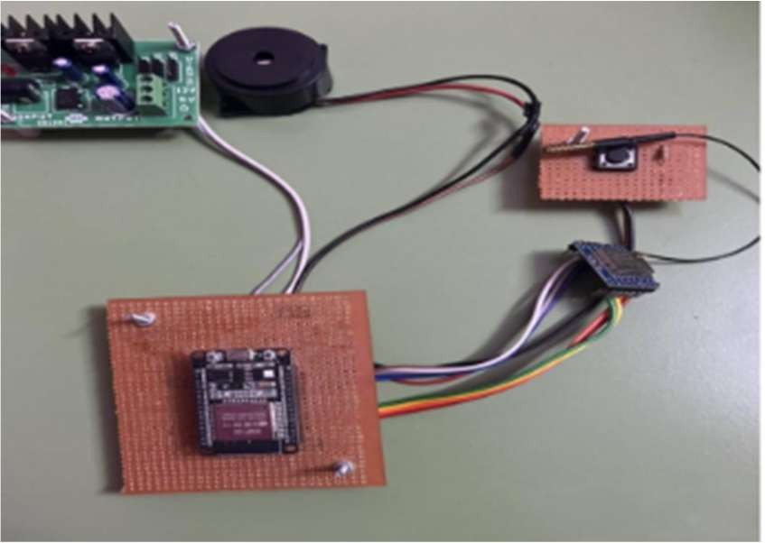

Fig 8.1 Hardware images
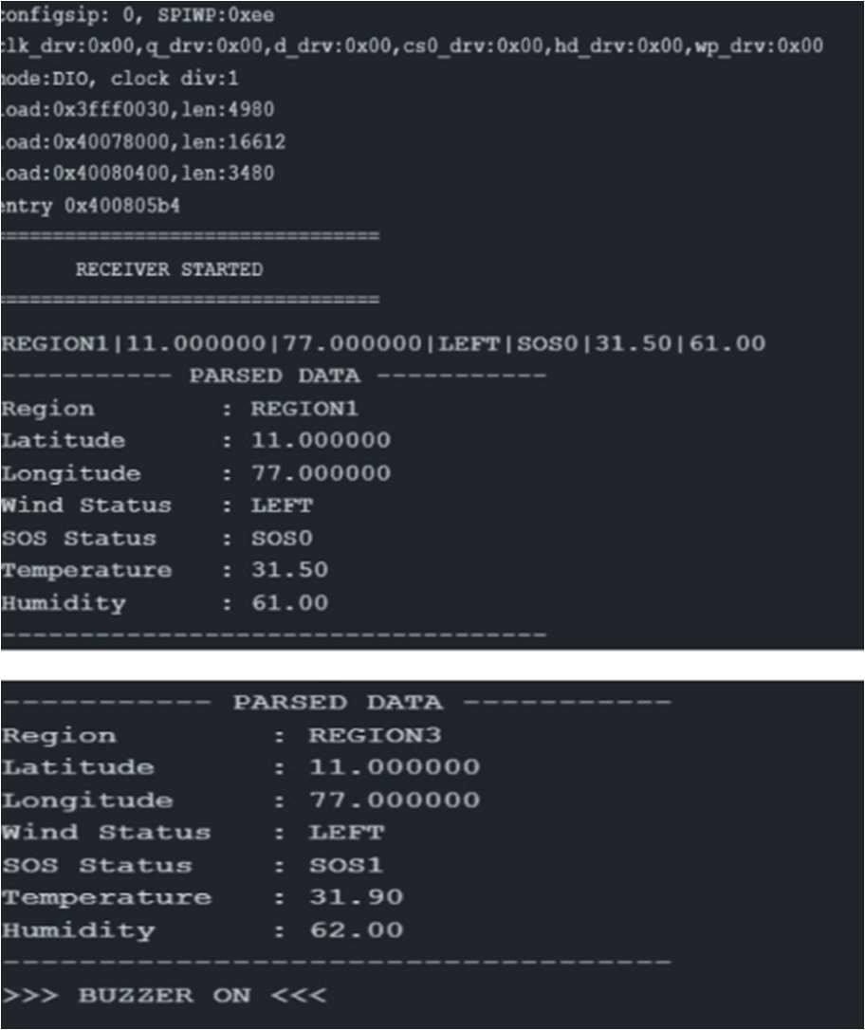

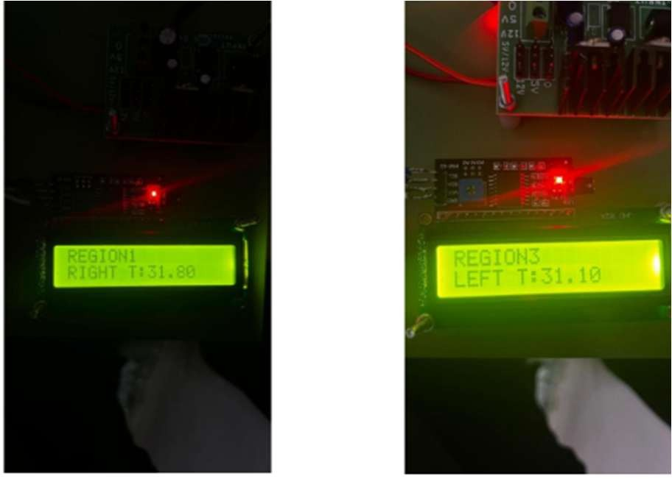

Fig 8.2 Output images

The obtained outputs demonstrate the effective functioning of the proposed Aazhi Aran: LoRaWAN- Enabled Intelligent Maritime Border Security and Crew Safety System under real-time conditions. The hardware output confirms successful integration of all components, including the ESP32 microcontroller, LoRa module, GPS module, sensors, buzzer, and motor driver. The compact hardware arrangement indicates that the system can be practically deployed on fishing boats with minimal space and power requirements.

From the software output, it is observed that the system accurately receives and processes transmitted data. The parsed data includes region identification, latitude, longitude, wind status, SOS status, temperature, and humidity. This confirms that the LoRa communication between transmitter and receiver modules is functioning correctly, with reliable data transmission over distance.

The comparison between two outputs shows dynamic system behavior. In the first case, the SOS status is normal (SOS0), and the system operates under safe conditions without triggering alerts. In the second case, the SOS status changes to SOS1, indicating a critical situation. As a result, the system activates the buzzer, demonstrating proper execution of the alert mechanism. This validates the system’s ability to respond to emergency conditions in real time.

Environmental parameters such as temperature and humidity are also monitored continuously, and slight variations between outputs indicate real-time sensing capability. The consistent GPS coordinates confirm accurate location tracking, which is essential for maritime boundary detection.

Overall, the outputs verify that the system successfully integrates hardware and software components to provide real-time monitoring, reliable communication, and immediate safety alerts. The ability to detect status changes and trigger appropriate responses highlights the effectiveness of the system in enhancing maritime safety and reducing risks for fishermen operating in remote sea regions.

ADVANTAGES

  - Long-range communication ensures remote connectivity. 2.Low-power modules save onboard energy.
3.Automated motor control prevents crossings. 4.Boat-to-boat alerts work without internet.

DISADVANTAGES

  - Boundaries require predefined coordinate storage.
  - Manual activation triggers distress alerts.

CONCLUSION

The proposed LoRaWAN-Enabled Intelligent Maritime Border Security and Crew Safety System has been successfully designed and implemented to enhance the safety of fishermen operating in remote maritime environments. The system integrates GPS-based navigation tracking, environmental sensing, automated motor control, and long-range LoRaWAN communication into a unified embedded platform. By continuously monitoring the boat’s location and comparing it with predefined maritime boundaries, the system effectively minimizes accidental border crossings and associated risks.

The implementation of a multi-level safety alert mechanism ensures timely warnings and automated corrective actions during critical situations, thereby reducing reliance on manual intervention. In addition, environmental monitoring using temperature, humidity, and air quality sensors enables early detection of hazardous onboard conditions, improving overall crew safety. The use of LoRaWAN technology ensures reliable communication over long distances, allowing distress alerts and GPS data to be transmitted even in areas without cellular or internet connectivity.
Overall, the system is cost-effective, energy-efficient, and reliable, making it suitable for deployment in small- scale fishing vessels. By improving situational awareness, enhancing emergency response capabilities, and ensuring safer navigation, the proposed system significantly contributes to maritime safety and supports sustainable fishing operations.

REFERENCES

- W. W. C. D. Fernando and M. A. A. Karunarathna, “A Portable IoT and Lora-Enabled Safety and Communication Framework for Small-Scale Fishing Vessels,”International Journal of Research and Innovation in Applied Science (IJRIAS), vol.10,no.9,Sept.2025.

- D. Amarnath, G. Renganayahi, S. Abirami, and A. Kayalvizhi, “IoT based Fisherman Border Alert System,” International Journal of Advanced Research in
Science, Communication and Technology (IJARSCT), vol. 5, no. 2, pp. 107-111, Feb.2025.

- S. Kancharla, S. Gundu, N. Pavani, and T. Suman, “Border Alert System for Fisherman using GPS and GSM,” International Journal of Engineering & Science Research (IJESR), vol. 15, no. 1s, pp. 302- 308, Jan.-Mar. 2025.

- T. Menakadevi, R. Charitha, S. Harini, and L. Keerthana, “Smart Marine Border Monitoring and Fisherman Safety Alert System,” Alochana Journal, vol. 14,no.7,pp.371-376,2025.

- P. Manne, E. Kavya, G. Jahnavi, and K. Manasa, “LORA Frequency Communication Based Safety and Security System for Fishermen,” Journal of Nonlinear Analysis and Optimization (JNAO), vol. 15, no. 2, pp. 127-133, 2024.

- N. A. Abdul Latiff, I. S. Ismail, N. F. Munajat, and M. R. Awal, “Evaluating the Efficacy of Long- Range Technology in Boat Tracking Systems,” Journal of
Engineering Science and Technology (JESTEC), vol. 19, no. 4, pp. 1221-1234, Aug.2024.

- B. A. Apriliansyah and M. Iqbal, “LoRa based long-range traceable life jacket system design,” BIO Web of Conferences, vol. 106, p. 01003, 2024.

- E. Charumathi, N. Ragavi, S. Umamaheswari, and S. Senthazhai, “LoRa Based Fisherman Border Alert and Weather Alert Security System,” International Journal of Research Publication and Reviews (IJRPR), vol. 5, no. 3, pp. 2881-2884, Mar.
2024.

- R. Karthikeyan, P. Manikandan, S. Praveen,“Smart Maritime Border Alert System for Fishermen Using GPS and IoT,”International Journal of Engineering Research and Applications, 2024.

- S. Rajesh, M. Praveena, K. Lavanya,“LoRa Based Long Range Communication System for Marine Monitoring,”IEEE International Conference on IoT and Communication Systems, 2024.

- G. Amsaveni, R. Purnachandrigaa, M. Selvanayaki, and S. Vishnupriya,“Border Alert System for Fishermen Using GPS,” International Advanced Research Journal in Science, Engineering and Technology (IARJSET), vol. 10, no. 3, pp. 63-
66, March 2023.

- A. Senthil Kumar, P. Karthick, R. Saravanan,“Real Time Fisherman Safety System Using GPS and Wireless Communication,”International Journal of Scientific Research in Computer Science, 2023.

- M. Nithin, V. Arun Kumar, K. Rakesh,“Design of IoT Based Smart Marine Monitoring System,”International Journal of Advanced Computer Science and Applications, 2023.
- M. Nithin, V. Arun Kumar, K. Rakesh,“Design of IoT Based Smart Marine Monitoring System,”International Journal of Advanced Computer Science and Applications, 2023.

- B. A. Anandh, et al., “Alert system of fisherman for secure navigation,” Journal of Physics: Conference Series, vol. 2267, no. 1, p. 012007, 2022.

- S. K. Sharma, R. Gupta,“Long Range Communication in IoT Using LoRa Technology,”IEEE International Conference on Communication Systems, 2021.

- J. Arun, P. Dinesh Kumar, M. Balamurugan,“Marine Environmental Monitoring Using IoT Sensors,”International Journal of Engineering and Technology, 2021.

- H. Lee, K. Ke, and T. Yu, “An IoT-based emergency rescue system for maritime safety,” IEEE Access, vol. 7, pp. 118–129, 2020.

- T. Raza, Z. A. Khan, and S. Ali, “GPS-based vessel tracking and monitoring
system using IoT,” International Journal of Computer Applications, vol. 178, no. 7,
pp. 22–27, 2020.

- K. Mekki, E. Bajic, F. Chaxel, and F. Meyer, “A comparative study of LPWAN technologies for large-scale IoT deployment,” ICT Express, vol. 5, no. 1, pp. 1–7,
Mar. 2020.

