Financial Struggles and Coping Strategies of First-Year University Students from Low-Income Families: A Case Study at the University of Ruhuna
Abstract
This research paper analyzes the financial difficulties and ways of dealing with them by first-year students belonging to low-income families at the University of Ruhuna. In spite of the fact that free education is provided in Sri Lanka, a large number of students still find it difficult to cover their daily needs, apply for academic support, and get institutional assistance that is not very much. The selection of 22 first-year students that were financially verified employed purposive sampling in a qualitative-dominant mixed-methods design, where 22 students who were financially verified were selected. The collection of data was done by means of semi-structured interviews and a questionnaire with Likert-scale and open-ended questions. Thematic analysis pointed out four major financial difficulties: basic living costs, academic expenses, emotional stress, and insufficient support systems. The students commonly had problems in getting meals, paying for transport, and accommodation, as well as, being involved in printing and buying study materials which all affected their academic concentration, participation, and mental well-being. The research also managed to list down five coping mechanisms: budgeting and minimizing expenses, borrowing from friends or family, taking up part-time or freelancing jobs, and working through the financial difficulties emotionally and professionally plus sharing academic materials. These strategies indicate the students' determination, but they are frequently not sufficient to completely ease the financial burden.
Key words: Financial difficulties, Coping-strategies, Low-income families

Introduction
The results show that financial difficulties are a major factor preventing the students from getting academically engaged, and negatively impacting their overall university experience. The authors suggest that it is necessary to provide the students with good scholarships, have campus services that are reasonably priced, and give financial literacy programs to support the institutions and make possible equal access to higher education.
The economic challenges faced by low-income families in Sri Lanka have influenced their ability to support the higher education of their children. Inequalities still exist even though the Sri Lankan government is capable of providing free education for all students in the country. Research by Sarma, Wijesiri, and Letchamanan (2019) mentioned that people from high-income families are getting benefits from free education more than students from low-income families, highlighting the fact that the free education system has not been distributed equally. Furthermore, this suggests that free education does not cover the costs of university life, including rent, food, and other academic and non-academic facilities by making it difficult for students from low-income families.
University students, especially many first-year might be negatively affected by financial issues can affect both their academics and mental well-being. As mentioned, Mendis (2024) and Richardson et al. (2022), students from low-income families have higher stress levels compared to those who are coming from higher-income families. For the first years adjusting to a new culture and environment, managing responsibilities as an undergraduate, and taking care of families make it more difficult for them to survive, leading them to miss lectures, lose focus, or even drop out without completing their degrees. Some even decided to end their university studies with a general degree to get a job as soon as possible in order to help their families overcome financial issues.
To manage these difficulties, there are various coping strategies used by students, such as talking to friends and family whenever they are dealing with unbearable stress, taking on part-time jobs to take care of their families, and trying to manage their time and do assignments on time instead of procrastinating. Some might even rely on their religion to gain strength to manage the stress they cope with in university. However, there is little research has been done on focusing on the first year of low-income families to identify their financial challenges and coping strategies. So, this study aims to fill this gap by examining and interviewing first-year students who at a state university in Matara to identify their financial stress and their coping strategies that they use in order to overcome the financial stress to gain their academic success.
Significance of the Study

There are various significances in this study. Firstly, this is capable of highlighting the financial struggles of first-year students who are coming from low-income families. This study will also be useful to spread awareness about these students and their struggles to ensure that they are getting support from the university as well. By understanding their coping strategies, educators will be able to create ways for these students to get more benefits and support from the free education.

Problem Statement

Even though Sri Lanka provides free education, there are many students from low-income families who struggle with financial issues in this economy due to various reasons. Most previous studies seem to focus more on students in general rather than giving attention to students from a specific university in a specific area. So that this study is aiming to fulfill this gap by exploring financial struggles and coping strategies of first-year undergraduates.

Research Questions
- What are the primary financial challenges faced by first-year undergraduates from low-income families?
- What coping strategies do these students employ to manage their financial difficulties?

Research Objectives
- To identify and describe the financial challenges encountered by first-year undergraduates from low-income families
- To explore the coping strategies employed by these students to manage their financial difficulties.
Literature Review
Financial struggles of university students
There are various financial struggles faced by university students around the world that can affect their mental, physical health, and their overall well-being. These struggles are common mostly in developing and collapsed countries. In Sri Lanka, there are various financial issues faced by students from low-income families that limit their ability to use learning resources in universities effectively and thoroughly Mendis (2024).
As Kaushani found out in 2023 at the University of Ruhuna, students face financial problems, especially during COVID-19, which leads to stress and weak academic performance. Students struggle with dealing with the rising and unaffordable cost of living and learning materials, with less help from families and the government. So many students are forced to focus on doing part-time work, earning money, rather than going to miss any lectures. This aligns with the World Socialist Web Site (2024), which reports that inflation in the country and bursaries given by the government do not fulfill their financial struggles completely since they have to afford meals, books, and transport, leading for them drop out or graduate with general degree rather than following a special degree or continuing their studies to get masters and PhDs.
Financial struggles are common not only in Sri Lanka but also worldwide. As Mendis (2024) found out, Sri Lankan students who are coming from low-income families are more likely to face financial distress, and he also mentioned that awareness of budgeting and facing financial struggles should be spread among youth in Sri Lanka. Moreover, Richardson et al. (2022) in the UK also found that the anxiety of lower-income families reduces their academic focus and social engagement by leading them to isolation. As mentioned by these studies, financial stress causes both emotional and academic disparities.
Adapting Strategies Employed by Students
There are various strategies used by students to cope with financial issues. Kaushani (2023) observed both helpful and unhelpful approaches used by undergraduates of the University of Ruhuna as coping strategies. There were productive strategies observed by the researcher, including acceptance, problem-solving, meditation, and strongly relying on religion, while some of them prefer avoidance and distraction.
Moreover, Kaushani (2023) highlights the role of culture and social networks that play in Sri Lanka by showing how students prefer to rely on religion, families, and friends to seek emotional and financial support. Similarly, González-González et al. (2025) found that international students either do part-time jobs or reduce their expenses in order to overcome their financial struggles by showing how offering advice and workshops on budgeting can reduce financial stress faced by the students. It is clear that the choice of coping method mostly relies on support from family and friends, personality, and access to resources. Students with supportive family backgrounds and better financial knowledge use proactive strategies compared to those who rely on short-term avoidance due to a lack of support and understanding of budgeting. Therefore, universities must be capable of providing assistance for students to overcome financial struggles.
Impact on Academic Performance and Mental Health
Financial stress is capable of affecting both academic performance and the mental well-being of students directly. Students from lower-income families who have to deal with a higher amount of stress lack the strength to get motivated to gain their academic success (Mendis, 2024; Richardson et al., 2022). Senevirathne (2025) also found that financial stress affects the focus and problem-solving abilities of students, reducing the energy of their mental health. Similarly, Zhao (2024) used Chinese students as the sample of the study to show how financial stress reduces engagement and satisfaction with their studies. Moreover, Richardson et al. (2022) stated that most students who are dealing with financial struggles avoid social and extracurricular activities, leading them into isolation and fewer opportunities to increase their learning.
Role of Financial Literacy
To help students with effective budgeting and reducing stress, financial literacy plays a crucial role in their lives. Mendis (2024) has a good understanding of managing finance, making students more responsible and confident about their finances. Kumari and Yathusanth (2024) further reported how budgeting and saving without spending money on unnecessary expenses improves students’ control in finance and reduces anxiety. Moreover, international researchers such as Lusardi and Mitchell (2014) stated that students make better decisions and cope effectively with financial struggles when they are financially literate. So that universities can support with workshops and counseling programs to integrate financial literacy to help students prevent them from getting stressed over financial struggles that might hinder their capabilities of having academic success. Building awareness among students through these might help them to have a stable mental well-being both during and after university life.

Methodology
Research Design
This study utilizes a qualitative-dominant and mixed-method design to examine the financial challenges and adaptation strategies of first-year undergraduates, specifically from low-income families, at the University of Ruhuna. This is qualitative research that has incorporated both interviews and questionnaires. The questionnaire facilitates identifying not only common financial challenges but also adapting routines among students, while the interviews deliver deeper explanations of their experiences in their own expressions.
A case study perspective was chosen because it allows detailed examination within a single real-life context—the University of Ruhuna. Since this study centers on a specific group of students in a specific environment, the case study method aids in understanding their condition more meaningfully. This approach suits well with a subjective perspective, which values not only participants’ experiences but also personal viewpoints rather than focusing only on numbers or conclusions.
Population and Sampling Procedure
The study was based on first-year undergraduates from low-income families studying at the University of Ruhuna. A purposive sampling method was used to select contributors who authentically belong to the low-income category. This is because not all the first-year students are struggling with financial issues.
To recognize these students, the researcher first monitored and spoke informally with colleagues to understand who might truly be facing financial difficulties. However, specifically to avoid personal bias, these evaluations were later validated not only using the university bursary but also the Mahapola scholarship lists, which officially record students from financially vulnerable backgrounds to ensure validity and reliability.
After verification, a small group of about 22 students was appointed to participate. From this group, ten students were invited for short semi-structured interviews, and the rest completed the questionnaire. The selected students represented different departments, genders, and living environments (as shown by hostel, boarding, or home). This diversity ensured that the data represented a range of student experiences. As found out by the researcher, encouraging positive coping methods will be useful in helping students to manage their stress and maintain academic focus.
Data Collection Procedure

The process of obtaining data lasted for two weeks. The approval authorities were consulted to ensure validity, and participants were informed about the study. The data was collected anonymously, and participation was voluntary. To avoid bias, even though the researcher in person knew some low-income students, the selection was based specifically on verified financial need, not friendship or familiarity. Throughout both the questionnaire and interviews, the researcher retained not only a neutral attitude but also minimized expressing personal opinions. Students were not required to write their names, ensuring anonymity. The questionnaire was filled out individually, giving sufficient time for participants without bias. Interviews were facilitated with willing participants at their convenience, respecting their privacy and schedules.

Data Collection Instruments

A questionnaire with Likert-scale questions and open-ended questions, and semi-structured interviews were used as data tools to gather information. The questionnaire created by the research was divided into four main sections, as shown below:
- Background information
- Financial challenges
- Coping strategies
- Personal reflections
To collect data semi-structured interview was conducted before and after giving the questionnaire to find out whether they are truly from lower-income families and to find out more difficulties and their coping strategies. They were encouraged to talk for around 10 to 15 minutes in a quiet and comfortable place within the university. Most of the time, only notes were taken because they were not really comfortable taking audio or video recordings due to their shyness.

Data Analysis
The qualitative approach was used with the support of simple descriptive data from a Google form. There were 8 female students and 14 male students who participated to this process. For the collected data from both the questionnaire and interviews, a theme-oriented analysis was conducted following Braun and Clarke’s (2006) framework. This involves integrated reading of the responses multiple times, coding key ideas, grouping similar codes, and then identifying broader themes. The core themes that appeared included “financial pressure and emotional stress,” “adaptive coping methods,” “support systems,” and “institutional limitations.” This approach supported the incorporation of both types of data — numbers and descriptions — to give a more complete understanding of the obstacle.
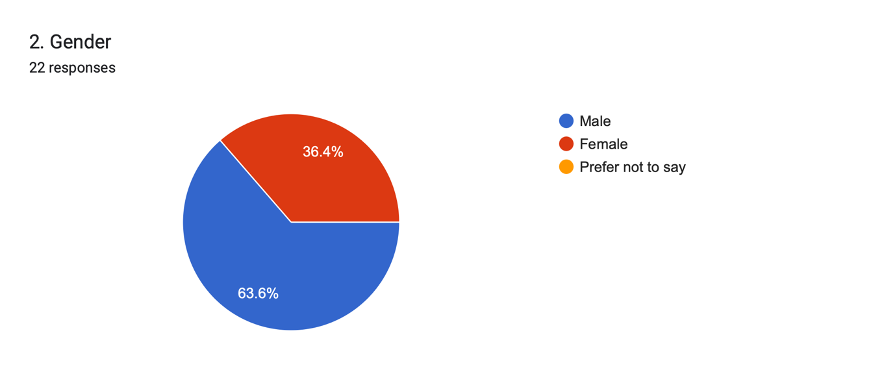
Ethical Considerations
There were ethical considerations followed by the researcher. Firstly, the researcher made sure that participants were aware of the study, and they were allowed to withdraw at any time. All data and personal identities of participants were protected and anonymized. They were used only for academic purposes. Since financial issues are sensitive and personal, the researcher treated participants with integrity. Moreover, confidentiality and honesty were continuously maintained throughout the process.

4.0 Results and Discussion
Research Question 1: What are the primary financial challenges faced by first-year undergraduates from low-income families?
The first research question is used to get to know the financial struggles faced by first-years coming from low-income families. the results of the study that are collected from both Likert-scale and open-ended questions show how they struggle with spending their day-to-day expenses and academic expenses while maintaining emotional and physical well-being. These challenges were examined across four main areas: daily living and essential costs, academic expenditures, emotional and psychological pressure, and institutional boundaries. Most of them are in shared boarding (40.9%), private boarding (18.2%), and hostels (40.9%).
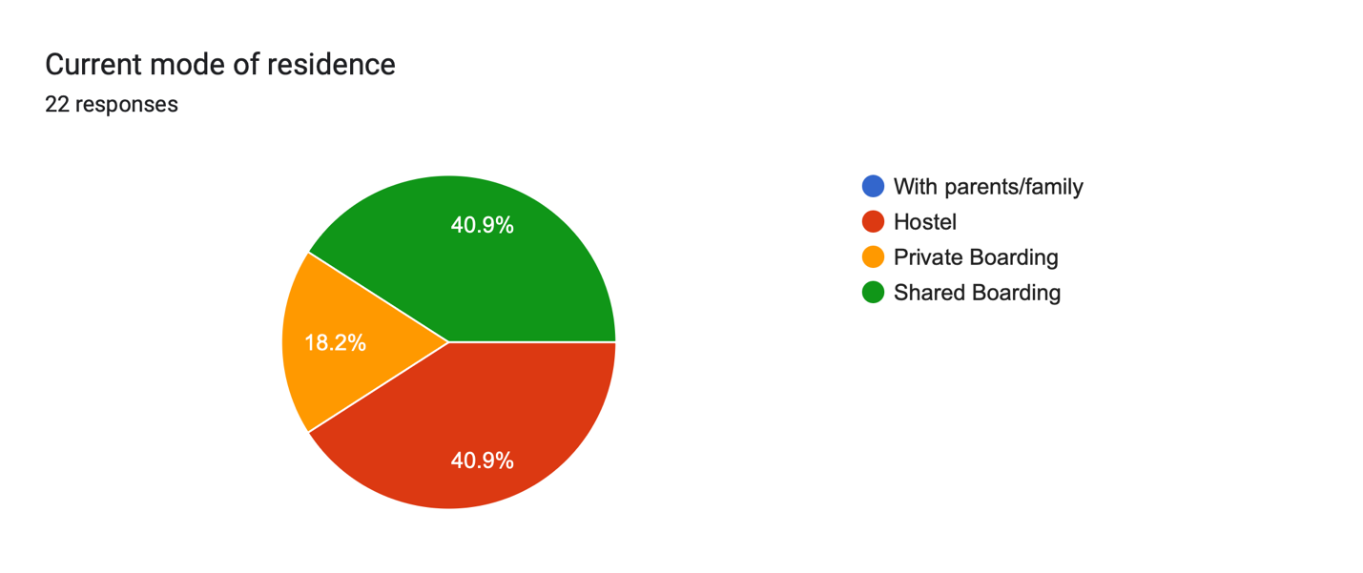
Daily Living and Essential Costs
Quantitative findings pointed out that students experienced significant challenges with core living expenses. According to the Likert-scale statistics, 77.3% (17/22) of participants agreed or strongly agreed that they encounter difficulty not only covering daily meal costs but also pointing out food as one of the most critical concerns. Transportation costs were also defined as a challenge, though to a lesser level, with 27.3% (6/22) agreeing that transportation notably impacts their finances. Not only inflation but also rising prices further deteriorated financial tension, as 50% (11/22) of respondents noted that the current economic situation had escalated their financial state.
Table 1: Likert-scale responses on essential living costs (n=22)
Statement | Strongly Disagree | Disagree | Neutral | Agree | Strongly Agree
Transportation costs are a major burden | 1 (4.5%) | 5 (22.7%) | 10 (45.5%) | 6 (27.3%) | 0 (0%)
Difficulty covering daily meal expenses | 1 (4.5%) | 4 (18.2%) | 6 (27.3%) | 11 (50%) | 0 (0%)
Inflation has worsened financial condition | 0 (0%) | 5 (22.7%) | 6 (27.3%) | 9 (40.9%) | 2 (9.1%)
Qualitative responses gathered from the questionnaire help the researcher to dive deeper into matters. Many students responded, saying that they struggle not only with covering basic needs but also with transportation from either home to campus or bodim to campus. For instance, one student wrote, "ගමන් වියදම්, නවාතැන් වියදම්, අධ්‍යන කටයුතු සඳහා සහ ආහාර පාන වැනි දෑ සදහා යන වියදම්" (travel expenses, accommodation expenses, and expenses for studies, foods and drinks). Another signified the financial outcome of academic and living costs by noting, "Boarding fee, transportation cost, food cost." Various students also reported that they are struggling with issues with food and finance, "අහාර ගැටලුව, මුදල් ගැටලුව". Together these comments highlight how financial issues negatively impact students' academic and personal lifestyles.
Academic Expenses
Academic expenses were another considerable challenge faced by them, according to their responses. The Likert scale reflected that around 68.2% (15/22) of students agreed or strongly agreed that they found it challenging to afford textbooks, stationery, and other study materials even though they are in need of buying them. Moreover, 40.9% (9/22) reported delaying the purchase of academic materials due to a lack of funds. These figures highlight how financial limitations limit academic performance by creating an immense gap in students those who are coming from low-income families.
Table 2: Likert-scale responses on academic expenses (n=22)
Statement | Strongly Disagree | Disagree | Neutral | Agree | Strongly Agree
Hard to afford textbooks/study materials | 0 | 7 (31.8%) | 7 (31.8%) | 8 (36.4%) | 0
Delayed purchasing academic materials | 1 (4.5%) | 6 (27.3%) | 6 (27.3%) | 9 (40.9%) | 0
As many students mentioned according to the qualitative data gathered they struggle with cost of printing, stationary and study materials. One student criticised, "I missed submitting one assignment because I didn’t have money for printing." Another noted, "ලිපි ද්‍රව්‍ය වියදම්, ආහාර වියදම්" (stationery expenses, food expenses). These responses illustrate specifically how financial tension directly impacts academic performance, indicating the importance of reasonable access to educational resources.
Emotional and Psychological Burden
Financial barriers also affected students’ emotional well-being. 36.4% (8/22) of respondents agreed or strongly agreed that their financial situation in a harmful way influenced not only their concentration but also their academic performance. 59.1% (13/22) mentioned that they repeatedly had to limit personal or academic expenditures due to financial conditions, while 36.4% (8/22) reported feeling socially eliminated because of financial limitations.Open-ended responses illustrated the emotional outcomes of financial hardship. Students frequently outlined stress, pressure, and anxiety: "විශාල පීඩනයක් ඇති කරනාවා" (Creates great pressure), "ඉතාම දැඩි පීඩනයක්" (Very intense pressure), and "අධික පීඩනය, විශාදය" (Excessive pressure and depression). One student reported, “Sometimes it’s hard to manage daily expenses, which makes me stressed and distracted from my studies.” These responses clarify the interconnected link between financial stress and mental health.
Institutional Limitations
Although institutional support, remarkably the Mahapola scholarship, is available to a large number of students, it is often insufficient. Among participants, 68.2% (15/22) reported being given the Mahapola scholarship, yet 8 out of 22 still agreed that they lacked sufficient financial support from the university or government. Only 18.2% (4/22) received parental financial facilitation. Open-ended responses recommended the need for additional scholarships, monthly allowances, and subsidized essential services. For instance, one student wrote, "The Mahapola is not enough even for food for a month," and another pointed out in Sinhala, "නේවාසික පහාසුකම් ශක්තිමත් කිරිම, අධ්‍යාන වලට අදාල උපකරණ සහන මිලට ලබාදිම, මාසික දිමනාවක් ලබා දිම" (Strengthening residential facilities, providing study equipment at concessionary prices, and providing a monthly allowance). As these findings mentioned support systems that are currently using are unable to meet students' essential needs.
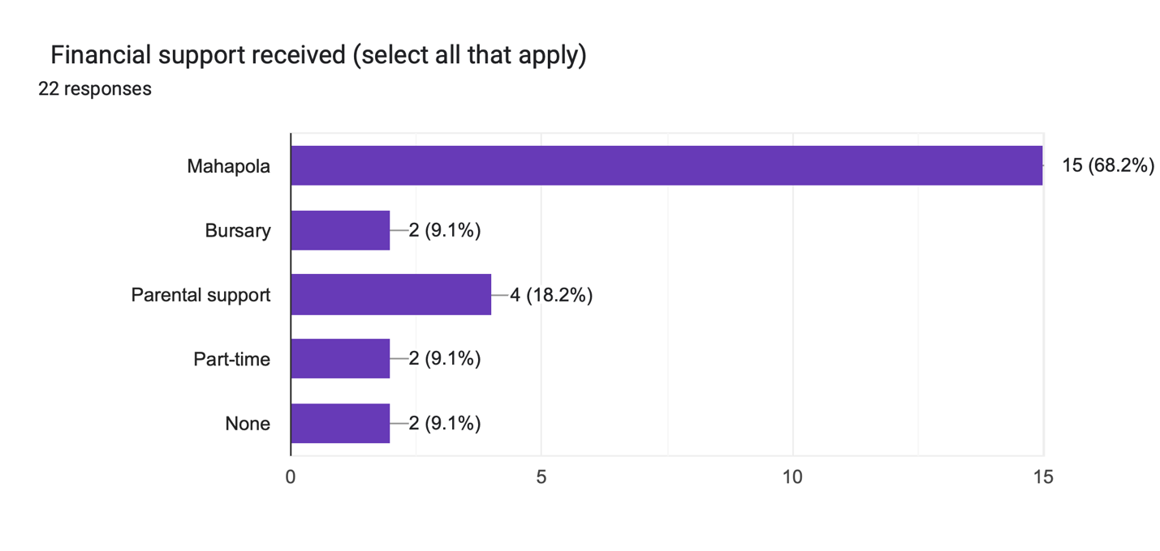
Research Question 2: What coping strategies do these students employ to manage their financial difficulties?
The second question of this study sought coping strategies used by first-years that are coming from low-income families to manage these financial issues. According to the gathered data, around 72% of respondents use budgeting tips and reduce unnecessary expenses to avoid these issues.
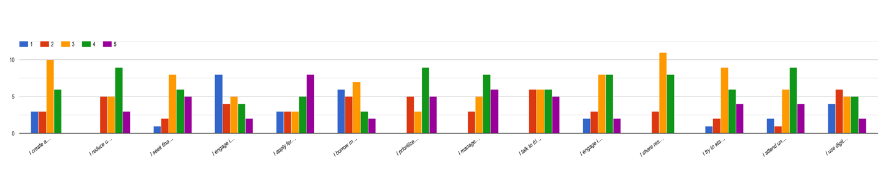
Table 3: Coping Strategies (n=22)
Strategy | Strongly Disagree | Disagree | Neutral | Agree | Strongly Agree | % Agree/Strongly Agree
Create a monthly budget | 3 | 3 | 10 | 6 | 0 | 72.7%
Reduce unnecessary spending | 0 | 5 | 5 | 9 | 3 | 72.7%
Seek financial help from family | 1 | 2 | 8 | 6 | 5 | 50%
Part-time/freelance work | 8 | 4 | 5 | 4 | 2 | 27.3%
Prioritize academic expenses | 0 | 5 | 3 | 9 | 5 | 63.6%
Share resources with peers | 0 | 3 | 11 | 8 | 0 | 36.4%
Talk to friends/lecturers for support | 0 | 6 | 6 | 6 | 5 | 50%
Engage in religious/spiritual activities | 2 | 3 | 8 | 8 | 2 | 45.5%
Qualitative responses of respondents added depth to the findings of the study. Many of the participants of the study mentioned "අත්‍යවශ්‍යම දේවල් මිලදී ගැනීමට පමණක් යොමු වීම", that they prioritize their expenses to make sure they spend money only on necessary goodies. Qualitative responses added depth to these findings. Some have started to do part-time and freelance work, such as teaching kids and secondary school students, while others are getting support from both family and friends. Emotional coping strategies were also used commonly among them, like talking to friends or lecturers or seeking religious and spiritual comfort. From the data gathered from the questionnaire and thematically analyzed, five coping strategies were found. They are:
- Budgeting and expense management
- Borrowing and social support
- Part-time or freelance work
- Emotional and religious coping
- Academic adaptation

4.2.1 Budgeting and Expense Management

Most of the students used budgeting as their coping strategy. Quantitative data that gathered from the questionnaire highlight that around 72.7%, which is around 16 respondents out of 22, cut off their unnecessary spending by prioritizing necessary expenses. This proves that some students are well aware of their savings and expenses. One student respondent said that "I try to manage my financial difficulties by planning my monthly expenses carefully and prioritizing essential needs like food and transportation," while one of them in their native language explained that “අපහසුතා ක්‍රමයෙන් මැඩලාගෙන ඉදිරියට යාම”, “අඩුවෙන් වියදම් කිරීම,කෑම වේල් දෙකකට සීමා කිරීම”, “අත්‍යවශ්‍යම දේවල් මිලදී ගැනීමට පමණක් යොමු වීම.” " අනවශ්‍ය වියදම් කපා හැර අත්‍යවශ්‍ය වියදම් පමණක් දැරීම, (only spending on essential items). Some also said that noting down their daily expenses and tracking and identifying expenses is also helpful to ensure that they are not struggling much with financial struggles. Around 63.6% of students stated they prioritize their academic expenses to ensure that financial struggle will not prevent them from getting academically successful. This highlights how students form cognitive coping strategies with conscious planning and regulating their spending in order to become financially stable during their university life.

4.2.2 Borrowing and Social Support
They have also used another coping strategy, which is seeking financial support from both family and peers and roommates to overcome financial burden, as mentioned by 50% and 22.7% of respondents, as they mentioned in comments like these: "Friends help," while another wrote, "මුදල් ණයට ලබා ගැනිම" (Obtaining money as a loan). Whereas responses for open-ended questions that were asked in the interviews highlight how they feel emotionally helpless and unstable when they ask for money from family, knowing that they are also struggling financially. One student even admitted that “I feel bad to always ask friends for money. It makes me feel dependent”, highlighting the guilt and helplessness that they feel when they had to ask for money from their friends highlight how financial burden make people dependent on others.

4.2.3 Part-Time or Freelance Work
Moreover, only a few of them, around 19% of respondents, said that they are doing part-time or freelance work, like doing classes or seeking part-time work daily for around 1500 or 1000 rupees for a day to overcome financial struggles. Students reported activities such as tutoring younger students or doing freelance work online. Like one of the respondents shared, “I teach English part-time to school students to cover my expenses,” while another said that he is doing an extra job in his native language, "අමතර රැකියාවක් කිරීම". Even though doing part-time and freelance work helps them to find extra money, they are struggling with managing both financial difficulties and academic work, as mentioned by them saying that part-time work affects their performances.
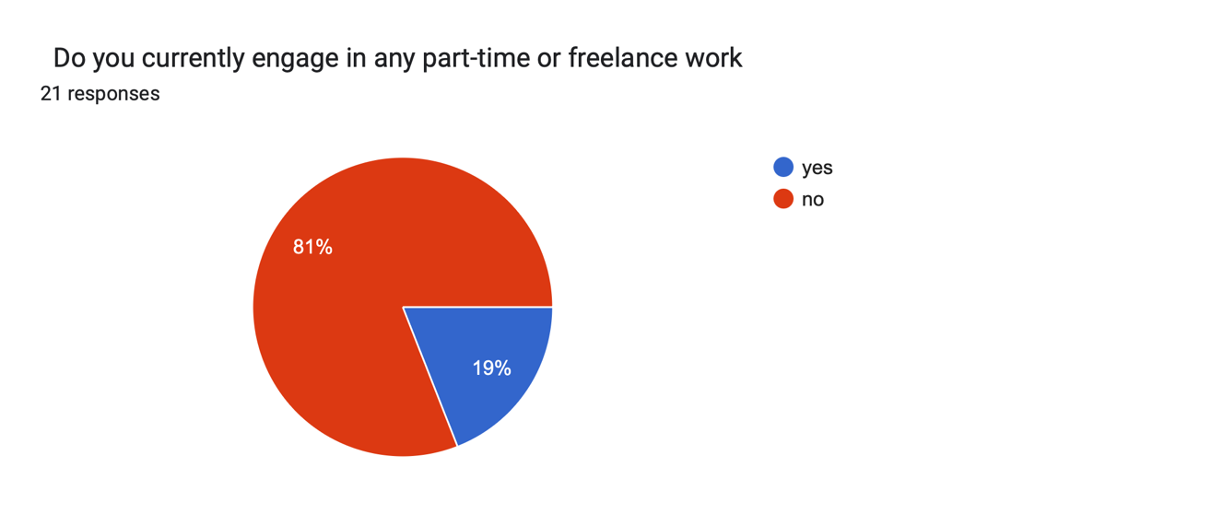

4.2.4 Emotional and Religious Coping
Moreover, students also use both emotional and religious coping strategies to ensure they don't get stressed and depressed. According to the data that was gathered from the interview, around 45% engaged in religious or spiritual activities to clear their mind from the stress that is caused by financial burden, while around 55% of students share their stressful thoughts and feelings by talking with their family and friends. Open-ended responses emphasized the importance of emotional support. One participant wrote that, “Talking with family and friends’ helps me stay emotionally balanced and positive during stressful times,” while another said that he finds following religious and spiritual rituals calm and motivation. These coping strategies highlight how psychological support helps them to stay resilient.

4.2.5 Academic Adaptation
Lastly, the low - cost academic strategies were employed by the students to reduce the financial burden. The quantitative data reveals that 36.4% (8/22) of the respondents talked about sharing resources like textbooks or notes with their friends. On the other hand, qualitative data pointed out methods like dividing topics among classmates to save time and money or using free online resources instead of buying the expensive books. One student said, “We divide up the topics and share the notes, so we don’t spend too much time and money,” whereas another one said, “I use free online resources rather than buying textbooks.”
These strategies are a manifestation of academic resilience. Students, despite the financial difficulties, are able to find ways to teach themselves effectively without cutting down on their learning.

4.3 Discussion
The findings of this study bring out the challenges faced by first-year students who are coming from low-income families, highlighting how these challenges affect their academic and personal lives. Gathered data from both Likert-scale and open-ended questions highlight that these struggles badly affect daily living, academic performances and emotional well-being of students.
Most of the students were struggling with the cost of basic needs, including food, transport and accommodation. 77.3% of students struggle to buy and pay for their daily meals, while around 50% said that rising prices of goods make their financial struggle worse in the surveys. Their comments, such as “ගමන් වියදම්, නවාතැන් වියදම්, අධ්‍යන කටයුතු සඳහා සහ ආහාර පාන වැනි දෑ සදහා යන වියදම්” and “අහාර ගැටලුව, මුදල් ගැටලුව”, were able to highlight the fact that these financial struggles negatively impact on their life styles. This supports the research by Callender and Jackson (2008) and Richardson et al. (2017), who stated that spending money on daily expenses is one of the key sources of stress for undergraduates.
Moreover, most of the students agreed, saying expenses of academic goodies are also a significant concern. Around 68.2% of the respondents mentioned that textbooks and stationery that they need for the university are expensive, while 40.9% of students said that they delayed buying these to avoid financial burden. The personal comments shared by them when they were asked a few open-ended questions, such as “I missed submitting one assignment because I didn’t have money for printing” and “ලිපි ද්‍රව්‍ය වියදම්, ආහාර වියදම්” (stationery and food expenses), highlight how these issues directly make a negative impact on students’ academic growth. These support collaborative studies done in 2017 and 2008 that show educational inequalities are worsened by financial difficulties and limit access to learning resources that are essential to students (Joo et al., 2008; Richardson et al., 2017).
Financial disparities seem to create emotional stress too. Around 36.4% of respondents have stated that financial issues affect their concentration, while 59.1% of them said that they had to limit their personal and academic activities to prevent them from doing so. Struggling due to financial burdens. Most of them have given their comments to open-ended questions in their native language, saying that these financial burdens create "විශාලපීඩනයක් ඇති කරනවා" (pressure) and "අධික පීඩනය, විශාදය" (excessive pressure and depression). The results of this study align with research conducted by various researchers stating that financial difficulties harm both the mental health and social lives of students, causing depression, anxiety and low self-esteem (Joo et al., 2008; Norvilitis et al., 2006). Likewise, some researchers mentioned that financial difficulties limit students’ extracurricular and social work too (Callender & Jackson, 2008).
As mentioned by this study, coping strategies used by students were both emotional and practical. Most of the respondents, around 72.7%, have created and followed budgeting tips and cut off their unnecessary expenses, saying comments like they are fine with spending money only on necessary goodies: "අත්‍යවශ්‍යම දේවල් මිලදී ගැනීමට පමණක් යොමු වීම". Meanwhile, around 36.4% of students have said that they are sharing resources with their peers to avoid financial difficulties. For instance, they stated that they share books that they should buy and read for their courses to save money. Moreover. Some are used to borrowing from peers (22.7%) and families (50%) with the guilt of being dependent on someone. However, there were students around; 27.3% of respondents do part-time and freelance jobs. These comments highlight how students are trying to manage their financial issues while maintaining their academic goals and highlight their dedication to improving their future. There are some students who also highly depend on emotional coping, like talking to someone, reassurance, counselling and religious coping, to prevent them from getting stressed over their financial struggles. These findings also align with a study done in 2017 which highlights that students actively try to find ways to cope with their struggles despite limited options (Richardson et al., 2017).
Moreover, around 68.2% said that the Mahapola scholarship and bursary, which are given by institutions, were also helpful for them slightly even though they have to spend more for their meals and to afford both academic and personal other resources. These also match with past studies highlighting that providing financial assistance reduces the stress of students, creating an environment where they can equally engage in learning (Callender & Jackson, 2008; Richardson et al., 2017).

Conclusion, Implications, and Recommendations

As this study mentioned, first-year undergraduates that are coming from low-income families face various challenges, including financial, academic, and emotional. They are struggling financially since they have to take care of their everyday expenses, the cost of academic items, and limited institutional support. So that they are struggling to fulfil their academic goals of attending lectures daily and getting good marks, as they have to spend time on doing part-time jobs and taking care of their financial disparities. Moreover, they are usually stressed all the time since financial disparities affect their mental health, causing anxiety, low self-esteem, and pressure.
However, despite these difficulties, students were able to show remarkable resilience. They have created and know how to plan budgets, they have decided to cut off unnecessary expenses, and they have shared academic resources with their friends. Some have started part-time jobs to overcome financial difficulties, while some rely on emotional and spiritual coping strategies to prevent themselves from getting stressed. It is clear that the approaches that are used by students are resourceful even though their coping strategies are preventive rather than reactive. Moreover, they have also mentioned that without sufficient support from the family and peers, the financial burden continues to affect their studies and well-being.
The implications of this study are crucial for both policymakers and universities. This is because financial hardships are not just a personal issue; they also affect students’ learning outcomes, participation in social work and lectures, and mental health. Increasing scholarships and subsidised meals, making accommodation more affordable, and providing access to expensive study materials might help them to reduce the stress. Moreover, providing financial literacy for students might help them to do budgeting effectively, and doing part-time work while attending campus can allow them to earn extra income without sacrificing their studies. Furthermore, providing counselling when needed can also reduce their mental struggle that is caused by financial struggles.
In conclusion, it is clear that financial pressure faced by the first years that are coming from low-income families struggle with many areas in their lives. Students were able to adopt a mix of practical and emotional coping strategies even though they have limited support from others. Therefore, a holistic approach is needed to ensure that students are able to ease their stress and focus solely on their academic goals. Future researchers can explore how students in different areas and universities face different kinds of financial challenges or examine long-term effects of financial disparities on students’ academic and professional development.

References
Callender, C., & Jackson, J. (2008). Does the fear of debt deter students from higher education? Journal of Social Policy, 37(4), 509–534. https://doi.org/10.1017/S004727940500913X
González-González, D. M., González-Martínez, J., Barcala-Furelos, R., Arufe-Giráldez, V., & Martínez-Rodríguez, R. (2025). Coping strategies and their sociodemographic correlates. Frontiers in Education, 10, Article 1565149. https://www.frontiersin.org/articles/10.3389/feduc.2025.1565149/pdf
Joo, S., Durband, D. B., & Grable, J. E. (2008). The academic impact of financial stress on college students. Journal of College Student Development, 49(1), 61–74. https://doi.org/10.2190/CS.10.3.c
Kaushani, T. H. M. (2023). Coping strategies among undergraduates of the University of Ruhuna, Southern Province, Sri Lanka, during the COVID-19 pandemic. Sri Lankan Journal of Nursing, 2(1), 22–38. https://sljn.sljol.info/articles/37/files/652e2135dc1e3.pdf
Kumari, L. M. T. M., & Yathusanth, R. (2024). Financial literacy for effective financial planning among Sri Lankan university students. Annals of Financial Research, 5(1), 1–13. https://journals.sjp.ac.lk/index.php/afr/article/view/7880
Lusardi, A., & Mitchell, O. S. (2014). The economic importance of financial literacy: Theory and evidence. Journal of Economic Literature, 52(1), 5–44. https://doi.org/10.1257/jel.52.1.
Mendis, B. V. G. (2024). The relationship between financial literacy and financial risk tolerance among university students in Sri Lanka (Master’s thesis, Dalarna University). https://www.diva-portal.org/smash/get/diva2:1879768/FULLTEXT01.pdf
Norvilitis, J. M., Szablicki, P. B., & Wilson, S. D. (2006). Factors influencing levels of credit-card debt in college students. Journal of Applied Social Psychology, 33(5), 935–947. https://doi.org/10.1111/j.1559-1816.2003.tb01932.x
Richardson, T., Elliott, P., Roberts, R., & Jansen, M. (2017). A longitudinal study of financial difficulties and mental health in a national sample of British undergraduate students. Community Mental Health Journal, 53(3), 344-352. https://doi.org/10.1007/s10597-016-0052-0
Richardson, T., Elliot, P., & Roberts, R. (2017). The relationship between personal unsecured debt and mental and physical health: A systematic review and meta-analysis. Clinical Psychology Review, 57, 79–92. https://doi.org/10.1016/j.cpr.2013.08.009
Sarma, M., Wijesiri, B., & Letchamanan, H. (2019). Educational inequalities in Sri Lanka. Centre for Poverty Analysis (CEPA). https://www.cepa.lk/wp-content/uploads/2020/10/2019-Sarma-et-al.-Educational-Inequalities-English.pdf
Senevirathne, C. P. (2025). Examining the economic burden and mental health outcomes among teachers in Sri Lankan government schools. BMC Public Health, 25, Article 117764. https://pmc.ncbi.nlm.nih.gov/articles/PMC12117764/
World Socialist Web Site. (2024, March 19). Sri Lankan students and lecturers speak out about deteriorating conditions.https://www.wsws.org/en/articles/2024/03/20/ycma-m20.html
Zhao, Y. (2024). The impact of college students’ academic stress on student satisfaction: A latent profile analysis based on academic self-efficacy and positive coping strategies. Behavioral Sciences, 14(4), 311. https://www.mdpi.com/2076-328X/14/4/311

