FLIGHT CONTROL STRATEGIES FOR QUADROTOR UAVs: A REVIEW AND BACKSTEPPING-BASED CASE STUDY

Vũ Xuân Tùng^{1*} ,Lê Thị Thu Hà¹

¹TNUT – Thai Nguyen University of Technology

ARTICLE INFO |  | ABSTRACT
Received: |  | This paper presents a structured review of flight control strategies for quadrotor unmanned aerial vehicles and identifies key research gaps affecting reliable operation under uncertain conditions. The study applies a systematic classification and analytical comparison of control approaches, including linear control, nonlinear Lyapunov-based methods, sliding mode control, adaptive and observer-based control, predictive control, and learning-enhanced strategies. Based on this review, a backstepping-based trajectory tracking controller is developed as a representative case study. The quadrotor dynamic model is established using Newton–Euler equations and organized into a cascade control structure with an outer-loop position controller and an inner-loop attitude controller. Stability of the closed-loop system is ensured using Lyapunov theory. Simulation results show that the proposed controller achieves accurate trajectory tracking with position and attitude errors converging to zero within approximately 5–8 seconds, while maintaining stable and feasible control inputs. The results confirm that backstepping provides strong theoretical stability and good tracking performance under nominal conditions; however, its robustness remains limited when disturbances and uncertainties are present. Therefore, integrating disturbance observers and adaptive mechanisms into backstepping control is identified as a promising direction for improving robustness and practical applicability in quadrotor control systems.
Revised:
Published:
KEYWORDS
Quadrotor UAV;
flight control; backstepping;
adaptive control;
trajectory tracking

* Corresponding author. Email: vutung.tbd@tnut.edu.vn

1. Introduction
Quadrotor unmanned aerial vehicles have attracted extensive attention because they combine vertical takeoff and landing capability, hovering, compact structure, and high maneuverability. These characteristics make them suitable for inspection, mapping, surveillance, logistics, and rescue applications [1], [3]. However, despite their mechanical simplicity, quadrotors exhibit nonlinear, coupled, and underactuated dynamics, which make flight control a challenging problem.
A practical controller must ensure attitude stabilization and trajectory tracking while remaining robust to wind disturbances, sensor noise, payload variation, actuator limits, and parameter uncertainty [3], [4], [8]. For this reason, the literature has expanded from classical proportional–integral–derivative and linear quadratic regulator methods to nonlinear Lyapunov-based methods, sliding mode control, adaptive and observer-based approaches, predictive control, and learning-enhanced strategies [2]–[12]. Existing studies show that no single controller can simultaneously achieve low computational cost, strong robustness, and rigorous stability guarantees over the entire operating envelope [2], [3], [10].
Among nonlinear methods, backstepping remains particularly attractive because quadrotor dynamics can be organized in a cascade structure that is suitable for recursive Lyapunov design [5]–[7]. Recent studies also show that backstepping can be extended with disturbance observers, adaptive laws, and intelligent estimators to improve robustness [4]–[7], [9], [11]. Therefore, this paper provides a concise review of recent quadrotor control strategies and presents a backstepping-based trajectory tracking controller as a representative case study. The paper aims to identify current research gaps and highlight promising directions for robust quadrotor control.
The main contributions of this paper can be summarized as follows:
(1) A structured and up-to-date review of quadrotor UAV control strategies is provided, covering recent developments from 2022 to 2025.
(2) A unified analytical comparison of classical, nonlinear, robust, adaptive, predictive, and learning-based control approaches is presented, highlighting their strengths, limitations, and application scenarios.
(3) A backstepping-based trajectory tracking controller is developed as a representative case study, explicitly linking theoretical analysis with practical implementation.
(4) Key research gaps are identified, particularly in achieving a balance between robustness, computational efficiency, and experimental validation.
(5) Future research directions are proposed, emphasizing disturbance-observer-assisted and adaptive backstepping control architectures.
2. Literature Review and Research Gap
“Quadrotor control strategies can be grouped into several major categories. Linear control methods such as proportional–integral–derivative and linear quadratic regulator remain widely used because of their simplicity and low computational cost. However, their performance deteriorates under strong nonlinearities, large maneuvers, and time-varying disturbances [2], [3].
Nonlinear Lyapunov-based methods, especially backstepping, are attractive because they match the cascade structure of quadrotor dynamics and provide explicit stability guarantees. Their main limitation is sensitivity to modeling errors and external disturbances when no additional compensation mechanism is included [5]–[7].
Sliding mode control provides strong robustness to matched disturbances, but chattering remains a significant drawback that may degrade actuator smoothness and increase wear [5], [11]. Adaptive and observer-based methods improve performance under uncertainty by estimating parameters or disturbances online, although they usually increase design and tuning complexity [4], [6], [9].
Model predictive control is effective for multivariable optimization and constraint handling, but its computational demand remains a limitation for embedded implementation [10]. Learning-enhanced control methods offer higher flexibility in complex environments, but stability certification and real-time reliability are still open issues [9], [12].
Overall, the literature shows that no single controller simultaneously provides simplicity, robustness, and strict stability guarantees. Backstepping remains a promising baseline because of its analytical transparency and compatibility with quadrotor cascade dynamics, but practical deployment requires augmentation through disturbance estimation or adaptive compensation.”
3. Proposed Control Strategy for the Case Study
To connect the review with a concrete design, this paper presents a backstepping controller as a representative case study. The quadrotor is modeled as a six-degree-of-freedom rigid body with four control inputs corresponding to total thrust and body torques. The translational and rotational dynamics are derived from Newton-Euler equations. Two coordinate frames are employed: an inertial frame fixed to the Earth and a body-fixed frame attached to the vehicle center of mass. The resulting model captures gravitational effects, thrust coupling, angular motion, and simplified aerodynamic drag.
3.1 Quadrotor Dynamic Model
The quadrotor's structure, along with the coordinate systems used in constructing its dynamic model, is shown in the figure.
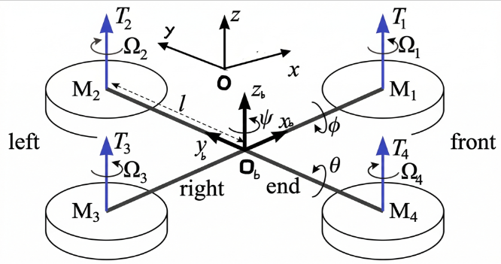
Figure 1: “Quadrotor geometry and coordinate frames used for dynamic modeling (inertial frame and body frame).”
The quadrotor operates by independently controlling the rotational speed of four rotors to generate lift and control torque. Figure 1 illustrates the direction of rotation of the rotors and the direction of thrust generated. As the rotors rotate, they generate torque in the opposite direction to the direction of rotation. Therefore, designing symmetrical rotors rotating in opposite directions (motors 1 and 3 rotate in the same direction, opposite to motors 2 and 4) helps to cancel out the total torque, preventing the quadrotor from rotating unintentionally.
To control the motion, the thrust distribution between the rotors needs to be changed as follows:
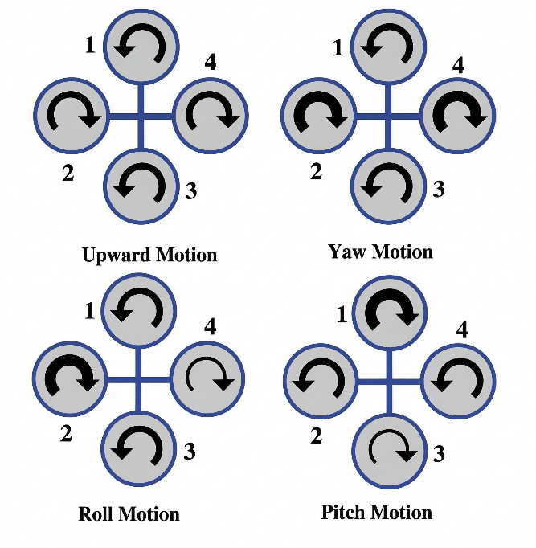
Figure 2. “Illustration of quadrotor motion primitives: (a) vertical motion, (b) yaw, (c) roll, (d) pitch; arrows indicate rotor speed changes.”
The quadrotor performs an upward movement, with its four propellers rotating at the same speed and in opposite directions to generate a combined lift force large enough to overcome the drone's gravity and propel it upwards. To achieve the yaw (rotation around the vertical axis) of the quadrotor, by varying the speed of propeller pairs rotating in the same direction (e.g., increasing the speed of pair 1-3 and decreasing the speed of pair 2-4), the system creates a torque difference in the opposite direction, allowing the device to perform a body rotation without changing altitude. The roll control mechanism creates a lift difference between the left and right sides; specifically, the rotation speed of engine number 2 increases (bold line) while engine number 4 decreases (thin line), creating torque around the vertical axis of the aircraft body, causing the quadrotor to tilt to the right. Pitch motion occurs through the creation of a lift difference between the front and rear engine pairs. Specifically, as engine speed increases (bold line) and engine speed decreases (thin line), torque is generated around the horizontal axis of the fuselage, causing the Quadrotor to perform pitching or tilting maneuvers.
The Quadrotor's dynamic model is based on Newton-Euler equations in both fixed and object-attached reference frames. The equations of motion are described as follows:
(1)
In this case, the symbols C(.) and S(.) respectively represent the cos(.) and sin(.) functions of the Euler angles.
The total lift force of the 4 propellers is:
(2)
The torque acting on each axis of rotation is:
(3)
3.2 Backstepping Controller Design
The control model is constructed as follows:
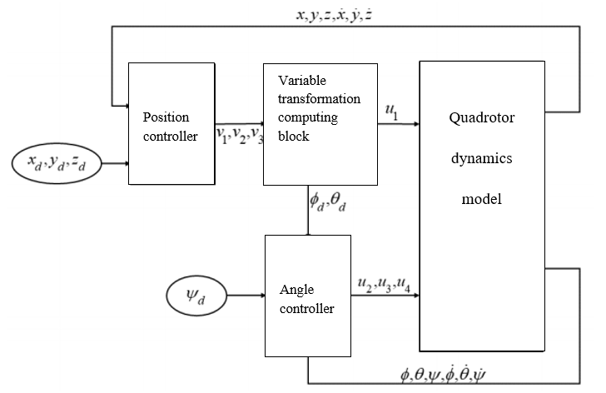
Figure 3. “Cascade backstepping flight-control architecture: outer-loop position control and inner-loop attitude control.”
The control structure is divided into two loops. The outer loop regulates translational motion and produces virtual control signals for x, y, and z tracking. These virtual signals are then converted into desired roll and pitch references and a collective thrust command. The inner loop stabilizes roll, pitch, and yaw through backstepping laws obtained by recursive Lyapunov design. Each subsystem is expressed in a backstepping-compatible form and equipped with Lyapunov functions whose time derivatives become negative under the selected virtual and actual control laws.
Lemma 1: Consider a linear system with the following backpropagation structure:
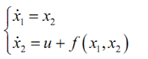
(4)
The controller with makes the (4) system asymptotically stable globally.
Prove:
Consider the Lyapunov function:
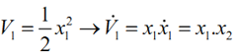
(5)
Therefore, with a virtual control signal, then
(6)
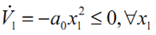
Consider the Lyapunov function:
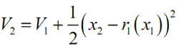
(7)
Therefore:
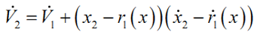
(8)
Select a controller:
(9)
Replace equation (9) with equation (8).
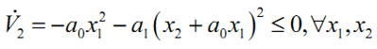
(10)
The equality sign "=" occurs if and only if
The main benefit of this strategy is analytical clarity: the underactuated quadrotor is decomposed into tractable subsystems, global asymptotic stability is argued in the nominal case, and trajectory tracking can be implemented without requiring online optimization. However, the nominal design neglects exogenous disturbances during controller synthesis, which motivates the future addition of a disturbance observer or adaptive estimator.
4. Results and Discussion
Simulations were conducted in MATLAB/Simulink using the derived 6-DOF nonlinear model with standard quadrotor parameters (mass m=0.8 kg, arm length l=0.3 m, inertia values as in typical literature). The reference trajectory is a smooth spatial path (e.g., circular or lemniscate in the horizontal plane with sinusoidal altitude variation).

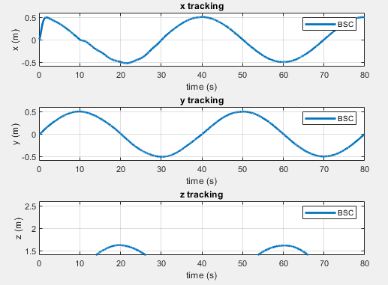 | 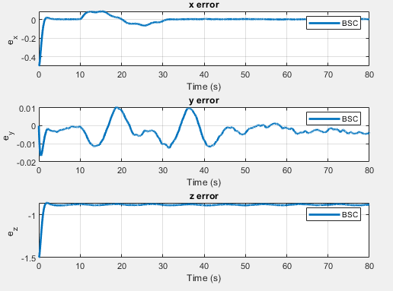
Figure 4: “3D trajectory tracking: reference vs actual trajectory.” | Figure 5: “Position tracking errors along x, y, and z axes showing exponential convergence.”

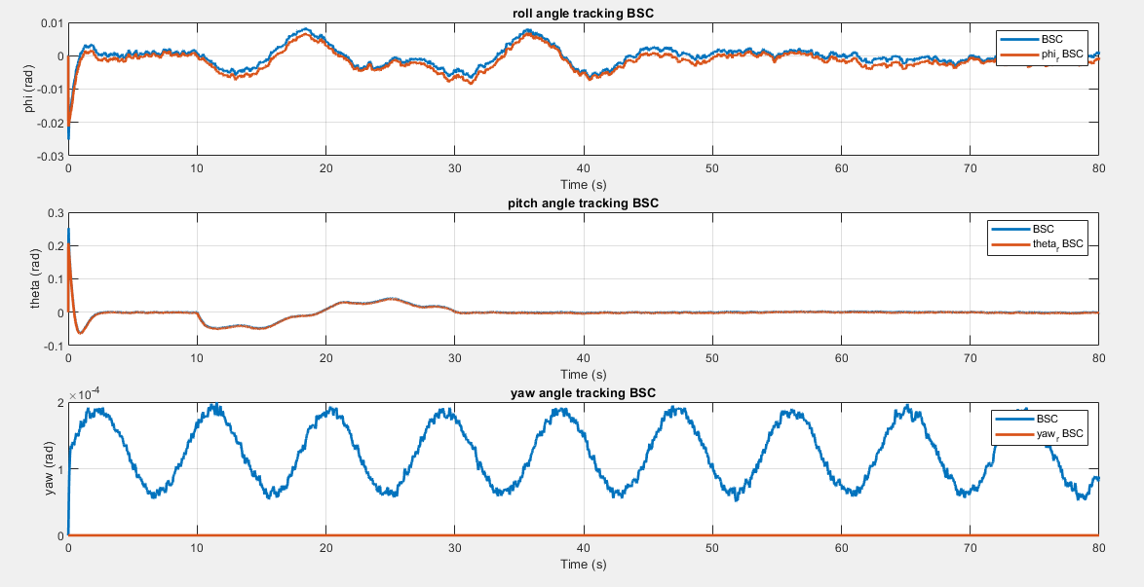 | 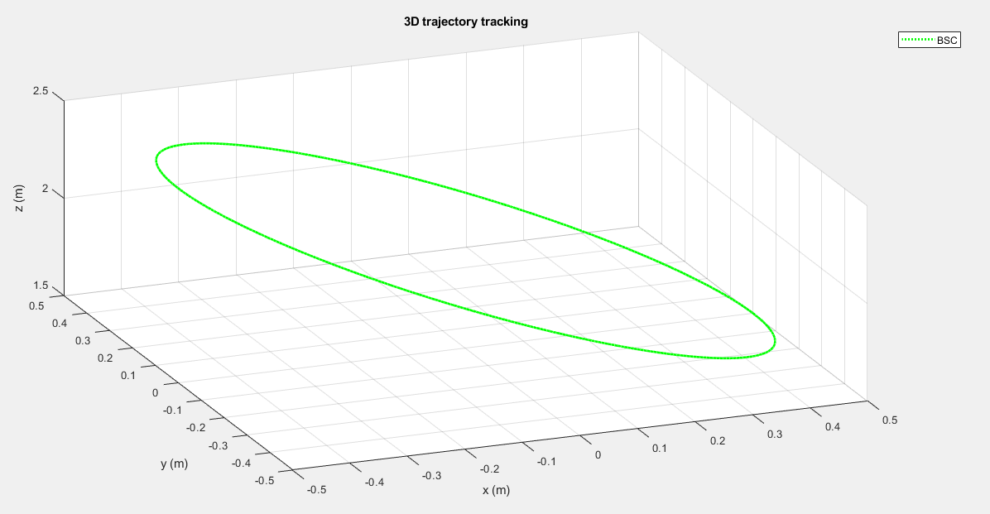
Figure 6: “Attitude tracking errors in roll, pitch, yaw.” | Figure 7: “Overall 3D flight path visualization, illustrating stable hovering and maneuvering.”
The simulation study reports results for position tracking, coordinate errors, attitude errors, control signals, and the overall flight trajectory. The position responses in x, y, and z follow the commanded trajectory closely, while the error plots show clear decay toward zero. The attitude error figures indicate that roll, pitch, and yaw remain bounded and converge sufficiently for stable flight. The control input plots also appear feasible and do not show pathological divergence.
These results are consistent with the theoretical expectation of a nominal backstepping design: when the model structure is known and disturbances are limited, cascade stabilization through Lyapunov-based virtual control can provide smooth and accurate trajectory tracking [5]-[7]. The observed strengths are also aligned with the broader literature, namely stability grounded in Lyapunov theory, good tracking quality, and a structured nonlinear model.
At the same time, the case study still exhibits three practical shortcomings that are consistent with the recent literature: the parameters are assumed rather than experimentally identified, no disturbance observer is included, and the controller is not validated on hardware. These limitations are important because they explain why nominal backstepping often performs impressively in simulation but still needs augmentation for field deployment. Therefore, the case study does not close the research gap; rather, it illustrates it clearly. The next logical step is to retain the backstepping backbone but incorporate online disturbance estimation, adaptive gains, or finite-time/sliding auxiliary mechanisms for stronger real-world robustness [4]-[6], [9], [11].
5. Conclusion
This paper reviewed major control strategies for quadrotor UAVs and analyzed a backstepping-based case study developed within the present work. The review showed that the field is evolving from standalone linear or nonlinear methods toward hybrid architectures that combine robust, adaptive, observer-based, predictive, and learning-assisted elements [4]-[12]. Classical PID and LQR controllers remain useful for simple missions, but they are limited in strongly nonlinear and uncertain regimes [2], [3]. Backstepping remains highly relevant because it maps naturally onto the quadrotor cascade structure and offers rigorous Lyapunov-based design, yet its practical weakness under uncertainty remains clear unless it is paired with additional robustness mechanisms [5]-[7], [11].
The simulation evidence summarized in the case study indicates that backstepping can achieve satisfactory nominal trajectory tracking for a quadrotor model. However, the broader literature and the case-study limitations jointly indicate that future work should focus on disturbance-observer-assisted backstepping, adaptive robust backstepping, and hardware validation under realistic environmental conditions [4]-[6], [8], [9], [11]. Such directions are likely to provide a better balance between theoretical rigor, computational feasibility, and operational robustness.

Acknowledgment: This paper was completed under project code T2025-NCS04, funded by the Thai Nguyen University of Technology (TNUT).

References
[1] M. Idrissi, M. Salami, and F. Annaz, “A Review of Quadrotor Unmanned Aerial Vehicles: Applications, Architectural Design and Control Algorithms,” Journal of Intelligent & Robotic Systems, vol. 104, no. 2, art. 22, 2022.
[2] I. Lopez-Sanchez and J. Moreno-Valenzuela, “PID Control of Quadrotor UAVs: A Survey,” Annual Reviews in Control, vol. 56, art. 100900, 2023.
[3] M. Rinaldi, S. Primatesta, and G. Guglieri, “A Comparative Study for Control of Quadrotor UAVs,” Applied Sciences, vol. 13, no. 6, art. 3464, 2023.
[4] H. Jeong, J. Suk, and S. Kim, “Control of Quadrotor UAV Using Variable Disturbance Observer-Based Strategy,” Control Engineering Practice, vol. 150, art. 105990, 2024.
[5] M. Maaruf, A. N. Abubakar, and M. M. Gulzar, “Adaptive Backstepping and Sliding Mode Control of a Quadrotor,” Journal of the Brazilian Society of Mechanical Sciences and Engineering, vol. 46, art. 604, 2024.
[6] H. L. N. N. Thanh, T. V. Khang, and N. P. Nguyen, “Quadcopter UAVs Extended States/Disturbance Observer-Based Nonlinear Robust Backstepping Control,” Sensors, vol. 22, no. 14, art. 5082, 2022.
[7] A. Kapnopoulos, C. Kazakidis, and A. Alexandridis, “Quadrotor Trajectory Tracking Based on Backstepping Control and Radial Basis Function Neural Networks,” Results in Control and Optimization, vol. 14, art. 100335, 2024.
[8] K. Ahmadi, D. Asadi, A. Merheb, S.-Y. Nabavi-Chashmi, and O. Tutsoy, “Active Fault-Tolerant Control of Quadrotor UAVs with Nonlinear Observer-Based Sliding Mode Control Validated through Hardware-in-the-Loop Experiments,” Control Engineering Practice, vol. 137, art. 105557, 2023.
[9] R. Mousavi, A. Mousavi, Y. Mousavi, M. Tavasoli, A. Arab, I. B. Kucukdemiral, and A. Fekih, “Observer-Based Adaptive Neural Control of Quadrotor Unmanned Aerial Vehicles Subject to Model Uncertainties and External Disturbances,” Actuators, vol. 13, no. 12, art. 529, 2024.
[10] X. Wang and G. Duan, “Comprehensive Reconstructions and Predictive Control for Quadrotor UAV Information-Gathering Tracking Missions Based on Fully Actuated System Approaches,” ISA Transactions, vol. 150, pp. 540–553, 2024.
[11] V. Borja-Jaimes, J. García-Morales, R. F. Escobar-Jiménez, G. V. Guerrero-Ramírez, and M. Adam-Medina, “A Backstepping Sliding Mode Control of a Quadrotor UAV Using a Super-Twisting Observer,” Applied Sciences, vol. 15, no. 18, art. 10120, 2025.
[12] Y. Bai, K. Li, and G. Wang, “A Hybrid Quadrotor Unmanned Aerial Vehicle Control Strategy Using Self-Adaptive Bald Eagle Search and Fuzzy Logic,” Electronics, vol. 14, no. 11, art. 2112, 2025.
[13] Yasmine, Z. “Adaptive fuzzy logic control of quadrotor UAV,” International Journal of Robotics and Control Systems. 2024.
[14] Zhou, L. et al, “ Fuzzy adaptive backstepping trajectory tracking control for quadrotor systems,” International Journal of Fuzzy Systems,2024
[15] Al-Jiboory, A. K. et al, “Adaptive trajectory tracking control using dynamic mode decomposition,” Robotics and Autonomous Systems, 2024
[16] Ren, Z. et al,” Adaptive fault-tolerant control for quadrotor UAV based on fuzzy gain sliding mode,” Journal of Northeastern University, 2024
[17] Wei, P. et al, ” Adaptive backstepping neural control for quadrotor UAVs under disturbances,” Expert Systems with Applications, 2025

