WattWise: Mobile-Based Energy Monitoring and Forecasting System for Home Appliances

ABSTRACT

The research presents WattWise, a smartphone application that enables households to track and forecast electricity usage for improved management. The study aims to address the growing issue of high electricity costs in the Philippines by providing users with a convenient way to monitor appliance-level energy usage, estimate electricity expenses, and receive practical energy-saving recommendations. It integrates three core functions—live monitoring, appliance recognition, and predictive analysis—into one accessible mobile platform. The study utilized a developmental research approach guided by the Agile methodology to support the continuous design, development, testing, and improvement of the system. WattWise integrates an ESP32 microcontroller and PZEM-004T energy monitoring module to gather real-time electrical measurements such as voltage, current, power, and energy consumption. The system also incorporates a YOLOv8-based appliance identification feature, allowing users to scan household appliances using the mobile application camera. Captured data are processed through a Flask-based API and stored in Firebase Firestore for monitoring and analysis. Past consumption data are processed through ARIMA time-series analysis to generate forecasts of upcoming electricity demand and expenses. The system provides users with a dashboard that displays real-time energy usage, cumulative electricity consumption, estimated costs, and forecasted consumption trends. It also generates personalized recommendations and alerts that encourage more efficient electricity usage. Results indicate that combining AI, predictive modeling, and IoT-based monitoring enhances household energy management and raises user awareness of consumption patterns.

Keywords: Energy Monitoring, Forecasting System, Internet of Things (IoT), Appliance Detection, ARIMA Model

INTRODUCTION

Electricity prices in the Philippines continue to increase, making it more challenging for many households to manage their monthly expenses. During hotter seasons, the continuous use of appliances such as electric fans and air conditioners often results in higher electricity consumption and increased utility costs (Albay, 2025). Since electricity has become an important part of everyday living, there is a growing need for practical and accessible tools that can help households better understand and control their energy usage.

Although electricity billing systems are widely available, most households only receive a single total bill without detailed appliance-level information. Because of this, users often cannot identify which appliances consume the most electricity, making it difficult to practice efficient energy-saving habits and improve budgeting decisions. In addition, many existing monitoring systems are either costly, difficult to use, or lack forecasting and recommendation features that could support better energy management.

Recent advancements in mobile technology, Internet of Things (IoT), and smart monitoring systems have created opportunities for more accessible energy management solutions. Studies showed that IoT-based monitoring and forecasting systems can improve energy awareness and help households better manage electricity consumption (Angdresey et al., 2023). According to Kenjale et al. (2024), smartphone-based monitoring systems with real-time alerts can also help users avoid unexpectedly high electricity costs.

In response to these challenges, this study proposes WattWise, a mobile-based energy monitoring and forecasting system designed to help users monitor and manage household electricity consumption more effectively. The system integrates artificial intelligence, IoT-based monitoring, and forecasting techniques to identify household appliances, monitor energy usage, and estimate future electricity consumption and costs. By combining real-time monitoring, forecasting, and energy-saving recommendations within a single mobile application, WattWise aims to provide Filipino households with a convenient and accessible platform that promotes smarter energy management, better budgeting practices, and more efficient electricity consumption.

Statement of the Problem

These challenges highlight the need for a more accessible and intelligent energy monitoring solution that can provide households with clearer insights into their electricity consumption. Despite the growing availability of digital technologies, many households still lack tools that can monitor appliance-level energy usage, generate consumption forecasts, and provide practical recommendations for reducing electricity costs. Addressing these limitations may help households improve energy awareness, budgeting practices, and overall electricity efficiency.

Specifically, this study aims to address the following problems:
- Lack of clear visibility into appliance-level electricity consumption, making it difficult for households to identify which appliances contribute most to high electricity bills.
- Limited access to real-time monitoring and personalized energy-saving recommendations, which reduces the ability of households to practice efficient electricity usage.
- Absence of localized forecasting tools that can estimate future electricity consumption and projected costs based on household usage patterns and local electricity rates.

Objective of the Study

The main goal of this study is to develop a mobile-based energy monitoring and forecasting system that helps Filipino households better understand and manage their electricity consumption. The study aims to provide a practical and accessible platform that promotes energy awareness, improves household budgeting, and encourages efficient electricity usage.

Specifically, this study aims to:
- Develop a hardware-based appliance monitoring and recognition system that identifies household appliances through smartphone-based object detection and estimates their energy consumption.
- Provide real-time monitoring and user-friendly energy-saving recommendations that help households reduce unnecessary electricity usage and adopt more efficient energy practices.
- Design an ARIMA-based forecasting model that analyzes historical energy consumption data to generate short- and medium-term electricity usage and cost predictions for improved household budgeting and energy management.

Scope and Limitations
This study focuses on the development of WattWise, a mobile-based energy monitoring and forecasting application designed for Filipino households using Android devices. The system aims to monitor appliance-level electricity consumption and provide users with clearer insights into their household energy usage. WattWise integrates artificial intelligence and hardware-based monitoring to identify common household appliances through smartphone image scanning and estimate their energy consumption. For appliances that cannot be recognized automatically, the system provides a manual input option. Detected appliances are linked to an internal database containing estimated wattage information, which is used to calculate electricity consumption in kilowatt-hours (kWh) and estimated costs based on Philippine electricity tariffs, primarily using Meralco rates as reference.
In addition to energy monitoring, the system provides real-time consumption feedback, historical usage tracking, personalized energy-saving recommendations, and short- and medium-term electricity consumption forecasts using the ARIMA model. WattWise is limited to appliances that can be monitored through identifiable usage duration, such as electric fans, televisions, lights, and air conditioners. The system is intended for Android smartphones and requires a stable internet connection for data synchronization and monitoring features.
Despite efforts to improve system accuracy, certain limitations remain. Appliance detection accuracy depends on the completeness of the dataset, the reliability of the object detection model, and the correctness of user-provided information. Some appliances may not be identified accurately, and appliances that are not scanned or manually added will not be included in the monitoring results. Forecasting accuracy may also be affected by sudden changes in appliance usage, electricity rates, outages, or other external factors beyond the system’s control. The study does not guarantee reduced electricity bills but instead aims to provide households with useful consumption estimates, forecasting insights, and recommendations that may support better energy management and budgeting decisions.
THEORETICAL FRAMEWORK
The present study on WattWise: Mobile Energy Monitoring and Forecasting System for Home Appliances is anchored in established concepts and technologies related to smart energy monitoring, Internet of Things (IoT), real-time tracking, and electricity forecasting. These concepts provide the foundation for understanding how households can monitor appliance-level electricity consumption, analyze energy usage patterns, and improve energy management practices through mobile and AI-assisted technologies. The framework also supports the integration of IoT devices, real-time monitoring systems, forecasting models, and mobile applications in delivering accessible and user-friendly energy management solutions for Filipino households.
Smart Energy Monitoring Systems
Smart energy monitoring systems have become an important approach in improving household energy awareness through the use of IoT devices, real-time monitoring, and mobile applications. These technologies allow users to monitor electricity consumption continuously, helping households better understand appliance usage and manage energy expenses more effectively. In study of Gopikrishna and Mathew (2021), they have developed an IoT-based smart home monitoring system that collected real-time appliance consumption data and applied the ARIMA model to forecast future electricity usage. Their study aimed to reduce unnecessary electricity consumption by improving user awareness through continuous monitoring and forecasting. The researchers found that combining IoT monitoring with ARIMA forecasting produced accurate short-term electricity demand predictions in a smart home environment. This study supports WattWise by demonstrating how real-time monitoring and forecasting can help households better understand and manage their electricity consumption.
In a local context, Santos et al. (2021) designed an IoT-based monitoring system for tenants and landlords using sensors, microcontrollers, and an Android application for real-time electricity monitoring. The system provided users with accessible utility consumption information through a mobile platform and demonstrated reliable monitoring performance during testing. The findings highlighted the importance of user-friendly mobile applications in improving household energy awareness and monitoring accessibility. This study is relevant to WattWise because both systems utilize mobile-based monitoring to provide users with convenient access to real-time electricity consumption data.
Similarly, Pagaduan et al. (2023) developed a Real-Time Energy Consumption Monitoring (RECM) device that used IoT sensors and Wi-Fi connectivity to monitor household electricity usage continuously. Their system transmitted energy data to an online platform with a smartphone-accessible dashboard that allowed users to track electricity usage patterns in real time. The researchers found that real-time monitoring improved user awareness regarding electricity consumption and encouraged more responsible energy usage behavior. The study supports the development of WattWise by reinforcing the value of IoT-based monitoring and mobile accessibility in promoting energy-efficient practices among households.
AI and Appliance-Level Monitoring
Artificial intelligence and machine learning technologies have become increasingly important in modern energy monitoring systems, particularly in appliance-level analysis and smart energy management. These technologies enable systems to identify appliance usage patterns, analyze consumption behavior, and provide more intelligent monitoring and forecasting capabilities for households. Zangrando et al. (2022) conducted a study on appliance-level energy monitoring within smart buildings, emphasizing the importance of collecting detailed appliance consumption data for forecasting and energy management applications. Their work explored how appliance-level monitoring can support load prediction, anomaly detection, and predictive maintenance in connected environments. The study found that fine-grained appliance monitoring improves the accuracy of energy analysis and forecasting systems. This study supports WattWise by highlighting the value of appliance-level monitoring in providing users with more accurate and meaningful electricity consumption insights.
Similarly, Motta et al. (2023) developed a smart home energy architecture that integrated IoT devices, mobile applications, and machine learning techniques to analyze household electricity consumption. Their system applied artificial intelligence methods to disaggregate whole-home energy usage into appliance-level consumption data without requiring separate sensors for every device. The researchers found that machine learning techniques can improve appliance-level analysis and provide users with more detailed consumption information. This study is relevant to WattWise because it demonstrates how AI-assisted monitoring systems can help users better understand appliance usage patterns and energy consumption behavior.
Rahman et al. (2025) proposed an IoT-based home energy management framework that combined machine learning models and explainable artificial intelligence techniques for electricity forecasting and smart analysis. Their system collected appliance consumption data through IoT sensors and applied predictive models to generate user-friendly energy insights and recommendations. The study found that integrating AI with IoT monitoring improved forecasting accuracy and enhanced user understanding of energy consumption patterns. These findings support the development of WattWise by reinforcing the importance of combining artificial intelligence, IoT monitoring, and intelligent analysis in creating accessible and efficient household energy management systems.
ARIMA-Based Energy Forecasting
ARIMA-based forecasting has been widely used in energy management systems for analyzing historical electricity consumption and predicting future energy demand. As a time-series forecasting technique, ARIMA is commonly applied in household and smart energy systems to support electricity monitoring, cost estimation, and energy planning.
Silagpo et al. (2024) developed an IoT-based home energy management system that utilized the ARIMA model to predict daily household electricity consumption. Their system combined real-time monitoring, mobile notifications, and forecasting features to help users monitor energy usage more effectively. The researchers found that the ARIMA model produced accurate day-ahead electricity consumption forecasts and improved user awareness through real-time alerts and monitoring. This study supports WattWise by demonstrating how ARIMA forecasting and IoT monitoring can be integrated to help households better manage electricity consumption and anticipate future energy costs.

Similarly, Guo et al. (2021) proposed an ARIMA-based forecasting approach designed for electricity consumption data collected from IoT devices. Their study focused on improving forecasting accuracy by preprocessing sensor data through noise reduction and data smoothing techniques before applying the forecasting model. The findings revealed that proper preprocessing and model tuning significantly improved short-term forecasting performance for building-level electricity consumption. This study is relevant to WattWise because it highlights the importance of preprocessing and time-series analysis in improving the reliability of household electricity forecasting systems.
In a local context, Caw-it and Talirongan (2025) applied the Box–Jenkins ARIMA method to forecast household electricity expenses in the Philippines using historical monthly billing data. Their study aimed to help households improve budgeting and financial planning through localized electricity forecasting. The researchers found that the ARIMA(1,1,1) model produced accurate electricity cost predictions that aligned with observed consumption trends and seasonal patterns. This study supports the development of WattWise because it demonstrates the effectiveness of ARIMA forecasting in estimating future household electricity consumption and projected costs within the Philippine setting.

METHODOLOGY

This chapter provides a complete picture of the technical design and methods used to build WattWise: Mobile Energy Monitoring and Forecasting System for Home Appliances. It presents key diagrams, including the system flowchart, datasets, hardware and software components, use cases, and the entity-relationship diagram, while explaining how data flows within the system.

Research Design

According to Sharma et al. (2012), Agile methodology consists of continuous and iterative phases such as planning, designing, development, testing, deployment, and feedback. This approach is appropriate for the study because WattWise was developed incrementally, allowing the researchers to continuously improve the system based on user feedback and testing results. Agile methodology also helps reduce development risks by identifying issues early and improving the system throughout each iteration.

The researchers adopted the Agile methodology under the Software Development Life Cycle (SDLC) framework to guide the development process of the system, Agile was selected because of its flexible and iterative approach.

Figure 1. Agile Methodology Phases
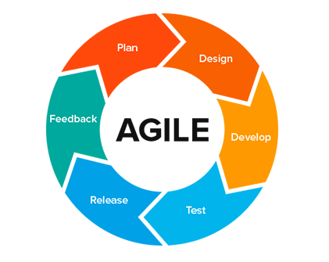
Planning Phase

During the planning phase, the researchers identified the objectives, requirements, and core features of WattWise. The study focused on developing a mobile-based system capable of monitoring appliance-level electricity consumption in real time and forecasting future energy usage using the ARIMA model. Hardware requirements such as the ESP32 microcontroller and PZEM-004T sensor, cloud storage through Firebase Firestore, and mobile application functionalities were also identified. Feasibility studies involving sensor accuracy, internet reliability, and data security were conducted to ensure the practicality of the system.

Designing Phase

In the designing phase, the researchers created the system architecture, interface layouts, database structure, and process flow of the application. Logical and technical designs were developed to illustrate how appliance data are collected, processed, stored, and transformed into forecasting results and recommendations. Diagrams such as flowcharts, use case diagrams, entity relationship diagrams (ERD), and data flow diagrams (DFD) were also prepared to serve as guides during development.

Development Phase

During the development phase, the concepts and designs were transformed into a functional system. The WattWise mobile application was developed using React Native to provide a responsive Android-based user interface, while Node.js was utilized for backend communication and API handling. Firebase Firestore served as the cloud-based database for storing appliance information, user records, and energy consumption data with real-time synchronization capabilities.

The system also integrated Python and Flask API to support appliance object detection and ARIMA-based forecasting. YOLOv8 was utilized to identify household appliances through image recognition, while ARIMA analyzed historical energy consumption data to generate short- and medium-term electricity forecasts. Appliance wattage and energy consumption datasets used by the system were gathered from publicly available references from the Department of Energy (DOE) to support more realistic energy usage estimations and forecasting outputs. Pandas and JSON were used for dataset preparation and structured data processing, while IoT communication between the ESP32 and Firebase was handled through HTTP or MQTT protocols. Development and testing were conducted using tools such as Visual Studio Code, Android Emulator, Postman, Git/GitHub, Firebase Console, and ESP-IDF.

Testing Phase

The testing phase ensured that both the software and hardware components functioned properly and met the objectives of the study. The researchers tested real-time Firebase synchronization, ARIMA forecasting outputs, YOLOv8 appliance detection accuracy, ESP32 and PZEM sensor communication, and mobile application responsiveness across Android devices. Continuous testing throughout development also helped identify and resolve errors early in the process.

Deployment Phase

The deployment phase involved configuring and integrating the completed system within a live environment. The application, database, APIs, and IoT components were deployed and tested to ensure stable operation and proper communication between all modules. Final system checks were also performed to verify reliability, usability, and real-world functionality.

Feedback Phase

The feedback phase focused on evaluating the usability and effectiveness of WattWise through continuous user assessment. End-users provided feedback regarding dashboard usability, forecast readability, appliance detection convenience, and overall application responsiveness. The collected feedback was used to identify improvements and support further refinement of the system.

System Architecture

The system architecture of WattWise: Mobile Energy Monitoring and Forecasting System serves as the structural foundation that illustrates how various components of the study interact to achieve its overall objectives. It provides a clear overview of layers of inputs, processes, and outputs, from initial input and processing to the generation of meaningful insights for users. This architecture ensures that all hardware, software, and analytical elements work cohesively to support accurate monitoring and forecasting of household electricity consumption. By establishing a well-defined architectural framework, WattWise promotes system efficiency, reliability, and scalability, ensuring that the platform can adapt to future technological advancements in energy management.

Figure 2. Input-Process-Output (IPO) Model of WattWise

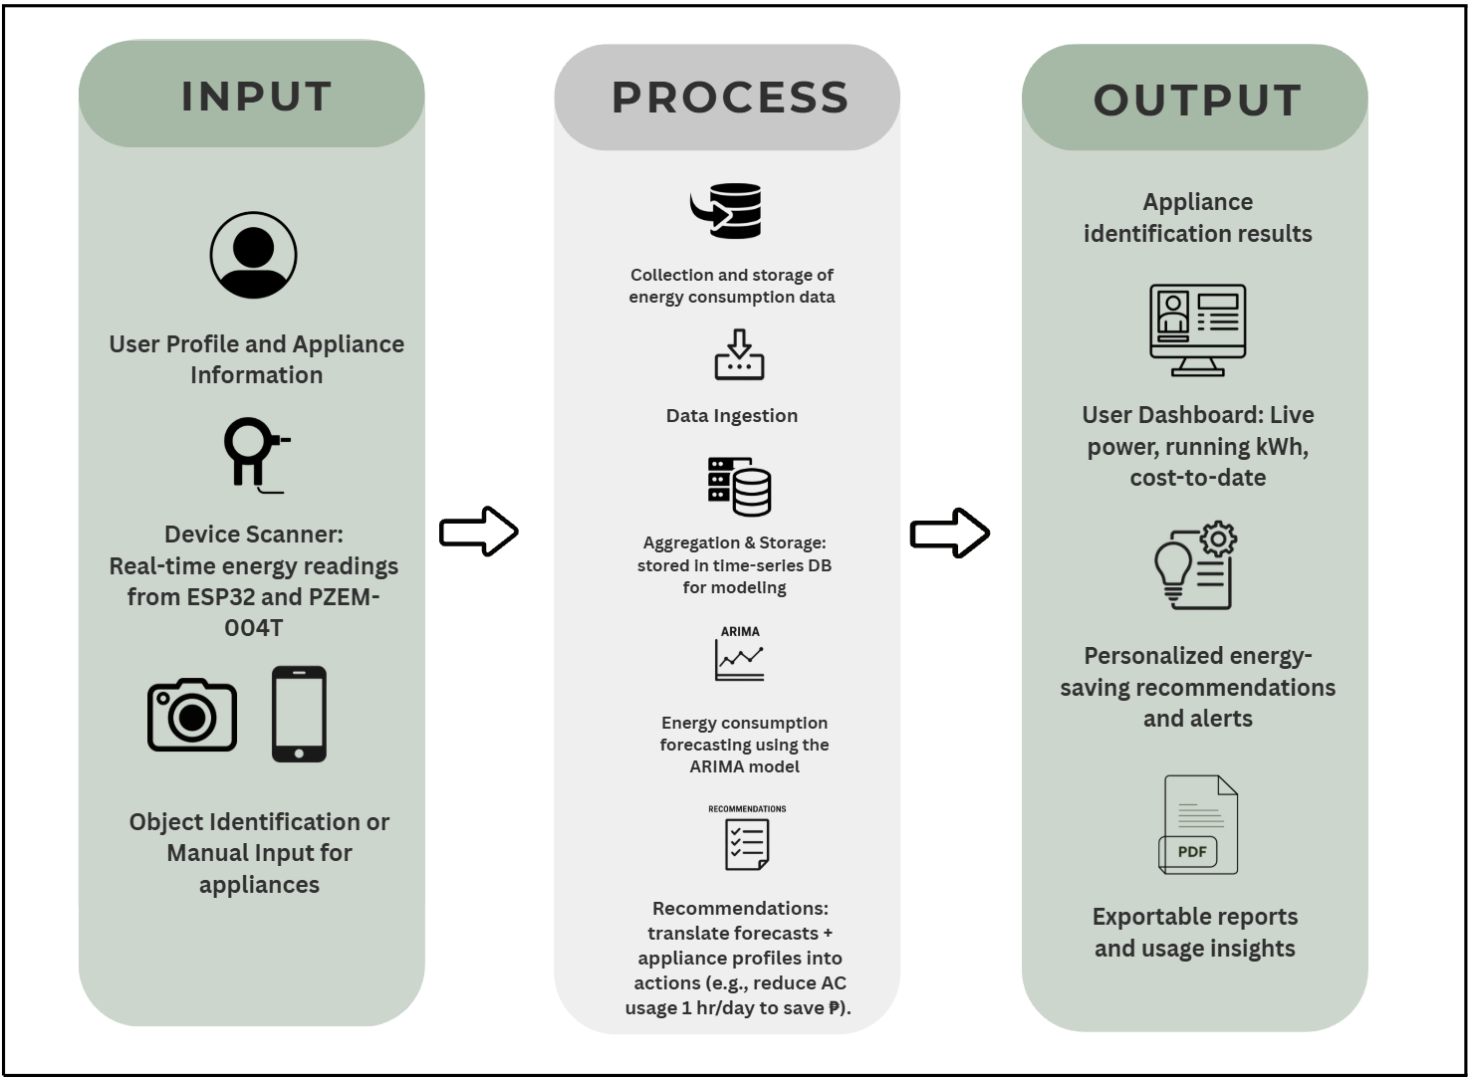

The system architecture of WattWise: Mobile Energy Monitoring and Forecasting System serves as the structural foundation that illustrates how various components of the study interact to achieve its overall objectives. It provides a clear overview of layers of inputs, processes and outputs, from initial input and processing to the generation of meaningful insights for users. This architecture ensures that all hardware, software, and analytical elements work cohesively to support accurate monitoring and forecasting of household electricity consumption.

User Profile. The system begins by establishing a basic user profile that captures household information relevant to energy monitoring. This may include location, household size, and electricity tariff details. The profile helps personalize cost computations, translate energy use into local currency, and tailor recommendations according to the household’s context.

Energy Scanner. An energy scanner serves as the primary source of electrical measurements. It records timestamped data such as voltage, current, instantaneous power, and cumulative energy consumption. These readings form the raw telemetry that enables both device-level and whole-household analysis. By continuously collecting data, the scanner provides a real-time picture of how electricity is being used.

Device Identification. The appliance recognition feature utilizes a YOLOv8 object detection model trained using custom appliance datasets. Users may capture appliance images through the mobile application camera interface. The captured image is transmitted to a Flask-based middleware API, where the YOLOv8 model processes the image and identifies the detected appliance category. The detection result is returned to the mobile application, where appliance-related fields such as appliance type, estimated wattage, and runtime presets are automatically populated. This minimizes manual input and improves user convenience.

Historical Billing Records. Past monthly electricity bills are incorporated to provide long-term context. These records help validate cumulative energy totals, refine cost calculations, and calibrate forecasting models. By comparing real consumption data with previous billing trends, the system improves the accuracy of projections and recommendations.

Data Ingestion. All collected inputs, sensor readings, appliance scans, and billing data, are securely transmitted to the cloud. During ingestion, the system validates entries, aligns timestamps, and ensures data consistency before storage.
Aggregation and Storage. The system automatically groups raw appliance usage logs into daily energy summaries. Each appliance log contains timestamped energy consumption and corresponding cost values. These records are aggregated by date to compute total household energy usage (kWh), total estimated electricity cost, and the number of active appliances for a specific day.

The aggregated data is stored in a dedicated collection named daily_energy_usage within Firebase Firestore. This structured time-series dataset serves as the primary input for the ARIMA forecasting model.

Energy Consumption and Cost Computation. The system computes appliance energy consumption using estimated or measured appliance wattage and runtime duration. Runtime values are converted into kilowatt-hour (kWh) consumption using standard electrical energy computation formulas.

Energy Consumption Formula
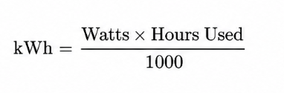
• Watts = appliance power consumption
• Hours Used = appliance runtime duration
• 1000 = conversion factor from watts to kilowatts

Electricity Cost Formula
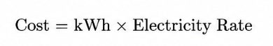
• kWh = computed energy consumption
• Electricity Rate = local electricity tariff per kilowatt-hour
The resulting energy and cost values are automatically stored within the appliance_logs collection and later aggregated into daily summaries for forecasting and analytics.

Forecasting (ARIMA Model). Using historical aggregated data, the system applies an ARIMA-based forecasting model to estimate short- and medium-term electricity demand. The model produces point forecasts and confidence ranges, helping households anticipate future consumption and possible bill amounts.
Recommendation Engine. Forecast outputs are combined with appliance profiles and tariff information to generate actionable suggestions. For example, the system can estimate how reducing air-conditioner use by one hour per day may translate into monthly savings. Recommendations are practical, measurable, and directly linked to household behavior.

User Dashboard. The primary interface is a live dashboard displaying real-time power usage, cumulative kilowatt-hours (kWh), and running cost-to-date in local currency. This immediate visibility encourages awareness and informed decision-making. The forecasting dashboard additionally visualizes ARIMA-generated predictions for upcoming household electricity consumption. Forecast outputs include estimated future kilowatt-hour usage, projected electricity costs, and trend-based consumption insights to support proactive energy management.

Actionable Tips and Alerts. Beyond live monitoring, the system provides contextual advice such as peak-hour warnings, projected bill spikes, and appliance-specific conservation tips. These alerts help users act before costs escalate.

Reports and Community Insights. For documentation and broader analysis, the platform can generate downloadable PDF reports. It can also produce anonymized, aggregated consumption insights for local government units or utility programs. This ensures user privacy while supporting community-level planning and energy efficiency initiatives.

Methods

This section presents the three (3) main methods used by the researchers to develop the core features of the WattWise system. Each method corresponds to the identified challenges and objectives discussed in Chapter 1, ensuring that every technical approach implemented in the system directly supports the overall goals of the study.

Method 1: Power Monitoring Process and AI-Driven Appliance Detection

Figure 3. Smart Reading Process

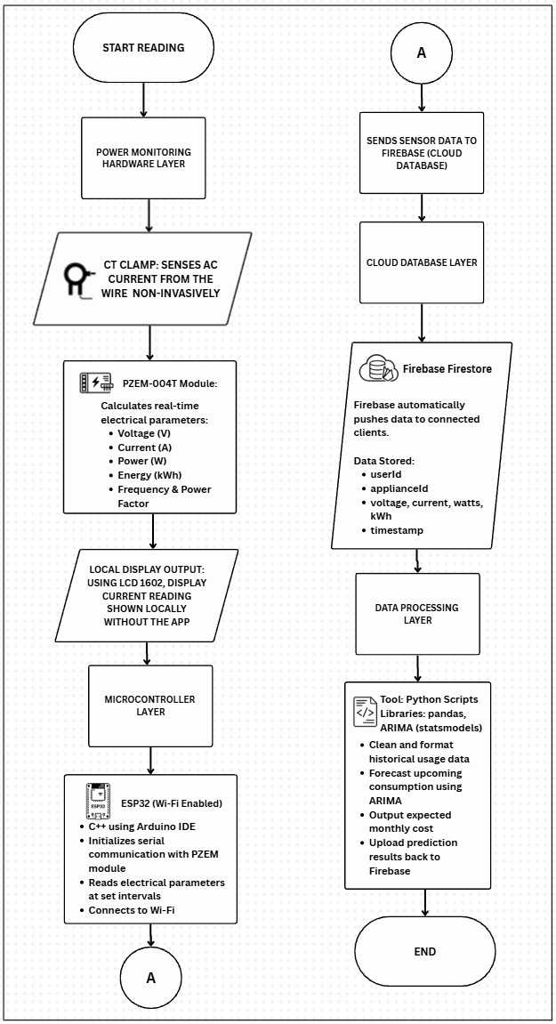

The proponents developed a hardware-based power monitoring tool wherein it will be able to monitor power consumption of a household. The system begins with the Start Reading phase, where the power monitoring process is initiated. Under the Power Monitoring Hardware Layer, the CT Clamp is attached non-invasively to the electrical wire. This sensor detects the alternating current (AC) flowing through the conductor without interrupting the circuit. The measured current signal is then transmitted to the PZEM-004T module, which functions as the primary energy measurement device. The PZEM-004T calculates real-time electrical parameters including voltage (V), current (A), active power (W), cumulative energy consumption (kWh), frequency, and power factor. These readings provide the fundamental data needed to evaluate household electricity usage. Simultaneously, a local display output using the LCD 1602 module presents current readings directly to the user, allowing real-time monitoring even without accessing the mobile application.

The processed electrical measurements are then transmitted to the Microcontroller Layer, specifically the ESP32 (Wi-Fi enabled). Programmed using C++ in the Arduino IDE, the ESP32 initializes serial communication with the PZEM-004T module, reads electrical parameters at defined intervals, and establishes a Wi-Fi connection. Through this connectivity, the ESP32 sends sensor data to Firebase (Cloud Database). Within the Cloud Database Layer, Firebase Firestore automatically stores and synchronizes the data, including user ID, appliance ID, voltage, current, watts, kWh, and timestamps. The system then enters the Data Processing Layer, where Python scripts utilizing libraries such as Pandas, Statsmodels, and ARIMA clean and analyze historical consumption data. The ARIMA model forecasts future electricity usage and predicts expected monthly costs. These prediction results are uploaded back to Firebase, making them accessible to connected clients such as the mobile application. The entire process ensures seamless integration from hardware-level sensing to cloud-based forecasting and user-level visualization.

Figure 4. Hardware Setup of the ESP32 and PZEM-004T Module for Appliance Energy Monitoring

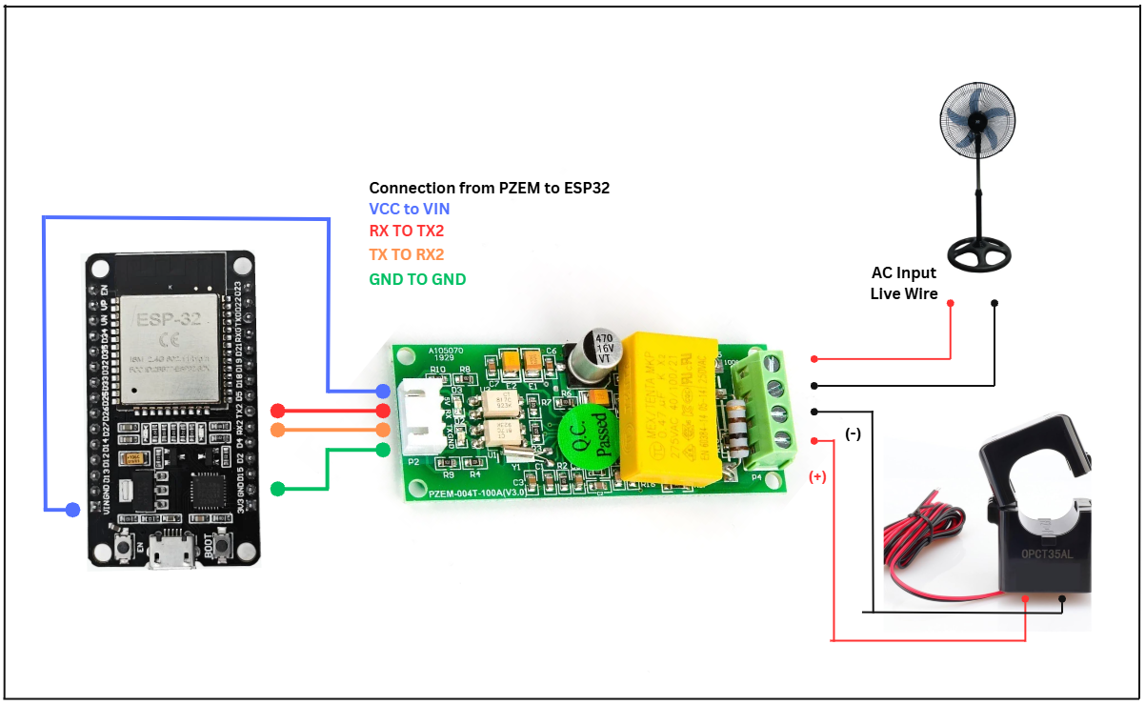

Figure 4 shows the hardware connection used in the WattWise system for real-time energy monitoring. The setup consists of an ESP32 microcontroller connected to a PZEM-004T energy monitoring module and a current transformer (CT) clamp sensor attached to the appliance’s live wire. The PZEM-004T measures electrical parameters such as voltage, current, power, and energy consumption, while the ESP32 processes and transmits the collected data to the mobile application through Wi-Fi connectivity. This hardware configuration allows the system to continuously monitor household appliance energy usage and support real-time data visualization and forecasting within the WattWise platform.

Figure 5. AI-Driven Appliance Detection Process Using YOLOv8

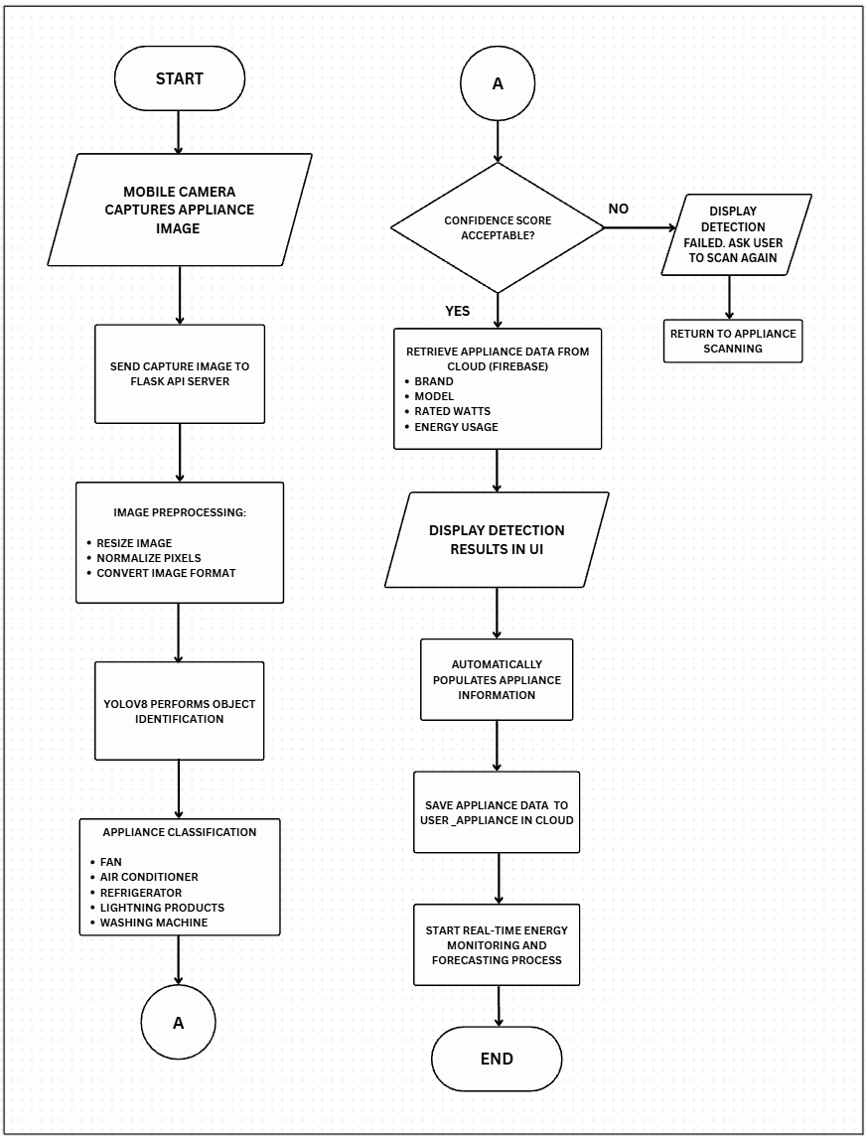
The AI-driven appliance detection process of WattWise begins when the user opens the mobile application and selects the “Scan Appliance” feature. The system activates the mobile device camera to capture an image of the household appliance. The captured image serves as the input data of the detection process. After the image is taken, it is transmitted to the Flask API server through an HTTP request for further processing.
Once the image is received by the server, preprocessing operations are performed to improve detection accuracy and compatibility with the artificial intelligence model. These preprocessing procedures include image resizing, normalization of pixel values, and image format conversion. After preprocessing, the YOLOv8 object detection model analyzes the image to identify the appliance type. The model classifies appliances such as electric fans, air conditioners, refrigerators, and washing machines by recognizing visual patterns and object features learned during training.

Following the detection process, the system evaluates the confidence score generated by the YOLOv8 model. The confidence score determines whether the detected appliance is reliable enough to proceed. If the confidence score is acceptable, the system retrieves related appliance information from the Firebase Firestore database, including the appliance brand, model, rated wattage, and estimated energy consumption data. The processed information is then returned to the React Native mobile application where the detected appliance details are automatically populated into the appliance form.

However, if the confidence score is insufficient, the system displays a detection failure message and prompts the user to perform another scan. This allows the application to maintain reliable and accurate appliance identification. Once the user confirms the detected information, the appliance data is saved into Firebase Firestore for monitoring and forecasting purposes. The stored information is then utilized by WattWise to support real-time energy monitoring, electricity usage analysis, and forecasting functionalities within the mobile application.

Method 2: Personalized Recommendation

Figure 6. Implementing Personalized Recommendation to WattWise

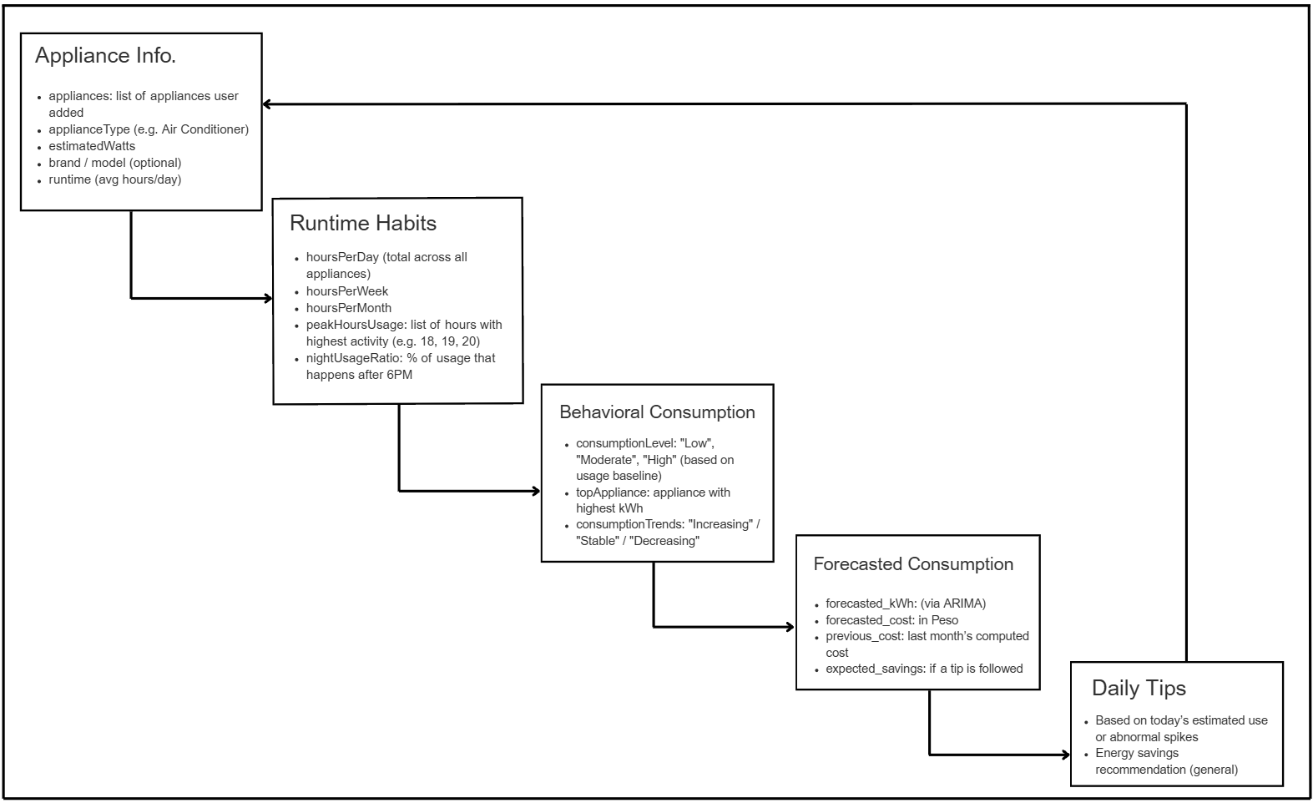

The diagram presents the personalized recommendation method used by the WattWise system to help users manage their electricity consumption more effectively. The process begins with collecting appliance-specific information such as type, wattage, and daily runtime. From there, the system observes the user’s habits, including how many hours appliances are used per day or during peak hours, and categorizes overall consumption behavior as low, moderate, or high. It also highlights which appliance contributes most to the user's energy usage, offering insights into daily routines and patterns.

Using this information, the system forecasts monthly consumption and estimated costs based on previous usage. Tips are then generated to help users adjust their habits, either through general reminders (like avoiding peak hours) or personalized advice based on past behavior. These tips are tracked to avoid repetition and improve future suggestions. Overall, this approach makes energy-saving more accessible by helping households understand their own usage patterns and make informed changes without needing technical expertise.

Method 3: Forecasting Electricity Consumption using ARIMA

Figure 7. ARIMA Process

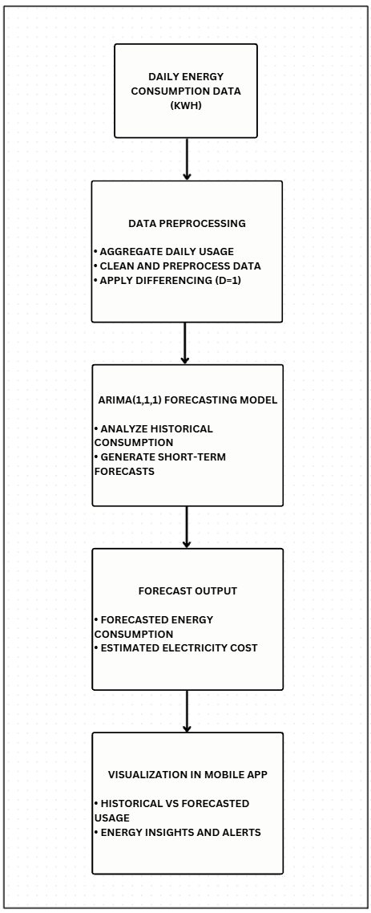

Figure 7 presents the forecasting process utilized by WattWise to estimate future household electricity consumption and projected electricity costs. The process begins with the collection of daily energy consumption data measured in kilowatt-hours (kWh) through the monitoring sensors integrated within the system. These collected readings are stored and organized to serve as the primary dataset for forecasting and energy analysis.Before the forecasting stage, the gathered data undergo preprocessing to improve the quality and reliability of the dataset. This process includes aggregating daily energy usage records, handling incomplete or inconsistent entries, and applying differencing to stabilize the time-series data for forecasting. These preprocessing steps help ensure that the historical consumption data are suitable for analysis using the ARIMA model.

After preprocessing, the ARIMA(1,1,1) forecasting model is applied to analyze historical electricity consumption patterns and generate short-term predictions of future energy usage. The forecasted values are then converted into estimated electricity costs using the current local electricity rate. The generated forecasts are presented within the mobile application through graphical visualizations that compare historical and predicted consumption trends. In addition, the system provides users with energy insights, estimated bill projections, and alerts that may help households make informed decisions and manage their electricity consumption more efficiently.

Tools

This section presents the hardware, software, and development tools used in the design and implementation of WattWise: Mobile Energy Monitoring and Forecasting System. These tools support the system’s functionality and are represented through technical models such as flowcharts, use case diagrams, entity relationship diagrams (ERD), and data flow diagrams (DFDs). The flowchart illustrates the step-by-step process of appliance monitoring and forecasting, while the use case diagram shows user interactions within the system. The ERD defines the relationships between system entities stored in Firebase, and the DFDs demonstrate how data flows from the ESP32 and PZEM-004T sensors to the cloud database and mobile application. Together, these tools and diagrams provide a structured overview of how WattWise performs real-time energy monitoring, data processing, forecasting, and recommendation generation.

Figure 8. Flowchart of the Proposed System

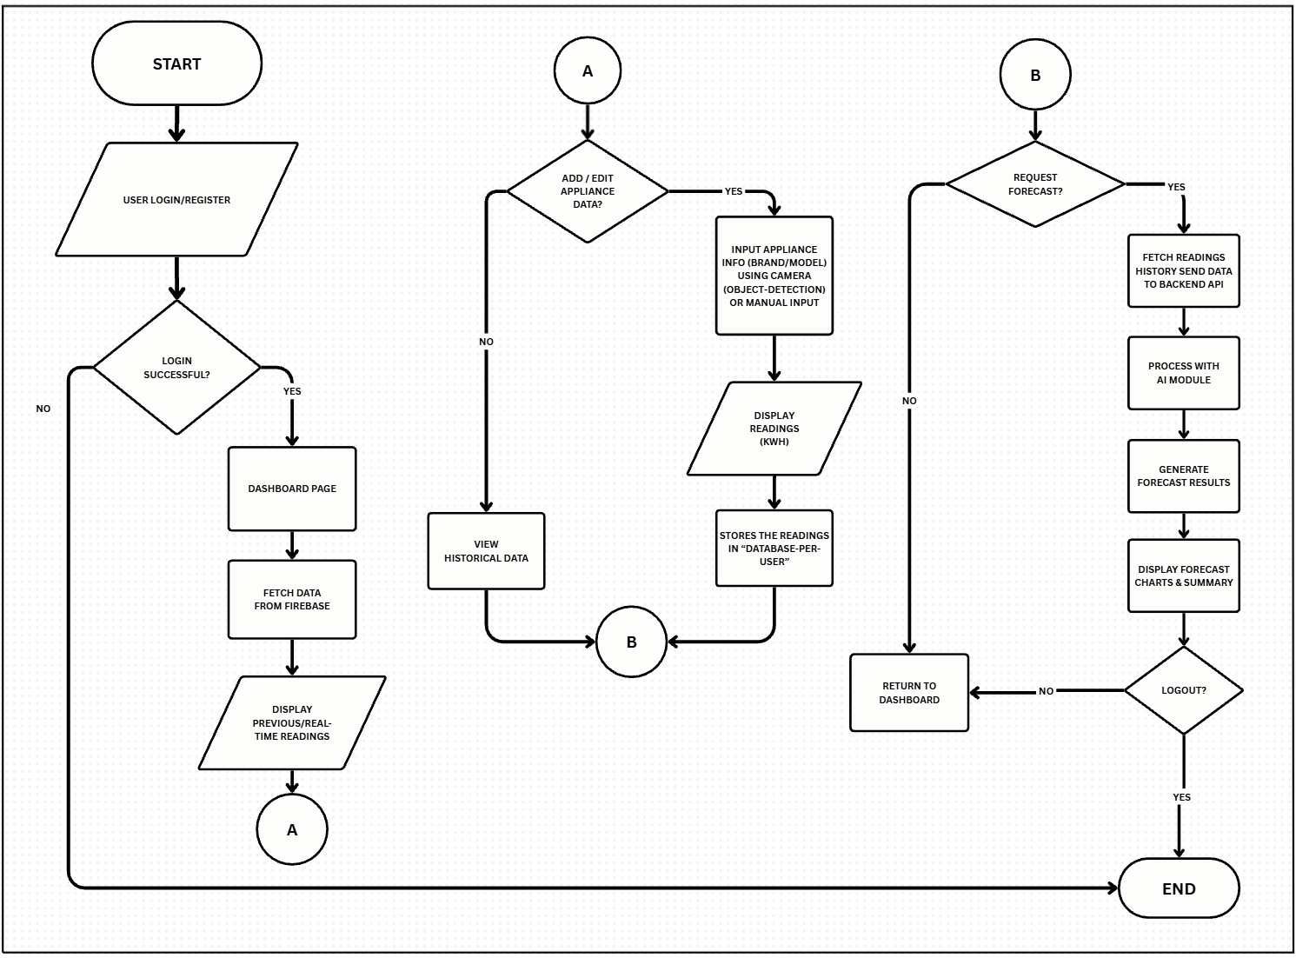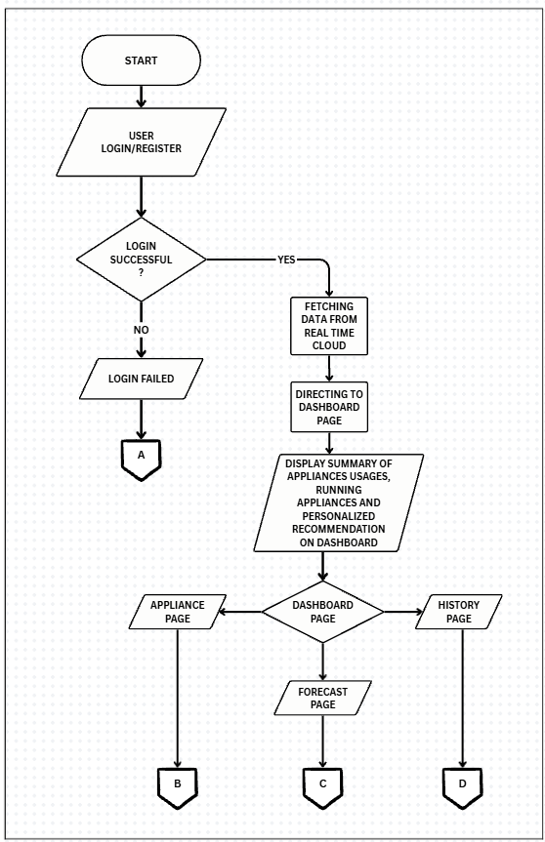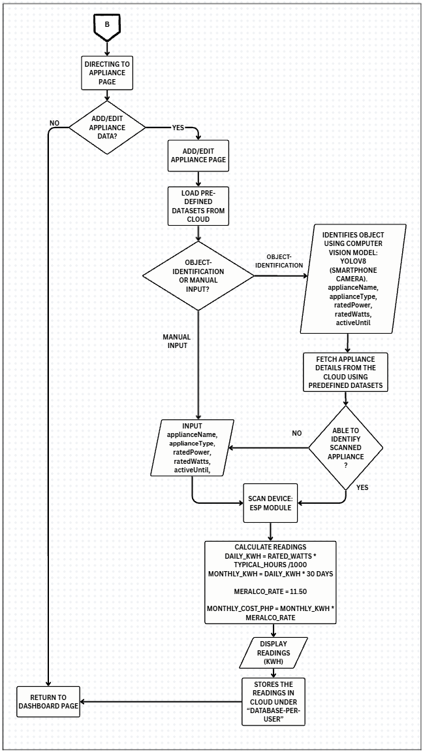

Figure 8 maps the WattWise system flow from user entry to actionable output: after secure registration or login, users add appliances by scanning or manual input and the app saves each device’s details (type, brand/model, estimated wattage) to the user’s dataset; the system then collects and aggregates sensor readings and usage entries, runs validation and time-series processing, and applies forecasting (ARIMA) together with local tariff data to estimate future consumption and costs, finally presenting results on an interactive dashboard, generating exportable reports (PDF/CSV), and delivering tailored energy-saving recommendations, users may act on suggestions, provide feedback, or end their session via logout.

Figure 9. Use Case Diagram

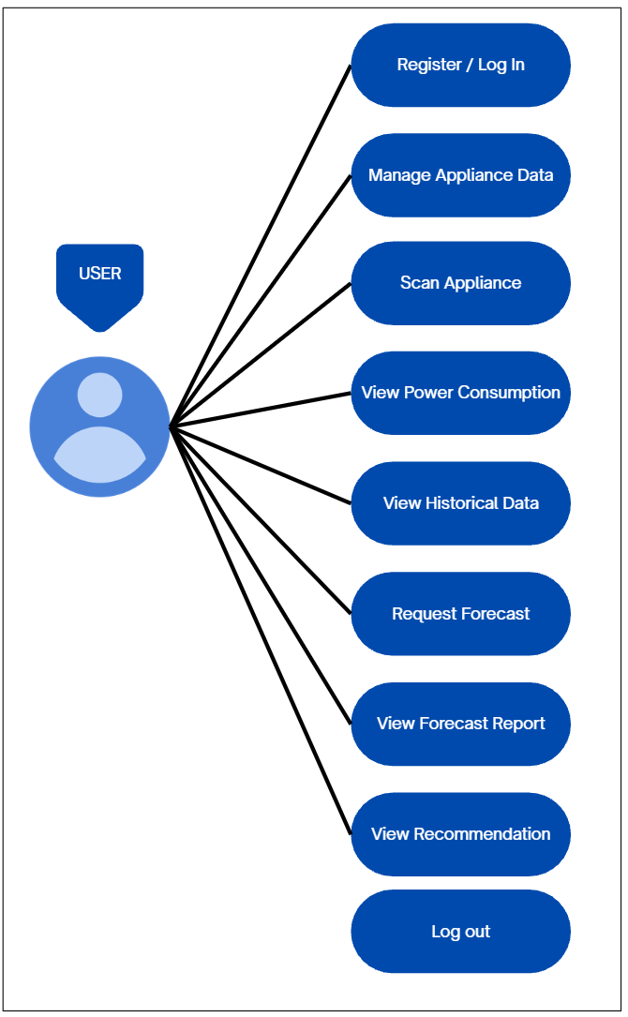
Figure 9 shows the primary use-case flow of the WattWise mobile application, beginning with secure user authentication. Users may register or log in to their accounts, then add home appliances to their profile; each account maintains its own database of time-stamped entries so users can inspect historical device data and past billing information.

Stored sensor readings and user-entered appliance details feed the forecasting engine, which produces short- and medium-term consumption and cost estimates. Forecast outputs are displayed on the dashboard and can be exported as PDF reports; each forecast is accompanied by targeted, actionable recommendations that translate predicted usage into practical steps for reducing consumption and saving money.

The diagram also includes routine account management actions such as session logout and optional account termination. In conclusion, the use-case layout highlights a straightforward, secure workflow that integrates appliance logging, telemetry collection, ARIMA-based forecasting, and recommendation delivery, helping Filipino households better understand their electricity use and make informed budgeting decisions.

Figure 10. Entity Relationship Diagram

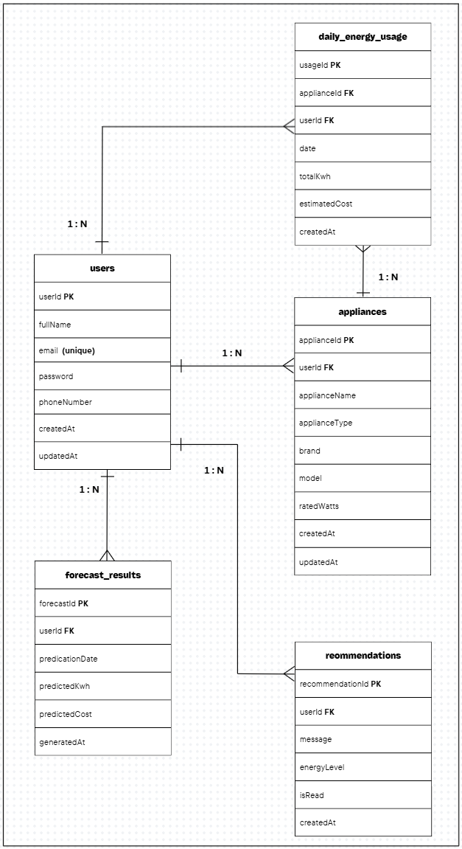

Figure 10 illustrates database structure of WattWise primarily utilizes one-to-many relationships to support user-based appliance monitoring and energy forecasting. A single user can register multiple appliances, generate multiple energy usage records, receive several recommendations, and store multiple forecasting results over time. Furthermore, each appliance can produce numerous daily energy usage records to support continuous monitoring and historical analysis. These relationships allow the system to efficiently organize appliance information, monitor electricity consumption, and generate personalized forecasting and recommendation outputs for each user.

Figure 11. Data Flow Diagram Level 0

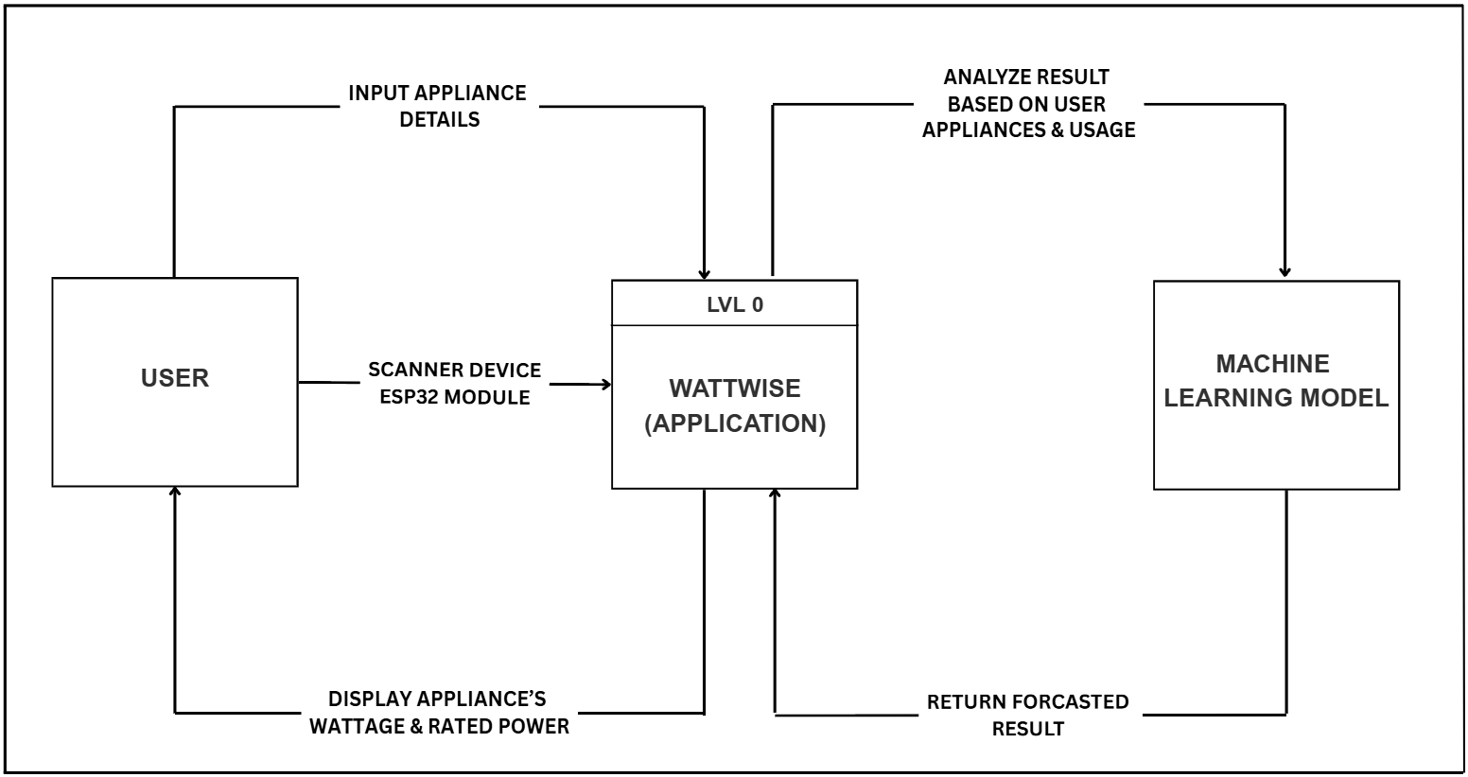

The Level 0 Data Flow Diagram (DFD) illustrates the overall flow of information between the user and the WattWise application. It simplifies the system into a single process block and focuses on interactions with the user and forecasting engine.

The process begins when the User inputs their appliance details into the WattWise mobile application. These details include the applianceName, applianceType such as refrigerator, fan, etc., and runtime duration, such as the number of hours the appliance is typically active per day, week, or month. Users may also optionally input the estimated wattage per hour if known.

Once received, WattWise processes this input and returns the appliance's estimated wattage and rated power consumption, helping the user immediately understand the energy load of the appliance. The application then communicates with the cloud database (Firebase) to fetch additional reference data, such as wattage standards for known brands and models. With the complete dataset, the system performs monthly consumption forecasting using an ARIMA-based model.The ARIMA forecasting module computes the estimated monthly kWh based on historical usage trends and inputs, and converts the result into local currency (Philippine Peso) using the latest Meralco rate. Finally, the forecasted results, including estimated monthly usage and cost, are sent back to the WattWise app and displayed to the user in real-time, supporting informed decision-making and awareness of energy consumption.

Figure 12. Data Flow Diagram Level 1

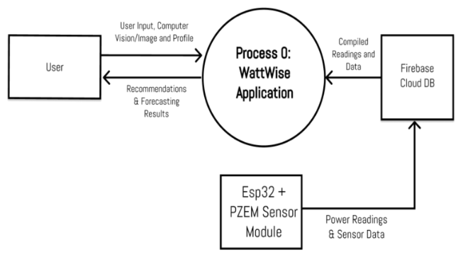
The user communicates with the system through the mobile app. The user can log in, send an appliance image for detection, and view the energy data and forecast results. The system processes whatever the user inputs and then returns the needed information on the app screen. The ESP32 with the PZEM 004T sensor works as the source of power readings. It collects real-time measurements such as voltage, current, and energy use of the appliances. These readings are then sent to the WattWise system for display and for use in forecasting. The Firebase Cloud Database acts as the storage area for all system data. It keeps user information, appliance details, sensor readings, and forecast results. The system sends and retrieves data from Firebase to make sure everything is updated and in sync between the hardware and the app.

At the center is the WattWise System, which processes all the information it receives. It handles user input, manages data from the ESP32, recognizes appliances using AI, and uses the ARIMA model to forecast energy usage. Once everything is processed, it sends the results back to the user’s mobile app in a clear and easy-to-understand format. Overall, this diagram shows the full flow of information from the sensors to the cloud and then to the user, explaining how each part of the study works together to provide real-time monitoring and accurate energy forecasting.

RESULTS AND DISCUSSIONS

This chapter presents the results and discussion of the developed WattWise: Mobile Energy Monitoring and Forecasting System for Home Appliances. The findings are presented through screenshots, system outputs, and demonstrations of the application’s major features, including appliance recognition, real-time energy monitoring, forecasting, and recommendation generation. These results demonstrate the overall functionality, usability, and integration of the system’s hardware, software, artificial intelligence, and forecasting components.

The discussion in each section explains how the implemented features operate within the mobile application and how the integrated technologies contribute to energy monitoring and forecasting. In addition, this chapter presents the performance of the system in collecting, processing, and visualizing electricity consumption data through the developed Android application.

Objective 1: Appliance Monitoring and Object-Identification System

The first objective was to develop an appliance-level monitoring and object-identification system capable of recognizing common household appliances and estimating their electricity consumption through real-time monitoring and smartphone-based object detection. This objective was successfully achieved through the integration of ESP32 and PZEM-004T monitoring hardware, Firebase cloud services, and the YOLOv8 object detection model within the WattWise mobile application.

Results:

Figure 13. Utilizing ESP32 and PZEM-004T Module

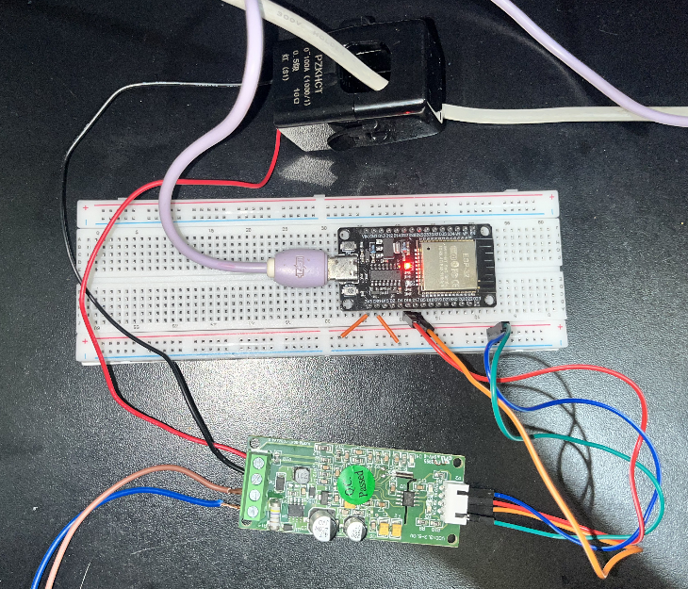
Figure 13 shows the hardware connection used in the WattWise system for monitoring household electricity consumption in real time. The setup includes an ESP32 microcontroller, a PZEM-004T energy monitoring module, and a CT clamp sensor connected to the live wire of a Camel electric fan. The PZEM-004T gathers electrical readings such as voltage, current, power, and energy consumption, while the ESP32 sends the collected data to the mobile application through Wi-Fi. The system calculates energy usage using the kilowatt-hour (kWh) formula and estimates the corresponding electricity cost based on the current Meralco residential rate. This setup allows the system to continuously monitor appliance energy consumption and provide users with updated electricity usage information.

Table 1. Real Time Energy Monitoring Result

Scan Interval | Power (W) | Estimated Daily Energy Consumption (kWh) | Estimated Daily Cost
1 | 65.00 W | 0.52 kWh | PHP 6.24
2 | 67.00 W | 0.54 kWh | PHP 6.43
3 | 63.00 W | 0.50 kWh | PHP 6.05
4 | 70.00 W | 0.56 kWh | PHP 6.72
5 | 66.00 W | 0.53 kWh | PHP 6.34
6 | 65.00 W | 0.52 kWh | PHP 6.24
7 | 67.00 W | 0.54 kWh | PHP 6.43
8 | 63.00 W | 0.50 kWh | PHP 6.05
9 | 70.00 W | 0.56 kWh | PHP 6.72
10 | 66.00 W | 0.53 kWh | PHP 6.34
11 | 65.00 W | 0.52 kWh | PHP 6.24
12 | 67.00 W | 0.54 kWh | PHP 6.43
13 | 63.00 W | 0.50 kWh | PHP 6.05
14 | 70.00 W | 0.56 kWh | PHP 6.72
15 | 66.00 W | 0.53 kWh | PHP 6.34
16 | 65.00 W | 0.52 kWh | PHP 6.24
17 | 67.00 W | 0.54 kWh | PHP 6.43
18 | 63.00 W | 0.50 kWh | PHP 6.05
19 | 70.00 W | 0.56 kWh | PHP 6.72
20 | 67.00 W | 0.54 kWh | PHP 6.43

Table 1 presents the real-time energy monitoring results generated by the WattWise system during the testing of a Camel electric fan. Across 20 measurements, the fan’s power draw varied from 63 W up to 70 W. on the measured wattage and the estimated daily usage duration, the system computed daily energy consumption values ranging from 0.50 kWh to 0.56 kWh. With Meralco’s residential electricity rate of approximately ₱12.64 per kilowatt-hour (Meralco, 2025), the daily electricity cost was estimated at about ₱6.05–₱6.72. The slight variations observed in the readings indicate normal changes in appliance power consumption during operation. These findings show that WattWise can continuously monitor electricity usage at the appliance level, calculate energy consumption in kilowatt-hours (kWh), and provide real-time electricity cost estimates.

Results:

Figure 14. Process of Object-Identification

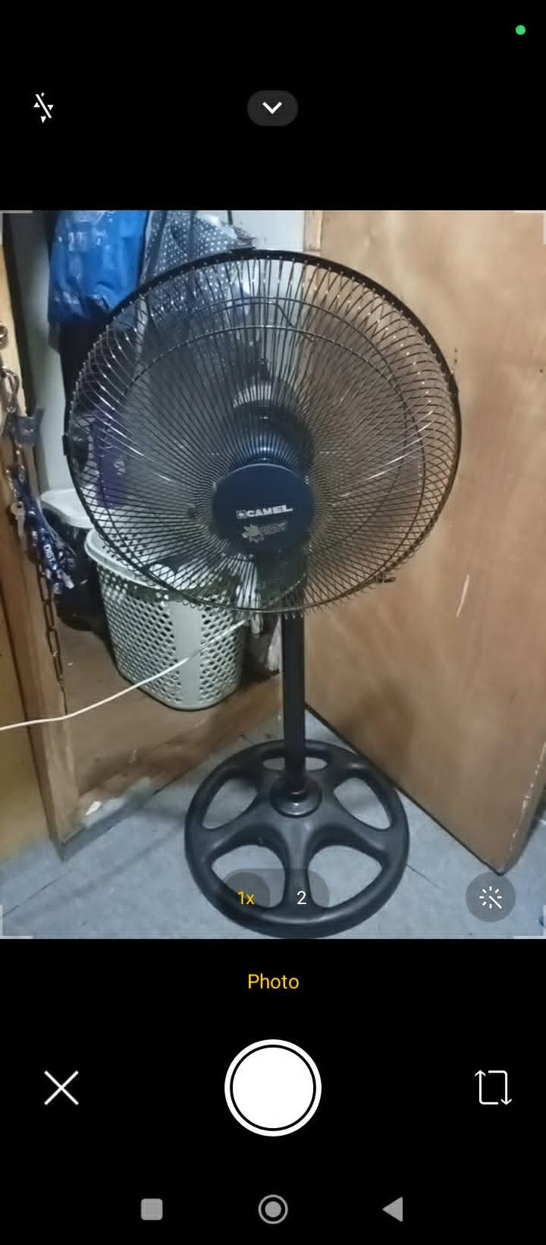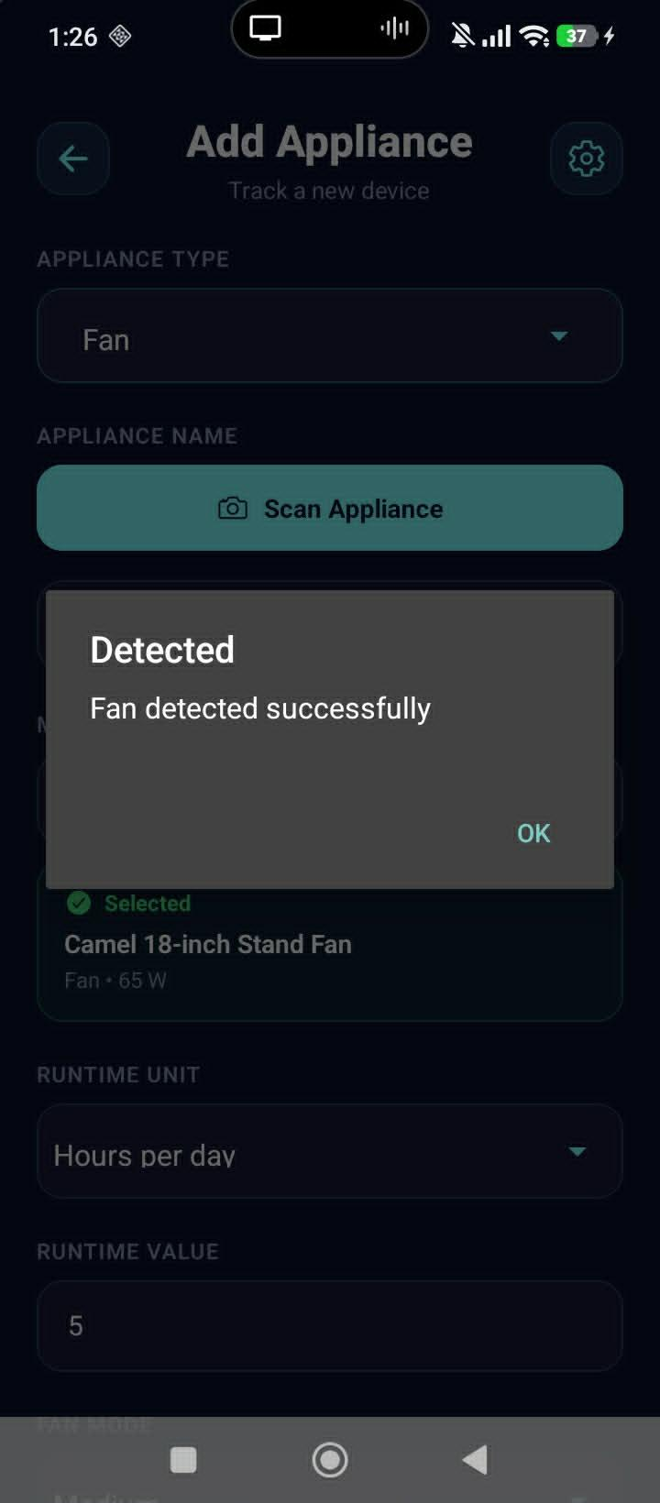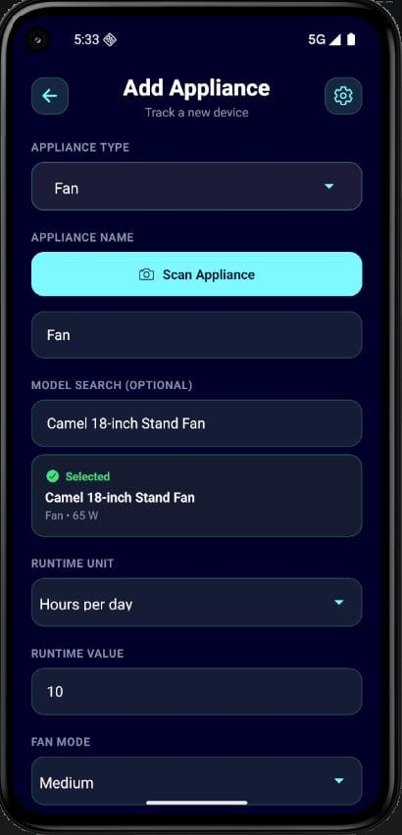

Figure 14 shows the object-identification process implemented in the WattWise mobile application. As illustrated, the user begins by capturing an image of a household appliance using the Android smartphone camera integrated within the application. Once the image is captured, the system sends the image data to the Flask API server, where the trained YOLOv8 object detection model processes and analyzes the appliance image in real time. After detection, the identified appliance type is returned to the mobile application and automatically displayed to the user.

Furthermore, the system automatically populates appliance-related information such as the appliance category, model name, and estimated wattage based on the matched data stored in Firebase Firestore. For example, when a stand fan is detected, the application automatically assigns the appliance type as “Fan” and retrieves the corresponding appliance information from the database. The detected appliance and its estimated electricity consumption details are then displayed in the appliance management interface, allowing users to review, monitor, and save the appliance within the WattWise system.

Discussion:

The object-identification feature simplifies appliance registration by allowing users to scan household appliances using the smartphone camera instead of manually entering appliance information. After detection, the system automatically identifies the appliance type and retrieves related details such as the model and estimated wattage from Firebase Firestore. The displayed wattage information is later used by the system to estimate electricity consumption in kilowatt-hours (kWh) and calculate the corresponding electricity cost, providing users with a more convenient and informative energy monitoring experience.

Objective 2: Real-Time Energy Monitoring and Recommendation Features

The second objective was to provide real-time energy monitoring and user-friendly recommendation features that allow households to track electricity consumption and receive practical energy-saving insights through the mobile application. This objective was successfully achieved through the integration of real-time Firebase synchronization, dashboard visualization features, consumption tracking, and personalized energy-saving recommendations within the WattWise system.

Results:

Figure 15. User Appliance page and Suggestion feature

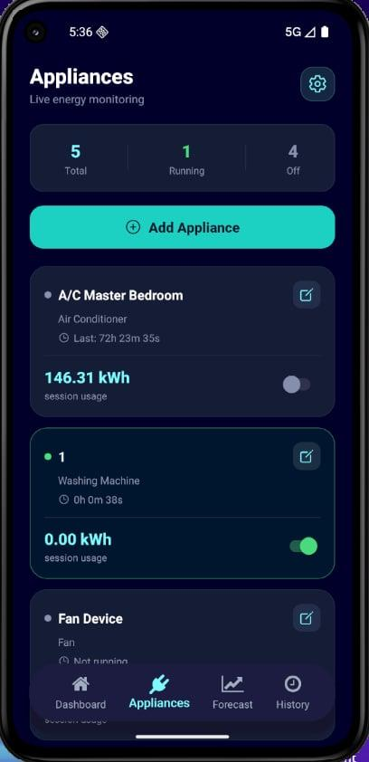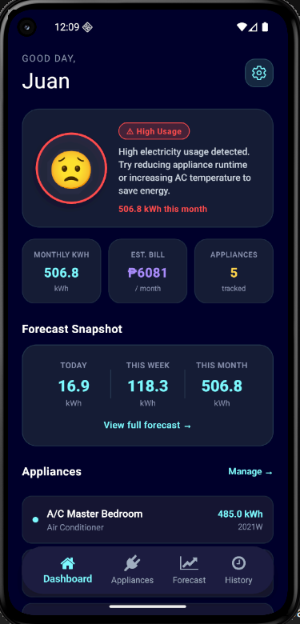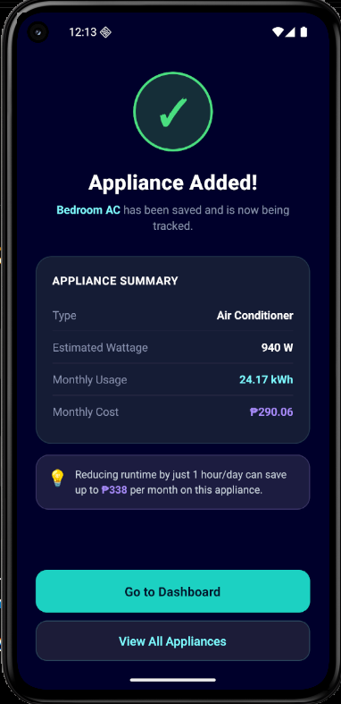
Figure 15 illustrates the appliance registration confirmation module implemented within the WattWise mobile application after an appliance record has been successfully stored in Firebase Firestore. Upon successful submission, the system retrieves and passes appliance parameters such as appliance name, appliance type, estimated wattage, monthly energy consumption, and projected monthly electricity cost through React Native route parameters for dynamic rendering within the confirmation interface. The module utilizes React Native’s Animated API to execute sequential scale, fade, and slide animations, improving visual feedback and enhancing user interaction during the appliance registration process.

The interface also performs energy consumption and cost visualization by displaying the computed monthly kilowatt-hour (kWh) usage and estimated electricity bill derived from the appliance’s rated wattage, runtime configuration, and predefined electricity rate. In addition, the system generates a contextual recommendation by calculating potential energy savings when appliance runtime is reduced by one hour per day. This computation allows the application to provide immediate energy-awareness feedback to users after appliance registration. Navigation controls were also integrated to redirect users either to the dashboard module for real-time monitoring or to the appliance management module for viewing and managing registered appliances within the system database.

Discussion:

The recommendation feature provides users with practical energy-saving suggestions based on their estimated electricity consumption. By analyzing the user’s energy usage, the system generates recommendations such as reducing appliance runtime, turning off unused devices, or adjusting appliance settings to encourage more efficient electricity consumption. In addition, the application includes a dedicated appliance monitoring page where users can view the list of registered appliances and monitor their estimated energy usage in real time. Recommendations are also automatically provided whenever a new appliance is added, helping users become more aware of their electricity consumption and possible ways to reduce energy costs.

Objective 3: ARIMA-Based Electricity Forecasting System

The third objective was to design an ARIMA-based electricity forecasting system capable of analyzing historical energy consumption data to generate short- and medium-term electricity usage and cost predictions. This objective was successfully achieved through the implementation of the ARIMA forecasting model integrated within the WattWise system to provide projected energy consumption trends and estimated electricity costs through the mobile application.

Results:

Figure 16. Forecasted Data

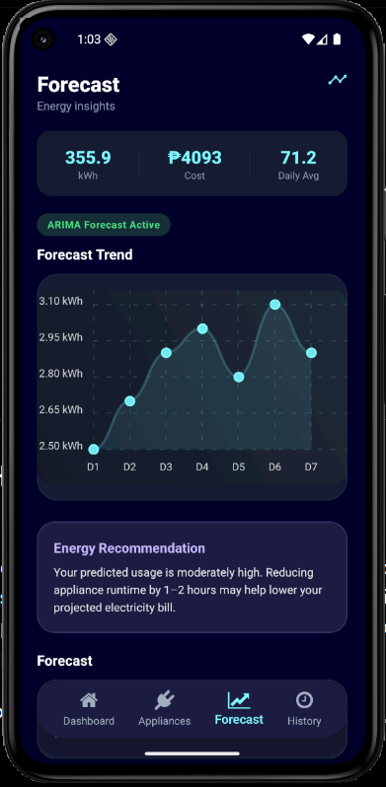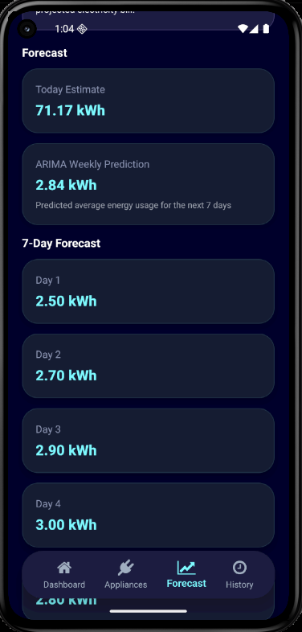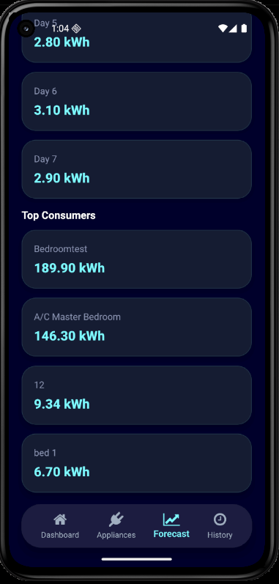

Figure 16 presents the forecasting interface of the WattWise mobile application. As shown, the system displays projected household electricity consumption using an ARIMA-based forecasting model integrated within the application. The interface visualizes the predicted energy usage for the next seven days through a line graph and forecast summary cards, allowing users to easily interpret expected electricity consumption trends. The forecast values are processed and rendered dynamically within the React Native application using predefined prediction datasets during prototype testing and interface validation.

Furthermore, the forecasting module computes the average predicted energy consumption in kilowatt-hours (kWh) and presents additional energy insights such as estimated daily usage, electricity cost summaries, and top energy-consuming appliances. The interface also includes an energy recommendation component that provides practical suggestions for reducing electricity usage based on the predicted consumption patterns. By integrating forecasting visualization, energy analytics, and recommendation features within a single interface, the system provides users with a more accessible and informative approach to household energy monitoring and planning.

Discussion:

The forecasting feature allows the WattWise application to estimate future household electricity consumption using historical energy usage data processed through the ARIMA forecasting model. By integrating the forecasting module with a Flask API and Firebase Firestore, the system can generate predicted energy usage values and display them through graphical charts and forecast summaries within the mobile application. In addition, the forecasting interface provides users with energy-saving recommendations based on predicted consumption patterns, helping users become more aware of their electricity usage and encouraging more efficient energy management practices.

CONCLUSION AND RECOMMENDATIONS

The WattWise: Mobile-Based Energy Monitoring and Forecasting System for Home Appliances successfully achieved its objective of providing a mobile and intelligent solution for monitoring and managing household electricity consumption. By integrating ESP32 and PZEM-004T for real-time energy monitoring, YOLOv8 for appliance identification, and the ARIMA model for electricity forecasting, the system was able to monitor appliance-level energy usage, estimate future consumption, and provide energy-saving recommendations through a single mobile platform. The study demonstrated that combining IoT, artificial intelligence, and forecasting techniques can improve user awareness regarding electricity consumption and support more informed energy management decisions.

During the development phase, several technical challenges such as API connectivity, real-time database synchronization, and appliance detection consistency were encountered. These issues were addressed through continuous testing, debugging, and system refinement using Agile development practices. The integration of Firebase, Flask API, and React Native also improved the overall responsiveness and scalability of the system throughout the testing phase.

For future development and improvement of the study, it is recommended to:

- Integrate Additional Appliance Datasets: To improve the accuracy of appliance identification and provide more comprehensive energy consumption estimations for various household devices.
- Improve Forecasting Accuracy: To support longer-term electricity forecasting by integrating larger historical datasets and exploring advanced forecasting models alongside ARIMA.
- Enhance IoT Integration and Real-Time Monitoring: To further improve the system by expanding the deployment of ESP32 and PZEM-004T modules across multiple household appliances, enabling more accurate real-time energy monitoring, improved data collection, and more reliable forecasting and recommendation outputs under actual household conditions.

ACKNOWLEDGEMENTS

The proponents would like to convey their heartfelt thanks to their research adviser for the guidance, patience, and constructive feedback shared throughout the conduct of this study. Deep appreciation is also given to the Department of Information Technology at Jesus Reigns Christian College, for providing the academic support needed for the successful completion of this project. Moreover, the researchers are grateful to their families, classmates, and friends whose encouragement and moral support inspired them to continue and accomplish this prototype successfully.

REFERENCES

- Albay, R. L. (2025). High electricity prices, frequent outages underscore need for rooftop solar in the Philippines. Eco-Business. https://www.eco-business.com/news/high-electricity-prices-frequent-outages-underscore-need-for-rooftop-solar-in-the-philippines/

- Apriandy Angdresey, Lanny Sitanayah, & Zefanya Marieke Philia Rumpesak (2023). An electricity consumption monitoring and prediction system based on the Internet of Things. In Proceedings of the International Conference on Intelligent Computing (ICIC 2022). IEEE. https://doi.org/10.1109/ICIC56845.2022.10007020Kenjale, et al. (2024). Smart electricity tracking system. International Journal of Engineering Research & Technology (IJERT), 13(11). https://doi.org/10.5281/zenodo.18130844

- U.S. Department of Energy. (n.d.). Reducing electricity use and costs. Energy Saver. https://www.energy.gov/energysaver/reducing-electricity-use-and-costs

- Gopikrishna, P. B., & Mathew, J. A. (2021). Power consumption analysis and prediction of a smart home using ARIMA model. SSRN. https://doi.org/10.2139/ssrn.3819512

- Pagaduan, L. J. L., Portolazo, J. G., Delfin, J. X. D., Dela Cruz, J. P. O., & Estanda, M. B. O. (2023). The development of real-time energy consumption monitoring using IoT. Advanced Computing: An International Journal, 10(1/2/3). https://doi.org/10.5121/acii.2023.10302

- Silagpo, G. M., Cabacang, E. J. M., Ilustrisimo, R. L., Inajada, M. R., & Jueco, J. (2024). Monitoring and prediction of household power consumption using Internet of Things and ARIMA. In 2024 3rd International Conference on Computational Modelling, Simulation and Optimization (ICCMSO). IEEE. https://doi.org/10.1109/ICCMSO61761.2024.00044

- Zangrando, N., Fraternali, P., Petri, M., Vago, N. O. P., & González, S. L. H. (2022). Anomaly detection in quasi-periodic energy consumption data series: A comparison of algorithms. Energy Informatics, 5. https://doi.org/10.1186/s42162-022-00230-7

- Motta, L. L., Ferreira, L. C. B. C., Cabral, T. W., Lemes, D. A. M., Cardoso, G. dos S., Borchardt, A., Cardieri, P., Fraidenraich, G., de Lima, E. R., Neto, F. B., & Meloni, L. G. P. (2023). General overview and proof of concept of a smart home energy management system architecture. Electronics, 12(21), 4453. https://doi.org/10.3390/electronics12214453

- Rahman, A., Hossain, S., Ahmed, S., & Ahmed, M. T. (2025). IoT based smart energy consumption prediction for home appliances. International Journal of Intelligent Engineering and Electronic Business, 17(2). https://doi.org/10.5815/ijieeb.2025.02.06

- Guo, N., Chen, W., Wang, M., Tian, Z., & Jin, H. (2021). Applying an improved method based on ARIMA model to predict the short-term electricity consumption transmitted by the Internet of Things (IoT). Wireless Communications and Mobile Computing, 2021, Article 6610273. https://doi.org/10.1155/2021/6610273

- Caw-it, J. G., & Florence, J. B. (2025). Forecasting household electricity consumption using ARIMA: A time series approach. International Journal for Multidisciplinary Research, 3(7), 129–144. https://doi.org/10.5281/zenodo.15836495

- Sharma, S., Sarkar, D., & Gupta, D. (2012). Agile processes and methodologies: A conceptual study. International Journal on Computer Science and Engineering, 4(5). https://www.researchgate.net/publication/267706023_Agile_Processes_and_Methodologies_A_Conceptual_Study

- Meralco. (2025). Higher rates this July 2025. Manila Electric Company. https://company.meralco.com.ph/news-and-advisories/higher-rates-july-2025

