Hexagonal-Petal Inspired Planar Antenna for

Wideband 5G/6G Wireless Applications
- Nagaraja
Assistant Professor.
Department of Electronics and communication Engineering,
Madanapalle Institute of Technology & Science (MITS), Deemed to be University, Madanapalle, Andhra Pradesh, India-517325.
vvlncnagaraja@gmail.com
H. Shree Kumar
Assistant Professor.
Department of Electronics and communication Engineering,
Madanapalle Institute of Technology & Science (MITS), Deemed to be University, Madanapalle Andhra Pradesh, India-517325. hshreekumar@gmail.com

M Kiran
Student Department of Electronics
and communication Engineering,
Madanapalle Institute of Technology & Science (MITS), Deemed to be University, Madanapalle, Andhra Pradesh, India-517325.
Moondkiran7777@gmail.com
M Lakshmi Pathi
Student Department of Electronics
and communication Engineering,
Madanapalle Institute of Technology& Science (MITS), Deemed to be University, Madanapalle, Andhra Pradesh, India-517325.
Mlakshmipathi28052004@gmail.com
K Mahalakshmi
Student Department of Electronics
and communication
Engineering,
Madanapalle Institute of Technology & Science (MITS), Deemed to be University, Madanapalle, Andhra Pradesh, India-517325.
konampallimahalakshmi@gmail.com

Abstract: In this paper, the design and performance analysis of a planar hexagonal microstrip patch antenna operating within a wide frequency band in the millimeter wave regime has been introduced. The design has a hexagonal patch and six flared slots equally spaced around the patch. The parameters used in the design of the patch are the thickness of the substrate, which is 2 mm; the width of the patch, which is 140 mm; the length of the slot, which is 160 mm; and the width of the feeding patch, which is 4 mm.
The simulated results of the S-parameter (S11) show a very wide impedance bandwidth with a return loss of about -30 dB at around 90 GHz, which clearly depicts good impedance matching. The radiation efficiency, though moderate, is in the range of 0.5 % to 3.2 % for different frequencies and depicts peaks at higher frequencies. The far-field radiation patterns of the antennas depict their directional patterns and reduced back lobes at certain frequencies. The polar plots of the antennas clearly show their good gain performance at the operating frequencies, though some distorting effects and sidelobes are produced at higher frequencies due to slot and substrate effects.
The proposed antenna has a small overall size and can easily be integrated with high frequencies. The directional pattern, low reflection coefficient, and satisfactory gain properties of the proposed antenna make it viable for usage in terahertz imaging, wireless communication, and radar applications. For improved radiation efficiency, the substrate material and feed mechanism can be optimized. This work validates the concept of employing a hexagonal slotted patch configuration to obtain a wideband design in mm-wave applications.

Keywords— Hexagonal microstrip antenna, Slot-loaded planar radiator, Millimeter-wave wideband operation, Impedance bandwidth enhancement, 5G/6G.

I.INTRODUCTION

The advent of wireless communication systems, high resolution imaging, and radar technology at millimeter wavelengths has fueled the need for miniature, highly efficient antennas that operate effectively in the millimeter wave frequency range

and Terahertz frequencies. As the operating frequency increases, there are tight requirements for the bandwidth, gain, and radiation efficiency of the antenna designs while retaining a lightweight and planar form factor that is suitable for use in modern communication systems. Microstrip patch antennas have been widely researched and used owing to their simplicity and compatibility with printed circuit technology; however, the standard rectangular or circular patch antenna is often characterized by low bandwidths and inefficient radiation at higher frequencies.

To cope with these issues, slotting and patch geometric designs have proved useful ways of improving the performance of antennas. Of these designs, the hexagonal patch has proved beneficial in terms of having a simple structure along with good bandwidth performance. For these patches, the symmetrical design ensures a well-balanced current path distribution, while the judicious use of slots ensures the occurrence of multiple resonances that widen the operational bandwidth.

In the above study, a hexagonal slotted microstrip patch antenna has been designed and simulated for operation in a wide frequency band. The proposed design includes six flared slots etched symmetrically around the hexagonal patch, contributing to both improved impedance matching and the effect of the far-field patterns of the proposed antenna. The design variables of the antenna, including the substrate thickness, width of the patch, length of the slot, and width of the feed, have been optimized using full-wave simulations for improving the antenna performance. The design variables include a substrate thickness of 2 mm, a width of 140 mm, length of 160 mm, and width of 4 mm for the feed.

The SIMulated return loss (S11) clearly reveals the reduction and approaches -30 dB at 90 GHz, thereby showing good impedance matching characteristics. This is an indication that the antenna is capable of efficiently transmitting power with low reflection losses. The radiation efficiency

varies from 0.5% to 3.2% over the investigated frequency band, which is quite moderate but as expected in mmWave designs where losses from the dielectric and conductor start make a difference. The polar plots of the radiation pattern show a more directed radiation pattern with well-defined main lobes and suppressed back lobes at lower frequencies. As the frequency increases, some deviation and creation of sidelobes occur, as is to be expected owing to the higher modes being excited in a slot-loaded arrangement.

The proposed antenna has a few favorable characteristics, which make it suitable to be used within the millimeter-wave system. These include its small size, planar structure, and end-fire radiation pattern. Moreover, its simple manufacturing process allows it to be produced on a mass scale using a printed circuit board. Although the proposed antenna has a relatively poor radiation efficiency, which could be considered a limitation, there are still ample opportunities to make improvements.

It is clear that this study portrays the ability of the hexagonal slotted microstrip patch to provide a broad impedance bandwidth with acceptable radiation performance, thus emerging as a credible contender for the next generation of high-frequency applications. These results indicate the possibility of achieving superior performance using modification approaches like the addition of slots to overcome the limitations associated with millimeter-wave patch antennas.
LITERATURE SURVEY

[1] Since recent breakthroughs in wireless communication technology, and in order to cater to the needs of the next generation communication network, namely, 6G, sub-THz frequency, especially around the band of D-Band (110-170 GHz), has gained prominence. The previous generations, right from 1G through to 5G, were basically meant for communication involving voice, mobile, ultra-reliable low-latency communication, but with 6G, data
100 Gb/s speeds, sub-millisecond latency, and very high device connectivity. Such performance levels require innovations at various levels, right from transmitter designs to antenna designs and integration techniques.
[2] The terahertz (THz) frequency band, with an approximate range of 0.1-10 THz, has also been regarded as a spectrum of prime importance for beyond 5G and 6G communication because of the very wide bandwidths available for supporting very high data rates with lower latencies. However, the complex absorption in the ionospheres of water vapor and oxygen causes huge losses in terahertz frequencies.
[3] Studies on the design and analysis of microstrip patch antennas in 6G millimeter wave communication indicate that small-sized high gain and economical antennas are feasible in the upper mm-wave spectrum to provide efficiency and bandwidth benefits in 6G communication systems.
[4] Compact hexa-band microstrip patch antennas of high performance have been designed and fabricated for terahertz applications, which are well suited for wireless 6G communication systems due to their widened bandwidth and increased gain.
[5] Research papers on the design of high gain array antenna for the 6G terahertz wireless communications have proved the efficiency offered by multi-element design, which increases the gain and directivity.
[6] Multi-band high-frequency antenna designs have been proposed that relate to satellite communication, automotive radar systems, as well as 6G communication. These designs emphasize the combination of small size and wide bandwidth to facilitate multiple wireless applications.
[7] Simulation results for the 6th generation microstrip patch antennas designed for MIMO technology have presented better performance and isolation. It is thus hoped for the integration of high-speed networks in the 6th generation.
[8] Asymmetric coplanar waveguide-fed patch antennas with slits have been investigated for use in terahertz communications and provided high efficiency and a wide impedance bandwidth beneficial in compact 6G transceiver modules.
[9] Quad-patch, triple-band microstrip antennas for use in the 5G/6G mm-wave band show enhancement in gain and bandwidth properties, proving their viability for smart vehicles, IoT devices, and radar technology.
[10] The design and analysis of rectangular and circular microstrip patch antennas indicate the attempts to increase the gain and return loss, laying the basic for the advanced patch designs introduced for the 6G research.
[11] Three-band and two-port MIMO antennas with decoupling structures have demonstrated improved isolation and radiation efficiency. This has indicated advancements in combining the concept of MIMO in the development of future 6G technology.
[12] The development of high-gain microstrip patch antennas operating in multiple frequency bands validates the potential of combining compactness, bandwidth, and gain for terahertz communication.
[13] Studies surveying the horizon of 6G technologies pick out the trend of THz communication, AI-optimized resource allocation, large intelligent surfaces, and energy-efficient architecture as the enablers of the future of wireless communication connectivity.
[14] Overall reports regarding the development of the 6th generation highlight the upcoming generation as the successor to the current 5G technology, as the new generation integrates the ground, aerial, and satellite systems to provide seamless global connectivity with ultra-low latency, reliability, and security.
[15] Microstrip patch antennas gained recognition for their low profile, lightweight, and easy manufacturing process, but the bandwidth limitations and losses associated with the surface waves have remained obstacles. Many variations and methods of excitation have been investigated to improve the designs.
[16] Research interests concerning radar systems had earlier focused on the visibility of antennae and its impact on the search and rescue transponder response rate.

RESULT & DISCUSSION

S-PARAMETERS:

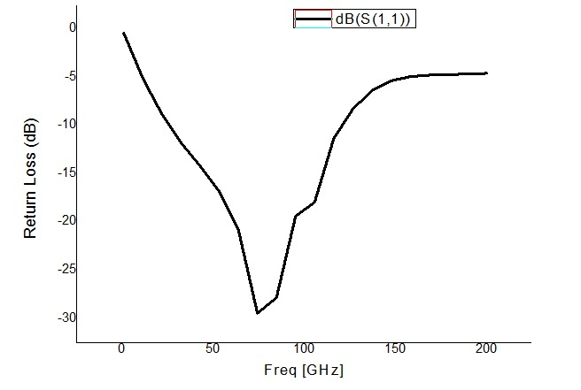 T
Figure I
Figure I shows the return loss or S₁₁ parameter versus the frequency. From this, it is clear that the antenna or the device is impedance-matched at a frequency band around 80–90 GHz, since the return loss is minimum at this point with a value of –30 dB, which is an indicator of efficient power transmission and lack of reflection. Below 50 GHz and above 150 GHz, the return loss is high, and this indicates a poorly matched device, with the device being most optimal around 85 GHz

II.RADIATION EFFICIENCY:

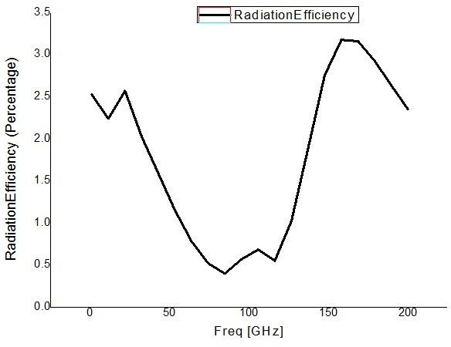
Figure II

Figure II illustrates the variation of radiation efficiency with frequency. From the graph, the efficiencies vary with frequency, with peaks at 150-170 GHz and lower efficiencies at 90-100 GHz. However, the maximum efficiencies only reach 3%, which means that the antenna works well at that frequency. The troughs in the graph illustrate that there are certain frequencies that experience losses or mismatch. However, the graph provides a way to interpret the exact frequency at which the antenna works.

III.VSWR Parameter:
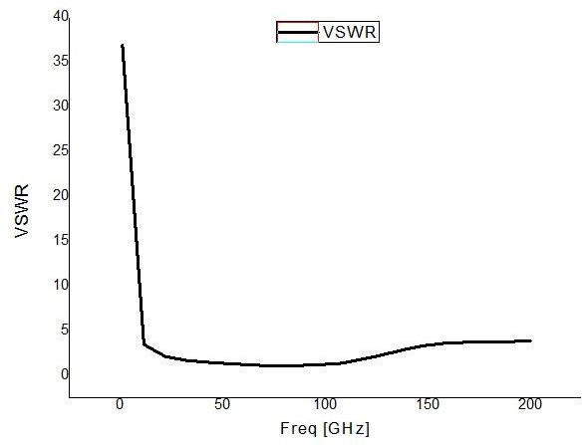
Figure III

Figure III shows VSWR characteristics the change in the value of the Voltage Standing Wave Ratio with respect to the frequency. The VSWR value is initially large, implying a poor matching condition. A drastic reduction in the VSWR value is observed along with a stable value of unity for a wide range of frequencies. A slight increase is noticed after 150 GHz. It clearly depicts that the impedance matching condition is excellent throughout most of the frequencies.

IV .Gain Total

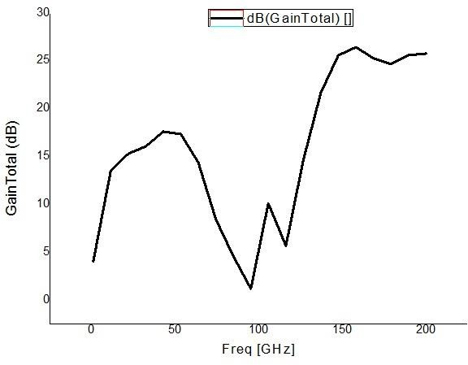
Figure IV

Figure IV shows the gain variation between the total gain and the frequency. It is seen that the gain of the antenna is slowly increasing up to 50 GHz. It goes into a valley at 100 GHz. After this valley, the gain increases heavily and attains its peak value of 25 dB between 150-170 GHz. This clearly states that the antenna has a better performance at higher frequencies. It has a good gain attribute over a high frequency band.

V.2D POLAR PLOT:
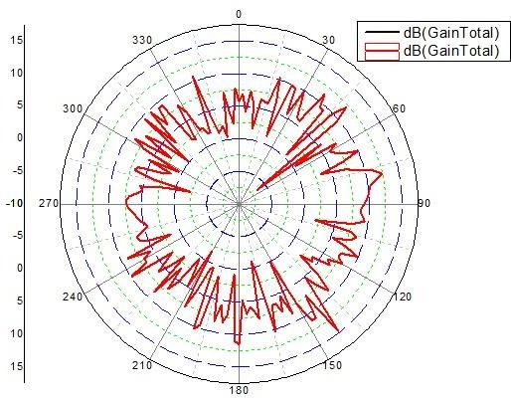

Figure V

Figure V represents the 2D radiation pattern antenna properties of functioning in all directions. The changes in the gain values in all the directions reveal the fact that the antenna does not radiate uniformly in all directions. The major lobe of the graph reveals the region where the antenna functions at its best, and the slight variations in the graph reveal the side lobs and losses caused by the antenna

VI . POLAR PLOT

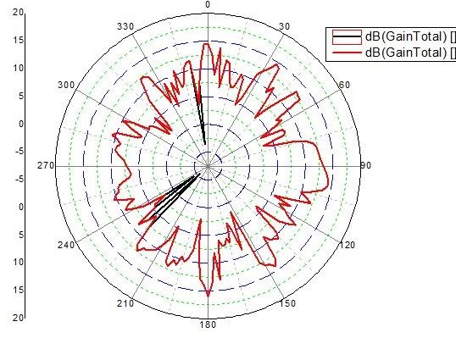

Figure VI
The polar plot gives information regarding the antenna gain distribution at various angles. The antenna gain distribution pattern exhibited variations, which indicated the antenna is directional with multiple peaks and null points. The main lobe indicated the direction with the highest gain, and the other lobes indicated the antenna’s reduced gain. The polar plot is an indicator that the antenna operates with greater efficiency at some points, which are depicted in the plot, indicating the directional property of the antenna.

VII. 2D POLAR PLOT
Parameter name | Value | Unit | Evaluated Value | Type
S | 5 | mm | 5mm | Design
Rate | 25 | mm | 25mm | Design
TL | 50 | mm | 50mm | Design
H | 2 | mm | 2mm | Design
S1 | 160 | mm | 160mm | Design
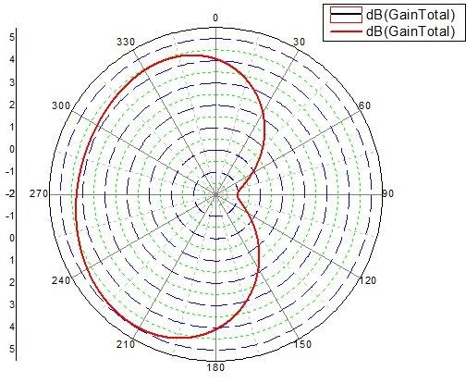
Figure VII

Parameter name | Value | Unit | Evaluated Value | Type
SW | 200 | mm | 200mm | Design
P1 | 130 | mm | 130mm | Design
PW | 140 | mm | 140mm | Design
F1 | 65 | mm | 65mm | Design
FW | 4 | mm | 4mm | Design
The 2D polar graph above displays the radiation pattern of the antenna in decibels. This pattern gives the distribution of the power away from the antenna. The graph provides clear information about the directionality and radiation pattern of the antenna. The antenna has a directional pattern that favors the main lobe and has little or no back lobe. This clearly illustrates that the antenna has directionality and favors the enhancement of the signal along a certain direction.
DESIGN STRUCTURE
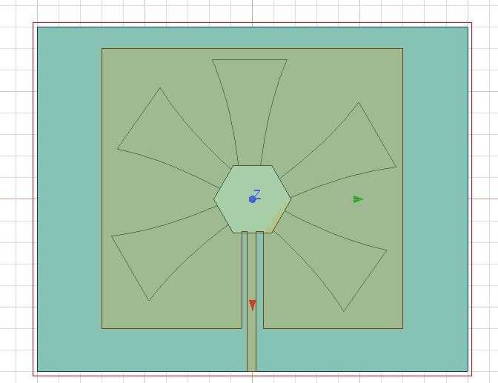
Figure VIII
The design consists of a microstrip feed line that is properly connected at the center for efficient signal transmission. The flared arms are positioned symmetrically for bandwidth and radiation properties. On the whole, the ground planes and substrate layers ensure stability and control the impedance matching properties. This design would assist in obtaining increased gain, directivity, and the possibility of miniaturization, especially suited for wideband communications at high frequencies.

Table 1. Antenna Design Parameters

Table 2. Antenna Design Parameters

Table 1 below highlights the design specifications utilized in the antenna model. These specifications all have specific dimensions, which form an important part of the model.
Table 2 presents the key design parameters used in the antenna structure for simulation. It includes critical dimensions such as substrate height, slot size, and line characteristics of the feeding line. These parameters are optimized to enhance bandwidth, impedance matching, and overall antenna performance.
Acknowledgement

We would like to thank Mr. V. Nagaraja, Assistant Professor, Department of Electronics and Communication Engineering, with deep regards for his continuous guidance, technical insights, and encouragement throughout the design, analysis, and preparation of this research work. His valuable suggestions greatly contributed to enhancing the technical depth and clarity of the manuscript.

The authors would also like to thank Dr. H. Shreekumar, who provided valuable comments, academic encouragement, and guidance during the preparation of this manuscript and enabled them to strengthen the overall presentation of their work. The authors acknowledge with gratitude the contributions of the student contributors who have been sincerely devoted in simulation work, interpretation of results, drafting of the manuscript, and plagiarism checking to ensure originality and academic integrity of the research work. The authors thank Dr. S. Rajasekaran, Head of the Department, ECE, with respectful thanks for providing a very encouraging research environment and necessary facilities within the department. His encouragement and administrative support were highly instrumental for successful completion of this work.

Future Scope

The Hexagonal Slotted Planar Antenna designed and analyzed in this paper can be used at millimeter wave and for the demands of the newly emerging 6G technology. In the future, the antenna’s efficiency can be improved with the use of low-loss substrates. The same design can be modified as MIMO and antenna arrays to improve the gain and isolation of the antenna. Experimental verification at sub-THz can be performed to increase the applicability of the proposed design. Studies can also be conducted to explore the possibility of designing the antenna at the system level to be used in the 6G transceiver and terahertz imaging systems.

Conclusion

The main focus of the current work is based on the design and analysis of a hexagonal slotted planar microstrip antenna for wideband millimeter wave application. The proposed antenna design based on a hexagonal shape and symmetrically arranged slots is developed for better bandwidth and impedance matching characteristics. The simulation results of the proposed design of the antenna have shown a high return loss of around -30 dB near the frequency of 90 GHz for efficient transmission of the signal without any significant reflection.
Moreover, the analysis of the proposed antenna design indicates a directional radiation pattern and an improvement in gain for high-frequency bands. Though the radiation efficiency is low for the proposed antenna design, which is a general problem for millimeter wave antennas due to inherent material and propagation losses, the overall performance of the antenna is stable over a wideband of frequency. The proposed design is compact and simple for integration into modern technology for high-frequency application.
The proposed antenna design is promising for application in modern technologies such as 5G/6G communication systems, terahertz imaging systems, and radar systems. The proposed design may be optimized for better performance by selecting better substrate materials and feeding techniques for application in next-generation wireless communication systems.

References
[1]. S. Z. Aslam, A. Wilcher, B. Chatterjee, Y. K. Yoon,
D. P. Arnold and S. Sinha, "Challenges and Opportunities in D-Band Transmitter Architectures and Antenna Design, Integration, and Scalability for 6G Communications: A Brief Review," IEEE Access, vol. 13, pp. 33849–33873, 2025, doi: 10.1109/ACCESS.2025.3542771.
[2]. H. Jahanbakhsh Basherlou, M. Odiamenhi, N. Ojaroudi Parchin, C. Hwang See and M. Shen, "An Overview of THz Antenna Design for 5G/6G Wireless Communications," Advanced Wireless Communications and Mobile Networks – Current Status and Future Directions, Intech Open, Apr. 25 2025. doi: 10.5772/intechopen.1010047.

[3]. Ramineni, P., & Dharmapuri , Y. G. (2025). Design and Analysis of Microstrip Patch Antenna for 6G Millimeter-Wave Communication. Journal of Scientific Research, 17(3), 737–753. https://doi.org/10.3329/jsr.v17i3.77923
[4]. Uddin, M. A., Islam, M. M., Khatun, M. and Smrity,
M. S. A., 2025. "High Performance Hexa Band Compact Microstrip Patch Antenna Design for Terahertz Applications." Journal of Electrical and Electronic Engineering, 13(4), pp. 154-167. DOI 10.11648/j.jeee.20251304.12.
[5]. Nataraj, D., Rao, K. C., Chakradhar, K. S., Sudhir, B., Vinutna Ujwala, G., Lakshmunaidu, M. and Rao, P. K. (2025) "A High-Gain Array Antenna Design for 6G Terahertz Wireless Systems," Engineering, Technology & Applied Science Research, 15(4), pp. 25479–25485. doi: 10.48084/etasr.11467.
[6]. Yadav, S. V., Yadav, M. V., Yadav, D. et al. "Multi- band high-frequency antenna for satellite, automotive radar, and 6G communication." Scientific Reports 15, 30400 (2025). https://doi.org/10.1038/s41598-025-16217-9.
[7]. Sivanandam, K. and Dhevasenathipathi, C., 2025 May. "Design and Simulation of 6G Microstrip Patch Antenna for MIMO Applications." In International Conference on Sustainability Innovation in Computing and Engineering (ICSICE 2024) (pp. 1462-1475). Atlantis Press. DOI 10.2991/978-94-6463-718-2_122.
[8]. Naik, K. K. (2024). "Asymmetric CPW-fed patch antenna with slits at terahertz applications for 6G wireless communications." Wireless Networks 30, 2343–2351. https://doi.org/10.1007/s11276-024-03695-4.
[9]. Singh, R. K. and Mamta, K., 2024. "A compact novel quad patch high gain triple band microstrip antenna for 5G/6G mm wave applications." Journal of Scientific Research, 16(1),
pp. 187-199. DOI: https://doi.org/10.3329/jsr.v16i1.66715.
[10]. Ijraset, "Design and analysis of rectangular and circular microstrip patch antenna," IJRASET, 2024. https://doi.org/10.22214/ijraset.2024.59625.
[11]. Zhonggen Wang, Wanying Ren, Wenyan Nie, Weidong Mu and Chenlu Li, "Design of Three-Band Two- Port MIMO Antenna for 5G and Future 6G Applications Based on Fence-Shaped Decoupling Structure," Progress In Electromagnetics Research C, Vol. 134, 249-261, 2023. doi: 10.2528/PIERC23051503.
[12]. Niyaz Mahmud Sayem, Abul Kalam Muhammed Baki, Fahim Faysal, Sheikh Tanvi Mahmud, Ahmed Jubayer and Tawsif Ahmed Rifat, "Development of Novel and High Gain Microstrip Patch Antennas at Different Frequency Bands for 6G Applications," Progress In Electromagnetics Research C, Vol. 137, 263-275, 2023. doi: 10.2528/PIERC23071302.
[13]. C. D. Alwis et al., "Survey on 6G Frontiers: Trends, Applications, Requirements, Technologies and Future Research," IEEE Open Journal of the Communications Society, vol. 2, pp. 836-886, 2021, doi: 10.1109/OJCOMS.2021.3071496.
[14]. W. Jiang, B. Han, M. A. Habibi and H. D. Schotten, "The Road Towards 6G: A Comprehensive Survey," IEEE Open Journal of the Communications Society, vol. 2, pp. 334- 366, 2021, doi: 10.1109/OJCOMS.2021.3057679.
[15]. Singh, I. and Tripathi, V. S., 2011. "Micro strip patch antenna and its applications: a survey." Int. J. Comp. Tech. Appl., 2(5), pp. 1595-1599.
[16]. Trim, R. M., "A Technique for Improving the Radar Visibility of Search and Rescue Transponder Responses." Journal of Navigation, 49(2): 284-285, 1996. doi: 10.1017/S0373463300013461

