Hybrid Satellite–Cloud Architecture for Large-Scale Live Sports Broadcasting: A Case Study of IPL 2026

ABSTRACT :
Live sports streaming has grown very fast in recent years, but it is still difficult to deliver smooth and high-quality video to millions of users at the same time. Traditional satellite broadcasting is very reliable and has very low delay, but it does not support personalization or flexible services. On the other hand, OTT platforms provide better user experience and customization, but they often suffer from higher delay and network issues. This paper presents a hybrid satellite–cloud architecture for large-scale live sports broadcasting, using IPL 2026 as a case study. The proposed system combines the strength of satellite communication with cloud computing, content delivery networks, and adaptive streaming techniques. It also includes a simple predictive approach to manage sudden increases in user traffic during important match moments.The system is designed to improve streaming quality, reduce buffering, and support a large number of viewers at the same time. The study shows that combining satellite and cloud technologies gives better performance compared to using only one method. This approach can be useful for future live streaming systems where both reliability and user experience are important.
Keywords : Content Delivery Networks (CDN), Cloud Computing
INTRODUCTION
Live sports streaming has become very popular with the growth of mobile phones, internet services, and digital platforms. In the past, people mainly watched matches through satellite television, which provided stable and low-delay streaming. However, this system did not support user interaction or personalized viewing.In recent years, OTT platforms have changed the way people watch sports. Users can now watch matches on mobile phones with different features such as multiple camera views, language options, and highlights. Even though OTT platforms improve user experience, they often face problems like buffering and delay when a large number of users watch the match at the same time. The IPL 2026 is one of the biggest live sports events, with millions of viewers watching matches simultaneously through both television and mobile platforms. This makes it a good real-world example to study how modern broadcasting systems work at a very large scale.
This paper presents a case study of IPL 2026 broadcasting technology and explains how a hybrid satellite–cloud system is used to deliver live matches efficiently. It studies how satellite communication, cloud computing, content delivery networks, and streaming technologies work together to handle high traffic and provide better viewing experience. The main objective of this paper is to understand the working of this hybrid system, identify its advantages and challenges, and explain why such an approach is important for future large-scale live streaming systems.
EXISTING SYSTEMS
Live sports broadcasting mainly uses two types of systems today: satellite-based broadcasting and OTT (internet-based) streaming. Both systems are widely used, but each has its own strengths and limitations.
i) Satellite-Based Broadcasting
Satellite broadcasting is the traditional method used for live sports telecast. In this system, the match is first captured by cameras in the stadium, and the video signal is sent to a ground station. From there, the signal is uplinked to a satellite, which then transmits it back to television service providers. Finally, viewers receive the broadcast through DTH or cable connections.

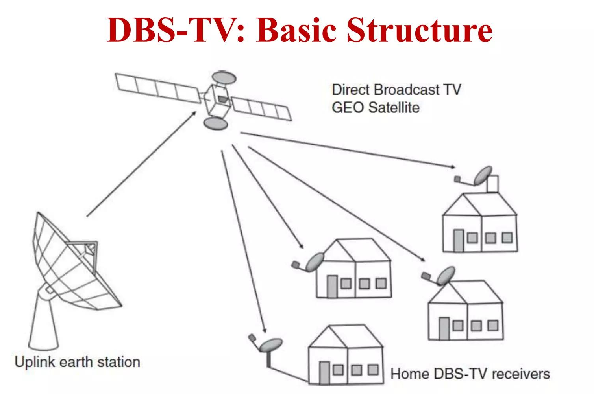
Figure 1 : Basic Structure of Satellite Broadcasting
The process starts with cameras capturing the live match in the stadium. The captured signal is then sent to a ground station, where it is uplinked to a satellite. The satellite receives the signal and transmits it back to different regions, where TV providers distribute it to viewers through DTH or cable networks.
Advantages
Satellite broadcasting offers very low delay, providing almost real-time viewing experience. It is highly reliable and ensures stable transmission even during large-scale events. Another major advantage is its wide coverage, as it works effectively even in remote and rural areas where internet connectivity is limited.
Limitations
Satellite broadcasting has several limitations. It does not support personalization, so all users receive the same content without any customization. It also offers very limited interactivity compared to modern streaming platforms. In addition, the infrastructure cost is high, making it expensive to set up and maintain. Another drawback is that it is not flexible for mobile users, as it is mainly designed for television viewing rather than on-the-go streaming.
ii)OTT (Over-the-Top) Streaming
OTT platforms deliver live sports through the internet to mobile phones, tablets, and smart TVs.
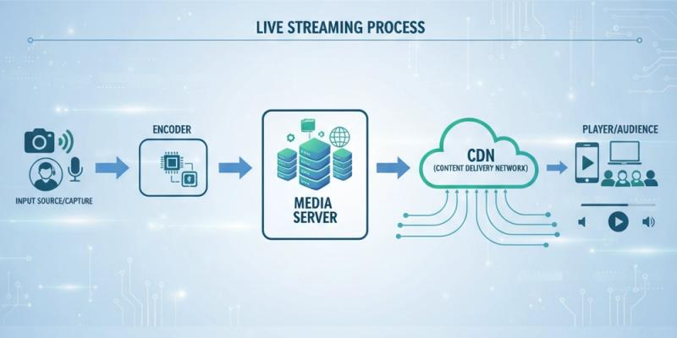
Figure 2: Working Process of OTT Streaming
Working Process of OTT Streaming
In OTT streaming, the video is first captured from the stadium and encoded into digital format. This encoded video is then sent to cloud servers, where it is processed and prepared for distribution. The content is delivered through Content Delivery Networks (CDNs), which help send the video efficiently to users across different locations. Finally, viewers watch the live match on their devices through the internet.
Advantages
OTT streaming can support millions of users at the same time, making it suitable for large-scale events. It offers personalization features such as different languages and multiple camera angles, improving the user experience. It also works on various devices like mobile phones, tablets, smart TVs, and laptops. In addition, it provides interactive features that allow users to engage more with the content.
Limitations
Despite its benefits, OTT streaming has some limitations. It usually has higher delay compared to satellite broadcasting. Users may experience buffering, especially during heavy traffic or peak viewing times. The performance depends heavily on internet quality, and poor connectivity can affect streaming. It also consumes a large amount of data, which can be a concern for many users.
Feature | Satellite Broadcasting | OTT Streaming
Delay | Very low | Higher
Reliability | Very high | Medium
Scalability | Limited | High
Personalization | Not available | Available
Device Support | TV only | Mobile, TV, Web
Table 1: Difference between Satellite and OTT streaming systems
Proposed System (Hybrid Satellite–Cloud Architecture)
Satellite broadcasting ensures reliability, whereas OTT platforms provide flexibility but struggle during peak loads. To overcome these limitations, a hybrid satellite–cloud architecture is proposed for efficient IPL 2026 live sports broadcasting. To overcome the limitations of both satellite broadcasting and OTT streaming, this paper proposes a hybrid satellite–cloud architecture for large-scale live sports broadcasting. This system combines the reliability and low delay of satellite communication with the scalability and flexibility of cloud-based streaming.
The proposed system uses a dual delivery approach. Satellite broadcasting is used as the primary backbone for stable and low-latency transmission, while cloud infrastructure and OTT platforms are used to deliver content to mobile and internet users with personalization features. By combining both methods, the system ensures better performance during high-traffic events like IPL 2026.
Key Components of the System
- Capture & Production:
Live match is captured using multiple cameras and processed in a production unit.
- Encoding:
The video is compressed using formats like H.264 or H.265 to reduce data size.
- Satellite Transmission:
The encoded signal is uplinked to a satellite for wide and reliable broadcast coverage.
- Cloud Processing:
The same feed is also sent to cloud servers for OTT streaming and further processing.
- Content Delivery Network (CDN):
CDNs distribute the video efficiently to users across different regions.
- User Devices:
Viewers receive the content through TV (satellite) or internet-enabled devices (OTT).
Working Principle (Hybrid Approach)
The proposed Hybrid Satellite–Cloud Architecture combines the strengths of satellite broadcasting and cloud-based OTT delivery to support large-scale live sports events such as IPL 2026. In this model, satellite communication ensures low-latency, reliable, and wide-reaching content delivery for television viewers, while cloud computing and Content Delivery Networks (CDNs) provide scalable, flexible, and personalized streaming services for internet and mobile users. By integrating both technologies, the system can efficiently serve millions of concurrent viewers, reduce buffering during peak traffic conditions, and enhance overall service reliability. This hybrid approach leverages satellite technology for stability and extensive coverage, while utilizing cloud and OTT platforms for adaptability and improved user experience, making it a promising solution for the future of large-scale live sports broadcasting.

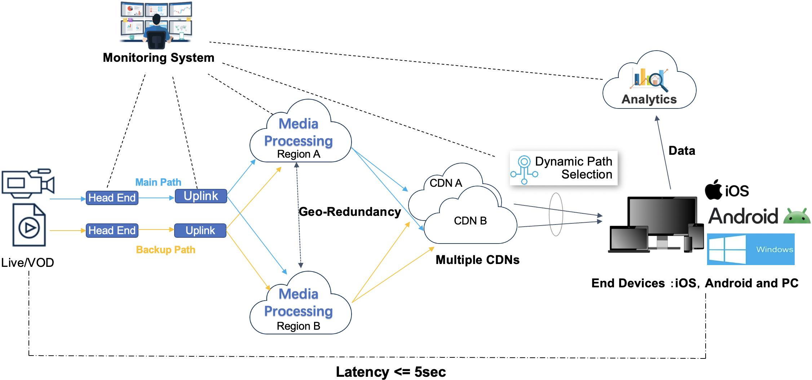
Figure 3: Architecture diagram for hybrid satellite–cloud streaming system
The given diagram shows how a hybrid satellite–cloud streaming system works to deliver live video efficiently to users with low delay (less than 5 seconds).
1. Input Source (Live/VOD)
The process starts with live video or recorded content (VOD). This is captured using cameras and sent to the Head End system, where the content is prepared for transmission.
2. Main Path and Backup Path
The proposed architecture employs two parallel transmission paths: a main path and a backup path. The main path serves as the primary route for streaming video content, while the backup path acts as a secondary route that automatically takes over in the event of a failure or disruption in the main path. Both paths pass through dedicated uplink systems, providing redundancy and fault tolerance. This dual-path approach enhances system reliability, minimizes service interruptions, and ensures continuous, high-quality streaming for viewers during large-scale live sports broadcasts.
3. Media Processing (Region A & Region B)
The video stream is transmitted to cloud-based media processing units located in two geographically separate regions, namely Region A and Region B. This approach, known as geo-redundancy, ensures service continuity by maintaining an alternative processing location if one region experiences a failure or outage. Within these cloud regions, the video undergoes essential processing tasks such as encoding, compression, and stream preparation to optimize it for efficient delivery across various devices and network conditions. By utilizing geo-redundant cloud infrastructure, the system enhances reliability, availability, and resilience, ensuring uninterrupted live streaming for large-scale sporting events.
4. Multiple CDNs (Content Delivery Networks)
After media processing, the video content is distributed through multiple Content Delivery Networks (CDNs), such as CDN A and CDN B, to ensure efficient and reliable content delivery to viewers. The use of multiple CDNs helps balance traffic loads across different network infrastructures, reducing the risk of congestion during peak viewing periods. This multi-CDN strategy improves streaming speed, minimizes buffering, and enhances the overall viewing experience while effectively supporting millions of concurrent users during large-scale live sports events.

5. Dynamic Path Selection
The proposed architecture incorporates dynamic path selection to optimize content delivery and ensure a seamless streaming experience. This mechanism continuously monitors network conditions, server availability, and user location to automatically select the most efficient CDN or delivery path for each viewer. By intelligently routing traffic through the best-performing path, the system minimizes latency, reduces network congestion, and enhances streaming quality. As a result, viewers experience faster content delivery, lower delays, and improved reliability, particularly during high-traffic live events.
6. End Users (Devices)
The processed and optimized video content is ultimately delivered to end users across a wide range of devices, including smartphones running iOS and Android, personal computers with Windows operating systems, and other smart devices such as smart TVs and tablets. Through internet-based streaming, users can access live content seamlessly regardless of their device or location. The integration of cloud infrastructure, multi-CDN distribution, and dynamic path selection ensures smooth playback, reduced buffering, and a high-quality viewing experience, even during large-scale live sports events with millions of concurrent viewers.
7. Analytics & Monitoring System
A comprehensive monitoring and analytics system is integrated into the proposed architecture to oversee the entire content delivery workflow. The monitoring component continuously tracks key performance indicators, network traffic, system health, and potential errors across all stages of the streaming process. Simultaneously, the analytics module collects and analyzes user behavior data, viewing patterns, and system performance metrics. These insights enable proactive traffic management, rapid issue detection, and real-time decision-making to optimize resource utilization and service quality. As a result, the system can improve streaming performance, maintain reliability during peak traffic conditions, and deliver an enhanced viewing experience for users.
8. Low Latency Goal
The system is designed to maintain latency ≤ 5 seconds, which is very important for live sports streaming.
Technologies Used
This section explains the main technologies used in the proposed hybrid satellite–cloud system. These technologies work together to deliver smooth, scalable, and high-quality live streaming.
1. Video Encoding (Compression Technology)
Before transmission, the raw video is compressed using encoding techniques such as H.264 and H.265 (HEVC). These formats reduce the size of the video while maintaining good quality. Encoding also helps in creating multiple quality levels (low to high resolution) so that users with different internet speeds can watch without interruption.
2. Content Delivery Network (CDN)
CDNs are used to deliver video content quickly to users. Instead of sending data from a single server, CDNs store content in multiple servers located in different regions. When a user requests a video, it is delivered from the nearest server, reducing delay and buffering. Using multiple CDNs also helps in handling large traffic during peak events.
3. Cloud Computing
Cloud platforms are used for processing, storing, and managing video streams. The cloud handles:
- Video transcoding
- User requests
- Load balancing
- Data storage
Cloud systems are scalable, meaning they can increase resources automatically when more users join, which is very important for events like IPL 2026.
4. Adaptive Bitrate Streaming (ABR)
ABR technology automatically adjusts video quality based on the user’s internet speed. If the network is slow, the video quality is reduced to avoid buffering. If the network is strong, higher quality is delivered. This ensures smooth playback for all users.
5. Artificial Intelligence (AI) and Analytics
AI is used to improve system performance and user experience. It helps in:
- Predicting traffic spikes
- Optimizing resource allocation
- Personalizing content (language, highlights)
- Detecting streaming issues
Analytics collects data about user behavior and system performance, which helps in making better decisions.
6. Satellite Communication
Satellite technology is used for reliable and low-latency broadcasting. It ensures that live content reaches wide areas, including remote locations, without depending on internet connectivity.
7. 5G and Edge Computing
5G networks and edge computing improve last-mile delivery. Edge servers process data closer to users, reducing delay and improving streaming quality, especially for mobile users.
Technology | Description | Role in System
Video Encoding (H.264 / H.265) | Compresses raw video into smaller size while maintaining quality | Reduces bandwidth usage and enables smooth streaming
Content Delivery Network (CDN) | Network of distributed servers across regions | Delivers content faster with less buffering and handles large traffic
Cloud Computing | Provides scalable storage and processing power | Handles video processing, user requests, and system scaling
Adaptive Bitrate Streaming (ABR) | Adjusts video quality based on internet speed | Ensures smooth playback without interruptions
Artificial Intelligence (AI) & Analytics | Uses data to optimize performance and user experience | Predicts traffic, manages resources, and personalizes content
Satellite Communication | Transmits signals over large distances via satellites | Provides reliable, low-latency broadcasting, especially for TV users
5G & Edge Computing | High-speed network with local processing near users | Improves streaming speed and reduces delay for mobile users
Table 2 : Technologies used

Analysis & Discussion
This section explains how the proposed hybrid satellite–cloud system performs in real-world conditions and why it is better than using only satellite or only OTT streaming.
1. Performance Analysis
The hybrid system improves overall streaming performance by combining the strengths of both technologies. Satellite broadcasting provides very low delay and stable delivery, while cloud and CDN systems handle a large number of users at the same time. This reduces buffering and improves video quality, especially during high-traffic events like IPL 2026.
2. Latency Analysis
Latency is one of the most important factors in live streaming.
- Satellite systems: Very low delay (1–3 seconds)
- TT systems: Higher delay (8–15 seconds)
- Hybrid system: Optimized delay (around 5 seconds or less)
By using satellite for primary broadcast and cloud for adaptive streaming, the hybrid system balances delay and flexibility.
3. Scalability Analysis
OTT platforms alone can handle many users, but they may struggle during sudden spikes. The hybrid system uses:
- Cloud auto-scaling
- Multiple CDNs
This allows the system to support millions of concurrent users without performance drop.
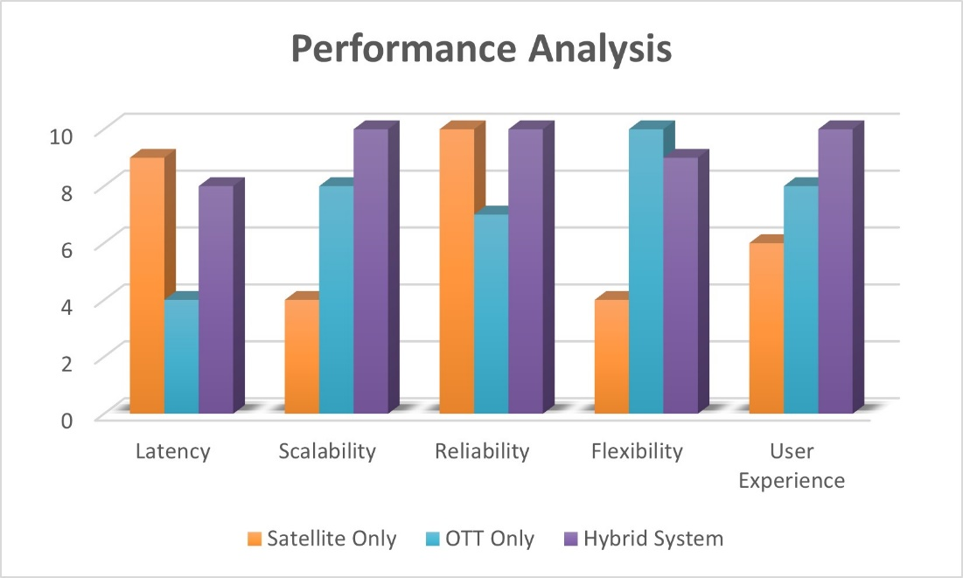
Figure 4: Performance Analysis
4. Reliability Analysis
Reliability is improved using:
- Main path + backup path
- Geo-redundant cloud regions
- Multiple CDNs
If one part fails, another part continues the service. This ensures continuous streaming without interruption.
Aspect | Satellite Only | OTT Only | Hybrid System
Latency | Low | High | Medium (Optimized)
Scalability | Limited | High | Very High
Reliability | High | Medium | High
Flexibility | Low | High | High
User Experience | Basic | Advanced | Best
Table 4: Comparison of Satellite ,OTT and Hybrid System
5. User Experience Analysis
The hybrid system provides a better user experience by:
- Reducing buffering
- Supporting multiple devices
- Offering personalization (language, views)
- Providing stable playback even in weak networks

Conclusion

This paper proposed a hybrid satellite–cloud architecture for large-scale live sports broadcasting using IPL 2026 as a case study. By combining the reliability and low latency of satellite systems with the scalability and flexibility of cloud-based OTT platforms, the framework enhances streaming quality, reduces buffering, and supports millions of concurrent users. The results indicate that the hybrid approach offers improved latency, reliability, scalability, and user experience, making it a promising solution for future live sports broadcasting.

References
[1] Indian Space Research Organisation (ISRO), “Satellite Communication and Broadcasting Services.” [Online]. https://www.isro.gov.in
[2] Amazon Web Services (AWS), “Media Services and Live Streaming Solutions.” [Online]. Available: https://aws.amazon.com/media-services/
[3] Akamai Technologies, “Content Delivery Network Overview.” [Online]. Available: https://www.akamai.com
[4] T. Stockhammer, “Dynamic Adaptive Streaming over HTTP—Standards and Design Principles,” in Proc. ACM MMSys, 2011
[5] S. Lederer, C. Müller, and C. Timmerer, “Dynamic Adaptive Streaming over HTTP (DASH): Standards and Design Principles,” in Proc. ACM MMSys, 2012
[6] J. De Cicco, S. Mascolo, and V. Palmisano, “Feedback Control for Adaptive Live Video Streaming,” in Proc. ACM MMSys, 2011
[7] Y. Liu et al., “A Case for a Coordinated Internet Video Control Plane,” in Proc. ACM SIGCOMM, 2012
[8] R. K. Sitaraman, “Network Performance and Content Delivery Networks,” Communications of the ACM, vol. 58, no. 6, pp. 44–52, 2015
[9] Cisco Systems, “Cisco Annual Internet Report (2023–2026).” [Online]. Available: https://www.cisco.com
[10] Netflix, “Open Connect CDN and Streaming Architecture.” [Online]. Available: https://netflixtechblog.com
[11] Intelsat, “Global Satellite Communication for Media Distribution.” [Online]. Available: https://www.intelsat.com
[12] Cloudflare, “How CDNs Improve Streaming Performance.” [Online]. Available: https://www.cloudflare.com
[13] X. Yin, A. Jindal, V. Sekar, and B. Sinopoli, “A Control-Theoretic Approach for Dynamic Adaptive Video Streaming over HTTP,” ACM SIGCOMM Computer Communication Review, vol. 45, no. 4, pp. 325–338, 2015
[14] M. Seufert, S. Egger, M. Slanina, T. Zinner, T. Hoßfeld, and P. Tran-Gia, “A Survey on Quality of Experience of HTTP Adaptive Streaming,” IEEE Communications Surveys & Tutorials, vol. 17, no. 1, pp. 469–492, 2015
[15] K. Spiteri, R. Urgaonkar, and R. K. Sitaraman, “BOLA: Near-Optimal Bitrate Adaptation for Online Videos,” IEEE/ACM Transactions on Networking, vol. 28, no. 4, pp. 1698–1711, 2020

