Design Strategies for Zero-Energy and Zero-Carbon Buildings

Abstract
Global warming, which is mostly caused by carbon emissions, is one of the most important issues the world is currently experiencing. As a result, reducing carbon dioxide emissions has emerged as one of the world's most pressing issues. To meet carbon reduction goals, low-carbon or zero-carbon building design is crucial. The building construction sector has been found to be one of the main sources of carbon emissions across all industries. This study's goal is to find architectural design solutions that lower energy use and carbon dioxide emissions. The necessary data was gathered from books and scholarly publications, and the study methodology is based on a descriptive-analytical approach. The results show that advancing toward zero-energy and zero-carbon buildings and incorporating their design concepts into architectural ideas is necessary to achieve energy consumption reduction. Therefore, in order to better safeguard the environment and prevent climate change, energy consumption levels, energy reduction techniques, and carbon dioxide emissions are taken into account throughout the early stages of design worldwide.

Keywords: Zero-energy building, zero-carbon building, energy consumption, climate change, carbon dioxide emissions.

- Introduction
It has now been established that human activity contributes significantly to climate change. According to the Intergovernmental Panel on Climate Change's (IPCC) Fourth Assessment Report, human activity caused a 70% rise in greenhouse gas emissions between 1970 and 2004 [1]. Scientific evidence suggests that rising sea levels, an increase in the frequency of extreme weather events, food shortages, changes in disease patterns, severe water scarcity, and the loss of tropical forests are all consequences of climate change, though the full extent of these effects is still unknown. The majority of specialists predict that the globe will experience catastrophic climate change in the ensuing decades, which will have an impact on nearly every facet of human society, the economy, and the environment [2]. According to the IPCC's Fourth Assessment Report, building-related greenhouse gas emissions totaled about 8.6 billion metric tons of CO₂ in 2004 [3]. The fact that carbon dioxide emissions from buildings' use of energy rose by 2.5% annually in commercial buildings and 1.7% in residential structures between 1971 and 2004 is especially alarming regarding greenhouse gas emissions. By 2030, this trend is predicted by the IPCC to reach 15.6 trillion metric tons of CO₂ [3].
Fossil fuels (coal, oil, and natural gas) provide the majority of the energy used today. As a direct result, greenhouse gases, chief among them carbon dioxide (CO₂), are released into the atmosphere. By absorbing and reemitting infrared radiation, these gases contribute to climate change and global warming. Governments everywhere have pledged to increase the production and use of renewable energy sources and decrease greenhouse gas emissions in response to this danger [4]. Since the building sector produces more than half of greenhouse gas emissions and supplies about 40% of the world's material inputs, it is now generally acknowledged that it is one of the biggest causes of climate change [5]. Without a question, the most important factor contributing to climate change is carbon dioxide, which makes mitigation measures the most urgent priority [6]. Architectural design gradually moved away from a strictly architectural perspective after the Industrial Revolution [7]. The contamination of the environment caused by building construction and energy use was the main cause of this change. Nowadays, one of the top goals in architectural design is to reduce energy usage. Since carbon dioxide is regarded as the most important greenhouse gas pollutant, the idea of zero-carbon buildings developed after the idea of zero-energy buildings.
- Energy Consumption
Climate and location are just two of the many connected aspects that affect how much energy a building uses while it is in operation. These variables include building performance and usage patterns, energy supply and sources, building design and construction materials, occupant behavior and income level, and building performance.
Every facet of a building's energy use over its lifetime is influenced by the local climate and environmental context. The majority of nations, as well as various areas within a single nation, have diverse climate zones [2].
The potential for greenhouse gas emissions rises primarily for two reasons as nations grow and gas and electricity replace conventional fuels. First, having availability to electricity can boost demand for electrical appliances, which elevates total energy consumption above levels seen in the past when electricity was hard to get by [2]. Second, unless it uses sustainable energy sources like hydropower, solar energy, or nuclear energy, the production of electricity itself is a significant source of greenhouse gas emissions. According to estimates, the direct combustion of fossil fuels in buildings produced about 3 GtCO₂ globally in 2004, while total energy usage produced 8.6 GtCO₂ annually [3]. In a similar vein, the Carbon Monitoring for Action (CARMA) database [8], which documents carbon emissions from over 50,000 power plants and 4,000 electrical companies globally, shows that almost 40% of all carbon emissions come from the production of electricity using fossil fuels.
Global energy use from fossil fuels between 1971 and 2009 is depicted in Figure 1. Oil is still the most popular energy source in the world, but natural gas and electricity usage have been trending upward, as the figure 1 illustrates.
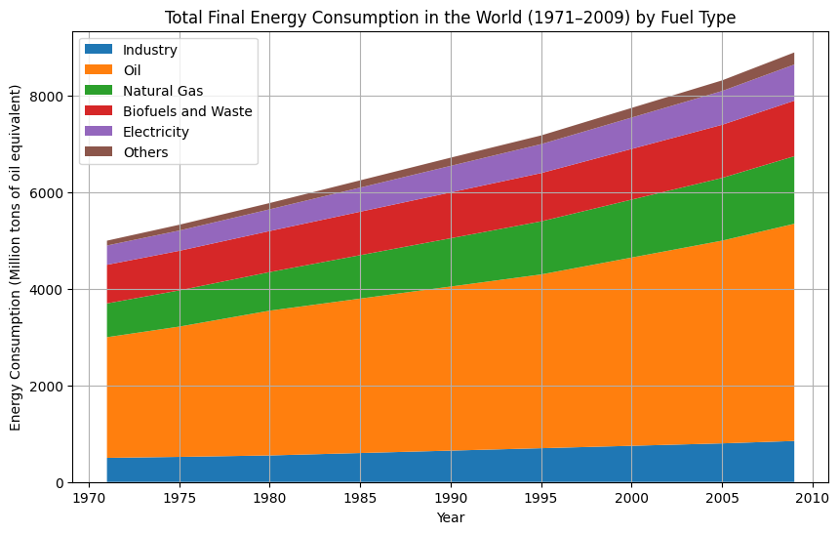
Figure 1: Final global consumption of fossil fuels between 1971 and 2009 [9].
Table 1 illustrates the trend of energy consumption in Iran, categorized by consumption sectors and fuel types from 1356 to 1400 (1977–2021), including the average annual growth rate [10]. As observed, energy consumption in residential, commercial, and administrative buildings is higher than in other sectors.
Table 1. Iran's energy consumption patterns from 1356 to 1400 (1977–2021), broken down by fuel types and consumption sectors. Reference: [10].
Sector | 1351 | 1377 | 1374 | 1400 | Avg. Annual Growth 1367-1374 (%) | Avg. Annual Growth 1374-1400 (%) | 1351 (%) | 1377 (%) | 1374 (%) | 1400 (%)
Total Final Consumption | 30.79 | 331.4 | 854 | 1058.2 | 8.4 | 3.8 | 100 | 100 | 100 | 100
Residential & Commercial | 11.6 | 111.2 | 211.9 | 378.7 | 9.6 | 7.3 | 37.8 | 33.7 | 24.4 | 24.4
Industry | 5.72 | 49.5 | 118.9 | 163.7 | 8.2 | 5.0 | 18.6 | 17.8 | 13.9 | 15.5
Transportation | 5.72 | 82.4 | 137.7 | 225.1 | 7.4 | 3.7 | 18.6 | 25.2 | 32.5 | 32.3
Agriculture | 11.2 | 37.8 | 30.9 | 123.9 | 2.0 | 5.8 | 8.1 | 8.1 | 5.2 | 8.6
Energy Carrier | 1351 | 1377 | 1374 | 1400 | Avg. Annual Growth 1367-1374 (%) | Avg. Annual Growth 1374-1400 (%) | 1351 (%) | 1377 (%) | 1374 (%) | 1400 (%)
Oil Products | 60.4 | 394.5 | 345.2 | 690.4 | 4.4 | 0.5 | 81.2 | 78.8 | 69.8 | 78.8
Natural Gas | 17.1 | 34.9 | 175.4 | 611.3 | 7.5 | 4.9 | 8.3 | 10.3 | 30.0 | 34.5
Electricity | 9.8 | 32.1 | 41.7 | 183.2 | 8.1 | 5.8 | 4.7 | 7.0 | 7.3 | 11.8

Residential and administrative energy usage is on the rise, according to Avami and Farahmandpour [11]. The industrial sector is the only one that has grown at a somewhat slower rate than the other sectors, and it has been trending downward since 2005. Transportation, residential and commercial, and industrial energy consumption have average yearly growth rates of 6.1%, 3.4%, and 2.7%, respectively. As a result, global energy consumption is rising. Iran's energy consumption has also been rising, with the country's residential and commercial sectors consuming more energy than any other sector. As a result, it is crucial to pay attention to the energy usage of the residential and commercial sectors.
  - Energy Conservation
Reducing the use of fossil fuels is the main goal of energy conservation, which is regarded as a demand-side reduction strategy. In addition to using energy for lighting, heating, and cooling, buildings also need energy for construction. Architectural materials need to be removed, processed, and delivered to the construction site. A significant amount of energy is frequently needed for numerous operations during the construction process. A building needs a constant flow of energy during its operational phase after construction. The extraction of energy resources and energy production processes related to construction activities are the main causes of the environmental effects of building energy consumption. It is impossible to recover the energy used in buildings for equipment operation, lighting, heating, and cooling. The kind of energy supplied determines the kind, location, and extent of environmental effects brought on by building energy usage. Pollutants as SO₂, CO₂, CO, and NOₓ are released into the environment by coal-fired power plants. There is currently no completely dependable long-term management solution for the radioactive waste produced by nuclear power reactors. Large-scale water storage reservoirs and dams are necessary for hydropower plants; building such dams can upset river ecosystems and result in the devastation of plant and animal habitats [12].

- Zero-Energy Buildings
The Zero Energy Building (ZEB) concept is seen as an ideal future concept and a workable way to lower energy usage and/or greenhouse gas emissions in the building industry. ZEBs are receiving more attention, as evidenced by the growing number of demonstration projects and international research interest in this area [13–19]. The idea of a zero-energy building is complicated, and there are a number of current strategies that deal with various facets of ZEBs. Furthermore, it is difficult to calculate the energy balance of a building with on-site renewable energy generation equipment, communicate with the utility grid, and reach the "zero energy" target [20]. Additionally, there isn't a widely recognized standard procedure for figuring out the "zero" balance. There are optional environmental assessment frameworks like LEED and BREEAM, although they often cover more ground than the present definition of ZEB. A research facility in the United States [21] has investigated the possible effects of zero-energy homes and found that they need incorporate extremely efficient design, cutting-edge technologies, and on-site renewable energy generating systems that can offset annual energy usage. Rooftop solar panels and solar water heating systems are examples of these systems. In addition to achieving great performance and energy efficiency, these homes are made to be comfortable for their residents while yet having a look that is comparable to traditional residences. Figure 2 demonstrated An overview of on-site and off-site renewable energy possibilities.
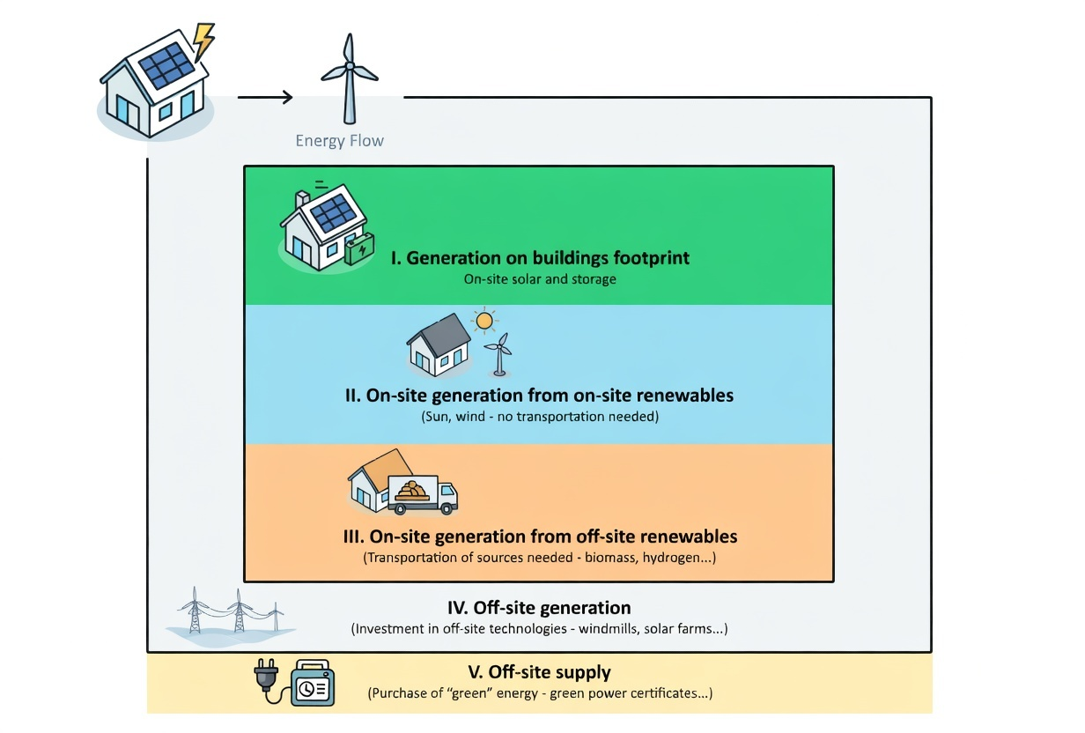
Figure 2. An overview of on-site and off-site renewable energy possibilities, Reference: [20].
Renewable electricity produced on-site should be used in zero-energy homes. The primary goal of zero-energy buildings is self-sufficiency in energy production, even though acquiring electricity from the grid through approved green power suppliers may also be regarded as reaching net-zero carbon emissions [22]. Low-energy buildings are generally defined as those having an annual energy use of 30–40 kWh/m² [2,23]. In terms of energy use, UK laws state that passive homes have an energy performance level comparable to zero-carbon homes [2]. A building can be regarded as nearly zero-energy if its annual energy use is less than 10 kWh/m² [24]. Therefore, it is crucial to define the boundaries between low-energy buildings, zero-energy buildings, and passive dwellings when designing zero-carbon structures.
3-1 Goal of Passive House (Passivhaus)
A Passivhaus is a structure that eliminates the need for traditional auxiliary heating systems while maintaining a comfortable interior atmosphere. Among the essential performance traits are:
The annual maximum heating demand should not be more than 15 kWh/m². Alternative energy sources should be used to meet energy needs.
    - Passivhaus Design Standards

- The building envelope needs to be small, well-insulated, and have few thermal bridges and thermal transmittance values less than 0.15 W/m²K (R38).
- Windows, including glass and frames, must have U-values of no more than 0.8 W/m²K (0.14 Btu/ft²·h·°F).
- A maximum of 0.6 air changes per hour must be permitted within the building envelope, which must be totally airtight.
- The majority of windows and living areas should face south, and the building design should have as few indentations or recesses as possible.
- The building should get its fresh air supply passively, for instance through ground ducts (earth tubes).
- It is recommended to employ mechanical ventilation with heat recovery (MVHR) with an efficiency higher than 80%.
- Water should be heated through alternative heating sources, such as solar panels and heat pumps.
- The appliances used in the building should be energy-efficient [25].

4. Zero-Carbon Buildings

Three of the five types of zero-carbon buildings that the University College London (UCL) has identified based on varying degrees of constraints are explained below:
- independent website
a location that is intended to run entirely on electricity and gas produced on-site.
- Building a yearly zero-carbon balance
Every year, the building generates and exports enough zero-carbon energy (or perhaps gas in the future) to offset the carbon emissions from all of the fuel and electricity used on-site.
- Every year, a zero-carbon building linked to local renewable energy
a structure that is directly connected to nearby renewable energy sources to attain zero-carbon performance [26].
The UK's Code for Sustainable Homes [27] stipulates that energy usage related to space heating and cooling systems, household hot water, ventilation, all interior lighting, cooking, and electrical appliances must be considered. Because it necessitates the integration of multiple factors, such as site characteristics, building energy demands, the efficient integration of on-site renewable energy sources, and realistic patterns of energy consumption within the building, designing a zero-carbon building is difficult [28]. The following factors need to be taken into account in order to create zero-carbon homes:
- There are no greenhouse gas emissions from fixed lights, home hot water, ventilation, or space heating.
- estimation of the amount of energy used by laptops, gas stoves, and other household gadgets.
- Energy is exported and imported via centralized energy networks and development initiatives (direct link to energy facilities) [29].
For a whole year, buildings must sustain net zero carbon emissions. Thus, according to zero-carbon housing guidelines, a structure ought to:
- be built with a great degree of energy efficiency.
- Combine energy-saving techniques, on-site energy sources, or direct connections to low-carbon or renewable energy sources to achieve a minimum degree of carbon reduction.
- To make up for residual emissions, use a variety of extra (mainly off-site) remedies.
The following elements should be taken into account when defining a zero-carbon home precisely:
- Technical viability
- Financial and economic effectiveness
- Flexibility and compatibility
- Potential for associated carbon reduction
- A relevant legal framework
- More comprehensive environmental factors
- Providing an attractive and healthful living environment
The creation of design techniques becomes more crucial because Iran has not yet established many research centers that concentrate on zero-carbon approaches. As a result, Table 2 offers pertinent design tactics.
Table 2. Design strategies proposed by the researcher for zero-carbon buildings
No. | Design Strategy
1 | Integrating energy efficiency strategies with renewable energy options from the beginning of the project design process [30].
2 | Maximizing the implementation of passive design strategies in building design to reduce overall energy demand [30].
3 | Reducing water consumption through decreasing the demand for domestic hot water [30].
4 | Selecting appropriate construction materials that enhance passive design performance and possess low embodied energy [30].
5 | Reducing energy consumption in all building subsystems [30].
6 | Achieving a balance between energy efficiency and renewable energy use, which represents an important issue in sustainable building design [30].
7 | Designing according to the climatic conditions of Tehran and considering the site characteristics of Pardisan Park.
8 | Developing the optimal building form based on site conditions for the proposed research building.

A useful definition of zero-carbon dwellings and non-residential structures has been developed. High energy efficiency, on-site carbon reduction measures, and a list of approved solutions (mostly off-site) to manage the residual greenhouse gas emissions are the foundations of the definition of a zero-carbon home [31]. In actuality, zero carbon refers to a house's net carbon emissions from its overall energy use being equal to zero over the course of a year. According to another definition, a distinct, logical, and broadly applicable definition of zero-carbon buildings is one that directs innovation in the building sector toward a cohesive vision of a sustainable environmental future [32]. Beginning in 2016, every home in the UK is expected to have zero new energy use. Renewable energy sources, such as biomass boilers, rooftop solar and wind converters, better wall and window insulation, and related technologies, are used to offset all energy needs [30]. A foundation for attaining zero-carbon development has been established by the majority of building rules and associated planning policies [33]. The progressive goals set forth in the UK's sustainable building policy framework for cutting carbon emissions in the building industry are shown in Table 3. By progressively raising energy performance requirements over time, the policy presents a phased strategy for reaching zero-carbon buildings. Stricter building standards and improved energy efficiency measures were needed to achieve the first milestone, which called for a 25% improvement in building energy performance by 2010 and a 44% improvement by 2013. After then, the strategy shifted toward total carbon neutrality, aiming to achieve zero-carbon status for all buildings by 2019, zero-carbon houses and schools by 2016, and zero-carbon public buildings by 2018. By gradually increasing energy efficiency standards and promoting the incorporation of renewable energy technologies in buildings, this methodical approach shows how regulatory frameworks can direct the shift toward sustainable construction.
Table 3. United Kingdom Code for Sustainable Homes targets (Source: [30])
Year | Target
2010 | 25% improvement in energy performance according to building regulations
2013 | 44% improvement in energy performance according to building regulations
2016 | Zero-carbon homes and zero-carbon schools
2018 | Zero-carbon public buildings
2019 | Zero-carbon buildings

The higher efficiency of on-site renewable energy resources, better integration of renewable systems, and increased consumer awareness and comprehension of their energy use are the main benefits of creating zero-carbon or zero-emission buildings. If renewable energy solutions are used on-site, close to the site, or off-site, many new non-residential buildings may be able to achieve zero carbon emissions from energy use [30].
Furthermore, more legislative actions are needed to bring the building industry's pollution emissions down to almost zero. These could include measures to lower electricity generation's carbon intensity, encourage investment in on-site renewable energy systems, and progressively curb the rise in demand for energy services [34]. Therefore, the site and adjacent areas can be used to capture clean energy resources in order to achieve zero-carbon buildings. This helps to reduce greenhouse gas emissions, especially carbon dioxide (CO₂).

5. How to Achieve Zero-Carbon Buildings
Finding the necessary energy consumption, expressed in kWh/m²/year, is the first step towards creating zero-carbon buildings. Calculating the carbon emissions, given in kg/m²/year, is the second stage. Calculating the economic cost of solutions, which is usually stated in $, is the third component [4]. Solar photovoltaic panels, solar thermal systems, and wind turbines can provide the energy needed for heating, ventilation, domestic hot water (DHW), lighting, and building equipment in zero-energy buildings, according to a design solution put forth in the UK [35].
Three main core principles are required to achieve zero-carbon buildings:
- Reducing energy demand.
- Ensuring that any CO₂ emissions from heating, cooling, lighting, and ventilation operations are less than or equal to the carbon limits established in UK building regulations.
- Ensuring that CO₂ emissions resulting from energy use are reduced to zero.
These requirements can be achieved by fulfilling the first two principles or by reducing carbon emissions directly on-site. Brian Edwards and Paul Hyett stated that although architecture alone cannot solve environmental problems, it can play an effective role in creating sustainable living environments [36].
6. Conclusion
Building design significantly contributes to or mitigates these effects, depending on the degree of environmental contamination. Buildings must so carefully regulate energy use, which is a significant contributor to environmental pollution and carbon emissions in the atmosphere. The design and construction of low-energy, zero-energy, and eventually zero-carbon buildings has been prompted by these worries. The primary prerequisite for designing zero-carbon buildings is that they must achieve zero-energy performance, which means that the energy generated by clean and renewable sources must equal the energy used by the structure.
In order to optimize building volume and performance, the suggested building mass and form should be built in an ideal configuration in the first stage. The Genetic technique (GA) is one example of an optimization technique that can help with this process. The integration of renewable energy systems, such as solar panels and wind energy systems, comes next after the building's internal design and energy consumption and carbon emissions have been calculated.
Buildings are classified as low-energy if their annual energy use is between 30 and 40 kWh/m². In terms of energy use, UK rules state that passive homes have an energy performance level comparable to zero-carbon homes. If the energy consumption of a building is less than 10 kWh/m² per year, it can be considered close to a zero-energy building. In actuality, a zero-energy building's design calls for the building's energy use to match the energy generated from renewable sources. It is anticipated that the use of zero-energy and zero-carbon building design techniques will grow in Iran as well, and that future architects and designers would prioritize their significance.

References
[1] Intergovernmental Panel on Climate Change (IPCC) Working Group III. Climate Change 2007: Mitigation of Climate Change – Contribution of Working Group III to the Fourth Assessment Report of the Intergovernmental Panel on Climate Change. Cambridge: Cambridge University Press; 2007.
[2] United Nations Environment Programme – Sustainable Buildings and Climate Initiative (SBCI). Buildings and Climate Change: Summary for Decision-Makers. Paris; 2009.
[3] Levine M., Ürge-Vorsatz D., Blok K., Geng L., Harvey D., Lang S., Levermore G., Mongameli Mehlwana A., Mirasgedis S., Novikova A., Rilling J. Residential and Commercial Buildings. In: Climate Change 2007. August 2007.
[4] UK Building Regulations and EU Directives. Zero Carbon Hub. Available at: www.zerocarbonhub.org; 2014.
[5] Asif M., Muneer T., Kelley R. Life cycle assessment: A case study of a dwelling home in Scotland. Building and Environment. 2007;42(3):1391-1404.
[6] Sodagar B., Fieldson R. Towards a low carbon construction practice. Construction Information Quarterly. 2008;10(3):101-108.
[7] Torcellini P., Pless S., Deru M., Crawley D. Zero Energy Buildings: A Critical Look at the Definition. National Renewable Energy Laboratory (NREL), Golden, Colorado; 2006.
[8] Carbon Monitoring for Action (CARMA). Power plant emissions database. Available at: http://greencodeproject.org/en/carma-power-plant-emissions; 2015.
[9] International Energy Agency (IEA). Key World Energy Statistics 2011. Paris; 2011.
[10] Zabihi A. Energy Status in Iran and the World. Faculty of Water and Power Industry; 2011.
[11] Avami A., Farahmandpour B. Environmental and greenhouse gas emission analysis. WSEAS Transactions on Environment and Development. 2008.
[12] Kim J.J., Rigdon B. Sustainable Architecture Module: Introduction to Sustainable Design. National Pollution Prevention Center for Higher Education; 1998.
[13] Åkarp V. Villa Karp: A positive net energy house in Malmö, Sweden. Available at: http://greenlineblog.com/2009/02/villa-karp-a-positive-net-energyhouse-in-malm-sweden/; 2009.
[14] International Energy Agency (IEA). World Energy Outlook. Paris; 2006.
[15] Noguchi M., Athienitis A., Delisle V., Ayoub J., Berneche B. Net zero energy homes of the future: A case study of the EcoTerra™ house in Canada. In: Renewable Energy Congress. Glasgow, Scotland; 2008.
[16] Heinze M., Voss K. Goal: Zero energy building—Exemplary experience based on the Solar Estate Solarsiedlung Freiburg am Schlierberg, Germany. Journal of Green Building. 2009;4(4):93-100.
[17] Musall E., Weiss T., Lenoir A., Voss K., Garde F., Donn M. Net zero energy solar buildings: An overview and analysis of worldwide building projects. In: EuroSun Conference. 2010.
[18] The BOLIG+ Project. Available at: http://www.boligplus.org.
[19] The Active House Project. Available at: http://www.activehouse.info.
[20] Marszal A.J., Heiselberg P., Bourrelle J.S., Musall E., Voss K., Sartori I., Napolitano A. Zero Energy Building – A review of definitions and calculation methodologies. Energy and Buildings. 2011;43(4):971-979.
[21] NAHB Research Center. The Potential Impact of Zero Energy Homes. National Renewable Energy Laboratory, Golden, Colorado; 2006.
[22] Australian Government. Your Home Technical Manual. 4th ed. Department of the Environment, Water, Heritage and the Arts, Canberra; 2008.
[23] European Commission. Low Energy Buildings in Europe: Current State of Play, Definitions and Best Practice.
[24] Wuppertal Institute. It Is Really Worth It: The Potential for Energy Savings in Buildings. Available at: http://www.bigee.net/en/tour/; 2012.
[25] Paola Sassi. Strategies for Sustainable Architecture. London: Taylor & Francis; 2006.
[26] UK Green Building Council. Report on Carbon Reductions in New Non-Domestic Buildings. 2007.
[27] Department for Communities and Local Government (DCLG). Code for Sustainable Homes: Technical Guide. London; 2008.
[28] Chartered Institution of Building Services Engineers (CIBSE). Energy Efficiency in Buildings: CIBSE Guide F. 2nd ed. London; 2004.
[29] Communities and Local Government UK. Definition of Zero Carbon Homes and Non-Domestic Buildings. London; 2008.
[30] Sam C. M. Hui. Zero energy and zero carbon buildings: Myths and facts. In: Proceedings of the International Conference on Intelligent Systems, Structures and Facilities (ISSF2010). Asian Institute of Intelligent Buildings; 2010.
[31] Department for Communities and Local Government (DCLG). Definition of Zero Carbon Homes and Non-Domestic Buildings: Consultation. London; 2008.
[32] Fulcrum Consulting. Fulcrum’s Dream Definition of Zero Carbon Buildings. London; 2009.
[33] Department for Communities and Local Government (DCLG). Building a Greener Future: Towards Zero Carbon Development. London; 2006.
[34] Loper J., Capanna S., Devranoglu S., Petermann N., Ungar L. Reducing Carbon Dioxide Emissions through Improved Energy Efficiency in Buildings. Presidential Climate Action Project; 2008.
[35] Wang L., Gwilliam J., Jones P. Case study of zero energy house design in the United Kingdom. Energy and Buildings. 2009;41(11):1215-1222.
[36] Brian Edwards and Paul Hyett. Rough Guide to Sustainability. London: Royal Institute of British Architects (RIBA) Publications; 2001.

