Anthropometric Mismatch Evaluation for Female Clerical Office Workers

INTRODUCTION

The field of human sciences known as anthropometry, which comes from the Greek words anthropos (human) and metron (measure), is concerned with measuring and analysing the physical characteristics of the human body, including its size, form, strength, and functional capacity (Centers for Disease Control and Prevention [CDC], 2024; International Labour Organization [ILO], 2011). A population's characteristics are determined by several factors such as gender, age, ethnicity, and occupation, all of which must be considered in the design of systems, environments, and products. To ensure that workplaces and products are appropriate for workers’ body size and motion, it is necessary to align design with the physical traits of the target users (CDC, 2024).
From its origins in physical anthropology, anthropometry has evolved into a multidisciplinary field influencing industrial design, ergonomics, and other applied sciences (Gorce, 2025). Within ergonomics, anthropometry plays a critical role in defining human capacity, limits, and physical dimensions, with the primary objective of ensuring compatibility between users and their working or living environments (ILO, 2011). The importance of anthropometric considerations in workplace design is further emphasized by international standards such as ISO 7250-1, which provide guidance on human body measurements to support ergonomic design and ensure safety, health, and usability in workplaces (International Organization for Standardization [ISO], 2017).
To address the problem of “fitting people to machines,” anthropometry has long been recognised as a fundamental foundation of ergonomics, as it provides essential data for aligning human physical characteristics with design requirements (Saha et al., 2024; ILO, 2011). Ergonomics focuses on optimising the interaction between individuals, their tasks, tools, and working environments to ensure safety, efficiency, and well-being (Gorce, 2025). However, when designers generalise population characteristics without adequately accounting for variability in physical attributes, the resulting products often fail to meet user needs. Consequently, an ergonomic design approach that incorporates user-specific anthropometric data is critical to improving user satisfaction and reducing health risks (Fitrianto et al., 2025).
When workstations, furniture, or other designed environments are incompatible with users’ anthropometric characteristics, a mismatch occurs, leading to poor posture and biomechanical strain (Castellucci et al., 2016). This mismatch forces users to adopt awkward and sustained postures, which overload muscles and joints and increase the likelihood of developing work-related musculoskeletal disorders (WMSDs) (Lopes & Lages, 2026). These disorders commonly affect the neck, shoulders, and lower back, and are strongly associated with risk factors such as prolonged sitting, repetitive motion, and non-neutral posture (Hoe et al., 2018). In Malaysia, WMSDs represent a major occupational health concern and contribute significantly to worker disability, absenteeism, compensation costs, and reduced productivity (Hasan et al., 2020).
Furthermore, female workers may be at greater risk of anthropometric mismatch and WMSDs, as office furniture is often designed based on male anthropometric data, resulting in poorer fit for female populations (Varte et al., 2015). This highlights the need for ergonomic design practices that incorporate anthropometric variability across gender and demographic groups.
In office environments, workers are typically exposed to prolonged sitting while using desks, chairs, and computer equipment. Poorly designed furniture—particularly inappropriate desk and monitor heights—can force users into unnatural postures, increasing strain on the spine, shoulders, and upper limbs. Epidemiological studies indicate that musculoskeletal symptoms among office workers are highly prevalent, particularly in the neck, shoulders, and lower back, with prevalence rates frequently exceeding 40–60% depending on exposure conditions (Hoe et al., 2018; Lopes & Lages, 2026). Therefore, it is essential to regulate ergonomic risk factors such as workstation design, prolonged sitting, repetitive tasks, and awkward posture in order to mitigate WMSD risks and improve occupational health outcomes (Hoe et al., 2018).
Anthropometric mismatch evaluation among clerical office workers highlights the increasing importance of incorporating ergonomic considerations into workplace design. More studies focusing on the compatibility of office furniture with the anthropometric characteristics of the Malaysian population are necessary to ensure safer and more inclusive work environments. Previous local and international studies have demonstrated that mismatch rates can be significantly reduced through targeted modifications of workstation parameters, including desk height, seat height, backrest height, clearance, and work surface angles (Castellucci et al., 2016; Saha et al., 2024).
In addition, empirical evidence suggests that female office workers are more susceptible to musculoskeletal discomfort due to anthropometric mismatch. For instance, studies have reported a higher prevalence of neck, shoulder, and upper back pain among female clerical workers compared to their male counterparts, which is attributed to inadequate furniture design that does not reflect female anthropometric profiles (Varte et al., 2015). This issue is particularly relevant in the Malaysian public sector, where the clerical workforce is predominantly female, thereby contributing to a higher incidence of work-related musculoskeletal disorders (WMSDs) (Hasri et al., 2024; Hasan et al., 2020).
Therefore, there is a clear need to further investigate gender-specific anthropometric mismatch in local contexts and to develop ergonomic solutions that address these disparities. By applying systematic anthropometric mismatch evaluation methods, it is possible to identify critical incompatibilities between users and workstation dimensions, thereby informing targeted redesign interventions. These improvements can ultimately enhance worker comfort, reduce musculoskeletal risk, and promote long-term occupational health.

METHODOLOGY

This study focused on female clerical office workers at Public University XYZ as anthropometric differences between males and females are well-documented and can significantly influence ergonomic compatibility. Furniture and equipment designed based on male-dominated datasets may not suit female users, potentially causing discomfort or work-related musculoskeletal disorders. Therefore, the study was specifically designed to address gender-specific mismatches in furniture design by concentrating on the ergonomic requirements of female workers. This targeted approach ensures that the findings are directly applicable to the intended user group, promoting inclusive and user-centred design practices. Ethical approval was obtained from the XYZ Research Ethics Committee, and written informed consent was collected.
Twelve participants were selected to represent the target population within XYZ. The methodology is separated into two sections, starting with anthropometric data collection using standardised procedures outlined in MS ISO 7250-1:2008 and lastly mismatch analysis between the users’ body dimensions and the furniture based on the data computation and comparison to standardised guidelines. The mismatch analysis results can form the basis for evaluating ergonomic compatibility and informing the development of appropriate furniture dimension guidelines tailored to the anthropometric characteristics of female office workers.

Anthropometric and furniture dimension data collection
The second method is performing anthropometric data collection and mismatch analysis. Anthropometric collection in the workplace entails measuring all individual workers' dimensions as well as their office furniture dimensions. All measurements were taken using measuring tapes while workers are in normal positions.
The anthropometric measurements in this study were conducted according to the procedures outlined in MS ISO 7250-1:2008 (Malaysian Standard, 2008) using a measuring tape. As shown in Figure 1, the key body dimensions recorded include popliteal height (PH), which is the vertical distance from the floor to the underside of the knee while seated with feet flat; popliteal length (PL), which refers to the horizontal distance from the back of the buttocks to the back of the knee (popliteal space) with the knees flexed at 90 degrees; hip width (HW), defined as the horizontal distance between the widest points of the hips in a seated posture; elbow sitting height (E), measured as the vertical distance from the seat surface to the tip of the elbow (olecranon) with the elbow bent at a right angle; and shoulder sitting height (S), which is the vertical distance from the seat surface to the top of the shoulder (acromion).

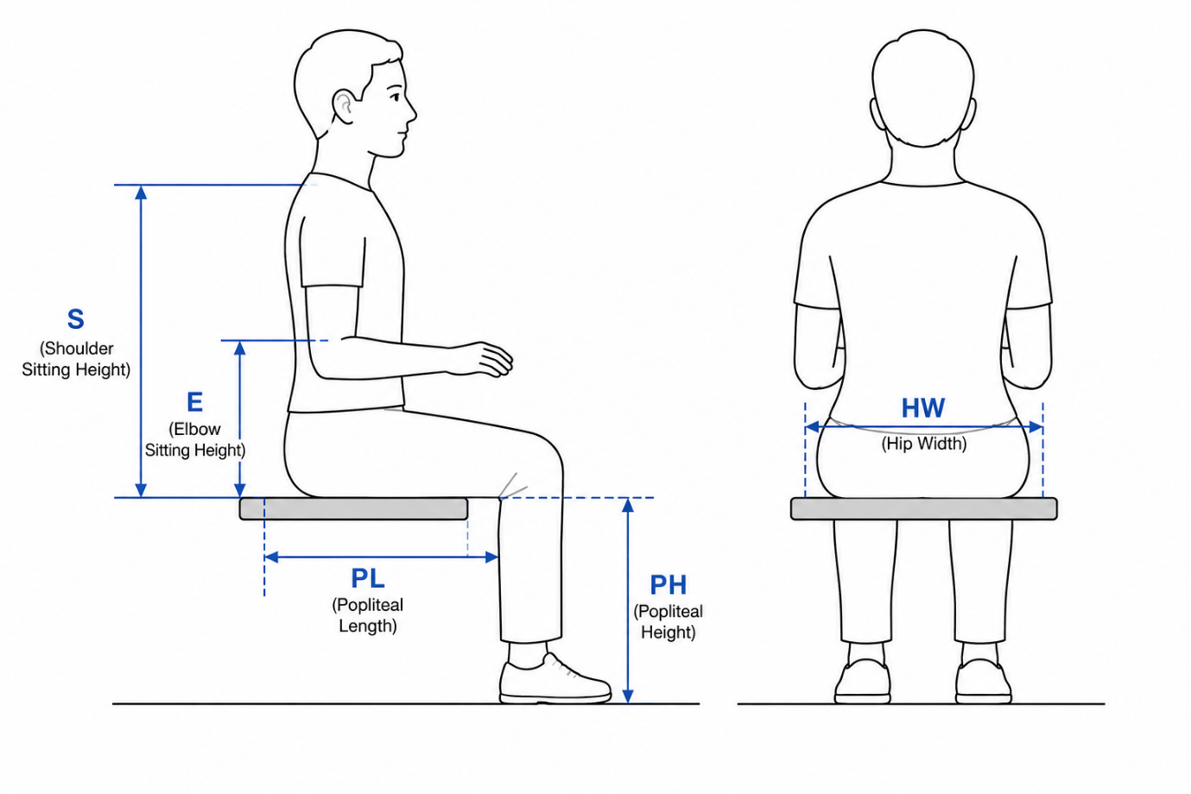
Figure 1. Anthropometric Measurements.

In addition to these anthropometric measurements, dimensions of the seat and workstation components in the office were also recorded. Each office furniture dimension consists of measurements of an office desk and a chair as illustrated in Figure 2. These measurements include seat height (SH), which is the vertical distance from the floor to the front edge of the seat surface; seat depth (SD), measured from the front to the back of the seat pan; seat width (SW), which is the horizontal distance across the seat surface; desk height (DH), defined as the vertical distance from the top of the desk surface to the seat surface; and the upper edge of the backrest (UEB), measured as the vertical distance from the top of the seat to the midpoint of the upper edge of the backrest.

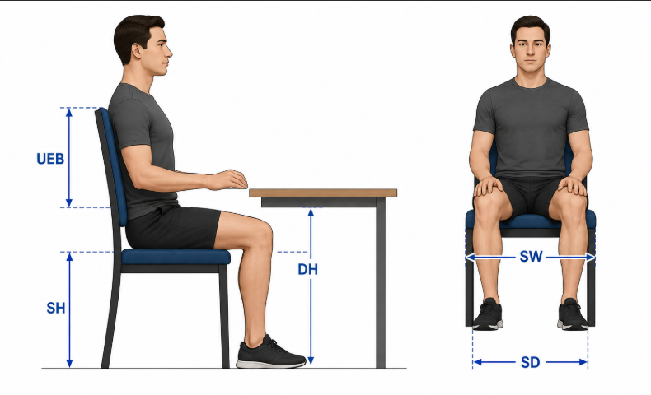

Figure 2. Furniture Dimensions.

Mismatch analysis between furniture dimensions and anthropometric data
Subsequently, calculation was done using both the anthropometric measurements and furniture dimensions via mismatch analysis. Five parameters were used in the analysis which are seat height (SH) against popliteal height (PH), seat depth (SD) against popliteal length (PL), seat width (SW) against hip width (HW), desk height (DH) against shoulder sitting height (S), and upper edge of the backrest (UEB) against shoulder sitting height (S). The computations for mismatches based on the parameters were done using formulae depicted in Table 1.

Table 1 : Computation For Mismatch.
Parameter | Computation for mismatch
SH against PH | (PH + 2) cos30° ≤ SH < (PH + 2) cos5°
SD against PL | 0.80PL ≤ SD ≤ 0.95PL
SW against HW | HW < SW
DH against S | E + (PH + 2) cos30° ≤ DH ≤ [(PH + 2) cos5°] + 0.8517E + 0.1483S
UEB against S | S ≥ UEB

To identify mismatches, the existing furniture dimensions were compared to the acceptable range from computation results. Mismatches are discrepancies between the anthropometry of workers and the dimensions of office furniture such as whether the chair that is too high or the desk that is too low. Furthermore, the frequency of mismatch for each parameter was calculated by dividing the number of mismatches for the furniture dimension to total number of participants and then multiplying with 100 as shown in equation (1).

Frequency of mismatch = $\frac{Number of mismatches}{Total participants}×100$ (1)

The frequency of mismatch is the percentage of mismatch present at the existing workstation. High frequency for the parameter indicated high WMSD risk and high urgency for improvements on furniture dimension to match with workers’ anthropometry. This technique directs ergonomists’ attention to specific factors of workstation dimension when determining the best methods to enhance occupational health and safety. Better furniture dimension can be proposed by designing furniture which aligns the dimensions more closely to existing staff or offer furniture with more adjustability. The results of the analysis can also act as a guide to make adjustments for similar workplace set up. Last but not least, the gender-specific anthropometric data can be used as reference for more inclusive ergonomics research particularly of Malaysian population in the future to provide a safer and more supportive work environment for all workers.

RESULTS AND DISCUSSION

Analysis of questionnaire responses
From the survey, the demographics of the clerical workers (N=12) in study consist of all females ranging from 38 to 50 years old, with a mean age of 42.92 years. The average height is 157.42 cm, with the shortest at 146 cm and the tallest at 169 cm. The mean weight is 68.83 kg, with the lightest at 46 kg and heaviest at 95 kg. A significant portion of the group falls into overweight BMI category with percentage at 41.7% while one-fourth is both of normal weight and obese. The duration is sitting at workstation for workers varies from a brief 30 minutes to the entire 8-hour shift without any significant preference, indicating a need for flexible and adaptable workstation design to accommodate different work styles while promoting long-term health.

The demographic profile of the clerical workers in this study reflects a relatively homogenous occupational group, comprising exclusively female respondents (N = 12) aged between 38 and 50 years, with a mean age of 42.92 years. In terms of physical characteristics, the average stature was 157.42 cm (range: 146–169 cm), while the mean body weight was 68.83 kg (range: 46–95 kg). The Body Mass Index (BMI) distribution indicates that 41.7% of the respondents fall within the overweight category, while equal proportions (25% each) are classified as normal weight and obese. This distribution suggests a tendency towards higher body mass within the cohort, which is consistent with age-related metabolic changes and sedentary occupational demands commonly observed among clerical staff. Despite the relatively small sample size (N = 12), all clerical staff in the office were included in the study. This approach eliminates sampling bias and ensures that the findings accurately reflect the actual users of the workstation. In ergonomics studies focused on specific workplaces, such full coverage is more relevant than large sample sizes, as the objective is to assess real user–workstation compatibility rather than generalise to broader populations.

Table 2: Summary of Mismatch Results

Case | Desk Height (DH) 75cm | Seat Height (SH) | Backrest Height (UEB) | Seat Width (SW)  48cm | Seat Depth (SD)  47cm
1 | ✅ Match | ✅ Match | ✅ Match | ✅ Match | ❌ Mismatch
2 | ❌ Mismatch | ❌ Mismatch | ❌ Mismatch | ✅ Match | ❌ Mismatch
3 | ❌ Mismatch | ❌ Mismatch | ❌ Mismatch | ✅ Match | ❌ Mismatch
4 | ❌ Mismatch | ❌ Mismatch | ✅ Match | ✅ Match | ❌ Mismatch
5 | ✅ Match | ✅ Match | ✅ Match | ✅ Match | ❌ Mismatch
6 | ❌ Mismatch | ✅ Match | ❌ Mismatch | ❌ Mismatch | ❌ Mismatch
7 | ✅ Match | ✅ Match | ✅ Match | ✅ Match | ❌ Mismatch
8 | ❌ Mismatch | ❌ Mismatch | ❌ Mismatch | ❌ Mismatch | ❌ Mismatch
9 | ❌ Mismatch | ❌ Mismatch | ❌ Mismatch | ✅ Match | ❌ Mismatch
10 | ❌ Mismatch | ❌ Mismatch | ❌ Mismatch | ✅ Match | ❌ Mismatch
11 | ❌ Mismatch | ✅ Match | ✅ Match | ✅ Match | ❌ Mismatch
12 | ❌ Mismatch | ✅ Match | ✅ Match | ✅ Match | ❌ Mismatch

The results from the anthropometric mismatch analysis show that seat depth has a complete mismatch for all respondents (100%), which clearly indicates a systematic issue in the current design. This suggests that the seat depth provided is not suitable for any of the users involved in the study. Besides that, desk height also shows a high mismatch rate of 75%, implying that the fixed desk dimension does not properly match with the anthropometric characteristics of most users.
Meanwhile, both seat height and backrest height recorded a moderate mismatch level of 50%, meaning that only half of the users are adequately supported, especially in terms of lower limb positioning and lumbar support. On the other hand, seat width appears to be less problematic, as only two cases (Cases 6 and 8) were identified as mismatched.
Although Cases 1, 5, and 7 demonstrate relatively better overall compatibility compared to others, it is still important to highlight that no respondent meets all five ergonomic criteria at the same time. This finding indicates that the current workstation design, in general, is still not fully suitable to accommodate the anthropometric needs of the users.

DISCUSSION AND PRACTICAL IMPLICATIONS
The findings of this study show that there is a clear and systematic anthropometric mismatch between the clerical workers and the existing workstation design. This situation indicates that the current furniture is not really suitable to accommodate the user population properly. In line with previous ergonomic studies in office environments, the most critical issue observed is the 100% mismatch in seat depth, which can be considered as a major design problem rather than just a minor incompatibility. This may be because the fixed seat depth (47 cm) is too large compared to the users’ buttock–popliteal length, causing users to either sit in a forward-sliding posture or experience pressure behind the knees. These conditions may lead to discomfort such as restricted blood circulation and increased stress on the contact area, and over time may contribute to work-related musculoskeletal disorders (WMSDs).
In addition, the high percentage of desk height mismatch (75%) further shows that the workstation design does not fully consider anthropometric requirements. The fixed desk height (75 cm) might not be suitable for many users, especially in relation to their seated elbow height. As a result, users may adopt awkward postures such as raising their shoulders, bending their wrists, or leaning their body forward. These positions can increase strain on the upper body and are commonly associated with long-term discomfort and possible injury. At the same time, seat height and backrest height both recorded a mismatch rate of 50%, indicating that only half of the respondents are adequately supported, particularly in terms of leg positioning and lower back support. This condition may affect sitting balance and proper spinal alignment.
On the other hand, seat width shows comparatively better compatibility, with only a small number of mismatches identified. This may suggest that the design has somewhat considered differences in hip width among users. However, this alone is not enough to compensate for the other mismatches observed. It is also important to highlight that none of the respondents fulfilled all five ergonomic criteria at the same time, which means that the workstation design is still lacking in providing overall ergonomic suitability.
Overall, these findings highlight an important ergonomic principle, where fixed-dimension furniture is generally not suitable for users with varying body dimensions, even within a group that appears quite similar. The dominance of mismatch in seat depth and desk height clearly suggests that the current furniture design was not based on specific anthropometric data of the target users. Therefore, there is a strong need to move towards a more data-driven and adjustable design approach to better support user comfort, safety, and well-being.

Conflict of interest

The authors whose names are listed in this paper certify that they have no affiliations with or involvement in any organization or entity with any financial interest.

Acknowledgement

The authors would like to express their sincere gratitude to the Faculty of Industrial and Manufacturing Technology Engineering (FTKIP) and the Centre for Research and Innovation Management (CRIM) at Universiti Teknikal Malaysia Melaka (UTeM) for their continuous support and facilitation of this research.

REFERENCES

- Centers for Disease Control and Prevention (CDC). (2024). Anthropometry and work: An overview. https://www.cdc.gov/niosh/anthropometry/about/index.html [cdc.gov]
- Gorce, P. (2025). Theoretical and applied ergonomics: A new open access journal. Theoretical and Applied Ergonomics, 1(1), 1. https://doi.org/10.3390/tae1010001 [mdpi.com]
- International Labour Organization (ILO). (2011). Anthropometry. In Encyclopaedia of Occupational Health and Safety. https://iloencyclopaedia.org/part-iv-66769/ergonomics-52353/physical-and-physiological-aspects/item/486-anthropometry [iloencyclopaedia.org]
- International Organization for Standardization (ISO). (2017). ISO 7250-1: Basic human body measurements for technological design—Part 1: Body measurement definitions and landmarks. https://www.iso.org/standard/65246.html [webstore.ansi.org]
- Castellucci, H. I., Catalán, M., Arezes, P. M., & Molenbroek, J. F. (2016). Evaluation of the match between anthropometric measures and school furniture dimensions. Work, 53(3), 563–572. https://doi.org/10.3233/WOR-152233
- Fitrianto, T. R., Rahmat, B., Nugroho, A. R., Prakoso, G., Afifah, A. S., Anggiriani, S., & Juwitasari, D. (2025). Evaluation of office chair design from ergonomic and anthropometric perspectives. J@ti Undip: Jurnal Teknik Industri, 20(3), 148–154. https://doi.org/10.14710/jati.20.3.148-154
- Gorce, P. (2025). Theoretical and applied ergonomics: A new open access journal. Theoretical and Applied Ergonomics, 1(1), 1. https://doi.org/10.3390/tae1010001
- Hasan, N. H., Zulkifly, S. S., & Ali, N. M. (2020). The risks of work-related musculoskeletal disorders among business service workers. NIOSH Malaysia Journal.
- Hasri, H., Rajendran, K., Mostafa, N., & Muhamma, N. E. S. (2024). Prevalence of work-related musculoskeletal disorders among office workers. International Journal of Future Medical Research, 6(4). https://doi.org/10.36948/ijfmr.2024.v06i04.25385
- Hoe, V. C. W., Urquhart, D. M., Kelsall, H. L., & Sim, M. R. (2018). Ergonomic interventions for preventing work-related musculoskeletal disorders of the upper limb and neck among office workers. Cochrane Database of Systematic Reviews, (10), CD008570. https://doi.org/10.1002/14651858.CD008570.pub3
- Lopes, M., & Lages, M. (2026). Work-related musculoskeletal disorders: Prevalence and contributing risk factors. Exploration of Musculoskeletal Diseases, 4, 1007117. https://doi.org/10.37349/emd.2026.1007117
- Saha, A. K., Jahin, M. A., Rafiquzzaman, M., & Mridha, M. F. (2024). Ergonomic design of computer laboratory furniture: Mismatch analysis utilizing anthropometric data of university students. Heliyon, 10(14), e34063. https://doi.org/10.1016/j.heliyon.2024.e34063
- Varte, L. R., Rawat, S., Singh, I., & Majumdar, D. (2015). Testing the furniture dimension match levels with anthropometry among working women. International Journal of Occupational and Environmental Medicine, 6(2), 122–124. https://doi.org/10.15171/ijoem.2015.526
- Saha, A. K., Jahin, M. A., Rafiquzzaman, M., & Mridha, M. F. (2024). Ergonomic design of computer laboratory furniture: Mismatch analysis utilizing anthropometric data of university students. Heliyon, 10(14), e34063. https://doi.org/10.1016/j.heliyon.2024.e34063
- Varte, L. R., Rawat, S., Singh, I., & Majumdar, D. (2015). Testing the furniture dimension match levels with anthropometry among working women. International Journal of Occupational and Environmental Medicine, 6(2), 122–124. https://doi.org/10.15171/ijoem.2015.526

