Performance-Based Learning to Strengthen Grade 10 Learners' Understanding of Slope

ABSTRACT
Slope is a foundational concept across school algebra, calculus, and statistics, yet learners frequently fail to move beyond memorized procedures toward flexible, transferable understanding, and traditional testing rarely reveals or remediates these difficulties. This study investigated whether performance-based learning activities improved Grade 10 learners' achievement in, and communication of, slope concepts, and identified the specific areas in which improvement occurred. A one-group pretest–posttest quasi-experimental design was employed with 90 Grade 10 learners from two intact classes (basic curriculum, n = 49; science curriculum, n = 41) at a public high school in Iligan City, Philippines. Learners completed two performance tasks: an outdoor activity measuring the slopes of surfaces around the school, and a choreographed slope formula action song. A validated 10-item assessment scored out of 20 points (Cronbach's alpha = 0.82) was administered before and after the intervention. Data were analyzed using descriptive statistics, an item-level misconception analysis, a paired-samples t-test with a Wilcoxon signed-rank robustness check, and rubric-based evaluation of the performances. Mean scores improved from 5.04 (SD = 1.63) to 19.20 (SD = 1.46) out of 20, t(89) = 61.83, p < 0.001, with a very large within-subjects effect size (Cohen's d = 6.52), although a pronounced ceiling effect qualified the magnitude of this gain. Misconceptions identified at pretest were largely resolved, and learners' written and verbal mathematical communication improved. The findings indicate that performance-based tasks embedded in slope instruction can be a practical, engaging means of developing both procedural fluency and conceptual understanding, providing classroom-ready tasks and rubrics that teachers can adapt, while underscoring the need for controlled, longitudinal replication.
Keywords: slope; performance-based assessment; authentic assessment; mathematics education; conceptual understanding
INTRODUCTION
The concept of slope weaves through school mathematics from basic algebra to advanced calculus. As a building block for understanding linear relationships, rates of change, and the behavior of functions, slope plays a pivotal role in learners' mathematical development. However, research consistently shows that many learners struggle to grasp and apply the concept effectively across contexts [1], [2]. The difficulty lies not merely in calculating slope but in developing the deeper conceptual understanding required to use it in diverse situations. Learners often memorize formulas without comprehending the underlying principles: they may select correct answers on multiple-choice tests yet falter when asked to explain their reasoning or to apply their knowledge to real-world scenarios [3]. This disconnection between procedural fluency and conceptual understanding poses a significant obstacle for mathematics education, and addressing it matters because slope underpins quantitative literacy in science, technology, and everyday decision-making.
Slope is also a multifaceted construct. Moore-Russo, Conner, and Rugg [4] identified numerous conceptualizations of slope — among them ratio, behavior indicator, physical property, and functional property — and observed that learners rarely move fluidly among them. Stanton and Moore-Russo [5] documented its prominence across curriculum standards, and Casey and Nagle [6] highlighted its role in statistical ideas such as the line of best fit. Teachers' own concept images of slope, moreover, shape what they emphasize in instruction [7].
In response to such challenges, performance-based learning and assessment have emerged as promising approaches. Darling-Hammond and Adamson [8] argued that performance assessments support 21st-century learning more effectively than traditional testing, and earlier work positioned performance assessment as a route to more equitable evaluation of what learners know and can do [9]. Ernst and Glennie [10] demonstrated positive outcomes of performance assessment in STEM settings, Fuchs, Fuchs, Karns, Hamlett, and Katzaroff [11] showed that classroom mathematics performance assessment improves teacher planning and learner problem-solving, and Brown [12] emphasized the role of authentic assessment in helping learners learn. The National Research Council [13] likewise called for instruction that develops procedural fluency and conceptual understanding in tandem, while Lesh and Lamon [14] advocated authentic forms of assessment in school mathematics.
Despite this convergence, there is little research that specifically examines performance-based approaches to teaching slope at the secondary level. This study addresses that gap. The aim was to investigate the effects of performance-based learning activities on Grade 10 learners' understanding and application of slope. Four research questions guided the study: (1) What was the level of learner achievement on the pre-assessment? (2) In what areas of understanding of slope did learners need improvement? (3) How did performance-based learning activities enhance learners' ability to communicate mathematically? (4) Was there a significant difference in learners' achievement between the pre-assessment and post-assessment?
METHODOLOGY
Research Design
A one-group pretest–posttest quasi-experimental design was employed. The design was chosen because it permitted a comparison of learner performance before and after the intervention within the practical constraints of a school timetable, which precluded randomization and the withholding of the intervention from a control class. The absence of a comparison group is acknowledged as a limitation and is addressed in the Discussion.
Participants and Setting
Ninety Grade 10 learners from a public high school in Iligan City, Philippines, participated. Purposive sampling of two intact classes was used to preserve existing class structures: Group A comprised 49 learners from the regular basic curriculum, and Group B comprised 41 learners from the science curriculum. Including both tracks allowed the intervention's effects to be examined across different academic backgrounds. All learners enrolled in the two classes participated, and there was no attrition between pretest and post-test.
Intervention
Learners completed two performance-based tasks over two weeks, each occupying approximately one 50-minute class period. In Task 1, an outdoor slope measurement activity, the class toured locations around the school grounds, collected vertical and horizontal measurements of ramps and other inclined surfaces, and then worked in five-member teams to complete a structured “Slope” worksheet: calculating and explaining the slope at four locations, plotting points representing equivalent slopes, and generating two further real-world examples of slope. The session closed with a reflective whole-class discussion of the challenges encountered, the problem-solving strategies used, and other real-world scenarios involving slope. In Task 2, learners first mastered a slope formula song (set to the tune of “Row, Row, Row Your Boat,” with lyrics verbalizing m = (y₂ − y₁)/(x₂ − x₁)), then worked in teams to choreograph actions to accompany it and performed the action song the following day. Both tasks were assessed with detailed rubrics that had been shared with learners in advance.
Instruments and Data Collection
Achievement was measured with a 10-item pre- and post-assessment scored out of 20 points (two points per item). Items ranged from determining slope from a graph and from two given points, through classifying slopes as positive, negative, zero, or undefined, to sketching lines from a point and a slope and solving a real-world staircase problem. Content validity was established through expert review by mathematics education specialists, and internal consistency was acceptable (Cronbach's alpha = 0.82). The same instrument was administered under standardized 50-minute conditions one week before the intervention and one week after its completion. Task 1 was evaluated with a 16-criterion rubric (0–2 points per criterion; maximum 32) covering data collection, slope calculations and explanations, graphing, timeliness, participation, legibility, and organization. Task 2 was evaluated with a five-criterion rubric (1–4 points per criterion; maximum 20) covering choreography, rhythm, confidence, clarity of voice, and team coordination. Qualitative data comprised learners' written assessment responses, video recordings and photographs of the performances, and structured teacher observational notes.
Data Analysis
Quantitative data were analyzed using PSPP. Descriptive statistics (means, standard deviations, frequencies, and percentages) summarized pre- and post-assessment performance. An item-level analysis of pretest responses identified and quantified misconceptions. A paired-samples t-test compared pre- and post-assessment scores; because the Shapiro–Wilk test indicated non-normality of the difference scores (W = 0.96, p = 0.005), a Wilcoxon signed-rank test was conducted as a robustness check and corroborated the parametric result. The within-subjects effect size was computed as Cohen's d = mean difference divided by the standard deviation of the difference scores. Qualitative data were analyzed thematically: written responses were coded for misconception types, and video records and observational notes were examined for evidence of engagement and mathematical communication.
Ethical Considerations
Ethical approval for the study was obtained, written informed consent was obtained from parents or guardians and written assent from the learners, including consent for video recording of the performance tasks. Participation was voluntary, and learners could withdraw at any time without consequence. Confidentiality was maintained by replacing names with alphanumeric codes (e.g., S1A, G1B) in all records and reports, and no identifying information appears in the data presented. The study was conducted in accordance with the principles of the Declaration of Helsinki.
RESULTS AND DISCUSSION
Pre-Assessment Achievement
Table 1 summarizes pre-assessment performance, which served as the baseline. No learner scored above 8 out of 20. Thirty-three learners (36.67%) scored 6–8, fifty-three (58.89%) scored 3–5, and four (4.44%) scored 0–2; the overall mean was 5.04 (SD = 1.63), well below the 50% passing threshold. Learners therefore entered the intervention with very limited mastery of slope.
Table 1. Pre-Assessment Scores of Learners (Maximum Score = 20)
Score range | Group A | Group B | Total | Percentage
18–20 | 0 | 0 | 0 | 0.00
15–17 | 0 | 0 | 0 | 0.00
12–14 | 0 | 0 | 0 | 0.00
9–11 | 0 | 0 | 0 | 0.00
6–8 | 10 | 23 | 33 | 36.67
3–5 | 37 | 16 | 53 | 58.89
0–2 | 2 | 2 | 4 | 4.44
Total | 49 | 41 | 90 | 100.00
Mean | 4.73 | 5.41 | 5.04
SD | 1.48 | 1.74 | 1.63

Areas of Understanding Needing Improvement
An item-level analysis of pretest responses (Table 2) identified the misconceptions underlying the low scores. On Item 1, 70 learners (78%) failed to coordinate the value of one variable with changes in the other or made basic operational errors. On Items 2 and 3 (84% and 44% in error, respectively), learners were confused about how to apply the concept of slope, including when a slope is undefined and the meaning of “rise over run.” On Item 4 (61% in error), learners knew the slope formula but could not identify the coordinate values to substitute, and on Item 5 (50% in error) they did not coordinate the direction of change in one variable with change in the other. Strikingly, Items 6–10 — finding slope from two given points, sketching lines from a point or intercept and a slope, and a real-world staircase application — drew no response from any learner (100% non-response), indicating that these aspects of slope were entirely unfamiliar at pretest. Sample pretest responses illustrating these misconceptions are shown in Figure 1.
Table 2. Pretest Misconceptions by Item, with Frequency Among the 90 Learners
Item | Description of misconception or error | Frequency | Percentage
1 | Does not coordinate the value of one variable with changes in the other; basic operational errors in addition, subtraction, multiplication, or division | 70 | 78%
2 | Does not know, or is confused about, how to apply the concept of slope | 76 | 84%
3 | Does not know, or is confused about, how to apply the concept of slope | 40 | 44%
4 | No response or non-viable answer; does not know the coordinate values of the variables | 55 | 61%
5 | Does not coordinate the direction of change in one variable with changes in the other | 45 | 50%
6 | No response (slope from two given points) | 90 | 100%
7 | No response (slope from two given points) | 90 | 100%
8 | No response (sketching a line from a point and a slope) | 90 | 100%
9 | No response (sketching a line from the y-intercept and a slope) | 90 | 100%
10 | No response (real-world staircase application of rise over run) | 90 | 100%

Figure 1. Sample Pretest Responses Illustrating Learners' Misconceptions About Slope (Codes S1A–S5B)
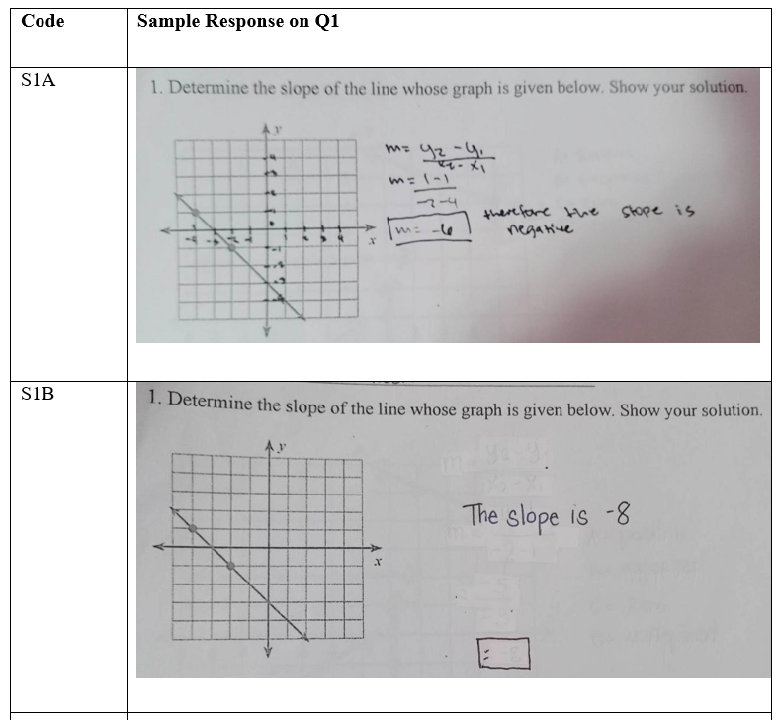

The answers and solutions of Students S1A and S1B indicate that the students do not know the coordinates and values of one variable with changes in the other variable. They also neglect to use properly the math basic operations.
Student S2A and S2B do not know or they are confused on how to apply the concept of slope. They do not know how to assign values and select at least two points on the line to determine the slope of the given line. They do not know as to when the slope becomes undefined. They also do not know the concept of rise over run.
Students S3A and S3B do not know or are confused on how to apply the concept of slope. They do not even know when is the slope positive, or undefined.
Students S4A and S4B do not have a correct response. They know the formula in finding the slope of the given line but do not know the values of the coordinates of the variables. And they do not even know the slope of a horizontal line.
S5A and S5B do not coordinate the direction of change in one variable with changes in the other variable. They also do not know the concept of slopes that are positive, negative, undefined or zero.

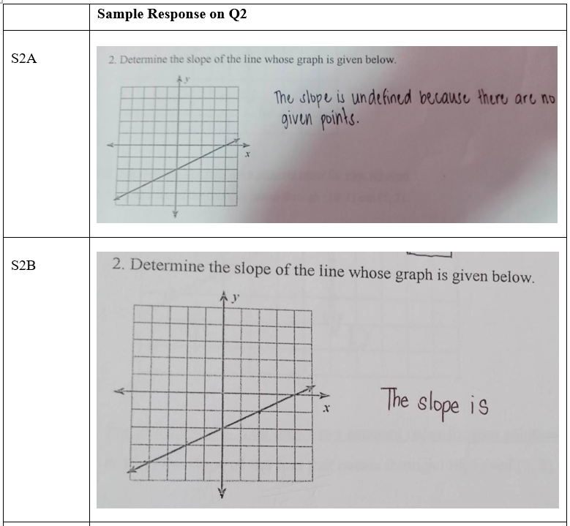
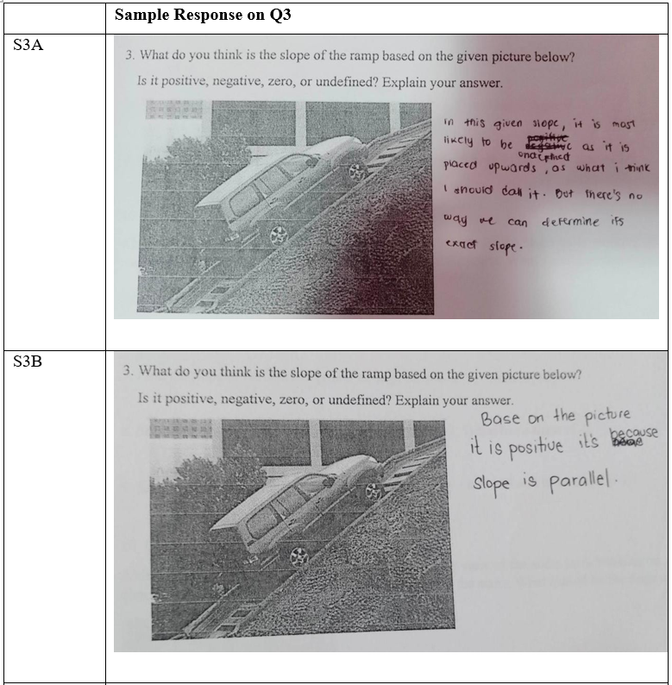
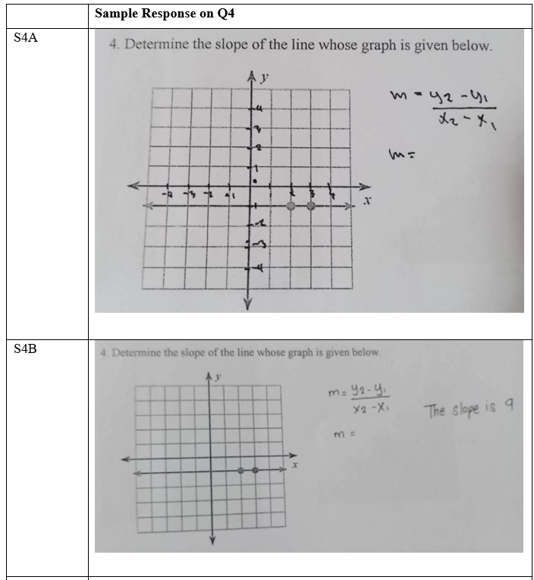
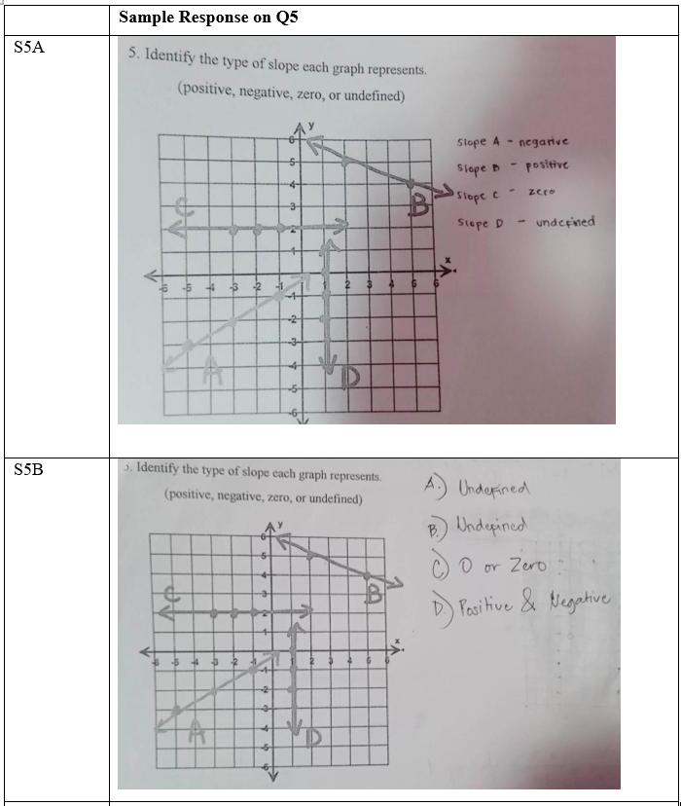
Performance Tasks and Mathematical Communication
Both groups completed Task 1 successfully, attaining the maximum rubric score of 32 on all 16 criteria: data were collected at all locations, slopes were calculated and explained, equivalent slopes were plotted, worksheets were completed on time, written work was legible and well organized, and learners participated actively and respectfully in the reflective discussion. During that discussion, learners articulated the challenges they faced, the problem-solving strategies they used, and additional real-world scenarios requiring slope, providing direct evidence of growth in mathematical communication. On Task 2, Group B attained the maximum rubric score of 20, and Group A scored 19 of 20, with a slightly lower rating for team cooperation and coordination. The uniformly high rubric scores indicate strong engagement and successful task completion, although, as noted below, they also suggest that the rubrics discriminated weakly at the upper end of performance.
Post-Assessment Achievement
Table 3 summarizes post-assessment performance. Seventy-nine learners (87.78%) scored 18–20, and the remaining 11 (12.22%) scored 15–17; no learner scored below 15. The overall mean was 19.20 (SD = 1.46), with 66 learners (73.3%) attaining the maximum score of 20 — a pronounced ceiling effect.
Table 3. Post-Assessment Scores of Learners (Maximum Score = 20)
Score range | Group A | Group B | Total | Percentage
18–20 | — | — | 79 | 87.78
15–17 | — | — | 11 | 12.22
12–14 | 0 | 0 | 0 | 0.00
Below 12 | 0 | 0 | 0 | 0.00
Total | 49 | 41 | 90 | 100.00
Mean | 18.86 | 19.61 | 19.20
SD | 1.71 | 1.05 | 1.46
Comparison of Pre- and Post-Assessment Scores
A paired-samples t-test compared learners' pre- and post-assessment scores (Table 4). The mean difference of 14.16 points (SD = 2.17) was statistically significant, t(89) = 61.83, p < 0.001, with a very large within-subjects effect size (Cohen's d = 6.52). Because the difference scores departed from normality, a Wilcoxon signed-rank test was conducted and confirmed the result (p < 0.001); every learner improved from pretest to post-test. The magnitude of the standardised effect should be interpreted with caution: it reflects both the genuine instructional gain and the restricted variance produced by the ceiling effect and by the fact that half of the pretest items drew no responses at all.
Table 4. Paired-Samples t-Test Results for Pre- and Post-Assessment Scores (N = 90)
Measure | Mean | SD | SE mean | Statistic
Post-assessment | 19.20 | 1.46 | 0.15
Pre-assessment | 5.04 | 1.63 | 0.17
Difference | 14.16 | 2.17 | 0.23 | t(89) = 61.83, p < 0.001
Effect size |  |  |  | Cohen's d = 6.52

Qualitative Analysis of Learner Responses
Post-assessment work samples (Figure 2) evidence the qualitative character of the improvement. Where pretest responses had asserted, for example, that a graphed line's slope was “undefined because there are no given points,” post-test responses showed learners selecting two points on the line, correctly writing and applying the slope formula, computing accurately, and expressing the result in both fraction and decimal form. Learners who at pretest had confused negative with undefined slopes correctly classified all four slope types (positive, negative, zero, undefined) from graphical representations at post-test. Across the samples, responses became longer, better organized, and more explicitly reasoned, indicating improved mathematical communication alongside procedural accuracy. Misconceptions catalogued in Table 2 — failure to coordinate variables, confusion about undefined slope, inability to extract coordinates from a graph — were largely absent from post-test work.
Figure 2. Sample Post-Test Responses Demonstrating Accurate Slope Calculation and Classification
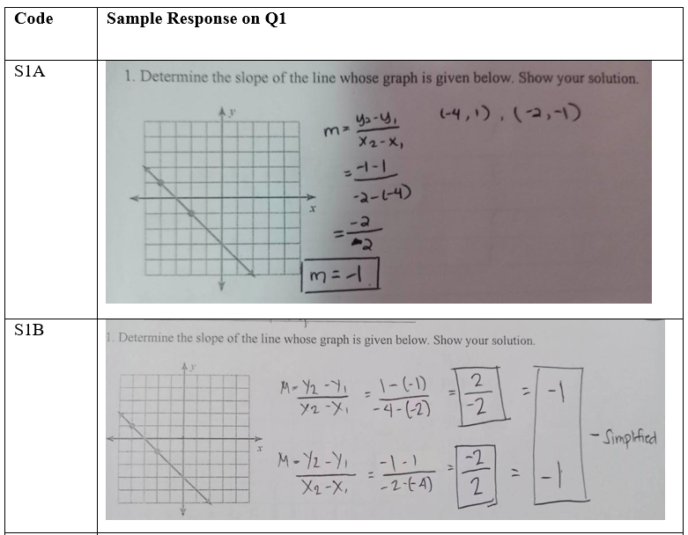

S1A and S1B already know the coordinates and values of one variable with changes in the other variable. Operations used are correct.
S2A and S2B already know how to apply the concept of slope using the formula and are clear about the values of the variables.
S3A and S3B already know how to apply the concept of slope.
S4A and S4B already know the values of the coordinates of the variables.
S5A and S5B already know the coordinates and the direction of change in one variable with changes in the other variable.

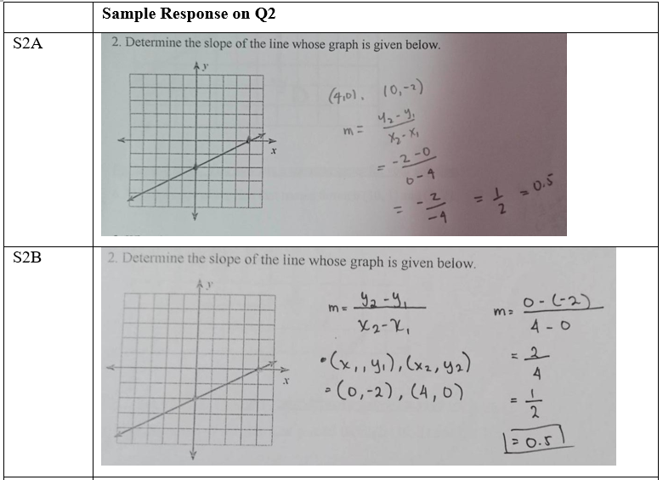
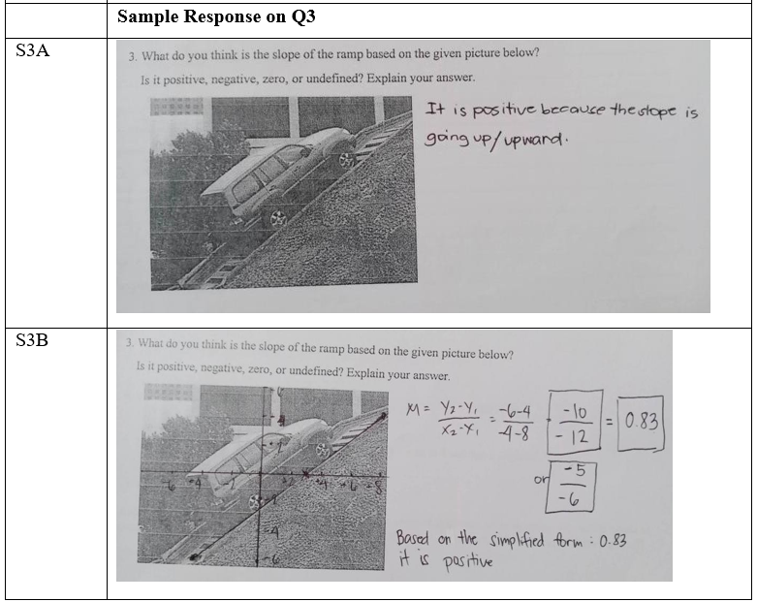
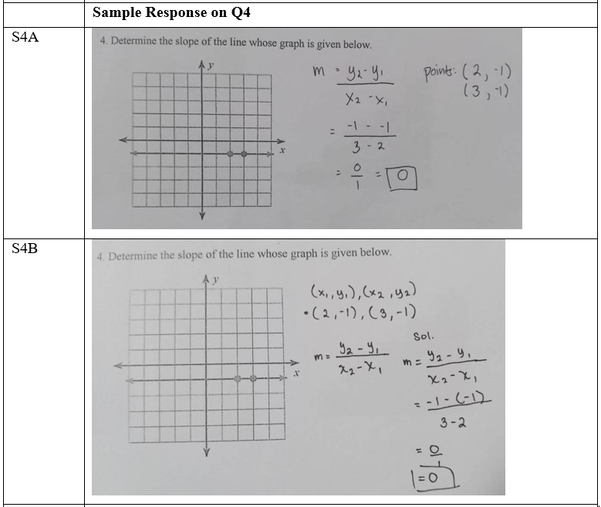
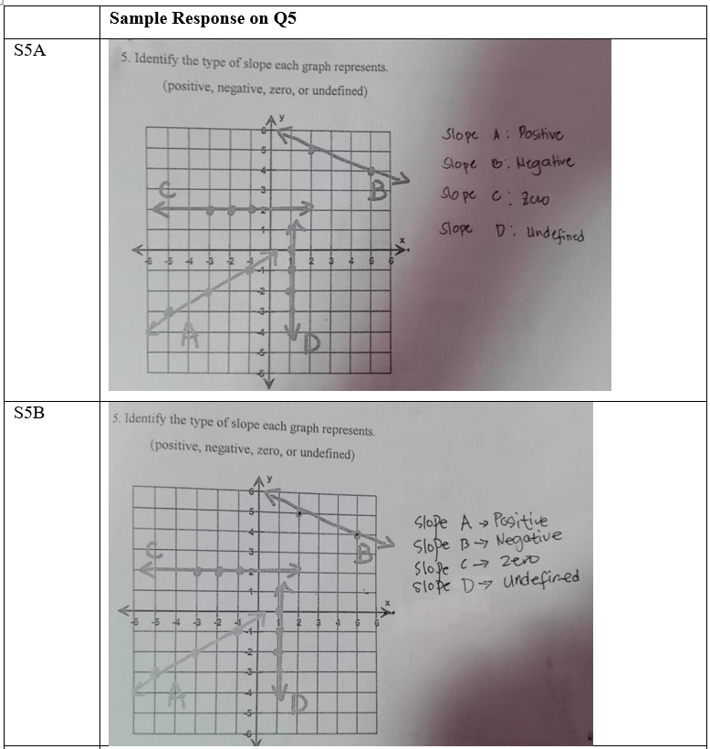
Discussion of Key Findings
The improvement is consistent with literature on the value of performance-based and authentic assessment in mathematics [8], [10], [11], [12]. The outdoor measurement task connected the abstract ratio conception of slope to physical situations, addressing the contextual-transfer difficulty documented by Planinic, Milin-Sipus, Katic, Susac, and Ivanjek [2], while the formula song supported retention and verbalization of the procedure, addressing the limited procedural proficiency described by Hattikudur et al. [3]. The tasks also engaged multiple conceptualizations of slope — ratio, physical property, and behavior indicator — of the kind identified by Moore-Russo et al. [4], and the improvement in learners' explanations aligns with calls for assessment that develops mathematical communication [13], [14].
Limitations of the Study
Several limitations qualify the findings. First, the one-group design lacks a control condition, so gains cannot be attributed uniquely to the performance-based character of the activities; maturation, ordinary instruction, and testing effects cannot be excluded. Second, the universal non-response to Items 6–10 at pretest indicates that much of the assessed content had not yet been taught to these learners, so part of the gain reflects first formal instruction in slope rather than the performance-based approach per se. Third, a pronounced ceiling effect (73.3% of learners attained the maximum post-test score) restricted variance and inflates standardized effect sizes; the reported Cohen's d of 6.52 should be read in that light. Fourth, the uniformly perfect or near-perfect rubric scores suggest the rubrics discriminated weakly among levels of performance. Fifth, the novelty of the tasks may have elevated engagement in the short term (a Hawthorne-type effect), and the two-week duration cannot speak to retention. Finally, the single-school setting and purposive sampling of intact classes limit generalizability.
CONCLUSION
This study examined the effects of performance-based learning activities on 90 Grade 10 learners' understanding of slope. Following an outdoor slope measurement task and a choreographed slope formula song, learners' achievement on a 20-point assessment rose from a mean of 5.04 to 19.20, every learner improved, and the misconceptions identified at pretest were largely resolved, with learners demonstrating clearer mathematical communication. Although the one-group design, ceiling effect, and first-instruction confound preclude strong causal claims, the results indicate that performance-based tasks can be a practical and engaging vehicle for developing both procedural fluency and conceptual understanding of slope, and they provide classroom-ready materials for teachers seeking alternatives to traditional testing. Future research should employ a comparison group receiving conventional instruction, use delayed post-tests to examine retention, recruit larger and more diverse samples across grade levels, and observe how teachers themselves address slope in their classrooms.
DECLARATIONS
Conflict of Interest
The author declares no conflict of interest.
Data Availability
The data supporting the findings of this study are available from the corresponding author upon reasonable request. The data are not publicly available because they contain information that could compromise the privacy of the minor research participants.
Funding
The author received no specific funding for this research.

Acknowledgements
The author thanks the participating learners, their parents and guardians, and the school administration for their support.
REFERENCES
[1] Nagle, C., & Moore-Russo, D. (2014). Slope across the curriculum: Principles and standards for school mathematics and the Common Core State Standards. The Mathematics Educator, 23(2), 40–59.
[2] Planinic, M., Milin-Sipus, Z., Katic, H., Susac, A., & Ivanjek, L. (2012). Comparison of student understanding of line graph slope in physics and mathematics. International Journal of Science and Mathematics Education, 10(6), 1393–1414. https://doi.org/10.1007/s10763-012-9344-1
[3] Hattikudur, S., Prather, R. W., Asquith, P., Alibali, M. W., Knuth, E. J., & Nathan, M. (2011). Constructing graphical representations: Middle schoolers' intuitions and developing knowledge about slope and y-intercept. School Science and Mathematics, 112(4), 230–240. https://doi.org/10.1111/j.1949-8594.2012.00138.x
[4] Moore-Russo, D., Conner, A., & Rugg, K. I. (2011). Can slope be negative in 3-space? Studying concept image of slope through collective definition construction. Educational Studies in Mathematics, 76(1), 3–21. https://doi.org/10.1007/s10649-010-9277-y
[5] Stanton, M., & Moore-Russo, D. (2012). Conceptualizations of slope: A review of state standards. School Science and Mathematics, 112(5), 270–277. https://doi.org/10.1111/j.1949-8594.2012.00135.x
[6] Casey, S., & Nagle, C. (2016). Students' use of slope conceptualizations when reasoning about the line of best fit. Educational Studies in Mathematics, 92(2), 163–177. https://doi.org/10.1007/s10649-015-9655-6
[7] Nagle, C., & Moore-Russo, D. (2013). How do teachers' concept images of slope relate to their intended instructional foci? Investigations in Mathematics Learning, 6(1), 1–18. https://doi.org/10.1080/24727466.2013.11790328
[8] Darling-Hammond, L., & Adamson, F. (2014). Beyond the bubble test: How performance assessments support 21st century learning. Jossey-Bass.
[9] Darling-Hammond, L. (1994). Performance-based assessment and educational equity. Harvard Educational Review, 64(1), 5–30. https://doi.org/10.17763/haer.64.1.j57n353226536n42
[10] Ernst, J. V., & Glennie, E. (2015). Redesigned high schools for transformed STEM learning: Performance assessment pilot outcome. Journal of STEM Education, 16(4), 27–35.
[11] Fuchs, L. S., Fuchs, D., Karns, K., Hamlett, C. L., & Katzaroff, M. (1999). Mathematics performance assessment in the classroom: Effects on teacher planning and student problem solving. American Educational Research Journal, 36(3), 609–646. https://doi.org/10.3102/00028312036003609
[12] Brown, S. (2015). Authentic assessment: Using assessment to help students learn. RELIEVE – Electronic Journal of Educational Research, Assessment and Evaluation, 21(2), 1–8. https://doi.org/10.7203/relieve.21.2.7674
[13] National Research Council. (2001). Adding it up: Helping children learn mathematics. National Academies Press. https://doi.org/10.17226/9822
[14] Lesh, R., & Lamon, S. J. (Eds.). (1992). Assessment of authentic performance in school mathematics. AAAS Press.

