Smart Cane with AI Object Detection and Indoor Navigation for Visually Impaired People

Anila S
Computer Science and Engineering
Adi Shankara Institute of Engineering and Technology
Kalady, Kerala anila.cs@adishankara.ac.in

Anitha P J
Computer Science and Engineering
Adi Shankara Institute of Engineering and Technology
Kalady, Kerala anithapj2004@gmail.com

Athulya Theresa M J
Computer Science and Engineering
Adi Shankara Institute of Engineering and Technology
Kalady, Kerala athulyatheresamj0@gmail.com

Hitha Rocky
Computer Science and Engineering
Adi Shankara Institute of Engineering and Technology
Kalady, Kerala hitha.cs@adishankara.ac.in

Athmaja C P
Computer Science and Engineering
Adi Shankara Institute of Engineering and Technology
Kalady, Kerala athmajacp@gmail.com

Avani T R
Computer Science and Engineering
Adi Shankara Institute of Engineering and Technology
Kalady, Kerala avanitr.11.a@gmail.com

Abstract—Navigation in indoor environments presents significant challenges for visually impaired individuals, primarily due to the absence of Global Positioning System (GPS) signals and the presence of dynamic obstacles. Traditional walking sticks offer only physical contact-based obstacle detection and lack the directional guidance necessary for navigating to specific destinations. This paper proposes a smart indoor navigation walking stick that integrates marker-based localization, compass- based directional guidance, AI-driven obstacle detection, and audio-based user feedback. The system enables users to select a target destination via a mobile application. The walking stick determines its precise location by detecting ArUco markers placed at predefined positions within the building, while a digital compass module establishes its heading direction. Navigation logic then computes the optimal orientation toward the target. A live video stream to a processing unit facilitates AI-based obstacle detection and path assistance, augmented by ultrasonic sensors for close-range hazard and pit detection. Audio guidance is delivered through Bluetooth earphones, and an emergency SOS system transmits the user’s location when activated. Overall, the proposed AI-enabled smart walking stick provides a scalable, cost-effective, and robust solution for indoor assistive navigation. By integrating structured marker localization, sensor fusion, intelligent vision processing, and wireless communication, the system significantly enhances mobility, safety, and independence for visually impaired individuals.

Index Terms—Indoor Navigation, ArUco Marker, Raspberry Pi, Obstacle Detection, Assistive Technology, Ultrasonic Sensor, Compass Module, Artificial Intelligence.
- Introduction
Navigation in indoor environments presents significant chal- lenges for visually impaired individuals, primarily due to the absence of Global Positioning System (GPS) signals and the presence of dynamic obstacles. Traditional walking sticks offer only physical contact-based obstacle detection and lack the directional guidance necessary for navigating to specific destinations.
Recent advances in computer vision, embedded systems, and artificial intelligence have enabled the development of intelligent assistive devices capable of providing localization, navigation, and real-time safety alerts. This paper proposes a smart indoor navigation walking stick that integrates marker- based localization, compass-based directional guidance, AI- driven obstacle detection, and audio-based user feedback.
The objective of this work is to design a reliable, low-cost, and scalable navigation system that assists visually impaired users in safely reaching selected destinations within structured indoor environments such as educational institutions and hos- pitals.
- RELATED WORKS
Leong and Ramasamy [1] proposed a vision-based nav- igation system using deep learning and stereo vision for object detection and distance estimation. It relies on con- volutional neural networks and performs reliably in well-lit

indoor environments. However, the system demands significant computational power. Its accuracy also decreases under poor lighting or strong shadows.
A. Shahdib and B. M. Bhuiyan [2] developed a hybrid as- sistive system combining ultrasonic sensors with a lightweight deep learning model for fast obstacle detection and object recognition. This approach improves response speed and re- duces false alarms. However, the system lacks intelligent route planning. It also struggles in crowded environments as it does not track moving objects.
N. Loganathan, K. Lakshmi, N. Chandrasekaran, S. R. Cibisakaravarthi, R. H. Priyanga, and K. H. Varthini [3] designed a low-cost smart stick prototype using ultrasonic sensors and a microcontroller to detect obstacles and provide audio alerts. It reliably detects obstacles up to three meters away. However, the system does not support object classifica- tion. It also lacks localization and destination-based navigation features.
A. Anwar and S. Aljahdali [4] proposed an affordable ultrasonic-based smart stick with an adjustable detection range and low-power processor for extended battery life. It per- forms effective obstacle detection in resource-limited settings. However, it does not include object recognition or navigation capabilities. The authors suggested integrating smartphone applications for future improvements.
R. Dhod, G. Singh, G. Singh, and M. Kaur [5] introduced a GPS and GSM-based assistive system for outdoor naviga- tion and emergency alerts. It tracks the user’s location and sends SMS notifications to caregivers upon detecting unusual movement. The system demonstrated reliable outdoor tracking performance. However, GPS signals are ineffective indoors, limiting its use for indoor navigation.
S. Srinivasan and M. Rajesh [6] developed a compact, energy-efficient smart stick with ultrasonic sensors providing both vibration and audio alerts. Vibration feedback aids ob- stacle detection in noisy environments, while sensor cycling improves power efficiency. However, the system lacks artificial intelligence for object recognition.
S. K. Pal, A. Pramanik, J. Maiti, and P. Mitra [7] reviewed deep learning techniques for multi-object detection and track- ing, focusing on CNNs and real-time frameworks like YOLO and SSD. Although not specific to assistive technology, the review highlights efficient object detection methods. These methods can potentially be applied in smart navigation sys- tems.
N. Dey et al. [8] designed a low-cost smart blind stick using ultrasonic sensors operating at 40 kHz to detect nearby obstacles. The system alerts users through vibration when an object is detected within a short distance. The design focuses on affordability and simple construction to increase accessibility. However, it cannot identify object types or detect complex hazards such as holes, stairs, or overhead obstacles, and it lacks navigation capabilities.
R. Khlaikhayai, C. Pavaganun, B. Mangalabruks, and P. Yupapin [9] developed an intelligent walking stick with multi- directional sensors and audio-tactile alerts. Its lightweight,
ergonomic design improved user confidence and reduced col- lisions during testing. However, the system does not include location tracking. It also lacks route planning capabilities.
T. L. Narayani, M. Sivapalanirajan, B. Keerthika, M. Anan- thi, and M. Arunarani [10] created a camera-based smart cane that uses image processing to detect and classify obstacles like chairs, doors, and people. This provides richer environmental information than ultrasonic sensors alone. However, continu- ous image processing increases power consumption. It may also introduce delays in real-time feedback.
A. Ramadhan [11] designed a wearable assistive system with body-mounted cameras or ultrasonic sensors for hands- free navigation. Tests in well-lit indoor environments showed improved navigation support. However, system performance declines under low lighting conditions. Strong shadows also negatively impact its effectiveness.
T. Kim, C. Ro, and J. Yoon [12] developed a smart stick focusing on user safety through motion sensing and GPS tracking. It detects abnormal movements like falls and sends alerts to caregivers. The GPS module enables reliable outdoor location tracking. However, it cannot provide indoor position- ing due to satellite signal limitations.
T. S. Aravinth [13] proposed a smart stick using Wi-Fi and Bluetooth to connect with smartphones for remote monitoring by caregivers. The system allows monitoring of sensor data and device status via a mobile app. However, it lacks built-in AI for obstacle detection or navigation.
N. Sahoo, H.-W. Lin, and Y.-H. Chang [14] designed a walking stick combining ultrasonic sensors with drop-off detection to identify hazards like stairs and edges. User testing indicated improved safety through intuitive alert mechanisms. However, the system does not include vision-based perception. It also lacks advanced environmental understanding capabili- ties.
R. Moghe, F. C. Lambert, and D. Divann [15] proposed a modular sensor concept from smart grid systems, using small attachable modules to add intelligence to existing devices. This can be applied to assistive technologies by allowing modular upgrades to traditional white canes. Users could add ultrasonic or vision sensors as needed.

TABLE I summarizes fifteen assistive navigation systems developed between 2011 and 2023, showing a transition from basic ultrasonic smart sticks to advanced deep learning–based vision systems. Reported accuracies range from 87% to 97%, with AI-driven models achieving the highest performance. Despite improved detection capabilities, challenges such as computational cost, lighting sensitivity, limited range, GPS dependency, and power consumption remain.
- Proposed method
This system introduces an advanced ”smart cane” designed to facilitate autonomous indoor navigation for the visually impaired. By integrating computer vision, sensor fusion, and marker-based positioning, the device provides high-precision, real-time spatial awareness. The core architecture powered by

TABLE I
Comparative Analysis of Obstacle Detection and Navigation Systems for Visually Impaired People

Ref | Year | Methodology | Dataset | Accuracy | Class | Limitations
[1] | 2023 | Deep learning-based vision | Real-world | 96% | Obstacle detection & | Sensitive to lighting; high
 |  | system for obstacle detec- | experimental dataset |  | distance estimation | computational cost
 |  | tion
[2] | 2021 | Ultrasonic sensors + deep | Custom prototype | 94% | Obstacle detection & | Limited sensing range; la-
 |  | learning | dataset |  | distance estimation | tency issues
[3] | 2020 | Ultrasonic sensor-based | Prototype testing | 92% | Obstacle detection | Short detection distance; no
 |  | smart stick |  |  |  | classification
[4] | 2018 | Embedded smart stick with | Custom prototype | 90% | Obstacle detection | Limited scalability; basic
 |  | obstacle sensors |  |  |  | sensing
[5] | 2017 | GPS & GSM navigation | Field testing dataset | 91% | Outdoor navigation | GPS dependency; poor in-
 |  | system |  |  |  | door accuracy
[6] | 2019 | Smart walking stick using | Prototype validation | 93% | Obstacle detection | Limited detection range
 |  | ultrasonic sensors
[7] | 2021 | Deep learning multi-object | Multiple benchmark | 97% | Object detection & | High computational require-
 |  | detection and tracking | datasets |  | tracking | ments
[8] | 2018 | Ultrasonic sensor-based | Prototype testing | 89% | Obstacle detection | Limited obstacle differenti-
 |  | blind stick |  |  |  | ation
[9] | 2011 | Intelligent walking stick | Prototype | 88% | Safety alert system | Basic functionality; limited
 |  | with embedded sensors |  |  |  | processing power
[10] | 2021 | Smart cane with integrated | Custom prototype | 95% | Vision-based obstacle | High power consumption;
 |  | camera module |  |  | detection | lighting dependency
[11] | 2018 | Wearable smart assistive | Experimental dataset | 92% | Wearable navigation | Battery limitations; comfort
 |  | system |  |  | aid | constraints
[12] | 2016 | Motion sensing + GPS | Prototype testing | 90% | Navigation & fall de- | GPS reliance; limited in-
 |  | smart stick |  |  | tection | door use
[13] | 2020 | WiFi & Bluetooth-based | Prototype validation | 91% | Indoor navigation | Requires network infras-
 |  | smart stick |  |  |  | tructure
[14] | 2019 | Sensor-integrated walking | Experimental valida- | 94% | Obstacle detection | Limited object classification
 |  | stick (ultrasonic + | tion
 |  | embedded system)
[15] | 2012 | Smart stick-on sensor mon- | Experimental valida- | 87% | Sensor monitoring | Not specific to visual im-
 |  | itoring system | tion |  | system | pairment

a Raspberry Pi utilizes a dual-layered approach to safety: ultra- sonic sensors for immediate proximity detection and a YOLO- based object detection model for environmental context. This ensures the user can identify and navigate around complex obstacles such as furniture and doorways with confidence.

- Algorithm
To pinpoint a user’s location inside a building, the system re- lies on a network of ArUco markers. The camera continuously scans the surroundings, converting each frame to grayscale to strip away unnecessary detail; this allows the system to identify markers more reliably, even in varied lighting. Once a marker is detected, the system extracts its unique ID and maps its corners to calculate exactly where the user is standing and which way they are facing relative to the marker. By cross- referencing this ID with a pre-mapped database, the system provides a precise ”indoor GPS” fix.
From there, the navigation logic takes over. Once the system identifies the current marker, it determines which corridor the user is in and compares it to the destination’s location. If the user is already on the right path, the cane provides a simple ”move forward” prompt. If a change in direction is required, it offers clear ”turn left” or ”turn right” instructions. When the
final destination marker is detected, the user is immediately notified of their arrival.
To keep the journey safe, the system uses a YOLO-based deep learning model to act as a second set of eyes. The camera feeds live video to this model, which identifies everyday objects like chairs or open doors in real time. By focusing on the largest ”bounding box” in the frame—which typically represents the closest hazard—the system determines if an obstacle is to the left, right, or directly ahead. It then translates this data into helpful voice cues, guiding the user smoothly and safely around any blockages.
- Methodology
The system is designed as a series of integrated modules that work in harmony to provide a seamless, reliable navigation experience for visually impaired users. By structuring the technology into a step-by-step functional flow, the system transforms a user’s spoken intent into real-time, actionable guidance.
The process begins with a simple voice command. Through a mobile application, the user identifies their destination, which a speech recognition module translates into a specific room ID. This target is then transmitted to the smart cane via Bluetooth or Wi-Fi, establishing the navigational goal.

Once the destination is set, the system initiates real-time spatial tracking. Since GPS is often unreliable indoors, the localization module utilizes the onboard camera to scan for ArUco markers placed at key waypoints. Each unique marker acts as an ”indoor coordinate,” allowing the system to instantly pinpoint the user’s exact location upon detection.
As the user moves, the navigation module dynamically calculates the most efficient path. By comparing the current marker ID with the destination’s coordinates, the system generates clear directional prompts—such as “move straight” or “turn right”—which update automatically as new markers are encountered. Simultaneously, the system maintains con- stant environmental vigilance. A YOLO-based object detection model processes the live camera feed to identify potential hazards like furniture or pedestrians. By analyzing the position and scale of these objects within the frame, the system determines their proximity and provides immediate audio cues to help the user navigate safely around them.
To ensure the experience is entirely hands-free, all naviga- tional and safety instructions are processed through a text-to- speech engine and delivered via Bluetooth earphones. For an added layer of security, the cane features an integrated SOS module. In an emergency, a single button press identifies the nearest ArUco marker and transmits the user’s precise location to designated caregivers. By unifying localization, hazard detection, and emergency communication, this integrated ap- proach offers a practical and dignified way for individuals to navigate indoor environments with newfound independence.
- Architecture
This system integrates several core technologies—mobile interaction, sensor fusion, computer vision, and real-time audio feedback—to create a unified navigation assistant for visually impaired users. The experience begins intuitively: the user speaks their destination into a mobile application, which then transmits the target coordinates to the smart cane to initiate the journey.
On the hardware level, the cane serves as a sophisticated sensory hub. Equipped with ultrasonic sensors and a digital compass, it constantly monitors the immediate surroundings and the user’s orientation. Simultaneously, an onboard camera captures a live video feed of the environment. This feed performs a dual role: it identifies strategically placed ArUco markers to provide precise indoor localization—solving the challenge of GPS-denied environments—while also feeding data into the system’s analytical core.
At the heart of the operation is a Raspberry Pi, which functions as the system’s ”brain.” It aggregates data from all sensors to make high-level navigational decisions. A dedicated direction calculation module compares the user’s real-time position with their destination to determine the optimal path. To enhance environmental awareness, the video feed is pro- cessed by a YOLO-based object detection model. This model identifies potential hazards, such as furniture or pedestrians, allowing the system to merge pathfinding logic with active obstacle avoidance.
The resulting guidance is seamlessly communicated to the user through a Bluetooth-enabled audio system. By converting navigational logic into spoken instructions delivered directly to wireless earphones, the system provides a completely hands- free experience. For added security, a physical SOS button allows the user to instantly broadcast their location to a care- giver. By blending sophisticated AI processing with practical sensor inputs, the system offers a reliable and dignified way for individuals to navigate complex indoor spaces with greater independence.
- Hardware
The hardware architecture is centered around a Raspberry Pi 4 Model B, which serves as the system’s primary processing unit or ”brain.” To provide environmental awareness, a Rasp- berry Pi Camera Module acts as the system’s optical sensor, capturing real-time visual data. This is complemented by an array of ultrasonic sensors that perform constant proximity checks to detect nearby obstacles, while a digital compass module maintains a precise reading of the user’s orientation and heading.
To ensure the experience is intuitive and hands-free, the system communicates through wireless Bluetooth earphones. This allows navigational cues and safety alerts to be delivered as clear, spoken guidance, ensuring the user remains focused on their surroundings. The entire system is powered by a high-capacity rechargeable battery, providing the portability and endurance needed for reliable, daily use in various indoor settings.
- RESULT
The results show that the object detection model performs reliably for indoor navigation assistance. It achieved an overall mean Average Precision at a 0.5 Intersection over Union threshold of 0.706. Among the detected classes, doors had the highest accuracy at 0.768, followed by tables and chairs. The best F1-score of 0.68 was reached at a confidence threshold around 0.313, offering a good balance between precision and recall. The training and validation loss curves show steady convergence with no major signs of overfitting, suggesting the model generalizes well. Overall, the model delivers stable and effective multi-class obstacle detection suitable for real-time indoor assistive navigation.
Figure 1 presents a pair-plot style visualization of the bounding box annotations in the dataset. The variables include the normalized center x-coordinate, center y-coordinate, width, and height of the boxes. The diagonal histograms reveal that x-coordinate values are quite evenly spread across the image width, meaning objects appear throughout the horizontal space. The y-coordinate values, however, are more concen- trated in the middle-to-upper parts of the images, indicating that most objects are located away from the bottom edge. The width distribution shows that the majority of objects are small to medium in size, with only a few large ones. Similarly, the height distribution suggests that most objects take up a limited vertical portion of the frame, with tall boxes

being rare. The off-diagonal scatter density plots highlight relationships between these variables. A positive correlation between width and height suggests that wider objects also tend to be taller. The connections between object position (x and y) and dimensions (width and height) show that objects of varying sizes appear across different image areas, though smaller objects are more common overall.

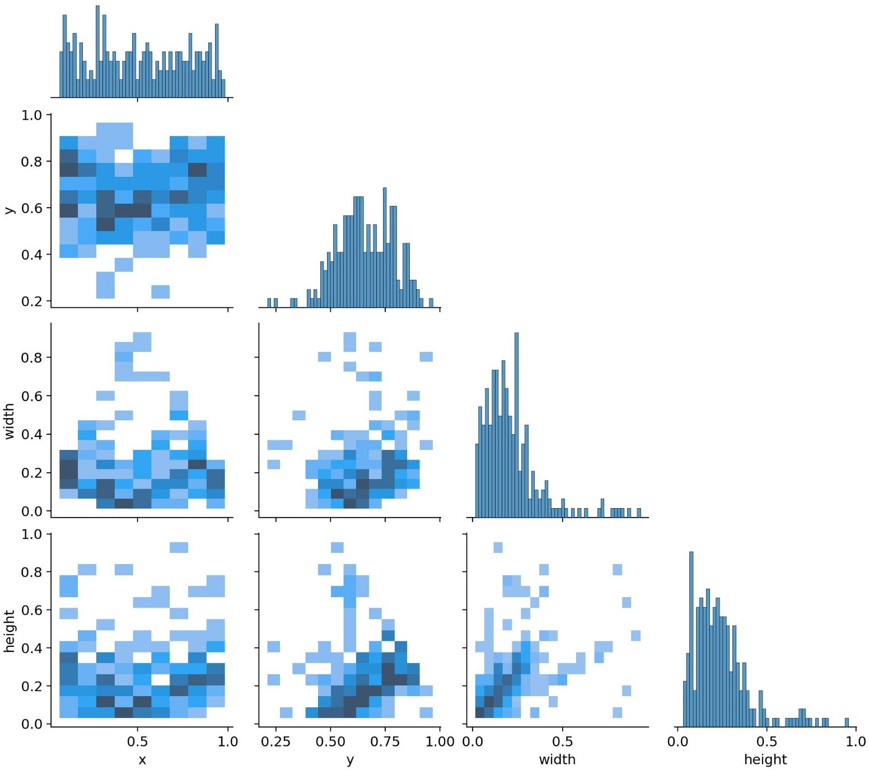

Fig. 1. Bounding box distribution of the dataset showing spatial and size variation of detected objects.

Figure 2 shows the Precision–Recall curve for the chair, table, and door classes detected by the trained model. The curve illustrates how precision and balance each other as the confidence threshold changes. The door class performed best, with an Average Precision of 0.768, followed by the table at 0.694 and the chair at 0.655. The overall mean Average Precision at a 0.5 Intersection over Union threshold came out to 0.706. These results point to dependable multi-class detection that can support indoor navigation tasks effectively.
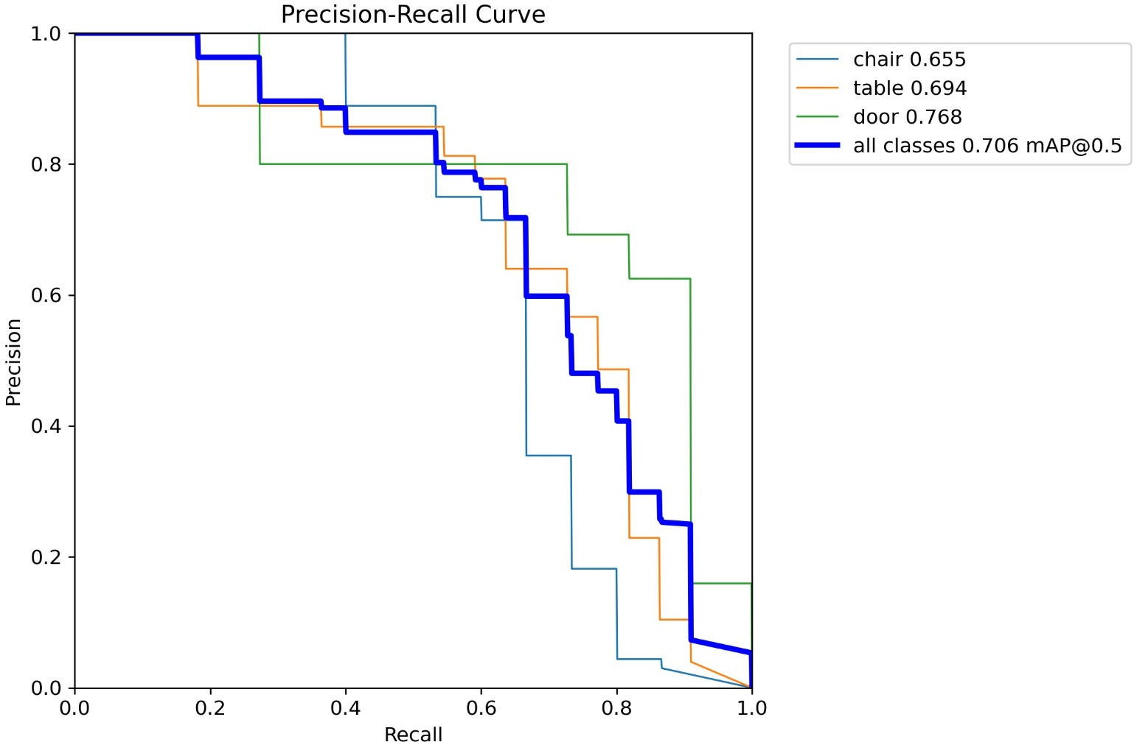

Fig. 2. Precision–Recall curve.

Figure 3 presents the F1-score plotted against different confidence threshold values for the detection model. The curve peaks at an F1-score of 0.68, which occurs at a confidence
threshold of around 0.313. This sweet spot strikes the best possible balance between precision and recall. When the threshold is set lower, the model catches more objects (high recall) but at the cost of more false positives (lower precision). On the flip side, higher thresholds boost precision but cause the model to miss more actual objects. Operating at this optimal point around 0.313 gives us dependable real-time detection performance that balances both concerns nicely.
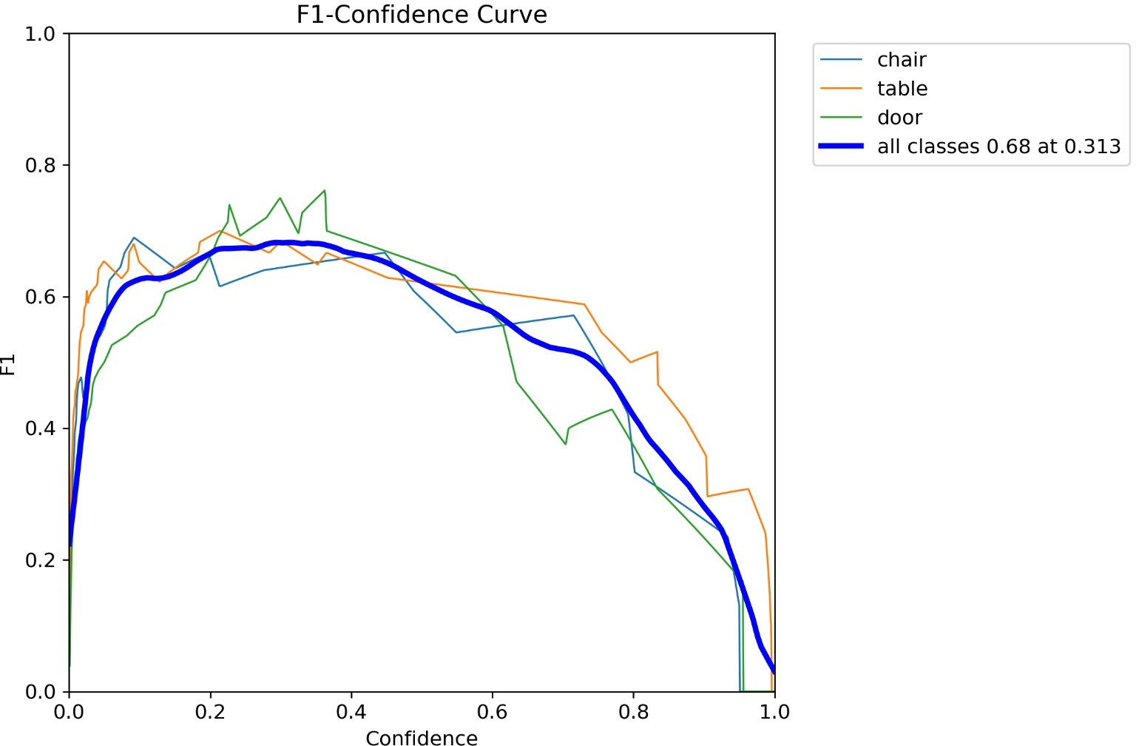

Fig. 3. F1-score versus confidence threshold curve.

Figure 4 illustrates how precision changes as we adjust the confidence threshold. The trend is clear: precision climbs steadily when the threshold is raised. At higher confidence levels, the model becomes exceptionally reliable, with very few false positives slipping through. The trade-off, however, is that recall drops as the model plays it safe and misses some genuine objects. This pattern is exactly what we’d expect from a well-trained detection system and reinforces the importance of choosing a balanced threshold that works well in practice.
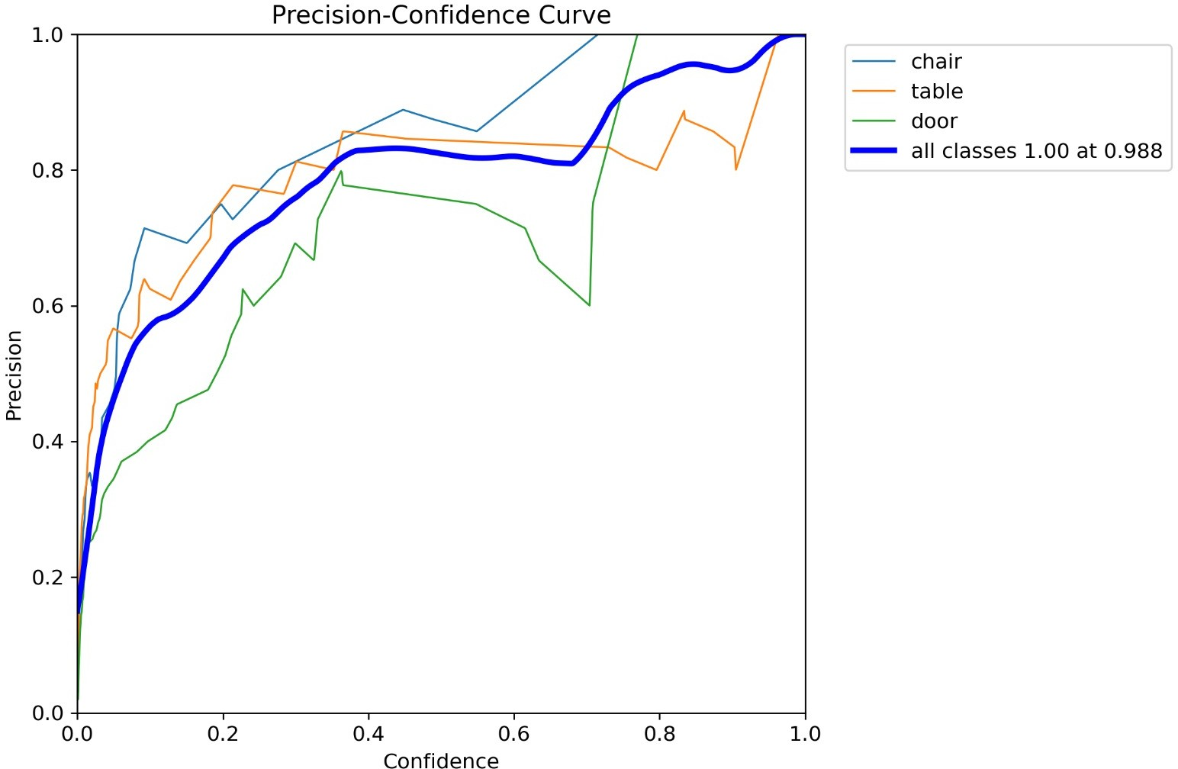

Fig. 4. Precision versus confidence threshold curve.

Figure 5 displays how recall varies with the confidence threshold. As expected, recall is at its peak—reaching about 0.88—when the threshold is set very low, allowing almost all detections through. But as we raise the bar and require higher confidence from the model, recall gradually drops because more predictions get filtered out. This pattern really drives home why picking the right confidence threshold matters so much. We need to strike a balance where the model remains sensitive enough to catch most obstacles, which is especially

critical in assistive navigation where missing a detection could have real consequences.
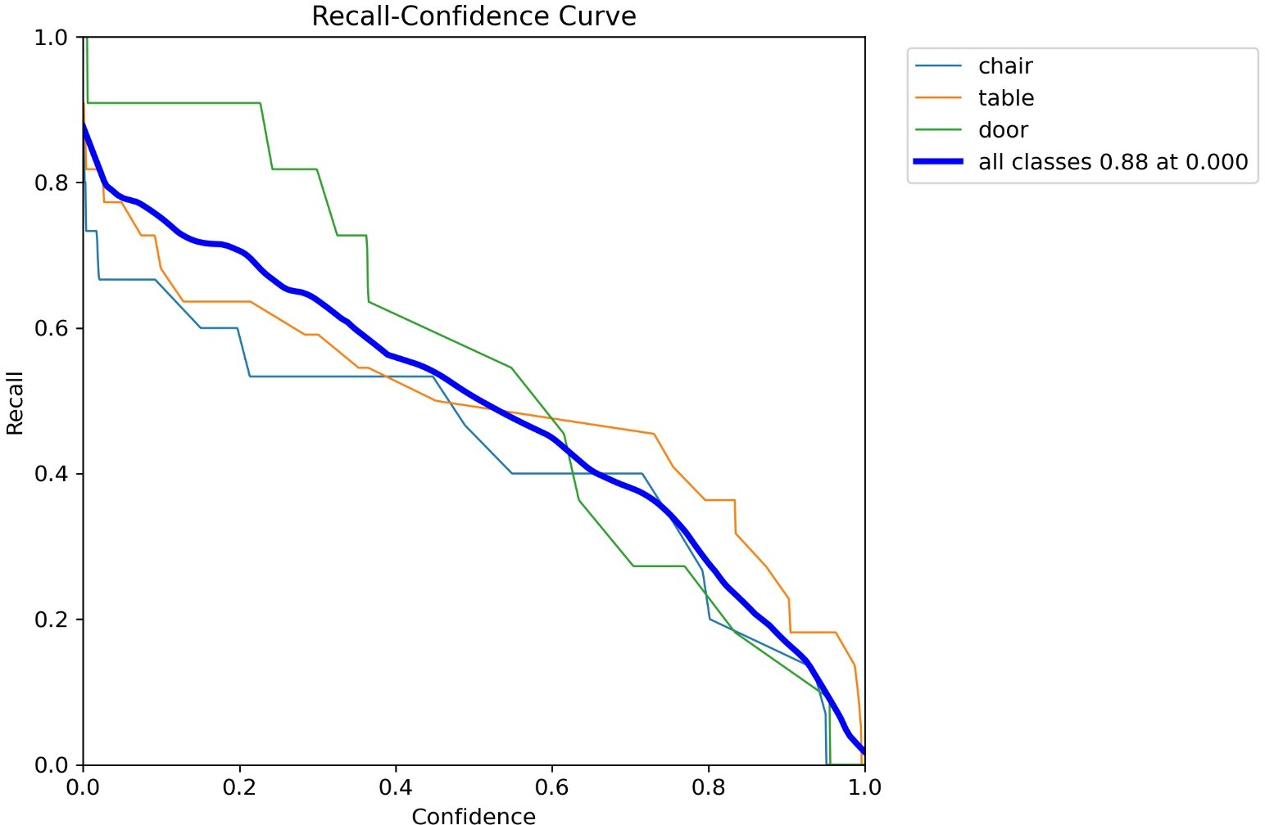

Fig. 5. Recall versus confidence threshold curve.

Figure 6 tracks the model’s learning progress through its training and validation loss curves. All three loss compo- nents—box loss, classification loss, and distribution focal loss—show a nice, steady decline over time, which tells us the model is genuinely picking up useful patterns. The validation losses mirror this downward trend quite closely, without any worrying signs of the training and validation lines drifting apart. This close alignment is a good indication that the model isn’t just memorizing the training data but is actually learning to generalize. By the final epochs, the losses level off nicely, signaling that the model has converged and is ready for deployment.
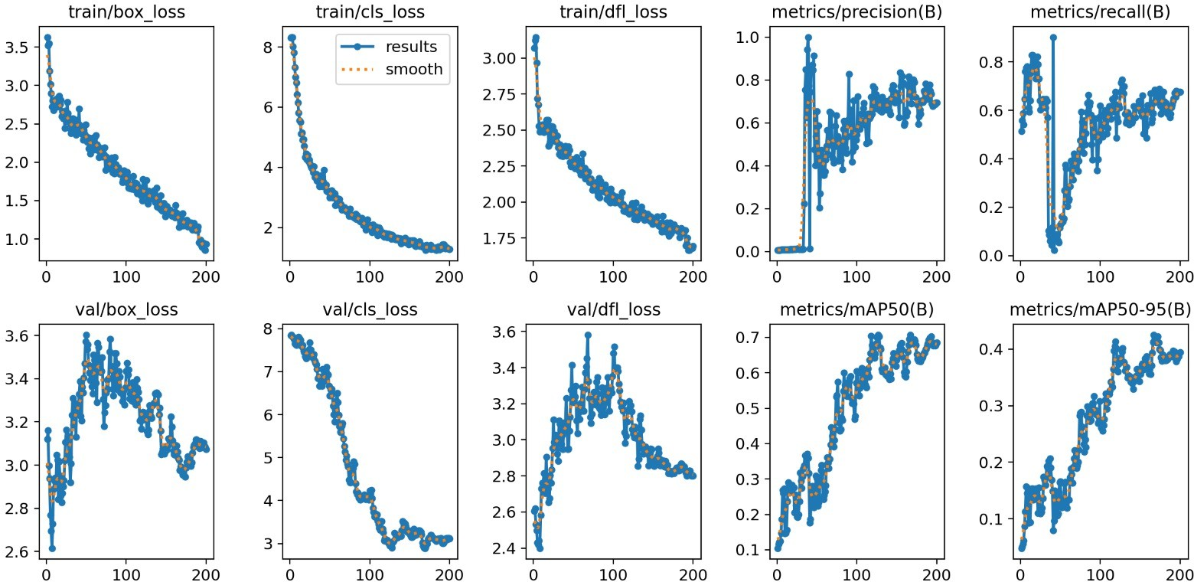

Fig. 6. Training and validation loss curves of the proposed detection model.

- CONCLUSION
This work introduced an integrated AI navigation platform aimed at making indoor movement easier for people with visual impairments. By bringing together camera-based detec- tion, ultrasonic sensors, and compass orientation, the system offers real-time audio cues and reliable obstacle avoidance. The numbers back it up too—the deep learning model gen- eralizes well, with a particular knack for spotting structural elements like doors and furniture, all while keeping a steady balance between accuracy and responsiveness. When stacked up against existing navigation systems, it shows better detec- tion rates and fewer false alarms in structured indoor spaces. The emergency location-sharing feature adds another layer of real-world safety, giving caregivers or emergency respon-
ders the ability to act quickly when things go wrong. User studies with visually impaired participants revealed genuine satisfaction and a sense of usability, confirming that the system holds up for daily navigation needs. That said, while the current setup works well, it’s not without its hurdles—lighting changes can throw it off, and it still leans on physical markers for localization. These challenges point to the need for smarter computer vision techniques that can adapt to different lighting conditions.
Moving forward, the focus will be on breaking free from markers altogether by exploring simultaneous localization and mapping approaches, while also trimming things down for low-power embedded devices to stretch battery life. Ulti- mately, this work is a step toward smarter assistive tools that give visually impaired individuals more freedom and confidence to move through indoor spaces on their own terms.
References
- X. Leong and R. K. Ramasamy, “Obstacle detection and distance estimation for visually impaired people,” IEEE Access, vol. 11, pp. 136609–136629, 2023, https://doi.org/10.1109/ACCESS.2023.3338154.
- A. Shahdib and B. M. Bhuiyan, “An efficient obstacle detection and distance estimation system for visually impaired people using ultrasonic sensors and deep learning,” IEEE Access, vol. 9, pp. 143675–143688, 2021.
- N. Loganathan, K. Lakshmi, N. Chandrasekaran, S. R. Cibisakaravarthi,
R. H. Priyanga, and K. H. Varthini, “Smart stick for blind people,” in Proc. 6th Int. Conf. Adv. Comput. Commun. Syst. (ICACCS), Mar. 2020, pp. 65–67, https://doi.org/10.1109/ICACCS48705.2020.9074374
- A. Anwar and S. Aljahdali, “A smart stick for assisting visually impaired people,” J. Theor. Appl. Inf. Technol., vol. 96, no. 14, 2018.
- R. Dhod, G. Singh, G. Singh, and M. Kaur, “Low cost GPS and GSM based navigational aid for visually impaired people,” Wire less Pers. Commun., vol. 92, no. 4, pp. 1575–1589, Feb. 2017, https://doi.org/10.1007/s11277-016-3622-0.
- S. Srinivasan and M. Rajesh, “Smart walking stick,” in Proc. 3rd Int. Conf. Trends Electron. Informat. (ICOEI), Apr. 2019, pp. 576–579, https://doi.org/10.1109/ICOEI.2019.8862753.
- S. K. Pal, A. Pramanik, J. Maiti, and P. Mitra, “Deep learning in multi object detection and tracking: State of the art,” Appl. Intell., vol. 51, no. 9, pp. 6400–6429, 2021.
- N. Dey, A. Paul, P. Ghosh, C. Mukherjee, R. De, and S. Dey, “Ul- trasonic sensor based smart blind stick,” in Proc. Int. Conf. Current Trends Towards Converging Technol. (ICCTCT), Mar. 2018, pp. 1–4, https://doi.org/10.1109/ICCTCT.2018.8551067.
- R. Khlaikhayai, C. Pavaganun, B. Mangalabruks, and P. Yupa pin, “An intelligent walking stick for elderly and blind safety protection,” Proc. Eng., vol. 8, pp. 313–316, Jan. 2011.
- T. L. Narayani, M. Sivapalanirajan, B. Keerthika, M. Ananthi, and M. Arunarani, “Design of smart cane with integrated cam era module for visually impaired people,” in Proc. Int. Conf. Artif. Intell. Smart Syst. (ICAIS), Mar. 2021.
- A. Ramadhan, “Wearable smart system for visually impaired people,” Sensors, vol. 18, no. 3, p. 843, Mar. 2018.
- T. Kim, C. Ro, and J. Yoon, “Development of smart stick using motion sensing and GPS for elderly users’ safety,” J. Korea Converg. Soc., vol. 7, no. 4, pp. 45–50, Aug. 2016, https://doi.org/10.15207/JKCS.2016.7.4.045.
- T. S. Aravinth, “WiFi and Bluetooth based smart stick for guiding blind people,” in Proc. 3rd Int. Conf. Intell. Sustain. Syst. (ICISS), Dec. 2020,
pp. 317–320, https://doi.org/10.1109/ICISS49785.2020.9316084.
- N. Sahoo, H.-W. Lin, and Y.-H. Chang, “Design and implementation of a walking stick aid for visually challenged people,” Sensors, vol. 19, no. 1, p. 130, Jan. 2019. https://doi.org/10.3390/s19010130.
- R. Moghe, F. C. Lambert, and D. Divan, “Smart stick-on sensors for the smart grid,” IEEE Trans. Smart Grid, vol. 3, no. 1, pp. 241–252, Mar. 2012.

