Spatial Assessment of Water, Sanitation, and Hygiene

Abstract
Access to safe drinking water, improved sanitation, and adequate hygiene facilities is fundamental to human well-being and the achievement of Sustainable Development Goal 6 (SDG 6). Despite substantial policy interventions, significant disparities in Water, Sanitation, and Hygiene (WASH) services persist across regions of India. This study examines the geographical dimensions and spatial disparities of WASH development in West Bengal using district-level data from the National Family Health Survey (NFHS-5, 2019–2021). A Composite WASH Index was constructed using ten indicators related to drinking water, sanitation, hygiene, housing conditions, and household amenities. Principal Component Analysis (PCA) was employed to identify the underlying structure of WASH indicators, while Local Indicators of Spatial Association (LISA) and Moran’s I statistics were used to investigate spatial clustering and autocorrelation.

The findings reveal considerable inter-district variation in WASH development across West Bengal. Kolkata emerged as the highest-performing district (0.89), whereas Purulia recorded the lowest WASH Index value (0.15). PCA extracted three principal components explaining 78.69% of the total variance, with sanitation and hygiene-related variables contributing most significantly to district-level differences. Spatial analysis identified significant High–High clusters in northern West Bengal and Low–Low clusters in the western and south-western districts, indicating geographically concentrated patterns of advantage and deprivation. Moran’s I value (0.12766) suggests weak but positive spatial autocorrelation in WASH development. The study highlights the existence of persistent regional inequalities and underscores the need for geographically targeted interventions under programmes such as the Jal Jeevan Mission and Swachh Bharat Mission. The findings provide valuable insights for policymakers seeking to promote equitable WASH development and accelerate progress towards SDG 6 in West Bengal.

Keywords: Water, Sanitation and Hygiene (WASH), Composite WASH Index, Spatial Disparities, Principal Component Analysis, LISA, SDG 6, West Bengal.

Introduction:-
For human health, societal well-being, and sustainable development, access to safe drinking water, sufficient sanitation, and hygienic facilities—collectively known as Water, Sanitation, and Hygiene (WASH)—is crucial. In addition to improving educational achievements, increasing productivity, and lowering the burden of waterborne illnesses, safe water and sanitation services also play a major role in reducing poverty. Under Sustainable Development Goal (SDG) 6 of the United Nations' 2030 Agenda for Sustainable Development, the international community has included universal access to clean water and sanitation as a priority aim due to its significance.

Significant differences still persist across and within regions, despite significant advancements in the expansion of WASH services in developing nations. Significant differences in access to clean drinking water, better sanitation facilities, and hygiene habits have been brought about by India's fast population expansion, urbanization, socioeconomic disparities, and environmental issues. The Government of India has launched a number of programs, such as the National Rural Drinking Water Programme (NRDWP), Jal Jeevan Mission (JJM), and Swachh Bharat Mission (SBM), to improve WASH infrastructure and guarantee fair access to vital services in order to address these issues.

One of the most populous states in India, West Bengal, offers a distinctive setting for analyzing WASH issues. The state has a wide range of geographical locations, from the coastal Sundarbans in the south to the foothills of the Himalayas in the north, and it shows significant socioeconomic and demographic diversity. The accessibility, quality, and availability of drinking water and sanitation services are all impacted by this variety. Even though there have been notable advancements in recent years, worries about unequal access still exist, especially in rural areas, economically disadvantaged groups, and environmentally vulnerable places.

Previous research has shown that characteristics including income, education, urban/rural residency, social group, and geographic location are strongly linked to discrepancies in WASH services. Malnutrition, diarrheal infections, and other communicable diseases are among the health concerns associated with inadequate sanitation and poor hygiene practices, particularly among children and vulnerable groups. For the purpose of creating focused interventions and attaining inclusive development, it is therefore essential to comprehend the spatial distribution and determinants of WASH facilities.

Against this backdrop, the present study aims to examine the status of drinking water, sanitation, and hygiene facilities in West Bengal and explore the spatial disparities that exist across districts. The study specifically aims to: (i) evaluate district-level access to better sources of drinking water, sanitary facilities, and handwashing facilities; (ii) pinpoint regional disparities and spatial trends in WASH coverage; and (iii) offer policy-relevant insights to promote equitable and sustainable WASH development in the state. It is anticipated that the results will add to the expanding body of research on WASH disparities and help policymakers accomplish the objectives of inclusive and universal access to basic services.

Literature Review:-

People's quality of life can be greatly enhanced by having access to WASH (water, sanitation, and hygiene). Improved WASH services are less accessible to underprivileged and vulnerable populations, especially children under five and teenage girls (Hutton & Chase 2017). According to the UN General Assembly, everyone has a fundamental right to improved water and sanitation. Human health is also negatively impacted by inadequate WASH services Over 2.6 billion people are thought to lack access to proper sanitation, which contributes to an estimated 10% illness burden (Mara et al. 2010).

There are geographical differences between states in India, and there are very few sanitary facilities, particularly in areas like Madhya Pradesh, Bihar, and Assam. Assam, Rajasthan, and Maharashtra are still having difficulty reaching their goals, despite Haryana's notable advancements throughout the years (Agarwal & Saha 2021).WASH poverty is more prevalent in the group of districts in central and eastern India (Ghosh et al. 2022).
Families with low WASH scores are strongly linked to underweight and stunted children in West Bengal (Sabud et al.,2020). According to the results (Ghosh et al., 2021), there was a moderate to very high geographical dependence on all dimensions of WASH poverty in Indian districts. Additionally, the central and eastern Indian states of West Bengal, Bihar, Odisha, Jharkhand, Chhattisgarh, Uttar Pradesh, and Madhya Pradesh were found to have clusters of districts with higher levels of WASH poverty. In West Bengal, India, health outcomes and disparities are influenced by water, sanitation, and hygiene (WASH). Comprehensive analysis of the trends, determinants, and geographical inequalities affecting WASH conditions in the state, highlighting significant regional variations and the complex variables affecting access to WASH services (Trivedy et al., 2024).

Despite having relatively ample access to water, a large majority of households (85.1%) had "good" water ratings, but only 14.6% practice "good" hand hygiene, indicating gaps in hygiene habits despite relatively adequate water access. This disparity highlights how crucial behavioral patterns and infrastructure are to the prevention of disease (Chatterjee et al., 2023). There is a high prevalence of diarrhea in children under five associated with a lack of WASH facilities. The study highlights the impact that poor WASH conditions have on children's health, particularly in underprivileged metropolitan areas (Sarkar et al., 2024). Despite advancements, there are still large gaps in West Bengal's access to clean water and sanitary services (Roy et al., 2022). Poor WASH contributes to malnutrition and health vulnerabilities in rural areas by directly connecting environmental sanitation and hygienic practices to women's and children's nutritional status (Sabud et al.,2020). WASH accessibility is greatly influenced by household affluence, urbanization, literacy, and socioeconomic development. The equitable distribution and behavioral adjustments pertaining to hygiene practices are necessary in addition to improvements in sanitation infrastructure (Trivedy and Khatun, 2024).

Compared to rural settlements, socioeconomically developed urban areas showed noticeably improved service coverage. Urbanization does not, however, always ensure sufficient sanitation infrastructure, as seen by the persistence of problems in drainage and sewerage systems even in many metropolitan areas (Chattopadhyay, 2022). The availability, accessibility, and socio-economic inequalities in Water, Sanitation, and Hygiene (WASH) services across major Indian metropolitan cities. The study found that despite overall improvements in urban WASH infrastructure, substantial disparities persist among households based on income, education, and residential location, highlighting the need for inclusive urban planning and equitable service provision (Saroj et al.,2020).

There are still a number of research gaps despite the expanding body of knowledge on WASH in West Bengal. The majority of research either concentrate on certain districts and rural areas or on individual WASH components. There are very few thorough district-level evaluations that look at drinking water, sanitation, and hygiene indicators all at once. Additionally, only a small number of research have used spatial analytical techniques to find regional trends and disparities within the state. Further analysis utilizing current datasets is also necessary to assess the dynamic changes brought about by recent government programs, such as the Jal Jeevan Mission and Swachh Bharat Mission. In order to close these gaps, the current study uses NFHS-5 (2019–2021) data to provide a thorough evaluation of drinking water, sanitation, and hygiene facilities in West Bengal. The study advances knowledge of regional disparities in WASH services and provides evidence-based insights for sustainable development planning and policy formulation by analyzing district-level disparities and spatial patterns.

Research Question:-

The following research questions have been attempted to be addressed by the study:
1. How do the districts of West Bengal differ in their overall level of Water, Sanitation, and Hygiene (WASH) development as measured through a composite WASH Index?
2. Which districts of West Bengal emerge as the best-performing and lagging regions with respect to access to drinking water, sanitation, and hygiene facilities?
3. How can the identification of spatial clusters and regional disparities in WASH facilities contribute to more targeted policy interventions for achieving Sustainable Development Goal 6 (SDG 6) in West Bengal?

Objectives:-
Objectives of the study are as following,
1. To construct a composite WASH index for ranking districts according to their level of WASH development.
2. To identify the best-performing and lagging districts in terms of drinking water, sanitation, and hygiene (WASH) facilities.
3. To examine the extent and nature of spatial dependence and clustering in WASH facilities using Local Indicators of Spatial Association (LISA) and Moran’s I, in order to highlight regional disparities and draw policy-relevant insights for achieving Sustainable Development Goal 6 (SDG 6).

Data and Methods:-

The nationally representative NFHS-5 data collected between 2019 and 2021 served as the basis for this study. The National Family Health Survey (NFHS), a large multi-round survey conducted by the Government of India's Ministry of Health and Family Welfare (MoHFW), gives estimates of a number of variables at the national, state/union territory (UT), and district levels. The International Institute for Population Sciences in Mumbai has been named the nodal agency for several NFHS rounds.

Table 1 Selected dimension and indicators of WASH index
Sub-components | Indicators | Descriptions
Drinking Water Index | Access to improved drinking water sources | Households (%) accessing improved drinking water sources
Drinking Water Index | Water sources close to HH | Households (%) using drinking water close to HH
Sanitary Index | Drainage Facilities | Households (%) having drainage facilities
Sanitary Index | Improved Sanitation Facilities | Households (%) having improved sanitation facilities
Hygiene Index | Hand washing facilities | Households (%) having hand washing facilities
Hygiene Index | Use soap for hand wash | Households (%) using soap for hand wash
Hygiene Index | Access to electricity | Households (%) having electricity
Hygiene Index | Access to separate kitchen | Households (%) having separate kitchen facilities within HH
Hygiene Index | Improved cooking facilities | Households (%) having improved cooking facilities
Hygiene Index | Suitable for living Residence | The proportion (%) of suitable housing condition of residence to total residence

There are particular data issues when working with the NFHS- datasets for district-level (Sample size N = 23 districts of West Bengal) analysis of WASH index. The two main drawbacks are the possibility of sample bias and non-random missing data, both of which might skew results if improperly handled. These issues are addressed through using correct subsamples, survey weights and using benchmarks from the Census.

Methods:-
Composite Index is calculated after calculating Dimension Index. We used the Dimension Index approach, which is what the UNDP uses to create the human development index, to normalize the indicators in our analysis. The original dataset had values between 0 and 1. Consequently, the following formula is applied to scale equivalency:

$${DI}_{ik}(Dimension Index)= \frac{X_{ik}-Min (X…1_{k})}{Max (X…1_{k})-Min (X…1_{k})}$$
Where:
${DI}_{ik}$ = Dimension Index for the $i^{th}$ unit and $k^{th}$ dimension
$X_{ik}$ = observed value of the $i^{th}$ unit in the $k^{th}$ dimension
$Min (X…1_{k})$ = minimum value of the $k^{th}$ dimension
$Max (X…1_{k})$ = maximum value of the $k^{th}$ dimension

The value of DIik ranges from zero to one, with a number of one indicating that the district in question has the greatest level of authority in relation to the other districts in the state. For a value of 0, the opposite is true.

After calculating DI of each indicator all the indicators wise values have been aggregated for each district to get aggregate score. Later the composite score is divided by the number of indicators (here 10 indicators) to get the index value by using the following formula –
$$C_{i}(Composite Score)= \frac{\sum_{i}^{n}{1 index X_{ik} }}{n}$$
Where:
$C_{i}$ = Composite Score for the $i^{th}$ unit
$X_{ik}$ = index value of the $i^{th}$ unit for the $k^{th}$ indicator
$n$ = total number of indicators
Higher values indicate higher levels of empowerment, while lower values indicate lower levels. The index value goes from 0 to 1.

Ten indicators relating to WASH index were factor analysed using Principal Component Analysis (PCA). Local Moran I and LISA is carried out to analyse spatial autocorrelation.

Results and Discussion:-

Spatial Pattern of WASH Index in West Bengal

The composite WASH Index map (Figure 1) illustrates the spatial distribution of Water, Sanitation, and Hygiene (WASH) development across the districts of West Bengal based on

NFHS-5 (2019–2021) data. The districts have been classified into three categories—Low, Moderate, and High WASH Development—revealing marked regional disparities in access to drinking water, sanitation, and hygiene facilities.

The analysis indicates that high WASH development is concentrated primarily in the northern and central districts of the state. Districts such as Cooch Behar, Uttar Dinajpur, Dakshin Dinajpur, Malda, Murshidabad, Hooghly and Kolkaya fall within the high WASH category. These districts exhibit relatively better performance in terms of access to improved drinking water sources, sanitation facilities, and hygiene amenities. Kolkata, in particular, stands out as one of the best-performing districts, reflecting the positive influence of urbanization, infrastructural development, and improved public service delivery.

The moderate WASH category includes Jalpaiguri, Purba Bardhaman, Nadia, North 24 Parganas, Howrah, and Purba Medinipur. These districts demonstrate intermediate levels of WASH development, indicating substantial progress but also highlighting areas where improvements are still required. The presence of rapidly urbanizing districts such as Howrah and North 24 Parganas in this category suggests that urban growth alone does not necessarily guarantee universal access to WASH facilities.

The low WASH development category is predominantly concentrated in the western and south-western districts, including Purulia, Bankura, Paschim Medinipur, Paschim Bardhaman, Birbhum, South 24 Parganas, and Darjeeling. These districts are characterized by relatively poor access to one or more components of WASH services. In the western districts of Purulia and Bankura, geographical constraints, lower socio-economic development, and rural dominance may contribute to inadequate WASH infrastructure. Similarly, South 24 Parganas faces challenges arising from its deltaic environment and dispersed settlement pattern. Darjeeling's mountainous terrain may also limit the provision of WASH services.

Fig: 1 Spatial Pattern of WASH index
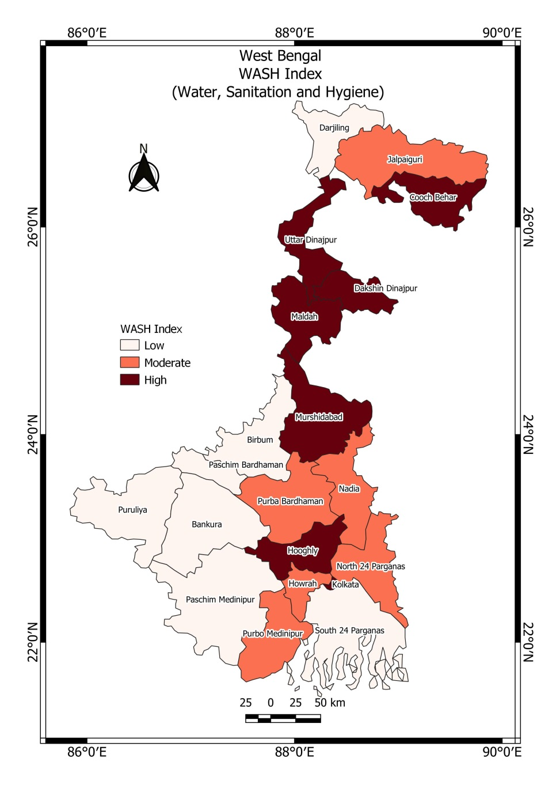
A notable feature of the spatial pattern is the emergence of a north–south and east–west contrast in WASH development. Northern districts generally perform better than many western and southern districts. This pattern suggests that WASH development in West Bengal is not spatially uniform but influenced by geographical, socio-economic, and infrastructural factors.

The map further reveals the existence of regional clustering of WASH development. High-performing districts are spatially contiguous in northern West Bengal, while low-performing districts form clusters in the western plateau region and parts of southern Bengal. Such clustering indicates the likelihood of positive spatial autocorrelation, implying that neighboring districts tend to exhibit similar levels of WASH development. This observation provides a strong rationale for further examination using Local Indicators of Spatial Association (LISA) to identify statistically significant hotspots and cold spots.

Table 2 Ranking of districts as per WASH index
District | Final Index | Rank
Kolkata | 0.89 | 1
North Twenty Four Parganas | 0.80 | 2
Darjiling | 0.75 | 3
Haora | 0.71 | 4
Jalpaiguri | 0.70 | 5
Koch Bihar | 0.69 | 6
South Twenty Four Parganas | 0.64 | 7
Hugli | 0.63 | 8
Paschim Barddhaman | 0.62 | 9
Uttar Dinajpur | 0.62 | 10
Maldah | 0.61 | 11
Nadia | 0.59 | 12
Dakshin Dinajpur | 0.55 | 13
Purba Barddhaman | 0.54 | 14
Paschim Medinipur | 0.49 | 15
Murshidabad | 0.48 | 16
Birbhum | 0.40 | 17
Purba Medinipur | 0.35 | 18
Bankura | 0.34 | 19
Puruliya | 0.15 | 20

The gap between the highest-ranked district (Kolkata: 0.89) and the lowest-ranked district (Purulia: 0.15) is 0.74 index points, highlighting substantial regional disparities in WASH development across West Bengal (Table2). Such differences indicate that progress toward universal access to water, sanitation, and hygiene remains uneven across the state.
From a policy perspective, the findings highlight the need for geographically targeted interventions. Districts categorized as low WASH performers should be prioritized under programmes such as the Jal Jeevan Mission, Swachh Bharat Mission, and other state-level WASH initiatives. Special attention should be given to the western plateau districts, the Sundarbans region, and the hilly areas of Darjeeling, where geographical and infrastructural constraints pose significant challenges. Reducing these spatial disparities is essential for achieving Sustainable Development Goal 6 (SDG 6), which seeks to ensure universal and equitable access to safe drinking water, sanitation, and hygiene services.

Principal Component Analysis (PCA) of WASH Indicators

Principal Component Analysis (PCA) was employed to reduce dimensionality and identify the underlying structure among the selected WASH indicators. Prior to PCA, the suitability of the dataset was assessed using the Kaiser–Meyer–Olkin (KMO) Measure of Sampling Adequacy and Bartlett's Test of Sphericity.

The KMO (Table 3) value was 0.643, indicating a moderate level of sampling adequacy and suggesting that the variables share sufficient common variance for factor extraction. Furthermore, Bartlett's Test of Sphericity was highly significant (χ² = 144.001, df = 45, p < 0.001), confirming that the correlation matrix is not an identity matrix and that PCA is appropriate for the dataset.

Table 3 Data suitability statistics
KMO and Bartlett's Test
Kaiser-Meyer-Olkin Measure of Sampling Adequacy. |  | .643
Bartlett's Test of Sphericity | Approx. Chi-Square | 144.001
Bartlett's Test of Sphericity | df | 45
Bartlett's Test of Sphericity | Sig. | .000

The communalities indicate the proportion of variance in each variable explained by the extracted components. Most variables exhibit high communalities, suggesting that the extracted components adequately represent the original dataset.

Among the indicators (Table 4), Improved Cooking Fuel (ICKF) showed the highest communality (0.974), followed by Drinking Water Facility (DF) (0.965), Soap and Water Availability (SHWA) (0.899), and Household Electricity (HELEC) (0.889). Conversely, Water Source within Household Premises (WSHH) recorded the lowest communality (0.460), indicating that this variable is comparatively less explained by the extracted components. Overall, the communalities demonstrate that the selected indicators contribute substantially to the measurement of WASH development.

Table 4 Proportion of variance in each variable explained
Communalities
 | Initial | Extraction
DW | 1.000 | .765
WSHH | 1.000 | .460
DF | 1.000 | .965
IMPS | 1.000 | .612
HWF | 1.000 | .740
SHWA | 1.000 | .899
HELEC | 1.000 | .889
SPRKIT | 1.000 | .866
ICKF | 1.000 | .974
SUHH | 1.000 | .698
Extraction Method: Principal Component Analysis.

(DW = Improved drinking water, WSHH = Water source close to HH, DF= Drainage facilities, IMPS=Improved sanitation facilities, HWF=Hand washing facilities, SHWA= HH using soap for hand wash, HELEC= HH having electricity, SPRKIT=HH having separate kitchen, ICKF= Improved cooking facilities, SUHH= House suitable for living)

The PCA extracted (Table 5) three principal components with eigenvalues greater than one, satisfying the Kaiser criterion. These three components together explain 78.69% of the total variance, indicating a high level of information retention. Component 1 has an eigenvalue of 4.840 and explains 48.40% of the total variance. Component 2 has an eigenvalue of 1.851 and contributes 18.51% of the variance. Component 3 has an eigenvalue of 1.177 and explains 11.77% of the variance.
Since the first component alone accounts for nearly half of the total variance, it can be regarded as the dominant dimension of WASH development across the districts of West Bengal.

Table 5 Total Variance Explained by Principal Component Analysis
Component | Initial Eigenvalues |  |  | Extraction Sums of Squared Loadings
Component | Total | % of Variance | Cumulative % | Total | % of Variance | Cumulative %
1 | 4.840 | 48.402 | 48.402 | 4.840 | 48.402 | 48.402
2 | 1.851 | 18.514 | 66.916 | 1.851 | 18.514 | 66.916
3 | 1.177 | 11.772 | 78.688 | 1.177 | 11.772 | 78.688
4 | .722 | 7.222 | 85.910
5 | .608 | 6.077 | 91.987
6 | .365 | 3.652 | 95.639
7 | .203 | 2.031 | 97.670
8 | .160 | 1.599 | 99.269
9 | .052 | .517 | 99.786
10 | .021 | .214 | 100.000
Extraction Method: Principal Component Analysis.

The component matrix reveals the contribution of individual indicators to each extracted component.

Component 1 is strongly associated with: Soap and Water Availability (0.948), Suitable Household Housing (0.814), Improved Cooking Fuel (0.789), Handwashing Facility (0.771), Separate Kitchen Facility (0.759) and Household Electricity (0.740)

These high positive loadings suggest that Component 1 primarily reflects the overall level of household infrastructure, sanitation, hygiene, and living conditions.

Component 2 is characterized by Drinking Water Source (0.716), Negative loadings for Improved Sanitation (-0.642) and Drinking Water Facility (-0.557) This component appears to capture variations related to water accessibility and service availability, distinguishing districts based on access to drinking water facilities.

Component 3 shows relatively higher loadings for Drinking Water Facility (0.524), Drinking Water Source (0.477), Household Electricity (0.372) and Improved Cooking Fuel (0.334).

Table 6 Component Matrix
 | Component
 | 1 | 2 | 3
SHWA | .948 | .005 | -.032
SUHH | .814 | .002 | -.187
ICKF | .789 | -.491 | .334
HWF | .771 | .190 | -.332
SPRKIT | .759 | .299 | -.447
HELEC | .740 | .450 | .372
WSHH | .634 | .218 | -.103
DF | .616 | -.557 | .524
DW | .158 | .716 | .477
IMPS | .364 | -.642 | -.260
Extraction Method: Principal Component Analysis.
(DW = Improved drinking water, WSHH = Water source close to HH, DF= Drainage facilities, IMPS=Improved sanitation facilities, HWF=Hand washing facilities, SHWA= HH using soap for hand wash, HELEC= HH having electricity, SPRKIT=HH having separate kitchen, ICKF= Improved cooking facilities, SUHH= House suitable for living)

The PCA results indicate that WASH development in West Bengal is multidimensional, encompassing water access, sanitation facilities, hygiene practices, and broader household infrastructure. The dominance of the first principal component suggests that sanitation and hygiene-related indicators contribute most strongly to inter-district variation. Therefore, the factor scores derived from the extracted components provide a statistically robust basis for constructing a Composite WASH Index and ranking districts according to their level of WASH development.

The high cumulative variance explained (78.69%) confirms that the resulting WASH Index captures the majority of information contained in the original indicators and can be reliably used for subsequent spatial analysis, district ranking, and identification of regional disparities.

Spatial Autocorrelation Analysis of WASH Development: LISA Interpretation

To identify local spatial clusters and regional disparities in WASH development, Local Indicators of Spatial Association (LISA) were employed. The LISA Cluster Map reveals statistically significant local patterns of spatial association among districts, while the LISA Significance Map identifies the confidence levels associated with these clusters.

The LISA Cluster Map indicates the presence of two dominant types of spatial clusters: High–High (HH) and Low–Low (LL) clusters. No High–Low (HL) or Low–High (LH) spatial outliers were observed, suggesting a relatively stable spatial structure in WASH development across the state.

The High–High cluster (Hot Spot in Red colour in Fig 2) comprises four districts located in the northern part of West Bengal. These districts exhibit high WASH index values and are surrounded by neighboring districts with similarly high values. This pattern indicates a positive concentration of WASH development and reflects the existence of a regional hotspot characterized by better access to drinking water, sanitation, and hygiene facilities. The clustering suggests that neighboring districts may benefit from similar socio-economic conditions, infrastructural development, administrative effectiveness, and policy implementation.

Fig 2 LISA Cluster Map Fig 3 LISA Significance Map
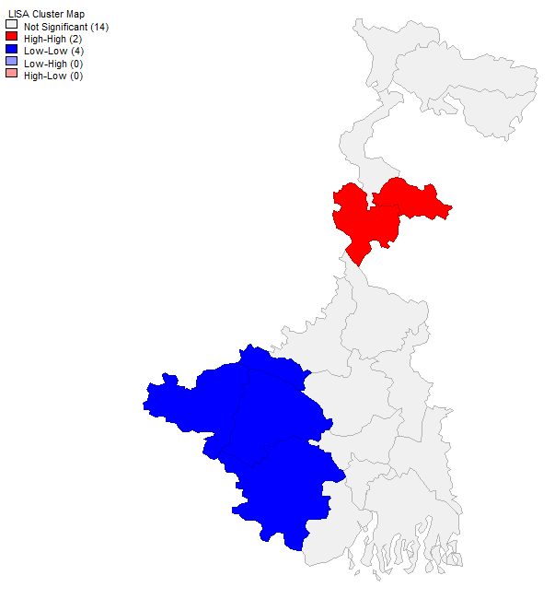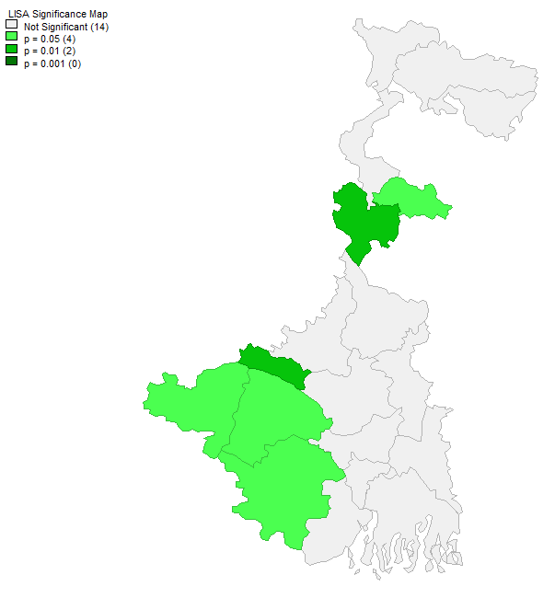
In contrast, the Low–Low cluster (Cold Spot in Blue colour in Fig 2) consists of four districts situated in the western and south-western part of the state. These districts possess low WASH index values and are surrounded by neighboring districts with similarly low levels of WASH development. This spatial concentration highlights a persistent zone of deprivation where inadequate access to water, sanitation, and hygiene facilities remains a significant challenge. The clustering of low-performing districts points toward shared structural constraints such as lower levels of economic development, rural dominance, infrastructural deficiencies, and geographical disadvantages.

The absence of High–Low and Low–High outliers suggests that no district substantially differs from its surrounding neighbors in terms of WASH development. Therefore, WASH disparities in West Bengal appear to be regionally concentrated rather than isolated phenomena. Such a pattern indicates that district-level WASH performance is influenced by broader regional processes rather than individual district characteristics alone.

The accompanying LISA Significance Map (Fig 3) further validates these findings. Significant clusters are observed at both the 95 percent (p < 0.05) and 99 percent (p < 0.01) confidence levels, confirming that the detected spatial patterns are unlikely to have occurred by random chance. The presence of statistically significant hotspots and cold spots provides strong evidence of local spatial dependence in WASH development. A Moran’s I value of 0.12766 indicates a weak, positive spatial autocorrelation. It is greater than 0. It shows similar values tend to cluster near one another in space. However, this clustering tendency is very weak.

These findings suggest that WASH development in West Bengal exhibits a clear spatial structure. High-performing districts tend to cluster together, while low-performing districts also form geographically contiguous groups. Such clustering supports the existence of positive spatial autocorrelation and indicates that neighboring districts often share similar WASH characteristics.

From a policy perspective, the identified Low–Low clusters should be prioritized for intervention under programmes such as the Jal Jeevan Mission and Swachh Bharat Mission. Since these districts form contiguous areas of deprivation, regional planning approaches may be more effective than isolated district-specific interventions. Similarly, the **High–High clusters** can serve as model regions from which successful practices and governance strategies may be replicated elsewhere.

Overall, the LISA analysis demonstrates that WASH inequalities in West Bengal are spatially clustered and regionally differentiated. The identification of statistically significant hotspots and cold spots provides valuable evidence for targeted resource allocation and contributes to achieving Sustainable Development Goal 6 (SDG 6), which aims to ensure universal and equitable access to safe water, sanitation, and hygiene services.

Conclusion:-

This study examined the geographical dimensions of Water, Sanitation, and Hygiene (WASH) development across the districts of West Bengal using NFHS-5 (2019–2021) data. By constructing a Composite WASH Index and applying Principal Component Analysis (PCA) and Local Indicators of Spatial Association (LISA), the study identified significant spatial disparities in access to drinking water, sanitation, and hygiene facilities.

The findings reveal marked inter-district variations in WASH development. While districts such as Kolkata, North 24 Parganas, Darjeeling, and Howrah demonstrate relatively high levels of WASH development, districts such as Purulia, Bankura, Birbhum, and parts of western West Bengal continue to lag behind. The gap between the highest and lowest performing districts highlights the persistence of regional inequalities despite ongoing government initiatives.

The PCA results show that sanitation and hygiene-related variables contribute most strongly to overall WASH development, emphasizing the importance of household infrastructure and living conditions alongside access to drinking water. Spatial analysis further demonstrates the presence of significant clusters of high and low WASH development, confirming that WASH inequalities are geographically concentrated rather than randomly distributed.

The study concludes that achieving universal and equitable access to WASH services in West Bengal requires geographically targeted and region-specific interventions. Special attention should be directed toward the western plateau region, environmentally vulnerable areas, and districts exhibiting low WASH performance. Strengthening sanitation infrastructure, promoting behavioral change related to hygiene practices, and ensuring equitable resource allocation will be essential for reducing disparities and advancing progress toward Sustainable Development Goal 6.

Overall, the study contributes to the growing literature on WASH inequalities by providing a comprehensive district-level assessment of WASH development in West Bengal and offering evidence-based insights for policy formulation and sustainable development planning.

Future Research:-

The present study opens several avenues for future research and policy development. First, future studies may incorporate more recent datasets and longitudinal analyses to assess temporal changes in WASH development and evaluate the effectiveness of flagship programmes such as the Jal Jeevan Mission and Swachh Bharat Mission. Such analyses would help understand whether regional disparities are narrowing over time.

Second, research can be extended to finer spatial scales such as blocks, municipalities, villages, or wards to identify localized pockets of deprivation that may remain concealed at the district level. High-resolution spatial analysis would facilitate more precise targeting of interventions and resource allocation.

Third, future studies may integrate socioeconomic, environmental, and demographic variables—including income, education, gender, caste, urbanization, climate vulnerability, and health outcomes—to examine the determinants of WASH inequalities. Such an approach would provide a more holistic understanding of the factors influencing WASH development.

Fourth, advanced spatial analytical techniques such as Geographically Weighted Regression (GWR), Spatial Regression Models, and Spatial Durbin Models may be employed to explore the spatial determinants and spillover effects of WASH development across districts.

Finally, future policy initiatives should focus not only on infrastructure expansion but also on behavioral change, community participation, climate-resilient water management, and sustainable sanitation practices. Given the increasing challenges posed by climate change, population growth, and environmental degradation, strengthening WASH resilience will be critical for improving public health, reducing inequalities, and achieving Sustainable Development Goal 6 in West Bengal and beyond.

References:-

Agarwal, S., & Saha, S. (2021). Spatial disparities in water, sanitation and hygiene facilities across Indian states. Journal of Social and Economic Development, 23(2), 215–232.
Chatterjee, S., Majumder, D., & Roy, M. N. (2023). Assessing water, sanitation and hygiene (WASH) practices and their association with diarrhoea in under-five children in urban Chandernagore: Community-based evidence from a small municipal corporation in Hooghly district of West Bengal, India. Journal of Water and Health, 21(10), 1468–1480. https://doi.org/10.2166/wh.2023.262
Chattopadhyay, S., 2022. Spatial analysis of access to basic services in urban West Bengal: Disparities and determinants. Journal of Asian and African Studies, 59(5), pp.1516–1538. https://doi.org/10.1177/00219096221141343
Chaudhuri, S., & Roy, M. (2017). Rural–urban spatial inequality in water and sanitation facilities in India: A cross-sectional study from household to national level. Applied Geography, 85, 27–38.
Ghosh, P., Hossain, M., & Alam, A. (2022). Water, sanitation, and hygiene (WASH) poverty in India: A district-level geospatial assessment. Regional Science Policy & Practice, 14(2), 396–417. https://doi.org/10.1111/rsp3.12468
Hutton, G., Chase, C., 2017 Water supply, sanitation, and hygiene. In: Injury Prevention and Environmental Health, 3rd edn. (Mock, C. N.,Nugent, R., Kobusingye, O. & Smith, K. R., eds). The International Bank for Reconstruction and Development/The World Bank Available from: http://www.ncbi.nlm.nih.gov/books/NBK525207/

Kothari, M. T., Coile, A., Huestis, A., Pullum, T., Garrett, D., & Engmann, C. (2019). Exploring associations between water, sanitation, and anemia through 47 nationally representative demographic and health surveys. Annals of the New York Academy of Sciences, 1450(1), 249–267.
Magalhães, R. J. S., Barnett, A. G., & Clements, A. C. A. (2011). Geographical analysis of the role of water supply and sanitation in the risk of helminth infections among children in West Africa. Proceedings of the National Academy of Sciences, 108(50), 20084–20089.
Mara, D., Lane, J., Scott, B. & Trouba, D. 2010 Sanitation and health. PLoS Medicine 7 (11), e1000363. https://doi.org/10.1371/journal.pmed.1000363
Rah, J. H., Cronin, A. A., Badgaiyan, B., Aguayo, V. M., Coates, S., & Ahmed, S. (2015). Household sanitation and personal hygiene practices are associated with child stunting in rural India: A cross-sectional analysis of surveys. BMJ Open, 5(2), e005180. https://doi.org/10.1136/bmjopen-2014-005180
Roy, C., Sati, V., Biswas, A., & Kumar, S. (2023). Status of drinking water, sanitation facilities, and hygiene in West Bengal: Evidence from the National Family Health Survey of India (NFHS), 2019–2021. Journal of Water, Sanitation and Hygiene for Development, 13(2), 145–158. https://doi.org/10.2166/washdev.2023.228
Sabud, P., Ghosh, T., Dhar, A., Dutta, S., Bisai, S., & Maiti Choudhury, S. (2020). Impact of environmental sanitation and hygienic practices on nutritional status of Lodha women and children of West Bengal, India. International Journal of Community Medicine and Public Health, 7(8), 3012–3019.
Sarkar, M., Lahiri, S., Gupta, A., & Mukhopadhyay, P. (2024). Water sanitation and hygiene at households and its implications on diarrhoea among under-five children of slums at field practice area of a peripheral medical college of West Bengal. Journal of Family Medicine and Primary Care, 13(1), 112–118.
Saroj, S. K., Goli, S., Rana, M. J., & Choudhary, B. K. (2020). Availability, accessibility, and inequalities of water, sanitation, and hygiene (WASH) services in Indian metro cities. Sustainable Cities and Society, 54, 101878. https://doi.org/10.1016/j.scs.2019.101878
Trivedy, A., & Khatun, M. (2023). Water, sanitation, and hygiene condition in India: A state-level analysis. In A. Alam, Rukhsana, N. Islam, B. Sarkar, & R. Roy (Eds.), Population, sanitation and health (pp. 275–292). Springer. https://doi.org/10.1007/978-3-031-40128-2_18
Trivedy, A., & Khatun, M. (2024). Water, sanitation, and hygiene (WASH) condition in West Bengal, India: Exploring geospatial inequality, patterns, and determinants. GeoJournal, 89(2), 1–21.

