Exploring Cultural Representation and Appropriation in Raya and the Last Dragon (2021) Animated Film
Nur Hidanah Afiqah Muhamad Rizal¹, Nelysa Nurshafira Mohd Roslan^{2*}
Faculty of Film, Theatre and Animation, Universiti Teknologi MARA Selangor, Malaysia
*Corresponding Author
DOI: https://doi.org/10.47772/IJRISS.2026.10100299
Received: 20 January 2026; Accepted: 25 January 2026; Published: 04 February 2026
ABSTRACT
This study explores the cultural representation and appropriation in the animated film Raya and the Last Dragon (2021), which Walt Disney Animation Studios produced. The film has received praise for its visual richness and criticism for its potential cultural generalisation and appropriation when it draws inspiration from various Southeast Asian cultures. Ultimately, it falls short of delivering an authentic depiction, resulting in criticisms of cultural appropriation and a lack of thoroughness. This research aims to examine how Southeast Asian cultural elements are constructed and whether their portrayal reflects cultural appreciation or appropriation. Therefore, using a qualitative method supported by visual semiotic methods and guided by Stuart Hall's Representation Theory (1997), the study focuses on three key aspects, which are cultural identity, visual representation (including setting, character design, and costume), and symbolic signs. The findings reveal a pattern of standardisation and hybridisation, where multiple Southeast Asian traditions are merged into a fictionalised world, raising concerns about cultural specificity, accuracy, and authenticity. This research contributes to the broader discourse on cultural sensitivity in global media and highlights the importance of respectful, inclusive, and accurate representation to avoid cultural appropriation in animated film. Aligned with Sustainable Development Goal (SDG) 10: Reduced Inequalities, the study underscored the role of media in promoting diversity and intercultural understanding on an international scale.
Keywords: Cultural Representation, Cultural Appropriation, Southeast Asia, Raya and the Last Dragon, Visual Semiotics
INTRODUCTION
Culture is a set of works and symbolic devices that define human activity and its significance. Activities including music, literature, visual arts, architecture, theatre, cinematography, and lifestyle can all be considered forms of culture. The term "culture" in anthropology refers to creating objects, their aesthetic meaning, and social relations associated with these processes. This way, spiritual systems, science, and art are all part of culture. Culture is a specific degree of human creativity and ability, as well as the historical development of society. It manifests itself in many ways in people's lives and pursuits, as well as in the wealth they produce, both tangible and spiritual. The concept of culture explains a specific historical period (ancient culture), a tangible society, its citizens and nation, and particular areas of human activity or life. In a limited sense, the term "culture" refers solely to people's spiritual life. Culture comes from the Arabic word madina (city), where Arabs divide people's lives into two groups: cultured life and Bedouin or desert life. People who live in cities and have their way of life are called culturalists, whereas Bedouins are nomadic people who inhabit the steppes and deserts (Makhmudova, 2022).
The term "cultural representation" refers to how different media portray and communicate cultural identities, values, and narratives to affect how society and individuals view themselves. To create meaning, linking concepts to the real or imagined world, Hall (1997) stated that it needs to include language, signs, and images. The process of creating meaning by connecting ideas to the actual or imagined world through language, signs, and images is known as cultural representation. Facilitating communication and comprehension within a cultural context necessitates the development of correspondences among objects, ideas, and signs (Hall, 2020). Overall, effective cultural representation is crucial for fostering understanding and dialogue in an increasingly globalised society (Wheatley, 2024).
According to Kershnar (2024), cultural appropriation refers to the adoption or use of elements from one culture by individuals or groups from another, often a more dominant culture. Critics argue that such appropriation can disrespect the original culture and echo colonialist dynamics. At the same time, proponents contend that cultural exchange can foster appreciation and innovation, arguing that no culture owns its symbols (Nguyen & Strohl, 2023). Cultural appropriation is also defined as the 'taking of intellectual property, cultural expressions or artefacts, history and ways of knowledge from one culture by another, often without permission or understanding, leading to ethical and legal concerns regarding ownership and respect (Siems, 2019). In short, cultural appropriation raises questions about power, representation, and the dynamics of cultural exchange in a globalised world (Asia, 2022).
Disney's Raya and the Last Dragon is an animated film, released in March 2021. The animated film showcases Southeast Asian cultures through its narratives, character development, and visual symbolism. Raya and the Last Dragon is an animated fantasy story that follows the film's protagonist, Raya, 's quest to bring the land back to health and the people back together. Raya goes through an adventure across five diverse regions in Kumandra, which reflects various cultural identities and mythologies from the region (Yono et al., 2024). The film's main plot builds on a backstory of disaster worsened by betrayal. Once upon a time, Kumandra was a prosperous land where people lived happily and under the protection of a magical dragon who brought rain, prosperity, and peace. However, Kumandra was devastated by a plague called Druun. The dragons sacrificed themselves, concentrating all their power on a single gem that defeated the Druun to save humanity. Only one dragon survived, but she has been missing. In fear, the people divided the chiefdoms, each fighting to possess the gem (Tanoto, 2024). Centuries later, Chief Benja of the Heart Tribe then invites all the other tribes for reunification. Unfortunately, it leads to betrayal when an attempt to steal the gem leads to its breaking, which causes the Druun to be rereleased. Raya then sets out to find the last dragon and to heal the land. After six years of searching, Raya is eventually able to revive the last dragon, Sisu, asleep in a tiny spring at the edge of a desert. They began on a mission to bring the gem's pieces together, which also serves to bring people together. At the last second, distrust between people, especially the distrust of Raya towards Namaari, again leads to disaster, in which Sisu is killed. As a result, the Druun overruns Fang, and all the water drains away. Raya then recalls Sisu's lesson that "the world is broken because you don’t trust anyone” when everything else seems hopeless. Like the dragons of old, she and her friends sacrifice themselves by giving Namaari fragments of the jewel. Upon assembling the gem, Namaari unleashes a magical rainstorm that resurrects the ancient dragons, including Sisu, and uses Kumandra to destroy the Druun (Tanoto, 2024).
Through its rich storytelling and cultural references, Raya and the Last Dragon inspires the creative industries and promotes a deeper understanding of Southeast Asian culture (Yono et al., 2024). However, although this animated film represents the culture of Southeast Asia, it has sparked discussions regarding cultural appropriation. It has been criticised for potentially oversimplifying and commodifying these cultures for a global audience (Panjaitan & Rachman, 2023). Therefore, in this research, the researcher will study the cultural representations and appropriation of the animated film Raya and the Last Dragon (2021).
The issue that will be focused on throughout the research is identifying the elements of culture in Southeast Asia. This research will also analyse the cultural appropriation in the film. While the animated film attempts to showcase a combination of Southeast Asian cultures through visual elements and character design, it ultimately fails to provide an authentic representation, which leads to critiques of cultural appropriation and a lack of thoroughness (Sutanto, 2022).
The absence of Southeast Asian voice actors further worsens the issue, resulting in a disconnection for audiences who may feel a lack of ownership over their cultural portrayal (Saraswati et al., 2021). While Raya and the Last Dragon aims to celebrate Southeast Asian culture, it simultaneously highlights significant cultural missteps and identity politics. Additionally, while studies often focus on the visual and narrative elements of the film, they pay less attention to how Southeast Asian audiences perceive its representation of their cultures. Research on audience reception could provide valuable insights into the film’s impact on cultural identity and its role in shaping global perceptions of Southeast Asia. Additionally, there is limited exploration of how the film’s portrayal influences discussions about cultural preservation and the ethical responsibilities of filmmakers in representing diverse communities.
The cultural representation and appropriation in Raya and the Last Dragon highlight the complexities of adapting real-world traditions for global audiences. Future research should explore audience perspectives and the broader implications of cultural representation in mainstream media. By addressing these issues, scholars and creators can contribute to more detailed and authentic portrayals of diverse cultures in global storytelling.
This study aims to critically analyse the cultural elements of Raya and the Last Dragon (2021), which are influenced by many Southeast Asian traditions. The study specifically seeks to analyse the unique components of Southeast Asian civilisations depicted in the film, encompassing both material culture, including architecture, clothing, and weaponry, and intangible factors, such as values, rituals, and communal customs. In addition to identifying these cultural indicators, the approach examines the representation of Southeast Asian cultures, challenging whether these portrayals reflect authenticity, hybridity, or intentional adaptation for global audiences. Lastly, the study looks at what cultural appropriation in the movie might mean, thinking about how mixing and selling different Southeast Asian cultures might strengthen stereotypes, weaken cultural specificity, or, on the other hand, promote intercultural understanding. The research enhances broader discussions on media representation, cultural identity, and the politics of appropriation within global animation.
This research focuses on the value of understanding how Southeast Asian cultures are represented in global media, primarily through high-profile productions such as Disney's Raya and the Last Dragon (2021). As the media has become the mainstream medium for cultural exchange, the accurate and respectful portrayal of cultures is important, as it could shape public perception, emphasise inclusivity, and avoid risky generalisations. By examining the visual, narrative, and symbolic aspects of the film, this research contributes to the academic discourse surrounding media representation and cultural identity, as being focused on by Hall (2020) and Wheatley (2024). It gives hope on how cultural identities can be both celebrated and distorted when adapted into mainstream media entertainment.
This research also aligns with SDG 10: Reduced Inequalities, by showing how media can either spread unfair ideas about cultures or help people understand and respect each other better. This study highlights how films like Raya and the Last Dragon can affect the way different cultures are seen and treated.
LITERATURE REVIEW
A representation of culture in animated films has become a critical area of research in cultural studies and media analysis, which reaches global audiences. Raya and the Last Dragon (2021), a Disney animated film that was inspired by Southeast Asian cultures, has caused a massive debate about its portrayal of cultural elements. Through its setting and characters, the film aims to capture the diversity and richness of Southeast Asia. However, the film has also faced criticism for cultural appropriation. Therefore, this literature review examines the existing studies on cultural representation and appropriation in the film, focusing on its visualisation of Southeast Asian cultures, the question of authenticity, and the wonder effects towards global media's cultural commercialisation.
Culture in Southeast Asia
Southeast Asia (SEA) is a vibrant and diverse region consisting of 11 countries, which are Vietnam, Laos, Cambodia, Thailand, Malaysia, Singapore, Myanmar, Indonesia, Brunei, the Philippines, and Timor-Leste (Suranto, 2025). SEA is said to be the most densely populated region globally, characterised by diverse climates and ecosystems (Paris & White, 2024). SEA is also a culturally diverse region, which is characterised by historical change and the coexistence of multiple cultures (Mahadevan, 2024).
For example, external influences, such as Spanish and Indian Traditions, have transformed local practices into supplementary luxury foods rather than staples when it comes to the adaptation of milk culture in the Philippines and Indonesia (Hirata & Tsuji, 2024). Additionally, the Arabic literary culture, especially in the 17th and 18th centuries, emphasises the intellectual exchanges between the Middle East and Southeast Asia (Peacock, 2024). The spread of ideas and artistic expressions among many societies has been made possible by the elite's crucial role in cultural circulation through trade, conflict, and religion (Andaya, 2023). Furthermore, a shared cultural legacy that blends regional customs with more general religious influences is shown in the mystical beliefs that are common across countries like Indonesia, Malaysia, and Thailand (Kurniasih & Yuniar, 2023).
Cultural Representation in Animated Film
Cultural representation in animated films encompasses the portrayal of diverse cultural elements through visual storytelling, which can significantly influence audience perceptions and understanding of different societies. Animated films like Disney’s Encanto effectively showcase Colombian culture by integrating authentic elements such as language, food, and traditional practices, thereby communicating cultural messages through visual cues (Ani & Jupriani, 2023). However, the challenge remains in avoiding disrespectful portrayals, as seen in past criticisms of films like Mulan (1998), which struggled with cultural adaptation. Overall, animated films serve as a powerful medium for cultural representation, which is required for a balance between authenticity and audience engagement.
Cultural Appropriation in Animated Film
Cultural appropriation in animated films, with a focus on Disney productions to some degree, is concerned with the problem of global cultural diffusion and its local expressions. The producers create this image, but it sinks into the sociopolitics of the intended audience. In the particular adult market, there is a possibility of cultural discount, which has also been raised regarding Disney's Mulan, which was dealt with earlier in the Chinese case (Chen et al., 2021). Part of these discussions had to do with similar concerns. If the cast of Moana is true, its casting clearly demonstrates a deeper understanding of the need for accurate portrayal. However, part of their narratives still reflects a certain degree of coloniality (Anjirbag, 2018). In any case, it is undeniable that animated movies may become the medium of cultural exchange; however, they can also overlook what culture they are showcasing, which will have dire consequences on how the audience accepts it and how the culture survives (Belkhyr, 2013).
Cultural Representation in Raya and the Last Dragon
The animated film Raya and the Last Dragon is a big part of Southeast Asian culture, mainly because it has a lot of different cultural features from places like Indonesia, Vietnam, and Malaysia. The film's narrative, set in the fictional land of Kumandra, reflects the concept of "Bhinneka Tunggal Ika", which symbolises "unity in diversity", which is visually represented through various artistic elements such as "Wayang kulit" and traditional clothing (Panjaitan & Rachman, 2023). Additionally, the film also promotes female power, which challenges traditional gender roles by applying both strength and vulnerability through the characters, particularly the female protagonists Raya and Namaari (Purwanto & Kurniawan, 2024). Overall, the film is rich with cultural tapestry and complicated character relationships that add to the conversation about how people are portrayed in popular media (Subekti, 2024).
Cultural Appropriation in Raya and the Last Dragon
The animated film Raya and the Last Dragon has sparked discussions regarding cultural appropriation, particularly in its representation of Southeast Asian cultures. While the film is celebrated for showcasing elements from various Southeast Asian nations, including Indonesia, Vietnam, and Malaysia, critics highlight that these representations often lack authenticity and fail to fully encapsulate the rich diversity of the cultures portrayed (Sutanto, 2022). The film uses costumes and sets that are based on Southeast Asian traditions, yet these are often put together in a way that may misinterpret their original meanings. This complicated interaction raises important questions about the balance between showing cultural representation and appropriation in mainstream media (Panjaitan & Rachman, 2023).
Stuart Hall’s Representation Theory (1997)
Stuart Hall's Representation Theory (1997) remains one of the most influential frameworks in cultural and media studies. Hall's central argument is that representation is not merely about reflecting reality, but about actively constructing meaning. In his view, media texts do not simply mirror the world, but they shape and frame how we interpret it. Representation, according to Hall (1997), is the process through which meaning is produced and exchanged between members of a culture via language, symbols, and signs. This theory has been widely used in the media to study identity, race, gender, and culture.
Hall (1997) distinguishes between three approaches to representation, which are the reflective, intentional, and constructionist. The reflective approach suggests that language reflects a meaning that already exists in the world, while the intentional approach argues that the speaker or creator imposes meaning. However, Hall stated that the constructionist approach holds that meaning is constructed through language and cultural codes, and it is within this shared system of signs that meaning is understood. This approach aligns with semiotic theory and post-structuralism, emphasising that signs do not carry inherent meaning but rather gain significance through social and historical contexts.
In the context of animated films such as Raya and the Last Dragon (2021), Hall's Representation Theory offers a critical view to understand how Southeast Asian cultures are constructed and represented for global audiences. The theory helps to reveal how cultural signs like costume, architecture, and mythical symbols are selectively chosen and stylised to serve a narrative that may appeal to Western viewers. It also opens up questions of authenticity, power, and cultural ownership, especially in cases where diverse traditions are merged into a single, homogenised identity.
METHODOLOGY
This study adopts a qualitative research methodology to examine cultural representation and appropriation in Disney’s animated film Raya and the Last Dragon (2021). A qualitative approach is particularly suitable for this research as it allows for a deep exploration of meanings, cultural constructions, and symbolic interpretations where elements are best understood through context rather than measurable data. This method provides the flexibility to critically engage with both textual and visual dimensions of the film, offering a subtle understanding of how Southeast Asian identities are portrayed.
The study primarily applies content analysis and visual semiotic analysis. Content analysis is used to identify themes, production choices, and patterns in character construction that reflect or distort cultural elements. Semiotic analysis, on the other hand, focuses on the interpretation of signs and symbols that are both visual and verbal within the film's narrative structure. These methods are used to analyse how meaning is constructed through costume design, character behavior, architectural aesthetics, mythical symbols, setting, and the use of invented language.
A descriptive and interpretive framework is being used for this research, aiming to analyse the cultural layers applied in character design, visual composition, and thematic storytelling. Special attention is given to the film's aesthetic choices, such as costume, landscape, weaponry, and architecture; this is to evaluate the authenticity of their Southeast Asian inspirations. Through repeated viewings of the film, scenes and dialogue are annotated and categorised to maintain consistency in analysis.
The study is theoretically framed by Stuart Hall’s Representation Theory (1997), which argues that media do not reflect reality directly but instead construct meaning through representational systems such as language and imagery. Hall’s theory supports this study’s goal of understanding how specific cultural representations are encoded in the film and why certain cultural elements are emphasised over others. This framework allows for a critical reading of how Raya and the Last Dragon both represent and reinterpret Southeast Asian cultures for global audiences.
Primary data for this study includes scholarly articles, journal publications, and books that discuss cultural representation, Southeast Asian identity, media theory, and cultural appropriation. The secondary data is the film itself, which serves as the main case study. Additionally, publicly accessible resources such as film reviews, critiques, interviews with filmmakers, and online discussions are incorporated to provide supplementary insights and broader context. To ensure the credibility and reliability of the findings, a systematic process of coding and categorisation is applied. This helps maintain consistency in the interpretation of visual and textual data.
Finally, this study acknowledges its limitations, such as the reliance on a single film and the interpretive nature of qualitative analysis, which may not fully represent the diverse perspectives of Southeast Asian communities. Nevertheless, the research maintains a respectful and balanced approach by being critically reflective and avoiding generalisations or cultural stereotyping.
In short, this research methodology integrates qualitative, visual, and theoretical tools to critically investigate how Raya and the Last Dragon constructs and negotiates cultural identities. By combining content and semiotic analysis with a strong theoretical framework, the study aims to contribute to ongoing discussions on cultural representation, authenticity, and appropriation in global animated media.
The qualitative approach is suitable for analysing visual media, as it allows the researcher to interpret meaning, symbolism, and cultural narratives applied in the film. The study uses visual and thematic analysis to closely examine the film's use of cultural elements such as costume design, character development, architecture, settings, and storytelling. These elements are observed through the lens of semantic theory, particularly drawing on Stuart Hall's (1997) statement that meaning is created through signs, language, and imagery. By applying this theoretical framework, the research identifies how Southeast Asian identities are encoded and communicated to global audiences through symbolic forms.
The animated movie itself serves as the case study. To understand how particular cultural symbols are, such as traditional attire, mythological animals, martial arts, and local landscapes, these cultural symbols are presented and understood, the researcher examines a variety of visual and narrative elements. Semantic theory allows the researcher to go into in-depth observation and take into account how the film's signs and pictures contribute to more comprehensive meanings and social understandings, as culturally relevant messages that are either consistent with or derived from absolute Southeast Asian values, themes like unity, trust, and tradition are examined.
The research heavily relies on primary resources, including academic journals, books, and online scholarly articles. Stuart Hall’s theory of representation provides the central theoretical grounding, helping to decode how media constructs identities and influences perception. Makhmudova (2022) is referenced to define the broader understanding of culture, while Mahadevan (2024), Paris and White (2024), and Suranto (2025) offer detailed context on the diversity and complexity of Southeast Asian societies. These cultural insights help the researcher identify which elements in the film are rooted in authentic practices and which are stylised for cinematic appeal.
Additional support is provided by literature on cultural appropriation, such as works by Nguyen and Strohl (2023) and Kershnar and Bray (2024), which examine the power dynamics and moral dilemmas associated with incorporating aspects of other cultures. These texts are used to determine if the movie engages in problematic appropriation or respectful cultural exchange. To assess the film more precisely, the study includes film-specific analyses like those by Sutanto (2022) and Panjaitan and Rachman (2023), who contend that although Raya and the Last Dragon aims to integrate a variety of cultural elements, it frequently lacks specificity and runs the risk of diluting the distinctive identities of Southeast Asian countries. Saraswati et al. (2021) add to this discourse by highlighting how the casting of non-Southeast Asian voice actors distances the film from the communities it aims to represent. On the other hand, Yono et al. (2024) present a more positive view, discussing how the film has inspired creative growth within Southeast Asia’s animation and media industries.
Through this combination of film analysis, semantic interpretation, and scholarly support, the research provides a deep examination of how Raya and the Last Dragon presents Southeast Asian culture on screen. It also assesses the impact and ethical implications of such portrayals within the context of globalised media. This method also allows for a deeper understanding of the film's cultural messages and contributes to wider conversations about authenticity, representation, and cultural sensitivity in animated storytelling.
In addition to visual and thematic components, the research also considers production-level decisions such as the casting of voice actors and the degree of consultation with Southeast Asian cultural experts. These factors are essential in understanding how accurately and respectfully the film handles cultural representation. The interactions of these elements collectively shape how the audience perceives Southeast Asian culture within the context of the film, and whether that representation leans more toward cultural appreciation or falls into cultural appropriation.

THEORETICAL FRAMEWORK
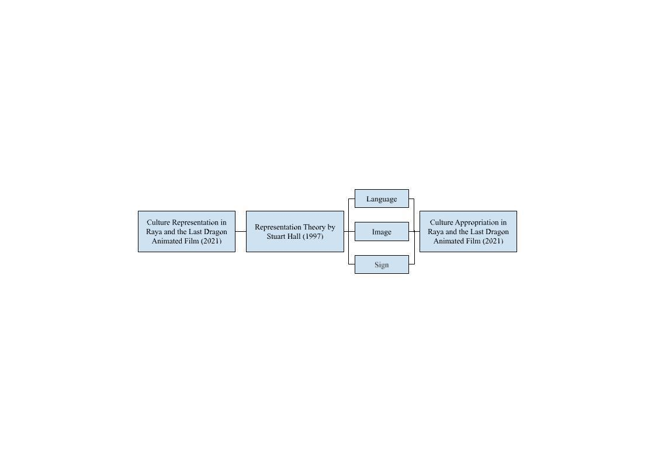
Figure 1. Representation Theory by Stuart Hall
(Source: Stuart Hall, 1997)
The theoretical framework of this study is built around the analysis of how Southeast Asian cultures are represented and possibly appropriated in the animated film Raya and the Last Dragon (2021). At the core of this research is the film itself, which acts as the case study through which cultural symbols, themes, and narratives are carried. The study investigates how Southeast Asian culture is reflected through three major elements in the film: visual design, narrative structure, and production decisions, as shown in Figure 1. These include tangible aspects such as costume design, architecture, and setting, as well as deeper elements like values portrayed through storytelling, character development, and thematic messages such as unity, trust, and cultural identity.
The theoretical framework in Figure 1 linking cultural representation and cultural appropriation in Raya and the Last Dragon (2021) through Stuart Hall's Representation Theory (1997). The framework illustrates how meaning is constructed in media texts through language, images, and signs, which shape both the representation of Southeast Asian cultures and the implications of cultural appropriation. Hall argues that language, images, and signs function as symbolic instruments through which cultural concepts are encoded by creators and subsequently interpreted by audiences. In Raya and the Last Dragon (2021), cultural representation is influenced by visual features such as clothing, landscapes, and architecture, as well as linguistic components like names, accents, and dialogue that reflect Southeast Asian identities. Simultaneously, symbolic signs, such as rituals, artefacts, and legendary creatures, function as indicators of cultural importance, although they may also be selectively reinterpreted or hybridised for global consumption. This study utilises Hall's theory to analyse how representational choices emphasise Southeast Asian cultural characteristics while simultaneously obscuring cultural borders, hence prompting enquiries on authenticity and cultural appropriation. This framework facilitates a critical comprehension of how the film navigates cultural identity, power, and significance in its depiction of Southeast Asia.
RESULTS AND DISCUSSION
This section presents the findings of the study based on a qualitative analysis of Raya and the Last Dragon (2021), interpreted through Stuart Hall's Representation Theory (1997). Hall argues that meaning in media is constructed, where it is not merely reflected through systems of language, image, and Sign. Drawing on both scholarly articles (primary data) and film analysis (secondary data), this chapter discusses how cultural representation and appropriation are manifested in the film. The three most frequently referenced themes are Culture, Visual and Sign, where all three keywords are examined under each representational category to evaluate how Southeast Asian identity is portrayed and whether the representation is authentic or appropriate.
Based on the frequency analysis of keywords extracted from both primary and secondary data, three dominant themes emerged: Culture (12 mentions), Sign (6 mentions), and Visual (5 mentions). Other notable terms, such as Narratives, Language, Character Design, and Image, appeared less frequently but still contributed to the thematic richness. The recurring prominence of Culture, Sign, and Visual suggests that the film's portrayal of Southeast Asian identity heavily relies on visual and semiotic strategies, which align with Hall's framework that meaning is not fixed but constructed through symbolic systems.
Table 1. Language
(Source: Raya and the Last Dragon, 2021)
No | Discussion
1 |   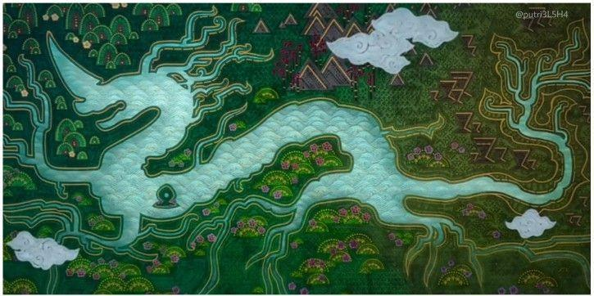 | Culture | The film Raya and the Last Dragon (2021) offers a fictionalised version of Southeast Asia but avoids authentic regional languages such as Bahasa Malaysia, Tagalog, Thai, Khmer, or Vietnamese. Instead, it introduces fabricated terms like “Druun” and “Kumandra,” which, while enhancing its fantasy setting, lack grounding in Southeast Asian linguistic heritage. This absence reduces cultural specificity and risks homogenising the region, raising concerns about representation and cultural appropriation.
2 | 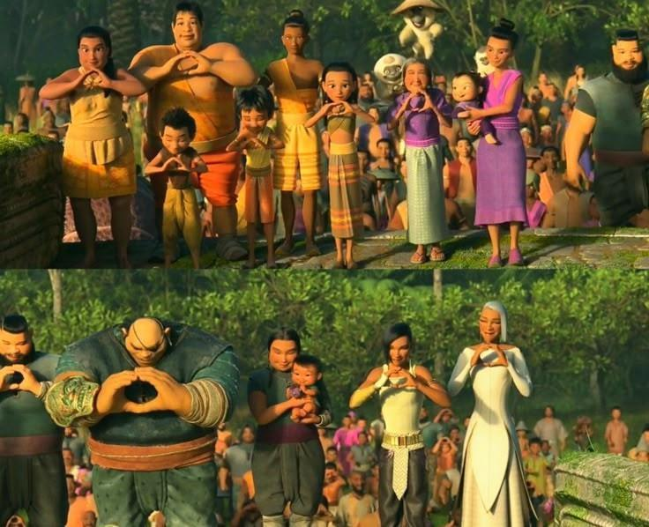 | Sign | The naming of characters, places, and objects, such as “Sisu” or the “Heart” and “Fang” kingdoms, creates signs that suggest cultural allusions but lack ties to any specific community. As Hall explains, these become “floating signifiers,” mimicking authenticity without cultural grounding. Such invented names function as semiotic appropriation, borrowing symbols while stripping them of original significance.
3 | 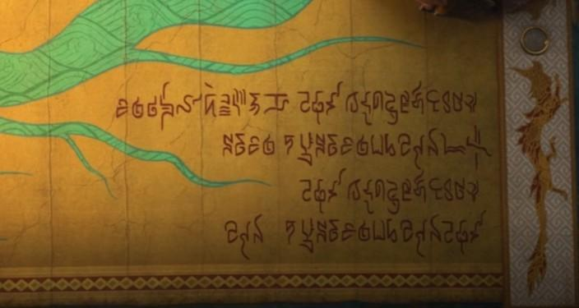 | Visual | In Raya and the Last Dragon, language is presented not only through dialogue but also through visual signs and stylised scripts. The dialogue emphasises universal themes like unity and trust, while fictional glyphs replace real scripts such as Jawi, Baybayin, or Balinese. Though visually similar, these scripts are decorative rather than meaningful, reducing cultural depth and exemplifying visual appropriation in linguistic design.

Table 2. Image
(Source: Raya and the Last Dragon, 2021)
No | Discussion
1 | 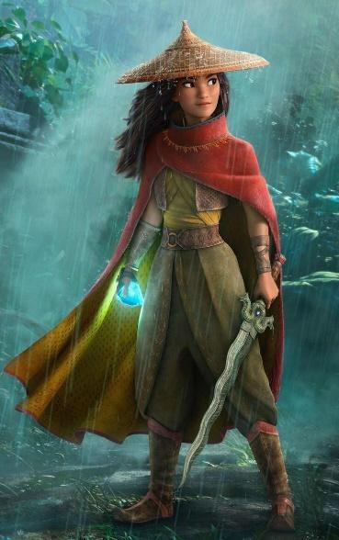 | Culture | Visual signals are central to Raya and the Last Dragon’s depiction of culture, drawing from Southeast Asian attire, cuisine, customs, and scenery. Raya’s outfit, for instance, echoes Indonesian batik, Vietnamese áo dài, and Malaysian baju kurung, yet these influences are merged into a single aesthetic without acknowledgement. While visually appealing, this fusion reduces diverse traditions to a homogenised fantasy, reflecting Hall’s view that compromising authenticity for aesthetics risks turning representation into appropriation.
2 | 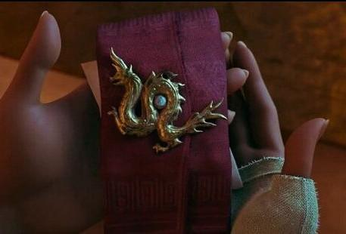 | Sign | Objects like the dragon gem, scrolls, and statues function as signs in Raya and the Last Dragon, yet their cultural associations are vague or fabricated. The dragon, traditionally a Southeast Asian symbol of power, protection, and water, is reimagined as a playful, Western-style creature, stripped of spiritual depth. This simplification of sacred symbols into decorative motifs supports Hall’s view that media constructs meanings that can misrepresent culture.
3 | 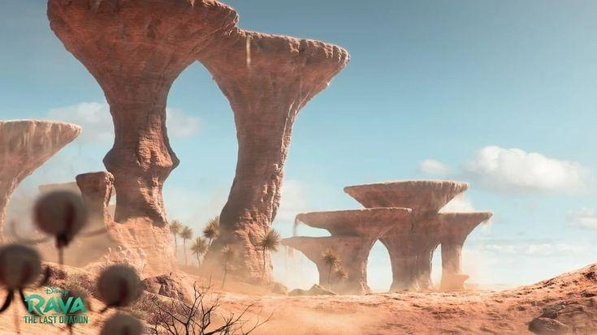 | Visual | Character and setting design in Raya and the Last Dragon draw heavily from Southeast Asian landscapes and architecture, with the five fictional kingdoms inspired by elements such as Cambodia's Angkor Wat, Thai floating markets, and Indonesian or Filipino villages. However, these designs lack a distinct national identity, functioning more as symbolic representations than authentic records. As Hall notes, representation is constructed, not reflected, and the film uses Southeast Asian influences for narrative immersion rather than cultural realism.

Table 3. Sign
(Source: Raya and the Last Dragon, 2021)
No | Discussion
1 |  | Culture | In Raya and the Last Dragon, cultural symbols such as ceremonial gestures, the keris, and traditional architecture appear frequently but without context, reducing them to ornamentation. Raya's keris, for instance, loses its deep Malay-Indonesian ceremonial significance and functions only as an exotic prop. This decontextualisation reflects Hall's critique of representation that risks sliding into cultural appropriation.
2 |  | Sign | Ironically, the film manipulates signs by reassigning meanings to sacred objects and gestures, detaching them from their origins. This transforms culturally specific symbols into fantasy icons, appropriating authentic traditions and undermining cultural integrity, as Hall notes in his critique of how signs are commodified in global media.
3 | 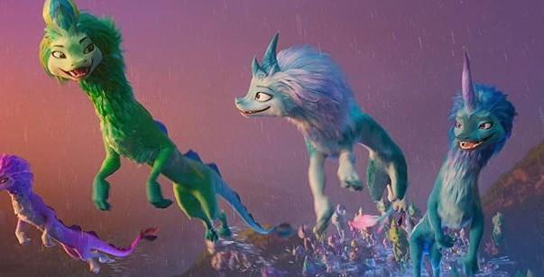 | Visual | In Raya and the Last Dragon (2021), the naga, a sacred water guardian in Southeast Asian belief, is reimagined as Sisu, a pastel-coloured, comical dragon shaped by Western cartoon traits. This transformation strips the naga of its spiritual depth, reducing it to a fantasy figure and exemplifying how decontextualised cultural signs risk appropriation and commodification in global media.

CONCLUSION
This study examined the cultural representation and appropriation in Raya and the Last Dragon (2021) by using Stuart Hall’s Representation Theory (1997). The findings and discussion show that the film leans more towards cultural appropriation because of its hybridised portrayal of Southeast Asian elements without any specific cultural attribution. Although there is the aesthetics of the visual, the mix of diverse traditions into a single fictional culture (Kumandra) results in cultural ambiguity, which some Southeast Asian viewers criticise as general and appropriative. The study also highlights the importance of cultural specificity and authenticity in global media, especially when portraying underrepresented regions such as SEA. Although the film promotes values like unity and trust, the absence of real Southeast Asian languages, creators, and distinct cultural grounding limits its potential for authentic representation. Limitations include the focus on a single film and the lack of audience reception analysis. Future studies should also look into how the industry handles cultural consultation and how consumers in Southeast Asia understand these kinds of representations so that no appropriation will occur. In short, Raya and the Last brings Southeast Asian art and culture to a global audience. However, it also shows how important it is for foreign media to research and tell more truthful, courteous, and inclusive stories about different cultures.
ACKNOWLEDGMENT
We want to extend our heartfelt gratitude to the Faculty of Film, Theatre and Animation, Universiti Teknologi MARA (UiTM), for their invaluable support, expert guidance, and generous permission to utilise the faculty's facilities throughout our research titled "Exploring Cultural Representation and Appropriation in Raya and the Last Dragon (2021) Animated Film”. Their continuous encouragement and assistance played a crucial role in shaping the direction and execution of this study. Our sincere appreciation also goes to the Office of Research and Innovation, FiTA, for endorsing and approving this research for academic publication. Their trust in the potential of our work has been instrumental in advancing our scholarly contributions to the field of game narrative and cultural studies. Finally, we would like to acknowledge and thank all individuals, academics, collaborators, game developers, and respondents who have directly or indirectly contributed to the successful completion of this research.
REFERENCES
- Andaya, L. Y. (2023). The Role of the Elite in the Circulation of Culture in Southeast Asia. Performing Arts and the Royal Courts of Southeast Asia, Volume One, 54–76. https://doi.org/10.1163/9789004686533_004
- Ani, P., & None Jupriani Jupriani. (2023). Representasi Visual Budaya Kolombia Pada Film Animasi “Encanto.” SENIMAN Jurnal Publikasi Desain Komunikasi Visual, 1(2), 197–208. https://doi.org/10.59581/seniman-widyakarya.v1i2.1099
- Anjirbag, M. (2018). Mulan and Moana: Embedded Coloniality and the Search for Authenticity in Disney Animated Film. Social Sciences, 7(11), 230. https://doi.org/10.3390/socsci7110230
- Asia, D. (2022). Culture and Cultural Appropriation. Academic Questions, 35(4), 75–78. https://doi.org/10.51845/35.4.11
- Belkhyr, S. (2013). Disney animation: Global diffusion and local appropriation of culture. Études caribéennes, (22).
- Chen, R., Chen, Z., & Yang, Y. (2021). The Creation and Operation Strategy of Disney’s Mulan: Cultural Appropriation and Cultural Discount. Sustainability, 13(5), 2751. https://doi.org/10.3390/su13052751
- Hall, S. (1997). The spectacle of the other. Representation: Cultural representations and signifying practices, 7, 223-290.
- Hirata, M., & Tsuji, T. (2024). Milk Culture in Insular Southeast Asia Recognised as a Non-milk Cultural Sphere. Southeastern Philippines Journal of Research and Development, 29(2), 1–14. https://doi.org/10.53899/spjrd.v29i2.357
- Kershnar, S., & Bray, N. (2024). In Defense of Cultural Appropriation. Public Affairs Quarterly, 38(4), 265–292. https://doi.org/10.5406/21520542.38.4.01
- Kurniasih, D., & Krismonita, F. Y. (2023). The fireball ghosts, in three major countries of Southeast Asia culture. SHAHIH: Journal of Islamicate Multidisciplinary, 8(1), 26–33. https://doi.org/10.22515/shahih.v8i1.5971
- Makhmudova, A. A. (2022). Culture Is a Certain Level of Historical Development of Society, Human Creative Power and Abilities. European International Journal of Multidisciplinary Research and Management Studies, 02(09), 99–105. https://doi.org/10.55640/eijmrms-02-09-23
- Mahadevan, J. (2024). Southeast Asia: a kaleidoscope of cultural diversity. In Global Leadership Practices (pp. 230-249). Edward Elgar Publishing.
- Nguyen, C. T., & Strohl, M. (2023). Cultural Appropriation.
- Panjaitan, A., & Rachman, A. (2023). Representasi Artistik Kebudayaan Indonesia dalam Film Animasi" Raya and the Last Dragon". Rekam, 19(2), 153-161.
- Paris, D. H., & White, N. J. (2024). Southeast Asia. Routledge Handbook of Infectious Diseases, 196–212.https://doi.org/10.4324/9781003531425-16
- Peacock, A. C. S. (2023). Arabic Literary Culture in Southeast Asia in the Seventeenth and Eighteenth Centuries. https://doi.org/10.1163/9789004548794
- Purwanto, A. M., & Kurniawan, M. H. (2024). Namaari Power in Raya and the Last Dragon Movie: Multimodal Discourse Analysis. Language Literacy: Journal of Linguistics, Literature, and Language Teaching, 8(1), 211-221.
- Saraswati, A., Widhiyanti, K., & Galuh Fatmawati, N. (2021). Desain karakter film animasi Raya and the Last Dragon dalam membangun politik identitas Asia Tenggara. Satwika: KajianIlmuBudaya Dan Perubahan Sosial, 5(2), 254–267. https://doi.org/10.22219/satwika.v5i2.17587
- Subekti, A. S. (2024). I’m not, like, the best dragon, ya know?: A deconstructionist reading of Disney’s Raya and the Last Dragon. Jurnal ProTVF, 8(1), 36-51.
- Suranto, B., Kovač, N., Haryono, K., Abdul Rahman, S. F., Mohd Shukri, A. F., Suder, M., ... & Žugić, D. (2025). State of digitalisation in the Southeast Asia region–bibliometric analysis. Quality & Quantity, 1-28.
- Sutanto, S. M. (2022). Southeast Asian Visual Culture in The Animated Film “Raya and the Last Dragon.” Lekesan: Interdisciplinary Journal of Asia Pacific Arts, 5(2), 82–92. https://doi.org/10.31091/lekesan.v5i2.2089
- Tanoto, R. (2024). The Analysis of Raya’s Trust in The Movie “Raya and the Last Dragon “Using The Pilar of Trust” By Don Hall & Carlos Lopez Estrada (Doctoral dissertation, KODEUNIVERSITAS041060# UniversitasBuddhiDharma).
- Wheatley, M. (2024). Media Representation and Cultural Identity. Premier Journal of Social Science, 2024. https://doi.org/10.70389/pjss.100004
- Yono, S., Yohanes Adhi Satiyoko, Kustri Sumiyardana, Wibowo, K., & Tirto Suwondo. (2024). “Raya and the Last Dragon” Animation Film: A Source of Inspiration for the Development of Indonesia’s Culture-Based Creative Industry. Widyaparwa, 52(1), 165–177. https://doi.org/10.26499/wdprw.v52i1.1667

