CRIMINAL IDENTIFICATION AND PATROLLING SYSTEM: A REVIEW

Abstract
This research introduces a cutting-edge facial detection and recognition system intended to help law enforcement effectively identify offenders. The system makes use of the Local Binary Pattern Histogram (LBPH) method for precise face recognition and the Haar-cascade classifier for facial feature identification. To guarantee accuracy and dependability, it uses specially created datasets and runs in real time. Through the smtplib library, the system instantly notifies authorities via email when a suspect's face is recognized, facilitating prompt action. Large amounts of facial data are supported by its scalable database while accuracy and speed are maintained. The system is a flexible and effective way to enhance security and public safety because it can be modified for uses like access control and attendance tracking in addition to criminal identification.
Keywords - Criminal identification, real-time processing, scalable databases, email notifications, LBPH algorithms, Haar-cascade classifiers, face detection, and law enforcement.

Introduction
Security and monitoring are becoming crucial components of public safety in the modern world. Conventional criminal identification techniques, which frequently rely on witness testimony and manual inspection, are laborious and prone to mistakes. Automated face identification and recognition systems have become revolutionary tools for rapidly and correctly identifying suspects as a result of advancements in computer vision and artificial intelligence. These systems help police departments and investigative agencies improve operational efficiency and response times by analyzing large amounts of visual data in real time.
By offering a real-time, automated solution, the Face Detection and Recognition for Criminal Identification System seeks to solve the inefficiencies of manual identification techniques. By utilizing unique image datasets gathered straight from law enforcement sources, the approach reduces reliance on potentially unreliable publically accessible photographs. To guarantee robustness against changing lighting conditions, angles, and face expressions, methods including grayscale conversion, Haar-cascade detection, and LBPH recognition are used. The system can handle massive amounts of image data while still operating at excellent performance thanks to the integration of scalable databases.
Beyond identifying suspects, this technology exhibits adaptability in a variety of industries. For instance, it can help find missing people, improve access management in limited areas, and automate attendance in educational institutions. Through the use of regulated access and secure data storage, the initiative also tackles ethical and privacy issues. Systems like these open the door to safer societies and more responsible law enforcement as artificial intelligence develops.
Methodology
The proposed system follows a structured methodology to ensure accurate and real-time criminal identification using face recognition techniques. The complete workflow is divided into multiple stages:

1. Data Collection
- Facial image datasets are collected from authorized sources such as police records.
- Each individual image is assigned a unique ID for identification.
- Dataset includes variations in:
  - Lighting conditions
  - Facial expressions
  - Angles and poses

2. Data Preprocessing
- Input images are converted into grayscale to reduce computational complexity.
- Noise removal and normalization techniques are applied.
- Images are resized to a uniform dimension for consistency.

3. Face Detection
- The system uses Haar-Cascade Classifier to detect faces from input images or live video.
- It identifies facial regions by detecting features like:
  - Eyes
  - Nose
  - Mouth
- Only the detected face portion is extracted for further processing.

4. Feature Extraction
- Extracted face regions are processed to identify important facial patterns.
- The system uses texture-based feature extraction for better accuracy.

5. Face Recognition (Core Module)
- LBPH (Local Binary Pattern Histogram) Algorithm is applied:
  - Converts face image into binary patterns.
  - Generates histograms representing facial features.
- The system compares extracted features with stored dataset images.
- Matching is performed based on similarity score.

6. Model Training
- The dataset is trained using LBPH algorithm.
- The trained model is stored and updated regularly.
- Training improves accuracy for real-time recognition.

7. Real-Time Detection
- Live video stream is captured using a camera.
- Faces detected in real-time are matched with trained data.
- If a match is found → person is identified instantly.

8. Alert & Notification System
- When a criminal is detected:
  - System triggers an automatic email alert.
  - Uses SMTP protocol to send notifications.
- Authorities receive:
  - Detected person image
  - Time and location details

9. Database Management
- Stores:
  - Facial images
  - User IDs
  - Recognition logs
- Designed to be scalable for large datasets.
- Ensures fast retrieval and secure storage.

10. User Interface (GUI)
- Developed using Python Tkinter.
- Provides features:
  - Add new criminal data
  - Train dataset
  - Start/Stop detection
  - View results

11. System Evaluation
- Performance is evaluated based on:
  - Accuracy
  - Detection speed
  - False recognition rate
- System is tested under different real-world conditions.
WorkFlow
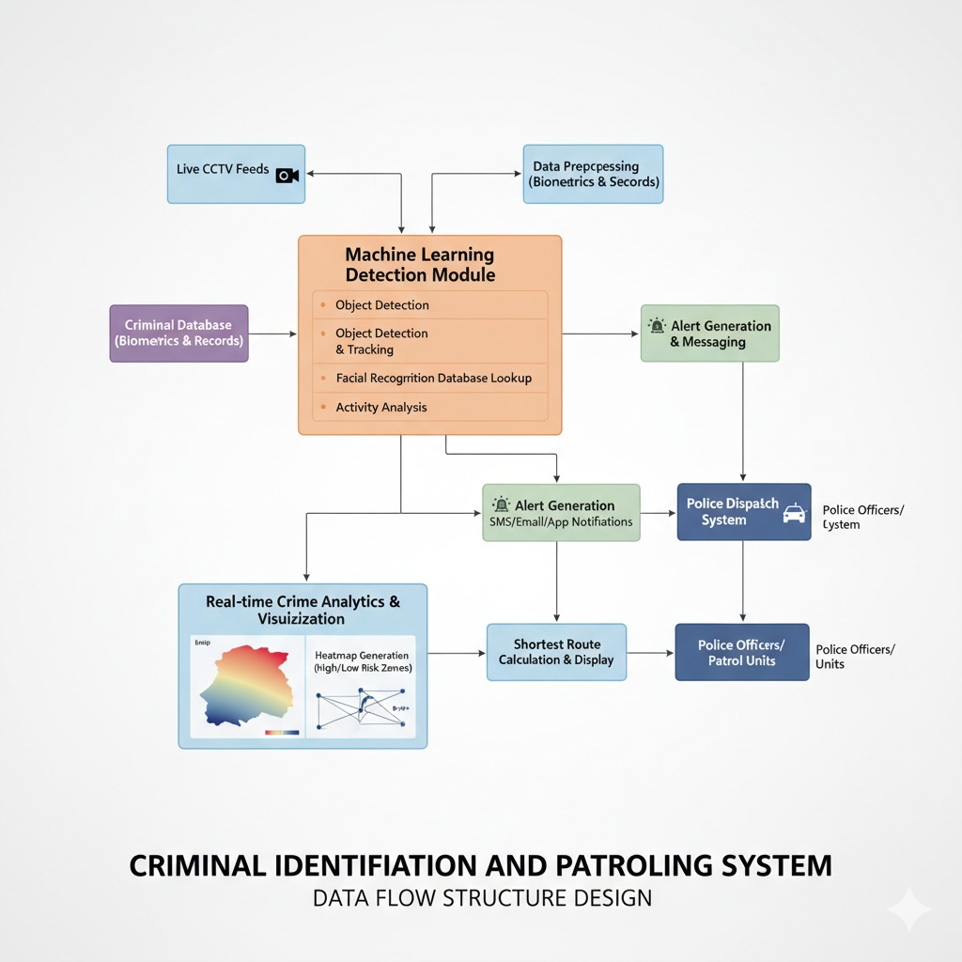
Result

A. Experimental Setup
The experimental setup for the criminal identification system was designed to evaluate real-time face detection and recognition performance. The system was implemented using Python with libraries such as OpenCV for image processing and Tkinter for the graphical user interface.
- Hardware Requirements:
  - System with minimum 8GB RAM
  - Webcam for live video capture
  - Processor: Intel i5 or above
- Software Requirements:
  - Python (3.x)
  - OpenCV library
  - NumPy and PIL libraries
  - SMTP library for email alerts
- Dataset:
  - Custom dataset containing facial images of individuals
  - Each image labeled with a unique ID
  - Dataset includes multiple variations (lighting, angle, expressions)
- Algorithms Used:
  - Haar-Cascade for face detection
  - LBPH (Local Binary Pattern Histogram) for face recognition
The system was tested using both stored images and real-time webcam input to simulate real-world conditions.

B. Performance Evaluation
The performance of the system was evaluated based on multiple parameters:
- Accuracy:
The system achieved high recognition accuracy when trained with sufficient dataset images. It successfully identified known individuals with minimal errors.
- Detection Speed:
Real-time face detection was performed efficiently with low latency, enabling quick identification.
- False Acceptance Rate (FAR):
The system showed low false positives, meaning unknown individuals were rarely misidentified as criminals.
- False Rejection Rate (FRR):
In some cases (poor lighting or occlusion), the system failed to recognize known faces, but this was minimal.
- Scalability:
The system handled increasing dataset size without significant performance degradation.

C. Explanation & Analysis
The results demonstrate that the integration of Haar-Cascade and LBPH algorithms provides an effective solution for real-time criminal identification.
- The Haar-Cascade classifier efficiently detects faces even in dynamic environments.
- The LBPH algorithm performs well under varying lighting conditions and is computationally efficient.
- The system shows strong performance in controlled environments and acceptable performance in real-world scenarios.
However, some limitations were observed:
- Reduced accuracy in low-light conditions
- Difficulty in recognizing partially covered faces
- Dependence on dataset quality
Overall, the system proves to be a reliable and efficient tool for law enforcement, significantly reducing manual effort and improving response time through automated detection and alert mechanisms.
Discussion
The Criminal Identification and Patrolling System effectively demonstrates how computer vision techniques can be used for real-time surveillance and identification. The combination of Haar-Cascade for face detection and LBPH for face recognition provides a reliable and computationally efficient solution. The system performs well in controlled environments, accurately detecting and recognizing faces with minimal delay, making it suitable for practical law enforcement applications.
The integration of real-time processing and automated email notification enhances the overall efficiency of the system. It allows authorities to receive immediate alerts when a suspect is identified, thereby reducing response time and improving decision-making. The user-friendly interface and scalable database further contribute to the system’s usability and adaptability in handling large volumes of data.
However, the system faces certain limitations such as reduced accuracy in low-light conditions, difficulty in detecting partially covered faces, and dependency on dataset quality. Despite these challenges, the system provides a strong foundation for future improvements, such as integrating deep learning models to enhance accuracy and robustness, making it a promising solution for advanced security and surveillance systems.
Conclusion
An important development in surveillance and law enforcement technology is the Face Detection and Recognition for Criminal Identification System. It effectively integrates an automatic email notification system for real-time warnings and combines the Haar-cascade and LBPH algorithms for quick, precise face recognition. In addition to serving the needs of law enforcement, the technology also finds application in areas like access control and institutional attendance. This system exemplifies how AI-driven surveillance may improve safety, operational effectiveness, and trust in public security infrastructure by prioritizing data protection, ethical use, and scalability.

Future Scope
- Integration of deep learning models like CNN for better accuracy
- Improvement in performance under low light and face covering conditions
- Use of larger and more diverse datasets
- Implementation of cloud storage for better scalability
- Integration with IoT-based surveillance systems
- Development of mobile application for real-time alerts
- Addition of multi-biometric authentication such as fingerprint and iris
- Enhancement of real-time processing speed
- Deployment in smart city security systems
- Use for missing person identification
References
- Rue Marconi 19, CH- 1920, Martigny, Switzerland,” Cross Modal Focal Loss for RGBD Face Anti-Spoofing”, published year-1 march 2021.
- Mathilde Caron12 Julien Mairal2 Hugo Touvron13 Ishan Misra1 Piotr Bojanowski1 Herv´e Jegou1 Armand Joulin1,” Emerging Properties in Self-Supervised Vision Transformers”, published year-24 may 2021.
- Anukul Muley1, Akash Bendre2, Priti Maheshwari3, Shanmukh Kumbhar4, Prof.Bhagyashree Dhakulkar5,” Anti-Spoofing Based Secured Transaction Using Facial Recognition And 2FA”,published year -5 may 2022.
- Jianyu Xiao 1, Wei Wang 2, Lei Zhang 1 and Huanhua Liu,” AMobileFaceNet-Based Face Anti-Spoofing Algorithm for Low-Quality Images”, published year – 9 july 2024.
- RaghavendraMudgalgundurao1,2 | PatrickSchuch1,2KiranRaja2,RaghavendraRamachandra2,NaserDamer3,”pixel-wise supervision for presentation attack detection on identity document cards”,published year – 14 july 2022.
- Akshay Kumar1, Pooja Joshi2, Anju Bala3, PravinkumarSudhakar Patil4, Dilip Kumar Jang Bahadur Saini5 and Kapil Joshi6,”published year – 2/13/2023.
- Siddhika Pokharkar1, Bhagyashri Bhalerao2, Pratiksha Dolas3, Dr.Anand Khatri4,” A Real Time Face Detection & Security System for ATM Machine., published year – 5 may 2025.
- Ashlin Furtado1*, Rehan Sayed1*, Arvin Nooli1*, Sriram Radhakrishna1, Rishabh Oruganti2, N. Venugopal3,” Real-Time ATM Booth Suspicious Behavior Monitoring System”, published year – 12 Dec 2021.

