Branding and Digital Marketing Strategies for Inbound Tourism in Sri Lanka: A Strategic Framework for a First of its kind Travel Planning Platform

S. Mark Robinson¹, D.G.C.P. Nawarathne¹
¹ Department of Computing, Esoft Uni, Kandy, Sri Lanka.

ABSTRACT
Sri Lanka’s tourism is getting back on its feet after the COVID-19 lockdown period. Recent times have seen a surge in the number of Tourists, especially from Spain, visiting Sri Lanka. This situation presents an opportunity to offer custom tourism services tailored to Spanish-speaking travelers. This paper aims to create a culturally relevant brand identity for a first-of-its-kind digital platform in Sri Lanka, designed to connect Spanish-speaking tourists with local Spanish-speaking tour guides, facilitating culturally informed, personalized, and seamless travel experiences. In addition, it proposes a structured three-month integrated digital and print marketing strategy to generate initial brand awareness and market penetration. This paper follows a 3-step research plan that includes pre-production, production, production and post-production. Pre-production starts with in-depth research on subjects such as tourism marketing, past efforts of Sri Lanka to promote tourism, target market and audiences, forming the foundation for brand positioning and visual identity development. Photography and Video production support the digital media creation process in the production phase. At the end of post-production, outcomes of this research include a digital photo album of Sri Lanka, along with social media posts, reels, videos, ads, banners, and brochures targeting both tourists and tour guides. This research concludes with a clear brand identity and guidelines to be followed in all future creations, along with content for a 3-month social media marketing campaign that will start getting new users for the platform from day one. This study educates any new tourism-related brand about the importance of culturally resonant branding and marketing that will help both the brand and the destination it promotes to flourish.

Keywords: Destination Branding, Travel & Tourism, Tourism Marketing, Digital & Print Marketing, Travel Experiences

INTRODUCTION
This project is about creating a high-value brand identity for “Vamos Lanka” and researching, planning, and producing content for a strategic 3-month social media marketing campaign that will create awareness for Vamos Lanka and enlarge its user base. As a brand targeting tourists and local tour guides, the brand should resonate with the culture, heritage, and specialty of Sri Lanka and its people while being relatable and exciting to the Spanish Tourists who will be using it. The goal of this branding and social media marketing campaign is to earn space in the minds of our target audience and become their preferred option for doing travel planning in Sri Lanka (Hubspot, 2019).

The motivation for this branding effort is the significant growth of Sri Lanka’s tourism. The number of foreign tourist arrivals in Sri Lanka climbed by 17.3% year-on-year to 174,608 in April 2025, accelerating from a 9.62% growth in the previous month (SLTDA, 2025). With this, the number of tourists from Spain has also increased to the point that the travel agencies are finding it difficult to recruit Spanish tour guides for the tours they arrange. Moreover, initiatives such as the familiarization tour for 14 elite Spanish travel agents in October 2024 highlight efforts to attract Spanish-speaking visitors to Sri Lanka (Sunday Times, 2024). Though Sri Lanka is a very tourist-friendly country, Tourists do encounter problems from time to time, such as safety concerns, harassment, and limited entertainment options, which can detract from the overall travel experience. Infrastructure issues, including inadequate roads and unreliable public transport, further impact tourist satisfaction (RSIS, 2024). Due to this, tourists are searching for safe and secure ways to spend their vacations travelling. Similarly, tour guides also find it difficult to get jobs during off off-season. So, introducing a useful platform to both these sectors is a very good way to inspire travelers to choose Sri Lanka as their destination.

The visual brand identity will be a unique mix of the logo, a colour palette, typography, and special elements. The logo will represent both Sri Lanka and Spain, where the primary and secondary target audiences of Vamos Lanka are. It will be an icon of the brand and also the tourism industry in Sri Lanka, among countless other companies. The same goes for the colour palette, typography, and other branding elements. Key messages and the brand’s voice will be modelled after thorough research of the target market and audience. This will be vital to create an effective social media marketing campaign that gives the right message to the right audience.
As the next step, after referring to all the research data available, a user journey will be created and optimized for both the primary and secondary audiences. With this, a 3-month content plan will be developed that includes static posts, advertisements, reels, animations and videos. All this content will follow a particular brand guideline, creating a unique place for Vamos Lanka on the social platform. Based on the specific target audience of the content, it will either be in Spanish or English. During the production process, a collection of photographs will be taken to create a digital photo album consisting of beautiful locations of Sri Lanka which have not yet been seen by tourist eyes. This will be an eye-opener for a lot of the tourists by giving a glimpse of what Sri Lanka has to offer. All of this will create immediate awareness of the brand among the target audience from the get-go and is expected to yield a net positive outcome within a short span of time.

LITERATURE REVIEW

Importance of Branding for New Companies
Research and Academic studies state that the importance of branding and visual design is critical for new companies. It’s important for startups to build trust and stand out. For example, Bresciani and Eppler (2010) find that “branding is a crucial activity for the successful establishment of a new company,” aiding customer acquisition and retention. Likewise, Jahan et al. (2024) emphasize the “paramount significance of branding” in business, noting it “plays a pivotal role in shaping consumer perceptions, influencing purchasing decisions, and fostering brand loyalty”. In simple terms, a good logo and visual identity help brands to stand out in a crowded marketplace. Nasir et al. (2023) report that effective branding through graphic design helps brands “stand out in a crowded market, establish an emotional connection with customers, and increase brand recognition and loyalty over time”. It’s clear that a strong brand identity, from logos and colour schemes to font and messaging, builds trust and familiarity, which will become helpful, especially for new companies.

Key takeaways are that a strong visual identity differentiates a new brand and showcases its values. Consistency across different design elements of the same company builds recognition and reputation over time. Also, these factors not only contribute to the aesthetics but can often influence the loyalty and decision-making of the customer.

Destination Branding & Digital Storytelling
When it comes to Travel & Tourism, Destinations themselves become the brand as it is the key factor that attracts travelers. Studies show that destination branding and visual identity are key to positioning places in tourists’ minds. For example, Escobar-Farhan et al. (2024) identifies cultural identity and place branding as major themes in destination-brand research. Logos and promotional images help to help to build a unique sense for a place. Likewise, storytelling also plays a huge role in building a destination’s image. Hussain et al. (2024) argue that visual storytelling on social media, through images and videos, plays a central role in destination branding. As social media platforms like Instagram are based on visuals, high-quality visual content on these platforms can capture the attention of potential tourists and evoke emotions that inspire them to travel. Many Destination Marketing Organizations now use narrative-driven content with visuals of the destination, local people, and events to tell a destination’s story and values. As Hussain et al. note, DMOs “have increasingly adopted strategies that priorities visually appealing content” (especially on Instagram), since “aesthetics drive engagement”. This means government and private authorities, which are related to tourism, use digital storytelling mediums like photo posts, photo essays, videos, blogs, and vlogs to highlight heritage, culture, or unique experiences, thereby making the destination relatable to the viewer.

The key takeaways are that visual identity elements like the logo, signage, and colour palettes embody a destination’s brand and help tourists to recognize it. Methods of digital storytelling, like videos and social media campaigns, created an emotional connection. For example, using local people to strengthen the authenticity of a place. New tourism platforms like travel planning and booking apps need tailored branding, emphasizing trust, user experience, and cultural context on each platform.

Tourism Marketing via Social Media
Social media is the new revolution in the tourism industry. Studies show that social networks increase destination visibility and influence the travel decisions of users. Bonilla-Quijada et al. (2025) note that in tourism, social media “have had a considerable impact, enabling users to research potential destinations and document their experiences”. In other words, travelers rely more on Facebook, Instagram, and TikTok to research rather than search engines or other resources. User-generated content on these platforms has a very high trust level. Tourists often rely on photos, reviews, and suggestions of other tourists rather than ads. For instance, Hussain et al. (2024) report that positive user content can elevate a destination’s appeal, while negative reviews can deter visitors. Xiang et al. (2022) and others argue that user-generated content has “greater credibility than traditional marketing messages,” since it comes from real tourists. This means a lot of marketers encourage UGC (hashtags, challenges, etc.) while actively monitoring feedback.

Marketing on social media also enables marketers to actively engage with their potential customers by responding to messages and comments, to have Q&A sessions, to run targeted ad campaigns by interests and location, and to also use influencers. Engagement metrics such as Likes, Comments, and Shares give a clear idea of what the users like and engage with. Overall, social media extends the potential of tourism marketing by leveraging interactive content and peer networks.

Important points to note about Tourism Marketing via social media are that social platforms boost the visibility of a destination. Attractive photos and videos can go viral and draw tourist interest. Marketers must encourage positive reviews and use generated stories as tourists place trust in their peers about travel locations.

Emerging Technologies in Tourism Marketing
Like every other industry, tourism is also affected by the rise of Artificial Intelligence. AI combined with big data allows personalized and predictive advertising. Ferhataj (2024) observes that “AI is revolutionizing the tourism industry by delivering hyper-personalized travel experiences”. As an example, AI-powered advertising engines can predict and deliver tailored destination suggestions based on a user’s past behavior. Machine learning, Chatbots, and Computer Vision are reshaping how tourists interact with a destination.

Similar to the AI tools, big data analytics, and geo marketing enable marketers to do precise audience targeting. Nkatekho (2024) highlights the “transformative potential of leveraging big data analytics to drive customer engagement, satisfaction, and revenue growth” in hospitality. By analyzing online behavior, search volume, and social media trends of millions of users with the help of AI, tourism marketers have the ability to segment audiences and customize their offerings according to those segments. Geomarketing is especially powerful as it uses geographic data to segment and reach travellers. Peñarrubia-Zaragoza et al. (2019) explain that geomarketing “allows geographic units to be defined with a certain degree of homogeneity in terms of tourists’ preferences, behaviours, [and] needs,” enabling “territorial segmentation” of tourism demand. For example, a company promoting coastal destinations might target a different audience than someone who targets adventurous travellers. Overall, data-driven insights that come from AI-powered tools can help in creating effective tourism marketing campaigns.

Past Efforts of Sri Lanka to Promote Tourism
Several digital and multimedia campaigns were done by the government and private organisations of Sri Lanka that promoted Sri Lanka as a travel destination among overseas travellers. Recent efforts helped the stakeholders of Sri Lankan Tourism to get back on track after the COVID-19 pandemic and the difficulties during the economic crisis. These efforts range from national-level branding campaigns to emotionally resonant storytelling by the national airlines. These initiatives are a good precedent for a new brand like Vamos Lanka to optimise its marketing campaigns and to be a useful link in the vast tourism industry.

One of the memorable initiatives is the “So Sri Lanka” campaign, launched by the Sri Lanka Tourism at the 2018 World Travel Market in London. This was a digital-first rebranding effort that targeted the young travellers who accounted for half of the global travel spending by 2020, Tourism Promotion Bureau (2018). Fresh brand identity assets, visual teasers, and video content were used to reach out to potential travellers directly.

According to the Sri Lanka Tourism Alliance (2022), the “Fall in Love Again” campaign was launched in 2022 across digital platforms targeting travellers in the UK, Germany, Spain, and France. #100ReasonsToLoveSriLanka hashtag was used to drive and measure engagement. As to STPB (2024), in 2024, Sri Lanka Tourism Promotion Bureau enlisted several global influencers, such as Nas Daily, for its “You Will Come Back for More” campaign. More than 200 social media content pieces were generated highlighting the beauty and authenticity of Sri Lanka.

The latest addition to this list is the “Ramayana Trail” campaign by Sri Lankan Airlines, which used an emotionally resonating video on YouTube and other social media platforms. This video went viral and connected well with the targeted indian audience.

All of these efforts generated great results by utilising consistent emotional storytelling methods, multi-platform campaigning, influencer & user-generated content marketing and always-on content flow.

Cultural Adaptation for Spanish Tourists
In order for social media content to be effective, it should be culturally and linguistically tailored to the target audience. This is important when targeting an audience that comes from a totally different background from the promoted destination. To connect with the Spanish-speaking tourists, marketing materials should use the Spanish language and should have relatable cultural references to Spaniards. General tourism marketing research advises segmenting audiences by culture (Hogan 2019). In practice, Spain’s DMOs exemplify this: they run “highly localised ad campaigns tailored to individual countries, cultures” and even “speak in their own language”. Using colloquial Spanish phrases, highlighting unique attractions, festivals, and cultural elements from the travel destination are some of the ways.

Timing social media content to local culture is important, be it the content of the post or the publishing time itself (Siesta Culture, Holiday seasons). Marketing content should have elements that are known to appeal to Spanish tourists, such as gastronomy or family-friendly aspects of the travel destination. Key takeaways are that social media content should feel local for the target audience, especially for Spaniards who have a culturally rich background.

Ethics, Sustainability, and Overtourism
Overtourism is becoming a rising concern in the West, particularly in Europe. A recent BBC (2025) article read, “Tourism is hugely important to Spain and Barcelona is a top destination for visitors. But the crowds are growing so fast that many locals complain they're being squeezed out of their own cities”. Similarly, considering Sri Lanka is a small island nation, viral posts and influencer content can flood tourist attractions with both local and foreign visitors. Past incidents like these were linked to social platforms by tourist scholars. Tourism scholars have linked social platforms to crowding: social media “certainly encourages behaviours that lead to crowding” even if it isn’t the sole cause of overtourism. In many cases, once a spot is popular online, visitor numbers can surge beyond local carrying capacity.

Many instances in Sri Lanka have already been reported to the authorities where local communities were affected because of overtourism in certain tourist attractions, religious sites, and beaches. Some enterprises are denying service to local travellers to accommodate foreign tourists, AsiaNews (2025). LankaNow (2025) says, “In numerous establishments catering to tourists, a discernible divide exists in the quality of service extended to locals compared to foreign visitors.” Gretzel (2019) argues that social media itself can be part of the solution: platforms may be used to “promote sustainable tourism behaviour” and even enable “early-warning” crowd management. Another better way to tackle this challenge is to attract tourists to lesser-known sites. Similarly, authorities should take necessary action to mitigate these issues and create a safe experience for both local and foreign tourists, upholding ethical values.

Green Tourism is an important chapter in today’s tourism landscape. Promoting eco-friendly practices attracts the growing segment of environmentally conscious travellers. Cizreliogullari and Günay (2024) observe that “marketing of green tourism destinations focuses on promoting environmentally friendly and sustainable travel experiences to attract tourists who value ecological responsibility”. Advertising with eco-friendly facts, such as low-impact tourism, organic food, green hotels, and renewable energy resorts, attracts tourists while also giving a competitive advantage for the destination and the marketer. It is important to note that Green Tourism Marketing must be genuine and clear, as research warns against “greenwashing” and stresses transparent communication of environmental commitment (Font & Tribe 2001; Cizreliogullari & Günay 2024).

METHODOLOGY

Pre-Production
All the necessary research and data gathering will be done during the pre-production process. This phase can be broken down into the following subsections.

Research & Data Collection
During this, in-depth research will be done on the tourism industry in general, the tourism landscape in Sri Lanka, and the existing service providers in the industry. This will help to understand the current trends in the industry and how Vamos Lanka should position itself with the brand identity and marketing. Creating surveys to do target audience research to gather insights from Spanish-speaking tourists, local tour guides, and tourism-related businesses. Reviewing existing literature as a secondary data collection method for this project.

Target Audience Research
Vamos Lanka’s branding and marketing will target two different yet connected target audience segments. They are travellers who create the demand and local guides who supply/ provide the service.

Primary Target Audience
Demographic
The ideal primary target audience for the brand is millennials (Age 25- 40) and Gen Zs (Age 18- 24), who are the driving force of authentic travel in Sri Lanka and around the world. Considering Spain is among the top 10 European source markets to Sri Lanka (SLTDA, 2025), with a high growth rate, the primary audience captures the fastest-growing segment of travellers who prioritise experiences over material goods.

Psychographic
The primary target audience values authenticity, immersion into the local culture, adventure, sustainability and personal enrichment. They want something more than a regular tourist itinerary with popular landmarks. They look for unique experiences and customised itineraries that go beyond traditional travel practices. They also prefer small or private group tours. These psychographic points resonate well with Vamos Lanka’s main goal of connecting Spanish-speaking tourists with local tour guides and businesses.

Behaviour
They highly rely on eWOM (Electronic word of mouth), reviews, testimonials and social media content from relatable creators for validation. Very literate in the digital domain. They use smartphones to research destinations, plan and purchase tourism-related services (three out of four Spanish internet users purchase tourism products online). Vamos Lanka’s strong social media presence, and the features that the platform offers, such as a review/ rating system for tours and tour guides, seamless mobile experience and are very relevant to the behaviour of the target audience.

Motivation
Safety and comfort are two of the main concerns of the primary target audience. Travelling a long way to a country where even English is not spoken everywhere, having a local Spanish-speaking tour guide is seen as a major factor in reducing risks, uncertainty and ensuring a great travel experience. Vamos Lanka caters for a trusted and proven solution to this important pain point, language barriers and unreliable services.

Secondary Target Audience
Demographic
Licensed Tourist Guides or Chauffeur tourist guides (Drivers), ideally aged between 22-40 with experience. This is a small and skilled group due to achieving fluency in Spanish and being verified as a tour guide. They are the service providers for Vamos Lanka. They justify the platform’s professionalism and premium service offerings.

Psychographics.
They are looking for ways to increase their income and be independent from traditional tour agencies that employ tour guides. They love the freedom of direct client interaction, pricing control, and the ability to offer customised tour packages that go beyond the traditional ways. As Vamos Lanka is based on the direct-to-consumer model, these tour guides will appreciate the facilities offered by the platform.

Key Motivation
Increased Value and exposure will be their key motivations. They want a dedicated platform that markets their language skills and tour guiding experience, thereby increasing their bookings and increasing their income. Vamos Lanka acts as a unique marketing tool and a booking management system specific to their business.

Figure 1: Primary and Secondary Target Audience Personas
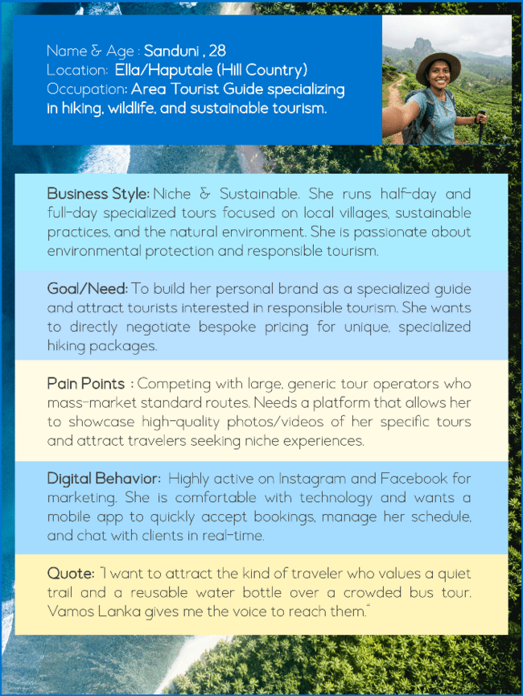

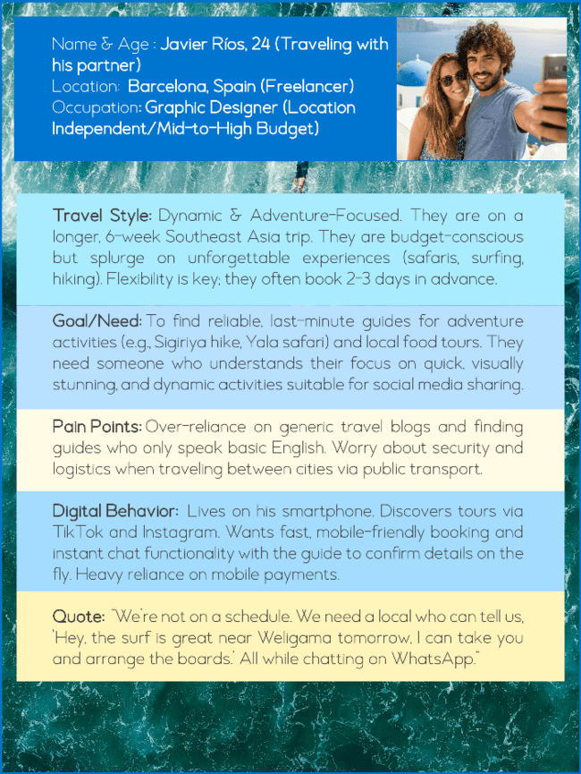

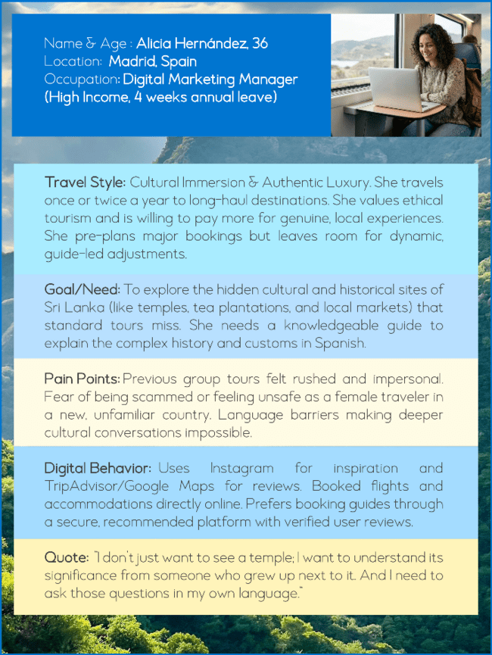
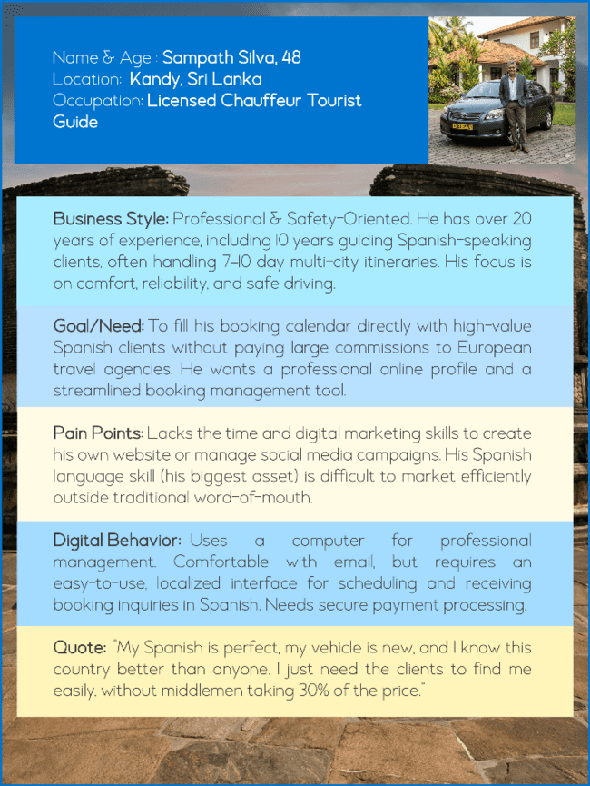

Concept Development
Finalise the visual elements of Vamos Lanka, including logo, colour palette, typography, and overall aesthetic.
Develop a detailed plan outlining goals, target audience, key messages, and channels for social media marketing. Creating a project plan and necessary templates for the social media campaign (content plans, upload schedule, etc).

Production
This phase involves the actual creation of visual and multimedia content aligned with the established brand identity.

Design
Based on the research data, the visual brand identity for Vamos Lanka will be designed. This will include the logo, colour palette, typography details, and extra design elements. Adobe Illustrator and Photoshop will be primarily used for this.

Figure 2: Logo Design Process
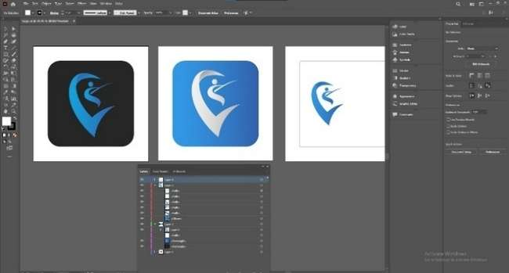

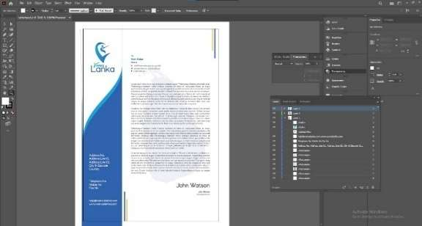

Marketing materials such as social media posts, reels, banners, and brochures will be designed in Photoshop and Illustrator. Access Envato Elements and Freepik for additional images, icons, and templates to complement original content.

Figure 3: Social Media Posts Creation inside Adobe Photoshop

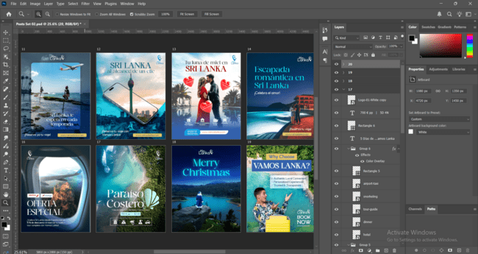

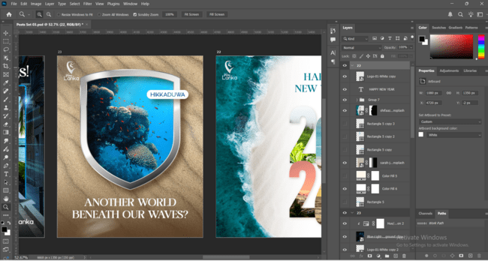

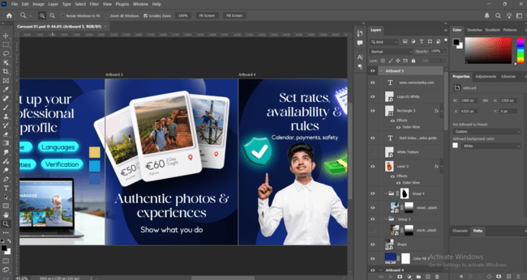

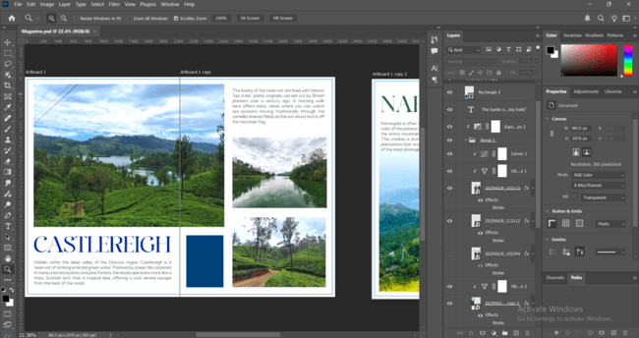



Photo/ Videography
Capture high-quality images of Sri Lanka's landscapes, culture, and tourist attractions. Film promotional videos and interviews that highlight the experiences offered by Vamos Lanka. Using generative AI to create compelling content whenever necessary.

Figure 4 Photo & Videography Process in Tourism Destinations

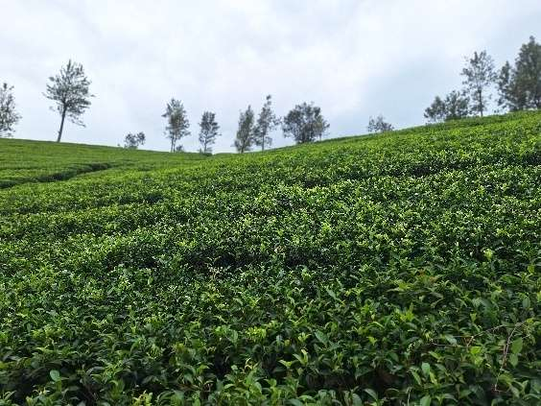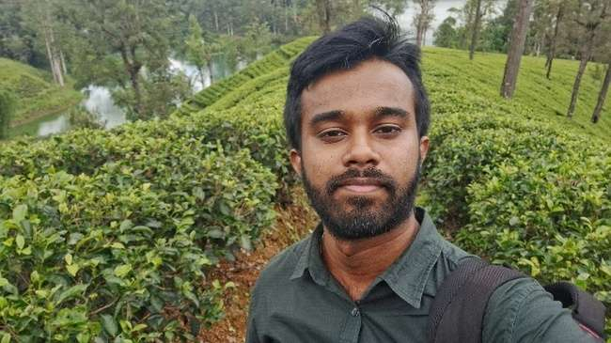
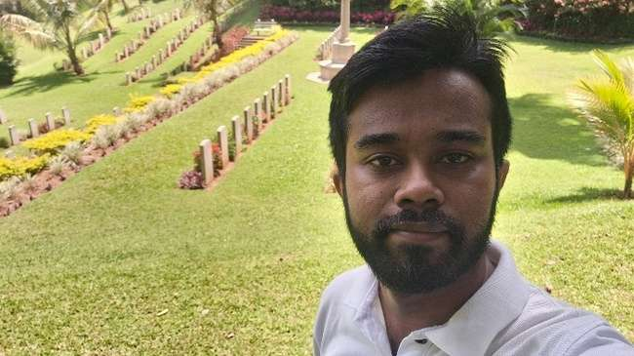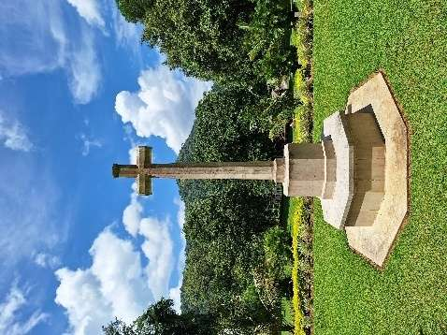

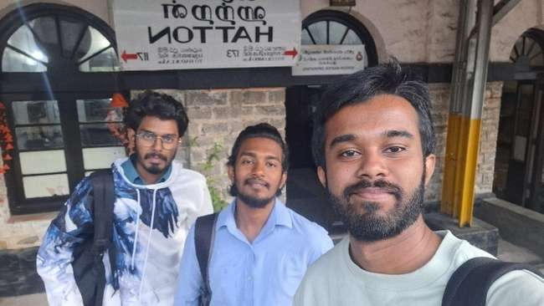

Post-Production
The last phase focuses on finalising all the content created for the social media marketing campaign.

Editing
This includes both videos and stills. Editing the clips, colour grading, retouching the photographs, and preparing them for the digital photo album. Using post effects to maintain visual consistency with all the digital media available.

Figure 5 Post Production
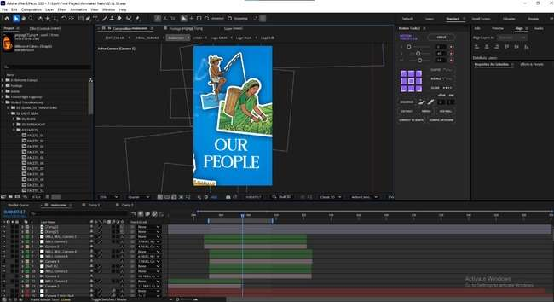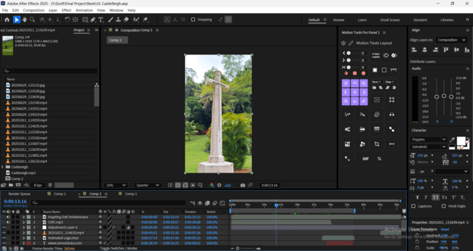

Feedback
Discussing with the supervisor and finalising the deliverables. Discussing with peers to get their opinion and improve the outputs.

Social Media
Preparing the content for social media, along with the captions and hashtags.
Organise all project files, including designs, reports, and media assets, in Google Drive.

RESULTS AND DISCUSSION

Logo Design
Vamos Lanka logo is a combination of a stylised V, the initial letter of the brand, and it has the silhouette of a stilt fisherman, which is an icon of Sri Lankan coastal culture, and both of these together create the shape of a location pin. The initial idea for this logo was found after stakeholder meetings, as the researcher discovered the interest in stilt fishing and fishermen among the tourists from Spain. The logo came to life through many iterations of concepts, sketches and designs.

Figure 6 Logo Design process and the Finalized Logo Variations.

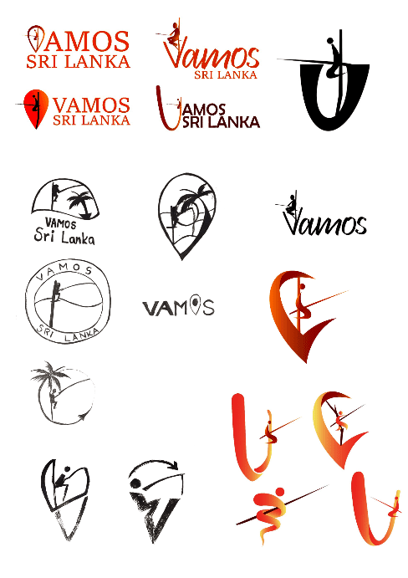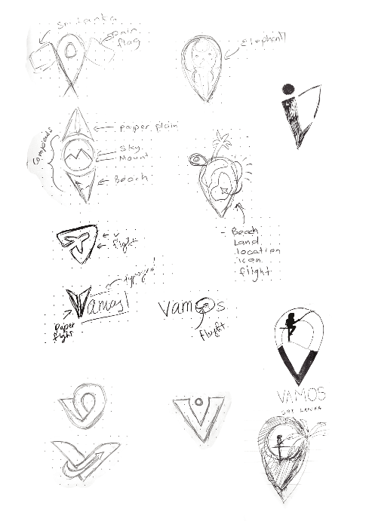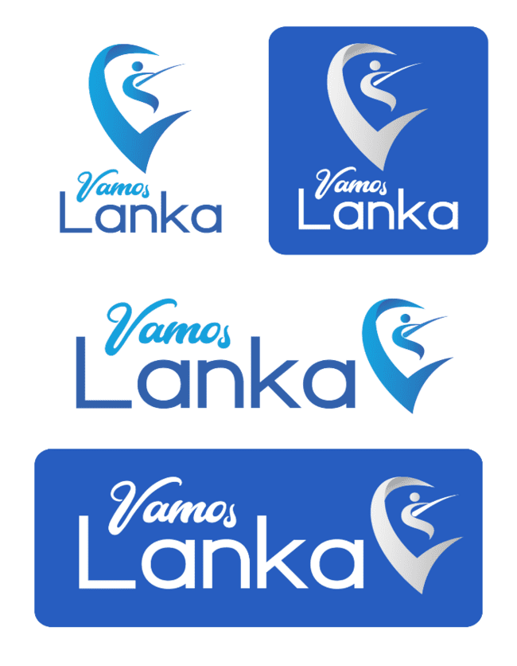

Brand identity development

Figure 7 Brand Guidelines
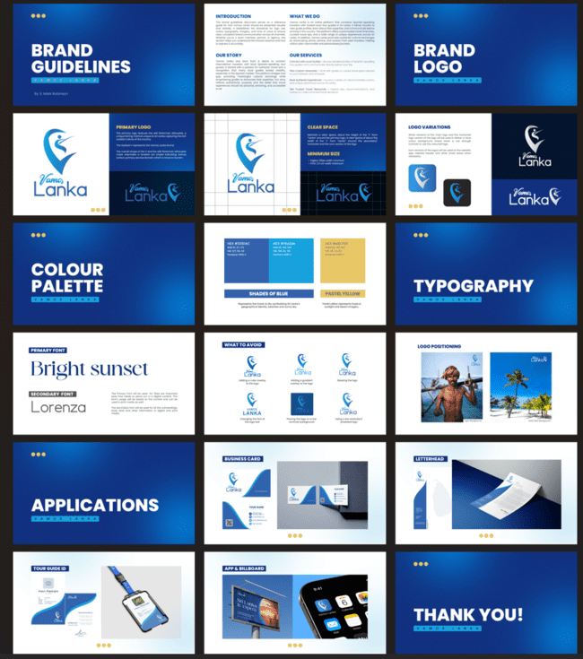

Social Media Posts
Social media posts were created in Adobe Photoshop and contain copyright-free images from online archives. The posts are primarily targeted towards Spanish tourists, thus designed in the Spanish language. A portion of the posts is made to attract local tour guides to the platform. Vamos Lanka logo and a call to action are consistent in all the social media content to create brand awareness and increase interest.

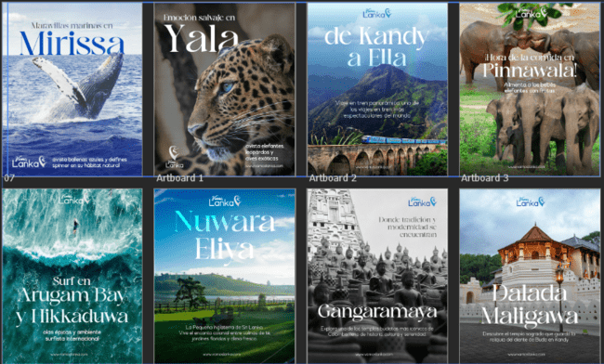
Figure 8 Social media posts

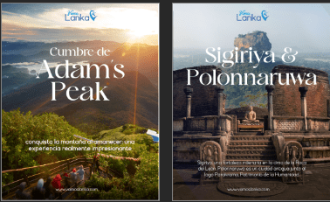

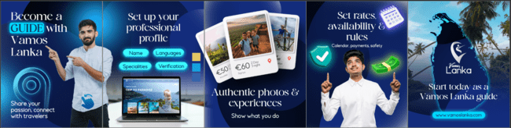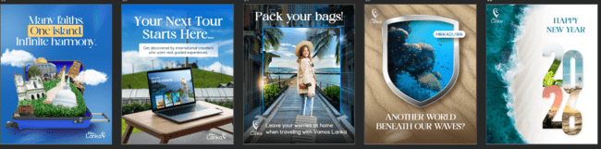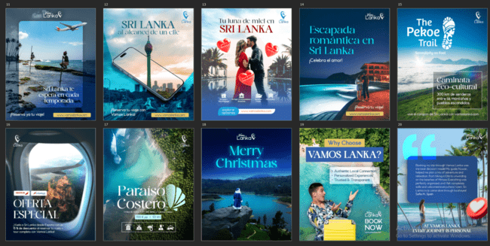

Print Material
Figure 14 Print Material
The printable designs were created in Adobe Illustrator and Adobe Photoshop. The designs primarily use the brand colours and are mainly targeted towards local tour guides, inviting them to try Vamos Lanka. Copyright-free and AI-generated images were used for these designs.

Figure 9 :Print Material
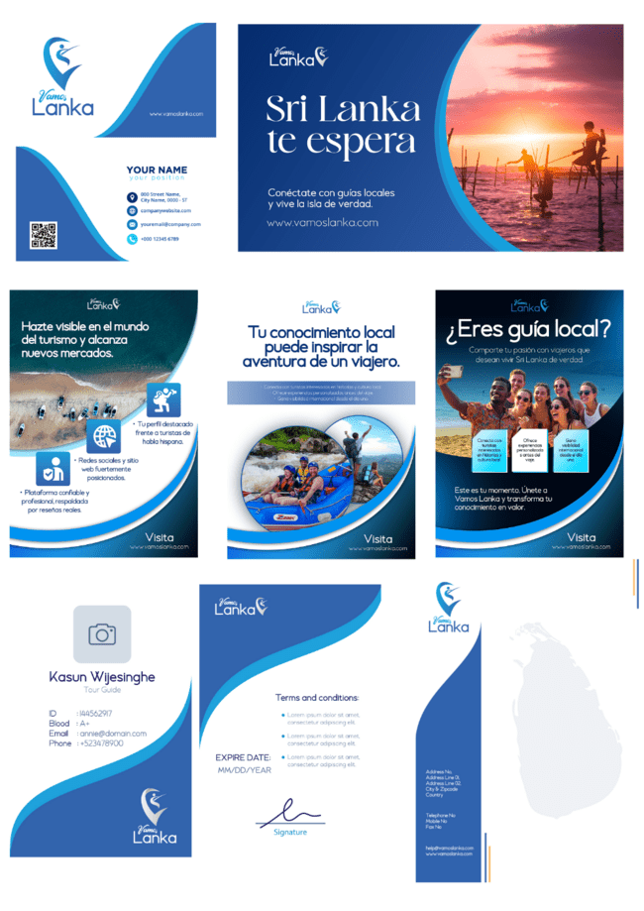

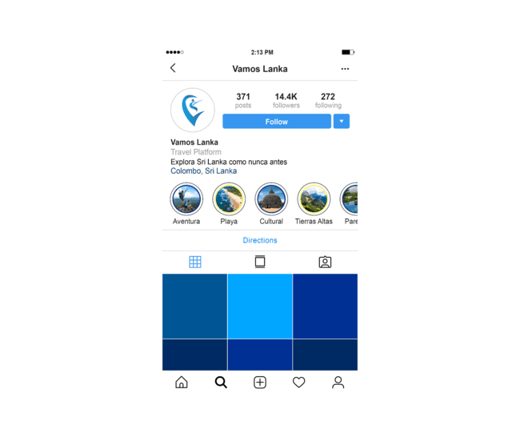
Social Media Mockups
Two sample social media pages (Facebook and Instagram) were created with profile image, cover photo, and other relevant content and descriptions.

Figure 10 Social Media Mockups
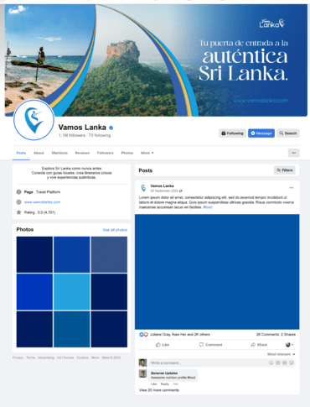
It’s important to validate the outcomes of this research with quantitative and qualitative indicators. This will help the important stakeholders of Vamos Sri Lanka to maintain a good brand image through effective branding and marketing campaigns, and to also improve results over time with a feedback loop. Similar past rebranding efforts from other travel and tourism-related brands show measurable impact in social media engagement metrics such as likes, comments and shares. This also translates to higher platform traffic and conversion.

Based on the insights gathered from Tourists, tour guides and designers regarding perception of brand identity through interviews, surveys and questionnaires, it’s evident that Vamos Lanka’s content quality, style and storytelling is on par with the top travel brands in the world. Market trend analysis: Comparing social media content to assess the relevance of the campaigns to current times.

Figure 11 Collecting Feedback from the Audience

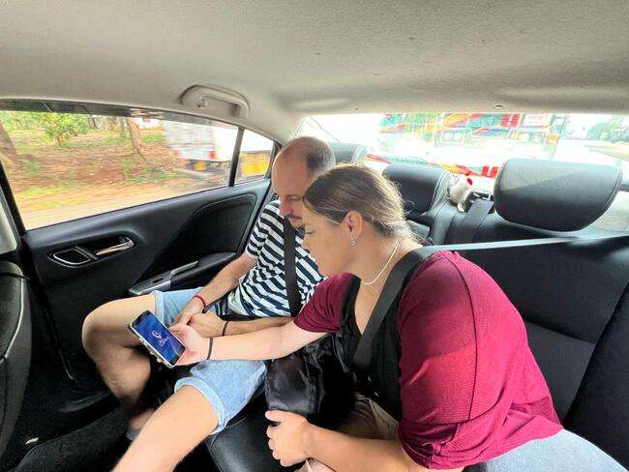

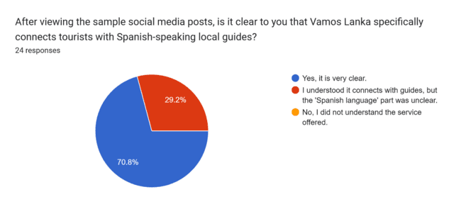
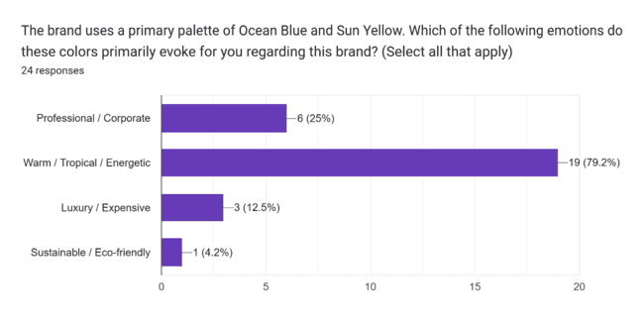
Figure 12 Target Audience Survey Results
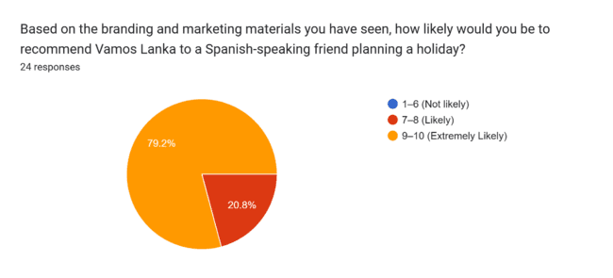
CONCLUSIONS AND RECOMMENDATIONS
The branding and marketing project for Vamos Lanka shows alignment with current trends in tourism branding, destination marketing and brand identity designing in general. The logo, colours and designs combine tradition and modernity, reflecting the authentic nature of the brand and its connection with its target audiences, stakeholders and the location that the brand operates in. All the important decisions were made after considering the facts from stakeholder meetings and market analysis. Authentic branding and marketing are proven tactics that can improve brand awareness and customer interest (Miska Irani Tarigan et al., 2024). This supports the focus on using culturally related content for the brand identity and marketing assets. Unfortunately, Sri Lanka still doesn’t have a proper national-level branding. This means that anything Vamos Lanka does can be subsumed by the wide variety of promotional content that comes out by various government and private parties in the tourism industry. Thus, Vamos Lanka must put extra effort in keeping the content consistent to build a brand around it instead of relying on the national level branding. Similarly, numerous studies show that social media content is vital for destination marketing (Fernando Oscar et al, 2024). Vamos Lanka’s digital-first approach acts as a strength for the brand by increasing its chances of reaching more tourists via social media. But as Sri Lanka faces environmental concerns around over-tourism, the marketing efforts must highlight sustainable practices, responsible travel, and local community benefit. However, a digital led branding requires a lot of resources, especially financial as it will involve content creation, visual sourcing and advertising costs. Print material related to the brand can easily reach local tour guides as they regularly visit tourism-based businesses. Informative flyers. QR/NFC plaques and branded stationery can create brand awareness for Vamos Lanka among local tour guides. This will increase the number of guides associated with the brand, thus increasing competition and the variety of services offered through the platform. In conclusion, Vamos Lanka’s branding and marketing efforts are well-positioned to succeed its focus on authenticity, digital-first approach and local guide connection. Maintaining ongoing validation, feedback loops, market & competitor analysis, and data-based decision making will ensure its aim is within reach. If these key points were managed well, Vamos Lanka could become the next big thing in Sri Lanka’s fast-evolving tourism industry.

REFERENCES

- Bonilla-Quijada, M., Ripoll-Quintana, J., & Olmo-Arriaga, J. L. (2025). Social media as a factor in tourism attraction: A case study. Street Art & Urban Creativity. https://www.urbancreativity.org/journal/index.php/saucp/article/view/social-media-factor-tourism-attraction
- Bresciani, S., & Eppler, M. J. (2010). Brand new ventures? Insights on start-up’s branding practices. Journal of Product & Brand Management. https://www.researchgate.net/publication/235265430_Brand_new_ventures_Insights_on_start-up's_branding_practices
- Cizreliogullari, M. N., & Günay, T. (2024). The marketing of green tourism destinations: Strategies for sustainable travel promotion. Proceedings of the 4th International Eurasian Conference on Educational & Social Studies. https://www.researchgate.net/publication/383941098_The_Marketing_of_Green_Tourism_Destinations_Strategies_for_Sustainable_Travel_Promotion
- Decker, A. (2019). The ultimate guide to branding in 2020. HubSpot. https://blog.hubspot.com/marketing/branding
- Escobar-Farfán, M., Cervera-Taulet, A., & Schlesinger, W. (2024). Destination brand identity: Challenges, opportunities, and future research agenda. Cogent Social Sciences. https://doi.org/10.1080/23311886.2024.2312151
- Ferhataj, A. (2024). AI-driven personalization in tourism: Analyzing sustainable travel preferences with machine learning. https://www.researchgate.net/publication/381452145_AI-Driven_Personalization_In_Tourism_Analyzing_Sustainable_Travel_Preferences_With_Machine_Learning
- Hussain, R., et al. (2024). Social media’s role in destination image formation. Contemporary Journal of Social Science Review. https://www.researchgate.net/publication/380451642_From_Likes_to_Luggage_The_Role_of_Social_Media_Content_in_Attracting_Tourists
- International Journal of Research and Innovation in Social Science. (2024). Tourism development in Sri Lanka: A review of literature. https://rsisinternational.org/journals/ijriss/articles/tourism-development-in-sri-lanka-a-review-of-literature/
- Jahan, T., et al. (2024). A study on importance of branding and its effects on products in business. International Research Journal on Advanced Engineering and Management. https://irjaem.org/index.php/irjaem/article/view/156
- Kumarasinghe, T. (2021). Conservation through the lens of tourism: The role of biodiversity in tourism. Sri Lanka Tourism Alliance. https://www.srilankatourismalliance.com/news-and-updates/conservation-through-the-lens-of-tourism-the-role-of-biodiversity-in-tourism/
- Li, X. (2022). Research on the user-generated content in brand marketing. Advances in Economics, Business and Management Research. Atlantis Press. https://www.atlantis-press.com/proceedings/febm-22/125981143
- Mustafa, N., Olodo, H. B., Tolulope, T., Afua, W., Ofodile, O. C., & Oyewole, T. (2024). Digital marketing in tourism: A review of practices in the USA and Africa. International Journal of Applied Research in Social Sciences, 6(3), 393–408. https://doi.org/10.51594/ijarss.v6i3.896
- Nasir, S., et al. (2023). The importance and challenges of graphic design branding: An overview and discussion. International Journal of Academic Research in Business and Social Sciences. https://doi.org/10.6007/IJARBSS/v13-i10/18654
- Nkatekho, A. (2024). Leveraging big data analytics for personalized marketing strategies in the hospitality sector. Journal of Modern Hospitality. https://www.researchgate.net/publication/382103456_Leveraging_Big_Data_Analytics_for_Personalized_Marketing_Strategies_in_the_Hospitality_Sector
- OnLanka. (2021). Sri Lanka continues to struggle with brand image, says tourism industry veteran. https://www.onlanka.com/news/sri-lanka-continues-to-struggle-with-brand-image-says-tourism-industry-veteran.html
- Peñarrubia-Zaragoza, M. P., Simancas-Cruz, M., & Forgione-Martín, G. (2019). Application of geomarketing to coastal tourism areas. Tourism & Management Studies. https://doi.org/10.18089/tms.2019.150403
- Sri Lanka Tourism Development Authority. (2025). Monthly tourist arrivals reports 2025. https://www.sltda.gov.lk/en/monthly-tourist-arrivals-reports-2025
- Sri Lanka Tourism Development Authority. (n.d.). Weekly report 1st to 30th April 2025. https://www.sltda.gov.lk/storage/common_media/Weekly_Report_1st_to_30th_April_2025.pdf
- Tarigan, M. I., Silalahi, E., Tinambunan, A. P., Margery, E., & Lusiah, L. (2024). Impact of destination brand experience to increase destination brand loyalty. Jurnal Aplikasi Manajemen, 22(1). https://doi.org/10.21776/ub.jam.2024.022.01.17

