Engineering Technology in Renewable Energy: A Comprehensive Review of Solar, Wind, and Hybrid System
¹OLOFINJANA Atolagbe ² Ogunsakin Olaolu ³AWE Oluwatobi Omotosho
Department: Electrical/Electronic Engineering, the Federal Polytechnic Ado-Ekiti, Ekiti State olofintola92@gmail.com, oogunsakin1@yahoo.co.uk., aweoluwatobi1@gmail.com.

Abstract
Nigeria’s electricity sector continues to experience persistent challenges including inadequate supply, fragile grid infrastructure, fuel dependency, and exposure to economic and climatic shocks. At the same time, the country is endowed with vast renewable energy resources and stands at a critical juncture in its energy transition. This paper examines emerging renewable energy technologies and strategic pathways for building resilient power systems in Nigeria. Drawing on synthesized evidence from peer-reviewed literature, international policy reports, and energy transition frameworks, the study explores advances in solar, wind, hybrid systems, digitalisation, energy storage, and hydrogen technologies. It further discusses strategic pathways such as distributed generation, smart grid deployment, institutional reforms, and long-term transition planning. The paper argues that integrating emerging technologies with coherent policy, robust governance, and inclusive planning is essential for developing a resilient renewable-based power system capable of supporting Nigeria’s socio-economic development and climate goals.
Keywords
Emerging technologies, Energy transition, Engineering Technology, Renewable energy, smart grids, Nigeria
1. Introduction
Electricity supply remains one of the most critical constraints to Nigeria’s economic growth and social development. Despite an installed grid capacity of approximately 13GW, effective available generation typically averages below 5GW due to gas supply limitations, aging infrastructure, hydrological variability, and transmission bottlenecks (International Renewable Energy Agency (IRENA, 2023). Consequently, households and industries rely heavily on diesel and petrol generators, resulting in high energy costs, environmental degradation, and reduced economic competitiveness. Globally, energy systems are undergoing rapid transformation driven by declining renewable energy costs, technological innovation, and the urgency of climate change mitigation. For Nigeria, this transition presents a strategic opportunity to diversify its energy mix, enhance system resilience, and expand access to affordable electricity. Emerging renewable energy technologies, when integrated with modern grid infrastructure and enabling policy frameworks, can address long-standing structural weaknesses in the power sector (Ogbonnaya et al., 2019). This paper examines emerging technologies and strategic pathways for resilient renewable power systems in Nigeria. However, recurring issues such as gas shortages, outdated infrastructure, seasonal water scarcity, and limited grid capacity continue to hamper progress (Diyoke, et al ;2023) By synthesising insights from technology reviews, national energy roadmaps, and energy transition literature, the study provides a comprehensive perspective on how Nigeria can strengthen power system resilience while advancing sustainable development objectives.
2. Materials and Methods.
Research Methodology
The study adopted a quantitative descriptive research design to systematically evaluate the effectiveness and performance of Engineering Technology in Renewable Energy, and the effectiveness of Hybrid Renewable Energy Systems (HRES), specifically those integrating solar, hydro, and wind energy sources. This methodological approach enabled the researchers to collect, measure, and analyze numerical data, ensuring an objective evaluation of energy output efficiency, environmental benefits, and cost-effectiveness associated with hybrid systems. A key advantage of this design is its ability to provide statistical insights into patterns and trends, facilitating a deeper understanding of how HRES contribute to energy availability.
.
Fig. 1. Comparative analysis of Nigeria's power system capacity levels showing installed (~1.8 MW), available (~1.4 MW), transmission (~0.45 MW), and generation capacities versus peak load demand (~1.2 MW), illustrating infrastructure constraints and operational deficits (Obiora et al., 2025).

Fig. 2. Monthly profile showing persistent supply-demand mismatch in Nigeria's power sector, with grid supply averaging ~0.4 MW against demand of ~1.6 MW throughout the year, indicating a significant baseline deficit (Orovwode et al., 202
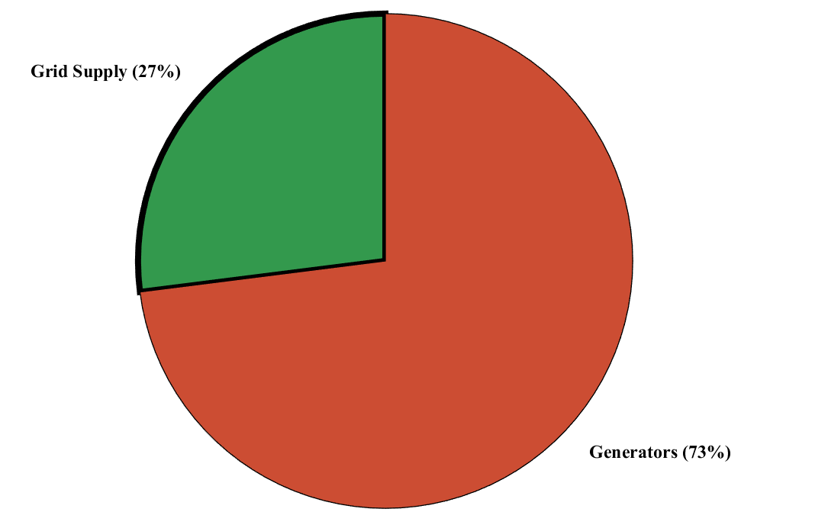
Fig. 3. Evaluation of power delivery efficiency in Nigerian distribution networks, demonstrating technical and non-technical losses with available capacity (~4,500 MW) versus delivered capacity (~2,700 MW), resulting in 60% system efficiency and 1,800 MW losses (Orovwode et al., 2020; Sesay, 2026).
Fig 4 Total Energy Mix

Fig. 4. Nigeria's electricity composition showing 27% from grid supply versus 73% from private generators, highlighting heavy reliance on decentralized backup generation due to grid unreliability (Adesanya & Schelly, 2019; International Energy Agency, 2022).
2. Power System Resilience and Energy Transition
Power system resilience refers to the ability of an electricity system to anticipate, absorb, adapt to, and recover from disruptions such as equipment failures, fuel supply shocks, cyber threats, and extreme weather events (Fang et al., 2024). In renewable-dominated systems, resilience is closely linked to system flexibility, diversity of energy sources, decentralisation, and digital control capabilities (Fang et al., 2024).

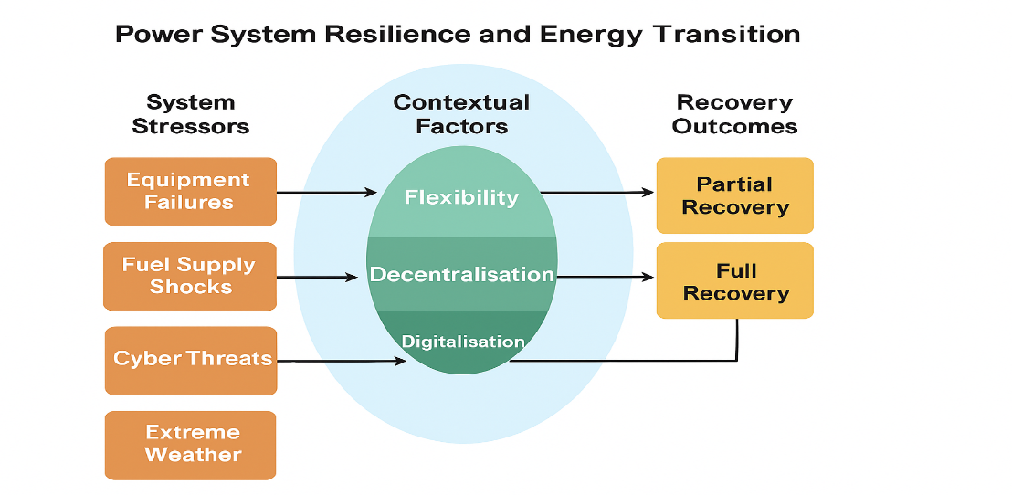
Fig. 5. Conceptual framework of power system resilience and energy transition pathways, illustrating the relationship between system stressors, contextual mitigation factors, and recovery outcomes.(source; Fang et al., 2024).
The data confirms that the current power system is trapped in a state of chronic "Partial Recovery" due to the unmitigated impact of System Stressors like equipment failure and transmission bottlenecks. The lack of Resilience Attributes specifically the absence of operational Flexibility to meet the 18,000 MW demand and a 40% loss in distribution prevents the transition to a stable energy future. As per Su’ait et al. (2025), overcoming these stressors requires a shift toward Decentralisation and Digitalisation to bridge the massive 13,500 MW supply-demand gap.
3. Emerging Renewable Energy Technologies Relevant to Nigeria
3.1 Solar Energy Technologies
Nigeria possesses one of the largest solar energy potentials in Africa, with average solar irradiation levels between 1,600 and 2,200 kWh/m² annually. The intensity of solar radiation is well distributed within the country (Akinbulire et al, (2014). During the day it is estimated Nigeria receives about 4.851 x 1012 kWh of energy from the sun, which is equivalent to about 1.082 million tons of oil per day. While domestic consumption of oil is 297 thousand barrel per day. When we change barrels into tones we see very exiting number; 297000 barrels = 47219.2281 tons. It is obviously seen that domestic demand for oil can be substituted by solar energy Aydogun et al, (2001). (The World Bank Group, 2019).
The 210 GW solar potential (IRENA, 2023) across Nigeria's high-irradiance zones serves as a critical contextual factor to mitigate the stressors identified in Fig. 5. By integrating advanced PV technologies (Su’ait et al., 2025), the system can achieve the decentralization and flexibility required to bridge the current 13,500 MW deficit. This strategic deployment transition effectively moves the national energy profile from chronic "Partial Recovery" toward a resilient and inclusive "Full Recovery" outcome
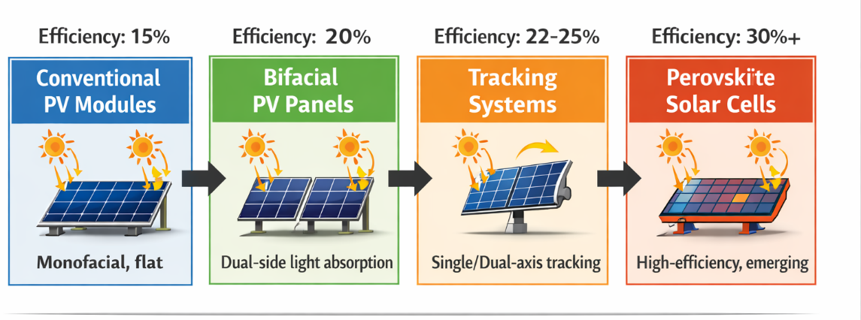
Fig. 7. Evolution of photovoltaic technologies and their corresponding conversion efficiencies. (source; Fluxim, 2026),
The evolution from conventional 15% efficiency modules to bifacial and tracking systems, culminating in emerging perovskite cells that exceed 30% efficiency (Fluxim, 2026), represents a significant technological advancement in photovoltaic technology. Bifacial modules on dual-axis trackers have demonstrated 14% higher annual energy production compared to monofacial counterparts, with gains reaching up to 40% during winter months. This technological progression is further enhanced by AI and machine learning for optimized forecasting and fault detection, facilitating smoother grid integration. When combined with battery storage, these advanced PV systems offer a highly viable solution for Nigeria's expanding off-grid and mini-grid markets (Infra Credit, 2025).
3.2 Wind Energy and Hybrid Systems
Nigeria’s wind energy potential is moderate but geographically significant, particularly in northern and coastal regions. The estimated technical onshore wind potential is approximately 3.2 GW (IRENA, 2023). Technological improvements in turbine design, power electronics, and condition monitoring systems have enhanced reliability and reduced operational challenges. Hybrid renewable energy systems that combine wind, solar, and energy storage offer enhanced resilience by smoothing variability and improving supply reliability. Such systems are well suited for rural electrification, industrial clusters, and critical infrastructure, where uninterrupted power supply is essential (Ogbonnaya et al., 2019).
3.4 Energy Storage Technologies
Energy storage is a cornerstone of resilient renewable power systems. Battery energy storage systems, pumped hydro storage, and emerging long-duration storage technologies provide balancing services, frequency regulation, and backup power (Lui, 2024). Advances in lithium-ion, sodium-ion, and supercapacitor technologies are improving performance while reducing costs (Su’ait et al., 2025).In Nigeria’s context of frequent outages, coupling storage with renewable generation can significantly reduce reliance on diesel generators for households, healthcare facilities, and small businesses.
Table 1: Performance Improvements of HRES Compared to Single Renewable Systems
Energy System Combination | Performance Metric | Mean Score | Improvement (%) | Implications for Energy Production
Solar + Wind + Biomass | Energy Output Efficiency | 4.2 | 25% | Enhanced energy output allows for meeting higher demand.
Solar + Wind | Energy Reliability | 3.8 | 20% | Increased reliability minimizes outages and fluctuations.
Solar + Biomass | Resource Utilization | 3.5 | 15% | More effective use of available resources reduces waste.
Wind + Biomass | System Synergy | 3.6 | 18% | Synergistic effects lead to improved overall system performance.
S(Source; Mahfuj Hosen et al ;2024)
3.5 Hydrogen and Emerging Energy Hybrid
A typical hybrid system combines two or more energy sources, from renewable energy technologies such as PV-panels, wind or small-hydro turbines; and from conventional technologies usually diesel generator sets. In addition, it includes power electronics and electricity storage bank (Prajapati and Sukhadiya, 2018). Renewable hydrogen produced via electrolysis using renewable electricity is increasingly recognised as a strategic energy carrier for long-term storage and sector coupling. Hydrogen can support decarbonisation of hard-to-abate sectors and provide seasonal energy storage (Ogbonnaya et al., 2019; Su’ait et al., 2025). Although hydrogen deployment in Nigeria remains nascent, it represents a long-term opportunity within a resilient energy transition pathway
4.0. Findings and Discursions
The findings of this study shows that, In Fig 1,2and 3 it shows power grid capacity analysis generation, transmission and the distribution with the power loses as a result of long transmission losses .while in Hybrid Renewable Energy Systems (HRES) significantly enhance energy output efficiency, reliability, and resource utilization and optimisation when compared to single-source renewable energy supply systems as showed in table 1. The combination of multiple sources of energy sources demonstrated the highest energy output efficiency, with a 25% for Solar + Wind + Biomass, 20% for Solar + Wind, 15% for Solar + Biomass and 18% for Wind + Biomass. Improvement, highlighting the synergistic potential of hybrid configurations. Solar and wind, though highly sustainable, are subject to intermittency issues; however, the integration of biomass energy provides a steady power supply, ensuring continuous electricity generation even when solar or wind conditions are unfavourable. This balanced energy generation structure minimizes fluctuations, making HRES more suitable for both off-grid rural electrification and grid-connected energy generation. The findings emphasize that diversifying energy sources through hybrid systems enhances energy reliability, with a 20% improvement in energy stability, ensuring uninterrupted power supply and reducing dependence on fossil fuel-based backup systems

6. Conclusion
Emerging renewable energy technologies provide a credible pathway for addressing Nigeria’s long-standing power sector challenges. Advances in only single renewable energy supply system like solar, wind, and biomass to hybrid systems, digitalisation, energy storage, and hydrogen technologies, when aligned with distributed generation, smart grid deployment, and enabling policy frameworks, can significantly enhance power system resilience. This paper demonstrates that a holistic and inclusive energy transition strategy is essential for building a resilient renewable power system capable of supporting Nigeria’s development aspirations and climate commitments. Hybrid Renewable Energy Systems (HRES) as a viable solution to address challenges related to energy production, security, and energy sustainability. The findings indicate that hybrid systems as highly efficient, economically reliable, and environmentally beneficial, reinforcing the need for integrated renewable energy solutions to power system. The study demonstrated that HRES significantly improve power output and system reliability, availability, efficiency, compared to single-source renewable energy systems, thereby addressing the intermittency issues associated with solar and wind power. By integrating solar, wind, and biomass, hybrid systems provide a stable and consistent power supply system, reducing the space and infrastructure limitations that hinder the large-scale expansion of standalone renewables energy supply system.

References
Adesanya, A. A., & Schelly, C. (2019). Solar energy development in Nigeria: A review of the opportunities, challenges, and future prospects. Renewable and Sustainable Energy Reviews, 113, 109261.
Akinbulire, T. O., Oluseyi, P. O., & Babatunde, O. M. (2014). Techno-economic and environmental evaluation of demand side management techniques for rural electrification in Ibadan, Nigeria. International Journal of Energy and Environmental Engineering, 5(132), 1–11.
Aydogan, O., Hasan, Y., & Ozgur, S. (2001). Wind energy utilization in a house in Izmir, Turkey. International Journal of Energy Research, 25, 253–261.
Diyoke, C., Ngwaka, U., & Ugwu, K. (2023). A comprehensive analysis on the grid-tied solar photovoltaics for clean energy mix and supply in Nigeria’s on-grid power. Journal of Energy Systems, 7, 1–17. https://doi.org/10.30521/jes.988844
Fang, J., Zheng, X., Zheng, J., Chen, X., Zheng, C., & Zheng, J. (2024). A comprehensive review on power system resilience. Applied Sciences, 14(3), 1118. https://doi.org/10.3390/app14031118
Fluxim. (2026, January 16). Highest perovskite solar cell efficiencies (2026 update). https://www.fluxim.com/research-blogs/perovskite-silicon-tandem-pv-record-updates
InfraCredit. (2025,). Providing distributed renewable energy via solar hybrid mini grid solutions. https://infracredit.ng/portfolio/providing-distributed-renewable-energy-via-solar-hybrid-mini-grid-solutions.
International Renewable Energy Agency (IRENA). (2023). Renewable energy roadmap Nigeria.
International Renewable Energy Agency (IRENA). (2026, January 21). Digitalisation and AI for power system transformation: Perspectives for the G7. https://www.irena.org/Digital-Report/Digitalisation-and-AI-for-power-system-transformation-Perspectives-for-the-G7
Lui, R. (2024). Renewable energy: Emerging technologies and innovations to reduce climate change. UNICEF Office of Innovation.
Mahfuj Hosen ;Rabbi Khan; Mohammad Samiul Islam; Faria Jahan; Jakaria Talukder;(2024)
Hybrid Renewable Energy Systems: Integrating Solar, Wind, And Biomass For Enhanced
Sustainability And Performance. American Journal Of Scholarly Research And
Innovation Volume 02 Issue 01 (2022) Page No: 01-24 Doi: 10.63125/8052hp43
Obiora, G. N., Igbinosa, G. O., & Fiemobebefa, C. B. (2025). Technical losses across distribution networks in Nigeria and mitigative measures: A review. ABUAD Journal of Engineering Research and Development (AJERD), 8(1), 43–49. https://doi.org/10.53982/ajerd.2025.0801.05-j
Ogbonnaya, C., Abeykoon, C., Damo, U. M., & Turan, A. (2019). The current and emerging renewable energy technologies for power generation in Nigeria: A review. Thermal Science and Engineering Progress, 13, 100390. https://doi.org/10.1016/j.tsep.2019.100390
Orovwode, H., Simeon, M., Amuta, E., & Alashiri, O. (2020). Losses in the Nigerian distribution systems. International Journal of Engineering Research and Technology, 13(11), 3251–3254. https://dx.doi.org/10.37624/IJERT/13.11.2020.3251-3254
Prajapati, P., & Sukhadiya, R. P. (2018). Review and simulation of solar-wind hybrid system with smart grid integration. International Journal of Creative Research Thoughts, 617–621.
QinetiQ. (2015). A smart grid solution to non-technical loss [White paper]. https://www.qinetiq.com/-/media/fb618a1d9a8e4513b677fd4284267243.ashx
Su’ait, M. S., Ahmad Ludin, N., & Sopian, K. (2025). Introduction to renewable energy technologies and energy transition strategies. Solar Energy Research Institute (SERI), Universiti Kebangsaan Malaysia; Universiti Teknologi Petronas.
The World Bank Group. (2019). Global Solar Atlas 2.0: Solar Resource Map of Nigeria. Energy Sector Management Assistance Program (ESMAP), Washington, DC: World Bank. https://globalsolaratlas.info
Usmonov, D., & Kurbonov, N. (2024). Digital transformation in power systems: Smart grid components, control, and challenges. International Journal of Global Optimization and Its Applications, 3(3), 248. https://journal.srnintellectual.com/index.php/ijgoia/article/view/435

