HUMAN MACHINE COLLABORATION FRAMEWORKS FOR ENHANCING TRANSPARENCY AND INNOVATION IN OPEN ECOSYSTEMS
CN HARISHMITHA¹, SB JAISURYA², V VEERAKUMARAN³
¹UG Student, Department of Computer Science and Data Science, Nehru Arts and Science
College, Coimbatore, Tamil Nadu, India.
²UG Student, Department of Computer Science and Data Science, Nehru Arts and Science
College, Coimbatore, Tamil Nadu, India.
³Assistant Professor, Department of Computer Science and Data Science, Nehru Arts and
Science College, Coimbatore, Tamil Nadu, India
¹cnharishmitha@gmail.com, ²jaisurya051205@gmail.com, ³veerakumaranvvk@gmail.com

Abstract:
Collaborative intelligence has emerged as a transformative paradigm in enabling open innovative ecosystems across industries. It integrates human creativity with machine-driven analytics to accelerate problem-solving and decision-making. Open ecosystems demand dynamic knowledge exchange among diverse stakeholders including researchers, enterprises, and digital platforms. A collaborative intelligence framework provides structured mechanisms for combining distributed expertise. This paper explores how such frameworks enhance co-creation, transparency, and cross-domain innovation. The study examines the role of AI-enabled tools in facilitating data sharing and collaborative ideation. It highlights governance models that ensure trust, inclusivity, and ethical participation. The proposed framework emphasizes interoperability to connect heterogeneous systems. Human–machine collaboration is positioned as a catalyst for scalable innovation cycles. We analyze how open innovation platforms benefit from adaptive learning algorithms. The integration of real-time analytics improves knowledge flow efficiency. Stakeholder engagement is extended through participatory digital environments. The framework supports decentralized decision processes essential for open innovation. Security and privacy considerations are incorporated to safeguard shared resources. Case insights demonstrate enhanced innovation outcomes through collaborative intelligence. The paper identifies key metrics to evaluate ecosystem performance. Findings reveal that open ecosystems thrive when supported by intelligent coordination tools. The framework offers actionable pathways for organizations adopting open innovation strategies. Overall, this study positions collaborative intelligence as a core enabler of sustainable and inclusive innovation ecosystems.
Keywords: Human Machine Collaboration, Open Innovation Ecosystems, Transparency in AI Systems, Collaborative Intelligence, Socio-Technical Frameworks.
1.Introduction:
The elaboration of artificial paradigms has always been necessary in shaping the line of mortal progress. Assiduity 1.0 saw the robotization of labor through water and brume power. Assiduity 2.0 marked the dawn of mass product eased by electric power the digital period actualized with Assiduity 3.0 through the integration of computers and robotization, which further evolved into the cyber – physical systems of Assiduity 4.0. Now, as we stand at the cusp of a new period, we're witnessing the emergence of Assiduity 5.0, a paradigm that seeks to harmoniously integrate mortal imagination with machine capabilities. It revolves around the central tenet of collaboration rather than bare robotization, emphasizing the symbiotic relationship between mortal suspicion and machine perfection. As civic geographies come decreasingly characterized by interconnectedness and real- time data, smart metropolises are ripe platforms for the deployment of Assiduity 5.0 generalities. By easing mortal – machine collaboration at an unknown scale, Assiduity 5.0 has the implicit to revise civic structure, service delivery, and communal engagement in smart metropolises. This dynamic interplay promises to render civic spaces more adaptive, effective, and responsive to the ever- evolving requirements of their occupants. The conception of smart metropolises has gained significant instigation in the once decade, getting a prominent area of interest among experimenters, civic itineraries, and policymakers worldwide. At its core, a smart megacity utilizes Information and Communication Technologies (ICT) to enhance the quality and performance of civic services, reduce costs and resource consumption, and ameliorate the commerce between citizens and the government. Beforehand models of smart metropolises concentrated on using technology to ameliorate structure and services videlicet automating waste collection, managing business inflow, and optimizing energy use. still, the vision for smart metropolises has expanded and evolved over the times, incorporating advanced technologies to give sophisticated, integrated, and intelligent results for civic challenges. The arrival of technologies, similar as the Internet of effects (IoT), Artificial Intelligence (AI), blockchain, and 5G, has dramatically altered the geography for smart metropolises. These technologies promise a paradigm shift in civic operation, with the eventuality to transfigure everything from business systems to energy grids, waste
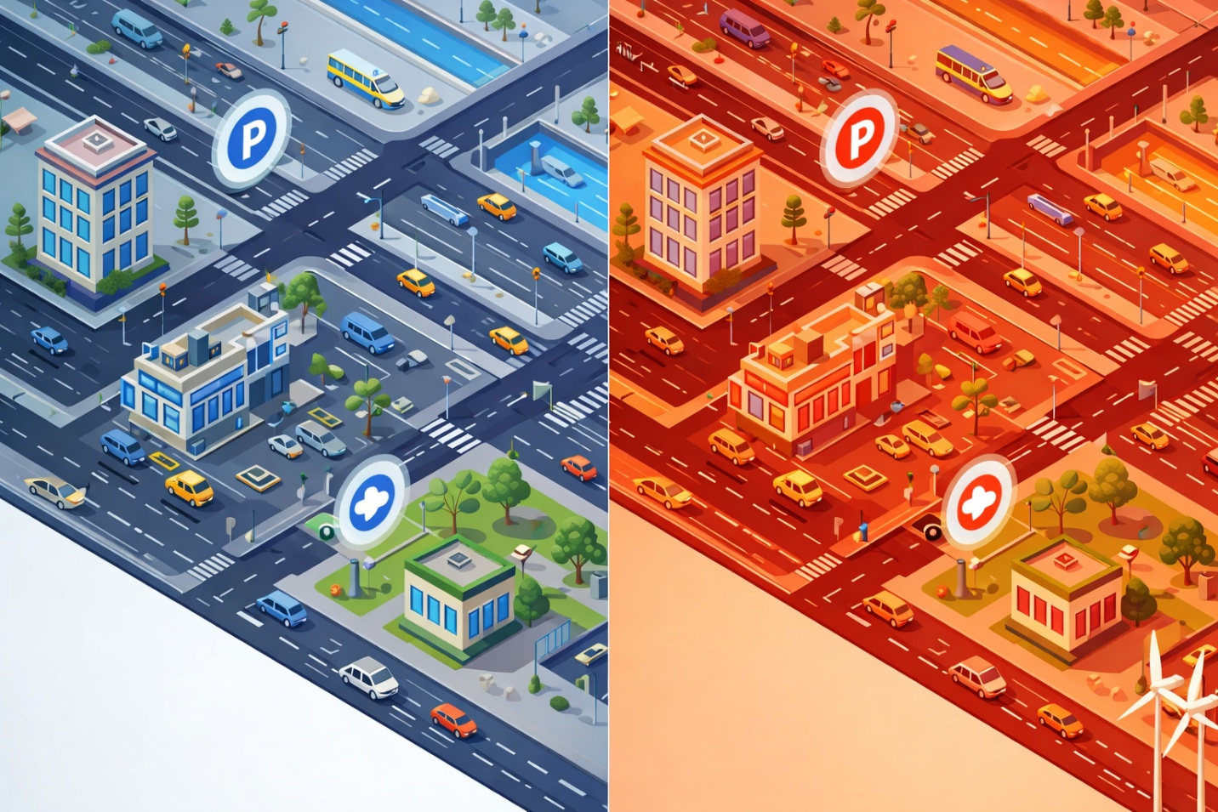
Figure 1. ICT-Enabled Smart Infrastructure in Urban Environments.
operation, public safety, and citizen services. For illustration, IoT bias enable real- time monitoring of megacity operations, AI can optimize service delivery and make prophetic models for colorful civic systems, blockchain can give secure and transparent deals, and 5G networks insure high- speed and dependable connectivity for all these digital relations. Figure 1 presents an elucidative definition of a typical smart structure connected through Information and Communication Technology (ICT). The figure serves as a clear visual aid, revealing how colorful rudiments of a smart megacity are networked to produce a cohesive, effective, and responsive civic terrain.

2.Evolution from Industry 4.0 to Industry 5.0:
The shift from Industry 4.0 to Industry 5.0 plays a crucial role in developing modern smart cities. This concept emphasizes blending digital technologies with urban infrastructure to enhance citizens' quality of life, boost operational efficiency, and support sustainable development. Smart cities depend on connected systems that collect, analyze, and use large amounts of urban data to aid smart decision-making. In Industry 5.0, technology focuses on not just automation but also teamwork between humans and machines. This approach highlights the importance of human creativity, ethical values, and social well-being, while also leveraging powerful digital tools like artificial intelligence, the Internet of Things, cyber-physical systems, and advanced communication networks. Cities face growing challenges, including rapid population growth, environmental issues, traffic congestion, and rising energy needs. By integrating smart technologies, urban areas can enhance transportation systems, energy distribution, healthcare services, and emergency response. Data from sensors and connected devices enables real-time monitoring and predictive analytics, allowing city planners to tackle new challenges proactively. Another key part of the transition from Industry 4.0 to Industry 5.0 is the focus on sustainability. Smart technologies help cut carbon emissions, use resources more effectively, and promote renewable energy. For instance, smart energy grids can manage power demand, incorporate renewable sources, and minimize waste. Likewise, smart transportation systems can reduce traffic jams and lower pollution by optimizing routes and encouraging public transport use. Ultimately, the aim of smart city development backed by Industry 5.0 technologies is to create a balanced ecosystem where digital innovation complements human knowledge and governance. This integration makes sure technology benefits society while also driving economic growth and supporting environmental sustainability.
3.Setting the Foundations for Smart Urban Environments Based on Related Studies:
To develop future smart cities successfully, several essential prerequisites must be established. These prerequisites serve as the foundation for implementing smart technologies and systems. Without these basic requirements, achieving efficient, sustainable, and intelligent urban environments becomes challenging. The main prerequisites from previous research studies include: - Infrastructure development and connectivity - Data integration and management - Collaboration and stakeholder engagement These three components work together to transform traditional cities into smart and sustainable urban systems. Figure 2 shows these prerequisites clearly. It presents a framework made up of three main pillars, each representing a key aspect of smart city development. Together, these pillars highlight the technological, informational, and social elements needed for building future smart cities. Infrastructure Development and Connectivity The first pillar focuses on infrastructure development and connectivity, which form the physical and digital foundations of a smart city. A strong infrastructure ensures that various technologies and systems can operate efficiently and communicate with one another. This pillar includes several key elements: - High-speed communication networks - Internet of Things (IoT) devices and sensor networks - Wireless communication technologies - Smart grid systems for efficient energy distribution These components act like the nervous system of a city, enabling continuous data exchange and communication between different urban systems.
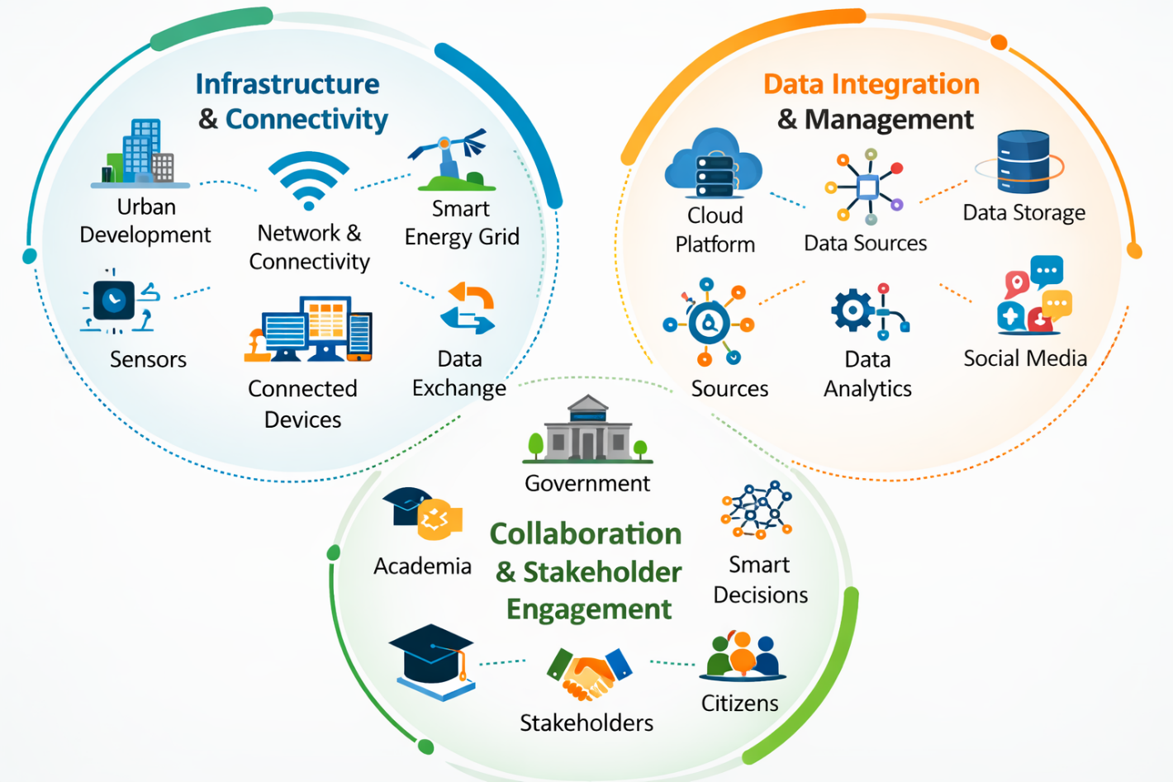
Figure 2. Foundational Prerequisites for Transitioning to Future Smart Urban Environments.

Enhanced connectivity allows devices, sensors, and platforms to interact smoothly, supporting services like smart transportation, energy management, and smart healthcare. Data Integration and Management The second pillar highlights the importance of data integration and management. Smart cities generate large amounts of data through sensors, connected devices, and digital platforms. Proper management of this data is essential for extracting useful insights and supporting effective decision-making. Key aspects of this pillar include: - Data collection from various urban sources - Data storage and processing systems - Advanced analytics and machine learning techniques - Data governance and security frameworks This pillar functions as the brain of a smart city, processing information and turning raw data into valuable insights. These insights help city officials improve urban planning, optimize resource allocation, and enhance public services. Collaboration and Stakeholder Engagement The third pillar focuses on collaboration and stakeholder engagement, representing the human and social aspect of smart city development. Successful smart city initiatives require cooperation among various stakeholders, including: - Government authorities - Private sector organizations - Technology providers - Academic institutions - Citizens and local communities Active participation and collaboration ensure that smart city solutions meet the real needs of residents.
This pillar emphasizes transparent governance, community involvement, and shared responsibility in planning and managing urban areas. In this way, collaboration can be seen as the heart of a smart city, ensuring that technological advancements ultimately benefit society and improve residents' quality of life. Importance of Integrating These Pillars Combining these three pillars into a unified framework underscores the interconnected nature of smart city development. Infrastructure provides the technological base, data management supports intelligent decision-making, and stakeholder collaboration ensures responsible implementation. Together, these prerequisites create a roadmap that guides urban planners, policymakers, researchers, and city officials in designing and carrying out smart city strategies for the future.

4. Analysis of Technological and Management Attributes for Future Smart Cities
Smart City Applications and Taxonomies The idea of smart cities has quickly grown at the intersection of urban development and modern digital technologies. As urban populations continue to rise, cities face more challenges like traffic congestion, resource shortages, environmental pollution, and poor public services. To tackle these problems, many cities worldwide are embracing smart city solutions. A smart city uses modern technologies to improve urban services, optimize resource use, and enhance the quality of life for its residents. These technologies include: - Internet of Things (IoT) - Big Data analytics - Artificial Intelligence (AI) - Advanced communication networks By integrating these technologies into city infrastructure, cities can monitor and manage different systems more effectively. Smart city applications cover many areas, including: - Smart transportation systems - Energy management and smart grids - Waste management systems - Public safety and surveillance - Healthcare and emergency services - Environmental monitoring Due to the many applications and technologies involved, researchers have created taxonomies to organize and classify smart city initiatives. A taxonomy offers a structured framework that groups different smart city solutions based on their functions, technologies, or application domains. These classification systems are important because they help: - Policymakers identify priority areas for development - Urban planners design effective smart city strategies - Technology providers create suitable solutions - Researchers track trends and innovations in smart city technologies Overall, smart city taxonomies support the organized development of sustainable, connected, and livable urban environments for future generations. 4.1 Cyber-Physical Systems in Smart Cities Cyber-Physical Systems (CPS) combine computing technologies with physical processes. These systems link sensors, computing platforms, communication networks, and physical infrastructure to create intelligent and automated environments. CPS has become a key technological foundation for developing smart cities. By connecting digital systems with real-world environments, CPS helps cities run more efficiently and intelligently. Emergence of Cyber-Physical Systems in Urban Environments Cyber-Physical Systems emerged as a powerful model that connects the physical world to the digital world. These systems work through constant interaction between computing components and physical processes. In CPS, sensors gather information from physical spaces, which is then processed by computing systems. This data is used to control or adjust physical operations through feedback mechanisms. In simple terms, physical processes influence computing decisions, and computing results influence physical actions. Over time, CPS technologies have been adopted in various areas such as: - Healthcare systems - Transportation networks - Energy management systems - Industrial automation - Smart city infrastructures Because they can integrate multiple systems, CPS technologies are crucial for intelligent and sustainable urban development. Role of Cyber-Physical Systems in Smart Cities Smart cities function as complex ecosystems that mix information and communication technologies (ICT) with physical infrastructure.
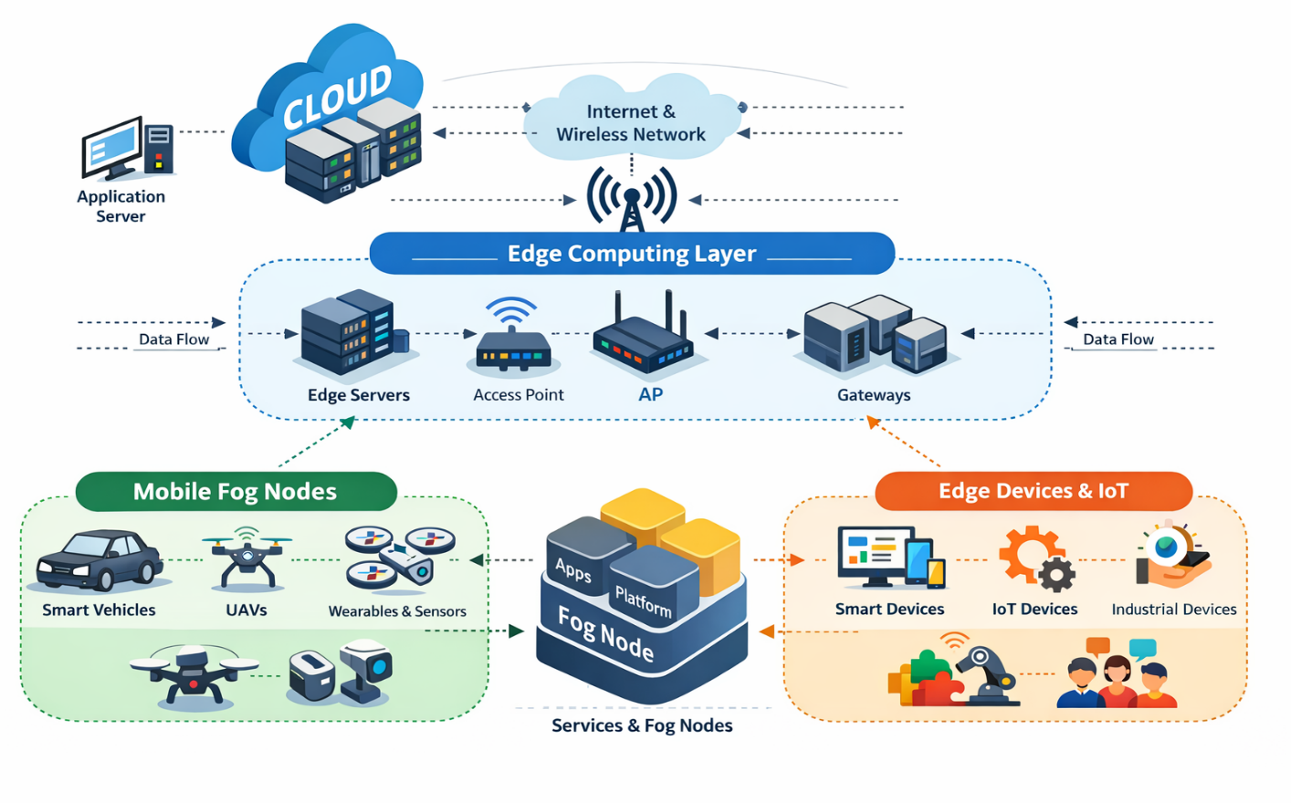
Figure 3. Architectural Design of Fog Computing in Smart Cities.
The main goal of this integration is to improve the efficiency, reliability, and responsiveness of urban services. Within this ecosystem, Cyber-Physical Systems play an essential role. CPS allows cities to monitor infrastructure, analyze real-time data, and make intelligent decisions to enhance urban management. Some key contributions of CPS in smart cities include: Efficient Energy Management CPS supports smart grid systems that monitor energy consumption patterns and optimize electricity distribution. This reduces energy waste and lowers greenhouse gas emissions. Predictive Infrastructure Maintenance By constantly monitoring infrastructure conditions, CPS can foresee potential failures in systems like bridges, roads, pipelines, and power networks. Predictive maintenance lowers repair costs and extends the lifespan of urban infrastructure. Intelligent Traffic Management CPS enables real-time traffic monitoring and dynamic traffic signal control. This helps ease traffic congestion, improve road safety, and increase urban mobility. Improved Urban Services By integrating sensors, communication networks, and data analytics, CPS enhances several city services like waste management, water distribution, public transportation, and emergency response systems. Literature Review on CPS in Smart Cities Table 2 presents a detailed summary of existing research studies related to Cyber-Physical Systems in smart cities. The table is organized into three main columns: Authors This column lists researchers who have contributed to the study of CPS in smart cities. It helps identify key scholars and institutions actively engaged in this field. Detailed Summary This section offers an overview of each research study, including research objectives, methodologies, and major aspects investigated by the authors. It allows readers to quickly grasp the scope and focus of each study. Main Findings The final column highlights the major conclusions and contributions of each study. These findings show how CPS technologies are advancing smart city development and improving urban management systems. Together, the information in Table 2 provides valuable insights into current research trends, technological developments, and practical applications of Cyber-Physical Systems in smart cities.

5.Unresolved Concerns Identified through the Literature Review:
In this section, key challenges and open issues recognized in the current literature are explored. Examining these unresolved matters is essential because they can guide future research and exploration. These issues can range from methodological limitations in existing studies to gaps in theoretical frameworks or inconsistencies in findings. Unexplored areas or topics that have not received enough attention may also be included. Identifying and addressing these concerns aims to contribute to the growth and development of the field.

Data Privacy
As smart cities leverage data to improve urban life, significant privacy concerns arise. Smart cities usually involve extensive collection, storage, and use of personal data, including travel patterns and energy consumption. This data-driven method allows for more efficient and personalized urban services, but it also threatens citizens’ privacy rights. The challenge is to protect this data, ensure individual privacy, and guarantee its ethical use while still gaining valuable insights to enhance city services. Currently, there are no comprehensive and universally accepted solutions for these privacy concerns, making this a critical area for future research and policy development.
Cybersecurity
The growing connectivity in smart cities comes with numerous advantages, but it also heightens the risk of cyber threats. As urban infrastructure becomes more digital and interconnected, it also becomes more susceptible to cyber-attacks that could disrupt essential services, such as power grids and transportation systems. The challenge remains how to securely protect smart city infrastructure and services from a wide range of constantly evolving cyber threats. Despite improvements in cybersecurity measures, ensuring the security of smart cities continues to present significant challenges, requiring ongoing innovation and vigilance.
Interoperability
A smart city framework often consists of various information technologies and systems. Integrating and ensuring seamless communication between these different systems within a single city-wide framework is a complex endeavor. Achieving standardization and interoperability among various systems and devices is vital for the effective functioning of smart cities. However, technological, vendor-specific, and regulatory barriers make this challenging. Consequently, developing common standards and interoperable solutions remains a prominent issue in smart city literature.
Data Management
Smart cities generate vast amounts of data from multiple domains and sources. Effectively managing this data—from collection and storage to analysis and transfer—is critical for enabling data-driven decision-making and service delivery. However, the sheer volume and complexity of data, along with privacy, security, and interoperability issues, create significant challenges. Developing efficient and effective data management strategies is still ongoing, and their implementation on a city-wide scale remains uncertain.

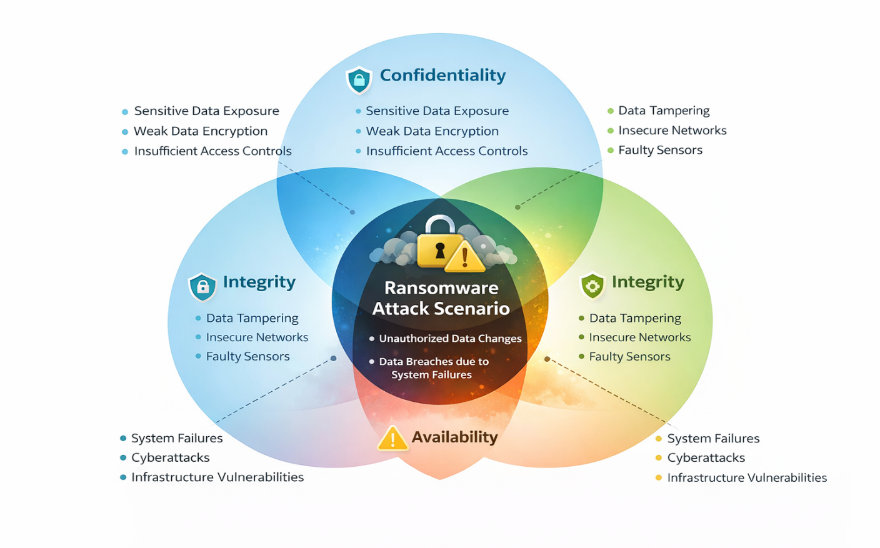
Figure 4. Cybersecurity Challenges in Smart Cities.

Reliability
Smart cities depend heavily on information technologies to provide services and function effectively. Ensuring these IT services' reliability and continuous availability is crucial, especially for essential services like energy, water, and transportation. This involves protecting against various potential disruptions, such as system failures or cyber-attacks. Despite advances in technology and system design, achieving high reliability amidst diverse potential disruptions remains an unresolved issue.
Digital Divide
The emergence of smart cities has highlighted the issue of the digital divide. As cities become smarter and increasingly rely on digital technologies, those without access—due to economic barriers, lack of skills, or other factors—risk being left behind. This can worsen existing socio-economic inequalities and create new ones. Tackling the digital divide within smart cities is a complex challenge that requires a mix of technological, policy, and social solutions.
Legal and Regulatory Frameworks
The rapid advancement of digital technologies in smart cities often outstrips the development of legal and regulatory frameworks. Existing laws and regulations may not adequately address the new situations and challenges smart cities present, ranging from data privacy issues to the use of autonomous systems. Therefore, creating updated, relevant, and effective legal and regulatory frameworks that keep pace with technological changes remains a significant challenge.
Sustainability of IT Infrastructure
Along with the benefits of digitization, the sustainability of large-scale IT infrastructure in smart cities is a pressing concern. The environmental impact of maintaining such infrastructure, including energy use and electronic waste, can be considerable. Despite progress in green IT solutions, developing truly sustainable IT infrastructure that balances performance with environmental impact remains a significant challenge. This issue represents an important area of ongoing research, with the need for innovative and sustainable solutions continuously growing.
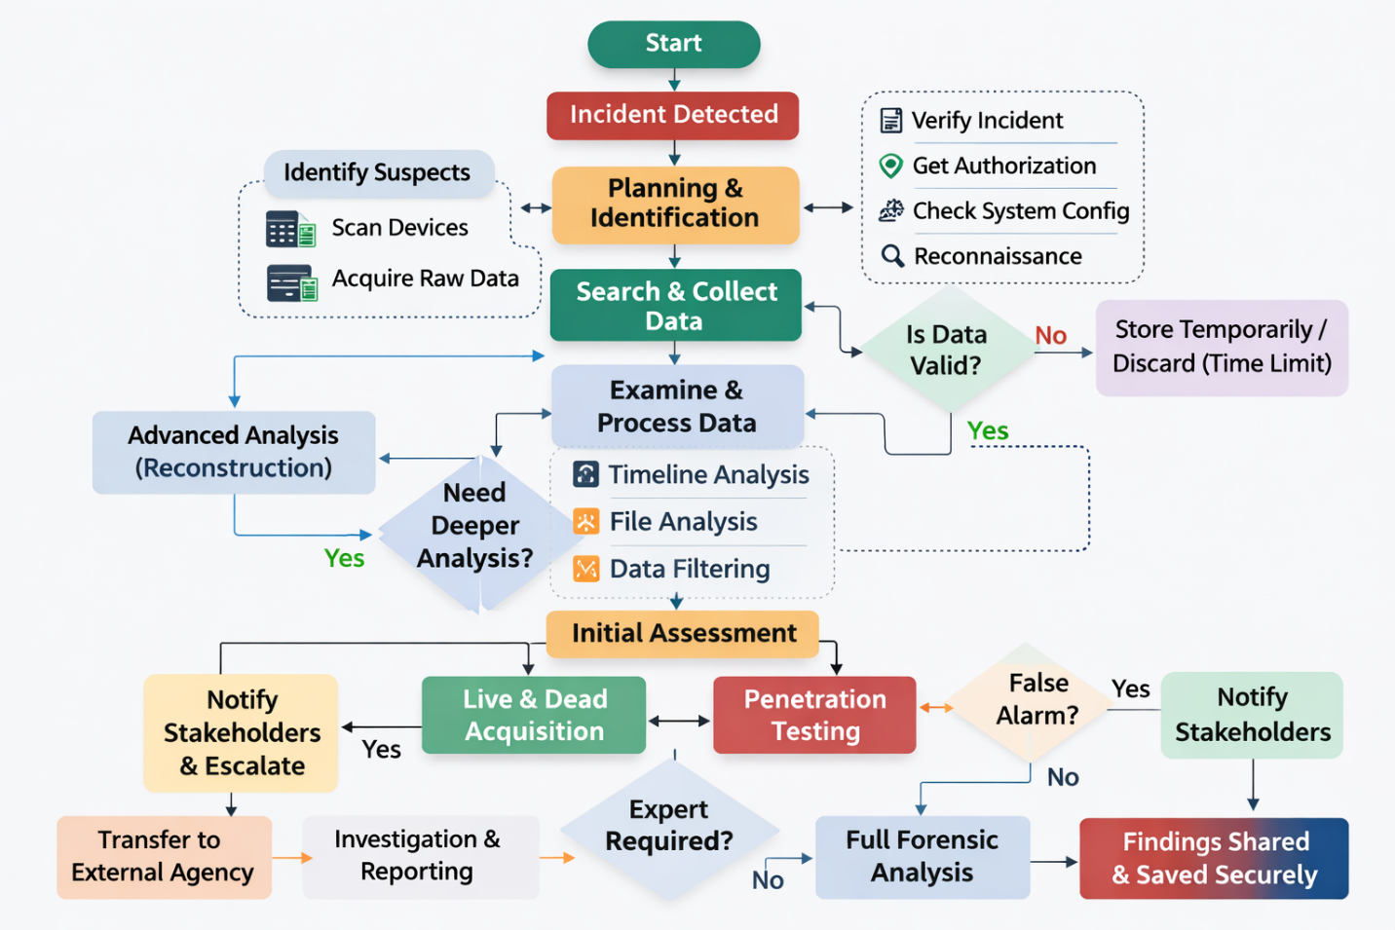
Figure 5. Digital Forensic Guideline for Smart Cities.

6. Future Research Directions:
Industry 5.0 introduces several new opportunities for research in the development of smart cities. As this concept focuses on the collaboration between advanced technologies and human intelligence, it opens many possibilities for improving urban systems, services, and governance. Future research can explore how Industry 5.0 technologies can transform cities into more efficient, sustainable, and human-oriented environments.
Human-Centric Smart Cities:
When we think about the future of cities, we need to consider how people and machines can work together. One important idea is to make sure that cities are designed with people in mind, so that technology helps make their lives better, not worse. We want cities where technology and humans complement each other, rather than machines replacing people. To achieve this, we should look into how we can create smart city systems that put the needs and comfort of citizens first, while still using automation and advanced technologies to improve things. The main goal is to build cities that use technology to make people's lives easier and more enjoyable, rather than just relying on machines to do everything. By doing this, we can create a better future for everyone.
Advanced Cybersecurity:
As cities get smarter and use more digital technology, they also become more open to cyber attacks. With more devices connected to the internet, cloud platforms, and data networks, the need for better cybersecurity is growing. To keep cities safe, we need to come up with new ways to protect them from cyber threats. One way to do this is to use artificial intelligence to detect threats and respond quickly. We also need to create strong security systems that can safeguard important city infrastructure. This is an area that will be important to study in the future, especially as we move towards Industry 5.0, which will bring even more technology and connectivity to our cities. By finding new ways to protect our cities from cyber threats, we can help keep them safe and secure for everyone.
Intelligent Automation in Urban Services:
Intelligent automation has the potential to significantly improve various urban services. Future research can explore how automated systems and smart technologies can be integrated into areas such as:
Transportation systems
Healthcare services
Waste management
Energy distribution and management
Researchers may also investigate the practical benefits of automation, implementation strategies, and the challenges associated with deploying such technologies in real-world urban environments.
Data Management and Decision-Making:
Cities are getting smarter and that means they're producing a huge amount of data from things like sensors, devices that can connect to the internet, and online platforms. Now, new technologies like advanced artificial intelligence and machine learning are being used to help make sense of all this data. These technologies can really improve how cities analyze data and make decisions. For example, they can help cities predict what might happen in the future and make decisions quickly when problems arise. It would be interesting to do more research on how these technologies can be used to help city leaders make better decisions and improve the way cities work. Maybe we can use them to create systems that can predict problems before they happen and help cities respond quickly to emergencies. This could make cities even smarter and more efficient in the future.
Sustainability and Efficient Resource Utilization:
Making our cities more sustainable is a big goal for us today. New technologies, like those in Industry 5.0, can really help us achieve this by using resources more wisely and cutting down on waste. Looking ahead, researchers might want to explore how these technologies can make our cities more energy-efficient, help us keep an eye on the environment, and support sustainable development, all while reducing the harm that urban activities can cause to the planet. This could be a key step in creating a better future for our cities and the people who live in them. By working together and using these new technologies, we can make a real difference and create a more sustainable world for generations to come.
Ethical, Legal, and Social Considerations:
The integration of Industry 5.0 technologies into urban environments also raises important ethical, legal, and social issues. Researchers will need to examine how these technologies affect privacy, security, employment, and social equality. Developing appropriate policies, ethical guidelines, and regulatory frameworks will be essential to ensure responsible implementation.
Interoperability Standards:
To make cities smarter, we need to get all the different technologies and systems working together. This means we have to figure out how to make them talk to each other, which is a big area of research right now. One thing we could do in the future is create a set of rules that lets all the different smart city technologies work together smoothly, so everything runs efficiently. This would make it easier to integrate all the systems and make the city work better as a whole. We should think about how to make this happen, so we can create a more connected and efficient city.
7. Conclusion
In conclusion, the rapid increase in the population of urban centers worldwide has presented various challenges for the future of smart cities. These challenges include the management of resources, transportation systems, environmental sustainability, and the efficiency of services. Nevertheless, this research paper has demonstrated the transformative impact of the application of advanced information and communication technologies on the future of smart cities with the newly emerging phenomenon of Industry 5.0. The analysis carried out in this research paper revealed that the newly emerging phenomenon of Industry 5.0 presents a novel paradigm that focuses on the application of intelligent automation with the collaboration of humans and machines. This technological revolution is bound to greatly impact the future of smart cities with the incorporation of the expertise of humans with the application of advanced technologies. One of the major findings of the study is the growing relevance of some of the latest technological advancements, which play a crucial role in the development of smart cities. Some of the latest technological advancements are Cyber–Physical Systems, fog computing, unmanned aerial vehicles, renewable energy solutions, machine learning, and deep learning algorithms. These technological advancements are helping to bridge the gap between the physical and digital world and are making smart cities work more intelligently and smartly.
In conclusion, the development of smart cities is not only about using the latest technologies. It is more about using the technologies strategically to create an intelligent urban ecosystem that is sustainable, resilient, and citizen-centric. Industry 5.0 is a powerful concept that can be used to achieve this vision by leveraging the power of technology and human creativity together.
References
- Tan, S.Y.; Al-Jumeily, D.; Mustafina, J.; Hussain, A.; Broderick, A.; Forsyth, H. Rethinking Our Education toFace the New Industry Era. In Proceedings of the 10th International Conference on Education and New Learning Technologies, Palma, Spain, 1–4 July 2018; pp. 6562–6571. [CrossRef]
- Adel, A. Future of industry 5.0 in society: Human-centric solutions, challenges and prospective research areas. J. Cloud Comput. 2022, 11, 40. [CrossRef]
- Fatima, Z.; Tanveer, M.H.; Waseemullah Zardari, S.; Naz, L.F.; Khadim, H.; Ahmed, N.; Tahir, M. Production Plant and Warehouse Automation with IoT and Industry 5.0. Appl. Sci. 2022, 12, 2053. [CrossRef]
- Kasinathan, P.; Pugazhendhi, R.; Elavarasan, R.M.; Ramachandaramurthy, V.K.; Ramanathan, V.; Subramanian, S.; Kumar, S.; Nandhagopal, K.; Raghavan, R.R.V.; Rangasamy, S.; et al. Realization of Sustainable Development Goals with Disruptive Technologies by Integrating Industry 5.0, Society 5.0, Smart Cities and Villages. Sustainability 2022, 14, 15258. [CrossRef]
- Sharifi, A.; Allam, Z.; Feizizadeh, B.; Ghamari, H. Three Decades of Research on Smart Cities: Mapping Knowledge Structure and Trends. Sustainability 2021, 13, 7140. [CrossRef]
- Kummitha, R.K.R.; Crutzen, N. How do we understand smart cities? An evolutionary perspective. Cities 2017, 67, 43–52. [CrossRef]
- Li, B. Effective energy utilization through economic development for sustainable management in smart cities. Energy Rep. 2022, 8, 4975–4987. [CrossRef]
- Bibri, S.E.; Krogstie, J. Smart sustainable cities of the future: An extensive interdisciplinary literature review. Sustain. Cities Soc. 2017, 31, 183–212. [CrossRef]
- Razmjoo, A.; Gandomi,A.; Mahlooji, M.; AstiasoGarcia, D.; Mirjalili, S.; Rezvani, A.; Ahmadzadeh, S.; Memon, S.AnInvestigation of the Policies and Crucial Sectors of Smart Cities Based on IoT Application. Appl. Sci. 2022, 12, 2672. [CrossRef]
- Sánchez-Corcuera, R.; Nuñez-Marcos, A.; Sesma-Solance, J.; Bilbao-Jayo, A.; Mulero, R.; Zulaika, U.; Azkune, G.; Almeida, A. Smart cities survey: Technologies, application domains and challenges for the cities of the future. Int. J. Distrib. Sens. Netw. 2019, 15, 1550147719853984. [CrossRef]

