IMPROVING PACKAGING WAREHOUSE OPERATIONAL EFFICIENCY THROUGH RELAYOUT STRATEGY AND MATERIAL HANDLING STANDARDIZATION IN INDONESIAN CHEMICAL COMPANIES

ABSTRACT
The speed of warehouse order processing is a key industry imperative for customer satisfaction. One way warehouse managers can achieve this is by comprehensively optimizing warehouse operations. Several researchers have observed that warehouse order processing activities contribute a significant portion of warehouse time and total costs. This study used the packaging materials warehouse of a chemical company in Tangerang City, Indonesia. The main problems identified in this study included long picking times, the risk of component picking errors, and low stock visibility. Several methodologies were used to address these issues. The process began with mapping SKUs based on service frequency and quantity (fast-moving/slow-moving). Based on the collected data, changes were made to the item layout. Furthermore, additional areas for packaging support components, such as lids, were added near the packaging to reduce errors during picking. Furthermore, 5S practices were implemented to remove unused items from the packaging warehouse. This also helped the warehouse expand its storage space. The results showed a 50% reduction in picking time, from the initial standard time of 4 seconds per item to 2 seconds per item. Several unsafe storage areas were also removed, improving operator safety during picking and contributing to increased warehouse capacity. Furthermore, the implementation of a pail storage system also facilitated faster receipt and service of goods. The incidence of damaged pails during storage was also reduced. The results of this study concluded that the 5S method and determining the layout based on the movement of goods in the warehouse can have a significant impact on warehouse productivity.
Keyword: warehouse, operational efficiency, Relayout, 5S

INTRODUCTION
In today's fast-paced manufacturing world, warehouse efficiency is no longer just an option, but a necessity. Warehouses host several critical activities, including receiving, storing, checking, picking, stock replenishment, shipping, administration, and warehouse stock handling. Research conducted by Baker P. and Canessa M. found that the largest cycle time and operational costs occurred in order picking activities, accounting for approximately 50%. Richard G. analysed activities in several types of warehouses using the time and motion study method. He found that warehouse operators spent 60-70% of their daily work time on picking and putting away. De Koster et al. analysed picking activities into several sub-activities: movement time or function, search time, the picking process, and preparation and documentation. The activity with the highest cycle time was travel time.
In a chemical plant, there are several main warehouses, including the packaging warehouse. The packaging warehouse is often a critical point due to the wide variety of items, from can sizes and packaging materials to lids and pails. Frequent problems include disorganized organization, repetitive activities, and other issues, which ultimately lead to a series of operational issues: long search times, component selection errors, and even a cramped and unproductive work area.

This report was prepared to document a series of improvement measures implemented in the packaging warehouse. The primary focus of these activities was to reorganize (relayout) and improve material handling. The ultimate goal is to achieve faster work processes, minimize errors, and create a more ergonomic work environment for all warehouse personnel.

METHODOLOGY
This research used quantitative methods and was supported by observations in the packaging warehouse area of ​​a chemical factory in Indonesia. Observations were conducted initially to identify ongoing problems in the warehouse, particularly the packaging area, and to determine the results after improvements were made.
Based on warehouse employee KPI data, a relatively high number of complaints were obtained for each operator. The warehouse manager then decided to conduct further evaluations related to the warehouse. The observations revealed several things that were analysed, including the standard packaging service time of 4 pcs/second. Furthermore, the largest complaint was caused by service that did not meet standards, the largest being the mismatch between the lid and the can. The cause of the mismatched lid occurred because the can and lid were far apart and the shape of the lid was also similar in appearance, increasing the possibility of errors when picking goods. In terms of safety, the rack position was also found to be unsafe, especially the second-level rack. The ladder position formed a 90-degree angle to the floor, requiring operators to raise and lower items manually. In the field, several areas within the warehouse were also found to store unused items, which also consumed warehouse capacity.
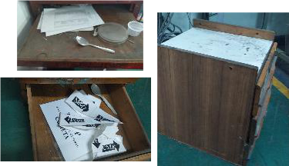
Figure 1. Finding unused items while doing 5S
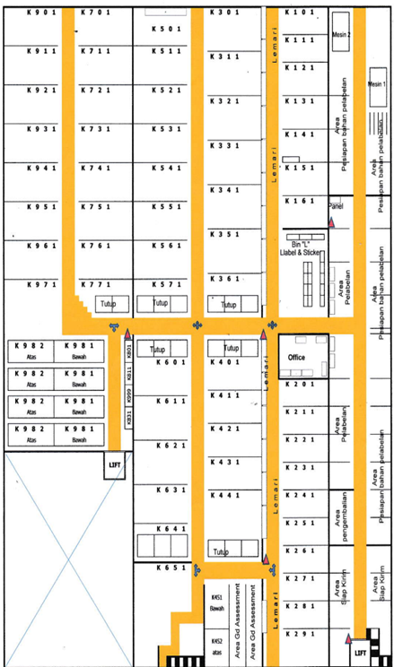
Figure 2. Initial warehouse layout before shelf elimination
The first methodology implemented is the 5S process in the warehouse area. Warehouse operators will determine which items are unused and which are used. Unused items are removed from the warehouse area. Then, areas that can increase warehouse capacity are identified, resulting in additional shelves in the storage area. Shelf sizes are also standardized, and dedicated space is added within the shelves for can lids. Determining can placement is done by calculating the number of cans taken and the frequency of taking them. Then, they are grouped into three groups: fast-moving, slow-moving, and dead-moving. Fast-moving items are placed in areas close to the exit. Dead-moving items are placed on special shelves for easier inspection and control. Shelves on level 2 are dismantled and removed to improve safety and operator convenience. Some shelves are made more accessible in both directions, making it easier for operators to provide service.
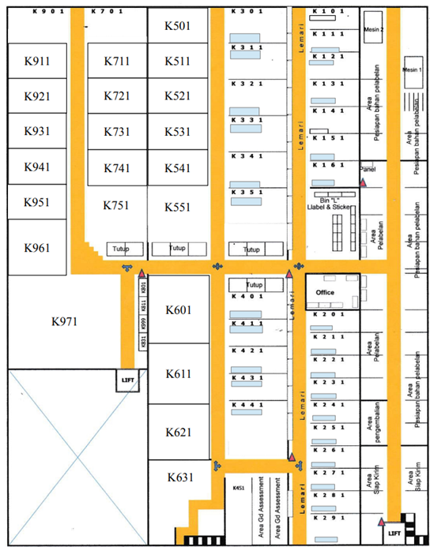
Figure 3. Latest layout after shelf elimination
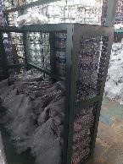
Figure 4. Special area for lids in the shelf area

RESULTS DISCUSSION
The implemented changes have had a very real impact on daily operations. The following is a summary of the results of comparing site performance before and after the intervention, as presented in Table 1.
Table 1. Comparison of Warehouse Key Performance Indicators
Parameter | Before Improvement | After Improvement
Pickup Time | 4 s/pcs | 2 s/pcs
Picking method for pail | Manual stacking | Pallet pulling system
Number of Complaints | High | Low

Integrating can body and lid locations significantly reduces picking errors. In addition to time savings of 50%, inventory visibility is improved due to more consistent grouping. This simplifies cycle counting and quality control of incoming materials from vendors.

CONCLUSION
A packaging warehouse relay layout based on service frequency analysis and component integration has proven effective in significantly increasing picking productivity. The use of new material handling standards not only speeds up the flow of goods but also improves operator safety. The study recommends standardizing similar layouts for other supporting warehouse areas to achieve optimal logistics synchronization.

REFERENCES
- Baker, P., & Canessa, M. (2009). Warehouse design: A structured approach. European Journal of Operational Research, 193(2), 425-436.
- De Koster, R., Le-Duc, T., & Roodbergen, K. J. (2007). Design and control of warehouse order picking: A literature review. European Journal of Operational Research, 182(2), 481-501.
- Richards, G. (2022). Warehouse Management: A Complete Guide to Improving Efficiency and Minimizing Costs in the Modern Warehouse (4th ed.). Kogan Page Publishers.

