Incidental Blue Nevus of the Cervix: A Rare Case Report

Abstract
Background: Blue nevi are benign melanocytic proliferations, most often cutaneous but rarely reported in extracutaneous sites. Cervical blue nevus is an uncommon incidental histological finding, with very few cases published.
Case Presentation: We report a 54-year-old multiparous woman with heavy menstrual bleeding who underwent total abdominal hysterectomy. Histopathological examination revealed an incidental blue nevus in the cervix, characterized by scattered brown pigment laden macrophages in stroma of subepithelium.
Conclusion: Cervical blue nevus is rare and benign. Recognition is essential to avoid misdiagnosis as malignant melanoma, thereby preventing overtreatment.
Keywords: Blue nevus; Cervix; Melanocytic lesion; Case report; Gynecological pathology

Introduction
Blue nevus is a benign melanocytic lesion first described by Jadassohn and Tieche in 1906. It typically arises in the skin but has been documented in extracutaneous sites such as the vagina, prostate, spermatic cord, pulmonary hilum, oral mucosa, esophagus, and lymph nodes^{1,2}. Cervical involvement is extremely rare.
Proposed pathogenesis includes aberrant migration of neural crest melanocytes into the Müllerian tract during embryogenesis or stromal cell metaplasia^{3,4}. Most cervical blue nevi are asymptomatic and detected incidentally during histopathological evaluation of gynecological specimens.

Case Presentation
A 54-year-old multiparous woman presented with heavy menstrual bleeding. Clinical examination and ultrasound revealed an enlarged uterus with intramural fibroids. Laboratory findings were normal. She underwent total abdominal hysterectomy.
Gross examination : revealed an enlarged uterus, with bosselated surface. Myometrium shows focal areas of trabeculations. The endocervix showed a small blue-black area measuring 0.4×0.3 cm and Nabothian cyst. (Fig 1).
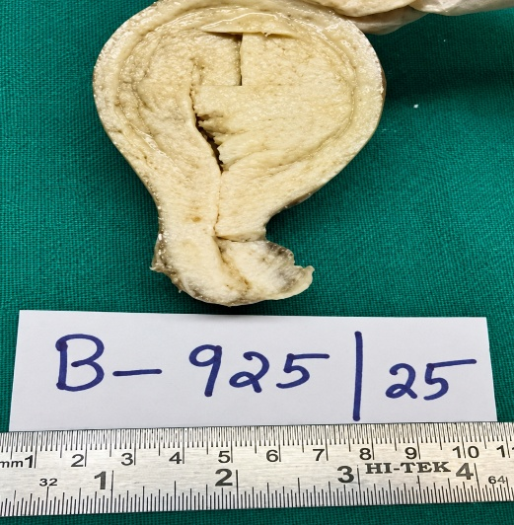
Fig 1: Cut section of the uterus showing blue-black area and Nabothian cyst.

Microscopic Findings
Histological sections of the cervix shows focal polypoidal cervical tissue with focal surface erosion and Nabothian cyst(Fig 2a). Subepithelium shows acute and chronic inflammation and scattered brown pigment laden macrophages in stroma (Fig 2b) These pigment laden macrophages are negative for Prussian blue stain (Iron stain) (Fig 2d).

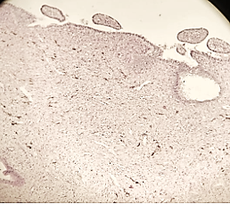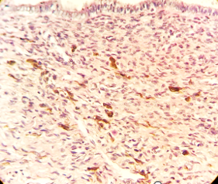
Fig 2b -high power view - H&E showing scattered brown pigment laden macrophages in stroma

Fig 2a -low power view - H&E showing scattered brown pigment laden macrophages in stroma

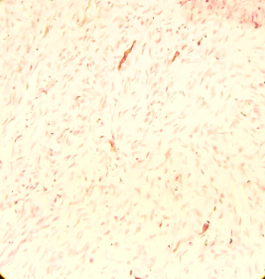
Fig 2c – low power view: Prussian blue stain showing pigment laden macrophages are negative

Although immunohistochemistry was not performed, blue nevi typically express S-100 protein and HMB-45, confirming melanocytic lineage⁵.

Discussion
Blue nevus is a benign melanocytic lesion most commonly encountered in the skin, particularly over the extremities and dorsal surfaces. Involvement of the uterine cervix is exceptionally uncommon, and only isolated case reports and small case series have been documented in the literature^{2,6}. Most cervical blue nevi are identified incidentally during histopathological examination of hysterectomy specimens performed for unrelated gynecological conditions^{5,8}. The lesion is usually asymptomatic and lacks characteristic clinical or radiological findings.
The exact histogenesis of cervical blue nevus remains uncertain. One proposed mechanism suggests aberrant migration of neural crest–derived melanocytes into the Müllerian tract during embryogenesis. Another theory supports melanocytic differentiation of cervical stromal cells through metaplastic transformation⁸. These explanations account for the presence of pigmented dendritic or spindle-shaped melanocytes within the cervical stroma.
Microscopically, cervical blue nevus is characterized by scattered spindle-shaped or dendritic melanocytes containing finely granular melanin pigment embedded within the cervical stroma⁶. The cells are cytologically bland, with inconspicuous nucleoli and absence of significant pleomorphism or mitotic activity. In most reported cases, the lesion remains localized without stromal destruction or infiltrative growth¹⁰. Immunohistochemical studies, when performed, typically demonstrate positivity for S100 and melanocytic markers such as HMB-45 or Melan-A, confirming melanocytic origin¹⁰.
The principal diagnostic consideration is primary malignant melanoma of the cervix, an extremely rare but highly aggressive neoplasm. Distinction between these entities is essential because their clinical implications differ markedly. Unlike blue nevus, malignant melanoma exhibits marked nuclear atypia, increased mitotic activity, pleomorphism, necrosis, and invasive growth⁹. Careful histomorphological assessment therefore plays a crucial role in avoiding overdiagnosis and unnecessary aggressive treatment.
Previously published studies by Tieng and Tavassoli¹ described cervical melanocytic lesions as uncommon incidental findings with benign biological behavior. Similarly, Veras and Malpica⁵ emphasized that most benign melanocytic lesions of the female genital tract are discovered incidentally and carry no adverse prognostic significance. Kaygusuz et al⁶. also highlighted the rarity of cervical blue nevus and stressed the importance of differentiating it from malignant melanoma on histopathological grounds.

Conclusion
Blue nevus of the uterine cervix is a rare benign melanocytic lesion usually detected incidentally during microscopic examination. Although clinically insignificant, recognition of its characteristic histopathological features is important to exclude malignant melanoma of the cervix. Documentation of additional cases contributes to better understanding of its pathogenesis, morphology, and differential diagnosis, thereby improving awareness among pathologists and gynecologists.

References
- Kurman RJ, Ellenson LH, Ronnett BM. Blaustein’s Pathology of the Female Genital Tract. 6th ed. New York: Springer; 2011. p. 253–6.
- Tieng A, Tavassoli FA. Melanocytic lesions of the cervix: a clinicopathologic study of five cases. Int J Gynecol Pathol. 1993;12(1):1–7.
- Miettinen M, Fetsch JF. Evaluation of melanocytic lesions in the female genital tract. Histopathology. 2006;48(1):77–85.
- Tavassoli FA. Melanocytic lesions of the female genital tract. Pathol Annu. 1986;21 Pt 2:327–47.
- Veras E, Malpica A. Melanocytic lesions of the female genital tract: a review. Adv Anat Pathol. 2009;16(6):362–8.
- Kaygusuz EI, Cesur S, Cetiner H, Gündüz U, Güngör T. Blue nevus of the uterine cervix: report of a case and review of the literature. Eur J Gynaecol Oncol. 2006;27(3):297–8.
- Batsakis JG, Rice DH. Extracutaneous melanocytic lesions: occurrence and significance. Ann Otol RhinolLaryngol. 1981;90(1 Pt 1):69–73.
- Park KJ, Soslow RA. Benign melanocytic lesions of the female genital tract. Arch Pathol Lab Med. 2009;133(6):896–903.
- Young RH, Scully RE. Malignant melanoma of the cervix: a clinicopathologic analysis of 13 cases. Am J Surg Pathol. 1989;13(10):777–86.
- Kurita T, Hata K, Nogawa T, Kitamura Y. Blue nevus of the uterine cervix: a case report with immunohistochemical study. Pathol Int. 1994;44(9):696–700.

