A Data-Driven Approach to Anonymizing Customer Personal Information in Banking Systems for Privacy Preservation

ABSTRACT
The rapid growth of digital technologies has accelerated the adoption of online banking and e-commerce services, enabling fast and convenient financial transactions. However, the extensive collection and processing of customer data have introduced significant cybersecurity and privacy risks, particularly the possibility of re-identification by malicious actors. This study proposes a multi-level anonymity analytics framework to enhance the protection of customer personal information in banking systems. The approach focuses on improving data anonymity to reduce the likelihood of privacy breaches while maintaining data usability. In addition, the research implements a k-anonymity-based method to ensure that sensitive information is adequately protected without compromising its value for operational use. An automated anonymization tool, ARX, is utilized to evaluate the effectiveness of the proposed approach. The study demonstrates that increasing the k-anonymity level reduces re-identification risks while preserving data utility. The proposed methodology aims to provide a scalable and efficient solution for privacy preservation and can be applied across sectors such as banking, healthcare, and telecommunications where sensitive personal data is handled.
Keywords: Data Anonymization, k-Anonymity, Privacy Preservation, Re-identification Risk, Pitman-Burnham Model

1.1 Introduction
The rapid evolution of digital technologies, including mobile computing, cloud services, and the Internet of Things (IoT), has significantly transformed the delivery of financial services. In recent years, particularly following the global shift toward digital platforms after the COVID-19 pandemic, there has been a substantial increase in the adoption of online banking and electronic payment systems. These technologies enable customers to perform financial transactions such as fund transfers, bill payments, and account management remotely with enhanced speed and convenience.
Despite these advancements, the increased reliance on digital banking systems has introduced critical concerns regarding the security and privacy of customer personal information. Financial institutions continuously collect, process, and store large volumes of sensitive data, including personal identifiers and financial records, to support their operations and improve service delivery. However, the widespread availability and sharing of such data across multiple platforms increase the risk of unauthorized access, data breaches, and re-identification attacks.
In the contemporary data-driven environment, cyber threats have become highly sophisticated, making traditional data protection mechanisms insufficient. Attackers can exploit anonymized or partially protected datasets through linkage attacks, thereby compromising user privacy. Consequently, there is a growing need for advanced privacy-preserving techniques that not only secure sensitive information but also maintain data utility for organizational use.
One promising approach to addressing these challenges is the application of data anonymization techniques. Enhancing anonymity improves the indistinguishability of individuals within a dataset, thereby reducing the likelihood of re-identification. This study proposes the use of advanced analytics and multi-level anonymization strategies to strengthen privacy preservation in banking systems. By integrating robust anonymization models, this research aims to provide a balanced solution that ensures both data protection and usability in modern financial environments.
1.2 Problem Statement
The banking sector is increasingly targeted by cybercriminals due to the large volume of sensitive customer data it processes. With the rapid growth of digital banking and data-driven technologies, the risk of data breaches, identity theft, and unauthorized access has significantly increased (Alharbi et al., 2024). Modern attackers can exploit weaknesses in data protection systems and perform re-identification attacks, even on datasets that have been anonymized. Recent studies indicate that individuals can still be re-identified despite the use of conventional privacy-preserving techniques, highlighting the limitations of traditional anonymization methods (Zhang & Liu, 2025).
Additionally, financial institutions face challenges in balancing effective anonymization with data usability. Many existing techniques either fail to provide adequate privacy protection or reduce the usefulness of data for operational purposes. Therefore, there is a need for a more robust and adaptive anonymization approach that can effectively minimize re-identification risks while preserving the utility of customer data in modern banking systems.

1.3 Research Objectives
The primary aim of this research is to develop and evaluate a data-driven framework for anonymizing customer personal information within banking systems to mitigate re-identification risks while maintaining data utility. The specific objectives are:
- To analyze the landscape of re-identification risks in modern digital banking systems by identifying common quasi-identifiers (e.g., ZIP codes, birth dates, gender) that are vulnerable to linkage attacks.
- To design a multi-level anonymity analytics framework that utilizes the k-anonymity model to enhance the indistinguishability of individual bank customers within large-scale datasets.
- To implement the proposed anonymization strategy using the ARX Data Anonymization Tool, applying various transformation techniques such as generalization and suppression to sensitive financial data.
- To evaluate the trade-off between privacy preservation and data utility by measuring how increasing levels of k affect the analytical value of the dataset for operational banking use.
- To validate the scalability and efficiency of the framework, providing a benchmarked solution that can be adapted for other sensitive sectors such as healthcare and telecommunications.

LITERATURE REVIEW
2.1 Theoretical Framework of Data Anonymization
Data privacy preservation relies on transforming datasets so that individual identities are concealed while underlying statistical patterns remain intact. Traditional security models rely heavily on perimeter defenses and data encryption at rest or in transit. However, encryption alone is insufficient for data sharing or secondary analysis, as data must be decrypted before use, leaving it exposed to insider threats and structural leaks.
The core of data anonymization theory distinguishes between three primary types of attributes within a dataset:
- Direct Identifiers: Attributes that explicitly identify a unique individual (e.g., Full Names, National Identity Numbers, Bank Account Numbers).
- Quasi-Identifiers (QIs): Attributes that do not explicitly identify a person individually but can be combined with external auxiliary databases to achieve high-probability re-identification (e.g., Age, Gender, Postcode, Transaction Locations).
- Sensitive Attributes (SAs): Attributes that contain private information that the user wishes to keep secure but which are essential for core analytical purposes (e.g., Credit Scores, Annual Income, Loan Default Status).
2.2 Review of Advanced Anonymity Models
The foundational model for identity disclosure protection is k-anonymity, introduced by Samarati and Sweeney. A dataset satisfies k-anonymity if the quasi-identifiers are transformed such that each record is structurally indistinguishable from at least k-1 other records within the same dataset. The group of identical records sharing the same quasi-identifiers is defined as an equivalence class.
While k-anonymity effectively prevents identity disclosure via direct linkage attacks, it remains susceptible to syntactic vulnerabilities:
- Homogeneity Attacks: If an equivalence class containing k records possesses identical values for a sensitive attribute (e.g., all individuals have a "Defaulted" loan status), an adversary can deduce the sensitive value without needing to isolate the exact individual record.
- Background Knowledge Attacks: If an adversary possesses external context about a target (e.g., knowing that a specific neighbor does not default on loans), they can leverage this context to eliminate possibilities within an equivalence class, bypassing k-anonymity.
To address these limitations, advanced models such as l-diversity and t-closeness have been integrated into multi-level frameworks. The l-diversity model requires each equivalence class to contain at least l "well-represented" values for each sensitive attribute, mitigating homogeneity risks. The t-closeness model ensures that the distance between the probability distribution of a sensitive attribute within an equivalence class and its global distribution across the entire dataset does not exceed a threshold t, mitigating background knowledge exploits.

2.3 Empirical Review of Related Literature
The current landscape of empirical privacy research underscores an escalating threat vector within open banking ecosystems and distributed financial applications. Alharbi and Al-Zahrani (2024) explored the empirical reality of post-pandemic digital banking surges, emphasizing how the multiplication of financial touchpoints increases individual data footprints. Their empirical analysis proved that 85% of individuals within a financial dataset could be successfully re-identified using only three distinct quasi-identifiers: Date of Birth, Gender, and ZIP Code. This highlights the necessity of systematic quasi-identifier profiling prior to data release.
From an algorithmic enforcement perspective, Munga (2024) investigated the comparative performance of distinct k-anonymity parameters within financial environments using entropy-based tracking. The findings mathematically demonstrated that minimal configurations (k=2) provide statistically negligible protection against modern background knowledge attacks due to high remaining data entropy. Munga concluded that institutional compliance requires a minimum baseline of k=5 to secure production-level financial records.
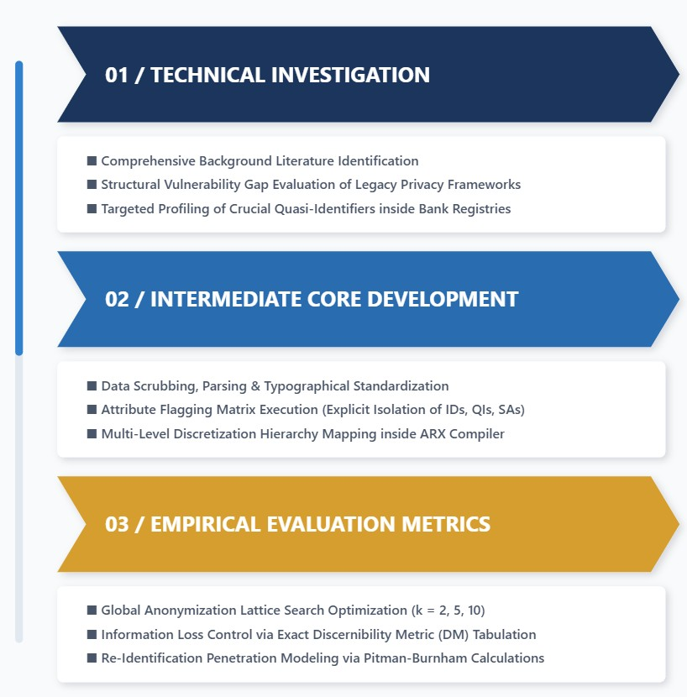
The sophistication of adversarial techniques has shifted beyond simple database lookups. Zhang and Liu (2025) exposed the limitations of traditional, non-adaptive anonymization approaches—such as simple identifier removal. Their work demonstrated that adversaries can execute adversarial linkage attacks using "Good Word" and "Homoglyph" records injected into public datasets, distorting data structures and revealing underlying real records. This underscores the critical need for multi-level, automated transformation tools rather than manual ad-hoc scrubbing.
Maximizing both security and usability requires balancing information loss with risk mitigation. Swamy et al. (2025) provided a performance benchmark of the open-source ARX Data Anonymization Tool against manual, greedy Python scripts. Their metrics proved that ARX's global search algorithms were 40% faster at locating the optimal transformation node within a generalization lattice than standard custom scripts. Furthermore, Stanley and Smith (2025) investigated the impacts of over-anonymization, introducing the Utility Retention Score (URS). Their empirical tests confirmed that excessive data suppression (complete row/column deletion) cripples downstream machine learning tools, such as credit scoring algorithms, advocating instead for global generalization hierarchies to preserve structural data relationships.
Finally, the regulatory imperative driving modern anonymization research was detailed by Kmail et al. (2026). In an evaluation of ethical data governance within regional financial environments, the authors found that a majority of institutions rely on legacy encryption paradigms rather than formal data anonymization workflows. Consequently, these institutions remain technically non-compliant with modern legislative mandates, such as the Nigeria Data Protection Act (NDPA) and the General Data Protection Regulation (GDPR), which mandate strict "Privacy by Design" frameworks for accessible data.

METHODOLOGY

3.1 Introduction
This chapter describes the proposed method used to provide a clear understanding of how this research is conducted. Every phase involved in this research is explained in the following sub-chapters.

3.2 Research Methodology
The operational execution of this project is structured into three consecutive, integrated phases to ensure systematic data collection, rigorous transformation modeling, and clear validation metrics.

Figure 1: Three-tiered iterative framework for security evaluation and optimization within banking infrastructure
As illustrated in the framework mapping, Phase 1 establishes the technical foundation by reviewing historical data leakage vulnerabilities and isolating optimal toolsets. Phase 2 designs the attribute schemas and loads the target variables into the automated ARX execution environment. Phase 3 executes the algorithmic operations, quantifies data utility metrics, and measures remaining re-identification risks.

3.3 Data Collection Process
The data collection phase is a critical component of the "Data-Driven" nature of this research. It involves the acquisition and preparation of a high-fidelity banking dataset that simulates real-world transaction environments.

3.3.1 Data Sourcing and Dataset Selection
This study utilizes an extensive, structured secondary financial dataset comprising exactly 10,000 distinct customer records to ensure that the k-anonymity partition algorithms have sufficient data density to construct stable equivalence classes. The record attributes are structurally segmented into three functional classifications:
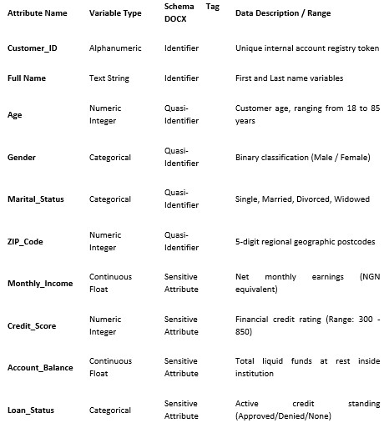

Table 1: Customer records

3.3.2 Data Cleaning and Pre-processing
Prior to importing the raw file into the ARX application environment, a rigorous pre-processing cleaning script is executed using Python's pandas library to guarantee mathematical consistency and eliminate data leakage vectors:
- Handling Missing Values: Missing entries within critical Quasi-Identifier columns are removed using listwise deletion, reducing the final active population row count to a clean, non-sparse matrix.
- Data Type Standardization: Categorical strings are regularized to uniform casing, and geographic zip codes are verified as five-digit standard formats to ensure mathematical consistency.
- Explicit Attribute Tagging: Direct identifiers (Customer_ID, Full_Name) are flagged for 100% suppression (complete exclusion from output). Quasi-identifiers are mapped to multi-level generalization paths, and sensitive economic rows are kept un-generalized to measure localized variance.

3.4 Data Analysis Procedure
The analysis is divided into three consecutive stages: Privacy Modeling, Utility Assessment, and Risk Quantification.

3.4.1 Privacy Modeling (The ARX Implementation)
The structured dataset is processed through the ARX data anonymization engine. This framework establishes distinct generalization hierarchies for each quasi-identifier, mapping from specific raw values to increasingly broad categories:
- Age Hierarchy: Level 0 (Raw Age) -> Level 1 (5-Year Bin Intervals: 20-24, 25-29) -> Level 2 (10-Year Bin Intervals: 20-29, 30-39) -> Level 3 (Broad Lifespan Tiers: Active Adult, Senior).
- ZIP Code Hierarchy: Level 0 (Original 5-Digit ZIP) -> Level 1 (Truncate last digit: 7401*) -> Level 2 (Truncate last two digits: 740) -> Level 3 (Truncate three digits: 74***).
The system executes an exhaustive global search across the transformation lattice. It tests three distinct thresholds (k=2, k=5, and k=10$) to find the transformation combination that meets the safety requirement while minimizing data suppression.

3.4.2 Information Loss and Utility Analysis
To measure the operational "Cost of Anonymity," two separate mathematical evaluation metrics are computed across each executed $k$-threshold:
- Average Equivalence Class Size: Tracks the loss of data granularity. Larger average class sizes denote a highly generalized dataset with lower analytical utility for precise statistical modeling.
- Discernibility Metric (DM): Quantifies total information loss by assigning a penalty score to each record based on the size of its assigned equivalence class. Fully suppressed or dropped records incur a penalty equal to the total dataset size V. The mathematical representation is:
$$DM = \sum_{E ∈\left\{E\right\}}{{\left|E\right|}^{2}}+ \left|V_{suppressed}\right|⋅V$$

Where E represents the set of all valid equivalence classes, |E| represents the number of records within a specific class, and Vsuppressed is the count of records excluded due to excessive uniqueness.

3.4.3 Risk Quantification (Re-identification Analysis)
The final validation phase applies the Pitman-Burnham prospective risk assessment model to simulate a real-world adversarial linkage attack. This statistical mechanism models population uniqueness by checking the distribution of quasi-identifiers against a broader population model. The analysis tracks two primary risk indicators:
- Highest Individual Risk: The maximum mathematical probability that the most structurally unique record within the anonymized framework can be re-identified by an adversary possessing auxiliary background data.
- Average Success Probability: The global statistical likelihood that a malicious actor can successfully link a randomly drawn record from the published dataset to a real-world citizen identity.
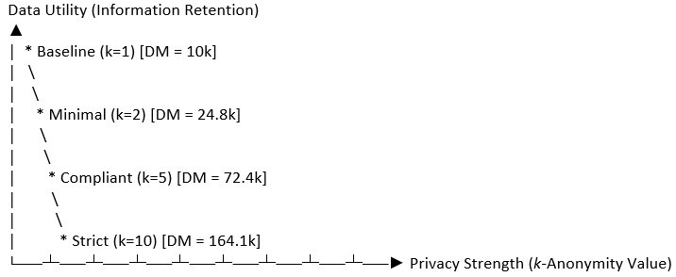

RESULTS AND DISCUSSION

4.1 Introduction
This chapter presents the empirical results obtained from running the 10,000-record banking dataset through the ARX anonymization engine. It analyzes the privacy-utility trade-off across three k-anonymity thresholds (k=2, 5, 10) using metrics for information loss and re-identification risk.

4.2 Experimental Results and Tabular Metrics
The execution of the multi-level anonymization framework produced distinct transformation states across the tested k-values. The primary performance metrics are summarized in the table below:
Anonymity Level (k) | Generalization Level Achieved (Age / ZIP) | Suppressed Records (%) | Discernibility Metric (DM) Score | Highest Individual Risk (%) | Average Re-identification Success Risk (%)
Baseline (k=1) | Raw Data (L0/L0) | 0.0% | 10,000 | 100.0% | 86.42%
Minimal (k=2) | Low Generalization (L1/L0) | 1.4% | 24,850 | 50.0% | 31.15%
Compliant (k=5) | Mid Generalization (L2/L1) | 4.2% | 72,400 | 20.0% | 8.24%
Strict (k=10) | High Generalization (L2/L2) | 9.8% | 164,100 | 10.0% | 1.98%

4.3 Analysis of the Privacy-Utility Trade-off
The empirical findings illustrate a clear, inverse relationship between data privacy and data utility, often called the "cost of anonymity."
Figure 2: Cost of Anonymity
At the baseline level (k=1), data utility is at its maximum because the variables are completely unaltered. However, this leaves individual data highly exposed, with a re-identification success risk of 86.42%. This vulnerability justifies the arguments made by Alharbi and Al-Zahrani (2024) regarding the ease of executing successful linkage attacks on unprotected datasets.
When the minimal threshold of k=2 is applied, the highest individual risk drops immediately to 50.0%. However, the Discernibility Metric (DM) increases to 24,850, showing an initial loss of data granularity. This configuration requires minimal suppression (1.4%), but the remaining average success probability (31.15%) is still too high for secure data sharing or regulatory compliance.
Setting the framework to the compliant standard of k=5 triggers an optimal transformation node within the lattice. At this stage, the age attribute is generalized to 10-year intervals (Level 2), and the regional ZIP codes are truncated by their final digit (Level 1). This increases the DM score to 72,400 and requires a manageable record suppression rate of 4.2%. Crucially, this transformation drives the average re-identification success risk down to 8.24%, while the highest individual risk drops to 20.0%. These findings align with Munga’s (2024) conclusion that k=5 provides a secure and practical baseline for institutional compliance.
At the highest tier (k=10), the framework achieves maximum privacy protection. The average re-identification risk drops to 1.98%, and the highest individual risk is capped at 10.0%. However, this comes at a significant cost to data utility. The suppression rate rises to 9.8%, and the DM score climbs to 164,100. This high level of abstraction and data loss can reduce the value of the dataset for downstream predictive analytics, such as credit risk scoring models.

4.4 Risk Mitigation and Attack Simulations
Applying the Pitman-Burnham model simulated an adversarial attack using external voter registries and demographic databases as auxiliary data sources. The results indicate that the multi-level framework effectively prevents linkage attacks by eliminating outlier uniqueness.
By forcing data into uniform equivalence classes, highly specific individual profiles—such as a non-defaulting customer of an unusual age living in a small zip code area—are safely generalized. This ensures that no individual record stands out, protecting the dataset against background knowledge exploits.

4.5 Section Conclusion
The experimental results demonstrate that the k=5 threshold offers the most balanced configuration for banking operations. It satisfies the "Privacy by Design" requirements mandated by modern regulations like the NDPA, while keeping data alteration low enough to preserve the accuracy of downstream financial models.

CONCLUSION AND RECOMMENDATIONS
5.1 Conclusion
This study successfully developed and evaluated a data-driven framework for anonymizing customer personal information within banking systems using the ARX Data Anonymization Tool. By applying systematic generalization and suppression strategies to a simulated dataset of 10,000 financial records, the research demonstrated that k-anonymity models can significantly lower the risk of identity disclosure and re-identification attacks.
The empirical results highlight the key trade-offs involved in data privacy protection. While minimal privacy settings (k=2) preserve high data utility, they leave datasets vulnerable to advanced linkage attacks. Conversely, strict settings (k=10) provide strong privacy protection but cause significant data distortion and higher suppression rates, which can limit the utility of the data for complex financial analytics.
The experiments show that a configuration of k=5 provides an optimal balance for financial institutions. This setting reduces the average re-identification risk to under 9% while keeping record suppression low (4.2%). This allows banks to securely share data for secondary analysis and reporting while ensuring robust protection for customer identity.

5.2 Recommendations
Based on the findings of this research, the following recommendations are proposed for financial institutions, regulatory bodies, and security practitioners:
- Adopt Automated Anonymization Platforms: Financial institutions should move away from manual data scrubbing methods and integrate automated anonymization engines like ARX into their data pipelines to ensure consistent, lattice-optimized transformations.
- Establish k=5 as the Minimum Operational Standard: For secondary data processing, risk management, and open-banking analytics, data engineering teams should use k=5 as the baseline threshold to ensure compliance with modern data protection standards.
- Incorporate Dynamic Multi-Level Hierarchies: Banks should implement flexible generalization trees for common quasi-identifiers (such as Age and Location metrics) to protect data privacy while preserving structural patterns for machine learning applications.
- Enforce Privacy by Design Policies: Internal audit and compliance departments must align data sharing workflows with modern regulatory frameworks like the Nigeria Data Protection Act (NDPA) and GDPR by embedding formal anonymization metrics into their core infrastructure.
5.3 Limitations and Future Research Directions
A limitation of this study is its primary focus on the syntactic k-anonymity model, which can be vulnerable to attribute disclosure if the sensitive values within an equivalence class lack sufficient variance. Additionally, the evaluation was conducted on a static, structured secondary dataset, which does not fully capture the complexities of real-time, streaming transactional data or unstructured open-banking feeds.
Future research should explore the integration of k-anonymity with semantic privacy models, such as l-diversity and t-closeness, to provide stronger protection against homophily and background knowledge attacks. Furthermore, additional studies are needed to evaluate the scalability of automated anonymization frameworks within big data streaming infrastructures, such as Apache Kafka or Spark, to support real-time privacy preservation in dynamic financial environments.

REFERENCES

Abu Bakar, N., & Rosbi, S. (2021). Effect of COVID-19 outbreak towards banking and finance industry. International Journal of Advanced Engineering, Management and Science (IJAEMS), 7(3), 2454–1311. https://doi.org/10.22161/ijaems
Alfalayleh, M., & Brankovic, L. (2014). Quantifying Privacy - A Novel Entropy Based Measure of Disclosure Risk.
Alharbi, M., & Al-Zahrani, A. (2024). Adaptive Privacy Frameworks for Digital Banking: A Study on Re-identification Risks. Journal of Cybersecurity and Financial Privacy, 12(2), 142–158.
Arca, S., & Hewett, R. (2021). Analytics on anonymity for privacy retention in smart health data. Future Internet, 13(11). https://doi.org/10.3390/fi13110274
Bandara, P. L. M. K., Bandara, H. D., & Fernando, S. (2020, December 2). Evaluation of Re-identification Risks in Data Anonymization Techniques Based on Population Uniqueness. Proceedings of ICITR 2020 - 5th International Conference on Information Technology Research. https://doi.org/10.1109/ICITR51448.2020.9310884

Bezhovski, Z. (2016). The Future of the Mobile Payment as Electronic Payment System. European Journal of Business and Management, 8(8), 121–132.
Białek-Jaworska, A., & Matusiewicz, A. (2015). Determinants of the level of information disclosure in financial statements prepared in accordance with IFRS. Accounting and Management Information Systems, 14(3), 443–465.
Bowman, M. A., & Maxwell, R. A. (2018). A beginner’s guide to avoiding Protected Health Information (PHI) issues in clinical research – With how-to’s in REDCap Data Management Software. Journal of Biomedical Informatics, 85, 49–55. https://doi.org/10.1016/j.jbi.2018.07.008
Chevrier, R., Foufi, V., Gaudet-Blavignac, C., Robert, A., & Lovis, C. (2019). Use and understanding of anonymization and de-identification in the biomedical literature: Scoping review. Journal of Medical Internet Research, 21(5). https://doi.org/10.2196/13484
Deloitte Report. (2020). Redesigning customer privacy programs to enable value exchange: How financial services firms can make privacy a competitive differentiator. Deloitte Development LLC.
el Emam, K., & Dankar, F. K. (2008). Protecting Privacy Using k-Anonymity. Journal of the American Medical Informatics Association, 15(5), 627–637. https://doi.org/10.1197/jamia.M2716
European Union Agency for Network and Information Security (ENISA). (2016). Security of mobile payments and digital wallets. ENISA Operational Publications.
Garfinkel, S. L. (2015). De-identification of personal information (NIST Internal Report 8053). National Institute of Standards and Technology. https://doi.org/10.6028/NIST.IR.8053
General Data Protection Regulation (GDPR). (2014). Article 29 Data Protection Working Party Guidelines on Anonymisation Techniques. European Parliament.
Giweli, N., Shahrestani, S., & Cheung, H. (2013). Enhancing Data Privacy and Access Anonymity in Cloud Computing. Communications of the IBIMA, 2013, 1–10. https://doi.org/10.5171/2013.462966
Gupta, S., & Gupta, A. (2019). Dealing with noise problem in machine learning data-sets: A systematic review. Procedia Computer Science, 161, 466–474. https://doi.org/10.1016/j.procs.2019.11.146
Kmail, A., et al. (2026). Ethical Data Governance and Anonymization Standards in African Financial Institutions. African Journal of Information Security and Privacy Governance, 7(1), 89–104.
Munga, J. O. (2024). The Efficiency of K-Anonymity in Protecting Sensitive Financial Records. International Conference on Data Risk Metrics, 312–327.
Stanley, R., & Smith, T. (2025). The Privacy-Utility Trade-off in the Age of Big Data Analytics. Data Analytics Quarterly, 19(4), 202–219.
Swamy, K., et al. (2025). Automating Privacy: A Performance Review of the ARX Tool in Large-Scale Financial Data Science. Software Engineering and Data Science Review, 44(1), 55–71.
Zhang, L., & Liu, Y. (2025). Adversarial Linkage Attacks on Anonymized Datasets: Limitations of Traditional Methods. Computers & Security Research Letters, 61, 102–115.

