RISK ASSOCIATED WITH MANAGEMENT OF ENGINEERING PROJECTS USING INTELLIGENT BASED CONTROL SYSTEM

Abstract
Some abandoned Engineering projects observed in some parts of the country this present era has arisen as a result of these factors Scope Creep, Schedule Delays, Budget Overruns, Safety Hazards, Technical Challenges and Additional Risk Factors. This is surmounted by introducing reducing risk associated with management of engineering projects using intelligent based control system. To achieve this, it was done in this manner, characterizing and establishing the causes of the risk associated with management of engineering projects, designing a conventional SIMULINK model for the risk associated with management of engineering projects, designing management rule base that will reduce the percentage of the risk associated with management of engineering projects, training ANN in the management rule base to enhance the efficacy of reducing the percentage of the risk associated with management of engineering projects, developing an algorithm that will implement the process, designing a SIMULINK model for reducing risk associated with management of engineering projects using intelligent based control system and validating and justifying the percentage improvement in the reduction of risk associated with management of engineering projects with and without intelligent based control system. The results obtained are the conventional Scope Creep that caused risk associated with management of engineering project was12%. On the other hand, when an intelligent based control system was introduced in the system, the percentage of risk observed in management of engineering project was reduced to10.4%, the conventional Safety Hazards that caused high risk associated with management of engineering projects was7%. However, when an intelligent based control system was integrated in the system the risk associated with management of engineering projects reduced to6.07% and the conventional Additional Risk Factors that caused risk associated with management of engineering projects was32% while when an intelligent based control system was imbibed in the system, it wittingly reduced to27.75%. Finally, with these results obtained, it shows that the percentage improvement in the reduction of risk associated with management of engineering projects when an intelligent based control system was integrated in the system over the conventional competitor was 4.25%.
Keyword, Reducing, risk, associated, management, engineering, project, intelligent, based, control, system
1.-0 INTRODUCTION
Engineering projects are inherently complex, often involving intricate designs, tight deadlines, and significant financial investments. Throughout the project lifecycle, various uncertainties and challenges can arise, leading to significant risks that can impact project success. These risks can manifest as schedule delays, budget overruns, safety hazards, and ultimately, project failure. This paper explores the potential of intelligent control systems to mitigate these risks and enhance the overall management of engineering projects. By leveraging artificial intelligence (AI) and machine learning (ML) techniques, intelligent control systems can offer a data-driven approach to project management, enabling proactive risk identification, mitigation strategies, and improved decision-making. We will delve into the specific functionalities of intelligent control systems and how they can be applied to various aspects of engineering project management. We will explore how these systems can:
- METHODOLOGY
To characterize and established the causes of the risk associated with management of engineering projects
Tabe1 characterize and established the causes of the risk associated with management of engineering projects
S/N | Causes of risk associated with management of engineering projects | Causes of risk associated with management of engineering projects (%)
1 | Scope Creep | 12
2 | Schedule Delays: | 8
3 | Budget Overruns: | 13
4 | Safety Hazards: | 7
5 | Technical Challenges: | 28
6 | Additional Risk Factors | 32

To design a conventional SIMULINK model for the risk associated with management of engineering projects

Fig 1 conventional SIMULINK model for the risk associated with management of engineering projects
The results obtained are as shown in figures9 through14.
To design management rule base that will reduce the percentage of the risk associated with management of engineering projects
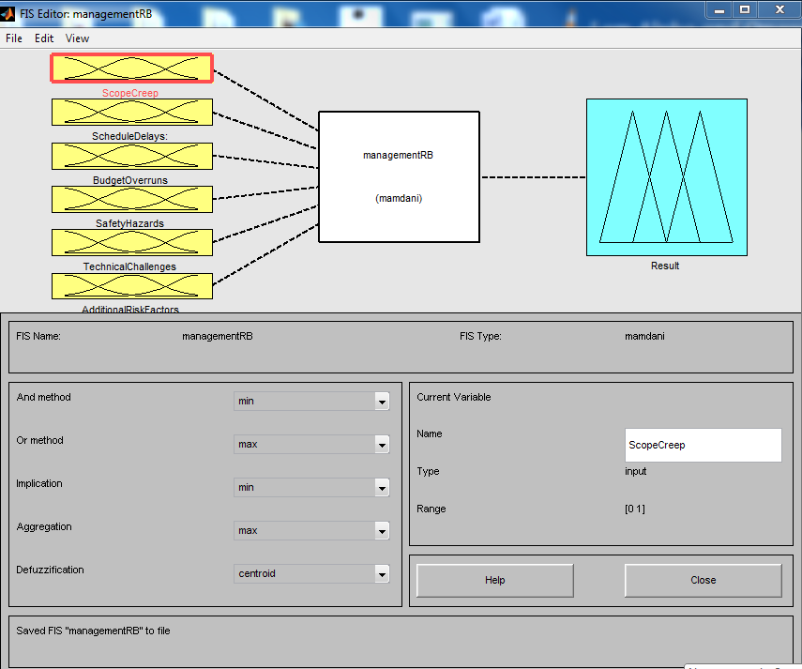
Fig 2 designed management fuzzy inference system that will reduce the percentage of the risk associated with management of engineering projects
Fig 2 has six inputs of the core causes of risk associated with management of engineering projects. These inputs ate Scope Creep, Schedule Delays, Budget Overruns, Safety Hazards, Technical Challenges and Additional Risk Factors. It also has an output result.

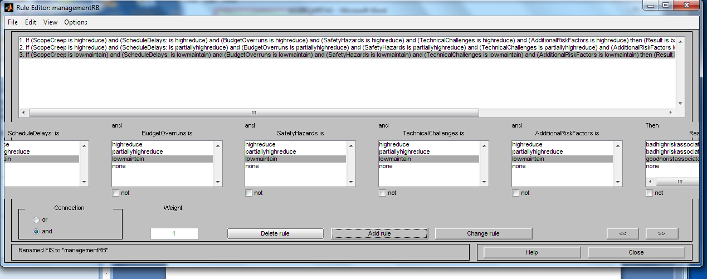
Fig 3 designed management rule base that will reduce the percentage of the risk associated with management of engineering projects
These rules are comprehensively written in table 2

Table 2 comprehensive management rule base that will reduce the percentage of the risk associated with management of engineering projects
1 | if Scope Creep is high reduce | And Schedule Delays is high reduce | And Budget Overruns is high reduce | And Safety Hazards is high reduce | And Technical Challenges is high reduce | And Additional Risk Factors is high reduce | Then result is bad high risk associated with Engineering management project
2 | if Scope Creep is partially high reduce | And Schedule Delays is partially high reduce | And Budget Overruns is partially high reduce | And Safety Hazards is partially  high reduce | And Technical Challenges is partially  high reduce | And Additional Risk Factors partially  is high reduce | Then result is bad high risk associated with Engineering management project
3 | if Scope Creep is low maintain | And Schedule Delays is low maintain | And Budget Overruns is low maintain | And Safety Hazards is low maintain | And Technical Challenges is low maintain | And Additional Risk Factors is low maintain | Then result is good no risk associated with Engineering management project

Fig 4 management rule base in operation to reduce the percentage of the risk associated with management of engineering projects
To train ANN in the management rule base to enhance the efficacy of reducing the percentage of the risk associated with management of engineering projects
Fig 5 trained ANN in the management rule base to enhance the efficacy of reducing the percentage of the risk associated with management of engineering projects
In fig 5, it shows that ANN was trained twenty times in the three management rules
Fig 6 trained ANN in the management rule base to enhance the efficacy of reducing the percentage of the risk associated with management of engineering projects
In fig 6 ANN was trained twenty times in the three management rules 20 x 3 =60 to give sixty neurons that look exactly like human brain that performs effectively what it is instructed to do.

Fig 7 result obtained at the course of the training.

To develop an algorithm that will implement the process.
  - Characterize the causes of the risk associated with management of engineering projects
  - Establish the causes of the risk associated with management of engineering projects
  - Identify high percentage of Scope Creep.
  - Identify high percentage of Schedule Delays.
  - Identify high percentage of Budget Overruns.
  - Identify high percentage of Safety Hazards
  - Identify high percentage of Technical Challenges
  - Identify high percentage of Additional Risk Factors
  - Design a conventional SIMULINK model for the risk associated with management of engineering projects and integrate 3 through 8
  - Design management rule base that will reduce the percentage of the risk associated with management of engineering projects
  - train ANN in the management rule base to enhance the efficacy of reducing the percentage of the risk associated with management of engineering projects
  - Integrate 10 and 11.
  - Integrate 12 in 9.
  - Do the high percentage of the established causes of the risk associated with management of engineering projects reduce?.
  - If NO go to 13
  - If YES go to 17
  - Reduced risk associated with management of engineering projects
  - Stop.
  - End

To design a SIMULINK model for reducing risk associated with management of engineering projects using intelligent based control system
Fig 8 designed SIMULINK model for reducing risk associated with management of engineering projects using intelligent based control system
The results obtained after the simulation of fig 8 are as shown in figures 9 through 14

To validate and justify the percentage improvement in the reduction of risk associated with management of engineering projects with and without intelligent based control system.
To find percentage reduction of Scope Creep causes of risk associated with management of engineering projects with intelligent based control system
Conventional Scope Creep causes of risk associated MEP =12%
Intelligent based control system Scope Creep causes of risk associated MEP =10.41%
% reduction of Scope Creep causes of risk associated with management of engineering projects with intelligent based control system =
Conventional Scope Creep causes of risk associated MEP - Intelligent based control system Scope Creep causes of risk associated MEP
% reduction of Scope Creep causes of risk associated with management of engineering projects with intelligent based control system = 12 %– 10.4%
% reduction of Scope Creep causes of risk associated with management of engineering projects with intelligent based control system = 1.6%

3.0 Result and Discussion
Table 3 comparisons of conventional andintelligent based control system Scope Creep causes of risk associated with management of engineering project
Time(s) | Conventional Scope Creep causes of risk associated with management of engineering projects (%) | Intelligent based control system Scope Creep causes of risk associated with management of engineering projects (%)
1 | 12 | 10.4
2 | 12 | 10.4
3 | 12 | 10.4
4 | 12 | 10.4
10 | 12 | 10.4

Fig 9 comparisons of conventional andintelligent based control system Scope Creep causes of risk associated with management of engineering project
In fig 9 the conventional Scope Creep that caused risk associated with management of engineering project was12%. On the other hand, when an intelligent based control system was introduced in the system, the percentage of risk observed in management of engineering project was reduced to10.4%.

Table 4 comparisons of conventional andintelligent based control system Schedule Delays causes of risk associated with management of engineering project
Time(s) | ConventionalSchedule Delays causes of risk associated with management of engineering projects (%) | Intelligent based control system Schedule Delays causes of risk associated with management of engineering projects (%)
1 | 8 | 6.94
2 | 8 | 6.94
3 | 8 | 6.94
4 | 8 | 6.94
10 | 8 | 6.94

Fig 10 comparisons of conventional andintelligent based control system Schedule Delays causes of risk associated with management of engineering project
The conventional Schedule Delays that caused risk associated with management of engineering projects was 8%.Meanwhile, when an intelligent based control system was introduced in the system the Schedule Delays that caused a lot of risk in management of engineering projects drastically reduced to 6.94%.

4.0 Conclusion
management of engineering projects, designing a conventional SIMULINK model for the risk associated with management of engineering projects, designing management rule base that will reduce the percentage of the risk associated with management of engineering projects, training ANN in the management rule base to enhance the efficacy of reducing the percentage of the risk associated with management of engineering projects, developing an algorithm that will implement the process, designing a SIMULINK model for reducing risk associated with management of engineering projects using intelligent based control system and validating and justifying the percentage improvement in the reduction of risk associated with management of engineering projects with and without intelligent based control system.The results obtained are the conventional Scope Creep that caused risk associated with management of engineering project was12%. On the other hand, when an intelligent based control system was introduced in the system, the percentage of risk observed in management of engineering project was reduced to10.4%, the conventional Safety Hazards that caused high risk associated with management of engineering projects was7%. However, when an intelligent based control system was integrated in the system the risk associated with management of engineering projects reduced to6.07% and the conventional Additional Risk Factors that caused risk associated with management of engineering projects was32% while when an intelligent based control system was imbibed in the system, it wittingly reduced to27.75%. Finally, with these results obtained, it shows that the percentage improvement in the reduction of risk associated with management of engineering projects when an intelligent based control system was integrated in the system over the conventional competitor was 4.25%.

References
Project Management Institute. A Guide to the Project Management Body of Knowledge (PMBOK Guide). 6th Edition, Project Management Institute, 2017.
Chapman, C. Risk Assessment and Management.Routledge, 2008.
Baccarini, David P. “The Body of Knowledge for Risk Management in Projects.” Project Management Journal, vol. 41, no. 2, 2010, pp. 5–18.
Liu, S., & Wang, Y. (2012). A fuzzy logic based risk assessment model for construction projects. Expert Systems with Applications, 39(2), 1803-1812.
El-Gohary, A. M., & El-Sawy, A. (2014).Applying machine learning for risk assessment in construction projects. Automation in Construction, 41, 102-111.
Tabrizi, B. H., Moslemian, E., &Nasirzadeh, A. (2011).Risk assessment using artificial neural networks in construction projects. Neural Computing and Applications, 20(3), 403-411.
Wang, Y., Zhang, Y., & Liu, S. (2016). A hybrid approach for risk assessment of construction projects based on fuzzy logic and neural networks. Automation in Construction, 62, 1-11.
Amini, M. H., Tavakkoli, M., &Rezania, M. (2014).Applying artificial neural networks for risk assessment in construction projects. International Journal of Project Management, 32(6), 1028-1040.
Lee, I., & Kim, J. S. (2016).A risk assessment model using machine learning for construction projects. Automation in Construction, 70, 17-27.
Li, H., Liu, G., & Wang, J. (2018). A cloud-based framework for risk management in construction projects using BIM and machine learning. Automation in Construction, 87, 1-12.
Bendeković, J., &Šarčević, M. (2018). Machine learning approaches for risk assessment in complex engineering projects. International Journal of Project Management, 36(4), 590-6

