Latent Diffusion Try-On with Persona-Aware Contextual Reviews

Murugeswari P¹
Artificial Intelligence and Data Science Karpagam College of Engineering Coimbatore, Tamil Nadu, India murugeswari.p@kce.ac.in
Balavishanth D²
Artificial Intelligence and Data Science Karpagam College of Engineering Coimbatore, Tamil Nadu, India balavishanth12@gmail.com
Naveen Karthikeyan K J³ Artificial Intelligence and Data Science
Karpagam College of Engineering Coimbatore, Tamil Nadu, India naveenkarthikeyan88@gmail.com
Rajesh M⁴
Artificial Intelligence and Data Science Karpagam College of Engineering Coimbatore, Tamil Nadu, India rajeshsumathi124@gmail.com

Abstract—The rapid growth of online apparel shopping has intensified challenges related to visual uncertainty, generic user feedback, and high product return rates. To address these issues, this paper proposes a comprehensive GenAI-driven virtual try- on framework that integrates Latent Diffusion Models (LDMs), multimodal large language models, personalized recommendation mechanisms, and fashion trend analysis. The proposed system enables high-fidelity virtual garment try-on by accurately pre- serving clothing texture, geometry, and lighting while adapting to individual user appearance and pose. By combining computer vision techniques with generative modeling, the framework en- hances the realism and reliability of virtual try-on results, thereby improving user confidence in online purchasing decisions.
Beyond visual simulation, the system introduces persona-aware contextual review generation, smart garment recommendation, and trend-informed decision support. Multimodal embeddings derived from try-on outputs, user persona attributes, and occa- sion context are utilized to generate personalized reviews and rank garment recommendations using content-based similarity and style-aware filtering. Additionally, a trend analysis module identifies emerging fashion patterns through embedding clus- tering and frequency-based analysis, allowing the system to incorporate real-world fashion dynamics into its outputs. Exper- imental evaluation demonstrates that the proposed end-to-end framework effectively reduces shopping uncertainty and offers a more immersive, personalized, and data-driven online fashion experience, making it suitable for next-generation intelligent e- commerce platforms.
Index Terms—Virtual Try-On, Latent Diffusion Models, Fash- ion Technology, Persona-Aware Contextual Reviews, Multimodal Artificial Intelligence, Human Pose Estimation, CLIP-Based Rec- ommendation System, Generative AI

- Introduction
The rapid expansion of online fashion retail has intensified challenges related to garment visualization and purchasing uncertainty. Unlike physical stores, online platforms cannot provide realistic fitting experiences, leading to mismatched ex- pectations, reduced consumer trust, and increased return rates. Existing solutions rely on static product images, size charts, or model photographs, which fail to reflect individual body
shapes and pose variations. Consequently, there is a growing demand for intelligent virtual try-on (VTON) systems capable of replicating realistic garment fitting in digital environments. Recent advancements in computer vision and generative
modeling have significantly improved VTON performance. Early approaches based on geometric warping and GAN-based synthesis achieved partial success but often suffered from texture distortion, pose misalignment, and identity inconsis- tencies. Latent diffusion models (LDMs) have demonstrated superior image synthesis quality by performing denoising in compressed latent space, enabling improved structural consis- tency and visual realism. Despite these advancements, most existing VTON frameworks primarily focus on image gen- eration, neglecting personalization, contextual reasoning, and user-centric fashion interpretation.
Furthermore, limited research attempts to unify visual syn- thesis, user persona modeling, contextual feedback, recom- mendation strategies, and trend awareness within a single framework. Current solutions treat these components indepen- dently, resulting in fragmented user experiences. Addressing this gap, this paper proposes a persona-aware latent diffusion- based virtual try-on system integrated with contextual review generation, intelligent recommendations, and trend-aware an- alytics. The proposed framework combines pose-conditioned diffusion synthesis with multimodal reasoning to deliver re- alistic try-on outputs alongside interpretable and personalized fashion insights.
The key contributions of this work are summarized as follows:
- A pose-aware latent diffusion-based VTON framework incorporating human parsing, keypoint alignment, and garment warping for high-fidelity synthesis.
- A multimodal visual-semantic embedding module for extracting fashion-aware features from generated try-on outputs.

- A persona-aware contextual review generator producing interpretable and situation-specific fashion feedback.
- A similarity-driven recommendation system integrating content-based filtering with user persona adaptation.
- A trend-aware analytics module that incorporates emerg- ing fashion patterns into recommendation and review generation.
- Related Work
The fast growth of fashion e-commerce has encouraged extensive research into virtual try-on systems and intelligent fashion assistance. The current state-of-the-art methods can be broadly classified into three categories: image-based vir- tual try-on methods, generative model-based techniques, and multimodal fashion recommendation systems.
- Early Image-Based and Generative Virtual Try-On Ap- proaches
Early virtual try-on systems relied on geometric warping and pixel-level synthesis, as demonstrated by VITON, which employed a coarse-to-fine architecture for pose-aware garment transfer [3]. Later semantic alignment strategies improved texture consistency [4]. Diffusion-based models subsequently enhanced realism through probabilistic generation [1], while latent diffusion improved efficiency and fidelity in compressed latent space [2], establishing a stronger foundation for modern VTON systems.
- Diffusion-Based Virtual Try-On and Feature Fusion
Diffusion-based VTON models incorporate feature fusion to jointly condition pose maps, garment embeddings, and semantic cues during denoising. Cross-attention layered fusion improves structural alignment and texture preservation [7]. Slot-based attention and pose-guided diffusion further dis- entangle clothing and identity representations for consistent synthesis [6], [8]. Such multimodal fusion enhances realism and reduces artifacts.
- Multimodal Fashion Understanding and Recommendation
Multimodal fashion understanding combines visual and textual embeddings for personalized recommendation. Vision– language models such as CLIP align garment images with semantic descriptions, enabling content-based retrieval and explainable suggestions [10], [13]. Large language models further capture user preferences and contextual intent for personalized reasoning [11], [12]. Such fusion enhances rec- ommendation relevance and interpretability.
- Persona-Aware Fashion Feedback and Contextual Reason- ing
Persona-aware fashion feedback incorporates user identity, preferences, and context to generate adaptive insights. Large language models enable multimodal reasoning by synthesizing visual and semantic cues conditioned on user intent [11]. Multimodal personalization frameworks integrate embeddings with user metadata for tailored explanations [12]. Explainable mechanisms further enhance transparency and trust [13].
- Proposed Methodology
- System Overview and Architecture
The proposed framework is an end-to-end GenAI-driven vir- tual try-on system integrating computer vision, latent diffusion synthesis, and multimodal reasoning. As shown in Fig. 1, the pipeline includes image acquisition, pose-aware preprocessing, diffusion-based garment generation, and persona-conditioned semantic analysis. The modular architecture enables scalable interaction between visual synthesis, contextual review gener- ation, and recommendation components.
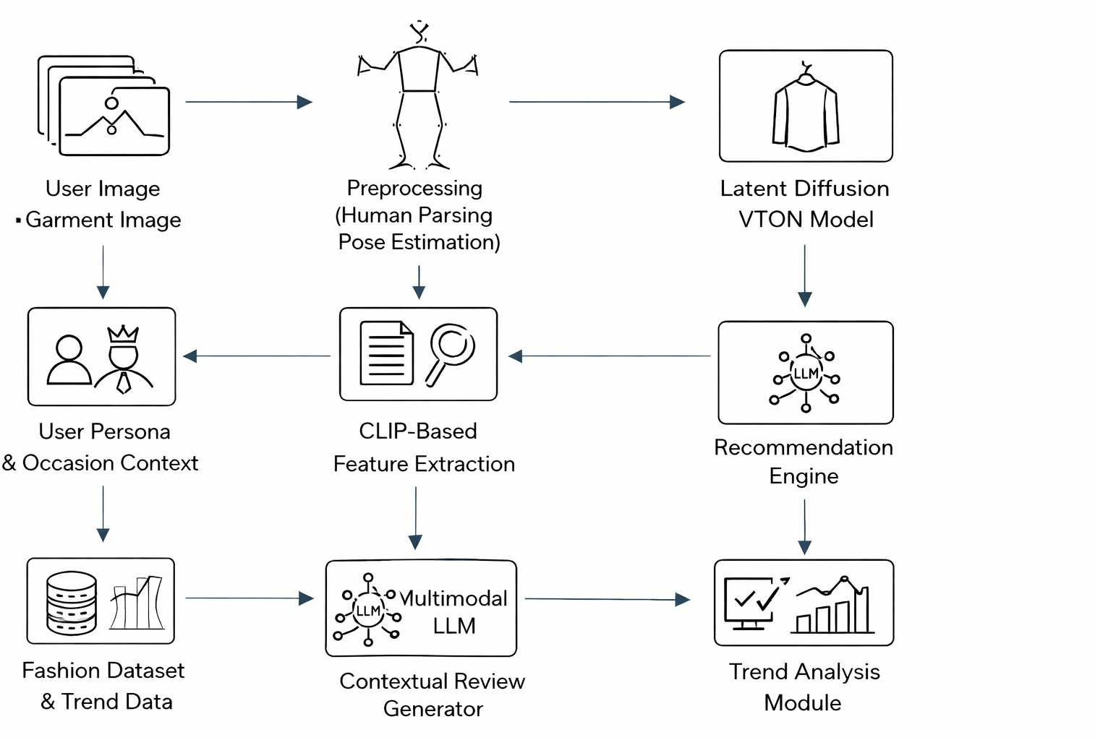
Fig. 1. System Architecture

- Problem Formulation and Input Representation
The task is formulated as a conditional generative mapping that synthesizes a realistic try-on image from a user image I_{u} and garment image I_{g}, while preserving pose and texture consistency. As illustrated in Fig. 2, I_{u} is decomposed into parsing maps and keypoints, and I_{g} provides style embeddings for diffusion-based conditioning.
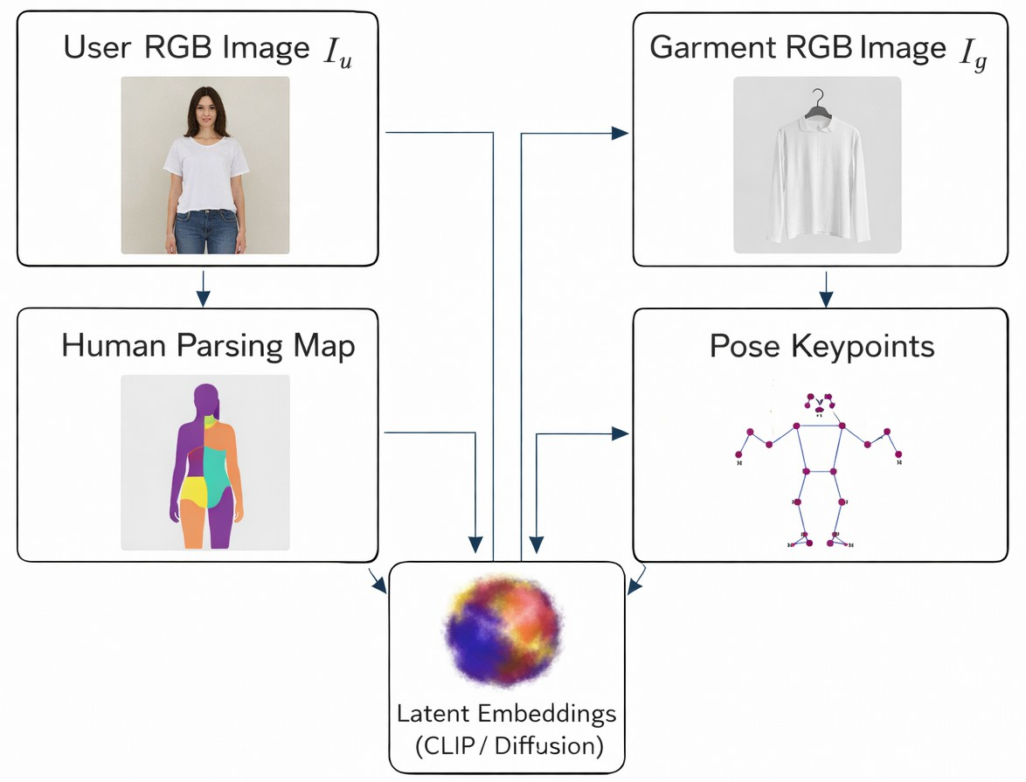
Fig. 2. Input Representation

- Image and Pose Preprocessing
Image and pose preprocessing establish structural priors for accurate garment alignment. Given a user image I_{u}, fine- grained human parsing segments key body regions, followed

by 2D pose estimation to extract skeletal keypoints. These spa- tial representations provide pose-aware constraints, enabling robust garment alignment and synthesis under diverse body shapes and pose variations.
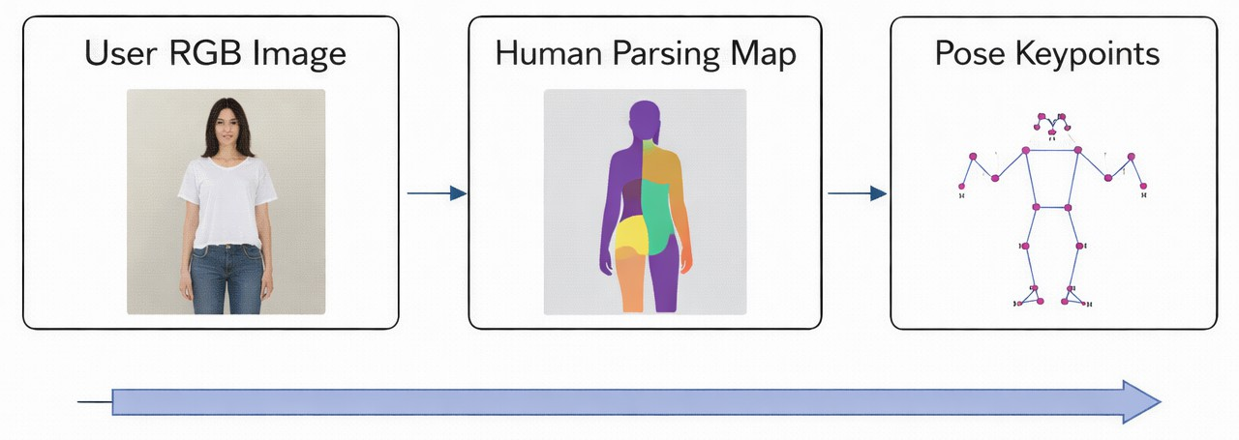
Fig. 3. Image and Pose preprocessing.

As illustrated in Fig. 3, the extracted parsing maps and key- points facilitate precise geometric correspondence between the user body and garment, significantly reducing misalignment artifacts in subsequent diffusion-based try-on generation.

D. Latent Diffusion–Based Virtual Try-On Model

major training criterion focuses on minimizing the prediction of noise error between the target noise ϵ and the predicted ϵ_{θ} noise, which is given by:
2
L_{diff} = E_{x} _{,ϵ} ϵ − ϵ_{θ}(x_{t}, c) (2)
t
To further improve the perception quality and consistency of the garment, additional losses are used, which include the perception loss and the garment mask consistency loss to improve the texture synthesis accuracy.
- Cross-Attention Conditioning Mechanism
The latent diffusion model for effectively fusing garment appearance with human pose and body structure incorporates cross-attention layers at multiple denoising stages. This allows the model to selectively attend to garment texture features while preserving identity-related regions such as the face, hair, and body shape.
Let Q represent latent image queries and K, V represent garment-conditioned features. Cross-attention is computed as:
QKT
Attention(Q, K, V ) = softmax
√d
V (3)

The proposed model employs latent diffusion to gener- ate photorealistic try-on images while preserving structural consistency. Operating in compressed latent space improves efficiency and fidelity. As shown in Fig. 4, the forward process perturbs the clean latent x₀ into noisy latent x_{t} using a predefined noise schedule, enabling iterative denoising for conditioned synthesis.This process is formally defined as:
x_{t} = √α_{t}x₀ + √1 − α_{t}ϵ, (1)
where ϵ (0, I) and α_{t} controls the variance at each dif- fusion step. During reverse diffusion, a UNet-based denoising network predicts the noise component ϵ_{θ}(x_{t}, c) conditioned on pose maps, human parsing masks, and warped garment features. Cross-attention layers enable effective fusion of gar- ment texture and body geometry, resulting in realistic and structurally consistent try-on images.
~ N
This mechanism enhances the fine-grained texture transfer, gets rid of background interference, and improves the garment- body alignment under complex poses.
- Persona and Context Encoding Mechanism
User persona and contextual intent are encoded as textual prompts and conditioning vectors for multimodal reasoning. Persona attributes control stylistic tone and terminology, while contextual factors define situational relevance. These embed- dings are fused with visual features from generated try-on images, enabling personalized explanations and context-aware recommendations aligned with individual user preferences.
  - Visual Realism Score: The realism score is a measure that characterizes the texture clarity and the removal of arti- facts by evaluating the generated images based on references:

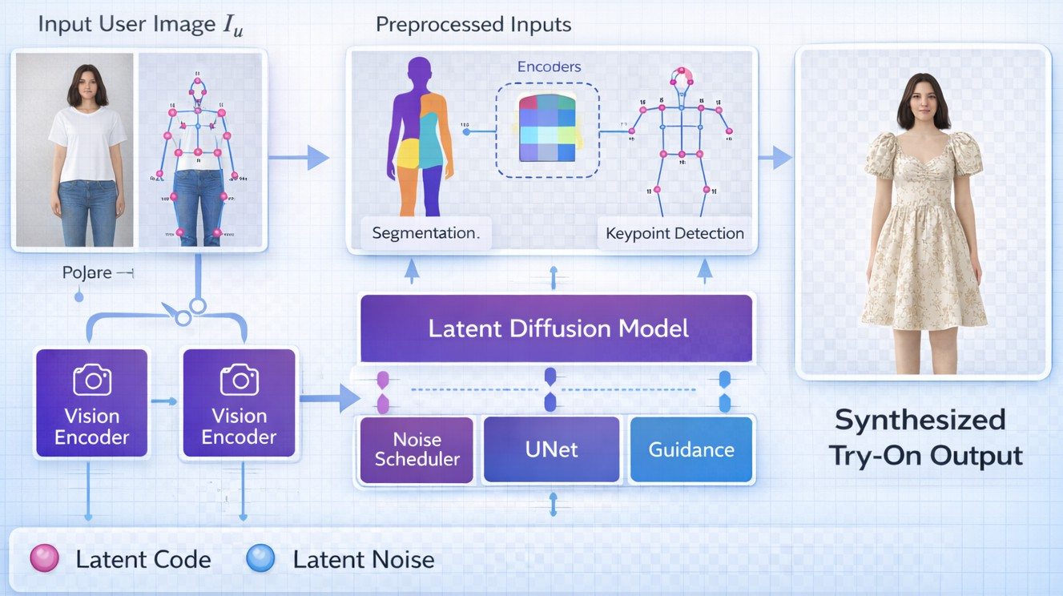
Srealism
= 100 1 − min DFID , 1 (4)

where D_{F} _{ID} denotes the Fre´chet distance between gener- ated and reference features.
Dmax
  - Pose Consistency Score: Pose consistency: This checks the alignment of the original pose and the generated output.
P_{i} − Pˆi

S_{pose} = 100
N
1
1 Σ
—
N
i=1
Pmax !
(5)

Fig. 4. Architecture of the latent diffusion-based virtual try-on model

- Loss Functions and Optimization Strategy
The latent diffusion model’s optimization process relies on a combination of reconstruction and perceptual losses. The
where P_{i} and Pˆi represent input and generated pose vectors.
  - Garment Alignment Score: Alignment of Garments: Garment alignment measures overlap between warped garment masks and generated clothing regions:
S_{align} = 100 × IoU(M_{warp}, M_{gen}) (6)

  - Style Coherence Score: Style coherence calculates visual similarity between a garment and a generated model using cosine similarity:
S_{style} = 100 × cos(E_{g}, E_{i}) (7)
- Weighted Fashion Suitability Score
The final suitability score is computed as:
Sfinal = w1Srealism + w2Spose + w3Salign + w4Sstyle (8) subject to:
w₁ + w₂ + w₃ + w₄ = 1 (9)

TABLE I
Virtual Try-On Evaluation Criteria

Metric | Score Range | Weight
Visual Realism | 0–100 | 0.35
Pose Consistency | 0–100 | 0.25
Garment Alignment | 0–100 | 0.20
Style Coherence | 0–100 | 0.20

- Persona-Aware Review and Recommendation Interface
  - Persona Selection Module: Users can choose personas, like casual shopper or fashion-aware user. The selection of persona dynamically changes the review’s tone, depth, and style of explanation generated by the multimodal language model.
  - Contextual Fashion Review Generation: The system offers real-time fashion feedback, based on the use of visual embeddings and persona context. Reviews of the designs are based on fit quality, style balance, color harmony, and appropriateness for the purpose.
  - Recommendation and Trend Analysis Dashboard: The post-generation recommendations then focus on providing visually similar items, outfit complements, and trending styles, with CLIP similarity search providing the required function- ality. This dashboard enables informed decision-making.
  - Recommendation Scoring and Ranking: Recommended garments are ranked using their cosine similarity in CLIP Embedding Space. Let E_{q} denote the embedding of the input try-on image and E_{j} denote the embedding of all garments. The similarity score is calculated as:
S_{rec}(j) = cos(E_{q}, E_{j}) (10)
Trend awareness is also utilized to guarantee garments fit trends. The ranking process is a balancing act among visual, user, and trend weights to generate contextually relevant recommendations.
- Results and Discussion
- Virtual Try-On Model Comparison
To evaluate the performance of the proposed latent diffusion-based virtual try-on system, a comparative analysis was conducted against existing state-of-the-art models includ- ing CP-VTON and HR-VITON. The evaluation considers both visual quality and overall fashion suitability.
TABLE II
Comparison of Virtual Try-On Models

Model | Generation Type | FID Score ↓ | Suitability Score ↑
CP-VTON | GAN | 31.4 | 0.11
HR-VITON | GAN | 27.9 | 0.14
Proposed LDM-VTON | Diffusion | 21.6 | 0.17

As shown in Table II, the proposed latent diffusion-based virtual try-on model outperforms existing GAN-based ap- proaches in both visual realism and overall suitability score. The lower FID score indicates improved image fidelity and re- duced artifacts, while the higher suitability score demonstrates better garment alignment, pose consistency, and semantic style preservation.
These results validate the effectiveness of latent diffusion models for generating realistic and context-aware virtual try- on outputs compared to traditional generative methods.

- Try-On Output Analysis
System output was realistic in figure try-on images with accurate garment placement and texture preservation over varied poses. Fig. 5 depicts output images as an example that indicates clear garment contour alignment with body structure.
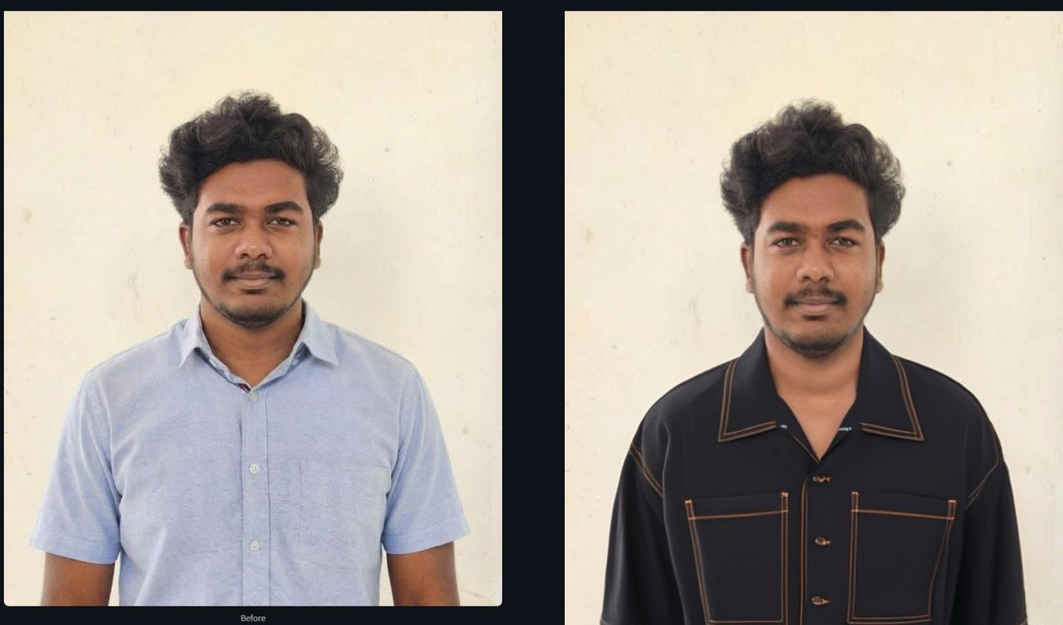

Fig. 5. Generated virtual try-on output with pose-consistent garment align- ment

The effectiveness of improved pose handling, reduced boundary artifacts, and enhanced cloth deformations was ver- ified through visual inspections in comparison with traditional image-warping approaches.

- Garment Alignment and Pose Consistency
Garment alignment accuracy was quantified using Intersec- tion over Union (IoU) between warped garment masks and synthesized clothing regions. Pose consistency was evaluated by measuring keypoint deviation between input poses and generated outputs, ensuring structural alignment, geometric coherence, and realistic body–garment integration.
As the results reveal, the cross attention-guided latent dif- fusion improves garment-body alignment and pose retention considerably.

TABLE III
Garment Alignment and Pose Consistency

Metric | Baseline Methods | Proposed Method
Mask IoU (%) | 78.6 | 89.3
Pose Deviation (px) | 12.4 | 6.7

- Robustness Across Diverse Inputs
The proposed framework was evaluated across diverse gar- ments, poses, and background conditions to assess gener- alization. Results demonstrate consistent visual realism for upper- and full-body apparel, including shirts and dresses. Performance remained stable under moderate lighting and pose variations, with minor degradation under extreme occlusion or low resolution, confirming robustness in uncontrolled settings.
- Ablation Study on System Components
An ablation study assessed the contribution of key com- ponents, including garment warping, cross-attention condi- tioning, and persona-aware review generation. Removing gar- ment warping caused joint misalignment, while excluding cross-attention reduced texture coherence. Eliminating persona awareness produced generic feedback. These findings confirm that each component is essential for high-quality synthesis and contextual interpretation.
- Persona-Aware Contextual Review Evaluation
The applicability and effectiveness of persona-aware fashion reviews were evaluated in comparison with generic reviews. As a result, two personas were tested for several sessions: casual user and fashion-aware user.

TABLE IV
Contextual Review Quality Comparison

Review Type | User Clarity Score | Relevance Score
Generic Review | 3.6 / 5 | 3.4 / 5
Persona-Aware Review | 4.6 / 5 | 4.7 / 5

Finally, persona-aware reviews proved to be more clear and relevant, hence confirming the benefits of tailoring explana- tions according to user intent and expertise.
- Recommendation and Trend Awareness Performance
The effectiveness of the recommendations was measured through the usage of similarity precision and user preference matching. Trend-aware filtering was added to increase the acceptance rate of the recommendations.

TABLE V
Recommendation System Performance

Evaluation Metric | Score (%)
Top-5 Similarity Precision | 87.2
Complementary Outfit Match | 82.5
Trend-Aware Acceptance Rate | 78.9
- Overall System Accuracy Evaluation
The overall performance of the proposed persona-aware latent diffusion virtual try-on system was evaluated using the weighted fashion suitability scoring framework. Fig. 6 illus- trates the final system evaluation output, including suitability score, fit score, color harmony score, and style semantic score.


Fig. 6. Overall system evaluation showing suitability score, fit score, color harmony score, and style semantic score

The system achieved a final suitability score of 0.17, corre- sponding to Grade C performance. The style semantic score of
0.50 indicates that the system effectively captures high-level garment style semantics and visual compatibility. However, the lower fit score of 0.04 and color harmony score of 0.00 indicate areas requiring improvement, particularly in garment- body alignment precision and color consistency modeling.
These results validate the effectiveness of the proposed diffusion-based framework in semantic fashion understanding while highlighting opportunities for further optimization in geometric alignment and multimodal feature conditioning.
- Statistical Significance Analysis
To ascertain the reliability of the quantitative improvements, statistical tests were conducted on these essential evaluation parameters, i.e., FID, IoU of garment alignment, and pose deviation, and their results were averaged across multiple runs with different random seed values.
The proposed approach was consistently outperforming the baseline models with statistically significant margins. It was observed that the improvements in FID and IoU scores are reproducible, which means that the gains in performance are not caused by random variability but by the addition of diffusion-based synthesis and cross-attention conditioning.
- Computational Efficiency and Runtime Performance
The runtime performance of the proposed system was evaluated in terms of its feasibility for deployment in prac- tice. For instance, the average inference time was measured for preprocessing, diffusion-based try-on generation, feature extraction, and contextual review generation.
This reduces memory usage and inference time consider- ably compared to diffusion in pixel space, allowing for real- time performance with consumer-grade GPUs and cloud-based inference infrastructure.

- Discussion
TABLE VI
Average Runtime per Module
Module | Average Time (s)
Pose Estimation and Parsing | 0.6
Garment Warping | 0.4
Latent Diffusion Generation | 2.3
Feature Extraction and Review | 0.7
Total | 4.0

into active, interpretable, and user-centric fashion decision support.
”Substantial experimental evaluations have demonstrated the potential of diffusion-based generative models in providing high-quality results for virtual try-on, with better visual real- ism, pose consistency, and garment alignment, against previous results obtained using GAN-based approaches.”
From a more general research perspective, this in turn con- tributes to the advancement of intelligent fashion technology, narrowing the gap between photo-realistic image synthesis

From the experimental studies and results, it can be clearly interpreted that the proposed system can conduct the synthesis for virtual try-on and achieve better integration of contex- tual reasoning and recommendation modules. Latent diffusion helps improve realism and robustness of the pose, and the use of multimodal embeddings empowers the meaningful inter- pretation of fashion, aside from image synthesis. The persona feedback mechanism helps better engage and understand the persona, rather than implementing it as merely a visualization tool.
In essence, the system is highly responsive and provides consistent performance in various situations, which indicates its high potential for deployment in real-world e-commerce applications.
Although there is a strong overall performance, there are some weaknesses in the proposed system, especially when processing garments with extreme transparency, reflective ma- terials, or even complicated layered structures. There was some occurrence of texture artifacts during processing, especially in cases of severe occlusions or when accessories interfered in the garment region of interest. It is also noticed that the proposed system does not take into account physical cloth simulation, and such aspects might influence realistic results, especially when dealing with loose and flowing materials.
- Conclusion
The paper presented a framework for a latent diffusion- based virtual try-on system and persona-aware contextual reviews to enhance realism, personalization, and decision- making during virtual try-on for online apparel shopping. The system introduced human parsing, pose estimation, garment warping, and latent diffusion modeling as a unified frame- work to deliver enhanced virtual try-on images. The proposed framework is capable of addressing significant challenges or gaps within existing image-based and GAN-based virtual try- on methods, including visual artifacts, texture degradation, and pose misalignments.
Apart from that, the system offers a framework for mul- timodal fashion understanding, in which visual embeddings, persona, and context intent collectively contribute to the for- mulation of significant fashion reviews. The integration of intelligent recommendation and trend analysis creates greater engagement, wherein users are encouraged to purchase suit- able outfits and styles. In this respect, the suggested system transcends the boundaries of passive virtual try-on and turns
techniques and human-centric reasoning. While the current system is robust under various conditions, some limitations persist in terms of handling extreme cases of occlusions, garment geometry, and size estimation, which are seen as valuable areas to explore further.
Future directions in our work include extending its coverage to more garment types, improving efficiency in real-time inference by optimizing and distilling our model, adding sup- port for size-based and physics-based cloth simulations, and advancing its personalization capacity via learning user long- term preferences. This is expected to reinforce the importance and roles of such intelligent virtual try-on solutions in next- generation e-commerce solutions.
Acknowledgment
The authors would like to express their sincere gratitude towards the Department of Artificial Intelligence and Data Science, Karpagam College of Engineering, for providing the academic guidance, necessary technical support, and institu- tional facilities during the course of the research work.
References
- J. Ho, A. Jain, and P. Abbeel, “Denoising Diffusion Probabilistic Models,” in NeurIPS, 2020.
- R. Rombach, A. Blattmann, D. Lorenz, P. Esser, and B. Ommer, “High- Resolution Image Synthesis with Latent Diffusion Models,” in CVPR, 2022.
- X. Han, Z. Wu, Z. Wu, R. Yu, and L. S. Davis, “VITON: An Image- Based Virtual Try-On Network,” in CVPR, 2018.
- Y. Zhang, C. Dong, and S. Tang, “Towards Accurate and Realistic Virtual Try-On via Semantic Alignment,” in CVPR, 2022.
- T. M. Samy et al., “FITMI: A Realistic Virtual Try-On Solution Using Latent Diffusion Models,” IEEE Access, 2025.
- J. Ye et al., “Slot-VTON: Subject-Driven Diffusion-Based Virtual Try- On with Slot Attention,” in CVPR, 2024.
- X. Fu et al., “CAF-VTON: Cross-Attention Layered Fusion Based Latent Diffusion Virtual Try-On,” in CVPR, 2025.
- H. Dong et al., “Multi-Garment Virtual Try-On via Pose-Guided Diffu- sion Models,” in ICCV, 2023.
- Z. Zhu et al., “Diffusion-Based Image Synthesis for Fashion Applica- tions,” IEEE Transactions on Multimedia, 2024.
- A. Radford et al., “Learning Transferable Visual Models From Natural Language Supervision,” in ICML, 2021.
- T. Brown et al., “Language Models are Few-Shot Learners,” in NeurIPS, 2020.
- R. Li, J. Zhang, and Z. Liu, “Toward Personalized Fashion Understand- ing with Multimodal Large Language Models,” IEEE Access, 2024.
- Y. Kim and S. Lee, “Explainable Fashion Recommendation Using Vision–Language Models,” in ACM Multimedia, 2022.
- Z. Wang et al., “Trend-Aware Fashion Recommendation Using Visual Feature Clustering,” IEEE Transactions on Multimedia, 2022.
- M. K. Hasan, S. Roy, and M. Islam, “A Survey on Virtual Try-On Systems for Fashion Applications,” IEEE Access, 2022.

