Environmental Mental Models of Pre-service Science Educators

ABSTRACT
This qualitative study aims to assess the Environmental Mental Models of 4th-year preservice science educators at the University of Mindanao and to investigate whether their experiences in nature helped shape their EMMs. There were ten respondents for this study. The data were collected through DAET, DAET-R, and in-depth interviews, and purposive sampling was applied. The study found that the 4th-year preservice science educators did not completely understand the environment, even though they included some of its factors. Five (5) respondents did not consider humans as part of the environment. Their experiences in nature include both campus-based and off-campus field activities. As future science educators, they already have a correct understanding of the environment; however, it is incomplete. They have also recognized the importance of protecting the environment through activities such as tree planting and coastal cleanups.
Keywords: environmental mental models, preservice science educators, DAET, DAET-R, Philippines

INTRODUCTION
Preserving global ecosystems and safeguarding natural resources are two facets of environmental sustainability. This will improve people's health and happiness both now and in the future. Considering the future is crucial to environmental sustainability because many environmental impacts do not have an immediate effect (Llopiz-Guerra et al., 2024). Environmental Education helps individuals develop environmental knowledge, responsible environmental behavior, and skills to improve the quality of the environment. It aims to increase an individual's awareness, knowledge, attitudes, and participation (Poonguzhali, 2021).
Environmental education is grounded in the core principles of education for sustainable development, which aim to equip individuals with the knowledge and skills to make informed, responsible choices. It serves as a process that encourages people to investigate environmental concerns, engage in problem-solving, and actively protect and improve the environment. Moreover, environmental education recognizes the importance of integrating social and economic concerns alongside environmental issues within educational curricula and programs, highlighting its interdisciplinary nature. Beyond teaching scientific concepts and technological solutions, it also promotes social responsibility and develops learners' environmental literacy. Consequently, integrating environmental education into the curricula and programs at all levels of education is considered essential (Vladova, 2023).
The study by Shepardson et al. (2007) reveals that environmental science education appears to have little impact on students' understanding of the environment across grade levels. It also inferred that educational resources and curricular programs, such as textbooks, promote a prototype perspective of the environment that applies to all grade levels and most community contexts. In fact, rather than building a conceptual model of the environment, many textbooks tend to adopt an ecological perspective or a pollution-oriented view.
The environmental mental models (EMMs) of topnotcher millennial science educators encompassed humans, other living components such as plants and animals, abiotic elements such as the sun, clouds, and mountains, as well as human-made structures such as cars, buildings, and highways. This reflects their aspiration for sustainable development, in which compromises are made to preserve natural ecosystems amid rapid urbanization. Although their understanding of the environment is primarily limited to one-way interactions among factors, their environmental knowledge and attitudes remain highly encouraging. They demonstrate concern for environmental conditions and hope to reduce bureaucratic barriers to the implementation of environmental laws. Furthermore, by recognizing humans as integral parts of the environment, they show a strong willingness to participate in addressing global warming, ecosystem depletion, and other environmental concerns (Mantilla, 2022).
According to Sprong and Martin (2020), in their study where they wanted to reveal the students' perceptions of the environment using the Draw-an-Environment Test (DAET), drawings of the students on how they view the environment demonstrated that, while they understood that humans had an impact on the environment, they did not fully comprehend that this impact is often negative and that pictures did not always reflect the reality of the local environment. In addition to this result, children's perceptions of the environment might be influenced by their geographical location.
This study aims to assess preservice science educators' understanding of the environment and to investigate whether their experiences in nature have helped shape their views of the environment. Additionally, this qualitative study aims to consolidate social and recreational goals that drive teamwork, collaboration, citizenship, and long-lasting outdoor activities. At the same time, they were providing another defense for joining outdoor and environmental education into educational programs and instructions.
The following research questions guided this study:
1. What mental models do preservice science educators have about the environment?
2. How do experiences in nature help shape preservice science educators' environmental mental models?
This study is grounded on the Mental Models theory by Philip Johnson-Laird (1980), which posits that individuals construct internal cognitive representations of external reality to understand, explain, predict, and interact with the world around them. These mental models are shaped by personal experiences, knowledge, perceptions, and beliefs, serving as the basis for reasoning, decision-making, and behavior. The theory further suggests that mental models are dynamic and continually evolve as individuals encounter new information and experiences. In the context of this study, Mental Models Theory provides a suitable framework for examining environmental mental models because it explains how individuals cognitively represent environmental systems, issues, and human-environment interactions.
METHODS
Research Design and Procedure
This study followed a qualitative research design. It points to the need to determine the Environmental Mental Models of Preservice Science Educators, particularly regarding the environment concept. The researchers collected data through environmental tasks and one-on-one in-depth interviews, which asked the two primary research questions. The researchers used the Draw-An-Environmental Test (DAET), DAET-R, and Pick-a-Photograph test to examine the Environmental mental models of preservice science educators. Environment tasks and one-on-one in-depth interviews with all eligible participants were conducted via Zoom. The interview was conducted privately to maintain greater confidentiality and minimize potential risks.
Research Respondents
In this study, 10 participants were purposefully selected from the 4th-year BSED-General Science preservice teachers studying at the University of Mindanao, aged 18 years and above, who have participated in an outdoor activity. According to Shetty (2022), based on specific research, even a sample size of 10 can be highly productive and yield beneficial results. Furthermore, Sandelowski (1995) stated that a sample size of ten in qualitative research may be sufficient for sampling a homogeneous community. Purposive sampling was applied in this study. The participants were selected to provide the in-depth, detailed information needed for the survey. It was best to use this sampling technique, as the population of 4th-year BSED-General Science preservice educators was very small. According to Palinkas et al. (2016), qualitative research often uses purposive sampling to identify and select highly informative cases.
Research Instrument
The instruments used in this research were the Draw-An-Environment-Test (DAET), the Pick-a-Photograph test, and a researcher-developed questionnaire for interviewing participants. The researchers adapted the Draw-An-Environment-Test Rubric (DAET-R) by Moseley et al. (2010). Shepardson et al. (2007) categorized it into four mental models, in which participants were asked to draw an environment, however they view or conceptualize it, and to provide a short explanation of their drawing. To further understand participants' environmental mental models, the researchers adapted the pick-a-photograph test from Shepardson et al. (2007), which presented seven photographs of the environment in the Philippines to examine participants' consistent conceptualization of the environment.
RESULTS AND DISCUSSIONS
The researchers analyzed and interpreted the respondents' drawings using the DAET-R by Moseley et al. (2010) to determine the level of understanding of the environment among preservice science educators. The respondents' drawings were scored based on the rubrics for all factors present. The rubrics contain a score on a scale of 0-3.
Table 1. DAET-R
O | Not present
1 | Present
2 | Interaction with other factors
3 | System interactions are made explicitly.

Four (4) elements were present in the DAET-R: humans, living organisms, abiotic organisms, and the human-built environment. The respondents were tasked with drawing an environment based on how they viewed it. The lowest score is 0, and the highest score is 12. A scale of 12 indicates a complete understanding of the environment.
Table 2. Participants’ DAET-R Results
Participants | Points
Vara | 9 points
Berna | 8 points
Veron | 8 points
Patty | 7 points
Cathy | 6 points
Lara | 4 points
Hero | 3 points
Mary | 2 points
Leri | 2 points
Tina | 2 points

Figure 1. Participants’ DAET
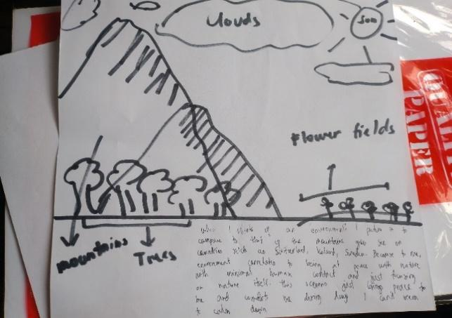  Hero | 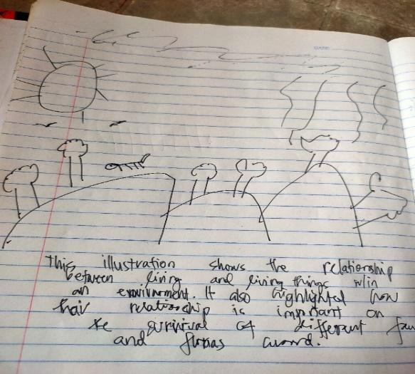  Lara
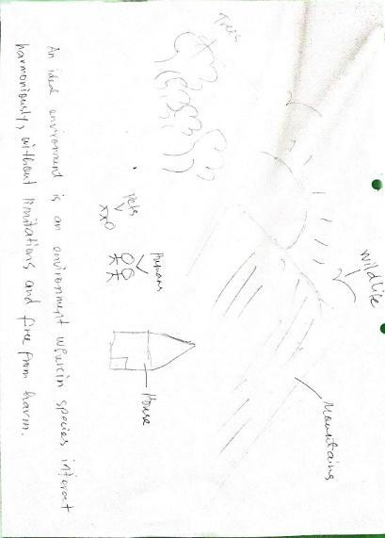  Patty | 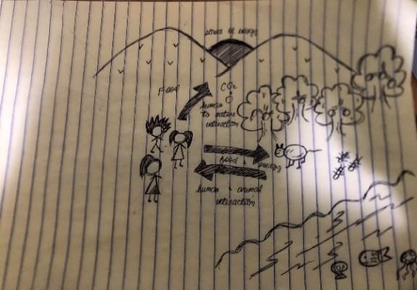  Veron
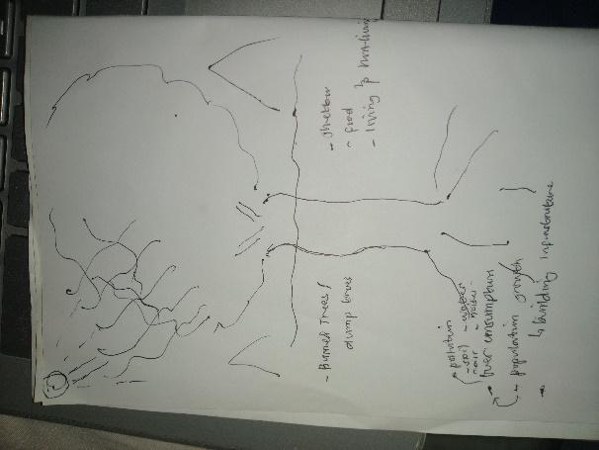  Tina | 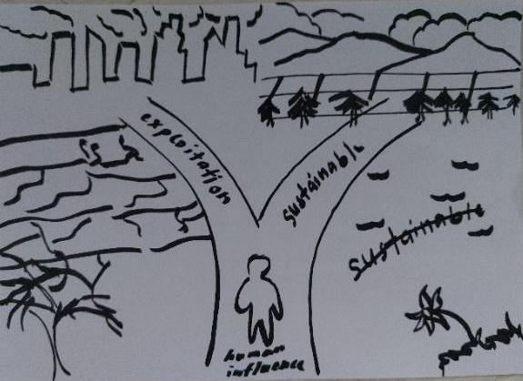  Berna
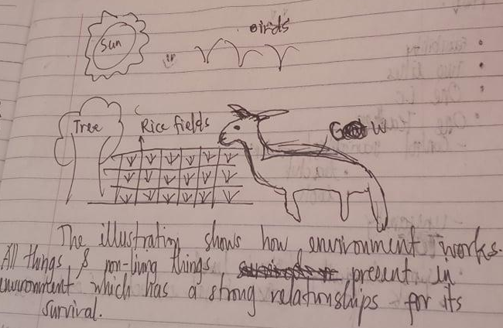  Leri | 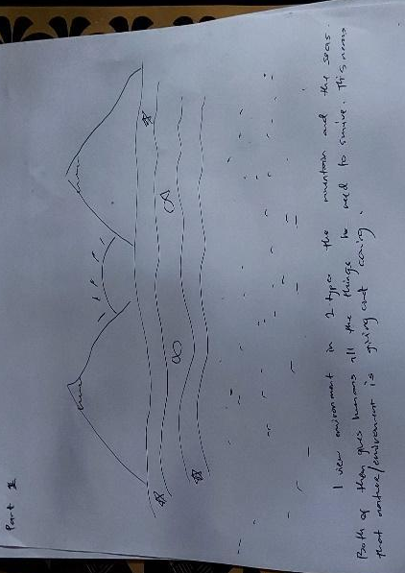  Mary

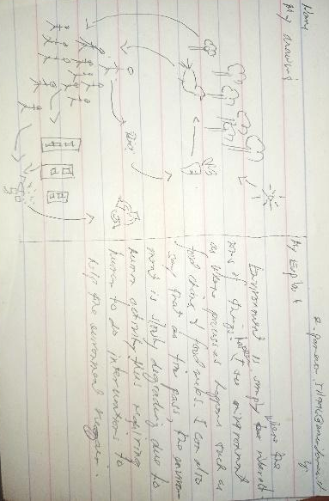  Vara | 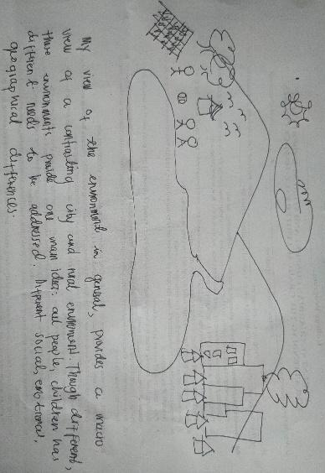  Cathy
The researchers found that the 4th-year BSED-General Science Pre-service teachers did not completely understand the environment. Although some respondents had scores closer to 12, this indicates an incomplete understanding of the environment. Based on the results, the lowest score is 2 points, and the highest score is 9 points. The results indicate that the respondents knew and understood some environmental components, but they still lacked knowledge about the environment. The respondents have not shown a complete interaction between humans, biotic and abiotic organisms, and the built environment in their drawings. Although some respondents have described the environment with interactions among various environmental factors, it is still insufficient for the researchers to conclude that they fully understood the environment based on the DAET-R.
This result is consistent with the study by Shepardson et al. (2007), which found that the environmental mental models of their respondents were incomplete. They lack sufficient knowledge of the environment, although they understand the other factors present in it. Half of the respondents did not consider humans as part of the environment. Below is the summary of the results of DAET-R.
On the other hand, the researchers categorized respondents' drawings into four mental models using the DAET developed by Shepardson et al. (2007). The DAET helped the researchers determine what type of environmental mental models each respondent possesses. Together with the respondent's drawings of the environment, their choice in the pick-a-photograph test was also used to further assess their view of the environment.
Figure 2. Categorization of Participants’ Environmental Mental Model

Mental Model 3
Berna
Vara
Cathy

Mental Model 4
Patty
Veron
Berna
Vara

Mental Model 2
Lara
Veron
Leri
Vara

Mental Model 1
Hero
Lara
Tina
Leri
Mary

Mental Model 1
(A place where animals/plants live, a natural place)

Mental Model 2
(Supports life)

Mental Model 3
(A place impacted or modified by humans)

Mental Model 4
(A place where animals, plants, and humans live)
Upon checking the respondents' drawings using DAET by Shepardson et al. (2007), the researchers found that one (1) respondent out of ten (10) possesses three environmental mental models, four (4) respondents out of ten (10) include two environmental mental models. Half of the respondents have only one (1) environmental mental model.
The results align with Sprong and Martin's (2020) study, which shows that respondents correctly view the environment. However, they still missed some components of the environment, and their understanding remains insufficient; they still need additional, concrete scientific information to achieve a complete understanding.
Table 3. Environmental Mental Models of Preservice Science Educators
Themes on Environment Mental Models | Significant Statements
Presence of Diverse Species | because different species, specifically humans, marine species, like birds, and even tiny species (IDI-BS 3)
Presence of Diverse Species | Because there are animals or living things in general (IDI-BS 7)
Presence of Diverse Species | Geographical, physical, chemical, and biological processes as well as components that interact with one another (IDI-BS 1)
Dynamic Interaction of Ecosystem Factors | interaction between flora and fauna (IDI-BS2)
Dynamic Interaction of Ecosystem Factors | interaction between the organisms, both non and living organisms (IDI-BS3)
Dynamic Interaction of Ecosystem Factors | Show the relationship that in an environment, there is the producer and consumer (IDI-BS10)
Natural Landscapes in Rural Areas | rice paddies, mountains, and farms which I can relate to because I am from a rural community (IDI-BS 6)
Natural Landscapes in Rural Areas | can see organisms, plants, structures, and geographical features in my rural community (IDI-BS 6)

Presence of Diverse Species. This theme depicts the variety of species present in the environment. It shows preservice science educators' understanding of the environment, highlighting the emergence of different species. The respondents' answers include the presence of diverse biotic factors in the environment that interact with one another. In their answers, humans, animals, plants, and other living organisms are present, which play a vital role in forming and maintaining a healthy environment.
Hero believed that the environment is composed of humans, marine species, and even tiny organisms, in addition to the trees and animals present. She also thought the environment had life within it. Hero, as a future science teacher, finds it very helpful for her to view the environment this way. She could impart correct knowledge about the environment to her students. In return, the students will have a proper understanding of the environment. It is crucial for science teachers to impart knowledge about the environment with diverse species. Through this, teachers and students could care for various species living in the environment. Although they still need to learn more about the environment, as they manifest insufficient understanding. This result is in consonance with the study by Shepardson et al. (2007), which found that their understanding of the environment was fragmented and incomplete.
Leri perceived the environment as a place where living organisms exist and survive, recognizing the presence of plants, animals, and other life forms. Similarly, Berna described the environment in terms of geographical, physical, chemical, and biological processes and acknowledged the interactions among environmental components and their effects on human life. Although both respondents demonstrated an understanding of key environmental concepts that could support their future teaching careers, their environmental mental models remained incomplete, consistent with Gio et al.'s (2025) findings that learners often recognize environmental components and ecological relationships but rarely exhibit highly complex, fully integrated environmental mental models.
The views of Hero, Leri, and Berna towards the environment are all correct. However, they still don't fully understand the environment. Their accurate conceptualizations are just parts of the whole environment. These arguments support the study by Shepardson et al. (2007), which found that preservice teachers provided only superficial, scientifically insufficient descriptions of the environment. It is true that the 4th-year preservice science teachers at the University of Mindanao view the environment superficially and need scientific information to fully understand it. They didn't mention the role of humans in the environment, even though they noted that humans themselves are part of it.
Dynamic Interaction of Ecosystem Factors. This theme shows the interactions among all ecosystem factors within a single environment. It shows that the dynamic interaction of all ecosystem factors in an environment has shaped the respondents' mental perspective and ideas about the background. The respondents' answers include interactions between flora and fauna, and between organisms, both living and non-living. Lastly, there is the connection between producer and consumer.
Three respondents considered the environment to be a dynamic interaction among ecosystem factors. Where one component does not apply to defining the environment but instead consists of a complex and varied set of interactions, this aligns with Mantilla's (2022) statement that the millennial views the environment with humans and other biotic and abiotic factors, as reflected in the respondent's answers. This knowledge could help not only preservice science teachers but also the students they will teach in the future.
Natural Landscapes in Rural Areas. This theme provides natural resources, natural life, living space, and motivation. It underpins the differences of life forms that make human life conceivable within the complex rural environment. The rural landscape features an assortment of topographical and geographic features, including mountains, rice paddies, farms, streams, and lakes. This should support human employment, a noteworthy contributor to global socio-economic systems.
Cathy had a sense of what the environment looked like, with rural settings featuring rice paddies, mountains, and farms. She can really relate to it because she lives in a rural community, feels at home, and can quickly identify its geographical features. However, as a future science educator, she should not only rely on the geographical features and other organisms present. She must give importance to each land feature, such as understanding its interaction with the environment, how it helps and affects other organisms, and, of course, humans in the environment. In this sense, she can impart her knowledge deeply to her future students. She can provide more details about the relationship between a particular geographical feature in the environment. This particular context and arguments are in consonance with the study by Wuellner (2017), which shows that preservice science educators' perceptions of the environment and the role of individuals within it are influenced by their geographic location and educational level, including rural and urban settings.
The results of the DAET and DAET-R agree with those of Shepardson et al. (2007), who revealed that 4th-year preservice science educators did not fully understand the environment. In their drawings, it was evident that they viewed the environment as a place with little interaction among different environmental factors and other elements. In addition, some respondents did not view humans as an essential part of the overall environment. This gap in the respondents' environmental mental models must be filled with the necessary knowledge for them to teach environmental subjects accurately. They must possess a complete and accurate understanding of the entire environment, its factors, and processes to preserve and maintain its equilibrium.

Table 4. Experiences in Nature that Shape Environmental Mental Models of Preservice Science Educators
Themes on Environment Mental Models | Significant Statements
Campus-based field activities | excursions in the mini-forest and sunset watching at the oval field track (IDI-BS 3)
Campus-based field activities | Science club activities related to the environment (IDI-BS 1)  serves a wise and reasonable purpose (IDI-BS 4)
___________________  Off-campus fieldwork | __________________________________________  inspired by mangrove planting experience (IDI-BS10)
___________________  Off-campus fieldwork | Exposure to mangrove planting and coastal clean-up develop empathy in protecting the environment (IDI-BS3)
___________________  Off-campus fieldwork | Glad to know the mangroves we planted during high school are now serving the community (IDI-BS4)
___________________  Strong Affinity for Nature | __________________________________________  I love being a science major because I get to be closer to nature (IDI-BS 3)
___________________  Strong Affinity for Nature | personally joined a hiking activity (IDI-BS 2)
___________________  Strong Affinity for Nature | Experienced wonder on how fantastic nature is (IDI-BS 5)

Campus-based Field Activities. This theme includes the activities experienced by the 4th-year preservice science teachers on campus at the University of Mindanao. These activities include searching for resources in the mini forest, watching the sunset at the oval field, and programs and activities conducted by the YEAST organization inside the campus. These activities are crucial for preservice science students, as they help shape their environmental mental models.
Hero shared her experiences on campus, including witnessing the sunset from the professional school building. She was also able to take a short journey through the mini forest, where several species of trees and plants are present, and to explore the oval surrounded by plants and trees. These experiences in nature, although on campus, are helpful to preservice science teachers like Hero, as they provide firsthand experience that can give them a concrete understanding of the environment. These responses align with the study by Batchar and Abad (2023), which found that pre-service teachers who are exposed to environmental experiences and learning opportunities develop greater awareness of environmental components.
Berna and Lara had experiences with the YEAST organization's activities, during which they saw the importance of environmental protection. As future science teachers, they already have an idea of the activities they will implement in their classes or at the schools where they will work to restore and maintain our environment. It is essential to recognize the significance of the environment for our survival. Preservice science teachers have the power to protect and nurture the environment by putting their ideas into action and making their students aware of the potential consequences of neglecting the environment. They are the ones who will spread environmental literacy among their students through organizational activities. However, they still don't fully understand the environment. Their conceptualizations are just parts of the whole environment. These findings align with the study by Lopiz-Guerra et al. (2024), which found that environmental education improves awareness and behavior towards environmental systems.
Off-campus fieldwork. This explains the experiences outside of the university. This implies that the student's perspective and care for the environment changed after an experience outside the school premises. This activity helped them shape their views and opinions on how to honestly care for the environment and what things must be done to protect it.
This suggests that these specific respondents had an outdoor experience of the environment that helped shape their ideas about protecting the environment and what should be done to preserve it. This result aligns with the study by Prevot et al. (2018), which found that people who have had natural experiences had more knowledge about biodiversity and conservation than those who have had natural experiences where biodiversity is implicit, or those who have not had such experiences. This explains that students' outdoor adventures can shape how they see the environment. This could be a major part of how they teach their students, especially in outdoor experiences.
Strong Affinity for Nature. This theme shows that we humans have a natural affinity for nature. This may or may not be something we deliberately interface with our time spent in nature. In any case, it is pivotal to individual well-being, mental, physical, emotional, and spiritual. For this reason, we would argue that it is imperative for us to provide deliberative opportunities for our youth to develop a fondness for nature.
Hero, Patty, and Mary already knew how to take advantage of the environment. They are equipped with such activities that they participated in during their college journey. With this, they can easily uplift their capabilities, especially in educating the youth and future students. This is not just for students but also for preservice science educators at the University of Mindanao. Moreover, both love nature for different reasons and in different ways. One says she loves the environment because it gives her a "relaxing and calm feeling." Others also say she loves the environment because "it gets her closer to nature." This argument aligns with the study by Rosa et al. (2018), which found that students have a medium to high level of connection to nature. The study found that participants spent a lot of time in nature during childhood and had less experience in nature in young adulthood.
IMPLICATIONS AND CONCLUDING REMARKS
Implications for Practice
The results of the DAET and DAET-R revealed that the 4th-year preservice science educators did not completely understand the environment. In their drawings, it was evident that they viewed the environment as a place with little interaction among different environmental factors and other elements. In addition, some respondents did not view humans as an essential part of the overall environment. This gap in the participants' environmental mental models must be filled with the necessary knowledge for them to teach environmental subjects accurately. They must possess a complete and accurate understanding of the entire environment, its factors, and the processes that maintain its equilibrium. On the positive side, they already have knowledge of the environment that would be very helpful in their future teaching career, especially in teaching science or environment-related subjects.
The 4th-year preservice science educators have some similarities in their experiences in nature. These include mangrove planting and a coastal clean-up drive. This is because they are classmates and belong to the same science organization. The results showed that they had participated in campus-based field activities and off-campus fieldwork. These activities helped them in shaping their Environmental Mental Models (EMMs). In addition, their strong affinity for nature helped them explore the environment further. Their natural experiences are significant in helping them understand the real environment. In the future, as they become science teachers, this will help them create tasks related to environmental activities that will also increase their future students' understanding of the environment.
Present in the Environmental Mental Models of the 4th year preservice science educators are humans, biotic and abiotic organisms, and the environment created by humans. It was a promising result of their understanding of the environment; however, they lack some of its key factors and features. Their experiences in nature were also favorable, and it is an essential factor that would help them fully understand the environment. As future science educators, they have seen the importance of caring for the environment through activities such as tree planting and coastal cleanups. It is already a positive outcome of their experiences, aside from helping them shape their EMMs. A complete understanding of the environment and firsthand experience in nature are critical to maintaining and protecting it. When they become science teachers, these factors would be beneficial for promoting environmental awareness among their future students.
Implications for Future Research
The result of this research will be beneficial to future researchers in this field, as it will provide additional information and have a substantial effect on Environmental Mental Models. This study will serve as one of their sources of information about EMMs. Furthermore, this study will help future researchers determine the EMMs of their chosen respondents and will also help them identify ways to complete the EMMs of preservice and in-service teachers. However, the respondents of this study came from one university and the same course and program. That is why future researchers must consider expanding their scope of respondents to include Teacher Education courses from different schools.
Future researchers must continue to conduct studies on EMMs to improve and correct respondents' EMMs. Science teachers must teach environment-related subjects properly and clearly define the environment's critical components to students. They must create tasks about the environment that would increase the students' understanding of the environment. Moreover, EMMs must be adapted for all science teachers to promote a broad understanding of the environment supported by their natural experiences. Aside from the design used in this study, future researchers may also use other research designs to help them achieve the study's objectives. They can also choose participants who are well-equipped or well-centered on the study, as they are beneficial for making a difference in the study. On the other hand, employing such a method for collecting data is crucial, as it is an empowering tool that helps all researchers properly correct and validate their studies. All of these must be references for future research, especially in science.
Concluding Remarks
As researchers, we learned something new about the environment from the different views of selected respondents. The study of EMMs speaks to how preservice science educators understand their environment. EMMs are the inside representation of the outside framework. However, EMMs are models, which implies they are deficient and often conflicting representations of reality. They are dynamic, alter over time, and can adjust to changing circumstances. Also, they advance over time through learning. As researchers, we realized that the instrument, particularly the DAET, was the best example of knowledge and understanding. Currently, there is much interest in environmental mental models in human-environment relationships. In this way, elucidating environmental mental models helps delineate distinctive conceptualizations of how an environment works, particularly in interactions between components or factors, based on the study's results; respondents had diverse interpretations and insufficient understanding of what an environment is.
REFERENCES
- Batchar, R. B., & Abad, G. D. (2023). Pre-service teachers’ environmental literacy and readiness towards environmental education. International Journal of Innovation Scientific Research and Review. https://www.researchgate.net/publication/370063103_PRE-SERVICE_TEACHERS%27_ENVIRONMENTAL_LITERACY_AND_READINESS_TOWARDS_ENVIRONMENTAL_EDUCATION
- Gio, A. N. L., Gio, A. J. L., Gadiana, K. R., Saguban-Borneo, A., Balinas, J. S., & Kinamot, V. B. (2025). Assessing the environmental mental models of grade school students in Negros Oriental, Philippines. Journal of Interdisciplinary Perspectives, 3(11), 189–198. https://doi.org/10.69569/jip.2025.598
- Johnson-Laird, P. N. (1980). Mental models in cognitive science. Cognitive Science, 4(1), 71–115. https://doi.org/10.1207/s15516709cog0401_4
- Llopiz-Guerra, K., Ruiz, D. U., Hernández, R. M., Mejia, V. L. V., Nunayalle, J. D. R. J., & Sanchez, K. R. (2024). Importance of Environmental Education in the Context of Natural Sustainability. Natural and Engineering Sciences, 9(1), 57–71. https://doi.org/10.28978/nesciences.1473461
- Mantilla, L. K. C., & Acledan, M. Y. (2022). Environmental mental models of science educators: A multiple case study of LET topnotchers. International Journal of Humanities Social Sciences and Education, 9(1), 174–183. https://doi.org/10.20431/2349-0381.0901014
- Moseley, C., Desjean-Perrotta, B., & Utley, J. (2010). The draw-an-environment test rubric (DAET-R): Exploring pre-service teachers' mental models of the environment. Environmental Education Research, 16(2), 189–208. https://doi.org/10.1080/13504620903548674
- Palinkas, L. A., Horwitz, S. M., Green, C. A., Wisdom, J. P., Duan, N., & Hoagwood, K. (2016). Purposeful sampling for qualitative data collection and analysis in mixed method implementation research. Administration and Policy in Mental Health and Mental Health Services Research, 42(5), 533–544. https://doi.org/10.1007/s10488-013-0528-y
- Poonguzhali, R. L. (2021). Environmental education: Importance & scope, aims & objectives, concepts & principles. UGC Care Journal.
- Prévot, A.-C., Cheval, H., Raymond, R., & Cosquer, A. (2018). Routine experiences of nature in cities can increase personal commitment toward biodiversity conservation. Biological Conservation, 226, 1–8. https://doi.org/10.1016/j.biocon.2018.07.008
- Rosa, C. D., Profice, C. C., & Collado, S. (2018). Nature experiences and adults' self-reported pro-environmental behaviors: The role of connectedness to nature and childhood nature experiences. Frontiers in Psychology, 9, Article 1055. https://doi.org/10.3389/fpsyg.2018.01055
- Sandelowski, M. (1995). Sample size in qualitative research. Research in Nursing & Health, 18(2), 179–183. https://doi.org/10.1002/nur.4770180211
- Shepardson, D. P., Wee, B., Priddy, M., & Harbor, J. (2007). Students’ mental models of the environment. Journal of Research in Science Teaching, 44(2), 327–348. https://doi.org/10.1002/tea.20144
- Shetty, S. (2022). Sample size determination in qualitative research: A practical guide. International Journal of Qualitative Methods, 21, 1–10.
- Sprong, L. E., & Martin, S. N. (2020) – Exploring Indian Middle School Students’ Conceptions of the Environment Using the Draw-an-Environment Test, published in Asia-Pacific Science Education.
- Vladova, I. (2023). Towards a more sustainable future: The importance of environmental education in developing attitudes towards environmental protection. SHS Web of Conferences, 176, Article 01009. https://doi.org/10.1051/shsconf/202317601009
- Wuellner, M. R., Vincent, L., & Felts, B. (2017). Environmental mental models of college students. International Journal of Environmental & Science Education, 12(2), 105–115. https://files.eric.ed.gov/fulltext/EJ1137396.pdf

