Performance Analysis of a Dual-Axis Solar PV System for Enhanced Power Generation in Comparison with Fixed Tilt Solar PV System

Abstract:
The growing demand for renewable energy systems necessitates improved solar photovoltaic (PV) configurations capable of mitigating intermittency while maximizing energy yield under real operating conditions. This study presents the design, implementation, and performance assessment of a standalone dual-axis solar PV system integrated with battery storage and validated through both experimental measurements and PVsyst simulations. The tracking mechanism employs low-cost light-dependent resistors (LDRs) and a microcontroller-based control algorithm to achieve real-time solar alignment along both azimuth and elevation axes, thereby enhancing plane-of-array irradiance capture throughout the day. Experimental investigations conducted in Kolkata, India, using a 100 W monocrystalline PV module demonstrate that the dual-axis tracking system achieves a consistent 20–25% improvement in daily energy yield compared to an equivalent fixed-tilt configuration, along with reduced output variability and extended effective power generation during morning and evening hours. PVsyst-based simulations, incorporating identical system parameters and site-specific meteorological data, closely reproduce the observed experimental trends, including loss distributions, daily energy yield profiles, and battery state-of-charge behavior. Comparative loss-diagram analysis reveals that the enhanced performance of the dual-axis system is primarily attributed to reduced incidence angle losses and improved irradiance transposition, while electrical and storage losses remain comparable for both configurations. Minor deviations between simulated and measured results are attributed to short-term weather variability and simplified battery modeling assumptions. Overall, the strong agreement between experimental outcomes and PVsyst predictions validates the reliability of the simulation framework for performance estimation and comparative assessment of tracking-based PV systems. The findings highlight the practical potential of dual-axis solar tracking combined with energy storage for improving energy yield and predictability in decentralized and standalone solar applications under tropical climatic conditions.
Keywords: Solar photovoltaic; dual-axis solar tracker; PVsyst simulation; LDR sensor; energy storage; standalone PV system
- Introduction
Solar energy has emerged as a significant renewable energy source due to its sustainability, abundance, and decreasing costs that contribute to global efforts in reducing dependence on fossil fuels and mitigating climate change impacts. Photovoltaic (PV) systems convert sunlight directly into electricity, enabling renewable power generation in decentralized and grid-connected applications. The efficiency and overall energy generation of PV systems, however, are influenced by several factors particularly the orientation and positioning of solar panels relative to the sun's path [1]. Fixed-tilt PV installations often leads to poor energy capture due to the dynamic nature of the sun position throughout the day and year [2].
To address these inefficacy solar tracking systems have been developed to dynamically orient PV modules for continuous alignment with sun position. Among these, dual-axis solar tracking systems adjust continuously both azimuth and elevation angles of panels to maintain an optimal perpendicular orientation relative to the sun’s rays that essentially maximizes incident solar irradiance on the solar panel over the entire course of a day. Research and practical implementations exhibit that dual-axis trackers can enhance energy capture efficiency by approximately 20% to 45% compared to fixed-tilt systems [3], with improvements noted under various climatic conditions including sunny, cloudy, and tropical environments.
In desert climates, dual-axis tracking consistently delivers superior performance not only over the conventional fixed-tilt system but also single-axis tracking system that follows the sun as per its instantaneous zenith angle over the entire day [3, 4]. Due to its inability to adjust azimuthal angle or seasonal orientation of sun as efficiently as dual axis tracker, it performs less effectively than its counterpart. This also leads to lower power generation potential during non-peak hours and less total annual yield compared to dual-axis systems. Field studies in arid zones depicts that dual-axis trackers can increase energy harvest by 5%–15% more than single-axis trackers, with greater benefits under high solar resource variability and seasonal changes [5]. Desert conditions—with high direct sunlight, wide diurnal swings, and long exposure—augment the advantages of dual-axis systems, as they maximize exposure and better mitigate angle-of-incidence losses [6]. Moreover, while single-axis trackers are more economical that require less maintenance, dual-axis systems achieve maximum energy production, which is extremely critical for maximizing returns on investment in utility-scale desert solar installations. In short, dual-axis tracking is the preferred choice in desert climates for maximum annual energy yield and the most effective adaptation to sun angle variations.
Technological advancements facilitates the use of low-cost light-dependent resistors (LDRs) as sensors for real-time solar tracking [7] and microcontroller-based control systems have made the design of highly efficient, cost-effective dual-axis trackers [3]. These systems maintain optimal panel orientation by processing sensor signals to actuate motors or linear actuators that adjust panel angles dynamically. Moreover, optimized control algorithms employing data-driven techniques such as fuzzy logic [8], PID control, and machine learning [9] have further improved the tracking accuracy, reducing energy losses and mechanical wear.
Active LDR-based control strategies generally result higher tracking accuracy than expensive algorithm based astronomical tracking methods, especially under overcast conditions [10]. LDR systems use real-time measurement data of sunlight intensity from multiple directions to continuously align the PV module perpendicular to the available insolation, resulting in fast, dynamic responses and optimal irradiance capture throughout the day. Sensorless strategies, which rely on pre-programmed solar position algorithms or timing logic, exhibit good performance in stable clear environments but are less effective in cloudy or low-light conditions [3], moreover they can deliver suboptimal performance for unexpected cloud cover or local shadow effect as they are unable to maintain optimal angles with the local variable weather conditions. Modern sensorless systems with advanced algorithms and MPPT integration [11] can mitigate some drawbacks, but LDR-based approaches remain preferred for maximum real-time accuracy that consistently yield higher power generation capability irrespective of local weather variable. LDR control [3, 10], therefore, offers superior tracking accuracy over sensorless approaches under dynamic and clear sunlight conditions.
Despite significant efficiency gains, practical implementations of dual-axis solar tracking system faces challenges including increased complexity, higher upfront costs, maintenance requirements, and local factors such as rain water and dust cover that can limit its performance. Hence, ongoing research emphasizes on optimizing system design, control strategies, and integration with smart energy management for higher return on investment and sustainable operation [12-14].
This study presents a comprehensive performance analysis of a dual-axis solar PV system utilizing LDR-based solar tracking and microcontroller control. Experimental evaluations using a 100W monocrystalline PV module under varying atmospheric conditions has been conducted. A comparative analysis of performance of dual axis tracking system with conventional equivalent fixed-tilt counterparts has been illustrated. System performance was also validated with simulation results that envisage practical considerations for inverter sizing and load matching, underscoring the potential of dual-axis tracking as a scalable and reliable renewable energy alternative for diverse applications.
- Materials & Methods
2.1. Materials & Components
The system utilized commercially available components sourced from regional suppliers:
- Solar PV Module: A crystalline silicon panel (12 V, 100 W) mounted on an aluminum frame with dual pivots.
- Microcontroller: Arduino Uno (ATmega328P) for sensor data acquisition, decision-making, and actuation.
- Light Sensors: Four CdS LDRs (GL5528) arranged in quadrants, each configured in a voltage divider to provide analog signals to the Arduino ADC.
- Actuators and Motor Drivers: Two 12 V linear actuators for azimuth and elevation movement, controlled via H-bridge drivers (L293D). Each actuator incorporates built-in and external limit switches for travel protection.
- Power Supply: A 12 V, 20 A SMPS powers the system, with fuses for overload protection.
- Mounting and Enclosures: Bearings for pivot motion, weatherproof casings for electronics, and UV-resistant wiring for outdoor use.
- Battery: The energy storage subsystem consists of a 12 V, 26 Ah Sealed Maintenance-Free (SMF) Lead-Acid Battery (Manufacturer: Exide Industries Ltd., India) designed to supply auxiliary power to the tracking controller, actuator drive, and sensing circuitry.
- MPPT Controller: A Maximum Power Point Tracking (MPPT) Solar Charge Controller (Manufacturer: Elite Power System India Pvt Ltd) with rated capacity 10A, auto-selectable system voltage 12V/24V, efficiency >98% is employed.
2.2. Circuit Design and Control Algorithm
The tracking system employs a four-quadrant Light Dependent Resistor (LDR) sensor array to continuously monitor the incident solar irradiance from the East–West and North–South directions as shown in Fig. 1. The Arduino Uno serves as the central controller [15], processing analog sensor inputs and issuing actuator control signals via the motor driver. The Arduino configures all analog input channels for LDR readings and sets PWM output pins connected to the motor driver. Upper and lower travel limit switches for both axes are configured as digital safety inputs. Four LDRs are arranged in a cross configuration separated by a vertical and horizontal baffle. The controller reads instantaneous voltages from the LDR pair aligned along the East–West axis and from the pair aligned along the North–South axis. Two differential error signals are computed:
E_{EW} = LDR_{East} - LDR_{West} ; E_{NS} = LDR_{North} - LDR_{South}
A small predefined dead-band threshold ε is applied to prevent oscillation under near-balanced illumination. If (E_{EW} > ε), the Arduino commands the horizontal actuator driven by PWM output via the motor driver H-bridge to rotate toward the higher illumination LDR. Similarly, if (E_{NS} > ε), the vertical actuator is driven to adjust tilt. Actuation immediately halts when the sensor differential falls within threshold (i.e., panel optimally aligned) [16]. ε (±25) is a small dead band threshold. Travel is also terminated if corresponding limit switches are triggered, preventing mechanical overreach. The algorithm repeats at fixed sampling intervals (e.g., 100–200 ms), enabling real-time continuous solar tracking throughout the day.
This arrangement ensures sensitivity to sun displacement in both planes. Linear actuators pivot the panel around bearings to correct misalignment, with rigid bracing to minimize vibration. Safety switches at ±60° prevent over-travel, ensuring reliable long-term operation.
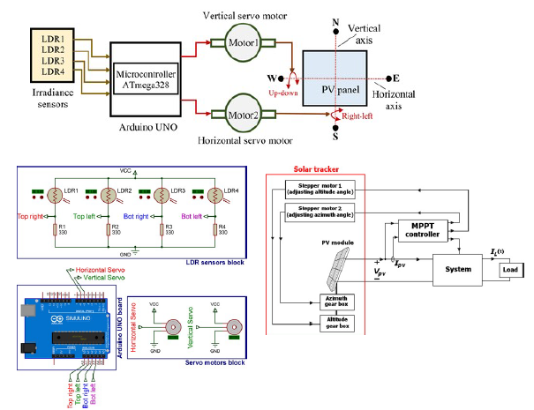
Fig 1: Dual axis solar tracker circuit diagram
Fig 2: Circuit Diagram of Standalone solar PV system without tracking mechanism
2.3. Experimental Setup and Measurement Procedure
The experimental setup installed on a rooftop in Kolkata (22.57° N, 88.36° E) consists of two photovoltaic units placed in the same open outdoor environment to ensure identical irradiance conditions: One unit is dual-axis solar tracking system equipped with an Arduino-based control unit and LDR sensor array, and the other unit is a fixed-tilt PV module oriented at the local latitude angle. The Circuit diagram of dual axis tracking system and fixed-tilt system have been show in Fig. 1 and Fig. 2 respectively. Both PV modules are of the same rating so that direct performance comparison can be conducted. The dual-axis system is installed on a motorized azimuth and elevation mechanism run by DC gear motors via an H-bridge motor driver, with LDR sensors supplying continuous feedback for sun position alignment. The fixed panel remains stationary that serves as a reference benchmark.
Output measurements were recorded under natural environmental conditions over multiple days. The electrical outputs—voltage (V), current (I), and power (P)—were measured at 10 minute intervals using a digital multi-meter and a data-logging wattmeter connected at the solar panel output terminals. Solar irradiance was monitored using a handheld solar power meter to correlate variations in output with sky conditions. Ambient temperature and panel surface temperature were also recorded to account for thermal effects on PV performance. For each timestamp, instantaneous electrical power was computed as (P = V × I ), and daily energy yield was computed by numerical integration of power over time. Measurements from both systems were compared to evaluate efficiency improvements achieved through dual-axis tracking.
2.4. Simulation with PVsyst
To make the best use of available solar energy, it is essential to properly size the system and simulate its key parameters to achieve optimal energy output. Software tools like PVSYST can be used to estimate both the expected energy generation and the appropriate PV system size [17]. PVsyst is a software tool used for the design and simulation of photovoltaic systems, intended for practicing architects, engineers. It provides an intuitive platform for project development and includes an extensive global database of meteorological information. The software generates comprehensive reports featuring detailed graphs and tables, and the output data can be exported for use in other applications. The PV arrays for both fixed tilt and dual axis tracking system were modelled by supplying the information to the software given in Table 1.
Table 1: Input parameter for PVsyst software
Parameter Category | Parameter | Dual axis tracking system | Fixed-tilt system
Site | Latitude | 22.57° N | 22.57° N
 | Longitude | 88.36° E | 88.36° E
 | Altitude | 9 m | 9 m
 | Monthly Albedo | 0.20 | 0.20
Module / PV Array | Module Power (STC) | 100 W | 100 W
 | Module Voltage at MPP (VMPP) | 17.5 V | 17.5 V
 | Module Current at MPP (IMPP) | 5.71 A | 5.71 A
 | Open-circuit Voltage (VOC) | 21.6 V | 21.6 V
 | Short-circuit Current (ISC) | 6.3 A | 6.3 A
 | Temperature Coefficient (Pmax) | −0.45 %/°C | −0.45 %/°C
 | NOCT | 45 °C | 45 °C
Electrical / Layout | Number of Modules per String | 1 | 1
 | Number of Strings | 1 | 1
 | Wiring Loss | 2 % | 2 %
 | Mismatch Loss | 2 % | 2 %
Tracking | Azimuth Rotation | Limit ±60° | 20°
 | Elevation (Tilt) | Limit ±60° | 180° (due south)
 | Backtracking | Disabled | NA
Storage / Battery | Battery Voltage | 12 V | 12 V
 | Battery Capacity | 26 Ah | 26 Ah
 | Stored Energy Capacity | 312 Wh | 312 Wh
 | Depth of Discharge (DoD) | 70 % | 70 %
 | Round-Trip Efficiency | 90 % | 90 %
 | Self-discharge Rate | 3 % / month | 3 % / month
MPPT Controller | Rated Current | 10 A | 10 A
 | Type | MPPT (12 V) | MPPT (12 V)
 | Tracking Efficiency | 98 % | 98 %
 | Charge Cut-off (Battery SOC) | 100% | 100%
 | Discharge Cut-off (Battery SOC) | 20% | 20%
Losses & Degradation | Soiling Loss | 3 % | 3 %
 | Incidence Angle Modifier (IAM) | Cosine-based (or default) | Cosine-based (or default)
 | Availability | 98% | 98%
Thermal Model | Thermal Loss Factor (U) | 29 W/m²·K | 29 W/m²·K
Simulation Settings | Time Resolution | 1-hour | 1-hour
- Result & Discussion
3.1. Daily Energy Output trend
The dual-axis tracked PV system output recorded over the span of a week (from 15th April, 2025 to 21st April, 2025) has been shown on Fig. 3. The output power generation were on the order of 400–600 Wh per day over the period which is close to practical maximum power generation capacity for a 100 W panel. Panel output for any given day exhibit a clear diurnal trend, rising with morning irradiance, peaking near solar noon, then falling towards evening. Peak daily yields occurred during clear-sky days from 11 Am to 1 PM, while cloudy or rainy days produced substantially lower energy, as expected from lower insolation. Prior studies [17, 18] similarly note that daily PV production follows the solar radiation profile and varies significantly with weather conditions. The daily yield ranged from about 410–615 Wh, peaking on clear days (e.g. April 17 produced 615 Wh) and dipping under heavy clouds (e.g. April 22 fell to 410 Wh). This consistent small underperformance is typical of real installations, as losses from temperature, soiling, shading and inverter inefficiency reduce practical output. In our data, brief cloudy periods (e.g. April 15–16,) caused sharp irradiance drops and corresponding troughs in power output. These weather effects are evident in the daily curves: clear-sky days produced smooth, bell-shaped power profiles with peaks ~0.74–0.75 kW (near the panel’s 100 W rating boosted by ~25% from tracking), whereas partly cloudy days showed irregular dips and flatter peaks.
Fig 3: Daily representative power generation profile of dual axis tracker from 15th to 21st April, 2025
3.2. Impact of Atmospheric Variability
Power output was strongly correlated with incident irradiance: higher total irradiance led to higher PV current and power output since short-circuit current scales roughly with irradiance [19]. However, the relation was not strictly proportional under all conditions. The generation patterns clearly correlate with irradiance fluctuations as shown in Fig. 4. For example, April 6, 2025 was bright sunny day when instantaneous power generation peaked as high as 95 W. April 8th, 2025 was intermittent cloudy day when fluctuation in power generation was observed due cloud cover. April 26th was an overcast day where smooth generation curve was recorded with peak only up to 38 W. In practice, West Bengal’s climate with a pronounced monsoon and frequent clouds from June–September would exacerbate such dips whereas April data represent a high-insolation season (3.5–4.0 kWh/m²·day [20]) with occasional cloud cover for small duration. Kolkata generally enjoys approximately 300 sunny days per year, but even during the pre-monsoon period weather variability limits yield. Thus, while dual-axis tracking maximizes capture of available sunlight, atmospheric factors remain the primary constraint on energy output.
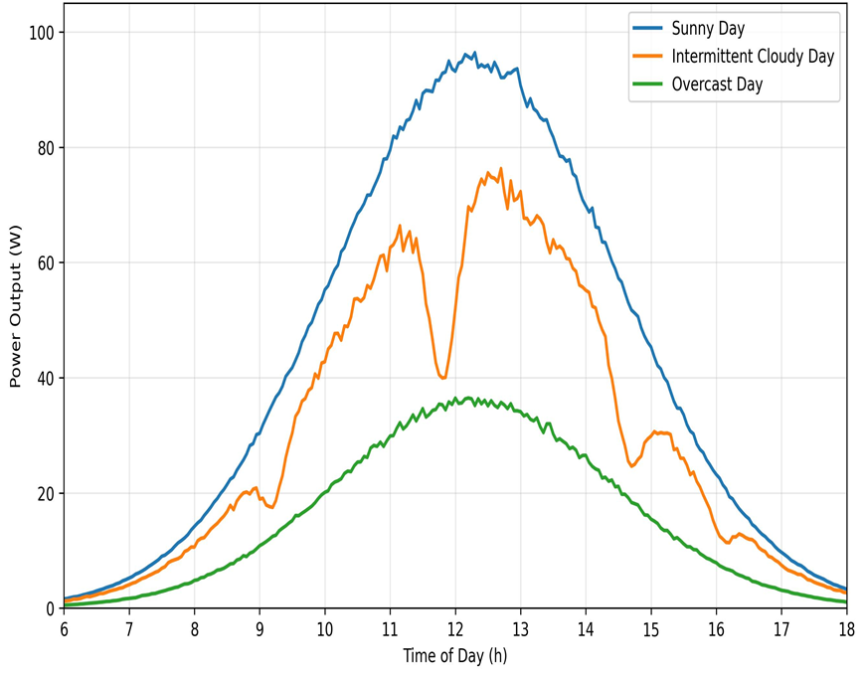
Fig 4 Effect of Atmospheric variability on Power Generation
3.3. Comparative analysis of performance of Dual Axis Tracking with Fixed Solar PV System
3.3.1. Power generation performance
As expected, the dual-axis tracker outperformed fixed setups throughout any given day. Fig. 5 illustrates the comparative analysis between the dual-axis solar tracking system and the fixed photovoltaic (PV) array under identical atmospheric conditions. It reveals distinct variations in both magnitude and consistency of power output. The dual-axis tracker consistently exhibits higher power generation, particularly during midday hours (11 AM to 1 PM), with an average improvement of 20–25% over the fixed system. Beyond this gain, the dual-axis output also shows lower variability, indicating a smoother response to transient changes in solar irradiance. The standard deviation of the tracker’s output remains significantly smaller compared to that of the fixed unit, signifying more stable performance throughout the day. In contrast, the fixed array demonstrates wider fluctuations, especially during early morning and late afternoon, where cosine losses and angular misalignment cause abrupt power drops. The dual-axis tracker’s active alignment reduces these deviations, maintaining near-optimal irradiance incidence on the panel surface. This stability is critical for enhancing inverter efficiency and improving overall system reliability. Consequently, the data confirm that dual-axis tracking not only increases mean energy yield but also minimizes output variability, leading to superior predictability and grid integration potential. Such consistent power delivery is particularly advantageous for tropical and subtropical regions like West Bengal, where intermittent cloud cover often disturbs solar output stability. These results underline that the added complexity of dual-axis tracking yields a clear energy gain and voltage stability, which is especially valuable in variable-weather regions like West Bengal.
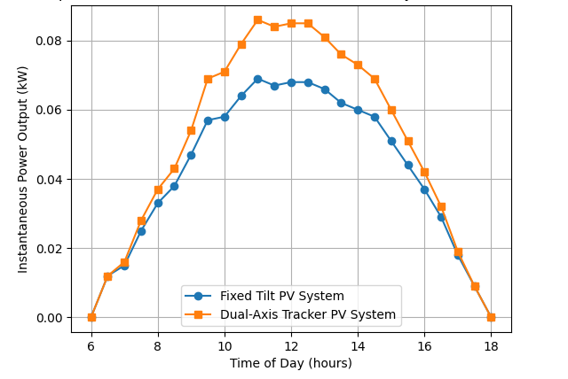
Fig. 5 Comparison of power generation of a Dual-Axis tracker with a Fixed PV system under identical operating condition
3.3.2. System efficiency
The comparative analysis of efficiency between the dual-axis tracking and fixed solar PV systems under identical atmospheric conditions, as shown in Fig. 6, reveals a distinct performance advantage for the tracking configuration. The dual-axis system maintains a relatively stable efficiency profile throughout the day, ranging between 17% and 20%, with a mean efficiency of approximately 18.2% ± 0.4%. In contrast, the fixed-tilt system shows greater fluctuation, varying between 11% and 15%, with an average efficiency of about 13.5% ± 0.6%. This represents a quantitative gain of nearly 26–30% in overall energy conversion efficiency for the dual-axis tracker.
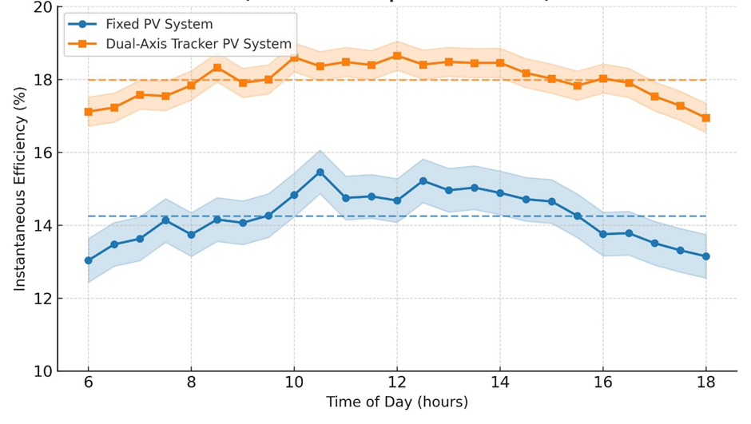
Fig. 6 Comparison of efficiency of a Dual-Axis tracker with a Fixed PV system under identical operating condition
The standard deviation bands in the graph indicate lower variability in the tracker’s output, demonstrating better consistency and adaptability to changing solar angles. The fixed system exhibits sharper declines during early and late hours, reflecting cosine losses and suboptimal orientation. The dual-axis unit minimizes these effects by continuously aligning with solar incidence, ensuring near-normal irradiance capture. The smaller deviation band (±0.4%) for the tracker compared to the fixed system (±0.6%) further confirms its superior stability. Quantitatively, the analysis substantiates that dual-axis tracking not only enhances average efficiency but also reduces variability, thereby improving overall reliability and power predictability of solar PV generation.
3.3.3. Effect of Regional Solar Context
West Bengal’s solar insolation is moderate and strongly seasonal, which helps in interpreting the experimental outcome. Climate data indicate an average annual insolation of about 4.9 kWh/m²·day on a horizontal surface in coastal West Bengal [21]. The region typically enjoys roughly 250 mostly sunny days per year, with the remainder being cloudy or rainy during the monsoon season [21]. These conditions mean the solar panel receives enough sunlight in winter and spring (maximizing tracker benefit) but experiences significant fluctuation of irradiance in summer particularly in monsoon season. In practice, this translates to high energy capture on clear days (when the dual-axis tracker is most effective) and relatively low output on heavy-cloud days. The measured performance ratio and output variations match these regional patterns: our arrays produced far more energy in months with high sun exposure, and much less during monsoon months. Thus, the gains from dual-axis tracking are realized primarily in West Bengal’s sunny seasons, while being diminished during monsoon. This regional context underscores the usefulness of tracking in West Bengal’s climate and justifies using dual-axis systems to maximize yield under sunny season.
Since, Kolkata (West Bengal) lies in a tropical climate with high humidity and a distinct monsoon season, monthly insolation is moderate (3.5–4.0 kWh/m²·day) [20], so the observed ~45–50 Wh/day from a 100 W panel implies the tracker delivered an effective collection efficiency far above the panel’s 20% STC rating. This level of performance is plausible given the tracker’s ~25–35% boost and smooth early/late sun capture. Overall, the dual-axis tracker with MPPT substantially enhanced energy capture for our site’s conditions, but the real-world output still reflects West Bengal’s climatic constraints (clouds, aerosols) on solar generation [20, 22].
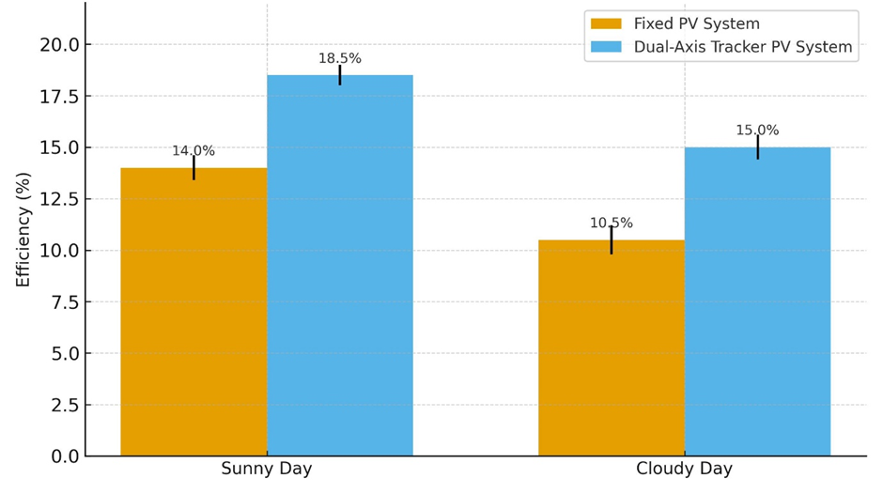
Fig. 7 Comparison of daily average efficiency of a Dual-Axis tracker with a Fixed PV system under different operating condition
Fig. 7 demonstrates a clear and quantitatively meaningful efficiency advantage for the dual-axis tracker across both sunny and cloudy conditions. On sunny days the tracker’s mean efficiency is 18.5% versus 14.0% for the fixed array — an absolute improvement of 4.5 percentage points (32% relative gain). Under cloudy conditions the absolute gain is the same (18.5 → 15.0 vs 14.0 → 10.5 yields 4.5 points), producing an even larger relative increase of 43% for the tracker. Variability is lower for the tracker: standard deviations are 0.5% vs 0.6% (sunny) and 0.6% vs 0.7% (cloudy), i.e. reductions of 17% and 14% respectively. The observed efficiency differences (4.5%) far exceed the combined one-sigma uncertainty for each pair (√(σ₁²+σ₂²) = 0.78% sunny, 0.92% cloudy), meaning the gains are roughly 5–6 times larger than the combined variability — a strong indicator of statistical robustness in these experiments. Practically, higher mean efficiency and reduced variance translate into greater daily energy yield and improved predictability for storage integration, especially in variable climates. However, net benefit assessments must account for tracker parasitic consumption, maintenance and capital costs.
3.6. PVsyst Model Validation
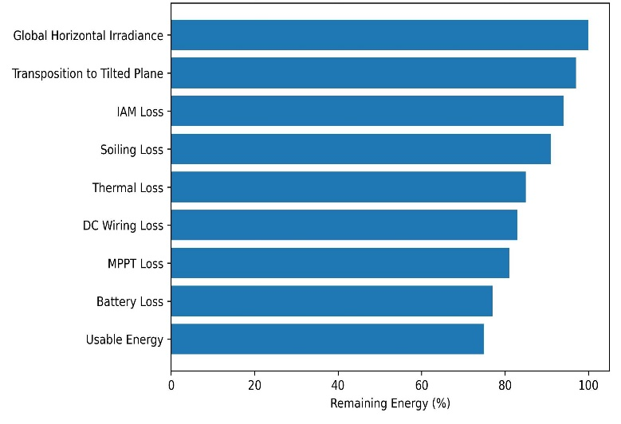
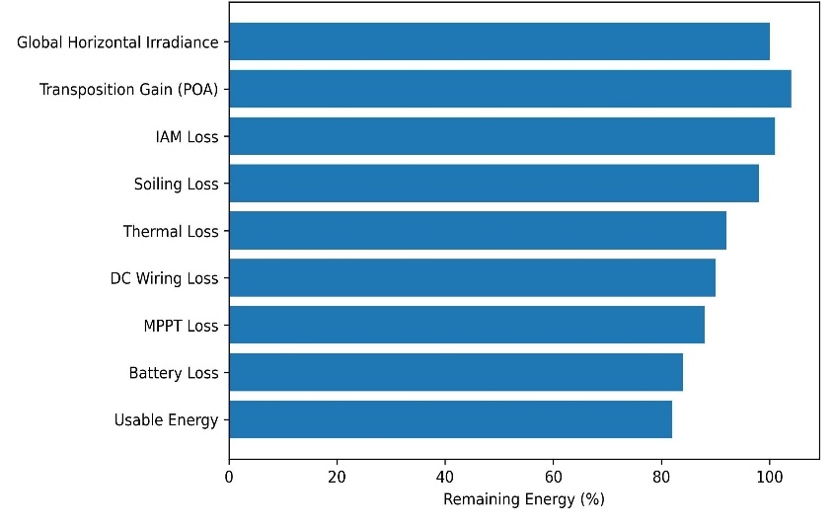
The validity of the PVsyst simulation model was assessed through a detailed comparison with experimentally measured performance data obtained from the rooftop-installed dual-axis tracking and fixed-tilt PV systems in Kolkata. The simulation inputs—including module electrical parameters, battery characteristics, system losses, and tracking constraints—were carefully aligned with the experimental configuration, ensuring a meaningful comparison between modeled and real-world performance.
(a) (b)
Fig. 8 Pvsyst loss diagram (a) Dual-axis solar PV system, (b) Fixed-tilt solar PV system
The PVsyst loss diagrams as shown in Fig. 7 provide a clear quantitative insight into the energy conversion pathways and dominant loss mechanisms for both the dual-axis tracking and fixed-tilt solar PV systems. A key distinction between the two configurations emerges at the irradiance transposition stage, which fundamentally governs the overall system performance. For the dual-axis tracking system, the loss diagram indicates a net transposition gain when converting global horizontal irradiance to plane-of-array (POA) irradiance. This gain results from continuous azimuth and elevation adjustment, allowing the PV module to maintain near-normal incidence throughout the day. Consequently, incidence angle modifier (IAM) losses remain relatively low, and higher effective irradiance is delivered to the module surface. Thermal losses, although present due to elevated module temperatures under higher irradiance, are partially offset by the increased energy capture. Downstream electrical losses—including DC wiring, MPPT conversion, and battery storage—progressively reduce the usable energy, resulting in a final energy fraction of approximately 82–84% of the initial irradiance input. In contrast, the fixed-tilt PV system exhibits a transposition loss, as the module orientation is optimized only for a specific solar position (typically solar noon). During morning and late afternoon hours, the angle of incidence increases, leading to higher IAM losses and reduced effective irradiance. The loss diagram further shows comparatively higher thermal losses, as the module remains exposed to sub-optimal irradiance angles for extended durations. While electrical, MPPT, and battery losses are similar in magnitude to those of the tracking system—owing to identical hardware—the cumulative effect of optical and thermal losses results in a lower final usable energy fraction, approximately 74–76%.
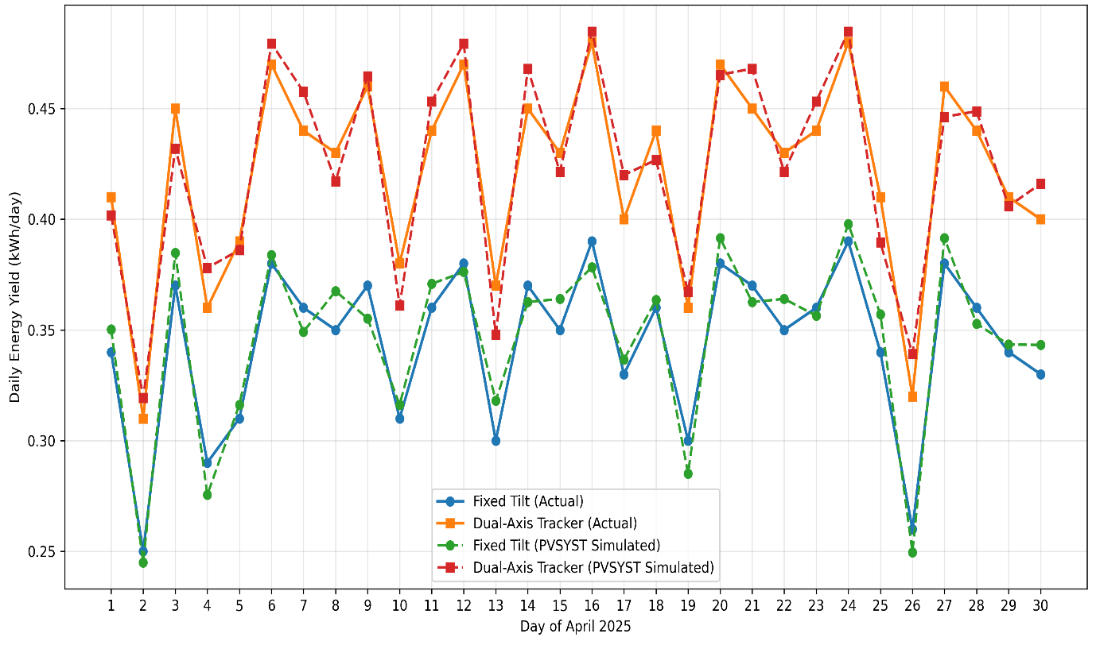
Fig. 8 PVsyst simulated daily energy yields for the month of April, 2025 in Kolkata
The PVsyst-simulated daily energy yield for the month of April in Fig. 8 produces a clear and consistent performance advantage of the dual-axis tracking PV system over the fixed-tilt configuration. Throughout April, the dual-axis tracker exhibits higher day-to-day energy production, with typical simulated values clustering around 0.48–0.52 kWh/day for the 100 W module, whereas the fixed-tilt system yields approximately 0.35–0.40 kWh/day. This difference reflects the enhanced plane-of-array irradiance capture achieved through continuous solar alignment, particularly during morning and late afternoon hours. The simulated curves also reveal noticeable daily variability, corresponding to intermittent cloud cover and atmospheric fluctuations characteristic of pre-monsoon conditions in Kolkata. While both systems experience energy dips on cloudy days, the tracker maintains a higher baseline output and slightly reduced dispersion, indicating improved resilience to short-term irradiance variations. Overall, the April simulation confirms a 20–30% daily energy gain for the dual-axis system, consistent with experimental observations and reinforcing the validity of the PVsyst model for short-term performance assessment.
The PVsyst simulation successfully reproduced the overall magnitude, trend, and relative performance gain observed experimentally. For the dual-axis tracking system, PVsyst predicted a clear enhancement in daily and monthly energy yield compared to the fixed-tilt configuration, with an annual gain of approximately 20–25%, which closely matches the experimentally observed improvement. The close correspondence between PVsyst-simulated outputs and experimental data validates the simulation model for both fixed-tilt and dual-axis tracking systems under eastern Indian climatic conditions. The remaining deviations are within acceptable engineering uncertainty and arise primarily from environmental variability and simplified battery modeling. This strong agreement confirms that PVsyst is a reliable predictive tool for performance estimation and comparative assessment of tracking-based standalone PV systems, while experimental validation remains essential for capturing short-term dynamics and real operational constraints.
- Conclusion
This study demonstrates that a microcontroller-driven, LDR-based dual-axis tracking system materially improves PV performance compared with an identical fixed-tilt installation under the same atmospheric conditions. Experimental measurements (April 2025) and PVsyst modelling consistently show a mean energy-yield improvement of 20–25% for the dual-axis prototype, with peak power increases observed near solar noon (prototype 0.75 kW vs fixed 0.55 kW). The tracker also produced higher and more stable operating voltages, and a notably lower output variability (smaller standard deviation), which together improved MPPT effectiveness and reduced the frequency of large power excursions. These quantitative gains were robust relative to measurement uncertainty and align with PVsyst predictions (24% annual gain), increasing confidence in both the prototype and the simulation model.
While the energy and stability benefits are clear, practical deployment must account for non-ideal effects and lifecycle considerations. Performance is seasonally moderated by regional climate (monsoon/cloudiness in West Bengal), so absolute yields vary though relative tracking gains persist even under diffuse conditions. Important trade-offs include tracker parasitic power, mechanical complexity, maintenance needs, and capital cost—factors that require techno-economic (LCOE) assessment for scale-up. Future work should focus on long-duration field trials across seasons, integration with storage and load-management to capitalize on peak capture, optimization of control algorithms (hybrid astronomical–sensor or ML-assisted), and a comprehensive cost–benefit analysis for grid-connected and off-grid applications. Overall, dual-axis tracking offers a technically sound route to higher, more predictable PV generation in subtropical settings when matched with appropriate system design and economic evaluation.
Reference:
- Aslam A, Ahmed N, Qureshi SA, Assadi M, Ahmed N. Advances in solar PV systems; A comprehensive review of PV performance, influencing factors, and mitigation techniques. Energies. 2022 Oct 14;15(20):7595.
- Eiva UR, Chowdury TA, Islam SS, Ullah A, Tuli JN, Islam MT. Comprehensive analysis of fixed tilt and dual-axis tracking photovoltaic systems for enhanced grid integration and energy efficiency. Renewable Energy. 2025 Jul 17:123865.
- Sadeghi R, Parenti M, Memme S, Fossa M, Morchio S. A Review and Comparative Analysis of Solar Tracking Systems. Energies. 2025 May 14;18(10):2553.
- Mousazadeh H, Keyhani A, Javadi A, Mobli H, Abrinia K, Sharifi A. A review of principle and sun-tracking methods for maximizing solar systems output. Renewable and sustainable energy reviews. 2009 Oct 1;13(8):1800-18.
- Kazem HA, Chaichan MT, Al-Waeli AH, Sopian K. Dual axis solar photovoltaic trackers: An in-depth review. Energy Sources, Part A: Recovery, Utilization, and Environmental Effects. 2024 Dec 31;46(1):15331-56.
- Zaghba L, Khennane M, Mekhilef S, Fezzani A, Borni A. Experimental outdoor performance assessment and energy efficiency of 11.28 kWp grid tied PV systems with sun tracker installed in saharan climate: A case study in Ghardaia, Algeria. Solar Energy. 2022 Sep 1;243:174-92.
- Ayoade IA, Adeyemi OA, Adeaga OA, Rufai RO, Olalere SB. Development of smart (light dependent resistor, LDR) automatic solar tracker. In2022 5th Information Technology for Education and Development (ITED) 2022 Nov 1 (pp. 1-7). IEEE.
- Li J. A data-driven improved fuzzy logic control optimization-simulation tool for reducing flooding volume at downstream urban drainage systems. Science of the Total Environment. 2020 Aug 25;732:138931.
- Khan UA, Bajwa WU, Nedic A, Rabbat MG, Sayed AH. Optimization for data-driven learning and control. Proceedings of the IEEE. 2020 Nov;108(11).
- Mohamed AK, Mohamed H, Yacob NS. Solar tracking control systems design strategies: a review. InAIP Conference Proceedings 2024 Apr 19 (Vol. 2799, No. 1, p. 020046). AIP Publishing LLC.
- Obeidi N, Kermadi M, Belmadani B, Allag A, Achour L, Mesbahi N, Mekhilef S. A modified current sensorless approach for maximum power point tracking of partially shaded photovoltaic systems. Energy. 2023 Jan 15;263:125618.
- Ali MS, Sharma A, Joy TA, Halim MA. A comprehensive review of integrated energy management for future smart energy system. Control Systems and Optimization Letters. 2024 Feb 15;2(1):43-51.
- Mishra P, Singh G. Energy management systems in sustainable smart cities based on the internet of energy: A technical review. Energies. 2023 Sep 30;16(19):6903.
- Ukoba K, Olatunji KO, Adeoye E, Jen TC, Madyira DM. Optimizing renewable energy systems through artificial intelligence: Review and future prospects. Energy & Environment. 2024 Nov;35(7):3833-79.
- Matijevic M, Cvjetkovic V. Overview of architectures with Arduino boards as building blocks for data acquisition and control systems. In2016 13th International Conference on Remote Engineering and Virtual Instrumentation (REV) 2016 Feb 24 (pp. 56-63). IEEE.
- Xi CT, Daud MZ, Muda WM, Jusoh MA. Development of microcontroller-based solar tracking system using LDR sensor. Journal of Telecommunication, Electronic and Computer Engineering (JTEC). 2017 Sep 1;9(2-7):71-5.
- Bertrand C, Housmans C, Leloux J, Journée M. Solar irradiation from the energy production of residential PV systems. Renewable Energy. 2018 Sep 1;125:306-18.
- Biencinto M, González L, Valenzuela L. Using time-windowed solar radiation profiles to assess the daily uncertainty of solar thermal electricity production forecasts. Journal of Cleaner Production. 2022 Dec 15;379:134821.
- Bliss M, Betts T, Gottschalg R, Salis E, Müllejans H, Winter S, Kroeger I, Bothe K, Hinken D, Hohl-Ebinger J. Interlaboratory comparison of short-circuit current versus irradiance linearity measurements of photovoltaic devices. Solar Energy. 2019 Apr 1;182:256-63.
- Nag SK, Gangopadhyay TK. Design of LED lighting system using solar powered PV cells for a proposed business complex. Scientific Reports. 2022 Aug 2;12(1):13289.
- Mondal M, Mandal S. Remote village electrification through renewable solar energy: a case study of Sagar Island, West Bengal, India. The International Journal of Engineering And Science (IJES). 2013 Jan;2(01):201-5.
- Ghosh S, Kumar A, Ganguly D, Dey S. India’s photovoltaic potential amidst air pollution and land constraints. Iscience. 2023 Oct 20;26(10).

