TITLE: EXPERIMENTAL INVESTIGATION OF NOISE AND VIBRATION REDUCTION IN AN INTERNAL COMBUSTION ENGINE-POWERED GRINDING MACHINE USING SAWDUST AND RICE HUSK AS NATURAL DAMPING MATERIALS.

ABSTRACT
Noise pollution from grinding/milling machines poses a significant occupational hazard in small and medium scale food processing industries. This study experimentally investigated the effectiveness of selected damping materials sawdust and rice husk, in mitigating noise generated by an internal combustion engine (ICE)-powered Grinding/milling machine. The experiment was conducted at the Mechanical Engineering Workshop of Waziri Umaru Federal Polytechnic, Birnin Kebbi, using a modified grinding setup with damping compartments incorporated into the hopper and grinding chamber. Noise measurements were taken at varying distances (0.5 m to 6 m) using a REED R8080 sound level meter and a vibrometer under both no-load and load conditions. Results revealed that the baseline machine noise exceeded 94 dB(A), which is above the 85 dB(A) occupational exposure limit recommended by NIOSH and international occupational health standards. Incorporation of damping materials significantly reduced noise levels, with sawdust showing the highest attenuation from 86 dBA at 0.5 m to 77 dBA at 6 m. Rice husk reduced noise levels from 92 dBA at 0.5 m to 80 dBA at 6 m. Sawdust exhibited superior damping characteristics due to its porous structure and greater sound absorption capacity. The findings indicate that natural and synthetic damping materials can effectively reduce both airborne and structure borne noise when properly applied. Vibration measurements indicated that shaft and hopper experienced the highest vibration amplitudes. The study concludes that using eco-friendly, materials such as sawdust and rice husk can improve machine acoustic performance, enhance operator comfort. However, to promote sustainable noise control and safe operating condition in food processing industries, earplug is recommended to operators

Keywords: Noise control, vibration analysis, sawdust, rice husk, damping material, internal combustion engine.

INTRODUCTION
Food is one of the essential needs of human life. It refers to any substance consumed by living organisms to provide nutrients that sustain growth, repair body tissues, and supply energy for daily activities (Vesković, 2025). According to the Food and Agriculture Organization (FAO, 2022), food can be of plant or animal origin and contains vital nutrients such as carbohydrates, proteins, fats, vitamins, and minerals necessary for maintaining health and proper functioning of the body.
Processing of food make them suitable for consumption, storage, and marketing (Potter & Hotchkiss, 2012). Traditionally, grinding was done manually using stones, mortars, and pestles, a method that is time‐consuming and laborious. However, with advancements in technology, mechanical grinding machines have been introduced, making grinding faster, more efficient, and less physically demanding (Bies, Hansen, Howard, & Hansen, 2023)
Grinding machines are mechanical devices designed to break down hard food items into smaller particles (Desta & Oumer, 2022). They typically consist of a hopper, grinding plates, transmission system, control and a power source. Unlike machines powered by electricity, many local grinding machines in rural and urban communities are powered by small internal combustion engines, which use petrol or diesel as fuel. These engines are preferred in areas where electricity supply is unreliable or unavailable.
Although effective, these machines generate excessive noise and vibrations during operation (Bies et al., 2023). Noise is simply an undesired sound which is harmful to health, disrupting the sleep and other activities, and affects the cognitive and emotional responses (Brandt, 2023; Mohammadi et al., 2024).
In grinding machines, noise is primarily generated by the mechanical excitation and vibration of metallic components, including the grinding plates, shaft, and housing. As these components rotate, their atomic structures become excited, producing continuous oscillations that release sound energy (Rao, 2019; Rinawati, Khusaini, Ciptadi, & Handayani, 2024). Occasional friction between grinding surfaces and misalignment of moving parts further amplify the noise level. Continuous exposure to such high noise levels can cause hearing loss, fatigue, and communication difficulties among machine operators (Singh, Palei, & Karmakar, 2024).
(Haruna & Agu, 2011) revealed that exposure to excessive noise for a short period of time will produce a loss of heavy sensitivity. Commercial damping materials such as EVA foam possess excellent vibration isolation properties, while agricultural by-products such as sawdust and rice husk offer low-cost alternative suitable for rural applications(Jang, 2023; Nurbaiti, Yulianto, & Nurbaiti, 2022). Therefore, this study investigates their effectiveness as damping materials for reducing engine-generated noise.

MATERIALS AND METHOD

Experimental Setup
The isometric view of the constructed grinding machine is shown in Figure 1. The grinding machine consisted of an internal combustion engine, pulley system, shaft assembly, grinding chamber, hopper, and supporting frame. Noise and vibration measurements were conducted under controlled operating conditions.

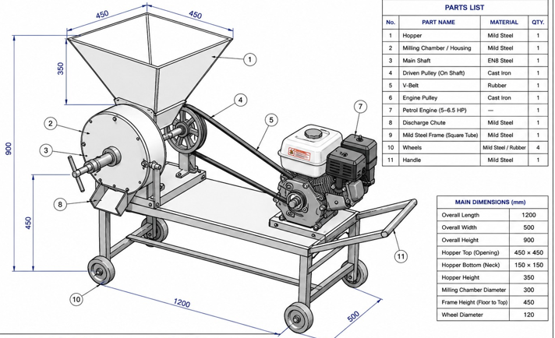
Figure 1: Grinding Machine

Noise Measurement
Noise measurements were recorded using a digital sound level meter at distances of 0.5 m, 1 m, 2 m, 3 m, 4 m, 5 m, and 6 m from the machine. Three measurements were taken at each distance and averaged. Measurements were recorded under the following conditions:
Baseline operation without damping material.
Internal combustion engine operation without load.
Operation with sawdust damping
Operation with rice husk damping
Each measurement was recorded after one minute of stable machine operation.
Vibration Measurement
A HT-1201 Spilt Vibrometer was used to determine vibration amplitude and frequency at the hopper, pulley, wheel, shaft, and machine bed. The temperature were recorded simultaneously to monitor thermal effects during testing.
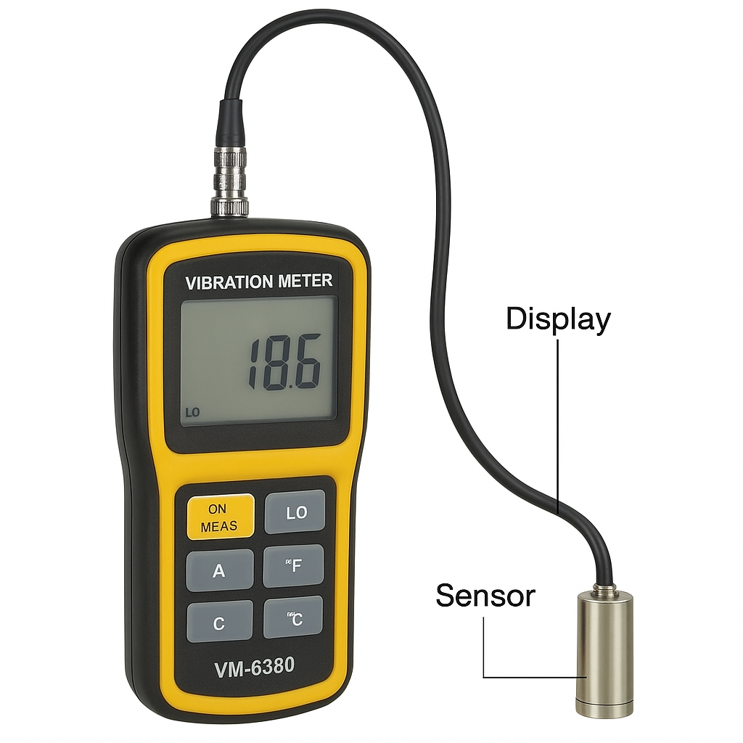
Figure 2: HT-1201 Spilt Vibrometer

Data Analysis
The measured noise levels were compared. Percentages noise reduction was calculated using:
Noise Reduction (%) = $\frac{L_{b-L_{d}}}{L_{b}}×100$ (1)
Were
$L_{b=}$ Baseline noise level (dBA)
$L_{d=}$ Noise level with damping material (dBA)

Error Analysis
SD$=\sqrt{\sum{{\left(\frac{x-\overline{x}}{n-1}\right)}^{2}}}$ (2)
Where SD = standard Deviation
x = individual measurement
$\overline{x}$ = mean value
n = number of trials
RESULTS AND DISCUSSION
The performance of the grinding machine was analyzed through a series of experimental tests conducted to evaluate its noise level, vibration characteristics and effectiveness of various damping materials under different conditions. The tests conducted are the baseline measure, the internal combustion engine test, vibrometer test, and damping material performance test using sawdust and rice husk.

Table 1: Baseline Test (Without Damping Material Separate)
Distance (m) | Trial 1 (Separate) | Trial 2 (Separate) | Trial 3 (Separate) | Mean
0.5 | 93 | 94 | 95 | 94
1.0 | 88 | 89 | 90 | 89
2.0 | 84 | 85 | 86 | 85
3.0 | 82 | 83 | 84 | 83
4.0 | 81 | 82 | 83 | 82
5.0 | 81 | 82 | 83 | 82
6.0 | 81 | 82 | 83 | 82

Table 2: Baseline Test (Without Damping Material Contact)
Distance (m) | Trial 1 (Contact) | Trial 2 (Contact) | Trial 3 (Contact) | Mean
0.5 | 97 | 98 | 99 | 98
1.0 | 96 | 97 | 98 | 97
2.0 | 95 | 96 | 97 | 96
3.0 | 94 | 95 | 96 | 95
4.0 | 93 | 94 | 95 | 94
5.0 | 92 | 93 | 94 | 93
6.0 | 91 | 92 | 93 | 92

Table 3: Sound Level Measurement for ICE (Internal Combustion Engine)
Distance (m) | Time (min) | Measurements Trial 1 (dBA) | Measurements Trial 2 (dBA) | Measurements Trial 3 (dBA) | Mean
0.5 | 1 | 79.0 | 79.0 | 79.0 | 79.0
1.0 | 1 | 78.0 | 78.2 | 77.8 | 78.0
2.0 | 1 | 75.0 | 75.3 | 74.7 | 75.0
3.0 | 1 | 74.0 | 74.0 | 74.0 | 74.0
4.0 | 1 | 74.0 | 74.1 | 73.9 | 74.0
5.0 | 1 | 73.0 | 73.0 | 73.0 | 73.0
6.0 | 1 | 72.2 | 71.8 | 72.0 | 72.0

Table 4: Vibration Measurement Results
Location | Frequency (Hz) | Vibration Amplitude (mm/s) | Temperature (°C)
Hopper | 1 kHz (high) | 199.9 mm/s | 33.1°C
Wheel | 1 kHz (high) | 164mm/s | 33.7°C
Pulley | 1 kHz (high) | 199mm/s | 33.3°C
Bed/Wood | 1 kHz (low) | 140 mm/s | 33.1°C
Shaft | 1 kHz (high) | 199.9 mm/s | 33.2°C

Table 5: (Noise Measurement with Sawdust Separate)
Distance (m) | Time (min) | Trial 1 (Separate) | Trial 2 (Separate) | Trial 3 (Separate) | Mean
0.5 | 1 | 85.0 | 86.0 | 87.0 | 86.0
1.0 | 1 | 82.0 | 81.8 | 82.2 | 82.0
2.0 | 1 | 81.0 | 82 | 83.0 | 82.0
3.0 | 1 | 78.8 | 79.0 | 79.2 | 79.0
4.0 | 1 | 76.0 | 77.0 | 78.0 | 77.0
5.0 | 1 | 77.0 | 77.0 | 77.0 | 77.0
6.0 | 1 | 77.0 | 76.0 | 78.0 | 77.0

Table 6: (Noise Measurement with Sawdust Contact)
Distance (m) | Time (min) | Trial 1 (Contact) | Trial 2 (Contact) | Trial 3 (Contact) | Mean
0.5 | 1 | 95.0 | 96.0 | 97.0 | 96.0
1.0 | 1 | 95.2 | 94.8 | 95.0 | 95.0
2.0 | 1 | 94.0 | 95.0 | 96.0 | 95.0
3.0 | 1 | 94.5 | 93.5 | 94.0 | 94.0
4.0 | 1 | 94.0 | 93.0 | 95.0 | 93.0
5.0 | 1 | 92.0 | 93.0 | 94.0 | 93.0
6.0 | 1 | 92.0 | 91.0 | 93.0 | 91.0

Table 7: (Noise Measurement with Rice Husk Separate)
Distance (m) | Time (min) | Trial 1 (Separate) | Trial 2 (Separate) | Trial 3 (Separate) | Mean
0.5 | 1 | 92.0 | 92.0 | 92.0 | 92.0
1.0 | 1 | 86.0 | 87.0 | 88.0 | 87.0
2.0 | 1 | 83.0 | 83.0 | 83.0 | 83.0
3.0 | 1 | 80.0 | 81.0 | 82.0 | 81.0
4.0 | 1 | 80.0 | 80.0 | 80.0 | 80.0
5.0 | 1 | 79.0 | 80.0 | 81.0 | 80.0
6.0 | 1 | 80.0 | 80.0 | 80.0 | 80.0
Table 8: (Noise Measurement with Rice Husk Contact)
Distance (m) | Time (min) | Trial 1 (Contact) | Trial 2 (Contact) | Trial 3 (Contact) | Mean
0.5 | 1 | 96.0 | 97.0 | 98.0 | 97.0
1.0 | 1 | 95.8 | 96.0 | 96.2 | 96.0
2.0 | 1 | 94.0 | 95.0 | 96.0 | 95.0
3.0 | 1 | 93.9 | 94.0 | 94.1 | 94.0
4.0 | 1 | 94.0 | 93.0 | 95.0 | 93.0
5.0 | 1 | 91.0 | 92.0 | 93.0 | 92.0
6.0 | 1 | 92.0 | 91.0 | 93.0 | 91.0

Table 9: Noise Reduction Efficiency of Sawdust
S/N | Distance (m) | Baseline (dBA) | Sawdust (dBA) | Reduction (%)
1 | 0.5 | 94.0 | 86.0 | 8.51
2 | 1.0 | 89.0 | 82.0 | 7.87
3 | 2.0 | 85.0 | 82.0 | 3.53
4 | 3.0 | 83.0 | 79.0 | 4.82
5 | 4.0 | 82.0 | 77.0 | 6.10
6 | 5.0 | 82.0 | 77.0 | 6.10
7 | 6.0 | 82.0 | 77.0 | 6.10

Average Sawdust Efficiency = 6.15%
Table 10: Noise Reduction Efficiency of Rice Husk
S/N | Distance (m) | Baseline (dBA) | Rice Husk (dBA) | Reduction (%)
1 | 0.5 | 94.0 | 92.0 | 2.13
2 | 1.0 | 89.0 | 87.0 | 2.25
3 | 2.0 | 85.0 | 83.0 | 2.35
4 | 3.0 | 83.0 | 81.0 | 2.41
5 | 4.0 | 82.0 | 80.0 | 2.44
6 | 5.0 | 82.0 | 80.0 | 2.44
7 | 6.0 | 82.0 | 80.0 | 2.44

Average Rice Husk Efficiency = 2.35%
One-way ANOVA
The mean noise level obtained for the baseline condition, sawdust damping, and rice husk damping were subjected to one-way ANOVA to evaluate the effectiveness of the damping materials in reducing noise
Table 11: One-way ANOVA for Noise Reduction Performance
Source of Variation | SS | df | MS | F- value | P- Value
Between Groups | 99.52 | 2 | 49.76 | 4.63 | <0.05
Within Groups | 193.43 | 18 | 10.75
Total | 292.95 | 20

Fcal= 4.63
At:
$$α=0.05$$
Fcrit (2, 18) = 3.55
Since
Fcal = 4.63> Fcrit = 3.55
Reject H₀

Table 12: Baseline Sound Level with Error Bar

S/N | Distance (m) | Baseline (dBA) | Error (SD)
1 | 0.5 | 94.0 | 1.0
2 | 1.0 | 89.0 | 1.0
3 | 2.0 | 85.0 | 1.0
4 | 3.0 | 83.0 | 1.0
5 | 4.0 | 82.0 | 1.0
6 | 5.0 | 82.0 | 1.0
7 | 6.0 | 82.0 | 1.0

Baseline Noise Characteristics
Figure 3 shows the baseline measurement, it reveal that the grinding machine generated relatively high sound pressure levels during operation. Separate sound measurements decreased from 94 dBA at a distance of 0.5 m to 82 dBA at 6 m. This reduction is attributed to attenuation of sound energy with increasing distance from the source (Nurbaiti et al., 2022). This observation agrees with acoustic propagation theory.
Baseline measurement contact reduce slightly from 98 dBA to 92 dBA over the same distance range. The higher contact noise levels compared to the separate measurement indicate the contribution (Singh et al., 2024) of structure-borne vibrations to overall noise generation. Vibration originating from the rotating shaft, grinding stones, pulley system, and machine frame were transmitted through the metallic components, resulting in amplification of noise through resonance. The contact measurement recorded are above the recommended 85 dBA suggesting a potential health risk for prolonged machine operation (NIOSH. 2020).
The contact measurements were consistently higher than the separate measurements because the measuring device detected vibration transmitted directly through the machine structure in addition to airborne sound. These structure-borne vibrations originated from the rotating shaft, pulley system, grinding chamber, and engine components. As vibration energy propagated through the metallic frame, resonance effects amplified the measured sound levels. This explains why contact measurements remained between 98 dBA to 92 dBA, while separate measurements decreased from 94 dBA to 82 dBA over the same distance range. The observation confirms that mechanical vibration is a major contributor to the total noise emitted by the grinding machine.

Figure 3: Baseline (Separate and Contact) Variation with Distance

Noise Contribution of the Internal Combustion Engine
The engine operating independently produced lower sound levels ranging from 79 dBA at 0.5 m to 72 dBA at 6 m, indicating that the engine alone is not the major source of noise within the grinding system. This observation shows that the grinding mechanism, rotating shaft, belt drive, pulley assembly, and grinding stones contribute significantly to the overall sound generation. Therefore the noise control should aimed also vibration control measures within the grinding unit.

Figure 4: Sound Level Variation with Distance
Vibration Measurements
The vibration amplitude distribution shows in figure 5. The hopper and shaft exhibited the highest vibration amplitudes of 199.9${mm}/s$, while the pulley recorded 199.0${mm}/s$. The machine bed recorded the lowest vibration amplitude 140.0${mm}/s$, indicating effective vibration damping by the support structure. This confirms that the hopper, pulley and shaft are the primary contributors to vibration-induced noise in the grinding machine. Similar observation were reported by Rao (2017), components directly connected to rotating systems often exhibit the highest vibration amplitudes due to dynamic imbalance and cyclic loading conditions. High vibration amplitudes contribute significantly to structure-borne noise generation and may accelerate wear of machine components. The comparatively lower vibration observed at the machine bed suggests that the support structure provided some degree of vibration isolation.

Figure 5: Vibration Amplitude Variation with Components
Performance of Sawdust as a Damping Material
The incorporation of sawdust significantly improved the acoustic performance of the grinding machine as shown in figure 6. At a distance of 0.5 m, the separate noise level decreased from 94 dBA to 86 dBA. Similar reduction were observed at all measured distances. The contact measurements also showed slight improvements. This result can be attributed to its porous structure which enhances sound absorption and energy dissipation through internal friction mechanisms (Tiuc, Nemeş, Vermeşan, & Toma, 2019; Tudor et al., 2021)
.

Figure 6: Sound level for Sawdust (separate and Contact) Variation with Distance
Performance of Rice Husk as a Damping Material
Figure 7 presents the noise measurements obtained when rice husk was used as damping material. The results indicate only a moderate reduction in noise levels compared to the baseline condition. Although rice husk possesses some sound absorption capability due to its fibrous structure, its relatively loose packing and lower density may have limited its ability to effectively dissipate vibrational energy (Guiman et al., 2023). Rice husk demonstrated lower noise reduction performance compared to sawdust.

Figure 7: Sound level for Rice Husk (separate and Contact) Variation with Distance
Effect of Sawdust and Rice Husk on Noise Reduction
Application of sawdust significantly reduced machine noise level. Mean noise values decreased from 86 dBA at 0.5 m to 77 dBA at 6.0 m compared with baseline values, sawdust achieved noticeable attenuation across all distance. Rice Husk also reduced machine noise but was less effective than sawdust. The low performance may be attributed to its comparatively lower density and reduced sound absorption capability.

Figure 8: Reduction for (Sawdust and Rice Husk) Variation with Distance
ANOVA Interpretation
A one-way Analysis of Variance (ANOVA) was performed to determine whether the damping materials significantly affected machine noise levels. The analysis yielded an F-value of 4.63, which exceeded the critical F-value of 3.55 at 5% significance level. Therefore, the null hypothesis was rejected, indicating that there was a statistically significant difference among the baseline, sawdust, and rice husk noise level. The result confirms that the application of damping materials significantly influenced noise reduction performance, with sawdust exhibiting the greatest attenuation effect.
Distance vs Average Baseline Sound Level (Error Bars)
Figure 9 shows the variation of baseline noise level with distance from the machine. The error bars represent the standard deviation of the three repeated measurements taken at each distance. The relatively small error bars indicate good repeatability and consistency of the experimental procedure. The overlap between adjacent error bars is minimal, suggesting that the reduction in noise level with increasing distance is a real trend rather than a result of random measurement error. The variability of repeated measurements and shows that the observed decrease in noise level is consistent across the testing distances.

Figure 9: Baseline Noise Level Variation with Distance
CONCLUSION
The study evaluated the effectiveness of sawdust and rice husk as damping materials for noise reduction in an internal combustion engine. Noise level decreased with increasing distance from the source in all operating conditions. The baseline noise level of the grinding machine exceeded the recommended occupational exposure limit of 85 dBA, indicating potential health risks to operators. Application of damping materials significantly reduce machine noise. Sawdust demonstrated superior sound absorption characteristic, achieving an average noise reduction efficiency of 6.15% reducing noise levels from 94 dBA to 86 dBA at a distance of 0.5 m, while rice husk achieved an average reduction efficiency of 2.35%, and provided limited damping performance. ANOVA analysis confirmed that the differences among the treatments were statistically significant (F=4.63. P< 0.05). Vibration measurement identified the shaft and hopper as major vibration sources. The use of sawdust is therefore recommended as low-cost and environmentally friendly noise control material for agricultural and small-scale industrial machinery.
RECOMMENDATION
In view of the above results, noise protective Ear-Muffs is recommended to grinding machine operators to protect them against negative impacts and bodily hurts from long term exposure to high level noise. Policy enforcement is recommended to regulatory bodies to ensure occupational noise exposure standard and promote awareness amongst small-scale mill operators.
ACKNOWLEDGEMENT
The authors express their gratitude to the Tertiary Education Trust Fund (TETFUND) for providing finance for this study and to Waziri Umaru Federal Polytechnics, Birnin Kebbi, for choosing us as the recipients of the TETFUND research.

REFERENCES
Bies, D. A., Hansen, C. H., Howard, C. Q., & Hansen, K. L. (2023). Engineering noise control: CRC press.
Brandt, A. (2023). Noise and vibration analysis: signal analysis and experimental procedures: John Wiley & Sons.
Desta, M. A., & Oumer, A. (2022). Design and Performance Evaluation of Grain Feed Grinding Machine. Turkish Journal of Agricultural Engineering Research, 3(2), 231-244.
Food and Agriculture Organization of the United Nations (FAO). (2022). The State of Food and Agriculture 2022: Leveraging automation in agriculture for transforming agrifood system. Rome, Italy: FAO
Guiman, M. V., Stanciu, M. D., Roșca, I. C., Georgescu, S. V., Năstac, S. M., & Câmpean, M. (2023). Influence of the grain orientation of wood upon its sound absorption properties. Materials, 16(17), 5998.
Haruna, A., & Agu, M. (2011). Grinding machine noise spectra in Kaduna metropolis, Nigeria. Journal of Environmental Issues and Agriculture in Developing Countries, 3(1), 157.
Jang, E.-S. (2023). Sound absorbing properties of selected green material—A review. Forests, 14(7), 1366.
Mohammadi, M., Taban, E., Tan, W. H., Din, N. B. C., Putra, A., & Berardi, U. (2024). Recent progress in natural fiber reinforced composite as sound absorber material. Journal of building engineering, 84, 108514.
NIOSH. (2020). Occupational noise exposure and hearing conservation. Retrieved from https:// www.cdc.gov/niosh
Nurbaiti, Y., Yulianto, A., & Nurbaiti, U. (2022). The Natural Composite of Sawdust Teak as a Sound Absorption Materials Using The Resonator Space Method. Physics Education Research Journal, 4(1), 29-34.
Rao, S. S. (2019). Vibration of continuous systems: John Wiley & Sons.
Rinawati, S., Khusaini, M., Ciptadi, G., & Handayani, D. (2024). Reducing Noised–The Impact of Biocomposite Noise Dampers with Grinting Grass (Cynodon dactylon) on Noise Intensity. Ecological Engineering & Environmental Technology, 25.
Singh, K. J., Palei, S. K., & Karmakar, N. C. (2024). Role of contributing factors on health risks of whole-body vibration exposure of heavy equipment and vehicle operators: A critical review. Journal of Vibration and Control, 30(11-12), 2338-2355.
Tiuc, A. E., Nemeş, O., Vermeşan, H., & Toma, A. C. (2019). New sound absorbent composite materials based on sawdust and polyurethane foam. Composites Part B: Engineering, 165, 120-130.
Tudor, E. M., Kristak, L., Barbu, M. C., Gergeľ, T., Němec, M., Kain, G., & Réh, R. (2021). Acoustic properties of larch bark panels. Forests, 12(7), 887.
Vesković, S. (2025). Natural food preservation: Controlling loss, advancing safety: Springer.

