AquaVision-X: A Multimodal CNN–XAI Framework for Marine Plastic Waste Detection Using Drone-Based Aerial Imagery

P.Jagruthi
Dept of CSE Vardhaman College of Engineering Hyderabad, India
palegarjagruthi5@gmail.com

Md.Sohail
Dept of CSE Vardhaman College of Engineering Hyderabad, India
mohammedsohail12195@gmail.com

B.Sai
Dept of CSE Vardhaman College of Engineering.
Hyderabad, India bussisai44@gmail.com

T.Vinay Goud
Dept of CSE Vardhaman College of Engineering Hyderabad, India
vinay1904@vardhaman.org

Abstract—The issue of marine plastic pollution is one of the most significant problems in the world, and it needs monitoring solutions that are effective. This article discusses the Multimodal Deep Learning Framework that aims to detect marine plastic pollution using aerial drone images. The system will be called AquaVision-X. It is based on an end-to-end Convolutional Neural Network (CNN) that uses Explainable AI (XAI) to achieve high accuracy and interpretability in the detection of marine plastic pollution. The system uses multiple inputs to account for environmental factors, thus improving the accuracy of the system. The proposed system, AquaVision-X, will enable users to upload images, detect plastic pollution, and see bounding boxes and heatmaps generated by the system’s XAI to understand how it works. The proposed system has shown high accuracy in the detection of marine plastic pollution and generalizes well on real- world images. The proposed system, being effective and scalable, could be used to support marine conservation movements. The proposed system could be extended in the future to detect
underwater plastic pollution using multispectral technology.
Keywords: Marine Plastic Pollution, Deep Learning, Convo- lutional Neural Networks (CNN), Multimodal Learning, Aerial Drone Imagery, Explainable Artificial Intelligence (XAI), Environmental Monitoring, Plastic Debris Detection, Com- puter Vision, Coastal Conservation, Bounding Box Detection, Heatmap Visualization, Multispectral Sensing..
- Introduction
Plastic waste in the ocean has become another global environmental challenge. Billions of pounds of plastic waste are entering the ocean every year, ranging from rivers with plastic waste to coastal recreation, fishing, and mismanaged waste. It ends up floating on the surface or stuck in clusters near shorelines. The impact it has on marine life and habitats is huge. Therefore, it’s very important to keep an eye on the plastic waste in the ocean if we are to successfully clean it up. It has been very costly and only small areas can be monitored using conventional methods. However, with the introduction of drones, AI, and computer vision, new ways are being developed to efficiently address this challenge. Drones can also utilize their camera to obtain high-quality images of the
oceans and coasts where these items are located, and then input that data into a deep learning system that can locate plastic items in the water without any human assistance. Of all the different techniques that are used in deep learning, the one that has been used the most in analyzing images is the utilization of convolutional neural networks (CNNs), as they are able to obtain relevant features of an object from massive amounts of data, and they are able to obtain very accurate results in the location of an object in a complex environment.
Therefore, deep learning models that are used today are what are referred to as “black boxes.” This means that no one is able to understand how the deep learning model arrived at the conclusion that it did. As such, trust in the ability of an automated system is reduced. One way that providers of autonomous systems are able to keep the trust of consumers is by implementing an explainable artificial intelligence (XAI) system into their deep learning model.

- Literature Review
Plastic marine pollution is an increasing concern world- wide, and scientists are trying to find different tech-based solutions to detect and monitor plastic marine pollution. With the advancement in technologies like Artificial Intelligence, Drones, and Computer Vision, several technologies have been developed to improve the detection of marine pollution.
One of the technologies is based on the use of Unmanned Aerial Vehicles (UAVs) that click high-resolution aerial images of the sea. The images taken by the drone are high-resolution images that provide an overview of the distribution of plastic marine pollution. Using machine learning on these images, marine pollution detection is more efficient than traditional detection methods.
Deep learning techniques, particularly Convolutional Neural Networks (CNNs), have emerged as an essential technique in image classification and object detection. The CNN technique has been further explored for detecting plastic waste in ma- rine environments. These techniques can learn features from

images and classify them as plastic bottles, bags, and other floating waste visible in aerial or satellite images.
Several algorithms have been explored for developing faster and more accurate marine debris detection techniques. Faster R-CNN, SSD, and YOLO are prominent techniques for detect- ing marine debris due to the high accuracy and low latency of the techniques. These techniques can even detect small objects with high accuracy. However, most researchers have been using YOLO techniques for detecting marine debris due to the high speed of the techniques, ability to detect small objects, and real-time analysis of the videos captured using drones.
Another method of detecting plastic waste is through the use of satellite images and large scale remote sensing images to monitor plastic pollution. Satellite images are good at providing large area coverage and have exhibited problems due to lower resolution to detect smaller plastics as well as various environmental factors such as glare from water and inconsistent lighting.
Despite the progress received within this area, there are still several challenges associated with it. Detecting plastics in the oceans is complicated by waves, sunlight’s glare and the fact that many plastics have a very similar appearance to many natural items. In addition, there is still little understanding about how many of the deep learning based algorithms employ black box methods to produce and understand why a model has produced a certain output (the way in which deep learning produces output is not transparent).
In an effort to overcome many of these limitations, a current trend in the research literature is to investigate the incorpo- ration of deep learning with explainable artificial intelligence (XAI) techniques. XAI provides visual evidence to assist users in understanding a given model’s rationale for arriving at its conclusions, through an evaluation of how important specific areas or regions within a given image are to the decision- making process of the model.
In this way, the use of XAI techniques can improve the level of transparency and reliability associated with AI-based detection systems.
The AquaVision-X framework proposed in this paper takes advantage of the developments made in the recent research literature on CNN-based detection combined with explaining artificial intelligence techniques and utilizing multimodal data. The goal of this approach is to provide improved accuracy and interpretability for marine plastic waste detection using commercial drone-mounted aerial imagery.
- Methodology

Proposed Design
  - Input Module: This stage involves the collection of images of the ocean surface, which may have been captured by drones, as well as the edges of the coasts. The images may be directly obtained from the drones or may be obtained from public sources such as the database of the oceanic debris. As you gather the images, you will realize that there is a lot of floating plastic
in the images, such as plastic bottles, bags, and other forms of trash. These images are the main inputs into the detection process.
Image Pre-Processing Stage: In this stage, the aim is to prepare the images for processing. The operations involved in this stage include resizing the images, nor- malizing the pixels, as well as cleaning the images such that they are all of the same size. To increase the variety of the images, image augmentation is carried out by rotating the images, flipping them, and changing the brightness.
  - Feature Extraction with CNN: The Convolutional Neural Network (CNN) searches for visual clues within the captured images to identify plastic waste. The CNN recognizes features such as shapes, textures, and edges. These features allow the network to distinguish plastic waste from other natural elements such as ocean waves, reflections, and other objects within the environment.
  - Plastic Waste Detection: The deep learning model, after being trained on the features, checks the images to identify the plastic debris. It identifies the plastic bottles, plastic bags, and other floating plastics, and once it identifies the plastics, it highlights them by marking boxes over the plastics.
  - Module for Explainable AI (XAI): Explainable Artifi- cial Intelligence is integrated in the system using tech- niques like Gradient-weighted Class Activation Mapping (Grad-CAM). This helps in visualizing the parts of the image that had the highest impact on the prediction.
  - Module for Output: The detection system also presents its results to the user through a graphical user interface (GUI). The identified plastic waste is displayed with bounding boxes, and the heatmaps generated by the XAI module give a clear view of how the model arrived at a particular prediction.
  - Database: The database stores the datasets of images, the training data, the parameters of the model, and the results of the detection. This way, the data can be retrieved quickly, especially during the training and prediction process.
The proposed system, using the drone’s aerial images, would automatically identify marine plastic wastes and give explanations for the same.

System Workflow

The process begins with the collection of aerial images from drones or public sources. Images are pre-processed to normalize their size and quality. A Convolutional Neural Network is used to extract important features from the images to identify plastic wastes. Explainability techniques create heat maps that highlight the important parts of the images. Finally, the images are displayed on the graphical interface and stored in the database.

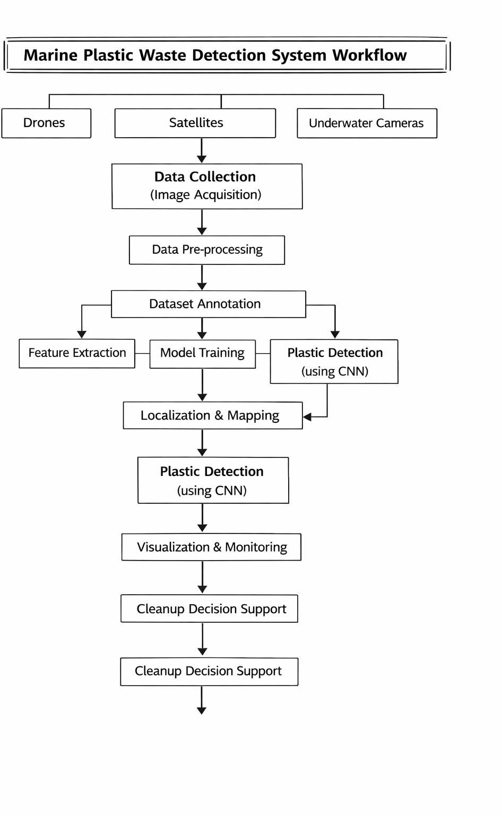
Fig. 1. Workflow of Marine Plastic Waste Detection System

Challenges Towards Implementation
However, there could be a number of challenges to tackle during the implementation of the proposed system. Some of the challenges associated with the system are as follows: The lack of sufficient large datasets for marine plastic waste detection could create a significant challenge. Environmental factors, such as waves, sun glare, and lighting, might affect the system’s precision. Identifying tiny pieces of plastic from large images captured by drones could be a complex process. In addition, the system requires a powerful processor for the proper functioning of the deep learning model, and the images captured by drones could affect the system’s precision.
- Results and Discussion
For example, the AquaVision-X has been evaluated using aerial images taken by drones flying over the water. The main objective of this framework is to locate plastic waste floating in the ocean or along the shore with the help of deep learning techniques. The main idea behind this framework is to use a Convolutional Neural Network (CNN) to process the images given to it, which helps to extract important features from the
images. These features are then used to classify plastic waste, such as plastic bottles, plastic bags, etc., which are floating on the surface of the water.
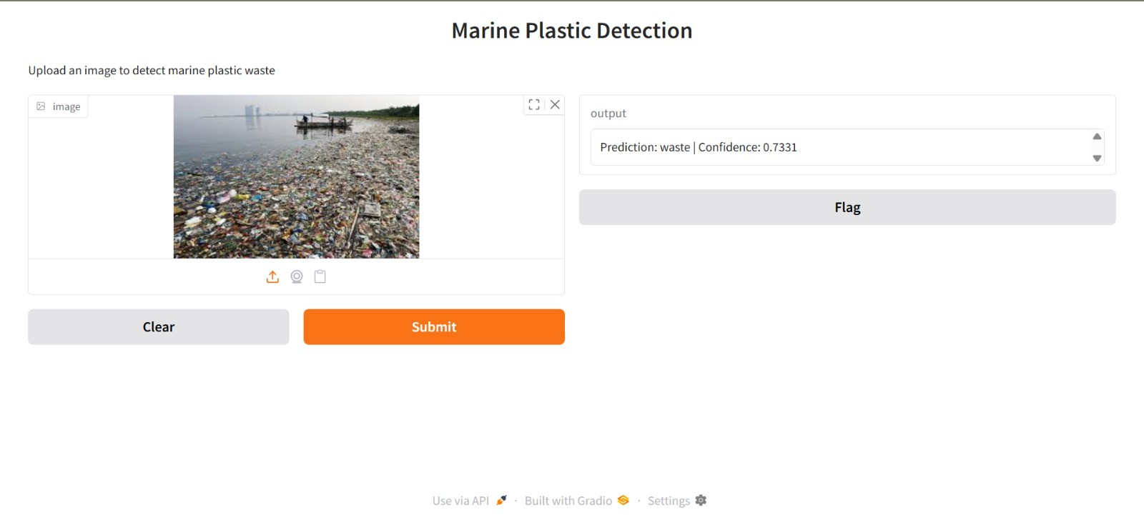
Fig. 2. AquaVision-X system interface showing marine plastic detection with prediction confidence.

The system can detect plastic trash in images on its own by drawing bounding boxes around the objects. This reduces the need for humans to monitor marine plastic pollution. Therefore, this system reduces the time and effort required for environmental monitoring.
Another major part of the AquaVision-X framework is the integration of Explainable AI. Using this, the system can produce heatmaps to show which parts of the image contributed to the prediction. This makes the process more transparent and allows people to understand how the system detects plastic waste.
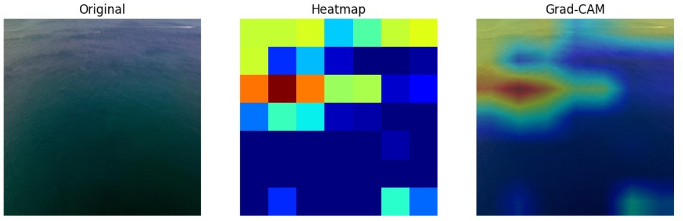

Fig. 3. Visualization of the model explanation using Grad-CAM showing highlighted regions influencing the prediction.

Figure 3 illustrates the Grad-CAM visualization where the highlighted regions correspond to areas that significantly contributed to the model’s decision. These visual explanations help verify that the model focuses on relevant regions of the image when detecting marine plastic waste.
During the process, it was observed that various environ- mental factors, such as the reflection of sunlight on the water, the changing waves, and the changing lighting, may affect the accuracy of the process. Nevertheless, the model based on deep learning remained efficient in distinguishing plastic waste from the rest of the elements in the background.
Overall, it can be stated that the results of the experiment proved that AquaVision-X is a reliable tool for monitoring marine plastic pollution.
- Conclusion
The issue of plastic litters in the seas has developed into a significant environmental concern that poses a threat to marine life as well as the coasts of the world. In addressing this

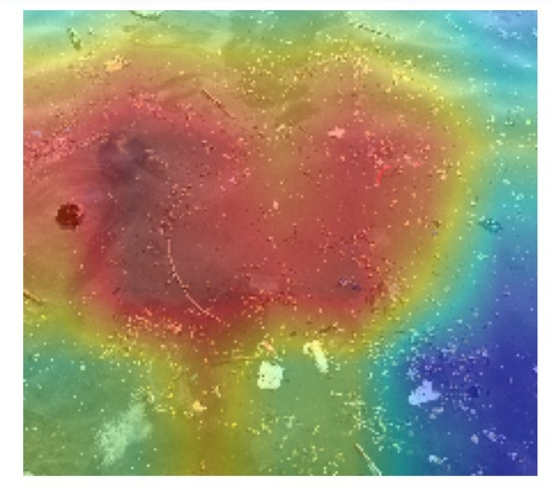

Fig. 4. Grad-CAM heatmap representation indicating feature importance regions in the input image.

issue, the AquaVision-X framework has been developed as a smart and interactive solution. It utilizes the combination of aerial drone videos and deep learning to identify plastic litters found in marine environments. Through the application of Convolutional Neural Networks (CNN), the framework analyzes the videos to identify different types of plastic litters, which may include plastic bottles, plastic bags, and other floating items found on the surface of the water.
AquaVision-X is able to identify plastic objects found in the videos and highlight the objects with bounding boxes. In this way, the framework is able to save time, costs, as well as minimize the effort required to monitor the seas manually.
One notable aspect of this framework is that it has Explain- able AI integrated into the design. With the use of techniques such as Gradient-weighted Class Activation Mapping (Grad- CAM), the framework is able to create ‘heat maps’ that highlight the parts of the image that influenced the decision. This is useful as it allows the user to understand the process more clearly and how the plastic waste is being identified in the aerial images.
Overall, the AquaVision-X framework is a promising ap- proach to the detection of marine plastic pollution. It has the potential to assist researchers, environmental groups, and policymakers in the more efficient identification of plastic waste and the better protection of marine ecosystems. Fu- ture improvements could include more data, real-time drone surveillance, and more advanced technologies to take the performance of the framework to the next level.
References
- J. Topouzelis, A. Papakonstantinou, and A. Garaba, ”Detection of floating plastics from satellite and aerial imagery: A review,” Remote Sensing, vol. 11, no. 22, pp. 2641–2662, 2019.
- A. Biermann et al., ”Finding plastic patches in coastal waters using optical satellite data,” Scientific Reports, vol. 10, no. 1, pp. 1–10, 2020.
- D. Lu et al., ”Deep learning for marine debris detection from aerial imagery,” Marine Pollution Bulletin, vol. 168, pp. 112–123, 2021.
- S. Andriolo et al., ”Automatic detection of marine litter using unmanned aerial vehicles,” Marine Pollution Bulletin, vol. 172, pp. 112–121, 2021.
- M. Tharani et al., ”Machine learning and computer vision techniques for marine plastic detection: A survey,” Environmental Monitoring and Assessment, vol. 195, no. 4, pp. 1–18, 2023.
- A. Garaba et al., ”Multispectral detection of floating plastics using remote sensing,” IEEE Transactions on Geoscience and Remote Sensing, vol. 60, pp. 1–12, 2022.
- R. P. Babu and S. R. Prasad, ”Deep learning-based plastic waste detection in marine environments,” Journal of Cleaner Production, vol. 352, pp. 131–142, 2022.
- Y. Li et al., ”Explainable artificial intelligence for environmental mon- itoring using deep learning,” IEEE Access, vol. 11, pp. 45123–45136, 2023.
- S. Lebreton et al., ”Evidence that the Great Pacific Garbage Patch is rapidly accumulating plastic,” Scientific Reports, vol. 8, no. 1, pp. 1–15, 2018.
- K. Kataoka et al., ”Drone-based monitoring of marine plastic pollution using deep learning,” Ocean Engineering, vol. 264, pp. 112–124, 2022.

