Mindfulness, Self-Compassion, and Student Performance: The Mediating Effect of Student Engagement

Almerah A. Mauna
PhD-EDMGT Student, Capitol University

Abstract. This study investigates the mediating effect of student engagement on the relationship between mindfulness, self-compassion, and student performance among Grade 6 learners in public elementary schools in the Philippines. Grounded in Self-Determination Theory and Engagement Theory, the study responds to the growing demand for holistic and evidence-based approaches to address persistent challenges in academic achievement and learner well-being. A quantitative, descriptive-correlational design was employed, involving 200 students selected through simple random sampling. Standardized instruments were used to measure mindfulness, self-compassion, and engagement, and data were analyzed using Structural Equation Modeling (SEM) and bootstrapping methods. The findings revealed that mindfulness significantly predicts student performance, both directly and indirectly through student engagement, indicating partial mediation. While self-compassion did not have a direct effect on performance, it influenced it indirectly and fully through engagement, confirming a full mediation model. Student engagement emerged as a critical mechanism linking these psychological traits to academic outcomes. The model demonstrated excellent fit across multiple indices (e.g., CFI = .988, RMSEA = .029, SRMR = .037). These results underscore the importance of integrating mindfulness and self-compassion into educational programs to enhance student engagement and learning performance. The study contributes to localized research on non-cognitive factors in education and advocates for learner-centered interventions in the Philippine basic education system.

Keywords: mindfulness, self-compassion, student engagement, academic performance, Structural Equation Modeling

I. Introduction

In the Philippine educational landscape, improving student academic performance remains a persistent and urgent concern, particularly at the elementary level where the foundations of lifelong learning are established. Despite numerous reforms introduced by the Department of Education (DepEd)—including the K to 12 Basic Education Program and the MATATAG Curriculum—students across the nation, especially in public schools, continue to grapple with underachievement, learning loss, and disengagement. These challenges are further exacerbated by socio-economic inequalities, high emotional stress, and limited access to quality learning resources. National assessments and reports from global institutions such as the World Bank reveal concerning rates of learning poverty in the Philippines, where a significant number of students fail to master basic literacy and numeracy skills (Hiver et al., 2021). These conditions highlight the need for transformative, evidence-based interventions that address not only academic competencies but also students' mental and emotional well-being (Wester et al., 2021).
In response to this growing need, there is increasing advocacy for the integration of non-cognitive, psychological constructs into basic education—most notably mindfulness and self-compassion. Mindfulness, characterized by intentional and non-judgmental awareness of the present moment, has been linked to improved self-regulation, reduced anxiety, and heightened academic engagement (Kuo et al., 2021; Tulabut et al., 2021). Likewise, self-compassion—extending kindness to oneself in the face of difficulties—has been associated with emotional resilience, intrinsic motivation, and lower stress levels (Mei-juan & Cheng, 2020; Chen & Zhang, 2022). These psychological capacities are especially relevant to Filipino learners, many of whom face multifaceted pressures from school, family, and community life. Fostering these internal strengths may equip students not only to cope more effectively with academic demands but also to thrive in emotionally supportive learning environments (Michael et al., 2020).
However, while the benefits of mindfulness and self-compassion have been well-documented in international research, their application and impact within the Philippine educational context remain insufficiently explored. There is a lack of empirical studies examining how these traits influence student learning, particularly among elementary learners (Hagedorn et al., 2021). Furthermore, the potential mechanism of student engagement—which includes behavioral, emotional, and cognitive involvement in learning—has not been extensively studied as a mediating pathway in this context. Engagement serves as the critical interface between psychological strengths and academic outcomes, yet it often receives limited attention in local educational research (Sajadifar & Namazi, 2023).
This study seeks to bridge this gap by examining the role of student engagement as a mediating variable in the relationship between mindfulness, self-compassion, and student performance. Focusing on Grade 6 learners in public elementary schools, this research recognizes the developmental importance of middle childhood as a stage where learners begin to consolidate both academic skills and emotional regulation. Through the use of Structural Equation Modeling (SEM), the study aims to uncover both direct and indirect pathways linking internal psychological resources to academic success (White et al., 2020; Lee & Jang, 2020).
By generating localized, data-driven insights, this study aims to inform the design of culturally relevant educational interventions and learner support programs. Ultimately, it contributes to the broader national goal of nurturing resilient, engaged, and high-performing learners—a vision that aligns with 21st-century learning frameworks and the holistic development agenda of the Philippine education system (Choi & Brochu, 2020).

Theoretical Framework
The theoretical foundation of this study is based on Self-Determination Theory (Deci & Ryan, 2020) and Engagement Theory (Fredricks et al., 2021), both of which offer valuable insights into the relationship between mindfulness, self-compassion, student engagement, and academic performance.
Self-Determination Theory (SDT) posits that individuals are intrinsically motivated when their basic psychological needs for autonomy, competence, and relatedness are fulfilled. This theory suggests that students who feel in control of their learning (autonomy), believe in their ability to succeed (competence), and experience meaningful social connections (relatedness) are more likely to be engaged in academic activities. Meanwhile, Engagement Theory highlights behavioral, emotional, and cognitive engagement as essential factors in academic success. Behavioral engagement refers to participation in academic tasks, attendance, and effort, while emotional engagement involves students’ feelings of belonging, interest, and motivation. Cognitive engagement reflects deep learning strategies and self-regulated learning. Mindful students are better able to manage stress and sustain attention, enhancing cognitive and emotional engagement
Based on these theoretical foundations, this study proposes that mindfulness and self-compassion positively influence student engagement, which, in turn, mediates the relationship between mindfulness/self-compassion and academic performance. Understanding this mediation process is crucial, as it highlights how psychological well-being contributes to academic success. By empirically testing this model, the study extends previous research on the role of student engagement in linking mindfulness and self-compassion to academic outcomes, contributing to the broader field of educational psychology.

Hypothesized Model of the Study
Based on these theoretical foundations, the study proposes the following conceptual framework:
- Mindfulness and self-compassion positively influence student engagement.
- Mindfulness and self-compassion positively influence student performance.
- Student engagement mediates the relationship between mindfulness/self-compassion and student performance.
- Higher engagement levels result in better academic performance.

This study extends previous research by empirically testing the mediating role of student engagement in linking mindfulness and self-compassion to academic outcomes, contributing to the growing body of knowledge in educational psychology.

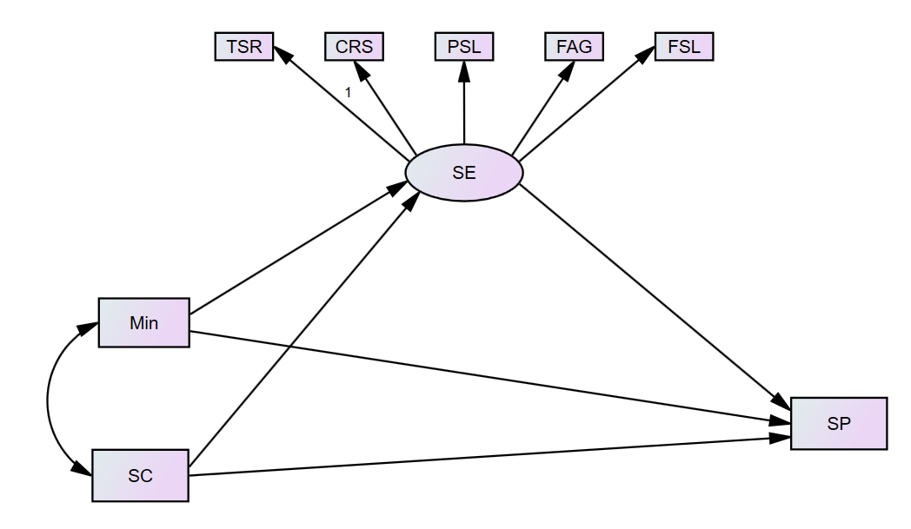

Figure 1. Hypothesized Model

Research Questions

This study seeks to investigate the mediating role of student engagement in the relationship between mindfulness, self-compassion, and student performance. Specifically, the research aims to address the following questions:
- Does mindfulness has a direct effect on student performance?
- Does self-compassion has a direct effect on student performance?
- Does mindfulness has a direct effect on student engagement?
- Does self-compassion has a direct effect on student engagement?
- Does student engagement has a direct effect on student performance?
- Does student engagement mediate the relationship between mindfulness and student performance?
- Does student engagement mediate the relationship between self-compassion and student performance?

Hypotheses
Based on the theoretical framework and research questions, the study formulates the following hypotheses:
- H1: Mindfulness has a direct effect on student performance.
- H2: Self-compassion has a direct effect on student performance.
- H3: Mindfulness has a direct effect on student engagement.
- H4: Self-compassion has a direct effect on student engagement.
- H5: Student engagement has a direct effect on student performance.
- H6: Student engagement mediate the relationship between mindfulness and student performance.
- H7: Student engagement mediate the relationship between self-compassion and student performance.
II. Methodology

Research Design
This study employs a quantitative, descriptive-correlational research design to investigate the relationships between mindfulness, self-compassion, student engagement, and student performance. The study also examines the mediating role of student engagement in the relationship between mindfulness/self-compassion and student performance. Structural Equation Modeling (SEM) will be utilized to test the proposed mediation model.

Participants and Sampling Procedure
The target population for this study consisted of 200 grade 6 students enrolled in an academic program, School Year 2024-2025. A simple random sampling technique was used to ensure an equal chance of selection among students from the district schools.

Instruments
The study used standardized and validated self-report instruments to measure the key variables:
The Mindful Attention Awareness Scale (MAAS), developed by Kirk Warren Brown and Richard M. Ryan (2003), is a widely used self-report instrument designed to measure dispositional mindfulness, which refers to an individual's general tendency to be attentive and aware of present-moment experiences. The MAAS consists of 15 items, each describing everyday experiences that reflect a lack of mindfulness. Responses are rated on a six-point Likert scale, ranging from 1 (Almost Always) to 6 (Almost Never), with higher scores indicating greater mindfulness. The scale has demonstrated high internal consistency (Cronbach’s alpha = 0.82), test-retest reliability (r = 0.81), and validity across various populations, including college students and clinical groups.
The Self-Compassion Scale - Short Form (SCS-SF), developed by Raes et al. (2011) based on the original Self-Compassion Scale (SCS) by Dr. Kristin Neff (2003), is a widely used self-report instrument that measures self-compassion as a unitary construct. It consists of 12 items, each rated on a five-point Likert scale (1 = Almost Never, 5 = Almost Always). Higher scores indicate greater levels of self-compassion.
While the SCS-SF retains the six-factor structure of the original scale, studies suggest that self-compassion can be analyzed as a single-dimensional construct, as supported by bifactor ESEM modeling (Neff et al., 2019). Given this, the present study utilizes the total SCS-SF score as an overall measure of self-compassion rather than analyzing individual subscales. The total score is computed by reverse-scoring the negatively worded items and calculating the mean score of all 12 items. The SCS-SF has demonstrated strong psychometric properties, with a Cronbach’s alpha of ≥ 0.86 and a near-perfect correlation (r ≥ 0.97) with the full 26-item SCS, making it a valid and reliable instrument for assessing self-compassion in this study.
The Student Engagement Instrument (SEI, developed by Appleton, Christenson, Kim, and Reschly (2006), is a self-report tool designed to measure cognitive and psychological engagement among students in school. It focuses on students’ internal perceptions of their learning experience, rather than observable behaviors such as attendance or participation. The instrument consists of 29 items rated on a four-point Likert scale ranging from 1 (Strongly Agree) to 5 (Strongly Disagree), with lower scores indicating higher levels of engagement. The SEI includes five subscales: (1) Teacher-Student Relationships, which assess students’ perceptions of support, fairness, and care from teachers; (2) Control and Relevance of School Work, which measures how meaningful and personally relevant students find their schoolwork; (3) Peer Support for Learning, which evaluates the emotional and academic support students perceive from their peers; (4) Future Aspirations and Goals, which captures the importance students place on education for their future success; and (5) Family Support for Learning, which reflects the extent to which students feel supported by their family or guardians in their academic pursuits. The SEI has shown good internal consistency, with Cronbach’s alpha coefficients ranging from 0.72 to 0.89 across its subscales, and has been validated across diverse student populations.

Data Collection Procedure
Prior to data collection, the study received ethical approval from the institutional review board. Participants provided informed consent after receiving a briefing outlining the study's aims, procedures, and their rights, emphasizing voluntary participation. Questionnaires were administered either in person or online, maintaining participant anonymity and confidentiality. Finally, collected responses underwent a screening process to identify and address incomplete data or missing values, ensuring data quality before analysis.

Data Analysis
Conducted using JASP and AMOS software, following these statistical procedures:
Descriptive Statistics. Mean, standard deviation, as well as skewness and kurtosis frequency were computed to summarize the data.
Structural Equation Modeling (SEM). Tested the hypothesized mediation model, evaluating direct and indirect effects among variables.
Mediation Analysis. The Bootstrapping method (2000 resamples) was used to determine the significance of indirect effects in the mediation model.

Ethical Considerations
The study adhered to ethical research standards, including informed consent, confidentiality, and voluntary participation. Participants had the right to withdraw from the study at any stage without any consequences. The data were securely stored and used solely for academic research purposes. By employing rigorous methodological procedures, this study provided robust evidence on the role of mindfulness and self-compassion in student engagement and academic performance.

III. Results and Discussion

The descriptive statistics presented in Table 1 offer valuable insights into the central tendencies, variability, and distribution shapes of key psychological and educational constructs among the student population. The variables include Mindfulness (Min), Self-Compassion (SC), Student Engagement subscales—Teacher-Student Relationships (TSR), Control and Relevance of School Work (CSR), Peer Support for Learning (PSL), Future Aspirations and Goals (FAG), Family Support for Learning (FSL)—and Student Performance (SP).

Table 1
Descriptive Statistics
Variables | Mean | SD | Skewness | Kurtosis
Min | 4.539 | .784 | -1.517 | 3.820
SC | 4.337 | .356 | -.805 | .941
TSR | 4.301 | .403 | -.950 | 1.312
CRS | 4.228 | .503 | -.246 | -.655
PSL | 4.121 | .579 | .189 | -1.164
FAG | 4.071 | .590 | -.185 | -.833
FSL | 4.289 | .454 | -.285 | -.619
SP | 3.955 | 1.175 | -.870 | -.517
Note: Standard Deviation (SD); Mindfulness (Min); Self-Compassion (SC); Teacher-Student Relationships (TSR); Control and Relevance of School Work (CSR); Peer Support for Learning (PSL), Future Aspirations and Goals (FAG); Family Support for Learning (FSL); Student Performance (SP)

Among the variables, Mindfulness had the highest mean score (M = 4.539), indicating a strong presence of mindfulness practices among the learners. This finding aligns with previous studies highlighting mindfulness as a significant factor contributing to academic resilience and psychological well-being (Sujadi, 2022; Salsabila & Widyasari, 2021). In contrast, Student Performance recorded the lowest mean (M = 3.955), suggesting that while learners generally possess favorable psychological attributes, their academic outcomes may not be equally high. This gap has been similarly observed in studies noting that while psychological well-being supports academic success, it does not automatically result in improved academic performance without adequate instructional and environmental support (Carnicer et al., 2020; Draper-Clarke, 2020).
In terms of variability, the standard deviation (SD) values reveal that Self-Compassion had the lowest SD (0.356), suggesting consistency in how learners perceive their self-compassion. This reflects the stability of self-compassion as a psychological trait, which has been linked to reduced stress and anxiety (Stogianni & Lin, 2022; Zhang & Shen, 2023). Conversely, Student Performance showed the highest variability (SD = 1.175), indicating diverse levels of academic achievement across the sample. Skewness values for all variables were negative, showing that most learners rated themselves on the higher end of the scales. The strongest negative skewness was observed in Mindfulness (-1.517) and Teacher-Student Relationships (-0.950), indicating a general tendency for learners to positively evaluate their psychological traits and relational experiences. This trend is supported by literature that underscores the benefits of mindfulness and supportive teacher-student relationships on learners’ academic engagement and psychological health (Kalika et al., 2022; Altinyelken, 2022).
Kurtosis values offer insights into the shape of score distributions. Mindfulness exhibited a high kurtosis value (3.820), characterizing it as leptokurtic—suggesting a peaked distribution where most responses were high, with a few extremely high values. This pattern supports findings that some learners may exhibit exceptional levels of mindfulness, leading to enhanced resilience and coping skills (Sujadi, 2022). In contrast, Peer Support for Learning (-1.164) and Future Aspirations and Goals (-0.833) showed platykurtic distributions, reflecting flatter score patterns and a broader range of responses. This indicates variability in how learners perceive peer relationships and future goals, which is consistent with previous findings that such constructs can vary greatly depending on individual and contextual factors (Burhanuddin et al., 2023; Shaw & Cassidy, 2021).
Overall, the results suggest that learners tend to have optimistic self-perceptions in psychological domains, which may contribute to greater resilience and readiness for learning. However, the substantial variability in academic performance signals the need for targeted interventions for those who may be lagging behind. Additionally, while the assumptions for parametric analyses are largely met, the pronounced skewness and kurtosis in the Mindfulness variable may require further investigation or transformation to satisfy normality assumptions in subsequent modeling procedures (Tran et al., 2022; Bùi et al., 2021; Egan et al., 2020). These findings establish a foundational understanding of the interplay between psychological characteristics and student outcomes, serving as a basis for further inferential analysis and educational policy implications.

Normality Assessment and Suitability for SEM Analysis
To assess the assumption of normality and determine the suitability of the data for Structural Equation Modeling (SEM), the skewness and kurtosis values of the measured variables were examined. In SEM, normality of the data is crucial, particularly for techniques such as Maximum Likelihood Estimation (MLE), which assumes multivariate normality. According to commonly accepted guidelines (Kline, 2016; Byrne, 2013), skewness values within the range of ±2 and kurtosis values within ±7 are considered acceptable for SEM analysis. In this study, all skewness values ranged from -1.517 (Mindfulness) to -0.185 (Future Aspirations and Goals), while kurtosis values ranged from -1.164 (Peer Support for Learning) to 3.820 (Mindfulness). These figures fall within the recommended thresholds, indicating that the univariate distributions of the variables do not significantly deviate from normality.
The highest skewness and kurtosis were observed in the Mindfulness variable, with values of -1.517 and 3.820, respectively, suggesting a moderately peaked distribution skewed to the left. While this may reflect a concentration of high scores, it does not necessarily pose a threat to normality given its acceptable range. Other variables, such as Control and Relevance of School Work (CRS), Future Aspirations and Goals (FAG), and Family Support for Learning (FSL), exhibited near-normal distributions with skewness and kurtosis values close to zero, suggesting balanced response patterns. Therefore, the overall distributional properties of the data indicate that the dataset meets the assumptions for SEM using robust estimation methods. Nonetheless, researchers may consider using robust maximum likelihood estimators (MLR) or bootstrapping techniques if multivariate normality is found to be violated in further assessments. In conclusion, the normality diagnostics support the appropriateness of SEM analysis for this dataset.

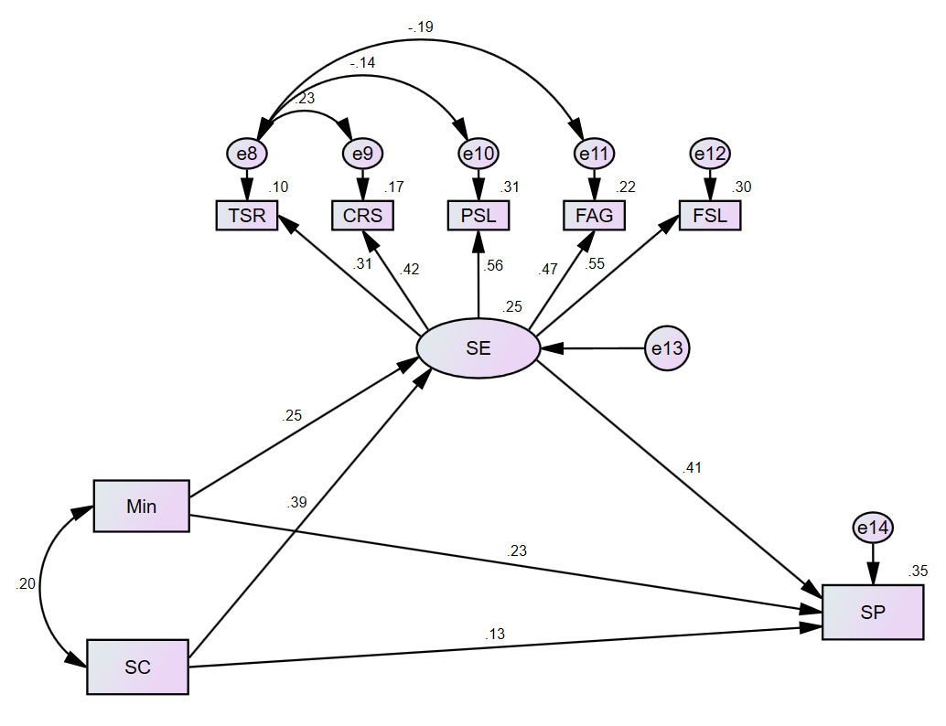
Figure 2. Final Model of the Study

The model fit indices presented in Table 2 indicate that the hypothesized structural model demonstrates a good overall fit to the observed data, based on the guidelines suggested by Kline (2016). The Chi-square value (χ² = 16.327, df = 14, p = .294) is not statistically significant (p > 0.05), indicating that the discrepancy between the model and the data is minimal and within acceptable limits. The relative Chi-square (χ²/df) is 1.166, well below the recommended threshold of 3.0, further supporting model adequacy. All incremental fit indices exceeded the minimum criterion of 0.90: GFI = .980, NFI = .924, CFI = .988, IFI = .988, and TLI = .975, reflecting an excellent fit between the hypothesized model and the empirical data.
Moreover, the Root Mean Square Error of Approximation (RMSEA) was .029, below the stringent cutoff of 0.05, indicating a close model fit in the population. The Standardized Root Mean Square Residual (SRMR) value of .037 is also well within the acceptable limit of ≤ 0.08, suggesting a minimal average residual discrepancy between the observed and predicted correlations. Collectively, these indices confirm that the final model satisfies the recommended standards for a well-fitting SEM, thereby validating its structural pathways and theoretical robustness. The satisfactory fit indices provide a sound foundation for interpreting the structural relationships among the variables, including both direct and indirect effects, in subsequent analysis.

Table 2
The results of model fit Indices.
Model Fit Indices | Suggested Threshold | Final Model | Interpretation
X² | - | 16.327 | -
df | - | 14 | -
X²/df | ≤ 3.0 | 1.166 | Excellent fit
p-value | > 0.05 | .294 | Good fit
GFI | ≥ 0.90 | .980 | Excellent fit
NFI | ≥ 0.90 | .924 | Good fit
CFI | ≥ 0.90 | .988 | Excellent fit
IFI | ≥ 0.90 | .988 | Excellent fit
TLI | ≥ 0.90 | .975 | Excellent fit
RMSEA | ≤ 0.05 | .029 | Good fit
SRMR | ≤ 0.08 | .037 | Good fit
Source: Kline (2016)

Direct Effects

Table 3 presents the results of hypothesis testing derived from the structural equation model, providing insights into the direct and indirect relationships among the variables through standardized path coefficients (β), standard errors (SE), and significance levels.

Table 3
Path coefficient for hypotheses testing
H | Path | β | SE | p-value | Decision
H1 | Min → SP | .227 | .102 | <.001* | Supported
H2 | SC → SP | .128 | .247 | .086 | Not Supported
H3 | Min → SE | .254 | .018 | .025* | Supported
H4 | SC → SE | .387 | .050 | .006* | Supported
H5 | SE → SP | .409 | 1.56 | .014* | Supported
Note: * Significant at p<0.05 level

The analysis revealed that Mindfulness significantly predicts Student Performance (H1: β = .227, p < .001), confirming a direct and positive relationship between mindfulness and academic outcomes. This finding is consistent with earlier studies indicating that mindfulness enhances attention regulation, emotional control, and academic engagement, ultimately contributing to improved performance (Vorontsova-Wenger et al., 2020; Kotera et al., 2021). In contrast, Self-Compassion did not have a significant direct effect on Student Performance (H2: β = .128, p = .086), suggesting that while self-compassion may improve emotional resilience and reduce stress, its impact on academic performance may be indirect or context-dependent (Kotera et al., 2020; Munawar et al., 2023).
Further examination of the mediation pathways revealed significant effects through Student Engagement. Specifically, Mindfulness positively influenced Student Engagement (H3: β = .254, p = .025), suggesting that students who practice mindfulness are more engaged in their learning—cognitively, emotionally, and behaviorally. Likewise, Self-Compassion significantly predicted Student Engagement (H4: β = .387, p = .006), supporting the notion that self-compassion promotes a more supportive internal dialogue and reduces anxiety, thereby enhancing engagement (Kotera et al., 2021; Dreisoerner et al., 2022). Notably, Student Engagement was also a significant predictor of Student Performance (H5: β = .409, p = .014), confirming its mediating role in the relationship between psychological traits and academic success.
These findings imply that Student Engagement serves as a key mechanism through which both Mindfulness and Self-Compassion exert their influence on academic outcomes. While Self-Compassion does not directly enhance Student Performance, its indirect effect through Student Engagement is meaningful and reinforces the value of promoting emotional self-regulation in educational settings. On the other hand, Mindfulness has both direct and indirect pathways to academic success, highlighting its integral role in fostering student achievement. Overall, the results support a partial mediation model, emphasizing the importance of cultivating both mindfulness and self-compassion to enhance engagement and academic performance.

Indirect Effects

Table 4 presents the results of the bootstrapping analysis with 2000 resampling conducted to evaluate the mediating effect of Student Engagement (SE) on the relationships between Mindfulness (Min), Self-Compassion (SC), and Academic Performance (AP).

Table 4
Bootstrapping analysis for mediating effects
Indirect Effects | Bootstrap Coefficient | SE | 95% CI |  | p-value | Decision
Indirect Effects | Bootstrap Coefficient | SE | Lower | Upper | p-value | Decision
(H6) Min → SE → SP | .104 | .053 | .016 | .220 | .021* | Supported
(H7) SC -> SE -> SP | .158 | .065 | .052 | .308 | .001* | Supported
Significant at p<0.05 level

The analysis reveals that Mindfulness exerts a significant indirect effect on Student Performance through Student Engagement (H6: β = 0.104, SE = 0.053, 95% CI [0.016, 0.220], p = 0.021). This indicates that students who exhibit higher mindfulness are more engaged in academic tasks, which in turn leads to improved academic outcomes. This finding aligns with studies by Pizarro-Ruiz et al. (2021), Badawy (2022), and Chaudhry et al. (2024), which collectively suggest that mindfulness promotes cognitive and emotional engagement, thereby enhancing performance.
Similarly, Self-Compassion demonstrated a significant indirect effect on Student Performance via Student Engagement (H7: β = 0.158, SE = 0.065, 95% CI [0.052, 0.308], p = 0.001). While earlier results (Table 3) indicated that Self-Compassion did not have a direct impact on academic performance, the mediation analysis reveals its crucial role in shaping student engagement, which ultimately influences performance outcomes. These results support prior research asserting that self-compassion fosters intrinsic motivation and emotional regulation, enabling students to better manage academic stress and engage more meaningfully in their learning (Badawy, 2022; Guo et al., 2023; Dreisoerner et al., 2022). The presence of significant indirect effects, in the absence of a direct effect for SC → SP, provides evidence for full mediation, whereas Mindfulness demonstrates partial mediation due to both direct and indirect pathways.
Altogether, these findings underscore the central role of Student Engagement as a mediating mechanism linking psychological resilience factors—Mindfulness and Self-Compassion—with academic success. The results advocate for the implementation of educational programs that integrate mindfulness practices and self-compassion training, thereby promoting student engagement and enhancing overall performance (Wang & Huang, 2021; Heidari et al., 2021; Nabais et al., 2024). By fostering these internal capacities, schools can cultivate a learning environment that supports both emotional well-being and academic excellence.

IV. Conclusion

This study investigated the mediating effect of student engagement on the relationship between mindfulness, self-compassion, and student performance among Grade 6 learners in Philippine public schools. Anchored in Self-Determination Theory and Engagement Theory, the study provided empirical support for the significance of psychological traits in shaping academic outcomes. Results from Structural Equation Modeling (SEM) demonstrated that mindfulness has both a direct and indirect effect on student performance, while self-compassion exerts an indirect influence fully mediated by student engagement.
The findings confirmed that student engagement serves as a key psychological conduit through which mindfulness and self-compassion contribute to academic achievement. Mindful students showed greater engagement in their academic activities, which led to better performance outcomes. Similarly, self-compassionate learners, although not directly excelling academically, benefited from enhanced engagement that translated into improved achievement. These results underscore the role of non-cognitive factors and emotional regulation in building resilient and academically successful learners—especially within a context where learners often face socio-economic challenges, learning loss, and psychological stress.
By highlighting the partial mediation effect of engagement in the mindfulness-performance link, and the full mediation in the self-compassion-performance pathway, the study provides actionable insights for educators, counselors, and school administrators. Interventions that foster mindfulness and self-compassion may yield meaningful improvements in engagement and, consequently, academic performance. The study ultimately contributes to a growing body of evidence advocating for holistic, learner-centered approaches in basic education, and reinforces the importance of integrating emotional and psychological development into the academic agenda of Philippine schools.

V. Recommendations

Based on the study’s findings, the following recommendations are strongly proposed to improve both student engagement and academic performance through mindfulness and self-compassion:
- Integrate Mindfulness Activities into the Daily Classroom Routine.
Teachers should be trained and supported to implement simple, age-appropriate mindfulness practices—such as breathing exercises, gratitude reflections, and mindful listening—within class transitions or homeroom sessions. These routines can enhance students’ focus, reduce stress, and prepare them mentally for learning tasks.
- Implement Structured Socio-Emotional Learning (SEL) Programs Focused on Self-Compassion.
Schools should develop and deliver SEL modules that cultivate self-kindness, emotional resilience, and positive coping strategies. Since self-compassion influences academic performance through student engagement, these programs should be integrated into Values Education, guidance sessions, or advisory periods.
- Enhance Student Engagement Through Active, Relevant, and Collaborative Learning.
To sustain high levels of student engagement, teachers should adopt instructional strategies that encourage participation, relevance, and collaboration. Techniques such as project-based learning, real-world applications of content, and peer interaction can boost students’ emotional and cognitive involvement, translating into better academic outcomes.

VI. References

Altinyelken, H. (2022). The benefits of a mindfulness program for university students: a qualitative exploration on intrapersonal and interpersonal relationships. The Journal of Humanistic Counseling, 62(1), 25-40. https://doi.org/10.1002/johc.12197
Burhanuddin, B., Hudriati, A., & Juniansyah, D. (2023). Efl higher education students’ psychological factor in speaking classroom activities at universitas muslim indonesia: a research report. Elt Worldwide Journal of English Language Teaching, 10(1), 52. https://doi.org/10.26858/eltww.v10i1.38370
Bùi, T., Nguyen, T., Pham, H., Tran, C., & Ha, T. (2021). The mediating role of self-compassion between proactive coping and perceived stress among students. Science Progress, 104(2). https://doi.org/10.1177/00368504211011872
Carnicer, J., Calderón, C., Calderón-Garrido, D., & Piñol, C. (2020). Academic progress, coping strategies and psychological distress among teacher education students. International Journal of Educational Psychology, 9(3), 290. https://doi.org/10.17583/ijep.2020.4905
Chen, H. and Zhang, M. (2022). The relationship between basic psychological needs satisfaction and university students’ academic engagement: the mediating effect of emotional intelligence. Frontiers in Psychology, 13. https://doi.org/10.3389/fpsyg.2022.917578
Choi, L. and Brochu, N. (2020). English-as-an-additional-language nursing student support group: student leadership and engagement. Nursing Education Perspectives, 43(1), 41-43. https://doi.org/10.1097/01.nep.0000000000000746
Draper-Clarke, L. (2020). Compassion-based mindfulness training in teacher education: the impact on student teachers at a south african university. South African Journal of Higher Education, 34(1). https://doi.org/10.20853/34-1-2525
Dreisoerner, A., Klaic, A., Dick, R., & Junker, N. (2022). Self-compassion as a means to improve job-related well-being in academia. Journal of Happiness Studies, 24(2), 409-428. https://doi.org/10.1007/s10902-022-00602-6
Egan, H., Keyte, R., Nash, E., Barrett, J., Regan, A., & Mantzios, M. (2020). Mindfulness moderates the relationship between emotional eating and body mass index in a sample of people with cystic fibrosis. Eating and Weight Disorders - Studies on Anorexia Bulimia and Obesity, 26(5), 1521-1527. https://doi.org/10.1007/s40519-020-00969-6
Hagedorn, R., Wattick, R., & Olfert, M. (2021). “my entire world stopped”: college students’ psychosocial and academic frustrations during the covid-19 pandemic. Applied Research in Quality of Life, 17(2), 1069-1090. https://doi.org/10.1007/s11482-021-09948-0
Hiver, P., Al‐Hoorie, A., Vitta, J., & Wu, J. (2021). Engagement in language learning: a systematic review of 20 years of research methods and definitions. Language Teaching Research, 28(1), 201-230. https://doi.org/10.1177/13621688211001289
Hong, L. and Zainal, S. (2024). The role of mindfulness skill and inclusive leadership in job performance among secondary teachers in hong kong. Journal of Asia Business Studies, 18(3), 609-636. https://doi.org/10.1108/jabs-08-2023-0313
Kalika, E., Egan, H., & Mantzios, M. (2022). Exploring the role of mindful eating and self-compassion on eating behaviours and orthorexia in people following a vegan diet. Eating and Weight Disorders - Studies on Anorexia Bulimia and Obesity, 27(7), 2641-2651. https://doi.org/10.1007/s40519-022-01407-5
Kotera, Y., Cockerill, V., Chircop, J., & Forman, D. (2020). Mental health shame, self‐compassion and sleep in uk nursing students: complete mediation of self‐compassion in sleep and mental health. Nursing Open, 8(3), 1325-1335. https://doi.org/10.1002/nop2.749
Kotera, Y., Tsuda‐McCaie, F., Edwards, A., Bhandari, D., & Maughan, G. (2021). Self-compassion in irish social work students: relationships between resilience, engagement and motivation. International Journal of Environmental Research and Public Health, 18(15), 8187. https://doi.org/10.3390/ijerph18158187
Kuo, T., Tsai, C., & Wang, J. (2021). Linking web-based learning self-efficacy and learning engagement in moocs: the role of online academic hardiness. The Internet and Higher Education, 51, 100819. https://doi.org/10.1016/j.iheduc.2021.100819
Lee, M. and Jang, K. (2020). Nursing students’ meditative and sociocognitive mindfulness, achievement emotions, and academic outcomes. Nurse Educator, 46(3), E39-E44. https://doi.org/10.1097/nne.0000000000000902
Mei-juan, J. and Cheng, J. (2020). The correlation of metacognitive ability, self‐directed learning ability and critical thinking in nursing students: a cross‐sectional study. Nursing Open, 8(2), 936-945. https://doi.org/10.1002/nop2.702
Michael, K., Anderson, S., Bagley, J., Ellingson, S., Sayles, H., White, R., … & Custer, T. (2020). Introducing mindful pause practice in sonography education: a strategy to improve classroom presence. Journal of Diagnostic Medical Sonography, 36(4), 336-343. https://doi.org/10.1177/8756479320914854
Munawar, S., Farid, T., Iqbal, S., & Gul, A. (2023). Exploring the relationship between self-compassion and prosocial behavior among university students; mediating role of empathy. Journal of Neuro and Spine, 1(1). https://doi.org/10.33140/jns.01.01.05
Sajadifar, S. and Namazi, S. (2023). Emotional pathways to engagement: predicting academic engagement through academic emotions among high school girls. KMAN Counsel and Psych Nexus, 1(1), 189-194. https://doi.org/10.61838/kman.psychnexus.1.1.22
Salsabila, H. and Widyasari, P. (2021). Mindfulness and academic resilience among unprivileged college students: the mediating role of self-compassion. Humanitas Indonesian Psychological Journal, 18(2), 139. https://doi.org/10.26555/humanitas.v18i2.19027
Shaw, R. and Cassidy, T. (2021). Self-compassion, mindful eating, eating attitudes and wellbeing. Sumerianz Journal of Social Science, (42), 73-80. https://doi.org/10.47752/sjss.42.73.80
Stogianni, E. and Lin, E. (2022). How mindfulness and self-compassion relate to the inclination of seeking support and to depression, anxiety, and stress levels. PBRJ, 2(1), 36-43. https://doi.org/10.54581/parf6856
Sujadi, E. (2022). Mindfulness, self-compassion, resilience, and academic anxiety among college students: a structural equation modeling approach. Tarbawi Jurnal Ilmu Pendidikan, 18(2), 122-139. https://doi.org/10.32939/tarbawi.v18i2.2460
Tulabut, O., Mangalus, R., Cruz, R., Gonzales, A., Pare, E., Evaristo, I., … & De, C. (2021). Improving academic success through applied learning theories, a general elective (ge) course.. https://doi.org/10.4108/eai.19-12-2020.2309187
Tran, M., Vo‐Thanh, T., Soliman, M., Khoury, B., & Chau, N. (2022). Self-compassion, mindfulness, stress, and self-esteem among vietnamese university students: psychological well-being and positive emotion as mediators. Mindfulness, 13(10), 2574-2586. https://doi.org/10.1007/s12671-022-01980-x
Vorontsova-Wenger, O., Ghisletta, P., Абабков, В., & Barisnikov, K. (2020). Relationship between mindfulness, psychopathological symptoms, and academic performance in university students. Psychological Reports, 124(2), 459-478. https://doi.org/10.1177/0033294119899906
White, K., Vincent-Layton, K., & Villarreal, B. (2020). Equitable and inclusive practices designed to reduce equity gaps in undergraduate chemistry courses. Journal of Chemical Education, 98(2), 330-339. https://doi.org/10.1021/acs.jchemed.0c01094
Zhang, D. and Shen, J. (2023). Dispositional mindfulness and mental health among chinese college students during the covid-19 lockdown: the mediating role of self-compassion and the moderating role of gender. Frontiers in Psychology, 13. https://doi.org/10.3389/fpsyg.2022.1072548

