A Digital Platform for Efficient Alumni Data Management and Institutional Engagement

Kavita Namdev
Department of Computer Science Engineering
Acropolis Institute of Technology and Research
Indore, India
kavitanamdev@acropolis.in

Mitesh Parmar
Department of Computer Science Engineering
Acropolis Institute of Technology and Research
Indore, India
mitesh1376d@gmail.com

Neelam Sharma
Department of Computer Science Engineering
Acropolis Institute of Technology and Research
Indore, India
neelamsharma220881@acropolis.in

Mohammed Babukhanwala
Department of Computer Science Engineering
Acropolis Institute of Technology and Research
Indore, India
mohammedbabukhan639@gmail.com

Mitali Patidar
Department of Computer Science Engineering
Acropolis Institute of Technology and Research
Indore, India
mitalipatidar220686@acropolis.in

Nivedita Sharma
Department of Computer Science Engineering
Acropolis Institute of Technology and Research
Indore, India
niveditasharma220044@acropolis.in

Abstract—As alumni relations become increasingly important in higher education, many colleges are developing digital platforms to increase their alumni engagement; however, most traditional methods used for managing alumni are inefficient (i.e., fragmented communication, limited networking opportunity, and poor records management). Thus, the purpose of this study is to develop a centralized web-based Alumni Management and Engagement System – Alum Connect (Alum) to provide opportunities for better structured interaction between alumni, students and institutional administrators. Alum will assist in communicating and storing large amounts of data related to alumni and providing access to mentorship, event participation, and career networking through one integrated digital space. The pilot test of the platform showed that the system successfully managed all information related to alumni, provided new opportunities for networking, and assisted with career development activities. Results indicate that the platform is easy to use, helped to keep alumni engaged and improved alumni/institutional relationship.
Index Terms—Alumni Engagement, Alumni Management Sys- tem, Web-Based Platform, Career Networking, Mentorship, Digital Communication, Higher Education.

- Introduction
Colleges consider alumni associations to be one of the most strategic resources and support structures available. They create lifelong relationships between graduates and their colleges, providing mentoring opportunities, career networking opportunities, building institutions’ reputations in the work- force, and enabling alumni to mobilize resources to enhance the colleges from which they graduated [4][10][21]. Effective alumni engagement is a major contributor to the sustain- ability of institutions, curriculum development through graduate feedback, student career development, and community development [8][12][20]. Despite the importance of alumni associations, there is a general difficulty among higher education institutions in developing consistent technology-based mechanisms for alumni engagement [2][13].
Traditional techniques of managing alumni relationships, such as maintaining records, email newsletters, social media groups, and reunions,
are not sufficient in the modern digital environment [11][15]. With the rapid growth of web technology, cloud computing, and database management systems, digital platforms have emerged as efficient solutions for managing large alumni communities in a more interactive manner [3][16]. Modern alumni management systems typically include centralized data management, event management, mentorship programs, and job posting modules [7][19][21].
These systems support two- way communication between institutions and alumni, thereby promoting stronger collaboration and engagement [5][18]. De- spite the availability of several tools and platforms for alumni engagement, many existing systems still face limitations such as high subscription costs, limited flexibility, and difficulties in onboarding users [10][20]. Some platforms remain outdated or partially automated and lack integrated communication, analytics, and engagement features within a single system [14][17]. So we have a lot of challenges to deal with. That is why we are making a system called Alum Connect. Alum Connect is a website that people can use to talk to each other. It is for alumni, students and the people who work at the school. The main goal of Alum Connect is to make it easier for the college to keep track of alumni information.
Alum Connect also helps alumni and the college talk, to each other. Work together. This way alumni and the school can stay in touch. Do things together with Alum Connect. Specifically, the system seeks to enhance alumni data management, strengthen communication among alumni and institutional stakeholders, and provide structured tools for networking and collaboration.
The purpose of this paper is to present an overview of the conceptual framework, system architecture, functional design, and implementation approach for the Alum Connect platform. Additionally, it explores how a centralized digital system can support sustainable institutional development while addressing challenges in alumni engagement [8][16].

- Problem Statement
Today’s tech-connected alumni network is a highly valuable resource for institutions through they have the potential to provide mentoring, forming industry partnerships, helping develop students and connecting student’s with professional opportunities and supporting institutions fundraising efforts [4]. However, most institutions lack a reliable, centralized way to manage and engage with their alumni [10]. They have no reliable way to keep track of where their alumni live, their course of study and where they have progressed after graduation due to this lack of reliable information - to date - most of the information is spread across many systems and documents (spread sheets, course files, spell check lists, etc.)
[13].
In today’s world a schools former students or alumni are a great source of help. They can offer guidance, connect with industries help students create networking chances and raise money for their school [5]. Many schools don’t have good tools to manage their alumni efforts [14]. This means most schools can’t tap into the support their alumni can offer [10]. When students graduate their contact info, education history and career progress aren’t always kept in one place. This info is often scattered across systems like spreadsheets, paper files and email lists [11]. Schools also communicate with alumni and students in a way using things like WhatsApp groups, social media or email. This makes it hard to reach alumni regularly [7].
The absence of a systematic method for administering and managing an alumni database can create the following challenges for educational institutions in the long run [13]:
- As a result alumni are being distributed across numerous locations, it is challenging to maintain a comprehensive and consistent alumni database [16].
- Unavailability of proper tools to update and verify the professional details of the alumni base [17].
- Unavailability of proper interaction between the alumni base, students, and administrators [21].
- Unavailability of proper tools to coordinate the events of the alumni base and the institutions [19].
- Unavailability of proper tools to leverage mentorship opportunities, internships, industry partnerships [20].
- No established method exists for collecting and organizing alumni data for the purpose of reporting on alumni participation and contributions [5].
Organizations do not have a centralized digital infrastructure which means they cannot utilize their alumni relationships fully for the purposes of academic and community growth, and strategic planning[21]. In this era of communication and collaboration being driven by digital platforms, institutions have a serious gap in their outreach to alumni and engagement with alumni due to the lack of a secure, integrated alumni management system[18].
Currently, there is an urgent need for an Alumni Management Platform that is centralized, scalable, secure and enables easy storage of alumni data, structured communication with alumni
and other stakeholders, and the long-term development of positive institutional alliances [21].

- Objectives
Alum Connect is a web-based Alumni Management and Engagement Platform that will provide a centralized location for institutions to build and maintain positive relationships with alumni and to promote structured communications among alumni, students and administrators .More specifically, the Alum Connect platform will enable the following objectives to be achieved:

- Improve connectivity
This would make possible for us to create a community where alumni, students can cooperate and support each other’s.

- Networking
Through the platform we can bridge communication gap between students and alumni. The alumni would be able to impart their knowledge to students, giving them to knowledge about how they can pursue a certain career path [4].

- Simplify Communication
We must create a platform giving information about event announcements as well as details about events involving students, faculty, administrators, and alumni [19].

- Centralized Data Management
Automate the collection, storage, verification and update processes of Alumni data via a centralized database system capable of providing long-term accuracy and sustainability of Alumni data.

- Role-Based Access and Security
Build secure authentication and role-based authorization software that will provide protection of sensitive user data while controlling access to the various platform functions.

- Analytic Reporting
Create reports and engagement insights/analytics that are useful to institutional administrators and help with decision making with regards to their strategic plans and improve relationships with alumni[21].

- Advantages
The proposed Alum Connect system provides many benefits over traditional ways of managing alumni, but most notably because it centralizes information and streamlines the way in which institutions communicate with their alumni, it greatly increases both the efficiency of the institution and the level of engagement of the alumni.

- Time Reducing
The system automates data management for alumni, event management, and communication associated with these activities [16]. Therefore, the time that administrators currently spend doing manual record keeping, finding alumni’s contact information, and sending individual notifications will be greatly reduced [11]. Furthermore, by having access to a single dashboard where they can manage their alumni information quickly, this will save them so much time [7].

- Easy Access
Alum Connect also provides a structured and easily search- able database of alumni .Users are able to search for given alum based on batch, department, company, job title, or location. Students and faculty find it easier to connect with alumni for purposes of mentoring, finding a job, and building their networks.

- Reduced Administrative Labor
Managing alumni records and communicating with alumni has typically required substantial administrative effort [11]. The Alum Connect system greatly minimizes the amount of administrative work involved with this process by automating the registration, profile updates, notifications, and reporting processes. Therefore, there will be a large decrease in the dependence on the manual process of recording alumni’s activities and the overall workload associated with managing alumni.

- Improved Connections
The Alum Connect platform helps alumni and others connect and network better. It offers access to announcements, event invites, mentoring tools and a job board.

- Single Source of Truth for Data Storage
All alumni information is held in one central data source, using role-based security, to allow alumni to access their data consistently, securely and without duplicates.

- Increased Event Participation Tracking
The Alum Connect system also enables institutions to document alumni participation in institutional events, mentoring activities and contributions; thereby allowing the institution to continue to refine their outreach and engagement strategy with alumni.

- More Career Opportunities
Having access to job postings, internships, and professional guidance from alumni enhances the exposure of students to the various industries while at the same time increasing their employability.
- Literature Review
Existing Research Gaps Due in part to the growing importance of alumni engagement in higher education, a range of digital programs have been developed to help colleges and universities build stronger ties with former students alumni [4][21]. Much of the research to date has focused on alumni networks as means for mentoring and supporting career paths, raising funds for the institution, promoting brand awareness for institutions, and creating long term community connections relative to the local community in which the institution operates .This section reviews existing research, identifies technological innovations related to alumni engagement, and summarizes gaps identified in prior studies that are motivating the design of Alum Connect[20][21].
Traditional approaches to alumni engagement have been primarily manual systems of record keeping (tabular records, spread sheets, printed directories, departmental records, etc.) and used primarily one-way communications (newsletters, alumni magazines, email blasts, and/or events to reunite alumni) solely for these activities[15]. While traditional methods provided a way to connect with alumni, there was limited opportunity for two-way dialogue (exchange of information) via traditional methods, and overall, there were significant hardware and software limitations when it came to creating opportunities for real-time communication, mentorship in a structured manner, or tracking alumni data in a systematic way [14]. Social networking sites such as LinkedIn and Facebook have become viable, informal networking options, but these sites are not specific to an institution and do not have features such as role-based access control (RBAC), verified alumni databases, or integrated event and job management capabilities [3][18]. Further compounding the limitations to traditional alumni engagement systems are the challenges of manually entering data, which creates data inconsistency, data duplication, and out-dated records that demand an inordinate amount of time to maintain accurate and timely alumni information. Due to a lack of centralized automation, it restricts search functionality capabilities along with analytics, personalization and secure data management [16]. As a result, conventional approaches do not provide adequate scalable, interactive or sustainable alumni engagement solutions that will meet the requirements of the new digital transformation [21].
- Existing Research Gaps
First, the majority of current systems only offer basic alumni data storage and profile maintenance services. There is very little development of complete engagement features within existing platforms, such as structured mentor scheduling; internship pipelines or collaborative interaction modules. Existing platforms may offer networking and/or event announcements; however, they are lacking in providing end-to-end engagement ecosystems (communication; job postings; analytics; participation tracking) that will integrate together into one total architecture.

TABLE I
Comparison of Existing Platforms

Platform | Technology | Key Features | Limitations
Alumni Class[23] | Front-End: HTML,CSS,  JavaScript Back-End: PHP  Database: MySQL | Alumni data storage  Communication tools .  Centralized database management. | Limited analytics Limited engagement tools Basic networking features
Graduway  [24] | Front-End: React Back-End: Node.js  Database: PostgreSQL | Alumni  networking platform.  Community building features. | High cost for institutions.  Limited  customization for small colleges.
PeopleGrove  [25] | Front-End: React  Back-End: Ruby on Rails  Database: PostgreSQL | Alumni mentorship programs.  Career networking  Student–alumni interaction, | Alumni  mentorship programs.  Career  Networking. Student–alumni interaction.
Almabase  [26] | Front-End: Angular  Back-End: Java (Spring Boot) Database: MySQL | Alumni  Engagement.  Advanced analytics and  Reporting. Fundraising tools. | Complex  onboarding process.  Requires technical expertise.

The second area is that no attention has been directed towards either automation or intelligent data handling . As a result; most systems require manual updates thus providing outdated records and inconsistencies in the dat. Most advanced features required within the field of alumni management, including; (automated verification); engagement analytics; AI-based matching of mentors to mentees; and personalized recommendations; exist in concept but are rarely implemented in practice.
Finally, it should be noted that there is a lack of both scalability and flexibility in regards to the customization of systems. Most commercial platforms have a large number of features but are prohibitively expensive and are not flexible, thus making them unsuitable for smaller to mid size institutions. Additionally; most academic prototype systems do not have long-term plans for deployment or optimization of performance in the management of very large alumni databases.
Another important area of concern relates to the limited attention paid to implementing the principles of role-based access control and secure architecture across various alumni engagement platforms; examples exist where there is no clear distinction between user role types (i.e., Alumni vs. Student vs. Administrator); as a result, there is risk for vulnerability from an information security standpoint as well as operational inefficiencies due to poor management workflows.
Additionally, although existing research in the field of alumni engagement generally provides a conceptual framework to describe frameworks related to alumni satisfaction and provide some examples of usage, very little empirical data is available
regarding the actual experiences of alumni concerning system usability, mobile responsiveness, and long-term availability of alumni engagement systems.
Likewise, very few existing systems fully implement student-centered engagements features including: structured mentoring modules, searchable alumni directories based on industry or companies, instantaneous notifications to support both alumni and students alike along with the digital tracking capabilities of alumni contributions towards institutional advancements. These areas of opportunity are representative of the need for a centralized (i.e., single-point-of-access) scalable (i.e., ability to support growth of alumni), secure and feature-rich alumni engagement platform, such as Alum Connect, which will support both structured engagement and automated data management in addition to role-based security and future-ready technology enhancements in one integrated solution.

- Need for Innovation
While many commercial alumni platforms have many advanced features such as event management and fundraising tools, they tend to be costly and not as customizable, nor do they typically meet all needs of particular institutions Most academic prototype systems focus is relatively minor, mostly on single functions like profile management or messaging, while failing to provide a unified Ecosystem of some type that includes the combined resources for Mentorship, Job opportunities, Analytics, and administrators[19].
Moreover, little if any of the existing systems utilize automation to provide real-time data updates, engagement tracking, or provide communication in a personalized manner [16]. Although countless institutions of higher education are experiencing immense growth with respect to size, area, program offerings, and services, the lack of some key components like role based access control, intelligent recommendation systems, and scalable architecture render most current systems ineffective.
Similarly, many platforms currently available to alumni do not adequately provide many of the student-centric types of functionality desired by the alumni community such as; structured mentor/mentee matching, searchable directories of alumni based on areas of expertise, and systematic tracking of alumni contributions to the institution [5], [20]. The world is changing fast because of digital transformation. This change is affecting schools and universities over the world[21]. So colleges and universities need to create a system that lets them stay in touch with their students also known as alumni in a safe and organized way. This system should help alumni connect with each other find jobs and stay updated about their school.
A newly developed Alumni Management System - known as ”Alum Connect” - addresses the need for a more comprehensive approach to managing alumni by allowing users to connect with each other and their alma mater through improved data management and sustainable engagement

methods via existing technology resources.

- Proposed Solution
Through the new system, alumni will also have a structured way to engage with their Alma Mater, as well as help the institution to achieve its goals through their continued engagement after graduation[21]. Alumni Management is an important part of developing and building lasting relation- ships between alumni and institutions [8]. A newly developed Alumni Management System - known as ”Alum Connect” - addresses the need for a more comprehensive approach to managing alumni by allowing users to connect with each other and their alma mater through improved data management and sustainable engagement methods via existing technology resources.
The level of structured engagement that occurs between alumni and current students will provide current students an opportunity to receive career advice, network with alumni, and experience real-world work experiences.
Unlike earlier systems that used spreadsheets, out-of-date mail systems, and unregulated social media networks to store alumni data, the proposed Alumni Management System stores all graduate and undergraduate student-alumni information in a centralized database. This is possible through the use of current technology that enables secure and efficient retrieval of graduate and undergraduate student-alumni information, with the ability to modify and maintain the information in real time. This real-time modification and maintenance of graduate and undergraduate student-alumni information is possible without the risk of data duplication or loss, by utilizing a centralized database with remote access, secure authentication, and role- based permission capabilities (permissions are defined using an authorization model).
- System Architecture
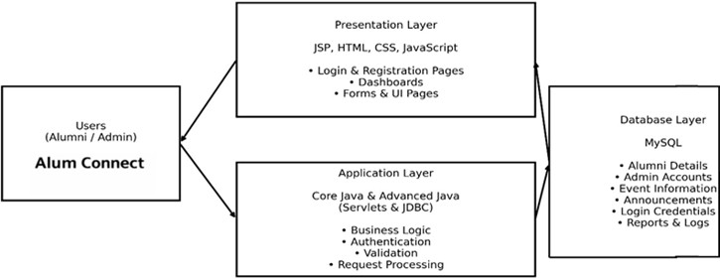

Fig. 1. System Architecture Diagram of Alum Connect

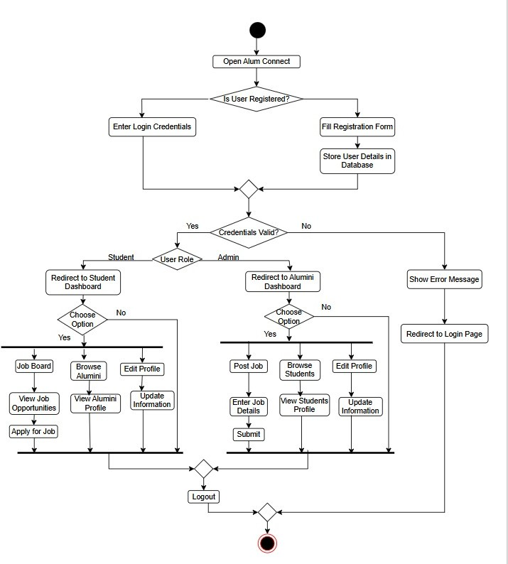

Fig. 2. Activity Diagram of Alum Connect

This system operates using a multi-layered client-server architecture made up of the User Interface components, functional modules, and centralized data structures.
  - User Interfaces: The Alum Connect platform provides profile management for each of the alumni, students and administrators.
The Alum Connect platform provides role-based access control to ensure the Alum Connect system security.
  - Networking and Mentorship Module: Students and alumni can connect to build relationships, for mentorship and career help.
Alumni can share their experience. Help students grow their professional network.
Alumni and students connect for career assistance and guidance.
  - Communication Module: This thing lets alumni, students and faculty members talk to each other. It also helps people make announcements and have discussions with users. Institutions can use it to share stuff that everyone needs to know, like big announcements and information, about the institution.
  - Event Management Module: Administrators will create and manage alumni events.
Users can register for networking-type sessions, reunion

events, or workshops.
  - Job and Opportunity Module: Alumni can post job openings and career opportunities in the database. This is where students can search for job openings.
The Job Opportunity Module is really going to help alumni with their career development. It will also increase their professional exposure to students. Alumni will get exposure and students will get to know about the career opportunities available to them, through the Job Opportunity Module and the job openings that alumni post.
  - Notification Module: People who use the Alum Connect platform will get notifications and alerts away for things like events, job openings and announcements, from the institution. The Alum Connect platform has a notification system that will make sure all users of the Alum Connect platform know what is going on with any activities that are important to the users of the Alum Connect platform.

- Key Components of the Solution
  - User Management:
    - Alumni
All alumni can make a profile on the platform. Use the platform to connect with other alumni. Alumni can make a profile update their employment history and take part in networking or mentorship programs, on the platform where alumni can connect with other alumni.
    - Students
All students can use the alumni directory. They can find alumni through it. They can look for mentorship and support, in their career. It helps them in their career journey. They can also take part in activities run by the institution.
    - Administrator
All administrators will be in charge of making sure the platform works properly. This means they have to do a things. They need to find users of the platform. They also have to keep an eye on what users are doing. The administrators will post messages and make sure the information about alumni is up to date, in the Centralized Alumni Directory.
  - Centralized Alumni Directory: Structurally; being a database of Alumni containing all previous academic history, current career, and contact details.
There is ability to search for previous alumni by Batch, Dept., Org., or Location.
  - Communication and Collaboration: Alumni will talk to each other using messages and they will also use online forums to have group conversations, about things that matter to the Alumni.
Alumni will be able to share their experience about their chosen career and genre/industry.
Alumni will collaborate with each other and students who are currently studying at the same college or university.
- Value Proposition
Alum Connect system provides a variety of benefits to the different sectors of the academic sphere.
  - Alumni Community: Provides an online platform for alumni to maintain contact with the Institution, and other alumni.
Provides opportunities for alumni to connect as Mentors to students providing their professional guidance and experience. Alumni will have the ability to be involved with Institutional events and networking activities.
  - Current Students: Provides current students with professional direction and insight into the current industries. Provides opportunities for current students to network with experienced alumni.
Provides current students with internship and job placement opportunities.
  - Institutions: Provides a centralized method for Institutions to manage their Alumni data offering better efficiencies. Provides an opportunity to improve the connection between alumni to engage them with Institution(s) also improve the image and standing of Institutions.
Provides Institutions with tools to support Career Development and collaborate with Alumni for property development opportunities.
- Methodology
This article outlines the creation of an online platform launched as Alum Connect, created to increased connections and networking opportunities among alumni, students and the institution by creating channels of communication between those users and the institution.
The authors outline one methodology to develop Alum Con- nect by prioritizing the need for the community of users and their connections throughout the entire Alumni Engagement process. Additionally, using a centralized database to hold all registered user information and generate each user with a unique verified profile based upon their registration infor- mation.
- Accessing the Platform
With regards to registering to use the Alum Connect system, new users (either Alumni or Potential Users) create a profile. The potential new users enter the essential information required to create an account (name, email address, student ID, etc.) into a centralized database and this information is used to start creating their verified user profile.
Also, existing users log into their Alum connect accounts with their existing registered credentials, and after successful verification of their credentials, have full access to the many system features (the alumni directory, job postings, events, social networking opportunities etc.)
- User Dashboard and Interaction
There are a few parts to this system. 1. Alumni can use a dashboard to see their own information and connect with other alumni and students.

- Students have their dashboard where they can look for alumni to talk to find jobs and join discussions about events.
- The people in charge or administrators use a dashboard to manage everything create events and keep track of what alumni are doing.
- Networking and Communication
This platform helps alumni talk to each other in ways. 1. Messaging Feature: Alumni and students can send messages to each other directly.
- Discussion Forums: People can. Share their experiences. They can also ask for advice on studies or jobs. Give professional tips.
- Notifications: Users get updates on events, job listings and announcements, from their university.
- Directory and Search for Alumni
Additionally to the dashboards or portals above, there is a central directory of alumni to allow users to search for and connect to other users of the alumni community.
  - Search for alumni by department, graduation year, company, industry or location.
  - Network with alumni from your school and grow the size of your professional network.
  - Search results are organized and ranked so users can easily locate relevant profiles.
- Event Management
Admins has the facility to organize alumni events such as reunions, webinars and users can attend these events and get notifications, about when they are scheduled.
- System Workflow
Alum Connect users will begin the overall workflow of the platform by creating an account or logging into the web application. When a user logs in to the platform they will go to a page that is just for them. This page is like a homepage. It is different for each type of user. On this page users can talk to users look at what other people who used to be part of the school are doing now join in on conversations find jobs and sign up for events at the school.
The people, in charge called Admin users make sure every- thing runs smoothly. They check what people are posting make sure users are who they say they are and keep track of all the alumni information. This helps the Admin users control what is happening on the platform. All user interactions and activities are securely stored in a central database to ensure the system provides reliable and effective data management.
- RESULT
The Alum Connect Platform for Alumni Networking and Engagement was created to be a centralized digital means by which alumni, students and institutional personnel can better engage with one another and communicate and collaborate. The result of implementing this type of platform indicates its ability to manage alumni data, provide networking opportunities for alumni, assist alumni with career development.

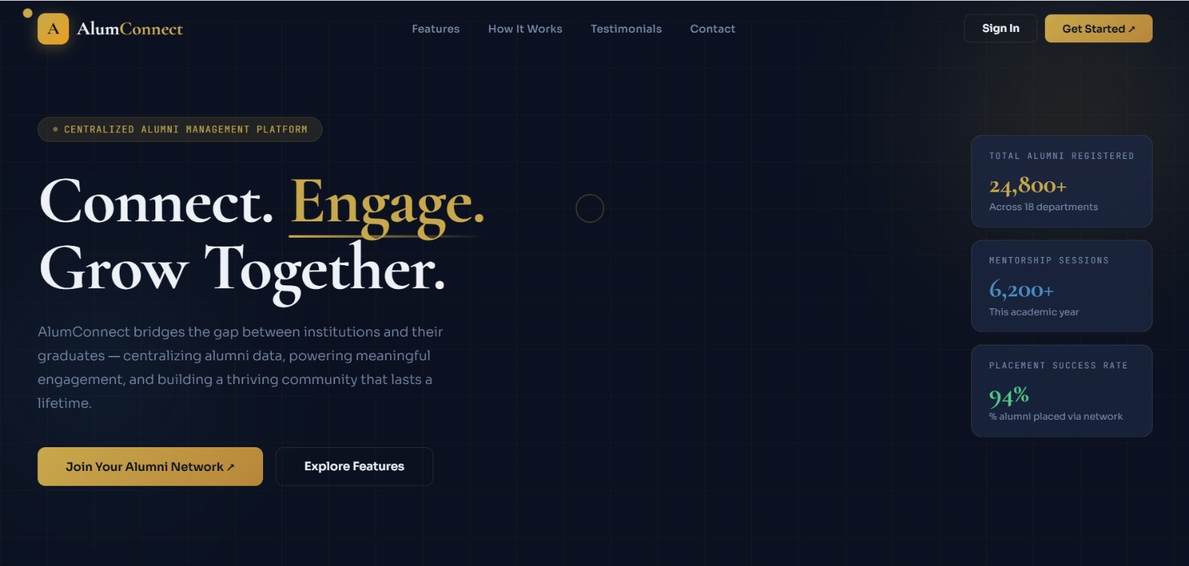

Fig. 3. Home Page of Alum Connect
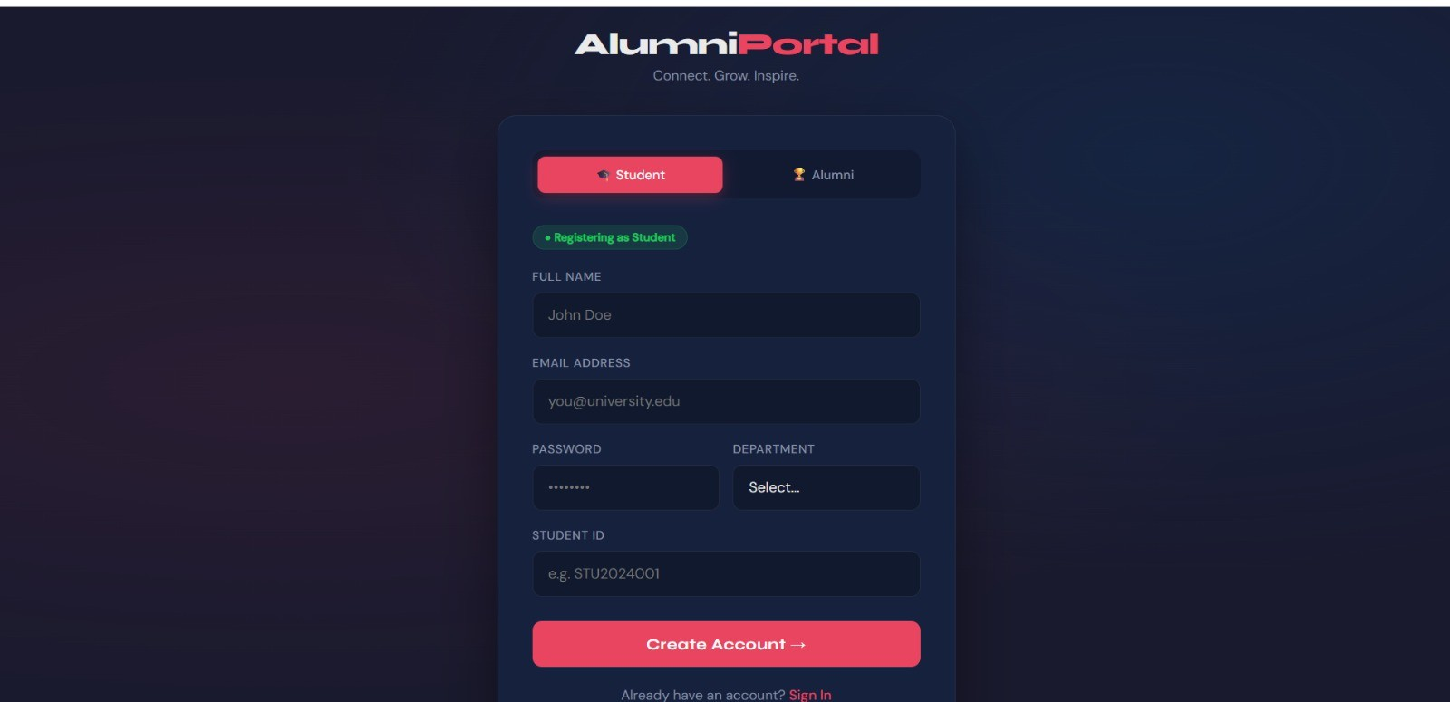

Fig. 4. Registration Page of Alum Connect

- Platform Usability and Engagement
The data results from implementing the platform demonstrate its high level of usability during the testing and piloting of the system. Users who tested the Alumni Connect platform were able to register create a profile and navigate around without needing support. The platforms interface is very user- friendly and easy to use.
Users could access facility like the Alumni Directory, Messaging system, job opportunities and event updates.
- Alumni Participation and Networking Impact
Alumni could participate by building a profile updating their information and sharing career experiences with students. The Alumni Directory helped students find alumni by department, graduation year, industry or current employer. The platforms networking features allowed alumni to connect with graduates and students creating opportunities and professional connections.
These features show the platforms potential to develop the alumni community and engage alumni, with the institution over time. Alumni Connect helped users connect and build relationships. The platform made it easy for alumni to share their experiences. Alumni and students used the platform to find job opportunities and event updates. The Alumni Directory and Messaging system were features.
- Student Experience
Access to alumni profiles and mentoring was a resource for current students to connect with alumni through an online

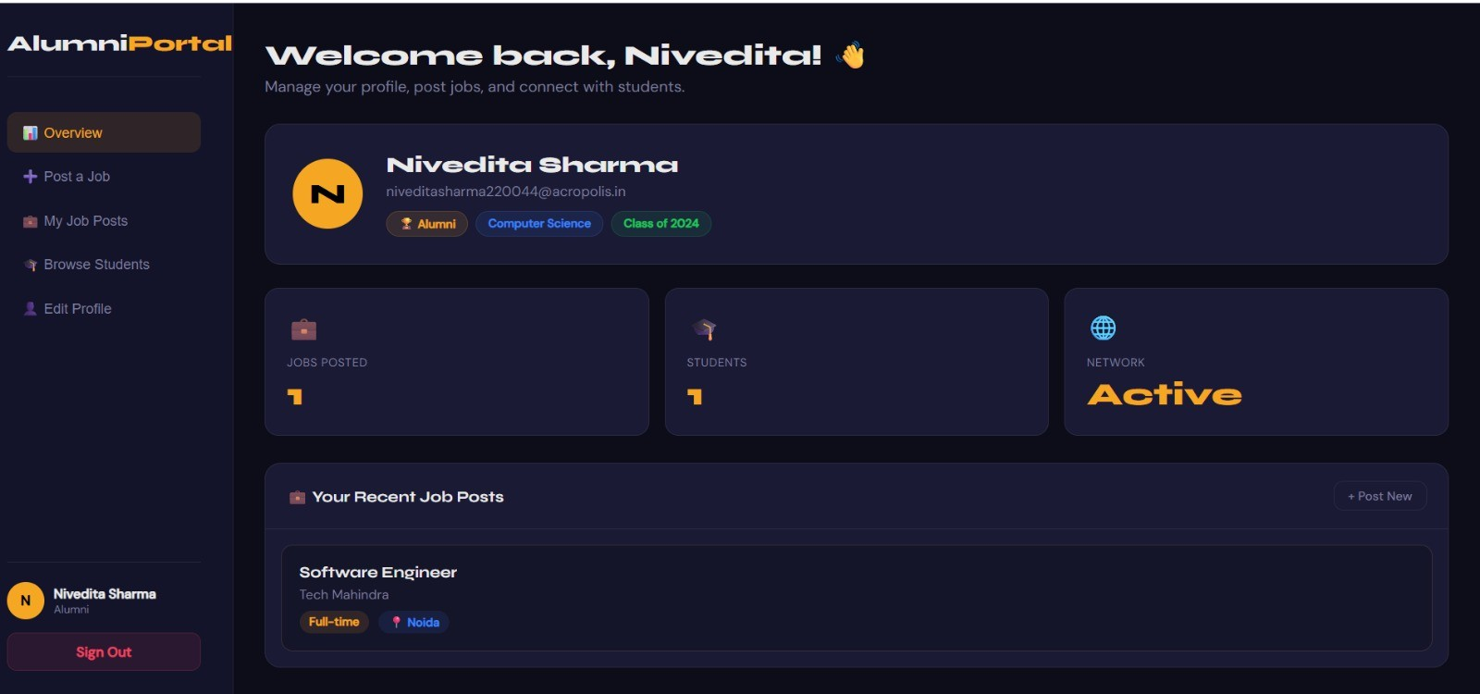
Fig. 5. Alumni Dashboard of Alum Connect
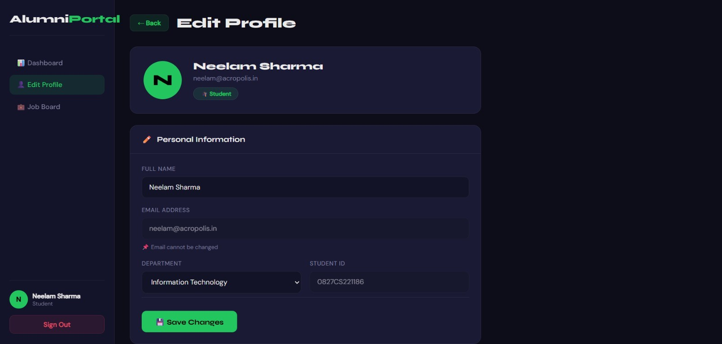

Fig. 6. Student Dashboard of Alum Connect

platform. Students could request connections, send messages, and ask for help with future job search and career development planning, and advance education opportunities, and gain insight into their industry through connections to alumni in those fields.
The platform provided a job and internship section that al- lowed alumni to share open positions within their organization with students. This provides a connection between what a student learned while in school and an employment opportunity outside of school.
- Institutional and Administrative Efficiency
The administrator dashboard provided the ability to conduct administrative functions much more efficiently when
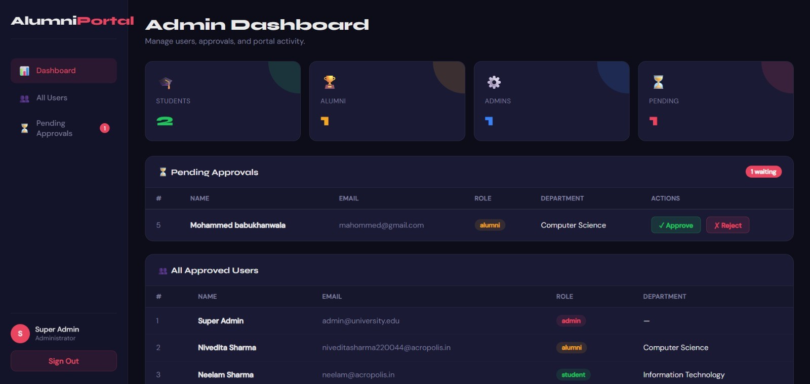

Fig. 7. Admin Dashboard of Alum Connect
managing alumni contact records and participating in activities on the alumni platform. The administrator could conduct such things as verifying newly enrolled users, updating alumni records, posting announcements for the institution, coordinating alumni events through one central control panel.
The database maintained by the alumni system provides the ability to store and retrieve all alumni records from a well- structured database. Data management was facilitated through automated processing, which minimized the need for manual data record maintenance and/or minimized the risk of lost data and/or outdated information.

- Key System Performance Metrics
During the implementation of the alumni platform, various performance measures could provide the necessary evaluation of the alumni platform.
User registration success rate: About ninety-four percent of users were successful finding and completing the registration process to log in to the system.
The metrics above indicate that the user base has broad potential space for adoption of the system, and the system is designed to support large alumni user communities.

- Challenges
While the systems were still performing well, there were some challenges during the implementation. First, many users needed help finding ways to navigate through the advanced features of their user profile, such as updates and networking tools. Second we need to make sure that the information about the alumni is current on the system. This means that all users have to be involved and help out.

- Future Scope
Alum Connect is a way for alumni to meet and talk to each other. It is, like a group where alumni, students and schools can all be connected . We made Alum Connect so that alumni can find alumni and get jobs . This is the start of something a place where everyone can come together online. This system also helps with events. We want to make it even better. We have ideas to make the system better in the future.

- Using Computers To Help Alumni Find Careers
We can use computers to help alumni find people they should talk to and jobs that are good for them . The computer will look at what the alumni’s interested in and what they have done in the past. Then it will suggest people they should meet and jobs they should apply for. This will help alumni connect with alumni and find jobs that are a good fit for them. The computer will also help them find people who can give them advice and help them with their careers. Using advanced techniques to provide a recommendation engine can significantly improve the ease of finding appropriate alumni mentors and job openings for students[16].

- Mobile App for Android and iOS
We should have an app for Android and iOS. This will help us reach people and make them use our service more.
If we have a version of Alum Connect, students and alumni can use it all the time and get messages right away about events, jobs and other things.
This will be great for people who like to use their phones to do things. It will also help us get alumni to use our service.
- Integration with Professional Networking Platforms
We can make our platform work with other websites like LinkedIn. This will make it easy for alumni to keep their profiles up to date with the things they do at work their jobs and the things they are good at. They will not have to do it themselves. If we keep the information about alumni relevant it will be good for both students and the people who run the institution.
- Real-Time Communication and Collaboration Tools
At present, alumni connect with each other via the system, future versions of the system will offer real-time collaborative communications (i.e., chat, video conferencing) to enable alumni to conduct virtual mentoring opportunities or career coaching and networking events.
- Advanced Analytics/Institutional Insights
The analytics dashboards can show job placement trends. Administrators can use the information from these analytics dashboards to make decisions. For example they can decide how to get alumni more involved with the platform. They can also use the information to develop career development programs that are really helpful to users. The platform and these programs can be made better by using the analytics dashboards for administrators.
- Conclusion
Whether in India or anywhere else within the global higher education community, it is important to maintain an active relationship between an education institution and its former students for the sake of academic progress as well as for building professional and community networks. The introduction of the Alum Connect Platform is a progressive move towards fully digitalizing the alumni relationship and will lead to strengthened connections because it will offer a complete and active environment to connect the alumni with one another, alumni with students and students with the administrators of their institutions[5][21].
The Alum Connect solution was created in response to a number of issues surrounding traditional alumni association practices. Many of them still utilize face-to-face communication and fragmented methods of creating networks and managing attendance records. The ability for alumni to access a web-based digital platform will allow them to keep their profile current, participate in institutional activities, post job opportunities and communicate with current students for the purpose of mentoring and advising one another[20].
In addition, the Alum Connect platform streamlines the management of alumnus data by creating a database that is secure and organized. The system helps the people in charge like administrators to keep track of information about the alumni. They can see what the alumni are doing for work and plan events that the alumni will like. This makes things easier. There is less work to do by hand. So there is chance of losing important information about the alumni or messing it up. Finally, the Alum Connect platform increases efficiency overall.
The Alum Connect platform is really helpful to schools and colleges. It will let them connected with their alumni. The platform also makes it easier for students to know about the college. This is good for the schools and colleges because it will help them to grow and become well known. The Alum Connect platform supports the development of Alum Connect networks and these Alum Connect networks are very good for the schools and colleges. They help the schools and colleges to become better and more famous. Alumni benefit from the direct connection with alumni and their network of contacts for mentorship, career advice, and job opportunities[21].
Although challenges (such as getting users to adopt the platform, users’ actual digital skills, and scalability) may arise in the future, due to the flexibility of the Alum Connect platform’s architecture, it continues to be updated for improved capability/existing function. Future developments to the platform may include a mobile app, AI-based recommendation systems, personalized features for communicating with alumni, and enhanced analytics for measuring alumnus participation and trends in their careers. In conclusion, the Alum Connect demonstrates how technology can provide effective solutions to assist institutions gap between alumnus (who are graduates) and institutions[7][21].

References

- K. G. Jagtap, D. P. Soni, P. N. Salve, and S. S. Bole, “Alumni Connect: Bridging Past and Present,” International Journal of Research Publication and Reviews, vol. 5, no. 11, pp. 5141–5144, Nov. 2024, ISSN: 2582-
7421.
- L. L. Occiano, A. J. V. Reyes, and K. T. Soberano, “Web-based Alumni Management Information System: Its Efficiency and Usability in Reach- ing Out Graduates,” International Journal of Research in Engineering and Science (IJRES), vol. 11, no. 8, pp. 28–32, Aug. 2023, ISSN: 2320-9364.
- S. Zatke and C. Tandel, “Alumni Management System Using LinkedIn API,” International Journal of Creative Research Thoughts (IJCRT), vol. 12, no. 5, May 2024, ISSN: 2320-2882.
- E. E. Azutiga, J. Annan, and M. A. O. Annan, “Exploring the Role of Digital Platforms in Enhancing Alumni Support Services: A Case Study of University of Education, Winneba (UEW) Alumni Engagement,” In- ternational Journal of Scientific Research and Engineering Development (IJSRED), vol. 8, no. 1, pp. 858, Jan.–Feb. 2025, ISSN: 2581-7175.
- V. Rao N., S. K., J. V., K. P., N. V., and S. R., “Developing a
Smart Alumni Engagement Platform,” International Journal of Scientific Research in Engineering and Management (IJSREM), vol. 9, no. 4, Apr. 2025, ISSN: 2582-3930.
- M. D., R. V., and S. B., “Student-Alumni Platform,” International Journal of Scientific Research and Engineering Trends, vol. 11, no. 4, Jul.–Aug. 2025, ISSN: 2395-566X.

- P. P. Sawai, P. V. Chambhare, A. N. Jaysingpure, A. G. Karhe, D. Rathod, and V. S. Gulhane, “Alumni Connect Hub: A Comprehensive Alumni Management System,” International Journal of Ingenious Research, Invention and Development (IJIRID), vol. 3, no. 1, Feb. 2024, ISSN: 2583-648X.
- A. Prasad, A. Kumar, A. Kumar, and A. Yadav, “An Intelligent Dig- ital Platform for Alumni Engagement and Networking,” International Journal for Multidisciplinary Research (IJFMR), E-ISSN: 2582-2160.
- R. S. Sathyaraj, A. Prasath, A. S., G. D. Bai, and J. J. J., “Implementa- tion of the Alumni Association Platform for University/Institute Batch Students,” International Journal of Innovative Research in Technology (IJIRT), vol. 11, no. 12, May 2025, ISSN: 2349-6002.
- R. B. Venkatapur, K. V., A. C. Prabhu, G. V. A., and K. Aditya, “Survey on AlumniConnect Enhancing Alumni-Student Interaction Platforms,” International Journal of Advanced Research in Computer and Com- munication Engineering (IJARCCE), vol. 14, no. 6, June 2025, doi: 10.17148/IJARCCE.2025.14635, ISSN: 2278-1021.
- K. Salve, S. Nagpure, S. Thombare, V. Bhalerao, and S. A. Gade, “Centralized Student Alumni Management Portal for SND College of Engineering and Research Center Yeola,” International Journal of Scientific Development and Research (IJSDR), vol. 8, no. 5, May 2023, ISSN: 2455-2631.
- S. Waghmare, S. Korade, B. Rathod, A. Dhumal, and H. Sahani, “Alumni Portal for Institutes: Connecting Past, Present, and Future,” International Journal of Innovative Research in Science, Engineering and Technology (IJIRSET), vol. 13, no. 11, pp. 18519, Nov. 2024, doi:
10.15680/IJIRSET.2024.1311066, ISSN: 2319-8753.
- R. S. Cordova, R. L. Maata, and F. Epoc, “A Model and Framework for Alumni Tracking and Information System,” International Journal of Advanced Computational Engineering and Networking, vol. 8, no. 6, Jun. 2020, ISSN (p): 2320-2106, ISSN (e): 2321-2063.
- P. Murugan and V. Sathya, “Student Alumni Connecting Website,” International Journal of Novel Research and Development (IJNRD), vol. 9, no. 4, Apr. 2024, ISSN: 2456-4184.
- A. Kadve, A. S. Kumbhar, S. H. Mulla, V. S. Patil, and O. S. Sawant, “Alumni Portal,” International Journal of Advanced Research in Science, Communication and Technology (IJARSCT), vol. 3, no. 2, June 2023, ISSN: 2581-9429.
- S. D. Vardhan and M. Swapna, “A Scalable MERN-Based Alumni Management System for Institutional Networking and Engagement,” International Journal of Research Publication and Reviews, vol. 6, no. 8, pp. 5424–5433, Aug. 2025, doi: 10.55248/gengpi.6.0825.3184, ISSN:
2582-7421.
- M. Mohanapriya, S. P. R., S. S., S. L., and V. K., “Alumni Registration and Maintenance Software,” International Journal of Research Publi- cation and Reviews, vol. 6, no. 1, pp. 5244–5247, Jan. 2025, ISSN:
2582-7421.
- S. Kathane, E. Dandge, V. Sahu, K. Shapane, J. Zaidi, and R. Mathane, “AlumiConnect: Building Bridges Between Alumni and Students,” In- ternational Journal of Research Publication and Reviews, vol. 5, no. 4,
pp. 3639–3643, Apr. 2024, ISSN: 2582-7421.
- M. Ved, H. Tanna, P. Yeole, and P. Kamble, “Alumni Management Sys- tem – Web Application,” International Research Journal of Engineering and Technology (IRJET), vol. 9, no. 4, Apr. 2022, ISSN (e): 2395-0056,
ISSN (p): 2395-0072.
- S. Manepatil, R. Nadaf, P. Sawant, and Z. Sutar, “Alumni Network Platform: A Digital Bridge Between Students and Alumni,” International Research Journal of Engineering and Technology (IRJET), vol. 12, no. 6, Jun. 2025, ISSN (e): 2395-0056, ISSN (p): 2395-0072.
- P. Pushpanjali and K. V. Kushal Kumar, “ALUM NET: A Unified Digital Platform for Alumni Networking, Mentorship, and Institutional Engage- ment,” International Research Journal of Modernization in Engineering Technology and Science (IRJMETS), vol. 7, no. 12, Dec. 2025, doi: 10.56726/IRJMETS86875, ISSN: 2582-5208.
- S. Katwale and M. Fujo, “Enhancing Alumni Interaction and Progress Tracking through Innovative Web-Mobile Solutions: A Case Study of Moshi Cooperative University (MoCU),” MSI Journal of Multidisci- plinary Research (MSIJMR), vol. 2, no. 7, July 2025, ISSN: 3049-0669.
- AlumniClass.com Inc., “AlumniClass.com Inc.,” ZoomInfo. Available: https://www.zoominfo.com/c/alumniclasscom-inc/10655005.
- Gravyty, “Graduway – Alumni engagement career mentorship plat- form,” Gravyty. Available: https://gravyty.com/graduway/.
- PeopleGrove, “PeopleGrove – Meaningful engagement and experiential education platform,” PeopleGrove. Available: https://www.peoplegrove.com/.
- Almabase, “Almabase – Alumni engagement and fundraising platform,” Almabase. Available: https://www.almabase.com/.

