Organizational Culture and Health Information Systems as Strategic Drivers of Hospital Quality and Patient Safety

Abstract
Improving hospital and patient safety continues to be a global goal in health systems. The purpose of this research is to explore the impact of organizational culture and information systems on healthcare quality and patient safety outcomes. The research adopts a quantitative approach to integrate socio-technical systems theory and high-reliability organization (HRO) concepts to analyze the combined influence of cultural aspects and digital health infrastructure on clinical performance. Results demonstrate that a strong safety culture, coupled with powerful health information systems, can lead to substantial improvements in patient outcomes, a reduction in medical errors and increased operational efficiency. This study adds to the literature by providing an integrated framework for hospital administrators to match cultural reform with technical investments.
Keywords: Hospital Quality; Patient Safety; Organizational Culture; Health Information Systems; Healthcare Management; Clinical Outcomes

1. Introduction
Healthcare institutions across the world are under continuous pressure to improve service quality while maintaining patient safety (Ahmed et al., 2025). Despite ongoing improvements in healthcare delivery, medical errors, operational inefficiencies, and system-level weaknesses remain major contributors to preventable patient harm (Al-Anezi, 2025). The World Health Organization reports that approximately one in ten patients experiences harm during healthcare delivery, and unsafe care contributes to more than three million deaths annually worldwide (Kumah, 2025).
Organizational culture, which reflects the shared values, beliefs, practices, and behavioral expectations within an institution, strongly influences how healthcare workers respond to safety risks and quality improvement initiatives (Abdullah Alharbi et al., 2024). A positive safety culture encourages open communication, learning from errors, teamwork, and accountability, which are essential for reducing adverse events and improving patient outcomes (Alrawili et al., 2024). At the same time, the growing adoption of health information systems, including electronic health records, clinical decision support systems, and hospital information systems, has changed how healthcare services are planned, documented, monitored, and delivered. Clinical decision support systems, for example, can support healthcare professionals by providing timely patient-related information at the point of care (Ahmed et al., 2025).
Therefore, this study investigates the relationship between organizational culture and health information systems in enhancing hospital service quality and patient safety. It focuses on how cultural factors and digital healthcare systems work together to reduce errors, strengthen clinical decision-making, and support safer healthcare practices.

2. Literature Review
2.1 Organizational Culture and Patient Safety
Organizational culture is important in improving patient safety in the health care environment. A healthy safety culture promotes open communication, teamwork, and error reporting without blame or penalty (Mistri et al., 2023). An environment that helps hospitals discover dangers early and eliminate preventable harm. Studies have found that hospitals with better safety climates have reduced rates of unfavorable patient outcomes (Fujiyoshi‐Ito et al., 2026). Similarly, the Agency for Healthcare Research and Quality notes that great patient safety culture includes leadership commitment, teamwork, effective communication, and a non-punitive attitude toward error reporting.
2.2 Health Information Systems in Healthcare
There is a significant contribution that health information systems provide to the enhancement of the accessibility and precision of healthcare documentation (Popescu et al., 2022). Through the provision of quick access to patient information, these systems contribute to the reduction of documentation errors and provide doctors with assistance in making more informed decisions on treatment (Adekunle Oyeyemi Adeniyi et al., 2024). Specifically, electronic health records (EHRs) and clinical decision support systems (CDSS) have been demonstrated to lessen the number of errors that are associated with medicine and to facilitate a more precise diagnosis (Biffi et al., 2026).
2.3 Integration of Culture and Technology
According to the socio-technical systems theory, an organization is able to function efficiently when its social components, which include its personnel, leadership, skills, and culture, are appropriately matched with its technical components, which include its tools, systems, and digital infrastructure (Thomas, 2024). According to Trist and Bamforth (1951) and Bostrom and Heinen (1977), technology cannot improve the outcomes of an organization on its own unless it is backed by a culture that supports adoption, collaboration, and effective use of the technology employed by the company (Govers & van Amelsvoort, 2023).
3. Theoretical Framework
This research is theoretically grounded in three different views that compliments one another. To begin, the Socio-Technical Systems Theory states that the performance of an organization is dependent on the effective alignment between human actors, work processes, and technology systems (Sharafkhani et al., 2025). In this particular investigation, the theory provides support for the viewpoint that healthcare technologies cannot be evaluated solely as technical tools; rather, the usefulness of these technologies is contingent not only on the capabilities of the users but also on communication patterns, workflow integration, and organizational readiness. The theory was initially developed by Trist and Bamforth, who placed an emphasis on the interdependence that exists between the social and technical components that are present in work frameworks (Kanaparthi, 2026).
Furthermore, the research makes use of High-Reliability Organization Theory, which is a theory that examines the ways in which organizations that are both complex and risk-prone may prevent errors and sustain safe performance (Morales et al., 2026). This hypothesis is pertinent due to the fact that healthcare systems function in uncertain contexts, where even little mistakes can have significant repercussions (Fricke et al., 2023). To better understand the significance of continuous monitoring, error anticipation, cooperation, and a robust safety culture in the process of lowering operational risks, HRO theory provides a useful explanation (Kutsch et al., 2025). Widespread recognition is given to Weick, Sutcliffe, and Obstfeld for their contribution to the expansion of HRO thinking through the conceptualization of collective mindfulness (Scott & Ford, 2025).
Lastly, the Donabedian Model is utilized as a framework for evaluating the quality of healthcare in this study. The relationship between structure, process, and outcome is established by this model (Yang et al., 2025). In this model, structural elements like resources, staffing, and technology have an impact on care processes, which in turn have an impact on the outcomes for both patients and organizations (Geada & Alturas, 2026). The model developed by Donabedian is helpful for analyzing how the quality of healthcare can be evaluated by analyzing the relationship between system capacity, service delivery, and measurable results (Geada & Alturas, 2026).
4. Conceptual Model

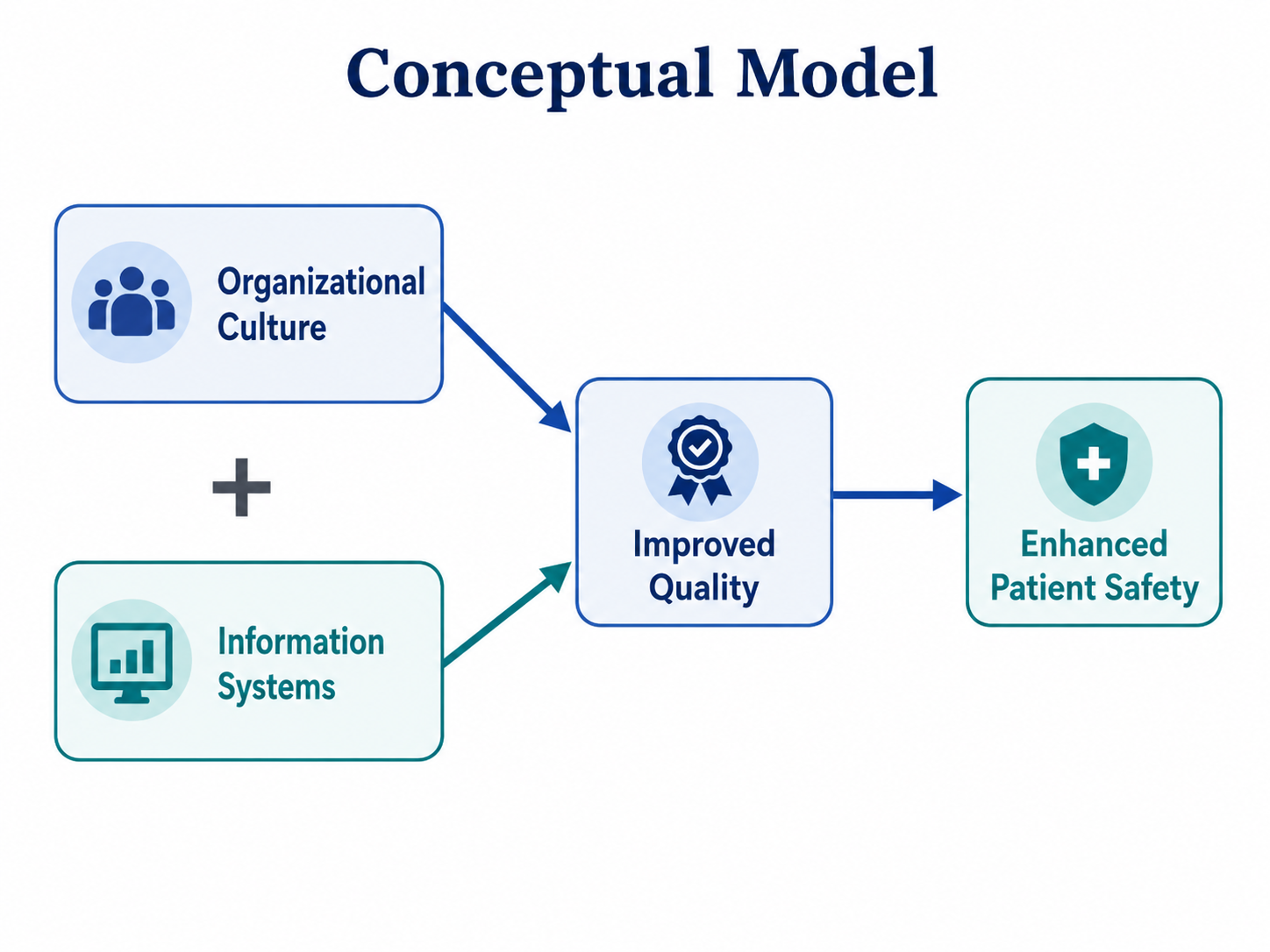
5. Methodology
5.1 Research Design & Data Collection
A quantitative cross-sectional research design is used in this study to collect numerical data from healthcare professionals at a single point in time. The data are gathered using structured questionnaires distributed to doctors, nurses, and administrative staff. This design is suitable because it allows the researcher to examine current perceptions, practices, or relationships among variables within a healthcare setting without manipulating the study environment.
A cross-sectional design is commonly applied when researchers aim to describe existing conditions or analyze associations between variables within a specific population at one particular time (Creswell & Creswell, 2018). In this study, structured questionnaires help ensure that all respondents answer the same set of questions, which improves consistency and supports statistical analysis. Since the respondents include doctors, nurses, and administrators, the approach also allows the study to capture perspectives from different professional groups within the healthcare system.
5.2 Data Analysis
The data collected from healthcare professionals will be analyzed using quantitative statistical techniques. Prior to analysis, the dataset will be screened for missing values, incomplete responses, outliers, and coding errors. Descriptive statistics, including frequency, percentage, mean, and standard deviation, will be used to describe the demographic profile of respondents and the general pattern of responses. The reliability of the measurement items will be examined using Cronbach’s alpha, with values of 0.70 and above considered acceptable for internal consistency. Pearson correlation analysis will then be conducted to assess the relationships among organizational culture, information systems, healthcare quality, and patient safety. Furthermore, multiple regression analysis will be used to examine the predictive influence of organizational culture and information systems on healthcare quality and patient safety. Where applicable, SEM or PLS-SEM will be employed to test the mediating role of healthcare quality in the relationship between organizational culture, information systems, and patient safety. A significance level of p < 0.05 will be used to determine statistical significance.
6. Results and Discussion
The findings of the study are expected to show that organizational culture and information systems have a positive and significant influence on healthcare quality and patient safety. After screening the dataset for missing values, incomplete responses, outliers, and coding errors, descriptive statistics will summarize the respondents’ demographic characteristics and overall response patterns. Reliability analysis using Cronbach’s alpha will confirm whether the questionnaire items are internally consistent, with values of 0.70 or above indicating acceptable reliability. Pearson correlation analysis is expected to identify significant relationships among organizational culture, information systems, healthcare quality, and patient safety. Multiple regression analysis will further determine the extent to which organizational culture and information systems predict improvements in healthcare quality and patient safety. Where SEM or PLS-SEM is applied, the results may also confirm whether healthcare quality acts as a mediating factor between organizational culture, information systems, and patient safety. Overall, findings with a significance level of p < 0.05 will support the proposed model that strong organizational culture and effective information systems contribute to improved healthcare quality, which in turn enhances patient safety.
7. Implications
7.1 Practical Implications
The findings suggest that hospital leaders should give equal attention to organizational culture and information systems when improving healthcare quality and patient safety. A strong safety culture encourages staff to report errors, communicate openly, and follow safe clinical practices. Therefore, hospital administrators should invest in regular training programs that strengthen teamwork, accountability, and safety-oriented behavior among healthcare professionals. The AHRQ Hospital Survey on Patient Safety Culture is commonly used to assess and improve safety culture in healthcare settings ((Rajagopala, 2025). Hospitals should also prioritize integrated health information technology systems, such as electronic health records, computerized physician order entry, and clinical decision support systems. These systems can reduce medication errors, improve communication between departments, and support evidence-based decision-making. Previous evidence shows that health information technology can improve patient safety by reducing medication errors, adverse drug reactions, and non-compliance with clinical guidelines (WHO, 2021).
Overall, patient safety improvement requires both human and technological development. A positive organizational culture creates the behavioral foundation for safe care, while integrated health IT systems provide the digital support needed for accurate, timely, and coordinated healthcare delivery. This aligns with the World Health Organization’s Global Patient Safety Action Plan 2021–2030, which emphasizes system-wide action to reduce avoidable harm in healthcare.

7.2 Policy Implications
The findings suggest that healthcare policymakers should make patient safety culture assessment a mandatory component of quality assurance systems. Regular evaluation of safety culture would allow healthcare organizations to detect weaknesses in communication, teamwork, incident reporting, leadership commitment, and learning from errors. This is important because patient safety culture directly shapes how healthcare professionals respond to risks, report mistakes, and engage in continuous improvement. Validated assessment tools, such as the AHRQ Surveys on Patient Safety Culture, can provide measurable evidence for designing targeted interventions and monitoring organizational progress over time (WHO,2021).
Furthermore, national healthcare strategies should actively support digital health transformation as a policy priority. Investment in electronic health records, digital information systems, telehealth services, interoperability, cybersecurity, and staff training can improve the availability, accuracy, and timely use of clinical information. These improvements may contribute to better quality of care and stronger patient safety outcomes. The WHO’s digital health strategy supports the integration of digital technologies into national health systems to improve health service delivery and strengthen system performance (WHO,2021).

8. Limitations and Future Research
- The cross-sectional design restricts causal interpretation because the data were collected at one time point.
- Self-reported responses may be affected by recall bias, social desirability bias, or personal interpretation.
- Future studies should use longitudinal research to examine how relationships among variables develop over time.
- Mixed-method research can provide stronger explanations by combining statistical results with qualitative evidence.
9. Conclusion
An integrated approach that integrates advanced information systems with organizational culture is necessary to enhance patient safety and hospital quality. Although health information technologies can facilitate improved communication, decision-making, and care coordination, their efficacy is significantly contingent upon the organizational culture's adaptability and readiness. Previous research indicates that the successful implementation of technology in healthcare is facilitated by a safety-oriented culture, staff engagement, collaboration, and leadership commitment (Sittig & Singh, 2010; Weaver et al., 2013). Consequently, hospitals should not regard information systems as isolated technical instruments, but rather as an integral component of a more comprehensive organizational strategy that aims to enhance the quality of care and mitigate patient safety risks.

References
Abdullah Alharbi, A. S., Mazi Alrehaili, Y. A., Hamed Alhejaili, T. A., Hammoud Al-Hujaili, M. M., Alsaedi, A. B., Alsaedi, I. S., Aljwaedi, M. S., Alghurabi, M. M., & AL mohammadi, S. D. (2024). The Role of Organizational Culture in Shaping Healthcare Service Quality: A Theoretical Perspective. Journal of International Crisis & Risk Communication Research (JICRCR), 7, 321.
Adekunle Oyeyemi Adeniyi, Jeremiah Olawumi Arowoogun, Rawlings Chidi, Chioma Anthonia Okolo, & Oloruntoba Babawarun. (2024). The impact of electronic health records on patient care and outcomes: A comprehensive review. World Journal of Advanced Research and Reviews, 21(2), 1446–1455. https://doi.org/10.30574/wjarr.2024.21.2.0592
Ahmed, S., Ashrafi, D. M., Ahammad, M. F., Rahman, M. K., & Sakib, Md. N. (2025). Role of governance on patient safety in private hospitals through the mediating effects of teamwork and continuous improvement. International Journal of Quality & Reliability Management, 43(2), 406–434. https://doi.org/10.1108/IJQRM-04-2025-0115
Al-Anezi, F. M. (2025). Challenges of Healthcare Systems in Saudi Arabia to Delivering Vision 2030: An Empirical Study From Healthcare Workers Perspectives. Journal of Healthcare Leadership, 17, 173–187. https://doi.org/10.2147/JHL.S516159
Alrawili, W. G. F., Alshammari, M. H. M., Alanezi, H. S., Alrashidi, R. H. I., Al-Ruwaili, G. M. A., & Alanezi, ‏Awatef Lafi. (2024). THE IMPORTANCE OF PATIENT SAFETY IN HEALTHCARE INSTITUTIONS. Gland Surgery, 9(2), 374–382.
Biffi, A., Castellini, G., Castillo, G. del, Nard, F. D., Vismara, C., Cabitza, F., Corrao, G., & Gianola, S. (2026). Effectiveness of computerized decision support systems linked to electronic health records: An updated systematic review with meta-analysis. International Journal of Medical Informatics, 207, 106220. https://doi.org/10.1016/j.ijmedinf.2025.106220
Fricke, J., Galligan, M., Douma, C., Souder, J., Hedden-Gross, A., & Mull, N. (2023). Examining the Impact of Implementing High-Reliability Organization Principles on Patient Safety Outcomes: Rapid Review. In Making Healthcare Safer IV: A Continuous Updating of Patient Safety Harms and Practices. Agency for Healthcare Research and Quality (US). http://www.ncbi.nlm.nih.gov/books/NBK619050/
Fujiyoshi‐Ito, A., Ogata, Y., Sasaki, M., & Sato, K. (2026). Nurses’ Patient Safety Compliance and Patient Safety Participation: A Scoping Review. Scandinavian Journal of Caring Sciences, 40(2), e70258. https://doi.org/10.1111/scs.70258
Geada, N., & Alturas, B. (2026). Patient Satisfaction in the Digital Health Era: Digital Literacy and Digital Inclusion Perspective Under the Donabedian Framework. Education for Information, 01678329261427324. https://doi.org/10.1177/01678329261427324
Govers, M., & van Amelsvoort, P. (2023). A theoretical essay on socio-technical systems design thinking in the era of digital transformation. Gruppe. Interaktion. Organisation. Zeitschrift Für Angewandte Organisationspsychologie (GIO), 54(1), 27–40. https://doi.org/10.1007/s11612-023-00675-8
Kanaparthi, N. (2026). The Adoption and Human Systems Layer: AI Agents as Organizational Members and the Implications for Organizational Behavior [SSRN Scholarly Paper]. Social Science Research Network. https://doi.org/10.2139/ssrn.6404938
Kumah, A. (2025). Poor quality care in healthcare settings: An overlooked epidemic. Frontiers in Public Health, 13. https://doi.org/10.3389/fpubh.2025.1504172
Kutsch, E., Siala, H., Cantarelli, C., & Djabbarov, I. (2025). Categorizing errors in high‐reliability organizations: Adaptive range and adaptive capacity in incident response. Risk Analysis, 45(8), 2356–2374. https://doi.org/10.1111/risa.70024
Mistri, I. U., Badge, A., Shahu, S., Mistri, I. U., Badge, A., & Shahu, S. (2023). Enhancing Patient Safety Culture in Hospitals. Cureus, 15. https://doi.org/10.7759/cureus.51159
Morales, M. J. G., Hilton, P., Hong, O., Bialous, S., Martin, M., Sewnath, J., & Lee, S.-J. (2026). High reliability organizations and healthcare safety outcomes on patients and staff: Scoping review. PLOS Global Public Health, 6(4), e0006181. https://doi.org/10.1371/journal.pgph.0006181
Popescu, C., EL-Chaarani, H., EL-Abiad, Z., & Gigauri, I. (2022). Implementation of Health Information Systems to Improve Patient Identification. International Journal of Environmental Research and Public Health, 19(22), 15236. https://doi.org/10.3390/ijerph192215236
Rajagopala, M. (2025). World patient safety day: An overview of safer healthcare. Journal of Ayurveda Case Reports, 8(3), 143. https://doi.org/10.4103/jacr.jacr_250_25
Scott, A. L., & Ford, J. (2025). Beyond rationality: The unsettling presence of embodied trauma and grief after high reliability organization failure. Communication Monographs, 92(4), 814–836. https://doi.org/10.1080/03637751.2025.2497543
Sharafkhani, M., Geary, U., Kennedy, C., Browne, M., Codd, M., O’Dea, A., Shields, D., Hennessy, A., McDonagh, L., O’Hara, S., Kennedy, B., McCullagh, C., O’Reilly, M., & Ward, M. E. (2025). Using Socio-Technical Systems Analysis to Understand the Enablers of Resilience in Clinical Handover in Acute Hospital Settings. Theoretical and Applied Ergonomics, 1(1), 5. https://doi.org/10.3390/tae1010005
Thomas, A. (2024). Digitally transforming the organization through knowledge management: A socio-technical system (STS) perspective. European Journal of Innovation Management, 27(9), 437–460. https://doi.org/10.1108/EJIM-02-2024-0114
Yang, J., Liu, F., Yang, C., Wei, J., Ma, Y., Xu, L., Xie, J., & Wang, J. (2025). Application of Donabedian Three‐Dimensional Model in Outpatient Care Quality: A Scoping Review. Journal of Nursing Management, 2025(1), 6893336. https://doi.org/10.1155/jonm/6893336

