Reaction Wheel Assisted Stabilization for Micro Missiles

- R. Dev Sheron¹, I. Arnald Jeya Raj², S. Ramprasanth³, N.BalaKumaran⁴, Mr.S. Vignesh⁵
¹²³⁴Department of Aerospace Engineering, Mahendra Engineering College, Namakkal, India
⁵Assistant Professor Department of Aerospace Engineering, Mahendra Engineering College, Namakkal, India

ABSTRACT

This project presents the design, analysis, and simulation of a Reaction Wheel Assisted Stabilization System for Micro Missiles. The work combines three major engineering domains: nonlinear flight dynamics, CAD modelling using CATIA V5, and finite element analysis using ANSYS. The primary objective of the project is to develop a stabilization mechanism for micro missiles using a reaction wheel instead of conventional aerodynamic control fins.
Micro missiles generally experience very high thrust-to-weight ratios during the initial powered flight phase, leading to highly unstable motion and rapid attitude variations. In such conditions, aerodynamic fins become ineffective because sufficient airflow is not available to generate the required control forces and moments. To overcome this limitation, the proposed system utilizes a reaction wheel mechanism that generates internal control torque through the principle of angular momentum conservation. Since the stabilization torque is internally generated, the system operates independently of external aerodynamic forces, making it highly suitable for low-speed and early-launch conditions.
The missile dynamics are modeled using a complete six degrees-of-freedom (6DOF) nonlinear simulation developed in MATLAB. The translation motion is derived from Newton’s laws of motion, while rotational dynamics are formulated using Euler’s rigid body equations. The model also incorporates gyroscopic coupling effects between the missile body and the rotating reaction wheel, enabling accurate representation of attitude behaviour. Euler angle kinematics based on the ZYX rotation convention are used for orientation tracking. A Proportional-Derivative (PD) control algorithm regulates the reaction wheel speed to minimize attitude error and maintain stability. Simulation results demonstrate effective pitch stabilization, strong disturbance rejection capability, and smooth trajectory propagation throughout flight.
Keywords:Reaction Wheel Stabilization, Micro Missile Dynamics, 6DOF Nonlinear Simulation, PD Attitude Control, Gyroscopic Coupling Effects.
INTRODUCTION
Micro missile systems are compact, high-performance aerial vehicles designed for precision strike, defense suppression, and close-range engagement missions. Their small dimensions impose severe constraints on the design of attitude control systems: the available moment arm for aerodynamic surfaces is limited, control surface effectiveness depends on dynamic pressure which is insufficient at low speeds, and the compact fuselage leaves little room for conventional actuator mechanisms.
Roll stabilization is particularly critical in cylindrical missiles, as uncontrolled roll motion couples into pitch and yaw through gyroscopic effects, degrading guidance accuracy and potentially causing flight instability. Traditional roll control relies on canted fins or roll-control fins that impart a rolling moment through aerodynamic forces. However, these approaches introduce additional drag throughout the flight envelope and depend on sufficient airflow, rendering them ineffective during the initial launch phase when velocity — and therefore dynamic pressure — is minimal.
The reaction wheel offers a compelling alternative: an internal electromechanical device that generates control torque by accelerating or decelerating a spinning flywheel. By conservation of angular momentum, a torque applied to the flywheel is reacted onto the missile body as an equal and opposite moment. This mechanism operates entirely independently of external aerodynamic forces, providing reliable attitude control from the moment of launch throughout the powered phase.
Development of a complete 6DOF nonlinear dynamic model of a micro missile in MATLAB, incorporating transitional dynamics, rotational dynamics, reaction wheel dynamics, gyroscopic coupling, and PD attitude control. Three-dimensional CAD modeling of the missile air-frame and internal reaction wheel assembly in CATIA V5, including detailed dimension of all components.
Finite element analysis of the reaction wheel component in ANSYS Workbench under 500 RPM rotational boundary conditions for all three principal axes, evaluating total deformation, equivalent stress, and elastic strain.
METHODOLOGY

Existing power transfer systems in aerospace applications, whether wired or early wireless methods, face several inherent limitations that restrict their efficiency, reliability, and adaptability. Traditional wired power distribution has been the mainstay of aerospace electrical systems for decades; however, with increasing electrification, miniaturization, and molecularity requirements, the limitations of these conventional systems have become more pronounced. Understanding these limitations is crucial for justifying the transition to wireless resonant power transfer (WRPT) solutions in modern aerospace platforms.

Excessive weight and complexity

Wired power systems require extensive harnesses, connectors, and protective conduits to distribute electrical energy throughout an aircraft or spacecraft. These wiring networks can add significant weight, sometimes several hundred kilograms in large aircraft. Increased weight adversely affects fuel efficiency, reduces payload capacity, and increases operational costs. Moreover, complex wiring networks require careful routing to prevent interference with other systems, further complicating aircraft design and assembly.

Reliability issues

Mechanical connectors, wire insulation, and harnesses are prone to degradation over time due to vibration, thermal cycling, mechanical stress, and environmental exposure. In aerospace conditions, repeated stress on wiring can lead to insulation cracks, connector loosening, or conductor fatigue. Such failures may result in intermittent power supply, system malfunctions, or even complete mission failure. The risk is particularly high in critical systems such as avionics, navigation, and communication equipment, where a single failure can compromise safety or mission success.
Maintenance and accessibility challenges
Wiring harnesses in aerospace vehicles are often routed through confined spaces, making inspection, testing, and repair difficult. Aircraft maintenance crews may need to disassemble large sections of the fuselage or internal structures to access wiring, leading to increased downtime and higher maintenance costs.
CAD DESING CATIA V5
Missile airframe design
The complete three-dimensional missile model was developed in CATIA V5 using the Part Design and Assembly Design workbenches. The air-frame is designed as a hollow cylindrical shell with a conical nose section, internal structural ribs, and mounting provisions for the reaction wheel assembly. All dimensions are derived from the missile specifications: total length 1.2 m, outer diameter 74 mm.

Figure 1:CATIA V5 missile air-frame
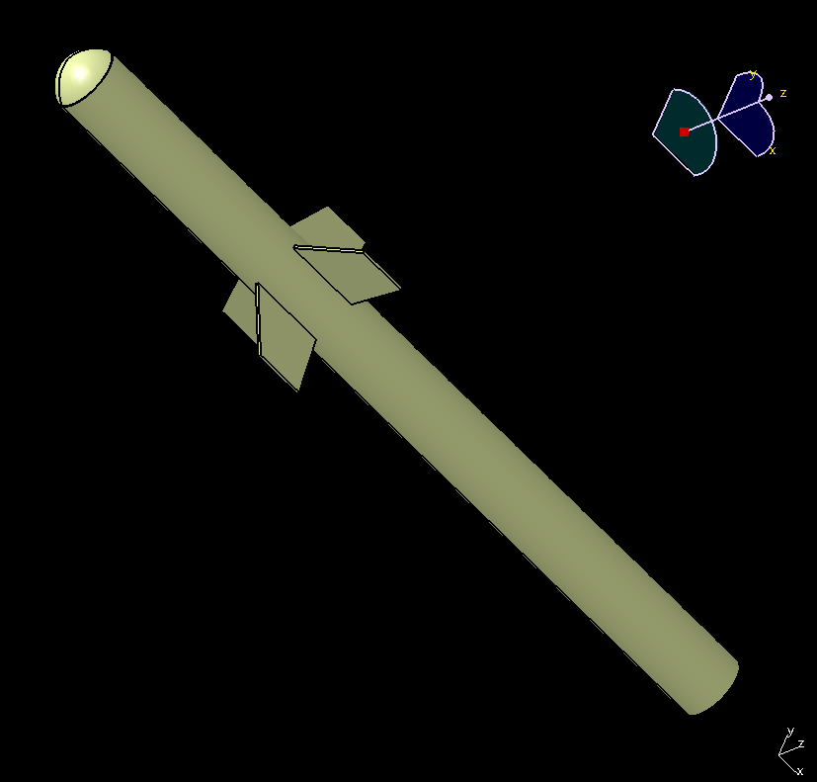

Full missile assembly

The full missile assembly integrates the air-frame, nosecone, tail section, and internal reaction wheel cavity. The assembly view demonstrates the spatial relationship between all components and confirms geometric compatibility. The center of gravity of the assembly is located near the midpoint of the fuselage, which is the optimal placement for the reaction wheel to minimize cross-inertia coupling.

Figure 2:CATIA V5 full missile assembly
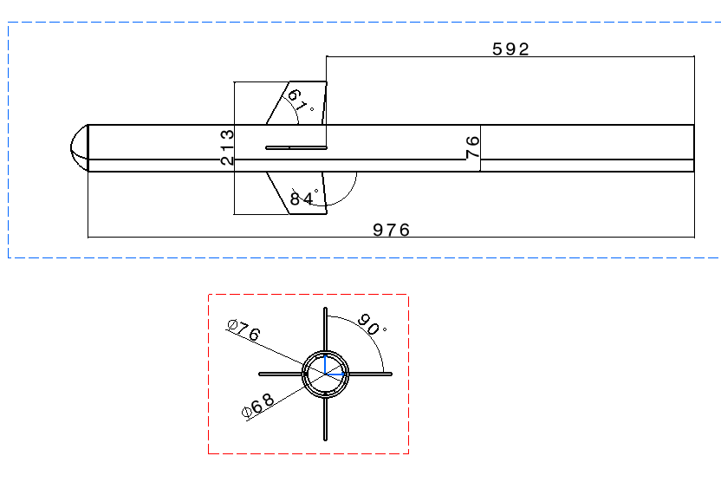

SIMULATION RESULTS AND ANALYSIS

Simulation setup and initial conditions

The 6DOF simulation is initialized with the following state vector:
- Initial position: [0; 0; 0] m (launch point, inertial frame)
- Initial velocity: [20×cos (45°); 0; 20×sin (45°)] m/s
- Initial Euler angles: [0; 45°; 0] (zero roll, 45° pitch, zero yaw)
- Initial angular rates: [0; 0; 0] rad/s
- Initial RW speeds: [0; 0; 0] rad/s
Attitude commands
- Φ cmd = 0° (maintain zero roll throughout)
- Ψ cmd = 0° (maintain zero yaw throughout)
- Θ cmd = 45° for t ≤ 1.5 s
- Θ cmd = 60° for t > 1.5 s (commanded pitch maneuver)

Plot-4 reaction wheel torque

The pitch axis reaction wheel control torque output is presented as a function of time. This plot directly reflects the control effort demanded from the actuator.

Figure 3:Pitch axis control torque
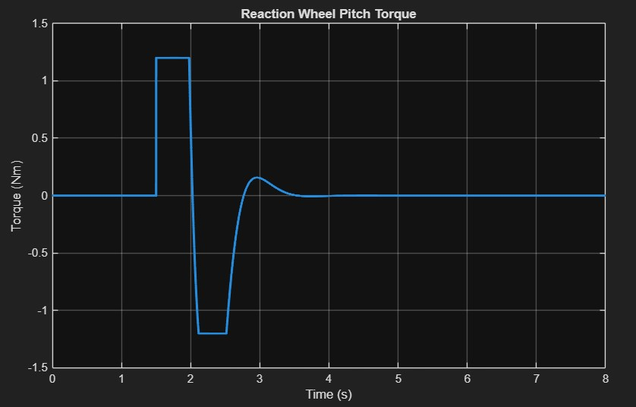

The torque output shows two distinct activity periods. The first is at launch (t = 0), where minor corrections are applied to maintain the initial 45° pitch attitude against launch disturbances. The second, and more significant, activity is at t = 1.5 s, where the controller commands maximum torque (reaching the ±1.2 N·m saturation limit) to execute the commanded 15° pitch maneuver. After the maneuver is completed, the torque demand reduces to near-zero as the missile settles at 60°. The controlled saturation confirms that the actuator is appropriately sized for the mission requirements.

STRUCTURAL FINITE ELEMENT ANALYSIS – ANSYS

Material assignment

An aerospace-grade aluminum alloy was assigned to the reaction wheel geometry. Aluminum alloys are the standard material choice for reaction wheel flywheels in small satellite and compact aerospace applications, offering an optimal combination of specific stiffness, fatigue resistance, and machinability. The material properties used in the analysis are consistent with standard aerospace aluminum specifications.

RESULT

The reaction wheel assisted stabilization system for the micro missile was successfully designed and evaluated using MATLAB, CATIA V5, and ANSYS Workbench. The developed simulation model showed stable missile behavior throughout the flight duration with effective attitude stabilization performance. The trajectory analysis confirmed smooth flight propagation with minimal deviation from the intended path. The pitch response showed stable maneuvering characteristics during the commanded flight condition changes. The reaction wheel system generated sufficient control torque for maintaining missile stability during powered and ballistic phases of flight. The velocity and acceleration profiles followed the expected behavior of a high thrust micro missile system. The range versus altitude plot confirmed proper flight trajectory characteristics under the given launch conditions. The CATIA V5 design successfully integrated the missile air-frame and internal reaction wheel assembly with proper structural arrangement. The reaction wheel placement near the center of gravity improved overall stability characteristics. ANSYS structural analysis showed that the reaction wheel assembly could safely withstand rotational loading conditions along all three axes. The deformation, stress, and strain distributions remained within safe operational limits for the selected material. The obtained results confirmed that the proposed stabilization concept is mechanically feasible and capable of improving missile attitude stability during flight operations.

CONCLUSION

This project successfully demonstrated the application of reaction wheel technology for stabilization of micro missile systems. The developed nonlinear flight dynamics model effectively represented the motion and stability characteristics of the missile during flight. The reaction wheel mechanism provided internal stabilization capability independent of external aerodynamic control effectiveness. The simulation results confirmed stable flight performance and reliable attitude correction during maneuvering conditions. The missile maintained controlled flight behavior throughout the simulation duration with satisfactory trajectory characteristics. The CAD modeling process successfully represented the complete missile configuration and internal component arrangement. Structural analysis validated the safety and mechanical strength of the reaction wheel assembly under operational loading conditions. The integrated use of MATLAB, CATIA V5, and ANSYS provided a complete engineering framework for system analysis and validation. The project demonstrated that reaction wheel assisted stabilization can be a promising alternative for compact missile applications where conventional control surfaces may have limited effectiveness. The developed work can be further extended through hardware implementation, advanced control methods, and experimental testing for future aerospace applications.

REFERENCES
- Wie, B., 'Spacecraft Attitude Control Using Reaction Wheels,' Journal of Guidance, Control, and Dynamics, AIAA, Vol. 21, No. 3, 1998, pp. 393-400.
- Tewari, A., 'Advanced Control of Aircraft, Spacecraft and Rockets,' Journal of Aerospace Engineering, Wiley, 2007.
- Zarchan, P., 'Tactical and Strategic Missile Guidance,' 6th Ed., AIAA Progress in Astronautics and Aeronautics, Vol. 239, 2012.
- Anderson, J. D., 'Introduction to Flight,' 8th Ed., McGraw-Hill, 2015. (Aerodynamic Drag Modeling)
- Cook, R. D., Malkus, D. S., Plesha, M. E., Witt, R. J., 'Concepts and Applications of Finite Element Analysis,' 4th Ed., Wiley, 2001.

