Agri-Scan: Mobile-based Rice Crop Health Detection and Monitoring Using Artificial Intelligence

- INTRODUCTION

Rice is one of the most widely consumed staple crops in the world, feeding more than half of the global population and serving as a critical source of nutrition and income for millions of people across different countries. According to the Food and Agriculture Organization of the United Nations (FAO, 2023), global rice production has been continuously increasing over the years, with Asia accounting for more than 90% of the world's total rice output, and countries across Southeast Asia have long depended on rice farming as a backbone of their agricultural economies, making crop health management a matter of both food security and economic stability.
In the Philippines, rice holds a central role in both the diet and livelihood of the Filipino people. According to the United States Department of Agriculture (USDA, 2024), the Philippines produced approximately 20.04 million metric tons of rice in 2022, placing it among the top rice producing nations in the world. However, despite this level of production, many Filipino farmers, especially those in rural and small-scale farming communities, continue to face challenges in managing rice crop health. Issues such as pest infestations, plant diseases, and nutrient deficiencies remain common problems that lead to lower yields, financial losses, and reduced productivity. Studies have shown that crop diseases alone can reduce rice yield by up to 30% if left undetected and untreated (Savary et al., 2019).
In Alaminos City, near Bolinao in the region of Pangasinan, also known as the “Home of the Hundred Islands”, rice farming can be commonly observed in the more rural areas of the city. The Agricultural Office of Alaminos City supports farmers through consultations, training seminars, and field visits, and is composed of around 30 agricultural staff, technicians, and extension workers. Out of the total land area of 16,623.39 hectares, about 60% or approximately 9,949 hectares are suitable for agricultural development, and most of these lands are used for rice cultivation.
Based on interviews conducted by the researchers with the Agricultural Sector of the Local Government Unit, farmers in Alaminos City mainly rely on manual visual inspection when monitoring the health of their rice crops. Seminars related to rice disease awareness are conducted from time to time, but these are often limited and not very in-depth. Because of this, access to proper agricultural education and facilities remains lacking, and many small-scale farmers still depend on traditional farming practices, personal experience, and advice from other farmers or agricultural staff when identifying crop diseases. These conditions show the need for more accessible and easy to use technology driven solutions that can help farmers improve productivity, sustainability, and decision making in rice farming, especially for those with limited technical knowledge.

OBJECTIVES OF THE STUDY
The main objective of this study is to design and develop a mobile-based application that detects rice crop health using Artificial Intelligence. Thus, the study aims to achieve the following objectives:
(a) To determine the current process involved in traditional means of crop health management.
(b) To identify the gaps and limitations of existing technological solutions used for crop health monitoring and management.
(c) To design and develop the key features of the Agri-Scan mobile application for rice crop health detection and monitoring; and
(d)To determine the level of acceptability and usability of the proposed system in terms of functionality, reliability, usability, efficiency, maintainability and portability.
II. METHODOLOGY
This study employed a combination of descriptive and developmental research methods using the Rapid Application Development (RAD) model as seen in Fig. 1, is the main framework for system development. Descriptive research methods were used to examine the existing rice crop health monitoring practices implemented by the Agricultural Office of Alaminos City. Through interviews, observations, and informal discussions, the researchers gathered information on how farmers currently detect rice diseases, the tools they use, and the challenges they commonly experience. These data provided a clear understanding of the present situation and helped identify areas that require improvement.
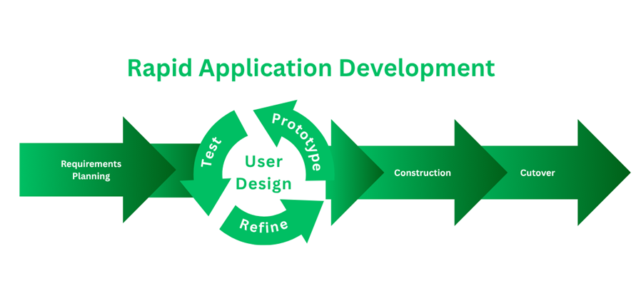
Figure 1.
Rapid Application Development Model

The developmental research approach focused on the design and creation of Agri-Scan, a mobile-based rice crop health detection and monitoring application that utilizes artificial intelligence and computer vision. This approach allowed the researchers to transform the identified problems into a functional technological solution that addresses the needs of both farmers and agricultural staff. The combination of descriptive and developmental methods ensured that the system was grounded in real-world conditions while also offering a practical innovation.
​To support system development, the Rapid Application Development (RAD) methodology was applied due to its emphasis on fast development cycles, flexibility, and continuous user involvement. RAD consists of four main phases: Requirements Planning, User Design, Construction, and Cutover.
This model was selected to allow constant feedback from intended users, which is essential in developing a system that is accessible and intuitive for farmers (Beynon-Davies & Holmes, 2020; Samsul et al., 2022). Research in the Philippines has likewise shown that technological readiness, socio-economic status, institutional support, and behavioral factors significantly affect farmers' adoption of digital extension services, emphasizing the need for accessible and user-centered technological tools (Guay et al., 2025).
Respondents | Number of Respondents
Agriculturists | 30
Farmers | 30
IT experts | 2
Total | 62
Table I.
Respondents of the Study
During the Requirements Planning phase, the researchers coordinated with the Agricultural Office of Alaminos City and conducted interviews and observations involving farmers, agriculturists, and staff. With the help of Sir Geneos A. Bantolino and Sir Richard C. Espiritu, these activities helped greatly in identifying current crop health monitoring practices, system limitations, and user needs. The collected data were analyzed to define the system’s objectives, scope, and functional requirements, which served as the foundation for Agri-Scan: Mobile-based Rice Crop Health Detection and Monitoring Using Artificial Intelligence.
Scale | Statistical Boundaries | Rating Description | Descriptive Interpretation
1 | 1.00 - 1.80 | Poor | Performance is below expectations. Improvements are warranted.
2 | 1.81 - 2.60 | Fair | Performance is below average. Did not perform as expected. Improvements warranted.
3 | 2.61 - 3.40 | Good | Performance meets expectations, though there is room for improvement.
4 | 3.41 - 4.21 | Very Good | Performance exceeds average expectations. Displaying good results.
5 | 4.21 - 5.00 | Excellent | Outstanding performance beyond expectations in all areas.

Table II.
Scale of Measurement for Acceptance Test

A survey questionnaire was employed to determine the acceptance and usability level of the developed mobile application. Responses were measured using a five-point Likert scale ranging from 1 (Poor) to 5 (Excellent), with corresponding statistical boundaries and descriptive interpretations to ensure consistent evaluation of system performance. The weighted mean was computed using the formula x̄ = Σxw / n, where x̄ is the weighted mean, x is the mean value of the set of given data, w is the weight corresponding to each response, and n is the total number of respondents. Likert-type scales are widely recognized in system evaluation studies as a robust method for measuring subjective perceptions such as usability, performance, and user satisfaction in a structured and quantifiable manner (Lewis, 2020; Shrotiya & Tyagi, 2020).
The User Design phase focused on translating system requirements into initial designs and workflows. The researchers developed preliminary interface prototypes using Figma and consulted farmers and agricultural personnel to gather feedback on layout, navigation, and usability. Suggestions from users were used to revise the interface and improve system flow, ensuring that the application remained simple, intuitive, and suitable for users with limited technical experience.

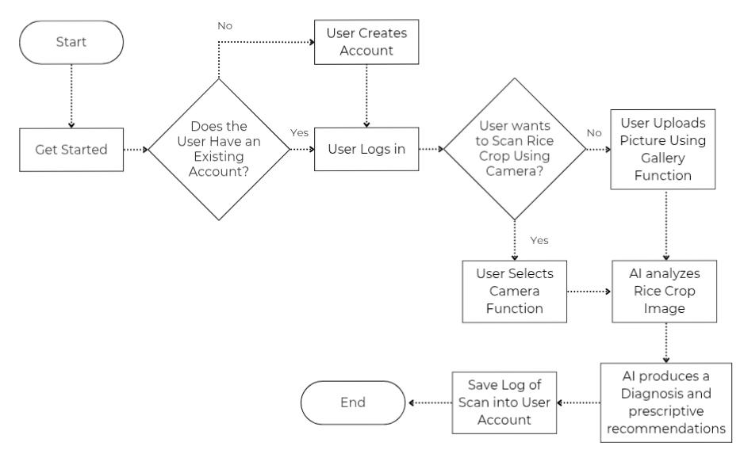
Figure 2.
Flowchart Model

In the Construction phase, the mobile application was developed using Flutter for the front end and Firebase for backend services such as authentication, database management, and cloud storage. The artificial intelligence component utilized the YOLO11 model trained through Roboflow to detect rice crop diseases from image inputs. The development of the computer vision model went through five major revisions of the image training dataset to ensure the AI remained responsive to the specific environmental conditions and crop varieties of the target locale. The proponents also identified a trade off between offline functionality and system accessibility, and since an offline mode was found to impose a heavy burden on device storage and processing power, an API reliant approach was adopted to prioritize broad compatibility with low to mid range smartphones used by local farmers.
The final phase, Cutover, involved system deployment and evaluation. The Agri-Scan application was deployed for pilot testing to selected farmers and agricultural staff at the Tangcarang Tech Demo Farm. Users were oriented on how to use the application, including scanning rice crops and interpreting results. Feedback on system usability, reliability, and overall performance was collected through surveys and observations and was used to make final adjustments before full implementation.
III. Results and Discussion
Traditional Rice Crop Health Management in Alaminos City is Predominantly Manual, Experience Based, and Reactive
To determine the current process involved in traditional crop health management, the proponents conducted interviews with rice farmers and observed their day to day farming activities. Based on the gathered data, it was found that traditional rice crop health management follows a step by step but experience based process, and although the process is systematic in nature, it is mostly manual and reactive.
The process begins with routine monitoring of the rice fields, where farmers regularly visit their paddies to inspect the leaves, stems, and panicles for unusual signs such as discoloration, spots, wilting, or the presence of insects, with special attention given to leaf lesions that may indicate rice blast disease. Farmers also observe the color of the leaves for possible nutrient deficiencies and assess water levels and soil conditions. If no abnormalities are observed, the farmer continues the regular monitoring routine; if abnormalities are detected, the farmer proceeds to symptom identification and diagnosis.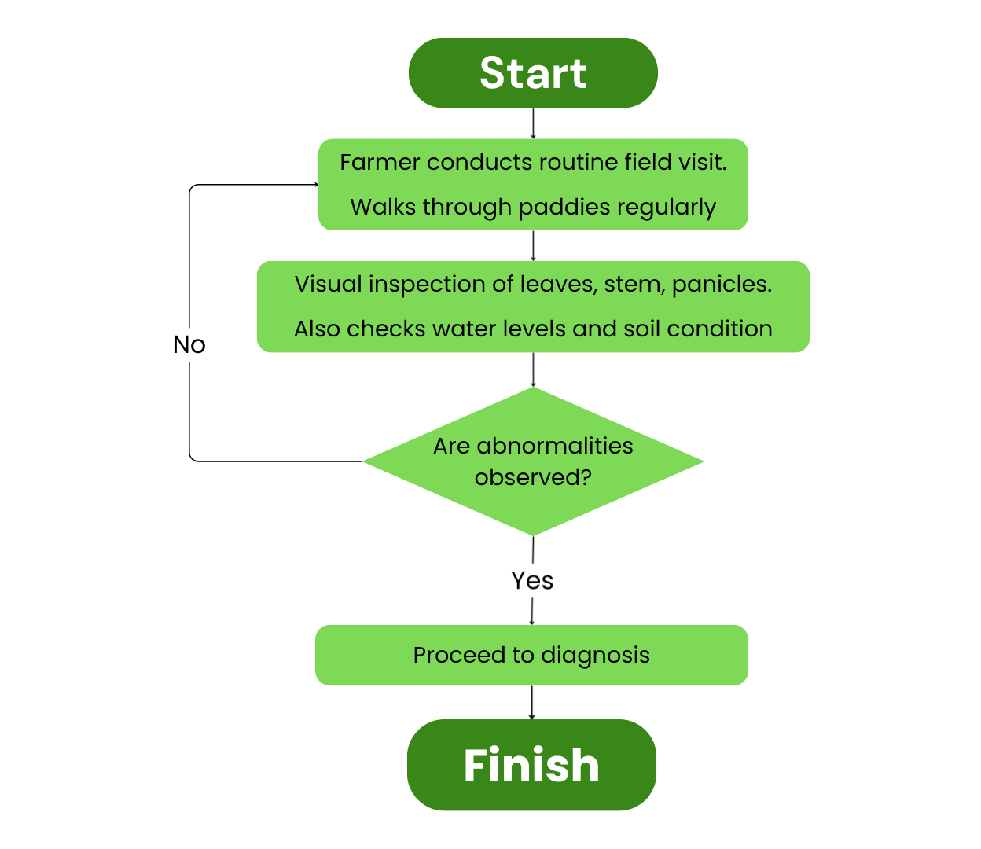
Figure 3.
Monitoring Process in Alaminos City
When a farmer notices something unusual, diagnosis is mostly based on memory and visual comparison with what they have encountered in previous planting seasons, or by asking neighboring farmers for advice. This introduces a significant risk of error, since different rice diseases often present similar looking symptoms; for example, leaf spots may be caused by fungal infection, bacterial disease, or nutrient deficiency, making it difficult to distinguish between conditions without proper diagnostic tools. If the farmer feels confident about the diagnosis, treatment preparation begins immediately. If there is uncertainty, the farmer contacts the Agricultural Office of Alaminos City for expert assistance, where a technician or Plant Surveillance Officer is assigned to conduct an ocular inspection.

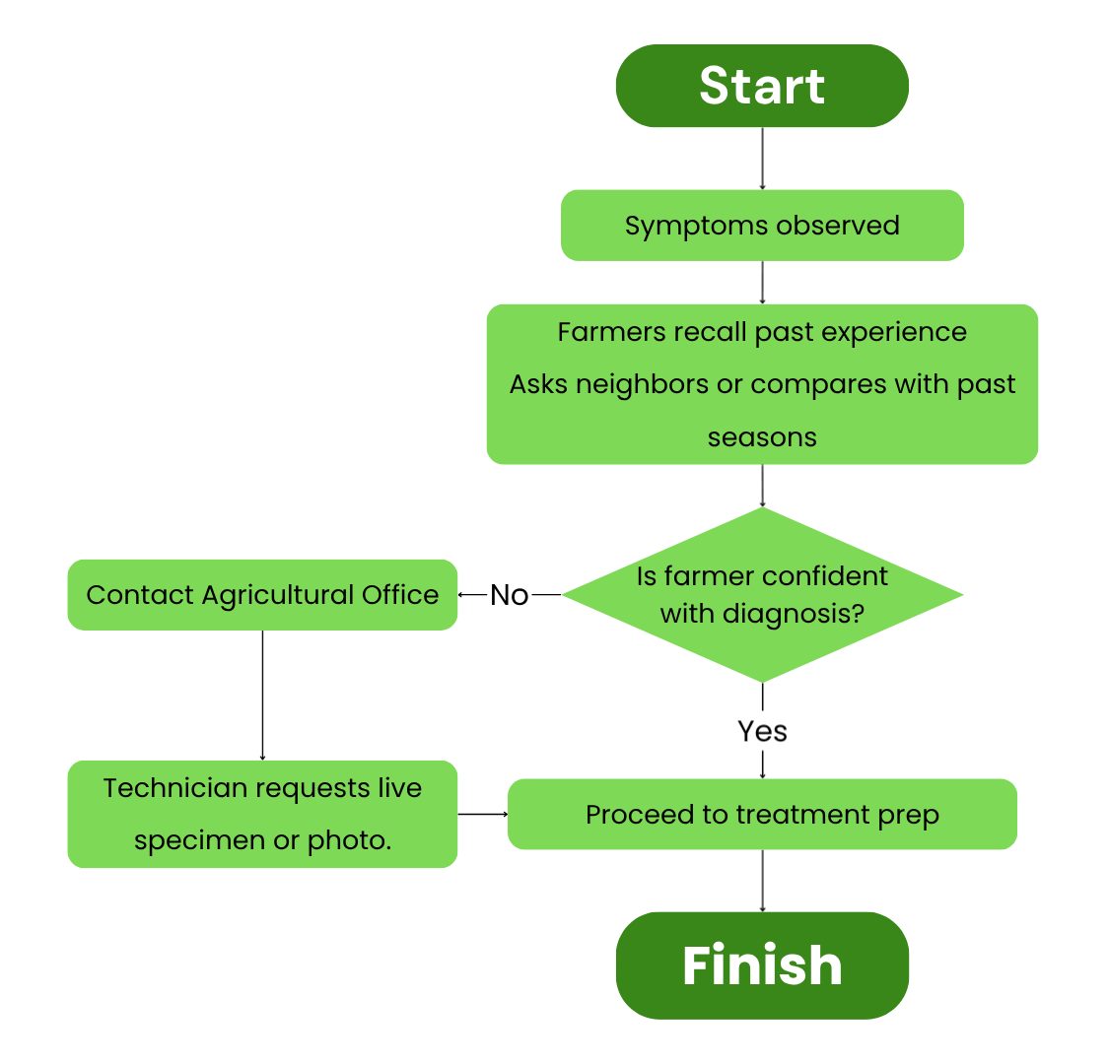
Figure 4.
Diagnosis Process in Alaminos City
When consultation is needed, the farmer brings a live specimen or a photo of the affected crop to the Agricultural Office, which assigns an available technician or Plant Surveillance Officer to visit the farm and conduct an on site ocular inspection. However, technician availability is not always immediate, particularly during peak farming seasons, and this delay can allow a disease to spread further before treatment can be applied. Once the technician arrives and confirms the diagnosis, treatment preparation can begin.
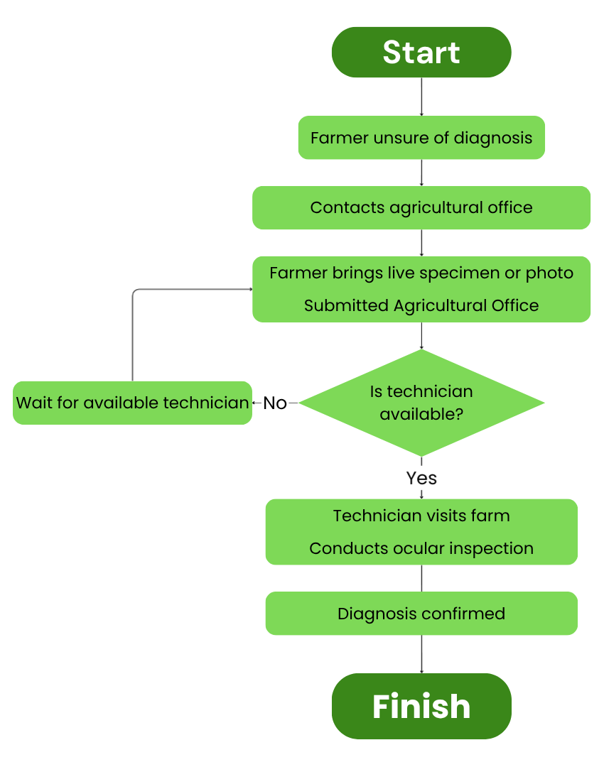
Figure 5.
Escalation Process in Alaminos City
Once a diagnosis is confirmed, treatment preparation begins by selecting an appropriate treatment method based on the diagnosis and the resources available to the farmer. If the necessary materials are already on hand, the farmer gathers them and prepares the mixture manually; if not, the farmer acquires the materials from a local agricultural store or the Agricultural Office. Some farmers prepare herbal extracts or use natural remedies such as wood ash and lime, while others purchase commercial pesticides and fungicides when budget permits. A notable concern observed is that pesticide dosage is often estimated by the farmer rather than measured precisely, which can lead to variations in treatment effectiveness.
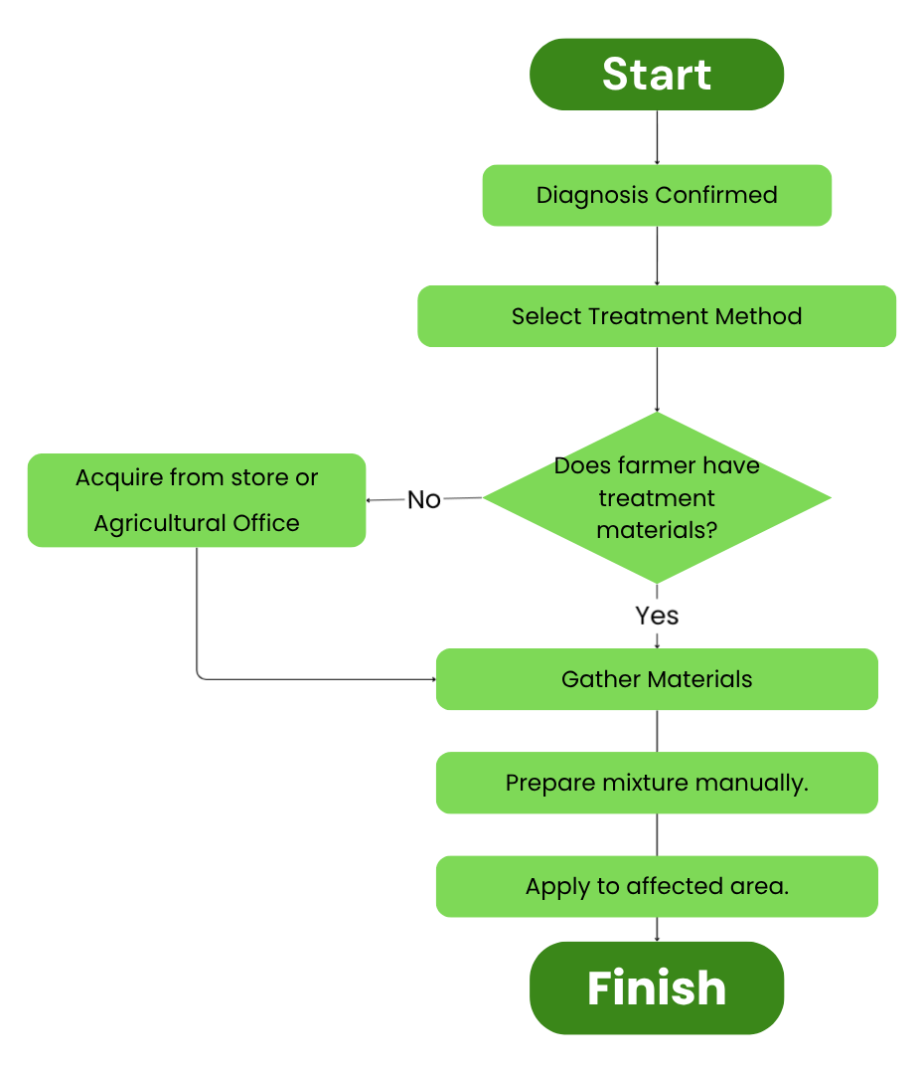
Figure 6.
Treatment Process in Alaminos City
After the treatment mixture has been prepared, it is applied to the affected areas of the field, with farmers manually spraying the crops or adjusting water levels as part of integrated pest control. Environmental conditions such as rain or strong wind may reduce the effectiveness of the treatment, sometimes requiring reapplication. The final stage is evaluation and follow up monitoring, where the farmer returns to the treated area after several days to observe whether lesions have stopped spreading, leaf color has returned to normal, or pest activity has decreased. If clear signs of improvement are observed, the farmer resumes regular monitoring; if the condition shows no improvement or has worsened, the farmer re-assesses the symptoms and returns to the diagnosis process.

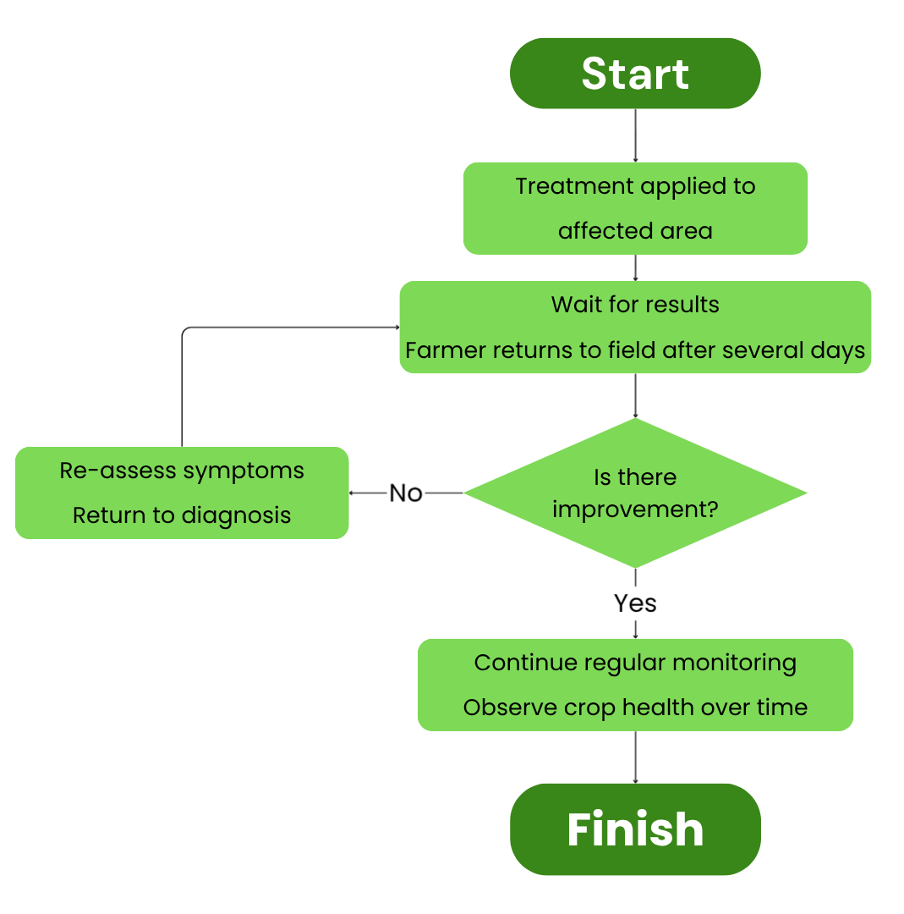
Figure 7.
Treatment Process in Alaminos City
Existing Technological Solutions for Crop Health Monitoring Remain Inaccessible, Inconsistent, and Inadequate for Small-Scale Farmers in Alaminos City
Based on the field observations and interviews conducted with 30 farmers and 30 agriculturists, several significant gaps and limitations were identified in the current crop health monitoring practices in Alaminos City. One of the most critical gaps is the absence of real time detection tools, which forces farmers to rely entirely on manual visual inspection that is inherently limited by the farmer's ability to recognize disease symptoms accurately. The dependence on personal experience was also identified as a major limitation, since more experienced farmers tend to make more accurate assessments while newer or younger farmers lack the accumulated knowledge to diagnose diseases confidently.
The current process is also fundamentally reactive, since monitoring depends on symptoms becoming visually obvious before any action is taken, with no mechanism in place for early or predictive detection. Access to agricultural technicians is also not always immediate, and during high demand periods, delays are more pronounced, increasing the window for disease to worsen unchecked. Inconsistent pesticide dosage measurement was another concern raised by respondents, since most farmers estimate chemical concentrations without standardized tools, which affects treatment effectiveness and may increase costs due to repeated applications. Finally, the complete absence of digital records means that farmers have no way to track disease patterns over time or analyze recurring outbreaks.

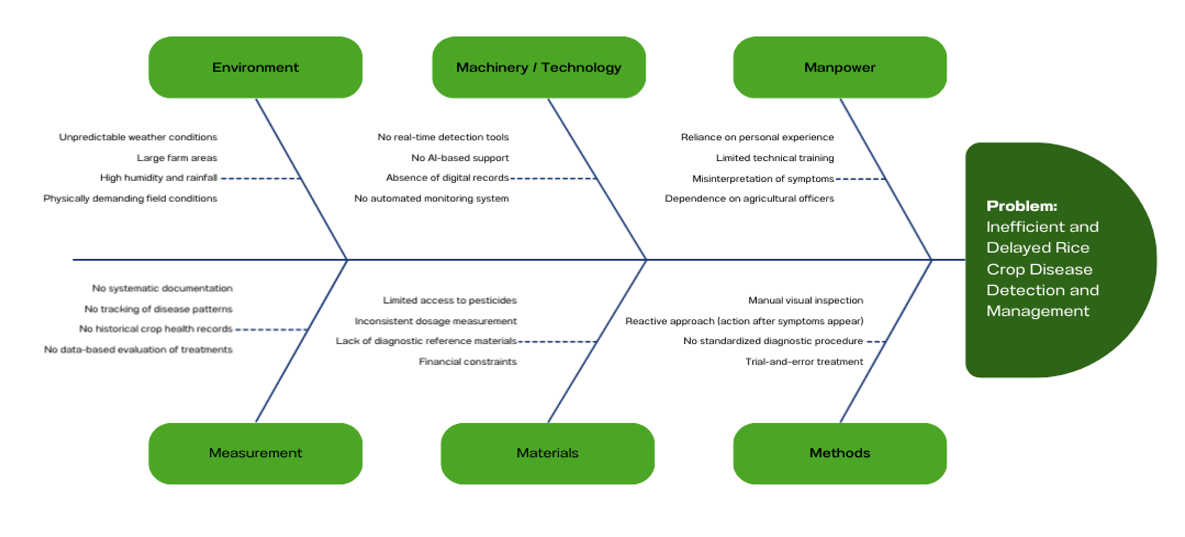
Figure 8.
Fishbone Diagram
Figure 5 presents a fishbone diagram illustrating the root causes of inefficiency in traditional rice crop health monitoring. The main problem identified is the delayed and inefficient detection and management of rice crop diseases. Contributing factors are grouped under six categories: Environment, Machinery/Technology, Manpower, Measurement, Materials, and Methods. Under Environment, unpredictable weather conditions, large farm areas, high humidity, and physically demanding field conditions were cited. Under Machinery/Technology, the absence of real-time detection tools, AI-based support, digital records, and automated monitoring systems were identified. Under Manpower, reliance on personal experience, limited technical training, misinterpretation of symptoms, and dependence on agricultural officers were noted. Under Measurement, the lack of systematic documentation, disease pattern tracking, historical records, and data-based evaluation were raised. Under Materials, limited access to pesticides, inconsistent dosage, lack of diagnostic reference materials, and financial constraints were observed. Under Methods, manual visual inspection, a reactive approach, the absence of standardized diagnostic procedures, and trial-and-error treatment were highlighted. These interconnected factors collectively demonstrate that the inefficiency is not caused by a single issue but by a combination of systemic challenges that a digital tool like Agri-Scan can meaningfully address.
Key Features of the Developed System Were Designed to Address the Identified Gaps in Rice Crop Health Monitoring
To address the identified problems and limitations, the researchers designed and developed Agri-Scan, a mobile based rice crop health detection and monitoring application powered by Artificial Intelligence and computer vision. The system was developed using Flutter for the front end interface and Firebase for backend services, including authentication, cloud storage, and database management. Each feature of the system was designed in direct response to the specific challenges identified during interviews and field observations.
Disease Detector (Camera Scanner)
The Disease Detector is the core feature of Agri-Scan. Using the phone's camera or an uploaded image, the system analyzes a rice plant through the trained AI model by examining visual patterns, textures, and symptoms to identify potential diseases. This feature directly addresses the problem of inaccurate manual diagnosis, as it removes dependence on human memory and personal experience. Once an image is processed, the application displays the detected disease, a description of the condition, and expert-recommended actions for treatment.
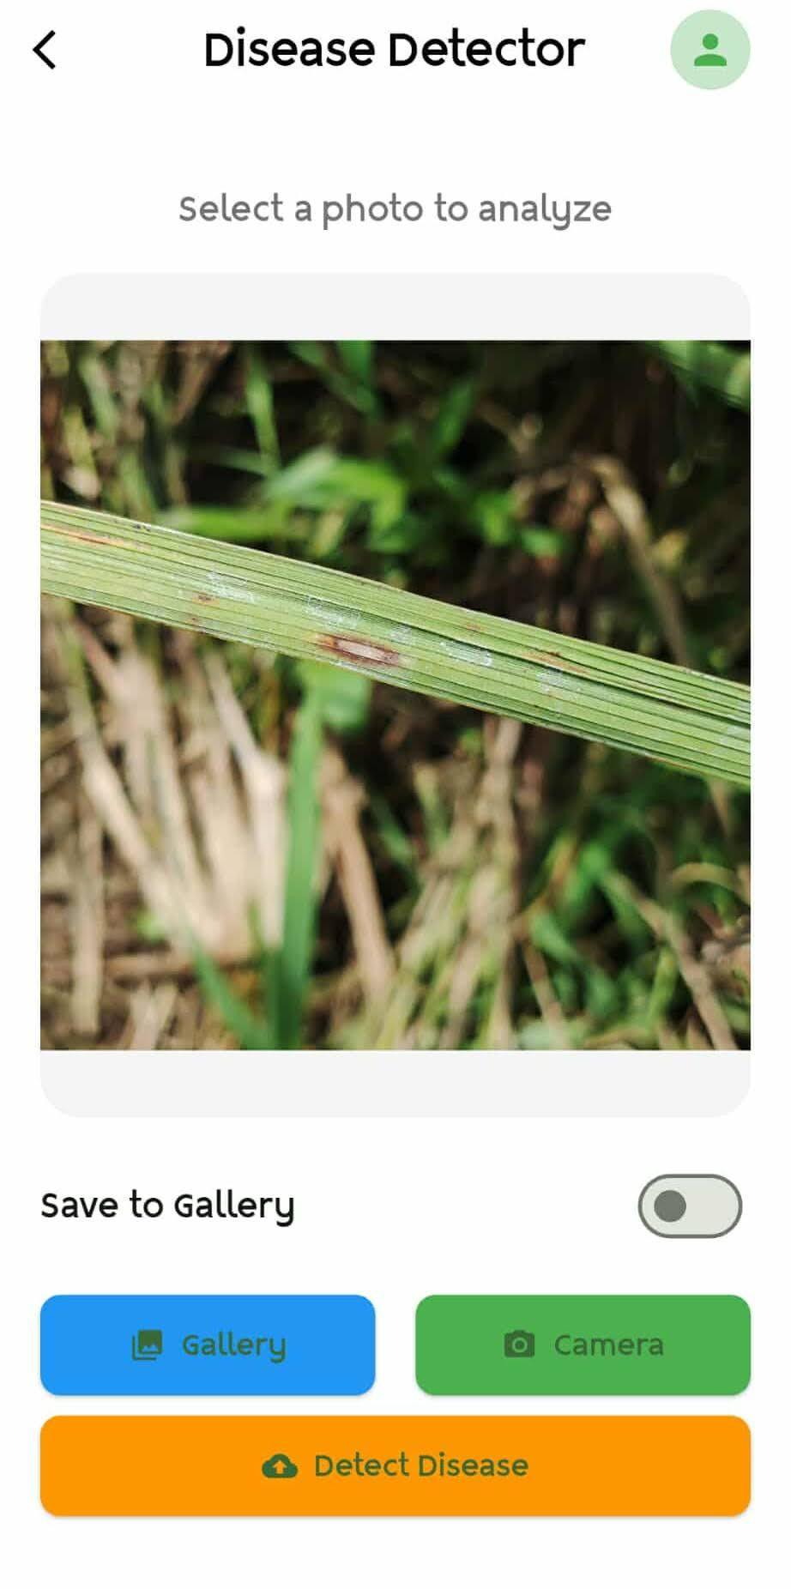
Figure 6.
Camera Scan Feature
Disease Status and Diagnosis
Alongside the detection result, the Status feature provides the farmer with a clear diagnosis showing the identified disease, virus, or pest based on visible symptoms in the image. Treatment recommendations are drawn from the agricultural manual of the Department of Agriculture, ensuring that the guidance given is locally relevant and practically applicable. The feature also suggests further soil analysis where appropriate, supporting a more comprehensive assessment of crop condition.
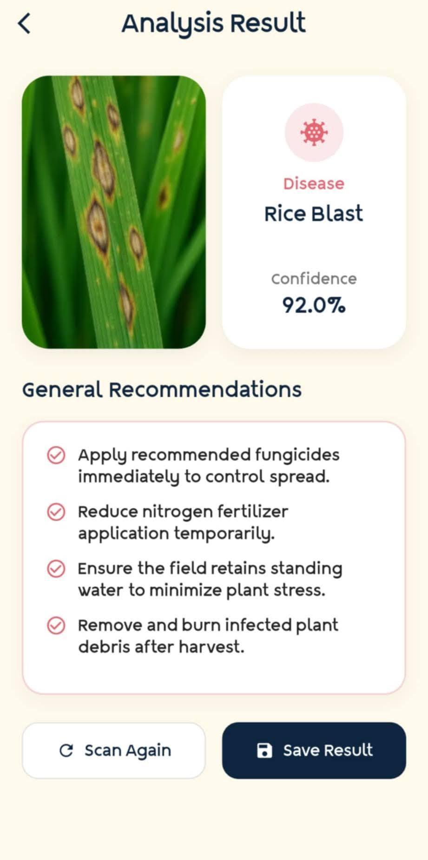
Figure 7.
Analysis Result and Diagnosis
Scan Log
The Scan Log feature stores all previous scans performed by the user, displaying each captured image alongside the identified disease and the date and time of the scan. This directly addresses the gap of having no digital records of past disease occurrences. Farmers can review scan history to track the progression of their crop's health over time, and agricultural officers can use these records during consultations instead of relying on verbal descriptions alone.

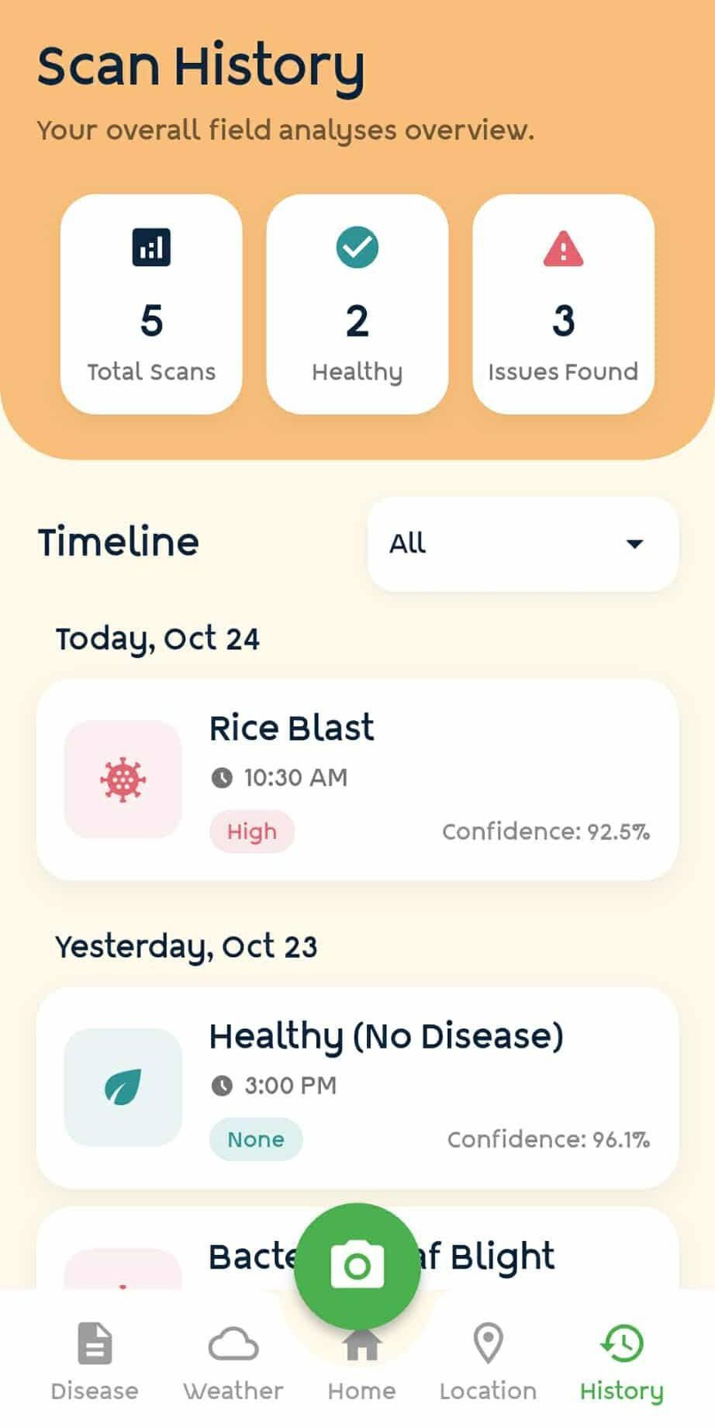
Figure 8.
Scan Log Feature
Geolocation
The Geolocation feature records the metadata location of each scan, documenting where a particular crop issue was identified. This makes it easier for agricultural technicians to locate specific fields that need follow-up inspection, improving coordination between farmers and the Agricultural Office. It also supports systematic reporting, especially when monitoring multiple areas within the same farming community.
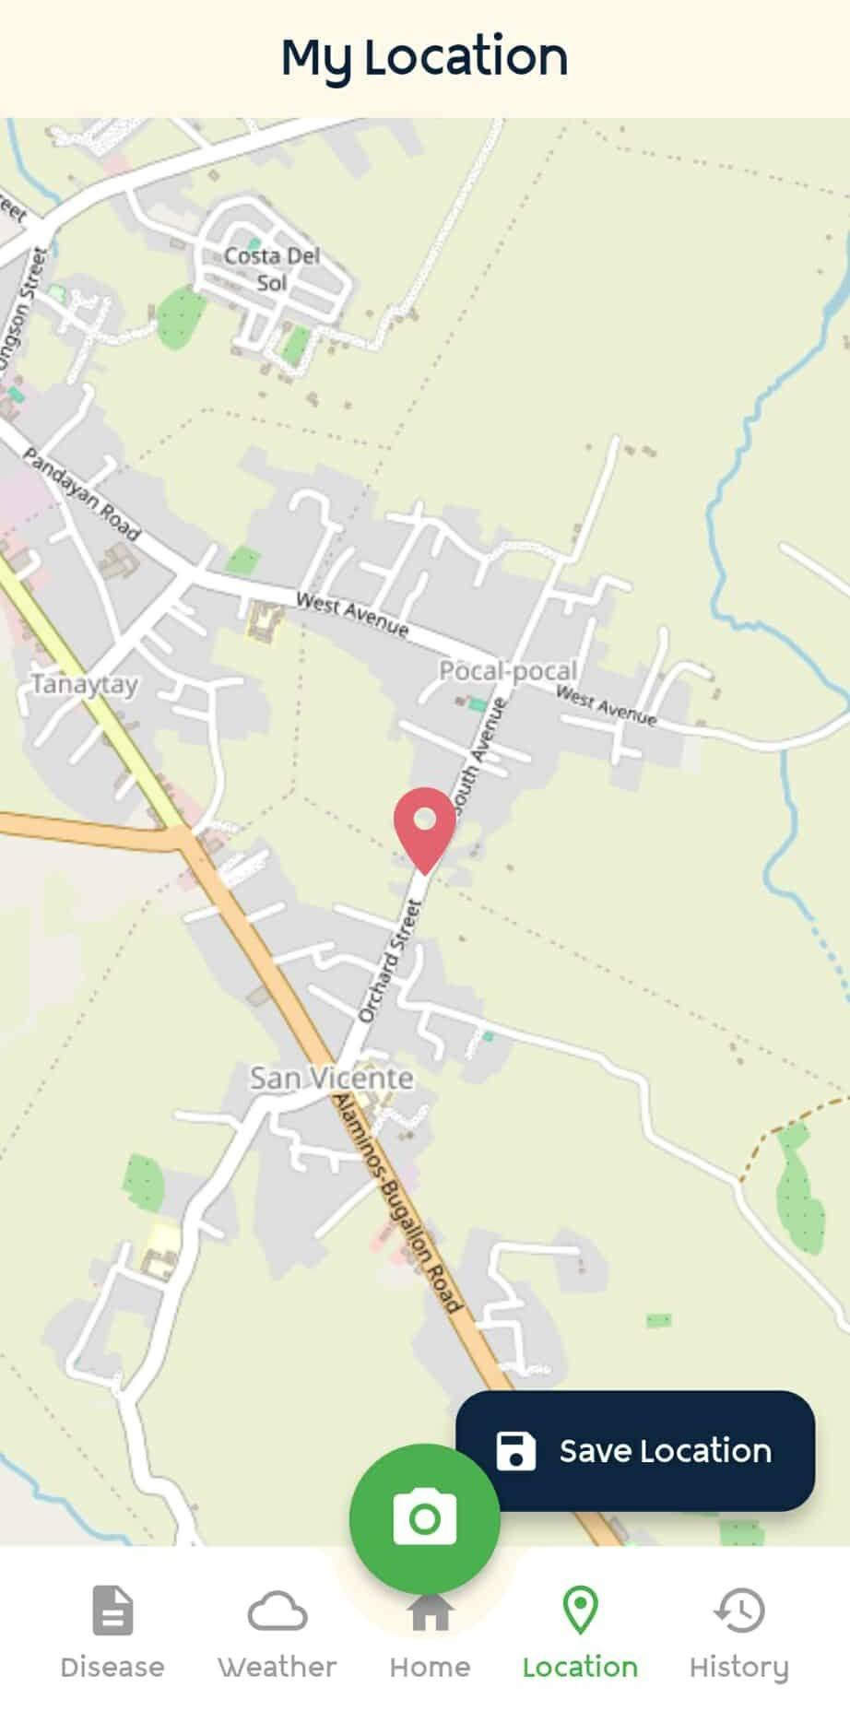

Figure 9.
Geolocation Feature

Palay Diseases Reference Guide
The Palay Diseases section functions as a built-in reference guide that allows farmers to learn about different rice diseases, their symptoms, causes, treatments, and prevention practices. It also includes a description of what a healthy rice plant looks like, enabling farmers to compare their crops against a normal baseline. This feature addresses the limited access to agricultural education that was commonly cited during interviews, providing farmers with reliable information at any time without needing to visit the Agricultural Office.
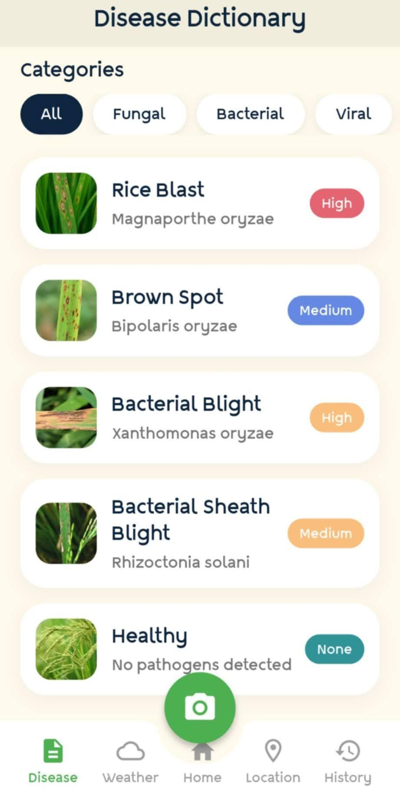
Figure 10.
Palay Disease Feature
Weather Information and AI Disease Advisor
The Weather Information feature provides users with updated weather conditions and short-term forecasts based on their current location. Since many rice diseases are influenced by environmental variables such as rainfall, humidity, and temperature, this feature helps farmers plan their daily field activities more effectively. An integrated AI Disease Advisor interprets the weather data and translates it into practical recommendations, helping users anticipate potential disease risks before they occur.

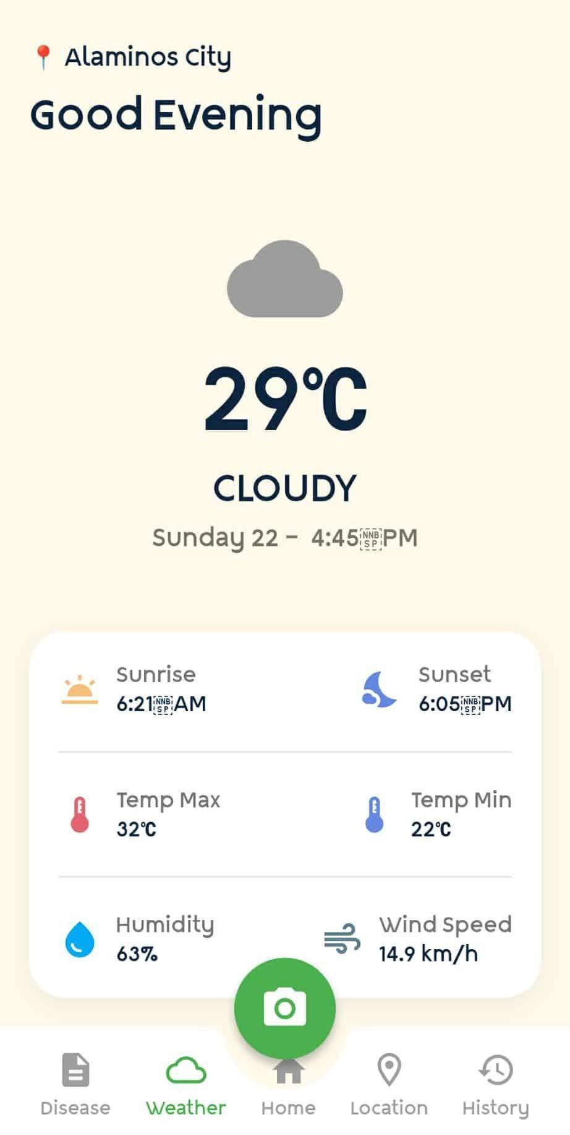
Figure 11.
Weather Feature
Farming Guide
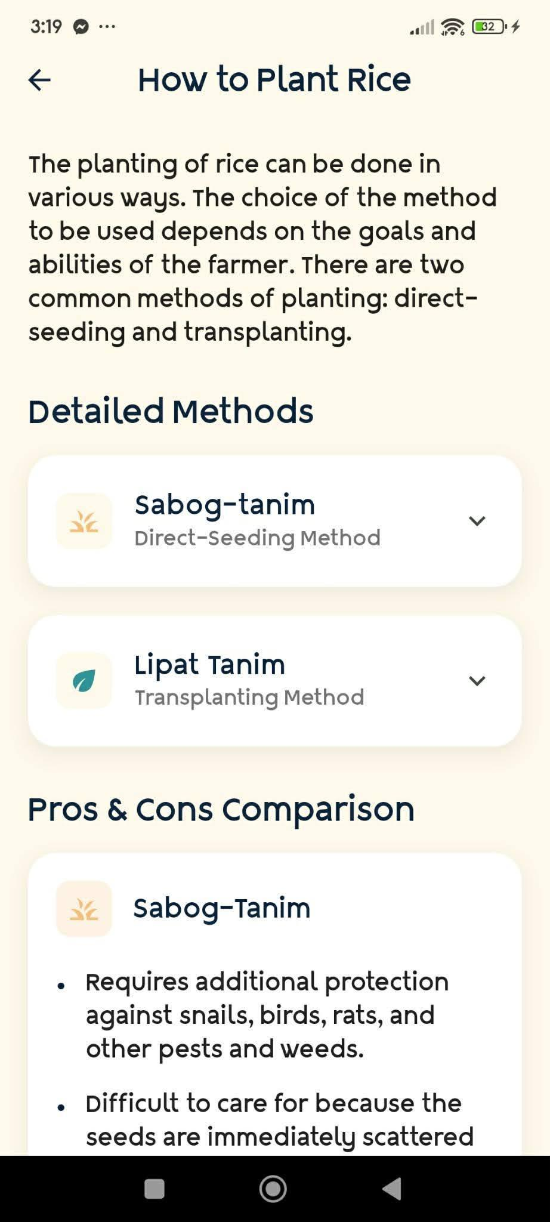

Figure 12.
Farming Guide
The Farming Guide provides farmers with practical information on crop rotation, irrigation, and soil conservation. This feature was included in response to the finding that many small-scale farmers have limited access to formal agricultural education. By offering structured guidance on sustainable farming practices directly within the application, Agri-Scan supports farmers in improving long-term crop productivity and soil health.
The Developed System Demonstrated a High Level of Acceptability and Usability Across All Evaluated Criteria
The usability and acceptability of Agri-Scan were evaluated across six categories based on the ISO/IEC 25010 software quality model, namely Functionality, Reliability, Usability, Efficiency, Maintainability, and Portability. The proponents amassed the entire population of the Tangcarang Tech Demo Farm of the Agricultural Office of Alaminos City, consisting of 30 respondents including agriculturists, temporary job orders, and field workers of the farm, who rated the system using a five point Likert scale.
Functionality obtained a weighted mean of 3.7, described as Very Good, with respondents confirming that Agri-Scan accurately identifies crop health, that the system features fit their intended purpose, and that the system delivers insightful analysis with a validated core workflow.
Reliability likewise obtained a weighted mean of 3.7, described as Very Good. Respondents noted that the system functions without errors, yields reliable outputs, and demonstrated high stability even when repeating scans or navigating between pages.
Usability obtained the highest weighted mean of 4.3, described as Excellent. Respondents agreed that the interface of the system is simple and easy to understand, that the buttons, icons, and instructions are clear and well labeled, and that the system can be easily operated even by users with minimal technical experience.
Efficiency obtained a weighted mean of 4.0, described as Very Good. Respondents reported that the system responds quickly when performing tasks such as scanning or analyzing images, processes crop images without significant delay, and performs efficiently using available device resources.
Maintainability also obtained a weighted mean of 4.0, described as Very Good, with respondents expressing confidence that the design of the system allows for future modifications, that possible errors can be identified and fixed without major difficulty, and that the system's structure is flexible enough to support future improvements.
Portability obtained a weighted mean of 4.1, described as Very Good. Users confirmed that the application is accessible and usable on their current smartphones, that it works effectively even with limited internet connectivity in the farming area, and that Agri-Scan is a cost effective alternative to other advanced agricultural technologies.

Assessment | Mean | Description
Functionality | 3.7 | Very Good
Reliability | 3.7 | Very Good
Usability | 4.3 | Excellent
Efficiency | 4.0 | Very Good
Maintainability | 4.0 | Very Good
Portability | 4.0 | Very Good
Weighted Mean | 4.1 | Very Good
Table III.
Overall System Evaluation

Overall, Agri-Scan achieved a combined weighted mean of 4.1, interpreted as Very Good. This result demonstrates that the application was well-received by its intended users and is considered acceptable for practical deployment in actual farming environments. The consistently positive ratings across all six quality criteria confirm that Agri-Scan successfully meets its primary objectives of providing an accessible, functional, and reliable mobile tool for rice crop health monitoring in Alaminos City, Pangasinan.

IV. CONCLUSION

Based on the findings of this study, the following conclusions can be drawn corresponding to each objective. First, traditional rice crop health management in Alaminos City is predominantly manual, experience based, and reactive, with farmers relying heavily on personal knowledge and visual inspection without a standardized procedure, resulting in delayed interventions and potential crop losses. Second, existing technological solutions for crop health monitoring remain largely inaccessible, inconsistent, and inadequate for small-scale farmers in the area, due to the digital divide, high cost of technology, lack of technical training, and the absence of real time detection tools and digital records. Third, the Agri-Scan mobile application was successfully designed and developed through the Rapid Application Development model, with each feature, including the Disease Detector, Scan Log, Geolocation, Palay Diseases Reference Guide, Weather Information and AI Disease Advisor, and Farming Guide, developed in direct response to the gaps identified during the research process. Fourth, the developed system demonstrated a high level of acceptability and usability across all evaluated criteria, obtaining an overall weighted mean of 4.1 described as Very Good, with Usability rated Excellent at 4.3, confirming that Agri-Scan is a dependable, efficient, and accessible mobile tool for rice crop health monitoring.
Agri-Scan presents itself as an AI powered tool designed to assist farmers in monitoring the health of rice crops. The system demonstrated strong functionality and consistent reliability, performing its core features with minimal errors, which makes it suitable for practical, real world farming conditions. By integrating emerging technology such as artificial intelligence to provide accessible digital tools, Agri-Scan is able to address the lack of digital agricultural tools for small-scale farmers in Alaminos City, and it bridges this gap by being an accessible tool while at the same time educating farmers to improve their agricultural skills in rice cultivation. It also addresses the possibility of human error in which a farmer may not be able to diagnose a rice plant properly due to poor eyesight or color blindness. The application also supports maintainability, allowing developers to implement updates and improvements as agricultural challenges and technologies evolve, justifying its use of the Rapid Application Development model that focuses on user involvement. This concludes that Agri-Scan provides a practical, user friendly, and adaptable solution that not only enhances rice crop management but also empowers local farmers with knowledge and tools to improve productivity and support sustainable agricultural practices in Alaminos City.
REFERENCE
Abeleda, A. S., Gabriel, A. G., & Macaraeg, A. J. (2021). Digital agriculture in the Philippines: Challenges and opportunities for smallholder farmers in the 21st century. International Journal of Agricultural Technology, 17(5), 1655–1670.
Almalki, F. A., Al-Zahrani, F. A., & Soufiene, B. O. (2022). Low-cost platform for identifying rice diseases using deep learning and IoT. IEEE Access, 10, 68932–68947. https://doi.org/10.1109/ACCESS.2022.3186748
Beynon-Davies, P., & Holmes, S. (2020). Rapid Application Development (RAD): A review of its impact on modern software engineering and user-centered design. Journal of Systems and Software, 164, 110549.
Dayioğlu, M. A., & Türker, U. (2021). Digital transformation for sustainable agriculture. Sustainable Agriculture Reviews, 52, 1–36. https://doi.org/10.1007/978-3-030-73245-5_1
Food and Agriculture Organization of the United Nations. (2023). World food and agriculture: Statistical yearbook 2023. FAO.
Guay, C. M. B., Esteban, J. C., Bacus, M. J. S., & Quijano-Pagutayao, A. S. (2025). Factors influencing farmers' adoption of digital extension services in Kibanggay, Lantapan, Bukidnon, Philippines. International Journal of Research and Innovation in Social Science.
Javaid, M., Haleem, A., Singh, R. P., & Suman, R. (2022). Understanding the adoption of Industry 4.0 technologies in agriculture: Insights and future directions. Journal of Industrial Integration and Management, 7(1), 103–121.
Klerkx, L., Jakku, E., & Labarthe, P. (2020). A review of social science on digital agriculture, smart farming and agriculture 4.0: New contributions and a future research agenda. Agricultural Systems, 172, 1–16. https://doi.org/10.1016/j.agsy.2019.01.002
Lewis, J. R. (2020). The System Usability Scale: Past, present, and future. International Journal of Human–Computer Interaction, 36(1), 1–2. https://doi.org/10.1080/10447318.2020.1717435
Liakos, K. G., Busato, P., Moshou, D., Pearson, S., & Bochtis, D. (2020). Machine learning in agriculture: A review. Sensors, 20(2), 434. https://doi.org/10.3390/s20020434
Magsino, J. R., Panopio, R. G., & de Guia, A. P. (2020). Technological readiness of Filipino farmers toward smart agriculture: A case study in Central Luzon. Philippine Journal of Science, 149(3), 605–615.
Mercado, R. S., Delos Reyes, M., & Bautista, J. (2024). Cross-platform portability and accessibility in mobile-based crop monitoring systems for Southeast Asian smallholders. Journal of Agricultural Informatics, 15(2), 45–59.
Pimentel, J. L. (2020). Some biases in Likert scaling usage and its correction. International Journal of Sciences: Basic and Applied Research, 48(1), 183–191.
Samsul, S., Rizal, S., & Muttaqin, M. (2022). Implementation of Rapid Application Development (RAD) in developing mobile-based monitoring systems for agricultural health. Journal of Informatics and Computer Science, 8(1), 22–31.
Savary, S., Willocquet, L., Pethybridge, S. J., Esker, P., McRoberts, N., & Nelson, A. (2019). The global burden of pathogens and pests on major food crops. Nature Ecology & Evolution, 3, 430–439. https://doi.org/10.1038/s41559-018-0793-y
Shrotiya, A. K., & Tyagi, A. (2020). Usage of Likert scale in academic research and its reliability. International Journal of Management, 11(5), 122–131.
Subeesh, A., & Jagdeep, S. (2022). Deep learning from a user perspective in smart agriculture: A review of recent trends and future directions. Artificial Intelligence in Agriculture, 6, 17–32. https://doi.org/10.1016/j.aiia.2022.01.002
Taherdoost, H. (2022). What are the different types of questionnaires and how to analyze them? Symmetry, 14(3), 458. https://doi.org/10.3390/sym14030458
Tang, Y., Chen, M., Wang, C., & Luo, L. (2023). Deep learning for plant disease detection and diagnosis: Recent advances and challenges. Frontiers in Plant Science, 14, 1159010. https://doi.org/10.3389/fpls.2023.1159010
United States Department of Agriculture. (2024). Grain: World and markets: Rice production, supply, and distribution. Foreign Agricultural Service. https://apps.fas.usda.gov/psdonline/
Upadhyay, S. K., & Kumar, A. (2022). A novel approach for rice plant disease detection using convolutional neural networks and mobile computing. Journal of Food Quality, 2022, 1–12. https://doi.org/10.1155/2022/2312341
Zulfiqar, S., Casari, G., & Sadowski, J. (2021). Smartphone adoption and its impact on agriculture perceived performance and psychological well-being. Technology in Society, 67, 101744. https://doi.org/10.1016/j.techsoc.2021.101744

