NeighbourFit: A Comprehensive Review and Intelligent Framework for Neighbourhood Lifestyle Recommendation Using Urban Analytics and Machine Learning

Ayush Bhatt
Department of Computer Science and Engineering, Galgotias University, Greater Noida, India ayushbhatt994@gmail.com

Abstract. It has undergone a high rate of urbanization which has led to. and the choice of residence and urban living in neighbourhood, which is a multi-criteria activity based on safety, Demographic Variables, Ac- cess to, and Environmental Health. essential amenities. Traditional place and real estate offer. all dead and inert data, which has to be entered by people. assess various data sources. In the recent past it has developed to some extent. Urban intelligence in geospatial intelligence, machine learn- ing and analytics. can enable The creation of smart systems that enable. integrating urbanized city data and creating style of life based prescrip- tions of areas. In this paper, a proposal to do so is given. com- all-inclusive review system and intelligent framework of NeighbourFit, Introducing A neighbourhood lifestyle recommender system. a combination of amenity crime data, air measurement. density, and properties to empower wise residential. choice-making. This review looks at the present condition of. studies on the topic of smart cities location recommendation. methodol- ogy, mega-architecture, methodology of evaluation, limitations and con- straints. Furthermore, a Respectively, recommendation system, which is aided by ML technology, is proposed. the use of a regression scheme of a Random Forest and a hybrid. scoring mechanism. Much focus has been directed towards the dataset. preprocessing pipelines, integration, and system deployment architecture and evaluation strategies. It is the discussion that establishes the. problems of research, importance of es- tablishing important research trends, the problems of deployment, and gaps in the research, with the future directions in mind. to scalability, explanability, and user-friendliness neighborhood intelligence platforms.

Keywords: Neighbourhood Recommendation · Smart Cities · Urban Analytics · Machine Learning · Recommender Systems

Introduction
As cities grow in size and density, a residential area selection process has be- come a complex decision process, including not just being close and having good

prices but whether it is crime-free, clean. air, health care that is free, education institutions, transportation, and much more. These, on the other hand, have effects on the health, moods, socialization, performance and productivity of an individual. overall satisfactions. Nonetheless, regardless of the creation of digi- tal mapping tools and the environmental dashboards use, it is still needed in. to guide the prospective purchaser navigate through a number of systems to reach. independently consider the neighbourhood. Furthermore, the most of the systems which have been developed so far have. the focus on the property list- ings and does not trend as lifestyle. matching. Rapid developments in machine learning, in recent years, geospatial analytics, as well as urban computing have had a considerable impact. improved the processing, integrating and interpreting ability. scaled coarse-grained city data. Contemporary cities constantly produce colossal amounts of both structured and unstructured data of various types like environmental. location-based services, transportation services, open government portals, sensors, and satellite imagery. Machine learning The techniques enable the disclosure of hidden patterns and predict the complex processes in the city and simulate non-linear relationships among city markers. At the same time, urban computing systems provide scalable systems. and mathematics to cope with big data in cities. geospatial and streams analysis, facilitate proper spa- tial. locality-based concrete broadcasting, urban environmental modelling and interpretation. The interplay of these technologies opens up new possibilities to develop smart urban decision-support systems. Integrating different models with the machine learning is possible by involving the geospatial intelligence pipeline and urban analytics pipelines by fusing them together. go beyond rigid visual- ization systems to alive, intelligence-based neighbourhood systems. This type of integration underpins overall assessment of residential neighborhoods. safety, by mutually comprehending the safety measures. accessibility of infrastructure and quality as well as demographics.

Major Contributions
    - An analytical survey of systems of intelligent neighbourhoods and livability focusing on recommendation systems.
    - Critically compare smart-city, GIS, and machine. learning-based urban in- telligence.
    - Model of a neighbourhood that is scalable and assisted with ML. lifestyle recommendation framework. pipeline, feature engineering, and formalization of item Data. deployment architecture.
    - Research gaps: Explainability, Real time integration, and personalization.

Review Strategy
The existing intelligent neighbourhood analytics and smart-city platforms as well as location-based recommendation have been studied using a systematic literature review methodology. systems. Articles found in IEEE Xplore were

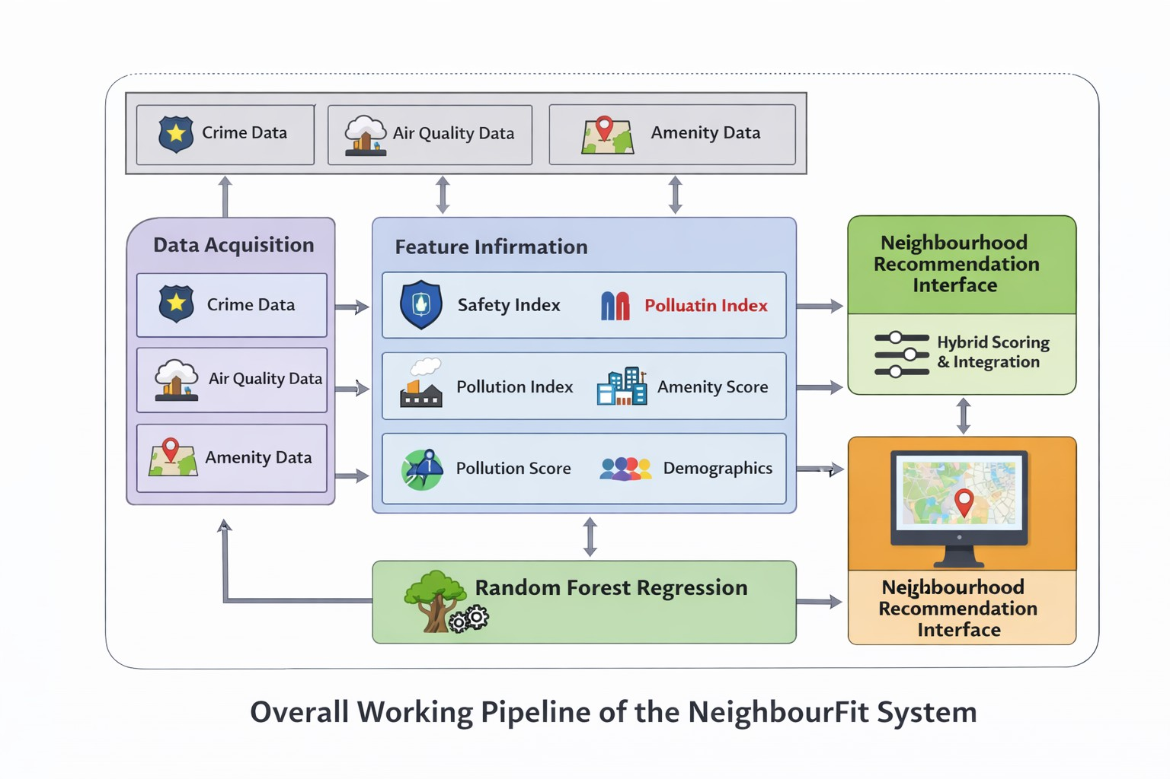

Fig. 1. Overall Working Pipeline of the NeighbourFit System

used as Material Articles. The sources of SpringerLink, ScienceDirect, arXiv and Google Scholar. 2020 to 2025.
Key words were neighborhood recommend. urban livability analytics, smart city machine learning, system. An environmental monitoring system, and crime mapping using GIS. Unnecessary, non technical and domain irrelevant studies. were discarded, through successive screening.
The architecture of the system, methods of data analysis, sources of the data and review of the evaluation methodology and the limited resources applied in all the selected works were analyzed.

Discussion of Existing Systems
The review of the literature demonstrates the use of analytics more frequently. and architectures of smart city applications. Crime mapping and air quality study are based on the use of GIS to look into the safety and. environmental risks, respectively. The applications, though, has a large dependency on visualization component, and lacks the decision support component.
Urban analytics based on machine learning algorithms demonstrate. enhance- ment of level of prediction more specifically when carried out in union in a manner that considers several aspects like pollution, infrastructure, and demo- graphics. But none of these, however, algorithms offer any good personalization, reading or scalability.

The literature of recommender systems focuses on ranking and personalisa- tion, and is not likely to have a bias towards being utilised. strategies of decision making on the neighborhood scale where. issues of interest

Research Gap and Motivation

Current limitations include:
- Lack of coordinated city data.
- Small explainability of ML models
- Single-indicator analysis techniques.
- Problem no user based systems.
Although progress has been made, there are a number of areas that have not been covered. There is deficiency of shared. urban livability datasets. There are different models that have not covered the aspect of using mechanism of explanation. The common model has been using Single-Indicator analysis. There has had low scales of fully citizen-centric fully deployed models. NeighborFit has the motivation of the necessity to possess a hybrid, explainable, and lifestyle- based neighborhood intelligence device.

Proposed NeighbourFit Framework

System Architecture
This includes some of the architecture Data Acquisition, Preprocessing. Machine Learning,Application service strata, andFeature Engineering.

Functional Workflow
The system reads and retrieves the indicators of the urban areas, generates the locality feature vectors, forecasts and displays suitability scores. ranking neighbourhoods with interactive dashboard.

Dataset Description

NeighbourFit merges multi-source information of urban areas. Information about crime is collected in crime portals at the are. the government. Helped with the measurements of air quality are taken. OpenAQ. The OpenStreetMap is used to collect the Amenity information. Demographic variables are collected using census databases. Both of the localities are portrayed as high-dimensional cities. feature vector.
A high-dimensional feature representation of each locality is given.

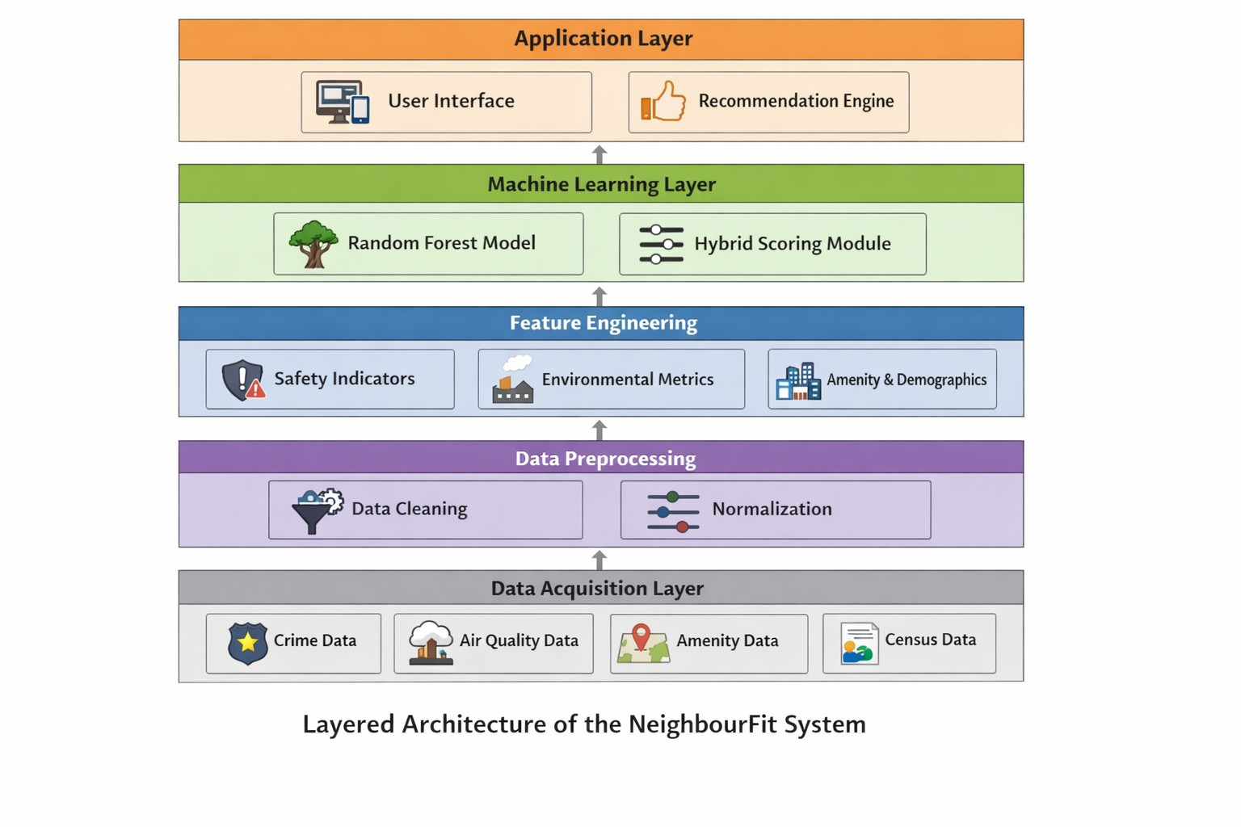

Fig. 2. Layered Architecture of the NeighbourFit System

Data Preprocessing and Feature Engineering
The city: there are gaps in the city data, spatial inaccuracy. and scale imbalance. There are spatially clumped incidences of crime. Smoothing of pollution values is done on a temporal basis. Amenity density computations of functions are done by proximity thresholds. The standardization of demographic variables is provided.

Composite indices include:
- Safety Index
- Pollution Index
- Amenity Score
x′ = x − x_{min}
xmax − xmin

(1)

- Demographic Suitability Index

Machine Learning Model Design
NeighbourFit is based on a Random Forest regression model. Ensemble learning boosts robustness, defense against non-linearity and the interpretation of fea- tures. Feature importance analysis supports explainable recommendations. The hybrid scoring model is an amalgamation of both ML predictions and. user- defined weight adaptation.

System Modules and Deployment
- Frontend: React, Leaflet
- Backend: Node.js, Express
- Database: MongoDB
- ML Engine: Python microservice
The architecture supports scalability and real-time integration.

NeighbourFit Recommendation Algorithm

Algorithm 1:
- Input: Localities L, user preferences U
- For each locality:
  - Collect data
  - Preprocess and normalize
  - Create feature vector
- Predict suitability score
- Rank neighbourhoods
- Output ranked list

Evaluation Metrics
MAE, RMSE, ranking stability, and response latency and interpretability, are some of the measures considered. Pilot study across. urban areas chosen revealed that mixed neighbourhoods. consistently achieve higher scores

Performance Analysis
Results indicate that multi-indicator modelling in combination. outperforms single-indicator platforms. The hybrid ML + scoring method enhances the strength and reliability.

Limitations and Ethical Considerations
crime/ sensor error,/ reporting crime, part/ and algorithmic bias can impact the reliability of recommendations. Deployment should be done ethically and must be explainable and transparent. fairness.

Conclusion and Future Work
The context has given an in-depth analysis and brilliant model of neighbourhood lifestyle suggestion in the paper. NeighbourFit has proven that it is viable to transform. adapted city information into scalable decision support services.
It will work on deep learning, explainable AI in the future. live streaming, mobbing and mass user. studies.

Acknowledgments. The author thanks the faculty of Galgotias University for their guidance and support.

Disclosure of Interests. The author declares no competing interests.

References
- R. Kitchin: The real-time city? GeoJournal (2014)
- M. Batty et al.: Smart cities of the future (2012)
- United Nations: World Urbanization Prospects (2019)
- OpenAQ Platform (2024)
- OpenStreetMap (2024)
- M. Ester et al.: DBSCAN clustering (1996)
- T. Mitchell: Machine Learning (1997)
- L. Breiman: Random Forests (2001)
- P. Resnick: Recommender Systems (1997)

