Secure UPI for Web3: Integration of Solana with Unified Payments Interface

ABSTRACT

To make the payment system robust and user friendly, decentralized based Scan and Pay system need to be designed. This paper integrates the Unified Payments Interface (UPI) of India with the Solana-based Blockchain to make the payment system decentralized. Solana offers a high throughput and low-cost based decentralized infrastructure which is combined with the simple and reliable UPI system. So, the proposed system enables cryptocurrency transactions linked to UPI while maintaining user friendliness, scalability, and regulatory compliance. The designed method uses a secure architecture powered by smart contracts and modular design. It offers a viable bridge between centralized financial networks and emerging Web3 ecosystems. Proposed Solana-based UPI is compared with the Non-Solana based UPI which is using Blockchain. Results show that there is improvement of 91% in transaction latency and 95% in transaction cost as compared to the Non-Solana based UPI system.

Keywords: UPI, Blockchain, Solana, Web3, Cryptocurrency, Digital Payments

INTRODUCTION

The rapid transformation of global payment systems has opened new directions for digital financial innovation. Among the innovations in this space, India's UPI has emerged as a remarkable one. It is introduced in 2016 by the National Payments Corporation of India (NPCI). UPI allows for real-time bank-to-bank transactions through a mobile interface, making it one of the most inclusive, scalable, and widely adopted payment platforms in the world [2]. By February 2024, UPI had processed over 12 billion transactions in a single month, with services extending across public utilities, retail purchases, and peer-to-peer payments [7, 11].

However, the UPI system, despite its remarkable domestic success, is inherently centralized [13, 14]. This architectural constraint introduces different kinds of limitations, such as susceptibility to systemic failures, restricted cross-border transaction capabilities, and dependence on centralized financial institutions. However, Blockchain technology spearheading the Web3 movement by offering an alternative financial model characterized by decentralization, immutability, and trustless peer-to-peer interactions [10]. Despite its promise, Blockchain’s adoption remains limited by barriers such as technical complexity, volatile transaction fees, and user experience challenges [16, 18].

This research brings a unique opportunity to use the strengths of both systems: the accessibility and institutional trust of UPI with the transparency and decentralization of Blockchain. Specifically, our work does the integration of UPI with the Solana Blockchain, leveraging Solana’s high throughput and low transaction costs to create a hybrid “Scan and Pay” solution suitable for modern world adoption. Solana, which is known for its innovative Proof of History (PoH) consensus mechanism, provides a robust infrastructure for implementing scalable financial applications with very minimum latency and cost as compared to other platforms like Ethereum.

The proposed model allows users to initiate crypto currency payments using their existing UPI. It links crypto ecosystems through a middleware layer that facilitates identity resolution, transaction verification, and real-time settlement on the Blockchain. This integration not only enhances financial efficiency but also helps in inclusion by enabling even non-technical users to engage with Web3 applications.

The motivation behind this study is presented by using three key observations. First, as Blockchain-based payment systems are matured matured technically, they remain disconnected from traditional financial platforms that people trust and use daily. Second, the centralized nature of UPI makes it vulnerable to single points of failure and regulatory bottlenecks. Third, the increasing global acceptance of digital assets and decentralized finance (DeFi) requires the bridge to simplify user access without sacrificing compliance or security.

The remainder of this paper is structured as follows. Section 2 provides a detailed background and literature review, exploring the evolution of UPI, the fundamentals of Blockchain, and the features of Solana. Section 3 outlines the system architecture and transaction flow of the proposed system. Section 4 presents the snapshot of the designed architecture with some transactions. Section 5 details the testing methodologies and results. Section 6 compares the performance of Solana-based UPI and Non-Solana Blockchain-based UPI. Finally, Section 7 concludes with a summary of findings and the future scope of the proposed system.

BACKGROUND AND LITERATURE REVIEW

This section provides an overview of the technologies used and existing research related to the integration of traditional financial systems with decentralized networks. In this part we have covered the evolution of the UPI fundamental concepts of Blockchain technology, the design capabilities of the Solana Blockchain, and the current landscape of related payment systems.

Unified Payments Interface (UPI)

The Unified Payments Interface (UPI) is a real-time payment system developed by the National Payments Corporation of India (NPCI) under the regulation of the Reserve Bank of India. Since its inception in 2016, UPI has been pivotal in transforming India’s digital payment ecosystem. It allows users to transfer money between bank accounts using simple identifiers such as virtual payment addresses (VPAs), mobile numbers, or QR codes. Unlike traditional methods, UPI transactions are instantaneous, require no card or bank account number entry, and operate 24/7.

UPI has introduced features such as interoperability across different banking platforms, low-cost transaction processing, and seamless integration with third-party apps like Google Pay, PhonePe, and Paytm. By February 2024, UPI had reached over 350 million active users, demonstrating its accessibility and scalability.

Despite its success, UPI is inherently centralized. Transactions are routed through NPCI’s infrastructure and dependent on Indian banking systems. While this offers regulatory oversight and institutional trust, it also introduces vulnerabilities related to downtime, censorship, and limited international use. As digital economies become more interconnected, there is growing interest in extending UPI’s usability beyond domestic confines through integration with decentralized technologies.

Blockchain Technology

Blockchain is a distributed ledger technology that allows secure, transparent, and tamper-proof recording of digital transactions. Each block contains a cryptographic hash of the previous block, a timestamp, and transaction data, forming a chronological and immutable chain. Unlike traditional ledgers maintained by central authorities, Blockchain operates in a decentralized manner where participants reach consensus without needing a trusted third party.

The key characteristics of Blockchain include decentralization, immutability, transparency, and programmability through smart contracts. These attributes make it suitable for financial applications, supply chain tracking, digital identity, and secure voting.

However, several challenges hinder Blockchain’s mainstream adoption. These include limited transaction throughput, high network fees (especially in Proof-of-Work systems like Bitcoin and Ethereum), energy consumption, and complex user interfaces. Moreover, regulatory uncertainties and lack of interoperability with traditional systems remain unresolved issues.

Solana Blockchain

Solana is a high-performance, open-source Blockchain designed to enable fast, scalable, and low-cost decentralized applications. It distinguishes itself through its unique Proof of History (PoH) mechanism—a cryptographic clock that sequences transactions without requiring extensive consensus overhead. This innovation allows Solana to achieve transaction speeds exceeding 65,000 transactions per second (TPS) while maintaining low transaction fees (fractions of a cent per operation).

In addition to PoH, Solana incorporates several other mechanisms that enhance performance and developer experience, including Tower BFT (Byzantine Fault Tolerant consensus), Gulf Stream (transaction forwarding), and Sealevel (parallel smart contract execution). These features make it one of the few Blockchain platforms capable of supporting real-time applications without compromising decentralization.

Solana’s developer ecosystem includes tools like Solana Pay for QR-based payments, Anchor for smart contract development in Rust, and integrations with leading wallet providers such as Phantom and Solflare. Given these capabilities, Solana is a suitable platform for implementing a decentralized payment solution that mirrors the speed and efficiency of traditional systems like UPI.

Related Work

Over the past decade, various efforts have emerged to bridge the gap between traditional financial systems and decentralized networks. Early projects like Ripple and Stellar aimed to facilitate cross-border remittances using Blockchain-based settlement. Ripple, for instance, collaborated with banks and payment providers to enable instant international money transfers, though its consensus model remains permissioned and centrally influenced.

Alharby M. [1] performed the studied on the Blockchain-Based smart contracts. The author analysed the smart contract applications and its vulnerabilities. It is observed from the study that smart contracts suffer from different vulnerabilities such as logic errors and re-entrancy errors. Kosba A. et al. in [8] proposed a Hawk model based on Blockchain. The model uses the privacy preserving smart contracts and cryptography. The model preserves the privacy quite efficiently but the limitation of the model lies in its complex cryptographic operations and computational overhead over time. Ferdous M. et al. [6] conducted a survey on the Blockchain. The authors conducted the review of Blockchain in finance and its security. The study suggests that there are several challenges occurred in Blockchain adaptation and its integration with traditional financial systems.

Wood G. presented the Ethereum technical architecture and its transaction processing model in [17]. The model uses Ethereum Virtual Model for the processing. It is observed from the model is that smart contract execution cost is high and the security of the model depends upon the contract method. Buterin V. [3] presented a next generation smart contract application which is decentralized. The authors introduced the programmable Blockchain and decentralized applications. The model has low throughput and high network congestion. Mettler M. in [9] introduced the application of Blockchain in healthcare. The authors demonstrated Blockchain transparency and data integrity applications. However, the model does not discusses about the payment scalability and financial interoperability. A survey on security issues on Bitcoin is introduced by Conti M. et al. in [4]. The authors discusses on Bitcoin but remain silent about the integration with the conventational payment system. Smith B. in [15] discussed a unique digital architecture and its systematic transformation on financial infrastructure. The authors remain silent about the practical implementation and testing in real life. Dinh T. et al. introduced a Blockbench for performance evaluation using throughput, latency parameters in [5]. The authors mainly focused on private Blockchain and does not discussed about public payment systems. Pierro G. [12] discussed the role of Solana in the Blockchain scalability. The authors presented the Solana clearly but practical use of Solana in the Blockchain needs further research.

Existing works introduced decentralized based Blockchain for payment; however these systems suffer scalability and high transaction issues. To overcome these, Solana based high-speed and low-cost transactios are introduced by different authors, but these systems lack the integration with traditional payment system. To overcome these, a secure hybrid framework integrating UPI with Solana Blockchain is required. This will take the advantages of traditional banking system and the Wbe3 decentralized finance.

SYSTEM ARCHITECTURE AND TRANSACTION FLOW

The proposed Secure UPI for Web3 architecture is designed as a layered framework that combines the convenience of Unified Payments Interface (UPI) with the security, transparency, and decentralization features of the Solana Blockchain. The architecture consists of four major layers: the front-end layer, middleware layer, Blockchain layer, and storage and key management layer. Each layer performs a specific function to ensure secure communication, transaction processing, and reliable payment execution between traditional banking systems and Web3 infrastructure. The proposed system architecture is shown in Figure 1.

Front-end Layer
The front-end layer acts as the primary interaction interface between users and the proposed payment system. It is responsible for providing a simple and accessible environment through which users can initiate payments, monitor transactions, and manage their digital wallets. The layer integrates cryptocurrency wallets such as MetaMask and Phantom with UPI-based payment services, enabling users to interact with Blockchain transactions without significant changes to their existing payment experience.
A QR-based payment mechanism is incorporated into this layer to simplify transaction initiation. Users can scan dynamically generated QR codes containing payment details such as recipient information, wallet address, and transaction amount. The interface is designed using responsive web technologies to provide consistent usability across mobile and desktop platforms. Additionally, real-time transaction notifications are generated through application alerts or messaging services to inform users about successful payments, failures, or pending transactions.
The user interface can be developed using modern front-end frameworks such as React.js or Vue.js, which provide reusable components and responsive design capabilities. Application state management frameworks including Redux or Context API can be utilized to maintain transaction states, wallet connectivity, and user session information efficiently.

Middleware Layer
The middleware layer functions as the communication bridge between the existing UPI infrastructure and the decentralized Solana Blockchain network. Since conventional UPI transactions and Blockchain transactions follow different communication protocols, this layer performs the necessary conversion and validation operations required for interoperability.
When a payment request is generated, the middleware converts the UPI payment information into a Blockchain-compatible transaction format. It verifies user authentication details, validates wallet addresses, and ensures that transaction parameters comply with security requirements before forwarding the request to the Blockchain network. This layer also provides encryption mechanisms to protect sensitive information during data exchange between the user application, banking services, and Blockchain nodes.
The middleware manages API communication between UPI service providers and Solana Remote Procedure Call (RPC) nodes. Backend technologies such as Node.js or Python can be used for implementing transaction logic, while frameworks such as Express.js or FastAPI can provide REST-based communication services. This intermediate layer improves interoperability by hiding the complexity of Blockchain operations from end users.

Blockchain Layer
The Blockchain layer provides the decentralized foundation of the proposed system and is responsible for transaction execution, verification, and permanent recording. The Solana Blockchain is selected due to its high throughput, low transaction cost, and fast confirmation capability, which makes it suitable for large-scale digital payment applications.
Smart contracts deployed on the Solana network manage essential transaction operations including payment execution, fee calculation, and automated dispute handling. Once a transaction request is validated by the middleware, the corresponding smart contract is invoked to transfer digital assets from the payer's wallet to the recipient's wallet according to predefined rules.
The transaction pool temporarily maintains pending transactions before they are processed and recorded on the Blockchain. Solana's Proof of History (PoH) mechanism combined with Proof of Stake (PoS) enables efficient ordering and validation of transactions, resulting in reduced confirmation time. Compared with traditional Blockchain platforms, Solana provides significantly higher transaction processing capability, lower latency, and minimal transaction fees, making it more appropriate for real-time payment scenarios.

Storage and Key Management Layer
The storage and key management layer is responsible for securely maintaining user information, transaction records, and cryptographic credentials. Since payment applications handle sensitive financial information, this layer ensures confidentiality, integrity, and controlled access to stored data.
User profiles, transaction history, wallet information, and system logs are maintained using secure database systems. Structured data can be stored using relational databases such as PostgreSQL, whereas flexible and unstructured information can be managed through databases such as MongoDB. To protect user credentials and cryptographic keys, secure key storage mechanisms such as Hardware Security Modules (HSMs) or cloud-based key vault services can be employed.
Data security is maintained through encryption techniques. Advanced Encryption Standard (AES-256) can be applied for protecting stored information, while Transport Layer Security (TLS) ensures secure communication during data transmission. The layer also supports compliance with data protection standards such as GDPR by implementing controlled data access and privacy-preserving mechanisms.
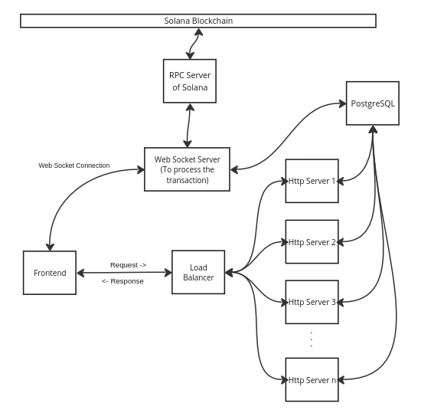
Figure1: System Architecture Diagram of Proposed Solana-based Payment System

Data Flow of the Proposed System
The transaction process begins when a user initiates a payment request through the front-end application by scanning a merchant's QR code. The application extracts the required transaction information, including the recipient wallet address and payment amount, and forwards the request to the middleware layer.
The middleware performs authentication and validation procedures by verifying the user's UPI credentials and checking the correctness of the transaction details. After successful verification, the request is transformed into a Blockchain transaction format and transmitted to the Solana network.
At the Blockchain layer, the smart contract processes the transaction according to predefined conditions. The required amount is transferred from the payer's wallet to the recipient's wallet, and transaction fees are calculated automatically based on smart contract logic. After successful execution, the transaction details are permanently recorded on the Blockchain.
Finally, the confirmed transaction status is returned to the middleware, which synchronizes the payment information with the UPI system. The user receives a real-time notification indicating the completion or failure of the transaction. The proposed transaction processing flow diagram is shown in Figure 2.
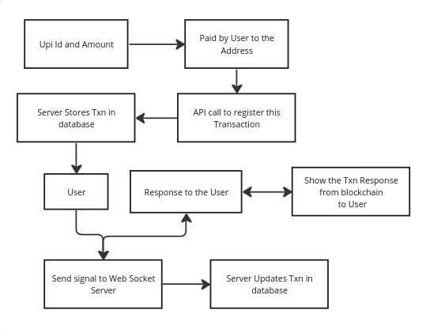
Figure 2: Transaction Processing Flow Diagram of Proposed System
Integration Components
The proposed framework integrates multiple components to establish communication between Web2 payment infrastructure and Web3 Blockchain services. The UPI integration module enables interaction with banking networks and supports conversion between traditional fiat payment mechanisms and Blockchain-based assets. Blockchain RPC nodes provide communication between the middleware and the Solana network by submitting transactions and retrieving Blockchain status information.
Third-party services are also incorporated to support additional functionalities such as payment processing, token conversion, and notification delivery. These services improve system usability by allowing users to access Blockchain-based payments without requiring deep technical knowledge of Web3 technologies.
Scalability and Reliability Mechanism
To support increasing transaction volume and user demand, the proposed architecture incorporates scalability and reliability mechanisms. Horizontal scaling techniques are applied using load balancing methods, allowing multiple application instances to process requests simultaneously. This approach reduces system congestion and improves response time during high transaction loads.
Fault tolerance is achieved through redundant Blockchain nodes and backup database systems. In case of service interruptions or node failures, alternative resources can maintain continuous operation. System monitoring tools such as Prometheus and Grafana can be integrated to analyze performance parameters, detect abnormal conditions, and maintain overall system health.
The combination of layered architecture, decentralized transaction processing, and secure data management enables the proposed Secure UPI-Web3 framework to provide a scalable, efficient, and user-friendly digital payment environment.

VISUAL SNAPSHOTS OF THE PROPOSED SYSTEM

The proposed system uses Solana-based UPI for transaction. The created GUI based on Solana is shown in Figure 3. It contains the button for showing the history of the past transactions, list of deposits and withdrawn performed. To support the UPI-based payment, QR code generation is also provided. Figure 4 shows the transaction initiation request. Due to the involvement of payment related transactions, two stage verifications are being carried out. Once the initiation request is confirmed, it is again confirmed as shown in Figure 5. After the transaction is done, the lists of transactions are shown in the wallet with digital signature, sender and receiver information, amount, status and timing of the transaction in Figure 6.

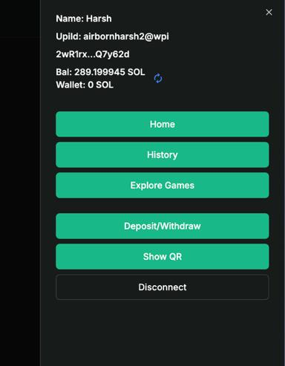  Figure 3: Home Page of Proposed Architecture | 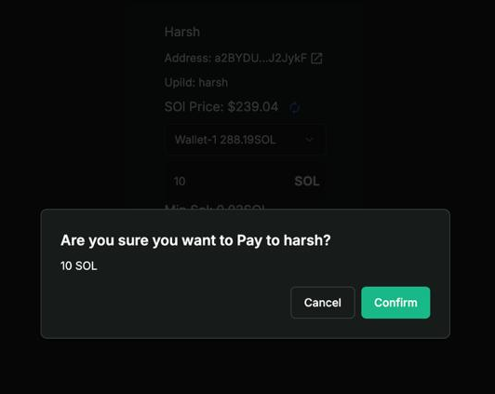  Figure 4: Transaction Initiation Request
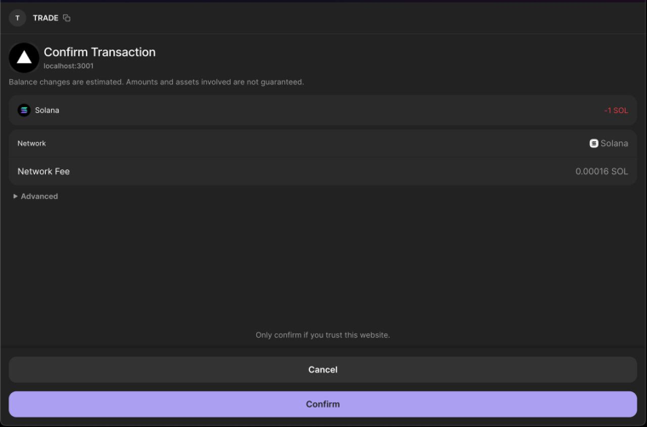  Figure 5: Transaction Confirmation Request | 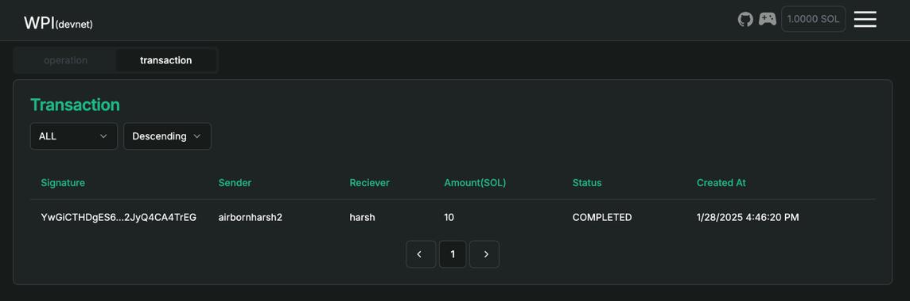  Figure 6: Transaction Shown in Wallet

TESTING METHODOLOGIES
The proposed Secure UPI for Web3 framework is evaluated through a comprehensive testing methodology to verify its functional correctness, performance efficiency, security strength, and practical usability. Since the system integrates multiple components including the user interface, middleware services, UPI infrastructure, and Solana Blockchain network, different levels of testing are performed to ensure that each individual component and the complete system operate reliably under various conditions. The evaluation process includes unit testing, integration testing, performance testing, security testing, user acceptance testing, regression testing, and continuous monitoring.

Unit Testing
Unit testing is performed to verify the correctness of individual modules and functional components of the proposed system. The objective of this testing phase is to identify errors at the component level before integrating the complete framework. The front-end components are tested to validate the correctness of user interface elements such as QR code scanning, payment forms, wallet connection modules, and user input validation mechanisms. The testing process ensures that invalid inputs, incorrect wallet addresses, and boundary conditions are properly handled by the application.
The middleware layer is tested to verify the accuracy of REST API communication, request-response processing, authentication mechanisms, and error-handling procedures. The interaction between UPI services and Blockchain interfaces is validated using simulated API endpoints before deployment in the actual environment. Similarly, smart contract functions deployed on the Solana Blockchain are individually tested to ensure correct execution of operations such as payment initiation, fee distribution, and transaction completion. Special test cases are considered for abnormal situations including insufficient balance, duplicate transaction requests, invalid transaction parameters, and replay attempts.
The front-end testing process can be performed using tools such as Jest and React Testing Library, whereas backend APIs can be tested using Mocha, Chai, and Postman. Blockchain-related functional verification can be carried out using smart contract testing environments and Blockchain development frameworks.

Integration Testing
Integration testing evaluates the interaction between different layers of the proposed architecture. The main objective of this phase is to ensure that independent modules communicate correctly and maintain consistency during transaction processing. The communication between the front-end application and middleware layer is tested by validating the complete payment flow starting from QR code scanning to transaction confirmation. The system verifies whether payment requests are correctly transmitted and whether updated transaction states are reflected on the user interface.
The interaction between the middleware and Solana Blockchain network is also evaluated to ensure proper smart contract invocation, transaction submission, and response handling. The system verifies that Blockchain-generated events, transaction confirmations, and failure responses are correctly interpreted by the middleware layer. Furthermore, UPI integration testing is performed to validate fiat payment processing, transaction synchronization, and handling of delayed or unsuccessful banking transactions.
Tools such as Postman are used for API-level integration testing, while the Solana Testnet environment is utilized for validating Blockchain interactions. Container-based environments such as Docker can be used to simulate integrated UPI and Blockchain services during the testing phase.

Performance Testing
Performance testing is conducted to analyze the ability of the proposed system to process a large number of transactions while maintaining acceptable response time and reliability. Since digital payment applications require real-time processing capability, performance evaluation focuses on transaction throughput, latency, and scalability.
Transaction throughput testing measures the maximum number of transactions that can be processed within a given time period. Different transaction loads are generated to simulate real-world payment scenarios involving multiple users and concurrent requests. Latency measurement evaluates the time required from payment initiation to transaction completion, including QR code processing, wallet communication, Blockchain confirmation, and final status notification.
Scalability testing is performed by gradually increasing the number of simultaneous users and transactions to identify possible performance bottlenecks. The system behavior under high workloads is analyzed to determine whether additional computing resources are required. Load testing tools such as Apache JMeter and Locust can be used to generate traffic, while Solana benchmarking tools are used for Blockchain performance analysis. Monitoring platforms such as Prometheus and Grafana help in observing system response time, resource utilization, and transaction processing statistics.

Security Testing
Security testing is an essential component of the evaluation process because the proposed framework handles financial transactions and sensitive user information. This phase examines the ability of the system to resist possible attacks and ensures that confidentiality, integrity, and authentication mechanisms are properly maintained.
The security of smart contracts is evaluated by analyzing transaction execution logic, access control mechanisms, and fund transfer operations. Vulnerability analysis is performed to detect issues such as unauthorized access, incorrect fee calculation, reentrancy attacks, and transaction manipulation attempts. API security testing is carried out to verify authentication mechanisms, including token-based authentication, and to protect interfaces against common web attacks such as SQL injection, cross-site scripting (XSS), and cross-site request forgery (CSRF).
Data protection testing ensures that sensitive information such as UPI credentials, wallet addresses, and cryptographic keys are securely stored and transmitted. Encryption mechanisms are verified to ensure that data remains protected during storage and communication. Blockchain security testing focuses on preventing double-spending attacks, transaction replay attacks, and unauthorized smart contract execution.
Security analysis can be performed using tools such as Slither and MythX for smart contract auditing, OWASP ZAP and Burp Suite for API security assessment, and cryptographic testing libraries for encryption verification.

User Acceptance Testing (UAT)
User Acceptance Testing is conducted to evaluate the practical usability of the proposed system from the perspective of end users. The objective of this phase is to determine whether the system provides a simple, understandable, and efficient payment experience.
The usability evaluation focuses on the complete transaction workflow, including wallet connection, QR code scanning, payment confirmation, and transaction notification. The system is tested under realistic scenarios such as payments between different Blockchain wallets and merchant-based QR transactions. User feedback is collected regarding interface simplicity, transaction speed, reliability, and overall user experience.
The collected feedback is analyzed to identify usability issues and improve system design. Small groups of users can participate in testing sessions, where their interaction with the application is monitored and reported issues are prioritized for future improvements.

Regression Testing
Regression testing ensures that modifications, bug fixes, or feature enhancements do not affect previously working functionalities of the system. Since Blockchain-based payment systems require continuous updates, regression testing is performed after every major change.
Critical transaction paths such as payment initiation, wallet authentication, smart contract execution, and transaction finalization are repeatedly tested to verify consistent behavior. Previously detected defects are also re-evaluated to confirm that they have been successfully resolved without introducing new errors.
Automation frameworks can be used to reduce repetitive testing effort. Selenium can support front-end regression testing, Cypress can automate integration testing scenarios, and Jenkins can be integrated with CI/CD pipelines for automated test execution.

Continuous Testing and Monitoring
Continuous testing and monitoring are required after deployment to maintain system quality and operational reliability. The deployed system is continuously monitored to analyze transaction success rates, API response time, Blockchain confirmation delays, and unexpected failures.
Real-time monitoring tools are used to detect performance degradation and security issues before they affect users. System logs and performance metrics are collected periodically to support troubleshooting and optimization. A structured issue management process is maintained using bug tracking platforms, allowing developers to record, prioritize, and resolve identified problems.
Tools such as Prometheus and Grafana provide real-time visualization of system performance, while project management platforms such as Jira or Trello can be used for issue tracking and maintenance activities.

Overall Evaluation Summary
The complete testing methodology ensures that the proposed Secure UPI for Web3 framework satisfies essential requirements of a modern digital payment system. Unit testing validates individual components, integration testing verifies communication among layers, performance testing evaluates scalability, security testing protects against attacks, and user acceptance testing measures practical usability. Together, these evaluation phases demonstrate the reliability, efficiency, and security of integrating Solana Blockchain capabilities with the existing UPI payment ecosystem.
PERFORMANCE COMPARISON

This section presents the comparison of the proposed work with Solana integration with the existing UPI with Blockchain approach without Solana integration. Transaction Latency and Transaction Cost are taken as the performance parameters with respect to Transaction Load. Figure 7 shows the effect of increasing transaction volume on the average transaction latency of the existing Blockchain-based UPI system and the proposed Secure UPI-Web3 architecture. In the existing approach, latency increases significantly with transaction load due to limited Blockchain throughput and transaction confirmation overhead. When the transaction count reaches 100,000, the latency increases beyond 34 seconds. The proposed framework maintains lower latency because Solana's Proof-of-History based transaction ordering and high throughput capability reduce processing delays. The proposed model achieves approximately 91% reduction in latency under heavy transaction load compared to without Solana system.
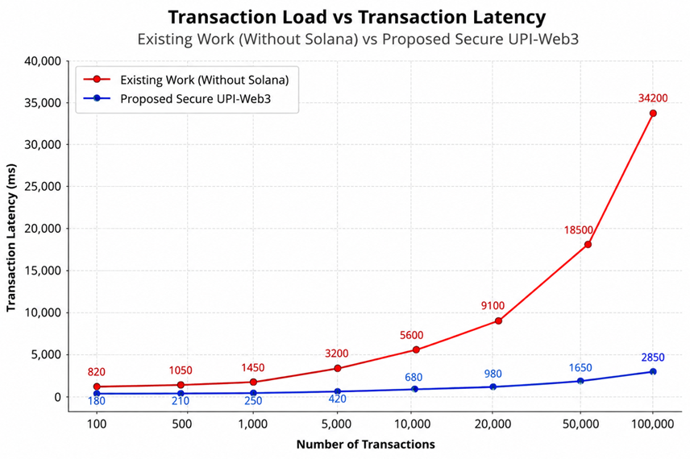
Figure 7: Figure showing the Transaction Latency with respect to Number of Transactions.

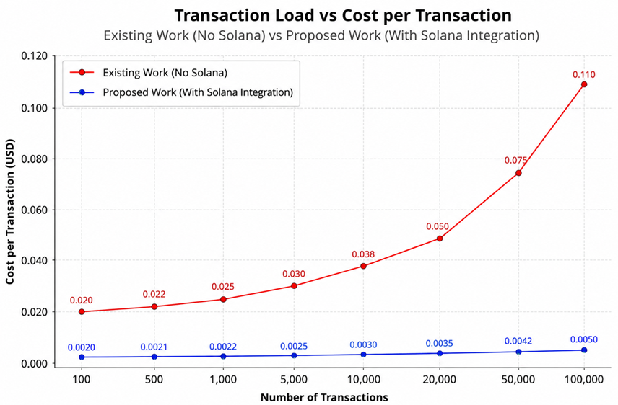
Figure 8: Figure showing the Transaction Costs with respect to Number of Transactions.

The cost analysis as shown in Figure 8 demonstrates that transaction cost increases significantly in existing Blockchain-integrated payment systems without Solana due to higher computational overhead and network congestion. In contrast, the proposed Secure UPI-Web3 architecture maintains consistently low transaction costs even under high transaction loads. This is primarily due to Solana’s low-fee structure and optimized consensus mechanism. At a load of 100,000 transactions, the proposed system reduces transaction cost by approximately 95% compared to the existing approach, making it highly suitable for large-scale real-time payment systems.

CONCLUSION

In this study, we have presented a Secure UPI-Web3 framework that integrates the convenience and widespread adoption of the UPI with the security, transparency, and decentralization offered by Blockchain technology. By using the high-performance capabilities of the Solana Blockchain, our proposed architecture enables secure, low-cost, and scalable digital transactions while maintaining compatibility with existing payment infrastructures. This integration of UPI and Web3 technologies has addressed several limitations of conventional payment systems, such as centralized control, limited transparency, and interoperability challenges. The proposed framework improves transaction security through cryptographic validation and smart contracts while providing users with greater control over their digital assets and payment related activities.

It is observed from the findings that the proposed solution can support efficient real-time payment processing with lower latency and transaction costs as compared to the traditional Blockchain-based approaches. Furthermore, our designed work has the potential to promote broader adoption of decentralized financial services by combining familiar payment mechanisms with emerging Web3 capabilities. To improve the system performance, our future work focus on large-scale deployment, regulatory compliance, cross-chain interoperability, and advanced security mechanisms. Overall, the proposed based on Secure UPI-Web3 model represents a promising step toward the development of a secure, scalable, and user-centric next-generation digital payment ecosystem.

REFERENCES

- Alharby, M., & Van Moorsel, A. (2017). Blockchain-based smart contracts: A systematic mapping study. arXiv preprint arXiv:1710.06372.
- Bhoi, A., Bhuyan, H. B., Nayak, R. P., Balabantaray, R. C., Pattanaik, A., & Chinmay, A. (2025). Smart crisis response leveraging social media content for effective disaster management. Discover Computing, 28(1), 1-25.
- Buterin, V. (2014). A next-generation smart contract and decentralized application platform. white paper, 3(37), 2-1.
- Conti, M., Kumar, E. S., Lal, C., & Ruj, S. (2018). A survey on security and privacy issues of bitcoin. IEEE communications surveys & tutorials, 20(4), 3416-3452.
- Dinh, T. T. A., Wang, J., Chen, G., Liu, R., Ooi, B. C., & Tan, K. L. (2017). Blockbench: A framework for analyzing private Blockchains. In Proceedings of the 2017 ACM international conference on management of data (pp. 1085-1100).
- Ferdous, M. S., Chowdhury, M. J. M., Hoque, M. A., & Colman, A. (2020). Blockchain consensus algorithms: A survey. arXiv preprint arXiv:2001.07091.
- Jena, K. K., Bhoi, S. K., Panda, S. K., & Nayak, R. P. (2025). A novel algorithm for consumer credibility estimation in cloud-internet of things systems. International Journal of Information Technology, 17(8), 4619-4629.
- Kosba, A., Miller, A., Shi, E., Wen, Z., & Papamanthou, C. (2016). Hawk: The Blockchain model of cryptography and privacy-preserving smart contracts. In 2016 IEEE symposium on security and privacy (SP) (pp. 839-858). IEEE.
- Mettler, M. (2016). Blockchain technology in healthcare: The revolution starts here. In 2016 IEEE 18th international conference on e-health networking, applications and services (Healthcom) (pp. 1-3). IEEE.
- Nayak, R. P., Bhoi, S. K., & Bhoi, A. (2025). Blockchain-enabled dynamic toll collection in highway VANETs using distance and weight-based payment with local validation. Computer Networks, 111612.
- Nayak, R. P., Bhoi, S. K., Sahoo, K. S., Sethi, S., Mohapatra, S., & Bhuyan, M. (2025). Unveiling Sybil Attacks Using AI‐Driven Techniques in Software‐Defined Vehicular Networks. Security and Privacy, 8(1), e487.
- Pierro, G. A., & Tonelli, R. (2022). Can solana be the solution to the Blockchain scalability problem?. In 2022 IEEE international conference on software analysis, evolution and reengineering (SANER) (pp. 1219-1226). IEEE.
- Sankritik, A., & Shetty, S. (2025). Digital Public Infrastructure: Setting Standards with the Hourglass Model. Background paper prepared for World Development Report.
- Shreya, K. G., Joshi, A. A., & Kamath, D. (2025, June). Cryptocurrency and UPI Convergence: A Next-Gen Digital Payment System. In 2025 International Conference on Computing Technologies (ICOCT) (pp. 1-7). IEEE.
- Smith, B. (2025). A novel digital payment architecture: A unified payment interface and its systematic transformation of financial infrastructure.
- Tillemann, T. (2022). How Digital Systems Will Transform the Future of Money and Development. Breakthrough: The Promise of Frontier Technologies for Sustainable Development, 181.
- Wood, G. (2014). Ethereum: A secure decentralised generalised transaction ledger. Ethereum project yellow paper, 151(2014),1-32.
- Yakovenko, A. (2018). Solana: A new architecture for a high performance Blockchain v0. 8.13.

