Motion-Activated Garage Door System with Parking Detection and IoT Notification

Abstract
Traffic has been a prevalent issue that has existed since the introduction of automobiles, and many countries face this issue, and one of its root causes is car parking. Improper parking of vehicles more often than not causes congested traffic in urban areas, as it is usually parked on sidewalks that obstruct not only the walkways of pedestrians but also the road that vehicles usually take. Parking garages should be required for every vehicle owner, whether it be a motorcycle or, most importantly, an automobile.
This research paper discusses the process and methods involved in the development of the motion-activated garage door system with parking detection and IoT notification, with a focus on the objectives of improving convenience, safety, and accessibility within homes. The technology used in the design includes an ESP32 microcontroller, an ultrasonic sensor to enable the door to respond to motion, another ultrasonic sensor to detect if there is any parked car inside the garage, a buzzer for sound cues, and a servo motor.

Keywords: Automatic Garage Door System, Arduino Uno, ESP32, Ultrasonic Sensor, Parking Detection, IoT, Blynk, Buzzer, Motion Detection, Embedded Systems, Automation

Introduction
The use of automation is considered to be an integral part of current technological innovations that help operate intelligent systems with little input from humans. An area where automation has shown its worth is garage control; in this regard, automated doors have made it possible to avoid manual opening without any danger associated with errors committed by humans. As highlighted by Orji et al. (2019), automated doors increase the accessibility of elderly people and those with disabilities, and, most importantly, decrease the effort involved in their operation.
With the integration of the IoT, embedded systems have become more capable in home automation. The use of IoT allows users to monitor home systems remotely and get updates on these in real time, thus improving convenience and situational awareness (Gupta et al., 2020). There are software platforms like Blynk that allow easy interfacing between microcontrollers and mobile apps to improve user experience with embedded systems.
Building on previous work done with door automation using ultrasonic sensors, the research presented here introduces new functions that go beyond just opening doors through motion sensing. In particular, the research presents the development of a prototype system with an extra ultrasonic sensor for detecting that a car has been successfully parked in the garage, a buzzer for providing audio feedback, and an ESP32 microcontroller for establishing IoT connections.

Theoretical Framework
This study is grounded in four established theoretical frameworks that collectively explain the operational behavior of the Motion-Activated Garage Door System with Parking Detection and IoT Notification.

Figure 1. Systems Theory
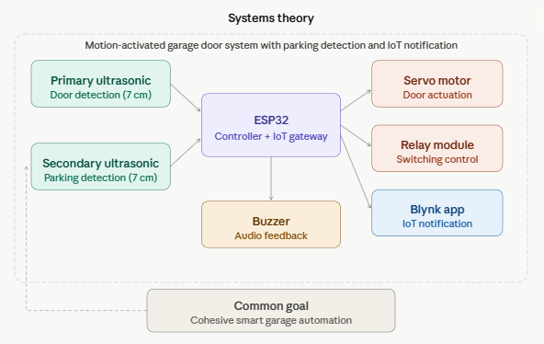

This functional system involves parts that are connected and act together in order to realize a certain purpose. In the current case, all the parts used, which are the HC-SR04 ultrasonic sensors, ESP32 microcontroller, servo motor, relay module, and buzzer, perform different functions but operate in harmony to automate the process of parking in a garage.

Figure 2. Input–Process–Output (IPO) Model

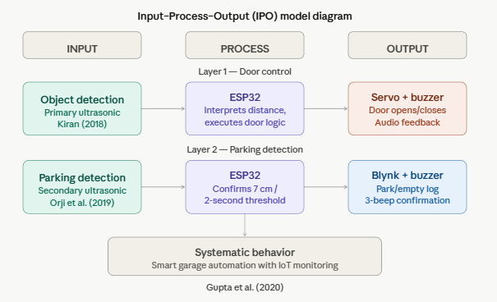

The IPO process describes the flow of the functions within the system at two operational levels. The first operational level involves door operation. In this case, the input for the process comes in the form of object detection using the primary ultrasonic sensor, while the output entails the actuation of the servo motor using a relay and buzzer activation. The second operational level involves parking detection, where the input entails proximity detection using the secondary ultrasonic sensor, while the output involves IoT Blynk logging and the activation of the buzzer for confirmation.

Figure 3. Embedded Systems Theory
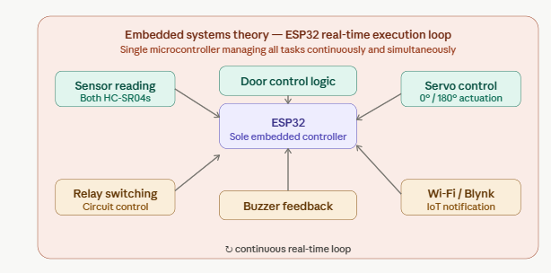
The embedded systems theory talks about the process of performing the allocated tasks by microcontroller-based systems. Here, the task allocation is such that the ESP32 functions alone as an embedded controller for performing the processes involved, which include acquiring data from sensors, implementing control of the door, controlling the buzzer, triggering the relay, and controlling the servo.

Figure 4. Control Systems Theory

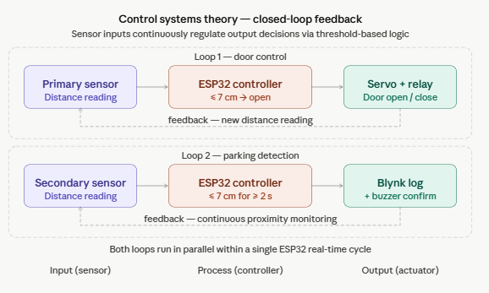

Control System Theory provides an insight into how the system output is controlled using continuous feedback of inputs. The ultrasonic sensors provide the distance information required for motor control and determining if the car has been parked. Using logic involving setting a threshold at 7 cm to trigger the door opening and 7 cm sustained for 2 seconds to ensure parking has taken place ensures precise performance of the system.

Review of Related Literature
The use of ultrasonic sensors for object detection and control of the motor using Arduino in the automated doors has proven to be effective. The research by Orji et al. (2019) shows accurate detection of objects through the use of ultrasonic sensors and reliable door control through servo motor control and Arduino technology. According to Gupta et al. (2020), it is both cost-effective and versatile to implement door control using the Arduino board.

Kiran (2018) explained the concept of motion-activated door control, whereby the use of sensors helps avoid unnecessary door activation and energy waste. Faroqi et al. (2018) further expanded this idea by incorporating SMS notifications into Arduino-based door control technology.

The introduction of the ESP32 chip as a microcontroller has significantly increased opportunities for embedding IoT capabilities in inexpensive devices. Unlike the Arduino Uno, which has no built-in Wi-Fi or Bluetooth functionality, the ESP32 makes the device highly suitable for wireless connection with cloud platforms, such as Blynk. Sahu et al. (2024) have observed that automatic door control using microcontrollers highly benefits from remote monitoring capabilities.

The use of the Blynk IoT development framework in various prototypes has been successful because of the ease with which it promotes the process of integration, the provision of dashboarding using mobiles, and the ability to have event logging and notifications. Together with the ESP32, it enables low-code development for IoT notifications and can be used in learning institutions and home settings.

The inclusion of a buzzer to generate audio alerts adds an element of usability in the proposed system that has not been adequately covered by other scholars. The audio alerts generated on door opening and closing activities and on parking confirmations make the user aware of any activity in the system.

Methodology
In this study, the research method that was used involved a descriptive and experimental approach to designing and testing the proposed motion-activated garage door system with parking detection and IoT notification. This project involved the use of an ESP32 (ESPRESSIF ESP-WROOM-32) microcontroller, which would act as the main
brain and the Internet of Things communication interface of the system; an ultrasonic sensor HC-SR04 for object and distance detection purposes; a servo motor to mimic the action of opening and closing a garage door; a relay module (JQC-3FF-S-Z, 5VDC); and a buzzer.

System Architecture
The system implementation is based on a single ESP32 microcontroller capable of carrying out tasks such as sensing, actuation, audio, and IoT communication simultaneously. This arrangement allows a combination of the above two arrangements on a single microcontroller by making use of the integrated WiFi functionality and adequate GPIOs.
For the door control, constant distance measurement is carried out using the HC-SR04 ultrasonic sensor. In case there is an object at less than 7 cm, the ESP32 controls the relay circuit to actuate the door opener mechanism and the rotation of the servo motor up to 160° (opening door process), while the buzzer sounds during actuation. When the object moves outside this distance range, the door shuts down, and the buzzer sounds, indicating the process.
For parking detection, you can use a single sensor or another one that would detect the presence of an object inside the garage. Upon the continuous presence of the car object for more than three seconds at a distance of 7 cm, the ESP32 operates the buzzer twice and sends the "Park Successfully" message to the Blynk IoT app through Wi-Fi. If there is no detected object at the threshold, the message "Garage Empty" is logged onto the Blynk dashboard.

Hardware Components and Wiring
- HC-SR04 Ultrasonic Sensor—Connected with the ESP32 board using VCC (5V), GND, TRIG (digital output), and ECHO (digital input) pins. The sensor sends out ultrasonic waves and detects the returning echo waves to determine the real-time object distance.
- Servo Motor – Connected to one of the digital pins on the ESP32 board that has PWM capabilities, sharing common voltage connections (VCC and ground) with the ESP32. The servo will rotate the motor shaft from 70 degrees (closed state) to 160 degrees (open state) based on sensor input data.
- Relay Module (JQC-3FF-S-Z, 5VDC/10A 250VAC) – Connected to the ESP32 board via a digital pin for controlling the relay module. The relay acts as an electric switch that controls larger circuit elements in the system controlled via the digital signal output by the ESP32.
- Buzzer – Connected to one of the digital pins on the ESP32 board with a common ground terminal. The buzzer is controlled when the door opens, producing three beeps in case of parking validation.
- ESP32 (ESPRESSIF ESP-WROOM-32) – Used as the main microcontroller and IoT hub in the system. It handles sensor operations, relay actions, servo operations, buzzer sound control, and communication with the Blynk app.

Development Phases
The functional needs were identified during the requirement analysis as follows: ultrasonic sensor for object detection and door trigger, secondary proximity sensing for parking confirmation, relay switching assistance, servo action to move the door, buzzer feedback, and notification to the Blynk app via ESP32.
During the system design process, component functions were described, and hardware connections were planned based on the circuit schematic. A flowchart depicting the system control was designed by specifying how the ultrasonic sensor would regulate the output signals of the relay, the servo, and the buzzer, as well as Blynk communication managed by ESP32.
Implementation included writing firmware and running it on ESP32, putting together the components and connecting them following the circuit schematic, and configuring the Blynk dashboard for two event logging widgets with "Successfully Parked" and "Auto Close" labels, respectively.
The testing and validation procedure ensured that ultrasonic sensor detection is precise, relay and servo actuations are reliable, the buzzer sounds correct, the parking sensing operation within 2 seconds works as intended, and Blynk notifications arrive while the Wi-Fi connection is stable.

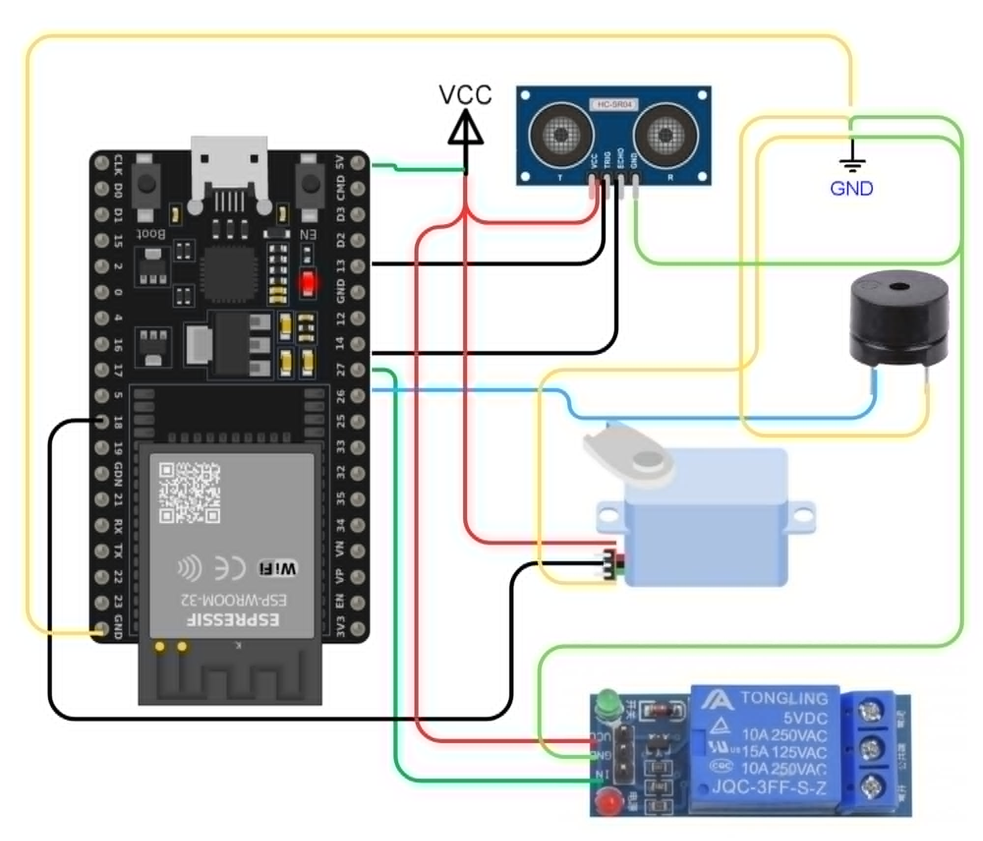
Schematic Diagram

The schematic diagram shows the entire wiring layout of the motion-activated garage door with parking detection and an IoT notifications system. The core of this project consists of the ESP32 microcontroller, which acts as the main controller to which all other parts are connected. The HC-SR04 ultrasonic sensor is connected through its trig and echo terminals, allowing distance calculation for both door opening and parking purposes. The servo motor is connected through the general-purpose input/output terminal, having pulse width modulation functionality. It moves the simulated door from 70° to 160°. The relay is connected to a digital pin and enables switching control of the circuits. The buzzer is connected to another digital output pin and offers audio notifications while opening the door or when detecting a parking spot.

RESULTS & DISCUSSION
Observations, Analysis & Interpretation
In general, the developed system was able to perform all the necessary functions. First, the primary ultrasonic sensor successfully detected objects closer than 7 cm, triggering the servo motor to open the garage door and the buzzer to emit audible signals during the process. Next, once the object was moved away, the door returned to its initial state, and the buzzer signaled the closing of the door. Moreover, the secondary ultrasonic sensor accurately registered a vehicle as parked once it remained within seven cm of the sensor for two seconds, producing three beeps and sending a "Successful Park" notification to the Blynk application. System logs were recorded with date and time stamps through Network Time Protocol (NTP) synchronization and displayed in the Blynk application for monitoring purposes. The Blynk application also allowed manual remote opening and closing of the garage door through virtual buttons, providing users with additional control and convenience. Finally, when no object was detected within the specified range, the system registered "Garage Empty" in Blynk. When the garage became empty, the system waited for three seconds before automatically closing the garage door to prevent premature closing caused by temporary sensor fluctuations, thereby improving the reliability and automation of the system.

Overall, the servo motor consistently operated at the specified angles, the relay module effectively controlled the power supplied to the servo motor, and the buzzer functioned properly as an audible notification device. In addition, notifications and status updates were successfully transmitted to the Blynk application through the Wi-Fi connection with no significant delay under normal network conditions. The 2-second parking verification period and the three-second automatic door-closing delay helped prevent erroneous actions caused by temporary sensor readings and environmental disturbances, resulting in more stable system performance.

Nonetheless, some limitations were observed during testing. Servo motor glitching occasionally occurred due to unstable power connections, particularly when the power supply was insufficient or inconsistent. Furthermore, delayed Blynk notifications were experienced under weak Wi-Fi signal conditions. Despite these limitations, the system was able to perform its intended functions effectively and demonstrated the feasibility of integrating automation, parking detection, remote monitoring, and IoT-based control within a smart garage door system.

Table 1. System Components, Variables, and Conditions
Variable / Component | Type | Parameter | Condition / Range | System Response
Primary Ultrasonic Sensor (HC-SR04) | Input | Distance to approaching object: | 0–7 cm / > 7 cm | Triggers the door to open or close
Secondary Ultrasonic Sensor (HC-SR04) | Input | Distance to parked vehicle | ≤ 7 cm for ≥ 2 s / > 7 cm | Triggers park confirmation or empty log
Servo Motor | Output | Angular position | 70° (Closed) / 160° (Open) | Opens/closes garage door
Relay Module (JQC-3FF-S-Z, 5VDC) | Output | Power switching | Activate during door movement/  deactivate when the door reaches the target position | Controls power supply to the servo motor, disconnecting power when idle to reduce unnecessary consumption.
Buzzer | Output | Audio alert | Door open/close, successful park detection | Produces an audible notification pattern to indicate system status
ESP32 | Controller + IoT Gateway | IoT transmission | Continuous real-time operation | Process all sensor inputs and outputs and send logs to the Blynk application
9V Li-ion battery and Buck  Converter | Input | Power Regulation | 9V DC input,  5V DV output | Provides regulated power for the ESP32, servo motor, relay module, ultrasonic sensor, and buzzer

Table 2. Test Results
Test # | Input Condition | Observed Output | Expected Output | Pass / Fail | Remarks
1 | No object within 7 cm | Servo at 70°, no buzzer | The door remains closed | Pass | Correct idle state
2 | Object placed within 7 cm | Buzzer sounds, servo → 160° | The door opens with audio feedback | Pass | Proper detection and actuation
3 | Object removed from range | Buzzer sounds, servo → 70° | The door closes with audio feedback | Pass | Correct closing behavior
4 | Toy car within 7 cm for 3 s | The buzzer sounds twice, and Blynk logs "Successful Park." | Park confirmation and IoT log | Pass | Parking detection confirmed
5 | No car inside the garage | Blynk logs "Auto Close." | Empty state notification | Pass | Correct empty state logging
6 | Object briefly within 7 cm (< 3 s) | No park confirmation triggered | No false positive | Pass | The 2-second window prevents a false trigger
7 | Continuous object presence at the door | The door remains open; no repeated servo commands | Stable open state | Pass | Logic prevents repeated commands
8 | Loose wiring on the servo line | Erratic servo movement | Stable movement | Fail | Resolved by securing the wiring
9 | Fluctuating power supply | Servo stops early, glitches | Full 180° rotation | Fail | Resolved by stabilizing power
10 | Weak Wi-Fi signal | Delayed Blynk notification | Immediate notification | Fail | Stable Wi-Fi required for consistent delivery
11 | Stable wiring and power, good Wi-Fi | All functions perform correctly | Full system operation | Pass | All issues resolved; system meets objectives

From the experiments above, it is evident that the proposed design can easily incorporate various functionalities such as motion-activated door controls, audio alerts, parking sensors, and IoT notifications into an embedded system design. The consistent performance of the ESP32 microcontroller, ultrasonic sensors, servo motor, relay module, and Blynk IoT platform confirms the effectiveness of the proposed motion-activated garage door system. These observations agree with previous literature regarding automation and embedded designs incorporating ultrasonic sensors and IoT technologies.

CONCLUSION
This research explores the design and development of the motion-activated garage door system that incorporates parking detection and IoT notifications. The system uses one ESP32 microcontroller, which acts as both an embedded controller and an IoT gateway. Hardware components used in this design include the HC-SR04 ultrasonic sensor to detect the object proximity for activation, another ultrasonic sensor to sense parking inside the garage, a servo motor to open the door, a relay to perform switch operations, and a buzzer for audio notifications. In terms of operation, the system offers reliable automatic opening of the door based on object detection and contextual audio notifications during the process and on parking. The system provides reliable parking detection using a 7 cm threshold maintained for 2 seconds and with a short delay to prevent premature closing due to sensor fluctuations it automatically closes the garage door when the parking area is detected to be empty, enhancing operational efficiency, convenience, and system automation.
Testing carried out in a controlled environment showed that the design met all functional requirements. Small problems such as servo glitches, power instabilities, and Wi-Fi signal dependency were sorted out by implementing better wiring techniques, ground connections, logic improvement, and creating an environment that would have a good network setup. Integrating all functionalities on a single ESP32 device proved how efficient the design is in meeting the functional requirements of the prototype despite simplifying the entire hardware design.
In addition to fulfilling the intended functionalities, the system has potential applications for academic purposes for exploring various technical skills. In particular, the project can serve as a learning tool in studying sensors, communication between microcontrollers, IoT connectivity, and embedded system design.

RECOMMENDATIONS
Directions for future research may involve the following improvements. For instance, an external regulated power source should be used instead of the battery for powering the servo motor in order to prevent glitches that occur as a result of voltage drops when the motor moves. The parking detection algorithm may be upgraded with the introduction of PIR and infrared detectors in addition to the existing ultrasonic sensor in order to increase reliability regardless of the size of a particular vehicle and the surface it stands on. Testing with the real garage door operation system, as opposed to a model, will offer a better evaluation of the results.
The security aspect may be developed with the incorporation of additional modules like unauthorized user entrance detection, PIN verification, access control, or even a camera module that is available for the ESP32-CAM variant. Blynk app integration might be further improved with the ability to receive push notifications, including time stamps, keep logs of the presence of cars in the garage, and remotely operate the garage door using the smartphone application. Lastly, future research may explore implementing a two-sensor detection method, divided into approaching and parked areas, and possibly optimization of the ESP32 code for faster response.

ACKNOWLEDGEMENT
The researchers would like to express their sincere appreciation to Prof. Engr. Jose C. Felipe Jr., who provided guidance and oversight throughout the duration of this project. His role in establishing project requirements and ensuring its proper completion was instrumental to the success of this study.
The researchers also extend their gratitude to the Computer Engineering Department of Eulogio “Amang” Rodriguez Institute of Science and Technology for providing the academic support, technical instruction, and resources necessary for the completion of this project.
Heartfelt thanks are extended to the researchers' families, classmates, and peers for their continued encouragement and support. Above all, the researchers give thanks to God Almighty for the strength and perseverance to complete this work.

REFERENCES
- Faroqi, A., Fitriadi, A., Adiningsih, N. U., & Ramdhani, M. A. (2018). Automatic door control system using SMS gateway based on Arduino Uno and ultrasonic sensor. International Journal of Engineering and Technology, 7(3.4), 122–126.
- Gupta, A., Sharma, R., Verma, S., & Singh, P. (2020). Design analysis of an automatic garage door opener. International Journal of Trend in Scientific Research and Development. https://www.ijtsrd.com/papers/ijtsrd31118.pdf
- Imania, S. N., Ghofur, A., & Lazim, F. (2024). Arduino-based automatic door opening and closing prototype design using ultrasonic sensors. G-Tech: Jurnal Teknologi Terapan, 8(3), 1386–1395.
- Kiran, B. (2018). Motion-based automatic garage door opener. International Journal of Engineering Technology and Applied Science, 5(2).
- Orji, R. O., Oleka, C. V., & Nduanya, U. C. (2019). Arduino-based door automation system using an ultrasonic sensor and servo motor. Journal of Scientific and Engineering Research.
- Sahu et al. (2024). Automatic door control systems with Arduino microcontrollers. IJSART, V10I3.
- Sharma, V., Patel, A., & Mehta, R. (2024). Object tracking system using Arduino and an ultrasonic sensor. ResearchGate.
- Susilo, S., Listijorini, E., Ardiansyah, F., & Ula, S. U. (2023). Design of an automatic sliding door based on Arduino using ultrasonic sensors. DINAMIS, 11(1), 43–47.
- Suryawanshi, R., Thosar, A., Singh, A., & Mehendale, N. (2024). Object detection system using Arduino and an ultrasonic sensor. SSRN. https://papers.ssrn.com/sol3/papers.cfm?abstract_id=5009923
- Madhavi, A., Uniyal, D., Jula, A., Sri, T., Vadlapatla, S., & Bonam, J. N. (2023). Smart parking assistant: Integrating ultrasonic sensors and IoT for enhanced driver experience. E3S Web of Conferences. https://doi.org/10.1051/e3sconf/202339101143
- Geetha, M. (2020). IoT-based car parking using Arduino and the Blynk application. International Journal for Research in Applied Science and Engineering Technology. https://doi.org/10.22214/ijraset.2020.6119
- Rudi, R., Dinata, I., & Kurniawan, R. (2017). Rancang bangun prototipe sistem parkir pintar berbasis IoT.
- Aziz, F. A. A., Muji, S. Z. M., Wahab, M. H. A., Tukiran, Z., Uttrapan, C., & Sudin, N. (2022). Smart parking system mobile application using an ultrasonic detector. International Journal of Integrated Engineering. https://doi.org/10.30880/ijie.2022.14.03.008

ABOUT THE AUTHORS
Clement Allen B. Comia is a Computer Engineering student at Eulogio “Amang” Rodriguez Institute of Science and Technology (EARIST). He has a strong interest in software design, programming, and the development of technology-driven solutions. He continuously seeks opportunities to expand his technical knowledge and apply engineering principles in creating innovative systems that address practical challenges.
Kianne Mari R. Animas is a Computer Engineering student at Eulogio “Amang” Rodriguez Institute of Science and Technology (EARIST). He is passionate about innovation, technology integration, and software development. Through academic and project-based activities, he continues to strengthen his abilities in designing systems that provide practical and effective solutions to real-world needs.
Mykhael Giann L. Sarmiento is a Computer Engineering student at Eulogio “Amang” Rodriguez Institute of Science and Technology (EARIST). His interests include software development, system design, and emerging technologies. He is committed to enhancing his skills in programming and problem-solving while contributing to projects that promote efficiency and technological advancement.
Cedrick O. Dalisay is a Computer Engineering student at Eulogio “Amang” Rodriguez Institute of Science and Technology (EARIST). He is particularly interested in embedded systems, automation, and software engineering. His goal is to utilize modern technologies to develop reliable and efficient solutions that can improve everyday processes and user experiences.
Shane Kian G. Murillo is a Computer Engineering student at Eulogio “Amang” Rodriguez Institute of Science and Technology (EARIST). He is dedicated to exploring innovative technologies and enhancing his expertise in programming, system development, and automation. He strives to create impactful technological solutions that contribute to the advancement of society and industry.
Engr. Jose C. Felipe Jr. is an instructor in the Computer Engineering Department of Eulogio “Amang” Rodriguez Institute of Science and Technology (EARIST). He provides guidance and mentorship in the fields of software development, embedded systems, and engineering design. Through his academic leadership and technical expertise, he supports students in conducting research, developing innovative projects, and strengthening their professional competencies in engineering and technology.

