The Connection between Human Resource Practices, Trust, and Performance in Higher Education Institutions

Abstract
The purpose of the study was to examine the relationship between trust and human resource practices in the performance of academic faculty within higher education institutions in Zambia. Using a survey design, 43 HEA-accredited HEIs participated, with 267 valid responses from 311 distributed questionnaires, yielding a strong response rate of 89%. The sample consisted of randomly selected 145 participants from public HEIs and 131 from private HEIs. Based on the pilot test results, no significant changes were made to the research instrument.
The collected data were analyzed using Smart PLS-SEM software to assess the correlations between individual and organizational trust and HR practices, with particular attention to performance indicators such as employee commitment, engagement, productivity, and effectiveness.
The findings indicate that trust is a crucial yet underutilized factor in the implementation of HR practices within Zambian HEIs, contributing to weakened employee confidence and, in turn, suboptimal performance. These findings validate the strategy of fostering trust through targeted HR practices as an effective approach to improving performance. Additionally, the study's multi-group analysis revealed no significant differences, suggesting that trust-performance dynamics are universal across Zambian HEIs. An important benefit for HR practices will be for HEIs’ recognition of the need to go beyond the personnel functions, which tend to solve functional tasks, to modern HRM concepts that are strategic and focus on the development of an entire organization and the potential of employees based on trust rather than control.
Keywords: Trust, HR Practices, HEIs, Employee Performance.
1. Introduction and Background
Higher education transcends mere knowledge dissemination; it encompasses the holistic development of individuals and requires both care and courtesy. Higher Education Institutions (HEIs) play a pivotal role in fostering the sustainable development of societies, with their influence recognized as surpassing that of any other singular sector (Dziminska et al., 2018). This influence is predicated on the trust and quality services rendered by HEIs, and cultivating trust within these institutions demands a degree of vulnerability from all stakeholders (Tse, 2023).
Organizational trust pertains to employees aligning themselves with the organization and being willing to cultivate enduring relationships with it. It involves employees assessing and aligning with organizational policies and being prepared to make themselves vulnerable in work-related situations (Robinson, 1996). Additionally, organizational trust is subsumed under the broader concept of institutional trust, encompassing confidence in both supervisors and the organization as a cohesive entity. When employees have profound trust in their organization, they not only exhibit a willingness to embrace its inherent risks but also demonstrate a greater capacity to discern potential hazards (Eckel, 2006). Individuals with a heightened sense of organizational trust are more likely to engage in reciprocal behaviors toward their organization than those with minimal organizational trust.
Performance has been identified as a foundational element of organizational success, and an expanding corpus of research substantiates the correlation between trust and performance. As HEIs endeavor to attain success, it is imperative for leaders, in conjunction with human resources departments to critically assess the value placed on employee performance. Neglecting to prioritize trust in these domains can lead to detrimental consequences, including diminished engagement and productivity, increased turnover, and adverse effects on morale and cohesion.
Organizations strive to avoid detrimental relationships, as they adversely affect motivation and, consequently, productivity; as Golembiewsky & McConkie (1975) observed, few variables influence interpersonal and group behavior as profoundly as trust. At the core of employment relations resides the mutual aspiration of management and employees to cultivate an exemplary, efficient, and effective organization grounded in mutual respect and trust. Employee relations unfold within a dynamic milieu that requires proficient leadership and human resource management to mitigate detrimental factors such as distrust, which obstruct the attainment of an exemplary, efficient, and effective organization.
Objectives of the study:
- To clarify the impact of human resource practices on the development of trust within both public and private universities in Zambia;
- To evaluate the effect of trust on employee performance in these educational establishments; and
- To investigate whether trust mediates the interplay between human resource practices and performance.
Mayer et al. (1995) defined trust as the willingness of a party to be vulnerable to the actions of another party based on the expectation that the other party will perform a particular action important to the trustor, irrespective of the ability to monitor that other party, which has become widely accepted by scholars on trust. McAllister (1995) defined trust as having two aspects: cognition-based trust – rooted in knowledge and rationality, such as the trustor's competence, accountability, reliability, dependability, and steadfastness; affect-based trust – founded on emotional connections between individuals, encompassing care, empathy, and allegiance; a belief in the inherent value of such a bond, and the assurance of mutual sentiments. McAllister posits that a baseline level of cognition-based trust is essential for the realization of effective relationships.
Trust is measurable. Cummings and Bromily (1996) devised the Organisational Trust Inventory to assess individuals' trust in organizations based on criteria such as adherence to commitments, honesty, and absence of exploitative behaviors. Butler (1991) formulated a Conditions of Trust Inventory comprising ten elements essential for fostering and sustaining trust, including availability, competence, consistency, fairness, integrity, loyalty, openness, overall trust, promise fulfillment, and receptivity (Rawlins, 2007). Cook & Hall (1980) developed a scale to assess trust in managers and colleagues, comprising 12 statements reflecting perceptions of coworkers' and superiors' reliability and trustworthiness in the workplace. Given the multifaceted nature of trust, this study examined its association with human resources management practices and employee performance within higher education institutions (HEIs).
2. Review of Literature
Although trust is crucial in the workplace, it is under-researched in higher education. (Gratz & Looney, 2025; Mushi et al., 2020; Niedlich et al., 2021; Jameson et al., 2023; Mahdinezhad et al., 2018). Moore (2024) argues that low trust causes inefficiencies in academia, such as bureaucracy, decision delays, faculty turnover, and student disengagement. High trust minimizes oversight, boosts collaboration, and enhances academic progress. Lewicka (2022) noted that trust-building in HEIs is a new issue, overshadowed by teaching quality and learning outcomes.
A comprehensive review of the principal body of research on trust over the past quarter-century from an evolutionary standpoint by Dirks & de Jong (2022) examined the findings and implications of the research on trust in leadership and identified two distinct waves that have shaped and advanced this concept. The inaugural wave laid the groundwork, while the subsequent wave interrogated prevailing assumptions and explored alternative perspectives. A third wave is anticipated, focusing on the implications of the first and second waves for workplace trust, which is the intended contribution of this study.
Akar’s (2018) meta-analysis of organizational trust in educational institutions from 2008 to 2018 synthesized findings on trust, support, citizenship, justice, commitment, mobbing, silence, satisfaction, cynicism, and leadership. Akar (2018) found that organizational justice, support, ethical leadership, and mobbing significantly affect trust perceptions among educational employees. In addition, perceptions of trust affect commitment, citizenship behaviors, motivation, satisfaction, and cynicism. Therefore, educational leaders should adhere to ethical principles and provide training in human resource management and ethics.
In Africa, higher education has expanded, with the number of universities increasing from 294 in 1980 to 1,682 in 2018, yet Africa's global representation is only 8.9%. Zeleza (2021) argued that fostering social trust and productive cultures in HEIs requires upholding academic freedom, shared governance, equity, civility, communication, and social responsibility. Lewin (2024) noted that trust in South African HEIs has declined due to high unemployment and systemic inequities. The TrustAfrica (2022) dialogue emphasized policy inconsistencies as a key factor eroding trust in African HEIs.
2.1 HR Practices and Trust
The interest of this study lies not in the HR practices themselves, but in the relationship between trust and the openness, fairness, and equity of these practices, and their association with the outcomes of employee commitment, engagement, productivity, and effectiveness (Figure 1). Openness in HR practices involves, for instance, open communication with employees regarding organisational strategy, and using the practices to foster trust and respect for overall engagement. Hainess et al. (2024), in a study of the fairness of HRM practices posit that this is an aspect that is often overlooked, despite being an inescapable concern. Results revealed that justice sensitivity was positively associated with subsequent assessments of the justice content of HR practices. An implication for this is that research should consider how systems of HR practices may best enhance fairness perceptions by providing clear and consistent rules and procedures for the collective (Hainess et al., 2024). Fair – According to Beugre (1998), organisational fairness (justice) is comprised of four categories: a) Distributive - the degree to which the outcomes received from the organisation are perceived to be fair; b) Procedural (Thibaut & Walker, 1975) - the degree to which fair decision-making procedures are used to arrive at a decision; involving processes, systems, and practices; c) Interactional - the degree to which people are treated with respect, kindness, and dignity in interpersonal reactions; and d) Systematic (or systemic) - which essentially aims to dismantle and rebuild systems to ensure equitable outcomes for all, moving beyond individual cases of unfairness to address the root causes of inequity. Equitable – Deutsch (1975) defined the principle of equity as the allocation of benefits according to effort. Going back to Adam’s (1963) Equity Theory, when employees make comparisons between efforts and rewards, and perceive there to be unfairness, injustice, or inequity in HR practices, they will react negatively through, for instance, reduced motivation, commitment, and performance (Dzansi, 2016), which all imply a lack of trust.
The link between HR practices and employee trust and attitudes is grounded in social exchange aimed at improving skills and knowledge will be reciprocated by employees in terms of positive attitudes and behaviors (Innocent et al, (2011), depicted in Figure 1. Reciprocity has a downside: distrustful acts can negate positive attitudes toward the organization. Leaders perform strategic functions like resource allocation, HR practices, and communication of organizational goals, Dirks & Ferrin (2002). HR managers should raise awareness of building trust cycles using HRM practices and their effects on commitment and performance (Nishanthi & Kulathunga, 2018). Guest and Conway (1999) state that trust explains how HR practices affect employee attitudes, aligning with the social exchange principle in the employment contract.
HR Practices Outcomes: Positive Attitudes
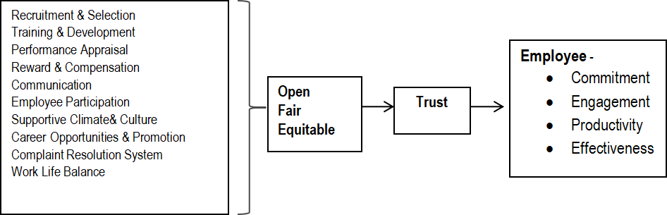
Figure 1. Outcomes of HR Practices Source: Adapted from Maurya & Chatterjee, 2018
Delery and Doty (1996) defined HR practices as theoretically linked to overall organizational performance. A study by Botwe et al (2016) outlined trust dimensions in HR practices as depicted in Figure 2. Findings showed that low trust in management due to dictatorial behavior led to low employee motivation, commitment, and engagement across all performance levels.
Whitener (2002) states that HR activities affect employee trust and calls for more research on trust-building and performance improvement. Mayrhofer et al. (2019) noted that many studies focus on the link between HRM and performance. Based on trust dimensions in Figure 3, organizations use HR practices like training, motivation, merit-based rewards, and fair compensation to develop employee skills. Involving employees in decision-making and sharing views enhances perceptions of transparency and fairness, strengthening trust. Findings by Barney & Hansen (1994) suggest that high internal trust is relatively rare and notoriously difficult for HR practitioners to reproduce; however, when achieved, it can serve as a durable competitive advantage. Accordingly, HR managers should regard trust as a strategic imperative—actively cultivating and reinforcing it to bolster overall organizational performance.
The HRM system should, therefore, be anchored in a framework of exemplary practices to secure its effectiveness; and if HRM is treated as a discipline, HR practices constitute its fundamental building blocks, enabling not only the management of employees but also strengthening organizational integration, nurturing employee commitment, enhancing organizational agility, and elevating the overall quality of work (Guest, 1987).
Human resource management systematically shapes organizational performance and refines organizational processes by cultivating trust—thereby motivating employees to perform at higher levels. Collectively, these elements provide a solid platform for extending research beyond European, Asian, and American contexts. Furthermore, they reinforce HR-led trust-building initiatives, highlight the strategic importance of HR practices, and provide persuasive evidence of improvements in HR performance.
2.2 HR Practices and Trust in HEIs
A study in the USA by Hancock et al (2022) noted that HEIs face governance structures that limit HR to processes, compliance, and administration, neglecting strategic activities. The study argues that there is a misalignment between HR and the university, worsened by bureaucratic processes that frustrate academic staff. Human resource practices are crucial for HEIs due to their link to performance and trust.
Boslu (2018) in India reported that employees may cultivate negative attitudes toward HR practices, expressing uncertainty about whether HR primarily serves organizational interests or employees’ needs. In Oman, Hinai & Bajracharya (2014) identified a positive association between job satisfaction and HR practices among academic staff across both the government and private sectors. In contrast, Agabekova & Kaptoyeva (2021) argued that universities in Kazakhstan often disregard core HRM challenges, thereby fostering a predominantly bureaucratic disposition. As a result, academic staff—whose contributions are indispensable for institutional development and competitiveness—remain comparatively under-recognized.
In East Africa, Ssemugeny et al. (2020) found that HR functions often fail to meaningfully affect academic performance, with HR practices proving unable to effectively develop, nurture, or retain staff. Their findings further suggest that, notwithstanding substantial investments, HRD initiatives do not translate into improved academic outcomes. Rono (2015) reported a rise in labor strikes across East Africa, attributing this to the absence of equitable HR policies. Tolly et al. (2012) noted limited recognition of the HR function in Tanzanian higher education institutions, underscoring the need for structured training for HR officers. Taken together, these trends resonate across the African continent and point to the necessity of examining how employees perceive HR practices in Zambia. Overall, HR practices play a crucial role in meeting academic staff expectations in HEIs.
3. Trust and Performance Outcomes
Performance outcomes are depicted in Figure 1. Employee engagement is a fulfilling, work-related state of mind characterized by vigor, dedication, and absorption. Employee engagement measures employees' involvement in their work and the organization. Employee engagement boosts productivity, lowers costs, and correlates with better customer ratings and lower turnover. In Uganda, Nanteza et al. (2023) reported low work engagement among academic staff in sub-Saharan Africa, citing absenteeism, tardiness, strike time wastage, lack of lecture planning, poor exam marking, plagiarism, and low research dedication. Employee commitment reflects attachment to the organization and can be assessed through their career aspirations and views on workplace quality. Commitment’s link to performance can be measured by turnover rates, productivity, or absenteeism. Employee commitment connects trust in management to achieving institutional goals, with trust being a foundational (Alshamary, 2025). Employee productivity and effectiveness are interconnected. Employers must foster a trust-based positive work environment and prioritize policies that strengthen emotional ties to organizational goals (Gimeno et al., 2025).
Robbins and Judge (2008) state that employee performance results from the interaction between ability and motivation; inadequacy in either factor negatively affects performance. HR managers must create conditions that maximize performance by valuing jobs, selecting capable individuals, clarifying expectations, and providing the necessary training (Kirkpatrick, 2006). These conditions foster trust as employees feel valued.
Underpinned by the mediating association with trust, this study delineates the indicators for evaluating the performance outcomes of academic staff in HEIs as employee commitment, engagement, productivity, and effectiveness.
4. Theoretical Review
The Social Exchange Theory (SET) is an applicable model for explaining the relationship between trust, and HR practices, and how these variables are associated with performance. The basis of SET is the premise that social interaction is an exchange activity, tangible and intangible, particularly of rewards and costs (Homans, 1961). Studies have pointed out that trust is gradually formed in the process of social exchange between two parties (e.g. and employee and an organization) if one party provides benefits to the other. Inherently, this relationship carries an obligation to respond by providing something beneficial in return; i.e., The norm of reciprocity dictates that we help those who help us (Goulder, 1960). This norm establishes the managerial expectation that recognition, empowerment, investment in employees and other favors will be reciprocated.
The study found it appropriate to use social exchange theory to explain the relationship between HR practices and trust, and its association with performance in higher education institutions. Trust in leadership, which is based more on the outcomes of organisational decisions, necessarily involves the inclusion of HR practices in employee relations, as they represent relationships and interactions between an employer and an employee in an organization.
Equity Theory: Other than reciprocity being central to SET, it also holds significant relevance within the framework of Equity Theory (ET). Individuals derive satisfaction in scenarios where they perceive the benefits received from their relationships to be commensurate with their contributions. ET scrutinizes how individuals assess social exchange relationships through the lens of the input-outcome ratio, predicated on three fundamental assumptions: a) individuals cultivate beliefs regarding what constitutes a fair and equitable return for their efforts; b) individuals invariably compare their perceived exchanges with those of their peers; c) when individuals perceive their own treatment as inequitable relative to the exchanges they observe others making, they are propelled to take actions they consider appropriate (Carrell, 1978). As with SET, when an organization demonstrates fairness in addressing issues, it can cultivate trust in management, alleviate fears of potential mistreatment, and foster collaboration (Colquitt et al., 2005). Equity within the organization is intricately linked to employees’ physical and psychological well-being, whereas inequity engenders stress and pressure in the workplace (Judge and Colquitt, 2004).
In the realm of higher education, equity should compel institutions to adhere to their professed principles of merit, diversity, inclusivity, and opportunity, thereby fostering trust and enhancing performance. A pivotal aspect of leadership and human resource practices is to ensure that justice, fair play, and equity are prioritized above all else when addressing educational resources and personnel. Equity theory will be pertinent to conceptualizing the study's investigation of the interplay among leadership, human resource practices, and trust, and their collective impact on performance within higher education institutions.
Influence of Theories on HR Practices, Trust, and Performance
SET and ET facilitate the conceptualization of the study, enhance comprehension of the intricate relationships among human resource activities, foster greater trust, and architect human resource initiatives to cultivate trust and augment performance. Equity Theory posits that employees endeavor to sustain a balance between the contributions they offer to their roles—such as education, time, experience, commitment, and effort—and the rewards they receive—such as promotions, recognition, and increased remuneration—relative to the perceived contributions and rewards of their peers. In the context of higher education, Equity Theory encompasses two fundamental components: fairness, which suggests that personal and social circumstances should not hinder the realization of educational potential; and inclusion, which asserts that all individuals should have the opportunity to achieve a fundamental standard of education (Amaral, 2022).
Concurrently, numerous theories of trust are rooted in Social Exchange Theory, which suggests that trust is cultivated through the recurring exchange of benefits among parties. This norm of reciprocity creates expectations that recognition, empowerment, and investment in human capital will be reciprocated. It is crucial for organizational HR practices to acknowledge that reciprocity can have detrimental aspects; for instance, the anticipation of hostility, fear, insincerity, and distrust will likely be reciprocated. Employees tend to develop skepticism toward HR practices that appear to undermine their trust or foster distrust; conversely, they are inclined to respond positively when such practices convey a belief in their capabilities. The connection lies in the need to address trust-related behaviors within the higher education employment relationship, which must encompass the organization’s transparent, equitable, and just HR practices, as these are associated with overall performance.
Drawing upon empirical evidence and the aforementioned theories, the relationships among HR practices, trust, and performance culminate in the model and hypotheses in Figure 4:
Figure 4: Research Model of HR Practices, Trust, and Employee Performance
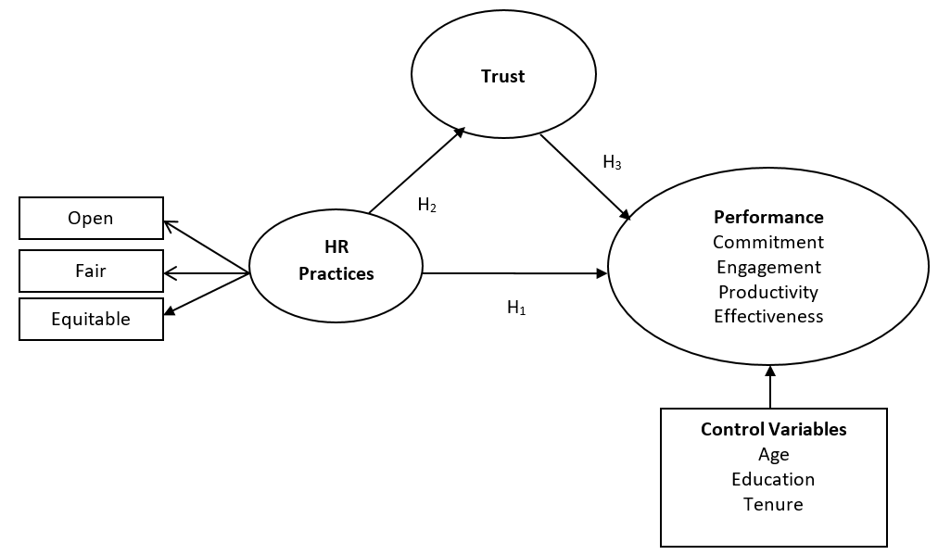
Based on the literature, theoretical reviews, and concepts, research hypotheses were developed, as depicted in Figure 4.
H₁ HR practices significantly affect employee performance.
H_{2:} HR practices significantly affect trust.
H_{3:} Trust positively affects employee performance.
H₄: There is a mediating influence of trust between HR practices and performance.

5. Methodology

5.1 Research Design and Population
A quantitative, cross-sectional survey design was adopted. The target population comprised academic staff at HEA-accredited public and private HEIs in Zambia. The sampling frame included 43 participating institutions (9 from public and 34 from private HEIs).

5.2 Sample and Data Collection
A total of 311 questionnaires were distributed; 276 were returned, yielding an 89% response rate. Participants were randomly selected academic staff, with representation across provinces and institutional types.

5.3 Measures
- HR Practices: Measured using items reflecting commitment, engagement, effectiveness, and productivity (Demo et al. (2012).
- Trust: Assessed with the Organisational Trust Inventory (Cummings & Bromiley, 1996).
- Employee Performance: Measured via dimensions of commitment, engagement, productivity, and effectiveness (Koopmans et al., 2012).
All items were rated on a five-point Likert scale (1 = Strongly Disagree, 5 = Strongly Agree).

5.4 Data Analysis
Data were analysed using SPSS for descriptive statistics and SmartPLS for Partial Least Squares Structural Equation Modelling (PLS-SEM). The measurement model was tested for reliability and validity before evaluating the structural model and mediation effects.
5.5 Respondents’ Characteristics
Respondents were predominantly male (69.9%); the largest age group was 40 to 50 years (39.9%); Master’s degree holders (28.6%), PhD (18.1%). The largest tenure group was 5-10 years (40.6%). 93.1% of participants were Zambians.

5.5.1 Non-Response Bias: 25% primary survey items were selected for non-response bias analysis using respondent characteristic variables. The sample of 276 respondents was divided into two groups; the first and last 25% returned surveys were designated for analysis, and an independent samples t-test was conducted to compare the mean responses of the two groups. The results, evaluated at a 95% confidence level, suggest that late respondents are similar to early respondents (p > 0.05) across the questionnaire items.
5.5.2 Common Method Variance (CMV): Both the independent and dependent variables were derived utilizing a uniform response format, specifically ordinal scales. Following the data collection phase, the study assessed the potential presence of CMV, which could skew the interrelationships among the modeled constructs, using Harman’s single-factor test. All measurement items were subjected to Principal Components Analysis (PCA) utilizing an un-rotated solution. None of the factors accounted for more than 50% of the variance.
5.5.3 Descriptive Statistics: To ascertain whether a sample originates from a particular distribution, the one-sample Kolmogorov-Smirnov Test (K-S) was employed. It identified a statistically significant threshold of 0.05, corresponding to a 5% probability of mistakenly rejecting the null hypothesis even when it is true. Consequently, all null hypotheses were rejected.
6. Measurement Model Results
The model examined how HR practices, when effectively implemented to cultivate trust, may yield quantifiable improvements in employee performance. The model first ensured the validity and reliability of the measurement framework by assessing indicator reliability, internal consistency, and both discriminant and convergent validity.
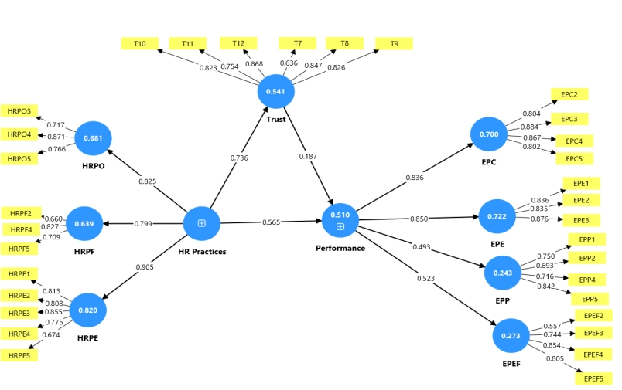
Figure 5: PLS Measurement Model Estimation
6.1 Indicator Reliability: Several indicators had loadings below 0.65. A loading relevance test assessed whether removing these indicators improved the average variance extracted (AVE) and composite reliability. According to Hair et al. (2017), indicators with loadings below 0.40 should be eliminated. Indicators were considered for deletion if their removal increased AVE and composite reliability above 0.5 and 0.7, respectively (Hair et al., 2013). Removing the indicators significantly improved content validity as they showed outer loadings of 0.7 or higher.6
6.2 Outer Loadings and Internal Consistency Reliability: Hair et al. (2013) states that values should be ≥0.60 but ≤0.95 in exploratory research to avoid redundancy. Table 5 shows that the composite reliability coefficients for HR Practices (0.906), Employee Performance (0.899), and Trust (0.884) are within the recommended range, indicating strong internal consistency.

Table 5: Outer Loadings and Internal Consistency Reliability
Construct (Latent Variables) | Sub-Dimensions Indicators | Composite Reliability | Outer Loadings
HR Practices |  | 0.906
HR Practices | Open HRPO3 |  | 0.717
HR Practices | HRPO4 |  | 0.871
HR Practices | HRPO5 |  | 0.766
 | Fair HRPF2 |  | 0.660
 | HRPF4 |  | 0.827
 | HRPF5 |  | 0.709
 | Equitable HRPE1  HRPE2 |  | 0.813  0.808
 | HRPE3 |  | 0.855
 | HRPE4 |  | 0.775
 | HRPE5 |  | 0.724
Trust |  | 0.884
Trust | IT8 |  | 0.847
Trust | IT9 |  | 0.826
Trust | IT10 |  | 0.823
Trust | IT11 |  | 0.754
Trust | IT12 |  | 0.868
Employee Performance |  | 0.899
Employee Performance | Commitment  EPC2 |  | 0.804
Employee Performance | EPC3 |  | 0.855
Employee Performance | EPC4 |  | 0.867
Employee Performance | EPC5 |  | 0.802
 | Engagement  EPE1 |  | 0.836
 | EPE2 |  | 0.835
 | EPE3 |  | 0.876
 | Productivity  EPP1 |  | 0.750
 | EPP2 |  | 0.694
 | EPP4 |  | 0.716
 | EPP5 |  | 0.842
 | Effectiveness
 | EPEF2 |  | 0.673
 | EPEF3 |  | 0.738
 | EPEF4 |  | 0.767
 | EPEF5 |  | 0.733
6.3 Convergent Validity and Discriminant Validity: Convergent and discriminant validity are key for PLS-SEM measurement model quality. The Fornell & Larcker (1981) criterion is the accepted method for evaluating both, with Average Variance Extracted (AVE) as a strong metric for convergent validity; the square root of AVE for each construct must exceed its correlations with others. Results in Table 5.11 show satisfactory convergent and discriminant validity in the measurement model. Specifically, HR practices, trust, and performance surpassed their inter-construct correlations. Convergent validity test results indicate that all indicators for HR practices, performance, and trust have outer loading values over 0.5, showing strong relationships with the constructs and confirming their validity.
Table 6: Convergent and Discriminant Validity
 | EPC | EPE | EPEF | EPP | HRPE | HRPF | HRPO | Trust
EPC | 0.828
EPE | 0.724 | 0.822
EPEF | 0.245 | 0.255 | 0.719
EPP | 0.200 | 0.233 | 0.509 | 0.728
HRPE | 0.637 | 0.559 | 0.208 | 0.158 | 0.788
HRPF | 0.582 | 0.533 | 0.195 | 0.137 | 0.638 | 0.731
HRPO | 0.594 | 0.540 | 0.246 | 0.257 | 0.666 | 0.620 | 0.779
Trust | 0.573 | 0.527 | 0.130 | 0.166 | 0.536 | 0.509 | 0.547 | 0.766
The values of AVE shown in bold in the diagonal and non-diagonal positions are the latent elements of the latent-variable correlations (LVC).
6.4 Evaluation of the Structural Model in PLS-SEM
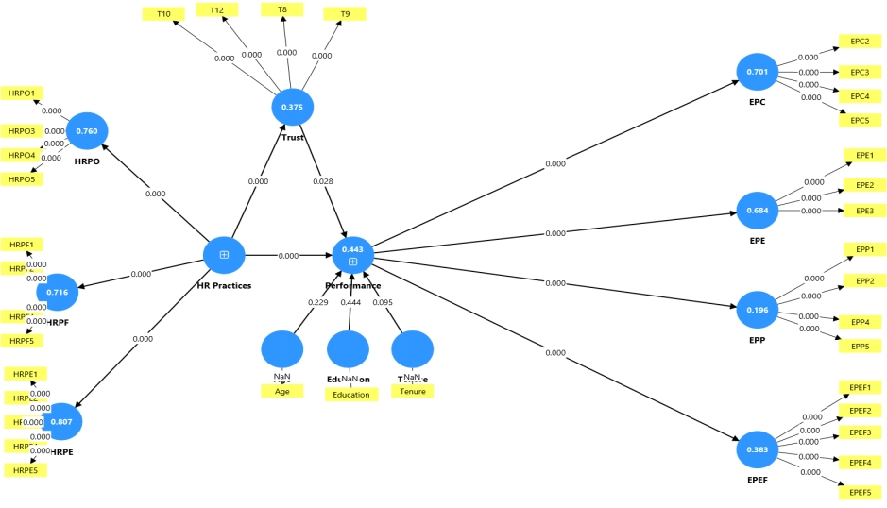
Figure 5: Structural Model Estimation
6.5 Collinearity Assessment: A VIF of 5 or higher indicates problematic collinearity (Hair et al., 2013). The collinearity assessment in Table 7 shows that all VIF values are below 5, indicating that multicollinearity is not an issue among predictors. VIFs below 5 are a good result, ensuring a healthy model regarding predictor collinearity.
Table 7: Collinearity Statistics Evaluation
Construct | VIF | Collinearity Problem?  (VIF>5?)
HR Practices > Performance | 1.168 | NO
HR Practices > Trust | 1.000 | NO
The 1.653 VIF value for HR Practices > Trust is ideal and indicates no multicollinearity for the predictor variable; it is completely independent of the other predictors in the model, while the value of 1.168 VIF (approximately 16.8%) for Performance indicates low to moderate multicollinearity, generally considered acceptable and not a substantial concern for the model.
6.6 Coefficient of Determination (R²): A major part of structural model evaluation is assessing the coefficient of determination (R²). In this model, employee performance is the main construct of interest. From the PLS path model estimation diagram (see Figure 5.4 above), the overall R² is 0.443. Given that the threshold values of 0.25, 0.5, and 0.7 describe a weak, moderate, and strong coefficient of determination (Hair et al., 2013), the R² falls in the weak to moderate range. In this case, it suggests that the two constructs, HR Practices and Trust, jointly explain 44.3% of the variance in the endogenous construct, employee performance.
R², the coefficient of determination, reflects a model’s predictive performance. In the present study, higher R² values indicate greater explanatory power. Values near 0.2 generally signal limited predictive power, whereas estimates exceeding 0.3 suggest moderate accuracy. Specifically, Performance (0.433) and Trust (0.373) demonstrate moderate explanatory strength. Gupta et al. (2024) notes that in the social sciences, R² values within the 0.10–0.30 range are often considered acceptable, owing to the inherent complexity of human behavior. Hair et al. (2013) further propose the following benchmarks: an R² of 0.75 accounts for 75% of the variance in the dependent variables; an R² of 0.50 denotes moderate variance explained; and an R² of 0.25 indicates weak variance explained.
Table 8: R-Square Mean, t-values, and p-values
 | Mean | t-values | p-values
EPC | 0.700 | 0.701 | 0.000
EPE | 0.683 | 0.684 | 0.000
EPEF | 0.381 | 0.383 | 0.000
EPP | 0.193 | 0.196 | 0.000
HRPE | 0.806 | 0.807 | 0.000
HRPF | 0.715 | 0.716 | 0.000
HRPO | 0.760 | 0.760 | 0.000
Performance | 0.433 | 0.443 | 0.000
Trust | 0.373 | 0.475 | 0.000
Analysis of Path Coefficients
Table 9: Significance Testing of the Structural Model Path Coefficients
 | Path | Path Coefficients | t-values | p-values
H1 | HR Practices > Performance | 0.576 | 8.442 | 0.000
H2 | HR Practices > Trust | 0.837 | 31.433 | 0.000
H3 | Trust > Performance | 0.120 | 1.910 | 0.028
6.7 Predictive Relevance (Q²): Q² values indicate a model's predictive ability for the dependent variable using independent variables. Common benchmarks are: <0, 0.02 -0.15, 0.15 – 0.35, and > 0.35, representing zero, small, medium, and large predictive relevance (Hair et al., 2013). In this study, the Blindfolding Algorithm yielded: HR Practices had a Q² value of 0.990, accounting for 99% variance in test outcomes. This shows remarkable predictive relevance and model effectiveness for new data points. Q² for Trust (0.368) and Performance (0.412) falls in the large predictive relevance category with substantial power.
Table 10: Results of Coefficient of Determination (R²) and Predictive Relevance (Q²)
Endogenous Latent Variables | R² Value | Q² Value
Trust | 0.377 | 0.368
Performance | 0.385 | 0.412
To summarize, the Q² values have a strong to exceptional ability to predict out-of-sample data.
6.8 The f² Effect Size: f² indicates a predictor's contribution to the model. According to Cohen (1988), values of 0.02, 0.15, and 0.35 represent small, medium, and large effects of an exogenous variable on an endogenous variable. Values less than 0.02 indicate no effect. Table 11 shows that the exogenous variable has a substantial effect on the endogenous variable, with the largest impact being HR Practices > Trust (0.599) and the smallest (0.016) on Trust > Performance, indicating a small effect of the exogenous variable on the endogenous variable.
Table 11: Results of f²
HR Practices, Trust, and Performance
 | Path Coefficient | f² Effect Size
HR Practices > Performance  HR Practices > Trust  Trust > Performance | 0.361  0.599  0.016 | 0.361  0.599  0.016
Summary of Hypotheses Testing
Table 5.15 indicates that the relationships between HR practices and performance (H1), as well as between HR practices and trust (H2), are statistically significant at p < 0.005. However, the proposed pathway from trust to performance (H3) is not supported at p < 0.005, despite yielding a p value of 0.043.
Table 12: Summary of Hypothesis Testing
 | Hypothesis | Supported?  YES/NO
H1 | HR Practices > Performance | YES
H2 | HR Practices > Trust | YES
H3 | Trust > Performance | NO
Conclusions of the Model
The model results show that well-designed HR practices significantly boost trust and performance. Analysis confirms a strong measurement model with high reliability and validity. Structural equation modeling indicates that HR practices enhance trust (H₂) and performance (H₁) at significant levels (p < 0.005). However, the trust-performance path (H₃) lacks statistical support, indicating that trust alone can't directly improve performance but works best with effective HR practices. The model has strong predictive relevance (Q²), moderate-to-high explanatory power (R²), and significant effect sizes for HR predictors. Overall, building trust through targeted HR practices effectively drives performance, while trust is necessary but not sufficient for optimal performance.
7. Mediation Analysis
HR practices significantly affect performance (H²: β = 0.608, p = 0.000). With a mediating variable, the effect became insignificant (β = 0.066, t = 1.691, p = 0.045). The direct effect of HR practices on performance through trust is significant (β = 0.452, p = 0.000). The indirect effect via trust is not significant, as the 95% confidence interval includes zeros, indicating no mediation between HR practices and performance.
8. Multi-Group Analysis Results

Multiple-group analysis (MGA) is a technique that allows researchers to study differences across demographics using structural equation models (SEMs) with group-specific or equal estimates. (Laura C.S., 2025). According to Ringle et al. (2024), SmartPLS provides MGA results to test if data groups differ statistically in parameter estimates (e.g., outer weights, loadings, path coefficients) via a permutation procedure. The analysis focused primarily on the two-tailed p-values obtained from the Bootstrap MGA, Parametric, and Welch-Satterthwaite tests. A p-value below 0.05 indicates a statistically significant difference in the pathways between Private and Public Higher Education Institutions. All alternative pathways, such as HR Practices > Performance, Trust > Performance, and Performance > Outcome variables, yielded p-values exceeding 0.05. This indicates that there are no statistically significant distinctions between private and public higher education institutions regarding these relationships. The effect sizes were commensurate across both categories of institutions.
9. Discussion of Findings
Results revealed that HR practices significantly affect trust among academic staff in both public and private HEIs, and clearly demonstrate that open, fair, and equitable HR practices have a significant positive effect on trust. These findings align with organisational behaviour theory, which treats HR practices as essential antecedents of trust. Open, fair, and equitable HR practices observed in this study corroborate previous research highlighting their importance in fostering organizational trust. Prior studies (Whitener, 1997; Jain, 2020; Verma & Kaur, 2024; Zeffane & Connell, 2003; Alfes et al., 2013) consistently highlight HR practices as antecedents of trust. Results confirm Social Exchange Theory by reinforcing trust across institutional types. By linking HR practices to trust outcomes in HEIs, this study advances organizational justice theory by contextualizing fairness and equity in a Sub-Saharan African setting. While Equity Theory predicts negative outcomes from perceived unfairness, this study shows that in Zambia, transparent HR practices foster trust equally in public and private HEIs.

Studies specific to HEIs (Agabekova & Kaptoyeva, 2021; Ali et al., 2022) support the current findings, reinforcing the relevance of open, fair, and equitable HR practices in both public and private university contexts in Zambia. The evidence suggests that academic staff who perceive HR practices as transparent and just are more likely to trust their institutions. The study reveals that HR practices should promote workplace equity, ensure fair treatment and equal opportunity, and address disparities (Omidi et al., 2023). Thus, this aligns with the three indicators of HR practices (open, fair, and equitable) to enhance employee trust, demonstrating that transparent and equitable HR practices have a significant positive effect on trust in both public and private HEIs in Zambia. This underscores the responsibility of HR practitioners in HEIs to foster a supportive climate that meets academic staff's expectations and enhances performance.
Implication: For policymakers, these findings challenge current HR practices, as efficiency-driven models risk eroding trust. Rather, Zambian HEIs must prioritise fairness and equity to sustain staff commitment. The findings highlight the importance of institutionalizing robust HRM systems that enhance openness, fairness, and equity. Based on such policies, HR practitioners should develop and enforce guidelines that mandate open, fair, and equitable practices to foster trust and enhance performance among academic staff. Trust-building practices also attract talent and reduce turnover by creating a culture of inclusion and increasing employee productivity and engagement. Practitioners also need to avoid overly rigid, efficiency-driven HR practices as they can lead to negative outcomes such as increased turnover and decreased morale. Thus, striking the right balance between fairness and efficiency in HR policies and procedures is important.
This research on open, fair, and equitable HR practices advances knowledge by empirically validating that transparent HR Practices foster trust equally in public and private HEIs in Zambia, challenging assumptions of institutional disparity. It bridges organisational justice theories with practical outcomes, which directly increase employee commitment, trust, engagement, and performance, and reduce intention to leave. The study, therefore, contributes to knowledge by contextualizing HR practices-trust subtleties within Zambian HEIs.
The study also reveals that trust is strongly associated with employee performance. Results show that the effect of trust on employee performance is statistically not different between private and public HEIs. The findings echo previous studies in organisational behaviour theory, which place trust as an essential antecedent of employee performance. Prior studies (Fulmer & Gelfand, 2012; Shore et al., 2006; Judge & Colquitt, 2004) consistently highlight trust as a performance antecedent. The results substantiate the critical role of trust in fostering greater commitment, engagement, productivity, and effectiveness, proof that in high-trust environments, employees are more likely to collaborate, innovate, and deliver superior performance outcomes, ultimately advancing the mission of HEIs. Findings also align with social exchange theory, which posits that a successful social exchange circle involves trust, which, in turn, is linked to employee performance (Zuker, 1986; Shore et al., 2006; Butler, 1991; Al-Subaie, 2021; Covey & Conant, 2016).
Another implication is that unlike contexts in which trust is assumed to vary by institutional type, Zambia’s HEIs require unified trust-building policies across public and private institutions. Policymakers need to underscore that building trust in higher education institutions is a strategic priority that shapes how well institutions perform and how much confidence the public places in them, as trust establishes credibility. In turn, for HEIs, credibility attracts talent, research funding, and international partnerships. It also makes governance easier, because high-trust environments tend to show less resistance to change and greater cooperation, whether in public restructuring or encouraging private institutions to align with national goals.
At the individual level, such policies improve students' experience by increasing staff motivation. For private institutions in particular, trust is a competitive advantage; it helps them grow and operate effectively in a regulated market. Ultimately, trust is built through three things: transparent governance, clear accountability for results, and open communication between policymakers, institutional leaders, and the public.
The findings provide clear support for the alternative hypotheses and firmly reject the null. The central contribution of this study in the context of Zambian HEIs, where this area is under-researched, is the robust evidence that trust is a key predictor of employee performance. By demonstrating trust’s equal predictive power across institutional types, this study advances social exchange theory by contextualising reciprocity in higher education settings. This advances organisational behaviour theory by showing that both open, fair, and equitable HR practices bear the responsibility of building trust among academic staff.
The results confirm that trust serves as a significant mediator for the effects of HR practices on performance, advancing theoretical understanding by positioning trust as a central mechanism through which these antecedents shape organizational outcomes. Prior studies (Yanik, 2018; Aryee et al., 2002) consistently highlight trust as a mediator of organisational outcomes. These findings reinforce the pivotal role of trust in translating HR practices into improved performance.

Results of Multi-Group Analysis: While prior studies often assume institutional type moderates organisational outcomes, this study shows a lack of significant differences, suggesting trust-performance dynamics are universal across HEIs. None of the examined paths showed a statistically significant difference between the public and private HEIs. The closest to significance was the path Trust → Performance, suggesting a possible trend, but it does not meet conventional significance thresholds. While prior studies (Schaffer, 2014; Dinesen et al., 2018) highlight mixed effects of institutional type, but this study confirms uniformity.
Implication: The importance of the MGA findings for policymakers is that they convey a clear, practical message: a one-size-fits-all approach will work here. Because the structural relationships in the model held consistently across both public and private HEIs, there is no need to design separate or segmented policies for each institution type. A unified policy framework is not only justified by the data; it is the more efficient path forward. This simplifies implementation, reduces the cost and complexity of specialised interventions, and ensures that diversity, equity, and inclusion efforts are applied consistently across the higher education landscape. For HR practitioners operating within these institutions, the implication is equally clear: practices and policies must be equitable and standardized, regardless of whether the institution is publicly or privately run.
In a developing-country context like Zambia, where public and private HEIs often operate under very different conditions regarding funding, governance, and resources, the assumption has typically been that their experiences and needs differ significantly. These findings challenge that assumption. The fact that group membership (public vs. private) did not influence the model's structural relationships suggests that the underlying dynamics of trust, performance, and stakeholder engagement transcend institutional type. This is a meaningful contribution to the literature, as it validates the model's robustness and generalisability in a Sub-Saharan African context — a setting that is often underrepresented in HEI research.
For Zambia specifically, this provides an evidence base for national policy coherence, encouraging a more integrated approach to higher education governance rather than fragmented, institution-type-specific strategies.
10. Conclusion
The research demonstrates that well-designed HR practices have a significant, positive direct effect on both trust and performance. The measurement model showed strong reliability and validity, and structural equation modelling revealed that HR practices significantly enhance trust and performance. However, the direct path from trust to performance was not always statistically significant at the same threshold, suggesting that trust alone may not be sufficient to drive performance; rather, it is most effective when coupled with robust HR practices. These findings validate the strategy of fostering trust through targeted HR practices as an effective approach to improving performance. Lastly, the study's multi-group analysis revealed no significant differences, suggesting that trust-performance dynamics are universal across Zambian HEIs.

11. Limitations and Future Research
This study provides valuable insights into the relationship between trust, human resource practices, and performance outcomes in Zambian higher education institutions. However, several limitations must be acknowledged.
First, the cross-sectional design restricts the ability to infer causality; the observed associations between trust, HR practices, and performance may vary over time. Future studies should adopt longitudinal designs to capture the dynamic evolution of trust and its impact on performance.
Second, the reliance on self-reported survey data introduces the possibility of response bias, as participants may have provided socially desirable answers. Incorporating multiple data sources, such as interviews, focus groups, or institutional records, would strengthen validity.
Third, the study’s focus on Zambian HEIs limits generalizability to other cultural and institutional contexts. Comparative, multi-country research would help identify contextual differences and similarities in trust-building mechanisms.
Fourth, while the study employed Smart PLS-SEM to test mediation, additional moderators and control variables such as organisational culture, leadership style, or diversity dimensions could provide a more nuanced understanding of the trust-performance relationship.
Finally, the literature review, though comprehensive, highlighted overlapping definitions of trust without fully integrating them into a unified theoretical framework. Future research should streamline conceptual models and deepen theoretical integration, particularly with Social Exchange Theory, to enhance explanatory power.
Future inquiries could also explore qualitative approaches to capture the lived experiences of academic staff, thereby enriching the quantitative findings. Additionally, examining the role of distrust alongside trust may provide a more balanced understanding of employee relations in HEIs. By addressing these limitations, subsequent studies can build on the present findings to advance both theory and practice in higher education management.
References
Akar, H. (2018). Meta-analysis of organisational trust studies conducted in educational organisations in the years between 2008 and 2018. International Journal of Education Methodology. https://files.eric.ed.gov/fulltext/EJ1196516.pdf

Alfes, K., Truss, C., Soane, E.C., Rees, C. & Gatenby, M. (2013). The Relationship Between Line Manager Behavior, Perceived HRM Practices, and Individual Performance: Examining the Mediating Role of Engagement. Human Resource Management and the Line. Vol. 52 Special Issue, Nov/Dec 2013. https://doi.org/10.1002/hrm.21512, pages 839-859

Alshamary, M.H. (2025). Organisational Commitment as a Mediating Factor between Trust in Management and the Achievement of Organisational Goals – An Applied Case in Tikrit University. South Asian Research Journal of Business and Management, 7(3), 321-332. DOI: https//doi.org10.36346/sarjbm.2025.v07i03.016 CC BY-NC 4.0

Al-Subaie, O.B.A. (2021). Leading organisational trust in educational institutions: A proposed leadership model. Journal of Entrepreneurship Education, 24(6). https://www.abacademies.org/articles/leading-organizational-trust-in-educational-institutions-a-proposed-leadership-model-11071.html

Barney, J. B., & Hansen, M. H. (1994). Trustworthiness as a Source of Competitive Advantage. Strategic Management Journal, 15, 175–190. http://www.jstor.org/stable/2486817

Botwe, P.B., Kenneth, A.B. and Masih, E. 2016. Concept of Trust and Its Effect on Performance in an Organisation. The International Journal of Business & Management. 4, 2 (Feb. 2016).

Camilleri, M. (2020). The Performance Management in Higher Education.
https://drmarkcamilleri.com/2020/04/03/the-performance-management-in-higher-education/
Carrell, M.R. and Dittrich, J.E. (1978) Equity Theory: The Recent Literature, Methodological Considerations, and New Directions. Academy of Management Review, 3, 202-210.
https://doi.org/10.2307/257661
Cummings, L. L., & Bromiley, P. (1996). The Organizational Trust Inventory (OTI): Development and validation. In R. M. Kramer & T. R. Tyler (Eds.), Trust in organizations: Frontiers of theory and research (pp. 302–330). Sage Publications.
Dirks, K.T. and Ferrin, D.L., 2002. Trust in leadership: meta-analytic findings and implications for research and practice. Journal of applied psychology, 87(4), p.611. doi: 10.3389/fpsyg.2022.797443. https://www.ncbi.nlm.nih.gov/pmc/articles/PMC9012151/pdf/fpsyg-13-797443.pdf

Dzansi, L.W. (2016). The Clute Institute A South African Study of Influence of Fairness of Human Resource Management Practices on Service Quality. The Journal of Applied Business Research, May/June 2016 Volume 32, Number 3.

Dziminska, M., Fijalkwska, J., Sulkowski, L. (2018). Trust-based quality culture conceptual model for higher education institutions. Sustainability July 24, 10 (8): 2599

Golembiewski, R.T., & McConkie, M. (1975). The Centrality of Trust in Group Processes. In C.L. Cooper (Ed.), Theories of Group Processes (pp. 131–185). New York: Wiley.

Fulmer, Ashley & Gelfand, Michele. (2012). At What Level (and in Whom) We Trust : Trust Across Multiple Organizational Levels. Journal of Management. 38. 1167-1230. 10.2139/ssrn.1873149.

Gimeno, D., Geroy, C. Y Prado, N. (2025). Employee Engagement, Job Satisfaction, and
Organizational Commitment on Employee Productivity in Higher Education Settings.
International Journal of Research and Innovation in Social Science.
https://doi.org/10.47772/ijriss.2025.903sedu0177

Guest, D. E. (1997). Human resource management and performance: a review and research agenda. The International Journal of Human Resource Management, 8(3), 263–276. https://doi.org/10.1080/095851997341630
Jameson, J., Barnard, J., Rumyantseva, N., Essex, R., & Gkinopoulos, T. (2023). A systematic scoping review and textual narrative synthesis of trust amongst staff in higher education settings. Studies in Higher Education, 48(3), 424–444. https://doi.org/10.1080/03075079.2022.2145278

Lewicka, D. (2022). Building and rebuilding trust in higher education institutions (HEIs). Student's perspective. Journal of Organizational Change Management 1 November 2022; 35 (6): 887–915. https://doi.org/10.1108/JOCM-02-2022-0037

Mayer, R. C., Davis, J. H., & Schoorman, F. D. (1995). An Integrative Model of Organizational Trust. The Academy of Management Review, 20(3), 709–734.
Mayer, R. C., & Gavin, M. B. (1999). Trust in management and performance: Who minds the shop while the employees watch the boss? Academy of Management Journal, 42(5), 874–888.
McAllister, D. (1995). Affect- and Cognition-Based Trust Formations for Interpersonal Cooperation in Organizations. Academy of Management Journal. 38. 24-59. 10.2307/256727.

Mugimu, C.B. (2021). Higher Education Institutions (HEIs) in Africa Embracing the “New Normal” for Knowledge Production and Innovation: Barriers, Realities, and Possibilities. https://www.intechopen.com/chapters/79255

Mushi, D., Njema, J., Maeda, A., Kahembe, N. (2020). Enhancing Leadership and Job Performance in Higher Public Education in Tanzania. International Journal of Management Sciences and Business Research, June-2020 ISSN (2226-8235) vol-9, Issue 6. https://www.ijmsbr.com

Nanteza, N., Mugizi, W., Nagasha, J.I., Waiswa, M.M. (2023). Diversity Management and Work Engagement of academic staff of Kyambogo University, Uganda. The Uganda Higher Education Review. https://doi.org/10.58653/nche.v11i.11

Nishanthi, H. M., & Kulathunga, M. G. M. D. (2018). The Impact of Human Resource Management Practices on Impersonal Organizational Trust (With special reference to financial institutions in Sri Lanka). Kelaniya Journal of Management, 7(1), 68. https://doi.org/10.4038/kjm.v7i1.7555

Rono, J. K. (2015). Effects of human resource management practices on industrial dispute in public universities in Kenya. Egerton and Maasaimara University, Kenya.

TrustAfrica Annual Report FY 2022. “Shaping the future we want for Africa.”
https://trustafrica.org/publication/annual-report-2022/

Tse, S. & Hildebrand, C. (2023). Putting trust at the heart of higher education. https://www.timeshighereducation.com/campus/putting-trust-heart-higher-education

Tzafrir, Shay & Dolan, Simon. (2004). Trust Me: A Scale for Measuring Manager-Employee Trust. Management Research. 2. 115-132. 10.1108/15365430480000505.

Yanik, O. (2018). The mediating role of trust in the effect of ethical leadership on employee attitudes and behaviours. Journal of Business Research Turk. https://isarder.org/2018/vol.10_issue.1_article23_extensive_summary.pdf

Zeleza, P. (2021). Quality higher education ‘indispensable’ for Africa’s future. Universityworldnews.com. Presentation at the general conference of the Association of African Universities on 5th July, 2021.

Zucker, L. G. (1986). Production of trust: Institutional sources of economic structure, 1840–1920. Research in Organizational Behavior, 8, 53–111. https://psycnet.apa.org/record/1988-10420-001

