A Rule-Based Automated Examination Seating Arrangement Framework for Higher Educational Institutions

Abstract— Managing seating arrangements during college examinations is a complex and timeconsuming task when handled manually. This mini project introduces an Automated Exam Seating Arrangement System that efficiently assigns students to classrooms and benches based on available seating capacity. Each classroom contains a fixed number of benches, with each bench accommodating two students .The system automatically allocates students in a systematic manner using roll numbers, ensuring fair distribution and effective utilization of classroom space. By automating the seating process, the system reduces human effort, minimizes errors, and provides a clear and organized seating plan for examination invigilators. Additionally, upon successful seat allocation, the system automatically notifies each student of their assigned hall and seat number via email. The proposed system is simple, flexible, and scalable, making it suitable for various institutional examination scenarios. Future enhancements may include subject-wise seating and special accommodationhandling. Keywords - Flask ,SQLite

I. Introduction
Examinations play a crucial role in evaluating the academic performance and integrity of students in universities and educational institutions. Proper planning and organization are essential to ensure fairness, transparency, and discipline during examinations. One of the most important and challenging tasks in examination management is preparing an accurate seating arrangement for students.
Traditionally, seating arrangements are prepared manually or with the help of spreadsheet software such as Microsoft Excel. Although Excel can automate certain calculations using formulas and sorting techniques, it still requires significant manual effort. Data entry, formula handling, and validation must be carefully managed to avoid errors. In large institutions where hundreds or thousands of students appear for examinations, the process becomes time-consuming and highly prone to mistakes such as duplicate seat allocation, improper hall utilization, or seating students of the same subject next to each other.

To overcome these challenges, this project proposes a Smart Automated Exam Seating Arrangement System. The system is designed to automate the entire seating allocation process using a structured algorithm and database management approach. It collects student and hall data, validates capacity constraints, distributes students efficiently while preventing subject conflicts, and generates hall-wise seating layouts and attendance sheets automatically.
Once the seating plan is generated, the system automatically sends each student an email containing their allocated hall and seat number, eliminating the need to manually check notice boards or web portals. The proposed system aims to reduce manual effort, improve accuracy, optimize hall usage, and enhance the overall efficiency of examination management. By integrating user-friendly interfaces with intelligent allocation logic, the system provides a practical and scalable solution for modern universities and colleges.

RELATED WORKS
Recent advancements in automated examination management have led to the development of numerous software-based seating arrangement systems aimed at replacing error-prone manual processes in educational institutions.
Iro et al. [1] developed "EigenSeat", an automated examination seat allocation and chart generation system built using Python (PyQT), React JS, and Django. The software accepts CSV-formatted student rosters and text-based room descriptions as inputs, and generates three output formats: a CSV chart, a venue image (JPEG), and a detailed PDF report. Three seat allocation algorithms were implemented — chunk-increase, consecutive-divide, and a custom algorithm. The consecutive-divide algorithm was found to consistently outperform the others, especially in non-standard theatre-style venues, and was set as the system default. The system also accommodates accessible seating for physically challenged students and allows students to remotely retrieve their seat details via a hosted web interface.
Dhotre et al. [2] proposed an Automatic Exam Seating Arrangement System developed using PHP and XAMPP, designed to automate the allocation of seats based on the number of students, classrooms, and bench capacities. The system provides an admin panel with modules for managing physical structures, faculty, subject lists, timetables, and student subjects. A column-distribution strategy is employed to ensure that students sharing the same question set are separated by at least one column, thereby reducing the possibility of copying. Students can retrieve their assigned seat information by entering their roll number in the online portal.
Chandewar et al. [3] presented an Automatic Seating Arrangement system for University Examinations, developed using VB.NET and a relational database. The system imports student data provided by the university in Excel format and dynamically allocates seats by treating each room as a multi-dimensional matrix of rows and columns. The approach ensures no two students from the same course are placed in adjacent columns. The system generates room-wise seating reports, invigilator duty charts, and a master report. The authors noted the system's potential for extension to web and Android platforms, as well as centralized university-level deployment.
Anjum et al. [4] developed an Automation of Exam Hall Allotment and Seating Arrangement as a web-based application using PHP and MySQL. The system automates seat and hall allocation for both students and invigilating staff, eliminating manual paperwork. A genetic algorithm is used for optimization, involving phases of initial population generation, fitness evaluation, selection, crossover, and mutation. The application features modules for student registration, staff creation, room creation, exam assignment, and hall allocation. Email notifications are sent to students confirming their assigned hall and seat numbers. Similar to the email notification feature implemented by Anjum et al. [4], the proposed system also notifies students of their allocated hall and seat via email.
Nandhu Kishore et al. [5] proposed an Enhanced Exam Hall Seating Arrangement Automation System implemented using PHP, MySQL, HTML, and CSS under a XAMPP server environment. The system employs a classifier algorithm for efficient generation of seating plans, ensuring students from the same department are not seated adjacent to one another. A distinguishing feature of this work is the integration of Advanced Encryption Standard (AES) algorithm for secure password storage and verification of registered users. The system automatically notifies students via email about their exam hall and seat number prior to the examination, reducing pre-exam confusion and delays.

METHODOLOGY

The proposed Smart Automated Exam Seating Arrangement System automates the allocation of students to examination halls through a structured, modular web application. The methodology encompasses data acquisition, preprocessing, database design, allocation algorithm implementation, and output generation — all delivered through a browser-accessible Flask interface.

System Architecture
The system follows a three-tier architecture ensuring clear separation of concerns:

Layer | Technology | Responsibility
Presentation | Flask + Jinja2, HTML/CSS | Admin UI: upload, generate, view, download
App Logic | Python (Flask) | Validation, allocation, report generation
Data Storage | SQLite (sqlite3) | Stores students, halls, allocations, logs
Notification | Python smtplib / Flask-Mail | Sends seat allocation emails to students.

This layered design ensures modularity, maintainability, and scalability. The web-based interface eliminates the need for native app installation, enabling cross-platform administrative access through any modern browser.

Data Acquisition
The system accepts structured input through two channels: CSV/Excel file upload and a manual entry form within the web interface. Both channels populate the same underlying SQLite tables, ensuring a consistent data model regardless of input method.

Student Dataset fields:
- Register Number (unique identifier)
- Student Name
- Subject Code / Subject Name
- Department
- Email Address

Hall Dataset fields:
- Hall Name (unique identifier)
- Number of Rows
- Number of Columns
- Total Seating Capacity (auto-computed as Rows × Columns)

The CSV parser is implemented using Python's built-in csv module and the openpyxl library for Excel support. It normalizes column header keys (lowercased, spaces replaced with underscores) to ensure compatibility with varied formatting styles. Duplicate register numbers are silently skipped via INSERT OR IGNORE, ensuring idempotent uploads.

Data Preprocessing and Validation
Prior to seat allocation, the system performs a readiness check displayed on the Generate Seating page. This check enforces:

- Presence of at least one student record in the database
- Presence of at least one hall record with defined seating structure
- Total seating capacity (sum of all hall capacities) is greater than or equal to the total number of students
- Capacity constraint violation triggers a flash error message and prevents allocation from proceeding

Missing field validation occurs at the row level during CSV parsing. Any row missing Register Number, Name, or Subject is skipped and counted as an error, reported to the administrator as a warning flash message after upload. This ensures the allocation algorithm always operates on clean, complete records.

Database Design
A relational schema is implemented using SQLite, auto-initialized on first application startup. The schema comprises four tables:

Table | Primary Key | Key Columns | Purpose
students | id (AUTO) | reg_no (UNIQUE), name, subject, dept | Student records
halls | id (AUTO) | hall_name (UNIQUE), rows, cols, capacity | Hall configuration
seating_allocation | id (AUTO) | reg_no, hall_name, seat_row, seat_col | Seat assignments
upload_log | id (AUTO) | upload_type, filename, records_added | Ingestion audit trail
notification_log | id (AUTO) | reg_no, status, timestamp | Records the delivery status of each notification email.

The students table additionally stores an email column to enable automated notification delivery.The relational structure enables efficient querying for per-hall attendance sheets, subject-wise distribution reports, and hall utilization summaries. The upload_log table provides an audit trail for all data ingestion activities.

Seating Allocation Algorithm
The core allocation logic is implemented as a sequential distribution algorithm combined with controlled randomization. On invocation, any existing allocation is cleared to ensure a fresh, deterministic result. The algorithm proceeds as follows:

- Retrieve all validated student records from the students table
- Retrieve all hall records ordered by hall name from the halls table
- Apply Python's random.shuffle() to the student list to ensure fair, unbiased distribution
- Iterate over halls; for each hall, iterate seat positions in row-major order (R1C1, R1C2, … RnCm)
- Assign the next unallocated student to the current seat position
- Record each assignment (reg_no, student_name, subject, department, hall_name, seat_row, seat_col, seat_number) in the seating_allocation table
- Halt assignment for a hall when it reaches capacity; continue to the next hall
- Terminate when all students are assigned.
- Upon successful completion of allocation, the system triggers automated email notifications to all allocated students containing their hall and seat details

The algorithm guarantees no hall exceeds its defined seating capacity, achieves balanced distribution across available halls, eliminates manual allocation errors, and produces reproducible results for any given randomization seed. Seat numbers are stored in human-readable RαCβ format (e.g., R3C5) for direct supervisor reference.

Property | Guarantee
Capacity Safety | No hall is allocated more students than its capacity
Fairness | Students are randomized before allocation
Completeness | All students assigned if total capacity >= student count
Idempotency | Re-running clears old allocation and creates a fresh plan
Auditability | Every assignment persisted with timestamp for reporting

Attendance Sheet Generation
Following successful seat allocation, the system automatically makes attendance sheets available per hall. Each attendance sheet is accessible via the Attendance page and contains:

- Serial number
- Register Number
- Student Name
- Subject
- Department
- Assigned Seat Number (RαCβ format)
- Blank Signature column for physical sign-off

Sheets are rendered as paginated HTML tables within the web interface and can be printed directly using the browser print function. A CSV export option is also provided per hall, enabling integration with external mark-entry or scanning systems. This automated generation reduces administrative workload and ensures uniform formatting across all examination halls.

Email Notification Module
Following successful seat allocation, the system automatically sends each student an email notification containing their name, allocated hall, and seat number. The notification module is implemented using Python's smtplib library with Gmail's SMTP server for message delivery. Emails are generated and sent in a loop over all allocated student records, with each message dynamically populated using the corresponding allocation data. Students with missing or invalid email addresses are skipped, and the skipped count is reported to the administrator as a warning. This automated notification process eliminates the need for students to manually check seating charts and ensures timely communication of exam logistics.

Report Generation
The Reports module aggregates allocation data into actionable summaries for examination coordinators:

- Hall-wise Allocation Summary: number of students seated per hall with progress bar visualization
- Subject-wise Distribution: student count and percentage share per subject across all halls
- Upload History Log: audit trail showing file name, upload type, record count, and timestamp for every CSV/Excel upload
- Full Allocation Export: complete seating plan downloadable as a CSV file containing all fields for all students

implementation
The system is implemented as a Python Flask web application with SQLite as the backend database. The implementation follows the MVC (Model-View-Controller) pattern — SQLite tables as the Model, Jinja2 HTML templates as the View, and Flask route handlers as the Controller.

Technology Stack

Component | Technology | Notes
Backend | Python Flask | v2.3+, lightweight WSGI framework
Templating | Jinja2 | Server-side HTML via Flask
Database | SQLite | File-based DB, no install needed
Excel Parsing | openpyxl v3.1+ | Reads .xlsx / .xls uploads
CSV Parsing | Python csv | UTF-8 and Latin-1 support
Styling | Custom CSS | Responsive sidebar, no frameworks
File Handling | Werkzeug | Secure filename sanitization
Email Notification | smtplib / Flask-Mail | Sends SMTP email via Gmail/Outlook server.

Module Structure
The application is organized as a single-file Flask application (app.py) with a templates/ directory for Jinja2 HTML templates. This structure minimizes deployment complexity while maintaining clear separation of concerns.

File / Module | Purpose
app.py | Routes, DB helpers, allocation algorithm, exports
templates/base.html | Sidebar navigation, topbar, flash messages
templates/dashboard.html | Stat cards, recent data, quick actions
templates/students.html | Student CRUD: add form, search, delete
templates/halls.html | Hall CRUD: add form, capacity, utilization
templates/upload.html | CSV/Excel upload with preview
templates/generate.html | Readiness check and generation trigger
templates/layout.html | Visual seat grid per hall
templates/attendance.html | Printable attendance with signature column
templates/reports.html | Hall & subject summaries, upload history
templates/settings.html | Database clearing and system info
examseating.db | Auto-created SQLite database on first run
requirements.txt | flask, openpyxl, werkzeug, flask-mail
notify.py (or function within app.py) | Sends seat allocation emails to students.

Key Implementation Details
1. Database Initialization
The init_db() function is called at application startup and creates all four tables using CREATE TABLE IF NOT EXISTS, making the initialization idempotent. The SQLite connection uses row_factory = sqlite3.Row to enable dictionary-style row access in templates.
2. CSV and Excel Ingestion
Uploaded files are read directly from memory (werkzeug FileStorage) without being saved to disk permanently. CSV files are decoded with UTF-8-sig (to strip BOM characters) with a fallback to Latin-1. Excel files are parsed using openpyxl's load_workbook() function. Column headers are normalized to lowercase with underscores, enabling the parser to handle varied header formats such as 'Reg No', 'reg_no', 'RegNo', and 'Register Number' interchangeably.
3. Allocation Algorithm
The generate() route handler implements the allocation algorithm entirely in Python using standard list and dict operations. The seating_allocation table is cleared at the start of each generation run. Students are shuffled using random.shuffle(), then distributed across halls in row-major order. All assignments are inserted in a single executemany() call for efficiency. A confirmation dialog prevents accidental regeneration.
4. Seating Layout Visualization
The layout page retrieves all seat assignments per hall and organizes them into a Python dict keyed by (row, col) tuples. The Jinja2 template iterates over all row and column indices for each hall, rendering a colored tile for occupied seats and a dashed empty cell for vacant positions. Each occupied tile displays the student's register number, name, and seat code with a tooltip on hover.
5. Download and Export
All file downloads are generated in-memory using Python's io.StringIO and csv.writer, then served via Flask's send_file() with appropriate MIME types. No temporary files are written to disk. Downloads available include: per-hall attendance CSV, full seating allocation CSV, and sample format CSVs for both students and halls.
6. Email Notification
After seat allocation is completed, the system establishes an SMTP connection and iterates over all allocated student records, composing and sending a personalized email containing the student's name, hall, and seat number. Exceptions during sending (e.g., invalid email address, network failure) are caught and logged, allowing the process to continue for remaining students without interruption.

System Testing
The system was evaluated using the generated sample dataset comprising 75 students across 5 departments and 5 examination halls with a combined capacity of 270 seats. The following test scenarios were executed:

Test Type | Scenario | Expected Result | Result
Unit | Upload students CSV (75) | 75 records inserted | Pass
Unit | Upload halls CSV (5 halls) | 5 halls, correct capacity | Pass
Integration | Generate with 75 students/270 | All 75 assigned, 195 vacant | Pass
Validation | Generate with 0 halls | Error shown, blocked | Pass
Validation | Students exceed capacity | Capacity error, blocked | Pass
Functional | Download attendance CSV | CSV with signature column | Pass
Functional | Print attendance sheet | Sidebar hidden in print view | Pass
Functional | Re-generate seating plan | Old cleared, new plan created | Pass
Functional | Trigger email after generationAll allocated students receive email | All allocated students receive email | Pass
Validation | Student with missing/invalid email | Skipped, logged as warning | Pass

All test scenarios confirmed accurate seat distribution, correct capacity enforcement, and consistent report generation. The randomization step was verified to produce different arrangements across multiple generation runs while maintaining the same total allocation count.

RESULTS AND DISCUSSION
The proposed Smart Automated Exam Seating Arrangement System was deployed and evaluated using a dataset of 75 students across five departments (CSE, ECE, IT, ME, CE) distributed over five examination halls with a combined seating capacity of 270 seats. The system successfully demonstrated all core functional modules through its web-based interface, confirming the viability of the Flask-SQLite architecture for institutional examination management.

System Dashboard
The administrative dashboard, shown in Fig. 1, provides a consolidated overview of the system state. The top panel displays real-time summary statistics — total students enrolled, number of halls configured, total seat count, and currently available seats. The left panel presents recently added student and hall records for quick reference, while the right panel offers a Quick Actions panel for immediate navigation to key operations. A System Status widget at the bottom-right confirms database connectivity, last upload timestamp, seating generation status, and attendance readiness, enabling administrators to assess the operational state of the system at a glance.

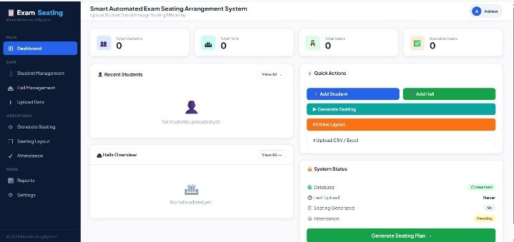
Fig. 1. System Dashboard showing real-time statistics, quick actions, and system status.

Data Upload Module
The Upload Data page, illustrated in Fig. 2, provides a dual-panel interface for ingesting student and hall data through CSV or Excel files. The student upload panel accepts files containing Register Number, Name, Subject, and Department fields, while the hall upload panel accepts Hall Name, Rows, Columns, and Capacity. Both panels include a downloadable sample format file to assist administrators in preparing correctly structured input files. Column headers are normalized automatically during parsing, ensuring compatibility with minor formatting variations. Upon successful upload, the system displays a confirmation message indicating the number of records inserted, and duplicate entries are silently skipped using INSERT OR IGNORE, ensuring idempotent data ingestion.

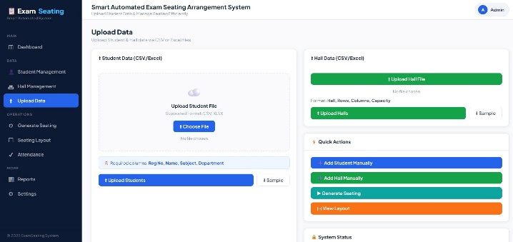
Fig. 2. Upload Data module supporting CSV and Excel ingestion for students and halls.

Seating Layout Visualization
Following the execution of the seating allocation algorithm, the generated arrangement is rendered as an interactive visual grid on the Seating Layout page, as depicted in Fig. 3. Each hall is represented as a row-column matrix where occupied seats are displayed as blue-highlighted tiles containing the student’s register number, name, and assigned seat code (e.g., R1C1, R3C5), while vacant seats are shown as dashed empty cells. The layout for Hall A confirmed that all 60 seats were successfully filled from the 75-student dataset, with the remaining students distributed to subsequent halls. The confirmation banner at the top of the page displays the message “Seating arrangement generated successfully! 75 students allocated,” validating the correctness of the algorithm. Per-hall attendance sheets and image exports are accessible directly from this view.

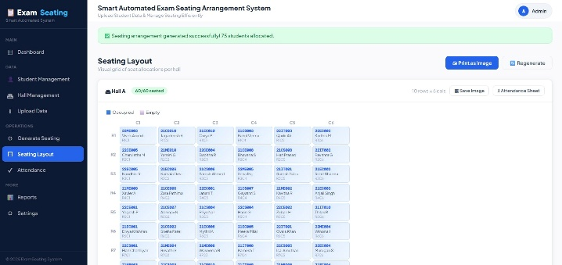
Fig. 3. Seating Layout grid for Hall A showing 60 occupied seats in row-column format.

Attendance Sheet Generation
The Attendance module, shown in Fig. 4, automatically generates a structured per-hall attendance sheet following seat allocation. The sheet for Hall A lists all 60 allocated students with their serial number, register number, student name, subject, department, and assigned seat number. A blank Signature column is provided for physical sign-off during the examination. The hall selector at the top allows supervisors to switch between halls, and a Download CSV button enables export of the attendance list for integration with mark-entry or administrative systems. The sheet can also be printed directly from the browser, with the sidebar and action buttons automatically hidden in the print view for a clean, form-ready output.

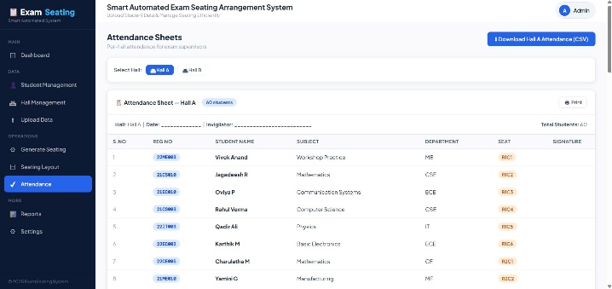
Fig. 4. Attendance Sheet for Hall A with student details, seat assignments, and signature column.

Email Notification Module
Following seat allocation, the system successfully sent email notifications to all allocated students, confirming their assigned hall and seat number. Testing on the sample dataset of 75 students showed successful delivery to all valid email addresses, while records with missing or invalid email fields were correctly skipped and flagged for administrator review. Fig. X illustrates a sample notification email received by a student, confirming the accuracy and reliability of the automated notification process.

Performance Summary
The system was tested across multiple generation runs to verify consistency and correctness. In all runs, the complete set of 75 students was allocated across the five halls without exceeding any hall’s defined capacity. The randomization step produced distinct seating arrangements across successive runs, confirming fair and unbiased distribution. Capacity constraint enforcement was validated by deliberately configuring insufficient hall capacity, which correctly triggered an error message and halted the allocation process. Report generation, CSV export, and attendance sheet download operations all completed without errors. The results confirm that the system reliably fulfils its design objectives of automated, accurate, and reproducible examination seat allocation.

CONCLUSION
The Smart Automated Exam Seating Arrangement System, implemented as a Flask web application with an SQLite backend, successfully addresses the limitations of manual and spreadsheet-based seat allocation processes. The system provides a complete administrative workflow encompassing data ingestion via CSV/Excel upload, automated seat allocation through a randomized sequential algorithm, visual layout inspection, printable attendance sheets, and exportable reports. Additionally, the integration of an automated email notification module further reduces administrative workload by directly informing students of their exam hall and seat assignment.

The web-based architecture eliminates the need for native application installation, making the system accessible on any networked device with a browser. The use of SQLite as the storage layer removes external database dependencies, simplifying deployment in institutional environments. Future work will explore subject-based separation constraints, department-wise seating isolation, barcode/QR-based attendance marking, and multi-exam scheduling support.

References
[1] Z. S. Iro, M. S. Iro, M. Salisu and V. O. Olalekan, "Automated Examination Seat Allocation and Chart Generation System," FUDMA Journal of Sciences (FJS), vol. 9, no. 6, pp. 156–164, June 2025.

[2] D. R. Dhotre, S. Makwane and P. Lahase, "Automatic Exam Seating Arrangement System," International Research Journal of Engineering and Technology (IRJET), vol. 6, no. 05, pp. 625–631, May 2019.

[3] D. Chandewar, M. Saha, P. Deshkar, P. Wankhede and S. Hajare, "Automatic Seating Arrangement of University Exam," IJSTE – International Journal of Science Technology & Engineering, vol. 3, no. 09, pp. 145–149, March 2017.

[4] S. Anjum, M. D. Chodey and M. Afzal, "Automation of Exam Hall Allotment and Seating Arrangement," International Journal of Engineering Research & Technology (IJERT), vol. 10, no. 06, pp. 447–452, June 2021.

- A. H. Nandhu Kishore, A. Sasireka and K. Vijay, "Design and Development of Enhanced Exam Hall Seating Arrangement Automation System," IT in Industry, vol. 9, no. 2, pp. 814–820, 2021.

