Dose-Dependent Effects of Lead Acetate on Cerebral Cortex Cytoarchitecture and Cholinergic–GABAergic Neurotransmission in Adult Male Wistar Rats

ABSTRACT
Background: Lead (Pb) remains one of the most pervasive environmental neurotoxicants worldwide, and the developing and adult central nervous system is particularly vulnerable to its dose-dependent effects. Although the cholinergic and oxidative consequences of lead exposure have been documented, the combined histopathological and neurochemical (acetylcholine, acetylcholinesterase, and γ-aminobutyric acid [GABA]) consequences of graded oral lead acetate exposure on the adult cerebral cortex remain incompletely characterised. Methods: Twenty adult male Wistar rats (150–200 g) were randomly allocated into four groups (n = 5/group): a distilled-water control, and three groups administered lead acetate at 100, 200, and 400 mg/kg body weight by oral gavage daily for 21 days. Serum acetylcholine, acetylcholinesterase (AChE) activity, and GABA concentration were measured, and cerebral cortical sections were processed for haematoxylin and eosin (H&E) histology. Data were analysed by one-way ANOVA followed by Duncan's Multiple Range Test (p < 0.05). Results: Lead acetate produced a dose-dependent increase in serum acetylcholine (from ~730 pg/mL in controls to ~970 pg/mL at 400 mg/kg) accompanied by a dose-dependent decline in AChE activity (from ~22 IU/L to ~14.8 IU/L) and GABA concentration (from ~7.1 to ~4.6 µmol/mL), all significant at p < 0.05 relative to control. Histologically, the control cortex showed normal neuropil with ramified, resting microglia and quiescent astrocytes, whereas lead-exposed cortices showed progressive, dose-related microglial activation, astrogliosis, and neuropil vacuolation, culminating in severe neuropil disorganisation and amoeboid microglial transformation at 400 mg/kg. Conclusion: Subacute oral lead acetate exposure produces concurrent, dose-dependent cholinergic dysregulation, GABAergic suppression, and neuroinflammatory histopathology in the adult rat cerebral cortex, supporting a multi-mechanistic model of lead neurotoxicity in which impaired acetylcholine catabolism, loss of inhibitory tone, and glial activation act in concert to compromise cortical integrity.
Keywords: lead acetate; neurotoxicity; cerebral cortex; acetylcholinesterase; GABA; microglia; Wistar rats

1. Introduction
Lead (Pb) is a non-essential, soft heavy metal with no known physiological function in mammalian biology, yet it remains one of the most extensively studied and persistent environmental contaminants of the modern era ^{[1,2].} Despise the phase-out of leaded petrol and the tightening of occupational exposure limits across many jurisdictions, anthropogenic sources — including used lead-acid battery recycling, mining, smelting, contaminated spices and cosmetics, leaded paints, and electronic waste — continue to introduce substantial quantities of bioavailable lead into food, water, soil, and air ^{[3,2].} Because lead has no established biological role and no safe threshold of exposure has been identified, even low-level chronic exposure continues to pose a measurable burden of disease ^{[3].s}
The scale of this burden is considerable. Recent modelling places the number of children globally with blood lead levels exceeding the World Health Organization's reference value of 5 µg/dL at several hundred million, with the overwhelming majority residing in low- and middle-income countries where regulatory enforcement, nutritional buffering, and clinical surveillance are weakest ^{[4,5,6].} Beyond its well-described haematological, renal, and cardiovascular effects, lead is classified as a developmental and adult neurotoxicant, contributing an estimated tens of millions of lost intelligence quotient (IQ) points annually in children and a substantial share of the global cardiovascular mortality attributable to environmental chemical exposure ^{[4,6].}
Mechanistically, lead neurotoxicity is now understood to arise from the convergence of several interacting pathways rather than a single lesion. Because the ionic radius of Pb²⁺ closely resembles that of Ca²⁺ and, to a lesser extent, Zn²⁺, lead substitutes for calcium at numerous calcium-binding sites, including protein kinase C, calmodulin, and voltage-gated calcium channels, thereby dysregulating synaptic vesicle release, second-messenger signalling, and mitochondrial calcium handling ^{[7,8].} This ionic mimicry is compounded by lead's capacity to deplete glutathione and inhibit antioxidant enzymes, driving sustained oxidative and nitrosative stress, mitochondrial dysfunction, and — at sufficiently high systemic burdens — disruption of the blood–brain barrier, which in turn facilitates further parenchymal lead accumulation ^{[7,9,10].}
A growing body of evidence implicates neuroinflammation, mediated principally by microglia and astrocytes, as a central amplifying mechanism in lead neurotoxicity. Under physiological conditions, microglia exist in a ramified, surveillant state, continuously sampling the neuropil without provoking an inflammatory response ^{[11,12].} Upon exposure to lead and other neurotoxic insults, microglia retract their processes, enlarge their soma, and transition toward an amoeboid, phagocytically active phenotype associated with the release of pro-inflammatory cytokines, while neighbouring astrocytes undergo reactive hypertrophy (astrogliosis) and upregulate glial fibrillary acidic protein ^{[11,13,14].} In rodent models, perinatal and chronic lead exposure has been shown to activate hippocampal and cortical microglia via the NLRP3 inflammasome and to produce concurrent astrocytic reactivity, glutamine synthetase dysfunction, and chemokine-mediated glial crosstalk, with downstream consequences for learning, memory, and autonomic regulation ^{[13,15,16].}
Among the neurochemical systems affected, the cholinergic pathway has attracted particular attention because acetylcholine (ACh) and its hydrolysing enzyme, acetylcholinesterase (AChE), are indispensable for attention, learning, and memory consolidation in the cerebral cortex and hippocampus ^{[17,18].} Physiologically, AChE rapidly terminates cholinergic neurotransmission by hydrolysing synaptic ACh; inhibition of this enzyme — whether pharmacological, as with AChE-inhibitor therapeutics, or toxicological, as with organophosphates and certain heavy metals — leads to ACh accumulation at the synapse ^{[17].} While moderate increases in cholinergic tone can transiently enhance encoding, sustained or excessive ACh accumulation paradoxically impairs learning and memory and has been implicated in seizure susceptibility and excitotoxic injury, illustrating that cholinergic neurotransmission must be tightly regulated rather than simply maximised ^{[18].} Several rodent studies have reported lead-induced suppression of brain or serum AChE activity accompanied by compensatory or pathological elevation of ACh, alongside oxidative stress markers, reinforcing the cholinergic system as a sensitive target of lead toxicity ^{[19,20,9].}
Less extensively characterised, but mechanistically complementary, is the effect of lead on γ-aminobutyric acid (GABA), the principal inhibitory neurotransmitter of the mammalian central nervous system, responsible for establishing the excitatory–inhibitory (E/I) balance that underlies normal cortical network function ^{[21].} Disruption of GABAergic signalling — whether through altered synthesis, impaired vesicular release, or receptor dysfunction — has been linked to network hyperexcitability, neurodevelopmental disorders, and exacerbation of neuroinflammatory injury, since GABA also exerts direct immunomodulatory actions on microglia and astrocytes ^{[22,23].} A lead-induced decline in cortical or serum GABA would therefore be expected to compound both the excitotoxic and the neuroinflammatory consequences of cholinergic dysregulation.
Despite the individual documentation of cholinergic, GABAergic, and glial disturbances in various lead-exposure paradigms, comparatively few studies have examined these three domains concurrently — alongside corresponding cortical histoarchitecture — within a single, clearly graded, subacute oral dosing paradigm in the adult rat. The present study was therefore designed to characterise, in a dose-dependent manner, the effect of 21 days of oral lead acetate administration (100, 200, and 400 mg/kg) on (i) the histological integrity of the cerebral cortex, with particular attention to microglial and astrocytic morphology, and (ii) serum acetylcholine, acetylcholinesterase activity, and GABA concentration, in order to clarify how cholinergic and GABAergic dysregulation may relate mechanistically to the observed neuroinflammatory histopathology.

2. Materials and Methods

2.1 Study Design and Animals
This study employed an experimental, parallel-group, controlled in vivo design to evaluate the dose-dependent neurotoxicity of lead acetate. Twenty (20) adult male Wistar rats, with an initial body weight range of 150–200 g, were obtained and housed in standard polypropylene cages under controlled environmental conditions (ambient temperature 22 ± 2 °C, 12-hour light/dark cycle), with ad libitum access to a standard laboratory diet and water. Following a one-week acclimatization period, animals were randomly allocated into four experimental groups of five rats each (n = 5/group):
• Group 1 (Control, n = 5): received distilled water orally.
• Group 2 (Lead-100, n = 5): received lead acetate, 100 mg/kg body weight, orally.
• Group 3 (Lead-200, n = 5): received lead acetate, 200 mg/kg body weight, orally.
• Group 4 (Lead-400, n = 5): received lead acetate, 400 mg/kg body weight, orally.
All treatments were administered once daily by oral gavage for 21 consecutive days. Dose selection (100–400 mg/kg) was guided by previously published sub-lethal lead acetate paradigms used to model dose-dependent organ and neuro-toxicity in rodents over comparable exposure windows ^{[24,25].} At the end of the dosing period, animals were humanely euthanised under appropriate anaesthesia; trunk blood was collected for serum neurochemical assays, and brains were rapidly excised for cerebral cortical histology. All procedures were conducted in accordance with institutional and international guidelines for the care and use of laboratory animals, with approval obtained from the appropriate institutional animal ethics committee prior to commencement.

2.2 Histological Processing
Cerebral cortical tissue was fixed in 10% neutral buffered formalin, dehydrated through a graded ethanol series, cleared, and embedded in paraffin wax. Sections of 5 µm thickness were cut using a rotary microtome, mounted on glass slides, and stained with haematoxylin and eosin (H&E) for light-microscopic evaluation of general cytoarchitecture, neuropil integrity, and glial morphology. Sections were examined and photomicrographed at ×100 magnification.

2.3 Neurochemical Assays
Serum acetylcholine and GABA concentrations were determined using commercially available rat-specific assay kits, and acetylcholinesterase (AChE) activity was determined colorimetrically, in accordance with the respective manufacturers' protocols. All assays were performed in duplicate.

2.4 Statistical Analysis
Experimental data are presented as mean ± standard error of the mean (SEM). Statistical analysis was performed using SPSS version 20.0 (SPSS Inc., Chicago, IL, USA). One-way analysis of variance (ANOVA) was used to compare variables among the four groups, and post hoc multiple comparisons were performed using Duncan's Multiple Range Test. Differences between means were considered statistically significant at p < 0.05.

3. Results

3.1 Cerebral Cortical Histoarchitecture
Photomicrographs of H&E-stained cerebral cortical sections revealed a clear, dose-dependent progression of histopathological change across the four experimental groups (Figure 1).
In the control group (Figure 1A), the cortex displayed normal architecture with well-preserved neuropil, evenly distributed and widely spaced microglia in a resting, ramified state, quiescent astrocytes with delicate processes, and uniformly distributed oligodendrocytes of intact morphology.
At 100 mg/kg lead acetate (Figure 1B), mild histopathological alterations were observed, characterised by a slight reduction in microglial spacing, early microglial activation with increased cellular prominence, mild astrocytic reactivity consistent with early gliosis, and subtle neuropil disruption with mild vacuolation.
At 200 mg/kg (Figure 1C), moderate pathological change was evident, with marked reduction in microglial spacing and clustering, activated microglia with enlarged cell bodies, moderate astrocytic gliosis with thickened processes, and noticeable neuropil disruption with increased vacuolation.
At the highest dose, 400 mg/kg (Figure 1D), severe neurodegenerative changes were observed: a profound reduction in microglial spacing with dense clustering and aggregation, fully activated (amoeboid) microglia, marked astrocytic gliosis indicative of an intense inflammatory response, and severe neuropil disorganisation with prominent vacuolation and tissue rarefaction. In some regions, frank loss of normal cellular architecture was evident, reflecting advanced neurotoxicity at this dose.
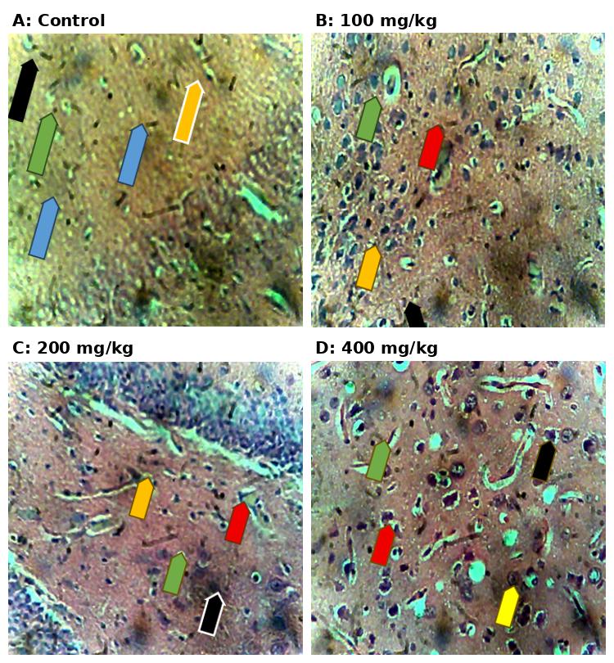
Figure 1. Representative photomicrographs of rat cerebral cortex (H&E, ×100). (A) Control group showing normal neuropil with resting, ramified microglia (black arrow), quiescent astrocytes (yellow arrow), and intact oligodendrocytes (green/blue arrows). (B) 100 mg/kg lead acetate: mild microglial activation (red arrow) and early gliosis (yellow arrow) with subtle vacuolation (green arrow). (C) 200 mg/kg lead acetate: moderate microglial clustering (black arrow), activated microglia (red arrow), and astrocytic gliosis (yellow arrow) with increased vacuolation (green arrow). (D) 400 mg/kg lead acetate: dense microglial clustering and amoeboid transformation (red arrow), marked astrogliosis (green arrow), and severe neuropil vacuolation/rarefaction (yellow arrow).

3.2 Serum Acetylcholine Concentration
Lead acetate administration produced a significant, dose-dependent increase in serum acetylcholine concentration (Figure 2). The control group recorded a mean acetylcholine level of approximately 730 pg/mL. Treatment with lead acetate elevated this value to approximately 850 pg/mL, 860 pg/mL, and 970 pg/mL in the 100, 200, and 400 mg/kg groups, respectively. The increases observed in the 100 and 200 mg/kg groups (superscript a) were statistically significant relative to control (p < 0.05), while the 400 mg/kg group (superscript b) showed a significantly greater elevation than both the control and the lower-dose groups. These findings indicate that lead acetate exposure elevates circulating acetylcholine in a dose-dependent manner, consistent with disrupted cholinergic neurotransmission and/or impaired acetylcholine catabolism.
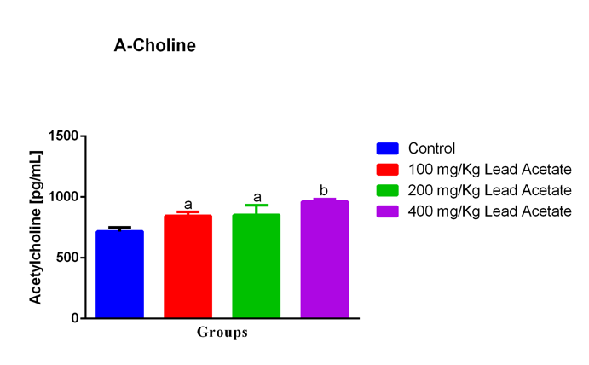
Figure 2. Serum acetylcholine concentration across experimental groups. Values are mean ± SEM (n = 5/group); bars not sharing a superscript letter differ significantly (a, b: p < 0.05 vs. control / between dose groups, one-way ANOVA with Duncan's Multiple Range Test).

3.3 Serum Acetylcholinesterase Activity
Acetylcholinesterase (AChE) activity declined significantly and in a dose-dependent fashion following lead acetate administration (Figure 3). The control group exhibited the highest AChE activity, at approximately 22 IU/L. Lead acetate exposure reduced AChE activity to approximately 18, 14.5, and 14.8 IU/L in the 100, 200, and 400 mg/kg groups, respectively. The reduction observed at 100 mg/kg (superscript a) was statistically significant relative to control, while the 200 and 400 mg/kg groups (superscript b) exhibited a more pronounced, statistically significant decrease. These findings indicate that lead acetate administration significantly inhibits AChE activity in a dose-related manner, with the greatest inhibition observed at the two higher doses.
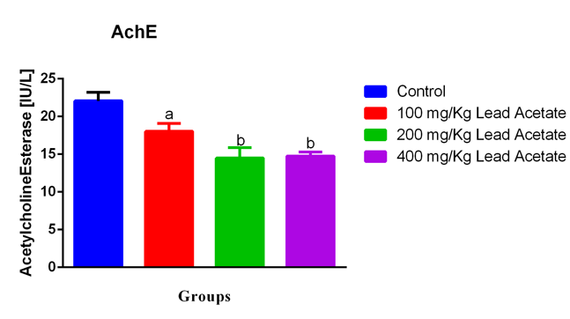
Figure 3. Serum acetylcholinesterase (AChE) activity across experimental groups. Values are mean ± SEM (n = 5/group); bars not sharing a superscript letter differ significantly (a, b: p < 0.05, one-way ANOVA with Duncan's Multiple Range Test).

3.4 Serum GABA Concentration
Serum GABA concentration was significantly reduced across all lead acetate-treated groups relative to control (Figure 4). The control group recorded the highest GABA level, at approximately 7.1 µmol/mL, compared with approximately 5.9, 6.1, and 4.6 µmol/mL in the 100, 200, and 400 mg/kg groups, respectively. All treated groups (superscript a) differed significantly from control (p < 0.05), with the greatest reduction in GABA concentration observed at the highest dose (400 mg/kg). These findings indicate that lead acetate administration suppresses GABA concentration, with a clear dose-related gradient of severity.
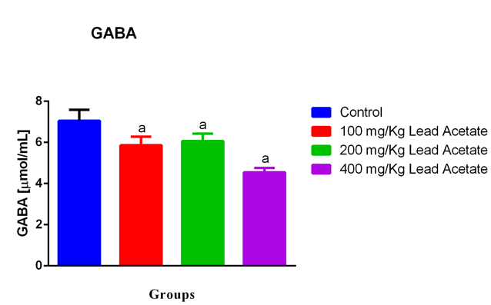
Figure 4. Serum γ-aminobutyric acid (GABA) concentration across experimental groups. Values are mean ± SEM (n = 5/group); bars sharing the same superscript letter (a) differ significantly from control (p < 0.05, one-way ANOVA with Duncan's Multiple Range Test).

4. Discussion
The present study demonstrates that 21 days of oral lead acetate administration produces a clear, dose-dependent triad of effects in the adult rat cerebral cortex: (i) progressive histopathological injury characterised by microglial activation, astrogliosis, and neuropil vacuolation; (ii) a paradoxical rise in serum acetylcholine accompanied by a reciprocal decline in acetylcholinesterase activity; and (iii) a graded suppression of GABA concentration. Considered together, these findings support a model in which lead-induced neuroinflammation and impaired neurotransmitter homeostasis act in concert, rather than independently, to compromise cortical integrity.

4.1 Histopathological Findings in the Context of Lead-Induced Neuroinflammation
The progressive shift observed here, from ramified, evenly spaced 'resting' microglia in control tissue to amoeboid, densely clustered microglia at the highest dose, recapitulates the classical morphological spectrum of microglial activation described in both general neuroinflammation and lead-toxicity literature ^{[11,12,14].} Ramified microglia continuously survey the neuropil without disrupting it, whereas activation drives process retraction, soma hypertrophy, and ultimately an amoeboid, phagocytically competent phenotype associated with pro-inflammatory cytokine release ^{[11,12].} Direct histological and molecular evidence that perinatal and adult lead exposure activates microglia (with up-regulation of Iba1 and the cytotoxic M1 phenotype markers Il1b, Il6, and Tnfa) and drives concomitant reactive astrogliosis, including disturbances in astrocytic glutamine synthetase, has previously been reported in rat models using comparable immunohistochemical endpoints ^{[13].} The concurrent astrocytic hypertrophy observed in the present study at increasing lead doses is consistent with this pattern and with reports that chronic and intermittent lead exposure produce hippocampal and cortical astrogliosis (increased glial fibrillary acidic protein expression) alongside microgliosis and presynaptic dysfunction in rats ^{[15].}
Mechanistically, this neuroinflammatory cascade is increasingly attributed to NLRP3 inflammasome activation within microglia. In a murine model of chronic lead exposure, Pb-induced learning and memory impairment was shown to depend on microglial NLRP3 inflammasome activation via mitochondrial reactive oxygen species production and calcium redistribution, an effect reversible by pharmacological or genetic NLRP3 inhibition ^{[16].} A related pathway implicates the autophagy-associated P62/Keap1/Nrf2 axis, whereby lead exposure promotes Keap1 accumulation, Nrf2 degradation, and consequent suppression of antioxidant defences such as haem oxygenase-1 and glutathione peroxidase, driving oxidative neuronal injury ^{[26].} These molecular cascades provide a plausible mechanistic substrate for the dose-dependent vacuolation, tissue rarefaction, and loss of normal cytoarchitecture observed at 200 and 400 mg/kg in the present study, and align with the broader principle that Pb²⁺ ionic mimicry of Ca²⁺ disrupts mitochondrial calcium handling and amplifies reactive oxygen species generation throughout the neuropil ^{[7,9].}

4.2 Cholinergic Dysregulation: Elevated Acetylcholine and Suppressed Acetylcholinesterase
The reciprocal pattern observed in the present study, rising acetylcholine alongside falling AChE activity, mirrors a substantial body of prior work linking lead exposure to cholinergic enzyme inhibition. In rats co-exposed to lead acetate and assessed for brain AChE activity, lead acetate alone produced a significant reduction in enzymatic activity together with increased malondialdehyde and depleted glutathione, indicating that AChE inhibition occurs within a broader context of oxidative stress rather than as an isolated enzymatic lesion ^{[20].} Similarly, in a model examining the interaction between nitric-oxide signalling and hypoxia resistance, lead-induced disturbances in the acetylcholine–acetylcholinesterase system tracked closely with indices of oxidative damage, reinforcing a mechanistic link between redox imbalance and cholinergic enzyme dysfunction following lead exposure ^{[27].} Naringenin-treated rats exposed to lead acetate likewise showed lead-induced downregulation of multiple brain neurotransmitter systems alongside oxidative and apoptotic injury, from which protection was conferred by antioxidant co-treatment, again supporting oxidative stress as the proximate driver of lead-induced cholinergic and neurochemical disturbance ^{[25].}
The functional significance of the resulting hyperacetylcholinergic state deserves emphasis. Acetylcholine is essential for attention and memory encoding, and pharmacological AChE inhibition is exploited therapeutically in Alzheimer's disease precisely because moderate increases in synaptic ACh can enhance cognitive performance ^{[18].} However, recent reviews have emphasised that this relationship is bidirectional: sustained or excessive central ACh accumulation, as would be expected from prolonged AChE inhibition, paradoxically impairs rather than enhances learning and memory, and has been implicated in cholinergic system dysfunction associated with both Alzheimer's and Parkinson's disease dementia ^{[18].} Within this framework, the marked elevation in acetylcholine observed at 400 mg/kg in the present study should not be interpreted as a compensatory or beneficial adaptation, but rather as a pathological consequence of impaired cholinergic clearance, with the potential to compound, rather than offset, the cognitive and behavioural deficits associated with lead exposure.

4.3 GABAergic Suppression and Excitatory–Inhibitory Imbalance
The dose-dependent decline in GABA concentration observed across all treated groups extends the cholinergic findings into the inhibitory neurotransmitter domain. GABA is the principal inhibitory neurotransmitter of the mature mammalian cortex, and its transport and synthesis are critical determinants of the excitatory–inhibitory (E/I) balance that underlies stable cortical network activity; disruption of glutamate–GABA transport dynamics has been directly linked to pathological network hyperexcitability ^{[21].} Because GABAergic interneurons and their signalling machinery are themselves products of, and contributors to, activity-dependent circuit refinement, sustained suppression of GABA — as observed here, with the greatest reduction at 400 mg/kg — would be expected to shift cortical microcircuits toward a state of relative disinhibition, a mechanism implicated in numerous neurodevelopmental and neurological disorders when GABAergic signalling is dysregulated ^{[22].}
Beyond its classical role in fast synaptic inhibition, GABA exerts direct immunomodulatory actions on glial and peripheral immune cells: activation of GABA receptors on immune cells has been shown to downregulate pro-inflammatory cascades, while conversely, inflammatory mediators can themselves alter GABA receptor composition, synthesis, and release, establishing a bidirectional crosstalk between GABAergic signalling and neuroinflammation ^{[23].} Viewed through this lens, the GABA suppression observed in the present study is unlikely to be mechanistically independent of the concurrent microglial and astrocytic activation documented histologically; rather, declining GABA may both result from, and further permit, unchecked glial inflammatory activity, creating a self-reinforcing cycle of disinhibition and neuroinflammation that intensifies with increasing lead dose.

4.4 Integration: A Multi-Mechanistic Model of Cortical Lead Neurotoxicity
Taken together, the histological and neurochemical findings of the present study are consistent with, and extend, a growing consensus that lead neurotoxicity in the cerebral cortex reflects the convergence of at least three interacting processes: (i) ionic mimicry-driven oxidative and mitochondrial injury ^{[7,9,10]} (ii) NLRP3 inflammasome-dependent microglial and astrocytic activation ^{[13,15,16]} and (iii) consequent dysregulation of both excitatory (cholinergic) and inhibitory (GABAergic) neurotransmission ^{[18,21,23].} This pattern is broadly consistent with findings from rats exposed to comparable lead acetate doses (50 mg/kg) for 4–8 weeks, in which motor cortex and cerebellar tissue showed oxidative stress, proteomic alterations in synaptic and survival-associated proteins, reduced mature neuron density, and disrupted histoarchitecture that paralleled motor performance deficits ^{[28,29].} Protective studies using curcumin, naringenin, and probiotic-derived interventions against lead acetate-induced neurotoxicity have similarly reported amelioration of oxidative stress markers and restoration of histological architecture when antioxidant or chelating co-treatments are administered, providing indirect confirmation that oxidative injury is a tractable upstream node in this pathway ^{[29,25,30].} The dose-response gradient observed across all four outcome measures in the present study, from mild at 100 mg/kg to severe at 400 mg/kg, further supports a threshold-sensitive, cumulative model of cortical injury rather than an all-or-none toxic response.

4.5 Public Health and Translational Relevance
These experimental findings carry direct relevance for human risk assessment, given that an estimated several hundred million children worldwide continue to register blood lead levels above the WHO reference value, with disproportionate representation in low- and middle-income settings where occupational and informal-sector lead exposure (battery recycling, mining, and contaminated consumer products) remains common ^{[4,5,6].} The global burden of lead-attributable disease, estimated in recent modelling at several trillion US dollars annually when cardiovascular mortality and IQ-related income loss are combined, is driven substantially by the same neurological and cardiovascular mechanisms explored mechanistically in the present rodent model ^{[4,2].} Insofar as cholinergic and GABAergic imbalance, together with neuroinflammatory glial activation, are reproducible and dose-sensitive endpoints in this model, they may serve as useful biomarkers for evaluating both the efficacy of candidate neuroprotective interventions and the adequacy of regulatory exposure limits.

4.6 Limitations and Future Directions
Several limitations should be acknowledged. First, neurochemical assays were performed on serum rather than dissected cortical tissue; while serum acetylcholine, AChE, and GABA are widely used surrogate indices of central cholinergic and GABAergic status, direct cortical or hippocampal tissue measurement would more precisely localise the observed neurochemical changes. Second, the 21-day exposure window, while sufficient to demonstrate clear dose-dependent injury, does not address whether these changes are reversible following cessation of exposure, nor does it capture the distinct vulnerability of the developing brain to lead, which is generally considered more severe than that of the mature brain ^{[3,6].} Third, the present design did not include direct molecular markers of the NLRP3 inflammasome, glial cytokine profile, or Nrf2/Keap1 pathway activity, nor behavioural correlates such as learning and memory testing; incorporating these endpoints in future work would help to causally link the observed histological and neurochemical changes to functional outcomes ^{[16,26].} Finally, group sizes (n = 5) were modest, consistent with the exploratory aims of this study, but would benefit from replication in larger cohorts powered to detect more subtle dose-response relationships.

5. Conclusion
Subacute oral exposure to lead acetate (100–400 mg/kg for 21 days) produced a clear, dose-dependent pattern of cerebral cortical injury in adult male Wistar rats, characterised histologically by progressive microglial activation, astrogliosis, and neuropil vacuolation, and neurochemically by a paradoxical elevation of serum acetylcholine, suppression of acetylcholinesterase activity, and decline in GABA concentration. These findings support a multi-mechanistic model of lead neurotoxicity in which oxidative, neuroinflammatory, cholinergic, and GABAergic disturbances are mechanistically interlinked rather than independent, and they reinforce the cerebral cortex as a sensitive and clinically relevant target of dose-dependent lead toxicity. Further studies incorporating direct cortical tissue analysis, molecular markers of glial and inflammasome activation, and behavioural assessment are warranted to clarify the causal sequence of these events and to evaluate candidate neuroprotective strategies.
Ethical Approval: All animal procedures were conducted in accordance with institutional and international guidelines for the care and use of laboratory animals, following review and approval by Nile University of Nigeria Abuja Animal Care and Use Committee/Ethics Committee.
Conflict of Interest: The authors declare no conflict of interest.

References
- Bereda, G. (2026). Global burden of lead exposure: Integrating epidemiology, molecular mechanisms, and mitigation approaches. Health Science Reports, *9*(3), e71952.
- Generalova, A., Davidova, S., & Satchanska, G. (2025). The mechanisms of lead toxicity in living organisms. Journal of Xenobiotics, *15*(5), 146.
- González-Villalva, A., et al. (2025). Lead systemic toxicity: A persistent problem for health. Toxicology, *515*, 154163.
- Peng, D., Wei, P., Li, Z., Wei, R., Li, H., & Li, S. (2025). The role of P62/Nrf2/Keap1 signaling pathway in lead-induced neurological dysfunction. CNS Neuroscience & Therapeutics. https://doi.org/10.1111/cns.70566
- Kurhaluk, N., et al. (2024). NO system in modulating lead-induced neurotoxicity in rats with different resistance to hypoxia. Cellular Physiology and Biochemistry, *58*, 597–629.
- Shvachiy, L., Amaro-Leal, Â., Outeiro, T. F., Rocha, I., & Geraldes, V. (2023). Intermittent lead exposure induces behavioral and cardiovascular alterations associated with neuroinflammation. Cells, *12*(5), 818.
- Mansour, L. A. H., Elshopakey, G. E., Abdelhamid, F. M., Albukhari, T. A., Almehmadi, S. J., Refaat, B., El-Boshy, M., & Risha, E. F. (2023). Hepatoprotective and neuroprotective effects of naringenin against lead-induced oxidative stress, inflammation, and apoptosis in rats. Biomedicines, *11*(4), 1080.
- Gąssowska-Dobrowolska, M., Chlubek, M., Kolasa, A., Tomasiak, P., Korbecki, J., Skowrońska, K., Tarnowski, M., Masztalewicz, M., & Baranowska-Bosiacka, I. (2023). Microglia and astroglia—the potential role in neuroinflammation induced by pre- and neonatal exposure to lead (Pb). International Journal of Molecular Sciences, *24*(12), 9903.
- Zhu, J., Zhou, F., Zhou, Q., Xu, Y., Li, Y., Huang, D., Chen, L., Liu, A., Zou, F., & Meng, X. (2023). NLRP3 activation in microglia contributes to learning and memory impairment induced by chronic lead exposure in mice. Toxicological Sciences, *191*(1), 179–191.
- Larsen, B., & Sánchez-Triana, E. (2023). Global health burden and cost of lead exposure in children and adults: A health impact and economic modelling analysis. The Lancet Planetary Health, *7*(10), e831–e840.
- Long, X., Wu, H., Zhou, Y., Wan, Y., Kan, X., Gong, J., & Zhao, X. (2022). Preventive effect of Limosilactobacillus fermentum SCHY34 on lead acetate-induced neurological damage in SD rats. Frontiers in Nutrition, *9*, 852012.
- Zhou, N., Huang, Y., Li, M., Zhou, L., & Jin, H. (2022). Trends in global burden of diseases attributable to lead exposure in 204 countries and territories from 1990 to 2019. Frontiers in Public Health, *10*, 1036398.
- Huang, Q., Liao, C., Ge, F., et al. (2022). Acetylcholine bidirectionally regulates learning and memory. Journal of Neurorestoratology, *10*(2), 100002.
- Vidal-Itriago, A., Radford, R. A. W., Aramideh, J. A., Maurel, C., Scherer, N. M., Don, E. K., Lee, A., Chung, R. S., Graeber, M. B., & Morsch, M. (2022). Microglia morphophysiological diversity and its implications for the CNS. Frontiers in Immunology, *13*, 997786.
- Cherubini, E., Di Cristo, G., & Avoli, M. (2022). Dysregulation of GABAergic signaling in neurodevelopmental disorders: Targeting cation-chloride co-transporters to re-establish a proper E/I balance. Frontiers in Cellular Neuroscience, *15*, 813441.
- Michalettos, G., & Ruscher, K. (2022). Crosstalk between GABAergic neurotransmission and inflammatory cascades in the post-ischemic brain: Relevance for stroke recovery. Frontiers in Cellular Neuroscience, *16*, 807911.
- Leão, L. K. R., Bittencourt, L. O., Oliveira, A. C. A., Nascimento, P. C., Ferreira, M. K. M., Miranda, G. H. N., Ferreira, R. O., Eiró-Quirino, L., Puty, B., Dionizio, A., Cartágenes, S. C., Freire, M. A. M., Buzalaf, M. A. R., Crespo-Lopez, M. E., Maia, C. S. F., & Lima, R. R. (2021). Lead-induced motor dysfunction is associated with oxidative stress, proteome modulation, and neurodegeneration in motor cortex of rats. Oxidative Medicine and Cellular Longevity, *2021*, 5595047.
- Ericson, B., et al. (2021). Blood lead levels in low-income and middle-income countries: A systematic review. The Lancet Planetary Health, *5*(3), e145–e153.
- Sears, S. M., & Hewett, S. J. (2021). Influence of glutamate and GABA transport on brain excitatory/inhibitory balance. Experimental Biology and Medicine (Maywood), *246*(9), 1069–1083.
- Lier, J., Streit, W. J., & Bechmann, I. (2021). Beyond activation: Characterizing microglial functional phenotypes. Cells, *10*(9), 2236.
- Fang, Y., Lu, L., Liang, Y., Peng, D., Aschner, M., & Jiang, Y. (2021). Signal transduction associated with lead-induced neurological disorders: A review. Food and Chemical Toxicology, *150*, 112063.
- Virgolini, M. B., & Aschner, M. (2021). Molecular mechanisms of lead neurotoxicity. Advances in Neurotoxicology, *5*, 159–213.
- Abubakar, K., Mailafiya, M. M., Danmaigoro, A., Chiroma, S. M., Rahim, E. B. A., & Zakaria, M. Z. A. B. (2019). Curcumin attenuates lead-induced cerebellar toxicity in rats via chelating activity and inhibition of oxidative stress. Biomolecules, *9*(9), 453.
- Rădulescu, A., & Lundgren, S. (2019). A pharmacokinetic model of lead absorption and calcium competitive dynamics. Scientific Reports, *9*, 14225.
- Sahin, Z., Ozkaya, A., Uckun, M., Yologlu, E., Kuzu, M., Comakli, V., Demirdag, R., Tel, A. Z., Aymelek, F., & Yologlu, S. (2019). Evaluation of the effects of Cyclotrichium niveum on brain acetylcholinesterase activity and oxidative stress in male rats orally exposed to lead acetate. Cellular and Molecular Biology (Noisy-le-grand), *65*(5), 3–8.
- Abdel Moneim, A. E. (2016). Indigofera oblongifolia prevents lead acetate-induced hepatotoxicity, oxidative stress, fibrosis and apoptosis in rats. PLOS ONE, *11*(7), e0158965.

