Outcomes of Lacrimal Sac Hydrostatic Pressure Application in Congenital Nasolacrimal Duct Obstruction in Infants: A Retrospective Cohort Study
Namrata Srivastava
Department of Optometry, Era University, Lucknow, Uttar Pradesh, India

Corresponding Author:
Dr. Namrata Srivastava
Email: nam.dropth@gmail.com

ABSTRACT
Background: Congenital nasolacrimal duct obstruction (CNLDO) is a common ocular disorder in infants characterized by persistent epiphora and mucopurulent discharge caused by blockage of the nasolacrimal duct. Although many cases resolve spontaneously within the first year of life, conservative management is usually recommended as the initial treatment. Lacrimal sac hydrostatic pressure application (HPA), a physician-performed pressure technique, has been proposed as an effective office-based intervention to relieve obstruction and accelerate symptom resolution.
Aim: To evaluate the efficacy and safety of lacrimal sac hydrostatic pressure application as a conservative treatment for infants with congenital nasolacrimal duct obstruction.
Methods: This retrospective cohort study included 179 infants (261 eyes) diagnosed with CNLDO who underwent HPA performed by a pediatric ophthalmologist. The procedure involved applying controlled downward pressure over the lacrimal sac to generate hydrostatic force within the nasolacrimal duct. Treatment success was defined as complete resolution of epiphora and/or mucopurulent discharge within 48 hours after the procedure. Patients were followed with a mean follow-up duration of 11.6 ± 13 months, and statistical analyses including logistic regression were used to determine predictors of success.
Results: Complete resolution after the first HPA occurred in 102 eyes (39.1%). Infants aged ≤6 months had significantly higher success compared with older infants (43.7% vs 30.9%, p = 0.04). Younger age was a significant predictor of success. A second HPA resulted in additional resolution in 12 eyes (26.1%) without major complications.
Conclusion:
Lacrimal sac hydrostatic pressure application is a safe, practical, and effective conservative treatment for CNLDO, particularly in infants younger than six months, and may reduce the need for surgical intervention.
Keywords:
Congenital nasolacrimal duct obstruction; hydrostatic pressure application; Crigler maneuver; infants; epiphora..

INTRODUCTION
Congenital nasolacrimal duct obstruction (CNLDO) is one of the most common ocular disorders affecting infants, with a reported incidence ranging from 6% to 20% during the first year of life [1–3]. The condition typically presents shortly after birth with persistent epiphora, mucopurulent discharge, and recurrent conjunctivitis.
The most common cause of CNLDO is incomplete canalization of the nasolacrimal duct resulting in a membranous obstruction at the valve of Hasner [4]. Other etiological factors include developmental abnormalities of the lacrimal drainage system, narrowing of the distal nasolacrimal duct, or proximal obstruction near the valve of Rosenmüller [4,5]. Prematurity has also been associated with a higher incidence of CNLDO due to delayed development of the lacrimal drainage pathway [6].
The natural history of CNLDO often involves spontaneous resolution, particularly during the first year of life, with reported resolution rates ranging from 78.4% to 96% [7]. Because of this high spontaneous resolution rate, conservative treatment is widely recommended as the initial management strategy [8–10]. Conservative approaches include observation, topical treatment when necessary, lacrimal sac massage performed by caregivers, and physician-performed hydrostatic pressure techniques.
The lacrimal sac compression technique, commonly known as the Crigler maneuver, was first described by Crigler in 1923 as a method to generate hydrostatic pressure within the nasolacrimal duct and rupture the obstructing membrane [11,12]. Subsequent studies have supported the role of massage techniques in promoting resolution of obstruction [13].
Several investigators have reported favorable outcomes with lacrimal sac massage performed by parents or caregivers, demonstrating success rates as high as 81%–96% [14–18]. Randomized controlled trials and observational studies have further confirmed the effectiveness of conservative treatment approaches for CNLDO [19].
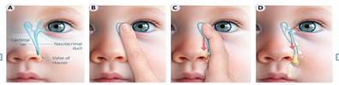
Figure 1 Hydrostatic pressure application (HPA) technique A: The anatomy of the nasolacrimal drainage system; B: The physician’s forefinger f inger is placed on the area overlying the lacrimal sac; C: The finger is pressed inwards and downwards. The arrow shows the motion of the compressed fluid within the nasolacrimal duct; D: The obstructing membrane at the valve of Hasner is ruptured, and the accumulated fluid can now drain into the inferior nasal meatus.
Hydrostatic pressure application performed by a physician in a clinical setting may offer advantages over home-based massage by ensuring proper technique and adequate pressure. This approach may lead to faster resolution of symptoms and improved outcomes in selected patients [20].
In addition to symptomatic discomfort, prolonged CNLDO has been associated with visual developmental concerns such as anisometropia and amblyopia risk factors [21–24]. Therefore, timely management of this condition is important to prevent long-term visual complications.
The present study aimed to evaluate the outcomes of physician-performed lacrimal sac hydrostatic pressure application in infants with congenital nasolacrimal duct obstruction and to identify factors associated with successful treatment.

METHOD

Study Design and Setting
This retrospective cohort study was conducted at Era University, Lucknow, India. Medical records of infants diagnosed with congenital nasolacrimal duct obstruction were reviewed.
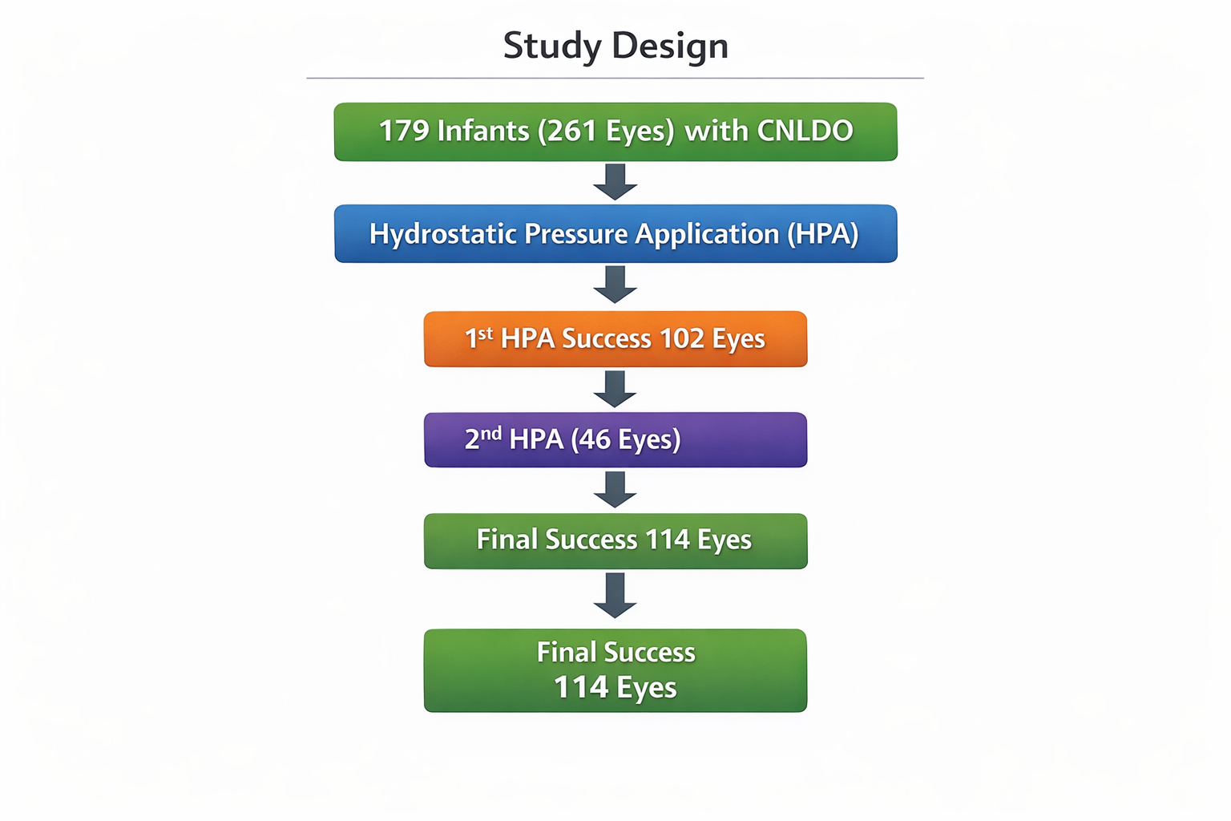
The study followed the principles of the Declaration of Helsinki and was approved by the institutional ethics committee.

Study Population
Infants were included if they had:
- Persistent epiphora
- Mucopurulent discharge
- Positive regurgitation on pressure over the lacrimal sac

Exclusion Criteria
The following patients were excluded:
- Congenital dacryocystocele
- Acute dacryocystitis
- Congenital ocular anomalies
- Previous lacrimal surgery

Procedure
Hydrostatic pressure application was performed by a pediatric ophthalmologist in the outpatient clinic.
The procedure involved:
- Stabilizing the infant’s head with assistance from a caregiver.
- Placing the forefinger over the lacrimal sac region.
- Applying firm downward pressure to generate hydrostatic force within the nasolacrimal duct.
- Repeating the maneuver 5–10 times during the session.
Parents were advised regarding follow-up visits and monitoring of symptoms.

Outcome Measures
The primary outcome was treatment success defined as:
Complete resolution of epiphora and mucopurulent discharge within 48 hours after the procedure.
Patients were followed up at:
- 1 week
- 1 month
- Additional visits if required
A second hydrostatic pressure application was performed in cases where symptoms persisted.

Statistical Analysis
Data were analyzed using descriptive statistics. Associations between clinical factors and treatment outcomes were evaluated using:
- Chi-square test
- Logistic regression analysis
A p-value <0.05 was considered statistically significant.

RESULT
A total of 194 patients (281 eyes) initially underwent hydrostatic pressure application (HPA) for the management of congenital nasolacrimal duct obstruction (CNLDO). Among these, 179 patients (261 eyes) completed the follow-up period and were included in the final analysis. Patients who did not complete follow-up were excluded to ensure accuracy and reliability of the outcome assessment. The mean age at presentation was 5.8 ± 5.9 months, indicating that most infants were treated during early infancy. Regarding laterality, unilateral CNLDO was observed in 97 patients (54.2%), whereas bilateral involvement was present in 82 patients (45.8%), demonstrating that both presentations were relatively common within the study population.
Following the first hydrostatic pressure application, complete resolution of symptoms—defined as disappearance of epiphora and mucopurulent discharge—was achieved in 102 eyes (39.1%). In contrast, 159 eyes (60.9%) continued to show persistent symptoms after the initial procedure.
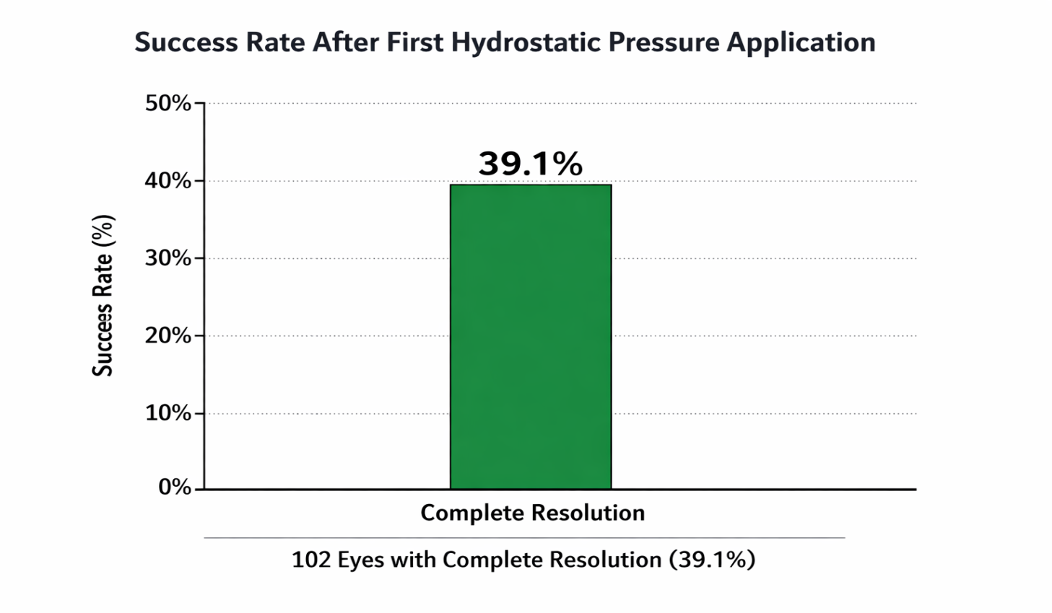 The overall treatment success rate after the first HPA procedure is illustrated in Figure 2, which visually represents the proportion of eyes achieving complete resolution compared with those that did not respond.
The detailed distribution of treatment outcomes after the first HPA procedure is summarized in Table 1.

Table 1. Success Rate after First Hydrostatic Pressure Application (HPA)
Outcome After First HPA | Number of Eyes | Percentage (%)
Complete Resolution | 102 | 39.1%
No Resolution | 159 | 60.9%
Total | 261 | 100%

Further subgroup analysis based on age revealed a significant difference in treatment outcomes. Infants aged ≤6 months demonstrated a higher success rate compared with infants older than six months (43.7% vs 30.9%, p = 0.04).
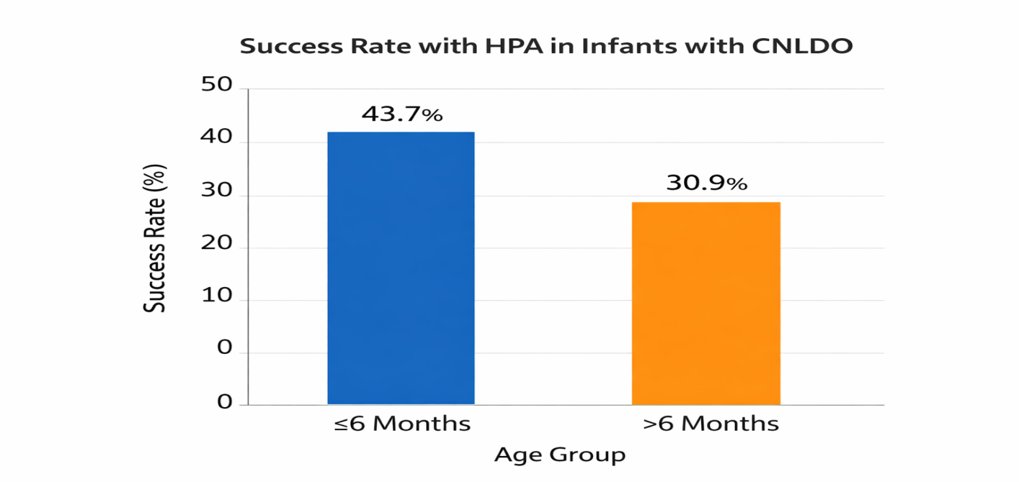
This difference highlights the importance of early intervention in improving treatment outcomes. The comparison between age groups is illustrated in Figure 2, which shows the variation in success rates according to age category.
The treatment outcomes according to age group are summarized in Table 2.

Table 2. Treatment Outcome by Age Group
Age Group | Success Rate (%) | Statistical Significance
≤ 6 Months | 43.7% | p = 0.04
> 6 Months | 30.9% | Significant difference
Logistic regression analysis further supported these findings, demonstrating that younger age was significantly associated with a higher likelihood of treatment success (odds ratio 0.93, p = 0.004). However, other clinical variables—including sex, prematurity, laterality of disease, and presenting symptoms—did not show any statistically significant association with treatment outcomes.
For cases that did not respond to the initial intervention, a second hydrostatic pressure application was performed in 46 eyes. Among these, 12 eyes (26.1%) achieved complete resolution following the second procedure, indicating that repeat application may provide additional benefit in selected patients.
Importantly, no major complications such as infection, canalicular injury, or bleeding were observed during or after the procedures. This finding supports the safety and feasibility of HPA as a conservative office-based treatment for infants with CNLDO.

DISCUSSION
The findings of this study demonstrate that hydrostatic pressure application performed by a trained physician is an effective conservative treatment for congenital nasolacrimal duct obstruction.
The overall success rate observed in this study is consistent with previously reported outcomes of hydrostatic pressure techniques [20]. Early treatment appears to play an important role in improving clinical outcomes, as infants younger than six months demonstrated significantly higher success rates.
Previous studies investigating lacrimal sac massage have reported high success rates, ranging from 81% to 96% [14–18]. However, these studies often involved prolonged follow-up periods during which spontaneous resolution could have occurred. In contrast, the present study defined treatment success within 48 hours of the procedure, which helps distinguish treatment effect from natural resolution.
The pathophysiology of CNLDO supports the effectiveness of hydrostatic pressure techniques. The obstruction is commonly due to a thin membranous barrier at the distal nasolacrimal duct that can be ruptured by sufficient pressure generated during lacrimal sac compression [4,5].
In addition to symptom resolution, early management of CNLDO is important because prolonged obstruction has been associated with refractive abnormalities and amblyopia risk factors [21–24]. Early intervention may therefore contribute to better visual development outcomes.
The results of this study suggest that physician-performed hydrostatic pressure application may serve as an effective early intervention before considering surgical probing procedures.

Limitations
The study has certain limitations:
- Retrospective design
- Single-center study
- Limited long-term outcome evaluation
Future multicenter prospective studies are recommended to further validate these findings.

CONCLUSION
Hydrostatic pressure application of the lacrimal sac represents a safe, effective, and minimally invasive conservative intervention for infants with congenital nasolacrimal duct obstruction (CNLDO). Our study demonstrates that performing this maneuver in a controlled clinical setting yields a substantial rate of symptom resolution, particularly in infants younger than six months, likely due to the pliability of the membranous obstruction and minimal chronic inflammation. Early intervention with this office-based procedure can significantly reduce the duration of epiphora and mucopurulent discharge, thereby improving the quality of life for both infants and caregivers while potentially minimizing the need for surgical probing. Moreover, timely management of CNLDO may play a critical role in preventing secondary visual complications such as anisometropia and amblyopia, which have been associated with prolonged obstruction. Given its safety profile, reproducibility, and rapid symptomatic relief, physician-performed hydrostatic pressure application should be considered an important first-line approach in the conservative management of CNLDO. Future multicenter prospective studies are warranted to further refine technique protocols, define long-term visual outcomes, and establish standardized guidelines for age-specific interventions.
Funding: None.
Conflict of interest: None declared.
Ethical approval: Not required (narrative review)

REFERENCES
- MacEwen, C. J., & Young, J. D. H. (1991). Epiphora during the first year of life. Eye, 5(5), 596-600.
- Sathiamoorthi, S., Frank, R. D., & Mohney, B. G. (2019). Incidence and clinical characteristics of congenital nasolacrimal duct obstruction. British Journal of Ophthalmology, 103(4), 527-529.
- Young, J. D., & MacEwen, C. J. (1997). Fortnightly review: Managing congenital lacrimal obstruction in general practice. Bmj, 315(7103), 293-296.
- Young, J. D., & MacEwen, C. J. (1997). Fortnightly review: Managing congenital lacrimal obstruction in general practice. Bmj, 315(7103), 293-296.
- Vagge, A., Ferro Desideri, L., Nucci, P., Serafino, M., Giannaccare, G., Lembo, A., & Traverso, C. E. (2018). Congenital nasolacrimal duct obstruction (CNLDO): a review. Diseases, 6(4), 96.
- Lorena, S. H. T., Silva, J. A. F., & Scarpi, M. J. (2013). Congenital nasolacrimal duct obstruction in premature children. Journal of Pediatric Ophthalmology & Strabismus, 50(4), 239-244.
- Sathiamoorthi, S., Frank, R. D., & Mohney, B. G. (2018). Spontaneous resolution and timing of intervention in congenital nasolacrimal duct obstruction. JAMA ophthalmology, 136(11), 1281-1286.
- Nucci, P., Capoferri, C., Alfarano, R., & Brancato, R. (1989). Conservative management of congenital nasolacrimal duct obstruction. Journal of Pediatric Ophthalmology & Strabismus, 26(1), 39-43.
- Sasaki, T., Matsumura, N., Miyazaki, C., Kamao, T., Yokoi, N., Fujimoto, M., ... & Committee for Congenital Nasolacrimal Duct Obstruction Clinical Guideline. (2024). Congenital nasolacrimal duct obstruction: clinical guideline. Japanese Journal of Ophthalmology, 68(4), 367-388.
- Heichel, J. (2024, October). Congenital nasolacrimal duct obstruction–early diagnosis and graded therapeutic approach as key points for successful management. In Seminars in Ophthalmology (Vol. 39, No. 7, pp. 510-520). Taylor & Francis.
- Hu, K., Patel, J., & Patel, B. C. (2020). Crigler Technique for Congenital Nasolacrimal Duct Obstruction.
- Crigler, L. W. (1923). The treatment of congenital dacryocystitis. Journal of the American Medical Association, 81(1), 23-24.
- Crigler, L. W. (1923). The treatment of congenital dacryocystitis. Journal of the American Medical Association, 81(1), 23-24.
- Karti, O., Karahan, E., Acan, D., & Kusbeci, T. (2016). The natural process of congenital nasolacrimal duct obstruction and effect of lacrimal sac massage. International ophthalmology, 36(6), 845-849.
- Bansal, O., Bothra, N., Sharma, A., Walvekar, P., & Ali, M. J. (2021). Congenital nasolacrimal duct obstruction update study (CUP study): Paper I—Role and outcomes of Crigler’s lacrimal sac compression. Eye, 35(6), 1600-1604.
- Lekskul, A., Preechaharn, P., Jongkhajornpong, P., & Wuthisiri, W. (2022). Age-specific outcomes of conservative approach and probing for congenital nasolacrimal duct obstruction. Clinical Ophthalmology, 1821-1828.
- Nanda, D., & Sarkar, M. (2022). Efficacy of lacrimal sac massage in management of congenital nasolacrimal duct obstruction in infants: an observational study of 853 cases from a single institute of Eastern Asia. Middle East African Journal of Ophthalmology, 29(4), 216-219.
- Srivastava, P., & Srivastava, N. (2023). A non-surgical conservative management of congenital dacryostenosis. Int. J. Community Med. Public Health, 10, 1459-1463.
- Asano, M., Takeuchi, M., Ohno, T., Nakamura, J., Mizuki, N., & Matsumura, N. (2024). Lacrimal sac massage for congenital nasolacrimal duct obstruction: a multicentre randomised controlled trial. British Journal of Ophthalmology, 108(9), 1281-1285.
- Stolovitch, C., & Michaeli, A. (2006). Hydrostatic pressure as an office procedure for congenital nasolacrimal duct obstruction. Journal of American Association for Pediatric Ophthalmology and Strabismus, 10(3), 269-272.
- Hareendran, H., Allapitchai, F., Ravindran, M., Shukul, K., & Rengappa, R. (2022). Anisometropia and refractive status in children with congenital nasolacrimal duct obstruction—a prospective observational study. Journal of American Association for Pediatric Ophthalmology and Strabismus, 26(2), 76-e1.
- Saleem, A. A., Siddiqui, S. N., Wakeel, U., & Asif, M. (2018). Anisometropia and refractive status in children with unilateral congenital nasolacrimal duct obstruction. Taiwan Journal of Ophthalmology, 8(1), 31-35.
- Vagge, A., Tulumello, C., Pellegrini, M., Di Maita, M., Iester, M., & Traverso, C. E. (2020). Amblyopia risk factors in newborns with congenital nasolacrimal duct obstruction. Journal of Pediatric Ophthalmology & Strabismus, 57(1), 39-43.
- Sims, D. T., Gillette, T. B., Lam, J. G., Liu, D., Lee, C., Ding, L., ... & Cabrera, M. T. (2024). Anisometropia and amblyopia outcomes in early versus late resolution of congenital nasolacrimal duct obstruction in older infants. Ophthalmic Plastic & Reconstructive Surgery, 40(1), 39-42.

