Healthcare Fraud Detection using Machine Learning Models in Big Data Environment

Anil Kumar Meher ¹
School of Computer Engineering, KIIT Deemed to be University,
Bhubaneswar, India
meheranil3@gmail.com
Rajesh Kumar Ojha ²
Department of Computer Science and Engineering, Silicon University, Bhubaneswar, India
rajesh.ojha@silicon.ac.in
Abhaya Kumar Sahoo ³
School of Computer Engineering,
KIIT Deemed to be University
Bhubaneswar, India
abhaya.sahoofcs@kiit.ac.in

Abstract- Big data analytics is one of the best ways to detect fraud by analyzing big data using machine learning and data mining. It helps organizations detect fraud quickly and accurately and reduce the risk of false positives and negatives. Scams such as ecommerce fraud, cyber-security threats, identity theft, fake bank accounts, money laundering, tax evasion, money laundering insurance and financial fraud pose a significant risk to consumers and businesses. These risks occur in many sectors, including retail, insurance, banking, healthcare, and insurance. Given the current security landscape, businesses are increasingly looking for risk management systems that combine advanced fraud prevention and rely on big data. For example, predictive modeling, alternative sources, and advanced machine learning techniques are helping policymakers develop new strategies and techniques to prevent fraud. Fraud, including e-commerce, insurance fraud, cyber-security threats, and financial fraud, poses a significant risk to individuals and businesses in the retail, insurance, banking, and healthcare sectors of the Chinese economy. To combat these risks, businesses are increasingly using fraud prevention technology and effective risk management strategies based on big data. For example, predictive modeling, alternative data sources, and advanced machine learning techniques are enabling decision-makers to develop new systems and methods to protect against fraud. This technology analyzes large amounts of data to identify patterns and anomalies that indicate fraud in the business, allowing businesses to take appropriate action. Fraud in financial and healthcare costs tens of billions of dollars each year, devastating financial institutions, creating personal impact on bank customers, and resulting in higher costs for patients. The strategies used to detect and prevent attempts to obtain money or property through fraud is nothing but fraud detection and prevention. Extortion information analytics has developed as a capable instrument within the battle against extortion, giving organizations with unused bits of knowledge around potential dangers and engaging them to anticipate, distinguish, and avoid false exchanges. By leveraging tremendous sums of information produced by day-to-day operations, extortion information analytics investigates designs and patterns of false behaviors, empowering businesses to fortify their security measures and secure their money related interface.
Keywords- Machine Learning, Deep Learning, Big Data, Fraud Detection, Artificial Intelligence, CMS;

Introduction
Big data is a key technology where data from various sources, including social media, financial transactions, IoT sensors, e commerce websites, and cloud infrastructure etc. are connected to the today’s digital world [1]. Healthcare and medical data is kind of a big data not because of its huge volume and size but also for its intricacy and timeliness [2]. Fraud has been described as the systematic abuse of the system of any profit-oriented organization, with the intention of taking undue advantage from the system [3]. There are many factors that influence the costs of healthcare and health insurance, including fraud, waste, abuse and false exercises [4]. False exercises can include a wide extend of cases, counting cash washing, cyber-security dangers, charge avoidance, false protections claims, fashioned bank checks, personality robbery, and psychological militant financing, and is predominant all through the monetary teach, government, healthcare, open division, and protections segments. To combat this developing list of openings for false exchanges, organizations are actualizing advanced extortion location and anticipation innovations and hazard administration procedures, which combine huge information sources with real-time checking, and apply versatile and prescient analytics methods, such as machine learning, to make a hazard of extortion score. Recognizing extortion with information analytics, extortion location program and apparatuses, and an extortion location and avoidance program empowers organizations to foresee customary extortion strategies, cross-reference information through robotization, physically and persistently screen exchanges and wrongdoings in genuine time, and translate unused and advanced plans. Extortion location and anticipation computer program is accessible in both restrictive and open source forms. Common highlights in extortion analytics program incorporate: a dashboard, information consequence and trade, information visualization, client relationship administration integration, calendar administration, budgeting, planning, multi-user capabilities, watchword and get to administration, Application Programming Interfacing (API), two-factor verification, charging, and client database administration. Healthcare fraud is classified as an international challenge and illegal actions, where perpetrators create a zero-sum game for maintenance costs that contribute to the cumulative effect on the quality of service [5]. Healthcare fraud includes billing for services undelivered or unnecessary, misrepresentation, or willful omission that are essential in determining benefits to be paid, rebilling, readmission, up-coding, unbundling, kickbacks practicing, and unjustified distribution of healthcare services and medications [6]. In the upcoming years, fraud transaction impacts the massive loss of capital as it is growing every year. For detecting the fraud automatically, e-system for detecting the fraud might be composed of a manual process and the expertise algorithm [7]. Healthcare data is highly dynamic and includes insurance claims, medical records, clinical data and provider data, all of which have posed a big challenge to traditional fraud detection algorithms [8]. Fraudulent activities are the cause of Healthcare fraud prevention. Enhancement of the efficiency and effectiveness of Medicare fraud detection systems is a key part of machine learning [9]. Current problem in healthcare will detect the fraud Using machine learning algorithm techniques such as strengths and suitability in addressing multiple aspects [10]. To improve medical outcomes and patient care, machine learning and deep learning techniques in healthcare are the key technologies used in the market [11]. By examining copious amounts of healthcare data to classify patterns of fraudulent activities, ML and AI play a vital role in mitigating healthcare fraud. Fraudulent billings like patterns comprised unintentional and intentional fraud for services are not provided [12]. Quality of service (QoS), standard protocol support, delay and bandwidth-limited and security and privacy etc. are the key challenges included for healthcare organizations [13].

By analyzing large datasets, enabling real-time monitoring and early anomaly detection; AI is advancing healthcare fraud detection by surpassing traditional auditing in efficiency and accuracy [14].Artificial Intelligence in healthcare refers to a variety of technologies, including as robotics, machine learning, and natural language processing that are intended to replicate human intelligence functions [15]. Fraud detection, a critical facet in safeguarding various industries, has evolved with the integration of Artificial Intelligence (AI) techniques [16]. Fraud data analytics methodologies can be categorized as either statistical data analysis techniques or artificial intelligence (AI). Statistical data analysis techniques include:
- Statistical parameter calculation, such as averages, quantiles, and performance metrics
- Regression analysis - estimates relationships between independent variables and a dependent variable
- Probability distributions and models
- Data matching - used to compare two sets of collected data, remove duplicate records, and identify links between sets
- Time-series analysis

AI techniques include:
- Data mining - data mining for fraud detection and prevention classifies and segments data groups in which millions of transactions can be performed to find patterns and detect fraud
- Neural networks - suspicious patterns are learned and used to detect further repeats
- Machine Learning - fraud analytics Machine Learning automatically identifies characteristics found in fraud
- Pattern recognition - detects patterns or clusters of suspicious behavior

The four most crucial steps in the fraud prevention and detection process include:
- Capture and unify all manner of data types from every channel and incorporate them into the analytical process.
- Continually monitor all transactions and employ behavioral analytics to facilitate real-time decisions.
- Incorporate analytics culture into every facet of the enterprise through data visualization.
- Employ layered security techniques.

Extortion location and anticipation analytics depends on information mining and Machine Learning, and is utilized in extortion analytics utilize cases such as installment extortion analytics, money related extortion analytics, and protections extortion location analytics. Information mining uncovers important designs, turning crude, huge datasets into profitable data. Machine Learning at that point submits that data to either Administered or Unsupervised calculations. Directed Machine Learning calculations, such as calculated relapse and time-series examination, learn from verifiable information and distinguish designs of intrigued that require advance examination. Unsupervised machine learning calculations, such as cluster examination and peer gather analysis, examines information without any distinguished extortion and uncovers unused peculiarities and designs of intrigued. Information investigators and researchers can at that point act on these peculiarities.

Big Data Analytics (BDA) is increasingly relevant in this context, offering powerful tools to enhance payment accuracy and fraud detection [17]. Most of the healthcare Intelligence applications are used by Big Data. So that the competitive advantages by developing smart business solutions will help hospitals, payers and healthcare agencies augment [18]. Medicare is being used to protect fraud and patient treatment which is an outlet of Big Data. Reliable and affordable care like Medicare significantly impacts insurance schemes' for healthcare fraud [19]. The ability to detect fraud in medical claims seems to be a major asset on the expenditure control stated by the international literature [20]. Successful application of big data technologies to support analytics has the potential to improve the health of the population and ultimately to save lives in healthcare sectors [21]. The potential of large records technology to address sizeable amounts of statistics in real-time is certainly one of their key advantages for fraud detection, so that fraud can be determined and stopped earlier than it has a major terrible effect. Large facts technology can also spot robbery that changed into formerly unknown and might have gone overlooked using greater traditional methods. [22]. The combination of huge facts generation with synthetic Intelligence (AI) has the potential to revolutionize patient-centered care and cozy facts control inside the healthcare industry, enhancing each operational performance and health consequences. Advanced technologies like system mastering and huge records analytics, which provide strong defenses in opposition to the developing risk of fraudulent activities, are turning into greater and extra essential in the healthcare industries for detecting fraud [23]. Governments can use tools like Tableau, Power BI, and Spark to benefit patients, pharmacies, and physicians, ultimately helping to build business trust, and address the impact of rising health care costs and fraud. Electronic health data sets which are large-scale and complex things that make difficult or even impossible the management of all the information with any traditional software or hardware or using common data management tools which is nothing but healthcare big data [24]. In the below three phase architectural diagram it is clearly mentioned that the data are collected and selected from Medicare source and processed through the popular big data tool called Spark whose role is to increase the performance of huge data processing and reduce the time required to process the data. Not only that but also it will handle the outliers, missing data and duplicate data etc. as a part of data filtration. After that the data visualization will happen through the tools like Power Bi and Tableau.

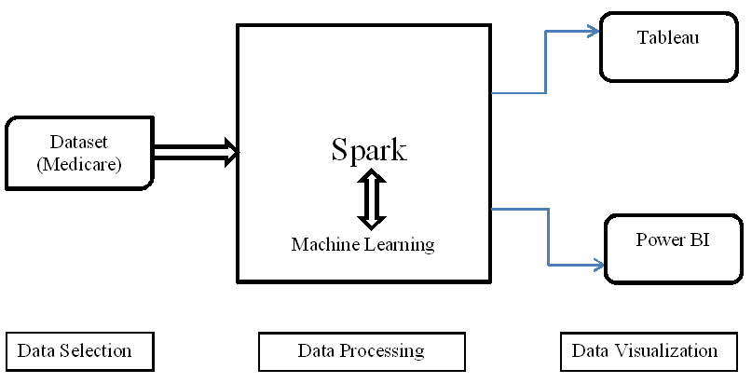

Figure 1. Architecture of data warehouse

Machine learning method has been integrated into the medical big data analysis platform to provide decision support for auditors in the medical insurance claims system to assess the possibility of fraud [25]. Healthcare fraud occurs when a person or organization intentionally misleads a doctor, insurance company, or patient in order to gain certain benefits. This can take many forms, including billing for services that were not performed, providing false information, and using someone else’s insurance information. These actions can lead to improper payments or financial benefits to the person or organization involved, ultimately increasing medical costs for patients and insurance companies. Healthcare fraud is a serious crime that can result in fines and penalties, including civil penalties, prison sentences, and loss of government health benefits [26]. The rise of health insurance fraud in recent years has raised alarms in the healthcare industry. This exposes individuals and physicians who engage in fraudulent practices designed to lead to medical malpractice. It involves detecting fraud such as medical claims and false claims that can cause financial harm to insurance companies and related parties in terms of good treatment. Individuals and physicians are receiving unauthorized, unauthorized benefits when paying for medical and surgical expenses. Fraud can originate from physicians, secretaries, or illegal activities. With medical solutions, doctors can crack down on fraud, ensuring fair payment and preserving the financial stability of insurance companies, which is important for maintaining the integrity of healthcare. This paper is dedicated to creating a large database with practical applications at the intersection of medical and preventive medicine. The health insurance case was studied because healthcare fraud is an international problem that results in the loss of millions of dollars worldwide [27]. Our goal is to develop a model using anomaly analysis to predict fraud in the health insurance sector. If we can detect fraud accurately, there are many benefits. Some of the benefits include prevention and cost reduction, early detection of extortion, no criminals being sought after payment, and smart and legal fees. A smarter way to work together and results need to be delivered, regardless of whether that cost impacts the importance of your own business or the importance of the open source content you work with. Fraud prevention will be easier when our models understand that we can help provide additional information to access any type of fraud. It helps to find patterns by comparing them with each other. As events show, analysis can be done step by step and goals are achieved faster. Programs such as the Medicare Fraud Strike Force, enacted to help combat fraud, but continued efforts are needed to better mitigate the effects of fraud which are initialized by government. It affects many people and results in significant financial burdens for individuals and governments as healthcare fraud is a crime [28].

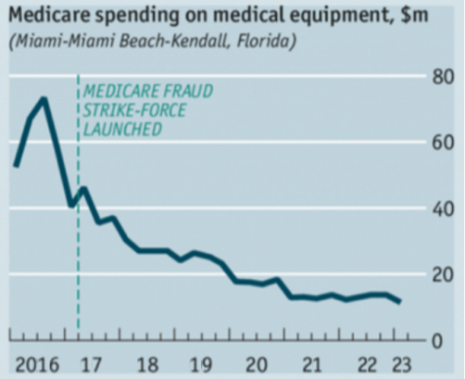

Figure 2. Medicare data analysis

- Motivation
Healthcare fraud detection has become a paramount concern for the medical insurance industry necessitating the development of efficient detection systems [29]. Healthcare systems globally face a significant challenge due to fraud, which impacts both their financial stability and moral principles [30]. Machine learning systems thrive on bigger data because it provides the system with more examples of good and bad, for example, real and fake customers. This means the model can identify differences and similarities in behavior and use this to predict fraud in future transactions. Machine learning is like having teams of analysts analyze hundreds of thousands of questions and compare the results to find the best ones - all on the fly, in milliseconds. Machine learning can do all the dirty work of profile analysis in a fraction of the time it takes 100 fraud analysts. Unlike humans, machines can perform repetitive, complex tasks 24/7, requiring additional human judgment only when specific insights are needed. Machine learning models can learn from behavioral patterns. They can quickly adapt to changes in normal behavior and detect patterns of deception.
- Healthcare has become a significant source of financial expenditure in most countries. According to National Healthcare Anti-Fraud Association (NHCAA), healthcare fraud causes loss in the tens of billions of dollars annually [31].
- According to the research of The Healthcare Research Market, US healthcare spending will be increased by 10% from 2025 to 2030 expectedly.
- Healthcare accounts increased up to USD 5 trillion in 2024.
- Fraud impact is estimated up to 15%.
- Approximately 17 billion to 57 billion funds were miss-utilized through healthcare frauds under the healthcare supported scheme, according to an estimate [32].
- The annual financial losses due to Medicare fraud in the United States is equivalent to 3–10% of healthcare expenditures, according to the Coalition Against Insurance Fraud [33].

- Contribution
- Building innovative machine learning model that predicts fraud in the medical industries.
- Tested with multiple models to get the good accuracy.
- Used anomaly analysis to visualize the fraud analysis.

- Organization
In this paper, section II tells about the literature review where multiple articles have been analyzed with comparison study among the features used. In section III we have discussed about the research methodology which tells the workflow of the detail study of this research paper. Section IV provides the result and discussion. Section V elaborates about the future scope of the study. Section VI concludes the paper.

LITERATURE REVIEW

Fraud in healthcare causes significant losses to individuals, organizations, and governments. Combating healthcare fraud has proven to be a critical issue. For this reason, some researchers have developed medical fraud techniques. A passage for stealers to manipulate the data, leading to a severe financial loss crisis for the healthcare sectors has been developed for the growth of assisting connected devices and communication technologies [34]. To detect, identify, and report fraud in the system is the job of fraud detection. Medicare is the United States’ public health insurance program. The mission of United States’ public health insurance program is to provide insurance for people aged 65 and over. It is important to note that Medicare is sporadically compromised by fraudulent insurance claims [35]. Medicare fraud has been defined by the Centers for Medicare and Medicaid Services (CMS) as submitted or caused to have been submitted, false acquisitions, or misrepresentations of facts that have obtained federal health care payment for which no entitlement would have otherwise existed [36]. The Centers for Medicare and Medicaid Services (CMS) publishes medical records that investigators often use to detect health care fraud. Develop applications for health insurance verification using big data to detect fraud, abuse, waste and errors. These applications can help private health insurance companies identify hidden costs that cannot be detected in the market, and can be used to detect health insurance claim fraud. Develop innovative research models to help predict fraud in the health insurance industry using real-time analytics and classification algorithms. Improper delivery of health care is a serious problem that significantly harms Medicare/Medicaid and the economy of savings. CMS relies on it to detect and prevent abuse, waste, and fraud in Part D programs. However, when similar techniques are used, each model can be miss-defined by experts. As a result, it turns out that these examples can be false or prohibitively expensive to detect. There are four types of extortion: fraud by service providers (doctors, hospitals and pharmacies), fraud by insurance companies (patients or employers of patients), fraud by insurance companies, and conspiracy to commit fraud (any party). Estimates from organizations like the National Health Care Anti-Fraud Association (NHCAA) suggest that healthcare fraud accounts for 3–10% of total healthcare expenditure annually, amounting to billions of dollars in preventable losses [37]. After conducting an in depth assessment of the associated literature, we finish that many authors have proposed answers for fraud detection in healthcare and feature additionally carried out the information-mining, particularly machine-mastering algorithms. Large numbers of fraud detection research tasks are efficaciously carried out global from neighborhood to national ranges to control healthcare fraud. The studies initiatives range in records units, healthcare frauds, analysis scale and techniques. The main goal of this article is to create a simple data model to show the connection between certain data and to distinguish the main tasks of ransom ware detection and finding best models to detect the fraud analysis. We have taken multiple articles to find a comparison study on fraud detection using different machine learning algorithms.

Year | Authors | Methods/  Algorithms | Datasets | Tools Used | Objectives | Remarks
2025 | Fourkiotis et al. | SMOTE-ENN | Kaggle dataset | Python | Designing of deployment-oriented framework for fraud analytics | N/A
2024 | Prova et al. | Random Forest | Medicare dataset | Python | Leveraging diverse ML techniques to combat healthcare fraud effectively. | N/A
2024 | Bounab, Rayene, et al. | SMOTE-ENN, Random Forest, Decision Tree, Logistic Regression | Medicare data Physician and Other Practitioners | Python | Increase model performance on noisy data | N/A
2021 | Ai et al. | Range of classifier algorithms | N/A
2021 | Ekin et al. | Random forest, Naive Bayes, Support vector machines, k-nearest neighbor, Neural nets, Linear discriminant analysis, Quadratic discriminant analysis, Random walk oversampling, random under sampling, SMOTE, Majority weighted Minority oversampling, PCA, Remotion | CMS Medicare Provider Utilization and Payment Data: Physician and Other Supplier, CMS Medicare Geographic Variation Public Use File, CMS Physician Fee schedules
2019 | Zafari and Ekin | Structural topic modelling and concentration functions | CMS Medicare Prescriber Part D
2019 | Sadiq et al. | Bump hunting, Propensity matching, inertia based clustering, mixed variable cosine distance | CMS Medicare
2019 | Herland et al. | Logistic regression, Gradient Boosted Trees and Random Forest | CMS Medicare Provider Utilization and Payment Data: Physician and Other Supplier, Prescriber and DMEPOS data calendar year
2019 | Fan et al. | Logistic regression, Naïve Bayes, SVM and decision tree | CMS Part B, Part D and DMEPOS, Social media data (healthgrades.com) | N/A | To detect physician fraud using open data | LEIE Database and Board actions

Table 1. Comparison study on healthcare-based articles

RESEARCH METHODOLOGY

The methodology of this article will be based on the following steps:
- Exploration, cleansing and preparation of data
- To join all datasets, build a simple data model
- For different fraud patterns, use feature engineering to choose the effective feature sets
- For detecting different fraud patterns, build a machine learning model
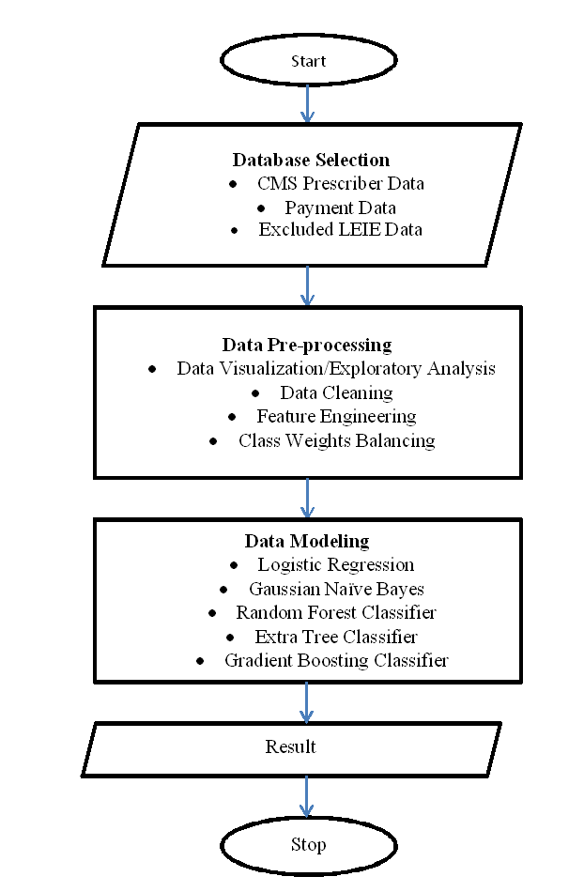

Figure 3. Workflow of fraud detection model

- Dataset Selection:
There are total 21 sections available in the dataset and it incorporates the accompanying key data like all medicines accumulated at the doctor and medication level, all data on usage, installments, and submitted charges by National Provider Identifier (NPI). Because of past medicinal services extortion, the database contains a rundown of people and substances that are prohibited from taking an interest in governmentally financed social insurance programs. LEIE dataset we have taken is the semi-named information, on the grounds that LEIE is not a misrepresentation data rather it is the fraudster-based objective.

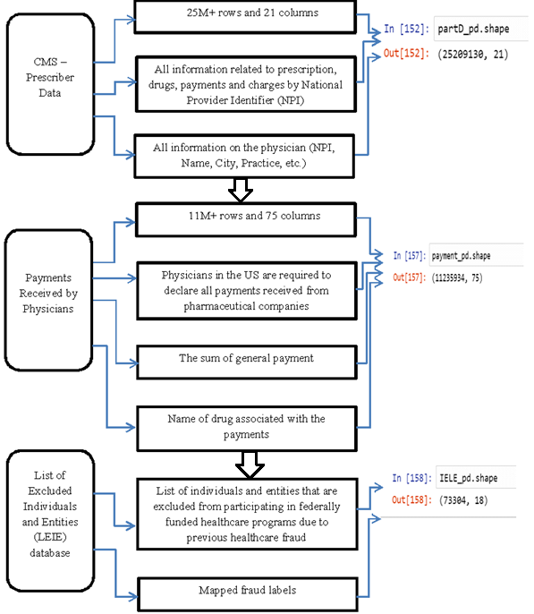

Figure 4. Dataset selection process

- Data pre-processing and cleaning:
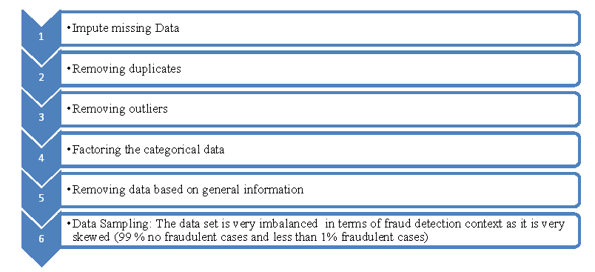

Figure 5. Data pre-processing and cleaning process workflow

- Drug-based fraudulent cases:
Fake medications that are not approved by health authorities, do not contain active ingredients, or contain the wrong amount are analyzed. Counterfeit drugs can also be mislabeled or have inaccurate packaging are included here. Making false claims about a drug's efficacy, expiration date, or storage methods are also the concern in the dataset taken. Marketing a drug for a use that is not approved by the FDA are also some fraudulent data. Paying physicians or others to increase prescriptions of a company's drugs, submitting claims for payment that violate government rules and Inflating expenses or failing to pay rebates are filtered here.

- Transforming Data
Using some class balancing techniques like under-sampling and over-sampling reduces the number of majority class samples to balance the sample proportions between classes and replicates or generates minority class samples to increase their quantity.

- Data Modeling:
We have used samples to create models that can assign new observations to one of the two groups using some methods like Logistic Regression, Gaussian NB, Random Forest, Extra Trees and Gradient Boosting and these samples are consisting of fraudulent and non-fraudulent records.

RESULT AND DISCUSSION

Around an amount of tens billions in dollars in healthcare fraud in the United States signifies a considerable illicit financial drain with estimations suggesting annual losses [38]. Association of Certified Fraud Examiners estimating annual losses exceeding $100 billion in the United States alone in healthcare fraud constitutes one of the most significant challenges facing modern healthcare systems, right now [39]. As the US Department of Justice and the Department of Health and Human Services has reported USD 2.6 lost in 2019 for fraud recoveries, Healthcare insurance fraud poses a substantial financial challenge [40].With the increasing number of population in US, healthcare fraud detection is essential now days. We have analyzed all types of fraud pattern. Out of 5 models performed, best resulting model is Random Forest with AUC 72 %.

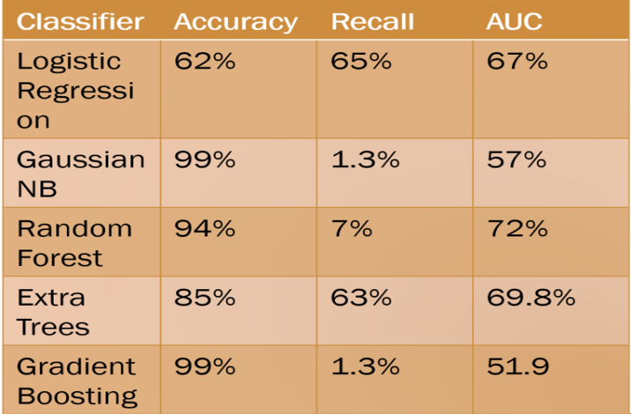

Figure 6. Model evaluation using different models

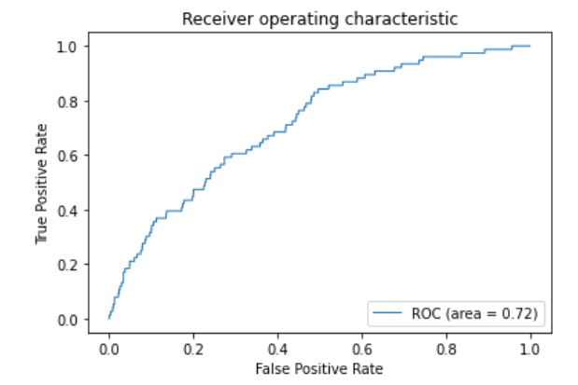

Figure 7. Model evaluation through data visualization

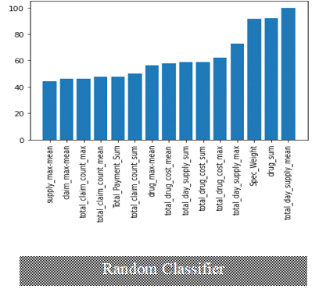

Figure 8. Model evaluation through Random Classifier

FUTURE SCOPE AND CHALLENGES

After examining different studies on health research, it can be concluded that fraud or abuse in health insurance will take different forms. More research is needed using advanced data mining and machine learning techniques to detect suspicious patterns. New methods should be proposed by considering the smallest details of medical records. To achieve this goal, the relationship between different clinical data can be determined. By integrating modern fraud detection tools with existing fraud detection software, healthcare organizations can implement effective and comprehensive data analytics. This approach will unlock insights, help reduce fraud, and improve risk management. The trend in fraud detection will evolve towards greater use of machine learning and neural networks to predict and identify fraudulent activities.
- For sampling the data into train-test split, we have to use cross validation.
- To increase the overall performance of the algorithm, we have to use hyper-parameter tuning.
- Using ML flow and Kafka we have to build a real-time fraud detection pipeline.
Because the users will keep interacting, the model needs to be retrained without stopping the prediction service.

CONCLUSION

As digital finance grows globally, fraud management is critical to reducing revenue and maintaining customer trust. AI and cloud-based detection enable modern systems to prevent the volume and efficiency of financial fraud. Best practices that leverage advanced analytics and shared intelligence enable organizations to improve fraud prevention. Platforms like Focal AI help bring cutting-edge technology to life without complex configuration, resulting in faster time to value. Healthcare fraud is a serious crime that affects everyone, and it’s a cost that everyone should be aware of - government officials and taxpayers, insurance companies and taxpayers, healthcare professionals and patients - and it’s a fact we can’t ignore. By taking steps to protect ourselves from healthcare fraud, we are helping to protect the integrity of our nation’s healthcare system and resources. That’s a big deal, but we’re not investing in it. The complexity and high cost of healthcare make it a prime target for fraud. Health insurance is a focus as the population ages. The Centers for Medicare and Medicaid Services (CMS) and other agencies continue to work to reduce fraud. While this problem is old, using publicly available Medicare information to detect and prevent fraud is newer. Effective machine learning solutions can reduce the incidence of fraud and reduce the resources needed to investigate fraud cases. This study demonstrates the benefits of health insurance audits from a decision-making perspective and provides a valuable foundation for future research using supervised and unsupervised studies to determine health insurance. This study aims to continue to improve efficiency and create a more informative and effective way to detect fraud in Medicare records.

REFERENCES

[1] Johnson, J. M., & Khoshgoftaar, T. M. (2023). Data-centric ai for healthcare fraud detection. SN Computer Science, 4(4), 389.
[2] Thaifur, A. Y. B. R., Maidin, M. A., Sidin, A. I., & Razak, A. (2021). How to detect healthcare fraud?“A systematic review”. Gaceta sanitaria, 35, S441-S449.
[3] Nabrawi, E., & Alanazi, A. (2023). Fraud detection in healthcare insurance claims using machine learning. Risks, 11(9), 160.
[4] Mehbodniya, A., Alam, I., Pande, S., Neware, R., Rane, K. P., Shabaz, M., & Madhavan, M. V. (2021). [Retracted] Financial Fraud Detection in Healthcare Using Machine Learning and Deep Learning Techniques. Security and Communication Networks, 2021(1), 9293877.
[5] Sayem, M. A. (2024). A Quantitative Analysis of Healthcare Fraud and Utilization of AI for Mitigation (Master's thesis, University of North Alabama).
[6] Mohammed, M. A., Boujelben, M., & Abid, M. (2023). A novel approach for fraud detection in blockchain-based healthcare networks using machine learning. Future Internet, 15(8), 250.
[7] Kumari, S. (2018, February). Big data analytics for healthcare system. In 2018 IADS international conference on computing, communications & data engineering (CCODE) (pp. 7-8).
[8] Georgakopoulos, S. V., Gallos, P., & Plagianakos, V. P. (2020, June). How to Extract and Explore Big Data for Fraud Detection in the Healthcare Sector: The EOPYY Case Study. In MIE (pp. 1307-1308).
[9] Abbassi, H., El Alaoui, I., & Gahi, Y. (2022, June). Fraud detection techniques in the big data era. In Proceedings of the 2nd international conference on big data, modelling and machine learning (Vol. 1, pp. 161-170).
[10] Ayusha, K., Parmar, H., Chhangani, B., & Kamble, A. (2023). The impact of big data on fraud investigations. Vidhyayana-An International Multidisciplinary Peer-Reviewed E-Journal-ISSN 2454-8596, 8(si7), 444-460.
[11] Harry, A., & Khan, A. (2024). Leveraging Artificial Intelligence and Big Data: A Comprehensive Examination of Workforce Performance Enhancement, Fraud Detection in the Petroleum and Banking Sectors, Healthcare Innovations, and Ethical Considerations in Information Management Systems. BULLET: Jurnal Multidisiplin Ilmu, 3(5), 638-647.
[12] Alexandru, A. G., Radu, I. M., & Bizon, M. L. (2018). Big Data in Healthcare-Opportunities and Challenges. Informatica economica, 22(2).
[13] Zhou, S., He, J., Yang, H., Chen, D., & Zhang, R. (2020). Big data-driven abnormal behavior detection in healthcare based on association rules. IEEE Access, 8, 129002-129011.
[14] Hamid, Z., Khalique, F., Mahmood, S., Daud, A., Bukhari, A., & Alshemaimri, B. (2024). Healthcare insurance fraud detection using data mining. BMC Medical Informatics and Decision Making, 24(1), 112.
[15] Amponsah, A. A., Adekoya, A. F., & Weyori, B. A. (2022). A novel fraud detection and prevention method for healthcare claim processing using machine learning and blockchain technology. Decision Analytics Journal, 4, 100122.
[16] Matloob, I., Khan, S. A., Rukaiya, R., Khattak, M. A. K., & Munir, A. (2022). A sequence mining-based novel architecture for detecting fraudulent transactions in healthcare systems. IEEE Access, 10, 48447-48463.
[17] Matloob, I., Khan, S. A., & Rahman, H. U. (2020). Sequence mining and prediction-based healthcare fraud detection methodology. IEEE Access, 8, 143256-143273.
[18] Lu, J., Lin, K., Chen, R., Lin, M., Chen, X., & Lu, P. (2023). Health insurance fraud detection by using an attributed heterogeneous information network with a hierarchical attention mechanism. BMC Medical Informatics and Decision Making, 23(1), 62.
[19] Hancock, J. T., Wang, H., Khoshgoftaar, T. M., & Liang, Q. (2024). Data reduction techniques for highly imbalanced medicare Big Data. Journal of Big Data, 11(1), 8.
[20] El-Enen, M. A. A., Tbaishat, D., Sahlol, A. T., Nazir, A., AlMaymun, K., AbdulRazek, M., ... & Sharma, R. (2024). Fraud Detection in Medical Insurance Claims Using Majority Voting of Multiple Unsupervised Algorithms. Procedia Computer Science, 244, 9-22.
[21] Sheeran, M., & Steele, R. (2017, October). A framework for big data technology in health and healthcare. In 2017 IEEE 8th Annual Ubiquitous Computing, Electronics and Mobile Communication Conference (UEMCON) (pp. 401-407). IEEE.
[22] Alexandru, A. G., Radu, I. M., & Bizon, M. L. (2018). Big Data in Healthcare-Opportunities and Challenges. Informatica economica, 22(2).
[23] Zhou, S., He, J., Yang, H., Chen, D., & Zhang, R. (2020). Big data-driven abnormal behavior detection in healthcare based on association rules. IEEE Access, 8, 129002-129011.
[24] Hamid, Z., Khalique, F., Mahmood, S., Daud, A., Bukhari, A., & Alshemaimri, B. (2024). Healthcare insurance fraud detection using data mining. BMC Medical Informatics and Decision Making, 24(1), 112.
[25] Amponsah, A. A., Adekoya, A. F., & Weyori, B. A. (2022). A novel fraud detection and prevention method for healthcare claim processing using machine learning and blockchain technology. Decision Analytics Journal, 4, 100122.
[26] Matloob, I., Khan, S., Rukaiya, R., Alfraihi, H., & Ali Khan, J. (2025). Healthcare fraud detection using adaptive learning and deep learning techniques. Evolving Systems, 16(2), 72.
[27] Prova, N. N. I. (2024, August). Healthcare fraud detection using machine learning. In 2024 Second International Conference on Intelligent Cyber Physical Systems and Internet of Things (ICoICI) (pp. 1119-1123). IEEE.
[28] Bounab, R., Zarour, K., Guelib, B., & Khlifa, N. (2024). Enhancing medicare fraud detection through machine learning: Addressing class imbalance with SMOTE-ENN. IEEE Access, 12, 54382-54396.
[29] Matloob, I., Khan, S. A., Rukaiya, R., Khattak, M. A. K., & Munir, A. (2022). A sequence mining-based novel architecture for detecting fraudulent transactions in healthcare systems. IEEE Access, 10, 48447-48463.
[30] Matloob, I., Khan, S. A., & Rahman, H. U. (2020). Sequence mining and prediction-based healthcare fraud detection methodology. Ieee Access, 8, 143256-143273.
[31] Lu, J., Lin, K., Chen, R., Lin, M., Chen, X., & Lu, P. (2023). Health insurance fraud detection by using an attributed heterogeneous information network with a hierarchical attention mechanism. BMC Medical Informatics and Decision Making, 23(1), 62.
[32] Arockiam, J. M., & Pushpanathan, A. C. S. (2023). MapReduce-iterative support vector machine classifier: novel fraud detection systems in healthcare insurance industry. International Journal of Electrical and Computer Engineering (IJECE), 13(1), 756.
[33] Hancock, J. T., Wang, H., Khoshgoftaar, T. M., & Liang, Q. (2024). Data reduction techniques for highly imbalanced medicare Big Data. Journal of Big Data, 11(1), 8.
[34] El-Enen, M. A. A., Tbaishat, D., Sahlol, A. T., Nazir, A., AlMaymun, K., AbdulRazek, M., ... & Sharma, R. (2024). Fraud Detection in Medical Insurance Claims Using Majority Voting of Multiple Unsupervised Algorithms. Procedia Computer Science, 244, 9-22.
[35] Owen, O. (2025). Real-Time Fraud Detection in Healthcare Transactions Using Streaming Machine Learning Models. Available at SSRN 5418576.
[36] Prova, N. Healthcare Fraud Detection Using ML.
[37] Rocha, J., Alves, M., Oliveira, R., & Santos, F. (2025). Applying Machine Learning Fraud Detection to Healthcare Payment Systems: An Adaptation Study.
[38] Nabrawi, E., & Alanazi, A. (2023). Fraud detection in healthcare insurance claims using machine learning. Risks, 11(9), 160.
[39] Panga, N. K. R. (2021). Financial fraud detection in healthcare using machine learning and deep learning techniques. International Journal of Management Research and Business Strategy, 11(3), 46-66.
[40] Pamulaparthyvenkata, S., Chintale, P., Avacharmal, R., & Mulukuntla, S. (2020). LEVERAGING BIG DATA ANALYTICS FOR ENHANCED FRAUD DETECTION AND PAYMENT ACCURACY IN CMS OPERATIONS. International Journal of Management (IJM), 11(9).

