Safeguarding Freedom of Movement along the River Nile and Sobat River by withdrawing Illegal Checkpoints: Onuses by the United Nations and the Government of South Sudan
“We are rebalancing our military peacekeepers to take a more nimble, robust, and proactive approach to the protection of civilians. We are deploying troops to conflict hotspots, setting up temporary bases, and intensifying patrols to deter conflict.”
- Nicholas Haysom, the SRSG and HOM of the United Nations Mission in South Sudan (UNMISS)

Introduction
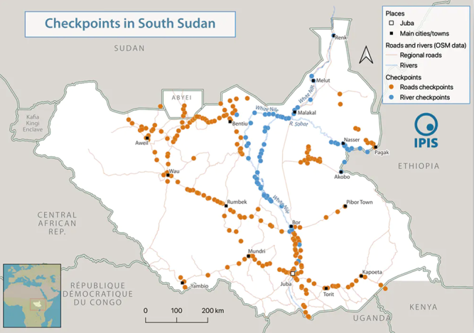
1. The River Nile and Sobat River are not only vital waterways but also lifelines for the people of South Sudan, facilitating transportation, trade, and sustenance. However, the proliferation of unauthorized checkpoints along these rivers has posed significant challenges, hindering freedom of movement and fostering a checkpoint economy characterized by extortion and corruption. Again, South Sudan has spent almost half of its life as a nation at war and continues to be roiled by outbreaks of politically motivated ethnic violence.
Pic: Different Checkpoints in South Sudan
2. The emergence of a checkpoint economy, characterized by extortion and corruption, further exacerbates these challenges, undermining efforts for peace and development in the region by The United Nations Mission in South Sudan (UNMISS). The multifaceted initiatives undertaken by the United Nations (UN) and the Government of South Sudan (GoSS) to address these challenges, focusing on diplomatic engagement, peacekeeping missions, capacity building, policy reforms, enforcement actions, and public awareness campaigns. But the situation did not improve. The sustained cooperation between international and national stakeholders in mitigating the detrimental effects of unauthorized checkpoints and fostering a conducive environment for economic growth and stability in South Sudan is needed. Against this backdrop, this journal seeks to explore the initiatives led by the UN and the GoSS to combat the checkpoint economy and ensure freedom of movement along the River Nile and Sobat River.
Statement of the Problem.
3. Militarized checkpoints in River Nile and Sobat pose significant barriers to trade, hinder civilian navigation, and contribute to fiscal pressures on local administrative entities. This study aims to explore the implications of these checkpoints and propose potential solutions.
Objectives of the Study.
4. This paper seeks to:
a. Investigate the historical and contemporary role of militarized checkpoints in the Nile River.
b. Analyse the impact of checkpoints on trade dynamics and freedom of Movement.
c. Analyse the present status of military and non-military checkpoints along the Nile River.
d. Identify challenges and opportunities for addressing checkpoint- related issues.
e. Propose the possible solution to reduce the number of CPs and find the alternative ways of life of locals.
f. Propose recommendation to safe use of River Nile and Sobat for economical prospect of South Sudan.
g. Propose recommendations for policy reform and the establishment of a marine unit to mitigate these challenges.
Context of Militarized River Trade Routes in South Sudan.
5. The White Nile River and Sobat River Corridor are of paramount strategic importance in South Sudan as a key transportation route, especially during the rainy season, when various roads become impassable. White Nile River and Sobat River Corridor access is impeded by the presence of unauthorized checkpoints. The key transportation routes are home to numerous communities from various ethnic groups. These communities experience severe hardship due to their isolated locations. They are involved in the running of unauthorized checkpoints, which often serve as the main source of income.
6. The unauthorized checkpoints are causing tensions and inter- and intra-communal violence against a backdrop that is characterized by deeply rooted ethnic divisions. However, the unchecked proliferation of unauthorized checkpoints along these rivers has severely impeded freedom of movement, resulting in economic stagnation and prolonging instability.
7. Early in 2021, the Dinka Jieng Council of Elders, a group that advocates for the rights of the Dinka community, stated that ‘corruption in South Sudan is the driver of political competition and hence the war’, fuelling fragmentation of elites as well as ground troops. The long-distance transport of bulk trade and aid, which because of the volumes involved represent concentrated wealth, sits at the heart of South Sudan’s militarised political economy.
Current Situation
8. Deadly Violence in the Disputed Abyei Area from March 2023 place South Sudanese central government in a difficult position. As GoSS faces an election later in 2024, cannot afford to alienate this key constituency with a crackdown. But continued intense communal fighting could halt an election in specific places, or risk the timeline of the general election. ‘Parallel bush Government’ by SPLA-IO, led by Riek Machar is another threat to durable peace. Though UNMISS conducted approximately 1000 patrols in last year, in contrast, there is little concrete evidence that patrolling more broadly necessarily deters violence or reduces threats in conflict-prone areas. Even number the river checkpoints are not reduced. This checkpoint economy is big resource of revenue though it is not transparent and income of Govt and Non Govt forces.
Checkpoint Economy.
8. The number of checkpoints across South Sudan has had inestimably increased during the recent past—deferred civil war. This includes a number of both legal and illegal checkpoints unilaterally set-up; before or after 2018, in the former “Oppositions and Government controlled areas”. Despite the partial establishment of the RTGoNU in March 2020, such unilateral creations of checkpoints; a collection of excessive and illegal taxes continued along the River Nile and roads linking up ten (10) States as well as those checkpoints at South Sudan’s borders with its neighbouring countries. In some places, the distance between this and that checkpoint range is five to six kilometres or even less.
9. The Government’s inability to pay Forces their already unliveable salaries in a timely manner drives South Sudan’s “checkpoint economy,” whereby these public servants – such as traffic police and SSPDF – engage in illegal taxation of vehicles and passengers. This does not only affect aid agencies moving around the country, but ordinary commuters as well. Illegal taxation increases the already high cost of living and doing business in South Sudan. It also raises the cost and inefficiency of delivering humanitarian and other assistance.
10. The international community finances humanitarian relief and peacekeeping to a level of US$1.4 billion annually (or 7% of all global humanitarian spending), an important influx of resources in a cash-strapped economy. It should not come as a surprise that bulk transport of humanitarian relief figures as a major source of checkpoint revenues across the country. Humanitarian logistics makes up a big part of the transport sector in South Sudan, with aid agencies outsourcing food deliveries and other bulk transport to national or regional trucking companies. These subcontractors are systematically taxed at 157, or 49%, of all South Sudanese checkpoints.
11. This means that scarce aid money is appropriated by South Sudan’s soldiers and rebels, ending up in the pockets of military elites. Locals in Juba often gist, ‘aid is the new oil’. Large volumes of humanitarian relief travelling overland may also constitute a factor driving the checkpoint phenomenon, as they constitute stable sources of revenue as well as flows of food that can be used strategically in struggles for control over people.
Key findings
12. Those are:
• 319 checkpoints in South Sudan, of which 253 (79%) are roadblocks and 66 (21%) river checkpoints. Based on averages, a typical checkpoint is manned by 6 people sharing 3 visible weapons among them, and levies about SSP 48,000 (USD 80) on a commercial vehicle.
• Checkpoints are numerous. On average, there is one checkpoint for each 16 km (or 6 checkpoints per 100 km) along South Sudan’s major trade routes. Checkpoints are more frequent on the routes from Juba-Wau, Juba-Bor, and Juba-Nimule, where there are on average 9 checkpoints per 100 km.
• The number of checkpoints has increased by nearly 50% since independence. In 2021, observed on average one checkpoint for each 16 km (or 6 checkpoints per 100 km), whereas in 2011 there was a checkpoint each 23 km (or 4 checkpoints per 100 km).
• Most individual payments are small. At 62 checkpoints (19%) payments are lower than SSP 1,000 (USD 1.5); only 8% of checkpoint taxes exceed SSP 100,000 (USD 166), and these are mostly concentrated geographically along the White Nile.
• Total payment is significant. For all major routes, average total payment exceeds 60,000 SSP (USD 100). For more than half of these routes, total checkpoint taxes exceeds 450,000 SSP (USD 750). Payment is the highest on the White Nile at about 4,170,500 SSP (USD 6,951) for the total route, or SSP 126,379 (USD 211) on average per checkpoint.
• River checkpoints taxes are higher than road checkpoints taxes in absolute terms, but lower in proportion to cargo weight. A 40-ton truck typically pays SSP 12,514 (USD 21) per checkpoint along the Western Corridor, which corresponds to SSP 313 (USD 0.52) per ton; by contrast, the SSP 126,379 (USD 211) on average per river checkpoint cover a charge of around 1,200 tons that barges carry, yielding an average per-ton checkpoint rate of SSP 123 (USD 0.20).
• Most payments are unreceipted. 84% of individual payments made during the survey were unreceipted.
• UN or NGO-contracted vehicles are subject to structural checkpoint taxation. 157 or 49% of checkpoints levy taxes on vehicles transporting humanitarian aid.
• The most commonly observed checkpoint operators are the Traffic Police and SSPDF, sighted at 43% and 38% of checkpoints respectively. At 57% of the checkpoints, more than one type of official or agency is present at a checkpoint.
• The SPLA/M-iO controls 60 (or 19%) of all checkpoints. Government forces operate most of the checkpoints along overland routes, whereas most river checkpoints (38 out of 66, or 58%) are under control of SPLA/M-iO forces.
• SPLA/M-iO river checkpoints are 45% more expensive than government river checkpoints. For rivers, average checkpoint taxes at SPLA-iO checkpoints were SSP 122,000 (USD 203), whereas average tax rates at non-iO checkpoints was SSP 55,700 (USD 93).
Main drivers of checkpoints
13. Identified factors are:
a. First, the plummeting of oil revenues that for a brief period after 2011 financed the government budget. As a response, government agents had to seek recourse to non-oil revenue generation mechanisms, among which checkpoints constitute a principal one.
b. Second, the fact that salaries are not corrected for hyperinflation and currency depreciation means that civil servants and security agents have to survive on worthless official monthly incomes, or seek to complement it by other means. These factors combined entail that government has become a self-financing enterprise, relying on decentralized revenue generation tactics. Indeed, any army deployment in practice is accompanied by setting up a checkpoint to feed the troops.
c. Third, since 2013, the SPLA-iO, being cut off from government resources, has to rely on autonomous revenue generation by taxing the portions of trade routes that are under its control.
d. Fourth, the administrative reshuffeling of states in South Sudan has entailed a profusion of new government administrations at the state and county level, often in need of raising their own revenues. They consequently set up checkpoints there, where trade routes intersect with their administrative entity.
e. Fifth, checkpoints are crucial for the armed forces to control movement of IDPs and restrict humanitarian access. Finally, in particularly checkpoints along high traffic routes are key devices for profit generation benefiting individuals higher up the chain of command.
Key Implications and Effects
14. There are direct and indirect implications and effects of checkpoints. Those are:
a. Given South Sudan’s long history of conflict, it is likely that checkpoints are an endemic phenomenon, and that they will remain a key interface between international trade, aid and parties to conflict in the country.
b. Systematic obstructions to the freedom of movement of UNMISS and its partners – by the Government and other parties with checkpoints has created serious impediments to the Mission’s ability to deliver on its protection and humanitarian mandates.
c. Checkpoints likely form the biggest non-oil source of cash for government agents and security forces.
d. The transport and trade sector is therefore thoroughly implicated in financing conflict actors.
e. Checkpoints are key factor in the high transport prices as compared to neighboring countries.
f. Price hike occurs for commodities.

Assessment of Different Initiatives to stop Unauthorised River Checkpoints
RTGoNU Initiative.
15. The RTGoNU formed on 22 February 2020 was an unfulfilled provision of the Resolution of the Conflict in the Republic of South Sudan (R-ARCSS) signed by warring parties in South Sudan on 12 September 2018. It was designed to revive the Agreement on the Resolution of the Conflict in the Republic of South Sudan (ARCSS) of 17 August 2015, which was meant to bring an end to the civil war that erupted on 13 December 2013 in the country. The RTGoNU rests on a fragile unity of long-time political adversaries and antagonists. No practical sign that can show a unified call it revitalized Government is formed, at all levels. The responsibility of these checkpoints looks like is still in the hands of those certain cliques of the bigwigs and the allied sections of communities. Therefore, the RTGoNU is having no power or audacity since it was established to generate one unified policy that can regulate the creation of checkpoints
Initiatives by the United Nations (UN).
16. In response to the disruptions caused by unauthorized Check Posts and armed conflicts along the River Nile and River Sobat in South Sudan, a Government and UN High-level Coordination Meeting convened on 24 November 2022. During this meeting, it was proposed to establish a joint Government/ UN Technical Working Group (JTWG) to address the challenges hindering the free movement of people and goods in the region. Consequently, the JTWG was formed, comprising representatives from the Government of the Republic of South Sudan (GRSS), the United Nations, and humanitarian partners.
17. The Working Group is undertaking the following key tasks:
a. Develop a comprehensive and coordinated plan for the unhindered access of the corridor, including measures to ensure safe and secure passage, through coordinated patrols, as well as identification of key hotspots, administrative impediments and triggers leading to obstruction and access challenges.
b. Utilize early warning information and analysis to identify potential triggers of obstruction and access challenges, including localized conflicts and thereby ensuring early action to address gaps, systemic issues, and emerging challenges.
c. Designate focal points to actively monitor any incidents of obstructions and/or unauthorized check points and inform the Working Group for relevant action and engagement.
d. Facilitate regular communication and coordination among all stakeholders, including the provision of information and awareness on the corridor, including on the responsibilities of all stakeholders.
e. Meet on a regular basis, including on an ad-hoc basis to deliberate on joint initiatives, as well as to make recommendations for improvements in particular short, medium and long-term solutions.
f. Develop and streamline reporting procedures to promptly identify and address concerns for all stalk holders, including engaging with the political Leaders of the groups / factions, local authorities, and relevant stakeholders to facilitate unhindered access.
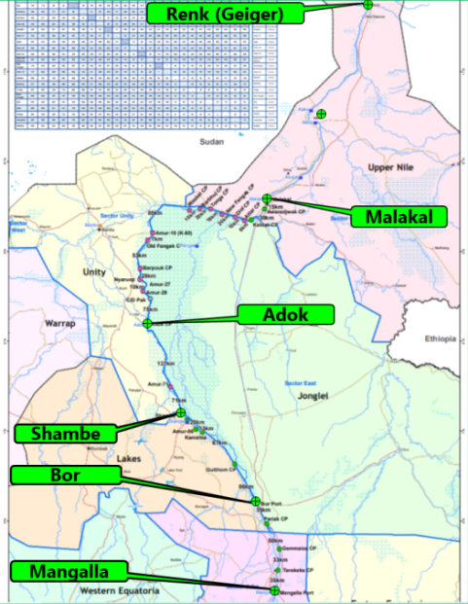
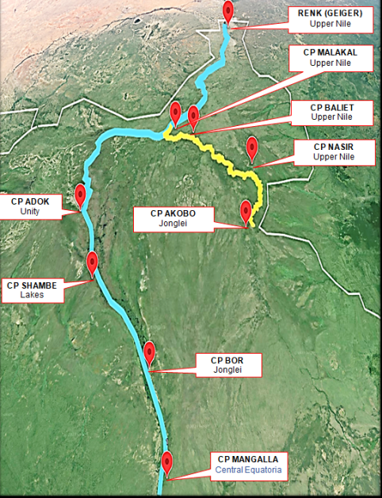
18. The first meeting of the JTWG took place on 26 April 2023, where discussions commenced regarding the identification and regulation of Check Posts along the rivers. Following the inaugural JTWG meeting, subsequent gatherings were held, including meetings of a subcommittee consisting of GRSS and UN representatives, aimed at mapping existing Check Posts and determining authorized ones.
19. On 25 May 2023, the second JTWG meeting took place, during which the Co-Chairs presented the outcomes of the subcommittee meetings. The JTWG affirmed the proposed directives put forth by the Co-Chairs, which included reducing the number of Check Points (CPs) along the River Nile from 45 to 6, and along the River Sobat from 19 to 3 (List included as annex), within a three-month timeline. These directives were seen as crucial steps toward enhancing the movement of people and goods along these vital waterways.
Challenges in Removing Checkpoints.
20. Since August 2022, checkpoints along the River Nile have mushroomed and hindered movements along the River Nile. Trade routes in South Sudan whether overland or waterways—are not spaces of free circulation but highly militarized spaces, off-limits to most civilians. Long-distance displacements are consequently also militarized, however much traders and aid organizations may seek to extricate themselves from the political economy of conflict in South Sudan. But barriers to checkpoint removal, this section explores logistical, institutional, and political challenges that hinder these efforts. Challenges are:
a. The operating environment in South Sudan is extremely challenging for a peacekeeping mission tasked with maintaining operational awareness and a protective presence in large, often difficult to access areas. This, combined with an array of obstructions by the Government and other forces across the country by unauthorized checkpoints, has often constrained the ability of the Mission to implement its protection mandate.
b. Government security forces deployed along the River Nile and Sobat do not honour approvals issued by their high command and other Government security authorities for UN and humanitarian actors.
c. Unwillingness and reluctant posture of GoSS to address the problem.
d. Absence of robust posture by UNMISS forces.
e. Frequent access denial occurs during patrols.
f. Implementation of DDR (Disarmament, Demobilisation and Reintegration) shifted to future dates hinders the path from deeply engrained dependencies of violence toward a better prospect.
RECOMMENDATIONS
21. The initial engagement with communities living along the White Nile River and Sobat River Corridor also offers, besides the diversion of running unauthorized checkpoints, the possibility to address other root causes of communal violence such as land disputes, ethnic and inter-clan rivalries, cattle migration and raiding. These are aggravated by the emerging issues. Herewith, the project which fosters the implementation of the Revised National Development Strategy, which and make shift from dependency on humanitarian aid to a development trajectory is needed. Considering these factors in mind the probable recommendations are:
Short Term Phases.
22. Phases are:
a. Immediate Policy Reforms. Implement short-term policy reforms aimed at streamlining checkpoint procedures, reducing unnecessary delays, and improving transparency.
b. Capacity Building. Provide training and support to checkpoint personnel to enhance efficiency, professionalism, and adherence to regulations.
c. Community Engagement. Engage with local communities to address grievances, build trust, and foster cooperation in checkpoint operations.
d. Intelligence, surveillance, and reconnaissance (ISR) capability. UNMISS needs to be equipped with an adequate ISR to be effective and able to deal with challenging situations, including restriction of movement. A Solution to the Problem ISR capability is absolutely necessary for UNMISS to be effective in South Sudan. ISR would improve the mobility and intervention capacity of the peacekeeping force by reducing uncertainty, improving situational awareness, and increasing the confidence of the peacekeepers when they are faced with obstacles such as restriction of movement.
e. International Support. Mobilize international support for short-term interventions, including technical assistance and funding to address immediate checkpoint-related challenges.
Mid-Term Phases.
23. Phases are:
a. Infrastructure Improvement. Invest in basic infrastructure upgrades like establishment of pontoons at major checkpoints to improve facilities and ensure the safety and comfort of crafts.
b. Reduction of CPs and Withdrawal of Arms. Reduce the number of CPs and banning of unauthorised CPs including withdrawal of arms from them by DDR (Disarmament, Demobilization, and Reintegration) process. Civilian firearm possession in South Sudan remains widespread and has been driven by high levels of insecurity. Again, downsizing armed forces is also an important part of Security Sector Reform, per implementation of Chapter II of R-ARCSS, and DDR is about helping ex-combatants (both male and female); Children Associated with Armed Forces and Groups (CAAFG); Women Associated with Armed Forces and Groups (WAAFG), and ex-combatants with disabilities, to provide a process for their smooth return to their communities. Bu again, This standard DDR programmes are not fit for purpose in a context like South Sudan. Lack of political will to implement DDR also placed a big deadlock on the implementation. Again, the DDR programme increased tensions and exacerbated internal conflicts. This is so because achieving security in the country goes beyond DDR and is not related to the ‘rightsizing’ of the South Sudanese Armed Forces nor to the ‘reintegration’ of combatants. Rather, to stop these fragmented and sub-standard DDR outcomes in a fragile and complex political and operational environment, it will depend on a serious engagement with the following twofold task:
- firstly, to comprehend and eventually change the basic structures and mechanisms of armed mobilization prevalent in South Sudan and,
- Secondly, to understand and adapt security sector reform to a political environment that is constructed in terms of potential for violence and threats of destabilisation.
c. Legal and Regulatory Framework. Develop and enforce clear legal and regulatory frameworks governing checkpoint operations, including guidelines for dispute resolution mechanisms, and accountability measures.
d. Regional Cooperation. Strengthen cooperation with neighboring countries to harmonize trade and transit procedures, reduce cross-border barriers, and promote regional integration.
e. Alternative Income Sources. Diversify income sources for local people entities to reduce dependence on checkpoint taxation, including exploring river and land-based options.
Long-Term Recommendations.
24. Phases are:
a. Trade Facilitation Measures. Implement long-term trade facilitation measures, such as customs reforms, infrastructure development, and trade agreements, to reduce the need for checkpoints and promote smoother cross-border trade.
b. Security Sector Reform.
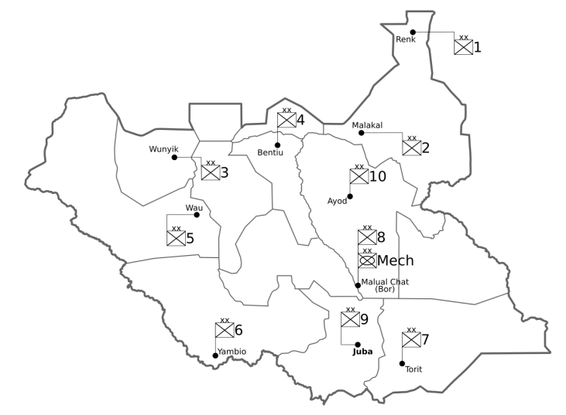
Undertake comprehensive security sector reform efforts to professionalize security forces, strengthen command and control structures, and enhance accountability in checkpoint operations. Formation of South Sudan Marine Corp can be the proper step. The basic unit of the South Sudan Marine Corp (SSMC) will be Marine Rifle Battalions (MRB), organized into a battalion headquarters (HQ), company HQs and rifle companies. The MRBs will be light infantry units that will operate independently from each other, though two or more companies from different battalions could be assembled to form temporary Combat Task-Forces (CTF) in operations. MRBs may not be equipped with organic armour, artillery, motor transport, medical or engineer support units, so Marine battalions need to rely on SSPDF for those supports. Meanwhile, MRBs may take support of SSPDF and SS Air Force for river and road transport, casualty evacuation and air, armoured and artillery support as well. MRB Operational Command will be placed under SSPDF.
SSPDF Deployment
c. Conflict Resolution. Address underlying political and social grievances that fuel conflict and insecurity, including through inclusive dialogue, reconciliation processes, and efforts to address root causes of violence.
d. Sustainable Development. Invest in sustainable development initiatives, including education, healthcare, and livelihood programs, to address socio-economic inequalities and promote long-term stability and prosperity in South Sudan.
e. Diplomatic Engagement. Diplomatic efforts by the UN have been instrumental in fostering dialogue and cooperation among relevant stakeholders, including the GoSS and regional actors. Through diplomatic negotiations and mediation, the UN seeks to address the underlying grievances fueling the proliferation of unauthorized checkpoints and promote peaceful resolutions to conflicts in the region.
f. Monitoring and Reporting Mechanisms. The UN has established robust monitoring and reporting mechanisms to assess the situation along the rivers continuously. These mechanisms enable the timely identification of instances of checkpoint extortion and other violations of freedom of movement, facilitating prompt intervention and enforcement actions. By providing accurate data and evidence-based analysis, monitoring mechanisms support informed decision-making and policy formulation at both the national and international levels.
g. Public Awareness Campaigns. Public awareness campaigns spearheaded by the GOSS seek to educate civilians and security personnel about the importance of freedom of movement and the adverse effects of checkpoint extortion.
Bridging Operation Gaps of BANFMU by Capacity Building.
25. BANFMU provides necessary Force protection and that responsibility is very ably discharged. BANFMU operates Since April 2015 in UNMISS AOR and has enhanced the Logistic line of supply. But conducting Riverine Operation by Expeditionary Force initiative along with other elements of UNMISS for withdrawal of unauthorized river checkpoints capacity and few operational gaps need to be address. Those are:
a. FMU has no organic capacity to independently perform as UNMISS demands for long distance and duration patrol. The LPCs has limited range capacity of only approx 100 km in one way.
b. Limited fuel storing capacity by LPCs limits the movement. If LCU presents in flotilla, then it could supply fuel to LPCs.
c. LCU with day and night operating capability can establish robust presence in AO and carry troops with heavier equipment across the river during emergency.
d. In present situation, for withdrawing unauthorized CPs, joint Riverine Operations with the consent of GoSS by Task Force comprising Govt operated force, BANFMU, Army, UNPOL and other units in UNMISS is required. So, BANFMU capacity building in respect of personnel, equipment in manifold is mandatory.
e. As identified in the UNMISS BANFMU SUR, it still remains essential, that in the medium-term, the BANFMU capacity be grown accordingly to promote security and Freedom of Movement on Nile and Sobat. SUR need to be revised for that. Enrolling LCU in inventory will enhance UNMISS ability to deter and interdict armed threat groups during withdrawal of unauthorized CPs and allow for tactical amphibious deployment of infantry personnel with full capacity, expanding our reach and tactical projection.
REQUIREMENT OF LANDING CRAFT UTILITY
26. the acquisition of a Landing Craft Utility is imperative to show robust posture at Nile and Sobat. During the rainy season when traditional means of transportation fail, LCU will ensure the foothold on the White Nile and Sobat by establishing the floating TOB. It will be a force multiplier in crisis and will increase the operational reach. Besides limited logistics transportation capability, it will be able to carry out Search & Rescue Operations and Medical Evacuation.
REQUIREMENT OF THE SURVEY
27. Historical evidence consistently points to the Nile-centric nature of civilizations, highlighting the enduring significance of the Nile River in shaping and sustaining advanced societies. A hydrographic survey of the White Nile River is imperative for various reasons. First of all, it is the only way to transport bulk logistics from Mangalla to Malakal. White Nile plays enormous importance for UN. Operation Life Line (OpLL) supports UN to provide logistics to other sectors of UNMISS via White Nile. Again, if we foster Riverine Operation, then there is no alternative other than surveyed chart.

ESTABLISHMENT OF PORT FACILITIES
28. Establishment of port facilities along the White Nile. Jetties are platforms where the boats and other watercraft are secured temporarily. Constructing jetties at critical junctures would help the inhabitants for the best use of the river. Jetties are also required for transporting people and goods from one place to another. It can be used as a berthing station for boats during operation and rough weather. It will also increase riverine transportation and boost the means of communication. Thus, it will help to improve the livelihood of SS people. Floating pontoons are cost-effective in this case and can be shifted as and when the river changes its direction.
Conclusion.
29. In conclusion, the initiatives undertaken by the UN and the GOSS to combat the checkpoint economy and ensure freedom of movement along the River Nile and Sobat River are indispensable for promoting stability, economic development, and respect for human rights in South Sudan. By prioritizing diplomatic engagement, peacekeeping missions, capacity building, policy reforms, enforcement actions, and public awareness campaigns, stakeholders can work together to address the root causes of unauthorized checkpoints and foster a conducive environment for peace and prosperity. Sustained cooperation between international and national actors is essential for translating these initiatives into tangible results and building a brighter future for the people of South Sudan.

ANNEX:
A. Proposed authorized River Checkpoints at River Nile and River Sobat.

ANNEX-A
LIST OF PROPOSED CPs FOR AUTHORIZATION
RIVER WHITE NILE
SER | NAME OF CP | GPS POSITION | CONTROLLED BY | NAME OF COUNTY | NAME OF STATE
 | MANGALLA | LAT- 05°42.68’N  LONG- 031°42.15’ E | GOVT. | JUBA | CENTRAL EQUATORIA
 | BOR | LAT- 06°12.16’ N  LONG- 031°33.12’ E | GOVT. | BOR | JONGLEI
 | SHAMBE | LAT- 07°08.13’ N  LONG- 030°46.20’ E | GOVT. | YIROL EAST | LAKES
 | ADOK | LAT- 08°11.10’ N  LONG- 030°19.16’ E | SPLA-IO | LEER | UNITY
 | MALAKAL | LAT- 09°34.98’ N  LONG- 031°39.48’ E | GOVT. | MAKAL | UPPER NILE
 | RENK(GEIGER) | LAT- 11°58.97’ N  LONG- 032°45.56’ E | GOVT. | RENK | UPPER NILE

LIST OF PROPOSED CPs FOR AUTHORIZATION
RIVER SOBAT

SER | NAME OF CP | GPS POSITION | CONTROLLED BY | NAME OF COUNTY | NAME OF STATE
1. | BALIET | Lat- 09°17.52'N  Long- 032°03.54'E | GOVT. | BALIET | UPPER NILE
2. | NASIR | Lat- 08°35.50' N  Long- 033°05.31'E | GOVT. | NASIR | UPPER NILE
3. | AKOBO | Lat- 07°47.39' N  Long- 033°00.30E | SPLAIO | AKOBO | JONGLEI

Photo from Peer Schouten and Ken Matthysens report
https://www.ohchr.org/sites/default/files/documents/hrbodies/hrcouncil/sessions regular/session52/A_HRC_52_CRP.3.pdf
Checkpoint economy: the political economy of checkpoints in South Sudan, ten years after independence by Peer Schouten, Ken Matthysen & Thomas Muller December 2021
Checkpoint economy: the political economy of checkpoints in South Sudan, ten years after independence by Peer Schouten, Ken Matthysen & Thomas Muller December 2021
Note To File Joint Technical Working Group on River Nile Access Ministry of Foreign Affairs and International Cooperation Juba April 26, 2023
EPON(Effectiveness of Peace Operation Network) Assessing the Effectiveness of the United Nations Mission in South Sudan / UNMISS R E P O R T 2 / 2 0 1 9
SSPDF Deployment Mapfrom Wikipedia
BANFMU SUR
Proposal for LCU submitted to FHQ
Proposal for River Survey submitted to FHQ

