INDEX

SL NO. | TITLE | PAGE NO.
01 | ABSTRACT | 06
02 | LIST OF TABLES | 07
03 | LIST OF FIGURES | 08-09
04 | CHAPTER 1  - Introduction | 10-11
05 | CHAPTER 2  - Study Area | 12-14
06 | CHAPTER 3  - Problem of the Area | 15-18
07 | CHAPTER 4  - Methods | 19-21
08 | CHAPTER 5  - Research and Findings i.Historical & Institutional changes | 22-34
08 | ii.Geomorphology, Land Use/ Land Cover & Sedimentary Environment of the Chilika Basin | 35-43
08 | iii.Environmental Changes in Chilika Lake | 44-59
08 | iv.Fishery Livelihood & Adaptation to Climate Change | 60-74
08 | v.Conservation of Environment and Protection of Marginalized Fishing Communities | 75-85
09 | CHAPTER 6  - Conclusion | 86-88
10 | REFERENCE | 89-94
11 | PHOTO GALLERY | 95-99

ABSTRACT
Chilika Lagoon, the largest brackish water lagoon in Asia, is a biodiversity hotspot and a Ramsar-designated wetland of international importance. Over the years, it has undergone significant ecological, geomorphological, and socio-economic transformations due to both natural processes and human interventions. The lagoon’s history highlights the dynamic interactions between its social, ecological, economic, and political components, shaping its trajectory of environmental change and sustainability.
During the 1980s and 1990s, Chilika faced severe environmental degradation, leading to large-scale siltation, declining salinity levels, habitat loss, and biodiversity depletion. These changes negatively impacted the local fishing economy and threatened rare and migratory species, such as dolphins and waterfowl. A major intervention in 2000, involving the opening of a new mouth to the sea, significantly improved water exchange, fish populations, and wetland health. This intervention helped restore ecosystem balance, leading to an increase in fisheries, growth of seagrasses, reduction in invasive weeds, and resurgence of migratory birds.
However, despite these improvements, continuous monitoring and adaptive management remain essential, as new challenges have emerged. Urban expansion, land-use changes, and human activities like shrimp aquaculture continue to put pressure on the lagoon’s ecological stability. Anthropogenic influences, including deforestation, agricultural expansion, and unregulated development, have led to the loss of natural land cover such as scrub forests and wetlands.
Chilika's history reflects the interconnected nature of social and ecological systems, demonstrating how economic history is shaped by environmental changes and vice versa. The depletion of fisheries in the late 20th century and subsequent conservation efforts highlight the two-way relationship between the lagoon’s ecological health and the livelihoods of local fishing communities. While restoration initiatives have revitalized fish stocks, many stakeholders still face economic uncertainty, and conflicts over resource management persist.
Additionally, the increasing demand for economic development has led to tensions between conservation efforts and commercial activities. The rise of shrimp aquaculture, driven by economic elites and businesses, has contributed to environmental degradation and social unrest among marginalized fishing communities. This has sparked movements advocating for sustainable resource use, community rights, and equitable governance.
Beyond direct human interventions, climate change poses additional risks to Chilika’s sustainability. Rising temperatures, erratic monsoons, and shifting salinity levels have made the ecosystem more vulnerable. Adaptation at the community level is crucial in mitigating these effects, and a Sustainable Livelihood Approach (SLA) has been suggested to integrate local knowledge into policy decisions. This approach emphasizes identifying local constraints and leveraging community strengths to build resilience against environmental changes.The case of Chilika Lagoon underscores the need for interdisciplinary approaches that bridge ecological science, economic policy, and social governance. Moving beyond theoretical and disciplinary boundaries, a more inclusive framework is required to study and manage complex social-ecological systems. Long-term conservation and sustainable development depend on balancing ecological preservation, community participation, and economic stability.

LIST OF TABLES

Table No. | TITLE | Page No.
01 | Profile of Fisher Caste group in Odisha | 22
02 | Fishers’ strategies to deal with livelihood | 29
03 | Major Changes in Institutional arrangements in Chilika | 33
04 | Landform changes within the Chilika Lake between 1980-2015 | 37
05 | Tidal inlet changes in between 1980-2015 | 38
06 | LULC Classification for 1980, 2000, 2005, 2010, 2015 | 42
07 | Physiographic attributes of the Chilika Lagoon | 44-45
08 | Physical-Chemical parameters of Chilika Lagoon | 45
09 | Biological parameters of the Chilika Lagoon | 48-49
10 | Ecological degradation & their impacts | 52
11 | Change in rank order (with respect to landing) often different commercial fisheries | 53
12 | Comparative account of salinity (ppt) regime during pre & post hydrological interventions | 57
13 | Ranking of Risk perception of climatic change hazards | 68
14 | Annual fish, Shrimp and Crab landing from capture fishing in Chilika Lake | 76
15 | Foreign export of shrimps from Chilika lake area (Quantity in metric tonnes), (value million Indian Rs.) | 76

LIST OF FIGURES

Fig. No. | TITLE | Page No.
01 | Temporal Scale of occurrence of drivers | 29
02 | Geomorphic maps of Chilika for 1980, 1988, 2000, 2015 documenting major landforms changes during the period 1980-2015 | 36-37
03 | Landforms changes in Chilika Basin during the years 1980, 1988, 2000, 2005, 2010, 2015 | 38
04 | Landforms as well as aquatic vegetation changes | 38
05 | - LANDSAT image of the area arounf the tidal inlet of Chilika  - (b-j) changes in tidal inlets & opening of new artificial mouth | 39  40
06 | Trend analysis of land use/ land cover in chilika between 1980-2015 | 42
07 | Annual variation of salinity (ppt) in four sectors of Chilica Lagoon during 2006-07 | 57
08 | Trend in landing fish, prawn, crab, in Chilika Lagoon | 58
09 | Trend in operation of boats and no.of fishing days in Chilika Lagoon | 59
10 | Trend of mean highest & minimum temperature in Bhubaneswar & Puri | 61
11 | Trend of monthly & heaviest 24hrs rainfall in Bhubaneswar & Puri | 63

12 | 2012 Ecosystem Health Report | 64
13 | 2014 Ecosystem Health Report | 65
14 | 30 sampling locations of chilika | 65
15 | Trend of Fish landing amounts (1926-2006) | 68
16 | Expected Fishery strategies for climate change adaptation in chilika lagoon | 72

CHAPTER-1 INTRODUCTION
India is endowed with an abundance of natural resources, including mineral deposits, vast agricultural lands, forests, rivers, and an intricate network of wetlands. Wetlands, both natural and human-made, freshwater and brackish, play a vital role in the country’s environmental sustainability and socio-economic framework. Regardless of their size, wetlands significantly contribute to human well-being by providing essential services such as drinking water, irrigation, groundwater recharge, flood control, and livelihood support. Furthermore, these ecosystems serve as rich biodiversity hotspots, harboring a variety of flora and fauna. However, in recent decades, wetlands worldwide have increasingly come under pressure from both natural forces and anthropogenic activities. Human encroachment, sewage disposal, heavy metal pollution, and eutrophication have severely impacted the health and functionality of many wetlands, including some of the most iconic ones such as Lake Okeechobee in Florida, Lake Balaton in Hungary, and Lake Victoria in Africa. Similar environmental degradation trends are evident in India, where wetlands face growing challenges due to land use/land cover (LULC) changes, pollution, and resource exploitation.
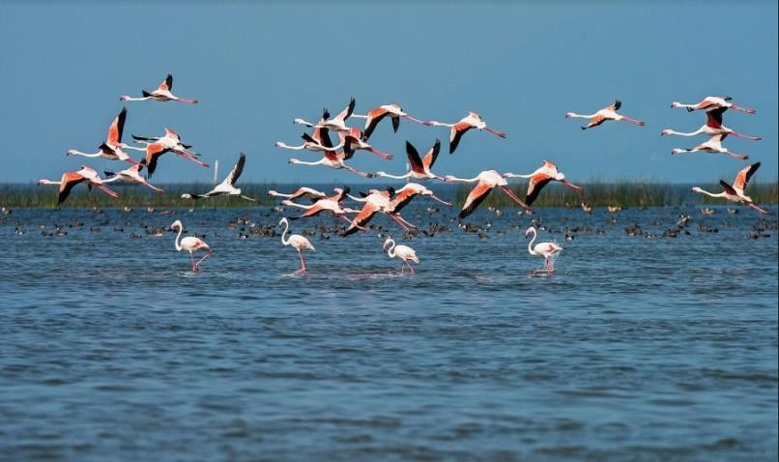
Chilika Lagoon, situated along the eastern coast of India in the state of Odisha, is one of the most prominent wetlands in Asia. Stretching between 19°30′N to 20°30′N latitude and 85°00′E to 86°00′E longitude, it is the largest brackish water lagoon in India and one of the largest in Asia. During the peak monsoon season, Chilika covers an area of approximately 1,165 km², providing sustenance to over 150,000 fishers residing in
132 villages along its periphery. Beyond its economic significance, Chilika is renowned for its ecological diversity, hosting a unique combination of marine, brackish, and freshwater ecosystems with distinct estuarine characteristics. It is also one of the largest wintering grounds for migratory birds along the Central and East Asian Australasian Flyway, with approximately 225 bird species recorded during the migratory season. Due to its ecological importance, Chilika was designated as a Ramsar Site in 1981 under the Ramsar Convention on Wetlands, highlighting its global significance.
Despite its ecological and socio-economic value, Chilika Lagoon has faced mounting environmental challenges over the past few decades. Since the 1990s, a combination of natural processes and anthropogenic pressures has driven significant changes in the lagoon’s ecological dynamics and, by extension, the lives of the local fishing communities. Key environmental issues include declining salinity levels, excessive nutrient inflow resulting in eutrophication, extensive macrophyte growth, and subsequent decomposition processes that have led to hypoxic and anoxic conditions. Additionally, hydrological changes in the upstream catchment, combined with pollution from agriculture, aquaculture, and domestic waste, have further stressed the lagoon’s ecological balance. These ecological changes have had cascading impacts on the region’s socio-economic fabric, affecting the fishers’ livelihoods, altering

traditional fishing practices, and influencing the economic and cultural life of the communities dependent on the lagoon.
In this paper, I investigate the processes of change in Chilika’s small-scale fishery systems, examining how regional, national, and international drivers have shaped the lagoon’s ecological, social, economic, political, and cultural dimensions. The study adopts a social-ecological systems perspective, which underscores the interconnectedness between the social (political, economic, and cultural) and ecological (biophysical, geological, and hydrological) subsystems. These subsystems are intricately linked, influencing one another and collectively driving changes in the lagoon’s overall system. By applying a historical lens, this research traces the long-term processes that have shaped the contemporary socio-ecological landscape of Chilika. Particular attention is given to the economic history of the region, which is deeply intertwined with the ecological changes in the lagoon.
The paper focuses primarily on contemporary history, spanning the second half of the twentieth century, while selectively drawing on older historical records dating back over the past two centuries. This historical perspective provides essential context for understanding the present-day challenges faced by Chilika’s fishery systems. It reveals how socio-political interventions, such as land reclamation policies, aquaculture expansion, and conservation efforts, have influenced the ecological health of the lagoon and the livelihoods of local fishers. Moreover, the study examines how market forces, policy changes, and environmental management initiatives have shaped the economic history of the region.
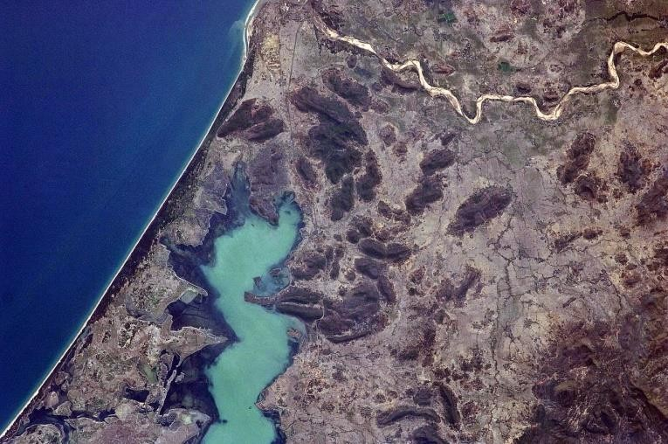
To analyze the spatial and temporal dynamics of ecological change, the study utilizes remote sensing and Geographic Information System
(GIS) technologies. These tools are instrumental in documenting and visualizing LULC changes, geomorphic processes, and the extent of environmental degradation and recovery in Chilika Lagoon. Historical maps, satellite imagery, and GIS-based spatial analysis are employed to assess the impact of human interventions and natural processes over the past 35 years. This approach provides valuable insights into the patterns of wetland transformation, the changing hydrological
regimes, and the socio-economic repercussions for the fishers.
The Chilika Lagoon serves as a compelling case study to explore the complex interplay between ecological and social forces in a wetland ecosystem. The analysis of historical and contemporary changes highlights how human interventions, policy decisions, and ecological processes have jointly shaped the lagoon’s fisheries and the livelihoods of the communities that depend on them. By integrating historical analysis with remote sensing and GIS-based assessments, this study offers a comprehensive understanding of the socio-ecological changes in Chilika Lagoon. It underscores the importance of adopting an integrated, long-term perspective in the management and conservation of wetland ecosystems, particularly in the face of growing environmental challenges and socio-economic pressures.

CHAPTER-2 STUDY AREA
Chilika Lake, the largest brackish water lagoon in Asia and the second-largest in the world after Lake Victoria, is a vital geographical and ecological feature of India. It runs parallel to the coastline of the Khordha and Ganjam districts of Odisha in a northeast to southwest direction.
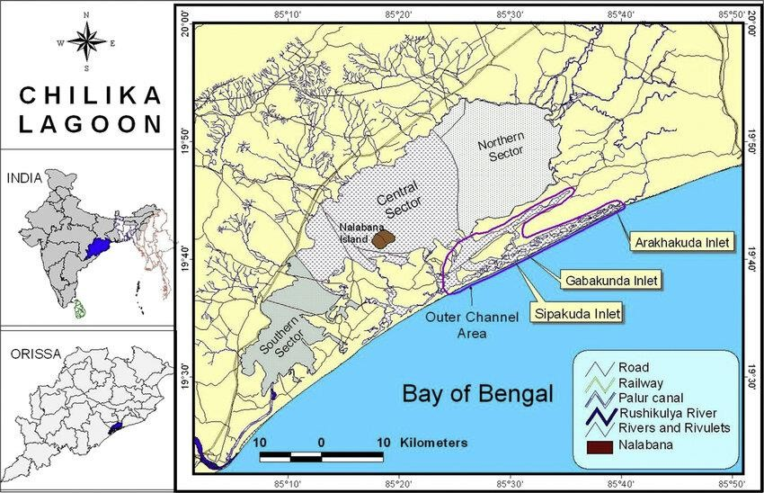
The lagoon’s length is approximately 65 km, with a width of about 18–20 km. To the north, west, and south, it is bordered by the Eastern Ghat hill ranges, while a 60 km long sandbar separates it from the Bay of Bengal to the east. The lagoon connects to the Bay of Bengal through a narrow outer channel, approximately 24 km long, which runs parallel to the coastline. Until September 2000, Chilika’s major mouth opened near Arakhakuda. However, the Chilika Development Authority (CDA) artificially created a new mouth at Sipakuda, near Satapada, to improve water exchange between the lagoon and the sea. At the southern end, the 18 km long Palur Canal links the Rambha Bay to the mouth of the Rushikulya Estuary, enhancing the lagoon’s hydrological connectivity.

FORMATION
Chilika Lake was originally part of the Bay of Bengal but gradually separated due to the deposition of silt and the formation of sandy ridges. Over time, these land formations created a natural barrier, giving rise to the present lagoon structure. The lagoon's shape is pear-like, with multiple channels and inlets. Chilika’s catchment area spans approximately 4,406 km², with 68% drained by non-perennial rivers and streams from the western catchment, and 32% by distributaries of the Mahanadi River, entering from the northeastern end. The lagoon receives freshwater inflow from several rivers, including the Daya, Nuna, Ratnachira, Bhargavi, Malguni, Dhanu, and Salia. It connects to the Bay of Bengal through several channels, the most notable being Muggar Mukh, Palur Muhana, and the artificially created mouth at Sipakuda.

HYDROLOGY AND SEASONAL VARIATIONS

Chilika Lake's water spread fluctuates seasonally, influenced by monsoonal and summer conditions:
- During the monsoon season: The lake expands significantly, covering an area of approximately 1,165 km² (earlier estimates) or 1,020 km² (more recent studies). Water depth ranges from 1.73 to 3.7 meters.
- During summer: The lagoon contracts to around 704 km² (recent estimates) or 906 km² (earlier estimates), with water depth varying between 0.93 and 2.6 meters.
- Salinity levels: These range from 0.1 to 30.6 ppt, depending on freshwater inflow and seawater intrusion, making the lake a dynamic brackish water system.
The region experiences a tropical monsoonal climate, with an average annual rainfall of approximately 1,300 mm and temperatures ranging between 14°C and 40°C. Wind directions fluctuate under the influence of the southwest and northeast monsoons, with speeds varying from 19 to 58 km/h. During pre-monsoon (May–June) and post-monsoon (October–November) months, severe cyclonic storms frequently hit the region, sometimes reaching speeds of over 200 km/h. These storms cause extensive flooding, altering the lagoon's hydrology and drastically impacting the biotic communities, including phytoplankton, zooplankton, higher plants, fishes, and birds.

ECOLOGICAL ZONATION AND BIODIVERSITY

Chilika Lake is divided into four major ecological zones:
- Northern Zone: Characterized by higher freshwater inflow and relatively lower salinity.
- Central Zone: Dominated by brackish water conditions with moderate salinity variations.
- Southern Zone: Features a mix of brackish and marine water, with considerable biodiversity.
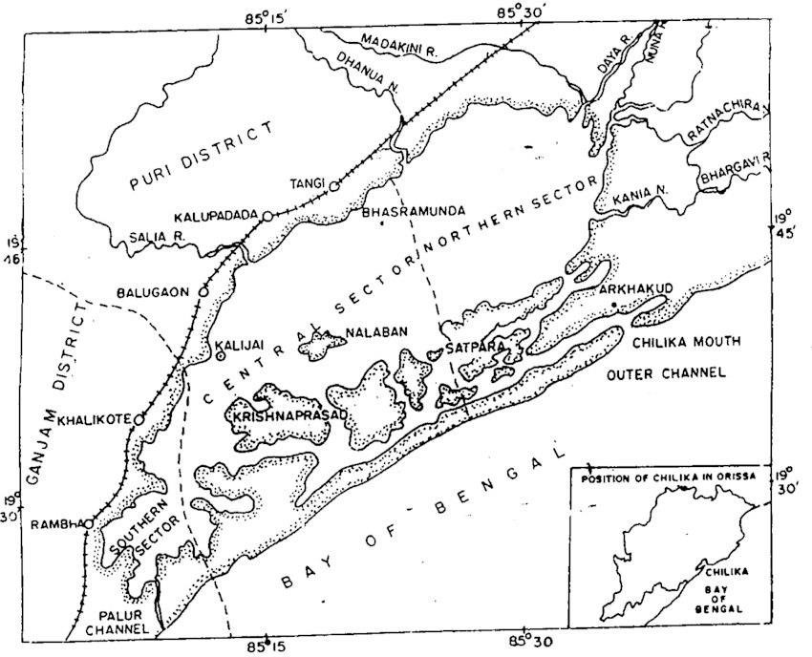
- Outer Channel: This 35 km long stretch connects the lake to the sea, facilitating the exchange of marine and brackish water.
Numerous islands are scattered throughout the lake, including Nalabana, Kalijai, Somola, Honeymoon, Breakfast, and Birds Island.
Nalabana Island, which covers approximately
15.53 km², was declared a bird sanctuary in 1973 under the Indian Wildlife (Protection) Act of 1972. The island serves as a vital habitat for migratory birds and supports thousands of avian species. Birds from distant regions such as the Caspian Sea, Lake Baikal, Aral Sea, Russia, Mongolia, Central and Southeast Asia, Ladakh, the Himalayas, and the Rann of Kutch flock to
Chilika during the winter months. The lagoon is home to numerous species categorized as near threatened, vulnerable, endangered, and critically endangered by the IUCN Red List.

SOCIOECONOMIC AND CULTURAL SIGNIFICANCE

Chilika Lake plays a critical role in the socioeconomic and cultural fabric of Odisha. It is a hub for fishing, aquaculture, and tourism, sustaining over 150,000 fisherfolk living in 132 villages around the lagoon. According to the Directorate of Fisheries Statistics (2000-2001), Chilika supported a fishing community of 122,339 individuals, including 36,540 men, 31,588 women, and 54,211 children. The local fishing practices, which have been passed down through generations, remain deeply connected to the lake’s ecological health.
Beyond its economic significance, Chilika holds cultural and spiritual importance. The Kalijai Temple, located on an island in the lagoon, is a revered pilgrimage site. The lake's scenic beauty, combined with its cultural festivals, has inspired poets, philosophers, and naturalists, making it an iconic symbol of Odisha's heritage.

ENVIRONMENTAL CHALLENGES AND CONSERVATION EFFORTS

In recent decades, Chilika Lake has faced multiple environmental challenges driven by both natural processes and anthropogenic pressures, including:
- Siltation of the lake basin and outer channel, reducing water depth and altering hydrology.
- Restricted seawater exchange due to blockage of natural channels.
- Eutrophication and excessive macrophyte growth, degrading water quality.
- Decline in fish and crustacean recruitment, threatening local fisheries.
- Pollution from domestic, industrial, agricultural, and aquaculture sources, contributing to water contamination.
- Overfishing and illegal pen culture practices, impacting fish stocks.
- Deforestation in the catchment area, increasing sedimentation and reducing water retention capacity.
- Unregulated tourism and encroachment, disturbing the ecological balance.
Due to the severe environmental degradation, Chilika Lake was designated a Ramsar site (Wetland of International Importance) in 1981 under the Ramsar Convention. However, due to persistent threats, it was added to the Montreux Record (Wetlands Under Threat) in 1993. In response, the Chilika Development Authority (CDA) was established in 1991 to implement restoration and conservation strategies. The CDA’s most notable intervention was the creation
of the artificial mouth at Sipakuda on September 23, 2000, which improved seawater exchange, enhanced fish productivity, and reduced eutrophication. As a result, the Ramsar Convention Authority removed Chilika from the Montreux Record in 2002.
However, local fisher communities have criticized the artificial mouth, arguing that the intervention was influenced by political biases rather than scientific evidence (Dujovny, 2009). Their concerns were validated when natural mouths formed near Gobakunda (2008) and Dhalabali (2012), indicating that natural processes play a significant role in regulating Chilika’s hydrology. Over time, the artificially created mouth has shifted northward, highlighting the dynamic and ever-changing nature of the lagoon's ecosystem.

CHAPTER-3 PROBLEM OF THE STUDY
Chilika has been under constant threats from both natural as well as artificial problems. These problems resulted in the degradation of the Lake’s ecosystem in such a way that the Lake was included in the Montreux Record of threatened list of Ramsar Sites in 1993. Some of those problems are:

Loss of Brackish Water Species and Expanding Landmass

One of the major ecological threats to Chilika Lake is the drastic reduction in its fish species. According to the Zoological Survey of India (ZSI), approximately 40% of brackish water fish species recorded in 1920 have vanished. By 1993, the number of recorded species had dropped from 126 to 69, indicating a significant biodiversity loss.
Simultaneously, the lake's surface area has been shrinking due to continuous sediment deposition. Between 1920 and 1993, nearly 393 square kilometers of landmass emerged along the lake’s fringes. In the Khurda district, between Bhusandpur and Balugaon, around 46 square kilometers of new landmass was formed. This expansion of land reduces the water spread area, further contributing to the loss of aquatic habitats.

Shrinking Lake Area and Decreasing Water Depth

Chilika Lake has been gradually shrinking in size, with a noticeable decline in its water depth. The lake's maximum depth in some areas is now only 4 meters, while the average depth is:

1.6 meters in summer
  - 2 meters during the rainy season
In contrast, in 1922, the average depth during summer was 3 meters, highlighting the significant reduction over the decades. The shrinking depth negatively affects the lake's aquatic life, reducing the habitat for fish and other brackish water species.

Acute Siltation Problem

Siltation is one of the most serious issues affecting Chilika Lake’s ecosystem. Over the years, heavy sediment deposition from rivers, such as the Daya and Bhargavi, has caused the lake’s northern portion to become heavily silted. This sediment buildup is gradually shifting southward, reducing the lake’s water-holding capacity.
Siltation not only decreases the lake's depth but also disrupts the natural water flow, making the lake more vulnerable to flooding during monsoons and drought-like conditions during summer.

Declining Brackish Water Species and Fish Catch

The lake's changing water characteristics due to reduced salinity and increased sedimentation have resulted in a decline in brackish water species. The populations of fish, shrimp, and crabs have drastically dwindled over time.
Official records show that within 10 years, the fish population was reduced to nearly one-third of its former size. The fish catch, which was:

8,872 million tonnes in 1986-87,
  - Dropped to 4,623 million tonnes by 1991-92.
This sharp decline has severely impacted the livelihood of fishing communities, which rely heavily on the lake's aquatic resources.

Obstructions and Silt Removal

One of the immediate concerns for Chilika Lake is the need to clear obstructions that block the free flow of silt-laden floodwater into the sea. Structures such as prawn gheris (embankments built for aquaculture) have been constructed within the lake, restricting water circulation. These obstructions contribute to:
  - Increased silt accumulation
  - Reduced water exchange between the lake and the sea
Removing such barriers is essential to restore natural water flow and prevent further degradation of the lake.

Littoral Drift and the Choked Outer Channel

The outer channel of Chilika Lake, known as Mugger Mukh, which connects the lake to the sea, is being increasingly choked by siltation. This is due to littoral drift, a process where sand and sediment move along the coast due to wave action.
The choking of this channel obstructs the outflow of floodwater and the inflow of tidal water, disrupting the lake’s natural salinity levels. To prevent further ecological damage:
  - The channel needs to be deepened and maintained regularly.
  - This will ensure the exchange of saline and fresh water, which is crucial for preserving the lake’s water quality and biodiversity.

Threat to Nalabana Bird Sanctuary

The Nalabana Bird Sanctuary, located within Chilika Lake, is a key habitat for migratory birds arriving from North Asia beyond the Himalayas, including regions such as Tibet, Mongolia, Manasarovar, the Caspian Sea, and Siberia.

Due to the lake's degradation:

  - The sanctuary’s wetlands are shrinking, reducing the feeding and resting grounds for the migratory birds.
  - The loss of biodiversity and habitat quality poses a severe threat to these bird populations, affecting the lake’s ecological balance.

Salinity Imbalance and Water Quality Issues

Chilika Lake's salinity levels are crucial for maintaining its brackish water ecosystem. However, the increasing siltation and choking of the outer channel have resulted in reduced inflow of saline water from the sea. This has led to:
  - Lower salinity levels, making the lake's water fresher.
  - A decline in brackish water species, such as crabs and prawns, which depend on specific salinity conditions for survival.
  - Increased growth of invasive freshwater species, further disrupting the natural balance of the ecosystem.

Pollution from Agricultural Runoff and Sewage

The lake is also facing pollution from agricultural runoff, containing chemical fertilizers, pesticides, and herbicides. Additionally, untreated sewage and waste disposal from nearby villages and towns flows into the lake, leading to:
  - Eutrophication, where excess nutrients cause rapid algae growth, depleting oxygen levels in the water.
  - The death of aquatic species due to low oxygen conditions.
  - Degradation of water quality, making the lake unsuitable for fish breeding and human use.

Invasive Aquatic Species

The proliferation of invasive aquatic plants, such as water hyacinth (Eichhornia crassipes), is another major problem affecting Chilika Lake. These species:
  - Clog the water channels, reducing water flow and circulation.
  - Decrease oxygen levels by covering the water surface and blocking sunlight penetration.
  - Compete with native plant species, further reducing biodiversity.

Climate Change Impact

Chilika Lake is increasingly affected by climate change, which has intensified the frequency of:

  - Cyclones and storms, causing more sediment deposition and erosion.
  - Unpredictable rainfall patterns, resulting in fluctuating water levels.

  - Rising sea levels, which could alter the lake’s salinity and water composition, further disturbing the fragile ecosystem.

Socio-Economic Impact on Fishing Communities

The ecological decline of Chilika Lake has had devastating socio-economic consequences for the fishing communities that depend on it. As fish populations dwindle, these communities face:
  - Deprivation: Their income and food security are heavily impacted by the falling fish catch.
  - Marginalization: The fishing community becomes increasingly marginalized as their economic stability weakens.
  - Alienation: As their traditional livelihood is threatened, they become disconnected from their cultural and social practices.
  - Child Labor: Economic pressures force families to engage children in fishing-related labor.
  - Migration: Many people are compelled to migrate in search of alternative livelihoods.
  - Occupational displacement: Due to the decline in fish catch, many fishermen are forced to shift to low-paying, unskilled jobs outside the region.
These socio-economic issues are deeply intertwined with the lake’s environmental problems, making the restoration of Chilika Lake not only an ecological necessity but also a humanitarian priority.

CHAPTER-4 METHODS
This case study primarily relies on secondary data sources to analyze the recent economic history of Chilika Lagoon’s small-scale fisheries and its social-ecological dynamics. The study synthesizes information from existing research, government records, satellite imagery, geospatial analyses, and historical data to assess the lagoon’s ecological changes, livelihood impacts, and socio-economic challenges.

Secondary Data Collection

The study draws on a wide range of pre-existing secondary data from credible sources, including:

Government Records and Policies:
    - Legislative documents, policy papers, and official reports from the Odisha State Government, the Chilika Development Authority (CDA), and the Fisheries Department were analyzed.
    - Records on fishing area lease rights dating back to 1957 were reviewed to understand historical fishing practices and ownership patterns.
    - Proceedings from the Odisha Legislative Assembly and district-level management plans were examined to assess government interventions and conservation policies.

Previous Research Studies and Reports:
    - Data from Zoological Survey of India (ZSI) and environmental studies on fish species loss, biodiversity changes, and lake degradation were incorporated.
    - Socio-economic reports and academic studies on fisher livelihoods, caste-based fishing practices, and aquaculture impacts were reviewed.
    - Research articles and case studies on Chilika’s hydrology, siltation, and ecological decline were analyzed.

Fish Traders’ and Tourism Records:
    - Historical records from fish traders and tourist boat associations were used to evaluate the economic trends of the region.
    - Data on fish catch volumes, sales, and tourism revenue provided insights into the changing livelihood patterns.

Geospatial Analysis Using Satellite Imagery and GIS

To assess land use and land cover (LULC) changes over time, the study utilizes geospatial analysis of satellite imagery and topographic maps from secondary sources. The following geospatial methods were employed:

Topographic Maps:
    - Survey of India topographic maps (73E–1, 2, 3, 5, 6, 9, 12, 15, and 16) at a 1:50,000 scale were used.
    - These maps were scanned and converted into digital format.

    - The maps were georeferenced with latitude and longitude coordinates using ArcGIS 10.1 to accurately delineate the Chilika Lagoon boundaries over time.

Satellite Imagery Analysis:
    - Landsat satellite images were obtained from the USGS Earth Explorer for the years 1980, 1988, 2000, 2005, 2010, and 2015.
    - The spatial resolution was 79 m for images from 1980 and 1988, and 30 m for subsequent years.
    - ERDAS Imagine (2014) software was used to create False Color Composites (FCCs) to enhance the visualization of land and water features.

Land Use and Land Cover (LULC) Classification:
    - A supervised classification was performed using 90 polygons representing different land cover types in each image.
    - The Maximum Likelihood Algorithm was applied to classify the satellite images into categories such as water bodies, vegetation, and aquaculture areas.

Accuracy Assessment:
      - 300 random points were used for accuracy validation.
      - The Kappa coefficient was calculated to measure the agreement between the classification and the ground reference data.
      - A Kappa coefficient value of > 0.8 indicated strong agreement and accuracy of the classification (Jensen, 2005).

Ground Verification (Using Secondary Sources):
    - While no direct fieldwork was conducted, the study referenced Google Earth maps and historical topographic sheets to verify the geospatial data for the years 2000, 2005, 2010, and 2015.
    - The geomorphic landforms within the lagoon were visually interpreted and manually digitized using ArcGIS.

Participatory and Socio-Economic Data (From Secondary Reports)

The socio-economic analysis is based on existing case studies and survey data from previous field-based research. The study incorporates:

Village and Household Surveys:
    - The study utilizes data from previously conducted village-level and household-level surveys that cover livelihood patterns, fishing practices, and socio-economic challenges in Chilika’s fishing communities.
    - These surveys document the impacts of shrimp aquaculture, encroachment, and outmigration on local fishers.

Focus Groups and Interviews (From Secondary Reports):
    - The study references semi-structured interviews and focus group discussions conducted by other researchers with local fishers, women, marginalized groups, and fisher federations.
    - Insights from NGOs, government officials, and tourism associations documented in secondary reports were also analyzed to understand the broader stakeholder perspectives.

Accuracy and Validation

To ensure the reliability of the study’s findings, multiple secondary data sources were cross-validated:

Comparative Analysis:
    - Satellite imagery data was compared with topographic maps and historical records to identify trends in lake shrinkage, siltation, and land encroachment.

Triangulation with Previous Studies:
    - The results were cross-checked with findings from earlier scientific studies, ZSI reports, and government publications.
    - This triangulation process ensured the consistency and accuracy of the conclusions drawn.

CHAPTER-5 RESEARCH FINDINGS & ANALYSIS
- Historical and Institutional Changes in Chilika Lagoon

PREINDEPENDENCE CHILIKA

The Chilika Lagoon was formed over a million years ago, but human interaction with it is relatively recent. Based on historical records, people have been living near and using the lagoon for only a few hundred years. However, ancient Hindu texts and local legends suggest that humans may have been present in the area for a few thousand years. Recent archaeological discoveries, including radiocarbon dating, provide proof of human settlements, maritime trade, and boat building in Chilika as far back as 2300 BCE.
Over time, caste-based rules were established to regulate fishing rights in the lagoon. These rules determined who could fish, where, when, what species they could catch, and in what quantity. These informal rules were gradually recognized by the state, both before and after India’s independence.
Although parts of Chilika’s property rights history are not fully documented, some local historical records show that fishers’ access and fishing rights were formally established as early as the late 1500s. During the Mughal and Maratha periods, fishers had to pay tributes
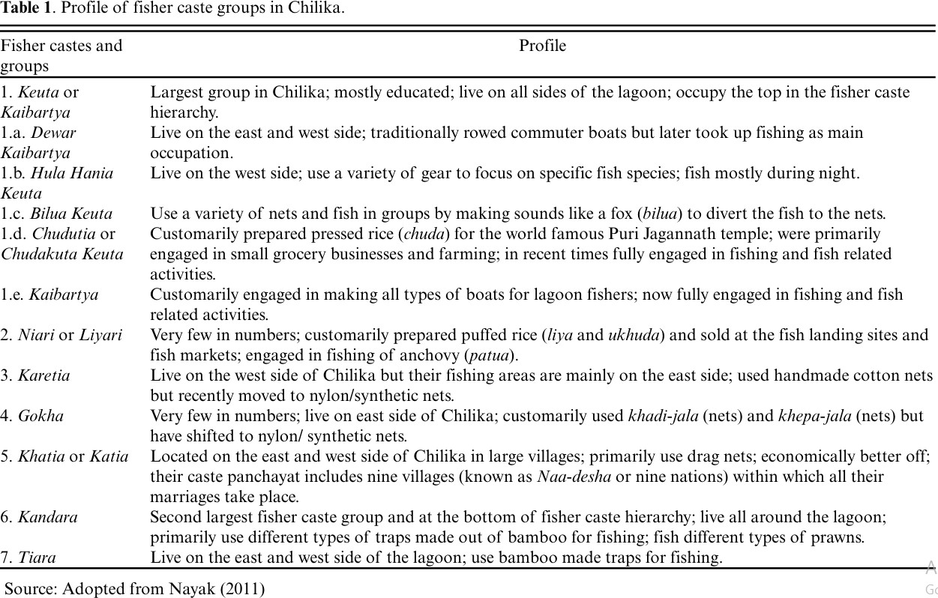

or gifts (called bheti or salami) to the king or local landlords (zamindars) to obtain permission or licenses to fish in certain areas, known as sairats (fishing grounds). This system started around 1790 and continued until the British colonial government took over the fishing activities in 1930. Even though Odisha came under British rule in 1803, the King of Parikuda retained ownership of the lagoon until the early 1900s.
In 1880, a British surveyor, J.H. Taylor, recorded that fishing rights in Chilika belonged entirely to the local fishers. During the British settlement of Odisha (1897-98), it was officially documented that caste-based fishers had exclusive fishing rights in the lagoon. However, the Kings of Parikuda, Khallikote, and Palur still owned the lagoon and managed its fisheries through local landlords (zamindars) from areas like Khallikote, Parikuda, Suna Bibi, Mirza Taher Baig, and Chaudhary families of Bhungarpur. The zamindars leased out fishing grounds to the local fishers and collected lease rents. This marked the beginning of a more formalized fishing rights system, which continues even today.
In 1926, the British established a cooperative store in Balugaon to sell fishing equipment to local fishers. During World War II, they also created 25 Primary Fishermen’s Cooperative Societies (PFCS) to support and organize fishers. These administrative and policy changes laid the foundation for Chilika's modern fishing economy, making it more structured and regulated.

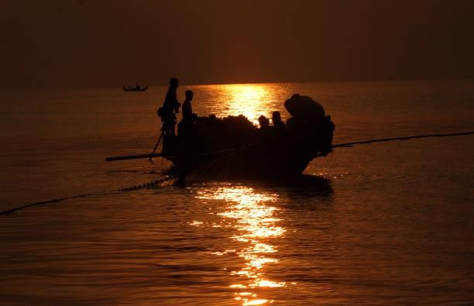

POST-INDEPENDENCE DEVELOPMENT

After India gained independence, the zamindari system (where landlords collected taxes) and the Zagir Mahals were abolished in 1953. The Zagir system referred to land given by rulers to individuals as a reward for their service, while a Mahal was a fiscal unit used for tax collection. So, Zagir Mahals were officially recognized tax-collection areas. Once these were abolished, the Odisha government’s revenue department took over control of the Chilika fisheries. From 1953 to 1959, the government continued the lease system by auctioning fishing rights. This was the first step in turning the Chilika fisheries into state-controlled property.
In 1956, the state government passed a law declaring complete ownership of the lagoon, making it state property. However, fishers who had been using these fishing grounds for generations—since the Mughal era or even earlier—continued to fish in certain areas. These areas were now labeled as ‘customary fishing areas’, meaning they were not officially owned by the fishers but they were traditionally used by them.
For about three decades, the Odisha government supported the fishers. In 1959, they introduced a pro-fisher policy by creating the Central Fishermen’s Cooperative Marketing Society (CFCMS). This society included several village-level Primary Fishermen’s Cooperative Societies (PFCS). The government allowed these cooperatives to lease fishing areas, using the CFCMS as the main organization representing the fishers. This system protected the fishers' traditional fishing rights and gave their cooperative organizations the power to make decisions about access to these areas.
However, after 1960, a series of policy changes began to threaten the fishers’ rights and economic stability. In 1965, the government introduced a 10% annual increase in fishing lease fees. In 1978, they issued an order that doubled the lease fees, making it even harder for the fishers to afford them.
In the 1980s, further changes weakened the fishers' position. The government shut down the CFCMS and replaced it with a state-controlled agency called FISHFED, which became the main body managing the PFCSs. This move reduced the fishers’ control over their own fishing rights.
In 1988, the lease policy was changed from three-year leases to just one-year leases. Fishers preferred longer leases because they allowed them to make long-term plans and business deals with fish traders. The short-term leases made it harder for them to plan ahead, and they had to spend more time and money on frequent paperwork. Fishers believed that influential aquaculture businesses pressured the government to prevent them from getting long-term leases, as they wanted to take over the fishing areas.
During a survey conducted in 2007-2008, 81 out of 88 fisher villages reported that they had partially or completely lost their fishing areas due to either government policies or encroachment by aquaculture farms. This shows how the government’s changing policies and the influence of aquaculture businesses gradually reduced the fishers' access to their traditional fishing grounds.

Controversies Around The Lease Policy Of 1991 And Changes In Institutional Hierarchies
In the early 1990s, India introduced economic liberalization policies, which aimed to boost the national economy by encouraging private investment and exports. In Chilika Lagoon, this led to intense pressure to promote shrimp farming as a way to attract capital investment and increase export revenues.
In 1991, the State Government introduced a new policy that had a major impact. It:
- Legalized shrimp aquaculture in Chilika, allowing it alongside the traditional fishing practices of the caste-based fishers.
- Increased the annual lease fee by 27% and made it compulsory for the leases to be managed by FISHFED, a government-controlled fisheries organization.
The lease fee hike was a big problem for the local fishers. Since fish production had declined, their incomes fell sharply, making it hard for them to afford the higher fees. As a result, many fishers migrated to other areas in search of work. The village-level fisher cooperatives that once supported the fishers collapsed, leaving the remaining fishers with the entire burden of the rising lease costs. This made it even harder for them to renew their fishing licenses.
In response to this policy, the fisher cooperatives filed a case in the Odisha State High Court. After a long legal battle:
  - In 1993, the High Court ruled in favor of the fishers.
  - In 1996, the Supreme Court of India also supported the fishers.
  - In 1997, the Odisha State Legislative Assembly House Committee upheld the customary fishing rights of the caste-based fishers and banned shrimp farming.
  - Finally, in 2001, the State Government officially banned shrimp aquaculture and canceled the 1991 lease policy.
However, despite the legal ban, illegal shrimp farming still continues in Chilika. Large portions of the leased areas have been illegally taken over for shrimp farming. This happens because of the lack of enforcement by the government agencies responsible for implementing the court orders. It also reflects the influence of wealthy business interests over the government, making it difficult for local fishers to protect their rights.
In 1992, another organization called the Chilika Development Authority (CDA) was created under the State Forest and Environment Ministry. Its role was to centrally manage the lagoon. However, over time, this centralized control weakened local institutions like:

Traditional village committees
  - Primary Fishermen’s Cooperative Societies (PFCS)
  - Jati Panchayats (caste assemblies)

The Fisher Federation
These institutions once provided a strong support system for local fishers, helping them with livelihoods and economic activities. Their decline made it even harder for the fishers to protect their rights and maintain their traditional way of life.

2001 Regulation Of Fishing In Chilika
In 2001, the Odisha Fishing in Chilika (Regulation) Bill was introduced in the State Legislative Assembly. Although the bill included some positive measures, one controversial provision sparked major disagreement. The bill proposed that 30% of the fishing area in the Chilika Lagoon be reserved for nonfishers—people who were not from the traditional fishing castes. The remaining 70% would be leased to the Primary Fishermen’s Cooperative Societies (PFCS), which represented the traditional fisher groups.
At first glance, the 70% share for traditional fishers seemed like an advantage for them. However, fisher leaders believed that the 30% allocation to nonfishers would legitimize illegal shrimp farming. In recent years, shrimp farming companies and individuals from nonfisher groups had been illegally encroaching on fishing areas. By giving legal fishing rights to nonfishers, the bill would protect and legalize this encroachment. This caused alarm among traditional fishers, who feared that nonfisher groups would gain permanent legal access to their customary fishing areas.
The fisher leaders argued that this policy would harm their livelihoods, weaken the local fishing economy, and damage the Chilika ecosystem. They believed that the bill, instead of protecting their rights, would actually encourage more illegal shrimp farming, which could further degrade the lagoon’s environment and threaten their traditional way of life.

MULTILEVEL DRIVERS CHANGING THE COURSE OF HISTORY
Several drivers contributed to the process of social-ecological change in Chilika and influenced the shaping of the lagoon’s history. However, two major drivers stood out. One was the growth of shrimp aquaculture in the 1980s, which led to questions about access, usage rights, and changes in the rules of the game in the lagoon fish economy. The second was the opening of a new sea mouth to the Bay of Bengal in 2001, which has had a direct impact on biophysical processes and, by extension, associated livelihood systems. Even though the two drivers followed distinctly different temporal scales, their cumulative impacts have been felt in the Chilika social-ecological system, which includes the lagoon and the fisher communities. However, focusing on the two drivers does not preclude the role of other drivers in Chilika and the multidirectional impacts of both relative stasis and relative change.

Shrimp Commercialization And Explosive Aquaculture

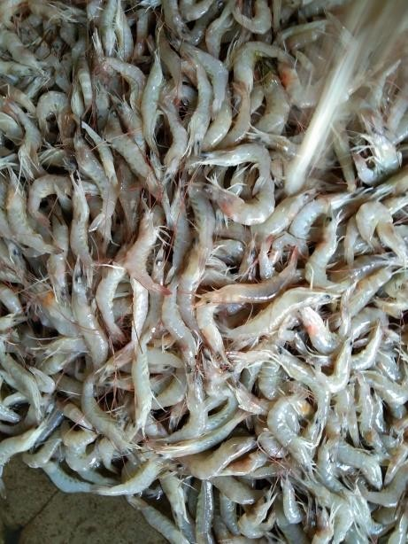
The commercialization of fisheries in Chilika Lagoon began when the British took control of the area in 1930. During this time, Kolkata (then called Calcutta) became the main market for Chilika’s fish. Fish from Chilika was transported to Kolkata by road and sea. During World War II, the fish trade expanded internationally, with dried fish from Chilika being exported to Rangoon (now called Yangon, Myanmar).
As demand for seafood grew in North America, Europe, and Japan, the prices of fish and shrimp increased significantly. This made shrimp farming a profitable business, encouraging many southern countries to focus on export-oriented aquaculture. The international market for shrimp started to develop in the 1970s, and in India, commercial shrimp farming became popular in the 1980s. Shrimp, which previously had little market value, became known as “pink gold” because of its high profitability.
In India, shrimp farming grew rapidly. By the mid-1980s, the country became one of the leading shrimp exporters in the world. In 2004, the total export value of shrimp from India reached
US$715 million. Between 1988-1989, shrimp exports accounted for 32% of the total seafood volume (18,300 metric tons) and 49% of the export value (US$40 million). By 2001-2002, cultured shrimp made up 59% of the volume (74,826 metric tons) and a massive 85.8% of the total seafood export value (US$631 million). This marked a threefold increase in volume and over a fourteenfold increase in value compared to earlier years.
The boom in shrimp farming was driven by a rising global demand for seafood and a decline in wild fish catches. Chilika Lagoon, which was already a natural habitat for tiger shrimp (Penaeus monodon), became a prime location for intensive shrimp farming. By the early 1980s, investors and policymakers recognized Chilika’s potential for large-scale shrimp aquaculture. Soon, shrimp farming spread rapidly across the lagoon, becoming a major force of change in the region.

Sea mouth creation and changes in Chilika’s social-ecological system (SES)
Sea mouths are natural openings that connect coastal lagoons to the sea. In Chilika Lagoon, there were once around seven sea and river mouths, which allowed a mix of marine, freshwater, and brackish water environments to exist. However, over time, most of these mouths naturally closed, and by the 20th century, only one sea mouth remained open. According to a 1908 report, this was the only active connection between the lagoon and the Bay of Bengal.
By the 1970s, this remaining sea mouth had become inefficient. It could no longer properly flush out sediments and silt from the lagoon into the sea. This caused increased sediment buildup, which negatively affected the lagoon’s water quality and ecosystem. To fix this, in 2001, a new sea mouth was artificially dredged (dug open) to restore the connection to the sea and improve water flow.
However, this solution caused unexpected problems. In 2007-2008, when researchers surveyed local fishing villages, many fishers believed that instead of creating a new sea mouth, it would have been better to reopen the old one. Once the new mouth was opened, it caused unintended ecological and livelihood issues. The new sea mouth allowed too much seawater to enter the lagoon, which disrupted the balance of freshwater and brackish water. This damaged the lagoon’s ecosystem and harmed fishers' livelihoods.
In two surveyed villages, the response was mostly negative:
- In Berhampur, all fisher households reported being negatively affected by the new sea mouth.
- In Badakula, 35% of households said they experienced negative impacts, but no one reported any positive effects.
The difference in responses between the two villages was largely due to their proximity to the sea mouth. Villages closer to the sea mouth were more affected, while those farther away were less directly impacted.
Despite the mixed responses, all the fishers agreed that the lagoon's condition was worsening and that fish production had decreased. However, not all of them blamed the sea mouth. Some fishers, especially those who had never seen the new mouth, linked the lagoon’s decline to other causes, such as:
- Intensive aquaculture activities (fish and shrimp farming)
- Degrading river channels, which reduced the flow of freshwater into the lagoon
- Massive forest degradation in the surrounding areas, which harmed the lagoon’s overall health.

Changes and Impacts on Chilika’s Social-Ecological System (SES)

The Chilika Lagoon has undergone significant transformations due to two major drivers of change: aquaculture expansion and the opening of a new sea mouth. These forces, although occurring on different timelines, collectively reshaped the lagoon’s ecological balance, livelihoods, and social-political structures.
The aquaculture boom began in the late 1980s, gradually expanding over the next two decades. During this period, large-scale shrimp farming spread throughout the lagoon, reducing the fishing areas available to traditional fishers and degrading the lagoon’s ecological health. In 2001, the government opened a new sea mouth, connecting the lagoon directly to the ocean. This intervention aimed to improve water quality and increase fish populations by enhancing the lagoon’s salinity and flushing capacity. However, instead of solving the existing issues, the sea mouth opening amplified the impacts of aquaculture.
The combined effects of these two drivers caused a synergistic disruption of Chilika’s social-ecological system. The sea mouth opening altered the lagoon’s hydrology, which affected fish migration patterns and water quality. Meanwhile, aquaculture expansion continued to encroach on traditional fishing grounds. The two forces acted together, worsening the challenges faced by local fishers. As a result:
- Livelihoods were lost → Fishers experienced declining catches, shrinking fishing grounds, and reduced income.
- Outmigration increased → many traditional fishers were forced to leave Chilika in search of work elsewhere.
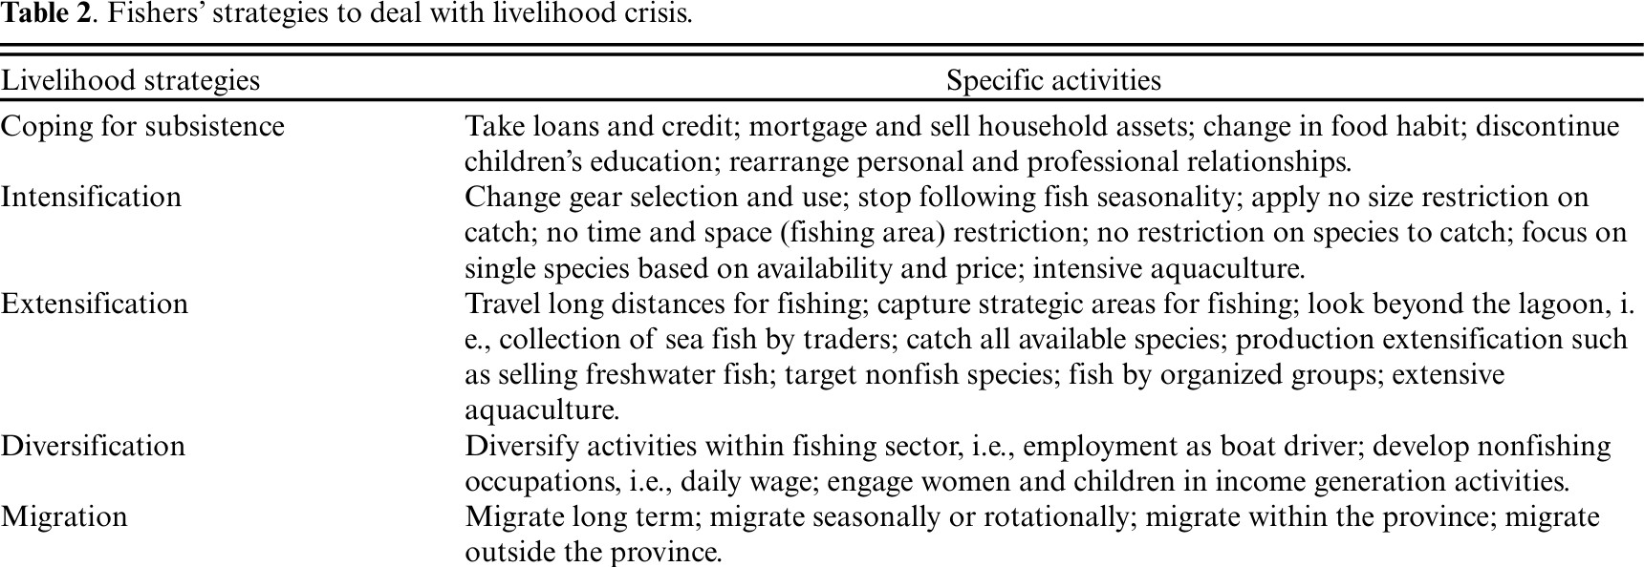

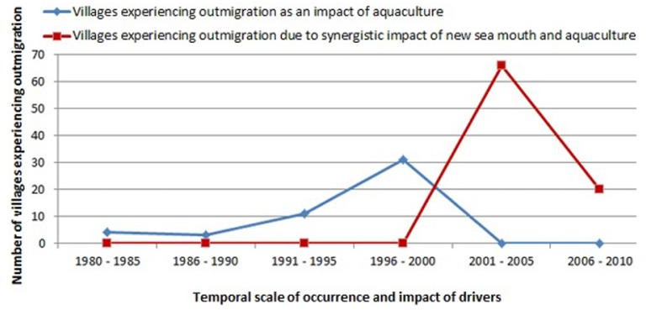
.

Fig. 1 -Temporal scale of occurrence of drivers, Â aquaculture and sea mouth, Â and their impact on outmigration in Chilika fisher villages

THESE CHANGES IMPACTED THREE KEY AREAS:

Shifts In Ecosystem Processes
Over the years, Chilika Lagoon’s ecosystem has undergone significant changes due to two main factors:
  - Aquaculture expansion (1980s) → Large-scale shrimp farming transformed natural fishing grounds into monoculture farms.
  - Sea mouth opening (2001) → The artificial connection between the lagoon and the ocean disrupted the lagoon’s natural hydrology and salinity balance.
These two events caused major shifts in the lagoon’s ecosystem processes, altering its biodiversity, water dynamics, and overall ecological stability.

CHANGES IN SALINITY AND WATER BALANCE
The sea mouth opening caused a rapid influx of saltwater from the ocean into the lagoon. This disrupted the lagoon’s natural salt-freshwater balance, which is essential for maintaining the habitat of many species.
  - Before 2001: The lagoon had a stable mix of fresh and saltwater, supporting a rich variety of fish and aquatic species.
  - After 2001: The increased saltwater flow made the lagoon more saline, reducing the habitat quality for freshwater species and altering the fish population.

FLUCTUATING WATER FLOW AND DEPTH
The sea mouth opening also changed the natural water flow patterns, making the lagoon’s hydrology unpredictable.
  - Irregular tidal inflows and outflows → Water movement during high and low tides became inconsistent. This affected the spawning and migration patterns of fish, making it harder for fishers to predict fishing seasons.
  - Unstable water depths → The depth of the lagoon became uneven, creating shallow and deep pockets, which disturbed the natural distribution of species.

HABITAT DESTRUCTION AND SPECIES LOSS
The combined effects of aquaculture and sea mouth opening damaged key habitats.
  - Aquaculture farms → Large-scale shrimp farms destroyed natural fish breeding grounds, turning species-rich areas into monoculture zones.
  - Loss of biodiversity: According to fishers, 11 fish species that were once common in Chilika disappeared. Many of these were high-market-value species, reducing fishers' income.
  - Disruption of food webs: The changes in species composition weakened the natural food chain, making the ecosystem less resilient.

INVASIVE SPECIES AND NEW MARINE CREATURES
With the new sea mouth, fishers started encountering unfamiliar sea creatures that disrupted the traditional fishing ecosystem.

  - Barnacle infestation: Barnacles grew rapidly, damaging fishers’ equipment and boats.
  - Appearance of new species: Fishers reported seeing stingrays, octopuses, and jellyfish—species they had never encountered before. These creatures often damaged nets and made fishing more difficult.

INCREASED UNCERTAINTY AND VARIABILITY
The shifts in ecosystem processes made the lagoon more unpredictable.
  - Uncertain fishing seasons: The changes in water flow and species availability made it harder for fishers to predict the best fishing times.
  - Declining fish yields: With fewer fish species and shrinking fishing grounds, fish production became inconsistent, directly impacting the livelihoods of local fishers.

OVERALL IMPACT:
The combined effects of aquaculture expansion and the sea mouth opening caused significant ecological disruptions in Chilika Lagoon. The loss of biodiversity, habitat destruction, and unpredictable water conditions made the ecosystem more fragile and less productive. These changes not only harmed the lagoon’s natural balance but also threatened the livelihoods of the local fishing communities who relied on the lagoon’s stable ecosystem for their survival.

Social, economic, and livelihood crises
The ecological changes in Chilika Lagoon, driven by aquaculture expansion and the sea mouth opening, had severe impacts on the lives of local fishers. These changes affected their livelihoods, income, and social well-being, creating a deep crisis for the community.

DECLINE IN FISH PRODUCTION AND LIVELIHOOD LOSS

As fish habitats were destroyed and the lagoon ecosystem became unstable, fish production plummeted, especially between 2007 and 2010. The once-thriving small-scale fishing economy—run by local fisher communities for generations—began to collapse. With fish yields dropping, many villages found fishing no longer profitable, leading to declining fisher incomes and pushing families into poverty.
Key Impact: In many villages, fishing livelihoods became unsustainable, forcing fishers to look for alternative jobs or leave the area.

FOOD INSECURITY AND FINANCIAL STRUGGLES

As fishing income decreased, food insecurity increased. Fishers, who once depended on rice and fish as their staple diet, could no longer afford these basic foods. The rising cost of rice and other essentials made it harder for families to meet their nutritional needs. To cope with the income loss, fisher families took large cash loans with extremely high interest rates (60-120% per year). In some villages, 100% of households relied on loans, but their low income made repayment impossible, trapping them in a cycle of debt.

Key Impact: Fishers became financially vulnerable, struggling with food scarcity and rising debt.

EDUCATION CRISIS AND CHILD LABOR

The financial hardship forced families to pull their children out of school to reduce expenses and increase household income. In Berhampur and Badakul villages, school records showed 51% dropout rates due to financial struggles and low enrolment rates (39%) as families could no longer afford schooling. A 70% decline in students appearing for high school exams between 2007-2008 reflected the severity of the education crisis. Many children were sent to work, often in labor-intensive jobs, to support their families.
Key Impact: The next generation faced reduced educational opportunities, affecting their future prospects.

OVERFISHING AND UNSUSTAINABLE PRACTICES

To cope with declining catches, fishers intensified their fishing efforts, using highly efficient but unsustainable techniques. They used catch-intensive gear that ignored traditional rules about fishing seasons, species size, and location. As a result, 40% of the catch during 2007-2008 consisted of immature fish and crabs, reducing the population of breeding species. Some fishers resorted to harvesting post-larval shrimp, further damaging the natural fish stocks. Aquaculture farms also took over fishing areas, reducing access to traditional fishing grounds.
Key Impact: Overfishing and habitat loss further depleted fish stocks, worsening the crisis.

MIGRATION AND OCCUPATIONAL DISPLACEMENT

As fishing became unviable, many fishers migrated to urban areas in search of alternative work. Over one-third of adult fishers left Chilika, often taking low-paying, unskilled labor jobs in cities. Only men migrated, leaving their families behind. This created a cultural and social disruption:
  - Without the men, fishing operations at home stopped, as fishing was traditionally a male-dominated activity.
  - Women, who were involved in fish processing, lost their income opportunities.
The emotional disconnect was profound. Displaced fishers felt they no longer belonged to either Chilika or the cities they moved to.
Key Impact: Migration caused social fragmentation, with families separated and cultural identities weakened.

GROWING INEQUALITY BETWEEN RICH AND POOR

As fishing became more capital-intensive, wealthier households had the resources to diversify into small businesses, such as grocery stores or convenience shops in nearby tourist areas. They could also invest in better fishing gear or expand their aquaculture farms. However, poorer households were excluded from these opportunities. Lacking financial resources, they were

forced into daily wage labor or outmigration, which offered low, unstable incomes. This widened the gap between rich and poor, creating economic inequality.
Key Impact: The crisis deepened social and economic inequality, marginalizing poorer fisher families.
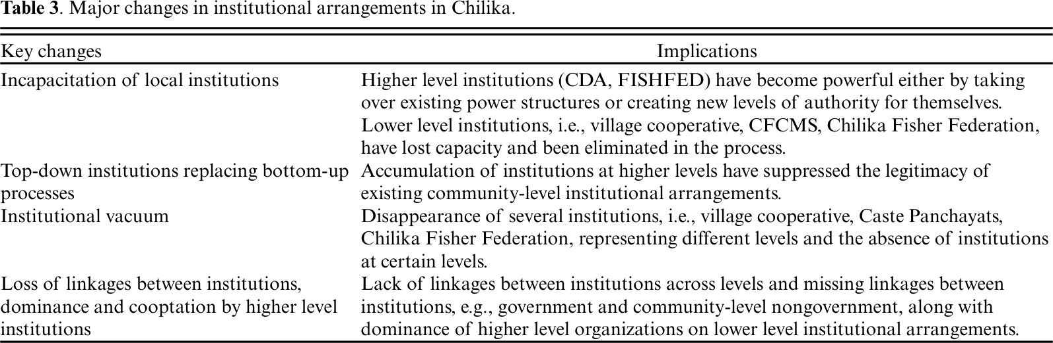

Institutional and Political Dynamics in Chilika
The growth of aquaculture in Chilika triggered significant institutional and political changes, with power gradually shifting from local fishers to wealthy elites and centralized authorities. As aquaculture expanded, elite groups—including higher castes, economically influential individuals, and those with political ties—encroached on customary fishing areas, displacing local fishers. Out of 86 villages eligible to lease fishing areas, 79 faced encroachment, and 81 reported partial or complete loss of their fishing grounds. This led to serious access rights issues, gradually stripping fishers of their control over the lagoon and diminishing their livelihoods.
In response, fishers fought legal battles to protect their rights. Both provincial and federal courts ruled in favor of the fishers and banned aquaculture in Chilika. However, despite these legal victories, illegal aquaculture operations continued to dominate. Estimates suggest that 60-80% of the lagoon’s fishing area remained under illegal aquaculture due to weak enforcement and the power of influential elites. Thus, even though fishers won in court, their fishing rights were not restored in practice.
The institutional landscape of Chilika also deteriorated. As fish production declined, around 90% of village fish cooperatives became inactive. This institutional decay weakened local governance structures and made it harder for fishers to organize and defend their rights. Instead, centralized institutions like FISHFED (a state-level cooperative federation) and the Chilika Development Authority (CDA) assumed control. These top-down institutions replaced traditional bottom-up governance, creating a gap in local representation and reducing fishers' influence over decision-making.
Overall, the institutional and political changes in Chilika led to:
  - Elite capture of traditional fishing areas, marginalizing local fishers.
  - Legal victories for fishers that failed to translate into real-world protection.
  - Collapse of local cooperatives, weakening the fishers' ability to self-govern.

  - Centralized control, reducing fishers' voice in managing the lagoon.
These changes eroded the traditional governance system, disempowered local fishers, and deepened the social-ecological crisis in Chilika.
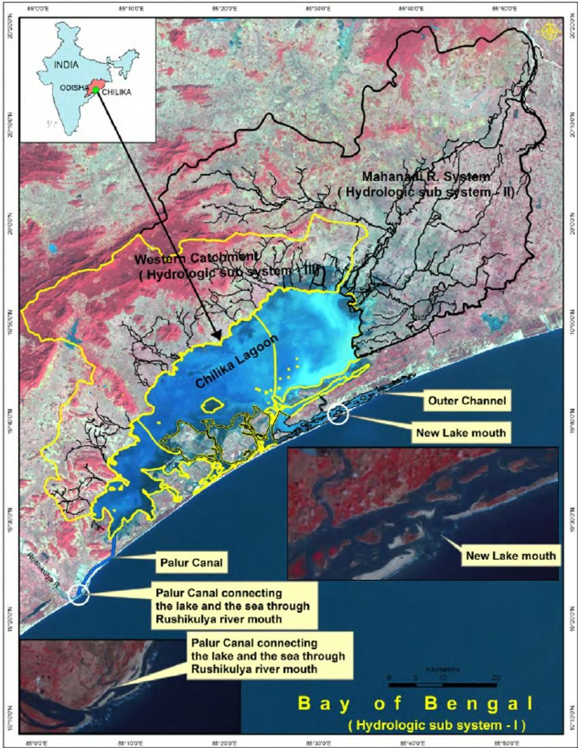

Geomorphology, Land Use/Land Cover and Sedimentary Environments of the Chilika Basin

Geomorphology of the Chilika Basin and Lagoon Based on Remote Sensing Data
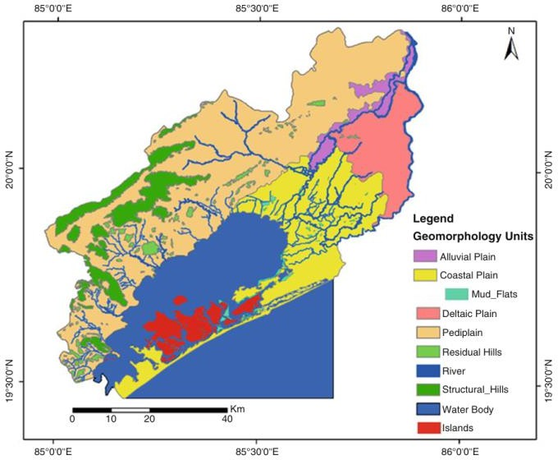
The various geomorphic units in the Chilika Basin are shown in Fig. 10.2. The northern and western parts of the Lagoon are surrounded by structural hills, residual hills and Pediplain whereas deltaic, alluvial, and coastal plains are present in the north-eastern and eastern parts. There is very little information available on the geomorphic evolution of the Chilika, particularly its origin. Pascoe (1964) suggested that it was a shallow brackish water inshore lake connected to the Bay of Bengal during the later stages of the Pleistocene period. However, a more recent study by Khandelwal et al. (2008) recovered a 8 m long sediment core from Chilika for a detailed sediment logical and pollen studies and argued that the Chilika was a part of a river or a river delta with fresh water vegetation about 13,500 years BP when the sea level was lower. It was only after ~9500 years BP, with the rise in sea level, it became an estuary and mangrove vegetation dominated the area. The fall in sea level after about 2000 cal years BP changed the morphology of the coast by forming barrier spits and sand ridges. Consequently, a large lagoon was formed replacing the marine species by fresh water species (Khandelwal et al. 2008). The
discharge of sediments by the tributaries of the Mahanadi River might have added to the formation of the spit bars (Krishnan 1968). The longshore drift and tidal currents and probably strong winds shifted sands to the shore resulting in the growth of the barrier spits and sand ridges. The barrier beach protected the Chilika from any direct influence of the Bay of Bengal and gradually transformed the lake into a shallow lagoon. The presence of a number of shoals, sand spits, sand bars and openings of
shallow depth helps in maintaining lake’s estuarine character by considerably reducing the tidal flow in and out of the lake.

Geomorphic Landform Changes

To study the landform changes in and around Chilika Lagoon, researchers used satellite images from April and May of the years 1980, 1988, 2000, 2005, 2010, and 2015. By analyzing these images, they created geomorphic maps showing changes in:
- The lagoon boundary

Barrier islands
- Sand bars
The study divided the analysis into two periods:
- 1980–2000 (Pre-intervention period) – Before the sea mouth opening.
- 2000–2015 (Post-intervention period) – After the restoration program, which included opening a new sea mouth near Satapada in September 2000.
KEY FINDINGS:

Lagoon Area:
    - 1980–1988: The lagoon area increased from 865.42 km² to 932.62 km².
    - 1988–2000: The area decreased to 909.28 km².
    - 2000–2015: It further reduced to 876.10 km².

Island and Sand Bar Changes:
    - 1980–2000: Both islands and sand bars decreased in size.
    - 2000–2015: The island area continued to shrink, but sand bars expanded significantly from 4.78 km² to 11.33 km².
    - This indicates that islands are gradually submerging due to their low elevation, making them more vulnerable to rising water levels.
    - The increase in sand bar area during the post-intervention period suggests a higher sediment inflow due to the new sea mouth opening.
Overall, the landform changes in Chilika reflect the impact of the restoration program, with increased sedimentation, expanding sand bars, and shrinking islands, reshaping the lagoon’s landscape.
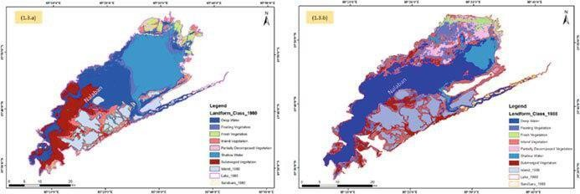

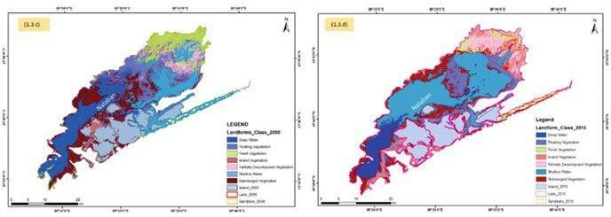
Fig 2- Geomorphic maps of the Chilika for (a) 1980, (b) 1988, (c) 2000 and (d) 2015 documenting major landform changes during the period 1980–2015 prepared from repetitive satellite images (this work).
Probing further, some of the most remarkable changes within the lagoon include a significant variation in various geomorphic elements (Table 2.1). During the period 1980–2000, all vegetation related elements (viz. floating vegetation, fresh vegetation, inland vegetation, and partially decomposed vegetation) show an increase whereas the submerged vegetation decreased drastically (Figs. 2,3 & 4). This change may be the manifestation of decreased salinity, depth and degradation of the overall ecological condition of the lagoon. Interestingly, these trends seem to have reversed in the post-intervention period (November 2000–2015), and most vegetation related elements, except for partially decomposed vegetation, show a decrease. The area under submerged vegetation was observed to increase significantly during the latter period, which may be attributed to the revival of the conducive salinity regime. Although the deep water areas decreased drastically during this period, the shallow water areas showed a remark able increase. We interpret this as a manifestation of increased sediment flux and siltation in the Chilika after the opening of the new mouth.
Table 4 Landform changes within the Chilika lake between 1980 and 2015
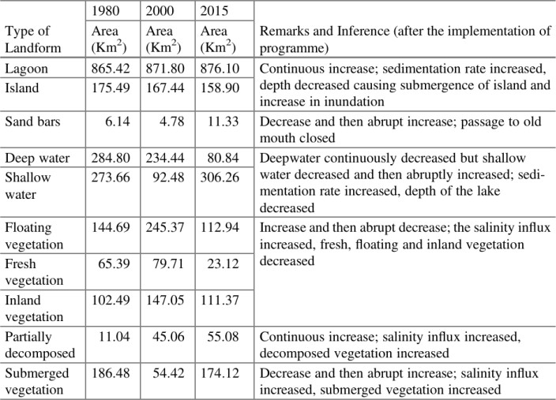

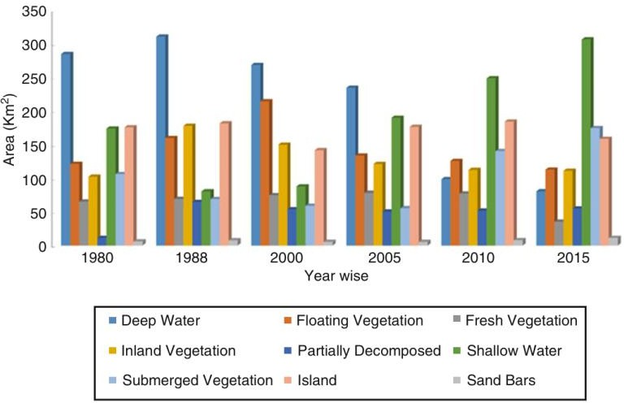
Fig. 3 Landform changes in Chilika Basin during the years 1980, 1988, 2000, 2005, 2010 and 2015
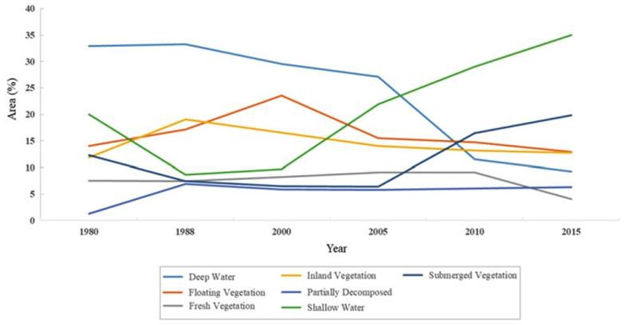
Fig. 4 Landform as well as aquatic vegetation changes in Chilika Basin during the years 1980, 1988, 2000, 2005, 2010 and 2015.
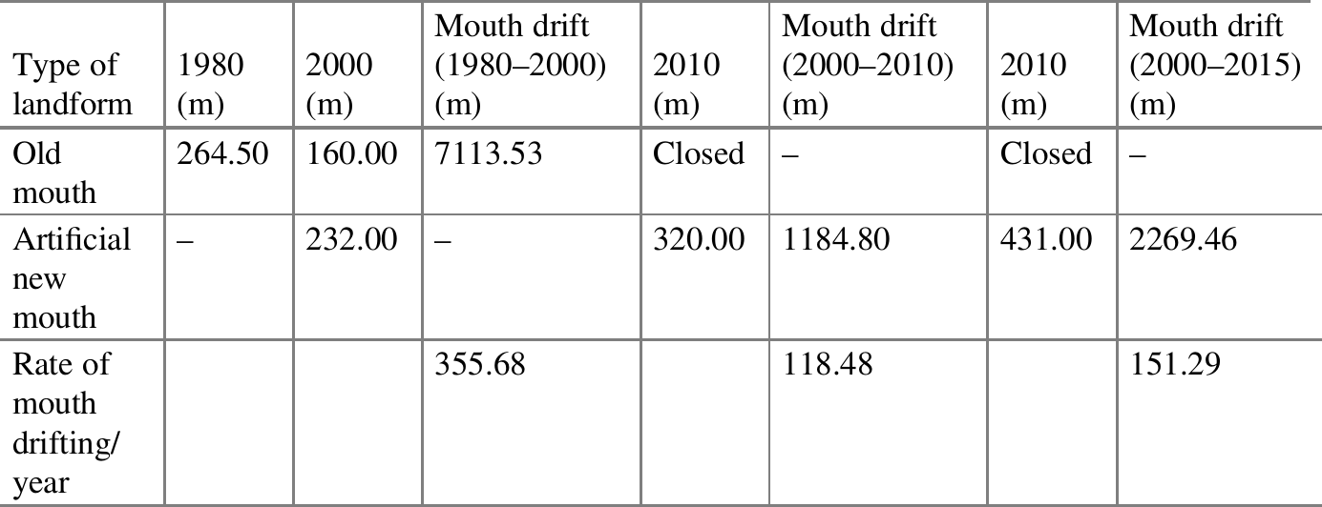
Table 5 Tidal inlet changes in between 1980 and 2015

An added factor is possibly increased flux from the tributaries of the Mahanadi River. Another notable change is the increase in the aerial extent of the Chilika lagoon, mainly due to a decrease in water depth because of high sediment input from the Mahanadi and its tributaries (Figs. 2, 3, & 4). We suggest that the storage capacity of the lagoon decreased due to sedimentation and therefore water spilled to the shore areas thereby increasing the lagoon area. We have also investigated the morphological changes around the tidal inlets during the period of observation. The natural mouth of the lagoon was 264.50 m wide in 1980 and situated in the NE part of the lake (Table 2.1, Figs. 5a and 5c). But in the year 2000, the natural mouth opening reduced to a width of 160 m and further shifted in NE direction approximately by 7 km (Fig. 5f and g). The drifting rate calculated was around 355.68 m per year that was much higher than the rate observed in the last 35 years.
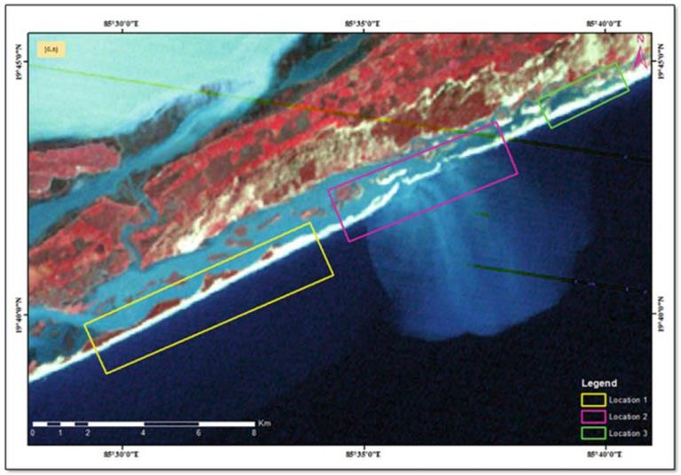
Fig. 5 (a) Landsat image of the area around the tidal inlet of Chilika. Rectangles mark the windows in which the detailed investigations were carried out.
The reducing width of the old mouth severely threatened the Chilika due to problems such as shrinkage of water spread area, a decrease in depth due to siltation, salinity reduction, macrophyte infestation, eutrophication, and loss of biodiversity.
After a series of assessments on the wetland environment on changes in salinity, sedimentation rates, and freshwater macrophytes, the CDA decided to open a new mouth to improve the salinity and the biodiversity in and around the lagoon. In September 2000, a 232 m wide new artificial mouth was opened (Fig. 5e). The opening of new lagoon mouth and desiltation of the channel to the sea through the barrier beach at Satapada restored the natural flows of water and sediment by reducing the distance of outflow from the lake by 18 km. This opening vastly improved the lagoon-sea connection and helped to minimise the problems of sedi mentation and invasive macrophytes.

The immediate positive impact was the stark and rapid recovery of the fishery along with the considerable improvement in salinity flux. Using the satellite mea surements, we observed that by the year 2010, this artificial mouth shifted ~ 1 km towards the northeast with an opening of 320 m and a drift rate of 118.48 m year 1. The natural mouth had closed by that time and further accumulation occurred around this by 2015 (Fig. 5i). The artificial mouth with a width of 431 m drifted further to a distance of 2269.46 m by 2015 (Fig. 10.6h) with a drift rate of 151.29 m/year. The reconstruction of spit growth and its dynamics indicate that as the width of the mouth increased, so did the rate of drift. The drift was mainly due to large northerly littoral sediment transport that continuously shifted the inlet mouth towards the north, resulting in elongation of the channel and reduction in channel cross section.
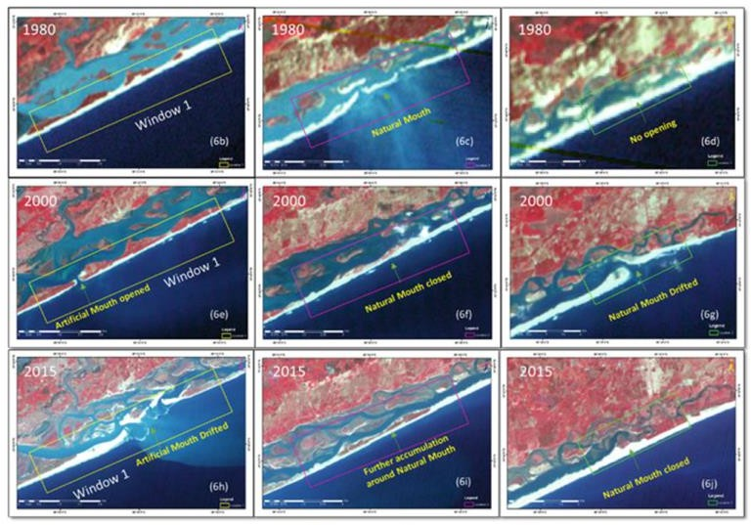
Fig. 5 (b–j) Changes in tidal inlets and opening of new artificial mouth in the three windows during the period 1980–2015.

Sedimentary Environment of Chilika
Three hydrological subsystems influence the hydrology of the Chilika Lagoon namely,
- the Mahanadi River system on the northern side,
- small river channels on the western side, and
- the Bay of Bengal on the eastern side.
The distributaries of the Mahanadi River namely, Daya, Nuna, Bhargavi and Makara drain directly into the Chilika (Fig. 10.1). These distributaries of the Mahanadi though controlled by the Naraj barrage upstream contribute maximum silt load and fresh water into the Chilika . Ghosh et al. (2006) and Khandelwal et al. (2008) estimated that 1.5 million tons of silt load are discharged every year by the Mahanadi distributaries along with 51% of the total freshwater inflow into the lake. As many as 52 small rivers and rivulets from western catchment (e.g. Kansari, Kusumi, Janjira, Tarimi) account for 0.3 million tons of sediments supply annually along with the total freshwater input of 39%. The longshore sediment transport (littoral drift) of the Bay of Bengal also contribute about 0.1 million tons of sediments annually. The discharge by the rivers to the Chilika is high during peak flood seasons of the Southwest monsoons (June–September) and very low during rest of the year. The lagoon receives 10% of freshwater input from direct precipitation. Due to high sediment supply by the Mahanadi distributaries, the sedimentation rate is comparatively higher in northern (7.6 mm year 1) and central sectors (8 mm year 1) and low in the southern sector (2.8 mm year 1).
Sediments to the Chilika are mostly derived from the denudation of hills and plateaus of the Eastern Ghats exposed on the northern, western and southern borders of the lake. The sediments are mostly of silt-clay size with biogenic debris and occasional intercalated lenses of sand. Sand predominates on the eastern and western shores of the central and southern sectors, at the bottom of the outer channel and spits and bars. Because of long-distance transport, the Mahanadi distributaries supply fine-grained sediments of mud size whereas the small rivers/rivulets originating from the nearby hills mostly carry coarser sediments. A seaward decrease in mud has been observed with an increase in sand content towards the mouth of the outer channel. The sediments show a predominance of quartz along with minor admixtures of feldspar (microcline), muscovite, and clay minerals. The clay minerals are composed of hydro–muscovite, illite, and kaolinite. The heavy metals exhibit slightly decreasing concentrations from northeast to southwest, thus indicating the supply of contaminants from the Mahanadi River. The organic matters within the sediments of the lagoon are from the decomposition of macrophytes and supplies by the rivers. The organic matter content is highest in the northern sector (1.29%) that decreases seaward.

Land  cover type | 1980 |  | 2000 |  | 2005 |  | 2010 |  | 2015 |  | Remarks
Land  cover type | Area (km²) | Area (%) | Area (km²) | Area (%) | Area (km²) | Area (%) | Area (km²) | Area (%) | Area (km²) | Area (%) | Remarks
Settlement | 564.38 | 9.74 | 812.8 | 14.02 | 858.8 | 14.82 | 913.5 | 15.76 | 1061 | 18.30 | Continuous increase, significant
Agriculture, plantation | 1292.5 | 22.30 | 1171 | 20.21 | 1063 | 18.34 | 987.9 | 17.05 | 953.8 | 16.46 | Continuous decrease
Agriculture, fallow | 246.35 | 4.25 | 264.2 | 4.56 | 246.6 | 4.25 | 276.6 | 4.77 | 255.4 | 4.41 | No change
Forest, evergreen | 238.42 | 4.11 | 327.6 | 5.65 | 324.5 | 5.60 | 281.1 | 4.85 | 301 | 5.19 | Some increase between 1980–2000  and then no change
Forest, scrub forest | 372.95 | 6.43 | 328.1 | 5.66 | 312.4 | 5.39 | 318.7 | 5.49 | 307.8 | 5.31 | Continuous decrease, minor
Lake wetland | 214.74 | 3.71 | 174.4 | 3.01 | 238.7 | 4.12 | 235.6 | 4.06 | 255.3 | 4.40 | Decrease between 1980–2000  and then increase
Inland wetland | 774.54 | 13.36 | 708.1 | 12.22 | 801.7 | 13.83 | 796.4 | 13.74 | 729.5 | 12.59 | No major change
Barren/ wasteland | 348.27 | 6.01 | 211.7 | 3.65 | 162.5 | 2.80 | 142.4 | 2.46 | 143.4 | 2.47 | Significant decrease throughout
Water bodies | 1743.6 | 30.08 | 1798 | 31.02 | 1788 | 30.85 | 1844 | 31.81 | 1788 | 30.86 | No change
Table 6 LULC classification for 1980, 2000, 2005, 2010 and 2015.

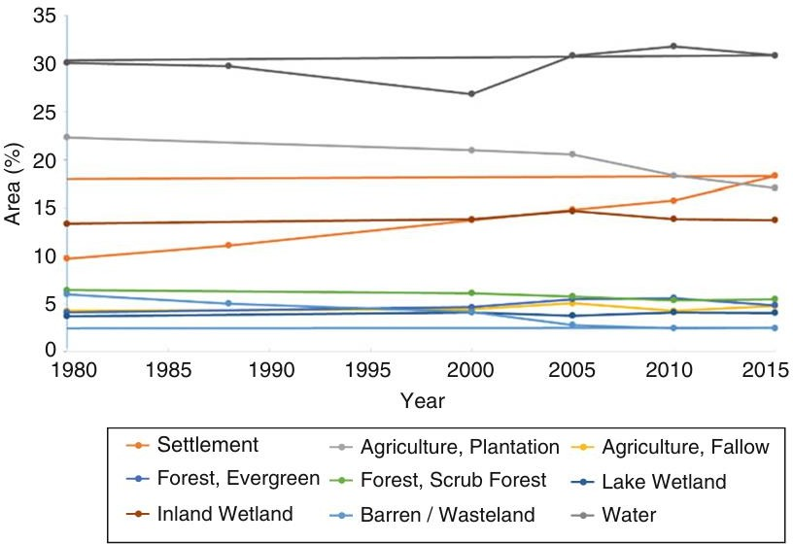
Fig. 6 Trend analysis of land use/land cover in Chilika between 1980 and 2015.

The monsoon rains play a significant role in shaping the hydrography of Chilika Lagoon. During the monsoon months, there is a large influx of water and sediment from rivers flowing into the lagoon, as well as from longshore ocean currents. This leads to massive flooding in the lagoon. The salinity of the water varies throughout the year due to the combined influence of tides and freshwater inflow from rivers.
During the monsoon season, the salinity decreases significantly due to the heavy inflow of freshwater from the northern and central parts of the lagoon. However, the southern sector is less affected by the monsoon and maintains its brackish-water conditions. In the summer months, the water level in the lagoon is at its lowest, allowing more saline water from the outer channel to flow into the lagoon, which increases salinity. The winds also play a crucial role by mixing water from different areas, further influencing salinity levels.
The diverse environment of the Chilika Lagoon supports freshwater, brackish, and marine species, making it a rich biodiversity hotspot. However, the population of these organisms changes depending on the season and location, as the salinity fluctuates. The biodiversity is heavily impacted by these seasonal and spatial changes in salinity, which are influenced by river inflows, tidal effects, and weak water circulation. In the outer channel, as salinity decreases, polyhaline and mesohaline organisms (which thrive in saltier water) are gradually replaced by oligohaline species (which prefer less salty water).
Siltation, or the accumulation of sediment, is a major threat to the lagoon’s ecosystem. It reduces salinity and disturbs the natural balance. Over the years, changes in land use and land cover (LULC) in the lagoon’s catchment area have intensified this problem. Satellite data shows that, over the last few decades, there has been a 5.84% decline in agricultural plantations and a 3.54% decrease in barren land. This suggests that increased upstream erosion is contributing to a higher sediment load flowing into the lagoon, although no direct measurements of erosion rates are available.
The river inflows into the lagoon are also being regulated by a series of hydraulic structures upstream, which affects the water availability needed to sustain the lagoon’s ecosystem. Since 2000, the lagoon has been experiencing greater tidal influence, causing it to act as a sink for terrestrial material. This has resulted in a gradual decrease in the average depth of the lake, although detailed bathymetric surveys are required to confirm this observation.
The accumulation of sediment is gradually choking the outer channel, preventing the free flow of silt-laden freshwater into the sea. This leads to blockages and shifting of the outer channel and mouth, which disrupts the natural exchange of water and sediment between the lagoon and the sea. As a result, the lagoon area is shrinking, and the increased sediment in the water has significantly reduced its transparency.
Apart from siltation, several natural and human factors are degrading the Chilika Lagoon’s environment. Activities in the Mahanadi River Basin and coastal processes in the Bay of Bengal are contributing to this deterioration. The growing human population around the lagoon and catchment area poses a serious threat. Increased agriculture, disposal of untreated waste, and wastewater discharge are introducing large amounts of nutrients and pollutants into the lagoon through rivers and tributaries. This nutrient enrichment promotes the excessive growth of aquatic plants (macrophytes), and their subsequent decomposition leads to low oxygen levels (anoxia and hypoxia) in the water.

Environmental Changes in Chilika Lake: Pre- and Post-Hydrological Intervention

Hydrology of the Lake
Table 7 Physiographic attributes of the Chilika lagoon

1 | Location | Lat. 19° 28′–19 º 54′ North Long. 85° 05′–85° 38′ East
2 | Boundaries | East: Bay of Bengal  West: Rocky hills of Eastern ghats North: Alluvial plain of Mahanadi delta South:  Rocky hills of Eastern ghats
3 | State | Odisha
4 | District | Puri, Khurda and Ganjam
5 | Shape | Pear Shaped
6 | Length and Breadth | Max length: 64.3 km Max breadth: 18.0 km Min breadth: 5.0 km
7 | Spit (Sandbar) | Length: 60 km  Width: 0.6–2.0 km
8 | Water spread area | Maximum: 1,020 km² (Monsoon) Minimum: 704 km² (Summer)
9 | No.of rivers and rivulets draining into the lagoon | 52
10 | Total area of islands | 223 km²
11 | Lagoon Mouth | Sipakuda, Gabakunda and Dhalabali
12 | Major Ecological Divisions | Northern Sector Central Sector  Southern Sector

13 | Depth | 0.38-6.20m
14 | Catchment area | 3989 km²
15 | Fisherman families | 12363
16 | Fisherman villages | 127
17 | Total no. of primary fish cooperative societies | 66 (active)
18 | No. of Jelly | 19
Source: Panda et at.(2008)

Table 8 Physical-chemical parameters of Chilika lagoon
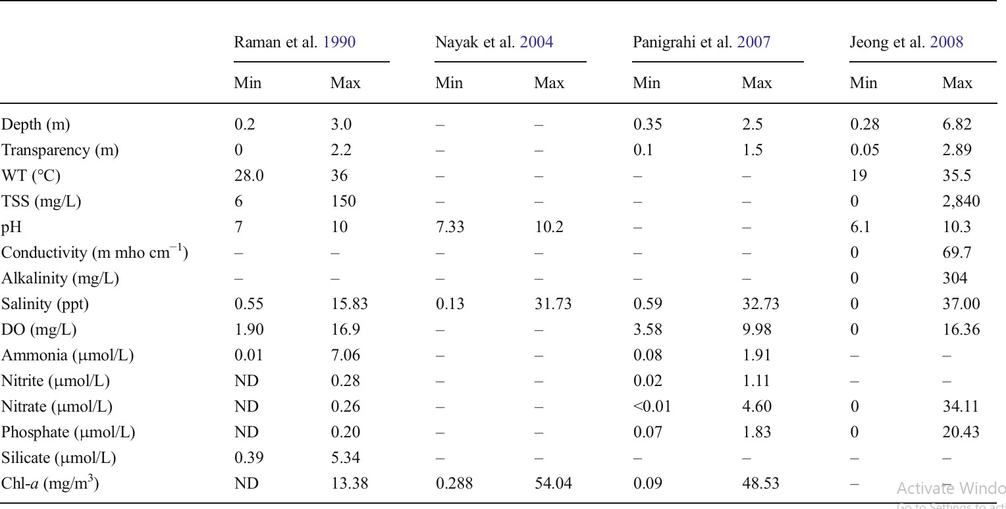

Ecology of the Lake before 2000

The salinity levels in Chilika Lake play a key role in determining the distribution of organisms in this estuarine environment. The lake supports a mix of freshwater, brackish water, and marine species, which vary across different areas and seasons. This rich environment makes Chilika a biodiversity hotspot along the eastern coast of India. It is also an important fishing ground, providing livelihoods for over 200,000 fisher families living around the lake.
However, ecological degradation of the lake began in the 1970s and accelerated significantly during the 1980s and 1990s. Chilika eventually became recognized as a highly degraded and sensitive coastal ecosystem. In 1981, it was declared a Ramsar site (wetland of international importance), and in 1993, it was added to the Montreux Record, which lists wetlands facing significant ecological issues.
Siltation: The Major Ecological Threat
One of the biggest threats to the lake’s ecology was siltation (accumulation of soil and sediments).
- 1.5 million tons of silt entered the lake annually from the Mahanadi river distributaries, and
- 0.3 million tons came from the western catchment area.
The increased land use and erosion in upstream areas added more sediment, significantly raising the sediment load. The siltation of the outer channel restricted the outflow of silt-laden freshwater, causing the lagoon to become more clogged with sediment. Additionally, storm surges and longshore drift (the movement of sand and sediment along the shore) gradually pushed the lake’s inlet farther north.
As a result of this sediment buildup:
- The lake inlet became narrower, and
- The outer channel became shallower, which reduced the seawater inflow and the freshwater outflow.
Recognizing the severity of this situation, Jhingran and Natarajan (1969) identified siltation as the major problem affecting the lake’s ecology and fisheries. They recommended several measures, including:
- Desilting the Magarmukha area
- Deepening the outer channel
- Widening the Palur canal
- Maintaining the lake inlet's position and width
These actions were seen as necessary to preserve the lake’s health and its biotic resources.

Salinity Decline and Its Impact
Salinity is a key factor that governs the distribution and abundance of organisms in the lake. However, minimal seawater intrusion and restricted freshwater outflow, due to the clogged lagoon mouth and silted outer channel, caused a significant drop in salinity.
The reduction in salinity altered the distribution of species, making the lake more favorable for freshwater organisms. This shift negatively impacted the diversity and abundance of brackish and marine species.

Weed Infestation: A Major Ecological Issue
The combination of siltation, reduced salinity, and nutrient enrichment facilitated the growth of freshwater weeds in the lake. Several studies reported the expansion of invasive weeds such as:
- Potamogeton
- Najas
- Hydrilla
- Chara
- Phragmites
- Water hyacinth (Eichhornia crassipes)
Initially, weed infestation was mainly limited to the northern sector, with dense patches of water hyacinth, pondweed, and tall weeds. However, over time, the weed spread to other areas of the lake.
By 2000, the weed cover had expanded to 523 km², compared to:
- 20 km² in 1973
- 100 km² in 1982
- 440 km² in 1998
According to Ghosh et al. (2006), Potamogeton made up 78% of the total weed composition. The massive weed infestation caused several problems:
- It hindered fishing activities by clogging fishing areas and damaging nets.
- It destroyed breeding and spawning grounds of many fish and shellfish species.
- The decomposition of the weeds created anoxic and hypoxic conditions (lack of oxygen), suffocating bottom-dwelling fish and benthic invertebrates (organisms living on the lakebed).
Thus, weed infestation became the third major problem contributing to the ecological degradation of Chilika Lake.

PHYTOPLANKTON
Species Composition
 | Mistra et al. 1988 | Raman et al. 1990 | CIFRI 2006
Total | 62 | 96 | 399
Diatoms | 43 | 60 | 181
Dianoflagellates | 8 | 3 | 50
Blue Green Alagae | 7 | 13 | 44
Green Algae | 4 | 16 | 29
Others |  | 4 | 95
Relative Abundance (%) Diatoms(67.3%),dinoflagellates(3.5%),bluegreenalgae(25.9%),greenalgae(2.3%)
Pigments ((mg/m3) TotalChlorophyll(ND-67.05),Chlorophyll-a(ND−54.04),Chlorophyll b(ND-18.60), Chlorophyll-c(ND−59.03)

ZOOPLANKTON
Plankton volume (ml/l) | 0.03 to 0.27
Species Composition | 170sp. (26 groups)
Relativea bundance of Dominant groups (%) | Copepoda(43–70), Velligers(5–30), Nauplii(16-18), Protozoans(7), Rotifers(4), Polychaetes(2), Mysids(1.5)
Biomass (g/m3) | 0.3213-3.3048
Algae:

MYCROPHYTES
Algae | Gracilaria verrucosa, Enteromorpha compressa, E.intestinalis, Spirogyrasp.,  Charasp., Nitella sp., Chaetomorphasp., Pithophorasp.etc.
Vascular Weeds: | Potamogeton pectinatus, Najas graminea, N.faveolata, Hydrilla verticillata, Eichhornia crassipes, Azollasp., Ipomoeasp., Typha angustata, Scripus  articulatus, Phragmites karka etc.
Seagrasses: | Halophila ovata, H.ovalis, H.beccarii, Halodule uninervis, H.pinifolia
Weed spread area:
1973 | 20
1977 | 60
1982 | 100
1985 | 200
1998 | 440
2000 | 523
2001 | 351
2010 | 285.96
2011 | 300

ZOOBENTHOS
Total Species | 62
Dominant Group | Foraminifera, Nematoda, Polychaeta, Copepoda, Ostracoda, Isopoda, Amphipoda, Gastropoda, Bivalves
Biomass (gm/m sq)
Northern Sector | 11.1
Central Sector | 18.3
Southern Sector | 11.1
Outer Channel Area | 13.8
Fish and Fisheries Biodiversity | ZSI (1914-1924) (Hora 1923) Kumar & Pattnaik 2012 Icythyofauna112sp Icythyofauna 314sp  Prawns 24sp Prawns 29sp  Crabs 26sp Crabs 35sp
Important Species | Mullets: Mugil cephalus, M. macrolepis Clupeids: Hilsa ilisha, Nematolosa nasus Sciaenids: Pseudosciaena coibor  Thread fins: Eleutheronema tetradactylum  Perches: Lates calcarifer  Prawns: Penaeus indices, P. monodon, Metapeneous Dobson, M. monoceros  Crabs: Scylla serrate, Neptunus pelagicus
Annual Fish Catch (MT) | 1274-14228 (year 1985-2012)
Birds | Dev 1990 BNHS 2005  Total Species: 151 Total Species: 225  Migratory: 96 Migratory: 110  Resident: 55 Resident: 115
Mammals (Aquatic) | Irrawaddy dolphin (Orcaella brevirostris)
Table 9 Biological parameters of the Chilika lagoon
Sources: Banarjee and RoyChoudhury (1966); Jhingran and Natarajan (1969); Pattnaik (1973); Patnaik and Sarkar (1976); Mohanty (1981); Misra et al. (1988); Raman et al. (1990); Ghosh (1998); Nayak et al. (2004); Ghosh and Pattnaik (2005); Mohapatra et al. (2007)

Fisheries were the main economic activity of Chilika Lake. Before the hydrological intervention, the lake was home to:
- 225 fish species
- 24 prawn species
- 28 crab species (Mohapatra et al., 2007)
These species included freshwater, brackish water, and marine forms. The main commercial fish species harvested from the lake were:
- Mullets: Mugil cephalus, M. macrolepis, and Liza parsia
- Milkfish: Chanos chanos
- Clupeids: Hilsa ilisha and Nemetolosa nasus
- Sciaenids: Pseudosciaena coibor
- Threadfins: Eleutheronema tetradactylum
- Perches: Lates calcarifer
The key prawn species caught were:
- Penaeus indicus
- P. monodon
- Metapenaeus dobsoni
- M. monoceros
The main crab species included:
- Scylla serrata
- Neptunus pelagicus

Decline in Fish and Shellfish Production
During the 1980s and 1990s, there was a steady decline in the catch of prawns, mullets, hilsa, and crabs (Mangla, 1989; Patro, 1988; Panigrahy, 2000). This drop in harvest was attributed to several factors, including:

Overfishing
- Conflicts over fisheries
- Ecological degradation of the lake
Another contributing factor was the reduced transfer of juvenile fish from the sea. This happened due to:
- The shrinking of the lake mouth, which blocked the natural movement of fish larvae into the lake.

The loss of breeding and spawning grounds due to weed infestation.
The decline was not only in the quantity of harvest but also in the species distribution. During the pre-hydrological intervention period, there were visible changes in the rank order of fish and shellfish species (Table 5).

Shrimp Farming and Its Consequences
The introduction of shrimp farming inside the lake in the 1980s became a highly sensitive issue. It was part of the "Blue Revolution" in India, which aimed to boost aquaculture production. With the development of new prawn farming technologies and liberal funding from the World Bank under the "Economic Rehabilitation of Rural Poor" program, prawn farming around the lake gained prominence.
Many local families turned to prawn farming because it was more profitable than traditional fishing. The higher profits attracted even external investors. During the 1980s, the TATA company showed interest in prawn farming in the Chilika basin. They signed an agreement with the Odisha Government to develop intensive prawn farming over 1,400 acres. However, this plan was abandoned due to opposition from local stakeholders.
Over time, the promotion of aquaculture led to conflicts between traditional fishers and prawn farmers. This eventually resulted in judicial intervention. In 1996, the Hon’ble Supreme Court of India banned all aquaculture activities within 1,000 meters of the lake.
However, despite the ban, prawn farming continued through informal practices such as:
- Gheries (enclosures made with nets or bamboo)
- Bandhas (small embankments)
- Pokhories (ponds)
These aquaculture practices caused adverse ecological impacts, including:
- Obstructing water movement, which reduced the lake’s natural flushing capacity.
- Promoting siltation, making the lake shallower.
- Minimizing water mixing, creating stagnant zones.
- Increasing nutrient levels, which encouraged excessive weed growth (Abbasi and Mishra, 1997; Pattnaik, 2008).

Impact on Migratory Birds
Chilika Lake is renowned for hosting a large congregation of resident and migratory birds during the winter months (November–January). According to Dev (1990), the lake recorded:
- 151 bird species, of which
- 96 were migratory, coming from regions such as:
  - The Caspian Sea

Lake Baikal
  - The Aral Sea
  - Remote areas of Russia, Mongolia, and Central Asia
  - The Great Himalayas, Pakistan, Ladakh, and the Rann of Kutch
However, environmental degradation of the lake significantly impacted these avian visitors. During the late 1980s and 1990s, a decline in migratory bird populations was observed. This was attributed to:

Pesticide pollution (Dev, 1992)
- Food scarcity due to declining fish populations
- Loss of habitat caused by weed infestation and shrinking wetlands

Pollution and Ecological Degradation
In recent years, the pollution load in Chilika Lake has increased due to:
- Agricultural runoff
- Aquaculture waste
- Domestic sewage
According to the Orissa State Pollution Control Board, sewage discharge into the lake from Bhubaneswar city alone was estimated at 550 million liters per day. Additionally, large volumes of contaminated domestic waste from local villages also entered the lake.
Studies by Panda et al. (1995) found toxic trace metals in the lake sediments, which were higher than the normal background levels. This pollution, combined with siltation and weed infestation, led to:

A drastic decline in fish, prawn, and crab landings
- A loss of overall biodiversity
- Significant ecological degradation of the lake ecosystem.
Table 10 Ecological degradations and their impacts
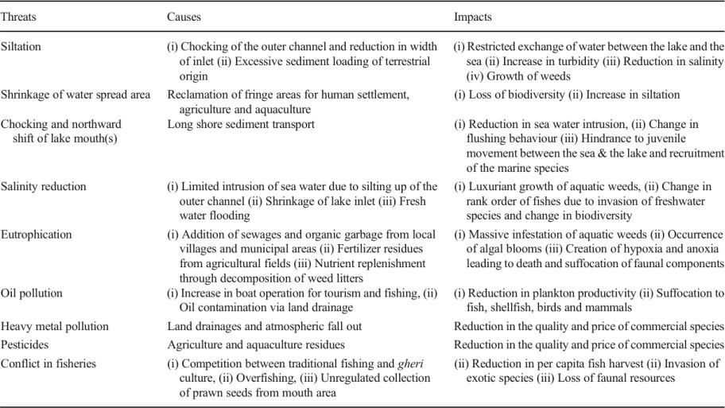
Sources: Jhingran (1985), Ghosh (1998), Panigrahy (2000), Ghosh and Pattnaik (2005), Mohapatra et al. (2007), Panigrahi et al. (2009).

THE HYDROLOGICAL INTERVENTION

The hydrological intervention at Chilika Lake refers to a series of restorative engineering and ecological measures aimed at reviving the lake's deteriorating health by improving the water exchange between the lake and the Bay of Bengal. For several decades, research on water quality, sediment deposition, and the biological conditions of the lake indicated that this water exchange was vital for maintaining the lake’s ecological balance. Historically, the lake's mouth was situated north of Manikapatna village, and it was artificially maintained through human interventions. As early as 1846, Sterling and Peggs documented that the lake’s opening to the sea required manual maintenance to prevent closure. In 1915, Annandale and Kemp further observed that the narrow channel linking the lake to the sea was periodically at risk of closing, requiring artificial measures to keep it open. However, despite these efforts, in 1927, the lake mouth completely closed, prompting the Bihar and Orissa governments to undertake a dredging operation to restore the opening, as reported by Pitt in 1932.
By the 1960s, the lake was already experiencing severe ecological stress. In 1963, Jhingran highlighted the urgent need for de-siltation of the outer channel and the widening of the lake’s inlet. These measures were necessary to allow free movement of fish and shellfish larvae between the sea and the lake, which was essential for sustaining the lake’s aquatic biodiversity and supporting the local fishing economy. However, the situation worsened by the 1980s. In 1989, Mangla reported that the lake mouth was shrinking at a rate of 1.4 km² per year, raising serious concerns. The continuous northward drift of the mouth, caused by coastal sediment transport (littoral drift), gradually reduced the exchange of water between the lake and the sea. This resulted in increased siltation, falling salinity levels, and growing ecological instability.
Table 11 Change in rank order (with respect to landing) often different commercial fisheries
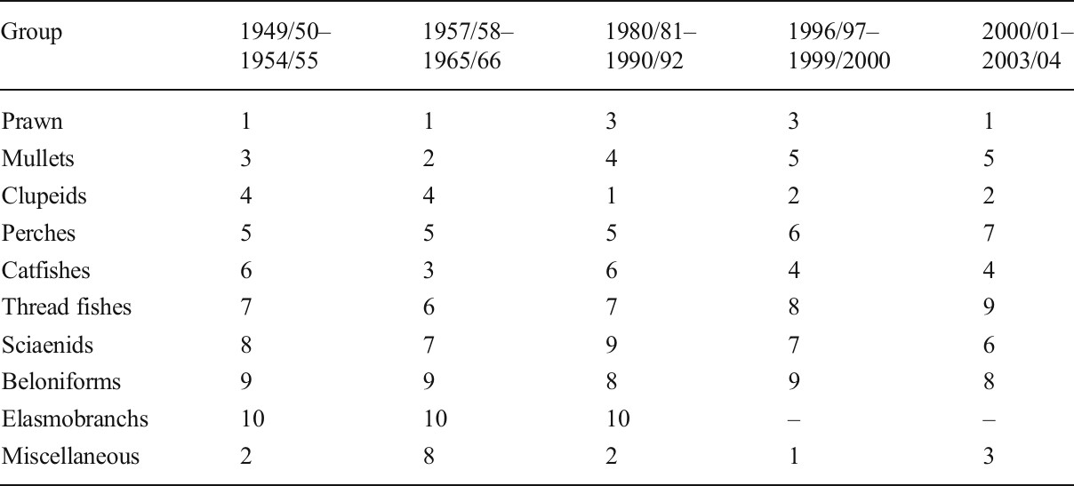
Source: Biswas(1995); Mohapatraetal.(2007)

Studies conducted by the Chilika Development Authority (CDA) revealed alarming signs of ecological deterioration. The lake's water quality had declined due to restricted water exchange, leading to reduced salinity, which in turn altered the lake's aquatic biodiversity. The drop in salinity encouraged the growth of freshwater weeds, such as water hyacinth and Potamogeton, which began choking the lake’s waterways. This further reduced the availability of oxygen and disrupted the lake’s natural food chain, causing a sharp decline in fish productivity. Consequently, the livelihoods of over 200,000 local fishermen, who depended on the lake, were severely impacted. The urgent need for hydrological intervention became evident, as restoring the lake’s water exchange with the sea was the only viable solution to reverse its ecological decline.
To address this crisis, the Government of Odisha, through the CDA, engaged several scientific agencies to carry out detailed studies and recommend solutions. The National Institute of Oceanography (NIO), the Central Water and Power Research Station (CWPRS), and the Space Application Centre (SAC) were commissioned to conduct an extensive hydrological and ecological assessment of the lake. Their studies revealed that siltation on the barrier spit caused by littoral drift was primarily responsible for the northward shifting of the lake mouth. This shift lengthened the outer channel, reducing the flow of seawater into the lake and impeding the outward flow of freshwater. As a result, the salinity levels dropped, weed infestation increased, and fish production declined, ultimately threatening the lake’s biodiversity and productivity.
The scientific experts recommended a series of hydrological measures to restore the lake’s health. The first major intervention proposed was the creation of a new inlet at Sipakuda, located near Satapada. This was intended to shorten the outer channel and facilitate better water exchange between the lake and the sea. Additionally, they recommended dredging the inner channel by approximately 6 km from Magarmukha to connect it to the central sector of the lake. To further improve water circulation, they suggested the construction of a 22.6 km-long lead channel from Magarmukha to the mouths of the Daya and Nuna rivers, enhancing the outflow of freshwater and preventing sediment accumulation.
On 23rd September 2000, the new mouth at Sipakuda was successfully opened as part of the hydrological intervention. This marked a significant turning point for Chilika Lake. The newly created inlet significantly shortened the distance between the lake and the sea, allowing for faster and more effective water exchange. This improvement restored the lake’s salinity levels to their natural range, which enabled the return of marine and brackish water species. As a result, the lake’s fish productivity surged, greatly benefiting the local fishing community.
In the following years, the lake's hydrology continued to evolve naturally. In August 2008 and again in September 2012, two additional mouths—Gabakunda and Dhalabali—formed naturally north of the existing mouth due to hydrodynamic forces. This further increased the connectivity between the lake and the sea, promoting better water exchange. Later, the Sipakuda and Gabakunda mouths merged, reducing the number of mouths from three to two. However, in October 2013, Cyclone Phailin caused the formation of a third mouth between the existing ones, restoring the number of mouths to three. The formation of multiple mouths significantly improved the lake’s ecological stability by ensuring greater seawater ingress and freshwater outflow.
The hydrological intervention had a profound and positive impact on Chilika Lake. The improved water exchange restored the salinity balance, which encouraged the return of

several fish and shellfish species that had previously declined. The weed infestation decreased due to the higher salinity, and the fish productivity surged. Fish production increased from 1,200 metric tons in 1999 to over 11,000 metric tons by 2005, revitalizing the local fishing economy. Additionally, the improved water quality led to the return of migratory birds, restoring Chilika’s status as a major bird sanctuary. The intervention also boosted eco-tourism, bringing economic benefits to the local population.
The success of the hydrological intervention at Chilika Lake became a model for wetland restoration worldwide. Its effectiveness was recognized globally, and the lake was removed from the Montreux Record (a list of degraded wetlands under the Ramsar Convention) in 2002, marking a major achievement in wetland conservation. This intervention not only restored the lake’s ecological health but also safeguarded the livelihoods of thousands of local fisherfolk, making it a landmark example of sustainable wetland management.

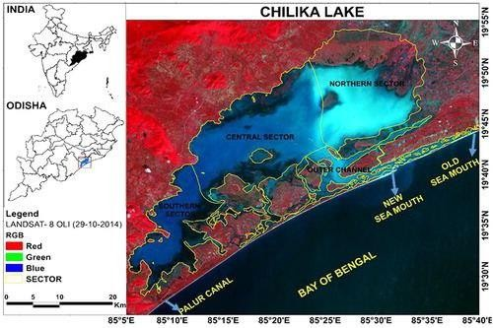

Ecology of the Lake After Hydrological Intervention

Before the hydrological intervention in Chilika Lake, seawater would enter the lake during high tide through a narrow and shallow, 35 km-long zigzag channel. This channel acted as the lake’s primary connection to the Bay of Bengal, but its length and winding nature restricted the flow of seawater, reducing the lake’s salinity levels. However, with the opening of the new mouth in September 2000, the length of the outer channel was significantly reduced by about 18 km. This reduction greatly improved the flow of seawater into the lake, increasing the water exchange rate. As a result, the lake experienced a notable change in salinity gradients, restoring it closer to its natural state. Intensive monitoring conducted in 2006–07 showed visible improvements in salinity levels in both the outer channel area and the central sector of the lake. However, during the monsoon season, a temporary drop in salinity was observed due to the heavy influx of freshwater. Fortunately, the post-monsoon period allowed the lake’s salinity levels to recover, creating a balance in the overall salinity regime. The increase in salinity significantly boosted fish and shellfish catches, as the improved conditions favored the return and reproduction of marine species.
The creation of the new, shorter outer channel also enhanced the flushing of sediments from the lake. This was a crucial improvement, as sediment build-up had been one of the major causes of siltation, which previously restricted water exchange. Following the intervention, the lake’s siltation problem was significantly reduced, preventing further shallowing of the basin. According to a study by Ghosh et al. (2006), the improved flushing helped maintain a healthier water flow, reduced stagnation, and enhanced the lake’s overall hydrodynamic efficiency.
Another remarkable impact of the hydrological intervention was the reduction in the growth and spread of noxious weeds. Before the intervention, large areas of the lake were choked by invasive aquatic plants, which thrived in the low-salinity environment. However, after the new mouth was opened, the increased salinity levels created an environment that was less favorable for weed growth. Consequently, the area covered by weeds dropped from 523.01 km² in October 2000 to 351.01 km² by May 2001. By 2010, the weed-covered area had further reduced to 285.96 km², as reported by the Chilika Development Authority (CDA) in 2011. The decline in weed infestation improved water circulation and oxygen levels, making the lake more hospitable for aquatic life.
The restoration of salinity also promoted the growth of seagrass meadows, which are essential for maintaining biodiversity and supporting aquatic ecosystems. Before the intervention, only two species of seagrasses were reported in the lake: Halophila ovata and Ruppia maritima. However, after the salinity levels were restored, Bhatta (2003) recorded the presence of six seagrass species, including Halophila ovalis, H. ovata, H. beccarii, Halodule uninervis, H. pinifolia, and Ruppia maritima. This significant increase in seagrass diversity and distribution indicated the positive ecological impact of the hydrological intervention.

Table 12 A comparative account of salinity (ppt) regime during pre and post hydrological interventions
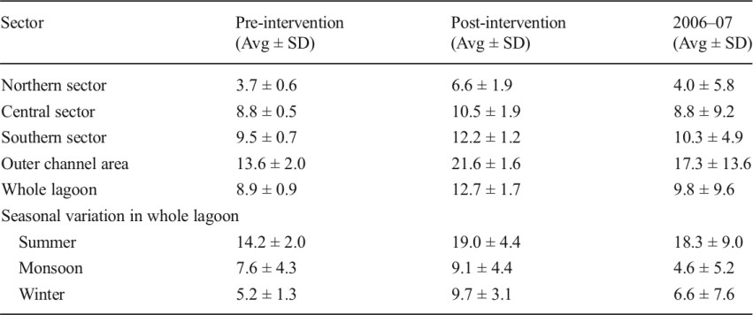
Source: Mohapatra et al. 2007 & Panda et al. 2008
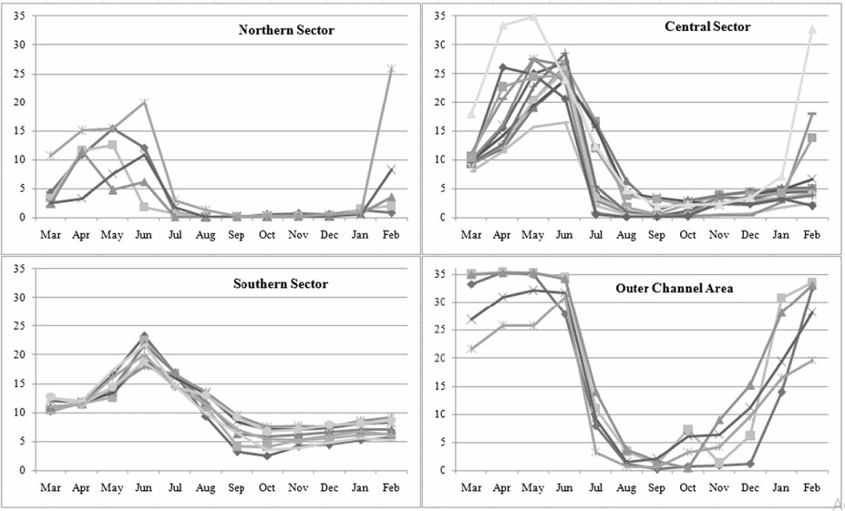
Fig. 7 Annual variation of salinity (ppt) in four sectors of Chilika lagoon during 2006–07 (The lines represent different regions of each sector) (Data Source: Panda et al. 2008)

The lake’s fish, prawn, and crab populations, which had significantly declined during the 1990s, showed remarkable improvement after the intervention. The primary reason behind this recovery was the restored salinity regime, which allowed for the free movement of marine juveniles into the lake. The improved water exchange ensured the recruitment of marine species, which were previously struggling to survive in the lake’s low-salinity waters. Consequently, the lake’s annual fish production, which had fallen to 1,274 metric tons (MT) in 1995–96, increased dramatically. By 2001–02, fish production rose to 11,989 MT, and by 2011–12, it further surged to 14,228 MT. This sharp rise in fish, prawn, and crab landings

was a direct result of the improved ecological conditions brought about by the hydrological intervention.
In addition to the increase in fish yield, there was also a remarkable improvement in species diversity. Several marine fish and shellfish species, which had become rare due to the lake's deteriorating conditions, made a comeback. For instance, the population of Mugil cephalus and Liza macrolepis, which had significantly declined before the intervention, increased notably after the new mouth was opened. Similarly, the harvest of Penaeus indicus (Indian white prawn), which had dwindled earlier, also improved due to the restoration of suitable environmental conditions. A species inventory survey conducted after the hydrological intervention documented 56 new species in the lake. These included 7 freshwater species, 20 brackish water species, and 29 marine species (Mohapatra et al., 2007). This increase in species diversity was a clear indication that the improved water exchange allowed more marine species to enter and thrive in the lake.
One of the most noteworthy outcomes of the hydrological intervention was the return of the Irrawaddy dolphin (Orcaella brevirostris), an endangered species that had become increasingly rare in the lake. After the opening of the new mouth, sightings of Irrawaddy dolphins became more frequent, especially near the inlet and channel areas (Ghosh and Pattnaik, 2005). The dolphins, which are highly sensitive to changes in salinity, benefited from the improved water quality and the increased availability of fish, their primary food source.
Chilika Lake is also internationally renowned as a wintering ground for migratory birds, making it one of the most important bird sanctuaries in the region. Following the hydrological intervention, the lake witnessed a significant increase in migratory bird populations. The World Bank (2005) identified Chilika as a vital destination for waterfowl. A study conducted by the Bombay Natural History Society (BNHS) between 2001 and 2005 documented 225 bird species, compared to only 151 species recorded in 1990 (Dev, 1990). This increase in avian diversity and population highlighted the overall ecological recovery of the lake, as the improved salinity and water quality created a more hospitable habitat for migratory birds.
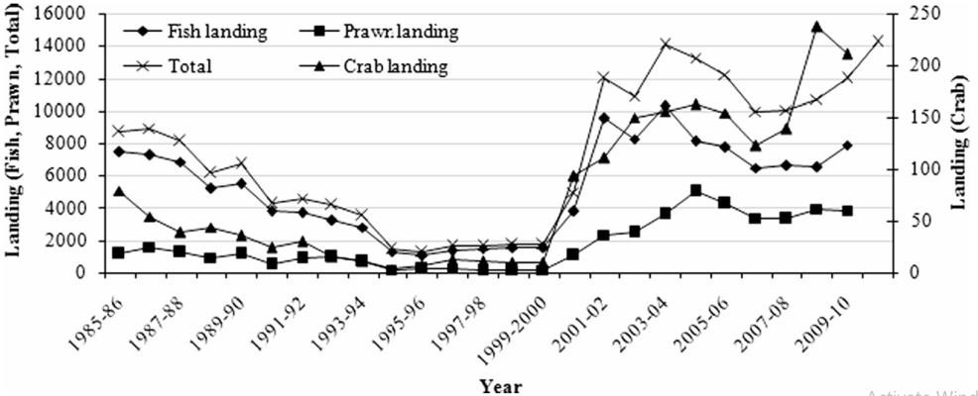
Fig. 8 Trend in landing of fish, prawn, crab (Metric Ton)in Chilika lagoon from 1985 to 2012.
Source: (i)1985 1999.2000: Directorate of Fisheries, Govt. of Odisha
(ii) 2000/01-2011/12:
Chilika Development Authority

Current and Persistent Problems of Chilika Lake

Wetlands, especially coastal lagoons, are highly vulnerable to rapid environmental changes caused by both natural factors and human activities. Across the world, the loss of wetlands has been significant. In Canada, nearly 85% of wetlands were lost to agricultural expansion since the 19th century. Similarly, in the United States, wetlands started disappearing after the arrival of European colonizers, as human settlement and farming expanded. In Australia, over the past 200 years, more than 120,000 square kilometers of wetlands have been destroyed, with over 50% of the loss attributed to human interventions, such as land reclamation and infrastructure development.
In India, the loss of both inland and coastal wetlands is happening at an alarming rate. The primary causes are direct human activities, including land reclamation for agriculture, human settlements, aquaculture, and urban expansion. Additionally, pollution and natural hazards have worsened the condition of wetlands. Chilika Lake, one of India's largest coastal lagoons, faces similar degradation due to anthropogenic pressures. The major threats to the lake include land conversion, overexploitation of resources, and destructive harvesting practices. The situation is further worsened by the dumping of municipal, agricultural, and industrial waste into the lake, which contributes to its on-going ecological decline.
Fig. 9 Trend in operation of boats and number of fishing days in Chilika lagoon. Source: Mohapatra et al. (2007)

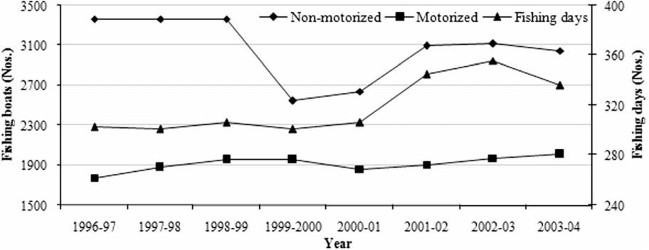

Fishery Livelihood And Adaptation To Climate Change

TREND OF CLIMATE VARIABILITY AND PEOPLE’S PERCEPTION

Trend of climate change in Chilika lagoon
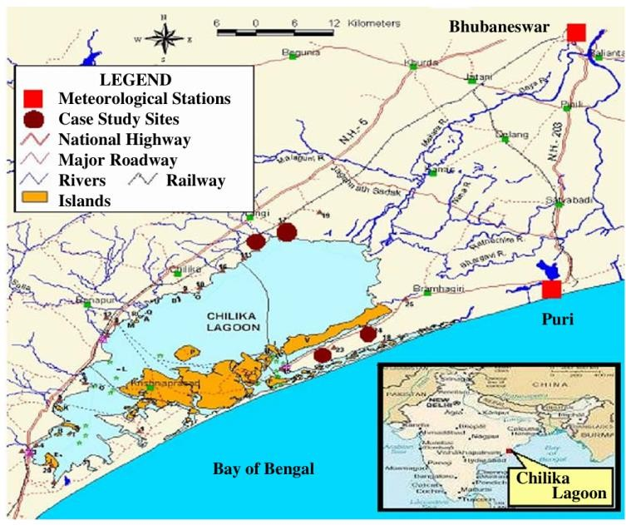

Chilika lagoon which is a part of Orissa state, India is considered to be climate-prone area in India. Although limited quantitative data on climate change effects in Chilika lagoon are available, floods, droughts, heat waves and sometimes cyclones are common features at the state level. The socio-economic condition of the people in Orissa state is strongly influenced by various natural forces.

Temperature
Chilika lagoon is typically tropical with average annual maximum and minimum temperatures of 39.9°C and 14°C, respectively (CDA 2008). Changes in temperature, even small changes in water temperature are expected to exert strong pressure upon fish ecology (WWF2005). Temperature variations also affect people’s health undermining their capacity for operating the fisheries. According to the statistical fixed-point observations in two meteorological stations (Bhubaneswar and Puri), it seems that the apparent warming trend has not been seen in Chilika lagoon (Fig. 10), as opposed to the world’s expectation (IPCC 2007). However, it seems that there is a slight warming trend of mean maximum and minimum temperature especially in the hottest month. On the other hand, some districts of Orissa state experienced in severe unusual high temperature in 1998 where 954 people died, the worst tolls in all India (IDR team 2000). As well, in 2004 strong sunstroke prevailed in 16 districts of Orissa state from April to June, causing the deaths of nine people in Chilika lagoon area (SRORD 2005).
Trend of Mean Maximum Temp. in Bhubaneswar Trend of Mean Minimum Temp in Bhubaneswar
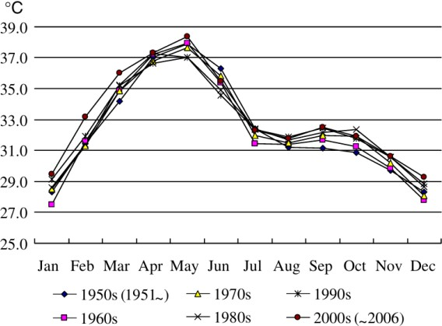
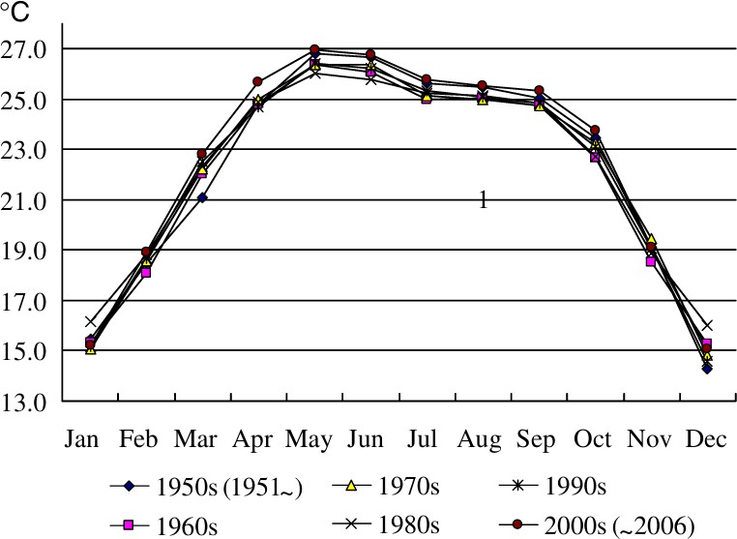

Trend of Mean Maximum Temperature in Puri Trend of Mean Minimum Temperature in Puri
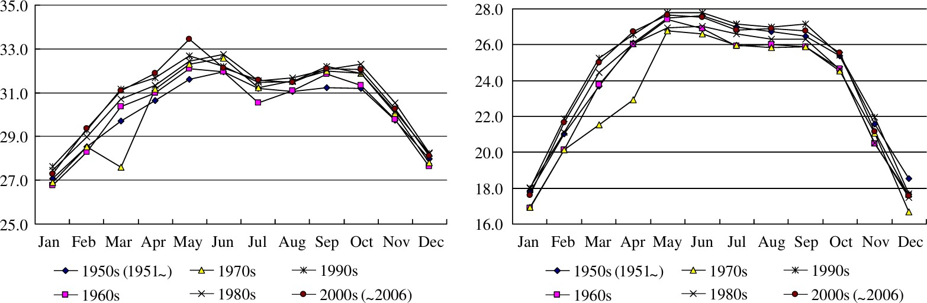
Fig. 10 Trend of mean highest and minimum temperature in Bhubaneswar and Puri.

Cyclones
Chilika lagoon which covers Khurda, Puri and Ganjam districts is classified in ‘very high damage risk zone (50 m/s)’ in terms of wind and cyclones. The lagoon is situated along with the Bay of Bengal which is one of the six major cyclone-prone regions of the world. The annual cyclone from the Bay of Bengal normally occurs in the months of April to May and October to November. Increasing warm sea temperature (approximate 26.5°C) in the Bay of Bengal induces the cyclone to become more intense as it gets close to the coastal areas of India. On an average, every year four to five cyclones strike the coastal regions of India. Coastal districts of Orissa state have been hit by 11 severe cyclones and 55 cyclone storms with a probable maximum storm surge height between 3.2 m to 5.5 m in the last 120 years. Importantly, Orissa state in 1999 experienced a ‘Super Cyclone’, its worst catastrophic cyclone in 100 years. The super cyclone swept the entire Orissa coastal area, affecting 15,681,072 people, 14,586 villages, causing 9,893 deaths and damaging 1,661,683 houses. Fortunately, Chilika lagoon avoided much of the possible loss of human life though the cyclone caused tremendous damage to fishing gears and houses in and around the lagoon. Cyclones have a short-term as well as long-term impact on fishery livelihoods in terms of damages to vital infrastructures (school, hospital road network) and less access to medical supports, water use and official loan provision. Those losses were evident in the Chilika lagoon after the 1999 super cyclone, led to the traumatic perceptions for fishing communities.
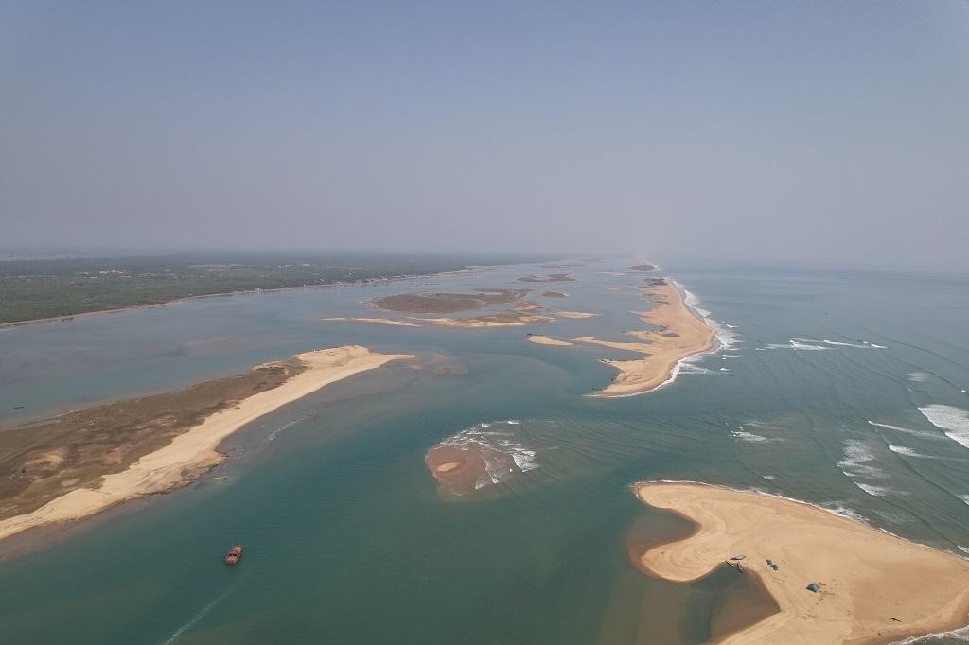
The intense storm surge that had accompanied extremely severe cyclone Fani in early May 2019 had opened four new mouths in the Chilika Lake in Odisha. These were distinct from the main mouth of the lake where it opens into the sea.

Floods & Droughts
In addition to cyclones, floods are common in Chilika lagoon. The majority of the annual rainfall occurs from June to November (Fig. 11). The southwest monsoon brings much rainfall from June to September while the northeast monsoon brings some rain in October and November. The highly concentrated rainfall in July and August provoked flooding of the major streams. Chilika lagoon receives fresh water from 52 channels, especially two principal streams (i.e. river Daya and Bhargavi) which are sub-branches of the Mahanadi river system which is prone to be affected by extreme floods. From 1834 to 2007, 76 flood events were recorded in Orissa state (OSDMA 2007). Although flood control efforts have been completed by the Orissa state government (e.g. construction of dams, weirs), there were 11 floods records during the past quarter century (1988 to 2007) while there were 32 floods records during the century from 1834 to 1933. The report indicates that vulnerability has been slightly increasing for decades both in terms of frequency and intensity of floods. Importantly, flood events have been continuously recorded in Orissa state since 2003. In terms of flood, the fishermen tend to suffer losses or damages of fishing boats and materials. There is a need to promote a coordinated flood response which people move their boats and nets to a secure location. Droughts are also of concern for the people’s livelihoods. It is likely that average monthly rainfall near Chilika lagoon is significantly decreased except during the monsoon season (Fig. 11). In the last decade (1995 to 2004), there have been six moderate and severe droughts in various parts of Orissa state (SRORD 2004, 2005). Although fishing communities are less vulnerable to droughts than agrarian communities, the former are faced with some difficulties in having an access to adequate water for drinking, cooking, bathing, and available water often is of low quality. The water scarcity and pollution combined with anthropogenic pressures endanger the health of the people and interfere with every aspect of life.

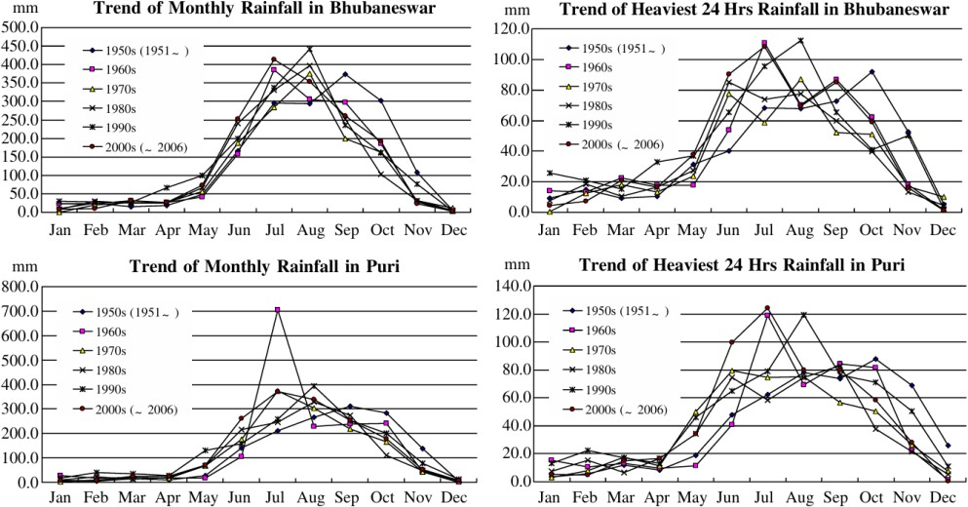
Fig. 11 Trend of monthly and heaviest 24 hrs rainfall in Bhubaneswar and Puri.

Environmental Degradation
Apart from direct effects of climate stimuli, a range of human activities on the landscape induce various types of environmental degradation. In particular, siltation is broadly recognized by stakeholders as a key environmental issue in Chilika lagoon. A large quantity of silt from the upstream has been deposited in the lagoon due to the combination of increased flooding and anthropogenic pressures such as deforestation and overgrazing. Pattnaik (2005b) estimated that around 1.6 million tones of sediment annually flowed into Chilika lagoon. The silt accumulation reduces the water spread area and hinders the exchange of water between the sea and river, resulting in decreased salinity and lower availability of fish species in the lagoon. Siltation into the lagoon also encourages prolific growth of freshwater invasive species. The area of Chilika lagoon dominated by invasive plants increased 20 sq. km. in 1972 to 685 sq. km. in May 2000 (CDA 2005). These changes reduce the area of fishing grounds in Chilika lagoon. That, in turn, leads to loss of income that can render fishers more vulnerable to climate change. Further, the weed
invasion presents physical difficulties for boat navigation, further undermining people’s adaptive capacity to climate change.
According to 2012 Ecosystem Health Report
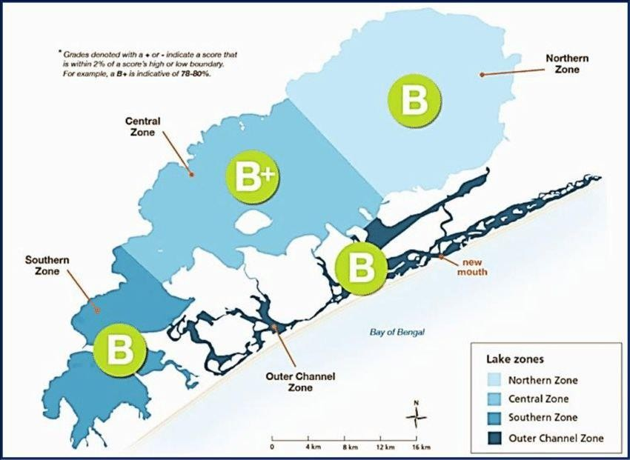
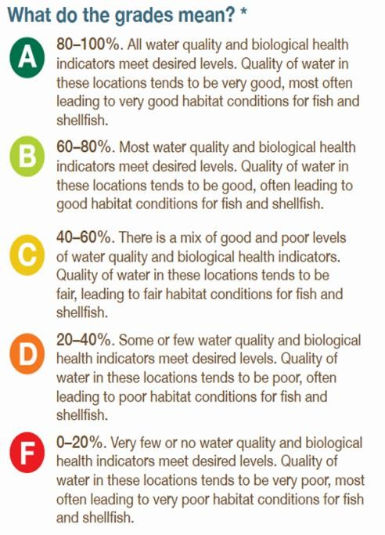
Grades denoted waith a +/-indicate a score i.e, within 2% of a score’s high or low boundary
Fig. 12 B+ is indicative of 70-80%
Overall, Chilika Lake scored a ‘B’ for ecosystem health based on perfpormance of water quality, fisheries, and biodiversity indices.

According to 2014 Ecosystem Health Report
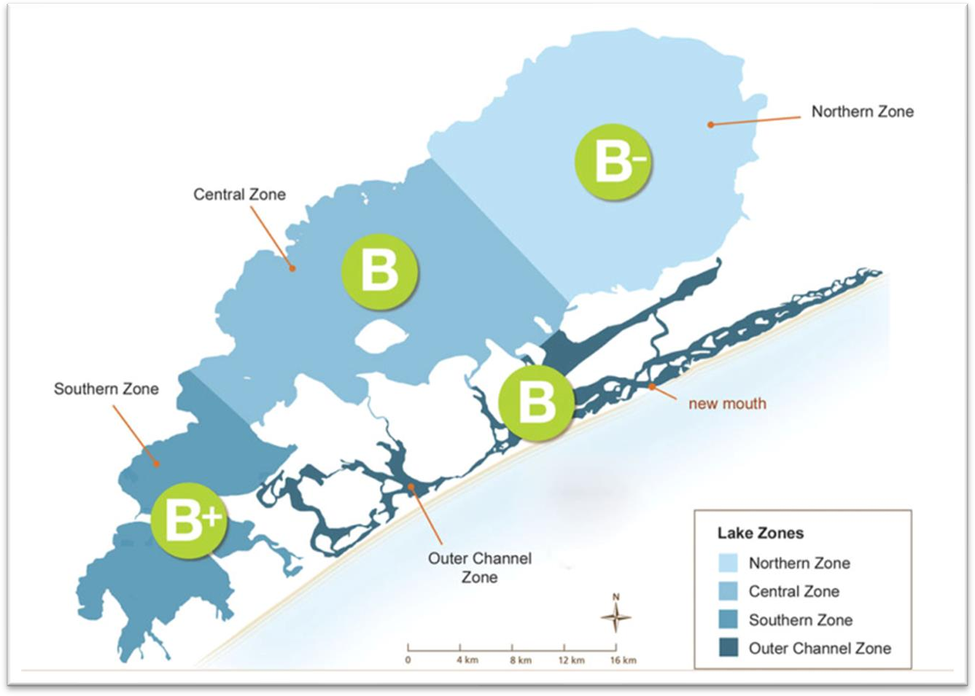
Fig 13

Fig 14 Thirty sampling locations of Chilika Lake for assessment of hydro-chemical characteristics from 1999 to 2021
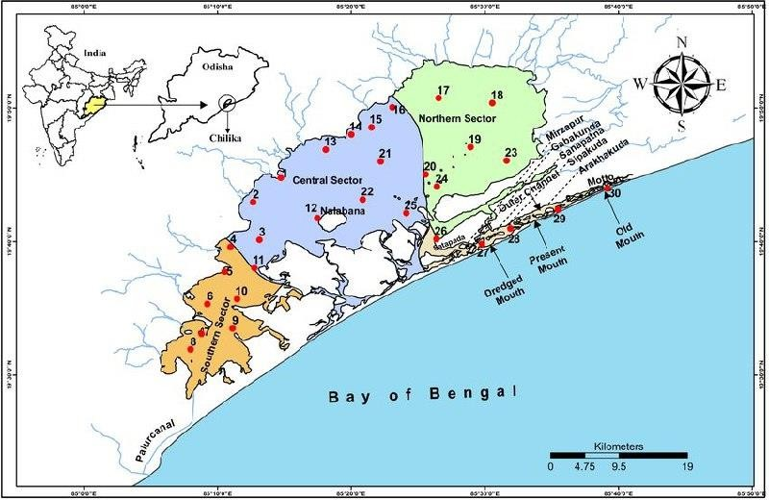

Risk Perception of Climatge Change
Research on climate change in Chilika Lagoon has mostly relied on scientific studies and secondary data. However, it is also important to consider how local people perceive the changes, as their awareness and actions play a key role in responding to these events. A questionnaire survey conducted in the region revealed that many people, regardless of whether they lived in inland or coastal areas, have noticed clear signs of climate change.
The majority of the respondents associated climate change with rising drought conditions (65%) and increasing temperatures (78%) in the region. Additionally, 72% of the people believed that a catastrophic cyclone similar to the 1999 super cyclone would strike Chilika Lagoon in the near future. However, there were differences in perception between inland and coastal residents when it came to flooding. Around 70% of inland residents believed that the frequency and intensity of floods had remained the same over the years. In contrast, 62% of coastal residents felt that flood events had become more unpredictable and severe.
Both inland and coastal communities agreed that cyclones were the most significant climate hazard. They also ranked floods, droughts, and rising temperatures as serious risks. However, inland residents perceived climate hazards as more dangerous compared to coastal residents. This difference in risk awareness may be linked to their past experiences, particularly during the 1999 super cyclone.
Although the super cyclone did not directly hit Chilika Lagoon, its impact was strongly felt by inland fishermen, as they were fishing in the lagoon when the storm struck. Despite receiving early warnings from the government, many inland fishermen did not take the alerts seriously. They did not believe the cyclone would reach Chilika or cause significant damage. As a result, they suffered heavy losses, including damage to their boats and harm to their health.
In contrast, coastal fishermen were more cautious. Due to their proximity to the sea, they were more aware of the risks and chose not to fish during the cyclone, avoiding direct losses. This difference in experience made coastal residents more aware of the potential impacts of future climate hazards.
The two communities also viewed vulnerability differently. In coastal areas, people identified disabled individuals as the most vulnerable group, followed by women, fishermen, and children. In inland areas, however, people considered fishermen to be the most vulnerable group, followed by women, children, and disabled persons. This difference in perception could be due to the coastal community's direct exposure to the sea, which makes them more familiar with climate-related challenges, while inland communities focus more on the livelihood risks faced by fishermen.
Overall, the diverse experiences of inland and coastal residents have shaped their perception of climate risks. Coastal residents, having faced more direct impacts from the sea, tend to be more aware of marine-related hazards, while inland residents are more concerned about livelihood-related risks, such as damage to their boats and fishing gear.

LIVELIHOOD ASSESTS ANALYSIS
This section aims to assess each livelihood asset (natural, human, financial, physical and social capital) and link it with climate change in community context. The research is based on the SLA framework (DFID 1999).

Natural capital

Chilika lagoon has experienced severe environmental deterioration primary from siltation since the 1980s. In combination with anthropogenic pressures such as deforestation, overgrazing and industrialization, seasonal climate forces such as cyclones and floods brought a lot of silt into the lagoon. Silt promotes agglutination and precipitation reactions when it flows into salty water, leading to silt accumulation in the lagoon area especially near the sea mouth. That causes a cut-off of the sea mouth between the sea and lagoon. The closure of sea mouth affects salinity level in the lagoon and prevents exchange of migratory fish species, which account for nearly 80% of lagoon fisheries catch. Climate changes affect not only fish in the eco-system but also fishing activities in certain periods. Fishers are forced not to fish during monsoon heavy rainfall and cyclones. In an effort to solve the serious situation, Chilika Development Authority (CDA) implemented a successful wetland restoration project around the year 2000. In short, CDA, which was established in 1991, enforced innovative hydrological interventions (opening of a new mouth and dredging water channels) in collaboration with research institutions, NGOs and the local people. The hydrological interventions resulted in the dramatic improvement of the natural and social lagoon environment (CDA 2005). Fish production remarkably improved (Fig. 12). At maximum, the amounts of fish landings were recorded to be around 14,053 metric tons in 2003 to 2004, compared to around 1,600 metric tons prior to the interventions. Related to this, the government estimated that fisher family income increased around ten times in 2003 to 2004 compared to before interventions in 2000 (DFGO CDA 2005). It should, of course, be kept in mind that the technical interventions can be just temporal end-of-pipe measures to cope with siltation. There has been a gradual decrease of fish landing amounts after the hydrological implementations (Fig. 12). In response to this situation, CDA adopted a concept of participatory micro-watershed management that seeks to involve the local people in the project, in order to mitigate the impacts of siltation caused by climate extreme events combined with anthropogenic pressures from upstream. These changes at the watershed level are expected to play an important role in reducing silt accumulation in the lagoon, leading to sustainable lagoon fisheries.

Table 13 Ranking of risk perception of climatic change hazards
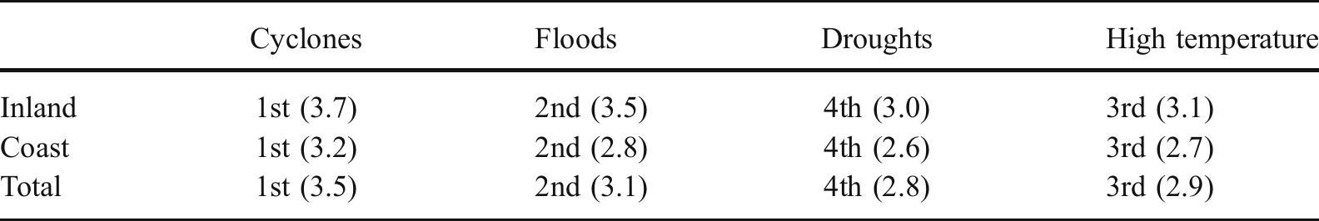
The ranking is based on the total numbers of risk perception. Value in blackets shows the average number of risk perception (Most risk–4, Risk–3, Less risk–2, Least risk–1)

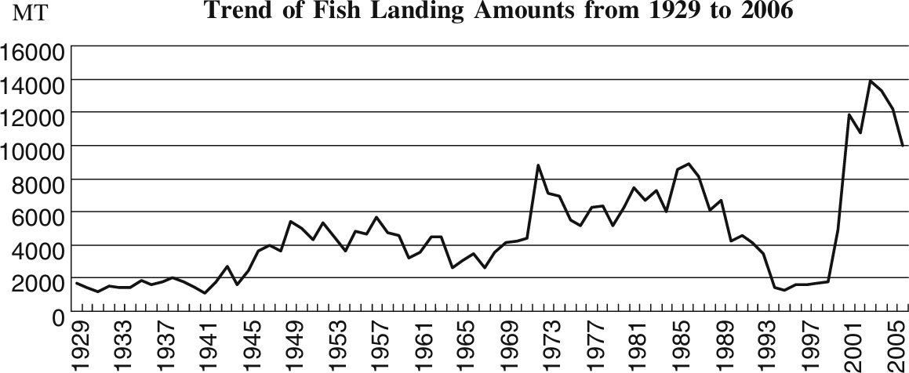

Fig. 15 Trend of fish landing amounts from 1929 to 2006 (revised from DFGO 1970; DFGO CDA 2005; CDA data).

Financial Capital

The livelihoods of fishing communities largely depend on the fisheries from Chilika lagoon. Most of them (97%) have no secondary occupation, so fishing is a sole income source for them. The fishermen normally use traditional small-scale boats with various fishing gears. On the whole, members of fishing boats in Chilika lagoon are limited to family or neighbors, and their profits are equally distributed among them. Household incomes per month in inland and coastal areas are Indian Rupee (INR) 1,190 (approximately US$ 30) and INR 1,332 (approximately US$ 34) in rainy season while INR 2294 (approximately US$58) and INR 2564 (approximately US$65) in dry season, respectively.1 The income is not sufficient to cover their living expenses especially during the rainy season because they cannot often go fishing due to extreme rainfall and winds. In fact, 90% of respondents borrowed money from fish merchants at an average of INR 29,483 with interest free. The loan provisions are addressed through purchasing or repairing fishing gears, instead of informal fish trade promises at lower price. As a result, the dependency pushes households to the brink and led to nearly-defunct fishery

cooperative societies in terms of fish marketing. Due to lack of money, around 50% of households have poor housings that are highly vulnerable to climate hazards. On account of this, expenditures for food and fishing gears were regarded as the highest priorities while electric products and savings were identified as lowest ones. Although private and government banks provided loans to the fishermen for the purpose of reducing dependency on fish merchants, the attempts were failed due to loan defaults with psychology of ‘loan waiver’; debtors could easily escape the duty for loan repayment from the lenders while continuing to lie about who were debtors. Indeed, only 57%, 49% and 10% of total loan amounts were repaid to private banks, government banks and National Cooperative Development Corporation, respectively. On account of this, the formal banking institutions were forced to withdraw the loan scheme for small-scale fishermen. It created more space for control of the fish economy by fish merchants combined with informal money lending, resulting in the high vulnerability of livelihood conditions against future climate.

Human Capital
The changing climate in Chilika Lagoon is significantly affecting the health of the local fishing communities. According to a problem tree analysis, people commonly identified disease outbreaks as a major issue caused by rising temperatures and water pollution. The increasing heat has led to frequent cases of eye inflammation, with nearly 48% of the population suffering from this condition. Water pollution is another major concern. Since the communities lack access to tap water, they depend on three types of wells—pipe wells, tube wells, and open wells—as well as ponds for their drinking water. However, due to climate changes and human activities, these water sources have become scarce and muddy, making them unsafe for consumption. As a result, people are frequently exposed to waterborne diseases such as cholera (17%), diarrhea (26%), and viral infections (35%).
Another pressing issue is the lack of proper sanitation facilities. The fishing villages do not have toilets, forcing people to use public spaces or even neighboring villages during heavy rains. This situation often leads to disputes among villagers over the use of shared spaces. The remoteness of the villages and the lack of financial resources also make it difficult for the local people to access medical care, which makes them even more vulnerable to diseases. Poor health reduces their ability to engage in fishing activities, directly threatening their livelihoods.
The region also faces a serious education crisis, with low literacy levels among the local people. Around 25% of individuals over the age of 15 have never attended school, and only 5% have been able to pursue college or university education. The majority (59%) drop out before completing high school. Due to this low educational attainment, only 55% of the population can read and write in Oriya, their native language. This lack of education creates significant barriers when it comes to finding alternative jobs, accessing health care, or applying for formal loans and financial support. With limited skills and literacy, the people are heavily dependent on fishing as their primary livelihood. This dependency increases competition over limited fishery resources, which in turn triggers frequent conflicts among the fishing communities.

Another alarming issue in Chilika Lagoon is the rise of child labor in fishing. Due to financial struggles, many children are forced to start working at a young age. These children are more vulnerable to climate variability and extreme weather events compared to adults. However, with limited income and lack of alternative job opportunities, their families have no choice but to make them work to support the household income.
Caste discrimination is another factor that affects education levels in the region. According to the problem tree analysis, many children from coastal fishing communities avoid going to high school because the schools are located in non-fishing villages. These villages still practice caste discrimination, making it difficult for children from fishing communities to feel accepted or comfortable. This social stigma creates barriers to education, preventing children from pursuing their studies and further limiting their chances of securing better jobs in the future.

Physical Capital

Natural calamities in combination with climate change often result in great degree of devastations to basic infrastructures and physical goods as well as a large number of causalities. The physical environment surrounding the fishing communities is very poor. The fishermen force to make use of unreliable boat jetties attached to just raised ground. Villagers stressed that the catastrophic cyclones and floods damaged physical capital, including infrastructures (e.g. community roads and fish landing centers) and physical goods (e.g, boats, nets and houses). Once such climate hazards occur, community roads are easily damaged by fallen trees. At the same time, poor housing conditions are affected to a great extent and various diseases are caused by unsanitary environments (as discussed in Section 4.2.3). Among physical capital assets, villagers identified fishing boats as the most seriously vulnerable to climate change (76%). 48% reported loss of boats. The loss leads to suspension of fishing activities, resulting in danger to family maintenance. Some of them may attempt to apply for loan finance from fish merchants. Confronting with this, Department of Fisheries and Animal Resources Development tries to encourage a disaster insurance scheme to fishermen through their fishery cooperative societies in order to mitigate impacts of climate hazards on lost or damaged fishing materials and causalities. That consideration could play a significant role in preventing the local people from experiencing disruption of fishery livelihoods.

Social Capital

Regarding the sense of social cohesion within communities, differences are observed between inland and coastal areas. In coastal areas, 84% respondents regarded their communities’ ties among villagers as strong. On the other hand, only 30% of respondents in inland areas regarded ties as strong while the others considered them as weak or very weak community. The difference seems to be related to population density. A major national highway touches Chilika lagoon along inland areas which bridges the route

between rural and urban areas. The easy transportation attracted a large number of people and as a result inland areas have become densely populated. In contrast, access from coastal to urban areas is not yet well developed so that the communities in coastal areas are relatively isolated from each other and need to build a give-and-take relationship within the villagers where appropriate. For this reason, it seems that the sense of social cohesion among villagers in coastal areas is higher than those in inland areas. The unity of social cohesion among villagers was strongly related to the different impacts of super cyclone between the two areas. However, it needs to be mentioned that the social cohesion in both areas is not adequate in terms of disaster preparedness. The local people have rarely prepared for keeping boats and nets in a safe place when cyclones or floods attack in their areas. Thus, the lack of mutual help combined with disaster awareness sometimes resulted in losses or damages of boat materials that undermined the people’s capacity for fishery livelihoods.

Responding to Climate Change

Toward integrated lagoon basin management
In the debates between fishery livelihood and climate change, the fishery resource (natural capital) is the core point to be addressed. The resource is the principal form of livelihood for survival and affects lives in various ways. However, the coastal zone that includes Chilika lagoon is considered to be a vulnerable water ecosystem. It is affected by the confluence of various aspects from the upland to the marine. In the case study of Chilika lagoon, siltation (soil erosion) is identified as among the most serious environmental problems in combination with climate variability such as extreme floods and cyclones. Exposure to silt accumulation reduces the water spread area and hinders the exchange of water between the sea and river, resulted in decreased salinity level and subsequent prolific growth of freshwater invasive species. As a result, the amounts of fish landing in Chilika lagoon rapidly decreased until 2000, thereby leading to the poorest people not being effectively able to adapt to climate variability and extreme events. Furthermore, the weed invasion obstructs passages from boat jetties to fishing grounds, sometimes leading to boat clashes and the subsequent disputes among fishers. In an effort to maintain (and preferably improve) fish stocks, there is a need to integrate fishery resources into a watershed perspective. In this respect, Chilika Development Authority (CDA) has conducted a successful hydrological intervention (sea mouth management) in the short period, and also has adopted participatory micro-watershed management at the watershed level in the long period. Practices regarded as integrated lagoon basin management help developing a pathway for strengthening adaptive capacity to climate change as well as sustaining fishery resources. There is a further need to build multi-level collaborations and partnerships such as governments, NGOs, researchers and local people including in the upstream area as CDA did.

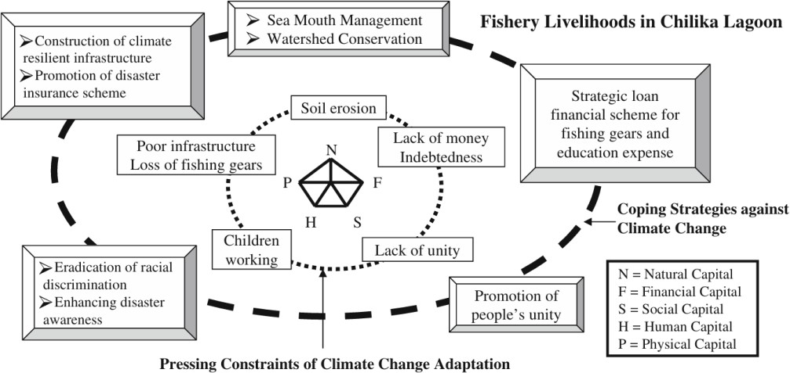

Fig. 16 Expected fishery strategies for climate change adaptation in Chilika lagoon

Enhancing Climate Resilient Fishing Communities
Fishing communities in Chilika Lagoon are highly vulnerable to climate variability and frequent environmental hazards. Natural disasters, such as cyclones, floods, and storms, frequently damage their livelihoods and infrastructure, making it difficult for them to recover. Among the most vulnerable groups are the elderly, disabled people, women, and children, who face even greater challenges. For instance, children are often forced into fishing at a young age due to their families' financial struggles. This exposes them to harsh weather conditions, including scorching heat and cold winds, instead of allowing them to attend school. Unfortunately, many children are denied access to education due to poverty and a lack of financial support, preventing them from escaping the cycle of hardship.
In the past, fishermen had access to loans from private and government banks, which could have helped them strengthen their livelihoods. However, many were unable to repay their loans. One reason for this was the belief in a “loan waiver” culture, where they assumed their debts would eventually be forgiven. This mindset left them heavily dependent on fish merchants for financial support (Samal and Meher, 2003). Relying on merchants weakened their ability to market their catch effectively or save money, making them even more vulnerable to climate impacts.
An innovative solution introduced by the South Indian Federation of Fishermen Society (SIFFS) could serve as a model to help Chilika’s fishermen. In southern India, SIFFS provided loans to fishing communities after thoroughly assessing their financial capacity. They also introduced a system of automatic loan repayment by deducting the amount from the fishermen’s income earned through cooperative fish marketing. This approach encouraged fishermen to participate in cooperative trade, which not only improved their economic stability but also resolved the issue of loan defaults. NGOs and researchers were involved in the process, offering consultations and support. This type of initiative could help fishermen in Chilika achieve financial stability, ensuring they can send their children to school and protect them from exposure to climate hazards.
Another challenge is the caste-based discrimination in schools. This social issue often pushes children from marginalized groups to drop out and join their families in fishing, even though fishing exposes them to climate-related risks. To reduce this problem, financial aid programs should cover not only fishing equipment but also educational expenses. Promoting discussions on caste discrimination among community members and stakeholders could help improve access to education and reduce the dependence on child labor in fishing communities.
The low physical capital of Chilika’s fishing communities makes them especially vulnerable to climate-related disasters. Their boats, nets, and other fishing gear are easily damaged or destroyed during storms and floods. To reduce these losses, it is crucial

to promote natural calamity insurance programs supported by the Department of Fisheries and Animal Resources Development. This insurance scheme could protect both wealthy and poor fishermen from sudden financial shocks caused by extreme weather events. Given the increasing frequency and severity of natural disasters in Odisha, such insurance programs would play a vital role in protecting the livelihoods of fishing families over the long term.
However, challenges remain. For example, when the 1999 super cyclone struck, many people in inland areas ignored the early warnings issued by the government. This led to severe losses of human lives and property. The reluctance to take warnings seriously remains a significant problem. Furthermore, both inland and coastal residents often fail to adjust their practices despite facing repeated climate hazards. Even when floods and cyclones damage their fishing equipment and infrastructure, many continue their activities without adopting protective measures.
To address this, it is essential to raise disaster awareness and strengthen community unity. Educating people about the importance of early warnings and promoting preparedness could help reduce the impact of future disasters. By building a sense of cooperation among local people and encouraging them to participate in disaster preparedness programs, the fishing communities of Chilika could become more resilient to climate change and its consequences.

Conservation Of Environment And Protection Of Marginalised Fishing Communities
While the problems have been widely acknowledged, the various committees instituted under various government reports have also suggested various measures for the conservation of the Lake ecology.

CHILIKA LEASE POLICY
Till the year 1991, there was no distinction between capture and culture sources, though culture was going on illegally in Chilika both by the fishermen and non-fishermen. The government of Orissa laid down some guidelines to regulate settlement of Chilika fisheries with effect from January 1, 1992. This is popularly known as “1991 lease policy” over which there was a hue and cry and which divided the whole fishing sources of the Lake into ‘Capture’ and ‘Culture’ and allowed the non-fishermen of the locality to involve themselves in ‘Shrimp Culture’ in the Lake. The landmass was earmarked for culture by non-fishermen.
It seems that after the introduction of shrimp culture in Chilika Lake, illegally during 1980s and legally during 1990s, fish captured from the Lake has been declining gradually. The reverse has been the case in Culture. Moreover, with the lease policy of 1991, the export of shrimps from culture sources has steadily increased and reverse has been the case in capture. Tables 13 and 14 emphasize this trend.
Note: From the above table it is seen that from 2001-2004 there is an increase in the landing of fish, shrimp and crab. This is due to the opening of a new mouth opposite to village Sipakuda of Puri district by CDA in sept-2004.Due to this dredge of new channels there was improvement in the water exchange and salinity flux which helps the migration of the fish and other economic species into the lagoon and vice-versa (as per the report of CDA,2004).
In addition to that, in later years, the Orissa High Court received some guidelines1 to regulate the settlement of Chilika Fishery with effect from 1st January 1994 which is called as 1994 lease policy of Chilika Lake by Government of Orissa.
The guidelines of 1994 are related to non-fishing zone, capture sources and culture sources. It gives a definition of both ‘capture’ and ‘culture’ sources and a role to Fishery Department. It reduced the lease value by Rs. 50 and fixed a maximum limit of area to be allotted to a PFCS (Primary Fishermen Co-operative Society) for culture.

Table 14: Annual fish, shrimp and crab landing from capture fishing in Chilika Lake

Year | Annual Landing in metric tones |  |  | Crab Landing
Year | Fish | Shrimp (Fish + Shrimp) | Total | Crab Landing
1985-86 | 7446 | 1174 | 8620 | 79
1986-87 | 7283 | 1589 | 8872 | 54
1987-88 | 6863 | 1241 | 8104 | 39
1988-89 | 5211 | 917 | 6128 | 44
1989-90 | 5493 | 1177 | 6670 | 36
1990-91 | 3792 | 481 | 4273 | 24
1991-92 | 3680 | 876 | 4556 | 30
1992-93 | 3207 | 951 | 4158 | 15
1993-94 | 2799 | 686 | 3458 | 11
1994-95 | 1239 | 176 | 1415 | 3
1995-96 | 1056 | 213 | 1269 | 5
1996-97 | 1352 | 281 | 1633 | 12
1997-98 | 1492 | 150 | 1642 | 10
1998-99 | 1565 | 137 | 1702 | 9
1999-2000 | 1565.32 | 180.4 | 1736.72 | 9.032
2000-01 | 3592.95 | 1296.26 | 4889.21 | 93.54
2001-02 | 9530.03 | 2347.78 | 11877.81 | 111.07
2002-03 | 8265.16 | 2478.82 | 10743.98 | 149.81
2003-04 | 7927.15 | 2857.65 | 10784.80 | 107.82
Sources: IGovernment of Orissa, 1997, Directorate of Fisheries, Handbook on Fisheries Statistics, Orissa, 1996 97, Cuttack. P-
48. II. Achievement Report, 2004, Chilika Development Authority (CDA), Government of Orissa, Bhubaneswar, page-22.

Table 15: Foreign export of shrimps from Chilika Lake area (Quantity in metric Tonnes), (Value in Million Indian Rs.)

Year | Capture Sources | Culture Sources | Total Quantity | % to total export from  the state | Total value
1986-87 | 1021.4 | 528 | 1549.4 | 22.87 | 66.10
1987-88 | 816.3 | 724.4953.4 | 1540.7 | 29.81 | 66.30
1988-89 | 610.0 | 1595.9 | 1563.4 | 23.86 | 75.32
1989-90 | 870.7 | 1498.6 | 2421.6 | 25.98 | 94.74
1990-91 | 356.9 | 1190.5 | 1855.6 | 20.21 | 120.00
1991-92 | 586.4 | 1679.7 | 1776.9 | 19.39 | 140.00
1992-93 | 615.6 | 1871.1 | 2295.3 | 19.22 | 174.04
1993-94 | 597.3 | 2037.7 | 2468.4 | 22.00 | 248.40
1994-95 | 181.5 | 2105.4 | 2219.2 | 14.50 | 233.26
1995-96 | 228.0 | 533.1 | 2333.4 | 13.00 | 229.39
1996-97 | 170.0 | - | 703.1 | 2.88 | 81.16
1997-98 | - | - | NA | - | -
1998-99 | - | - | NA | - | -
1999-2000 | - | - | NA | - | -
2000-01 | 575.0 | - | NA | - | -
2001-02 | 1177.0 | - | NA | - | -
2002-03 | 1240.0 | - | NA | - | -
2003-04 | 1589.0 | - | NA | - | -

According to the 1994 lease policy:-
- all capture sources like Jano, Dian, Uthapani and Bahani may be leased out to Orissa State Fishermen’s Co-operative Federation Ltd., which in turn shall sublease them to the affiliated PFCSs.
- the capture fishery may be divided into convenient operational size in the interest of better management. In no case, the size should exceed 1,000 acres.
- annual lease value shall be fixed at by adding 10 per cent over the previous year’s lease value.
- the area for shrimp culture shall be identified in fringe area of Chilika Lake and shall be demarcated in consultation with Fisheries Department subject to revive in every three years.
- the area of each culture fishery sources to be allotted to PFCSs shall not be less than 100 acres but no exceeding 500 acres.
Thus the 1994 lease policy did not make any significant change over 1991 lease policy. It was just a window dressing keeping the High Court decision in view. Culture sources were not identified for the villages in the Western bank of Chilika, such as Bhimpur, Galua, Baulabandha, Nairi, Sorana, Bhusandapur, Balipatpur, Mangaljodi, etc. No role is assigned to the Co-operative Department and Department of Forest and Environment for identification of culture source, though Fishery Department is to be consulted.
In addition to that the first and second NEERI (National Environmental Engineering Research Institute, Nagpur) report of 1995 recommended that:
- No installation of aquatic culture farms based on brackish water on indent brackish water bodies,
- Prohibition of wild seed collection
- Abandonment of commercial shrimp farms in Chilika Lake
- Removal of deposited silt in Chilika
- Immediate attention to 35 kms of the channel mount of the Lake
- Prohibition on conversion of agriculture lands and salt farms into commercial aquaculture farms.
- No permission of withdrawal of ground water for shrimp culture.
The Alagarswamy report also indicated that the demand for shrimp seed is growing with the expansion of shrimp culture and hatchery production was unable to meet it. Exploitation of natural seed resources is growing unabated, particularly in West Bengal, Orissa, and Andhra Pradesh. Large quantity of fry by-catch (the very small fish fingerlings) are discarded by the fry collectors because their value is insignificant. The report states “elimination of fry in the fry-by catch is not only detrimental to the predictor thriving on them, but it also creates an ecological imbalance”. Moreover, the report noticed agitations by the environmentally conscious people of the costal areas against polluting aquaculture technologies. People in general have become aware of the

environmental issues related to aquaculture. A current case in point is the agitation against a large commercial firm coming up in Chilika Lake (Orissa). The Alagarswamy report further states that paddy fields are being converted to shrimp farms and some paddy lands along the fringe of Chilika Lake have been lost in shrimp farming (AIR, 1997).
The Supreme Court also noted that normal traditional life and vocational activities of the local population of the coastal areas was seriously hampered by intensive aquaculture and held that the coast and beaches are a gift of nature. Any activity polluting the same cannot be permitted. Having taken cognizance of the reports of experts (NEERI, Central Board for Prevention and Control of Water Pollution, Dr. K. Alagarswamy report) the Court held that the intensified shrimp farming culture by modern methods is violative of constitutional provisions and central acts, especially the Environment Protection Act. Therefore it cannot be permitted to operate. However, traditional shrimp farming is pollution free (Supreme Court case finder, 2000).
On the basis of the recommendations of the Supreme Court, the government of India has also constituted an Aquaculture Authority of India under the Ministry of Agriculture’s Co-operation Department. Accordingly the government of Orissa has constituted state level and district level aquaculture committees. Thus the House committee on prawn culture constituted by the Orissa legislative assembly on 28.06.1997 constituted a sub-committee to look at shrimp culture in Chilika Lake. The committee arrived at the conclusion that the practice of leasing out some portions of Chilika Lake for prawn culture has encouraged people to indiscriminately encroach inside Chilika Lake using their affluence and influence. (House committee primary report, 1999). The draft report of the sub-committee2 of the shrimp culture suggested:
  - Stopping all leases of any portion of the Lake for shrimp culture.
  - The eviction of shrimp culturists in and around Chilika.
  - The prohibition of conversion of private agricultural land into shrimp ponds.
  - The proper excavating of the outer channel and clearance of gheris (bamboo embankments) and artificial obstructions to enable shrimp and fish juveniles to enter Chilika Lake from the sea.
The Orissa High Court in its decision (in 1994) had allowed only traditional extensive shrimp culture in Chilika only in the fringe areas of dian and uthapani by pen culture. The Supreme Court of India in its decision dated Dec.11.1996 also directed that
- no construction/set up of aquaculture industry/shrimp culture industry/shrimp culture ponds within 1000 metres of Chilika Lake,
- no use or conversion of agriculture land, salt pen land for shrimp ponds,
- Shrimp ponds may be constructed outside 1000 metres of Chilika Lake with the prior approval of the Authority as constituted by the Supreme Court.

The Sub-Committee of House Committee of Orissa Legislative Assembly, 1997 also suggested:
- the eviction of Shrimp culturist in and around Chilika
- stopping lease on any portion of the Lake to anybody for shrimp culture,
- proper excavating of outer channel and its clearance of Gheries and artificial obstruction to enable shrimp and fish juveniles to enter with Chilika Lake from the sea.
However, it should be noted in this present study that Lake Chilika is the life support system for more than one lakh people whose main livelihood is fishery. For ages, this Lake has been their resource base for living (Das, 1996). Prawns form the bulk of fishery catches at Chilika.
There is, at present, rapid growth of fishermen population in Chilika. Fishing techniques have also changed due to the introduction of motorized boats, nylon nets and other modern methods primarily because shrimp business has been highly lucrative in the markets both inside and outside. The total number of active fishermen in Chilika went up from only 8,060 in 1957 to 27,200 by 1986 (Mohanty and Das, unpublished). However, the number of active fishermen in Chilika today is probably closer to 70,000 while the total population of fishermen is about 1,22,339. The reason of such over growth was attributed to that the non-fisher caste who had hitherto looked down upon fishing as an “unclean” occupation, were drawn to it as prawn became a marketable and profitable commodity. The lease policy of the government of Orissa for shrimp culture in Chilika introduced in 1991 has been accused as the main cause behind the deterioration of Lake ecology as well as the deterioration of the socio-economic condition of the large-scale traditional fishermen who have faced a scenario of multiple problems.

Shrimp ponds: it’s impact on the lake environment
Shrimp culture using high protein feed, particularly in ‘shrimp ponds’ is a highly polluting activity. It has several adverse effects on the surrounding areas as mentioned by Alagarswami’s Report, FAO Report, First and Second NEERI (National Environmental Engineering Research Institute, Nagpur) Reports, Suresh Committee Report, UN Report and others.
Shrimp firms use both salt and fresh water to replenish their ponds. Due to commercial shrimp ponds, fresh water is insufficient to meet the customary needs for irrigation, drinking, washing and other households and livestock related uses (UN Report 1995). The overdose of fertilizer, therapeutants and drugs pollute the water. Due to earthen embankment of shrimp ponds, there is obstruction of natural drainage of flood water leading to water logging in the hinterland village, because in many cases, the shrimp ponds farm areas are the natural drainage areas of flood (according to Alagarswami’s report and FAO report).
Since Chilika is a brackish water Lake, the salt/brackish water is the primary medium of growth of the dominant species of shrimp culture– the tiger shrimp. Hence, salt water is taken into ponds and kept for 120-150 days with periodic replacement. Salt water remaining in the ponds for a long period seep into the neighboring cultivable land and salinises the soil which lose their productivity for crops. Thus, it deteriorates the soil quality in the adjoining areas (quoted in Samal and Meher Report, 1999).
Intensive shrimp ponds have a maximum life of only 5-10 years. Abandoned shrimp ponds can no longer be used for shrimp culture and there are few known alternatives uses for them except some other type of aquaculture. Apparently, they can seldom be economically rehabilitated to other uses such as crop land.
The demand for shrimp seedling is growing with the expansion of shrimp culture ( both for ‘shrimp ponds’ and net enclosure / pen culture). The hatchery production is unable to meet the increasing demand. This leads to growing exploi tation of natural seedling resources particularly in Orissa, Andhra Pradesh and West Bengal. Large quantity of fry-by-catch (bag net) are discarded by the fry collectors because their value is insignificant. Seedling collection of tiger shrimp (Panaeus monodon) by children is a regular practice. During the collection of seedling, the children pick only tiger shrimp seedling and throw away all other shrimp and fish seeds, thus, depleting the estuarine and coastal fishery resources. Algarswami report states that “elimination of fry in the ‘fry-by-catch’ is not only detrimental to the predators thriving on them but it also creates an ecological imbalance”.

Net Enclosure/ Pen Culture/ Shrimp Gheri
Shrimp gheri or bamboo embankments disrupt tidal flushing and reduce the level of oxygen and salinity. This leads to reduction in the natural growth of fish and creates problems for traditional method of fishing by the fishermen. Shrimp gheris reduce the fish stock in the Lake. Because, in a shrimp gheri, no other seedlings grow. So, the quantity of seedlings in gheries measuring more than 22 thousand acres in the leased area and around 20 thousand acres of encroached area in Chilika Lake has become negligible (as mentioned in Samal and Meher report, 1999). So also is the fish catch of the fishermen. There is also obstacle to ‘bahani’. In time of cyclone and heavy rain, the fishermen are unable to come easily to the bank of Chilika while fishing.
The prawn culture5 or shrimp gheries in Chilika cause:
- hindrance to free flow of water, tide migration,
- hindrance to free migration of shrimps and fish juveniles,
- loss of grazing grounds for the juveniles,
- act as silt trap and accelerate the process of silting of marginal areas of the Lake ( as per Das Committee Report, 1993).
Cage culture / pen culture in Chilika reduce the mixing of Lake water with the water either in cage or pen enclosure, or in pond in the shore and create uneven pattern of salinity reducing output of shrimp. Also, over the years, the use of traditional fishing gears has declined for fishing in the Lake today due to the substitute use of nylon nets like zero nets6 and disco nets.

Environmental Degradation of Chilika
Extensive prawn culture on the fringes of Chilika is said to have a serious impact on the ecology of the Lake. Massive excavations and gheribandhas (large embankments) have been made in such peripheral areas areas of Chilika, which were originally flooded during the monsoon period. After the conversion of such areas into brackish water culture ponds, the shallow and grass covered juvenile nursery grounds have been lost for good and this leads to a sharp decline in the juvenile population. Extensive implementation of brackish water ponds have resulted in serious obstructions for the flood water movement and sedimentation rate near the pond embankments which have led to eutrophication of the Lake ( Das Committee Report, 1993).
NEERI’s second Report (July 10, 1995) with reference to Chilika has mentioned the followings
- deposits carried out by the two rivers such as Daya and Bhargavi gets deposited in the Lake
- there is little exchange of water from the sea because the mouth of the Lake (35 meter long outer channel) has been blocked by 3 factors such as silt, improper mixing and large cluster of shrimp farms hindering the passage of water into/out of the Lake
- the bird sanctuary at Nalabana has also been affected by siltation and shrimp firming activities
- The other causes of concern are decline in fish yield, shrinkage of Lake area decreasing by 1.45 to 1.6 sq. km per year, decreasing salinity, shifting of the Lake mouth, siltation at Mugger Mukh, and consequent reduction in the tidal impact, forest destruction around the Lake and on estuaries of rivers causing heavy soil erosion leading ultimately to siltation of the Lake.

Socio-Economic Impact of Shrimp Culture on the Lake Ecology and upon the Community
The impoverishment of the Lake has meant the communities who depend on the natural base for sustenance have been deprived of their resourses. This alienation cannot be adequately described in terms of the loss of a material livelihood alone; it is most profoundly a wider loss of cultural autonomy, knowledge and power. In the name of development, people have been pushed off the land, their forests and water have been taken over by the state and the market, so that they have been deprived of everything except their labour power. Just as nature has become a commodity, so has human labour. This is a contradiction of capitalism that labour works with nature (Baviskar, 1995). It is quite applicable in case of Lake Chilika.
Lake Chilika is the life support system for more than 12,000 fishermen households (more than one lakh people). Since a large area (around 14,000 acres) (according to Samal and Meher, 2002) has been allotted for shrimp culture to the non-fishermen (because of the liberalization policy), it has reduced drastically the share of the fishermen in their fish capture activity. Along with this, encroachment of around 20,000 acres mostly by the non-fishermen has also affected the economic condition of the fishermen. Poor fishermen feel that their livelihood is threatened due to the entry of the non-fishermen, mostly from upper caste and upper class background, who have emerged as their strong competitors. Therefore, a psychology of insecurity now prevails among most of the fishermen. It was also noticed that some of the fishermen have started shifting to other places in search of livelihood which is alarming. It can be a case of potential occupational displacement in future.

Fishermen’s Agitation: Its Nature and Growth
However, in the meantime, a protest movement in the name of Chilika Bachao Andolan (CBA) or Save Chilika Movement was started by a large mass of local traditional fishermen. It was also supported by various other groups to save not only the Lake ecology but also the livelihood of a large mass of local fishermen. The protest became a movement in due course due to its nature and provided an alternative model of sustainable development as against the dominant and destructive model of development by the state.
The people (fishermen) started the protest in September 1991 when the proposed integrated shrimp farm project of Chilika Aquatic Farm (a joint project by OMCAD of government of Orissa and Tata) was being implemented (Ram et al., 1994). Because of the support of intellectuals and environmentalists who extended their solidarity to this protest and gave a new twist to it by adding environmental fall out of the project by raising the issue of Ramsar Convention and CRZ7 (Coastal Regulation Zone) Notification, the protest was transformed to an environment protection movement. As a result, it compelled the Tata to withdraw from the proposed project. But, unfortunately, after Tata had left, the same site has been used by the ‘mafias’ and ‘outsiders’8 for shrimp culture. The fishermen started a “Do or Die” movement in 1999 demanding for total prohibition of shrimp culture in the Lake with allied eight other demands. However, this movement led to a bloody fight between the fishermen of ‘Sorana’ village of Khurda district on one side and the state police on the other side than amounts to four deaths.
The Chilika movement organized by the marginalized fishing communities falls under the category of ‘lower class resistance’ which supports a kind of conflict situation over the use of resources. Because major works of conflicts have shown that at times, a more intensive resource use or mode of exploitation brings people in conflict which other group (see Kalland and Persoon, 1988). Here, conflicts are between the authorities in need of foreign exchange and local people fighting for their physical, economic, ecological as well as for their cultural survival. It is a kind of conflict between people who look upon the environment as a resource to be exploited for profit and those who defined themselves essentially as being part of the nature. Amita Baviskar in her work. “In the Belly of the River” (1995) explains how the changes brought by the independent state have created conflicts over competing claims to environment and how these conflicts range from the incessant battles between the forest department and local communities. She also explains how the attempts of elite to exploit the nature in the name of development have been challenged and collectively resisted by the very people whom they have sought to marginalize. It is absolutely applicable in case of Lake Chilika.

Conservation for Chilika?
“SAVE CHILIKA MOVEMENT”, which was a grassroots movement of the marginalized fishing community at the beginning, has become a people’s movement. It has become organized and broad based in due course. The poor, marginali zed group of Chilika have expanded their consciousness with their association with intelligentsia and carried forward their struggle in an organized way. From a simple grassroots movement of the marginalized it became a movement of the people and became broad based and organized. After the last agitation of people in December 2001 against the illegal and unauthorized shrimp culture in the Lake, the Orissa fishing in Chilika (regulation) Bill, 2002 by the Assembly has been passed out and it was expected that the Bill would put an end to intensive cultural fishing in the Lake area ( The Pioneer, 2.4.2002). The proposed legislation sought to protect the rights of the traditional fishing community in tune with the recommen dation made by various government appointed committees in the past. However it has not any such protection in reality.
The committees recommended complete ban on culture fishing through a comprehensive piece of legislation. The immediate purpose of the Bill is to eliminate culture fishing and protect the interest of traditional fishing community. The Bill, however, promised to be a revolutionary piece of legislation, but its efficiency would depend upon its proper implementation.
In spite of various other measures by different sources, there are several issues which still haunt our mind. The most serious problem affecting Chilika today is the complete control of fisheries by the “mafia”. They have no consideration for the environmental and natural balance of the Lake. Their quest for rapid profits have spoiled and polluted Chilika heavily. Therefore, there must be a suitable plan and solutions which should be designed to protect the Lake as well as the interest of the traditional fishing community and prevent subletting illegal encroachment and mafia-raj. The ‘Save Chilika Movement’ is, therefore, sending the same message to the people concerned for the survival of such as ecological heritage.
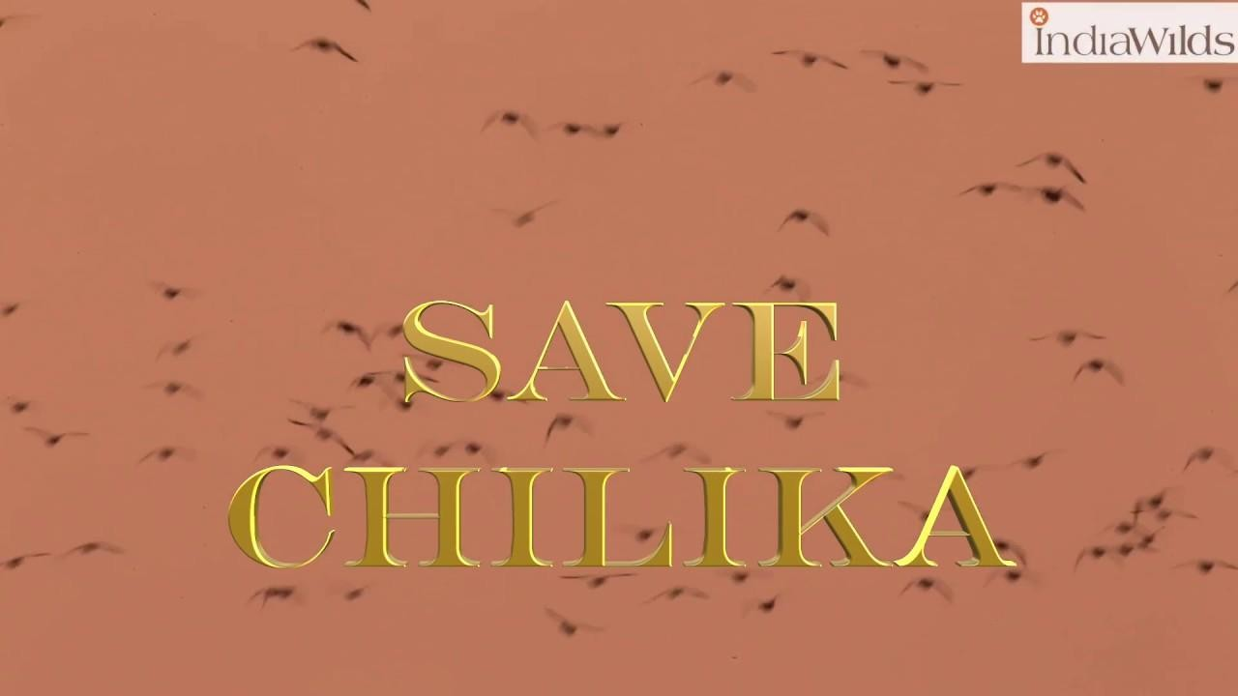

CHAPTER-6 CONCLUSION
The Chilika Lagoon stands as a poignant case study of the intricate and interdependent relationship between ecological, social, and economic systems. This study highlights how changes in the lagoon’s ecological subsystem have profoundly impacted the livelihoods and socio-political structures of the local fishing communities. The degradation of ecological capital due to various anthropogenic and natural drivers has triggered cascading negative effects on the economic and social well-being of the fishers. In turn, the changes in the social and economic spheres have fed back into the ecological system, demonstrating the two-way, interconnected nature of the Chilika social-ecological system.
The ecological health of Chilika has been severely impacted by multiple factors, including hydrological interventions, unsustainable aquaculture practices, and land use changes. The opening of a new sea mouth, intended to enhance water exchange and reduce salinity fluctuations, yielded mixed results. While it initially improved water quality, it also led to the disintegration of sandbars, altering the lagoon’s natural sediment dynamics. The increased sedimentation rates, influenced by riverine inputs and coastal longshore currents, have gradually reshaped the lagoon’s landscape, posing a serious threat to its biodiversity and productivity.
The transition from traditional fishing practices to intensive aquaculture, particularly shrimp farming, has further strained the lagoon’s ecological balance. Monoculture of high-value species, such as tiger prawn, replaced the diverse array of low-value fish that once supported local livelihoods. This biodiversity loss weakened the ecosystem’s resilience, making it more vulnerable to environmental shocks. As a result, the fishers faced diminishing catches, dwindling incomes, and increased occupational displacement.
The ecological decline in Chilika has had direct and devastating socio-economic consequences for the fisher communities. The loss of ecological capital translated into economic hardships, leading to reduced income levels, food insecurity, and increased outmigration. Encroachment of fishing areas by commercial aquaculture interests, often backed by powerful external stakeholders, further marginalized the local fishers. This resulted in resource conflicts, legal disputes over property rights, and socio-political disempowerment of traditional fishing groups.
The erosion of social capital, characterized by the weakening of traditional community ties and caste-based fishing identities, further destabilized the fishers’ socio-political fabric. Cultural disintegration became evident as younger generations increasingly abandoned the fishing profession due to its diminishing viability. The occupational displacement of fishers into non-fishing jobs, often characterized by poor working conditions and low wages, exacerbated their socio-economic vulnerability.

Chilika’s ecological challenges are further compounded by the impacts of climate change, which has intensified the vulnerabilities of the fisher communities. Increasingly erratic weather patterns, storm surges, and monsoonal floods have become more frequent, disrupting fishing activities and damaging the lagoon’s fragile ecosystem. The 1999 super cyclone, for example, revealed the stark differences in disaster preparedness and resilience between inland and coastal communities. The degree of social cohesion and disaster awareness among the villagers significantly influenced their capacity to withstand and recover from such extreme events.
The Sustainable Livelihood Approach (SLA) applied in this context underscores the multi-dimensional nature of climate resilience. It highlights that vulnerability is not uniform across regions or occupational groups, but rather depends on the adaptive capacity of the affected communities. Factors such as access to fishing grounds, equitable marketing systems, and community-level cooperation significantly influence the ability of fishers to cope with and adapt to climate-induced shocks.
The study also emphasizes the role of land use and land cover (LULC) changes in shaping the lagoon’s ecological dynamics. Agricultural expansion, urbanization, and unsustainable land practices in the catchment areas have contributed to increased siltation in the lagoon. The sediment flux from river systems, combined with tidal influences from the Bay of Bengal, has altered the lagoon’s geomorphology, reducing its depth and affecting water quality. The lack of detailed sediment flux data makes it difficult to assess the long-term impacts accurately, underscoring the need for more extensive geochemical and sedimentary studies.
The use of remote sensing and GIS tools has proven valuable in monitoring LULC changes, but long-term, high-resolution datasets are necessary for more effective management and conservation strategies. A combination of field investigations and satellite-based time series analysis would enable policymakers to better understand the ecological shifts and formulate sustainable interventions.
The complex and interconnected nature of Chilika’s socio-ecological challenges calls for a holistic and integrated management approach. Effective solutions must address both ecological conservation and the socio-economic well-being of the fisher communities. Some of the key policy recommendations include:
- Hydrological Management: Regular dredging and maintenance of the lagoon’s sea mouth and channels to prevent siltation and ensure proper water exchange with the Bay of Bengal.
- Regulation of Aquaculture: Implementing strict regulations on commercial shrimp farming, including the abolition of illegal enclosures (gheris) and banning mechanized boats that disrupt traditional fishing practices.
- Resource Access and Rights: Strengthening the property rights and resource access of local fishers through community-based cooperative societies, with legal and technical support from the government. This would empower the traditional fishers to manage the lagoon’s resources sustainably.

- Conservation and Restoration Efforts: Removing invasive aquatic weeds, restoring degraded wetlands, and promoting biodiversity conservation to enhance the lagoon’s ecological resilience.
- Climate Adaptation and Disaster Preparedness: Developing community-based disaster preparedness programs and promoting sustainable livelihood diversification strategies to reduce the fishers’ vulnerability to climate-induced shocks.
One of the most critical findings of the study is the recognition of Chilika as a common property resource (CPR). The lagoon’s management should prioritize the rights and interests of the local fishing communities, who have been its traditional stewards for centuries. CPR management frameworks, based on local collective action, should be empowered with legal backing to prevent exploitation by external commercial interests. Supporting fisher cooperatives with legal, financial, and technical assistance would enable more equitable and sustainable governance of the lagoon.
In conclusion, the Chilika Lagoon exemplifies the deeply intertwined relationship between ecological processes and human livelihoods. The study reveals that the sustainability of this social-ecological system hinges on recognizing the interdependence of its ecological, economic, and socio-political dimensions. Unchecked exploitation of natural resources, driven by short-term economic interests, poses a grave threat to both the ecosystem and the people who rely on it.
Ensuring the long-term sustainability of Chilika requires a multi-pronged approach that integrates ecological conservation, equitable economic practices, and community empowerment. Only through such holistic and inclusive strategies can Chilika’s ecological wealth, cultural heritage, and the livelihoods of its fishers be preserved for future generations.

REFERENCES
Béné, C. 2005. The good, the bad and the ugly: discourse, policy controversies, and the role of science in the politics of shrimp farming development. Development Policy Review 23(5):585-614. http://dx.doi.org/10.1111/j.1467-7679.2005.00304.x
Berkes, F. 2011. Restoring unity: the concept of marine social ecological systems. Pages 9-28 in R.
E. Ommer, R. I. Perry, K. Cochrane, and P. Cury, editors. World fisheries: a social-ecological analysis. Blackwell, Brighton, UK. http://dx.doi. org/10.1002/9781444392241.ch2
Berkes, F., and C. Folke, editors. 1998. Linking social and ecological systems: management practices and social mechanisms for building resilience. Cambridge University Press, Cambridge, UK.
Charles, A. T. 1995. Fishery science: the study of fishery systems. Aquatic Living Resources 8:233-
239. http://dx.doi.org/10.1051/ alr:1995023
Charles, A. T. 2001. Sustainable fishery systems. Wiley-Blackwell, Oxford, UK. http://dx.doi.org/10.1002/9780470698785
Charles, A. T. 2005. Toward sustainable and resilient fisheries: a fishery-system approach to overcoming the factors of unsustainability. Pages 221-233 in J. Swan and D. Greboval, editors. Overcoming factors of unsustainability and overexploitation in fisheries: selected papers on issues and approaches. FAO Fisheries Report, No.782. Food and Agriculture Organization of United Nations, Rome, Italy. [online] URL: http://www.fao.org/ docrep/009/a0312e/A0312E13.htm#ch2.11
Charles, A. T. 2007. Adaptive co-management for resilient resource systems: some ingredients and the implications of their absence. Pages 83-102 in D. Armitage, F. Berkes, and N. Doubleday, editors. Adaptive co-management: collaboration, learning, and multi-level governance. UBC Press, Vancouver, British Columbia, Canada.
Charles, A. T., M. Wiber, K. Bigney, D. Curtis, L. Wilson, R. Angus, J. Kearney, M. Landry, M. Recchia, H. Saulnier, and C. White. 2010. Integrated management: a coastal community perspective. Horizons 10:26-34. [online] URL: http://smu-facweb. smu.ca/~charles/PDFS_2005/094.pdf
Christie, P. 2011. Creating space for interdisciplinary marine and ecological research: five dilemmas and suggested resolutions. Environmental Conservation 38(2):172-186. http://dx.doi.org/10.1017/ S0376892911000129
Clark, W. C., and S. A. Levin, editors. 2010. Toward a science of sustainability: executive summary. Report from ‘Toward a science of sustainability’ conference, Warrenton, Virginia, USA. CID Working Paper No. 196. Center for International Development, Harvard University, Boston, Massachusetts, USA. [online] URL: http://scimaps.org/atlas/images/Towards_a_Science_of_Sustainability. pdf

Coulthard, S. 2008. Adapting to environmental change in artisanal fisheries: insights from a South Indian lagoon. Global Environmental Change 18(3):479-489. http://dx.doi.org/10.1016/ j.gloenvcha.2008.04.003
Crocker, T. D. 1999. A short history of environmental and resource economics. Pages 32-45 in J. C.
J. M. van den Bergh, editor. Handbook of environmental and resource economics. Edward Elgar, Northampton, Massachusetts, USA. http://dx. doi.org/10.4337/9781843768586.00011
Daily, G. C. 1997. Nature’s services: societal dependence on natural ecosystems. Island, Washington, D.C., USA.
Dale, V. H., S. Brown, R. A. Haeuber, N. T. Hobbs, N. Huntly, R. J. Naiman, W. E. Riebsame, M.
G. Turner, and T. J. Valone. 2000. Ecological principles and guidelines for managing the use of land. Ecological Applications 10:639-670. http://dx.doi. org/10.1890/1051-0761(2000)010[0639:EPAGFM]2.0.CO;2
Das, M. N., editor. 1977. Sidelights on history and culture of Orissa. Vidhyapuri, Cuttack, India.
Delgado, C. L., N. Wada, M. W. Rosegrant, S. Meijer, and M. Ahmed. 2003. Outlook for fish to 2020: meeting global demand. International Food Policy Research Institute, Washington, D.C., USA and WorldFish Center, Penang, Malaysia.
Desai, W. S. 1961. A pageant of Burmese history. Orient Longmans, New Delhi, India. Food and Agriculture Organization of the United Nations (FAO). 2006. FishStat Plus.
Food and Agriculture Organization of the United Nations, Rome, Italy. [online] URL: http://www.fao.org/ fi/statist/fisoft/fishplus.asp
Folke, C., T. Hahn, P. Olsson, and J. Norberg. 2005. Adaptive governance of social-ecological systems. Annual Review of Environment and Resources 30:441-473. http://dx.doi.org/10.1146/ annurev.energy.30.050504.144511
Garcia, S. M., and A. T. Charles. 2008. Fishery systems and linkages: implications for science and governance. Ocean and Coastal Management 51:505-527. http://dx.doi.org/10.1016/j. ocecoaman.2008.05.001
Glaser, M. 2006. The social dimensions in ecosystem management: strengths and weaknesses of human-nature mind maps. Research in Human Ecology 13:122-142. [online] URL: http://www.humanecologyreview.org/pastissues/her132/glaser.pdf
Pitt CH (1932) Report on the investigation into the possibilities of salt production in Bengal and Bihar and Orissa. Central Publication Branch, Kolkata
Pradhan D, Flaherty M (2008) National initiatives, local effects: trade liberalization, shrimp aquaculture, and coastal communities in Orissa, India. Soc Nat Resour 21:63–76
Rajawat AS, Gupta M, Acharya BC, Nayak S (2007) Impact of new mouth opening on morphology and water quality of Chilika lagoon: a study based on Resources at-I LISS-III and AWiFS and IRS-iD LISS-III data. Int J Remote Sens 28:905–923

Raman AV, Satyanarayan C, Adiseshasai K, Prakash KP (1990) Phytoplankton characteristics of Chilika Lake, a brackish water lagoon, east coast of India. Indian J Mar Sci 19:274–277
Sahu BK, Pati P, Panigrahy RC (2013) Plastic litters: a major environ mental issue in Chilika lagoon. Curr Sci 104(9):1133–1134
Satyanarayana Ch (1999) Hydrographic and phytoplankton characteris tics of Chilka Lake, a brackish water lagoon, on the east coast of India. Ph.D. thesis, Andhra University, Visakhapatnam, India
Sekhar NU(2004) Fisheries in Chilika Lake: how community access and control impacts their management. J Environ Manag 73(3):257–266
Sterling A, Peggs J (1846) Orissa: Its geography, statistics, history, religion and antiquities. Published for the author by John Snow, London
Venkatarathnam K (1970) Formation of the barrier spit and other sand ridges near Chilika Lake on the east coast of India. Mar Geol 9:101–116
World Bank (2005) Scenario assessment of provision of environmental flows to Lake Chilika from Naraj Barrage, Orissa, India. Reports from the environmental flows window of the bank Netherlands water partnership programme (World bank) to the Government of Orissa, India, 40 pp
Panda D, Subramanian V, Panigrahy RC (1995) Geochemical fraction ation of heavy metals in Chilika lake (east coast of India)– a tropical coastal lagoon. Environ Geol 26:199–210
Panda S, Bhatta KS, Rath KC, Misra C, Samal RN (2008) The Atlas of Chilika. Chilika Development Authority, Bhubaneswar, 133
Panigrahi SN, Acharya B, Panigrahy RC, Nayak B, Banarjee K, Sarkar S (2007) Anthropogenic impact on water quality of Chilika lagoon RAMSARsite:astatistical approach. Wetl Ecol Manag 15:113–126
Panigrahi SN, Wikner J, Panigrahy RC, Satapathy KK, Acharya BC (2009) Variability of nutrients and phytoplankton biomass in a shallow brackish water ecosystem (Chilka Lagoon), India. Limnology 10:73–85
Panigrahy RC (2000) Chilika lagoon- a sensitive coastal lagoon. J Indian Ocean Stud 7(2&3):222–242
Patnaik S, Sarkar SK (1976) Observations on the distribution of phyto plankton in Chilika Lake. J Inland Fish Soc India 8:38–48
Patro SN (1988) Chilika- The Pride of our Wetland Heritage (a state of the art report). Orissa Environmental Society, Bhubaneswar
Pattnaik S (1973) Observation on seasonal fluctuations of plankton in the Chilika lagoon. Indian J Fish 19:43–55

Pattnaik SS (2002) Estimation of sediment flow into Chilika Lake. In: The Proceedings of International Workshop on Sustainable Development of Chilika Lagoon, 12–14 December 1998. Chilika Development Authority, Bhubaneswar, India
Pattnaik S (2008) Conservation of environment and protection of mar ginalized of fishing community of Chilika in Orissa, India. J Hum Ecol 22:1–12
Phleger FB (1969) Some general features of coastal lagoons. In: Ayala Castaiieres A (ed) Lagunas Costeras, un Simposio. Universidad Nacional AuMnoma de MBxico, MBxico, DF, pp 5–26.
Rojas Blanco VA (2006) Local initiatives and adaptation to climate change. Disasters 30(1):140–147 doi:10.1111/j.1467-9523.2006.00311.x
Shanmugasundaram J, Arunachalam S, Gomathinayagam S, Lakshnaman P (2000) Cyclone damage to buildings and structures: a case study. J Wind Eng 84:369–380 doi:10.1016/S0167-6105(99)00114-2
Samal CK, Meher S (2003) Cooperative societies of fishermen of Chilika Lake; problems and prospects. J Rural Dev 22(4):517–525
Shaw R (2007) Community-based climate change adaptation in Vietnam: inter-linkages of environment, disaster, and human security. In: Sonak S (ed) Multiple dimension of global environmental changes. TERI, New Delhi
Smit B, Wandel J (2006) Adaptation, adaptive capacity and vulnerability. Glob Environ Change 16:282–292 doi:10.1016/j.gloenvcha.2006.03.008
Smit B, Burton L, Klein JTR, Street R (1999) The science of adaptation: a framework for assessment. Mitig Adapt Strategies Glob Change 4:199–213 doi:10.1023/A:1009652531101
Sperling F (ed) (2003) Poverty and climate change: reducing the vulnerability of the poor through adaptation. World Bank, Washington DC, p 43
SRORD (2004) Annual report on natural calamities 2003–2004. Special Relief Commissioner, Revenue Department, Bhubaneswar
SRORD (2005) Annual report on natural calamities 2004–2005. Special Relief Commissioner, Revenue Department, Bhubaneswar
Thomas SGD, Twyman C (2005) Equity and justice in climate change adaptation amongst natural-resource dependent societies. Glob Environ Change 15:115–124 doi:10.1016/j.gloenvcha.2004.10.001
Torresan S, Critto A, Valle DM, Harvey N, Marcomini A (2008) Assessing coastal vulnerability to climate change: comparing segmentation at global and regional scales. Sustain Sci 3:45–65 doi:10.1007/s11625 008-0045-1
UNDP(2007) Human development report 2007/2008: fighting climate change: human solidarity in a divided world. Oxford University Press, New York

UN/ISDR (2007) Environment and vulnerability: emerging perspectives. United Nations Environment Programme, Geneva
Van Aalst KM, Cannon T, Burton I (2008) Community level adaptation to climate change: the potential role of participatory community risk assessment. Glob Environ Change 18:165–179 doi:10.1016/j. gloenvcha.2007.06.002
WWF(2005) Are we putting our fish in hot water? http://assets.panda.org/downloads/fisherie_web_final.pdf. Cited 21 Dec 2008
Ziervogel G, Calder R (2003) Climate variability and rural livelihoods: assessing the impact of seasonal climate forecasts in Lesotho. Area 35(4):403–417 doi:10.1111/j.0004-0894.2003.00190.x
Ziervogel G, Bharwani S, Downing ET (2006) Adapting to climate variability: pumpkins, people and policy. Nat Resour Forum 30:294–305 doi:10.1111/j.1477-8947.2006.00121.x
Abbasi SA, Mishra PK (1997) Asia’s largest lake (Chilika)-ecology, threats imperatives. Discovery publishing house, New Delhi
Annandale N, Kemp S (1915) Introduction to the fauna of the Chilika Lake. Mem Indian Mus 5:1–20
Anonymous(2009)Report on“Theprojectforconservationandwiseuse of natural resources of the Chilika lagoon through community participation in India, Japan International Cooperation Agency (JICA) and Chilika Development Authority (CDA), Orissa”.
Banarjee AC, RoyChoudhury NC (1966) Observation on some physico chemical features of Chilka lake. Indian J Fish 13:395–429
Bhatta KS (2003) Environmental monitoring to access the impact of desiltation of the Outer channel on the ecosystem of the Chilika lagoon. Interim report, MoEF sponsored project, CDA, Bhubaneswar, pp 1–32
Biswas KP (1995) Ecological and fisheries development in wetlands: a study of Chilika Lagoon. Daya Publishing House, New Delhi
CDA(2011) Annual Report 2010–11. 36 pp Chandramohan P, Nayak BU (1994) A study for the improvement of the Chilika lake tidal inlet, east coast of India. J Coast Res 10:909–918 CIFRI (2006) A monograph on the algal diversity of Chilika lake, CDA sponsored consultancy project.
CIFRI, Barrackpore, pp 1–25
Dev UN (1990) Data book on birds of Chilika. Associates Project Bihanga, Bhubaneswar
Dev UN (1992) An assessment of bird conservation needs at Chilika Lake. Report of project Bihanga, Bhubaneswar
Dujovny E (2009) The deepest cut: political ecology in the dredging of a new sea mouth in Chilika Lake, Orissa, India. Conservat Soc 7(3): 192–204

Ghosh AK (1998) Integrated management strategy for Chilika, In: Proceeding International workshop on sustainable development of Chilika lagoon, Bhubaneswar, Orissa, India. Chilika Development Authority, Orissa, 1998, pp 274–280
Ghosh AK, Pattnaik AK (2005) Chilika lagoon- Experience and lessons learned brief. UNEP International Waters Learning Exchange and Resource Network. pp 115–132
Kumar R, Pattnaik AK (2012) Chilika- an integrated management planning framework for conservation and wise use. Wetlands International- South Asia, New Delhi, India and Chilika Development Authority, Bhubaneswar
Mangla B (1989) Chilika lake: desilting Asia’s largest brackish water lagoon. Ambio 18(5):298–299
Mishra SR, Griffin AL (2010) Encroachment: a threat to resource sus tainability in Chilika Lake, India. Appl Geogr 30:448–459
Misra PM, Sahu BK, Panigrahy RC, Tripathy SK, Padhy A, Panda D, Patnaik DK, Patra SK (1988) Studies on the hydrobiological fea tures of Chilika lake, Orissa. Final report, Dept of Environment and Forests, Govt of India, 45pp
Mitra GN (1946) The development of the Chilika Lake. Orissa Govt. Press. 46pp
Mohanty SK (1975) Some observation on physico-chemical features of outer channel during 1971–
73. Bulletin, Dept. of Marine Sciences, University of Cochin, VII:69:89
Mohanty PR (1981) Studies on the Gracilaria verrucosa (Hudson) Papenfuss of Chilka lake. PhD Thesis, Berhampur University, Berhampur, India, 102 pp
Mohanty SK (1988) Rational utilization of brackish water resources of the Chilka lagoon foraquaculture.In: Patro SN, SahuBN,RamaRao KV, Misra MK (eds) Chilka: the pride of our wetland heritage (a state-of-art report). Orissa Environmental Society, Bhubaneswar, pp 36–39
Mohapatra A, Mohanty RK, Mohanty SK, Bhatta KS, Das NR (2007) Fisheries enhancement and biodiversity assessment of fish, prawn and mud crab in Chilika lagoon through hydrological intervention. Wetl Ecol Manag 15:229–251
BNHS (Bombay Natural History Society) (2005). Habitat evaluation of Chilika lake with special reference to birds as bio-indicators. 140pp Nayak BK, Acharya BC, Panda UC,
Nayak BB, Acharya SK (2004) Variation of water quality in Chilika lake, Orissa. Indian J Mar Sci 33(2):164–169

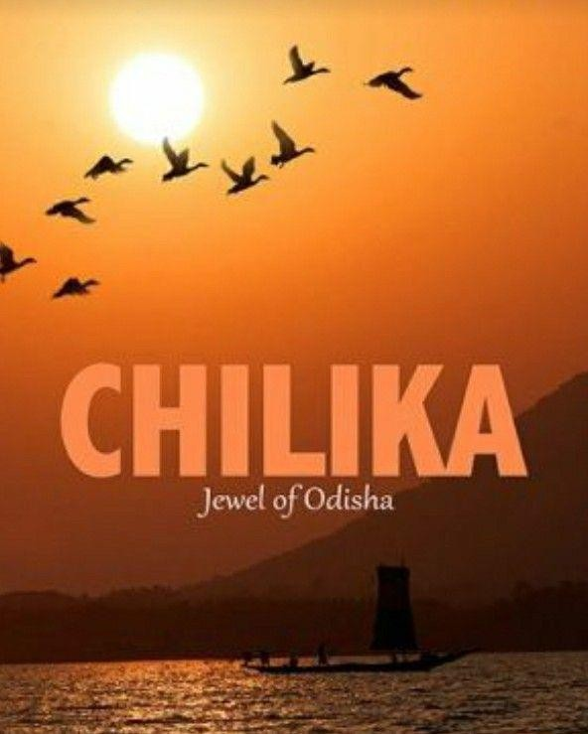

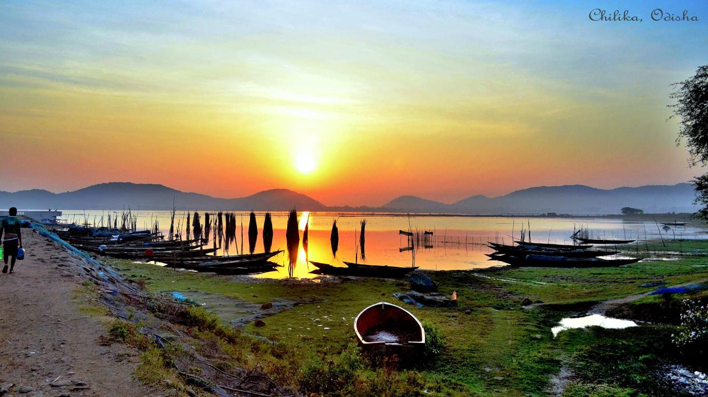

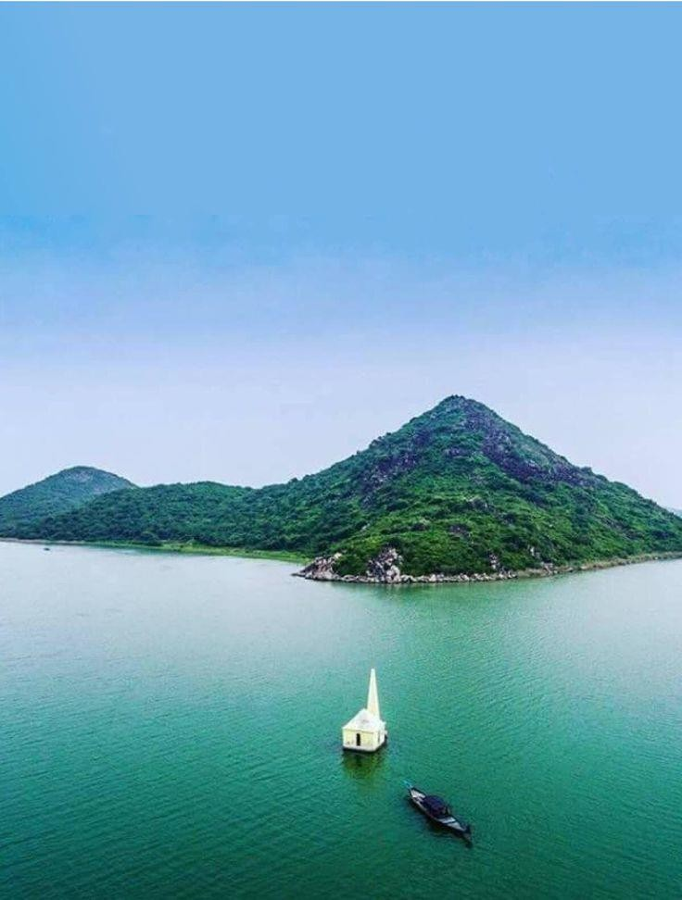
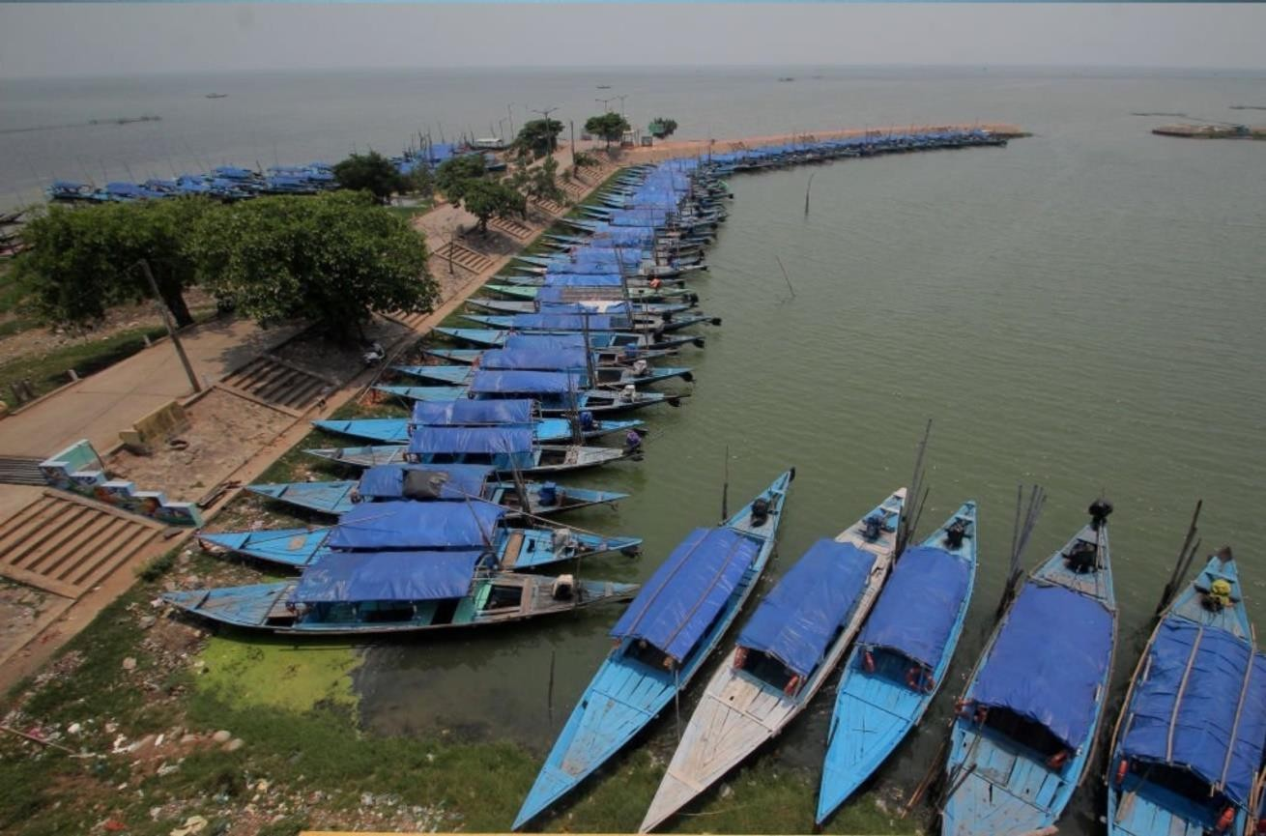

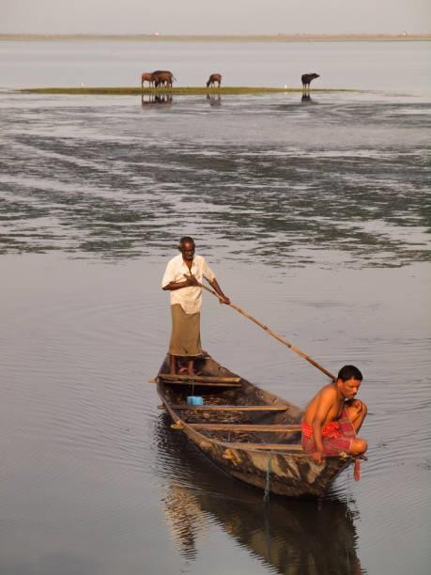
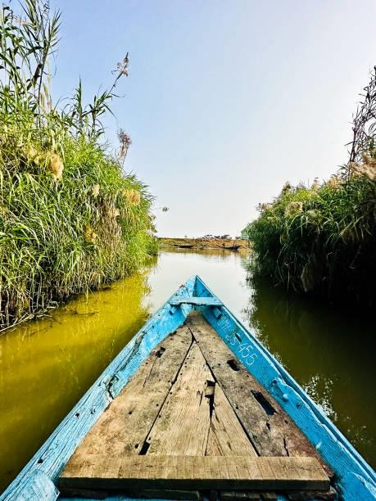
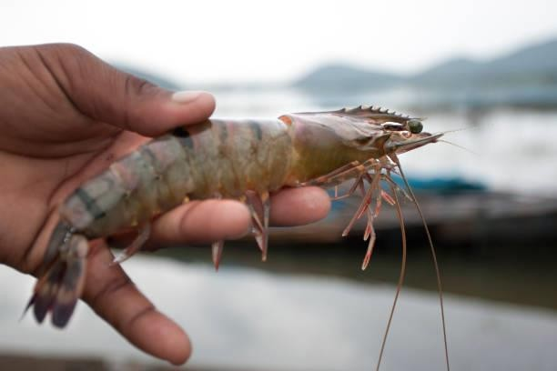
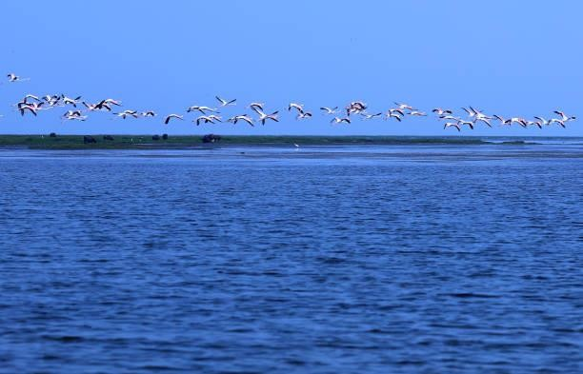

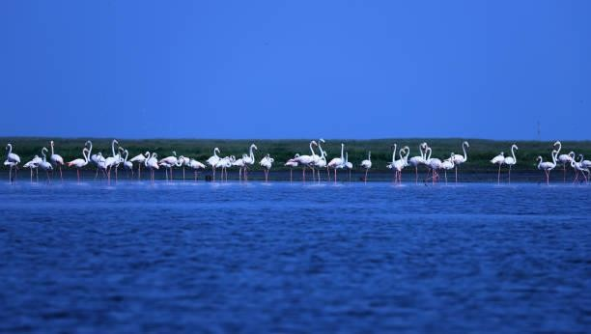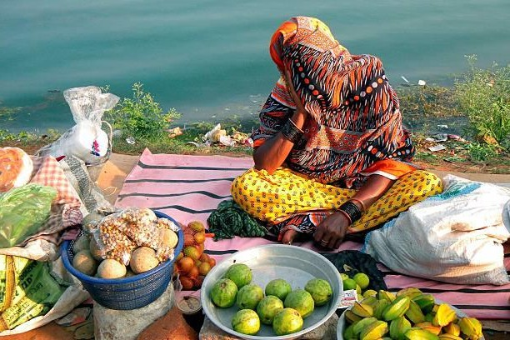
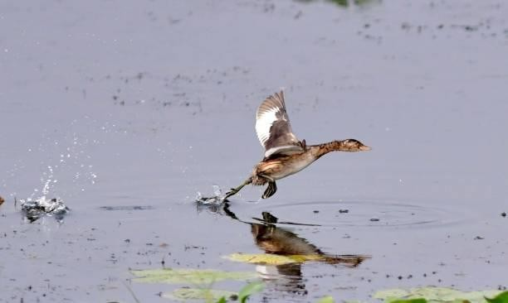
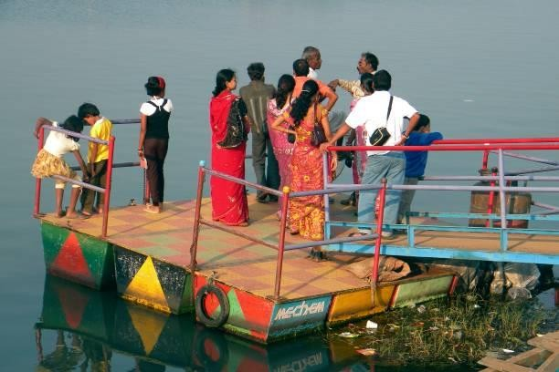

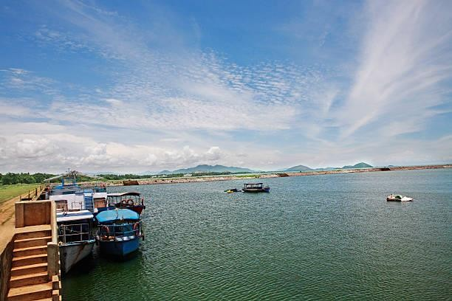



RADHANATH RAY



----------------------------------------------------------------------------------------------------------------
THANK YOU !

